Agroecological Education and Community Extension in The Brazilian Semi-Arid Region: Actions Developed at IFNMG – Araçuaí Campus

ABSTRACT

Agroecology combines ecological, social, and cultural knowledge to create resilient and sustainable agricultural systems. In semi-arid regions like Minas Gerais, Federal Institutes promote teaching, research, and extension to strengthen rural communities’ productivity and autonomy. This study aimed to analyze successful agroecological education and community extension actions developed at the Federal Institute of Northern Minas Gerais (IFNMG) – Araçuaí Campus, located in the Brazilian semi-arid region, highlighting their contributions to student training, the strengthening of family farming, and sustainable territorial development. The research is characterized as applied, qualitative, and descriptive, based on the systematization of pedagogical and extension experiences conducted between 2025 and 2026. The analyzed actions included discussion circles, technical lectures, a Field Day on agroecological cultivation, the implementation of portable sustainable gardens as a didactic modeling strategy, and the production and distribution of 300 fruit and forest seedlings. Data were collected through institutional records, participant observation, questionnaires, interviews, and focus groups, and analyzed using descriptive statistics and thematic categorization. The results demonstrated significant formative, technical, and socio-environmental impacts. Active methodologies strengthened systemic thinking and student protagonism, while extension activities enhanced dialogue between scientific knowledge and local wisdom. The high level of community participation evidenced the mobilizing potential of agroecological practices grounded in experiential learning and knowledge exchange. The production and distribution of seedlings reinforced environmental education and territorial sustainability. It is concluded that agroecology, when integrated into professional education and rural extension, constitutes a transformative strategy that consolidates the inseparability of teaching, research, and extension in semi-arid contexts.

Keywords: Agroecology; Rural Extension; Professional Education; Family Farming; Sustainable Territorial Development; Semi-Arid Region.

- INTRODUCTION

Agroecology has consolidated itself in recent decades as a scientific, political, and pedagogical field that articulates ecological, social, and cultural knowledge in the construction of more resilient and sustainable agricultural systems. More than a set of techniques, agroecology constitutes a systemic approach that integrates ecological principles into the management of agroecosystems and territorial dynamics (ALTIERI; NICHOLLS, 2020). In this context, its educational dimension becomes central, especially in territories marked by socio-environmental vulnerabilities, such as the Brazilian semi-arid region.
Rural education emerges as a strategic space for the dissemination and collective construction of agroecological knowledge, valuing traditional knowledge, participatory processes, and the formation of critical subjects. As argued by Caldart et al. (2012), rural education is not limited to schooling in rural areas, but represents a political-pedagogical project aimed at social emancipation and qualified permanence in the territory. From this perspective, the articulation between teaching, research, and extension assumes a structuring role in consolidating contextualized and transformative educational practices.
The Federal Institutes of Education, Science, and Technology, especially those located in semi-arid regions, play a strategic role in promoting integrated actions in teaching, applied research, and rural extension. These institutions contribute to strengthening sustainable production chains, family farming, and food security, acting as hubs of social and technological innovation (PEREIRA; SILVA, 2021). In the semi-arid region of Minas Gerais, characterized by irregular rainfall patterns and socioeconomic constraints, agroecological initiatives associated with education and extension become essential to enhance productive resilience and the autonomy of rural communities.
Recent literature highlights that territorial experiences based on agroecology promote not only productive gains, but also significant social impacts, such as strengthening community organization, income generation, and expanding food sovereignty (WEZEL et al., 2020). Furthermore, participatory extension actions grounded in the dialogue of knowledge foster horizontal learning processes and the collective construction of knowledge (CAPORAL; COSTABEBER, 2004).
In the educational sphere, strategies such as field days, the establishment of demonstration units, production of fruit and forest seedlings, pedagogical gardens, and the training of multipliers have been recognized as effective teaching-learning tools, as they articulate theory and practice, bringing students and farmers closer to the local productive reality (GLIESSMAN, 2015). Such initiatives contribute to consolidating agroecology as a structuring axis of technical and technological education, especially when linked to family farming.
Given this scenario, it becomes relevant to systematize and analyze successful experiences in agroecological education and extension developed within the institutional context of the Federal Institute of Northern Minas Gerais – Araçuaí Campus, considering its territorial insertion and its role in student training and support for family farming. The systematization of these actions allows for understanding their formative, social, and productive impacts, in addition to contributing to the advancement of academic discussions on agroecological education in the Brazilian semi-arid region.

- MATERIALS AND METHODS

This study is characterized as applied research with a qualitative and descriptive approach, based on the systematization of pedagogical and extension experiences developed at the Federal Institute of Northern Minas Gerais (IFNMG) – Araçuaí Campus, located in the Médio Jequitinhonha territory, Minas Gerais, Brazil. The actions were carried out from 2025 to 2026, involving students from the Technical Course in Agroecology, the Agricultural and Environmental Engineering program, and the local community, especially family farmers from the municipality of Araçuaí, MG.
The methodological framework was grounded in the systematization of experiences as a strategy for critical analysis of educational and extension practices. The actions were guided by recognized agroecological principles, including: (i) productive and biological diversity; (ii) nutrient cycling and reuse of local resources; (iii) soil conservation and ecological management; (iv) reduction of external inputs; (v) integration between system components; (vi) valorization of local knowledge; and (vii) socio-environmental sustainability. These principles served as analytical and operational criteria for planning, implementing, and evaluating all activities described in this study.

2.1 Didactic Modeling of Agroecological Systems
The first analyzed action corresponded to the project “Didactic Modeling of Agroecological Systems: Implementation of Portable Sustainable Gardens in Agroecology Education.” The project adopted an active, participatory, and experiential pedagogical approach aimed at integrating theory and practice.
The agroecological principles were applied through: use of reused or low-cost materials (resource recycling and reduction of external inputs); diversification of short-cycle vegetable species (productive diversity); structuring of drainage layers and substrate composition (soil conservation and ecological management); and collective planning (participatory construction of knowledge).
Students were organized in pairs and responsible for designing and constructing portable garden boxes. Each group developed a sketch defining dimensions, species selection, internal layout, and drainage strategies. Gardens were assembled including drainage organization, substrate preparation using locally available materials, and planting of diversified species.
During the monitoring phase, students conducted irrigation, basic agroecological management practices, and systematic observation of plant development, recording information in monitoring sheets. Evaluation criteria included coherence with agroecological principles, diversity of cultivated species, adequacy of soil management practices, and students’ ability to articulate theoretical concepts with practical implementation.

2.2 Environmental Education and Extension Practices
The second systematized experience corresponded to the project “Environmental Education and Extension Practices: Training Multipliers for Family Farming in Araçuaí/MG.” The methodology integrated theoretical instruction, participatory workshops, production of educational materials, and field-based actions.
Agroecological principles were operationalized by promoting crop diversification strategies, soil conservation techniques, low-input management practices, and dialogue between scientific and local knowledge. The training stage included lectures and discussion circles addressing sustainable production systems, ecological interactions, and family farming resilience.
Students and faculty prepared technical bulletins and institutional videos in accessible language, reinforcing the principle of knowledge democratization and community empowerment.
As a result of this action, the 1st Field Day – Agroecological Cultivation at IFNMG Araçuaí Campus was organized within the Rural Teaching and Extension Curricular Unit (UCE). The event was structured into three technical stations covering six crops (common bean, soybean, maize, sorghum, sunflower, and cotton). At each station, agroecological crop management strategies were presented, emphasizing soil conservation, crop diversification, ecological balance, and sustainable cultivation practices. The activity fostered interaction between technical-scientific knowledge and farmers’ experiential knowledge, reinforcing the participatory and territorial dimensions of agroecology.

2.3 Planting for the Future Project
The third systematized action refers to the project “Planting for the Future: Fruit and Forest Seedlings and Environmental Education for the Population of Araçuaí.” This action integrated technical training, seedling production, and community outreach.
Agroecological principles were applied through the prioritization of native and adapted species (biodiversity conservation), production of seedlings in locally structured nurseries (local resource use), and dissemination of ecological restoration practices (environmental sustainability).
Students participated in theoretical-practical training covering seed and cutting selection, substrate preparation using locally available materials, nursery organization, irrigation management, and seedling acclimatization. A nursery was established at IFNMG – Araçuaí Campus for fruit and forest seedling production. Periodic monitoring of growth and development was conducted using structured observation records.
Environmental education technical bulletins were developed addressing environmental conservation, native species valorization, urban afforestation, and ecological restoration. Seedlings were distributed at the Municipal Market of Araçuaí with technical guidance, reinforcing the territorial and socio-environmental outreach of the project.

2.4 Data Collection and Analysis
Data collection included institutional records, attendance lists, technical reports, photographic documentation, participant observation, structured questionnaires, semi-structured interviews, and focus groups involving students and farmers.
Quantitative data were analyzed using descriptive statistics (absolute and relative frequencies). Qualitative data were examined through thematic categorization, focusing on identification of formative processes, strengthening of family farming practices, integration between teaching and extension, and socio-environmental impacts. The agroecological principles defined at the beginning of this section were used as analytical categories to interpret the results.

3. results and discussion

In order to provide empirical support for the identified formative impacts, structured questionnaires were applied to students immediately after the activity. The results indicated that 94% of respondents reported an improved understanding of the social function of rural extension, while 89% emphasized the relevance of dialogical methodologies in strengthening trust between technical professionals and family farmers. Furthermore, 92% stated that the activity contributed to broadening their perception of agroecology beyond strictly productive aspects, incorporating social, territorial, and environmental dimensions.
Semi-structured interviews conducted with a group of students allowed the identification of three main thematic categories: (i) recognition of farmers’ knowledge as legitimate and complementary to scientific knowledge; (ii) development of communication, mediation, and active listening skills; and (iii) increased awareness of the complexity of rural development in semi-arid contexts marked by social and climatic vulnerabilities. Students emphasized that contact with practical experiences involving extension professionals enabled a more concrete understanding of the challenges inherent in implementing agroecological practices in socially vulnerable territories.
Focus group discussions reinforced these findings, highlighting the importance of participatory dialogue in overcoming traditional top-down and diffusionist extension models. Participants emphasized that horizontal knowledge exchange fosters the collective construction of context-based solutions, strengthening farmers’ autonomy and promoting greater adherence of agroecological practices to local realities. In this process, a clear convergence was observed between agroecological principles—particularly the valorization of local knowledge, integration of social and environmental dimensions, and territorial sustainability—and the pedagogical approach adopted in the activity.
The triangulation between quantitative data (high levels of perceived learning and satisfaction) and qualitative evidence (emergence of critical-reflective categories in interviews and focus groups) confirms the effectiveness of the action both as a formative instrument and as a strategic mechanism for territorial articulation. These results demonstrate that the discussion circle was not merely an isolated educational event, but rather a structured space for knowledge construction, institutional strengthening, and expansion of social capital within the territory.
This interpretation is consistent with contemporary studies highlighting that dialogical educational environments based on knowledge co-creation promote transformative learning and consolidate a professional identity committed to sustainable development (CARTAGENA et al., 2025). Recent research also demonstrates that participatory approaches in agroecological transition processes strengthen integration between scientific and traditional knowledge, enhancing social innovation capacity and territorial resilience (BOURCERET et al., 2026). Furthermore, interview-based investigations with farmers indicate that agroecological transitions are deeply associated with productive autonomy, environmental protection, and experiential knowledge (MARKIEWICZ-KESZYCKA et al., 2025), elements similarly observed in the present study.
Taken together, these findings corroborate evidence that the systematic incorporation of agroecological principles into teaching and extension activities contributes to multidimensional sustainability outcomes, including social empowerment, strengthening of family farming, and environmental responsibility (ADOYO et al., 2025). Thus, the experience developed at IFNMG – Araçuaí Campus demonstrates that the integration of teaching, research, and extension can generate measurable educational outcomes and significant qualitative socio-territorial impacts.
It can be concluded that agroecological education, when structured through participatory and territorially grounded methodologies, consolidates itself as a transformative practice in the Brazilian semi-arid region, articulating technical competence, social responsibility, and environmental sustainability in contexts marked by structural challenges. This experience reinforces the role of public educational institutions as strategic agents in promoting sustainable territorial development.
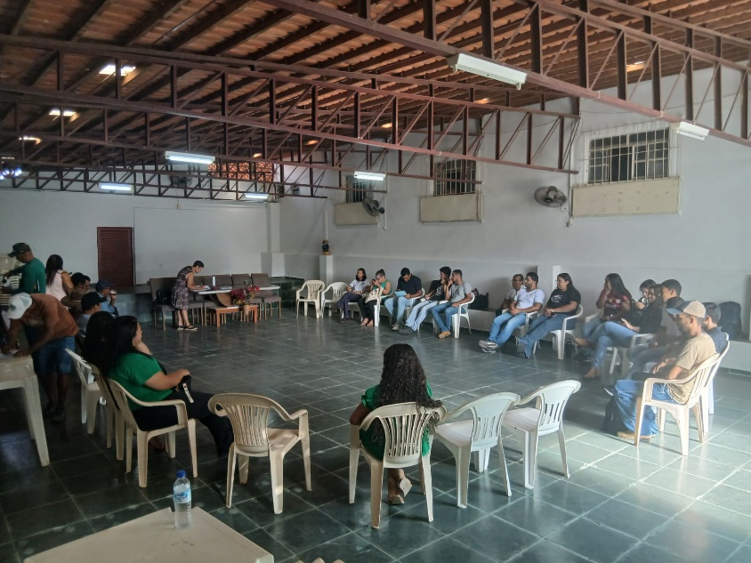
Figure 1 – Meeting and dialogue held during a session of the Municipal Council for Sustainable Rural Development (CMDRS) of Araçuaí, MG, Brazil.

The lecture “Technologies for Reducing Water Consumption in Pineapple Cultivation,” held on July 17, 2025, brought together 21 students, one professor, and two representatives from the external community. The topic proved to be strategic for the semi-arid region of Minas Gerais, characterized by water scarcity and irregular rainfall. The discussion on rational water management aligns with agroecological principles of efficient natural resource use and productive resilience (GLIESSMAN, 2015). Localized irrigation technologies and soil management practices aimed at increasing water retention are widely recognized as essential for sustainable production systems in water-deficit regions, contributing to climate adaptation and production security.
The lecture “Seed Quality: From Production to Storage,” held on August 14, 2025, involved 16 students, one professor, and one external community member. The discussion addressed physiological and technological aspects related to seed production and conservation, emphasizing the importance of moisture and temperature control for maintaining seed vigor. According to Marcos-Filho (2015), physiological deterioration initially compromises vigor before affecting final germination, making post-harvest management decisive for seed quality. When addressed within an agroecological context, the activity reinforced the importance of productive autonomy and seed sovereignty in family farming systems.
The lecture “Ornamental Peppers: An Alternative for Family Farming” gathered 23 students, one professor, and one external participant, highlighting growing interest in productive diversification strategies. Diversification is a central principle of agroecology, contributing to the economic and ecological stability of farming systems (ALTIERI; NICHOLLS, 2017). The introduction of value-added crops, such as ornamental peppers, expands income-generation opportunities, particularly in local markets and agroecological fairs.
The 1st Field Day – Agroecological Cultivation, held on August 1, 2025, stood out as the most far-reaching action, with 136 participants. Structured into three technical stations (Bean and Soybean; Maize and Sorghum; Sunflower and Cotton), the event was organized by students of the Rural Teaching and Extension Curricular Unit (UCE). The high level of participation highlights the potential of demonstrative methodologies in strengthening rural extension. Field days foster experiential learning and knowledge exchange, bridging theory and practice—an essential element in agroecological education (CAPORAL; COSTABEBER, 2004). Field-based experience contributed to consolidating systemic reasoning among students and strengthening the institutional bond with family farmers in the territory.

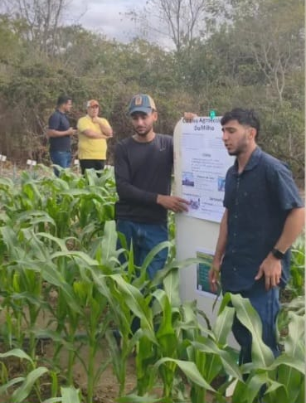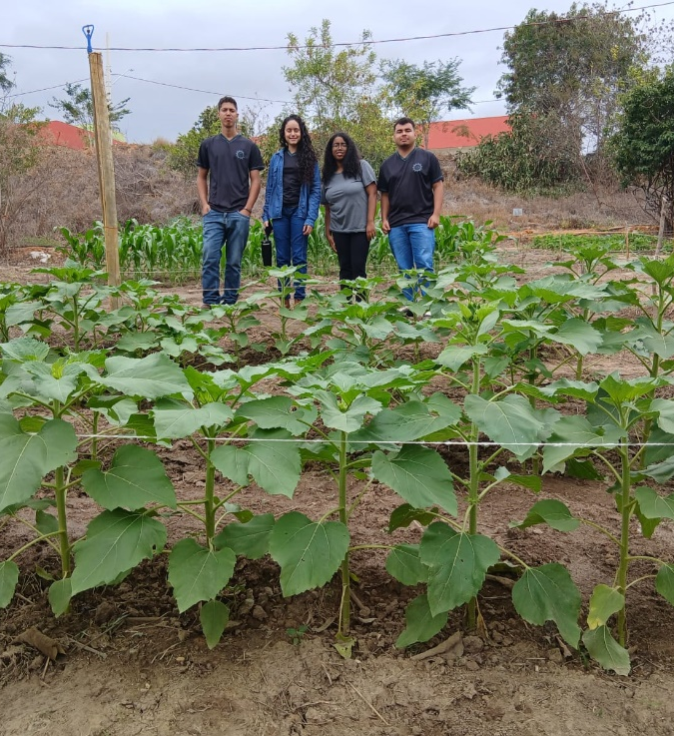
Figure 2 – Agroecological Cultivation Field Day at IFNMG – Araçuaí Campus, MG, Brazil.

In the pedagogical sphere, the project “Didactic Modeling of Agroecological Systems: Implementation of Portable Sustainable Gardens” involved 33 students, demonstrating strong student engagement. The construction and management of small-scale gardens enabled a concrete experience of agroecological principles, such as diversity, nutrient cycling, and rational use of inputs. Active methodologies and practice-based learning promote greater knowledge retention and the development of socio-environmental competencies (BACICH; MORAN, 2018). The didactic modeling approach proved to be an effective instrument for internalizing agroecological concepts within the context of professional education.
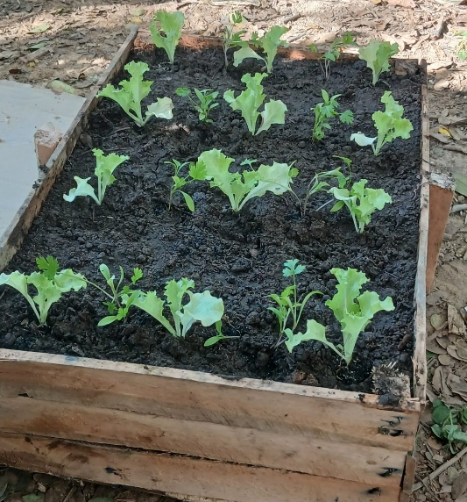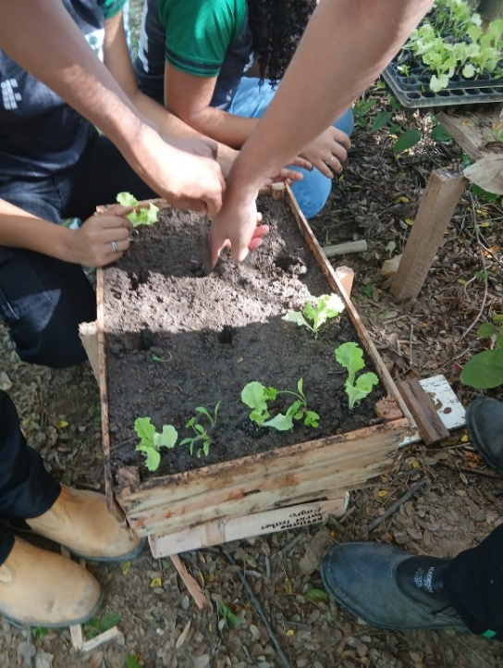
Figure 3 – Construction and implementation of portable sustainable gardens in Agroecology education.
The action “Planting for the Future,” culminating in the delivery of 300 seedlings of passion fruit (Passiflora edulis Sims), papaya (Carica papaya L.), and pink trumpet tree (Handroanthus heptaphyllus (Vell.) Mattos) on January 31, 2026, at the Municipal Market of Araçuaí, reinforced the socio-environmental commitment of the campus. The distribution of seedlings combined with technical guidance expands positive environmental impacts and strengthens the relationship between the institution and the community.
The inclusion of fruit and forest species contributes both to income generation and to environmental restoration and urban afforestation, aligning with the principles of territorial sustainability (GLIESSMAN, 2015).
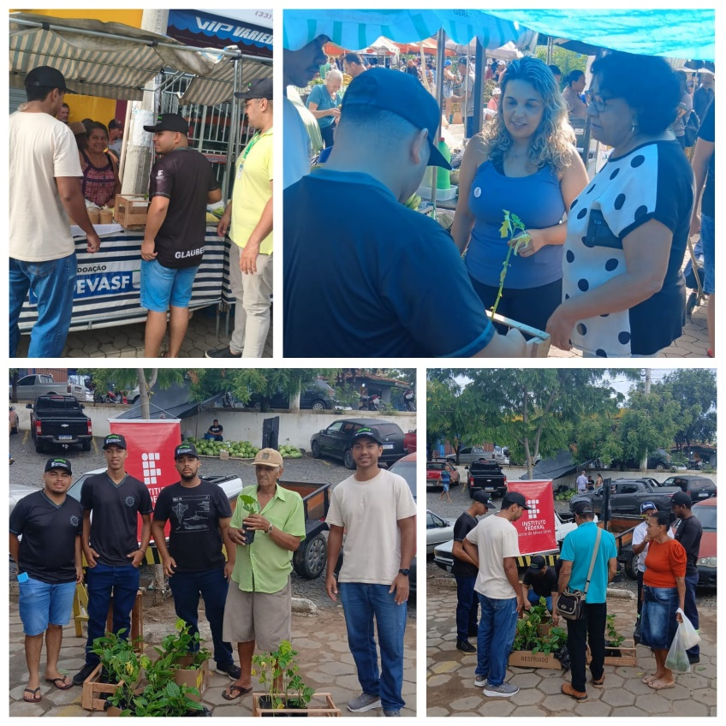
Figure 4 – Distribution of fruit and forest seedlings at the Municipal Market of Araçuaí, MG, to small rural producers, as an environmental education and agroecological extension action.

Overall, the results demonstrate that the successful actions went beyond the technical dimension, promoting critical education, strengthening family farming, and expanding dialogue between scientific knowledge and local wisdom. The articulation between teaching, research, and extension proved to be strategic for consolidating agroecology as a transformative educational practice, especially within the context of professional education in the semi-arid region of Minas Gerais.
More specifically, the dialogue established between technical-scientific knowledge and farmers’ experiential knowledge resulted in concrete processes of mutual learning and contextual adaptation of practices. Farmers contributed traditional strategies related to crop diversification, water-saving management, and adaptation to irregular rainfall patterns, while students and professors introduced technical principles associated with soil conservation, nutrient cycling, reduction of external inputs, and ecological management. This interaction enabled the collective refinement of agroecological practices, aligning scientific recommendations with the environmental, social, and economic realities of the territory.
As a result, agroecological management proposals were reformulated to incorporate locally validated techniques, increasing their practical feasibility and acceptance among participating farmers. At the same time, students developed a broader and more critical understanding of rural development dynamics, recognizing the limits of purely technical approaches and the importance of participatory construction of solutions.
Thus, the dialogue did not represent a unidirectional transfer of knowledge, but rather a process of co-creation and horizontal exchange, generating educational gains, strengthening territorial identity, and reinforcing farmers’ autonomy. This dynamic confirms that agroecological education, when grounded in participatory extension and territorial engagement, can function as a catalyst for socially embedded and environmentally responsible rural development in semi-arid contexts.

4. Conclusions

The actions developed within the integration of teaching, research, and extension at IFNMG – Araçuaí Campus demonstrated that agroecology, when articulated with professional education and rural extension, constitutes an effective strategy for technical, civic, and socio-environmental training.
The implementation of discussion circles, technical lectures, and the Field Day expanded dialogue between scientific knowledge and local wisdom, strengthening local family farming and promoting meaningful learning. The high level of community participation in the activities, especially during the Field Day, highlights the mobilizing potential of extension practices grounded in experience exchange and practical demonstration.
Didactic modeling through the implementation of portable sustainable gardens proved to be an effective active methodology for consolidating agroecological principles within the educational process, fostering systemic thinking, interdisciplinarity, and student protagonism.
The production and distribution of 300 fruit and forest seedlings reinforced the institutional commitment to sustainable territorial development, combining technical training, environmental education, and tangible socio-environmental impact.
It is concluded that extension actions structured under an agroecological perspective simultaneously contribute to students’ professional qualification, the strengthening of family farming, and the promotion of sustainable practices in the territory, consolidating the inseparability of teaching, research, and extension as a structuring axis of rural education.

Disclaimer (Artificial intelligence)

Author(s) hereby declare that NO generative AI technologies such as Large Language Models (ChatGPT, COPILOT, etc.) and text-to-image generators have been used during the writing or editing of this manuscript.

References

- ALTIERI, Miguel A. Agroecology: the science of sustainable agriculture. 2. ed. Boulder: Westview Press, 2012.
- ALTIERI, Miguel A.; NICHOLLS, Clara I. Agroecology: a brief account of its origins and currents of thought in Latin America. Agroecology and Sustainable Food Systems, v. 41, n. 3–4, p. 231–237, 2017. DOI: https://doi.org/10.1080/21683565.2017.1287147.
- ALTIERI, Miguel A.; NICHOLLS, Clara I. The agroecological revolution in Latin America: rescuing nature, ensuring food sovereignty and empowering peasants. Journal of Peasant Studies, v. 47, n. 3, p. 545–561, 2020. DOI: https://doi.org/10.1080/03066150.2019.1649939.
- ADOYO, Beatrice et al. Agroecology for sustainable development: evidence on multidimensional performance. Frontiers in Sustainable Food Systems, v. 9, 2025. DOI: https://doi.org/10.3389/fsufs.2025.1667882.
- BACICH, Lilian; MORAN, José. Metodologias ativas para uma educação inovadora: uma abordagem teórico-prática. Porto Alegre: Penso, 2018.
- BOURCERET, Aurélie et al. Participatory modelling for agroecological transitions: engaging stakeholders in transformative pathways. Agricultural Systems, v. 233, p. 104634, 2026. DOI: https://doi.org/10.1016/j.agsy.2026.104634.
- CALDART, Roseli Salete et al. Dicionário da educação do campo. Rio de Janeiro: EPSJV; São Paulo: Expressão Popular, 2012.
- CAPORAL, Francisco Roberto; COSTABEBER, José Antônio. Agroecologia: alguns conceitos e princípios. Brasília: MDA/SAF/DATER-IICA, 2004.
- CARTAGENA, Laura B. et al. How transformative is agroecological knowledge co-creation in pedagogy and extension? Agroecology and Sustainable Food Systems, v. 49, n. 2, p. 145–162, 2025. DOI: https://doi.org/10.1080/21683565.2024.2405885.
- FREIRE, Paulo. Pedagogia da autonomia: saberes necessários à prática educativa. São Paulo: Paz e Terra, 1996.
- GLIESSMAN, Stephen R. Agroecology: the ecology of sustainable food systems. 3. ed. Boca Raton: CRC Press, 2015. DOI: https://doi.org/10.1201/b17881.
- MARCOS-FILHO, Júlio. Fisiologia de sementes de plantas cultivadas. 2. ed. Londrina: ABRATES, 2015.
- MARKIEWICZ-KESZYCKA, Monika et al. Farmers' experiences of transitioning towards agroecology. Agriculture, v. 15, n. 6, p. 625, 2025. DOI: https://doi.org/10.3390/agriculture15060625.
- PEREIRA, João Carlos; SILVA, Maria Lúcia. Institutos Federais e desenvolvimento territorial: educação profissional e inovação no semiárido brasileiro. Revista Brasileira de Educação Profissional e Tecnológica, v. 21, 2021. DOI: https://doi.org/10.15628/rbept.2021.12345.
- WEZEL, Alexander et al. Agroecology as a science, a movement and a practice. A review. Agronomy for Sustainable Development, v. 29, p. 503–515, 2009. DOI: https://doi.org/10.1051/agro/2009004.
- WEZEL, Alexander et al. Agroecological principles and elements and their implications for transitioning to sustainable food systems. Agronomy for Sustainable Development, v. 40, n. 6, 2020. DOI: https://doi.org/10.1007/s13593-020-00646-z

