ASSESSMENT OF GENETIC PARAMETERS OF RICE (Oryza sativa L.) GENOTYPES UNDER LATE KHARIF CONDITION IN HYDERABAD-KARNATAKA REGION

ABSTRACT
Genetic diversity within crop germplasm forms the foundation of plant breeding and crop improvement programs. A broad genetic base enhances the probability of identifying genotypes with superior adaptability, stress tolerance, and yield potential. The present study was carried out at Agriculture Research Station, Gangavati during late kharif 2020 to assess variability for yield and its components among 120 rice genotypes maintained at All India Coordinated Rice Improvement Programme, Agriculture Research Station, Gangavathi. ANOVA revealed significant difference for all the characters except panicle length, kernel length and length/breadth ratio. High phenotypic and genetic coefficient of variance was exhibited by plant height, total number of tillers per hill, number of productive tillers per hill, flag leaf length, panicle weight, test weight, total number of spikelets per panicle, number of filled grains per panicle, kernel breadth and yield per plant. High heritability coupled with genetic advance per cent mean was observed for plant height, total number of tillers per hill, number of productive tillers per hill, flag leaf length, panicle weight, test weight, total number of spikelets per panicle, number of filled grains per panicle, panicle fertility, kernel length, kernel breadth, length/breadth ratio and yield per plant.
Key words: Genetic advance, genetic coefficient of variance, heritability, phenotypic coefficient of variance, rice.
INTRODUCTION
Rice (Oryza sativa L.) is a principal cereal crop of the family Poaceae and represents one of the most significant agricultural commodities in India. It constitutes the primary source of livelihood for millions of rural households and plays a pivotal role in ensuring national food security. In this context, the expression “rice is life” aptly reflects its socio-economic and cultural importance within the country. India holds a prominent position globally in terms of both the area under cultivation and total rice production. The adoption of improved production technologies—including high-yielding varieties and hybrids, expansion of irrigation infrastructure, and the increased application of chemical fertilisers—has enabled domestic rice supply to keep pace with rising demand. However, with continued population growth, the demand for rice is projected to increase further in the coming decades. Consequently, sustained enhancement of rice production remains imperative. Given the declining land area under rice cultivation, future gains in output must primarily be achieved through improvements in productivity (Mahajan et al., 2017).
The Tungabhadra River serves as the principal source of irrigation and is widely regarded as the lifeline of the districts of Koppal, Ballari, and Raichur. Thousands of farmers within the command area of the Tungabhadra Project (TBP), having prepared their fields and raised paddy seedlings in nursery beds, depend critically on timely water release for transplanting. However, delayed onset of the monsoon, inadequate storage in the TBP reservoir, and irregular water releases frequently result in postponed transplanting during the late kharif season.
Delayed transplanting exposes the rice crop to terminal cold stress during the later stages of growth, adversely affecting plant development and grain yield (Bashir et al., 2010). Furthermore, late kharif transplanting often increases susceptibility to a range of insect pests and diseases, thereby compounding yield losses. In this context, systematic evaluation of rice genotypes under late kharif conditions is essential to identify and develop suitable genotypes adapted to delayed transplanting in the TBP command area.
Genetic diversity within crop germplasm forms the foundation of plant breeding and crop improvement programs. A broad genetic base enhances the probability of identifying genotypes with superior adaptability, stress tolerance, and yield potential (Tanksley and McCouch, 1997). The effective utilization of diverse germplasm resources not only improves productivity but also strengthens resilience against climate variability, thereby contributing to long-term agricultural sustainability (FAO, 2019).
Heritable variation is frequently obscured by non-heritable (environmental) variation, thereby complicating the process of effective selection. It is therefore essential to partition the total observed variability into its heritable and non-heritable components in order to enable breeders to design appropriate subsequent breeding strategies. Direct selection based solely on crop yield often presents a paradox in breeding programmes, as yield is a complex trait governed by multiple genes and strongly influenced by its component characters. Enhancement of yield remains the principal objective of rice improvement programmes. Consequently, a comprehensive understanding of the nature and magnitude of genetic variability governing the inheritance of quantitative traits—such as yield and its associated components—is fundamental to achieving effective genetic advancement. Rigorous assessment of genetic variability parameters, including the genotypic coefficient of variability (GCV), phenotypic coefficient of variability (PCV), heritability, and genetic advance for economically important traits, constitutes a critical prerequisite for the successful implementation of crop improvement programmes (Bhattacharya and Chakraborty, 2019).
MATERIAL AND METHODS
The experiment was carried out during late kharif season, 2020 at Agriculture Research Station, Gangavathi. The material for experiment consists of 120 rice genotypes maintained at Agriculture Research Station, Gangavathi, which included advanced and traditional rice varieties sown in augmented block design with spacing of 20×15 cm and three checks (Gangavati Sona, BPT-5204 and GNV-10-89) repeated at 40 genotypes each. Standard agronomic practices and plant protection measures were adopted for normal crop growth. Data were recorded on five randomly selected plants for the traits days to 50% flowering, days to maturity, plant height (cm), total number of tillers/hill, number of productive tillers/hill, length of flag leaf (cm), panicle length (cm), panicle weight (g), number of filled grains per panicle, total number of spikelets per panicle, panicle fertility (%), test weight (1000 seeds weight) (g), grain yield per plant (g), kernel length (mm), kernel breadth (mm) and kernel length/breadth ratio. The data subjected to INDOSTAT software to estimate genetic coefficient of variation (%), phenotypic coefficient of variation (%), heritability (%) (broad sense), genetic advance and genetic advance as per cent mean.
RESULT AND DISCUSSION
Genetic variability is a pre-requisite for selection of superior genotypes over the pre -existing cultivars in any crop improvement.
Analysis of variance: The analysis of variance affirmed a significant difference for all the characters studied except panicle length, kernel length and kernel L/B ratio. This revealed the presence of significantly higher amount of variability among the genotypes for all the yield related characters studied (Table 1).
Genotypic and phenotypic coefficient of variance:
The data in Table 2 show estimates for mean values, range measurements, phenotypic coefficient of variation (PCV), genotypic coefficient of variation (GCV), broad-sense heritability (h²) estimation, and genetic advance as percent of mean (GAM). PCV was slightly higher than GCV, which actually indicates some environmental influence. The GCV and PCV estimates reached high values for plant height which measured at 20.86% and 20.98%, total number of tillers per hill which measured at 30.42% and 31.40%, number of productive tillers per hill which measured at 31.47% and 33.09%, flag leaf length which measured at 25.30% and 27.54%, panicle weight which measured at 33.72% and 34.71%, test weight which measured at 27.55% and 27.90%, total number of spikelets per panicle which measured at 44.85% and 45.34%, number of filled grains per panicle which measured at 48.34% and 48.73%, kernel breadth which measured at 23.94% and 24.23%, and yield per plant which measured at 39.15% and 39.43%. The high magnitude of variability for these traits suggests greater scope for improvement through direct selection. The study showed that panicle length had moderate GCV and PCV values which reached 14.38% and 18.70% while panicle fertility had GCV and PCV values which reached 12.88% and 13.00%. The GCV estimates for kernel length and kernel length/breadth ratio appeared to be moderate 18.12% and 19.16% while the PCV values showed higher measurements 20.93% and 23.01% which demonstrated that these traits experienced moderate environmental effects. The study found that days to 50% flowering measured at 6.53% and 6.63% and days to maturity measured at 6.71% and 6.81% which showed low GCV and PCV estimates. This result indicates that the characters showed low variability which results in restricted selection possibilities.
Figure 1 shows the visual display of PCV and GCV which indicates their relationship with yield-related traits. The present findings are in agreement with earlier reports by Sandeep et al. (2018), Mahantashivayogayya et al. (2016), Saha et al. (2019), Akter et al. (2018), Bothra et al. (2016), Singh et al. (2019), Pandey et al. (2018), Zahid et al. (2006), Bhattacharya and Chakraborty (2019), Pratap et al. (2012), Ajmera et al. (2017), Rukmini Devi et al. (2017), Kuramanchali et al. (2019), Dinesh et al. (2011), Farooq et al. (2019), Edukondalu et al. (2017), and Radha et al. (2019). The extent of variation among rice genotypes with respect to panicle length grain colour and kernel colour is illustrated in Plate 1 Plates 2a and 2b and Plate 3 respectively.
Heritability and genetic advance:
Most of the studied traits showed high broad-sense heritability which exceeded 60% for all traits including days to 50% flowering (98.49%), days to maturity (97.21%), plant height (98.82%), total and productive tillers per hill (93.55% and 90.44%), flag leaf length (84.38%), panicle weight (94.40%), test weight (97.49%), total spikelets per panicle (98.06%), filled grains per panicle (97.42%), panicle fertility (98.08%), kernel length (74.93%), kernel breadth (97.66%), kernel length/breadth ratio (69.34%), and yield per plant (98.60%). The high heritability estimates indicate strong genetic control of these traits, suggesting that selection would be effective for yield improvement. The panicle length measurement showed moderate heritability with a value of 59.10%. Plant height (42.78), total and productive tillers per hill (60.70 and 61.74), flag leaf length (47.93), panicle length (22.80), panicle weight (67.59), test weight (56.12), total spikelets per panicle (48.61), filled grains per panicle (63.93), panicle fertility (26.31), kernel length (32.36), kernel breadth (48.81), kernel length/breadth ratio (32.92), and yield per plant (80.10) all showed high genetic advance as percent of mean (GAM) values. Figure 2 shows the heritability and GAM graphical representation for yield-related traits. The research results showed similar outcomes to those found in previous studies conducted by Manjunath et al. (2017), Kalyan et al. (2017), Tiwari et al. (2019), Rathan et al. (2019), Girma et al. (2018), Ajmera et al. (2017), Singh et al. (2018a, 2018b), Dhakal et al. (2020), Khatun et al. (2015), Saha et al. (2019), Islam et al. (2020), and Umarani et al. (2018).
Among the 120 genotypes tested, Sindhura Madhusale, Mukanna Ratna Chudi, Kempu Battha, Aasanaleeya, Jugal Battha, NMS-2, Navalisaali, Siddhi Sanna, Barma Black, and Ralugalli performed better than the check varieties BPT-5204, Gangavati Sona, and GNV-10-89 regarding grain yield. The above-mentioned genotypes have shown potential with a significant yield advantage and adaptability for late Kharif conditions. However, since the evaluation was carried out at a single site and during a single season, these results are preliminary. multi-location and multi-seasonal evaluations would be necessary to confirm the stability and consistency of their performance before any recommendation for varietal release.
Table 1: Analysis of variance for yield and its components for rice genotypes

 | df | DFF | DM | PH | TTH | PTH | FLL | PL | PW
Block (eliminating Check+Var.) | 2 | 0.445 | 0.489 | 0.185 | 3.426 | 2.512 | 5.16 | 43.756 | 0.145
Entries (ignoring Blocks) | 122 | 70.802 ** | 104.619 ** | 462.202 ** | 17.487 ** | 15.413 * | 49.760 * | 15.906 | 0.527 **
Checks | 2 | 153.444 ** | 129.778 ** | 463.167 ** | 5.678 | 1.498 | 7.739 | 4.952 | 0.038
Varieties | 119 | 65.731 ** | 99.390 ** | 465.640 ** | 17.522 ** | 15.407 * | 45.509 * | 16.031 | 0.485 **
Checks vs. Varieties | 1 | 508.995 ** | 676.466 ** | 51.039 * | 36.957 ** | 43.966 ** | 639.646 ** | 22.968 | 6.459 **
Error | 4 | 2.778 | 2.756 | 5.495 | 1.13 | 1.473 | 7.11 | 6.557 | 0.027

 | df | TW | TSP | NFG | PF | KL | KB | L/B | YPP
Block (eliminating Check+Var.) | 2 | 1.066 | 1528.701 * | 1096.347 * | 4.312 | 0.254 | 0.014 | 0.129 | 1.288
Entries (ignoring Blocks) | 122 | 27.710 ** | 6688.303 ** | 5439.771 ** | 112.477 ** | 1.057 | 0.175 ** | 0.441 | 86.840 **
Checks | 2 | 3.299 | 214.054 | 203.476 | 1.126 | 0.086 | 0.008 | 0.086 | 4.359
Varieties | 119 | 28.226 ** | 6817.407 ** | 5572.848 ** | 106.819 ** | 1.079 | 0.179 ** | 0.449 | 84.890 **
Checks vs. Varieties | 1 | 15.065 ** | 4273.440 ** | 76.277 | 1008.388 ** | 0.402 | 0.016 | 0.132 | 483.897 ***
Error | 4 | 0.708 | 148.499 | 91.719 | 2.049 | 0.271 | 0.004 | 0.138 | 2.086
Note: * and **-significant @ 5% and 1% levels, respectively. df- degrees of freedom, DFF- Days to 50 per cent flowering, DM- Days to maturity, PH- Plant height (cm), TTH- Total number of tillers per hill, PTH- Number of productive tillers per hill, FLL- Flag leaf length (cm), PL- Panicle length (cm), PW- Panicle weight(g), TW- Test weight (g), TSP- Total number of spikelets per panicle, NFG- Number of filled grains per panicle, PF- Panicle fertility (%), KL- Kernel length (mm), KB- Kernel breadth (mm), L/B ratio- Kernel Length/Breadth ratio and YPP- Yield per plant (g).

Table 2: Mean and other genetic parameters of yield and yield related traits
Sl. No. | Character | Mean | Range |  | GCV (%) | PCV (%) | H (%) | GA@5% | GAM (%)
Sl. No. | Character | Mean | Max | Min
1 | DFF | 91.28 | 113.22 | 75.56 | 6.53 | 6.63 | 98.49 | 16.02 | 16.99
2 | DM | 146.45 | 169.22 | 123.56 | 6.71 | 6.81 | 97.21 | 19.99 | 13.65
3 | PHT (cm) | 102.83 | 157.93 | 62.92 | 20.86 | 20.98 | 98.82 | 43.99 | 42.78
4 | TTH | 13.30 | 25.12 | 6.80 | 30.42 | 31.45 | 93.55 | 8.08 | 60.70
5 | PTH | 11.86 | 27.65 | 6.55 | 31.47 | 33.09 | 90.44 | 7.32 | 61.74
6 | FLL (cm) | 24.49 | 41.75 | 11.95 | 25.3 | 27.54 | 84.38 | 11.74 | 47.93
7 | PL (cm) | 21.40 | 34.79 | 13.26 | 14.38 | 18.7 | 59.10 | 4.88 | 22.8
8 | PW (g) | 2.00 | 4.02 | 0.9 | 33.72 | 34.71 | 94.40 | 1.36 | 67.59
9 | TW (g) | 19.03 | 29.9 | 7.94 | 27.55 | 27.9 | 97.49 | 10.69 | 56.12
10 | TSP | 182.09 | 380.54 | 41.58 | 44.85 | 45.34 | 98.06 | 166.62 | 48.61
11 | NFG | 147.14 | 310.57 | 20.84 | 48.34 | 48.73 | 97.42 | 151.47 | 63.93
12 | PF (%) | 79.47 | 98.28 | 52.06 | 12.88 | 13 | 98.08 | 20.91 | 26.31
13 | KL (mm) | 4.96 | 6.68 | 3.04 | 18.12 | 20.93 | 74.93 | 1.61 | 32.36
14 | KB (mm) | 1.75 | 3.49 | 1.24 | 23.94 | 24.23 | 97.66 | 0.85 | 48.81
15 | L/B ratio | 2.91 | 4.08 | 1.28 | 19.16 | 23.01 | 69.34 | 0.96 | 32.92
16 | YPP (g) | 17.79 | 44.96 | 6.51 | 39.15 | 39.43 | 98.60 | 18.54 | 80.10
Note: GCV- Genotypic coefficient of variance, PCV- Phenotypic coefficient of variance, H- heritability in broad sense, GA- Genetic advance, GAM- Genetic advance as per cent of mean, DFF- Days to 50 per cent flowering, DM- Days to maturity, PTH- Plant height (cm), TTH- Total number of tillers per hill, PTH- Number of productive tillers per hill, FLL- Flag leaf length (cm), PL- Panicle length (cm), PW- Panicle weight (g), TW- Test weight (g), TSP- Total number of spikelets per panicle, NFG- Number of filled grains per panicle, PF- Panicle fertility (%), KL- Kernel length (mm), KB- Kernel breadth (mm), L/B ratio- Kernel Length/Breadth ratio and YPP- Yield per plant (g).

Fig. 1: Phenotypic (PCV) and genotypic (GCV) coefficient of variation for different yield and yield related traits in rice genotypes

Fig. 2: Heritability and Genetic Advance as per cent of mean (GAM) for different yield and yield related traits in rice genotypes

Note: DFF- Days to 50 per cent flowering, DM- Days to maturity, PTH- Plant height (cm), TTH- Total number of tillers per hill, PTH- Number of productive tillers per hill, FLL- Flag leaf length (cm), PL- Panicle length (cm), PW- Panicle weight (g), TW- Test weight (g), TSP- Total number of spikelets per panicle, NFG- Number of filled grains per panicle, PF- Panicle fertility (%), KL- Kernel length (mm), KB- Kernel breadth (mm), Kernel L/B ratio- Kernel L/B ratio and YPP- Yield per plant (g).

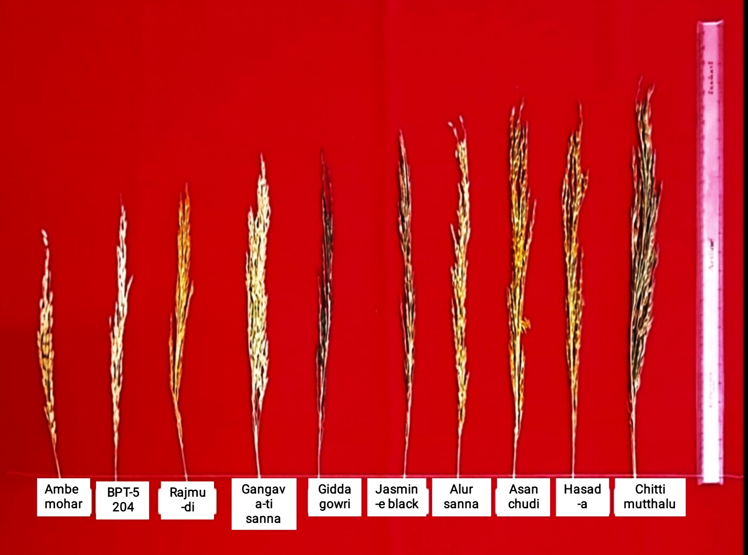
Plate.1 Variation in panicle length of rice genotypes

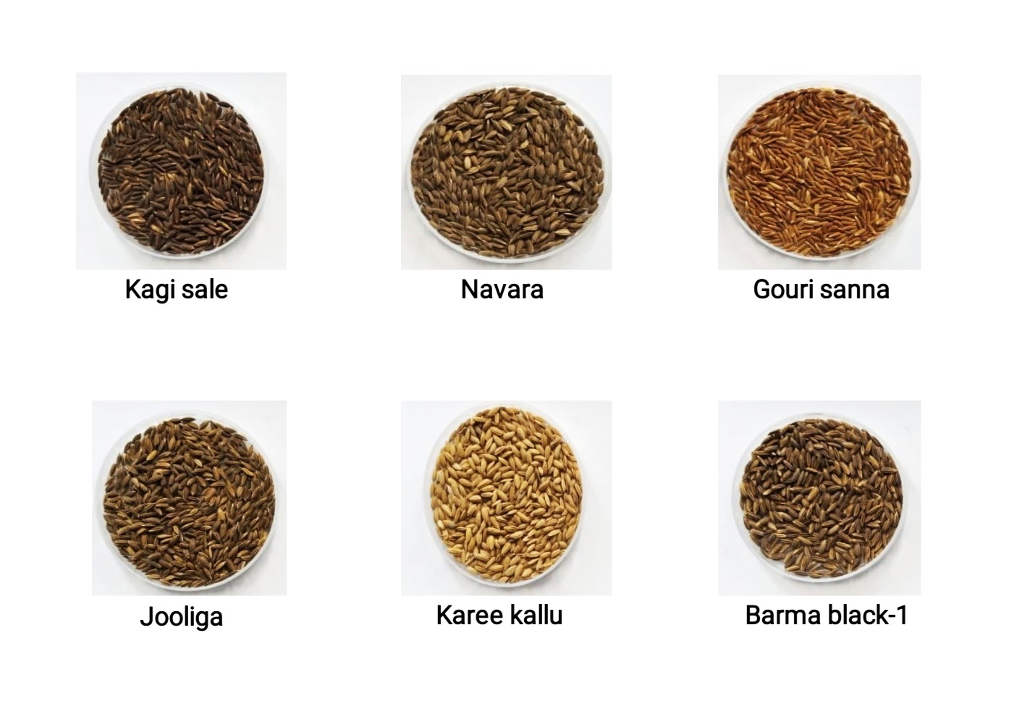
Plate.2a Variation in grain colour
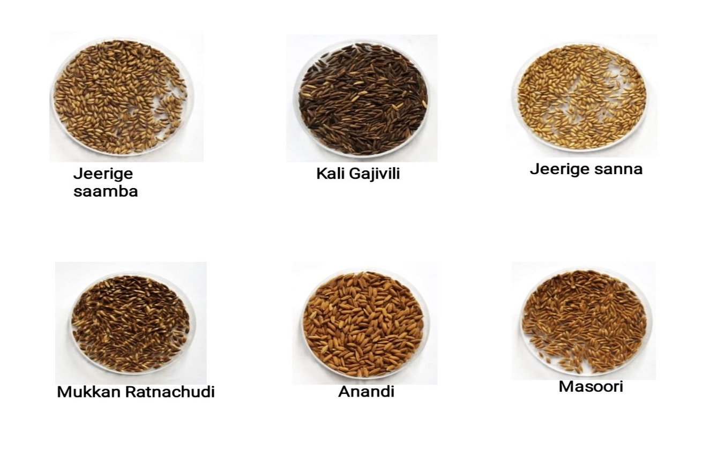
Plate.2b Variation in grain colour

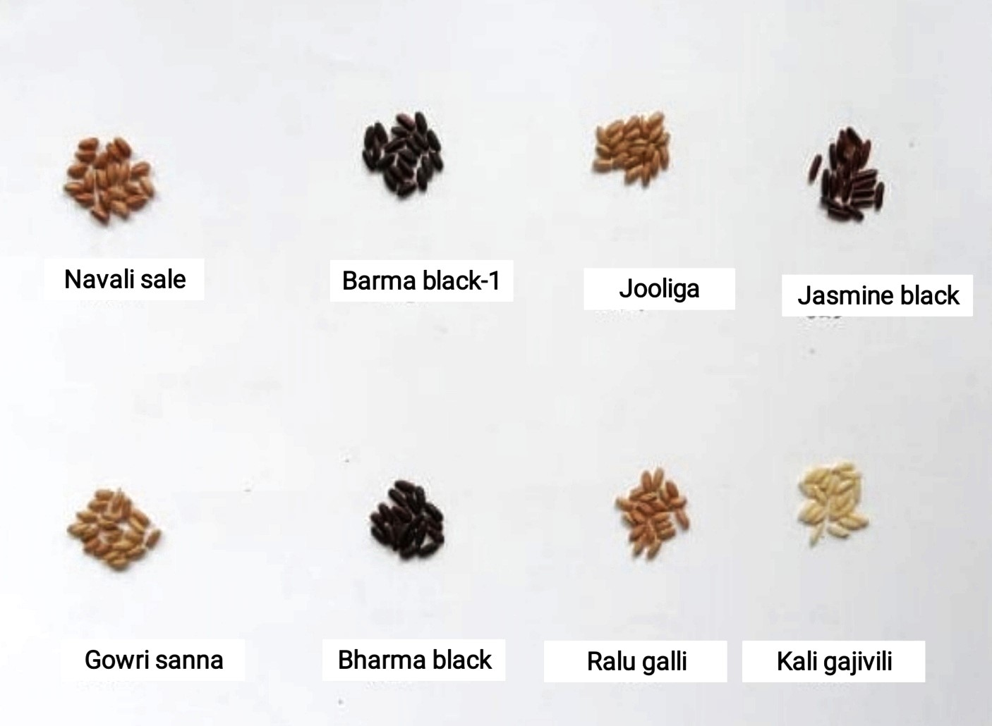
Plate.3 Variation in kernel colour

CONCLUSION
The study results demonstrated that the tested genotypes showed significant genetic variation among their different genetic characteristics. The genetic differences between crops enable breeders to implement successful selection methods which lead to their optimal breeding outcomes. The high genotypic coefficient of variation (GCV) together with the high phenotypic coefficient of variation (PCV) for most traits demonstrates that the two traits display substantial inherent variability which enables a successful selection process.
Most characters showed high broad-sense heritability and high genetic advance, suggesting a large contribution of genetics to the expression of characters. However, since only broad-sense heritability was estimated, the predominance of additive gene action cannot be ascertained. Characters showing high heritability and genetic advance can be amenable to selection, but further work on narrow-sense heritability is necessary to confirm the type of gene action and the effectiveness of direct selection. The data suggest the possibility of genetic improvement for yield and other characters, but the findings are tentative.

Disclaimer (Artificial intelligence)
Author(s) hereby declare that NO generative AI technologies such as Large Language Models (ChatGPT, COPILOT, etc.) and text-to-image generators have been used during the writing or editing of this manuscript.

REFERENCES
- Ajmera, S. Sudheer, K. and Ravindrababu, V., 2017, Evaluation of genetic variability, heritability and genetic advance for yield and yield components in rice genotypes. Int. J. Curr. Microbiol. App. Sci., 6(10): 1657-1664.
- Akter, N., Khalequzzaman, M., Islam, M. Z. Mamun, M. A. A. and Chowdhury, M. A. Z., 2018, Genetic variability and character association of quantitative traits in jhum rice genotypes. SAARC J. Agri., 16(1): 193-203.
- Bashir, M. U., Akbar, N., Iqbal, A. and Zaman, H., 2010, Effect of different sowing dates on yield and yield components of direct seeded coarse rice (Oryza sativa L.). Pak. J. Agri. Sci., 47(4): 361-365.
- Bhattachraya,S. and Chakraborty, N. R., 2019, Assessment of genetic variability, correlation and path association for yield and yield components in aromatic non-basmati rice. J. Pharmacogn. Phytochem., 8(3): 1907-1914.

- Bothra, S. D., Lal, G. M., Lal, S. S. and Rajesh, S., 2016, Genetic variability studies for yield and yield components in rice (Oryza sativa L.). Int. J. Agri. Sci., 8(51): 2198-2201.

- Dhakal, A., Sharma, S., Pokhrel, A. and Poudel, A., 2020, Variability and heritability estimate of 30 rice landraces of lamjung and tanahun districts, Nepal. Indo. J. Agri. Sci., 21(1): 1-10.
- Dinesh, K. T., Pandey, P., Tripathi, S., Giri, S. P. and Dwivedi, J. L., 2011, Studies on genetic variability for yield components in rice (Oryza sativa L.). Advn. Agri. Botan. Int. J. Bioflux. Soci., 3(1):76-81.
- Edukondalu, B., Reddy, V. R., Rani, T. S., Kumari, C. A. and Soundharya, B., 2017, Studies on variability, heritability, correlation and path analysis for yield, yield attributes in rice (Oryza sativa L.). Int. J. Curr. Microbiol. App. Sci., 6(10): 2369-2376.
- FAO, 2019, The State of the World’s Biodiversity for Food and Agriculture. FAO Commission on Genetic Resources for Food and Agriculture, Rome.
- Farooq, M. S. U., Diwan, J. R., Mahantashivayogayya, K., Kulkarni, V. V. and Shakuntala, N. M., 2019, Genetic evaluation of rice (Oryza sativa L.) genotypes for yield and nutritional quality traits. J. Exper. Bio. Agri. Sci., 7(2) page 117 – 127.
- Girma, B. T., Kitil, M. A., Banje, D. G., Biru, H. M. and Serbessa, T. B., 2018, Genetic variability study of yield and yield related traits in rice (Oryza sativa L.) genotypes. Adv. Crop. Sci. Tech., 6(4): 381-387.
- Islam, S. S., Anothai, J., Nualsri, C. and Soonsuwon, W., 2020, Genetic variability and cluster analysis for phonological traits of Thai indigenous upland rice (Oryza sativa L.). Indian. J. Agri. Res., 54(2): 211-216.
- Kalyan, B., Rajendra, P. K., Radha, K. K. V. and Rao, L. V. S., 2017, Studies on variability, heritability and genetic advance for quantitative characters in rice (Oryza sativa L.) germplasm. Eco. Envio. Con., 23(2): 331-334.
- Khatun, T. M., Hanafi, M. M., Yusop, M. R., Wong, M. Y., Salleh, F. M. and Ferdous, J., 2015, Genetic variation, heritability, and diversity analysis of upland rice (Oryza sativa l.) genotypes based on quantitative traits. Biomed. Res. Int. 3(4): 1-7.
- Kurmanchali, M., Kurmanchali, N., Kukreti, A., Sihag, N., Chaudhary, H. and Karnwal, M. K., 2019, Study of genetic variability, heritability and genetic advance for various yield attributing and quality traits in basmati rice (Oryza sativa L.). Int. J. Chem. Stud., 7(1): 2486-2489.
- Mahajan, G., Kumar, V. and Chauhan, B.S. 2017. Rice production in India. In: Chauhan B., Jabran K., Mahajan G. (eds) Rice Production Worldwide. Springer, Cham., pp 53-91.
- Mahantashivayogayya, K., Mahendrakumar,. Lakkundi. B. S., Prakash, H. K. and Vishwanath, J, 2016, Genetic variability studies on rice (Oryza sativa L.) mutants for yield and yield components in normal and saline stress soil. Electron. J. Plant. Breed., 7(4): 1162-1168.
- Manjunath, B., Krishnappa, M. and Kumara, N. B., 2017, Genetic variability studies in rice (Oryza sativa L.) genotypes. Biosci. Trends., 10(38): 8027-8028.
- Pandey, S., Doss, D. D. and Shashidhar, H. E., 2018, Assessment of genetic variability, heritability and genetic advance for yield contributing and quality traits in rice (Oryza Sativa L.) genotypes. J. Pharma. Phytochem. 7(4): 333-337.
- Pratap, N., Singh, P. K., Shekhar, R., Soni, S. K. and Mall, A. K., 2012, Genetic variability, character association and diversity analyses for economic traits in rice (Oryza sativa L.). SAARC J. Agri., 10(2): 83-94.
- Radha, T., Kumar, P. S., Saravanan, K. and Suganthi, S, 2019, Genetic variability, association and path analysis for grain yield and quality traits in rice (Oryza sativa L.). Plant. Archives. 19(2): 2522-2526.
- Rathan, N. D., Singh, S. K., Singh, R. K., Prudhvi, R., Vennela, D. K. S., Monika, S., Kumar, D. and Ashrutha, M. A., 2019, Variaility and path coefficient studies for yield and yield related traits in rice (Oryza sativa L.). Int. J. Agri. Envi. Biotech., 12(4): 323-329.
- Rukmini Devi, K., Chandra, B. S., Lingaiah, N., Hari, Y. and Venkanna, V., 2017, Analysis of variability, correlation and path coefficient studies for yield and quality traits in rice (Oryza Sativa L.). Agric. Sci. Digest., 37 (1): 1-9.
- Saha, S. R., Hassan, L., Haque, M. A., Islam, M. M. and Rasel, M., 2019, Genetic variability, heritability, correlation and path analyses of yield components in traditional rice (Oryza sativa L.) landraces. J. Bangladesh. Agril. Univ., 17(1): 26–32.
- Sandeep, S., Sujatha, M.., Subbarao, L. V. and Neeraja, C. N., 2018, Genetic variability, heritability and genetic advance studies in rice (Oryza sativa L.). Int. J. Curr. Microbiol. App. Sci (2018)., 7(12): 3719-3727.
- Singh S. K., Singh, M., Vennela, P. R., Singh, D. K., Shubhra, N. Kujur and Kumar, D., 2018a. Studies on genetic variability, heritability and genetic advance for yield and yield components in drought tolerant rice (Oryza sativa L.) landraces. Int. J. Curr. Microbiol. App. Sci., 7(03): 299-305.
- Singh, S. K., Singh, V. P., Choudhury, D., Dobhal, P., Kumar, S. and Srivastava, S., 2018b, Estimation of genotypic and phenotypic correlations coefficients for yield related traits of rice under sodic soil. Asian. J. Crop. Sci., 10(2): 100-106.
- Singh, A. K., Suresh, B. G., Mahto, A., Singh, A. K., Singh. S. P. and Verma, S., 2019, Genetic variability studies for yield and yield components in F₂ generation in rice (Oryza sativa L.). J. Pharm. Phytochem., 8(2): 2058-2062.
- Tanksley, S.D. and McCouch, S.R., 1997, Seed banks and molecular maps: Unlocking genetic potential from the wild. Science, 277: 1063–1066.
- Tiwari, D. N., Tripathi, S. R., Tripathi, M. P., Khatri, N. and Bastola, B. R., 2019, Genetic variability and correlation coefficients of major traits in early maturing rice under rainfed lowland environments of Nepal. Adv. Agric., 5(3): 27-36.
- Umarani, E., Radhika, K., Padma, V., SubbaRao, V. and Lella., 2018, Variability heritability and genetic advance for agro-morphological and grain quality parameters in landraces of rice (Oryza sativa L.). The J. Res. PJTSAU., 47(1):53-58.
- Zahid, M. A., Akhter, M., Sabar, M., Manzoor, Z. and Awan, T., 2006, Correlation and path analysis studies of yield and economic traits in basmati rice (Oryza sativa L.). Asian. J. Plant. Sci., 5(2): 643-645.

