Comparative Dairy Ecosystems and Women’s Empowerment: Evidence from Gujarat and Odisha, India

Abstract
Background: Dairying in rural India is predominantly sustained by smallholder women who play a key role in animal care, feeding, and milk management. Their contribution has been instrumental in India’s emergence as the world’s largest milk producer, largely supported by the Anand pattern of dairy cooperative model institutionalized through the National Dairy Development Board and operationalized in Gujarat under the Gujarat Cooperative Milk Marketing Federation Ltd.
Purpose: Despite the expansion of dairy cooperatives across the country, significant regional disparities persist in stakeholders’ integration and their livelihood outcomes. This study compares the dairy ecosystems of women members of Dairy Cooperative Societies in Anand district of Gujarat and Cuttack district of Odisha, India.
Research Methodology and Data Collection: Primary data were collected from eight cooperatives (four in each state) with at least 40% women membership, using structured schedule, focus group discussions, and field observations. The analysis focused on backward linkages (input supply, veterinary services, breeding support), forward linkages (milk procurement and market access), technological penetration, and institutional support mechanisms.
Findings: Findings revealed that Gujarat demonstrates a well-integrated dairy ecosystem characterized by reliable veterinary outreach, advanced breeding technologies, structured payment systems, and strong market linkages, resulting into higher productivity, income stability, and enhanced decision-making power among women. In contrast, Odisha exhibited service gaps, weaker institutional follow-up, and limited technological dissemination, leading to lower procurement levels and greater vulnerability to economic shocks.
Conclusions: The study concludes that the mere presence of dairy cooperatives is insufficient; rather, a strengthened, inclusive, and gender-responsive ecosystem is essential for achieving meaningful and equitable empowerment of women dairy farmers.
Keywords: Dairy, Women, cooperative, business ecosystem, backward - forward linkages
1.Introduction
Dairying is deeply embedded in the livelihoods of marginalized communities, especially women, as it provides a regular source of income, can be managed within the homestead, and ensures nutritional security to the society (Prusty and Tripathy, 2015; Patel and Mitra, 2015). Women play a pivotal role in the growth dynamics of dairying in India; however, their contributions have historically been undervalued, with limited monetary recognition and decision-making power (FAO, 2011). Across various region of India, western India particularly Gujarat presents a notable exception, where women receive relatively higher economic returns, visibility, and institutional recognition for their labour and enterprise (Farnworth et al., 2023). The post-liberalization period in India witnessed increased migration of male from rural areas, which further intensified women’s engagement in dairying and allied activities (Bidhan et al., 2024). Currently, women constitute nearly 70 percent of the workforce in the dairy sector and contribute approximately 55 percent of rural household income derived from dairy enterprises (Sharma et al., 2020; PIB, 2025). India’s emergence as the world’s largest milk producer over the past 25 years has been significantly supported by women’s labour, facilitated largely through the expansion of the Anand pattern dairy cooperative (DC) model across the country. The dairy cooperative system has played a transformative role by creating an organized, market-driven value chain, linking milk producers to consumers through assured procurement, processing, and distribution. The doorstep availability of milk markets through village level DCSs had helped to overcome mobility constraints faced by women farmers and while timely training and the provision of veterinary services have empowered them to adopt technological upgradation. (Mechakra-Tahiri et al., 2012; Farnworth et al., 2023). Despite the overall success of the cooperative movement, dairy development in India remains uneven across regions. A striking difference is observed between western and eastern India (DAHD, 2024). As challenges such as feed and fodder scarcity, animal health issues and climate stress persist across regions in the Indian dairy sector (Kaur et al., 2025), women farmers with limited access to support services are disproportionately affected. Although they participate in dairy activities but their ability to influence decisions related to breeding, feeding, healthcare, and marketing challenges remains limited (FAO et al., 2023; Ponnusamy et al., 2020). This disparity is prominent in western and eastern India. It raises critical questions regarding the effectiveness, inclusivity, and functionality of dairy cooperatives, particularly in terms of benefiting women dairy farmers. In this context, the present study undertakes a comparative analysis of the dairy ecosystems of women dairy farmers, using case studies from Gujarat and Odisha.

2.Material and Methods
2.1 Study Area
The study adopted a multi-stage purposive sampling. The study was conducted in Anand district of Gujarat and Cuttack district of Odisha, India (Figure 1). Both districts are among the leading contributors to milk production in their respective states, ensuring the presence of active dairy systems and functional cooperative structures. The selection of these districts was purposive and guided by their contrasting levels of dairy ecosystem development within their respective regions. This contrast enables a meaningful examination of how differences in ecosystem strength and cooperative functionality influence women’s participation, decision-making power and socio-economic empowerment across regions. A total of eight village level Dairy Cooperative Societies (DCSs) were purposively selected for the study, four each from Gujarat and Odisha. The selection criteria included a minimum of 40% women membership and a daily milk procurement exceeding 150 liters. These criteria ensured that the selected cooperatives had substantial representation of women dairy farmers and were operationally active, thereby providing an appropriate institutional context for assessing women-centric dairy ecosystems.
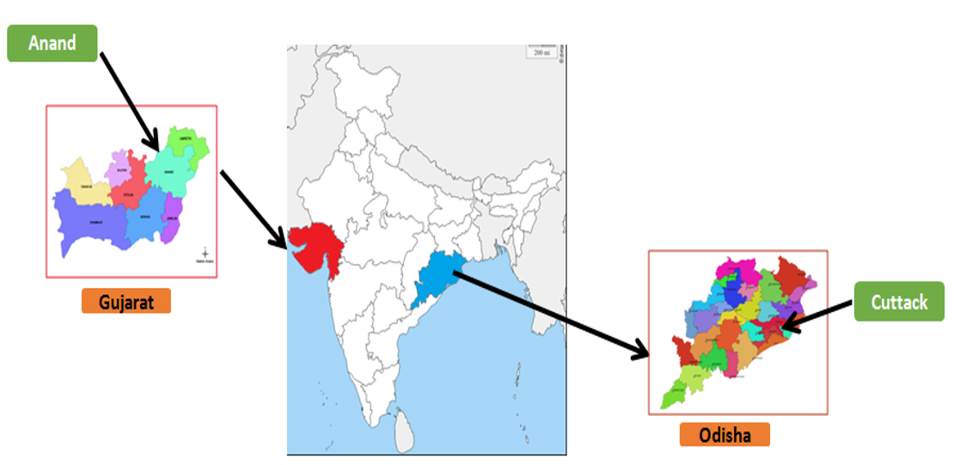
Figure 1: Locale of study

2.2 Data Collection
Primary data were collected through both structured schedules. Comparative case study research design was employed to capture the complex interactions among institutional, technological, and service-related factors influencing women’s participation and empowerment within dairy cooperatives. The interview schedule includes socio-economic characteristics of the respondents, participation in dairy activities, perceived benefits and constraints associated with cooperative membership, awareness, access and attitude of respondent towards different dairy-related services. About 25-30 women farmers from each DCS (n= 200) were interviewed. In addition, focus group discussions (FGDs) were conducted in selected DCSs to gain qualitative insights into collective experiences, institutional functioning, and gender-related challenges within the dairy ecosystem. Cooperative level data were also collected to know the availability of services and institutional linkages.
2.3 Analytical Framework
Mahida et al. (2022) explored the efficiency and status of dairy cooperative systems working in different zones of India. The eastern zone of India procures only 5 percent while the western zone procures 24 percent of their respective zonal production. This shows the progress of the dairy movement has not achieved its inclusivity across all parts of India. Though the reach of the dairy cooperatives appears impressive, but its coverage is only 18 percent of the total villages and only 17 percent of the total dairy farmers of India. Landless composed 39 percent of total households in India out of which only 14 percent were members of the milk cooperatives (Koushik, 2024). This might be due to the non-uniformity in performance of dairy cooperatives across India. Uttar Pradesh had the highest number of dairy co-operative societies (31,958) followed by Bihar (23,510), Maharashtra (20,762) and Gujarat (20,144) in the year 2020. Eastern states like Odisha (6,053) and West Bengal (4,236) had a smaller number of dairy co-operative societies. In case of milk procurement, about one-third of total milk procured by cooperatives comes from Gujarat followed by Karnataka, Tamil Nadu and Maharashtra. Not only the number of dairy co-operative societies but also in membership of western states and southern states are far high than eastern states. As per 2020 about 58.8 lakh members were enrolled in western states whereas only 18.66 lakh members in eastern states. The milk procurement through cooperative societies is only 10-15 percent of the total milk produced in India.
The dairy cooperative numbers of Gujarat (largest cooperative network) are more than 10 times of Odisha. In both these states women’s participation in dairy varies from 65-70 percent of total workforce in dairy but the depth of involvement of women in dairy farming in Gujarat is far more significant compared to Odisha. This paper is framed to discuss the regional discrepancy in performance of dairy cooperatives across India supported by comparative study in Odisha and milk giant Gujarat. It is proposed that socio-techno-economically challenged women dairy farmers need a dairy ecosystem that can provide hand holding support from milk to market strides through strategic interventions to strengthen the dairy cooperatives and support the marginalized women dairy farmers to gain resiliency to countervail market risks.
The analysis was carried out using a dairy ecosystem framework, which conceptualizes dairy development as an outcome of interlinked components, including institutional support, service delivery, technological access, market linkages, and gender inclusiveness.
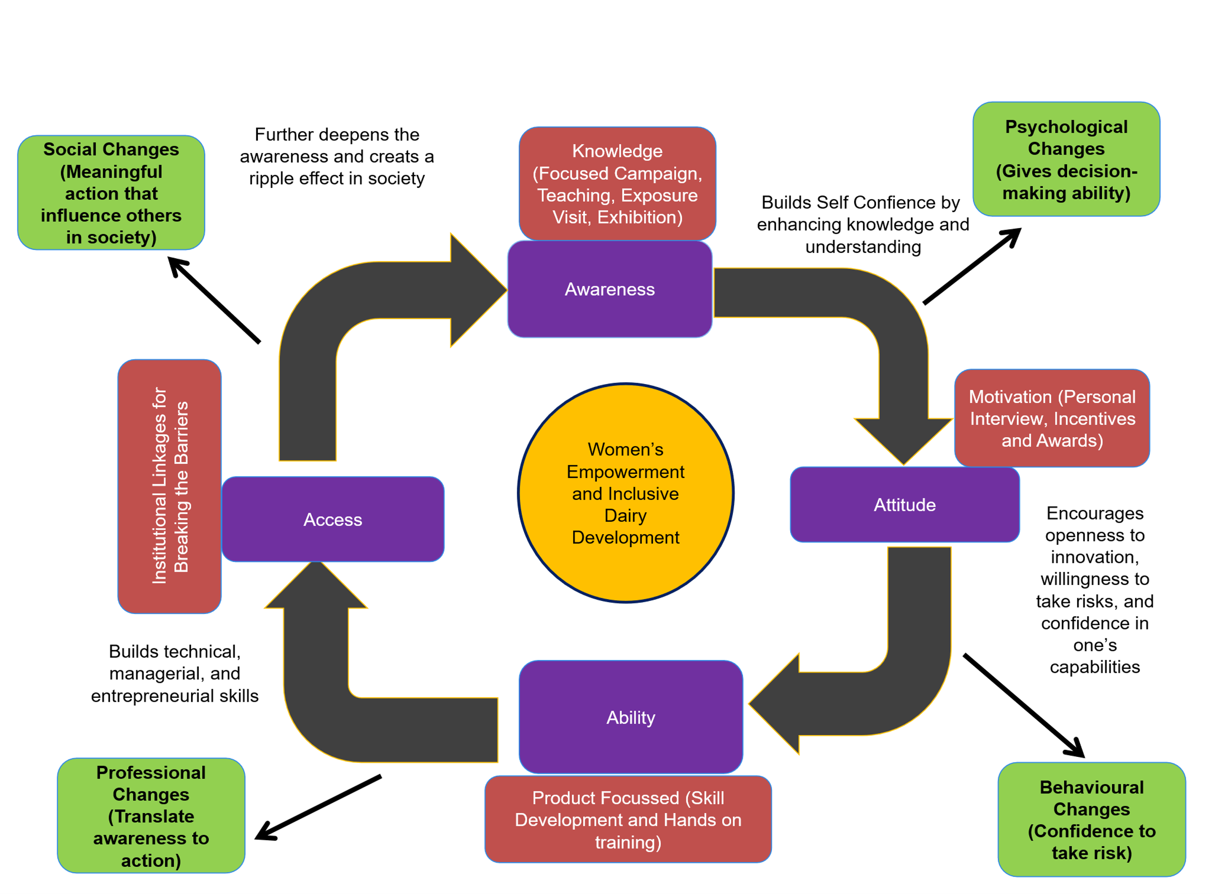
Figure 2: Conceptualized 4A Model of the Dairy Business Ecosystem for Women’s Empowerment
This model shows empowerment is not a linear but a continuous reinforcing cycle where knowledge builds awareness, awareness shapes attitude, attitude drives ability, ability improves access, and access deepens empowerment.
2.4 Statistical Analysis
Descriptive statistics were used to summarize socio-economic and service-related variables, while comparative analysis was employed to identify regional differences between Gujarat and Odisha. Qualitative data from interviews and FGDs were thematically analyzed to complement quantitative findings and provide contextual understanding. The data were analysed using descriptive statistics. Continuous variables were summarised using mean and standard deviation, while categorical variables such as awareness, adoption, ability, institutional access, and gender indicators were expressed as percentages of respondents. Inter-state comparisons were carried out using appropriate statistical tests, and significance was tested at 5 per cent level (p < 0.05).
2.5 Ethical Considerations
Participation in the study was voluntary, and informed consent was obtained from all respondents prior to data collection. Confidentiality of respondents’ identities and responses was maintained throughout the study.
3. Results and Discussions
The findings of the study were presented in alignment with the conceptual 4A Dairy Business Ecosystem Model, encompassing Awareness, Attitude, Ability, and Access. The results highlighted that a significant regional variation between Gujarat and Odisha in terms of institutional support, technological adoption, market integration, and gender inclusiveness.
Table 1. Socio-Economic Profile of Dairy Households n=200
Variable | Gujarat (Mean/%) | Odisha (Mean/%)
Average age of women (years) | 38.6±4.23 | 36.2±3.65
Average landholding of family (ha) | 1.1±0.03 | 0.7±0.05
Average Herd size (no. of animals) | 5.2±0.78 | 2.8±0.42
Women’s literacy rate (%) | 67 | 72
% Women primary caregivers | 82 | 88

The socio-economic profile revealed clear regional differences between Gujarat and Odisha owing to ability in dairy management (table 1). Women are in their productive age group in both states. Gujarat showed larger landholdings (1.1 ha) and bigger herd size (5.2 animals) indicating a more commercial dairy system. Odisha, with smaller landholdings (0.5 ha) and fewer animals (2.8) reflects subsistence orientation. However, women’s role as primary caregivers remains high in both states highlighting their central contribution to dairy management.
Table 2: Awareness Level of Women Members on Key Dairy Practices n=200
Awareness Indicator | Anand, Gujarat (%) | Cuttack, Odisha (%)
Awareness of Sex-Sorted Semen Technology | 82 | 46
Awareness of Balanced Feeding Importance | 88 | 54
Awareness of Vaccination Calendar | 91 | 63
Awareness of Cow Dung Value Addition Opportunities (biogas, pots, compost, etc.) | 76 | 38

Values represented the percentage of respondents who demonstrated awareness of each practice (table 2). Awareness was measured based on respondents correct understanding of its purpose and practical application. The findings indicated comparatively stronger knowledge dissemination and institutional ecosystem support in Gujarat than in Odisha.
Table 3. Technological Adoption showing Attitude n=200
Technology | Gujarat Adoption (%) | Odisha Adoption (%)
Chaff cutter (power/manual) | 65 | 28
Mineral mixture feeding | 74 | 39
Vaccination compliance | 88 | 61
Improved cattle shed | 57 | 22
Table 3 indicated markedly higher technological adoption in Gujarat compared to Odisha. Adoption of chaff cutters (65% vis-a-vis 28%), mineral mixture feeding (74% vis-a-vis 39%), vaccination compliance (88% vis-a-vis 61%), and improved cattle sheds (57% vis-a-vis 22%) was substantially greater in Gujarat. This suggests stronger extension outreach, better service access, and higher awareness, while Odisha reflects limited technological penetration and greater scope for productivity enhancement through targeted interventions.
Table 4: Ability of Women Members on managing a dairy enterprise n=200
Ability Parameters | Gujarat (%) | Odisha (%)
Ability to Prepare Balanced Ration | 59 | 32
Ability to Detect Heat Symptoms | 85 | 68
Ability to Maintain Milk Production Records | 74 | 36
Ability to Follow Vaccination Schedule Independently | 88 | 51
Ability to Manage Scientific Cattle Shed | 69 | 29
Ability to Undertake Cow Dung Value Addition (biogas/compost/pots) | 64 | 33
Ability to Access and Use Digital Tools (apps/sensors) | 58 | 18
Ability was validated by field observations and interviews. The table 4 indicated stronger technical, managerial, and entrepreneurial abilities among women members of DCS in Gujarat compared to Odisha, reflecting differences in training intensity and ecosystem integration.
Table 5. Institutional and Service Access n=200

Indicator | Gujarat (%) | Odisha (%) | Significance (p-value)
Access to veterinary services | 91 | 63 | 0.01
Artificial insemination access | 84 | 55 | 0.02
Active milk pourer in dairy cooperative throughout the year | 78 | 32 | 0.001
Access to extension training | 69 | 41 | 0.03

The table 5 shows significant regional disparities between Gujarat and Odisha in dairy service access. Gujarat reported higher access to veterinary care (91%), artificial insemination (84%), cooperative participation (78%), and extension training (69%) compared to Odisha. All differences are statistically significant (p < 0.05). This indicates a stronger institutional and market ecosystem in Gujarat, while Odisha requires improved service delivery and cooperative integration to enhance productivity and women’s empowerment.
Table 6. Gender Inclusiveness Indicators n=200
Indicator | Gujarat (%) | Odisha (%)
Women involved in feeding decisions | 76 | 69
Women control dairy income | 62 | 34
Women attended training | 58 | 27
Women in leadership roles (FIG/SHG) | 45 | 18
The table 6 indicated stronger gender inclusiveness in Gujarat compared to Odisha. While women’s involvement in feeding decisions was relatively high in both states, Gujarat showed greater income control, training participation, and leadership representation. Odisha reflected limited financial decision-making and institutional leadership among women, highlighting the need for targeted capacity building and empowerment initiatives to strengthen their role beyond caregiving functions. Depth of involvement of women in dairy depends on several factors like economic, technical, social and institutional factors.
The comparative case analysis of women members of Dairy Cooperative Societies (DCS) from Gujarat and Odisha (table 7) revealed how differences in dairy ecosystem integration shape livelihood outcomes, productivity, and empowerment. The findings aligned with the dairy ecosystem framework, where institutional support, technological access, forward–backward linkages, and gender inclusiveness collectively determine enterprise sustainability. As per World Bank (2022) structured livestock value chains as drivers of productivity and income resilience. Anand district of Gujarat demonstrates a mature ecosystem. Women members of DCS in Odisha primarily operated under resource-constrained conditions. Although artificial insemination services were provided through cooperative channels, the support lacked continuity and close supervision. Limited access to timely vaccination, delayed disease diagnosis, inadequate shed infrastructure, and poor awareness of insurance procedures resulted in severe economic losses.
Table 7: Comparative Dairy Ecosystem Analysis of Women Members of DCS (Gujarat vs Odisha)
Dimension | Women Members of DCS – Gujarat | Women Members of DCS – Odisha | Indication
Institutional Support | Strong cooperative structure of State Milk Marketing Federation and regular supervision | Limited monitoring and irregular services by State Milk Marketing Federation | Institutional depth determines sustainability
Veterinary & AI Services | Doorstep treatment at nominal cost; regular AI & infertility camps | Delayed diagnosis; costly treatment; irregular follow-up | Timely healthcare reduces mortality risk
Insurance & Risk Management | Better awareness and linkage with cooperative system | Insurance lapses due to poor awareness and generally claims were not settled | Financial literacy critical for resilience
Technological Access | Sensor belts, sex-sorted semen, embryo transfer, scientific feeding | Limited technology penetration; traditional practices dominate | Technology adoption enhances productivity
Feed & Fodder Support | Quality feed supplied regularly; deduction from milk payment; community fodder initiatives are started | Irregular feed supply; no community fodder access | Stable input supply improves efficiency
Market Linkages | Assured milk procurement; 20% annual bonus; strong value chain | Milk procurement available but limited incentives | Strong forward linkage boosts income stability
Value Addition | Biogas, cow dung pots/diyas; linked to research & niche markets | Cow dung cakes prepared manually for household use, Flexi biogas plants service by was limited | Value addition reduces drudgery and increases income
Training & Capacity Building | Regular training; exposure visits; linkage with institutes like Institute of Rural Management Anand and Anand Agricultural University | Limited training; low awareness of schemes and technologies | Capacity building strengthens empowerment
Economic Outcome | High annual profit; diversified income; employment generation | Low annual profit; vulnerable to shocks | Ecosystem strength influences profitability
Gender Empowerment | Leadership roles in DCS; entrepreneurial identity | Primarily caregivers; limited leadership exposure | Inclusive ecosystems foster leadership
Again, veterinary care was also expensive, and the absence of regular premium payments led to non-settlement of insurance claims (table 7). This indicates gaps in institutional follow-up and risk mitigation mechanisms. Furthermore, weak dissemination of interventions such as flexi-biogas plants, supported by National Dairy Development Board, reflects limited outreach and awareness generation. As a result, cow dung management remained labour-intensive, with women devoting long hours to dung cake preparation, reinforcing drudgery and limiting time for productive engagement. This study was supported by similar findings of National Sample Office (2021) which explains lower livestock productivity in eastern states, similarly Kumar (2021) highlights weaker FPO and cooperative penetration in eastern India and World Bank (2022) emphasised structural service gaps in eastern livestock systems.
In contrast, women members of DCS in Gujarat demonstrated strong integration within a well-structured cooperative network under Amul and the Gujarat Cooperative Milk Marketing Federation. Here, the dairy cooperative system provided comprehensive backward linkages, including regular training, doorstep veterinary services at nominal cost, artificial insemination with sex-sorted semen, infertility camps, and affordable quality feed supply. Financial innovations such as feed cost deductions directly from milk payments reduced liquidity constraints and enhanced women’s operational control. The availability of advanced technologies like sensor-based neck collars, embryo transfer support, and scientific feeding practices, demonstrates effective technological penetration within the cooperative framework.
Forward linkages were equally robust in Gujarat. Assured milk procurement, annual performance-based bonuses, value addition from cow dung (biogas, pots, diyas), and linkages with research institutions such as Institute of Rural Management Anand and Anand Agricultural University strengthened market access and entrepreneurial confidence. These interventions not only increased income but also reduced drudgery, diversified revenue streams, and enhanced leadership opportunities. The cooperative system functioned not merely as a milk procurement agency but as an integrated dairy business ecosystem. Economic comparison further substantiates ecosystem disparities. Women members in Gujarat achieved substantially higher annual profits due to economies of scale, diversified enterprises, and institutional incentives. Conversely, women members in Odisha earned marginal profits, highly vulnerable to disease shocks and service gaps. The radar analysis similarly indicated weaker access to information, markets, technology, and services in Odisha relative to Gujarat.
4.Conclusion
The dairy cooperatives must move beyond isolated service provision toward holistic ecosystem development. Strengthening homogeneous farmer groups, ensuring regular veterinary outreach, improving insurance literacy, promoting hydroponic fodder and biogas technologies, facilitating bank linkages, and encouraging exposure visits can enhance resilience among women members in resource-poor regions. Efficient forward and backward linkages are essential to transform women from primary caregivers into empowered dairy entrepreneurs. Overall, the farmer-owned cooperative model demonstrates significant potential for livelihood security and gender empowerment. However, its effectiveness depends on meticulous supervision, inclusive outreach, and sustained institutional engagement to bridge regional disparities and ensure equitable dairy development.
Disclaimer (Artificial intelligence)

Author(s) hereby declare that NO generative AI technologies such as Large Language Models (ChatGPT, COPILOT, etc.) and text-to-image generators have been used during the writing or editing of this manuscript.

References
- Bidhan, S., Tyagi, R., Kathpalia J., & Chander, S. 2024. Feminisation of dairy farming or distress? Tracking the progression of Women in Dairy farming in India. Shodh Sagar, Universal Research Reports, 11 (4), 85-105, ISSN: 2348-5612
- DAHD. (2024). Annual Report 2023–24. Government of India. https://www.dahd.gov.in
- FAO. (2011). The state of food and agriculture 2010–11: Women in agriculture – Closing the gender gap for development. Food and Agriculture Organization of the United Nations.
- FAO, ILRI, IFAD., & The World Bank. (2023). A Framework for Gender-Responsive Livestock Development. Contributing to a world free from hunger, malnutrition, poverty and inequality, Rome, FAO. https://doi.org/10.4060/cc7155en
- Farnworth, C. R., Bharati, P., & Galie, A. (2023). Empowering women, challenging caste? The experience of a dairy cooperative in India. Frontiers in Sustainable Food Systems, 7: https://doi.org/10.3389/fsufs.2023.1114405
- Kaur, H, Kaur S, Singh R, Singh H (2025). Climate change, fodder crisis, and marketing challenges in India’s dairy sector. Indian Farming Digests. 4(4): 16-19.
- Kaushik R. 2024. Dairy Cooperatives in India. Economics and Political Weekly. https://www.epw.in/journal/2024/9/insight/dairy-cooperatives-india.html.
- Kumar S. (2021). Value Chain Finance to Dairy Sector-A Case Study of Eastern Uttar Pradesh . Agricultural Science Digest, 41(4), 648-652. doi: 10.18805/ag.DR-1577.

- Mahida, D.P., Chandel, B.S. and Kumari, B. (2022). Dairy cooperativesin India: Trends of its coverage and determinants. IndianJournal of Animal Sciences. 92(4): 497-503.

- Mechakra-Tahiri, S. D., Freeman, E. E., Haddad, S. et. al. (2012). The gender gap in mobility: a global cross-sectional study. BMC Public Health, 2(12), 598. DOI: 10.1186/1471-2458-12-598.
- NSO 2021, Situation Assessment of Agricultural Households and Land and Holdings of Households in Rural India, 2019. 77th Round. https://mospi.gov.in/sites/default/files/publication_reports/Report_587m_0.pdf
- Patel, V., & Mitra, S. (2015). Preference for Dairying Among Rural Women Doing Domestic Duties in India: An Econometric Analysis of Unit Level Data from NSS 68th Round Employment-Unemployment Survey. Indian Economic Review, 50(2), 219–241. http://www.jstor.org/stable/44242764
- PIB. (2025). Press release on dairy sector contribution and women workforce participation. Press Information Bureau, Government of India. https://www.pib.gov.in/PressReleasePage.aspx?PRID=2225903&reg=3&lang=1
- Ponnusamy, K., Oberoi, P.S., & Kumar, A. (2020). Impact analysis of women centric technological interventions in rural dairy farming. Indian Journal of Dairy Science, 73(4).
- Prusty, R.S., & Tripathy, S. (2016). Economics of milk production in organised and unorganised sector in Cuttack district of Odisha- a comparative analysis. Indian Journal Dairy Science, 69, 360-367, DOI:10.5146/IJDS.V69I3.49950.G24382
- Sharma, V. K., Kulshrestha, R. K., & Sharma, A. (2020). Contribution of Rural Women in Dairy Income. Asian Journal of Dairy and Food Research, 39(4), 291-295, DOI: 10.18805/ajdfr.DR-1560
- World Bank. (2022). Strategy for Sustainable and Resilient Livestock Development in view of Climate Change in the IGAD Region (2022- 2037) https://documents1.worldbank.org/curated/en/099700412222223134/pdf/P17570408f1587040b7970f361f522545d.pdf

