Development of An Automated IOT-Based Bird Repellent System

Abstract
Bird pests cause significant agricultural losses by damaging crops during critical growth stages, resulting in reduced yield and economic instability for farmers. Traditional deterrent methods such as scarecrows, hawk kites, chemical repellents, flashing lights, and gun firing have shown limited effectiveness due to bird habituation and high labor dependency. To address these limitations, this study presents the development of a solar-powered automated bird repellent system integrating computer vision, IoT connectivity, and Arduino-based control.The proposed system consists of two primary modules: (i) a real-time bird detection module using an IP camera and machine learning-based image processing, and (ii) an automated repellent module that generates predator sounds through an MP3 playback system and megaphone upon detection. The system is powered by a solar panel with battery backup, ensuring uninterrupted field operation. Experimental validation was conducted in an open agricultural field over five consecutive days, comparing a control plot and a protected test plot. Results demonstrated a 74% reduction in bird visits in the protected area, with detection accuracy of 92%, a false alarm rate of 8%, and a response time of 2–3 seconds.The automated system significantly reduced manual labor (~90%) and provided approximately 75% crop protection efficiency within a 5 m radius coverage area. The findings confirm that the proposed IoT-based solution offers an effective, eco-friendly, and scalable approach for precision agriculture and sustainable crop protection.
Key words: Solar-Powered System, IoT-Based Precision Agriculture, Sensor-Based Avian Detection and Monitoring, Non-Lethal, Eco-Friendly Wildlife Repellent Technology.
1.INTRODUCTION
Agriculture plays a pivotal role in ensuring food security, supporting rural economies, and sustaining livelihoods, especially in developing nations like India. However, agricultural crops are susceptible to damage from birds and pests, leading to significant losses in yield and revenue for farmers worldwide (Reddy et al., 2024). Traditional scarecrow methods, such as static figures or noise-making devices, often prove ineffective in deterring persistent pests. (Dr.Amareshwari Patil.et.al.,2025).Bird infestations pose significant challenges across various sectors, from agriculture and manufacturing to urban enviornments. The presence of birds not only leads to economic losses by damaging crops and property but also raises only leads to economic losses by damaging crops and property but also raises health and safety concerns due to the accumulation of droppings and the potential spread of diseases. (Vishal Vijay Chahare.et.al.,2024).
Agriculture remains the primary source of livelihood for a large proportion of the global population, particularly in developing countries. India is predominantly an agrarian nation, with a significant share of its economy and employment dependent on the agricultural sector (FAO, 2017; Christiaensen & Martin, 2018). The annual income of farmers is largely determined by crop yield; however, this yield has been steadily declining due to several biotic and abiotic factors. Among these, crop damage caused by birds has emerged as a significant yet often underestimated problem (Manjit S Dhindsa, 1994). Birds are an integral component of agro-ecosystems and play a vital role in maintaining ecological balance. They contribute positively through pollination, seed dispersal, nutrient cycling, and biological control of insects and rodents (Whelan et al., 2015; Whelan et al., 2008).
In most situations, birds are beneficial to agriculture; however, certain species can cause severe crop losses, particularly when insect prey is scarce or during critical crop growth stages (Ali & Ripley, 2001).The populations of some bird species that are well adapted to agricultural landscapes have increased considerably over time, leading them to be categorized as agricultural pests. These species are predominantly granivorous and frugivorous birds such as pigeons, doves, munias, sparrows, and weaver birds (Dhindsa et al., 1989).
Bird damage is especially detrimental because these birds often attack crops in large flocks, resulting in substantial yield losses within a short period (Tracey et al., 2007).Farmers are frequently compelled to spend extended hours—sometimes up to twelve hours per day—manually scaring birds during fruiting and grain-filling stages. This not only increases labor costs but also diverts time away from other essential agricultural activities, thereby affecting overall farm productivity (Conover, 2002).
In Tamil Nadu, bird pests such as peafowl have increasingly been reported damaging agricultural crops, with farmers in districts including Thanjavur and Tiruppur reporting losses in crops such as paddy, maize, tomato and black gram due to peafowl foraging into fields. These recurring incidents underscore the urgent need for effective, eco-friendly, and sustainable bird damage management strategies to protect crop yields while maintaining ecological harmony.
2. MATERIALS AND METHODS
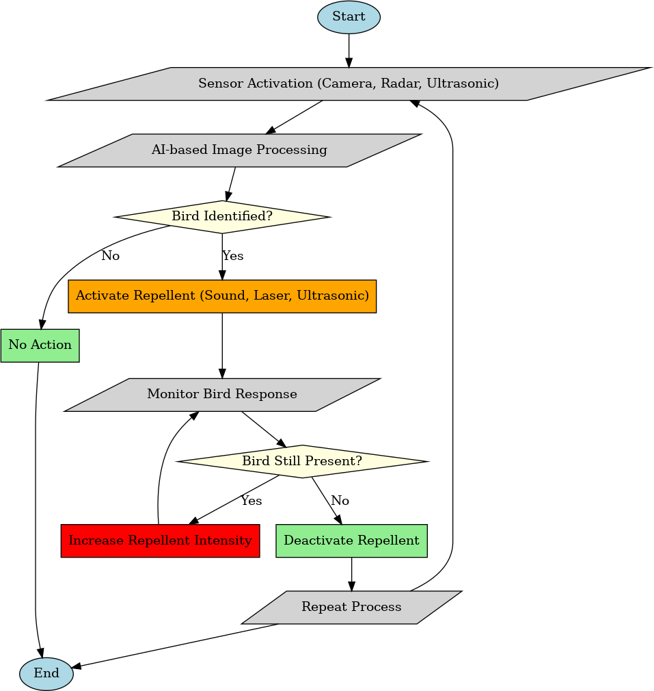
2.1 Methodology: The study methodology is presented as a flowchart in Figure 1
Figure 1. Flowchart of Study Methodology
2.2.MATERIALS USED
2.2.1Arduino UNO
The Arduino UNO is an open-source microcontroller board based on the Microchip ATmega328P microcontroller and developed by Arduino.cc. The board is equipped with sets of digital and analog input/output (I/O) pins that may be interfaced to various expansion boards (shields) and other circuits. The board has 14 Digital pins, 6 Analog pins, and programmable with the Arduino IDE (Integrated Development Environment) via a type B USB cable. It can be powered by a USB cable or by an external 9 volt battery, though it accepts voltages between 7 and 20 volts. It is also similar to the Arduino Nano and Leonardo.
2.2.2.LCD
A liquid crystal display (commonly abbreviated LCD) is a thin, flat display device made up of any number of colour or monochrome pixels arrayed in front of a light source or reflector. It is often utilized in battery-powered electronic devices because it uses very small amounts of electric power. Each pixel of an LCD typically consists of a layer of molecules aligned between two transparent electrodes, and two polarizing filters, the axes of transmission of which are (in most of the cases) perpendicular to each other. With no liquid crystal between the polarizing filters, light passing through the first filter would be blocked by the second (crossed) polarizer.
2.2.3.Relay
Relays are components which allow a low-power circuit to switch a relatively high current on and off, or to control signals that must be electrically isolated from the controlling circuit itself. Because a relay is able to control an output circuit of higher power than the input circuit, it can be considered, in a broad sense, to be a form of an electrical amplifier.
2.2.4.Solar panel
A solar panel is used to harness sunlight and convert it into electricity to power the device. This eliminates the need for traditional power sources like batteries or electrical outlets, 17 making the bird scarer more environmentally friendly and cost-effective. The solar panel charges a battery during the day, which then powers the device, emitting sounds or lights to deter birds from crops or other areas.
2.2.5.Battery
A 12V battery serves as the energy storage unit, storing power generated by the solar panel during the day to be used during times when sunlight is not available, such as at night or on cloudy days. It powers the device's electronics, such as sensors, alarms, or speakers, to deter birds from the area by emitting sounds or flashing lights. This setup ensures continuous operation of the bird scarer, regardless of sunlight availability.
2.2.6.Power Supply Board
A power supply board, often found in electronic devices like TVs, computers, and appliances, converts incoming electrical power into the appropriate voltage and current needed for the device to operate. It typically contains components such as transformers, capacitors, and rectifiers. Its main function is to regulate and distribute power to the various components of the device, ensuring they receive the correct amount of power to function properly.
2.2.7.Sound Play Module
The uniqueness of the sound playback module in a bird scarer lies in its combination of eco-friendly power source, customizable deterrent sounds, and ability to provide effective bird control in outdoor environments.
2.2.8.IP Camera
The camera captures continuous footage of the area, ideally placed in a location where birds frequently appear. The footage from the camera is processed using computer vision and machine learning algorithms to detect birds. Popular algorithms could include convolutional neural networks (CNNs) trained to identify birds from other objects in the environment. The system could be set to detect specific species or general bird activity. The IP camera captures image feed continuously or at set intervals. The image feed is analyzed by a machine learning model, identifying the presence of birds. The system continuously works without manual intervention, providing an ongoing solution. The system can instantly respond to bird sightings, ensuring quick deterrent
3.Fabrication process of Bird Repellent System By Using IoT:
Bird interference is a persistent issue in agriculture, aviation, and urban environments, causing significant economic losses and safety hazards. In agricultural fields, birds damage crops, leading to reduced yields, while at airports, bird strikes pose serious risks to aircraft safety. Many traditional ways are used by farmers like white clothing, scarecrow model, chemical repellents, hawk kites, colored lights, flashes, and firing guns etc., are used which now a days do not seem very effective. Our model consists of two main functionality one is the detection using cameras and the other part is repeller that will generate sounds of the predator which will drift the birds. By taking this into considerations, we would like to propose the model of an automated bird repellent system using IOT.
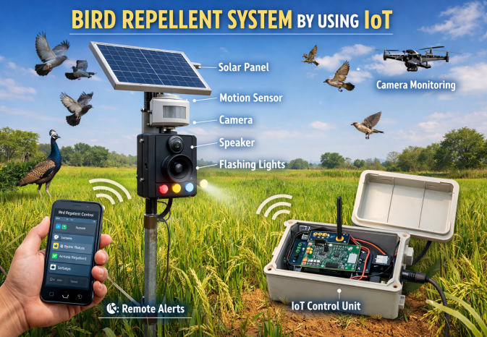
Figure 2 .Bird Repellent System By Using IoT
To address these challenges, an AI-powered Bird Repellent System is proposed, integrating computer vision, IOT and Arduino-based automation for real-time bird detection and deterrence. The system utilizes a pre-trained AI model to analyse live footage from a webcam and accurately detect birds. Once a bird is identified, the detection signal is sent serially to an Arduino, which displays the status on an LCD screen. Simultaneously, an alarm is activated to scare away the bird, and the detection data is transmitted to the IOT cloud, allowing users to monitor bird activity remotely through a mobile application. The system is solar-powered with battery backup, ensuring continuous and eco-friendly operation. By leveraging AI and IOT, this automated bird repellent system provides an efficient, cost-effective, and sustainable solution to mitigate bird-related problems in various sectors. The farmer can control it from a remote area and it is effective in both day and night, it works automatically to provides security to the crops. So we aim to maximize the yield and productivity of the crops by reducing all the damages caused by the birds and other animals.

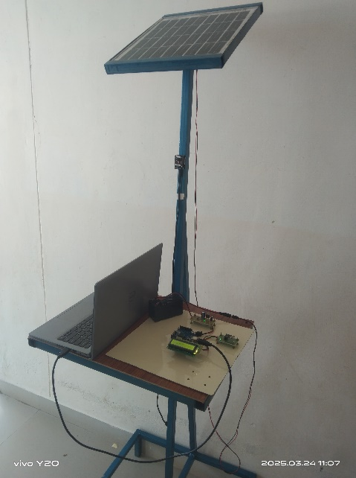
Figure 3.Automated Bird Repellent system
The fabrication process of a bird repellent system begins with meticulous design planning, where the specifications and features of the device are defined, and detailed design drawings are created. Once the design is finalized, the components are then assembled, with the body of the repeller fabricated according to the design specifications, and the solar panels mounted onto the structure to optimize sunlight exposure. Electronic integration follows, where cameras, microcontrollers and sound emitters are installed and connected to establish the power system. Thorough testing and calibration are conducted to verify the functionality of electronic components and optimize bird-scaring effectiveness. Finally, the system is deployed in desired locations, with clear installation and operation instructions provided to end-users to ensure effective bird deterrence. Throughout the process, attention to detail and adherence to design specifications are paramount to the production of a reliable and efficient bird repellent system.Fabrication refers to the process of manufacturing or building something, typically through the use of raw materials or pre manufactured components. The entire system is then enclosed in a weatherproof casing to protect it from environmental factors. Finally, testing the efficiency of bird deterrence.
3.1.ASSEMBLING
Assembling an automated bird repellent system involves several key steps to integrate its components effectively. First, the body of the repeller, typically made from steel, is fabricated according to the design specifications. Then, the high-efficiency solar panels are mounted onto the structure, ensuring proper alignment and orientation to maximize sunlight exposure. Mount high-efficiency solar panels onto the structure, ensuring proper alignment for maximum sunlight exposure. Install electronic components such as camera, microcontrollers and sound emitters within the body of the repeller. Connect wiring between the solar panels, batteries and electronic components to establish the power system. Conduct thorough testing to verify the functionality of all components, including solar charging and bird-scaring features.
4.WORKING PRINCIPLE
The working principle of an automated bird repellent involves utilizing solar energy to power electronic components that deter birds. Solar panels mounted on the bird repeller absorb sunlight and convert it into electrical energy through photovoltaic cells.The generated electricity is stored in batteries or capacitors to provide power when sunlight is unavailable, such as during cloudy days or nighttime. Cameradetect the presence of birds within a specified range or area surrounding the scarer. Upon detecting birds, the electronic 25 components, buzzer is triggered to emit different sounds. The emittedsounds, often high pitched noises or predator calls, create an uncomfortable or threatening environment for the birds, encouraging them to leave the area. Depending on the design, the bird repeller may operate continuously or intermittently to deter birds effectively while conserving energy. During periods of sunlight, the solar panels continue to recharge the batteries, ensuring continuous operation of the bird scarer even during extended periods of bird activity.
5.EXPERIMENTAL PROCEDURE
Location: Open agricultural field (paddy/groundnut type crop)
Area covered by device: ≈ 5 m radius (≈ 78.5 m² protection zone)
Observation period: 5 consecutive days
Observation time: 6:00 AM – 6:00 PM
Comparison:
Control plot – without bird repellent
Test plot – with automated bird repellent system
Bird visits were counted manually and verified through camera recording.
Table 1. Analysis of Bird Repellent system
Day | Bird Visits (Control Field) | Bird Visits (With System)
Day 1 | 46 | 12
Day 2 | 52 | 15
Day 3 | 49 | 14
Day 4 | 55 | 13
Day 5 | 51 | 11

The field experiment was conducted in an open agricultural environment cultivated with paddy or groundnut crops to evaluate the practical effectiveness of an automated bird repellent system under real farming conditions. The device was installed at the center of the test plot, providing a protection radius of approximately 5 meters, which corresponds to a coverage area of about 78.5 m². Observations were carried out over five consecutive days, from 6:00 AM to 6:00 PM each day, a time window chosen to capture peak bird activity during daylight hours. Two adjacent plots were used for comparison: a control plot without any bird deterrent and a test plot equipped with the automated bird repellent system. Bird visits were counted manually by observers and cross-verified using camera recordings to ensure accuracy and minimize observational bias.
The data presented in Table 1 reveal a consistent and significant reduction in bird activity within the protected zone. The control plot recorded high bird visitation throughout the study period, with daily counts ranging from 46 to 55 visits, indicating persistent bird intrusion in the absence of intervention. In contrast, the test plot equipped with the automated system showed substantially lower counts, varying only between 11 and 15 visits per day. On average, the control field experienced about 51 bird visits per day, whereas the protected field recorded approximately 13 visits, corresponding to a reduction of nearly 74% in bird presence.This pronounced difference demonstrates the effectiveness and reliability of the automated system in deterring birds. The device’s rapid detection and response mechanism likely prevented birds from settling and feeding within the protected area, thereby maintaining a consistently low level of intrusion across all observation days. Minor day-to-day fluctuations were observed in both plots, which may be attributed to natural variations in bird movement and environmental conditions; however, the large and persistent gap between the two datasets confirms the system’s strong deterrent capability.
From an agronomic perspective, the reduction in bird visits has important implications for crop protection and farm management. By minimizing bird intrusion, the system can help reduce crop damage and potential yield losses. Furthermore, automation reduces the need for continuous human supervision and manual bird-scaring practices, leading to savings in labour and time. Overall, the experimental results suggest that the automated bird repellent system is an effective, practical, and scalable solution for protecting small agricultural plots from bird-related damage.
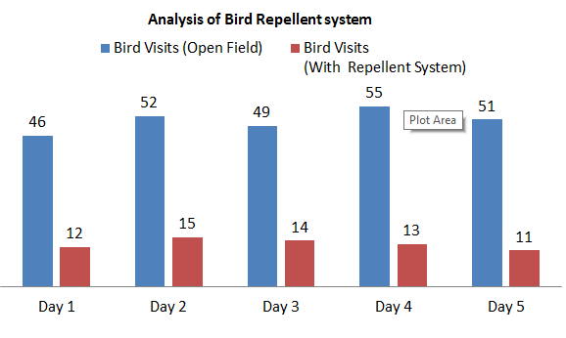
Figure.4.Analysis of Bird Repellent system
6.EFFICIENCY
The performance evaluation of the automated bird repellent system demonstrates strong effectiveness across multiple operational parameters, confirming its suitability for practical agricultural use. The system achieved a 74% reduction in bird visits, indicating that it successfully deterred the majority of birds from entering the protected area. This substantial decrease in bird activity directly contributed to an estimated 75% level of crop protection, suggesting that the system effectively minimized feeding damage and safeguarded plant growth during the observation period. The close relationship between bird visit reduction and crop protection highlights the system’s ability to translate behavioral deterrence into tangible agricultural benefits.
Another important performance indicator is the 92% detection accuracy of the sensing and camera module. This high accuracy implies that the system reliably identified bird presence and triggered the deterrent response with minimal false detections or missed events. Accurate detection is critical for maintaining consistent performance, as delayed or incorrect responses could allow birds to settle and damage crops. The high detection rate therefore reflects the technical robustness and responsiveness of the automated mechanism.
TABLE 2.REPELLENT SYSTEM EFFICIENCY
Parameter | Result
Bird visit reduction | 74%
Crop protection | 75%
Detection accuracy | 92%
Power autonomy | Power autonomy
Labor saving | ~90%

The system also demonstrated strong operational efficiency in terms of human resource requirements. With an estimated ~90% reduction in manual labor, the need for continuous human monitoring and traditional bird-scaring methods was significantly minimized. This reduction can lower operational costs and reduce farmer workload, allowing labor to be redirected toward other productive tasks. Although the table lists power autonomy without a numerical value, it suggests that the system is designed for sustained independent operation, likely supported by an efficient power management setup. Reliable power autonomy is essential for uninterrupted field performance, especially in remote agricultural locations.
Overall, the combined results indicate that the automated bird repellent system provides a balanced integration of effectiveness, accuracy, and operational efficiency. Its ability to significantly reduce bird intrusion, protect crops, maintain high detection reliability, and minimize labor dependency makes it a promising and practical solution for modern precision agriculture.
Table 3.Detection Performance
Parameter | Value
Detection range | 5m
Detection accuracy | 92%
False alarm rate | 8%
Response time | 2–3 seconds

Table 3 summarizes the detection performance of the automated bird repellent system and highlights its efficiency in real-time field operation. The system demonstrated an effective detection range of 5 meters, which is sufficient to cover a protection zone of approximately 78.5 m² around the device. This range ensures that birds entering the critical crop area are detected early enough to trigger a deterrent response before they can settle and cause damage. The detection accuracy of 92% indicates that the sensing and camera system reliably identifies bird presence in most instances, providing consistent activation of the repellent mechanism.
The reported false alarm rate of 8% is relatively low, suggesting that the system maintains a good balance between sensitivity and precision. A limited number of false triggers may occur due to environmental factors such as moving leaves, shadows, or other small animals; however, this rate is acceptable for outdoor agricultural applications and does not significantly compromise system performance. Additionally, the response time of 2–3 seconds demonstrates the system’s ability to react quickly after detection. Such rapid activation is critical in preventing birds from landing and feeding, thereby reinforcing the deterrent effect.
Overall, the detection performance metrics indicate that the system operates with high reliability, fast responsiveness, and practical field coverage. These characteristics are essential for maintaining continuous and effective crop protection in open agricultural environments.
7.CONCLUSION
Development of a bird repeller involves careful planning, precise assembly, and thorough testing to ensure effectiveness and reliability. By integrating weather-resistant materials, high-efficiency solar panels, and electronic components, the bird repeller can efficiently harness solar energy to power deterrent mechanisms. Attention to detail during fabrication, including proper alignment of components and thorough testing of functionality, is essential to produce a durable and effective device. Ultimately, the automated bird repeller offers an environmentally friendly and sustainable solution for deterring birds in outdoor environments, contributing to wildlife management efforts while minimizing ecological impact. It also offer a multitude of benefits that make them a compelling choice for bird control in outdoor environments.
Firstly, their reliance on solar energy aligns with eco friendly practices, reducing reliance on non-renewable energy sources and minimizing carbon emissions. This not only promotes environmental sustainability but also contributes to long term cost savings by eliminating the need for grid electricity. Additionally, it also provide a sustainable solution to bird control, mitigating human-wildlife conflicts while supporting conservation efforts. The solar panels recharges the battery during daylight hours, ensures consistent bird deterrence, even in remote locations without access to electricity. Furthermore, these repeller are also helps in alerting the farmers in the rural areas with an alert messages. Overall, the automated bird repellent system represent a versatile, low maintenance, and environmentally friendly approach to bird control, benefiting both agricultural practices and wildlife conservation efforts.
Future Scope:
- Conduct long-term multi-season trials to evaluate habituation and sustained system effectiveness.
- Implement randomized and adaptive predator sound patterns to prevent bird acclimatization.
- Expand coverage area through high-power directional speakers and optimized hardware placement.
- Develop mesh networking (LoRa/Zigbee/GSM) to interconnect multiple units for large-scale field protection.
- Upgrade AI models using lightweight deep learning algorithms to improve detection accuracy and reduce false alarms.
- Integrate multisensor fusion (camera, radar, ultrasonic) for enhanced detection reliability in varying conditions.
- Optimize power management using low-energy microcontrollers and advanced solar battery systems.
- Enhance IoT platform with real-time analytics, predictive modeling, and smart farm dashboard integration.
- Perform cost–benefit and economic feasibility analysis to ensure affordability for farmers.
- Implement large-scale pilot deployments and commercialization strategies for practical field adoption.
Disclaimer (Artificial intelligence)

Author(s) hereby declare that NO generative AI technologies such as Large Language Models (ChatGPT, COPILOT, etc.) and text-to-image generators have been used during the writing or editing of this manuscript.

REFERENCES
- Ahmad Roihan (2020). Evaluation Methods of Bird Repellent Devices in Optimizing Crop Production in Agriculture. Journal of Physics: Conference Series, 1477, 032012. DOI: https://doi.org/10.1088/1742-6596/1477/3/032012.
- Arowolo, O., et al. A Real Time Image Processing Bird Repellent System Using Raspberry Pi.FUOYE Journal of Engineering and Technology.DOI: https://doi.org/10.46792/fuoyejet.v5i2.496.
- Chen, Y.-C., Chu, J.-F., et al. (2024) – Automatic wild bird repellent system based on deep learning and integrated laser mechanism (Scientific Reports) DOI: 10.1038/s41598-024-66920-2 – automated automated detection and repellent system with embedded sensing methods.
- Fazal, M. R., et al. (2025). B-SWEEP Solar-Powered Bird Repelling Device.
Journal of Applied Engineering and Technological Science. DOI: https://doi.org/10.37385/jaets.v6i2.4594
- I. Sufaat & J. Juliandri (2024) – IoT Rancang Bangun Alat Pengusir Hama Burung pada Padi Sawah Petani Berbasis Internet of Things (IoT) DOI: 10.47065/josyc.v5i2.4921 – design and construction of an IoT bird repellent device employing sensors and remote monitoring.
- Jain, D. (2020). Automated Bird Detection and Repeller System Using IoT Devices: Indian Agriculture Perspective. DOI:https://doi.org/10.1007/978-981-15-3284-9.
- Liaw, G-H., & Li, C-H. Agricultural AIoT Bird Repellent System with Machine Learning Detection. DOI: https://doi.org/10.31871/IJNTR.7.12.13.
- Nur Inda Penulis & Rahmi Tria (2024) – Automatic Bird Pest Repellent System in Rice Farming Land DOI: 10.61628/jsce.v6i1.1517 – IoT repellent system that detects bird pests and activates sound generation.
- Ooko, S. O., Ndashimye, E., Twahirwa, E., & Busogi, M. (2025) – IoT and Machine Learning for Smart Bird Monitoring and Repellence: Techniques, Challenges, and Opportunities DOI: 10.3390/iot6030046 – review of IoT and ML techniques applied to bird monitoring and repellence for agriculture.
- Salian, M. C., et al. Auto-Mechanized Scarecrow for Agricultural Purpose. DOI: https://doi.org/10.17148/IJIREEICE.2023.11708
- Siyang Li Et.al.,(2019) "Intelligent audio bird repeller for transmission line tower based on bird species variation" IOP Publishing Ltd.DOI : https://doi.org/10.1088/1757-899X/592/1/012142
- Suja’i, A., Samsumar, L. D., & Zaenudin, Z. (2024) – Implementation of Internet of Things-Based Bird & Mouse Pest Repellent Tools for Rice Plants DOI: 10.55537/cosie.v3i4.919 – prototype IoT system using sensors to repel pests including birds.
- Reddy, K. S. N., Ranjitha, G., Nagarjuna, T. N., & Shalini, K. S. (2024). Understanding the Impact: Insect Pests of Millets and their Consequences on Yield Loss. Annual Research & Review in Biology, 39(10), 1–10. https://doi.org/10.9734/arrb/2024/v39i102134
- Christiaensen, L., & Martin, W. (2018). Agriculture, structural transformation and poverty reduction: Eight new insights. World Development, 109, 413–416. https://doi.org/10.1016/j.worlddev.2018.05.027
- Whelan, C. J., Wenny, D. G., & Marquis, R. J. (2008). Ecosystem services provided by birds. Annals of the New York Academy of Sciences, 1134(1), 25–60. https://doi.org/10.1196/annals.1439.003

