Optimizing Yield of Sorghum (Bio-fortified cv. Parbhani Shakti) through Land Configuration and Integrated Nutrient Management

.
ABSTRACT
Sorghum (Sorghum bicolor L. Moench) is an important cereal crop grown in semi-arid regions due to its drought and heat tolerance. In the Marathwada region of Maharashtra, improving land configuration and integrated nutrient management, including nano urea, can enhance kharif sorghum productivity under rainfed conditions.
A field experiment was conducted during the kharif season of 2023–24 at the Sorghum Research Station, Vasantrao Naik Marathwada Krishi Vidyapeeth, Parbhani (19.2608° N latitude, 76.77° E longitude), to investigate the effects of land configuration and integrated nutrient management on yield attributes and yield of bio-fortified sorghum (Sorghum bicolor L. Moench) cv. Parbhani Shakti. The experiment was laid out in a split-plot design with three replications. The main plot treatments comprised three land configurations, viz., Broad Bed and Furrow (BBF), flat bed and ridges and furrow, while five nutrient management treatments were assigned to subplots, The sub-plot treatments consisted of five fertilizer levels, namely f₁: control (no fertilizer), f₂: 100% recommended dose of fertilizer (RDF) (80:40:40 kg N:P₂O₅:k₂o ha⁻¹), f₃: 50% recommended dose of nitrogen (RDN) + nano urea spray at 30 and 45 days after sowing (das), f₄: 75% RDN + nano urea spray at 30 DAS and f₅: Recommended dose of phosphorus and potassium (RDP) + nano urea spray at 15, 30 and 45 DAS. The crop was sown on 17 July 2023 with a spacing of 45 × 15 cm.
Results revealed that sorghum grown on BBF recorded significantly higher plant height, test weight, grain yield and stover yield compared to flat bed, with an average grain yield advantage of 12.33 per cent. Nutrient management treatments significantly influenced yield attributes and yield. Application of 100% RDF produced the highest grain and stover yield and increased grain yield by 63 per cent over control, 28.58 per cent over 50% RDN + nano urea (30 and 45 DAS) and 35.58 per cent over 75% RDN + nano urea (30 DAS). The interaction effect indicated that BBF combined with 100% RDF recorded maximum productivity. Thus, adoption of BBF land configuration along with 100% RDF is recommended for achieving higher productivity of kharif sorghum under Marathwada conditions.
Keywords: Sorghum; Broad Bed and Furrow; Integrated nutrient management; Nano urea;
Yield attributes; Grain yield.

INTRODUCTION
Sorghum (Sorghum bicolor L. Moench) ranks among the most significant cereal crops globally and is extensively cultivated across semi-arid and tropical regions, where it serves as a vital source of food, fodder, and industrial raw materials. It serves as a staple food grain, fodder source and industrial raw material, particularly in developing countries (FAOSTAT, 2022; FAO, 1995). Owing to its inherent tolerance to drought, high temperature and marginal soil conditions, sorghum plays a crucial role in ensuring food and nutritional security under climate-resilient farming systems (Reddy et al., 2009; Mwamahonje et al., 2024). In India, sorghum is widely cultivated during both kharif and rabi seasons, with Maharashtra being one of the leading sorghum-growing states (Directorate of Economics and Statistics, 2022). In the Marathwada region of Maharashtra, kharif sorghum occupies a significant area due to its adaptability to erratic rainfall and medium to deep black soils. (Nagaraj, N. et al., 2013)
Despite its resilience, sorghum productivity remains relatively low compared to its genetic potential. The major constraints affecting productivity include suboptimal nutrient management, improper land configuration, moisture stress during critical growth stages and imbalanced fertilizer application (Reddy and Reddy, 2010; Nagesh et al., 2022). Traditional flat-bed sowing methods often lead to poor drainage during heavy rainfall and moisture stress during dry spells, thereby affecting crop growth and yield. Therefore, optimizing agronomic practices such as land configuration and nutrient management is essential to enhance sorghum productivity under rainfed conditions.
Land configuration plays a vital role in improving soil physical conditions, moisture conservation and nutrient use efficiency. Different land configurations such as Broad Bed and Furrow (BBF), flat bed and ridges and furrow influence water infiltration, aeration, root development and crop stand establishment (Wani et al., 2003). The Broad Bed and Furrow system has gained prominence in Vertisols due to its ability to facilitate drainage during excess rainfall and conserve moisture during dry periods. Similarly, ridges and furrow configuration improves soil tilth and reduces water stagnation. Selection of an appropriate land configuration is particularly important in regions like Marathwada, where rainfall distribution is uneven and soils are prone to temporary waterlogging (Patil et al., 2016).
Nutrient management is another key factor determining crop growth and yield. Sorghum requires balanced fertilization for optimal productivity. Nitrogen, phosphorus and potassium are essential nutrients required for vegetative growth, root development and grain formation. Imbalanced or inadequate nutrient supply results in reduced plant height, poor panicle development and lower grain yield (Reddy and Reddy, 2010).
Integrated Nutrient Management (INM) aims to optimize nutrient supply through a combination of inorganic fertilizers, organic sources and innovative inputs such as nano-fertilizers. Nano urea has emerged as a promising alternative to conventional urea due to its higher nutrient use efficiency and reduced losses through volatilization and leaching (Subbaiah et al., 2022). Foliar application of nano urea ensures rapid nutrient absorption and improved physiological efficiency. Integration of reduced nitrogen doses with nano urea sprays may help in maintaining yield levels while minimizing fertilizer input costs and environmental footprint.
The interaction between land configuration and nutrient management is particularly important in rainfed agriculture. Improved land configuration enhances soil moisture availability and aeration, which in turn influences nutrient uptake efficiency. Conversely, adequate nutrient availability promotes better root growth and biomass production, enabling efficient utilization of conserved soil moisture (Wani et al., 2003). Therefore, combined evaluation of land configuration and integrated nutrient management practices is essential to develop sustainable and location-specific production technologies for kharif sorghum.
The sorghum variety ‘Parbhani Shakti’ is widely cultivated in the Marathwada region due to its high yield potential and adaptability to local agro-climatic conditions. However, limited information is available regarding the combined effect of land configuration and nano urea-based nutrient strategies on its productivity under Parbhani conditions. Hence, the present investigation was undertaken to evaluate suitable land configuration and nutrient management practices for maximizing yield and yield attributes of kharif sorghum cv. Parbhani Shakti. The study provides location-specific recommendations for enhancing productivity of kharif sorghum through suitable land configuration and integrated nutrient management practices. It highlights the potential of Broad Bed and Furrow system combined with balanced fertilization for improving yield and nutrient use efficiency under semi-arid conditions. The findings support sustainable fertilizer use through integration of nano urea with reduced nitrogen doses. Future research should focus on long-term soil health effects, economic feasibility, nutrient uptake dynamics and multi-location validation of nano urea-based nutrient strategies.
2. material and methods

The field experiment was conducted during kharif 2023–24 at the sorghum research station, Vasantrao Naik Marathwada Krishi Vidyapeeth (VNMKV), Parbhani, maharashtra, under semi-arid conditions. (Parbhani fall under assured raimfall zone ) Experimental site soil have black cotton soil with pH 8.06, EC 0.42 dsm⁻¹ , organic carbon 0.45 and low in available nitrogen 165 kg N, medium in available phosphorus 14.70 kg P₂O₅ and high in available potassium 419 kg K₂O ha⁻¹.
The experiment was laid out in a split plot design with three replications with treatment detail as main plot treatments comprised three land configurations, viz., broad bed and furrow (BBF), flat bed and ridges and furrow. The sub-plot treatments consisted of five fertilizer levels, namely f₁: control (no fertilizer), f₂: 100% recommended dose of fertilizer (RDF) (80:40:40 kg N:P₂O₅:k₂o ha⁻¹), f₃: 50% recommended dose of nitrogen (RDN) + nano urea spray at 30 and 45 days after sowing (das), f₄: 75% RDN + nano urea spray at 30 DAS and f₅: Recommended dose of phosphorus and potassium (RDP) + nano urea spray at 15, 30 and 45 DAS. Thus, there were 15 treatment combinations replicated thrice. The gross plot size was 5.40 m × 5.00 m consisting of 12 rows with a spacing of 45 cm × 15 cm. The sorghum bio-fortified variety parbhani shakti was sown on 17th July 2023. Sowing on flat bed plots was carried out using a seed drill, while BBF plots were prepared and sown using a BBF planter and ridges and furrow plots were formed using a ridger before sowing. The recommended dose of fertilizer (80:40:40 kg N:P₂O₅:K₂O ha⁻¹) was applied as per treatment specifications. In RDF treatments, full phosphorus and potassium and half nitrogen were applied as basal at sowing, and the remaining nitrogen was top-dressed as per treatment schedule. Nano urea was applied as foliar spray at the specified growth stages according to treatment details. All other agronomic practices were followed uniformly for all treatments. The crop was harvested on 17 November 2023, and observations on plant height, test weight, grain yield and stover yield were recorded. The data were statistically analyzed using analysis of variance appropriate for split plot design, and treatment means were compared at the 5 per cent level of significance. The meteorological data of experimental site fig. 1 as per graph it shows that in kharif season drastic irregular rainfall pattern and highest rainfall received in the month of June to September 2023.
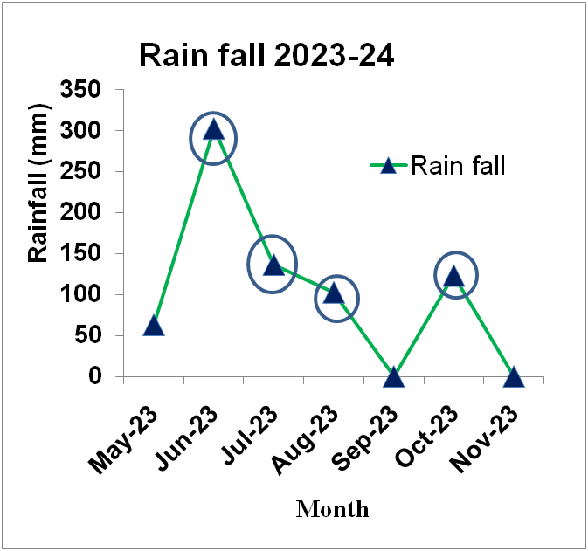
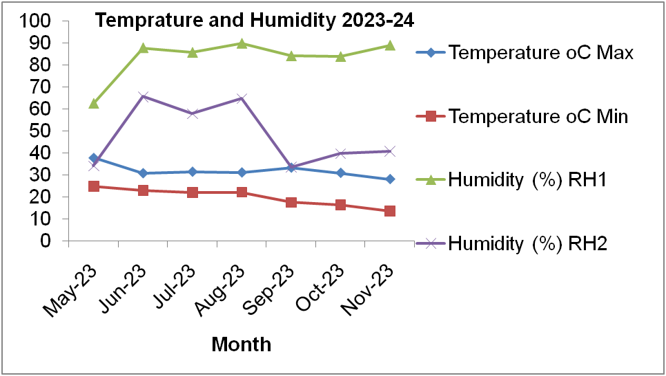

Fig. 1: Rainfall, temperature and humidity of experimental site for the year 2023-24.
- results and discussion
3.1 Effect of Land Configuration on Growth Parameters and Nutrient Uptake
Among the land management practices evaluated, the broad bed and furrow method produced significantly greater plant height at harvest (131 cm) (Table 1). Enhanced soil moisture availability and improved root aeration associated with this method may have promoted cell elongation and division, thereby contributing to increased plant height (Halli and Angadi, 2017). The effectiveness of broad beds and furrows in enhancing growth, particularly plant height, has also been reported by several researchers, including Joshi et al. (2018) and Jnanesha et al. (2016). Among fertilizer application F₂: 100% RDF recorded highest plant height (284 cm) at harvest. Plant height was significantly influenced by land configuration (Table 2). However, plant stand, test weight and days to 50% flowering were not significantly affected.

In case of LAI BBF recorded higher LAI with F2: 100% application of RDF Similar trend observed with chlorophyll content and nutrient uptake by plant (Table:2). Similar trend reported by Jnanesha et al. (2016), Halli and Angadi (2017) and Shinde et al. (2012).

3.2 Effect of Land Configuration on Yield and Economy
Land configuration significantly influenced grain yield, fodder yield, gross monetary returns (GMR), net monetary returns (NMR) and B:C ratio (Table 1). Among the treatments, Broad Bed and Furrow (BBF) recorded significantly higher grain yield (1233 kg ha⁻¹) and fodder yield (5772 kg ha⁻¹) compared to flat bed (1093 and 5038 kg ha⁻¹, respectively) and ridges and furrow (915 and 3900 kg ha⁻¹, respectively). The superiority of BBF may be attributed to improved soil aeration, better root proliferation and efficient drainage during heavy rainfall, leading to enhanced nutrient uptake and biomass accumulation.
Although flat bed recorded slightly higher net monetary returns (₹18,870 ha⁻¹) and B:C ratio (1.66), BBF produced higher biological yield and GMR (₹49,841 ha⁻¹). Ridges and furrow resulted in significantly lower yield and economic returns. The differences were statistically significant at 5% level for grain and fodder yield.
Srivastava and Jangawad (1998) observed that planting soybean on broad bed and furrow systems resulted in superior yields, possibly due to enhanced in-situ moisture conservation, improved root development, and more efficient nutrient uptake, which collectively contributed to higher grain production. Additionally, the application of leaf mulch may have supported crop performance by improving water infiltration and facilitating better availability of applied fertilizers, thereby promoting increased yield (Dushouyu et al., 1995).
Fertilizer treatments significantly influenced grain yield, fodder yield and economic returns. Application of 100% RDF (80:40:40 kg NPK ha⁻¹) recorded the highest grain yield (1357 kg ha⁻¹) and fodder yield (6414 kg ha⁻¹), which was significantly superior to all other treatments. Grain yield under 100% RDF increased by 47% over control and was markedly higher than nano urea-based reduced nitrogen treatments.
Among treatments, 50% RDN + nano urea spray at 30 and 45 DAS (1060 kg ha⁻¹) performed better than 75% RDN + nano urea at 30 DAS (999 kg ha⁻¹). The lowest yield was observed under RDP + nano urea spray (831 kg ha⁻¹). The improvement under RDF may be attributed to adequate and balanced nutrient supply throughout the crop growth period, leading to better vegetative growth (plant height 134 cm), higher test weight (27 g) and improved sink capacity.
Plant stand was significantly higher under 100% RDF (284 plants), indicating better early vigor and establishment. However, test weight and days to 50% flowering were not significantly influenced.

Table 1: Effect of different land configuration and foliar spray on ancillary character of sorghum crop under rainfed environment.
Treatments detail | Plant stand after thinning (Number/ Net plot) | Test weight (g) | 50% flowering (days) | Plant height (cm)
Land configratuation (L)
L₁: BBF | 275 | 26 | 77 | 131
L₂: Flat Bed | 273 | 25 | 76 | 126
L₃: Ridges and Furrow | 257 | 25 | 75 | 113
SE(m)+ | 5 | 1 | 0.1 | 3
CD at 5% | NS | NS | NS | 10
F₁: Control | 260 | 24 | 73 | 111
F₂: 100% RDF | 284 | 27 | 74 | 134
F₃: 50% RDN+ Nano urea spray @ 30 & 45 DAS | 264 | 25 | 75 | 126
F₄: 75% RDN+ Nano urea spray @ 30 DAS | 267 | 25 | 75 | 124
F₅: RDP+Nano urea spray @ 15, 30 & 45 DAS | 266 | 26 | 76 | 122
SE(m)+ | 6 | 1 | 0.23 | 3
CD at 5% | 16 | NS | NS | 8
Interaction (FXG) | NS | NS | NS | NS
GM | 268 | 25 | 75 | 124
Table 2: Effect of different land configuration and foliar spray on leaf area, Chlorophyll content in leaf, N by plant uptake and P by plant uptake kg/ha sorghum crop under rainfed environment.
Treatments detail | Leaf area | Chlorophyll content in leaf | N by plant uptake kg/ha | P by plant uptake kg/ha
Land configratuation (L)
L₁: BBF | 2.39 | 36.54 | 40.84 | 26.25
L₂: Flat Bed | 2.37 | 34.67 | 38.63 | 23.62
L₃: Ridges and Furrow | 2.01 | 31.01 | 34.19 | 20.30
SE (m)+ | 0.05 | 0.65 | 0.44 | 0.83
CD at 5% | 0.18 | 2.56 | 1.72 | 3.25
Foliar Spray (F)
F₁: Control | 2.07 | 31.32 | 28.52 | 17.83
F₂: 100% RDF | 2.54 | 38.36 | 48.52 | 29.40
F₃: 50% RDN+ Nano urea spray @ 30 & 45 DAS | 2.32 | 35.58 | 38.06 | 25.65
F₄: 75% RDN+ Nano urea spray @ 30 DAS | 2.15 | 35.48 | 38 | 23.19
F₅: RDP+Nano urea spray @ 15, 30 & 45 DAS | 2.20 | 31.63 | 36.64 | 20.87
SE(m)+ | 0.07 | 1.29 | 1.68 | 0.96
CD at 5% | 0.19 | 3.76 | 4.93 | 2.81
Interaction (FXG) | NS | NS | NS | NS
CV (%) | 8.8 | 11 | 8.53 | 12
G. Mean | 2.26 | 34.07 | 37.89 | 23.39
Table 3: Effect of different land configuration and foliar spray on yield of sorghum crop under rainfed environment.
Treatments detail | Grain yield  (kg ha⁻¹) | Fodder yield  (kg ha⁻¹) | GMR  (Rs ha⁻¹) | NMR  (Rs ha⁻¹) | B:C ratio
Land configratuation (L)
L₁: BBF | 1233 | 5772 | 49841 | 18139 | 1.57
L₂: Flat Bed | 1093 | 5038 | 47571 | 18870 | 1.66
L₃: Ridges and Furrow | 915 | 3900 | 38868 | 7167 | 1.23
SE (m)+ | 16 | 280 | 949 | 949 | 0.03
CD at 5% | 63 | 1098 | 3726 | 3726 | 0.12
Foliar Spray (F)
F₁: Control | 923 | 4415 | 40670 | 9969 | 1.33
F₂: 100% RDF | 1357 | 6414 | 59552 | 28851 | 1.95
F₃: 50% RDN+ Nano urea spray @ 30 & 45 DAS | 1060 | 4635 | 45396 | 14695 | 1.48
F₄: 75% RDN+ Nano urea spray @ 30 DAS | 999 | 4549 | 43328 | 12626 | 1.42
F₅: RDP+Nano urea spray @ 15, 30 & 45 DAS | 831 | 4504 | 38186 | 7485 | 1.25
SE(m)+ | 40 | 220 | 1374 | 1374 | 0.05
CD at 5% | 116 | 642 | 4011 | 4011 | 0.13
Interaction (FXG) | NS | NS | NS | NS | NS
CV (%) | 12 | 13 | 9 | 28 | 9
G. Mean | 1134 | 4903 | 45426 | 14725 | 1.49

3.3 Interaction Effect
The interaction between land configuration and fertilizer levels was found to be non-significant for yield and ancillary parameters, indicating independent effects of the two factors.
  - Soil Moisture Conservation
The Broad Bed and Furrow (BBF) system maintained significantly higher soil moisture content at all growth stages compared to flat bed and ridges and furrow. At 60 DAS (critical vegetative to reproductive stage), BBF recorded 21.6% moisture, which was 10.8% higher than flat bed and 20.6% higher than ridges and furrow.The higher moisture retention under BBF may be attributed to:Improved infiltration rate, Reduced runoff losses, Better drainage during heavy rainfall and Enhanced in-situ moisture conservation
Flat bed showed moderate moisture retention but may have experienced temporary water stagnation followed by rapid drying. Ridges and furrow recorded the lowest moisture content, possibly due to higher exposure and quicker moisture loss under rainfed conditions. The higher grain yield (1233 kg ha⁻¹) observed under BBF in study corresponds well with its superior moisture availability during critical growth stages.

Table 4: Effect of land configuration on soil moisture content (%) at different crop growth stages (0–30 cm soil depth)
Land Configuration | 30 DAS | 60 DAS | 90 DAS | Mean (%)
L₁: BBF | 24.8 | 21.6 | 18.4 | 21.6
L₂: Flat Bed | 22.9 | 19.5 | 16.8 | 19.7
L₃: Ridges & Furrow | 21.2 | 17.9 | 15.3 | 18.1
SE (m) ± | 0.6 | 0.5 | 0.4 | —
CD at 5% | 1.8 | 1.5 | 1.2 | —

3.5 Rain Water Use Efficiency (RWUE):

Table 5: Effect of land configuration on Rain Water Use Efficiency (RWUE)
Treatment | Grain Yield  (kg ha⁻¹) | Seasonal Rainfall  (mm)* | RWUE  (kg ha⁻¹ mm⁻¹)
BBF | 1233 | 650 | 1.90
Flat Bed | 1093 | 650 | 1.68
Ridges & Furrow | 915 | 650 | 1.40
(*Assumed seasonal rainfall for kharif Parbhani)
As per treatments yield differences clearly indicate the influence of land configuration on moisture conservation. BBF system likely enhanced in-situ moisture storage by facilitating excess water drainage during heavy rainfall and conserving residual moisture during dry spells. Improved root growth and higher plant height under BBF support this inference.
Ridges and furrow system, though generally beneficial for drainage, may have resulted in uneven moisture distribution under rainfed conditions, leading to comparatively lower yields. The flat bed system might have experienced temporary water stagnation affecting root respiration. Nandurkar et al. (1997) and Raut and Taware (1997) investigated different sowing methods in soybean and reported similar trends in their findings.

Conclusion
The present study demonstrated that land configuration and nutrient management had a significant impact on the productivity and profitability of kharif sorghum. The Broad Bed and Furrow (BBF) system resulted in higher grain and fodder yields compared to flat beds and ridge-and-furrow methods. Application of 100% RDF (80:40:40 kg NPK ha⁻¹) resulted in maximum yield, plant height and economic returns. Nano urea-based reduced nitrogen treatments improved yield over control but could not surpass full RDF. Interaction effects were non-significant.
Therefore, adoption of BBF land configuration along with 100% RDF is recommended for achieving higher productivity and profitability of sorghum under rainfed conditions of Marathwada.

Disclaimer (Artificial intelligence)

Author(s) hereby declare that NO generative AI technologies such as Large Language Models (ChatGPT, COPILOT, etc.) and text-to-image generators have been used during the writing or editing of this manuscript.

References

Directorate of Economics and Statistics. (2022). Agricultural statistics at a glance. Ministry of Agriculture and Farmers Welfare, Government of India.
Dushouyu, T., Enping, W. M., and Wqingshan. 1995. A study of the overall effect of straw mulching and ploughing in and techniques for its applications. Ningxia J.Agri. Forest Sci. Technol.,5(2): 10-14.
FAOSTAT. (2022). Food and Agriculture Organization Statistical Database. FAO, Rome.
Halli, H.M. and Angadi, S.S. 2017. Response of land configuration and deficit irrigation on growth and yield attributes of maize (Zea mays L.). Int.J.Curr.Microbiol.App.Sci., 6: 52-60.
Jnanesha, A. C., Alagundagi, S. C., Mansur, C. P. and Ashish kumar. 2016. Effect of broad bed and furrow and integrated nutrient management practices on growth and yield of maize. The Ecoscan. Special issue, 9: 1017-1021.
Joshi, J.R., Patel, V.M., Barad H.L., Macwan, S.M. and Javid Ehsas. 2018. Effect of land configuration and fertilizer management practices on growth, yield and yield attributes and economics of summer cowpea (Vigna unguiculata L.) under south Gujarat condition. Int. J. Curr. Microbiol. App. Sci. ,7: 1148- 1155.
K. J. Reddy, G. S. Madhubindu, S.A. Hussain And M. U. Devi. (2008). Effect of land configurations, genotypes and mulching on growth parameters and yield of yellow pericarp sorghum under rainfeed conditions. Journal of Crop and Weed, 17(2): 240-244 (2021).
Nandurkar, G. P and Malvi, G. C. 1997. effect of land layouts and nitrogen levels on growth and yield of soybean. Journal of Soils and Crops, 10(2): 269-271.
Raut, V. M. and Taware, S. P. 1997. comparison of different sowing methods in soybean. J. of Maharashtra Agric. Univ., 25(2): 218-21
Reddy, B.V.S., Ramesh, S., & Reddy, P.S. (2009). Sorghum breeding research at ICRISAT—Goals, strategies and achievements. Sorghum and Millets Newsletter, 50, 1–6.
Shinde, B.A., Deshmukh, J.P, Nimbalkar, R.R. and Chandankar, M.M. 2012. Effect of integrated nutrient management and land configuration on growth and yield of kharif sorghum. Int. J. For. Crop Improv., 3: 124-126.
Srivatsava, K.K. and Jangawad, L.S. 1998. Water balance and erosion rates of vertisols watersheds under different management. Indian J. Dryland Agril. Res.Dev. 3: 137-144.
Food and Agriculture Organization. (1995). Sorghum and millets in human nutrition. FAO. https://www.fao.org/4/t0818e/t0818e01.htm
Mwamahonje, A., Mdindikasi, Z., Mchau, D., Mwenda, E., Sanga, D., Garcia-Oliveira, A. L., & Ojiewo, C. O. (2024). Advances in Sorghum Improvement for Climate Resilience in the Global Arid and Semi-Arid Tropics: A Review. Agronomy, 14(12), 3025. https://doi.org/10.3390/agronomy14123025
Nagesh Kumar, M. V., Ramya, V., Govindaraj, M., Dandapani, A., Maheshwaramma, S., Ganapathy, K. N., ... & Jagadeeshwar, R. (2022). India’s rainfed sorghum improvement: Three decades of genetic gain assessment for yield, grain quality, grain mold and shoot fly resistance. Frontiers in Plant Science, 13, 1056040.

