Immune Editing of Stem Cell Fate: Implications for Cancer Initiation and Therapy Resistance

Abstract
Stem cell fate has traditionally been viewed as a product of intrinsic transcriptional programs and epigenetic regulation operating within specialized tissue niches. However, growing evidence suggests that immune-derived signals constitute a powerful and underappreciated force shaping stem cell behavior across both physiological and pathological contexts. In parallel, the concept of cancer immunoediting has revealed how immune pressure selects for tumor cell variants capable of survival, dormancy, and immune evasion. This review integrates these paradigms to propose immune editing of stem cell fate as a unifying framework linking inflammation, cellular plasticity, and malignant evolution. Recent studies demonstrate that immune-derived cytokines, inflammatory mediators, and checkpoint signaling pathways such as IL-6/STAT3, NF-κB, TGF-β/SMAD, and PI3K/AKT signaling actively reprogram stem and progenitor cells, promoting dedifferentiation, quiescence, epithelial-mesenchymal plasticity, and the persistence of stem-like phenotypes. In normal tissues, immune regulation helps balance regeneration and stem cell exhaustion, whereas under chronic inflammatory conditions and within the tumor microenvironment, immune-mediated selective pressures favor the emergence and maintenance of cancer stem cell-like states. This review further discusses how immune checkpoints such as programmed death-ligand 1 (PD-L1) and CD47 function beyond immune evasion by directly contributing to stemness maintenance and therapy resistance. Advances in single-cell transcriptomics, spatial profiling, and systems-level analyses are increasingly revealing the complex immune-stem cell interactions that shape tumor evolution. Finally, this review examines how chemotherapy and immunotherapy can inadvertently impose immune-selective pressures that enrich resistant stem-like populations, ultimately driving relapse and metastasis. By reframing stem cell fate as an immunologically sculpted and dynamically edited process, this review highlights emerging conceptual and therapeutic opportunities to disrupt immune-stem cell signaling networks and develop more effective strategies for durable cancer control.

Keywords: immune editing; stem cell plasticity; cancer stem cells; tumor microenvironment; therapy resistance; inflammation

Introduction
Stem cells are central to tissue homeostasis, regeneration, and repair due to their unique capacities for self-renewal and multilineage differentiation. Historically, stem cell fate decisions have been understood predominantly in the context of intrinsic factors such as lineage-specific transcriptional networks, epigenetic landscapes, and developmental signaling pathways operating within specialized microenvironments or niches (Aphkhazava et al., 2025). These classical frameworks emphasize the role of cell-autonomous mechanisms and niche-derived supportive signals in maintaining stem cell identity and function (Khlusov et al., 2018).
In parallel, a rich body of work has established the tumor microenvironment, particularly immune components, as a major determinant of cancer progression, heterogeneity, and therapeutic outcomes (De Visser & Joyce, 2023). The concept of cancer immunoediting, describing tumor evolution through phases of elimination, equilibrium, and escape, has revealed how immune pressure actively sculpts tumor cell phenotypes rather than simply eliminating malignant cells (Borroni & Grizzi, 2021). While cancer immunoediting has been extensively studied in the context of tumor cell populations, its implications for non-malignant stem and progenitor cells remain underexplored (Miebach et al., 2022).
Emerging evidence suggests that immune signals are not merely passive players but active regulators of stem cell behavior in both normal and disease contexts. Cytokines such as interleukins and interferons, pattern-recognition receptor signaling, and other inflammation-associated cues can profoundly alter stem cell quiescence, proliferation, and lineage choice (Hoelting et al., 2025). Moreover, chronic inflammation, a hallmark of many cancers and pre-cancerous states, can drive dedifferentiation and plasticity in epithelial stem populations, endowing them with properties reminiscent of cancer stem cells (CSCs) (Agudo & Miao, 2025). Recent single-cell and lineage tracing studies further demonstrate that immune components contribute to the selection of stem-like phenotypes, including dormant states that evade cytotoxic therapies and facilitate relapse (Mathan & Singh, 2025).
Despite these insights, the field currently lacks a unifying conceptual framework that integrates stem cell biology with immunological selection pressures across health, inflammation, and malignancy. Specifically, there is a need to move beyond isolated mechanistic descriptions toward an understanding of how immune editing mechanisms, originally described for tumor cells, apply to stem and progenitor cells, influencing their fate, resilience, and malignant potential (Han et al., 2025).
Here, immune editing of stem cell fate is proposed as a critical nexus linking chronic inflammation, stem cell plasticity, cancer initiation, and therapy resistance (Huang et al., 2020). This review synthesizes recent findings on cytokine-driven reprogramming, immune checkpoint signaling, and therapy-induced immune pressures to demonstrate that stem cell fate is not solely determined by intrinsic programs but is dynamically sculpted by the immune microenvironment (Kim, 2026). By reframing stem cell fate as an immunologically edited process, this perspective highlights novel conceptual and therapeutic opportunities for disrupting immune-stem cell signaling loops to improve durable cancer control (Chakraborty et al., 2025). The conceptual framework proposed in this review is summarized in Figure 1, which illustrates how immune pressure progressively sculpts stem cell states across normal tissue homeostasis, chronic inflammation, tumor initiation, therapy exposure, and relapse.
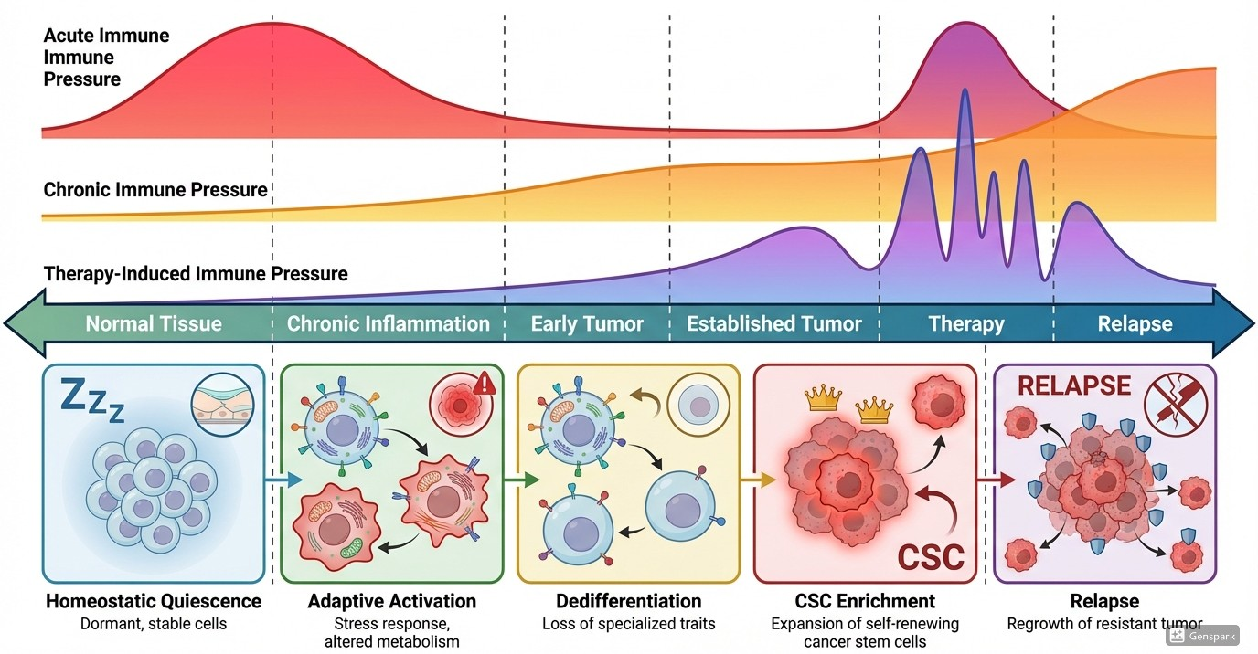
Figure 1: Immune Editing of Stem Cell Fate across the Disease Continuum

Immune Regulation of Normal Stem Cell Niches
Stem cell niches are traditionally defined as specialized microenvironments that provide structural support and molecular cues necessary for maintaining stem cell identity, quiescence, and regenerative potential (Khlusov et al., 2018). While stromal cells, extracellular matrix components, and metabolic factors have long been considered core constituents of these niches, it is now evident that immune cells are integral and dynamic regulators of stem cell behavior (Plaks et al., 2015). Rather than functioning solely as defenders against pathogens, immune cells actively participate in tissue maintenance, regeneration, and adaptation to stress (Eming et al., 2009). In this context, immune signals act as context-dependent modulators of stem cell fate, fine-tuning the balance between dormancy, activation, and differentiation (Chavakis et al., 2019).

Immune Control of Hematopoietic Stem Cells
Hematopoietic stem cells (HSCs) are among the best-characterized stem cell systems and provide a compelling model for understanding immune stem cell interactions (Höfer & Rodewald, 2018). Under homeostatic conditions, HSCs reside in a predominantly quiescent state within the red bone marrow niche, a strategy that preserves long-term self-renewal capacity and prevents exhaustion. This quiescence is actively maintained by immune-derived signals, particularly through tightly regulated cytokine gradients and low-level inflammatory tone (Rettkowski & Cabezas-Wallscheid, 2025).
Cytokines such as transforming growth factor-β (TGF-β), stem cell factor (SCF), and CXCL12 contribute to HSC maintenance by restraining excessive proliferation (Mayer et al., 2022). However, during infection or tissue injury, immune activation transiently overrides quiescence, enabling rapid hematopoietic output. Interferons, especially type I interferons (IFN-α/β), play a pivotal role in this process (De Morree & Rando, 2023). Acute IFN signaling induces HSC proliferation and differentiation to replenish immune cells, demonstrating that HSCs function as immune-responsive units rather than immune-isolated entities (Morales-Mantilla & King, 2018).
Importantly, sustained or chronic immune activation has deleterious consequences. Prolonged exposure to inflammatory cytokines such as IFN-γ, tumor necrosis factor-α (TNF-α), and interleukin-1 (IL-1) drives HSC cycling, DNA damage accumulation, and eventual functional exhaustion (Pievani et al., 2020). These findings highlight a central principle relevant to immune editing: immune signals that promote short-term regeneration can exert long-term selective pressure, favoring stem cell subsets that survive inflammatory stress (Jiang & Xu, 2020).

Immune Regulation of Epithelial and Intestinal Stem Cells
Beyond the hematopoietic system, immune regulation of stem cell fate is increasingly recognized in epithelial tissues, particularly the intestine and skin, which are continuously exposed to environmental insults and microbial stimuli. Intestinal stem cells (ISCs) reside at the base of crypts and sustain rapid epithelial turnover. Their activity is exquisitely sensitive to immune-derived cues, reflecting the need to integrate tissue repair with immune defense (Gehart & Clevers, 2019).
Macrophages and innate lymphoid cells (ILCs) emerge as key regulators of ISC behavior. Macrophage-derived factors such as Wnt ligands, prostaglandin E2 (PGE2), and IL-10 support epithelial regeneration following injury, promoting stem cell proliferation while limiting excessive inflammation (Harrell et al., 2019). Conversely, pro-inflammatory cytokines, including IL-6 and IL-22, can induce a state of heightened plasticity, enabling differentiated epithelial cells to revert to stem-like states during regeneration (Zheng et al., 2022).
While this plasticity is beneficial in acute injury, chronic inflammation profoundly alters epithelial stem cell dynamics. Persistent immune activation disrupts lineage fidelity, promotes aberrant self-renewal, and increases the likelihood of acquiring oncogenic alterations (Rees et al., 2020). Notably, lineage tracing studies have demonstrated that inflammatory environments can enable non-stem epithelial cells to regain stemness, challenging the notion of fixed stem cell hierarchies and underscoring the immune system’s role as a sculptor of cellular identity (Plaks et al., 2015).
Collectively, studies across hematopoietic and epithelial systems reveal that immune regulation of stem cell niches is bidirectional and adaptive but also inherently selective. Immune signals determine which stem cells activate, which persist in quiescence, and which succumb to exhaustion or differentiation. This continuous immune-mediated selection creates a foundation upon which pathological processes, including malignant transformation, can emerge (Agudo & Miao, 2025; De Morree & Rando, 2023).
Crucially, these observations blur the boundary between physiological regulation and pathological immune editing. The same mechanisms that preserve tissue integrity under stress can, under chronic inflammatory conditions, select for stem cell states characterized by resilience, dormancy, and survival advantage. This realization sets the stage for understanding immune editing not merely as a tumor-centric phenomenon, but as a broader biological principle governing stem cell fate across health and disease (Aponte & Caicedo, 2017; De Morree & Rando, 2023).

Immune Editing as a Driver of Stem Cell Plasticity
A central misconception in inflammation-associated pathology is that immune-derived signals primarily exert damaging or cytotoxic effects on tissues. While acute immune responses can indeed eliminate damaged or infected cells, accumulating evidence indicates that immune pressure actively reshapes cellular identity, promoting adaptive plasticity rather than simple destruction (Margraf & Perretti, 2022; Russo et al., 2024). In stem and progenitor cells, this manifests as dynamic reprogramming toward stem-like, stress-tolerant states. Immune editing, therefore, functions not only as a selective force but also as a reprogramming engine, enabling cells to survive hostile microenvironments (Allemailem et al., 2023). The molecular pathways linking immune signaling to dedifferentiation, EMT, and stem-like reprogramming are summarized in Figure 2.

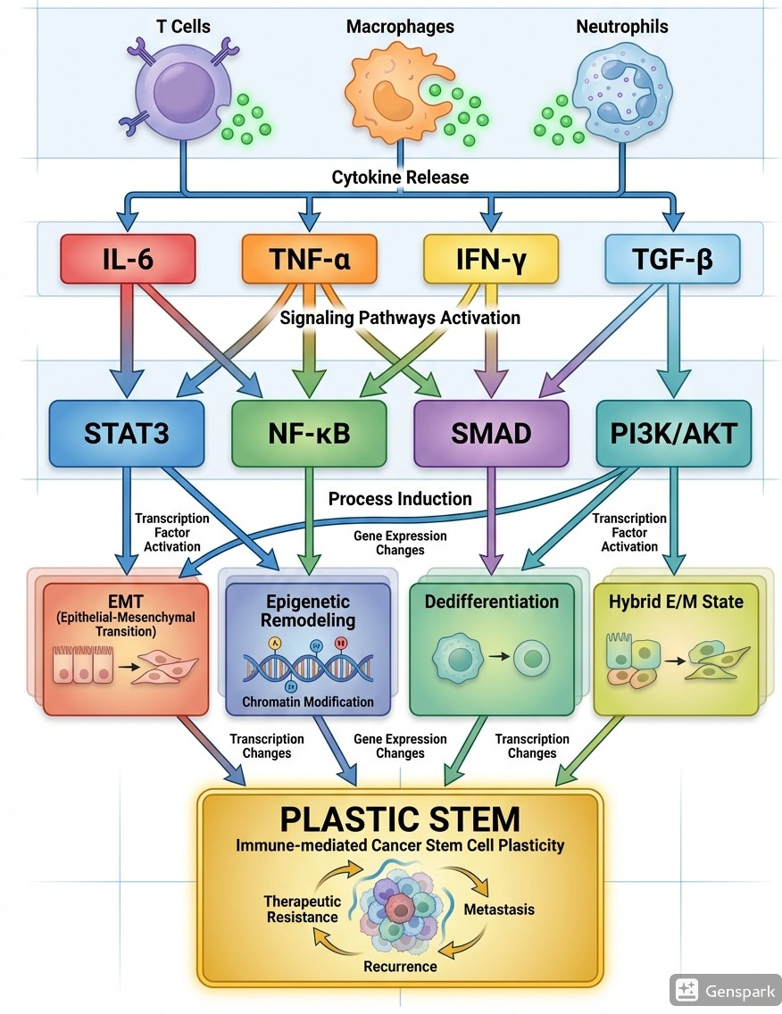
Figure 2. Mechanisms of Immune-Induced Stem Cell Plasticity

Inflammation and Dedifferentiation
Chronic inflammation represents one of the most potent drivers of stem cell plasticity (Li et al., 2023). Persistent exposure to inflammatory cytokines induces signaling programs that destabilize differentiated cell states and reawaken developmental or stemness-associated transcriptional networks. Among these, the IL-6/STAT3 axis has emerged as a central mediator linking immune activation to cellular reprogramming (Chen et al., 2020; Galassi et al., 2025).
IL-6, produced by immune cells such as macrophages, T cells, and myeloid-derived suppressor cells, activates STAT3 signaling in epithelial and progenitor cells. Sustained STAT3 activity promotes the expression of stemness-associated genes, including SOX2, NANOG, and OCT4, while suppressing differentiation programs (Galassi et al., 2025). In epithelial tissues, IL-6–STAT3 signaling enables differentiated cells to reacquire stem-like features, particularly during tissue repair. However, when inflammation becomes chronic, this adaptive response shifts toward pathological dedifferentiation, increasing susceptibility to malignant transformation (Chen et al., 2020).
In parallel, NF-κB signaling integrates inflammatory cues with stress-response pathways to further enhance plasticity. Activation of NF-κB downstream of TNF-α, IL-1β, or pattern-recognition receptors promotes survival signaling, epigenetic remodeling, and resistance to apoptosis (Deka & Li, 2023). Importantly, NF-κB has been shown to cooperate with STAT3 to maintain stem-like transcriptional states, creating a feedforward loop that stabilizes plastic phenotypes under continuous immune pressure (Rinkenbaugh & Baldwin, 2016).
Beyond transcriptional regulation, chronic inflammation induces epigenetic permissiveness, lowering the barriers to cell fate transitions. Inflammatory signaling alters chromatin accessibility through histone modifications and DNA methylation changes, facilitating rapid shifts between differentiated and stem-like states (Easwaran & Weeraratna, 2025; Markopoulos et al., 2019). These findings support the idea that immune-derived stress signals do not simply select pre-existing stem cells but can actively generate stem-like states through dedifferentiation (Bayik & Lathia, 2021; Clara et al., 2020).

Immune-Induced EMT as a Gateway to Stemness
One of the most compelling links between immune signaling and stem cell plasticity is the induction of epithelial-mesenchymal transition (EMT). Originally described as a developmental process, EMT is now recognized as a reversible and context-dependent program that endows epithelial cells with migratory, invasive, and stem-like properties (Lu & Kang, 2019).
Immune cells are major sources of EMT-inducing factors, particularly transforming growth factor-β (TGF-β). TGF-β released by macrophages, regulatory T cells, and stromal immune populations activates EMT transcription factors such as SNAIL, TWIST, and ZEB1 in epithelial cells (Ghafoor et al., 2025). These transcriptional changes suppress epithelial identity while promoting mesenchymal and stemness-associated programs (Galassi et al., 2025).
Importantly, EMT does not produce a fixed mesenchymal state. Instead, cells often adopt hybrid epithelial/mesenchymal phenotypes, which exhibit maximal plasticity and stem cell-like properties. These hybrid states are particularly resilient under immune pressure, as they combine survival advantages with immune evasiveness. Inflammatory cytokines such as IL-6 and TNF-α further reinforce EMT-associated stemness through STAT3 and NF-κB signaling, illustrating how immune pathways converge to stabilize plastic cell states (Garg, 2017).
This immune-induced EMT framework challenges the classical cancer stem cell (CSC) model, which assumes a rigid hierarchy of stem and non-stem cells. Instead, immune pressure promotes fluid transitions between differentiated and stem-like states, suggesting that stemness is an acquired and reversible trait shaped by the inflammatory microenvironment (Agudo & Miao, 2025).
Together, chronic inflammation, cytokine signaling, and immune-induced EMT establish immune editing as a driver of stem cell plasticity rather than a passive background condition. Immune-derived signals destabilize fixed cell identities, lower epigenetic barriers, and actively reprogram cells toward stem-like states optimized for survival under stress (Mathan & Singh, 2025; Wang et al., 2014). Importantly, these processes occur not only in overt malignancy but also during tissue regeneration and chronic inflammatory disease, creating a continuum between physiological adaptation and pathological transformation (Mierke, 2014).
This immune-driven plasticity provides the mechanistic foundation for understanding how cancer stem cells emerge and persist. Rather than arising solely from genetic mutations within a predefined stem cell pool, CSCs can be selected and continually regenerated through immune-mediated reprogramming, a concept explored in the following section (Mathan & Singh, 2025).

Cancer Stem Cells as Products of Immune Selection
The cancer stem cell (CSC) model has traditionally been interpreted through a developmental lens, in which a rare, hierarchically defined population of stem-like cells drives tumor initiation, heterogeneity, and relapse (Rich, 2016). While this framework has provided invaluable insights, it insufficiently accounts for the dynamic and adaptive nature of tumor ecosystems. Increasing evidence suggests that CSCs are not merely pre-existing entities but are continuously shaped, enriched, and regenerated by selective pressures within the tumor microenvironment, particularly those imposed by the immune system (Bayik & Lathia, 2021; Pan et al., 2025).
Borrowing conceptually from cancer immunoediting, CSCs can be understood as the outcome of immune-mediated selection, whereby immune surveillance eliminates highly immunogenic and differentiated tumor cells, while sparing or enriching phenotypes that exhibit stem-like plasticity, quiescence, and immune resistance. In this view, stemness is not a fixed identity but a selected survival strategy (Aponte & Caicedo, 2017; Galassi et al., 2021).

Applying Immunoediting Principles to Cancer Stem Cells
Cancer immunoediting describes tumor evolution through three interconnected phases: elimination, equilibrium, and escape. When applied to CSC biology, this framework offers a powerful explanation for the emergence and persistence of stem-like tumor populations (Borroni & Grizzi, 2021). As illustrated in Figure 3, the classical phases of immunoediting, elimination, equilibrium, and escape can be reinterpreted through the lens of cancer stem cell evolution.

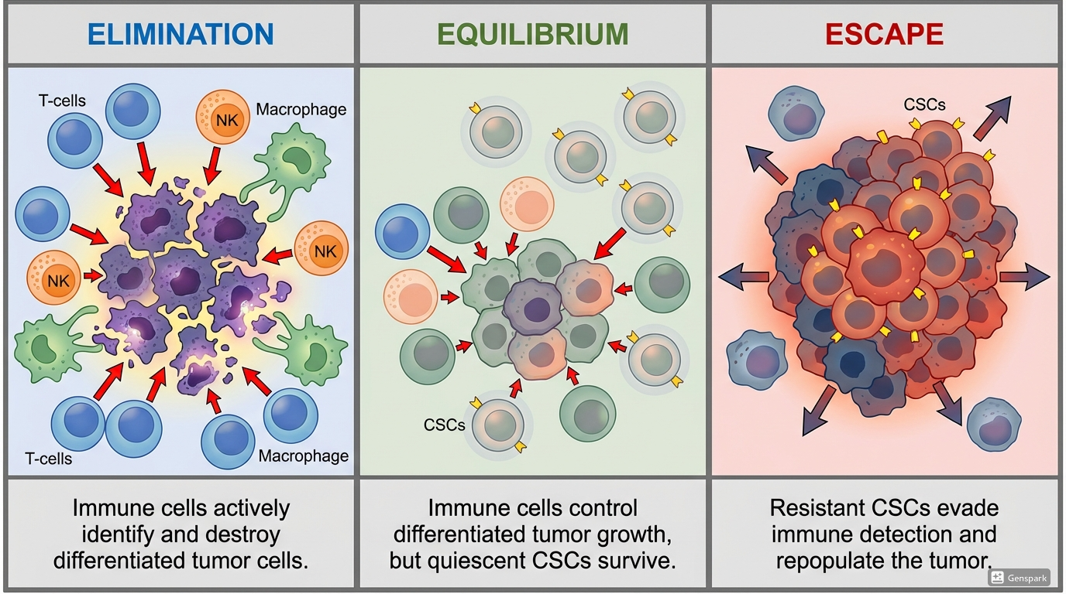
Figure 3. Immunoediting Phases Applied to CSC Evolution

During the elimination phase, immune effector cells, including cytotoxic T lymphocytes, natural killer (NK) cells, and macrophages, target tumor cells expressing high levels of tumor-associated antigens and stress ligands (Yang et al., 2023). Differentiated tumor cells, characterized by higher metabolic activity and antigen presentation, are preferentially eliminated. In contrast, cells with stem-like features often display reduced antigenicity, enhanced DNA repair capacity, and resistance to apoptosis, enabling them to survive early immune pressure (Galassi et al., 2021; Chakraborty et al., 2025).
The equilibrium phase represents a state of dynamic balance in which immune pressure constrains tumor growth without complete eradication. Under these conditions, CSC-like cells frequently enter dormant or slow-cycling states, minimizing immune detection while retaining tumor-initiating potential (Chen et al., 2021). Lineage tracing and single-cell studies reveal that such quiescent stem-like cells can persist for extended periods, maintaining tumor heterogeneity and serving as reservoirs for relapse (De Angelis et al., 2019b; Russo et al., 2024).
Eventually, immune pressure selects for cells capable of immune escape, marking the transition to the escape phase. CSCs enriched during equilibrium often possess intrinsic immune-evasive traits, including impaired antigen processing, resistance to interferon signaling, and expression of immune checkpoint molecules (Pan et al., 2025; Agudo & Miao, 2025). These adaptations allow CSCs not only to survive immune attack but to actively remodel the immune microenvironment in their favor, driving tumor progression and metastasis (Bayik & Lathia, 2021).

Dormancy, Quiescence, and Immune Invisibility
A defining feature of CSCs selected under immune pressure is their capacity for dormancy and quiescence. Quiescent CSCs exhibit low proliferative activity, reduced metabolic demand, and altered transcriptional programs that collectively minimize immune recognition. This state is not passive but actively maintained through immune-stem cell signaling loops (Lee et al., 2025; Huang et al., 2020).
Low expression of major histocompatibility complex (MHC) molecules and antigen-processing machinery reduces recognition by cytotoxic T cells, while diminished stress ligand expression limits NK cell-mediated killing. Simultaneously, quiescent CSCs upregulate stress-response pathways and autophagy programs that enhance survival under nutrient deprivation and immune-mediated stress (Massa et al., 2023).
Importantly, immune-derived cytokines can actively enforce dormancy. Interferons, while classically viewed as antitumor mediators, have been shown to induce reversible quiescence in stem-like tumor cells, promoting immune evasion and long-term persistence. This paradox underscores a central theme of immune editing: immune pressure does not simply eliminate tumor cells; it sculpts their phenotypic states (Agudo & Miao, 2025; De Visser & Joyce, 2023).
Dormant CSCs are particularly problematic clinically, as they are inherently resistant to therapies targeting proliferating cells and can reawaken in response to microenvironmental changes, including immune suppression or tissue injury. Thus, immune invisibility and quiescence form a synergistic axis that enables CSC survival across treatment cycles (De Angelis et al., 2019b; Mathan & Singh, 2025).
Collectively, these observations support a paradigm shift in CSC biology. Rather than viewing CSCs solely as a developmentally defined subpopulation, they can be more accurately described as products of immune selection, dynamically enriched through immunoediting processes. Immune pressure preferentially eliminates differentiated, immunogenic tumor cells while fostering the survival, plasticity, and expansion of stem-like phenotypes optimized for persistence (Borroni & Grizzi, 2021; Pan et al., 2025).
This framework reconciles longstanding debates regarding CSC rarity, plasticity, and heterogeneity and explains why CSC populations often expand following immune-based or cytotoxic therapies (Mathan & Singh, 2025). By positioning immune selection at the center of CSC evolution, this model provides a conceptual bridge between inflammation, immune escape, dormancy, and therapy resistance, setting the stage for understanding how immune checkpoints directly sustain stemness, explored in the next section (Francescangeli et al., 2023).

Immune Checkpoints beyond Immune Evasion
Immune checkpoint pathways have classically been conceptualized as mechanisms by which tumor cells suppress antitumor immune responses. However, emerging evidence indicates that several checkpoint molecules also exert cell-intrinsic effects on tumor and stem-like cells, functioning independently of immune cell engagement (Clara et al., 2020; Bayik & Lathia, 2021). These noncanonical roles position immune checkpoints as active regulators of stem cell fate, survival, and therapy resistance, rather than passive shields against immune attack (Galassi et al., 2021).
In the context of immune-edited tumors, checkpoint signaling contributes to the maintenance of stemness, enforcement of dormancy, and protection of cancer stem cells (CSCs) from both immune-mediated and therapy-induced stress. This dual functionality has profound implications for understanding resistance to immunotherapy and for designing combinatorial treatment strategies (Francescangeli et al., 2023).

Intrinsic Checkpoint Signaling in Stem Cells
Among immune checkpoints, programmed death-ligand 1 (PD-L1) has emerged as a central mediator of intrinsic stem cell regulation. Beyond its canonical interaction with PD-1 on T cells, PD-L1 can transmit reverse signaling into tumor cells, activating pathways associated with survival, DNA damage tolerance, and stemness maintenance (Kciuk et al., 2023).
Recent studies demonstrate that PD-L1 expression is enriched in CSC populations across multiple tumor types, including breast, lung, and glioblastoma. In these contexts, PD-L1 promotes stem-like phenotypes by activating PI3K-AKT-mTOR and STAT3 signaling cascades, pathways well-established in regulating self-renewal and resistance to apoptosis (Hao et al., 2020; Manni & Min, 2022). Notably, genetic or pharmacological disruption of PD-L1 signaling reduces sphere-forming capacity and tumor-initiating potential, even in immune-deficient models, underscoring its immune-independent role (Zhang & Zheng, 2020).
PD-L1 also interfaces with epigenetic regulators to stabilize stemness programs. For instance, PD-L1 signaling has been linked to chromatin remodeling and transcriptional repression of differentiation-associated genes, reinforcing plasticity and enabling CSCs to dynamically transition between proliferative and dormant states. These findings challenge the traditional view of PD-L1 solely as an immune suppressor and highlight its role as a cell-intrinsic fate regulator (Agudo & Miao, 2025; Chakraborty et al., 2025).
Crucially, inflammatory cues such as interferon-γ and NF-κB activation, common in immune-edited microenvironments, further induce PD-L1 expression in stem-like tumor cells, creating a feed-forward loop in which immune pressure reinforces stemness and immune resistance simultaneously (Han et al., 2020).

CD47 and “Don’t Eat Me” Signaling
CD47, a ubiquitously expressed transmembrane protein, delivers a “don’t eat me” signal by engaging signal regulatory protein α (SIRPα) on macrophages, thereby inhibiting phagocytosis. While CD47-mediated immune evasion is well established, accumulating evidence suggests that CD47 also plays a direct role in stem cell protection and CSC enrichment (Barclay & Van den Berg, 2014).
Normal stem cells, including hematopoietic and intestinal stem cells, express elevated levels of CD47, which protects them from immune-mediated clearance during tissue remodeling and regeneration. Tumors appear to exploit this physiological mechanism, selectively upregulating CD47 in CSC populations to evade macrophage-mediated elimination (Agudo & Miao, 2025; Mathan & Singh, 2025).
Beyond immune escape, CD47 signaling contributes to intracellular survival pathways that enhance resistance to oxidative stress and DNA damage. In CSCs, CD47 expression correlates with increased quiescence, metabolic adaptation, and resistance to chemotherapy (Zhang & Zheng, 2020). Disruption of CD47 signaling not only enhances macrophage-mediated clearance but also induces differentiation and loss of stem-like traits, indicating a dual immune-extrinsic and intrinsic function (Galassi et al., 2021; Chakraborty et al., 2025).
The translational relevance of CD47 is underscored by ongoing clinical trials targeting the CD47–SIRPα axis. However, variable responses and incomplete tumor eradication suggest that targeting phagocytosis alone may be insufficient unless combined with strategies that dismantle CSC-intrinsic survival programs (Weiskopf, 2017).
Together, PD-L1 and CD47 exemplify a broader principle: immune checkpoint molecules function as molecular bridges between immune pressure and stem cell fate regulation. By reinforcing stemness, quiescence, and survival under hostile conditions, these pathways enable CSCs to persist despite robust immune activation or therapeutic intervention (Mathan & Singh, 2025; Galassi et al., 2021).
This insight has direct clinical relevance. Checkpoint blockade therapies may fail to eliminate CSCs not only because of immune evasion but also because CSCs co-opt checkpoint signaling to maintain intrinsic resistance. Moreover, selective pressure imposed by checkpoint inhibition may further enrich stem-like populations unless stemness-associated signaling pathways are simultaneously targeted (Pan et al., 2025; Kalbasi & Ribas, 2020; Galassi et al., 2025).
Recognizing immune checkpoints as regulators of stem cell fate reframes immunotherapy resistance as a problem of immune-stem cell co-evolution rather than immune escape alone. This paradigm sets the stage for rational combination therapies that integrate immune checkpoint blockade with inhibitors of stemness, epigenetic plasticity, or dormancy, a strategy explored in the following section on therapy-induced immune editing and resistance (Galassi et al., 2025; De Angelis et al., 2019a).

Therapy-Induced Immune Editing and Resistance
Anticancer therapies are designed to eradicate malignant cells, yet increasing evidence indicates that they also profoundly reshape the immune microenvironment. Rather than acting as neutral background effects, therapy-induced immune responses impose selective pressures that actively sculpt tumor cell fate. Within this context, stem-like and plastic cell states are preferentially preserved, giving rise to therapy resistance, minimal residual disease, and eventual relapse (De Visser & Joyce, 2023; De Angelis et al., 2019a).
This process can be conceptualized as therapy-induced immune editing, wherein cytotoxic treatments and immunotherapies generate inflammatory and immunological conditions that select for cancer stem cell-like populations capable of survival under sustained stress (Chakraborty et al., 2025). The dual impact of chemotherapy and immunotherapy in reinforcing immune-selective pressure and enriching resistant stem-like populations is summarized in Figure 4.
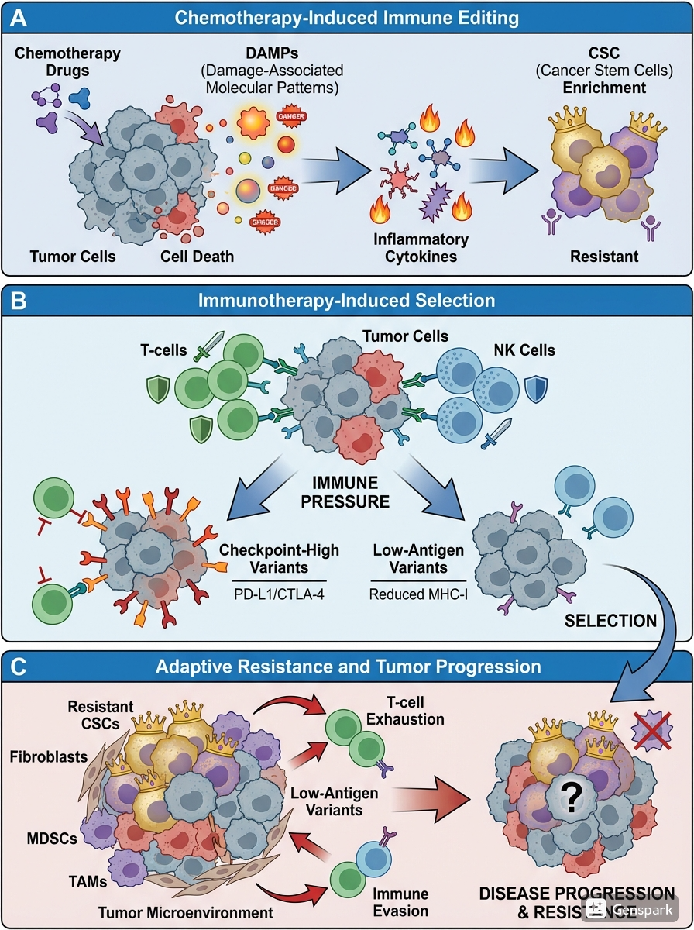
Figure 4. Therapy-Induced Immune Editing and CSC Enrichment

Chemotherapy and Inflammatory Feedback
Conventional chemotherapeutic agents induce widespread tumor cell death, leading to the release of damage-associated molecular patterns (DAMPs), including HMGB1, ATP, and nucleic acids. These signals activate innate immune pathways through pattern-recognition receptors such as Toll-like receptors and the cGAS–STING axis, triggering robust inflammatory responses within the tumor microenvironment (Garg & Agostinis, 2017).
While acute inflammation can promote immune-mediated tumor clearance, chronic or unresolved inflammatory signaling paradoxically enhances stemness and resistance (Agudo & Miao, 2025). Cytokines such as IL-6, TNF-α, and IL-1β, frequently elevated following chemotherapy, activate STAT3, NF-κB, and MAPK signaling pathways in surviving tumor cells, reinforcing self-renewal programs and suppressing differentiation (Behranvand et al., 2022; Pan et al., 2025).
Importantly, cancer stem cells exhibit intrinsic resistance to chemotherapy through enhanced DNA repair capacity, quiescence, and metabolic flexibility (De Angelis et al., 2019b). Chemotherapy, therefore, disproportionately eliminates differentiated tumor cells while sparing stem-like populations that are better equipped to tolerate genotoxic and oxidative stress. The resulting post-therapy tumor landscape is enriched for immune-edited CSCs that possess heightened plasticity and survival capacity (Chen et al., 2021; Huang et al., 2020).
Moreover, chemotherapy-induced inflammation promotes epithelial-mesenchymal transition (EMT), further facilitating dedifferentiation and acquisition of stem-like traits. This process is reinforced by immune-derived TGF-β and IL-6 signaling, creating a feed-forward loop in which therapy-induced immune activation accelerates the emergence of resistant cell states (Chen et al., 2018; Lee et al., 2025).

Immunotherapy and Cancer Stem Cell Persistence
Immune checkpoint blockade has revolutionized cancer treatment by restoring antitumor immune activity. However, durable responses are achieved in only a subset of patients, and many tumors eventually relapse despite initial sensitivity. Emerging data suggest that CSC persistence represents a major barrier to long-term immunotherapy success (Pardoll, 2012; Pan et al., 2025).
Cancer stem cells often exhibit features that render them poorly immunogenic, including low expression of antigen presentation machinery, reduced MHC class I levels, and altered metabolic states that limit immune recognition. These properties enable CSCs to survive immune elimination phases and persist in equilibrium or dormant states during immunotherapy (Chakraborty et al., 2025; Agudo & Miao, 2025).
Checkpoint blockade may further intensify immune selective pressure, accelerating immune editing. While differentiated tumor cells are efficiently targeted by reinvigorated T cells, CSCs that express immune checkpoint ligands such as PD-L1 or CD47 are preferentially retained. In this context, immune activation inadvertently selects for cell populations that combine immune resistance with stem-like properties (Agudo & Miao, 2025; Galassi et al., 2021).
Additionally, interferon signaling induced by immunotherapy can upregulate immune checkpoints and stemness-associated transcriptional programs within tumor cells. Persistent interferon exposure has been linked to adaptive resistance, exhaustion of immune responses, and reinforcement of quiescent CSC states, thereby undermining long-term tumor control (Pan et al., 2025; Agudo & Miao, 2025).
Together, these observations suggest that resistance to both chemotherapy and immunotherapy is not solely a consequence of genetic mutations but arises from immune-mediated selection of plastic, stem-like cell states (Ganesh & Massagué, 2021). Therapy-induced immune editing represents a convergence point where inflammation, immune pressure, and stem cell biology intersect to shape tumor evolution (Marine et al., 2020).
From a clinical perspective, this framework helps explain why tumors often recur with increased aggressiveness, therapy resistance, and metastatic potential. It also underscores the limitations of treatments that target bulk tumor cells without addressing immune-edited CSC reservoirs (De Angelis et al., 2019b; Marine et al., 2020).
Crucially, therapy-induced immune editing is not inherently detrimental; it reflects the immune system’s capacity to shape cellular ecosystems (Chakraborty et al., 2025). However, in cancer, this process is hijacked to promote malignant persistence. Recognizing this duality provides a rationale for combination strategies that simultaneously activate antitumor immunity while disrupting stemness-supportive signaling pathways (Agudo & Miao, 2025).

Therapeutic Implications and Future Directions
Reframing stem cell fate as an immunologically edited and dynamically regulated process has important implications for cancer therapy. Rather than viewing immune responses and stemness as independent contributors to resistance, the framework of immune editing highlights their functional convergence (Lee et al., 2025; Francescangeli et al., 2023). This perspective opens new therapeutic avenues aimed at disrupting immune-stem cell feedback loops that sustain malignant persistence, relapse, and metastasis (Pan et al., 2025).

Immune-Stem Cell Signaling Axes
A key implication of immune editing is that stem-like cancer cells are actively maintained by immune-derived signals rather than being intrinsically fixed entities. Cytokine-driven pathways such as IL-6/STAT3, TGF-β, IFN, and NF-κB emerge as critical nodes linking inflammation to stemness. Pharmacologic inhibition of these pathways, particularly when deployed alongside cytotoxic or immune-based therapies, may prevent therapy-induced enrichment of CSC populations (Hassan et al., 2025; Odarenko et al., 2023).
Importantly, therapeutic strategies must account for context and timing. Acute immune activation can promote tumor clearance, whereas chronic or unresolved signaling reinforces stem-like persistence (Clara et al., 2020). Interventions that modulate immune tone, dampening protumor inflammation while preserving antitumor immunity, may offer a more effective and durable therapeutic balance (Zhang et al., 2017).

Rethinking Immune Checkpoint Targeting
The recognition that immune checkpoints such as PD-L1 and CD47 exert intrinsic effects on stem cell survival and plasticity suggests that their therapeutic relevance extends beyond immune evasion. Targeting checkpoint signaling within tumor cells may directly disrupt stemness-associated transcriptional programs and sensitize CSCs to immune-mediated killing (Pan et al., 2025; Mathan & Singh, 2025).
This insight supports the rational design of next-generation checkpoint strategies, including combination approaches that pair checkpoint blockade with inhibitors of stemness pathways, epigenetic regulators, or metabolic dependencies unique to CSCs (Goswami et al., 2024; Marine et al., 2020). Such combinations may prevent immune editing from favoring resistant stem-like populations while enhancing overall therapeutic efficacy (Lee et al., 2025).

Combination Therapies to Prevent Immune-Edited Resistance
Therapy-induced immune editing underscores the limitations of sequential treatment strategies that apply cytotoxic, immune, and targeted therapies in isolation. Instead, integrated regimens that simultaneously target tumor cells, immune contexture, and stemness programs may be required to achieve durable responses (De Angelis et al., 2019a; Francescangeli et al., 2023).
For example, combining immunotherapy with agents that inhibit EMT, dedifferentiation, or inflammatory feedback may limit the emergence of immune-resistant CSC states. Similarly, transient targeting of quiescent or dormant populations during immunotherapy could reduce minimal residual disease and delay or prevent relapse (Sauer et al., 2021; Pan et al., 2025).
Crucially, such strategies must be guided by biomarkers that capture dynamic immune-stem cell interactions rather than static tumor features (Sistigu et al., 2020).

Biomarkers of Immune-Edited Stemness
A major future challenge lies in identifying biomarkers that reflect immune editing of stem cell fate in real time (Lee et al., 2025). Traditional markers of stemness or immune infiltration alone may be insufficient to predict therapeutic outcomes. Instead, composite signatures integrating immune signaling, stemness-associated transcriptional programs, and cellular plasticity may better capture tumor evolutionary trajectories (Pan et al., 2025).
Advances in single-cell transcriptomics, spatial profiling, and lineage tracing provide unprecedented opportunities to map immune stem cell interactions at high resolution. These approaches may reveal early indicators of immune-edited resistance and inform adaptive therapeutic strategies before overt relapse occurs (Zhang et al., 2025).

Implications for Clinical Trial Design
The immune editing framework also has consequences for clinical trial design and interpretation. Failure to account for therapy-induced stemness selection may obscure the true efficacy of novel treatments (De Angelis et al., 2019a). Longitudinal sampling, incorporation of immune and stemness biomarkers, and post-treatment analyses should become standard components of trials evaluating immunotherapies and combination regimens (Lee et al., 2022; Angelini et al., 2022).
Moreover, endpoints focused solely on short-term tumor regression may underestimate long-term risk if immune-edited CSC populations persist. Shifting emphasis towards durable control and prevention of relapse aligns more closely with the biological realities revealed by immune editing (De Angelis et al., 2019b).

Future Outlook
The recognition that immune editing shapes stem cell fate demands a fundamental rethinking of cancer biology and therapeutic strategy. Rather than viewing resistance as a late-stage adaptation, immune-stem cell co-evolution must be understood as an ongoing and dynamic process initiated early during tumor development and continually reinforced by therapeutic intervention (Mathan & Singh, 2025; Sistigu et al., 2020).

Future research should prioritize longitudinal, single-cell, and spatially resolved analyses to map how immune pressure remodels stemness programs across time and treatment contexts (Lee et al., 2025). Integrating immune profiling with stem cell state characterization will be essential for identifying early biomarkers of plasticity and impending resistance. Such approaches may enable preemptive therapeutic interventions that prevent the stabilization of therapy-resistant stem-like populations (Han et al., 2025; De Angelis et al., 2019b).

Importantly, therapeutic design must shift from indiscriminate immune activation toward precision modulation of immune-stem cell signaling circuits. Interventions that disrupt cytokine-driven reprogramming, checkpoint-mediated stemness reinforcement, or inflammatory niche stabilization could transform immune pressure from a selective force promoting resistance into one that constrains plasticity and enforces durable tumor control (Agudo & Miao, 2025; Lee et al., 2025).

Ultimately, targeting immune editing of stem cell fate represents an opportunity to move beyond transient tumor regression toward sustained evolutionary containment. By intervening at the interface of immunity and cellular plasticity, future therapies may achieve not only cytotoxic efficacy but long-lasting prevention of relapse and metastatic progression (De Angelis et al., 2019b; Ghorbian, 2025).

Conclusion
Stem cell fate is increasingly recognized as a dynamic and context-dependent process shaped not only by intrinsic transcriptional and epigenetic programs but also by sustained interactions with the immune microenvironment. Integrating principles of cancer immunoediting into stem cell biology reveals immune pressure as a central force that sculpts cellular plasticity, survival, and evolutionary trajectories across normal tissue homeostasis, chronic inflammation, and malignancy.
Rather than passive bystanders or collateral damage, stem and progenitor cells actively adapt to immune-derived cues, giving rise to quiescent, stem-like states that persist under selective pressure and contribute to cancer initiation, therapy resistance, and relapse. Immune checkpoints, inflammatory signaling, and treatment-induced immune perturbations collectively reinforce these adaptive programs, highlighting immune editing as a driver, not a consequence, of stemness and malignant evolution.
Recognizing immune editing of stem cell fate reframes resistance as an emergent property of immune-cellular co-evolution and underscores the need for therapeutic strategies that target both immune contexture and stemness plasticity. Disrupting these coupled processes will be essential for achieving durable cancer control and preventing relapse in the era of immunotherapy.

Disclaimer (Artificial Intelligence)

Authors hereby declare that NO generative AI technologies such as large language models (ChatGPT, Copilot, etc.) and text-to-image generators have been used during the writing or editing of this manuscript.

Competing Interests
Authors have declared that no competing Interests exist.

Reference

Agudo, J., & Miao, Y. (2025). Stemness in solid malignancies: coping with immune attack. Nature Reviews Cancer, 25(1), 27-40.
Allemailem, K. S., Alsahli, M. A., Almatroudi, A., Alrumaihi, F., Al Abdulmonem, W., Moawad, A. A., & Khan, A. A. (2023). Innovative strategies of reprogramming immune system cells by targeting CRISPR/Cas9-based genome-editing tools: a new era of cancer management. International Journal of Nanomedicine, 5531-5559.
Angelini, E., Wang, Y., Zhou, J. X., Qian, H., & Huang, S. (2022). A model for the intrinsic limit of cancer therapy: Duality of treatment-induced cell death and treatment-induced stemness. PLOS Computational Biology, 18(7), e1010319.
Aphkhazava, D., Sulashvili, N., & Tkemaladze, J. (2025). Stem cell systems and regeneration. Georgian Scientists, 7(1), 271-319.
Aponte, P. M., & Caicedo, A. (2017). Stemness in cancer: stem cells, cancer stem cells, and their microenvironment. Stem cells international, 2017(1), 5619472.
Barclay, A. N., & Van den Berg, T. K. (2014). The interaction between signal regulatory protein alpha (SIRPα) and CD47: structure, function, and therapeutic target. Annual review of immunology, 32(1), 25-50.
Bayik, D., & Lathia, J. D. (2021). Cancer stem cell–immune cell crosstalk in tumour progression. Nature Reviews Cancer, 21(8), 526-536.
Behranvand, N., Nasri, F., Zolfaghari Emameh, R., Khani, P., Hosseini, A., Garssen, J., & Falak, R. (2022). Chemotherapy: a double-edged sword in cancer treatment. Cancer immunology, immunotherapy, 71(3), 507-526.
Borroni, E. M., & Grizzi, F. (2021). Cancer Immunoediting and beyond in 2021. International journal of molecular sciences, 22(24), 13275.
Chakraborty, S., Basak, U., Mukherjee, S., Mukherjee, S., & Das, T. (2025). Cancer stem cells decide the fate of cancer immunotherapy by remodeling tumor microenvironment. Cancer Control, 32, 10732748251381441.

Chavakis, T., Mitroulis, I., & Hajishengallis, G. (2019). Hematopoietic progenitor cells as integrative hubs for adaptation to and fine-tuning of inflammation. Nature immunology, 20(7), 802-811.
Chen, K., Zhang, C., Ling, S., Wei, R., Wang, J., & Xu, X. (2021). The metabolic flexibility of quiescent CSC: implications for chemotherapy resistance. Cell death & disease, 12(9), 835.
Chen, M., Ye, X., Wang, R., & Poon, K. (2020). Research progress of cancer stem cells and IL-6/STAT3 signaling pathway in esophageal adenocarcinoma. Translational Cancer Research, 9(1), 363.
Chen, Y., Tan, W., & Wang, C. (2018). Tumor-associated macrophage-derived cytokines enhance cancer stem-like characteristics through epithelial-mesenchymal transition. OncoTargets and therapy, 3817-3826.
Clara, J. A., Monge, C., Yang, Y., & Takebe, N. (2020). Targeting signalling pathways and the immune microenvironment of cancer stem cells-a clinical update. Nature reviews clinical oncology, 17(4), 204-232.
De Angelis, M. L., Francescangeli, F., & Zeuner, A. (2019a). Breast cancer stem cells as drivers of tumor chemoresistance, dormancy and relapse: new challenges and therapeutic opportunities. Cancers, 11(10), 1569.
De Angelis, M. L., Francescangeli, F., La Torre, F., & Zeuner, A. (2019b). Stem cell plasticity and dormancy in the development of cancer therapy resistance. Frontiers in oncology, 9, 626.
De Morree, A., & Rando, T. A. (2023). Regulation of adult stem cell quiescence and its functions in the maintenance of tissue integrity. Nature Reviews Molecular Cell Biology, 24(5), 334-354.
De Visser, K. E., & Joyce, J. A. (2023). The evolving tumor microenvironment: From cancer initiation to metastatic outgrowth. Cancer cell, 41(3), 374-403.
Deka, K., & Li, Y. (2023). Transcriptional regulation during aberrant activation of NF-κB signalling in cancer. Cells, 12(5), 788.
Easwaran, H., & Weeraratna, A. T. (2025). Unravelling the genetics and epigenetics of the ageing tumour microenvironment in cancer. Nature Reviews Cancer, 25(11), 828-847.
Eming, S. A., Hammerschmidt, M., Krieg, T., & Roers, A. (2009). Interrelation of immunity and tissue repair or regeneration. In Seminars in cell & developmental biology (Vol. 20, No. 5, pp. 517-527). Academic Press.
Francescangeli, F., De Angelis, M. L., Rossi, R., Cuccu, A., Giuliani, A., De Maria, R., & Zeuner, A. (2023). Dormancy, stemness, and therapy resistance: interconnected players in cancer evolution. Cancer and Metastasis Reviews, 42(1), 197-215.
Galassi, C., Manic, G., Esteller, M., Galluzzi, L., & Vitale, I. (2025). Epigenetic regulation of cancer stemness. Signal transduction and targeted therapy, 10(1), 243.
Galassi, C., Musella, M., Manduca, N., Maccafeo, E., & Sistigu, A. (2021). The immune privilege of cancer stem cells: a key to understanding tumor immune escape and therapy failure. Cells, 10(9), 2361.
Ganesh, K., & Massagué, J. (2021). Targeting metastatic cancer. Nature medicine, 27(1), 34-44.
Garg, M. (2017). Epithelial, mesenchymal and hybrid epithelial/mesenchymal phenotypes and their clinical relevance in cancer metastasis. Expert Reviews in Molecular Medicine, 19, e3.
Garg, A. D., & Agostinis, P. (2017). Cell death and immunity in cancer: From danger signals to mimicry of pathogen defense responses. Immunological reviews, 280(1), 126-148.
Gehart, H., & Clevers, H. (2019). Tales from the crypt: new insights into intestinal stem cells. Nature reviews Gastroenterology & hepatology, 16(1), 19-34.
Ghafoor, S., Garcia, E., Jay, D. J., & Persad, S. (2025). Molecular Mechanisms Regulating Epithelial Mesenchymal Transition (EMT) to Promote Cancer Progression. International Journal of Molecular Sciences, 26(9), 4364.
Ghorbian, S. (2025). Cancer cell plasticity and therapeutic resistance: Mechanisms, crosstalk, and translational perspectives. Hereditas, 162(1), 188.
Goswami, S., Pauken, K. E., Wang, L., & Sharma, P. (2024). Next-generation combination approaches for immune checkpoint therapy. Nature Immunology, 25(12), 2186-2199.
Han, X., Li, X., Bai, L., & Zhang, G. (2025). Single-cell transcriptomics in metastatic breast cancer: mapping tumor evolution and therapeutic resistance. Frontiers in Genetics, 16, 1669741.

Han, Y., Liu, D., & Li, L. (2020). PD-1/PD-L1 pathway: current researches in cancer. American journal of cancer research, 10(3), 727.

Hao, C., Chen, G., Zhao, H., Li, Y., Chen, J., Zhang, H., & Jiang, W. G. (2020). PD-L1 expression in glioblastoma, the clinical and prognostic significance: a systematic literature review and meta-analysis. Frontiers in oncology, 10, 1015.

Harrell, C. R., Sadikot, R., Pascual, J., Fellabaum, C., Jankovic, M. G., Jovicic, N., & Volarevic, V. (2019). Mesenchymal stem cell‐based therapy of inflammatory lung diseases: current understanding and future perspectives. Stem cells international, 2019(1), 4236973.

Hassan, A. F., Kheraldine, H., Abujamous, L., Al-Thawadi, H., & Elhissi, A. (2025). Inflammation-associated drug resistance and tumor growth in TNBC. Frontiers in Immunology, 16, 1623137.

Hoelting, T. L., Park, T., & Brown, C. C. (2025). Antigen-presenting cells as arbiters of mucosal tolerance and immunity. Nature Immunology, 1-13.
Höfer, T., & Rodewald, H. R. (2018). Differentiation-based model of hematopoietic stem cell functions and lineage pathways. Blood, The Journal of the American Society of Hematology, 132(11), 1106-1113.
Huang, T., Song, X., Xu, D., Tiek, D., Goenka, A., Wu, B., & Cheng, S. Y. (2020). Stem cell programs in cancer initiation, progression, and therapy resistance. Theranostics, 10(19), 8721.
Jiang, W., & Xu, J. (2020). Immune modulation by mesenchymal stem cells. Cell proliferation, 53(1), e12712.
Kalbasi, A., & Ribas, A. (2020). Tumour-intrinsic resistance to immune checkpoint blockade. Nature Reviews Immunology, 20(1), 25-39.
Kciuk, M., Kołat, D., Kałuzińska-Kołat, Ż., Gawrysiak, M., Drozda, R., Celik, I., & Kontek, R. (2023). PD-1/PD-L1 and DNA damage response in cancer. Cells, 12(4), 530.
Khlusov, I. A., Litvinova, L. S., Khlusova, M. Y., & Yurova, K. A. (2018). Concept of hematopoietic and stromal niches for cell-based diagnostics and regenerative medicine (a review). Current Pharmaceutical Design, 24(26), 3034-3054.
Kim, D. J. (2026). Molecular and Immune Mechanisms Governing Cancer Metastasis, Including Dormancy, Microenvironmental Niches, and Tumor-Specific Programs. International Journal of Molecular Sciences, 27(2), 875.
Lee, J. Y., Kannan, B., Lim, B. Y., Li, Z., Lim, A. H., Loh, J. W., & Chan, J. Y. (2022). The multi-dimensional biomarker landscape in cancer immunotherapy. International Journal of Molecular Sciences, 23(14), 7839.
Lee, H., Kim, B., Park, J., Park, S., Yoo, G., Yum, S., & Youn, B. (2025). Cancer stem cells: landscape, challenges and emerging therapeutic innovations. Signal transduction and targeted therapy, 10(1), 248.
Li, J., Malouf, C., Miles, L. A., Willis, M. B., Pietras, E. M., & King, K. Y. (2023). Chronic inflammation can transform the fate of normal and mutant hematopoietic stem cells. Experimental Hematology, 127, 8-13.
Lu, W., & Kang, Y. (2019). Epithelial-mesenchymal plasticity in cancer progression and metastasis. Developmental cell, 49(3), 361-374.
Manni, W., & Min, W. (2022). Signaling pathways in the regulation of cancer stem cells and associated targeted therapy. MedComm, 3(4), e176.
Margraf, A., & Perretti, M. (2022). Immune cell plasticity in inflammation: insights into description and regulation of immune cell phenotypes. Cells, 11(11), 1824.
Marine, J. C., Dawson, S. J., & Dawson, M. A. (2020). Non-genetic mechanisms of therapeutic resistance in cancer. Nature Reviews Cancer, 20(12), 743-756.
Markopoulos, G. S., Roupakia, E., Marcu, K. B., & Kolettas, E. (2019). Epigenetic regulation of inflammatory cytokine-induced epithelial-to-mesenchymal cell transition and cancer stem cell generation. Cells, 8(10), 1143.
Massa, C., Wang, Y., Marr, N., & Seliger, B. (2023). Interferons and Resistance Mechanisms in Tumors and Pathogen-Driven Diseases. Focus on the Major Histocompatibility Complex (MHC) Antigen Processing Pathway. International journal of molecular sciences, 24(7), 6736.
Mathan, S. V., & Singh, R. P. (2025). Cancer Stem Cells Connecting to Immunotherapy: Key Insights, Challenges, and Potential Treatment Opportunities. Cancers, 17(13), 2100.
Mayer, I. M., Hoelbl-Kovacic, A., Sexl, V., & Doma, E. (2022). Isolation, maintenance and expansion of adult hematopoietic stem/progenitor cells and leukemic stem cells. Cancers, 14(7), 1723.
Miebach, L., Berner, J., & Bekeschus, S. (2022). In ovo model in cancer research and tumor immunology. Frontiers in Immunology, 13, 1006064.
Mierke, C. T. (2014). The fundamental role of mechanical properties in the progression of cancer disease and inflammation. Reports on Progress in Physics, 77(7), 076602.
Morales-Mantilla, D. E., & King, K. Y. (2018). The role of interferon-gamma in hematopoietic stem cell development, homeostasis, and disease. Current stem cell reports, 4(3), 264-271.
Odarenko, K. V., Zenkova, M. A., & Markov, A. V. (2023). The nexus of inflammation-induced epithelial-mesenchymal transition and lung cancer progression: A roadmap to pentacyclic triterpenoid-based therapies. International Journal of Molecular Sciences, 24(24), 17325.
Pan, Y., Yuan, C., Zeng, C., Sun, C., Xia, L., Wang, G., & Ding, Z. Y. (2025). Cancer stem cells and niches: challenges in immunotherapy resistance. Molecular Cancer, 24(1), 52.
Pardoll, D. M. (2012). The blockade of immune checkpoints in cancer immunotherapy. Nature reviews cancer, 12(4), 252-264.
Pievani, A., Biondi, M., Tomasoni, C., Biondi, A., & Serafini, M. (2020). Location first: targeting acute myeloid leukemia within its niche. Journal of clinical medicine, 9(5), 1513.
Plaks, V., Kong, N., & Werb, Z. (2015). The cancer stem cell niche: how essential is the niche in regulating stemness of tumor cells? Cell stem cell, 16(3), 225-238.
Rees, W. D., Tandun, R., Yau, E., Zachos, N. C., & Steiner, T. S. (2020). Regenerative intestinal stem cells induced by acute and chronic injury: the saving grace of the epithelium? Frontiers in Cell and Developmental Biology, 8, 583919.
Rettkowski, J., & Cabezas-Wallscheid, N. (2025). Regulation of Hematopoietic Stem Cell Dormancy and Quiescence: Insights into Regeneration and Disease. Annual Review of Cell and Developmental Biology, 41(1), 231-258.
Rich, J. N. (2016). Cancer stem cells: understanding tumor hierarchy and heterogeneity. Medicine, 95(1S), S2-S7.
Rinkenbaugh, A. L., & Baldwin, A. S. (2016). The NF-κB pathway and cancer stem cells. Cells, 5(2), 16.
Russo, M., Chen, M., Mariella, E., Peng, H., Rehman, S. K., Sancho, E., & Bardelli, A. (2024). Cancer drug-tolerant persister cells: from biological questions to clinical opportunities. Nature Reviews Cancer, 24(10), 694-717.
Sauer, S., Reed, D. R., Ihnat, M., Hurst, R. E., Warshawsky, D., & Barkan, D. (2021). Innovative approaches in the battle against cancer recurrence: novel strategies to combat dormant disseminated tumor cells. Frontiers in oncology, 11, 659963.
Sistigu, A., Musella, M., Galassi, C., Vitale, I., & De Maria, R. (2020). Tuning cancer fate: tumor microenvironment's role in cancer stem cell quiescence and reawakening. Frontiers in immunology, 11, 2166.
Wang, Y., Chen, X., Cao, W., & Shi, Y. (2014). Plasticity of mesenchymal stem cells in immunomodulation: pathological and therapeutic implications. Nature immunology, 15(11), 1009-1016.
Weiskopf, K. (2017). Cancer immunotherapy targeting the CD47/SIRPα axis. European journal of cancer, 76, 100-109.
Yang, Y. L., Yang, F., Huang, Z. Q., Li, Y. Y., Shi, H. Y., Sun, Q., & Xu, F. H. (2023). T cells, NK cells, and tumor-associated macrophages in cancer immunotherapy and the current state of the art of drug delivery systems. Frontiers in immunology, 14, 1199173.
Zhang, Q., Zhu, B., & Li, Y. (2017). Resolution of cancer-promoting inflammation: a new approach for anticancer therapy. Frontiers in immunology, 8, 71.
Zhang, Y., & Zheng, J. (2020). Functions of immune checkpoint molecules beyond immune evasion. Regulation of cancer immune checkpoints: molecular and cellular mechanisms and therapy, 201-226.
Zhang, Z., Zhang, Y., & Lieberman, J. (2025). Innate immunity in tumour immunoediting and immunosurveillance. The EMBO Journal, 45(1), 7.
Zheng, H., Liu, H., Li, H., Dou, W., Wang, J., Zhang, J., & Wang, X. (2022). Characterization of stem cell landscape and identification of stemness-relevant prognostic gene signature to aid immunotherapy in colorectal cancer. Stem cell research & therapy, 13(1), 244.

