Conservative Marsupialization of a Large Mandibular Odontogenic Keratocyst with CBCT Follow-Up: A Case Report
Abstract
Background: Odontogenic keratocyst (OKC) is a developmental odontogenic cyst characterized by aggressive biological behaviour and a relatively high recurrence rate. Management of large lesions in young patients is challenging because radical surgical approaches may compromise mandibular integrity and functional outcomes. Conservative treatment strategies such as marsupialization have gained increasing attention for their ability to reduce intracystic pressure, promote gradual lesion shrinkage, and stimulate bone regeneration while preserving surrounding structures.
Case Presentation: A 19-year-old female patient presented with a bony hard swelling in the left mandibular region that had progressively increased in size over one year. Cone beam computed tomography (CBCT) revealed a well-defined radiolucent lesion measuring approximately 51.7 × 22.2 mm involving teeth 34, 35, and 36. Management included extraction of the involved teeth, creation of a bony window through the alveolar crest, and marsupialization of the cystic cavity. Straw-coloured fluid was aspirated intraoperatively, and a custom acrylic obturator was placed after 15 days to maintain patency of the surgical window. Weekly follow-up visits included irrigation and replacement of chlorhexidine-impregnated packing. After one year, CBCT imaging demonstrated a reduction in lesion size to 38.5 × 13.6 mm, with radiographic evidence of progressive bone regeneration. Histopathological examination confirmed the diagnosis of odontogenic keratocyst, showing a parakeratinized epithelial lining with palisaded basal cells and satellite cysts.
Conclusion: Marsupialization proved to be an effective conservative approach for managing a large mandibular odontogenic keratocyst while preserving mandibular integrity. The technique facilitated progressive lesion shrinkage and bone regeneration, preparing the site for definitive surgical management. Continued long-term clinical and radiographic follow-up is essential due to the recurrence potential of OKC.
Keywords
Odontogenic keratocyst; Marsupialization; Mandibular cyst; CBCT; Conservative management; Implant rehabilitation; Oral surgery.
Introduction
Odontogenic keratocyst (OKC) is a developmental odontogenic cyst arising from remnants of the dental lamina and represents approximately 5–15% of odontogenic cysts. The lesion is known for its aggressive growth pattern and a higher recurrence rate compared with other odontogenic cystic lesions of the jaws [1–3].
OKCs most frequently occur in the posterior mandible and ramus region, and are commonly diagnosed during the second and third decades of life. Many lesions remain asymptomatic for long periods because they tend to grow along the cancellous bone with minimal cortical expansion. As a result, the lesion may reach a considerable size before becoming clinically evident [4–6].
Radiographically, odontogenic keratocysts typically appear as well-defined unilocular or multilocular radiolucencies with corticated margins. Larger lesions may cause displacement of adjacent teeth, thinning of cortical plates, and inferior displacement of the mandibular canal. Advanced imaging modalities such as cone beam computed tomography (CBCT) have significantly improved diagnostic accuracy by providing a detailed three-dimensional assessment of lesion dimensions and their relationship with surrounding anatomical structures [7–9].
Histopathologically, OKCs demonstrate a thin parakeratinized stratified squamous epithelial lining with a corrugated keratin surface and a palisaded basal cell layer. Satellite cysts and epithelial islands within the fibrous cyst wall are frequently observed and are believed to contribute to the high recurrence potential of the lesion [10–12].
Various treatment strategies have been proposed for the management of odontogenic keratocysts, including simple enucleation, enucleation with peripheral ostectomy, marsupialization, decompression, and resection. Although aggressive surgical approaches may reduce recurrence rates, they are associated with increased morbidity, including nerve injury, jaw fracture, and loss of mandibular continuity [13–15].
Marsupialization is a conservative surgical technique that involves creating a surgical window in the cyst wall and establishing communication between the cyst cavity and oral cavity. This procedure reduces intracystic pressure, allowing gradual shrinkage of the lesion and promoting new bone formation along the cyst walls [16–18].
The present case report describes the conservative management of a large mandibular odontogenic keratocyst in a young patient using marsupialization followed by radiographic monitoring with cone beam computed tomography. The report highlights the clinical presentation, radiographic characteristics, surgical management, histopathological findings, and treatment planning from both surgical and pathological perspectives. Additionally, the importance of long-term follow-up in the management of OKC is emphasized because of its well-documented recurrence potential.

Image. 1. 19-year-old female patient presented with the chief complaint of swelling in the left lower jaw region for one year.

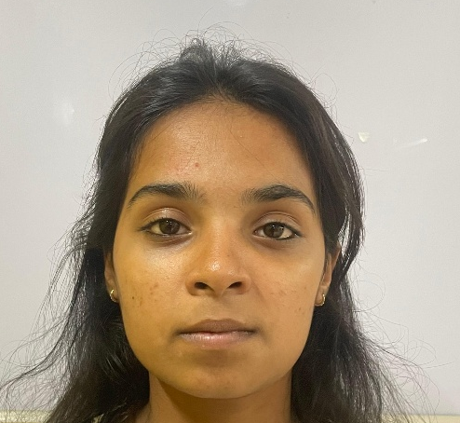
Case Report
A 19-year-old female patient presented with the chief complaint of swelling in the left lower jaw region for one year.
The patient first noticed a small swelling in the left mandibular premolar region approximately one year earlier. The swelling gradually increased in size over time.
Initially, the swelling was painless and asymptomatic. During the last two months, the patient experienced mild discomfort while chewing food. There was no history of trauma, pus discharge, paraesthesia, or fever. The progressive but painless nature of the swelling suggested a benign cystic lesion.
The patient reported no systemic illness, was not on any medications, and had no known allergies. Personal history revealed that she was a non-smoker, did not consume alcohol, and had no tobacco-chewing habits. Extraoral examination demonstrated mild facial asymmetry in the left mandibular body region. The overlying skin appeared normal, with no evidence of erythema or ulceration, and no regional lymphadenopathy was detected. Intraoral inspection revealed a diffuse swelling measuring approximately 3 × 3 cm on the lower left side of the face, extending anteroposteriorly from 1 cm away from the corner of the mouth to 1 cm anterior to the tragus of the ear, and super inferiorly from 1 cm below the tragus line to 1 cm above the lower border of the mandible.
Figure 1
Clinical findings included buccal cortical expansion, normal mucosal coloration, absence of ulceration, and no sinus tract formation. On palpation, the swelling was bony hard in consistency, non-tender, and exhibited buccal cortical expansion. An egg-shell cracking sensation was elicited on pressure, indicating thinning of the cortical bone. Vestibular tenderness was noted in relation to teeth 34, 35, 36, and 37.
Collectively, these findings were suggestive of a large intraosseous cystic lesion involving the left mandibular region.

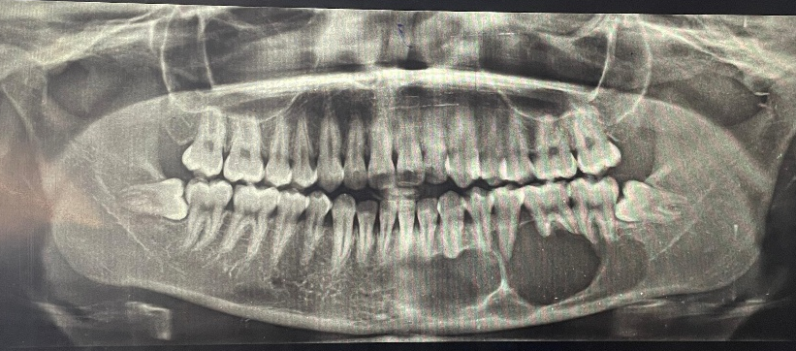
Radiographic Evaluation
Orthopantomogram revealed a multilocular radiolucency extending anteroposteriorly from tooth 41 to 37, and superoinferiorly from the interradicular bone of the same teeth to approximately 1 cm superior to the lower border of the mandible. The lower border of the mandible appeared intact. The inferior alveolar nerve canal was not traceable on the left side.
Internal septa were noted, dividing the radiolucent areas between teeth 34 and 35. Knife-edge root resorption was evident in relation to teeth 33, 34, 35, 36, and 37. Additionally, horizontal impaction was observed in relation to teeth 38 and 48.
These findings were consistent with a large intraosseous lesion exhibiting aggressive radiographic features.

Table 1. Vitality test using thermal cold test
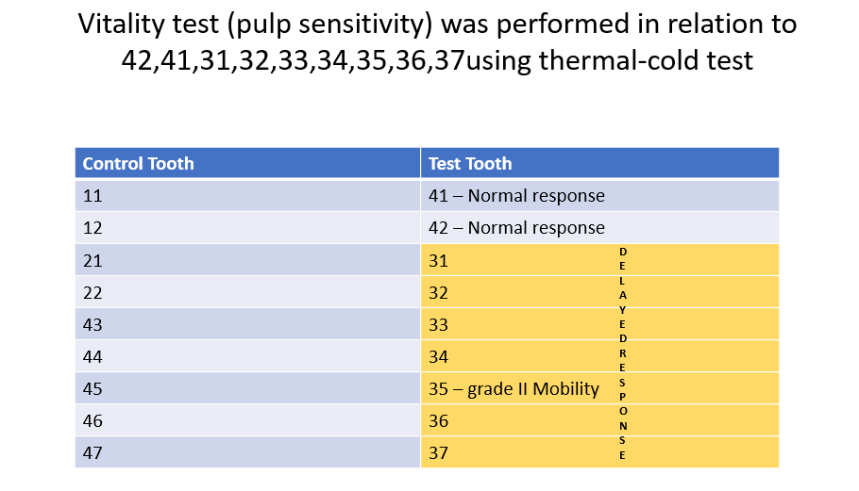

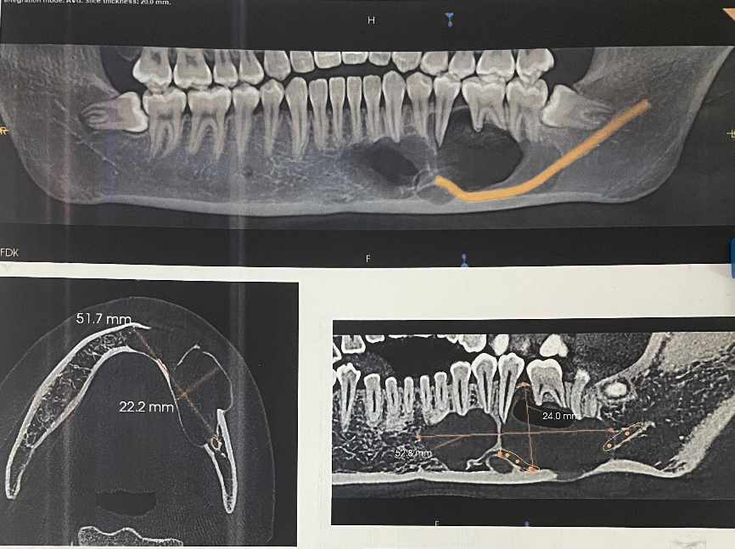
Cone Beam Computed Tomography
Cone beam computed tomography (CBCT) revealed a multilocular radiolucent lesion involving the left body of the mandible, extending mesiodistally from tooth 41 to the distal aspect of 37, and superoinferiorly from the alveolar crest to the lower border of the mandible, measuring approximately 51.7 mm anteroposteriorly, 22.2 mm buccolingually, and 24 mm superoinferiorly. A distinct septum was noted between teeth 34 and 35, imparting a multilocular appearance. The inferior alveolar nerve canal was displaced inferiorly. Knife-edge root resorption was evident in relation to teeth 32, 33, 34, 36, and 37.
Figure 2

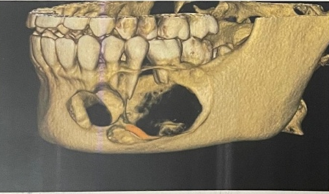
Buccolingual expansion was present, with thinning and areas of perforation of both buccal and lingual cortical plates. The lower border of the mandible remained intact, with no evidence of pathological fracture. Horizontal impaction of teeth 38 and 48 was also observed. The internal content of the lesion demonstrated cystic characteristics with low-density fluid.
Initial CBCT analysis (dimensions: 51.7 × 22.2 mm) confirmed buccolingual expansion, cortical thinning without perforation, inferior displacement of the inferior alveolar nerve canal, and multilocular radiolucency with cystic changes. Collectively, these findings were consistent with an aggressive intraosseous cystic lesion exhibiting classical radiographic features of odontogenic keratocyst.
Figure 3
The pulp vitality test was done

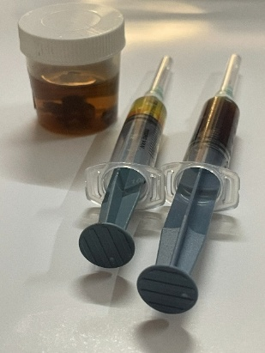
Management and Surgical Procedure
Given the large dimensions of the lesion, its multilocular nature, and the young age of the patient, a conservative approach was prioritized to preserve mandibular continuity and encourage gradual bone regeneration. Marsupialization was selected as the initial treatment modality to achieve decompression and facilitate shrinkage of the cystic cavity.
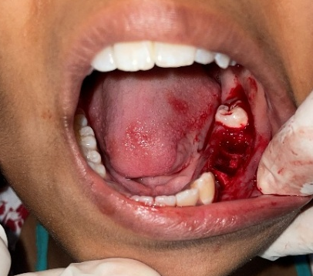
The procedure commenced with aspiration under local anaesthesia and aseptic precautions. A fine needle introduced into the cystic cavity yielded straw-coloured fluid, characteristic of odontogenic cysts, thereby confirming the diagnosis and providing initial decompression.
Figure 4
Teeth 34, 35, and 36, which demonstrated root resorption and loss of supporting bone, were extracted to eliminate potential foci of infection and facilitate surgical access. Haemostasis was achieved, and the surgical field prepared for entry.
Figure 5
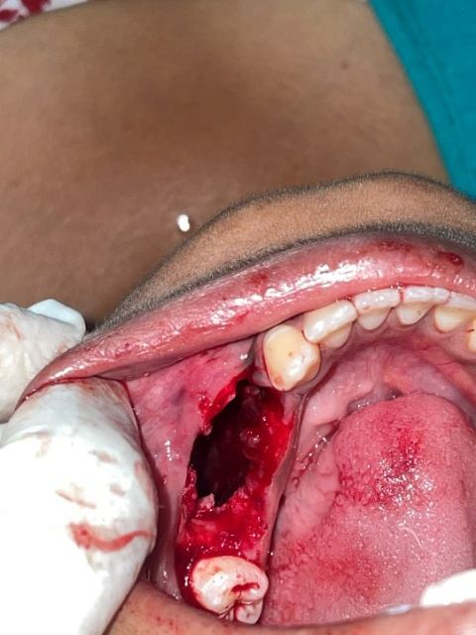
A crestal incision was placed, followed by elevation of a full-thickness mucoperiosteal flap. Using a surgical bur under copious irrigation, a bony window was created at the alveolar crest, providing direct access to the cystic cavity. Tissue fragments and cystic lining removed during entry were collected and submitted for histopathological examination. The cystic lining was sutured to the oral mucosa, establishing a marsupialization window that allowed continuous drainage, reduced intracystic pressure, and promoted gradual shrinkage of the lesion.
Figure 6

The cavity was packed with chlorhexidine-impregnated gauze to maintain hygiene and prevent secondary infection.
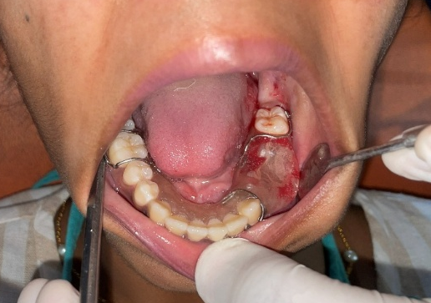
After 15 days, once initial healing was observed, a custom acrylic obturator was fabricated and placed to maintain patency of the marsupialization window, ensure patient comfort, and facilitate irrigation during follow-up. Postoperative care included meticulous oral hygiene, regular irrigation, and weekly review to monitor lesion reduction, bone regeneration, and obturator function. From the surgeon’s perspective, the sequence of aspiration, extraction, window creation with biopsy, marsupialization, medicated packing, and obturator placement was carefully planned to balance decompression with preservation of mandibular integrity.
Figure 7
This conservative approach minimized morbidity, maintained continuity, and provided a predictable pathway for progressive bone regeneration, offering favourable functional and aesthetic outcomes in a young patient.
Follow-Up Protocol
The patient was recalled on a weekly basis for clinical monitoring and maintenance of the marsupialization window. At each visit, the cystic cavity was irrigated with saline, the chlorhexidine-impregnated pack was replaced, and the size of the cavity was clinically evaluated. This regimen ensured continuous decompression, hygiene, and progressive reduction of the lesion.
Radiographic Follow-Up
After one year, CBCT imaging demonstrated a significant reduction in lesion dimensions, from an initial size of 51.7 × 22.2 mm to 38.5 × 13.6 mm. Radiographic evaluation revealed new bone formation along the cystic walls, confirming the effectiveness of marsupialization in promoting gradual osseous regeneration. The findings highlighted the progressive shrinkage of the lesion and preservation of mandibular integrity, validating the conservative treatment approach.
Histopathological Examination
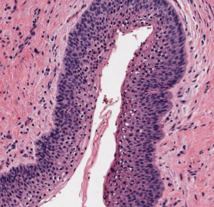
Microscopic evaluation of the submitted specimen revealed features characteristic of an odontogenic keratocyst (OKC). The cyst wall was lined by a thin parakeratinized stratified squamous epithelium, measuring approximately 6–8 cell layers in thickness. The epithelial surface demonstrated a corrugated parakeratin pattern, a hallmark feature of OKC, imparting a wavy appearance under low magnification.
At the basal layer, the cells were arranged in a palisaded configuration, with nuclei that appeared hyperchromatic and polarized, further supporting the diagnosis. This basal cell arrangement provided a distinct demarcation between the epithelial lining and the underlying connective tissue.
The fibrous connective tissue capsule was relatively thin and showed areas of mild chronic inflammatory infiltrate, predominantly lymphocytes. Importantly, within the cyst wall, daughter cysts and satellite cystic structures were identified. These microscopic foci are clinically significant, as they contribute to the well-recognized tendency of OKCs to recur following treatment.
Figure 8
Microscopic examination revealed a thin parakeratinized epithelial lining with a corrugated surface and a palisaded basal cell layer exhibiting hyperchromatic nuclei. The underlying fibrous capsule showed mild inflammatory infiltrate, and daughter cysts were present within the connective tissue wall. This constellation of features is pathognomonic for odontogenic keratocyst (OKC). These findings confirmed the diagnosis and explained the lesion’s aggressive clinical behavior, including its potential for progressive expansion, cortical perforation, and recurrence.
Satellite cysts and daughter cysts were also identified within the fibrous connective tissue wall, which are considered significant histopathological features contributing to the high recurrence rate of odontogenic keratocysts.
Future Treatment Plan
In view of the lesion’s aggressive nature and the progressive but incomplete reduction achieved with marsupialization, a staged treatment strategy has been formulated. The patient will continue marsupialization until further reduction in lesion dimensions is achieved, thereby minimizing surgical morbidity. Secondary enucleation of the residual cystic cavity will then be performed to ensure complete removal of the lesion. Topical application of 5-fluorouracil (5-FU) will be incorporated intraoperatively to reduce the risk of recurrence. Following enucleation, the site will be allowed to undergo natural bone healing, with radiographic monitoring to confirm adequate regeneration. Once sufficient bone volume and quality are established, dental implants will be placed in relation to teeth 34, 35, and 36 to restore function and aesthetics. This phased approach balances conservative management with definitive surgical intervention, ensuring long-term stability and rehabilitation.
Discussion
Odontogenic keratocyst (OKC) is a developmental odontogenic lesion characterized by aggressive biological behavior and a high tendency for recurrence compared with other odontogenic cysts. The lesion originates from remnants of the dental lamina and demonstrates a distinctive parakeratinized epithelial lining with a palisaded basal layer. Because of its unique histopathological features and growth pattern, OKC tends to spread along cancellous bone with minimal cortical expansion, allowing the lesion to reach considerable size before clinical detection. These characteristics contribute to the challenges associated with its management and long-term prognosis [1,2].
The recurrence rate of odontogenic keratocysts has been widely reported in the literature, ranging from approximately 2.5% to more than 60%, depending on the treatment modality, lesion size, and duration of follow-up [11]. Systematic reviews have estimated an overall recurrence rate of around 23% for OKC, emphasizing the need for careful treatment planning and prolonged postoperative monitoring [4]. Several factors have been implicated in recurrence, including the presence of daughter cysts, satellite cysts, incomplete removal of the epithelial lining, and the thin, friable nature of the cyst wall that may easily tear during surgical removal [12].
Various treatment strategies have been proposed for the management of odontogenic keratocysts, ranging from conservative procedures such as marsupialization or decompression to more aggressive surgical approaches, including enucleation with peripheral ostectomy or resection. Radical surgical procedures have the lowest recurrence rates but are associated with significant morbidity, including potential nerve damage, mandibular discontinuity, and loss of function. Therefore, treatment decisions often involve balancing the risk of recurrence with the need to preserve anatomical structures and minimize surgical morbidity [17].
Conservative treatment approaches such as marsupialization and decompression are particularly advantageous in young patients and in cases involving large cystic lesions. These procedures aim to reduce intracystic pressure by creating a communication between the cyst cavity and the oral environment, allowing continuous drainage of cystic fluid. The reduction in hydrostatic pressure within the cyst promotes gradual shrinkage of the lesion and stimulates new bone formation along the cyst walls. This biological response gradually reduces the size of the lesion and facilitates safer subsequent surgical removal if required [9].
Several studies have demonstrated the effectiveness of marsupialization as an initial treatment modality for large odontogenic keratocysts. By decreasing cyst size over time, marsupialization reduces the risk of injury to vital anatomical structures such as the inferior alveolar nerve, tooth roots, and surrounding cortical bone. Additionally, the procedure helps maintain mandibular continuity and avoids the complications associated with more aggressive surgical interventions. As a result, marsupialization is frequently recommended as part of a staged treatment approach, particularly in young individuals where preservation of bone structure is a major consideration [20].
Another advantage of marsupialization is the histological alteration that occurs in the cyst lining following decompression. Studies have shown that decompression may induce epithelial thickening and reduce keratin production within the cystic lining. These histopathological changes may decrease the proliferative activity of the epithelial cells and reduce the aggressive behavior of the lesion. Consequently, subsequent enucleation after a period of decompression may be easier to perform and associated with lower recurrence rates [2].
Radiographic imaging plays a crucial role in the diagnosis, treatment planning, and follow-up of odontogenic keratocysts. Conventional radiographs such as panoramic radiography can reveal radiolucent lesions with well-defined corticated margins; however, they provide limited information regarding the three-dimensional extent of the lesion. Cone beam computed tomography (CBCT) has significantly improved the evaluation of maxillofacial pathologies by providing detailed three-dimensional visualization of bone structures and lesion boundaries. CBCT allows accurate assessment of lesion dimensions, cortical plate involvement, and proximity to adjacent anatomical structures such as the inferior alveolar nerve canal [6].
Studies have shown that CBCT is particularly useful in the evaluation of odontogenic keratocysts because it provides precise volumetric measurements and facilitates monitoring of lesion regression during decompression therapy. Compared with conventional two-dimensional imaging techniques, CBCT offers superior visualization of buccolingual expansion, cortical perforation, and internal septations within the lesion. This detailed imaging capability assists clinicians in determining the appropriate treatment approach and evaluating the effectiveness of conservative management strategies over time [19].
In addition to conservative surgical approaches, various adjunctive treatments have been explored to reduce recurrence rates following surgical management of odontogenic keratocysts. Traditionally, chemical agents such as Carnoy’s solution have been used after enucleation to eliminate residual epithelial remnants within the cyst cavity. However, concerns regarding potential neurotoxicity and damage to adjacent tissues have led researchers to investigate alternative therapeutic agents [15].
One such adjunctive treatment that has gained attention in recent years is the topical application of 5-fluorouracil (5-FU). This antimetabolite chemotherapeutic agent interferes with DNA synthesis and selectively targets rapidly proliferating epithelial cells. Recent studies have suggested that the application of 5-FU following enucleation may effectively eliminate residual epithelial remnants and reduce recurrence rates. Clinical investigations have reported promising outcomes with this technique, demonstrating normal bone healing and regeneration with minimal complications [0]. Furthermore, meta-analyses have indicated that the use of 5-FU as an adjunctive therapy may significantly reduce recurrence rates compared with conventional treatments alone [5].
Another important consideration in the management of odontogenic keratocysts is the adoption of a staged treatment protocol. Several authors have recommended an approach involving initial decompression or marsupialization followed by delayed enucleation once the lesion size has sufficiently reduced. This strategy allows gradual bone regeneration and reduces the risk of pathological fracture or nerve injury during definitive surgery. Clinical studies have demonstrated that marsupialization followed by secondary cystectomy can significantly reduce recurrence rates compared with immediate enucleation alone [9].
In the present case, marsupialization was selected as the initial treatment modality because of the large size of the lesion and the young age of the patient. The conservative approach aimed to reduce cyst size gradually while preserving mandibular integrity and minimizing surgical morbidity. During follow-up, progressive reduction in lesion size was observed both clinically and radiographically. CBCT imaging after one year demonstrated a reduction in lesion dimensions from 51.7 × 22.2 mm to 38.5 × 13.6 mm, along with radiographic evidence of new bone formation along the cyst walls.
These findings are consistent with previous studies reporting favourable outcomes following decompression therapy for large odontogenic keratocysts. Reduction in cyst size not only facilitates easier surgical management but also promotes bone regeneration, thereby restoring the structural integrity of the mandible. Conservative treatment methods have therefore gained increasing acceptance as a first-line management strategy for large OKCs, especially in younger patients [24].
Despite the benefits of conservative treatment, long-term follow-up remains essential because of the inherent recurrence potential of odontogenic keratocysts. Recurrences may occur several years after initial treatment and are often associated with residual epithelial remnants or satellite cysts within the surrounding bone. Studies have emphasized the importance of periodic clinical and radiographic monitoring for several years following treatment to ensure early detection of recurrence and prompt management if necessary [7].
Overall, the management of odontogenic keratocysts requires a multidisciplinary approach involving careful clinical assessment, accurate radiographic evaluation, histopathological confirmation, and appropriate surgical planning. Conservative treatment strategies such as marsupialization provide an effective method for managing large lesions while preserving anatomical structures and minimizing morbidity. When combined with advanced imaging techniques and adjunctive therapies, these approaches may offer improved treatment outcomes and reduced recurrence rates.

Treatment | Advantages | Disadvantages
Enucleation | Complete removal of cyst | Higher recurrence if remnants remain
Marsupialization | Conservative, preserves bone | Requires long follow-up
Decompression | Gradual reduction of lesion | Patient compliance required
Resection | Lowest recurrence rate | High morbidity
Comparison of Treatment Modalities for OKC
Conclusion
Marsupialization represents a valuable conservative approach for the management of large odontogenic keratocysts, particularly in young patients where preservation of mandibular integrity is essential. The technique facilitates gradual reduction of cyst size, promotes bone regeneration, and minimizes surgical morbidity. In the present case, significant reduction in lesion size was achieved with favourable clinical and radiographic outcomes. A staged treatment approach involving marsupialization followed by definitive surgical management can provide predictable results. However, long-term clinical and radiographic follow-up remains essential due to the recurrence potential of odontogenic keratocysts.
Acknowledgements
The authors would like to acknowledge the contributions of the surgical team, radiology department, and pathology unit for their assistance in diagnosis, treatment, and histopathological evaluation. Special thanks are extended to the academic mentors and institutional support that facilitated the preparation of this manuscript.
Ethical Approval
This case was managed in accordance with institutional ethical standards and the principles outlined in the Declaration of Helsinki. All procedures performed were part of routine clinical care, and ethical guidelines were strictly adhered to throughout the management and reporting process.
Patient Consent
Written informed consent was obtained from the patient for both the surgical procedure and the publication of clinical details, radiographic images, and histopathological findings. The patient was assured that anonymity would be maintained and that no identifying information would be disclosed.
Author Contributions
The conceptualization and overall supervision of this study were provided by Dr. G. V. Reddy and Dr. G. Siva Prasad Reddy, who also guided the clinical management and provided academic oversight throughout the preparation of the manuscript. Dr. Godvine contributed to treatment planning, surgical supervision, and clinical management of the case. Dr. Sarah Fatima was primarily responsible for patient management, clinical documentation, literature review, data collection, and preparation of the original manuscript draft. The histopathological examination and interpretation were performed by Dr. Keerthi Muddana. Assistance with data collection, clinical documentation, and literature review was provided by Dr. Farya Muskaan Khan, Dr. Ummea Aiman Fatima, Dr. Momula Karthik Goud, Dr. Priyanka Bheemanapally, Dr. Fazeelah Fatima, Dr. Mokshitha Varma, Dr. Sadaf Sulthana Shariff, and Dr. Lasya Snkp Duggirala. Dr. Bobbili Malavika and Dr. Sunidhi Chavan contributed to manuscript editing, critical revision of the intellectual content, and served as the corresponding authors responsible for communication with the journal. All authors reviewed and approved the final version of the manuscript and agree to be accountable for all aspects of the work.
Disclaimer (Artificial intelligence)
Author(s) hereby declare that NO generative AI technologies such as Large Language Models (ChatGPT, COPILOT, etc.) and text-to-image generators have been used during the writing or editing of this manuscript.

Figure Legends
Figure 1: Front profile view of the patient showing facial asymmetry in the left mandibular region.
Figure 2: CBCT slices demonstrating the dimensions of the cystic lesion.
Figure 3: Three-dimensional CBCT reconstruction showing buccolingual expansion and cortical thinning.
Figure 4: Aspiration of cystic fluid from the lesion.
Figure 5: Post-extraction site of teeth 34, 35, and 36.
Figure 6: Creation of a bony window for marsupialization.
Figure 7: Placement of custom acrylic obturator.
Figure 8: Histopathological photomicrograph showing parakeratinized epithelial lining and palisaded basal cells.
Table legend
Table 1: Orthopantomogram showing multilocular radiolucent lesion extending from tooth 41 to 37.

References
- Johnson NR, Batstone MD, Savage NW. Management and recurrence of keratocystic odontogenic tumor: a systematic review. Oral Surg Oral Med Oral Pathol Oral Radiol. 2013;116(4):e271-e276. doi:10.1016/j.oooo.2011.12.028. Available from: https://doi.org/10.1016/j.oooo.2011.12.028
- Wright JM, Vered M. Update from the 4th edition of the WHO classification of head and neck tumors: odontogenic tumors. Head Neck Pathol. 2017;11:68-77. doi:10.1007/s12105-017-0794-1. Available from: https://doi.org/10.1007/s12105-017-0794-1
- Neville BW, Damm DD, Allen CM, Chi AC. Oral and Maxillofacial Pathology. 4th ed. St Louis: Elsevier; 2016.
- Fidele NB, Yueyu Z, Zhao Y, Liu J. Recurrence of odontogenic keratocysts and possible prognostic factors: review of 455 patients. Med Oral Patol Oral Cir Bucal. 2019;24(4):e491-e497. doi:10.4317/medoral.22977. Available from: https://doi.org/10.4317/medoral.22977
- Kaczmarzyk T, Mojsa I, Stypulkowska J. A systematic review of recurrence rate for keratocystic odontogenic tumor. Int J Oral Maxillofac Surg. 2012;41(6):756-767. doi:10.1016/j.ijom.2012.02.009. Available from: https://doi.org/10.1016/j.ijom.2012.02.009
- Blanas N, Freund B, Schwartz M, Furst IM. Systematic review of the treatment and prognosis of odontogenic keratocyst. Oral Surg Oral Med Oral Pathol Oral Radiol Endod. 2000;90(5):553-558. doi:10.1067/moe.2000.109569. Available from: https://doi.org/10.1067/moe.2000.109569
- Mohanty S, et al. Surgical management of odontogenic keratocyst: a 20-year experience. J Oral Maxillofac Surg. 2021. doi:10.1016/j.joms.2021.02.010. Available from: https://doi.org/10.1016/j.joms.2021.02.010
- Gonçalves T, et al. Management and recurrence of odontogenic keratocyst: overview of systematic reviews. J Stomatol Oral Maxillofac Surg. 2024. doi:10.1016/j.jormas.2024.02.004. Available from: https://doi.org/10.1016/j.jormas.2024.02.004
- Pogrel MA. Decompression and marsupialization as a treatment for the odontogenic keratocyst. Oral Maxillofac Surg Clin North Am. 2003;15(3):415-427. doi:10.1016/S1042-3699(03)00038-4. Available from: https://doi.org/10.1016/S1042-3699(03)00038-4
- Nakamura N, Mitsuyasu T, Mitsuyasu Y, Taketomi T, Higuchi Y, Ohishi M. Marsupialization for odontogenic keratocysts: long-term follow-up analysis of the effects and changes in growth characteristics. Oral Surg Oral Med Oral Pathol Oral Radiol Endod. 2002;94(5):543-553. doi:10.1067/moe.2002.128022. Available from: https://doi.org/10.1067/moe.2002.128022
- Briki S, Elleuch W, Karray F, Abdelmoula M, Tanoubi I. Cysts and tumors of the jaws treated by marsupialization: a description of 4 clinical cases. J Clin Exp Dent. 2019;11(6):e565-e570. doi:10.4317/jced.55304. Available from: https://doi.org/10.4317/jced.55304
- Nallanchakrava S, et al. Marsupialization of odontogenic keratocyst using thermoform surgical splint. J Indian Soc Pedod Prev Dent. 2022;40(3):310-314. doi:10.4103/jisppd.jisppd_71_22. Available from: https://doi.org/10.4103/jisppd.jisppd_71_22
- Scarfe WC, Farman AG. What is cone-beam CT and how does it work? Dent Clin North Am. 2008;52(4):707-730. doi:10.1016/j.cden.2007.11.005. Available from: https://doi.org/10.1016/j.cden.2007.11.005
- MacDonald-Jankowski DS. Kerato-odontogenic tumour: systematic review. Dentomaxillofac Radiol. 2011;40(1):1-23. doi:10.1259/dmfr/93082102. Available from: https://doi.org/10.1259/dmfr/93082102
- Astuti ER, et al. Treatment evaluation of odontogenic keratocyst using cone beam CT imaging. Imaging Sci Dent. 2020;50(3):223-230. doi:10.5624/isd.2020.50.3.223. Available from: https://doi.org/10.5624/isd.2020.50.3.223
- Wright JM. Odontogenic keratocyst: clinical and pathologic aspects. Head Neck Pathol. 2008;2(4):241-247. doi:10.1007/s12105-008-0068-2. Available from: https://doi.org/10.1007/s12105-008-0068-2
- Consolo U, Setti G, Tognacci S, Cavatorta C, Cassi D, Bellini P. Histological changes in odontogenic parakeratinized keratocysts treated with marsupialization followed by enucleation. Med Oral Patol Oral Cir Bucal. 2020;25:e897-e902. doi:10.4317/medoral.23898. Available from: https://doi.org/10.4317/medoral.23898
- Al-Moraissi EA, Kaur A, Gomez RS, Ellis E. Effectiveness of different treatments for odontogenic keratocyst: a network meta-analysis. Int J Oral Maxillofac Surg. 2023;52(4):487-496. doi:10.1016/j.ijom.2022.09.004. Available from: https://doi.org/10.1016/j.ijom.2022.09.004
- Caminiti MF, El-Rabbany M, Jeon J, Bradley G. 5-Fluorouracil is associated with decreased recurrence risk in odontogenic keratocyst management: a retrospective cohort study. J Oral Maxillofac Surg. 2021;79(1):148-155. doi:10.1016/j.joms.2020.07.215. Available from: https://doi.org/10.1016/j.joms.2020.07.215
- Aarthi S, et al. Efficacy of alternative agents to Carnoy’s solution in prevention of odontogenic keratocyst recurrence. Evid Based Dent. 2025. doi:10.1038/s41432-025-01138-3. Available from: https://doi.org/10.1038/s41432-025-01138-3
- Haribabu PK, et al. Model-assisted marsupialization of a large odontogenic keratocyst. Clin Case Rep. 2023;11:e7286. doi:10.1002/ccr3.7286. Available from: https://doi.org/10.1002/ccr3.7286
- Abdelfadil E, et al. Management of mandibular odontogenic keratocyst with peripheral ostectomy. Dent J. 2025;13:536. doi:10.3390/dj13110536. Available from: https://doi.org/10.3390/dj13110536
- Gelețu GL, et al. Various surgical interventions in treating odontogenic keratocysts. Healthcare. 2023;11(3):416. doi:10.3390/healthcare11030416. Available from: https://doi.org/10.3390/healthcare11030416
- Gilvetti C, et al. Recurrence rate of odontogenic keratocysts after surgical treatment. Oral Surg. 2025. doi:10.1111/ors.12933. Available from: https://doi.org/10.1111/ors.12933
- Yilmaz O, et al. Management of recurrence of ameloblastoma and odontogenic keratocyst. J Oral Maxillofac Res. 2020;11(2):e2. doi:10.5037/jomr.2020.11202. Available from: https://doi.org/10.5037/jomr.2020.11202

