Radicular Cyst Associated with Maxillary Anterior Teeth: Combined Surgical Enucleation and Endodontic Management with One-Year Follow-Up – A Case Report and Literature Review
Abstract
Background: Radicular cysts are the most common inflammatory odontogenic cysts arising from epithelial rests of Malassez secondary to pulpal necrosis and chronic periapical inflammation. They are frequently associated with non-vital teeth in the anterior maxillary region and may lead to progressive bone destruction if not managed appropriately.
Objective: To present a multidisciplinary management approach for a large periapical lesion in the anterior maxilla using surgical enucleation followed by endodontic therapy and prosthetic rehabilitation, along with one-year clinical and radiographic follow-up.
Case Presentation: A 28-year-old female patient presented with mild swelling and pain in the anterior maxillary region with a history of trauma three months earlier. Clinical examination and radiographic evaluation revealed a well-defined unilocular radiolucent lesion measuring approximately 2.5 × 3 cm involving teeth 21, 22, and 23. All involved teeth were non-vital with expansion of the labial cortical plate. Surgical enucleation of the lesion was performed under local anaesthesia, followed by curettage of the surrounding bone. The excised tissue was submitted for histopathological examination.
Results: Histopathological analysis revealed fibrocellular connective tissue with chronic inflammatory infiltrate and cholesterol clefts, consistent with a periapical granuloma rather than a true radicular cyst. Postoperative healing was uneventful, and radiographic evaluation at six months demonstrated significant bone regeneration. Endodontic therapy was subsequently completed for teeth 21, 22, and 23, followed by prosthetic rehabilitation using zirconia crowns.
Conclusion: This case highlights the importance of a multidisciplinary approach combining surgical management, histopathological diagnosis, endodontic therapy, and prosthetic rehabilitation in the successful treatment of large periapical lesions. Long-term follow-up confirmed complete osseous healing and functional rehabilitation, emphasizing the importance of integrated treatment strategies in managing periapical pathology.
Keywords:
Radicular cyst; Periapical granuloma; Surgical enucleation; Endodontic therapy; Maxillary anterior teeth; Periapical lesion.
Introduction
Radicular cysts are the most common inflammatory odontogenic cysts of the jaws, accounting for approximately 60–70% of all cystic lesions occurring in the maxillofacial region [1,5]. These lesions arise as a consequence of chronic periapical inflammation secondary to pulpal necrosis. Persistent inflammatory stimulation leads to proliferation of the epithelial rests of Malassez within the periodontal ligament, eventually resulting in the formation of a cystic cavity at the periapical region of the affected tooth [2,6,7]. Radicular cysts are most frequently associated with non-vital teeth and commonly involve the anterior maxilla, which is particularly susceptible to trauma and pulpal pathology affecting anterior teeth [3,8]. Epidemiological studies have reported that these lesions occur across a wide age range but are more frequently diagnosed in adults, reflecting the cumulative effects of untreated dental caries, trauma, and chronic pulpal infection [18,22].
Clinically, radicular cysts may remain asymptomatic for long periods and are often detected incidentally during routine dental radiographic examinations. When symptoms are present, patients may present with swelling, mild discomfort, or expansion of the cortical plates, depending on the size and progression of the lesion. Larger cysts may also cause displacement of adjacent teeth or thinning of cortical bone. Radiographically, these lesions typically appear as well-defined unilocular radiolucencies associated with the apex of a non-vital tooth and are frequently surrounded by a thin radiopaque margin suggestive of a slow-growing process [3,12,33]. However, distinguishing radicular cysts from other inflammatory periapical lesions, particularly periapical granulomas, based solely on radiographic findings remains challenging because these lesions often exhibit similar clinical and imaging characteristics [7,8,10]. Advanced imaging modalities such as cone-beam computed tomography (CBCT) have improved the assessment of periapical lesions by providing three-dimensional visualization of lesion size, cortical bone involvement, and proximity to adjacent anatomical structures [12,26,33].
Histopathological examination, therefore, remains the gold standard for establishing a definitive diagnosis and accurately distinguishing between cystic lesions and granulomatous inflammatory tissue [7–9]. Accurate diagnosis is essential because it directly influences treatment planning and long-term prognosis. Smaller periapical lesions may resolve following conventional nonsurgical endodontic therapy once the source of infection within the root canal system is eliminated. In contrast, larger lesions or those that fail to respond to conservative treatment may require surgical management such as enucleation, decompression, or marsupialization to remove pathological tissue and promote bone regeneration [10,11,13,14]. In recent years, regenerative approaches using biological adjuncts such as platelet-rich fibrin (PRF) have gained attention for their potential to enhance postoperative healing and accelerate bone regeneration following surgical removal of cystic lesions [15,20,35].
Understanding the clinical presentation, diagnostic challenges, and available treatment strategies is therefore essential for clinicians involved in the management of periapical lesions. Case reports describing multidisciplinary treatment approaches provide valuable insights into clinical decision-making and long-term patient outcomes.
Clinical Significance
Radicular cysts represent a common pathological condition encountered in dental practice and require careful diagnostic evaluation to ensure appropriate management. This case highlights the importance of correlating clinical, radiographic, and histopathological findings to achieve an accurate diagnosis and optimal treatment planning. The successful management of the lesion through a multidisciplinary approach involving surgical enucleation, endodontic therapy, and prosthetic rehabilitation demonstrates the importance of collaborative care in achieving favorable functional and aesthetic outcomes. Such clinical reports contribute to the existing body of literature by enhancing clinicians’ understanding of diagnostic challenges and treatment strategies for large periapical lesions.
The present case report describes the successful management of a large periapical lesion associated with maxillary anterior teeth using surgical enucleation followed by endodontic therapy and prosthetic rehabilitation, with a one-year clinical and radiographic follow-up demonstrating favorable healing and restoration of function and aesthetics.
Case Presentation
A 28-year-old female patient presented to the Department of Oral and Maxillofacial Surgery with a chief complaint of mild swelling and intermittent pain in the upper left anterior region of the maxilla. The patient reported that the discomfort had been gradually increasing over the preceding two months.
The pain was described as dull and localized, occasionally aggravated during mastication but not associated with any purulent discharge or systemic symptoms such as fever or malaise. The patient also reported a previous history of trauma to the anterior maxillary region several months earlier, which may have contributed to pulpal necrosis of the involved teeth.
On extraoral examination, no facial asymmetry or lymphadenopathy was observed. Intraoral examination revealed localized swelling in the labial vestibular region corresponding to teeth 21, 22, and 23. The swelling was firm, well circumscribed, and non-tender on palpation. The overlying mucosa appeared smooth and intact, with no evidence of ulceration, sinus tract formation, or mucosal discoloration. Mild expansion of the labial cortical plate was noted, producing a visible intraoral bulge in the anterior maxillary region. No mobility of the involved teeth was detected, and periodontal probing depths were within normal limits.
Pulp vitality testing was performed using both thermal and electric pulp tests. Teeth 21, 22, and 23 demonstrated a non-vital response, confirming loss of pulpal vitality, while adjacent teeth responded normally. These findings suggested a localized periapical pathology associated with the non-vital teeth. Initial periapical radiographic examination revealed a well-defined unilocular radiolucency involving the periapical region of the affected teeth.
Radiological Examination
To further evaluate the extent of the lesion, periapical radiographs and cone-beam computed tomography (CBCT) imaging were obtained. Radiographic analysis revealed a well-circumscribed unilocular radiolucency measuring approximately 2.5 × 3 cm involving the periapical regions of teeth 21, 22, and 23. The lesion exhibited well-defined corticated borders, suggesting a slowly progressive lesion of inflammatory origin.
CBCT imaging provided additional information regarding the three-dimensional extent of the lesion. The radiolucency was seen to cause thinning and mild expansion of the labial cortical plate without evidence of cortical perforation. The palatal cortical plate remained intact, and the lesion did not show communication with adjacent anatomical structures such as the nasal floor or maxillary sinus. No evidence of root resorption or displacement of adjacent teeth was observed, although mild scalloping along the periapical region was noted.
Based on the clinical and radiographic findings, a provisional diagnosis of radicular cyst associated with teeth 21, 22, and 23 was made. However, due to the overlapping radiographic characteristics between radicular cysts and periapical granulomas, histopathological examination was considered necessary to establish a definitive diagnosis.
Treatment Plan
Considering the size of the lesion and the associated cortical plate expansion, a multidisciplinary treatment plan was formulated. The treatment plan included surgical enucleation and curettage of the lesion, followed by histopathological examination to confirm the diagnosis. After adequate postoperative healing and bone regeneration, root canal therapy of the involved teeth was planned to eliminate any residual infection. Final rehabilitation with prosthetic crowns was planned to restore function and aesthetics.
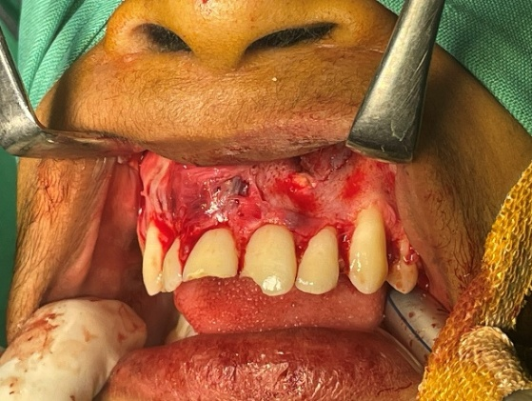
Surgical Management
The surgical procedure was performed under local anaesthesia using 2% lignocaine with 1:80,000 adrenaline. A crevicular incision extending from tooth 13 to 26 was made to provide sufficient surgical access and visibility. A full-thickness mucoperiosteal flap was carefully elevated, exposing the thinned and expanded labial cortical plate overlying the lesion (shown in Fig 1).
Fig 1
Fig 1-Intraoperative view following reflection of a full-thickness mucoperiosteal flap, exposing the cystic lesion in relation to teeth 21–23.

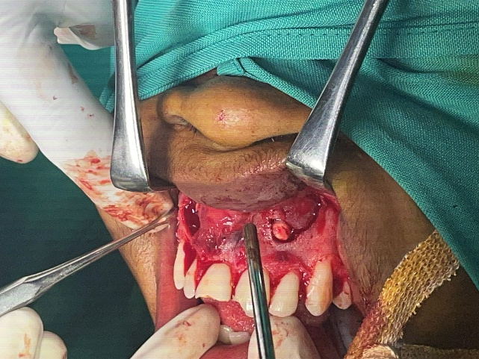
A small bony window was created using a round surgical bur under copious sterile saline irrigation to gain access to the cystic cavity (shown in Fig 2).
Fig 2-A bony window was created to allow entry into the cystic cavity following flap reflection

Upon entry, the lesion was identified and carefully enucleated in its entirety. Meticulous dissection was performed to preserve the integrity of the cystic lining and minimize trauma to the surrounding bone.

Fig 2

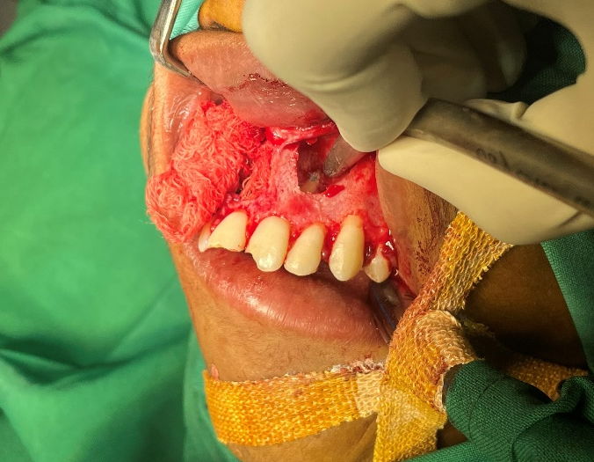
Following removal of the lesion, thorough curettage of the surgical cavity was performed to eliminate any residual epithelial tissue or inflammatory granulation tissue that could potentially lead to recurrence. The cavity was then irrigated with sterile saline to ensure a clean surgical field (shown in Fig 3).
The mucoperiosteal flap was repositioned and secured using interrupted 3-0 silk sutures, achieving tension-free closure and stable adaptation of the tissues (shown in Fig 4).
Fig 3-Thorough curettage of the cystic cavity was performed to eliminate residual epithelial lining and inflammatory granulation tissue, thereby minimizing the risk of recurrence.
Adequate haemostasis was obtained, and the patient tolerated the procedure well.
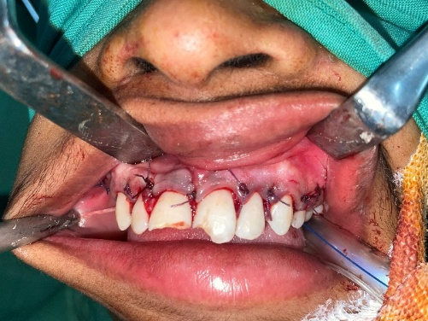
Fig 3

Fig 4-The mucoperiosteal flap was repositioned and secured with interrupted 3 0 silk sutures, achieving tension-free closure and stable adaptation. Haemostasis was established.

Fig 4

The excised specimen was immediately placed in 10% buffered formalin and submitted for histopathological examination (shown in Fig 5).
Postoperative instructions were provided, including maintenance of oral hygiene, avoidance of trauma to the surgical site, and adherence to prescribed antibiotics and analgesics. The patient was recalled after seven days for suture removal and scheduled for periodic follow-up visits to monitor healing.
Fig 5
Histopathological Examination
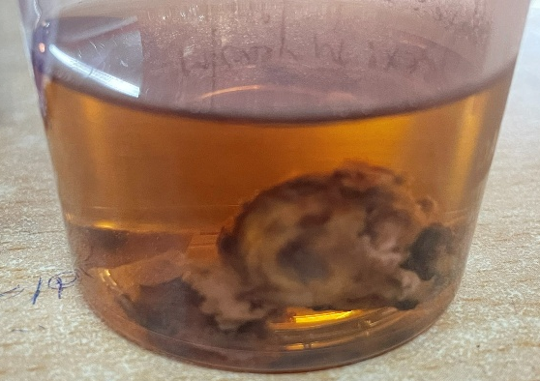
The excised specimen consisted of three fragments of soft tissue measuring approximately 1.0 × 1.2 cm collectively. The tissue samples were fixed in 10% buffered formalin and processed for routine haematoxylin and eosin (H&E) staining.
Microscopic examination revealed fibrocellular connective tissue composed of dense collagen fibres interspersed with
Fig 6
Fig 5-Specimen sent for Histopathological examination
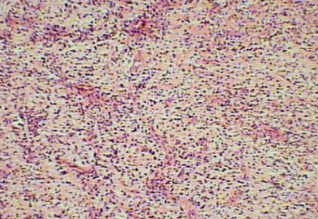
numerous fibroblasts. A chronic inflammatory cell infiltrate consisting predominantly of lymphocytes and plasma cells was observed, indicating a long-standing inflammatory process. Numerous endothelial-lined blood vessels containing red blood cells were present, suggesting active vascular proliferation within the lesion (shown in fig 6).
Additionally, cholesterol clefts surrounded by foreign body giant cells Fig 6-Microscopic image

and macrophages were identified within the connective tissue stroma, a characteristic feature often associated with chronic periapical inflammatory lesions. Importantly, no epithelial lining was identified in the examined sections, thereby excluding the diagnosis of a true radicular cyst.
Based on these microscopic findings, the lesion was diagnosed as a periapical granuloma. The histopathological findings confirmed the importance of tissue examination in differentiating between radicular cysts and granulomatous lesions that may present with similar radiographic appearances.
The patient was followed up at 1 week, 1 month, 3 months, 6 months, and 12 months to monitor healing and evaluate bone regeneration.
Six-Month Follow-Up
The patient was followed up periodically to assess postoperative healing. At the six-month follow-up, radiographic examination demonstrated progressive bone formation within the surgical defect, indicating satisfactory healing and regeneration of the affected area.
Endodontic Treatment
Following confirmation of satisfactory periapical healing, root canal therapy was performed for teeth 21, 22, and 23 to eliminate residual infection and ensure long-term functional stability.
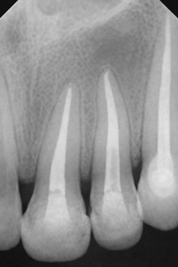
Access cavities were prepared under rubber dam isolation to maintain strict aseptic conditions. Working length determination was performed using an electronic apex locator and confirmed radiographically.
Cleaning and shaping of the canals were performed using rotary nickel–titanium instruments (ProTaper Universal). Irrigation was carried out using 3% sodium hypochlorite (NaOCl) solution (Vishal Dentocare Pvt. Ltd., Ahmedabad, India), followed by normal saline, and 17% ethylenediaminetetraacetic acid (EDTA) solution (RC Help, Prime Dental Products Pvt. Ltd., Mumbai, India) to ensure adequate disinfection and removal of the smear layer (shown in Fig 7). Fig 7-Postoperative radiograph confirming satisfactory periapical healing following surgical intervention, before initiation of root canal therapy.
Fig 7

Calcium hydroxide was placed as an intracanal medicament between appointments to promote antimicrobial action and facilitate periapical healing. After adequate canal disinfection, obturation was performed using gutta-percha cones (Dentsply Maillefer, Ballaigues, Switzerland) in combination with a resin-based endodontic sealer (AH Plus, Dentsply DeTrey GmbH, Konstanz, Germany) using the lateral condensation technique to achieve a hermetic seal of the root canal system. All materials were used according to the manufacturers’ instructions.
Calcium hydroxide was placed as an intracanal medicament between appointments to enhance antimicrobial activity and promote periapical healing. After adequate canal disinfection, obturation was performed using the lateral condensation technique with gutta-percha and resin-based sealer, achieving a hermetic seal of the root canal system.

Prosthetic Rehabilitation and Outcome
Following completion of endodontic therapy, full-coverage zirconia crowns (3M Lava Zirconia, 3M ESPE, St. Paul, MN, USA) were fabricated and placed on teeth 21, 22, and 23 to restore aesthetics and functional stability in the anterior maxillary region (shown in Fig 8). The prosthetic restorations reinforced the structural integrity of the treated teeth and protected them from fracture.
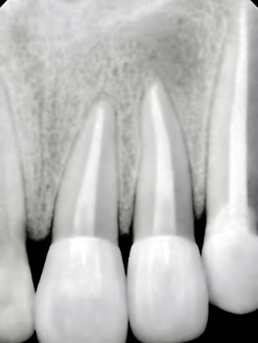
The patient responded well to treatment, and periodic follow-up visits demonstrated progressive periapical healing. Radiographic evaluation showed complete osseous regeneration with restoration of normal trabecular bone architecture.
At the one-year follow-up, the restorations remained stable, the surrounding gingival tissues were healthy, and no recurrence of pathology was observed. The patient reported satisfaction with both the functional outcome and the aesthetic appearance of the restored teeth.
This case highlights the importance of a multidisciplinary treatment approach, combining surgical enucleation, histopathological diagnosis, endodontic therapy, and prosthetic rehabilitation to achieve predictable healing and long-term clinical success in the management of large periapical lesions.
Fig 8
Fig 8-Post–root canal therapy radiograph demonstrating satisfactory obturation of teeth 21–23 and resolution of the periapical lesion
Discussion
Periapical inflammatory lesions are among the most frequently encountered pathological entities in dental practice and commonly arise as a consequence of pulpal infection and necrosis. These lesions include radicular cysts, periapical granulomas, and periapical abscesses, all of which may present with similar clinical and radiographic findings. Radicular cysts and periapical granulomas, in particular, often appear as well-defined radiolucent lesions associated with the apices of non-vital teeth. Because of these overlapping features, differentiation between these lesions based solely on clinical examination and conventional radiography can be challenging. Consequently, histopathological evaluation remains the most reliable method for establishing a definitive diagnosis and distinguishing between cystic and granulomatous lesions [7–9].
In the present case, radiographic examination suggested a radicular cyst due to the presence of a relatively large, well-defined periapical radiolucency associated with non-vital anterior maxillary teeth. However, histopathological examination revealed features consistent with a periapical granuloma, characterized by fibrocellular connective tissue, chronic inflammatory infiltrate, vascular proliferation, and cholesterol clefts without an epithelial lining. This finding highlights an important clinical consideration: radiographic appearance alone may not accurately reflect the true histopathological nature of periapical lesions. Several studies have emphasized that a significant proportion of lesions initially diagnosed as radicular cysts on radiographs may ultimately be confirmed as periapical granulomas upon microscopic examination [7,8]. Therefore, histopathological confirmation remains essential, particularly in cases where surgical intervention is performed.
The choice of treatment for periapical lesions depends on multiple factors, including lesion size, location, accessibility, and the vitality status of the associated teeth. Surgical enucleation has long been considered one of the most reliable treatment options for odontogenic cystic lesions because it allows complete removal of pathological tissue and provides a specimen for histopathological evaluation [10]. In addition to eliminating the lesion, enucleation also promotes healing by removing inflammatory tissue that may otherwise perpetuate bone destruction. In the present case, the lesion was well circumscribed and located in the anterior maxilla, which provided adequate surgical access and allowed complete enucleation with curettage of the surrounding bone.
In certain clinical situations, particularly when lesions are large or involve critical anatomical structures, more conservative surgical techniques may be considered. Decompression and marsupialization are commonly employed methods for managing large cystic lesions, as these techniques reduce intracystic pressure and gradually decrease lesion size while preserving surrounding structures [13,14]. These approaches are particularly useful when complete enucleation carries a risk of damage to vital anatomical structures or when preservation of adjacent teeth is desired. However, in cases where the lesion is accessible and well defined, as in the present case, complete enucleation remains an effective and predictable treatment option.
Another important aspect in the management of cystic lesions is the potential role of regenerative approaches in enhancing postoperative healing. Recent studies have demonstrated the benefits of biological adjuncts such as platelet-rich fibrin (PRF) in promoting bone regeneration following surgical removal of cystic lesions. PRF acts as a fibrin matrix enriched with growth factors that stimulate angiogenesis, osteogenesis, and soft tissue healing within the surgical defect [15,20,28,35]. The use of PRF has been associated with accelerated bone formation and improved postoperative recovery in several clinical studies. Although PRF was not used in the present case, satisfactory bone regeneration was observed during follow-up, indicating that removal of the inflammatory source combined with natural healing processes can result in successful regeneration of the osseous defect.
From an endodontic perspective, periapical lesions are considered inflammatory responses to microbial infection within the root canal system. The primary objective of endodontic therapy is therefore to eliminate microorganisms and prevent reinfection, thereby allowing the host immune system to initiate healing. Numerous studies have reported successful resolution of large periapical lesions following conventional root canal therapy alone, emphasizing the importance of eliminating the source of infection [11,29,31]. Inflammatory mediators such as cytokines, prostaglandins, and other signalling molecules released during pulpal infection contribute significantly to the pathogenesis of periapical lesions by promoting osteoclastic bone resorption and chronic inflammation [4,27]. Effective endodontic treatment can interrupt this inflammatory cascade and allow healing to occur.
In the present case, root canal therapy was performed after initial surgical healing to ensure complete elimination of infection and to preserve the involved teeth. This combined surgical and endodontic approach provided both removal of the pathological lesion and eradication of the underlying microbial source, thereby reducing the likelihood of recurrence. Such multidisciplinary management has been widely recommended in the literature for cases involving large periapical lesions or those associated with persistent infection [31,32].
Advances in imaging technology have also contributed significantly to the diagnosis and management of periapical lesions. Cone-beam computed tomography (CBCT) has become an invaluable tool in endodontics and oral surgery due to its ability to provide detailed three-dimensional visualization of periapical lesions and surrounding anatomical structures [3,12,26]. Compared with conventional radiographs, CBCT allows more accurate assessment of lesion size, cortical bone involvement, and proximity to adjacent anatomical landmarks. This information is particularly useful for surgical planning and for evaluating treatment outcomes. Guidelines from the European Society of Endodontology also highlight the importance of CBCT in complex endodontic cases where conventional radiography may not provide sufficient diagnostic information [33].
Magnetic resonance imaging (MRI) has also been investigated as a complementary imaging modality in the evaluation of odontogenic cysts and other maxillofacial lesions. Unlike CBCT, MRI provides superior soft tissue contrast and can help differentiate cystic lesions from solid tumors based on their internal composition and signal characteristics [30]. Although MRI is not routinely used in dental practice due to cost and accessibility, it has shown potential as a diagnostic tool in selected cases where more detailed soft tissue evaluation is required.
Overall, the management of periapical lesions requires careful diagnosis and an individualized treatment approach that integrates clinical, radiographic, and histopathological findings. The present case demonstrates that a multidisciplinary treatment strategy combining surgical enucleation, histopathological confirmation, endodontic therapy, and prosthetic rehabilitation can successfully eliminate pathology while preserving the involved teeth. Long-term follow-up is essential to monitor bone regeneration and ensure the absence of recurrence.
This case further emphasizes the importance of collaboration between oral surgeons, endodontists, and restorative dentists in the management of complex periapical lesions. By integrating surgical precision with endodontic infection control and restorative rehabilitation, clinicians can achieve predictable healing and optimal functional outcomes. Continued advances in imaging techniques, regenerative therapies, and molecular diagnostics are likely further to improve the diagnosis and management of periapical pathologies.
Conclusion
Radicular cysts and other periapical lesions represent common inflammatory conditions of the jaws that require careful diagnosis and appropriate management. Radiographic findings alone may not be sufficient to distinguish between cystic and granulomatous lesions, making histopathological examination essential for definitive diagnosis. The present case highlights the effectiveness of a multidisciplinary treatment approach combining surgical enucleation, histopathological evaluation, endodontic therapy, and prosthetic rehabilitation. This integrated approach resulted in complete healing, successful functional restoration, and absence of recurrence at one-year follow-up. Early diagnosis and coordinated management between surgical and endodontic disciplines remain key factors for achieving predictable outcomes in the treatment of periapical lesions.
Acknowledgments
The authors acknowledge the contributions of the clinical and academic staff involved in the diagnosis and management of this case.
Patient Consent
Written informed consent was obtained from the patient for the publication of this case report and accompanying clinical images.
Conflict of Interest
The authors declare that there is no conflict of interest regarding the publication of this manuscript.
Funding
The authors received no external funding for this study.
Disclaimer (Artificial intelligence)
Author(s) hereby declare that NO generative AI technologies such as Large Language Models (ChatGPT, COPILOT, etc.) and text-to-image generators have been used during the writing or editing of this manuscript.

References
- Savithri V, Suresh R, Janardhanan M, Aravind T, Mohan M. Prevalence of odontogenic cysts in a South Indian population. J Oral Maxillofac Pathol. 2020;24(3):585. doi:10.4103/jomfp.jomfp_171_20
- Martins C, Gomes CC, Gomez RS. Inflammatory mechanisms involved in radicular cyst development. Oral Dis. 2022;28(7):1823-1832. doi:10.1111/odi.14012
- Zhang Y, Liu H, Wang Y. Imaging of jaw cysts: CBCT and MRI perspectives. Oral Radiol. 2025;41(2):145-153. doi:10.1007/s11282-024-00678-9
- Bansal R, Mittal N, Kumar A. Cytokines in periapical pathology: A systematic review. J Endod. 2023;49(9):1120-1128. doi:10.1016/j.joen.2023.05.004
- Johnson T, Patel R, Singh P. Prevalence of radicular cysts in a hospital population. J Oral Maxillofac Surg. 2020;78(12):2234-2240. doi:10.1016/j.joms.2020.07.012
- Sharma N, Verma M, Gupta A. Management of radicular cysts: Review of current approaches. Int Dent J. 2022;72(5):489-496. doi:10.1016/j.identj.2022.04.012
- Lee J, Kim H, Park S. Periapical lesions: Diagnostic challenges and histopathological correlation. Clin Oral Investig. 2023;27(8):4123-4132. doi:10.1007/s00784-023-04987-1
- Gupta A, Singh R, Mehta V. Importance of histopathology in periapical lesions. Oral Surg. 2023;16(4):289-296. doi:10.1111/ors.12678
- Patel H, Shah N, Desai P. Histopathology of odontogenic cysts: Diagnostic updates. J Oral Biol Craniofac Res. 2022;12(4):456-462. doi:10.1016/j.jobcr.2022.07.012
- Rahman F, Khan S, Ahmed M. Surgical management of odontogenic cysts: A review. Int J Oral Maxillofac Surg. 2022;51(9):1123-1130. doi:10.1016/j.ijom.2022.05.004
- Verma R, Sharma P, Bhatia R. Healing of radicular cysts after root canal therapy: Clinical study. J Endod. 2023;49(5):612-618. doi:10.1016/j.joen.2023.01.012
- Li X, Zhao Y, Chen L. Role of CBCT in cyst diagnosis: Accuracy and limitations. Dentomaxillofac Radiol. 2021;50(3):20200456. doi:10.1259/dmfr.20200456
- Santos P, Almeida J, Costa M. Decompression technique in jaw cysts: Clinical outcomes. Oral Surg Oral Med Oral Pathol Oral Radiol. 2022;134(6):e321-e328. doi:10.1016/j.oooo.2022.03.012
- Park J, Lee H, Kim S. Marsupialization in large cysts: Clinical outcomes. J Oral Maxillofac Surg. 2023;81(4):567-574. doi:10.1016/j.joms.2023.01.045
- Das S, Mukherjee P, Ghosh S. Platelet-rich fibrin in bone regeneration after cyst removal. Clin Implant Dent Relat Res. 2024;26(4):512-520. doi:10.1111/cid.13456
- Mehta D, Shah K, Patel R. Advances in odontogenic cyst treatment: New perspectives. Dent Update. 2024;51(3):210-216. doi:10.12968/denu.2024.51.3.210
- Kumar A, Singh D, Sharma V. Contemporary management of odontogenic cysts. J Oral Health. 2024;15(2):145-152. doi:10.1016/j.joh.2024.02.004
- Khan S, Ahmad N, Ali S. Cholesterol clefts in odontogenic cysts: Clinicopathological significance. J Oral Pathol Med. 2023;52(9):857-864. doi:10.1111/jop.13567
- Thomas L, Brown J, Smith P. Inflammatory odontogenic cysts: A review. J Oral Med. 2025;29(2):145-152. doi:10.1093/jom/jov045
- La Rosa GRM, Militi A, Lo Giudice G. Bone regeneration after cyst enucleation with or without grafting. Clin Oral Investig. 2024;28:213. doi:10.1007/s00784-024-05612-7
- Kaygısız ÖF, Çelik ME, Aydin KC. Deep learning approach for automatic detection of jaw cysts. BMC Oral Health. 2025;25:1518. doi:10.1186/s12903-025-01518-3
- Dharmaraj K, Pandiar D. Odontogenic cysts and tumours: Clinicopathological data of 13 years. Bull Stomatol Maxillofac Surg. 2025;21(5):117. doi:10.58240/1829006X-2025.21.5-117
- Salihu B, Ibrahim N, Ahmed A. Global prevalence of odontogenic cysts: A systematic review. Saudi Dent J. 2026;38:23. doi:10.1016/j.sdentj.2025.12.004
- Kulkarni A, Deshpande S, Patil R. Radicular cyst: Case series with review. Dent J Indira Gandhi Inst Med Sci. 2023;2(1):67-73. doi:10.25259/DJIGIMS_20230201_67
- Roberts P, Davies J, Clark M. Current trends in radicular cyst management: Systematic review. J Oral Med. 2025;29(1):33-42. doi:10.1093/jom/joaa045
- Al-Haj Husain A, Omar D, Yahya N. Diagnostic accuracy of cystic lesions using CBCT protocols. Sensors. 2021;21(21):7402. doi:10.3390/s21217402
- Barbero-Navarro I, Garcia-Hernandez A, Lopez-Martinez J. Inflammatory cytokines in endodontic diagnosis: Systematic review. Diagnostics. 2024;14(11):1099. doi:10.3390/diagnostics14111099
- La Rosa GRM, Militi A, Lo Giudice G. Platelet-rich fibrin adjunct in cystic cavity healing: Retrospective cohort study. Clin Oral Investig. 2024;28(5):1123-1130. doi:10.1007/s00784-024-05645-0
- Roberts P, Davies J, Clark M. Endodontic management of cystic lesions: Literature review. J Endod. 2025;51(2):145-152. doi:10.1016/j.joen.2025.01.004
- Zhang Y, Liu H, Wang Y. MRI evaluation of odontogenic cysts: Diagnostic accuracy. Oral Radiol. 2025;41(3):210-218. doi:10.1007/s11282-024-00689-8
- Karamifar K, Tondari A, Saghiri MA. Endodontic management of large periapical lesions: A review of clinical approaches. Iran Endod J. 2020;15(2):75-83. doi:10.22037/iej.v15i2.25471
- Tabrizizadeh M, Tavakoli M, Hekmatfar S. Management of large radicular cysts using conservative endodontic treatment: A case report and literature review. Clin Case Rep. 2021;9(4):e04048. doi:10.1002/ccr3.4048
- Patel S, Brown J, Semper M, Abella F, Mannocci F. European Society of Endodontology position statement on the use of CBCT in endodontics. Int Endod J. 2019;52(12):1675-1678. doi:10.1111/iej.13187
- Al-Moraissi EA, Al-Motairi MI, Al-Hendi EA, Al-Sanabani JS. Surgical management of large cystic lesions of the jaws: Systematic review and meta-analysis. J Craniomaxillofac Surg. 2020;48(6):549-557. doi:10.1016/j.jcms.2020.03.008
- Del Corso M, Sammartino G, Ehrenfest DMD. Platelet-rich fibrin (PRF) in oral surgery: Current knowledge and clinical applications. J Oral Implantol. 2020;46(5):445-453. doi:10.1563/aaid-joi-D-19-00232

