Radial Forearm Free Flap for Microvascular Reconstruction of Post-COVID Mucormycosis Maxillary Defect: A Case Report

Abstract
Post-COVID mucormycosis has resulted in a significant increase in patients presenting with complex maxillary defects, necessitating exploration of effective reconstructive and rehabilitation strategies. This case report describes the microvascular reconstruction of an oroantral defect in a 52-year-old male following subtotal maxillectomy for rhino-maxillary mucormycosis. The patient initially underwent reconstruction using a patient-specific implant (PSI) to restore skeletal continuity; however, functional deficits persisted due to soft tissue deficiency. The defect measured approximately 8 × 4 cm and was subsequently reconstructed using a radial forearm free flap.
The surgical procedure involved flap harvesting with a long vascular pedicle, followed by microvascular anastomosis to the facial vessels and precise intraoral inset to re-establish palatal integrity. Postoperative recovery was uneventful, with no evidence of flap compromise. At the three-month follow-up, the patient demonstrated complete resolution of nasal regurgitation, significant improvement in speech articulation, and restoration of mastication.
This case highlights the limitations of PSI in addressing soft tissue defects and underscores the importance of microvascular reconstruction in achieving functional rehabilitation. Alternative rehabilitation options, including obturator prostheses, implant-supported prostheses, and regional flaps, should be considered based on defect size and patient factors. The radial forearm free flap remains a reliable and versatile option for restoring oral function and improving quality of life in patients with post-mucormycosis maxillary defects.
Keywords: Mucormycosis, Oroantral communication, Free tissue transfer, Maxillary reconstruction, Radial forearm flap, case report.
Introduction
Mucormycosis is a rapidly progressive and potentially life-threatening opportunistic fungal infection caused by organisms of the order Mucorales. It is characterized by angioinvasion, resulting in vascular thrombosis, tissue ischemia, and extensive necrosis of affected structures [1,5,12]. The disease predominantly affects immunocompromised individuals, particularly those with uncontrolled diabetes mellitus, haematological malignancies, organ transplantation, or prolonged corticosteroid therapy [1,12].
During the coronavirus disease 2019 (COVID-19) pandemic, a dramatic surge in mucormycosis cases was reported, especially in countries such as India. This rise has been attributed to immune dysregulation caused by SARS-CoV-2 infection, widespread corticosteroid use, and hyperglycaemia, which together create a favourable environment for fungal proliferation [2,3,41,42]. As a result, post-COVID mucormycosis has emerged as a significant clinical challenge, frequently requiring aggressive surgical management.
Rhino-orbital-cerebral mucormycosis is the most common presentation, often involving the nasal cavity, paranasal sinuses, orbit, and maxilla [3,4]. The maxilla is particularly susceptible due to its porous structure and proximity to the sinonasal region, allowing rapid spread of infection [4,8]. Surgical management typically involves aggressive debridement or partial maxillectomy to control disease progression, often resulting in extensive maxillary defects [5,8,9].
These defects frequently lead to oroantral or oronasal communications, which significantly impair essential oral functions such as speech, mastication, and swallowing, and may result in nasal regurgitation and compromised facial aesthetics [6,18]. Rehabilitation of such defects remains a major challenge, as both structural integrity and functional restoration must be achieved.
Various reconstructive and rehabilitative approaches have been described, including local flaps such as buccal fat pad flaps, regional flaps such as temporalis muscle flaps, and prosthetic rehabilitation using obturators or implant-supported prostheses [18,21,22,29,30]. While these methods may be effective in selected cases, they may not provide optimal outcomes in large composite defects, particularly when significant soft tissue loss is present.
Patient-specific implants (PSIs) have gained popularity in recent years for restoring skeletal continuity and facial contour. However, they are limited in their ability to address associated soft tissue defects and restore functional separation between the oral and nasal cavities. Consequently, patients may continue to experience functional impairment despite adequate bony reconstruction.
In this context, microvascular free tissue transfer has emerged as the gold standard for reconstruction of complex maxillofacial defects, as it provides well-vascularized tissue capable of restoring both anatomical continuity and function [16,31,32]. Among the available options, the radial forearm free flap is particularly advantageous due to its thin, pliable tissue, long vascular pedicle, and reliable vascular anatomy, making it highly suitable for intraoral reconstruction [10,13,17].
The present case is unique in demonstrating the limitations of PSI-based reconstruction in achieving functional rehabilitation and highlights the role of radial forearm free flap in successfully restoring palatal integrity and oral function. This report contributes to the growing body of literature by emphasizing the importance of soft tissue reconstruction in post-mucormycosis maxillary defects and provides clinical insight into selecting appropriate reconstructive strategies in such complex cases.
Case Report
A 52-year-old male presented to the Department of Oral and Maxillofacial Surgery with complaints of hyper nasal speech, nasal regurgitation of fluids, and difficulty in mastication following previous treatment for rhino-maxillary mucormycosis. The patient had no significant medical, family, or psychosocial history and no known comorbidities. The patient had undergone aggressive surgical management, including right-sided subtotal maxillectomy with debridement of necrotic bone, followed by systemic antifungal therapy with liposomal amphotericin B.
Approximately six months prior, reconstruction using a patient-specific implant (PSI) had been performed to restore midfacial skeletal continuity. Although the implant provided structural support, the patient continued to experience functional impairment due to persistent soft tissue deficiency and oroantral communication.
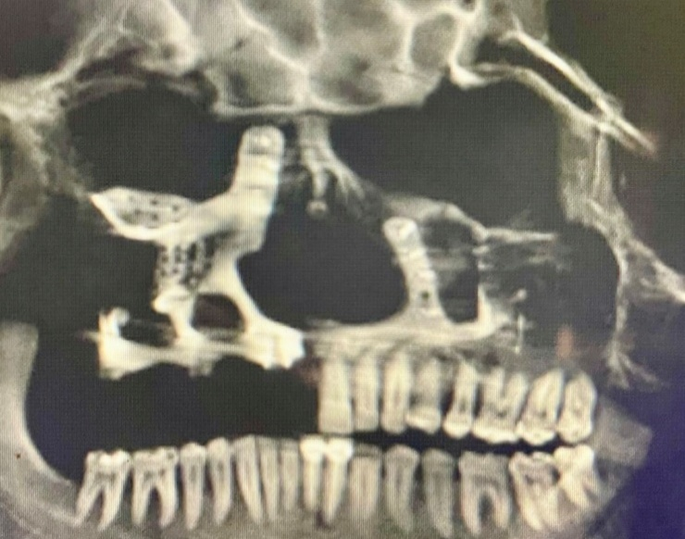

Fig 1 : Pre – operative CBCT image showing partial maxillectomy has been done, and PSI was placed in the earlier surgery

Clinical Examination
Intraoral examination revealed a persistent oroantral defect associated with palatal tissue loss, resulting in inadequate separation between the oral and nasal cavities.
This contributed to impaired speech resonance and nasal regurgitation.
Radiological Assessment
Computed tomography (CT) of the maxillofacial region demonstrated extensive post-infective osteonecrosis with destruction of the maxillary alveolus, sinus walls, and involvement of the orbital floor, resulting in a persistent oroantral communication. The previously placed patient-specific implant (PSI) was visualized, restoring skeletal continuity; however, it failed to address the associated soft tissue defect, correlating with the patient’s functional impairment.
Treatment Planning
Considering the persistent functional deficit and soft tissue deficiency, definitive reconstruction using a microvascular free flap was planned. A radial forearm free flap was selected due to its thin, pliable nature and reliable vascular anatomy, making it suitable for intraoral reconstruction. No significant diagnostic challenges were encountered.
Preoperative evaluation included routine hematological investigations, cardiopulmonary assessment, and vascular assessment of the donor limb using Allen’s test and Doppler ultrasonography, which confirmed adequate collateral circulation.
Timeline
- Initial diagnosis of rhino-maxillary mucormycosis → Surgical debridement and subtotal maxillectomy
- Postoperative antifungal therapy with liposomal amphotericin B
- 6 months later → Reconstruction with patient-specific implant (PSI)
- Persistent functional deficit (nasal regurgitation, speech difficulty)
- Presentation to our department
- Definitive reconstruction with radial forearm free flap
- 3-month follow-up → Successful functional rehabilitation
Surgical Procedure
A multidisciplinary approach was adopted for surgical planning, involving oral and maxillofacial surgeons, anaesthesiologists, and physicians. Preoperative evaluation included routine haematological investigations, cardiopulmonary assessment, and vascular assessment of the donor limb using Allen’s test and Doppler ultrasonography, confirming adequate collateral circulation. A fasciocutaneous radial forearm free flap was designed over the non-dominant forearm to minimize donor-site morbidity. The flap dimensions measured approximately 8 × 4 cm, corresponding to the size of the intraoral defect.
The skin paddle was carefully marked to include reliable perforators from the radial artery. Dissection was performed in a subfascial plane, with meticulous identification and preservation of the radial artery and its venae comitantes. The vascular pedicle was traced proximally to obtain a length of approximately 10–12 cm, ensuring tension-free microvascular anastomosis.
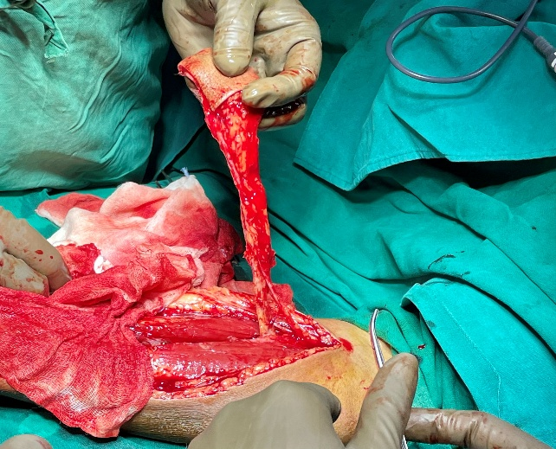
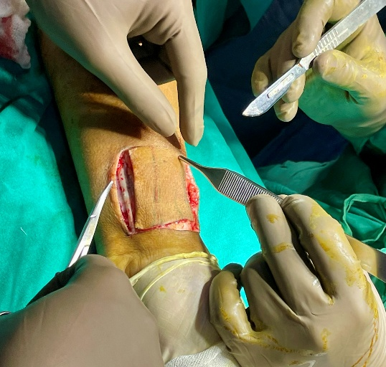
Following elevation, flap perfusion was confirmed. The donor site defect could not be closed primarily and was resurfaced using a split-thickness skin graft harvested from the abdominal region. The graft was secured and immobilized to facilitate optimal healing and graft take.
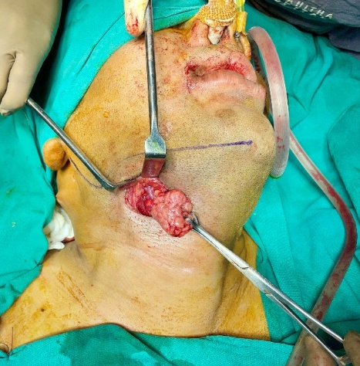

Fig.2 : Intra – operative image showing the submandibular incision and removal of the submandibular gland.

Recipient Site Preparation and Reconstruction
At the recipient site, fibrotic tissue surrounding the palatal defect was excised, and wound margins were refreshed to create a well-vascularized bed. The radial forearm flap was transferred to the intraoral defect and carefully contoured to recreate the separation between the oral and nasal cavities.
A submandibular incision was made to expose recipient vessels. The facial artery and vein were identified, and to facilitate adequate access and tension-free pedicle positioning, the submandibular gland was excised.

Fig. 3: Marking and harvesting of the radial forearm flap: The skin paddle is outlined over the non-dominant forearm, incorporating the radial artery and venae comitantes. Flap elevation provides a long, reliable pedicle with predictable vascularity, making it a dependable option for head and neck reconstruction.
Microvascular anastomosis was performed under magnification. The radial artery was anastomosed end-to-end to the facial artery, and the venae comitantes were anastomosed to the facial vein, ensuring reliable arterial inflow and venous drainage.
The flap was tunnelled into the oral cavity and inset into the palatal defect. Precise suturing was performed to achieve stable fixation and optimal mucosal adaptation, successfully restoring the palatal partition and intraoral continuity.
Postoperative Management
The patient was monitored in the intensive care unit for the first 72 hours. Monitoring included continuous hemodynamic observation, strict fluid and electrolyte balance, adequate analgesia, and administration of prophylactic antibiotics and anticoagulation therapy.
Flap viability was assessed hourly during the first 24 hours and subsequently every 2–4 hours. Parameters monitored included flap color, temperature, capillary refill time, turgor, and bleeding on pin-prick testing.
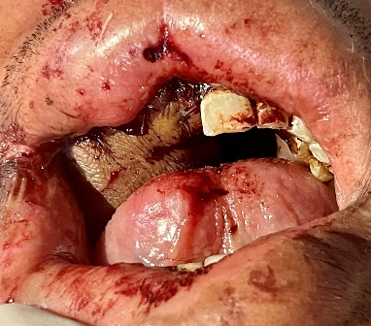
Enteral feeding via a nasogastric tube was maintained for one week, followed by gradual reintroduction of oral feeding after confirmation of satisfactory flap integration.

Fig. 4: Postoperative picture showing a tension free closure of the RFFF to close the OAC.
Outcome
The postoperative course was uneventful, with no evidence of vascular compromise or flap necrosis. The donor site healed satisfactorily without a functional deficit.
At follow-up, the reconstruction demonstrated stable flap integration with effective separation of the oral and nasal cavities. The patient showed complete resolution of nasal regurgitation, significant improvement in speech articulation, and restoration of mastication.
Overall, microvascular reconstruction using a radial forearm free flap successfully restored both anatomical continuity and oral function, effectively overcoming the limitations of prior patient-specific implant (PSI)-based reconstruction.
No adverse or unanticipated events were observed. The patient demonstrated good compliance and tolerated the procedure well.

Discussion
Mucormycosis is an aggressive opportunistic fungal infection characterized by angioinvasion, vascular thrombosis, and rapid tissue necrosis. The surge in mucormycosis cases during the COVID-19 pandemic, particularly in India, has been attributed to immune dysregulation, corticosteroid therapy, and uncontrolled hyperglycaemia [2,3,41,42]. As a result, an increasing number of patients are undergoing extensive surgical debridement or maxillectomy, leading to complex maxillofacial defects that require functional and aesthetic rehabilitation.
Reconstruction of post-mucormycosis maxillary defects presents a unique clinical challenge due to the combined loss of bone and soft tissue, as well as compromised vascularity of the surrounding tissues. These defects frequently result in oroantral or oronasal communications, leading to significant functional impairment, including nasal regurgitation, hyper nasal speech, and difficulty in mastication [6,18].
Several reconstructive options have been described depending on the size and complexity of the defect. Local flaps such as buccal advancement flaps and buccal fat pad flaps are suitable for small defects, while regional flaps such as the temporalis muscle flap may be used for moderate defects [29,30]. Prosthetic rehabilitation using obturator prostheses or implant-supported prostheses offers a non-surgical alternative, particularly in medically compromised patients [18,21,22]. However, these approaches may not provide adequate functional or aesthetic outcomes in large composite defects.
In recent years, patient-specific implants (PSIs) have gained popularity for reconstructing maxillary defects due to their ability to restore skeletal contour and facilitate dental rehabilitation. However, a key limitation of PSI-based reconstruction is its inability to address soft tissue deficiencies and re-establish functional separation between the oral and nasal cavities. In the present case, although PSI restored midfacial structural continuity, the patient continued to experience significant functional deficits, including nasal regurgitation and impaired speech. Possible reasons for PSI failure in such cases include poor vascularity of post-mucormycosis tissues, increased risk of infection, and the inability of alloplastic materials to provide dynamic soft tissue reconstruction.
Microvascular free tissue transfer has therefore emerged as the gold standard for reconstruction of complex maxillofacial defects. Free flaps provide well-vascularized tissue, improve resistance to infection, and enable restoration of both structural integrity and function [16,31,32]. Among the available options, the radial forearm free flap is particularly advantageous due to its thin, pliable skin paddle, long vascular pedicle, and consistent vascular anatomy [10,13,17]. These characteristics make it especially suitable for intraoral reconstruction, where precise contouring and reliable vascular supply are critical.
Alternative free flap options such as the anterolateral thigh flap and fibula free flap may be considered depending on the nature of the defect [11,28]. However, in cases primarily requiring soft tissue reconstruction and restoration of palatal integrity, the radial forearm free flap offers superior adaptability and functional outcomes. In the present case, the flap provided effective separation of the oral and nasal cavities, resulting in significant improvement in speech and mastication.
The postoperative outcome observed in this case is consistent with previous reports demonstrating high success rates and reliable functional outcomes with radial forearm free flap reconstruction [13,33]. At three-month follow-up, the patient showed complete resolution of nasal regurgitation, improved speech articulation, and satisfactory restoration of oral function. These findings highlight the importance of selecting an appropriate reconstructive modality based not only on structural requirements but also on functional considerations.
Strengths and Limitations
A key strength of this case report is the detailed documentation of a clinically relevant reconstructive challenge in the post-COVID era, along with a clear demonstration of the limitations of PSI-based reconstruction and the effectiveness of microvascular free tissue transfer in achieving functional rehabilitation.
However, certain limitations should be acknowledged. This report describes a single clinical case, and therefore, the findings cannot be generalized. Additionally, the follow-up period was limited to three months, and longer-term outcomes regarding flap stability, functional performance, and patient satisfaction require further evaluation.
Conclusion
Post-COVID mucormycosis has led to a significant increase in complex maxillary defects requiring comprehensive rehabilitation. While patient-specific implants can effectively restore skeletal continuity, they may not adequately address associated soft tissue deficiencies or restore functional separation between the oral and nasal cavities.
Microvascular reconstruction using a radial forearm free flap provides a reliable and versatile solution for such defects, enabling restoration of both anatomical integrity and oral function. The present case highlights the importance of individualized treatment planning and underscores the critical role of vascularized soft tissue reconstruction in achieving optimal functional outcomes.
This case emphasizes that successful rehabilitation of maxillary defects extends beyond structural reconstruction and requires careful consideration of functional restoration, thereby contributing valuable clinical insight for the management of post-mucormycosis defects.
Patient Perspective
The patient reported significant improvement in quality of life following the reconstructive procedure. He expressed satisfaction with the restoration of speech and the absence of nasal regurgitation, which had previously affected daily activities. The patient was also pleased with the functional and aesthetic outcome of the treatment.
Future Directions
Advances in digital surgical planning, three-dimensional imaging, and patient-specific implant technology are expected to play an increasingly important role in maxillofacial reconstruction. Integration of computer-assisted design with microvascular free tissue transfer may enhance surgical precision and improve functional outcomes in complex craniofacial defects.
Furthermore, emerging biomaterials and tissue engineering approaches hold promise for the simultaneous restoration of both skeletal and soft tissue components. Continued research, along with multidisciplinary collaboration, will be essential to optimize reconstructive strategies for patients with mucormycosis-associated defects and similar complex maxillofacial conditions.
Ethical Approval and Consent
Ethical approval for publication of this case report was obtained in accordance with institutional guidelines. Written informed consent was obtained from the patient for publication of clinical details and accompanying clinical images. All procedures were performed in accordance with the ethical standards of the institutional and national research committees and in compliance with the Declaration of Helsinki.
Acknowledgements
The authors sincerely acknowledge the contributions of the multidisciplinary team, including anaesthesiologists, endocrinologists, and infectious disease specialists, for their role in patient management and perioperative care. We also thank the Department of Oral and Maxillofacial Surgery, Panineeya Mahavidyalaya Institute of Dental Sciences and Research Centre, for providing the necessary clinical support and infrastructure.
We extend our gratitude to the surgical and nursing staff for their assistance during operative and postoperative management. Finally, we thank the patient for their cooperation and consent, which made this clinical documentation possible.

Disclaimer (Artificial intelligence)
Author(s) hereby declare that NO generative AI technologies such as Large Language Models (ChatGPT, COPILOT, etc.) and text-to-image generators have been used during the writing or editing of this manuscript.
References
- Cornely OA, Alastruey-Izquierdo A, Arenz D, et al. Global guideline for the diagnosis and management of mucormycosis. Lancet Infect Dis. 2019;19(12):e405-e421. https://doi.org/10.1016/S1473-3099(19)30312-3
- Singh AK, Singh R, Joshi SR, Misra A. Mucormycosis in COVID-19: a systematic review of cases reported worldwide and in India. Diabetes Metab Syndr. 2021;15(4):102146. https://doi.org/10.1016/j.dsx.2021.05.019
- Sen M, Honavar SG, Bansal R, et al. Epidemiology, clinical profile, management, and outcome of COVID-19-associated rhino-orbital-cerebral mucormycosis in 2826 patients in India (COSMIC study). Indian J Ophthalmol. 2021;69(7):1670-1692. https://doi.org/10.4103/ijo.IJO_1565_21
- Therakathu J, Prabhu S, Irodi A, et al. Imaging features of rhinocerebral mucormycosis: a study of 43 patients. Egypt J Radiol Nucl Med. 2018;49(2):447-452. https://doi.org/10.1016/j.ejrnm.2018.01.005
- Spellberg B, Edwards J Jr, Ibrahim A. Novel perspectives on mucormycosis: pathophysiology, presentation, and management. Clin Microbiol Rev. 2005;18(3):556-569. https://doi.org/10.1128/CMR.18.3.556-569.2005
- Killey HC, Kay LW. Observations based on the surgical closure of 362 oro-antral fistulas. Int Surg. 1972;57(7):545-549.
- Cordeiro PG, Santamaria E. A classification system and algorithm for reconstruction of maxillectomy and midfacial defects. Plast Reconstr Surg. 2000;105(7):2331-2346. https://doi.org/10.1097/00006534-200006000-00004
- Herrera DA, Dublin AB, Ormsby EL, Aminpour S, Howell LP. Imaging findings of rhinocerebral mucormycosis. Skull Base. 2009;19(2):117-125. https://doi.org/10.1055/s-0028-1096209
- Middlebrooks EH, Frost CJ, De Jesus RO, et al. Imaging of sino-orbital fungal infections: a comprehensive review. AJNR Am J Neuroradiol. 2021;42(3):404-412. https://doi.org/10.3174/ajnr.A6952
- Yang GF, Chen PJ, Gao YZ. Forearm free skin flap transplantation. Br J Plast Surg. 1981;34(2):162-165. https://doi.org/10.1016/0007-1226(81)90064-7
- Wei FC, Jain V, Celik N, Chen HC, Chuang DC, Lin YT. Have we found an ideal soft-tissue flap? Experience with 672 anterolateral thigh flaps. Plast Reconstr Surg. 2002;109(7):2219-2226. https://doi.org/10.1097/00006534-200206000-00007
- Ibrahim AS, Spellberg B, Walsh TJ, Kontoyiannis DP. Pathogenesis of mucormycosis. Clin Infect Dis. 2012;54(Suppl 1):S16-S22. https://doi.org/10.1093/cid/cir865
- Rapidis AD, et al. The radial forearm free flap in the reconstruction of intraoral defects. J Oral Maxillofac Surg. 2000;58(2):140-145. https://doi.org/10.1016/S0278-2391(00)00228-2
- Antonyshyn O, et al. Radial forearm free flap in head and neck reconstruction. Head Neck Surg. 1984;6(5):370-383. https://doi.org/10.1002/hed.2890060504
- Brown JS, Shaw RJ. Reconstruction of the maxilla and midface: introducing a new classification. Lancet Oncol. 2016;17(3):e248-e260. https://doi.org/10.1016/S1470-2045(16)00043-5
- Wong CH, Wei FC. Microsurgical free flap in head and neck reconstruction. Ann Plast Surg. 2007;59(2):210-216. https://doi.org/10.1097/SAP.0b013e31802f5c9a
- Soutar DS, et al. The radial forearm flap: a versatile method for intraoral reconstruction. Br J Plast Surg. 1983;36(1):1-8. https://doi.org/10.1016/0007-1226(83)90002-3
- Rogers SN, Lowe D, McNally D, Brown JS, Vaughan ED. Health-related quality of life after maxillectomy: comparison between prosthetic obturation and free flap reconstruction. Br J Oral Maxillofac Surg. 2003;41(1):7-14. https://doi.org/10.1016/S0266-4356(02)00267-7
- Mehrotra D, et al. Free flap reconstruction in mucormycosis patients: experience from India. Natl Med J India. 2021;34(6):341-345. https://doi.org/10.4103/0970-258X.333450
- Selvaraj V, et al. Microvascular reconstruction in post-mucormycosis maxillofacial defects: case series. J Maxillofac Oral Surg. 2022;21(2):282-288. https://doi.org/10.1007/s12663-021-01605-1
- Trivedi A, Agarwal S, Mowar A, Goswami R, Tyagi M. Futuristic rehabilitation technique of acquired maxillectomy defect in post-COVID-19 mucormycosis using polyether ether ketone obturator prosthesis: a case report. J Pharm Negat Results. 2022;13(Suppl 10):258-263. https://doi.org/10.47750/pnr.2022.13.S10.258
- Tyagi M, Trivedi A, Agarwal S, Mowar A, Goswami R. A case report depicting an implant-supported prosthetic rehabilitation of an immunocompromised patient with a bilateral subtotal maxillectomy defect secondary to mucormycosis. Int J All Res Educ Sci Methods. 2022. https://doi.org/10.56025/IJARESM.2022.1012221602
- Patel A, Agarwal R, Rudramurthy SM, et al. Multicenter epidemiologic study of mucormycosis in India. Emerg Infect Dis. 2020;26(9):1-9. https://doi.org/10.3201/eid2609.200915
- Skiada A, Pavleas I, Drogari-Apiranthitou M. Epidemiology and diagnosis of mucormycosis: an update. J Fungi. 2020;6(4):265. https://doi.org/10.3390/jof6040265
- Sarkar S, Gokhale T, Choudhury SS, Deb AK. COVID-19 and orbital mucormycosis. Clin Ophthalmol. 2021;15:2963-2974. https://doi.org/10.2147/OPTH.S311450
- Elledge R, et al. Reconstruction of maxillary defects: current concepts. Br J Oral Maxillofac Surg. 2020;58(4):e12-e20. https://doi.org/10.1016/j.bjoms.2020.05.004
- Futran ND, Mendez E. Developments in reconstruction of midface defects. Lancet Oncol. 2006;7(3):249-258. https://doi.org/10.1016/S1470-2045(06)70630-6
- Hidalgo DA. Fibula free flap: a new method of mandible reconstruction. Plast Reconstr Surg. 1989;84(1):71-79. https://doi.org/10.1097/00006534-198907000-00004
- Baumann A, Ewers R. Application of the buccal fat pad flap in oral reconstruction. Int J Oral Maxillofac Surg. 2000;29(3):173-176. https://doi.org/10.1016/S0901-5027(00)80017-3
- Temiz G, et al. Temporalis muscle flap reconstruction of maxillary defects. J Craniofac Surg. 2015;26(6):e564-e567. https://doi.org/10.1097/SCS.0000000000001881
- Urken ML, Weinberg H, Vickery C, et al. The combined use of composite free flaps in head and neck reconstruction. Head Neck. 1991;13(5):381-392. https://doi.org/10.1002/hed.2880130506
- Hanasono MM, Skoracki RJ. Microvascular reconstruction of complex defects. Clin Plast Surg. 2010;37(3):419-432. https://doi.org/10.1016/j.cps.2010.03.007
- Peng X, Mao C, Yu GY, Guo CB, Huang MX. Reconstruction of maxillary defects using radial forearm free flap. J Oral Maxillofac Surg. 2014;72(12):2489-2497. https://doi.org/10.1016/j.joms.2014.03.015
- Gil Z, Fliss DM. Reconstruction of skull base and midface defects. Head Neck. 2007;29(2):146-156. https://doi.org/10.1002/hed.20468
- Chandu A, Bridgeman A. Reconstruction of maxillectomy defects. Aust Dent J. 2012;57(1):102-107. https://doi.org/10.1111/j.1834-7819.2011.01653.x
- Sharma S, Grover M, Bhargava S, Samdani S, Kataria T. Post-COVID mucormycosis: a review of cases from India. J Oral Biol Craniofac Res. 2022;12(1):111-115. https://doi.org/10.1016/j.jobcr.2021.11.002
- Kulkarni R, et al. Surgical management of rhino-orbital mucormycosis. Indian J Otolaryngol Head Neck Surg. 2022;74(Suppl 2):2785-2792. https://doi.org/10.1007/s12070-021-02952-3
- Sen M, Lahane S, Lahane TP, Parekh R, Honavar SG. Mucor in a viral land: a tale of two pathogens. Indian J Ophthalmol. 2021;69(2):244-252. https://doi.org/10.4103/ijo.IJO_3774_20
- Skiada A, Lass-Florl C, Klimko N, Ibrahim A, Roilides E, Petrikkos G. Challenges in the diagnosis and treatment of mucormycosis. Med Mycol. 2018;56(Suppl 1):93-101. https://doi.org/10.1093/mmy/myx101
- Spellberg B, Kontoyiannis DP, Fredricks D, et al. Risk factors for mortality in mucormycosis. Clin Infect Dis. 2012;54(Suppl 1):S52-S60. https://doi.org/10.1093/cid/cir879
- Pal R, Singh B, Bhadada SK, Banerjee M, Bhogal RS, Hage N, Kumar A.
COVID-19-associated mucormycosis: An updated systematic review of literature.
Mycoses. 2021;64(12):1452–1459.
doi: 10.1111/myc.13338
- Selarka L, Sharma S, Saini D, Sharma S, Batra A, Waghmare VT, et al.
Mucormycosis and COVID-19: An epidemic within a pandemic in India.
Mycoses. 2021;64(10):1253–1260.
doi: 10.1111/myc.13353

