Microvascular Reconstruction of Maxillary Defects After Post-COVID Mucormycosis: Role of Radial Forearm Free Flap in Functional Rehabilitation
Abstract
Post-COVID mucormycosis has led to a surge in patients presenting with maxillary defects, necessitating exploration of diverse rehabilitation modalities. This case report highlights the reconstructive management of an oroantral defect using a radial forearm free flap. The patient initially underwent planning with a patient-specific implant (PSI), which was later abandoned due to technical limitations, and reconstruction was subsequently performed with microvascular free tissue transfer. The defect measured approximately 8x4 cm, and flap harvesting, vascular anastomosis, and inset were carried out meticulously. Postoperative outcomes demonstrated satisfactory healing, functional rehabilitation with restoration of oral competence, and improvement in speech and mastication. Follow-up over 72 hours confirmed stable results and patient satisfaction. This report underscores the importance of considering alternative rehabilitation options—including obturator prostheses, implant-supported prostheses, and regional flaps—in managing post-mucormycosis maxillary defects, while highlighting the role of radial forearm free flap as a reliable reconstructive choice.
Keywords: Mucormycosis, Oroantral communication, Free tissue transfer, Maxillary reconstruction, Radial forearm flap
Introduction
Mucormycosis is a rapidly progressive and potentially fatal opportunistic fungal infection caused by filamentous fungi belonging to the order Mucorales. These organisms exhibit a characteristic angioinvasive behaviour, invading blood vessels and producing vascular thrombosis, tissue ischemia, and extensive necrosis of the affected structures [1,5,12]. The infection predominantly affects immunocompromised individuals, particularly patients with uncontrolled diabetes mellitus, haematological malignancies, organ transplantation, or prolonged corticosteroid therapy [1,12]. The global incidence of mucormycosis increased significantly during the coronavirus disease 2019 (COVID-19) pandemic, especially in countries with a high prevalence of diabetes, such as India [2,3]. Several studies have demonstrated that the combination of immune dysregulation caused by SARS-CoV-2 infection, widespread corticosteroid use, and hyperglycaemia creates a favourable environment for fungal proliferation and invasive disease [2,3,38].
Rhino-orbital-cerebral mucormycosis represents the most common clinical presentation of this infection, frequently involving the nasal cavity, paranasal sinuses, orbit, and maxilla [3,4]. The maxilla is particularly susceptible to fungal invasion due to its relatively thin cortical plates, abundant vascular channels, and close anatomical relationship with the maxillary sinus and nasal cavity [4,8]. Progressive fungal invasion leads to osteomyelitis and necrosis of the maxillary bone, often necessitating aggressive surgical debridement or partial maxillectomy to eradicate infected tissues [5,8,9]. Early diagnosis and prompt management combining radical surgical debridement with systemic antifungal therapy, most commonly amphotericin B, are considered essential for improving patient survival [1,5].
Although aggressive surgical management is life-saving, it frequently results in extensive maxillary defects that compromise the structural integrity of the midface. Such defects commonly lead to oroantral or oronasal communications, which significantly impair oral function and quality of life [6]. Persistent oroantral communication may result in nasal regurgitation of fluids, hypernasal speech, chronic sinusitis, impaired mastication, and aesthetic deformity [6,18]. Restoration of these defects, therefore, represents an important component of comprehensive patient rehabilitation.
Various reconstructive approaches have been described for the management of post-maxillectomy defects. Small defects can often be managed using local or regional flaps such as buccal advancement flaps or buccal fat pad flaps [29]. Larger defects may require regional muscle flaps such as the temporalis muscle flap, which provides reliable vascularized tissue coverage for midfacial reconstruction [30]. Prosthetic rehabilitation using obturator prostheses or implant-supported prosthetic devices has also been widely employed for functional restoration in selected cases [18,21,22]. However, these approaches may be insufficient in cases involving large composite defects or extensive soft tissue loss.
In such situations, microvascular free tissue transfer has emerged as the gold standard for reconstructing complex maxillofacial defects. Free flaps provide well-vascularized tissue, allow restoration of both soft tissue and structural support, and improve functional outcomes related to speech, swallowing, and mastication [16,31,32]. Among the available options, the radial forearm free flap is widely regarded as one of the most versatile flaps for intraoral and midfacial reconstruction due to its thin, pliable tissue, long vascular pedicle, and reliable anatomy [10,13,17]. Numerous studies have demonstrated favourable outcomes with this flap in reconstructing intraoral defects, providing effective separation of the oral and nasal cavities while preserving functional rehabilitation [13,33].
With the rising incidence of post-COVID mucormycosis and the increasing number of patients undergoing maxillectomy for disease control, reconstructive surgeons are frequently confronted with complex maxillary defects requiring functional and aesthetic rehabilitation. The present case report describes the clinical application of a radial forearm free flap for the reconstruction of an oroantral communication following mucormycosis-related maxillary bone loss, highlighting the surgical considerations, reconstructive planning, and functional outcomes associated with this technique.
Case Report
A 52-year-old male presented to the Department of Oral and Maxillofacial Surgery following treatment for rhino-maxillary mucormycosis. The patient had previously undergone aggressive surgical management, including a right-sided subtotal maxillectomy with extensive debridement of necrotic bone, followed by systemic antifungal therapy with liposomal amphotericin B. After resolution of active infection, reconstruction using a patient-specific implant (PSI) had been performed approximately six months earlier to restore skeletal continuity of the midface.
Despite the initial reconstruction, the patient continued to experience significant functional impairment. The chief complaints included hypernasal speech, nasal regurgitation of liquids, and difficulty in mastication. Clinical examination revealed a persistent oroantral communication associated with palatal tissue deficiency, which compromised oral–nasal separation and speech resonance. The patient sought definitive reconstruction aimed at restoring oral function and improving quality of life.
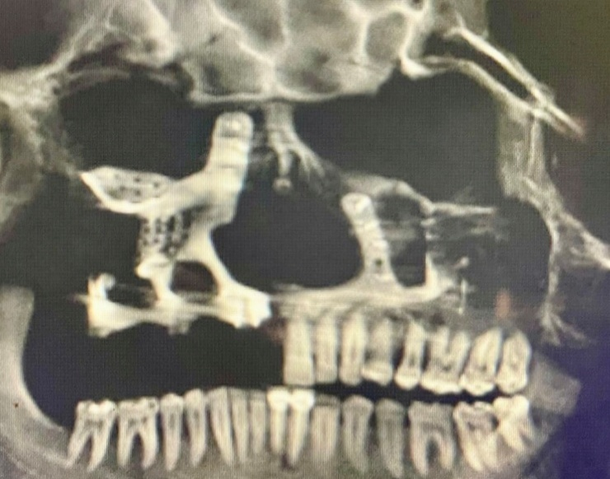
Radiological Assessment: Computed tomography (CT) of the maxillofacial region demonstrated extensive post-infective osteonecrosis changes involving the maxilla. Marked destruction of the left maxillary alveolus was noted, with extension into the anterior wall and lateral wall of the maxillary sinus. Superiorly, the defect involved the orbital floor and medial orbital wall. The pathology extended across the midline, with erosion of the medial wall of the right maxillary sinus.
A clear communication between the oral cavity and maxillary sinus was evident, consistent with a persistent oroantral defect. The previously placed patient-specific implant was visualized, restoring partial skeletal continuity of the midface. The PSI extended bilaterally across the medial wall of the nasal cavity toward the zygomatic buttresses and incorporated dental rehabilitation components on the right side.
The radiological findings were consistent with post-infective maxillary osteonecrosis secondary to rhino-maxillary mucormycosis, characterized by aggressive bony destruction with sinus and orbital involvement. Although the PSI restored structural support, soft-tissue deficiency persisted, resulting in functional compromise and necessitating definitive reconstructive intervention.

Surgical Management
Preoperative preparation was undertaken through a multidisciplinary approach involving oral and maxillofacial surgeons, anaesthesiologists, endocrinologists, and infectious disease specialists.
Baseline laboratory investigations, including complete blood count, renal and hepatic function tests, and coagulation profile, were performed to rule out systemic compromise. Chest radiography and electrocardiography were obtained to evaluate cardiopulmonary fitness for general anaesthesia.
Although the patient was non-diabetic, routine perioperative blood glucose monitoring was conducted as part of standard surgical protocol due to the known association between hyperglycaemia and mucormycosis.
The patient had previously completed systemic antifungal therapy with liposomal amphotericin B. Preoperative imaging and clinical evaluation confirmed the absence of active fungal infection. Prophylactic broad-spectrum antibiotics were initiated 24 hours before surgery to reduce the risk of perioperative infection.
Fig 1: Pre – operative CBCT image showing partial maxillectomy has been done, and PSI was placed in the earlier surgery.
Nutritional evaluation was performed, and high-protein supplementation was initiated to promote optimal wound healing. Electrolyte abnormalities were corrected, and hydration status was optimized before surgery.
Because a radial forearm free flap was planned, vascular evaluation of the donor limb was performed. Allen’s test confirmed adequate collateral circulation through the ulnar artery. Doppler ultrasonography further confirmed patency of the radial artery and suitability for flap harvest.
The perioperative medication regimen included:
Fig .2. Images showing the anatomy of RFFF harvesting

Antibiotics: Ceftriaxone and
metronidazole for broad-spectrum coverage.
Antifungal surveillance: Oral posaconazole was continued as maintenance therapy due to prior mucormycosis.
Analgesia: NSAIDs and opioids were administered for postoperative pain control.
Anticoagulation: Prophylactic low-molecular-weight heparin was administered to reduce the risk of microvascular thrombosis.
The patient was counselled regarding the planned microvascular reconstruction, possible donor-site morbidity, and the need for split-thickness skin grafting at the donor site. Informed written consent was obtained for radial forearm flap harvest, microvascular anastomosis, and donor site reconstruction.
Flap Design and Elevation
A fasciocutaneous radial forearm free flap was designed over the non-dominant forearm to minimize functional morbidity. The flap dimensions measured approximately 8 × 4 cm, corresponding to the size of the intraoral defect requiring reconstruction.
The skin paddle was carefully marked to include reliable perforators from the radial artery. Following the incision, dissection was carried out in a subfascial plane. The radial artery and its venae comitantes were identified and meticulously isolated. The vascular pedicle was traced proximally to obtain an adequate pedicle length of approximately 10–12 cm, allowing tension-free microvascular anastomosis at the recipient site.
Care was taken to preserve the integrity of the vascular bundle during flap elevation. The flap demonstrated adequate perfusion following pedicle isolation.

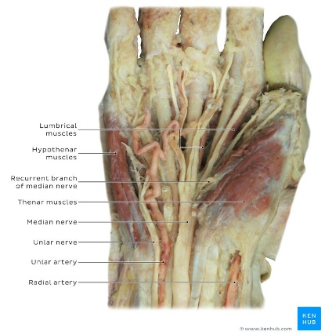
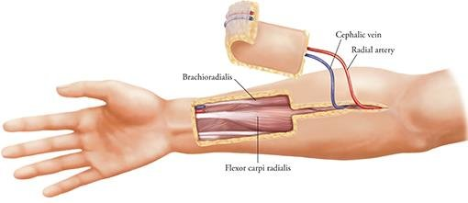
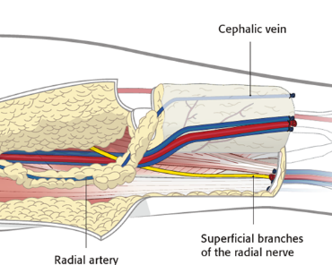

Images showing the anatomy of RFFF harvesting

The resultant donor site defect could not be closed primarily. Therefore, resurfacing was performed using a split-thickness skin graft harvested from the abdominal region. The graft was secured over the forearm defect and dressed with immobilization to facilitate graft take and minimize shear forces.
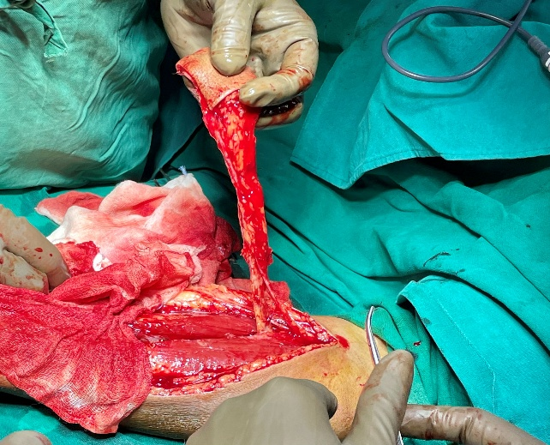
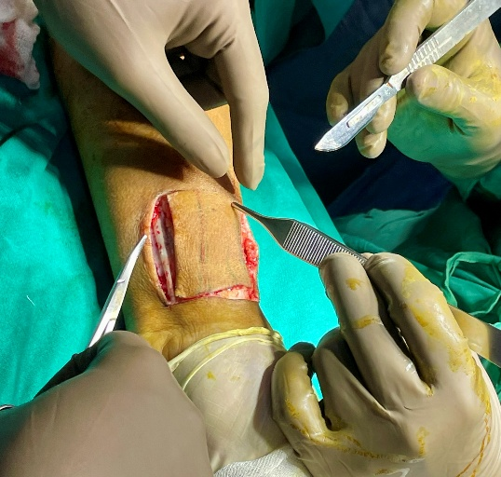
The radial forearm flap was selected because of its thin and pliable skin paddle, predictable vascular anatomy, and long pedicle length. These characteristics make it particularly suitable for intraoral and palatal reconstruction, where precise contouring and reliable vascular supply are essential. Reported survival rates of radial forearm free flaps exceed 95% in head and neck reconstruction, making it one of the most dependable reconstructive options.
Fig. 3: Marking and harvesting of the radial forearm flap: The skin paddle is outlined over the non-dominant forearm, incorporating the radial artery and venae comitantes. Flap elevation provides a long, reliable pedicle with predictable vascularity, making it a dependable option for head and neck reconstruction.

Advantages vs Limitations of Radial Forearm Flap
Advantages | Limitations
Predictable vascular anatomy with reliable venous drainage (radial artery + venae comitantes + cephalic vein) | Donor site morbidity (tendon exposure, need for skin graft)
Thin, pliable skin paddle ideal for intraoral lining and contour | Cosmetic concerns at donor site (visible scar, contour defect)
Long pedicle length allows tension-free anastomosis | Potential reduction in grip strength if harvested from the dominant forearm
High survival rates (>95%) in head and neck reconstruction | Requires careful patient selection (vascular status of the forearm must be adequate)
Versatile design adaptable to complex defects | Limited bulk—may not be suitable for large volume reconstruction

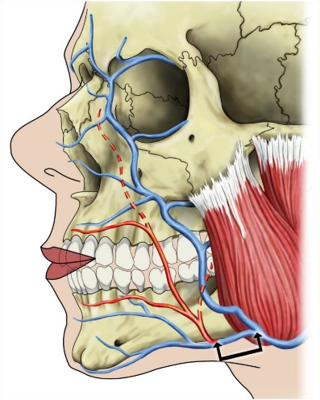
Recipient Site Reconstruction
Following preparation of the recipient site, fibrotic tissue surrounding the palatal defect was excised, and the wound margins were refreshed. The radial forearm flap was then transferred to the intraoral defect and carefully contoured to recreate the separation between the oral and nasal cavities.
Microvascular anastomosis was performed under surgical magnification. The radial artery was anastomosed end-to-end to the facial artery, while the venae comitantes were anastomosed to the facial vein, ensuring adequate arterial inflow and venous drainage.

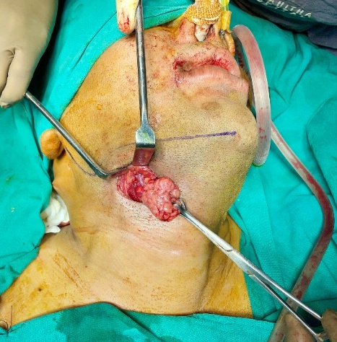
A submandibular incision was made to facilitate exposure of the recipient vessels. During this stage, the right submandibular gland was excised to improve surgical access and allow tension-free positioning of the vascular pedicle.
The flap was then tunnelled into the oral cavity and inset into the palatal defect. Precise suturing of the flap margins was performed to ensure stable fixation and optimal mucosal adaptation.
Fig -4: An anatomical image showing where anastomosis takes place with the facial artery in closing the OAC using RFFF
This technique successfully recreated palatal partitioning and restored intraoral continuity.
Postoperative Management: The patient was monitored in the intensive care unit for the first 72 hours following surgery.
Monitoring included: Continuous hemodynamic observation
Strict fluid and electrolyte balance
Regular pain control
Prophylactic antibiotics and anticoagulation therapy
Fig 5:Intra – operative image showing the submandibular incision and removal of the submandibular gland.
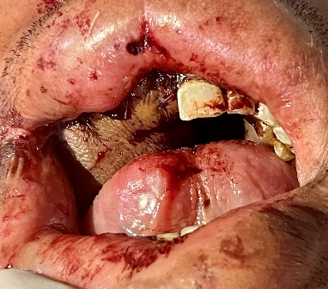
Flap viability was assessed hourly during the first 24 hours and every 2–4 hours thereafter. Parameters monitored included flap colour, temperature, capillary refill time, turgor, and bleeding on pin-prick testing.

Fig 6: Post operative picture showing a tension free closure of the RFFF to close the OAC.

Enteral feeding was maintained via a nasogastric tube for one week to protect the intraoral reconstruction. Oral feeding was gradually resumed after confirmation of adequate flap integration and mucosal healing.
Follow-up and Outcome
The postoperative period was uneventful with no evidence of vascular compromise or flap necrosis.
At the three-month follow-up, the patient demonstrated significant functional improvement: Complete resolution of nasal regurgitation
Marked improvement in speech articulation and resonance
Stable integration of the radial forearm flap with surrounding tissues
Adequate restoration of palatal separation
The donor site healed satisfactorily with the split-thickness skin graft, and no functional deficit of the forearm was observed.
Overall, the reconstruction successfully restored both structural integrity and oral function, highlighting the reliability of radial forearm free flap reconstruction in managing complex oroantral defects following mucormycosis-related maxillary bone loss.
On computed tomography, extensive post-infective osteonecrosis changes were noted in the maxilla. There was significant destruction of the left maxillary alveolus, with the defect extending into the anterior wall of the maxilla, the lateral wall of the maxillary sinus, and further involving the orbital floor and medial orbital wall. The pathology crossed the midline, with erosion of the medial wall of the right maxillary sinus, and a clear communication with the maxillary sinus cavity was evident, consistent with oroantral involvement. Reconstruction with a patient-specific implant (PSI) was visualized, restoring skeletal continuity. The PSI extended across the medial wall of the nasal cavity bilaterally, reaching up to the zygomatic buttresses on both sides, and incorporated dental rehabilitation on the right side. Overall, the radiological features were characteristic of post-infective maxillary osteonecrosis secondary to rhino-maxillary mucormycosis, demonstrating aggressive bony destruction with sinus and orbital extension, and subsequent PSI reconstruction to re-establish midfacial support and partial dental function.
Discussion
Mucormycosis is a rapidly progressive and life-threatening opportunistic fungal infection caused by organisms belonging to the order Mucorales. The disease is characterized by its angioinvasive nature, whereby fungal hyphae invade vascular structures, leading to thrombosis, ischemia, and extensive tissue necrosis. This vascular invasion not only accelerates local tissue destruction but also impairs the delivery of systemic antifungal agents, thereby complicating treatment and contributing to the high morbidity and mortality associated with the disease [1,5,12,39]. Mucormycosis most frequently affects individuals with compromised immune systems, particularly patients with uncontrolled diabetes mellitus, prolonged corticosteroid therapy, malignancies, organ transplantation, or other immunosuppressive conditions [1,12,40]. During the COVID-19 pandemic, a dramatic global surge in mucormycosis cases was reported, particularly in India, where a high prevalence of diabetes combined with extensive corticosteroid use created a favourable environment for fungal proliferation. Several epidemiological studies have demonstrated that COVID-19-associated immune dysregulation, hyperglycaemia, and steroid-induced immunosuppression significantly increase susceptibility to invasive fungal infections [2,3,23,25,36,38].
The rhino-orbital-cerebral form of mucormycosis represents the most common clinical presentation and typically involves the nasal cavity, paranasal sinuses, orbit, and adjacent craniofacial structures [3,4,8]. The maxillofacial skeleton is particularly vulnerable due to its close proximity to the sinonasal cavity, which serves as the primary portal of fungal entry through inhaled spores. Once established in the paranasal sinuses, the infection can rapidly spread to surrounding bones and soft tissues, leading to osteomyelitis and necrosis of the maxilla, palate, and orbital structures [4,8,9]. The maxilla is especially susceptible to fungal invasion because of its porous trabecular architecture and abundant vascular channels that facilitate rapid dissemination of fungal hyphae. In advanced cases, this destructive process may involve the alveolar bone, maxillary sinus walls, orbital floor, and nasal cavity, resulting in extensive midfacial defects [4,9,37].
Management of mucormycosis requires a multidisciplinary approach combining early diagnosis, aggressive surgical debridement, and systemic antifungal therapy. Liposomal amphotericin B remains the cornerstone of pharmacological treatment, often followed by step-down therapy with agents such as posaconazole or azaconazole [1,5,24]. Surgical debridement is essential because removal of necrotic tissue reduces fungal load and improves penetration of antifungal medications. However, radical surgical intervention frequently results in partial or subtotal maxillectomy, producing complex defects of the palate and maxillary sinus. These defects often create persistent oroantral or oronasal communications that severely compromise oral function and patient quality of life [6,18]. Functional consequences may include nasal regurgitation of fluids, hypernasal speech, impaired mastication, chronic sinus infections, and aesthetic deformity of the midface [6,18].
Reconstruction of such defects poses a significant clinical challenge because both structural integrity and functional separation of the oral and nasal cavities must be restored. Several reconstructive strategies have been described depending on the size and complexity of the defect. For small oroantral communications, local flaps such as buccal advancement flaps or buccal fat pad flaps have demonstrated reliable outcomes with relatively low morbidity [29]. Regional flaps, including the temporalis muscle flap, can be utilized for moderate-sized defects and provide vascularized tissue capable of restoring soft tissue bulk and improving oral-nasal separation [30]. Prosthetic rehabilitation with obturator prostheses has traditionally been widely used following maxillectomy because it allows restoration of oral function without additional surgical procedures [18]. More recently, implant-supported prosthetic rehabilitation and advanced biomaterials such as polyether ether ketone (PEEK) obturator prostheses have been introduced as innovative approaches for managing post-maxillectomy defects [21,22].
Despite these advances, prosthetic rehabilitation may not always provide optimal functional or aesthetic outcomes in patients with extensive composite defects involving both bone and soft tissue. In such cases, microvascular free tissue transfer has emerged as the preferred reconstructive modality because it provides well-vascularized tissue capable of restoring anatomical continuity and improving long-term functional outcomes. Free flaps also improve resistance to infection, enhance wound healing, and facilitate restoration of speech, mastication, and swallowing [16,31,32]. Several free flap options have been described for maxillofacial reconstruction, including the anterolateral thigh flap, fibula free flap, and scapular flap, each offering specific advantages depending on the nature of the defect [11,28,31,32].
Among these reconstructive options, the radial forearm free flap remains one of the most widely used techniques for intraoral and palatal reconstruction. Originally described for head and neck reconstruction in the early 1980s, this flap has gained widespread acceptance because of its thin, pliable skin paddle, long vascular pedicle, and consistent vascular anatomy [10,13,17]. The radial artery provides a reliable arterial supply, while the accompanying venae comitantes and cephalic vein ensure adequate venous drainage, contributing to the high success rates reported in the literature. Several studies have documented flap survival rates exceeding 95% in head and neck reconstruction, highlighting the reliability of this technique [16,31,32]. The thin and flexible nature of the radial forearm flap allows it to conform well to the complex three-dimensional contours of the palate and oral cavity, thereby facilitating effective restoration of oral-nasal separation and functional speech resonance [13,17,33].
Another advantage of the radial forearm flap is the length and calibre of its vascular pedicle, which permits tension-free microvascular anastomosis with recipient vessels such as the facial artery and vein. This feature simplifies the reconstructive procedure and improves flap viability. In addition, harvesting the flap from the non-dominant forearm minimizes functional morbidity, and the donor site can be effectively resurfaced using a split-thickness skin graft. Although donor site complications such as visible scarring or tendon exposure have been reported, careful surgical technique and appropriate grafting techniques can significantly reduce these risks [13,17,33].
In the present case, the patient had previously undergone reconstruction using a patient-specific implant following subtotal maxillectomy. Patient-specific implants have become increasingly popular in maxillofacial reconstruction because they allow precise anatomical restoration of skeletal defects through computer-assisted design and three-dimensional printing technologies. These implants can effectively restore midfacial contour and provide support for dental rehabilitation. However, while PSIs are highly effective in restoring bony architecture, they do not address associated soft tissue deficiencies or restore functional separation between the oral and nasal cavities. As a result, patients may continue to experience functional problems such as nasal regurgitation and hypernasal speech despite adequate skeletal reconstruction.
In such scenarios, soft tissue reconstruction using vascularized flaps becomes essential to achieve complete functional rehabilitation. In the present case, the radial forearm free flap was selected to reconstruct the persistent oroantral defect and restore palatal integrity. The thin and adaptable skin paddle allowed precise adaptation to the palatal defect, while the long vascular pedicle enabled reliable microvascular anastomosis with the facial vessels. Removal of the submandibular gland during the procedure facilitated improved access to recipient vessels and allowed tension-free positioning of the pedicle. This surgical approach ensured adequate arterial inflow and venous drainage, thereby enhancing flap viability and long-term stability of the reconstruction.
The postoperative outcome observed in this case was favourable and consistent with outcomes reported in previous studies of radial forearm free flap reconstruction. At three months of follow-up, the patient demonstrated complete resolution of nasal regurgitation and significant improvement in speech articulation. The flap integrated well with the surrounding tissues and maintained stable separation between the oral and nasal cavities. In addition, the donor site healed satisfactorily with the split-thickness skin graft, and no functional deficit of the forearm was observed. These findings further support the reliability and versatility of the radial forearm free flap in managing complex intraoral defects and restoring oral function [13,33].
Overall, this case underscores the importance of individualized reconstructive planning in patients with mucormycosis-associated maxillary defects. Although prosthetic rehabilitation and patient-specific implants can restore skeletal continuity and midfacial contour, microvascular soft tissue reconstruction remains essential for achieving optimal functional outcomes in patients with large oroantral communications. The radial forearm free flap continues to represent a dependable and versatile reconstructive option, offering excellent functional restoration, reliable vascularity, and acceptable donor site morbidity in the management of complex maxillofacial defects following mucormycosis.
Clinical Implications and Functional Rehabilitation
Successful rehabilitation of maxillary defects following mucormycosis requires restoration not only of anatomical continuity but also of essential oral functions, including speech, mastication, and swallowing. In the present case, the patient initially underwent reconstruction using a patient-specific implant, which successfully restored skeletal continuity of the midface. However, despite adequate structural reconstruction, the patient continued to experience functional limitations such as nasal regurgitation of fluids, hypernasal speech, and difficulty in mastication. These symptoms occurred because the implant alone could not restore the soft tissue barrier necessary for effective separation between the oral and nasal cavities. Such limitations highlight an important consideration in maxillofacial reconstruction: restoration of bony architecture does not always equate to restoration of function. In cases where significant palatal tissue loss persists, vascularized soft-tissue reconstruction becomes essential to achieve optimal rehabilitation.
The radial forearm free flap provided an effective solution in this scenario by recreating the palatal partition and restoring intraoral continuity. The thin and pliable nature of the flap allowed accurate contouring of the palatal defect, thereby improving speech resonance and preventing nasal regurgitation. At the three-month postoperative evaluation, the patient demonstrated marked improvement in articulation and complete resolution of nasal regurgitation, indicating successful functional rehabilitation. These outcomes support previous reports demonstrating that vascularized free flaps provide superior functional restoration in large palatal defects when compared with prosthetic obturation alone [13,18,33].
In addition to microvascular reconstruction, several alternative rehabilitation strategies have been described for patients with maxillary defects following mucormycosis. Prosthetic obturators remain an important option, particularly in medically compromised patients who may not tolerate extensive reconstructive surgery [18]. More recently, implant-supported prosthetic rehabilitation and advanced biomaterials such as polyether ether ketone obturator prostheses have been introduced as innovative approaches to improve stability and patient comfort [21,22]. Regional flaps such as the temporalis muscle flap and local flaps, including the buccal fat pad flap, also provide reliable options for selected defects depending on size and anatomical location [29,30]. However, in large composite defects involving both bone and soft tissue, microvascular free flap reconstruction remains the most comprehensive solution because it restores both structural and functional components of the defect [16,31,32].
Conclusion
Mucormycosis remains a devastating fungal infection that frequently necessitates aggressive surgical debridement to control disease progression. While life-saving, such surgical interventions often produce extensive maxillary defects that significantly impair oral function and quality of life. Reconstruction of these defects, therefore, represents a critical component of comprehensive patient management. The present case demonstrates that although patient-specific implants can successfully restore skeletal continuity of the midface, they may not adequately address associated soft tissue deficiencies or restore functional separation between the oral and nasal cavities.
Microvascular reconstruction using a radial forearm free flap provided an effective solution for restoring palatal integrity and achieving functional rehabilitation in this patient. The flap’s thin and pliable tissue characteristics, reliable vascular anatomy, and long pedicle length allowed precise adaptation to the palatal defect and facilitated tension-free microvascular anastomosis. Postoperative outcomes demonstrated stable flap integration and significant improvement in speech and swallowing function. These findings highlight the versatility and reliability of the radial forearm free flap in managing complex oroantral defects following mucormycosis-related maxillary bone loss.
Limitations of the Case Report
Despite the favourable outcome observed in this case, certain limitations should be acknowledged. This report describes the management of a single patient, and therefore, the findings cannot be generalized to all cases of mucormycosis-associated maxillary defects. Larger clinical studies and comparative analyses are required to evaluate long-term outcomes and to determine the relative advantages of different reconstructive techniques. In addition, long-term follow-up beyond three months would provide further insight into flap durability, functional outcomes, and patient satisfaction. Nevertheless, the present case contributes valuable clinical information regarding the reconstructive management of complex maxillary defects following mucormycosis.
Future Directions
Advances in digital surgical planning, three-dimensional imaging, and patient-specific implant technology are likely to play an increasingly important role in maxillofacial reconstruction. Integration of computer-assisted design with microvascular free flap reconstruction may further improve accuracy and functional outcomes in complex craniofacial defects. Additionally, emerging biomaterials and tissue engineering approaches may offer new possibilities for restoring both skeletal and soft-tissue components of the maxillofacial region. Continued research and multidisciplinary collaboration will be essential to optimize reconstructive strategies for patients affected by mucormycosis and other destructive maxillofacial conditions.
Ethical Approval and Patient Consent
Ethical approval for publication of this case report was obtained in accordance with institutional guidelines. Written informed consent was obtained from the patient for publication of clinical details and accompanying images. All procedures performed were conducted in accordance with the ethical standards of the institutional and national research committees and with the principles outlined in the Declaration of Helsinki.
Acknowledgements
The authors sincerely acknowledge the multidisciplinary team—including anesthesiologists, endocrinologists, and infectious disease specialists—for their invaluable contributions to patient care and perioperative optimization. We extend our gratitude to the Department of Oral and Maxillofacial Surgery, Panineeya Mahavidyalaya Institute of Dental Sciences and Research Centre, for providing clinical support and infrastructure. Special thanks to the surgical and nursing staff for their assistance during operative and postoperative management.
The authors also appreciate the patient’s cooperation and trust, which made this clinical documentation possible.
Disclaimer (Artificial intelligence)
Author(s) hereby declare that NO generative AI technologies such as Large Language Models (ChatGPT, COPILOT, etc.) and text-to-image generators have been used during the writing or editing of this manuscript.

References
- Cornely OA, Alastruey-Izquierdo A, Arenz D, et al. Global guideline for the diagnosis and management of mucormycosis. Lancet Infect Dis. 2019;19(12):e405-e421. https://doi.org/10.1016/S1473-3099(19)30312-3
- Singh AK, Singh R, Joshi SR, Misra A. Mucormycosis in COVID-19: a systematic review of cases reported worldwide and in India. Diabetes Metab Syndr. 2021;15(4):102146. https://doi.org/10.1016/j.dsx.2021.05.019
- Sen M, Honavar SG, Bansal R, et al. Epidemiology, clinical profile, management, and outcome of COVID-19-associated rhino-orbital-cerebral mucormycosis in 2826 patients in India (COSMIC study). Indian J Ophthalmol. 2021;69(7):1670-1692. https://doi.org/10.4103/ijo.IJO_1565_21
- Therakathu J, Prabhu S, Irodi A, et al. Imaging features of rhinocerebral mucormycosis: a study of 43 patients. Egypt J Radiol Nucl Med. 2018;49(2):447-452. https://doi.org/10.1016/j.ejrnm.2018.01.005
- Spellberg B, Edwards J Jr, Ibrahim A. Novel perspectives on mucormycosis: pathophysiology, presentation, and management. Clin Microbiol Rev. 2005;18(3):556-569. https://doi.org/10.1128/CMR.18.3.556-569.2005
- Killey HC, Kay LW. Observations based on the surgical closure of 362 oro-antral fistulas. Int Surg. 1972;57(7):545-549.
- Cordeiro PG, Santamaria E. A classification system and algorithm for reconstruction of maxillectomy and midfacial defects. Plast Reconstr Surg. 2000;105(7):2331-2346. https://doi.org/10.1097/00006534-200006000-00004
- Herrera DA, Dublin AB, Ormsby EL, Aminpour S, Howell LP. Imaging findings of rhinocerebral mucormycosis. Skull Base. 2009;19(2):117-125. https://doi.org/10.1055/s-0028-1096209
- Middlebrooks EH, Frost CJ, De Jesus RO, et al. Imaging of sino-orbital fungal infections: a comprehensive review. AJNR Am J Neuroradiol. 2021;42(3):404-412. https://doi.org/10.3174/ajnr.A6952
- Yang GF, Chen PJ, Gao YZ. Forearm free skin flap transplantation. Br J Plast Surg. 1981;34(2):162-165. https://doi.org/10.1016/0007-1226(81)90064-7
- Wei FC, Jain V, Celik N, Chen HC, Chuang DC, Lin YT. Have we found an ideal soft-tissue flap? Experience with 672 anterolateral thigh flaps. Plast Reconstr Surg. 2002;109(7):2219-2226. https://doi.org/10.1097/00006534-200206000-00007
- Ibrahim AS, Spellberg B, Walsh TJ, Kontoyiannis DP. Pathogenesis of mucormycosis. Clin Infect Dis. 2012;54(Suppl 1):S16-S22. https://doi.org/10.1093/cid/cir865
- Rapidis AD, et al. The radial forearm free flap in the reconstruction of intraoral defects. J Oral Maxillofac Surg. 2000;58(2):140-145. https://doi.org/10.1016/S0278-2391(00)00228-2
- Antonyshyn O, et al. Radial forearm free flap in head and neck reconstruction. Head Neck Surg. 1984;6(5):370-383. https://doi.org/10.1002/hed.2890060504
- Brown JS, Shaw RJ. Reconstruction of the maxilla and midface: introducing a new classification. Lancet Oncol. 2016;17(3):e248-e260. https://doi.org/10.1016/S1470-2045(16)00043-5
- Wong CH, Wei FC. Microsurgical free flap in head and neck reconstruction. Ann Plast Surg. 2007;59(2):210-216. https://doi.org/10.1097/SAP.0b013e31802f5c9a
- Soutar DS, et al. The radial forearm flap: a versatile method for intraoral reconstruction. Br J Plast Surg. 1983;36(1):1-8. https://doi.org/10.1016/0007-1226(83)90002-3
- Rogers SN, Lowe D, McNally D, Brown JS, Vaughan ED. Health-related quality of life after maxillectomy: comparison between prosthetic obturation and free flap reconstruction. Br J Oral Maxillofac Surg. 2003;41(1):7-14. https://doi.org/10.1016/S0266-4356(02)00267-7
- Mehrotra D, et al. Free flap reconstruction in mucormycosis patients: experience from India. Natl Med J India. 2021;34(6):341-345. https://doi.org/10.4103/0970-258X.333450
- Selvaraj V, et al. Microvascular reconstruction in post-mucormycosis maxillofacial defects: case series. J Maxillofac Oral Surg. 2022;21(2):282-288. https://doi.org/10.1007/s12663-021-01605-1
- Trivedi A, Agarwal S, Mowar A, Goswami R, Tyagi M. Futuristic rehabilitation technique of acquired maxillectomy defect in post-COVID-19 mucormycosis using polyether ether ketone obturator prosthesis: a case report. J Pharm Negat Results. 2022;13(Suppl 10):258-263. https://doi.org/10.47750/pnr.2022.13.S10.258
- Tyagi M, Trivedi A, Agarwal S, Mowar A, Goswami R. A case report depicting an implant-supported prosthetic rehabilitation of an immunocompromised patient with a bilateral subtotal maxillectomy defect secondary to mucormycosis. Int J All Res Educ Sci Methods. 2022. https://doi.org/10.56025/IJARESM.2022.1012221602
- Patel A, Agarwal R, Rudramurthy SM, et al. Multicenter epidemiologic study of mucormycosis in India. Emerg Infect Dis. 2020;26(9):1-9. https://doi.org/10.3201/eid2609.200915
- Skiada A, Pavleas I, Drogari-Apiranthitou M. Epidemiology and diagnosis of mucormycosis: an update. J Fungi. 2020;6(4):265. https://doi.org/10.3390/jof6040265
- Sarkar S, Gokhale T, Choudhury SS, Deb AK. COVID-19 and orbital mucormycosis. Clin Ophthalmol. 2021;15:2963-2974. https://doi.org/10.2147/OPTH.S311450
- Elledge R, et al. Reconstruction of maxillary defects: current concepts. Br J Oral Maxillofac Surg. 2020;58(4):e12-e20. https://doi.org/10.1016/j.bjoms.2020.05.004
- Futran ND, Mendez E. Developments in reconstruction of midface defects. Lancet Oncol. 2006;7(3):249-258. https://doi.org/10.1016/S1470-2045(06)70630-6
- Hidalgo DA. Fibula free flap: a new method of mandible reconstruction. Plast Reconstr Surg. 1989;84(1):71-79. https://doi.org/10.1097/00006534-198907000-00004
- Baumann A, Ewers R. Application of the buccal fat pad flap in oral reconstruction. Int J Oral Maxillofac Surg. 2000;29(3):173-176. https://doi.org/10.1016/S0901-5027(00)80017-3
- Temiz G, et al. Temporalis muscle flap reconstruction of maxillary defects. J Craniofac Surg. 2015;26(6):e564-e567. https://doi.org/10.1097/SCS.0000000000001881
- Urken ML, Weinberg H, Vickery C, et al. The combined use of composite free flaps in head and neck reconstruction. Head Neck. 1991;13(5):381-392. https://doi.org/10.1002/hed.2880130506
- Hanasono MM, Skoracki RJ. Microvascular reconstruction of complex defects. Clin Plast Surg. 2010;37(3):419-432. https://doi.org/10.1016/j.cps.2010.03.007
- Peng X, Mao C, Yu GY, Guo CB, Huang MX. Reconstruction of maxillary defects using radial forearm free flap. J Oral Maxillofac Surg. 2014;72(12):2489-2497. https://doi.org/10.1016/j.joms.2014.03.015
- Gil Z, Fliss DM. Reconstruction of skull base and midface defects. Head Neck. 2007;29(2):146-156. https://doi.org/10.1002/hed.20468
- Chandu A, Bridgeman A. Reconstruction of maxillectomy defects. Aust Dent J. 2012;57(1):102-107. https://doi.org/10.1111/j.1834-7819.2011.01653.x
- Sharma S, Grover M, Bhargava S, Samdani S, Kataria T. Post-COVID mucormycosis: a review of cases from India. J Oral Biol Craniofac Res. 2022;12(1):111-115. https://doi.org/10.1016/j.jobcr.2021.11.002
- Kulkarni R, et al. Surgical management of rhino-orbital mucormycosis. Indian J Otolaryngol Head Neck Surg. 2022;74(Suppl 2):2785-2792. https://doi.org/10.1007/s12070-021-02952-3
- Sen M, Lahane S, Lahane TP, Parekh R, Honavar SG. Mucor in a viral land: a tale of two pathogens. Indian J Ophthalmol. 2021;69(2):244-252. https://doi.org/10.4103/ijo.IJO_3774_20
- Skiada A, Lass-Florl C, Klimko N, Ibrahim A, Roilides E, Petrikkos G. Challenges in the diagnosis and treatment of mucormycosis. Med Mycol. 2018;56(Suppl 1):93-101. https://doi.org/10.1093/mmy/myx101
- Spellberg B, Kontoyiannis DP, Fredricks D, et al. Risk factors for mortality in mucormycosis. Clin Infect Dis. 2012;54(Suppl 1):S52-S60. https://doi.org/10.1093/cid/cir879

