Micro-Computed Tomography as a tool for assessing bone loss related to experimental periodontal disease: A review

.
ABSTRACT
Background: With continuous advancements in equipment and reconstruction algorithms, micro-CT has become increasingly accessible and essential for scientific research and industrial applications. Its ability to provide detailed quantitative and qualitative data reinforces its importance in material characterization and technological development.
Aims: This study aimed to review recent research employing micro-CT to assess bone loss in animal models of periodontitis, exploring its applicability in measuring parameters such as bone volume (BV), bone mineral density (BMD), trabecular thickness (Tb.Th), connectivity, and the cementoenamel junction to alveolar bone crest distance (CEJ-ABC).
Methodology: Articles published during the last five years were selected from PubMed, Google Scholar, and Web of Science, focusing on studies written in English that used experimental rodent models.
Results: The reviewed studies demonstrated that micro-CT enables precise assessment of bone resorption under various systemic conditions, pharmacological therapies, alternative interventions, and genetic modifications. Models combining chronic stress, metabolic syndrome, antibiotic use, probiotics, antipsychotics, and immunomodulatory compounds highlighted the versatility of micro-CT in detecting bone alterations. Additionally, the application of artificial intelligence, including deep learning algorithms, has enhanced accuracy and efficiency in volumetric analysis. The present review also incorporated unpublished data from an ongoing study showing the protective effect of dimethyl fumarate (DMF) on bone volume preservation in rats with ligature-induced periodontitis. The methodology included image reconstruction using NRecon, standardization with DataViewer, three-dimensional analysis in CTAn, and 3D rendering with CTvox. These procedures enabled precise segmentation of the region of interest (ROI) and detailed measurement of bone loss. The review emphasizes that micro-CT provides essential morphological and quantitative information to advance periodontal research, particularly due to its high resolution, reproducibility, and ability to integrate structural and functional data.
Conclusion:It is concluded that micro-computed tomography represents an indispensable tool for analyzing bone structure in periodontitis studies, significantly contributing to the development of more effective and personalized diagnostic and therapeutic strategies.

Keywords: Micro-computed tomography, Periodontitis, Animal models, Three-dimensional imaging.

1. INTRODUCTION

Periodontal diseases are inflammatory conditions affecting the gingiva and the dental supporting tissues. It is recognized as a global public health problem that affects the overall quality of life and health of individuals. The inflammatory response initiated in the gingiva due to host–microorganism interaction spreads to the supporting tissues of the teeth, leading to destruction of periodontal ligament fibers and alveolar bone loss (Ohamaeme et al., 2018; Sağlam and Dağ, 2025). Micro-computed tomography (micro-CT) is an advanced three-dimensional imaging technique that uses X-rays to obtain high-resolution micrometric images. Based on the same principles as conventional computed tomography, micro-CT enables internal visualization of materials and biological structures without the need for physical sectioning, making it an essential tool across multiple fields of science and engineering (Schulz et al., 2012). The operation of micro-CT involves acquiring multiple projections of the sample at different angles, which are subsequently processed by computational algorithms for three-dimensional reconstruction. Image quality depends on factors such as detector resolution, X-ray source power, and the application of mathematical filters. In some cases, contrast agents are used to improve the distinction between structures with similar densities (Schulz et al., 2012).
In the biomedical field, the technique has gained prominence in the analysis of bone tissues, biomaterials, and implants, enabling detailed assessment of mineral density, porosity, and material–tissue integration. In Dentistry, its applications include studies of dental morphology, degradation of restorative materials, and the effectiveness of endodontic treatments. This non-invasive approach provides a more accurate understanding of the interactions between materials and biological tissues (Ghavami-Lahiji et al., 2021; Vásárhelyi et al., 2020).
With continuous advancements in equipment and reconstruction algorithms, micro-CT has become increasingly accessible and essential for scientific research and industrial applications. Its ability to provide detailed quantitative and qualitative data reinforces its importance in material characterization and technological development. Consequently, micro-CT has emerged as a valuable tool for three-dimensional analysis of bone structure in periodontitis studies. This technique enables quantitative and qualitative evaluation of alveolar bone loss without invasive dissection, providing high-resolution images with precise structural detail. Studies indicate that micro-CT allows measurement of parameters such as bone volume, bone mineral density, and alveolar crest thickness, offering greater accuracy than conventional two-dimensional methods such as intraoral radiographs (Catunda et al., 2021; Choi et al., 2022). Loss of alveolar bone occurs as a consequence of pathogenic microorganisms, or the red-complex bacteria due to the host and the bacteria-induced inflammatory response. It is manifested clinically by losing the surrounding soft tissue that anchors and attaches the teeth with the underlying alveolar bone. A diagnosis can be established via a clinical examination of the gingival tissues, and radiographically by checking the interdental bone loss. The alveolar bone loss is directly related to the survival of teeth in the oral cavity. Alveolar bone loss measurement in radiography is a difficult task (Viana et al., 2024; Maithri et al., 2022).
Beyond its precision in quantifying bone loss, micro-CT is widely used to evaluate the effects of different periodontal therapies, including biomaterials and pharmacological agents. Research has shown that the technique supports the analysis of bone repair processes in experimental periodontitis models, enabling detailed comparison between treated and control groups (Furquim et al., 2021). Thus, micro-CT not only quantifies bone resorption but also provides insights into the effectiveness of innovative therapeutic approaches, contributing to the development of new treatments (Troian-Michel et al., 2025). Another important advantage is its ability to assess bone architecture at multiple levels, including trabecular microarchitecture. Studies indicate that alterations in bone connectivity and porosity can be identified early using this technique, aiding in understanding the mechanisms underlying periodontitis progression (Zheng & Han; Souza, 2021).
Its application in translational research has supported the development of more effective clinical protocols for diagnosing and managing periodontal disease. Thus, micro-computed tomography has established itself as an essential method for investigating bone loss associated with periodontitis, enabling significant advancements in modern periodontology. Therefore, the objective of this study was to compile relevant literature applying micro-computed tomography as a tool for assessing bone loss caused by experimental periodontal disease.

2. methodology
To better understand the use of micro-computed tomography in evaluating periodontitis, an advanced search was conducted in the PubMed, Google Scholar, and Web of Science databases using the keyword: “Microtomography and periodontitis.” As inclusion criteria, ten articles published in the last five years and written in English were selected. As exclusion criteria, studies not written in English and/or outside the scope of the search were discarded.

3. literature review

3.1 Periodontitis
Periodontitis is a multifactorial chronic inflammatory disease that affects the tooth-supporting tissues, characterized by progressive destruction of the periodontal ligament, alveolar bone resorption, and the formation of periodontal pockets (Martínez-García et al., 2021). Although its etiology is directly associated with the presence of bacterial biofilm, the host’s exacerbated inflammatory response plays a central role in disease progression, modulated by genetic, metabolic, environmental, and systemic factors (Silva et al., 2015).
Experimental rodent models have been widely employed to understand the pathophysiological mechanisms involved in periodontitis and to evaluate the effectiveness of new therapeutic strategies (Bhattarai et al., 2016). In this context, micro-computed tomography (micro-CT) has become an essential tool for three-dimensional and nondestructive analysis of the alveolar bone, enabling precise quantification of bone loss, mineral density, porosity, and microstructural parameters such as trabecular thickness and separation (Naito et al., 1998).
The present review aims to synthesize recent evidence obtained from experimental periodontitis models that used micro-CT to assess alveolar bone loss and the effects of different therapeutic interventions and systemic conditions, including medication use, comorbidities, alternative therapies, chronic stress, and genetic modulation. By gathering these findings, this review highlights the relevance of micro-CT in periodontal research and discusses scientific advances achieved through this methodology.

3.2 Micro-computed tomography in the evaluation of experimental periodontitis
One study investigated the effects of acetylsalicylic acid (ASA) on alveolar bone loss in a murine model of periodontitis associated with metabolic syndrome (MetS). Animals with MetS exhibited significantly greater bone resorption compared to controls, as indicated by a CEJ-ABC distance of 608.95 ± 45.07 µm in the MetS + PD + vehicle group, compared to 483.51 ± 30.21 µm in the control group (p = 0.0005). ASA treatment substantially reduced bone loss in animals without MetS (256.1 ± 19.23 µm, p < 0.0001), but was ineffective in MetS animals, suggesting resistance to aspirin in the presence of the syndrome (De Rossi et al., 2024).
In another study, antimicrobial photodynamic therapy (aPDT) with hypericin-glucamine was evaluated in experimental periodontitis in rats. At day 7, the aPDT-treated group showed greater bone volume (p < 0.01), demonstrating an initial beneficial effect. However, by day 15, the group treated with LED alone exhibited the best bone outcomes, suggesting that LED may exert more relevant late reparative effects than the combination with hypericin-glucamine (Macedo et al., 2019).
Temporal progression of periodontal bone loss was investigated in different mouse strains infected with Porphyromonas gingivalis. BALB/c mice exhibited earlier and more severe bone loss than C57BL/6 mice, with lower bone volume and higher porosity in the first week (p < 0.0001). Micro-CT analysis revealed that the peak of resorption occurred between the second and third weeks, followed by stabilization, reinforcing the role of genetic susceptibility in the chronology of bone destruction (Hernández Martínez et al., 2023).
In a model of chronic stress associated with apical periodontitis, propranolol significantly reduced lesion volume and area (p = 0.0152 and p = 0.0013, respectively). Although it did not alter total bone density (BV/TV), treatment mitigated the deleterious effects of stress-induced bone resorption, suggesting a potential beta-adrenergic protective effect (Khoury et al., 2024).
In the pharmacological context, atypical antipsychotics such as olanzapine and clozapine were associated with increased bone loss in female rats with periodontitis, although micro-CT did not detect significant changes in structural parameters. Recalcification striations observed in histology suggest that bone remodeling may mask deleterious effects in three-dimensional structural analysis (Soares et al., 2023).
Another study characterized bone loss at different stages of ligature-induced periodontitis. Significant progression was observed between days 4 and 8, followed by stabilization after day 8. The CEJ-ABC distance increased significantly during this period, indicating that the 4-to-8-day interval corresponds to the most active phase of resorption and represents the ideal window for therapeutic evaluation (Yoon et al., 2023).
The use of the probiotic Lactobacillus fermentum BELF11 was also investigated. In mice with induced periodontitis, treatment with L. fermentum reduced mesial bone loss by 23.21% compared to untreated animals (p < 0.05). Micro-CT analysis revealed improvements in CEJ-ABC distance and inflammatory parameters, indicating its potential as an adjuvant therapy (Lee et al., 2024).
SOCS2 protein deficiency was associated with exacerbated bone loss induced by Aggregatibacter actinomycetemcomitans. Socs2−/− mice showed worse bone profiles, with reduced BMD, BV, BV/TV, and Tb.Th, and increased osteoclast numbers. These findings reinforce the role of SOCS2 as a negative modulator of inflammation and bone remodeling in periodontal disease (Santos et al., 2023).
Minocycline demonstrated efficacy in reducing bone loss in rats with experimental periodontitis. Micro-CT revealed a reduction in CEJ-ABC distance (from 1.1 mm to 0.93 mm; p < 0.05), increased trabecular thickness (Tb.Th), and improvement in BV/TV (from 60% to 76%; p = 0.01), indicating preservation of bone microarchitecture beyond the expected anti-inflammatory effect (Frazão et al., 2024).
Lastly, an innovative study proposed an automated bone quantification model using artificial intelligence. Based on a U-Net architecture, the system achieved 98% accuracy in segmenting bone and teeth, enabling efficient analysis of bone loss induced by periodontitis. Bone volume decreased from 0.87 mm³ to 0.50 mm³ on day 9, with partial recovery by day 14. Bone mineral density (BMD) also progressively declined, reinforcing the applicability of the model for large-scale analyses (Xi et al., 2024).
Collectively, the analyzed studies demonstrate the value of micro-computed tomography in assessing bone loss in experimental periodontitis models, as well as the complex interplay between metabolic, inflammatory, pharmacological, and genetic factors that modulate bone destruction. The diversity of therapeutic approaches reported contributes to the advancement of more effective strategies for controlling periodontitis.

4. discussion
The present review highlights the diversity of experimental approaches used to investigate alveolar bone loss associated with periodontitis, with emphasis on the application of micro-computed tomography as a structural analysis tool. In all reviewed studies, micro-CT proved to be a sensitive, reproducible, and highly informative method for three-dimensional quantification of bone parameters such as volume, mineral density, and trabecular thickness and separation. This reinforces its relevance as the gold standard in preclinical research focused on periodontal bone destruction (Naito et al., 1998; Bouxsein et al., 2010; Catunda et al., 2021).
The compiled data demonstrate that the progression of bone loss can be intensified by various systemic factors, such as metabolic syndrome and chronic stress, which interfere with the host inflammatory response and the effectiveness of pharmacological therapies such as aspirin and propranolol (De Rossi et al., 2024). Likewise, therapeutic interventions—including antibiotics such as minocycline, probiotics, photodynamic therapy, and immunomodulatory agents—showed promising results in preserving alveolar bone (Frazão et al., 2024). These findings suggest that systemic and local modulation of inflammation is crucial to limiting bone resorption, reinforcing the need for combined and personalized therapeutic strategies.
Another relevant aspect is the influence of genetic variability on susceptibility to bone loss, as observed in different murine strains (BALB/c versus C57BL/6) (Hernandez Martinez et al., 2023) and in models with specific genetic alterations (such as SOCS2-deficient mice) (Santos et al., 2023). These studies reveal that the host response to periodontal infection can vary significantly and that experimental models should be selected according to the specific scientific question, considering the inflammatory and bone profile of the animal strain used.
Despite these advances, certain methodological limitations should be acknowledged. In some cases, the effects of medications on bone tissue were not fully detectable using micro-CT, possibly due to concurrent reparative processes, as observed in animals treated with antipsychotics (Soares et al., 2023). Additionally, the majority of studies focus on short-term analyses, limiting assessment of the chronic progression and long-term regeneration of bone tissue (Yoon et al., 2023). Finally, the emerging potential of artificial intelligence as a tool for automating and standardizing microtomographic analysis is noteworthy (Xi et al., 2024). The development of deep-learning models, such as U-Net architectures, represents a significant advancement in experimental research, reducing analysis time and increasing data accuracy and reproducibility.
Complementary to the studies presented in the literature review, an ongoing study (Costa et al., 2025 – manuscript in preparation) evaluated bone loss in rats with ligature-induced periodontitis around the mandibular first molars. Hemimandibles were scanned using a micro-computed tomography (μCT) imaging system. The standardized region of interest (ROI) was defined in the sagittal orientation at the furcation area of the mandibular first molar, extending from the top of the furcation to the root apices. Microtomography revealed that systemic administration of dimethyl fumarate (DMF), a compound approved by the FDA for the treatment of multiple sclerosis and psoriasis, significantly preserved alveolar bone volume. Additionally, linear measurements from the cementoenamel junction (CEJ) to the alveolar bone crest in the distal region of the first molar and mesial region of the second molar showed that DMF, at doses of 50 and 150 mg/kg, significantly reduced this distance, indicating reduced bone loss (Figure 1).

Figure 1. Representative images of rat hemimandibles in different planes (axial, coronal, sagittal) and 3D analysis.
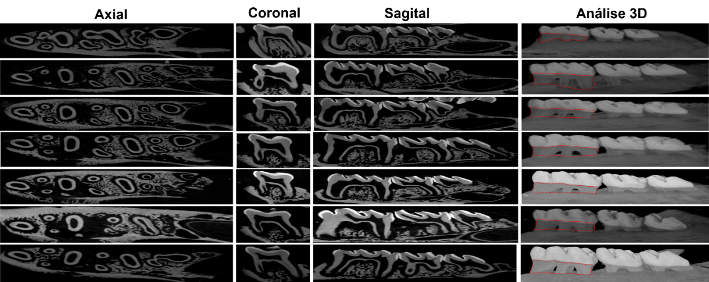
Source: Costa et al., 2025

This integration between digital technology and biological experimentation opens new avenues for optimizing diagnostics and developing more effective and targeted therapies in the field of periodontology. Table 1 presents a summary of the main findings from the articles discussed in this review to facilitate understanding of the data presented.

Table 1. Summary of the literature review studies
Study Title | Experimental Model | Intervention / Condition Studied | Analytical Tool | Main Findings | Conclusion
Metabolic syndrome promotes resistance to aspirin... | Rats with MetS and ligature-induced periodontitis | Acetylsalicylic acid (ASA) | Micro-CT | Aspirin reduces bone loss only in the absence of MetS | MetS induces resistance to aspirin’s protective effect
Hypericin-glucamine antimicrobial photodynamic therapy... | Rats with periodontitis | aPDT with hypericin-glucamine and LED | Micro-CT and histometry | Higher bone volume at 7 days with aPDT; LED alone superior at 15 days | aPDT has early beneficial effects; LED alone shows late action
Chronological analysis of periodontal bone loss... | BALB/c and C57BL/6 mice | P. gingivalis infection | Micro-CT | BALB/c showed earlier and more intense bone loss | Bone-loss progression varies between strains; micro-CT detects temporal changes
Systemic administration of propranolol reduces bone resorption... | Rats with apical periodontitis and chronic stress | Systemic propranolol | Micro-CT | Reduced lesion volume and area with propranolol | Propranolol protects against the effects of chronic stress on resorption
Atypical antipsychotics olanzapine and clozapine... | Wistar female rats with periodontitis | Olanzapine and clozapine | Micro-CT and histology | Apparent bone loss with no changes detected by micro-CT | Remodeling may mask antipsychotic effects in micro-CT
Temporal changes of periodontal tissue pathology... | Mice with ligature-induced periodontitis | Temporal analysis of bone loss | Micro-CT and histology | Peak bone loss between days 4 and 8 | Optimal evaluation window is between days 4 and 8 post-induction
Lactobacillus fermentum attenuates the alveolar bone loss... | Mice with ligature-induced periodontitis | Treatment with L. fermentum BELF11 | Micro-CT | Significant reduction of mesial bone loss (p < 0.05) | Probiotic attenuates bone resorption and inflammation
SOCS2 regulates alveolar bone loss... | Socs2−/− and WT mice infected with Aa | Genetic deficiency of SOCS2 | Micro-CT | Greater bone loss in Socs2−/− with fewer inflammatory cytokines | SOCS2 regulates osteoclastic activity and bone loss
Minocycline reduces alveolar bone loss... | Rats with ligature-induced periodontitis | Minocycline treatment | Micro-CT | Reduction in CEJ-ABC, increased Tb.Th and BV/TV | Minocycline preserves structure and reduces resorption
A reliable deep-learning-based method for alveolar bone quantification. | Mice with ligature-induced periodontitis | Application of AI model (U-Net) | Micro-CT with AI (Dragonfly) | High accuracy (98%) in quantification; bone loss measurable up to day 14 | AI improves efficiency and reproducibility of bone-analysis workflows

For performing the various analyses used to assess bone loss, specific software and a sequence of steps are required:

Image reconstruction
After scanning, the file is not yet ready for analysis and must undergo a reconstruction process, which essentially consists of converting the raw data acquired during scanning into three-dimensional images representing the internal structure of the scanned sample. This step is essential to obtain interpretable and quantitative 3D images of the microstructure of the evaluated material or tissue. The NRecon software, for example, allows adjustments of crucial parameters to improve reconstruction quality (such as smoothing, ring artifact reduction, beam hardening correction, etc.). It also generates slice-based images (e.g., TIFFs) that can later be analyzed in other software (Figure 2).

Figure 2. Representative image of the NRecon software interface.
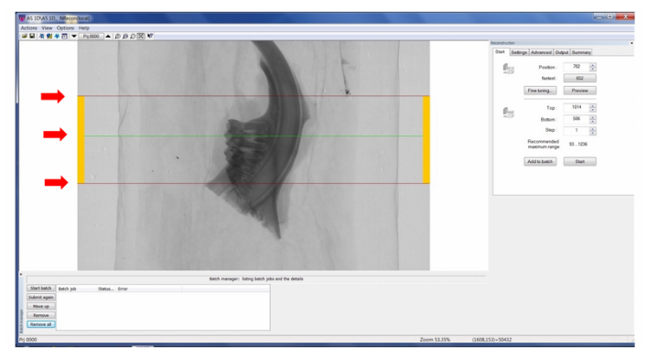
Source: Personal Archive

Orientation and standardization of images in the three planes
This is a preliminary step before quantitative analysis. The reconstructed transverse slices must be reoriented so that morphometric analysis can be standardized and reproducible across all experimental groups. The DataViewer software can be used during this step. In it, the sample is rotated along the three axes (X, Y, Z) to correctly position it, aligning anatomical reference structures in consistent planes. After proper orientation, a new set of reoriented images is exported (Figure 3).
Figure 3. Representative image of the DataViewer software interface showing axial, coronal, and sagittal planes.
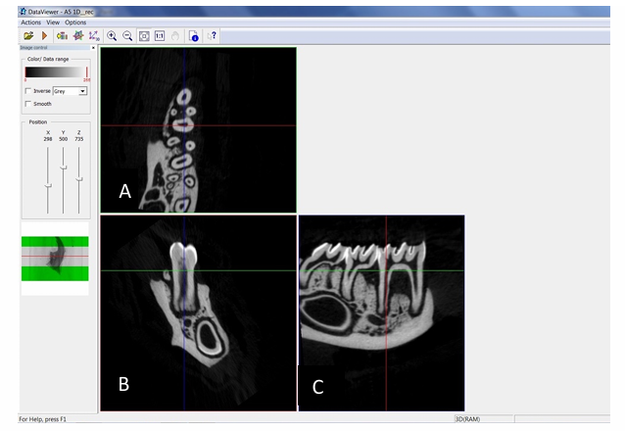
Source: Personal Archive

Determination of the region of interest (ROI) and 3D analysis
In this step, the region of interest (ROI) is defined. This region corresponds to the specific anatomical area or volume of the sample to be quantitatively analyzed and is essential to ensuring reproducibility, precision, and biological relevance of the data.
In CTAn software, for instance, the user can select the specific area to be analyzed (ROI) manually, automatically, or based on previous models. The user chooses the slice interval that composes the volume of interest, and ROI creation may be static (constant across all selected slices) or dynamic (adapting to tissue morphology in each slice). Additionally, thresholding tools are used to separate bone structures from soft tissue or voids.
Once the ROI is created, the software performs various three-dimensional analyses that quantify morphological properties of the tissue, generating a report with information such as:
- BV/TV (Bone Volume / Total Volume): ratio of bone volume to total volume within the ROI.
- Trabecular thickness, number, and separation.
- Total porosity: evaluation of total porosity within the bone structure.
- Connectivity density: a measure of the structural interconnection of trabeculae.
- Bone surface (BS), bone surface density (BS/TV) and other surface-related metrics (Figure 4).

Figure 4. Representative image of the CTAn interface showing ROI creation steps and threshold adjustments.
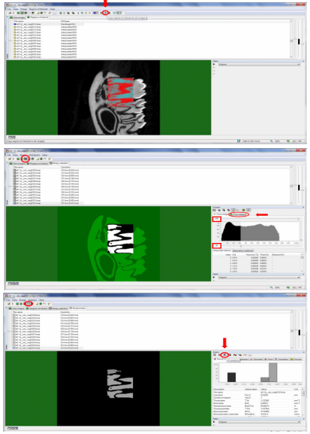
Source: Personal Archive

Generation of 3D images
Finally, three-dimensional images can be created for improved visualization of bone loss. The CTvox software, for example, enables the user to visualize the reconstructed 3D volume with free rotation, zoom, translation, virtual sectioning in different planes, and adjustment of opacity and color for different densities (Figure 5).

Figure 5. Representative 3D image (created in CTvox) of a rat hemimandible with ligature-induced periodontal disease.
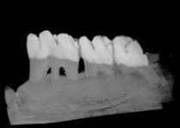
Source: Personal Archive

Table 2 presents a summary of the main analyses that can be performed using micro-computed tomography for the assessment of bone loss.

Table 2. Main analyses used for the assessment of bone loss using micro-computed tomography
Description | Indicators / Meaning | Analysis
Measures the volume of mineralized bone (BV) relative to the total volume (TV) | Quantitatively assesses the loss of alveolar bone volume | Bone Volume (BV) and BV/TV
Distance between the cementoenamel junction (CEJ) and the alveolar bone crest (ABC) | Evaluates marginal bone loss linearly | Linear Bone Loss (LBL)
Average thickness of the trabecular bone structures | Assesses the integrity of trabecular microarchitecture | Trabecular Thickness (Tb.Th)
Number of trabeculae per unit length (mm) | Reduction indicates bone rarefaction | Trabecular Number (Tb.N)
Average distance between trabeculae | Increased values indicate bone degradation | Trabecular Separation (Tb.Sp)
Measures the interconnection among trabecular structures | Reflects the tridimensional structural integrity of the bone | Connectivity Density (Conn.D)
Thickness of the alveolar cortical bone layer | Reductions indicate cortical resorption associated with periodontitis | Cortical Thickness (Ct.Th)

4. Conclusion
The analysis of the reviewed studies highlights the fundamental role of micro–computed tomography as a highly valuable tool for assessing alveolar bone loss in experimental models of periodontitis. This technology offers significant advantages in terms of accuracy, reproducibility, and three-dimensional detail, contributing to a deeper understanding of bone resorption dynamics and the response to different therapeutic interventions.
Several factors were identified as influencing disease severity and treatment outcomes, including comorbidities such as metabolic syndrome, chronic stress, the use of medications such as antipsychotics and antibiotics, as well as genetic susceptibility and the oral microbiome. Interventions such as probiotics, photodynamic therapy, anti-inflammatory agents, and immunomodulatory drugs showed promising results in attenuating bone resorption, although their effects vary according to the experimental model and the systemic conditions involved. Additionally, the incorporation of artificial intelligence tools—such as deep learning algorithms applied to automated micro-CT image analysis—represents a methodological advancement capable of accelerating and standardizing large-scale assessments with high precision.
Taken together, the findings compiled here reinforce the importance of micro–computed tomography in the field of experimental periodontal research and suggest promising pathways for the development of new diagnostic and therapeutic approaches. Further investigations may ultimately contribute to more effective and personalized clinical strategies for the treatment of periodontitis.

Disclaimer (Artificial intelligence)
Option 1:
Author(s) hereby declare that NO generative AI technologies such as Large Language Models (ChatGPT, COPILOT, etc.) and text-to-image generators have been used during the writing or editing of this manuscript.
Option 2:
Author(s) hereby declare that generative AI technologies such as Large Language Models, etc. have been used during the writing or editing of manuscripts. This explanation will include the name, version, model, and source of the generative AI technology and as well as all input prompts provided to the generative AI technology
Details of the AI usage are given below:
1.
2.
3.

References

Aguirre, J. I., Akhter, M. P., Neuville, K. G., Trcalek, C. R., Leeper, A. M., Williams, A. A., Rivera, M., Kesavalu, L., Ke, H. Z., Liu, M., & Wronski, T. J. (2017). Age-related periodontitis and alveolar bone loss in rice rats. Archives of Oral Biology, 73, 193-205. https://doi.org/10.1016/j.archoralbio.2016.10.018

Bhattarai, G., Lee, M. H., & Lee, J. C. (2016). Resveratrol prevents alveolar bone loss in an experimental rat model of periodontitis. Acta Biomaterialia https://doi.org/10.1016/j.actbio.2015.10.031

Bouxsein, M. L., Boyd, S. K., Christiansen, B. A., Guldberg, R. E., Jepsen, K. J., & Müller, R. (2010). Guidelines for assessment of bone microstructure in rodents using micro-computed tomography. Journal of Bone and Mineral Research, 25(7), 1468-1486. https://doi.org/10.1002/jbmr.141

Catunda, R. Q., Ho, K. K.-Y., Patel, S., & Febbraio, M. (2021). A 2-plane micro-computed tomographic alveolar bone measurement approach in mice. Imaging Science in Dentistry, 51(4), 389-398. https://doi.org/10.5624/isd.20210058

Choi, I. G. G., et al. (2022). Correlation among alveolar bone assessments provided by CBCT, micro-CT, and 14 T MRI. Dentomaxillofac Radiol., 51(5), 20210243. https://doi.org/10.1259/dmfr.20210243

Costa, V. B. (2025). Impacto da ativação e inibição de Nrf2 sobre a periodontite. Tese (Doutorado em Odontologia) – Universidade Estadual Paulista “Júlio de Mesquita Filho” – UNESP. Araraquara.

De Rossi, L. S., Nakama, R. P., Dos Santos, L. F., Berto-Pereira, L., Malvezi, A. D., Lovo-Martins, M. I., Cardoso, A. P. C., Tozoni-Filho, L. C., Jussiani, E. I., & de Freitas, A. M. D. (2024). Metabolic syndrome promotes resistance to aspirin in mitigating bone loss in murine periodontal disease. Life Sciences. https://doi.org/10.1016/j.lfs.2024.123224

Fernandes, P. G., da Silva, A. M. H., Stocco, T. D., Magalhães, D. S. F., Vanderlei, J. M. T. M. M., de Almeida, A. L. G., Oliveira, F. A., & Taba, M., Jr. (2024). Comparative assessment of alveolar bone loss in experimental periodontitis: a 2D and 3D microtomographic study in a rat model. Periodontal and Implant Research. https://doi.org/10.1007/s41894-024-00141-8

Frazão, D. R., Matos-Souza, J. M., dos Santos, V. R. N., Nazario, R. M. F., Chemelo, V. d. S., Bittencourt, L. O., et al. (2024). Minocycline reduces alveolar bone loss and bone damage in Wistar rats with experimental periodontitis. PLoS ONE. https://doi.org/10.1371/journal.pone.0309390

Ghavami-Lahiji, M., Davalloo, R. T., Tajziehchi, G., & Shams, P. (2021). Micro-computed tomography in preventive and restorative dental research: A review. Imaging Science in Dentistry, 51(4), 341-350. https://doi.org/10.5624/isd.20210087

Hernández Martínez, C.J., Silva, P.F., Salvador, S.L., Messora, M., & Palioto, D.B. (2023). Chronological analysis of periodontal bone loss in experimental periodontitis in mice. Clinical and Experimental Dental Research, 9(6), 1009-1020. https://doi.org/10.1002/cre2.806

Khoury, R.D., Prado, R.F., Matos, F.S., Meireles, B.R., Cardoso, F.G.R., Oliveira, L.D., Carvalho, C.A.T., & Valera, M.C. (2024). Systemic administration of propranolol reduces bone resorption and inflammation in apical periodontitis of chronically stressed rats. International Endodontic Journal, 57(10), 1478-1491. https://doi.org/10.1111/iej.14118

Lee, Y., et al. (2024). Lactobacillus fermentum attenuates the alveolar bone loss in ligature-induced periodontitis in mice. Oral Dis., 30(5), 3328-3335. https://doi.org/10.1111/odi.14739

Macedo, P. D., Corbi, S. C. T., Oliveira, G. J. P., Rodrigues, J., Perussi, J. R., Ribas, A. O., & Marcantonio, R. A. C. H. (2019). Hypericin-glucamine antimicrobial photodynamic therapy in the progression of experimentally induced periodontal disease in rats. Photodiagnosis and Photodynamic Therapy, 25, 43-49. https://doi.org/10.1016/j.pdpdt.2018.11.003

Martínez-García, M., & Hernández-Lemus, E. (2021). Periodontal Inflammation and Systemic Diseases: An Overview. Frontiers in Physiology. https://doi.org/10.3389/fphys.2021.709438

Naito, T., Hosokawa, R., & Yokota, M. (1998). Three-dimensional alveolar bone morphology analysis using computed tomography. J Periodontol. https://doi.org/10.1902/jop.1998.69.5.584

Santos, M. R. G., Chaves, I. d. M., Queiroz-Junior, C. M., Cramer, A. T., Anestino, T. A., Dos Santos, A. C. P. M., Leite, P. G., Macari, S., Barrioni, B. R., Pereira, M. d. M., Teixeira, M. M., de Souza, D. d. G., Madeira, M. F. M., & Machado, F. S. (2023). SOCS2 regulates alveolar bone loss in Aggregatibacter actinomycetemcomitans-induced periodontal disease. Inflamm Res., 72(4), 859-873. https://doi.org/10.1007/s00011-023-01711-5

Schulz, G., et al. (2012). Multimodal imaging of human cerebellum - merging X-ray phase microtomography, magnetic resonance microscopy and histology. Scientific Reports, 2(826). https://doi.org/10.1038/srep00826

Silva, N., Abusleme, L., Bravo, D., Dutzan, N., Garcia-Sesnich, J., Vernal, R., Hernández, M., & Gamonal, J. (2015). Host response mechanisms in periodontal diseases. Journal of Applied Oral Science, 23(3), 329-355. https://doi.org/10.1590/1678-775720140259

Soares, M. A., et al. (2023). Atypical antipsychotics olanzapine and clozapine increase bone loss in female rats with experimental periodontitis. J Periodontal Res. https://doi.org/10.1111/jre.13090

Troian-Michel, C. H., de Oliveira, M. G., de Souza, B. D., de Souza, P. A., de Oliveira, M. G., de Souza, B. D., & Scarparo, R. K. (2025). Effects of ovariectomy-induced osteoporosis and two photobiomodulation protocols on the repair of apical periodontitis in Wistar rats: A microCT study. Int Endod J., 58(7), 1042-1059. https://doi.org/10.1111/iej.14234

Vásárhelyi, L., Kónya, Z., Kukovecz, Á., & Vajtai, R. (2020). Microcomputed tomography–based characterization of advanced materials: a review. Materials Today Advances. https://doi.org/10.1016/j.mtadv.2020.100084

Xi, R., Ali, M., Zhou, Y., & Tizzano, M. (2024). A reliable deep-learning-based method for alveolar bone quantification using a murine model of periodontitis and micro-computed tomography imaging. Journal of Dentistry. https://doi.org/10.1016/j.jdent.2024.105057

Yoon, H., Jung, B. H., & Kim, K. (2023). Temporal changes of periodontal tissue pathology in a periodontitis animal model. J Periodontal Implant Sci., 53(4), 248-258. https://doi.org/10.5051/jpis.2203420171

Zheng, Y. & Han, N. (2021). Alveolar bone loss with microarchitecture changes in aged rat. Int. J. Morphol., 39(5), 1443-1446.

Sağlam G, Dağ A. Evaluating Factors Influencing Periodontal Bone Loss Using Cone Beam Computed Tomography: A Retrospective Study. Med Sci Monit. 2025 May 2;31:e947759. doi: 10.12659/MSM.947759. PMID: 40312889; PMCID: PMC12054308.

Maithri, M., Ballal, D. G., Kumar, S., Raghavendra, U., Gudigar, A., Chan, W. Y., Macherla, S., Vineetha, R., Gopalkrishna, P., Ciaccio, E. J., & Acharya, U. R. (2022). Development of a Computational Tool for the Estimation of Alveolar Bone Loss in Oral Radiographic Images. Computation, 10(1), 8. https://doi.org/10.3390/computation10010008
Yann Nobre Viana, Richelly Maria Rodrigues Holanda, Matéus Simplício Araújo, and Francisco Cesar Barroso Barbosa. 2024. “From Oral Hygiene to Cognitive Health: Examining the Relationship Between Periodontal Disease and Alzheimer’s”. Archives of Current Research International 24 (5):557–582. https://doi.org/10.9734/acri/2024/v24i5732.

M. C. Ohamaeme, J. N. Egwurugwu, I. G. Eberendu, U. F. Ogunnaya, C. N. Ekweogu, and S. D. Ejikunle. 2018. “Periodontal Diseases and Associated Risk Factors Among Residents in Orlu, Nigeria”. Asian Journal of Medicine and Health 12 (4):1–8. https://doi.org/10.9734/AJMAH/2018/44538.

