Homotopy Analysis of Activation Energy and Ohmic Heating Effects on Chemically Reacting Magnetohydrodynamic Non-Newtonian Micropolar Fluid Flow over a Stretching Surface

Abstract: The combined effects of activation energy and Ohmic heating on chemically reacting magnetohydrodynamic (MHD) non-Newtonian fluid flow across a stretching surface are thoroughly examined in the manuscript. The fluid behavior is modelled using an appropriate non-Newtonian constitutive relation, while the influence of a transverse magnetic field is incorporated to capture realistic electromagnetic interactions. The heat and mass transfer characteristics are examined by accounting for Ohmic heating and chemical reactions with activation energy, thereby enhancing the physical relevance of the model for industrial and engineering applications. The governing nonlinear partial differential equations are transformed into a coupled system of nonlinear ordinary differential equations via suitable similarity transformations. Semi-analytical Homotopy Analysis Method and MAPLE software were used to achieve a convergent solution and accuracy through optimal auxiliary parameters. A detailed parametric study elucidates the influence of key dimensionless parameters, including Hartmann number, activation energy parameter, chemical reaction rate, Ohmic heating parameter, Prandtl number, Schmidt number, Eckert number, temperature difference parameter, porosity parameter, Micropolar parameter, and spin-gradient viscosity parameter on velocity, temperature, and concentration distributions. The study reveals that higher $M$, $Ec$, and $δ$increase temperature, while larger $Pr$and $Sc$reduce thermal and concentration layer thickness. Increasing $λ$lowers concentration, and $Da$decreases velocity in porous media. The micropolar parameters $ζ$and $β$govern momentum–microrotation coupling. Overall, electromagnetic, chemical, and microstructural effects significantly influence flow, heat, and mass transfer characteristics.
Keywords: Micropolar fluid, Magnetohydrodynamics, Activation energy, Ohmic heating, Homotopy Analysis Method
1. Introduction
Over the past three decades, magnetohydrodynamic (MHD) flow over stretching surfaces has emerged as a fundamental research area in fluid mechanics due to its broad relevance in industrial and engineering applications. Stretching sheet models simulate processes such as polymer extrusion, glass fiber production, metal spinning, continuous casting, wire drawing, cooling of electronic components, and coating technologies. In such systems, the quality of the final product strongly depends on the control of momentum, heat, and mass transfer characteristics within the boundary layer. When the working fluid is electrically conducting, the application of a magnetic field introduces Lorentz forces that significantly modify the flow structure. This interaction enables regulation of velocity, temperature, and concentration fields, making MHD control particularly valuable in metallurgical processing, plasma engineering, MHD generators, and cooling technologies. Although classical studies have extensively examined MHD boundary-layer flow over stretching sheets, many investigations have been confined to Newtonian fluid assumptions and simplified physical models. However, real industrial fluids — including polymer melts, lubricants, blood analogues, suspensions, and liquid crystals — often exhibit non-Newtonian behaviour. Moreover, practical processes frequently involve chemical reactions, internal heat generation, viscous dissipation, radiation, and Joule heating. The simultaneous interaction of these effects significantly alters transport characteristics, yet comprehensive models incorporating all such mechanisms remain relatively scarce.
Considerable research efforts have been devoted to studying non-Newtonian fluid flow under magnetic influence over stretching geometries. Khan et al. [1] investigated tangent hyperbolic nanofluid flow over an exponentially stretching surface, incorporating magnetic field effects, chemical reaction, and variable thermal conductivity. Their parametric analysis demonstrated that magnetic forces suppress fluid motion while chemical reaction parameters reduce concentration levels. Similarly, Kumar et al. [2] examined Casson fluid flow under suction and double stratification conditions. Their results showed that the yield stress characteristic of Casson fluids significantly retards the velocity field, while suction enhances heat and mass transfer rates.
The mixed convective MHD flow of a power-law fluid with thermal radiation, heat generation, and chemical reaction was explored by Khan [3], revealing that magnetic and rheological parameters strongly influence momentum and thermal boundary layers. Reddy [4] further analyzed Casson fluid flow with slip effects, radiation, and chemical reaction, reporting substantial variations in skin friction, Nusselt number, and Sherwood number due to magnetic intensity and slip parameters. Sanni et al. [5] extended the analysis to cross-fluid models over nonlinear curved stretching sheets, highlighting the influence of rheology and curvature on heat and mass transport. In porous media configurations, Nayak et al. [6] studied viscoelastic fluid flow with chemical reaction and heat generation, demonstrating velocity suppression under increasing magnetic field strength and viscoelastic parameters. Shamshuddin et al. [7] incorporated Hall current, viscous dissipation, and Joule heating in power-law polymer dynamics over an exponentially stretching sheet. Their findings confirmed that dissipative mechanisms significantly elevate temperature profiles and alter thermal gradients.
Collectively, these studies emphasize the complex interplay between magnetic forces, rheological behavior, and chemical effects in non-Newtonian stretching sheet flows. Nevertheless, most investigations either exclude microstructural effects or treat thermochemical coupling in a simplified manner.
Many engineering and biological fluids possess a microstructure that influences macroscopic flow behavior. Classical continuum mechanics cannot adequately capture microrotation and couple stress phenomena arising from suspended particles or molecular orientation. To address this limitation, Eringen [8] introduced micropolar fluid theory, later elaborated by Łukaszewicz [9]. This theory incorporates micro-rotational degrees of freedom and additional stress tensors, providing a more accurate representation of complex fluids such as polymer suspensions, blood, liquid crystals, and lubricants [10–12].
Micropolar hydrodynamics has been investigated in various configurations. Zueco et al. [13] numerically analyzed micropolar flow in a Darcian porous medium, demonstrating that microrotation viscosity reduces velocity while enhancing particle rotation. Lu et al. [14] examined porous-walled channel flow with applications to dialysis systems, confirming the significant impact of microstructural parameters on velocity and rotational fields. In biological flow modeling, Akbar et al. [15] studied pressure-driven micropolar transport induced by metachronal waves, emphasizing the role of boundary interactions.
Engineering applications have also benefited from micropolar modeling. Lin et al. [16] analyzed slider bearings using micropolar fluids and showed enhanced load-carrying capacity due to microstructural effects. Beg et al. [17] investigated axisymmetric stagnation enrobing flow relevant to coating dynamics, demonstrating the strong influence of micropolar parameters on velocity, temperature, and concentration fields. Despite these advancements, comprehensive analyses integrating micropolar fluid dynamics with magnetic fields, stretching surfaces, and chemically reactive transport mechanisms remain limited. This gap motivates further investigation into fully coupled MHD micropolar systems.
Chemical reactions significantly influence boundary-layer mass transfer in catalytic reactors, polymerization processes, combustion systems, and biochemical transport. Traditional models frequently assume constant reaction rates, neglecting temperature dependence. However, realistic reaction kinetics follow Arrhenius-type behavior, where activation energy governs reaction intensity. Recent studies have incorporated activation energy into stretching sheet flows. Borah et al. [18] investigated MHD micropolar nanofluid flow with viscous dissipation and heat source effects, demonstrating that activation energy alters concentration boundary layers significantly. Mabood [19] studied binary chemical reactions in thermo-solutal micropolar nanofluid flow, reporting strong coupling between activation energy and nanoparticle transport. Eldabe et al. [20] incorporated electro-osmosis forces in activated micropolar nanofluid flow, revealing enhanced electromagnetic interactions. Zeeshan et al. [21] analyzed transient activation energy effects with radiation, while Alahmadi and Alsaeed [22] explored hydromagnetized flow between stretchable disks. Although these contributions highlight the importance of activation energy in micropolar and nanofluid systems, few works consider its interaction with Joule heating and strong magnetic dissipation in non-Newtonian micropolar flows over stretching surfaces.
Ohmic heating arises due to electrical resistance when conducting fluids move under magnetic fields. This internal heat generation mechanism is crucial in plasma dynamics, metallurgical processes, and MHD energy systems. Joule heating modifies temperature gradients, enhances thermal energy within the boundary layer, and may significantly influence reaction rates and fluid properties. Recent investigations have explored Joule heating in MHD systems. Goud et al. [23] examined melting heat transfer with activation energy and Joule heating over a stretching sheet. Merkin et al. [24] analyzed nonlinear permeable sheets with viscous and Ohmic dissipation, identifying dual solution behavior. Srinivasulu et al. [25] studied MHD micropolar flow over curved surfaces with chemical reaction. Nagaraj et al. [26] considered magnetic-field-dependent viscosity in second-grade fluids. Elsaid et al. [27] incorporated Hall current and entropy generation. Additional studies [28–30] further explored radiative nanofluid transport and dissipative magnetic effects. Despite this progress, the combined influence of activation energy and Ohmic heating within a chemically reacting MHD micropolar non-Newtonian framework has not been comprehensively examined using semi-analytical approaches.
The simultaneous inclusion of magnetic forces, microstructural rotation, Arrhenius activation energy, chemical reaction, and Joule heating results in a highly nonlinear and strongly coupled system of governing equations. Exact analytical solutions are generally unattainable. While numerical methods provide approximate solutions, they may obscure parameter dependencies and require extensive computational effort. Perturbation techniques often depend on small or large parameter assumptions, limiting applicability across wide physical regimes.
The Homotopy Analysis Method (HAM), introduced by Liao [31–34], provides a powerful semi-analytical alternative. Unlike perturbation methods, HAM does not require small parameters. It constructs a homotopy that continuously deforms an initial guess into the exact solution while employing a convergence-control parameter to ensure series stability. HAM has been successfully applied to nonlinear differential equations, integral equations, viscoelastic and Casson fluid flows, radiation problems, and stretching sheet configurations [35–45]. Its flexibility and convergence-control capability make it well-suited for addressing the complex problems of the present day.
From the foregoing review, it is evident that substantial progress has been made in modeling MHD non-Newtonian and micropolar flows with radiation, chemical reactions, and dissipative mechanisms. However, a comprehensive computational investigation that simultaneously incorporates activation energy, Ohmic heating, and chemically reactive MHD micropolar non-Newtonian flow over a stretching surface using HAM remains limited. Therefore, the present study aims to conduct a detailed computational scrutiny of the coupled momentum, microrotation, thermal, and concentration fields under the combined influence of magnetic field, Arrhenius activation energy, and Joule heating. The Homotopy Analysis Method is employed to derive convergent analytical series solutions with controlled convergence characteristics. The findings of this study are expected to enhance theoretical understanding and provide improved predictive capability for complex magneto-micropolar transport processes encountered in polymer processing, coating systems, energy devices, and bioengineering applications.
2. Mathematical Formulation of the Problem
We consider a steady, two-dimensional, laminar boundary layer flow of an incompressible, electrically conducting micropolar fluid past a flat stretching surface coinciding with the $x$-axis, while the $y$-axis is taken normal to the surface. The surface is stretched with a linear velocity. $U_{w}(x)=ax$, where $a>0$is a constant stretching rate. A uniform magnetic field of strength $B_{0 }$is applied normally to the surface. The induced magnetic field is neglected under the assumption of low magnetic Reynolds number.
The fluid is assumed to be chemically reactive, and the reaction rate follows the Arrhenius law incorporating activation energy. The effects of Ohmic heating are included in the energy equation. Viscous dissipation may be neglected or retained depending on the modeling requirement. All physical properties of the fluid are assumed constant, except where temperature dependence is explicitly introduced. Under boundary layer approximations, the governing equations for mass, momentum, microrotation, energy, and concentration are formulated as follows.
3. Governing Equations
$\frac{∂u}{∂x}+\frac{∂v}{∂y}=0$ (1)
$u\frac{∂u}{∂x}+v\frac{∂u}{∂y}=\left(ν+\frac{κ}{ρ}\right)\frac{∂^{2}u}{∂y^{2}}+\frac{κ}{ρ}\frac{∂N}{∂y}-\frac{σB_{0}^{2}u}{ρ}-\frac{v}{K_{p}}u$ (2)
$u\frac{∂N}{∂x}+v\frac{∂N}{∂y}=\frac{γ}{jρ}\frac{∂^{2}N}{∂y^{2}}-\frac{κ}{jρ}\left(2N+\frac{∂u}{∂y}\right)$ (3)
$u\frac{∂T}{∂x}+v\frac{∂T}{∂y}=\frac{κ_{F}}{ρc_{p}}\frac{∂^{2}T}{∂y^{2}}+\frac{\left(μ+κ\right)}{ρc_{p}}{\left(\frac{∂u}{∂y}\right)}^{2}+\frac{σB_{0}^{2}}{ρc_{p}}u^{2}$ (4)
$u\frac{∂c}{∂x}+v\frac{∂c}{∂y}=D\frac{∂^{2}c}{∂y^{2}}-k_{r}^{2}\left(c-c_{∞}\right){\left(\frac{T}{T_{∞}}\right)}^{m}exp\left(-\frac{Ea}{RT}\right)$ (5)
The appropriate boundary conditions are given as
$u=U_{w}=bx, v=0, N=-n\frac{∂u}{∂y}, T=T_{w}, C=C_{w}$ at $y=0$ (6)
$u→0, N→0, T{→T}_{∞}, C→C_{∞}$ at $y→∞$
To nondimensionalize the governing equations (1–5) subject to the conditions in (6), a stream function $ϕ(x,y)$is introduced, along with the following similarity variables, following [46]
$u=\frac{∂φ}{∂x}, v=-\frac{∂φ}{∂y}$ (7)
$u=bxf^{'}\left(η\right), v=-\sqrt{bv}f\left(η\right), η=y\sqrt{\frac{b}{v}} , N=\sqrt{\frac{b^{3}}{v}} xg\left(η\right)$ (8)
$$θ\left(η\right)=\frac{T-T_{∞}}{T_{W}-T_{∞}} ,ϕ\left(η\right)=\frac{C-C_{∞}}{C_{W}-C_{∞}}$$
Utilising Eq. (7), the continuity equation is automatically satisfied, whereas the remaining governing equations of momentum, energy, and concentration are reduced to the form
$\left(1+ζ\right)f^{'''}+ff^{''}+ζg^{'}-{\left(f^{'}\right)}^{2}-\left(M+\frac{1}{Γ}\right)f^{'}=0$ (9)
${ξg}^{''}+fg^{'}-f^{'}g-λ\left(2g+f^{''}\right)=0$ (10)
$θ^{''}+Prfθ^{'}+\left(1+ζ\right)PrEc{\left(f^{''}\right)}^{2}+PrJ{\left(f^{'}\right)}^{2}=0$ (11)
$ϕ^{''}+Scfϕ^{'}-Scγ{\left(1+δθ\right)}^{m}exp\left(-\frac{E}{1+δθ}\right)ϕ$ (12)
where the non-dimensional parameters are defined as follows
$$M=\frac{σB_{0}^{2}}{ρb}, ζ=\frac{k}{μ}, γ=\frac{K_{r}^{2}}{b}, Ec=\frac{U_{w}^{2}}{c_{p}\left(T_{W}-T_{∞}\right)}, Sc=\frac{ν}{D}, Pr=\frac{ρνc_{p}}{k_{f}},$$
$$Γ=\frac{bKρ}{ν}, δ=\frac{T_{W}-T_{∞}}{T_{∞}}, E=\frac{Ea}{αT_{∞}} , J=\frac{σB_{0}^{2}U_{w}^{2}}{ρc_{ρ}b\left(T_{w}-T_{∞}\right)} , λ=\frac{κ}{μ} ,ξ=\frac{γ}{μj}$$
The transformed boundary conditions are given as
$$f\left(0\right)=0, f^{'}\left(0\right)=1,g\left(0\right)=-nf^{''}\left(0\right), θ\left(0\right)=1, ϕ\left(0\right)=1$$$f^{'}\left(η→∞\right)→0, g\left(η→∞\right)→0, θ\left(η→∞\right)→0,ϕ\left(η→∞\right)→0$ (13)
Here, $u$and $v$are the velocity components along the $x$- and $y$-directions, respectively; $ν$is the kinematic viscosity; $κ$is the vortex viscosity; $ρ$is the fluid density; $N$denotes the microrotation component normal to the flow plane; and $σ$is the electrical conductivity. The spin-gradient viscosity coefficient is $γ$. Moreover, $T$is the fluid temperature, $α$is the thermal diffusivity, and $c_{p}$represents the specific heat due to Joule heating. The species concentration is $C$, $D$is the mass diffusivity, $k_{r}$is the chemical reaction rate constant, and $E_{a}$is the activation energy, with $R$denoting the universal gas constant. Finally, $μ$is the dynamic viscosity, and $C=C_{W}$represent the wall temperature and wall concentration, respectively, while $T=T_{∞}$and $C=C_{∞}$denote the ambient temperature and ambient concentration, $n$is the microrotation boundary parameter indicating weak or strong concentrations of microelements, and $\left(μ+κ\right)$ is the effective viscosity.
4. Mathematical Analysis using HAM
To solve the non-dimensional equations (9-12) subject to the boundary conditions (13) analytically via HAM, we choose the initial guess that satisfies the boundary conditions as
$f_{0}\left(η\right)=1-e^{-η},g_{0}\left(η\right)=1-e^{-η},θ_{0}\left(η\right)=e^{-η} ,ϕ_{0}\left(η\right)=e^{-η}$ (14)
Let $L_{f}, L_{g}, L_{θ}$ and $L_{ϕ}$ be linear operators defined as follows
$L_{f}\left[f\left(η;q\right)\right]=\frac{∂^{3}f\left(η;q\right)}{∂η^{3}}-\frac{∂f\left(η;q\right)}{∂η}$ (15)
$L_{g}\left[g\left(η;q\right)\right]=\frac{∂^{2}g\left(η;q\right)}{∂η^{2}}-\frac{∂g\left(η;q\right)}{∂η}$ (16)
$L_{θ}\left[θ\left(η;q\right)\right]=\frac{∂^{2}θ\left(η;q\right)}{∂η^{2}}-\frac{∂θ\left(η;q\right)}{∂η}$ (17)
$L_{ϕ}\left[ϕ\left(η;q\right)\right]=\frac{∂^{2}ϕ\left(η;q\right)}{∂η^{2}}-\frac{∂ϕ\left(η;q\right)}{∂η}$ (18)
The operators $L_{f}, L_{g}, L_{θ}$ and $L_{ϕ}$ satisfies the following properties
$L_{f}\left[c_{1}+c_{2}e^{-η}+c_{3}e^{η}\right],L_{g}\left[c_{4}e^{-η}+c_{5}\right], L_{θ}\left[c_{6}e^{-η}+c_{7}\right], L_{ϕ}\left[c_{8}e^{-η}+c_{9}\right]$ (19)
where $\left(c_{i}, 1≤i≤9\right)$ are arbitrary constants to be determined in view of the boundary constants
4.1 Zeroth-order deformation Equations
Suppose $q∈\left[0, 1\right]$ is the embedded parameter, $ℏ_{f},ℏ_{g}, ℏ_{θ}$ and $ℏ_{ϕ}$ are the non-zero auxiliary parameters, then we construct the following zero deformation equations
${\left(1-q\right)L}_{f}\left[f\left(η;q\right)-f_{0}\left(η\right)\right]=qℏ_{f}N_{f}\left[f\left(η;q\right),g\left(η;q\right),θ\left(η;q\right),ϕ\left(η;q\right)\right]$ (20)
${\left(1-q\right)L}_{g}\left[g\left(η;q\right)-g_{0}\left(η\right)\right]=qℏ_{g}N_{g}\left[f\left(η;q\right),g\left(η;q\right),θ\left(η;q\right),ϕ\left(η;q\right)\right]$(21)
${\left(1-q\right)L}_{θ}\left[θ\left(η;q\right)-θ_{0}\left(η\right)\right]=qℏ_{θ}N_{θ}\left[f\left(η;q\right),g\left(η;q\right),θ\left(η;q\right),ϕ\left(η;q\right)\right]$(22)
${\left(1-q\right)L}_{ϕ}\left[ϕ\left(η;q\right)-ϕ_{0}\left(η\right)\right]=qℏ_{ϕ}N_{ϕ}\left[f\left(η;q\right),g\left(η;q\right),θ\left(η;q\right),ϕ\left(η;q\right)\right]$(23)
Subject to the boundary conditions
$f\left(η=0,q\right)=0,\frac{∂f\left(η=0;q\right)}{∂η}=1,θ\left(η=0;q\right)=1,ϕ\left(η=0;q\right)=1,$ (24)$$N\left(η=0;q\right)=0, \frac{∂f\left(η→∞;q\right)}{∂η}=0,N\left(η→∞;q\right)=0,θ\left(η→∞;q\right)=0,ϕ\left(η→∞;q\right)=0$$
where the nonlinear operators are defined as follows
$$N_{f}\left[f\left(η;q\right),g\left(η;q\right),θ\left(η;q\right),ϕ\left(η;q\right)\right]=\left(1+ζ\right)\frac{∂^{3}f\left(η;q\right)}{∂η^{3}}+f\left(η;q\right)\frac{∂^{2}f\left(η;q\right)}{∂η^{2}}$$$+ζ \frac{∂g\left(η;q\right)}{∂η}-{\left(\frac{∂f\left(η;q\right)}{∂η}\right)}^{2}-\left(M+\frac{1}{Γ}\right)\frac{∂f\left(η;q\right)}{∂η}$ (25)
$$N_{g}\left[f\left(η;q\right),g\left(η;q\right),θ\left(η;q\right),ϕ\left(η;q\right)\right]=\left(1+\frac{ζ}{2}\right)\frac{∂^{2}f\left(η;q\right)}{∂η^{2}}+f\left(η;q\right)\frac{∂g\left(η;q\right)}{∂η}$$$-g\left(η;q\right)-ζ\left(2g\left(η;q\right)+\frac{∂^{2}f\left(η;q\right)}{∂η^{2}}\right)$ (26)
$$N_{θ}\left[f\left(η;q\right),g\left(η;q\right),θ\left(η;q\right),ϕ\left(η;q\right)\right]=\frac{∂^{2}θ\left(η;q\right)}{∂η^{2}}+Prf\left(η;q\right)\frac{∂θ\left(η;q\right)}{∂η}+$$$PrEc\frac{∂^{2}f\left(η;q\right)}{∂η^{2}}+PrEcM{\left(\frac{∂f\left(η;q\right)}{∂η}\right)}^{2}$ (27)
$$N_{ϕ}\left[f\left(η;q\right),g\left(η;q\right),θ\left(η;q\right),ϕ\left(η;q\right)\right]=\frac{∂^{2}ϕ\left(η;q\right)}{∂η^{2}}+Scf\left(η;q\right)\frac{∂ϕ\left(η;q\right)}{∂η}$$$-ScKr{\left(1+ δθ\left(η;q\right)\right)}^{m}exp\left(\frac{-E}{1+ δθ\left(η;q\right)}\right)ϕ\left(η;q\right)$ (28)
When $q=0,$the zeroth-order deformation equations in (20-23) take the form
$$L_{f}\left[f\left(η;q\right)-f_{0}\left(η\right)\right]=0$$$L_{g}\left[g\left(η;q\right)-g_{0}\left(η\right)\right]=0$ (29)$$L_{θ}\left[θ\left(η;q\right)-θ_{0}\left(η\right)\right]=0 \\ L_{ϕ}\left[ϕ\left(η;q\right)-ϕ_{0}\left(η\right)\right]=0$$
The consequence of Eq. (29) satisfies the following properties
$f\left(η;0\right)=f_{0}\left(η\right), g\left(η;0\right)=g_{0}\left(η\right),θ\left(η;0\right)=θ_{0}\left(η\right),ϕ\left(η;0\right)=ϕ_{0}\left(η\right)$ (30)
The corresponding boundary condition in view of Eq. (30) becomes
$f\left(η=0, 0\right)=0,\frac{∂f\left(η=0;0\right)}{∂η}=1,θ\left(η=0;0\right)=1,ϕ\left(η=0;0\right)=1,$ (31)$$N\left(η=0;0\right)=0, \frac{∂f\left(η→∞;0\right)}{∂η}=0,N\left(η→∞;0\right)=0,θ\left(η→∞;0\right)=0,ϕ\left(η→∞;0\right)=0$$
Similarly, when $q=1,$The zeroth-order deformation Equations (20-23) yield the expressions
$$0=ℏ_{f}N_{f}\left[f\left(η;q\right),g\left(η;q\right),θ\left(η;q\right),ϕ\left(η;q\right)\right]$$$0=ℏ_{g}N_{g}\left[f\left(η;q\right),g\left(η;q\right),θ\left(η;q\right),ϕ\left(η;q\right)\right]$ (32)$$0=ℏ_{θ}N_{θ}\left[f\left(η;q\right),g\left(η;q\right),θ\left(η;q\right),ϕ\left(η;q\right)\right] \\ 0=ℏ_{ϕ}N_{ϕ}\left[f\left(η;q\right),g\left(η;q\right),θ\left(η;q\right),ϕ\left(η;q\right)\right]$$
Eq. (32) immediately leads to the expressions
$f\left(η;1\right)=f_{0}\left(η\right), g\left(η;1\right)=g_{0}\left(η\right),θ\left(η;1\right)=θ_{0}\left(η\right),ϕ\left(η;1\right)=ϕ_{0}\left(η\right)$ (33)
Along with the boundary conditions given as
$f\left(η=0, 1\right)=0,\frac{∂f\left(η=0;1\right)}{∂η}=1,θ\left(η=0;1\right)=1,ϕ\left(η=0;1\right)=1,$ (34)$$N\left(η=0;1\right)=0, \frac{∂f\left(η→∞;1\right)}{∂η}=0,N\left(η→∞;1\right)=0,θ\left(η→∞;1\right)=0,ϕ\left(η→∞;1\right)=0$$
4.2 Higher-order deformation Equations
Employing Taylors series to expand $f\left(η;q\right), g\left(η;q\right), θ\left(η;q\right), ϕ\left(η;q\right)$ With respect to the embedding parameter, we obtained the expressions.
$f\left(η;q\right)=f_{0}\left(η\right)+\sum_{m=1}^{∞}{f_{m}\left(η\right)q^{m}}$ (35)
$g\left(η;q\right)=g_{0}\left(η\right)+\sum_{m=1}^{∞}{g_{m}\left(η\right)q^{m}}$ (36)
$θ\left(η;q\right)=θ_{0}\left(η\right)+\sum_{m=1}^{∞}{θ_{m}\left(η\right)q^{m}}$ (37)
$ϕ\left(η;q\right)=ϕ_{0}\left(η\right)+\sum_{m=1}^{∞}{ϕ_{m}\left(η\right)q^{m}}$ (38)
Where
$$f_{m}\left(η\right)={\frac{1}{m!}\left.\frac{∂^{m}f\left(η;q\right)}{∂q^{m}}\right\rceil }_{q=0}$$
$g_{m}\left(η\right)={\frac{1}{m!}\left.\frac{∂^{m}g\left(η;q\right)}{∂q^{m}}\right\rceil }_{q=0}$ (40)$$θ_{m}\left(η\right)={\frac{1}{m!}\left.\frac{∂^{m}θ\left(η;q\right)}{∂q^{m}}\right\rceil }_{q=0} \\ ϕ_{m}\left(η\right)={\frac{1}{m!}\left.\frac{∂^{m}ϕ\left(η;q\right)}{∂q^{m}}\right\rceil }_{q=0}$$
If the initial approximations, auxiliary linear operators, and the non-zero auxiliary parameters are carefully chosen such that Eqs. (36-39) are convergent at $q=1,$hence
$f\left(η;q\right)=f_{0}\left(η\right)+\sum_{m=1}^{∞}{f_{m}\left(η\right)}$ (41)
$g\left(η;q\right)=g_{0}\left(η\right)+\sum_{m=1}^{∞}{g_{m}\left(η\right)}$ (42)
$θ\left(η;q\right)=θ_{0}\left(η\right)+\sum_{m=1}^{∞}{θ_{m}\left(η\right)}$ (43)
$ϕ\left(η;q\right)=ϕ_{0}\left(η\right)+\sum_{m=1}^{∞}{ϕ_{m}\left(η\right)}$ (44)
4.3 mth-order Deformations Equations
To obtain the mth order deformation equations, we differentiate Eqs. (20-23) $m$ times with respect to $q,$dividing by $m!$ and setting $q=0$We have the expressions as follows
$L_{f}\left(f_{m}\left(η\right)-χ_{m}f_{m-1}\left(η\right)\right)=ℏ_{f}N_{f}\left(η\right)R_{m}^{f}\left(η\right)$ (45)
$L_{g}\left(g_{m}\left(η\right)-χ_{m}g_{m-1}\left(η\right)\right)=ℏ_{g}N_{g}\left(η\right)R_{m}^{g}\left(η\right)$ (46)
$L_{θ}\left(θ_{m}\left(η\right)-χ_{m}θ_{m-1}\left(η\right)\right)=ℏ_{θ}N_{θ}\left(η\right)R_{m}^{θ}\left(η\right)$ (47)
$L_{ϕ}\left(ϕ_{m}\left(η\right)-χ_{m}ϕ_{m-1}\left(η\right)\right)=ℏ_{f}N_{f}\left(η\right)R_{m}^{ϕ}\left(η\right)$ (48)
subject to the respective boundary conditions
$f_{m}\left(η=0, 0\right)=0,\frac{∂f_{m}\left(η=0; 0\right)}{∂η}=1,θ_{m}\left(η=0;0\right)=1,ϕ_{m}\left(η=0;0\right)=1,$ (49)$N\left(η=0;0\right)=0, \frac{∂f_{m}\left(η→∞\right)}{∂η}=0,N\left(η→∞\right)=0,θ_{m}\left(η→∞\right)=0,ϕ_{m}\left(η→∞\right)=0$ (50)
where
$$R_{m}^{f}\left(η\right)=\left(1+ζ\right)\frac{∂^{3}f_{m-1}\left(η;q\right)}{∂η^{3}}+\sum_{i=1}^{m-1}{f_{i}\left(η;q\right)\frac{∂^{2}f_{m-1-i}\left(η;q\right)}{∂η^{2}}}$$$+ζ \frac{∂g_{m-1}\left(η;q\right)}{∂η}-\sum_{i=1}^{m-1}{\frac{∂f_{i}\left(η;q\right)}{∂η}}\frac{∂f_{m-1-i}\left(η;q\right)}{∂η}-\left(M+\frac{1}{Γ}\right)\frac{∂f_{m-1}\left(η;q\right)}{∂η}$ (51)
$$R_{m}^{g}\left(η\right)=\left(1+\frac{ζ}{2}\right)\frac{∂^{2}f_{m-1}\left(η;q\right)}{∂η^{2}}+\sum_{i=1}^{m-1}{f_{i}\left(η;q\right)\frac{∂g_{m-1-i}\left(η;q\right)}{∂η}}$$$\sum_{i=1}^{m-1}{\frac{∂f_{i\left(η;q\right)}}{∂η}g_{m-1-i}\left(η;q\right)}-ζ\left(2g_{m-1}\left(η;q\right)+\frac{∂^{2}f_{m-1}\left(η;q\right)}{∂η^{2}}\right)$ (52)
$$R_{m}^{θ}\left(η\right)=\frac{∂^{2}θ_{m-1}\left(η;q\right)}{∂η^{2}}+Pr\sum_{i=1}^{m-1}{f_{i}\left(η;q\right)\frac{∂θ_{m-1-i}\left(η;q\right)}{∂η}}+$$$PrEc\frac{∂^{2}f_{m-1}\left(η;q\right)}{∂η^{2}}+PrEcM\sum_{i=1}^{m-1}{\frac{∂f_{i}\left(η;q\right)}{∂η}\frac{∂f_{m-1-i}\left(η;q\right)}{∂η}}$ (53)
$$R_{m}^{ϕ}\left(η\right)=\frac{∂^{2}ϕ_{m-1}\left(η;q\right)}{∂η^{2}}+Sc\sum_{i=1}^{m-1}{f_{i}\left(η;q\right)\frac{∂ϕ_{m-1-i}\left(η;q\right)}{∂η}}$$$-ScKc{\left(1+ ζθ_{m-1}\left(η;q\right)\right)}^{m}exp\left(\frac{-E}{1+ δθ_{m-1}\left(η;q\right)}\right)ϕ_{m-1}\left(η;q\right)$ (54)
and
$χ_{m}=\left\{\begin{matrix}0, m≤1 \\ \\ 1 m>1\end{matrix}\right.$ (55)
In view of the rule of ergodicity, the rule of solution expression, and the solution existence, we choose the auxiliary functions as follows
$H_{f}=H_{g}=H_{θ}=H_{ϕ}=1$ (56)
Suppose the particular solution of the deformation Equations (45-48) as $f_{m}^{'}\left(η\right), g_{m}^{'}\left(η\right), θ_{m}^{'}\left(η\right)$ and $ϕ_{m}^{'}\left(η\right)$, then the general solution of the unknowns becomes
$f_{m}\left(η\right)=f_{m}^{'}\left(η\right)+c_{1}+c_{2}e^{-η}+c_{3}e^{η}$ (57)
$g_{m}\left(η\right)=g_{m}^{'}\left(η\right)+c_{4}e^{-η}+c_{5}$ (58)
$θ_{m}\left(η\right)=θ_{m}^{'}\left(η\right)+c_{6}e^{-η}+c_{7}$ (59)
$ϕ_{m}\left(η\right)=ϕ_{m}^{'}\left(η\right)+c_{8}e^{-η}+c_{9}$ (60)
Now to solve for $f_{m}\left(η\right),g_{m}\left(η\right), θ_{m}\left(η\right)$ and $ϕ_{m}\left(η\right)$ for $m≥1,$We solve the Eqs. (45-48) using MAPLE subject to the boundary conditions (49-50).
From an engineering perspective, the flow behavior is characterised by three fundamental measures, namely the skin friction coefficient, the Nusselt number, and the Sherwood number, which are formulated as
$C_{f}=\frac{τ_{w}}{ρU_{w}^{2}} , Nu_{x}=\frac{xq_{w}}{k(T_{w}-T_{∞})} , Sh_{x}=\frac{xq_{m}}{D(C_{w}-C_{∞})}$ (61)
where $τ_{w}={\left[\left(μ + κ\right)\frac{∂u}{∂y} + κN\right]}_{y=0}, q_{w}=-k{\left(\frac{∂T}{∂y}\right)}_{y=0},q_{m}=-D{\left(\frac{∂C}{∂y}\right)}_{y=0}$

Using the similarity variables given in Eq. (8), the relevant engineering quantities are reformulated into a dimensionless framework as
$C_{f} Re_{x}^{\frac{1}{2}}=\left(1+ζ\right)f^{''}\left(0\right), C_{m} Re_{x}=g^{'}\left(0\right), Sh_{x} Re_{x}^{-\frac{1}{2}}=-ϕ^{'}\left(0\right), Re_{x}=\frac{U_{w}x}{ν}$ (62)
5. Results and Discussions
This section presents a comprehensive discussion of the effects of pertinent physical parameters on the velocity, microrotation, temperature, and concentration fields, as well as on the associated engineering quantities, namely the skin friction coefficient, wall couple stress, Nusselt number, and Sherwood number. The nonlinear coupled system of ordinary differential equations is solved analytically using the Homotopy Analysis Method (HAM). Convergence of the HAM solutions is ensured through the appropriate selection of auxiliary parameters, verified via $ℏ$-curves. The convergence regions for the velocity $f^{'}(η)$, microrotation $g(η)$, temperature $θ(η)$, and concentration $ϕ(η)$are examined through $ℏ$-curves. Optimal values of the auxiliary parameters are selected to ensure rapid convergence and solution accuracy. To validate the present results, a limiting case of the current model is compared with previously published results in the literature, showing excellent agreement.
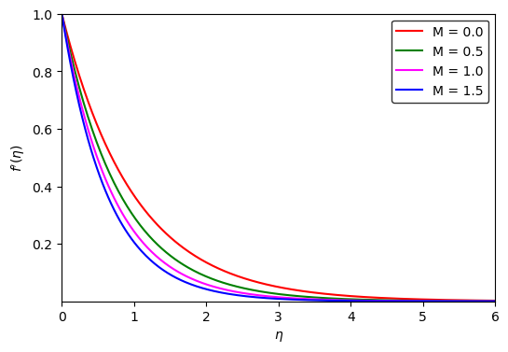
Figure 1. Effect of the magnetic field parameter on the velocity profile
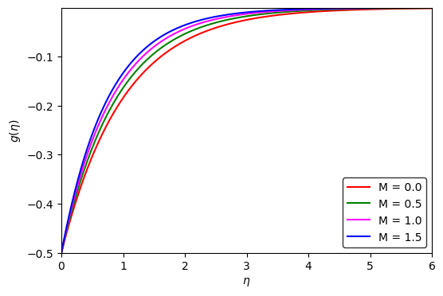
Figure 2. Effect of the magnetic field parameter on the microrotation profile

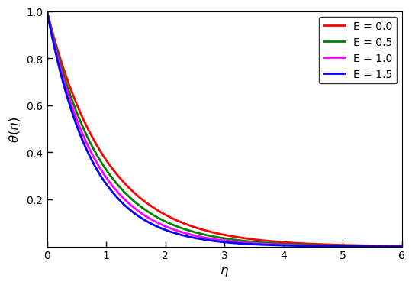

Figure 3. Effect of Magnetic field parameter on the temperature profile

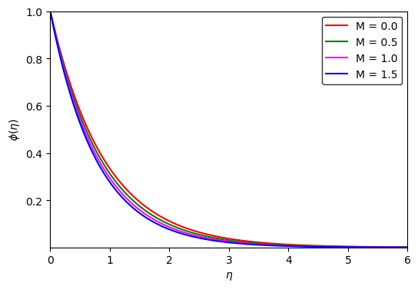
Figure 4. Concentration profile for variation in the magnetic field parameter

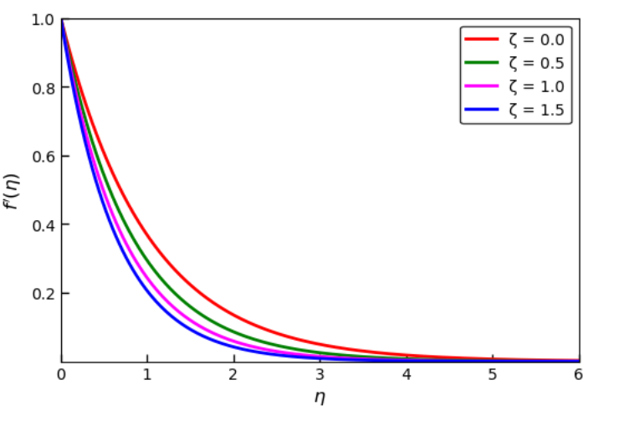
Figure 5. Effect of the micropolar parameter on the velocity profile
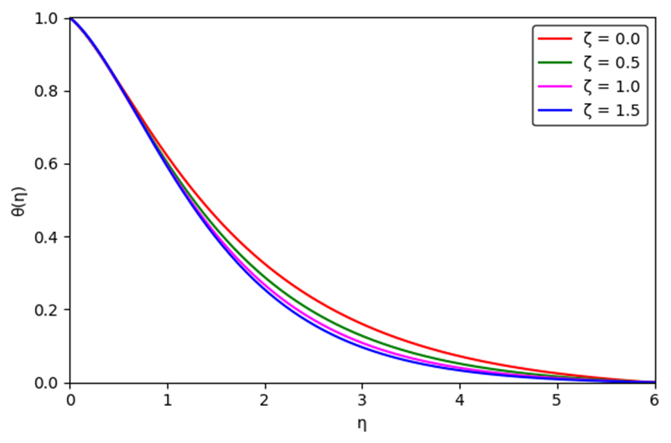
Figure 6: Temperature profile for variation in the Micropolar parameter

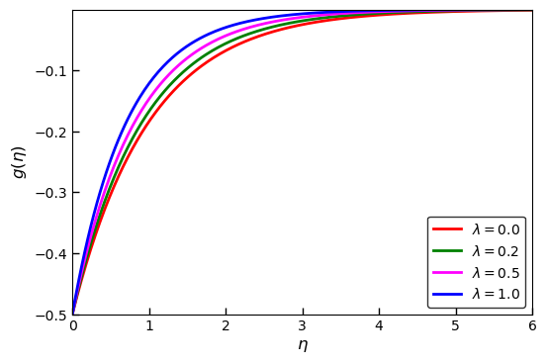
Figure 7. Effect of vortex viscosity parameter on microrotation profile

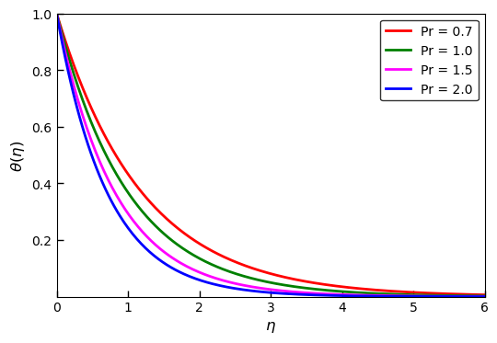

Figure 8: Influence of Prandtl number on temperature profile
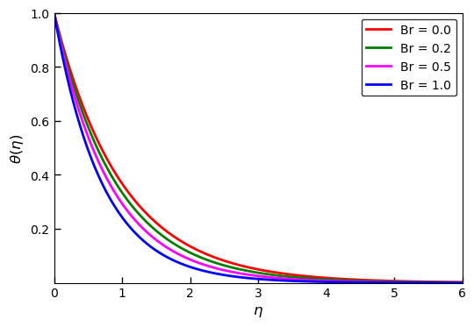
Figure 9: Effect of Brinkmann number on the temperature profile

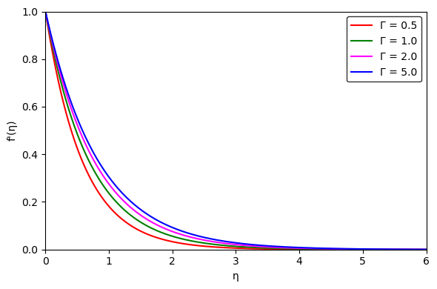
Figure 10: Effect of Darcy porosity parameter on the velocity profile

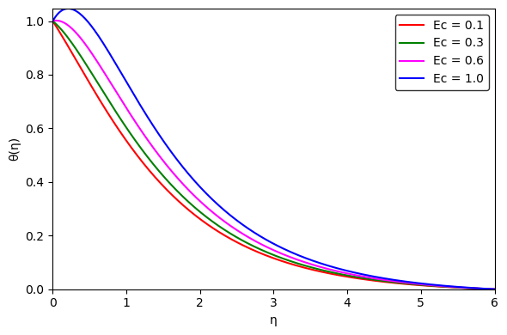
Figure 11: Influence of Eckert number on the temperature profile

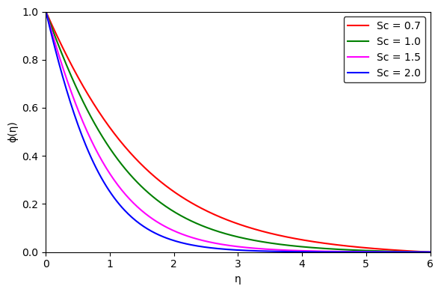
Figure 12: Concentration profile for variation in the Schmidt number
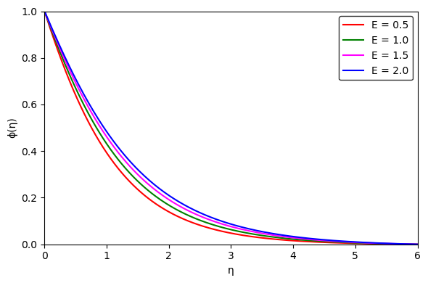
Figure 13: Effect of Activation energy on the concentration profile
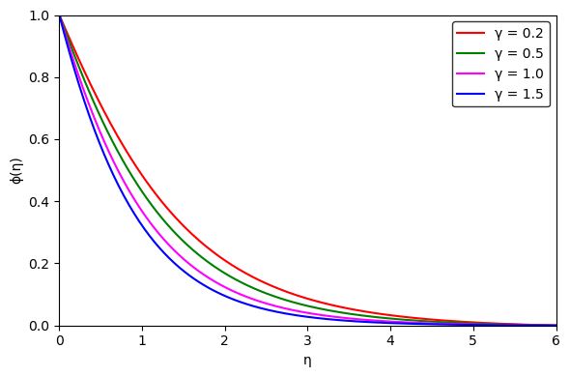
Figure 14: Effect of chemical reaction on the concentration profile
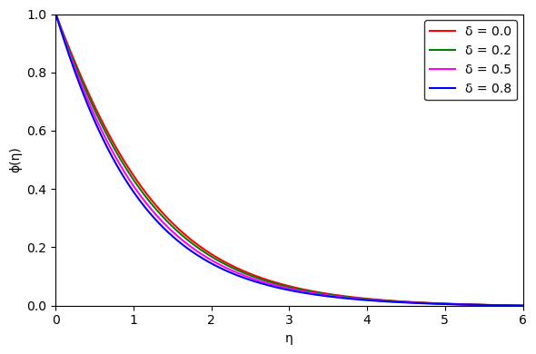
Figure 15: Effect of temperature difference parameter on concentration profile

Figures 1–4 illustrate the influence of the magnetic field parameter on the velocity, microrotation, temperature, and concentration distributions within the boundary layer. The results indicate that an increase in the magnetic parameter significantly enhances the velocity, temperature, and concentration profiles. In contrast, the microrotation profile exhibits a declining trend with increasing magnetic field strength. This opposing behavior suggests that the applied magnetic field augments the translational motion and associated thermal and mass transport processes, while simultaneously suppressing the rotational motion of microelements in the fluid.

The influence of the micropolar parameter on the velocity and temperature profiles is shown in Figures 5 and 6. It is observed that both profiles decrease as the micropolar parameter increases, indicating that stronger micropolar effects tend to inhibit both the translational motion of the fluid and the related thermal transfer. This behavior can be linked to the increased rotational activity of microelements within the fluid, which reallocates energy from translational motion to rotational motion, thereby lowering the overall fluid velocity and temperature near the boundary layer. These findings underscore the crucial role of micropolarity in regulating both momentum and heat transfer properties within the flow system.
Figure 7 illustrates the variation of the microrotation profile with respect to the spin-gradient parameter. The results indicate that an increase in the spin-gradient parameter leads to an exponential increase in the microrotation. The influence of the Prandtl number on the temperature profile is presented in Figure 8. It is observed that higher Prandtl numbers result in a decrease in the temperature profile, highlighting the role of thermal diffusivity in modulating heat transfer. Similarly, the effect of the Brinkman number on the temperature profile is shown in Figure 9. The results demonstrate an inverse relationship between the Brinkman number and the temperature profile, indicating that viscous dissipation has a significant impact on the thermal behavior of the system.
Figure 10 depicts the influence of the Darcy porosity parameter on the velocity profile. The results reveal that increasing the Darcy porosity parameter enhances the velocity, indicating that greater permeability facilitates fluid motion through the porous medium. Similarly, the effect of the Eckert number on the temperature profile is presented in Figure 11. The findings reveal a direct proportionality between the temperature profile and the Eckert number, underscoring the significant role of viscous dissipation in increasing the thermal energy within the system.
Figures 12–14 illustrate the effects of the Schmidt number, chemical reaction parameter, and temperature difference parameter on the concentration distribution. Increasing the Schmidt number leads to a reduction in the concentration profile, which can be attributed to the suppression of mass diffusivity at higher Schmidt numbers. Similarly, an increase in the chemical reaction parameter significantly diminishes the concentration field, reflecting the enhanced consumption of species due to stronger reaction rates. The temperature difference parameter also exerts a decreasing influence on the concentration profile, indicating that larger thermal gradients intensify species diffusion away from the boundary layer region.
In contrast, the influence of activation energy on the concentration profile is presented in Figure 15. The results demonstrate that higher activation energy enhances the concentration distribution. This behavior may be associated with the reduced effective reaction rate at elevated activation energy levels, which weakens species consumption and consequently leads to an accumulation of concentration within the boundary layer.

6. Conclusion
This study presents a semi-analytical framework for investigating the coupled effects of magnetohydrodynamics, microrotation, Arrhenius-type chemical reactions, and Ohmic heating in non-Newtonian micropolar fluid flow over a stretching surface. Using the Homotopy Analysis Method to solve the strongly nonlinear governing equations for momentum, micro-angular momentum, heat, and mass transfer, the work enables systematic parametric analysis and provides coherent physical insights into the transport mechanisms governing such complex reactive flows.
- Magnetic effects significantly enhance velocity, temperature, and concentration profiles while concurrently suppressing microrotation, indicating strengthened translational transport alongside reduced microelement rotation.
- Enhanced micropolar interactions lead to a marked reduction in velocity and temperature due to increased rotational activity of microelements, which redistributes energy from translational to angular motion.
- Stronger spin-gradient effects cause a pronounced amplification of the microrotation profile, highlighting their dominant influence on rotational dynamics.
- Reduced thermal diffusivity lowers the temperature profile, resulting in a thinner thermal boundary layer and diminished heat transfer.
- Viscous dissipation modulates the thermal field by converting kinetic energy into thermal energy, thereby influencing temperature distribution within the boundary layer.
- Greater permeability accelerates fluid flow, enhancing the velocity profile by reducing resistance in the porous medium.
- Higher viscous heating elevates the temperature profile, reflecting increased thermal energy generation due to internal friction.
- Reduced mass diffusivity diminishes the concentration profile, indicating slower species transport within the boundary layer.
- Intensified chemical reactions deplete species concentration, reflecting accelerated consumption of reactants in the flow
- Stronger thermal gradients suppress concentration by promoting enhanced species diffusion away from the boundary region.
- Higher activation energy promotes species accumulation by weakening the effective reaction rate, leading to increased concentration within the boundary layer.

- Nomenclature
- $u,v$ Velocity components along the $x$- and $y$-directions
- $x,y$ Cartesian coordinates
- $B_{0}$ Applied magnetic field strength
- $C$ Species concentration
- $C_{w}$ Wall concentration
- $C_{∞}$ Ambient concentration
- $C_{f}$ Skin friction coefficient
- $D$ Mass diffusivity
- $Ea$ Activation energy
- $Γ$ Permeability of porous medium
- $N$ Microrotation component
- $Nu_{x}$ Local Nusselt number
- $R$ Universal gas constant
- $Re_{x}$ Local Reynolds number
- $Sh_{x}$ Local Sherwood number
- $T$ Fluid temperature
- $T_{w}$ Wall temperature
- $T_{∞}$ Ambient temperature
- $b$ Stretching rate constant
- $c_{p}$ Specific heat at constant pressure
- $f(η)$ Dimensionless stream function
- $g(η)$ Dimensionless microrotation function
- $k_{f}$ Thermal conductivity
- $k_{r}$ Chemical reaction rate constant
- $m$ Fitted rate exponent
- Greek Symbols
- $λ$ Microrotation parameter
- $δ$ Temperature difference parameter
- $η$ Similarity variable
- $κ$ Vortex (micropolar) viscosity
- $γ$ Chemical reaction parameter
- $μ$ Dynamic viscosity
- $ν$ Kinematic viscosity
- $ρ$ Fluid density
- $σ$ Electrical conductivity
- $θ(η)$ Dimensionless temperature
- $φ(η)$ Dimensionless concentration
- $ϕ$ Stream function

Disclaimer (Artificial intelligence)
Author(s) hereby declare that NO generative AI technologies such as Large Language Models (ChatGPT, COPILOT, etc.) and text-to-image generators have been used during the writing or editing of this manuscript.

References
[1] Khan, N., Zeeshan, M., Hashmi, S. (2023). Variable thermal conductivity and chemical reaction aspects in MHD tangent hyperbolic nanofluid flow over an exponentially stretching surface,” Modern Physics Letters B, Doi: 10.1142/s0217984924500660.
[2] Kumar, H., Nath, R. S., Deka, R. (2024). MHD Casson Fluid Flow over a Stretching Surface with Suction, Double Stratification, and Heat and Mass Transfer Effects, Physica Scripta, Nov. 2024, DOI: 10.1088/1402-4896/ad9116.
[3] Khan, M., Karim, I., Biswas, H. A. (2012). Non-Newtonian MHD mixed convective power-Law fluid flow over a vertical stretching sheet with thermal radiation, heat generation, and chemical reaction. https://www.academia.edu/download/75277283/20123.3-09.pdf
[4] Reddy, P. B. A. (2016). MHD boundary layer slip flow of a Casson fluid over an exponentially stretching surface in the presence of thermal radiation and chemical reaction,” Journal of Naval Architecture and Marine Engineering, vol. 13, no. 2, pp. 165–177, Doi: 10.3329/JNAME.V13I2.23537.
[5] Sanni, K. M., Asghar, S., Rashid, S., Chu, Y. M. (2021). Nonlinear Radiative Treatment of Hydromagnetic Non-Newtonian Fluid Flow Induced by a Nonlinear Convective-Boundary-Driven Curved Sheet With Dissipations and Chemical Reaction Effects,” Frontiers of Physics in China, vol. 9, p. 283, June 2021, Doi: 10.3389/FPHY.2021.670930.
[6] Nayak, M. K., Dash, G. C., Singh, L. P. (2016). Heat and mass transfer effects on MHD viscoelastic fluid over a stretching sheet through porous medium in the presence of chemical reaction,” Propulsion and Power Research, Mar. 2016, Doi: 10.1016/J.JPPR.2016.01.006.
[7] Shamshuddin, M. D, Khan, U. S., Beg, O. A., Beg, T. A. (2020). Hall Current, Viscous and Joule Heating Effects on steady radiative 2-D magneto-power-law polymer dynamics from an exponentially stretching sheet with power-law slip velocity: A Numerical Study. Thermal Science and Engineering process, https://doi.org/10.1016/j.tsep.2020.100732
[8] Eringen, A. C. (1966). Theory of Micropolar Fluids. International Journal of Mathematics and Mechanics, 16:1–18.
[9] Łukaszewicz, G. (1999). Micropolar Fluids: Theory and Applications. Springer.
[10] Grzegorz, L. (2012). Micropolar Fluids: Theory and Applications. Birkhauser Boston, MA. ISBN: 978-1-4612-0641-5
[11] Zhu, W. (2021). Theoretical Study of Micropolar Fluid Flow in Porous Media. Advances in Geo-Energy Research, 5(4), 465–472.
[12] Pal, D., Chatterjee, S. (2010). Heat and Mass Transfer in MHD Non-Darcian Flow of a Micropolar Fluid over a Stretching Sheet Embedded in a Porous Media with Non-Uniform Heat Source and Thermal Radiation. communications in Nonlinear Science and Numerical Simulation, 15(7):1843–1857.
[13] Zueco, J., Bég, O.A. & Chang, TB. (2009). Network numerical simulation of two-dimensional nonlinear micropolar hydrodynamics in a Darcian porous medium. Korean J. Chem. Eng. 26, 1226–1234. https://doi.org/10.1007/s11814-009-0213-8
[14] Lu, D., Kahshan, M., Siddiqui, A. M. (2019). Hydrodynamical Study of Micropolar Fluid in a Porous-Walled Channel: Application to Flat Plate Dialyzer,” Symmetry, vol. 11, no. 4, p. 541, Doi: 10.3390/SYM11040541.
[15] Akbar, N. S., Tripathi, D., Khan, Z. H., Bég, O. A. (2018). Mathematical modelling of pressure-driven micropolar biological flow due to metachronal wave propulsion of beating cilia. Bellman Prize in Mathematical Biosciences, vol. 301, pp. 121–128, Doi: 10.1016/J.MBS.2018.04.001.
[16] Lin, J. R., Chou, T. L., Liang, L, J., Hung, T. C. (2012). Non-Newtonian dynamics characteristics of parabolic-film slider bearings: micropolar fluid model, Tribology International, Doi: 10.1016/J.TRIBOINT.2011.12.001.
[17] Beg, O. A., Bhargava, R., Sharma, S., Beg, T., Shamshuddin, M. D., A. Kadir, A. (2020). Numerical solutions for axisymmetric non-Newtonian stagnation enrobing flow, heat and mass transfer with application to cylindrical pipe coating dynamics,” Computational Thermal Sciences: An International Journal, vol. 12, no. 1, pp. 79–97, Doi: 10.1615/COMPUTTHERMALSCIEN.2020026228.
[18] Borah, K., Konch, J., Chakraborty, S. (2023). Effect of Arrhenius Activation Energy in MHD Micropolar Nanofluid Flow Along a Porous Stretching Sheet with Viscous Dissipation and Heat Source,” East European journal of physics, no. 4, pp. 98–108, Doi: 10.26565/2312-4334-2023-4-10.
[19] Mabood, F., Shamshuddin, M. (2021). A numerical model for analysis of binary chemical reaction and activation energy of thermo-solutal micropolar nanofluid flow through permeable stretching sheet: nanoparticle study,” Physica Scripta, vol. 96, no. 7, p. 075206, Doi: 10.1088/1402-4896/ABF794.
[20] Nabil T. E, Hussein, S. A., Mahmoud E. G., Abdullah, Z. Z. (2023). A novel mathematical model of MHD boundary layer flow of an activated micropolar nanofluid over a stretching surface under the effect of electro-osmosis forces. Modern Physics Letters B, Vol. 37, No. 5, 2350153 (22 pages). https://doi.org/ 10:1142/S0217984923501531
21] Zeeshan, Ahammad, N. A., Rasheed, H. U., El-Deeb, A. A., Almarri, B., & Shah, N. A. (2022). A Numerical Intuition of Activation Energy in Transient Micropolar Nanofluid Flow Configured by an Exponentially Extended Plat Surface with Thermal Radiation Effects. Mathematics, 10(21), 4046. https://doi.org/10.3390/math10214046
[22] Alahmadi, H., Alsaeed, S., Shahzad, S. M., & Rauf, A. (2025). Arrhenius Activation Energy Performance in Hydro magnetized Thermal Flow of Micropolar Fluid Between Two Parallel Stretchable Disks”, Available: https://onlinelibrary.wiley.com/doi/abs/10.1002/mma.70415

[23] Shankar Goud, B., Ankamma, K., Jyothi, A. M., Dharmaiah, G., Srihari, K. (2025). Melting heat transmission characteristics of MHD thermal radiation past a stretching sheet under activation energy and Joule heating features. Progress in Engineering Science.Volume 2, Issue 4, 100140.https://doi.org/10.1016/j.pes.2025.100140
[24] Merkin, J. Roşca, N. C., Roşca, A. V., Pop, I. (2025). Thermal analysis and magnetohydrodynamic flow with viscous dissipation and Joule heating effects over a nonlinear permeable stretching/shrinking sheet, doi: 10.1108/hff-03-2025-0174.
[25] Srinivasulu, C., Murthy, D., Babu, P. R. S., Srinivas, D., Kumar, A. K., Ravindra, N. R (2024). Mathematical Model for MHD Micropolar fluid with Chemical Reaction towards an Exponential Curved Surface, CFD Letters, vol. 17, no. 2, pp. 17–42, Sept. 2024, doi: 10.37934/cfdl.17.2.1742.
[26] Nagaraj, V. G., Sinivasan, K., Al-Mdallal, Q. M., Hirankumar, G. (2024). An Analytical Study on the Influence of Magnetic Field-Dependent Viscosity on Viscous and Ohmic Dissipative Second-Grade Fluid Boundary Layers,” Physica Scripta, doi: 10.1088/1402-4896/ad4f75.
[27] Elsaid, E. M., Elaziz, M. A., Aly, A. M., Alruwaili, A., Eid, M. R. (2024). Physical analysis and thermal case of magnetized fluid flow and heat transfer via stretchable cylinder: Hall impact and entropy generation. Modern Physics Letters B, Apr. 2024, doi: 10.1142/s0217984924503718.
[28] Vinothkumar, B. (2024). Two-phase numerical simulation of thermal and solutal transport exploration of a non-Newtonian nanomaterial flow past a stretching surface with chemical reaction,” Open Physics, vol. 22, no. 1, doi: 10.1515/phys-2024-0036.

[29] Ullah, Z., Alkinidri, M. (2023). Oscillatory and transient role of heat transfer and magnetic flux around magnetic-driven stretching cylinder under convective boundary conditions. Case Studies in Thermal Engineering, Volume 50, 103514. https://doi.org/10.1016/j.csite.2023.103514
[30] Govardhan, K., Mohammad, R. M., Basha, H., Reddy, G. J. (2023). Dissipative magnetic ohmic heating influence on radiative nanofluid flow about a permeable stretching sheet under a porous medium with heat source, International Journal of Ambient Energy, pp. 1–12, doi: 10.1080/01430750.2023.2224334.
[31] Zainab, M., Alwan, A. (2014). Homotopy Analysis Method for solving various nonlinear problems of partial Differential Equations. Mathematical Theory and Modelling. Vol. 4, No. 14, ISSN 2224-5804
[32] Liao, S. (2003). Beyond Perturbation: Introduction to the Homotopy Analysis Method. Chapman and Hall/CRC, ISBN: 9780429208614. https://doi.org/10.1201/9780203491164
[33] Liao, S. J. (2012). Homotopy Analysis Method in Nonlinear Differential Equations. Berlin / Heidelberg: Springer & Higher Education Press. ISBN: 978-3-642-25132-0. DOI: 10.1007/978-3-642-25132-0.
[34] Liao, S. J. (Ed.) (2013). Advances in the Homotopy Analysis Method. Singapore: World Scientific Publishing Company. 428 pp. ISBN: 978-981-455124-3.
[35] Matinfar, M., Saeidy, M., Vahidi, J. (2011). Application of Homotopy Analysis Method for Solving Systems of Volterra Integral Equations. Advances in Applied Mathematics and Mechanics, Vol. 4, No. 1, pp. 36-45. https://doi.org/10.4208/aamm.10-m1143.
[36] Idris, N. N. A., Mohamad, M., & Aman, F (2021). Homotopy Analysis Method to Solve Second-Order Nonlinear Ordinary Differential Equations.” Enhanced Knowledge in Sciences and Technology, vol. 1, no. 2, pp. 51–59. Shows HAM application to nonlinear ODEs with comparative analysis to exact solutions.
[37] Hamoud, J., Ghadle, A. K. (2018). Usage of the homotopy analysis method for solving fractional Volterra-Fredholm integro-differential equations of the second kind. Tamkang Journal of Mathematics, vol. 49, no. 4, pp. 301–315. DOI: 10.5556/j.tkjm.49.2018.2718.
[38] Naganthran, K., Zeeshan, A., Basir, M. F. M., Shehzad, N., Nazar, R., Choudhary, R., & Balaji, S. (2020). Concentration Flux Dependent on Radiative MHD Casson Flow with Arrhenius Activation Energy: Homotopy Analysis Method (HAM) with an Evolutionary Algorithm. International Journal of Heat and Technology, 38(4), 927–940. DOI: 10.18280/ijht.380403.
[39] Mabood, F., Lorenzini, G., Nopparat, P., Shateyi, S. (2018). Homotopy Analysis Method for Radiation and Hydrodynamic-Thermal Slips Effects on MHD Flow and Heat Transfer Impinging on Stretching Sheet. Defect and Diffusion Forum Vol. 388, Pages 317-327. https://doi.org/10.4028/www.scientific.net/DDF.388.317

[40] Hayat, T., Qasim, M., Mesloub, S. (2011). MHD flow and heat transfer over permeable stretching sheet with slip conditions. International Journal for Numerical Methods in Fluids, https://doi.org/10.1002/fld.2294
[41] Raftari, B. (2012). Homotopy Analysis Method for MHD Viscoelastic Fluid Flow and Heat Transfer in a Channel with a Stretching Wall. Communications in Nonlinear Science and Numerical Simulation, 17(11), 4149-4162. DOI: 10.1016/j.cnsns.2012.01.032.
[42] Liao, S. J., Abbasbandy, S. (2009). Homotopy Analysis Method for Solving the MHD Flow over a Non-Linear Stretching Sheet. Communications in Nonlinear Science and Numerical Simulation, 14(6), 2653-2663. DOI: 10.1016/j.cnsns.2008.08.006.
[43] Ziabakhsh, Z., Domairry, G., Bararnia, H., & Babazadeh, H. (2010). Analytical Solution of Flow and Diffusion of Chemically Reactive Species over a Nonlinearly Stretching Sheet Immersed in a Porous Medium. Journal of the Taiwan Institute of Chemical Engineers, 41(1), 22-28. DOI: 10.1016/j.jtice.2009.04.011.
[44] Ahmed, S. (2018). On the Homotopy Analysis Method (HAM) and Homotopy Perturbation Method (HPM) for a Nonlinearly Stretching Sheet Flow of Eyring–Powell Fluids. Engineering Science and Technology, an International Journal. DOI: 10.1016/j.jestch.2018.11.001
[45] Padmini, N., Tawade, J. V., Guled, C., & Sanamani, J. (2024). Homotopy Analysis Method (HAM) for an Analysis of Unsteady MHD Thin Film Nanofluid Flow Over a Moving Flat Surface. International Journal of Intelligent Systems and Applications in Engineering, 12(22s), 1356-1366. Retrieved from https://www.ijisae.org/index.php/IJISAE/article/view/6600.
[46] Shukla, H., Surati, H.C., Timol, M.G. (2018). Similarity analysis of three-dimensional nanofluid flow by deductive group theoretic method. Applications and Applied Mathematics, 13(2): 1260-1272.

