Original Research Article
INVESTIGATING THE NUTRITIONAL STATUS, PHENOLIC COMPOUNDS AND PHYTOCHEMICAL CONSTITUENTS OF POMELO (Citrus maxima) FRUIT

ABSTRACT
Introduction: Citrus fruits, particularly Citrus Maxima (commonly known as shaddock or pomelo), are renowned for their nutritional richness and bioactive compounds, yet limited research has focused on the comprehensive analysis of both the peel, pulp, and seed of this underutilized species.
Aim: The aim of this study was to conduct a comprehensive analysis of both the seed, peel, and pulp of Citrus maxima (pomelo), in order, to determine their nutritional compositions, polyphenolic and phytochemical constituents. This could promote sustainable utilization of Pomelo, by reducing agricultural waste and supporting circular bio-economy strategies in food systems.
Results: The proximate composition revealed that the peel contained (Crude protein (%) 8.14±0.65, ash (%) 5.18±0.78, crude fat (%) 3.82±0.42, crude fiber (%) 34.62±1.29, carbohydrate (%) 43.45 ±1.54, and moisture (%) 8.43±0.76. The pulp contained higher protein (3.80 ± 0.10%), ash (9.43 ± 0.21%), carbohydrate (52.56 ± 1.21%), and moisture (16.31 ± 0.44%) than the seed, while the seed was richer in fat (13.14 ± 0.33%) and fiber (20.12 ± 0.54%). Phytochemical screening showed that saponins were significantly higher in the seed (73.44 ± 1.93%) than in the pulp (62.97 ± 1.65%), whereas alkaloids were more abundant in the pulp (6.34 ± 0.17%) than in the seed (4.23 ± 0.11%). HPLC profiling of phenolic compounds indicated maleic acid, ferulic acid, tannic acid, rutin hydrate, and kaempferol as concentrated embedded phenolics in the various portions of pomelo.
Conclusion: The results of this study highlight the complementary nutritional and phytochemical significance of the various parts of pomelo fruit. Therefore, industries should explore pomelo fruit peels and seeds as raw materials for functional food and pharmaceutical formulations for biotechnological advancement.
Keywords: Pomelo fruit; nutritional composition; polyphenols; phytochemical analysis; antioxidant properties
- INTRODUCTION
Citrus maxima (shaddock or pomelo), a citrus species widely grown in tropical and subtropical regions, remains significantly underutilized and under-researched, especially in terms of its seed, peel, and pulp composition [1]. Pomelo is known for its large, juicy fruits, which are rich in vitamins, antioxidants, dietary fiber, and bioactive phytochemicals [2]. Traditionally, the pulp of pomelo is consumed fresh or processed into juices, jams, and desserts due to its sweet to slightly tangy flavor and high nutritional value. While the pulp and juice of this fruit are widely consumed, the peels and seeds are generally discarded as waste. The grape is widely recognized as a nutrient-dense fruit that provides important vitamins and antioxidants [3]. Grape, a less studied variety, has recently attracted attention because of its potential bioactive compounds [4]. The nutritional composition and bioactive properties of fruits have attracted significant scientific interest due to their potential health benefits. Among fruits, grapes are known for their high polyphenolic content, which contributes to their antioxidant, anti-inflammatory, and anticancer properties [5]. While grape cultivars are extensively studied, lesser-known varieties, such as the Grape (Pomelo), have not received as much attention [6]. Pomelo, a local variety found in tropical regions, is rich in nutrients, making it an ideal candidate for phytochemical and proximate composition analysis [1].
The pulp of Pomelo is a rich source of essential nutrients such as vitamin C, dietary fiber, potassium, and bioactive compounds, including flavonoids, phenols, and essential oils [7]. These bioactive compounds contribute to the fruit’s antioxidant, anti-inflammatory, and antimicrobial properties, supporting its traditional use in managing ailments like coughs, digestive problems, and hypertension [1]. The health benefits of citrus fruits are largely attributed to their phytochemical profile, particularly flavonoids like naringin and hesperidin, which are also present in pomelo pulp [8].
On the other hand, the peels and seeds of Pomelo often discarded as waste, have increasing interest in recent years due to its rich content of essential oils, polyphenols, fatty acids, and proteins [9]. Research has revealed that citrus peels and seeds may serve as valuable raw materials for the development of nutraceuticals and functional foods due to their bioactive potential and oil content, which often contains beneficial unsaturated fatty acids [1,10-11].
The valorization of such fruit by-products aligns with global efforts to reduce food waste and promote the circular bio-economy. Exploring the compositional characteristics of the seed alongside the pulp offers a more holistic understanding of the fruit’s nutritional potential and opens up new pathways for food, pharmaceutical, and cosmetic applications [12, 13]. Moreover, evaluating the phytochemical constituents in both parts of the fruit may reveal unique compounds or combinations that offer enhanced antioxidant or therapeutic effects.
Furthermore, the absence of proximate data (such as moisture, protein, lipid, ash, and fiber content) and polyphenolic profiles hinders efforts to formulate dietary recommendations or evaluate the fruit's potential contribution to human nutrition. Without this foundational information, both scientific and commercial communities are unable to harness the full nutritional and medicinal potential of Pomelo. Therefore, it becomes imperative to conduct a comprehensive analysis of both the seed, peel, and pulp of Citrus maxima to determine their nutritional composition, polyphenolic content, and phytochemical constituents.
The increasing demand for natural, health promoting, and functional foods has directed global scientific attention toward the bioactive compounds found in fruits and their by-products. Among these, citrus fruits are considered excellent sources of essential nutrients and phytochemicals that contribute to human health and disease prevention [14].
Researchers have focused on commonly consumed citrus varieties such as orange (Citrus sinensis) and lemon (Citrus limon), leaving a gap in the understanding of the nutritional and medicinal value of Pomelo, particularly its peels and seeds, which is often treated as waste [13]. Yet, previous research shows that citrus seeds may contain important phytochemicals such as flavonoids, alkaloids, tannins, and phenolic acids with antioxidant and antimicrobial activities [14-15]. The justification for this study lies in the potential of Pomelo to serve as a low-cost source of nutrients and bioactive compounds, especially in regions facing food insecurity and post-harvest losses. Moreover, assessing the proximate composition (moisture, ash, protein, lipid, fiber, and carbohydrate content) provides essential nutritional information that can inform dietary planning and food product development [17]. The polyphenolic content is equally important, as polyphenols are known to neutralize free radicals and contribute to the prevention of chronic diseases such as cardiovascular disorders, diabetes, and cancer [5, 14].
Therefore, this study brought about the comprehensive analysis of both the seed, peel, and pulp of pomelo, in order, to determine their nutritional compositions, polyphenolic and phytochemical constituents. This could promote sustainable utilization of Pomelo, by reducing agricultural waste and supporting circular bio-economy strategies in food systems. Evaluating both the peels, seeds, and pulp of pomelo could promote sustainable utilization of this fruit, by reducing agricultural waste and supporting circular bio-economy strategies in food systems. It could also advance scientific knowledge and public awareness about the nutritional and pharmacological importance of neglected tropical fruits [4 -6].
- MATERIALS AND METHODS
2.1 Materials and Equipment
2.1.1 Materials
Matured fruits of Pomelo, distilled water, concentrated H₂SO₄ (sulphuric acid), 1.5 N H₂SO₄, concentrated HNO₃ (nitric acid), NaOH (sodium hydroxide), petroleum ether (for Soxhlet extraction), magnesium carbonate (MgCO₃), isobutyl alcohol (But-2-ol), Iron (III) chloride (FeCl₃) solution, KMnO₄ (potassium permanganate), ammonium thiocyanate solution, Acetic acid in ethanol, ammonium hydroxide, Folin–Ciocalteu reagent, sodium carbonate (Na₂CO₃), aqueous acetone (70%), standard tannic acid, standard iron solution, among others.
2.1.2 Equipment
Hot-air oven (for drying at 105°C), Soxhlet extractor, Muffle furnace (for ash determination at 550°C), Analytical balance (sensitivity ±0.001 g), Centrifuge, UV-Visible spectrophotometer (for saponin and tannin analysis), Blender (for sample pulverization), Shaker, Water bath, beakers (100 ml, 250 ml), conical flasks, volumetric flasks (50 ml, 100 ml), pipettes, burettes, test tubes and sample bottles, Whatman No. 1 filter paper, and other consumables which were of high standard.

3.3 Sample Collection and Preparation
Fresh fruits of Pomelo were purchased from (King Market, Akure, Ondo State, Nigeria (7.2534ºN, 5.1953ºE), in February, 2025. The fruits were thoroughly washed with distilled water to remove surface contaminants. The peels and pulp were manually separated from the seeds. Both peels, pulp, and seeds were air-dried at room temperature, pulverized into fine powder using an electric blender, and stored in airtight containers at ambient temperature until analysis.
3.4 Proximate Composition Analysis
The proximate composition of Pomelo peels, pulp, and seeds samples were determined using standard AOAC [17] methods as follows:
- Moisture Content: Determined using a hot-air oven (AOAC 952.08) at 105°C until a constant weight was obtained.
- Crude protein: Estimated by the Kjeldahl method (AOAC 992.23). Total nitrogen was multiplied by a conversion factor of 6.25.
- Total fat: Extracted using the Soxhlet method (AOAC 948.15) at 60°C until constant weight was achieved.
- Crude fibre: Determined according to AOAC 985.29. Samples were digested with acid and alkali for 30 minutes each at 100°C, then oven-dried at 105°C to constant weight.
- Ash content: Measured using the gravimetric method (AOAC 930.30) by incinerating samples at 550°C until constant weight.
- Carbohydrate content: Calculated by difference.
3.5 Phytochemical Analysis of Pomelo Fruit
- Determination of Saponins
Saponin content was determined by the spectrophotometric method of Adeseko et al. [18], as described by Harborne [19]. Two grams of powdered sample were extracted with isobutyl alcohol, filtered, and treated with magnesium carbonate. Absorbance of the resulting solution was measured at 380 nm against a blank.
- Determination of Oxalates
The oxalate content was determined following Day and Underwood [20]. One gram of sample was soaked in 75 ml of 1.5 N H₂SO₄, filtered, and titrated at 80–90°C against 0.1 M KMnO₄ until a persistent pink colour appeared.
- Determination of Phytates
The phytate content was determined by the method of Wheeler and Ferrel [21]. Four grams of sample were soaked in 2% HCl, filtered, and titrated with standard iron (III) chloride solution using ammonium thiocyanate as an indicator.
- Determination of Tannins
The tannin content was determined by using the method of Makkar and Goodchild [22]. Tannins were extracted with 70% aqueous acetone, centrifuged, and treated with Folin–Ciocalteu reagent and sodium carbonate. Absorbance was read at 725 nm against a reagent blank, and tannic acid was used as standard.
- Determination Alkaloids
Following Harborne [19], five grams of sample were extracted with 10% acetic acid in ethanol, concentrated, and precipitated with ammonium hydroxide. The residue (alkaloid) was collected, dried, and weighed. Alkaloid percentage was calculated as:
%Alkaloid = W₃−W₂ / W₁ x 100
where:
W₁​= weight of sample
W_{2​}= weight of empty filter paper
W_{3​}= weight of filter paper + residue

9 Identification and quantification of phenolic compounds in Pomelo Fruit
The phenolic composition of pomelo fruit’s various parts was analyzed using an ultra-high-performance liquid chromatography system equipped with a Hybrid Quadrupole-TOF mass spectrometer with an ESI source (UHPLC-ESI-QTOF-MS/MS). UHPLC separations were performed on an appropriate column (e.g., Shim-pack GIST C18 column (2.1 × 75 mm, 2 μm) and the column temperature was maintained at 35 ℃. Samples were injected at 5 μL with a flow rate of 0.3 mL/min. The composition of the mobile phase was 0.1% formic acid in water (A) and acetonitrile (B). The gradient elution process was conducted as follows: 0 min, 3% B; 5 min, 8% B; 6 min, 20% B; 20 min, 35% B; 23 min, 50% B; 24–26 min, 100% B; and 26–30 min, 3% B. The electrospray ionization mass spectrum was performed by QTOF-MS/MS at negative ionization mode with an ESI source. Other necessary parameters were scanning range (80 – 1500), collision energies (−40 ± 20 eV), electrospray voltage (−4500 V), and the temperature of the ion source (550 ℃) were set. The identified compounds were compared with MassBank, ChemSpider, and other literature. The major phenolics including, maleic acid, caffeic acid, procatechuic acid, gallic acid, kaempferol, chlorogenic acid, saponin, salicylic acid, nairingin, rutin hydrate, ferulic acid, p-coumaric acid, quercetin, limonoids, and apigenin, were also quantified.
3. RESULT AND DISCUSSION
3.1 Results
3.1.1 Phytochemical Constituents of Citrus Maxima
The results of the phytochemical constituents were presented in Table 1. Phytochemical analysis further revealed high levels of saponins in both seed (73.44%) and pulp (62.97%), alkaloid content was higher in pulp (6.34%) than in seed (4.23%), oxalates were also higher in pulp (35.28%) compared to seed (27.46%), both seed and pulp had identical phytate levels (8.25%), tannin levels were relatively low in both pulp (0.49%) and seed (0.58%).
Table 1. Phytochemical Constituents of Pomelo (Dry Weight Basis)
Fruit | Saponin (%) | Phytate (%) | Tannin (%) | Alkaloid (%) | Oxalate (%)
Seed | 73.44 ± 1.93ᵃ | 8.25 ± 0.21ᵃ | 0.58 ± 0.01ᵃ | 4.23 ± 0.11ᵇ | 27.46 ± 0.63ᵇ
Pulp | 62.97 ± 1.65ᵇ | 8.25 ± 0.21ᵃ | 0.49 ± 0.01ᵇ | 6.34 ± 0.17ᵃ | 35.28 ± 0.08ᵃ
Peel | 95.56 ± 1.20^{c} | 5.25 ± 0.25^{c} | 0.62 ± 0.02^{c} | 5.56 ± 0.15^{c} | 25.32 ± 0.06^{c}
NOTE
Values are expressed as Mean ± SD. Means with the same superscript letter within the same column are not significantly different (p > 0.05). Means with different superscript letters within the same column are significantly different (p < 0.05).

3.1.2 Proximate Composition of Pomelo fruit
The results of the proximate composition of the fruit peel, pulp and seeds of pomelo were shown in Table 2. However, it was inferred that the peels contained higher levels of protein (8.14 %), crude fibre (34.62%). However, the pulp contained higher levels of moisture (16.31%), ash (9.43%), and carbohydrate (52.56%) while the seed contained more fat (13.14 %) than other pomelo fruit parts.
Table 2. Proximate Composition of Pomelo
Fruit | Fat (%) | Moisture (%) | Protein (%) | Ash (%) |  | Fibre (%) | Carbohydrate (%)
Seed | 13.14 ± 0.33ᵃ | 13.25 ± 0.35ᵇ | 2.84 ± 0.07ᵇ | 3.14 ± 0.07ᵇ | 20.12 ± 0.54ᵃ |  | 47.51 ± 1.38ᵃ
Pulp | 8.38 ± 0.21ᵇ | 16.31 ± 0.44ᵃ | 3.80 ± 0.10ᵃ | 9.43 ± 0.21ᵃ | 9.53 ± 0.25ᵇ |  | 52.56 ± 1.21ᵃ
Peel | 3.82 ± 0.42^{c} | 8.43 ± 0.76^{c} | 8.14 ± 0.65^{c} | 5.18 ± 0.78^{c} | 34.62 ± 1.29^{c} |  | 43.45 ± 1.54^{c}
NOTE
Values are expressed as Mean ± SD. Means with the same superscript letter within the same column are not significantly different (p > 0.05). Means with different superscript letters within the same column are significantly different (p < 0.05).

3.1.3 Identified and Quantified Phenolic Constituents in Pomelo Fruit using HPLC Analysis
HPLC profiling of phenolic compounds showed that the pulp contained higher concentrations of most phenolics compared to the seed. However, the phenolics that were quantified in the different portions of pomelo were presented in Table 3 while the chromatograms for the phenolics identified in various extracts were shown in Figures 1 (a, b, and c) respectively. In pulp the highest amount of maleic acid (2705.34 mg/L) was reported. Others include, ferulic acid (594.22mg/L), tannic acid (84.24mg/L), kaempferol (29.49 mg/L), rutin (25.60 mg/L), saponins (35.83mg/L), and quercetin (9.17mg/L), while the peels of pomelo contained higher amounts of (maleic acid (1790.78 mg/L), ferulic acid (1083.43mg/L), tannic acid ( 51.39mg/L), kaempferol ( 19.1mg/L), rutin (12.51 mg/L), saponins (50.45 mg/L), and quercetin ( 19.07mg/L) were prominent, along with detectable levels of naringin, caffeic acid, gallic acid, and eugenol. In contrast, the seed contained comparatively lower amounts of phenolics, with apigenin (19.66 mg/L), ferulic acid (18.07 mg/L), maleic acid (19.22 mg/L), and tannic acid (8.06 mg/L) being dominant, while most other compounds were present in trace amounts.
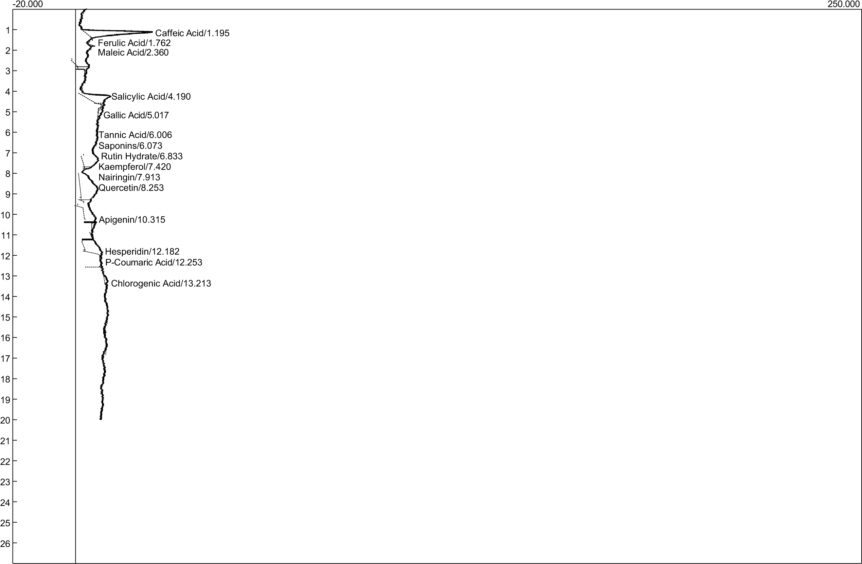

Figure 1a. HPLC-UV Spectra of Pomelo Peel Extract

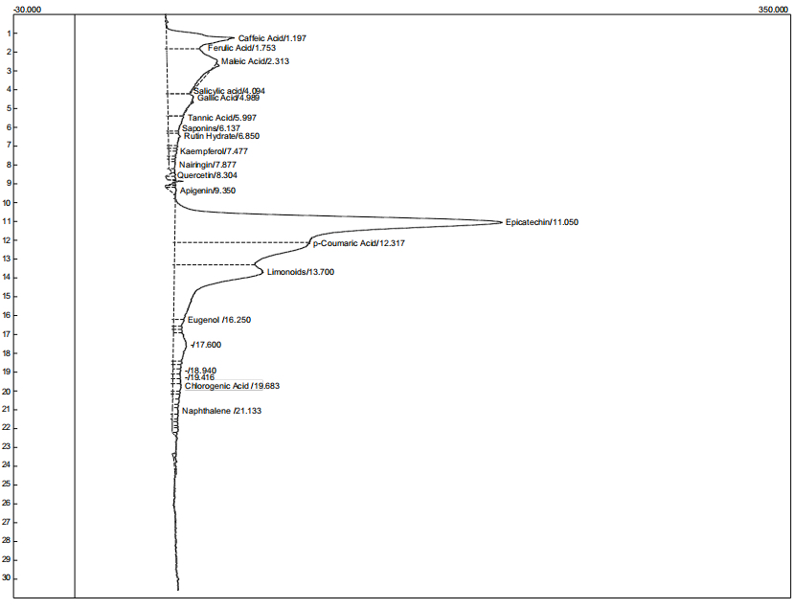

Figure 1b. HPLC-UV Spectra of Pomelo Seed Extract

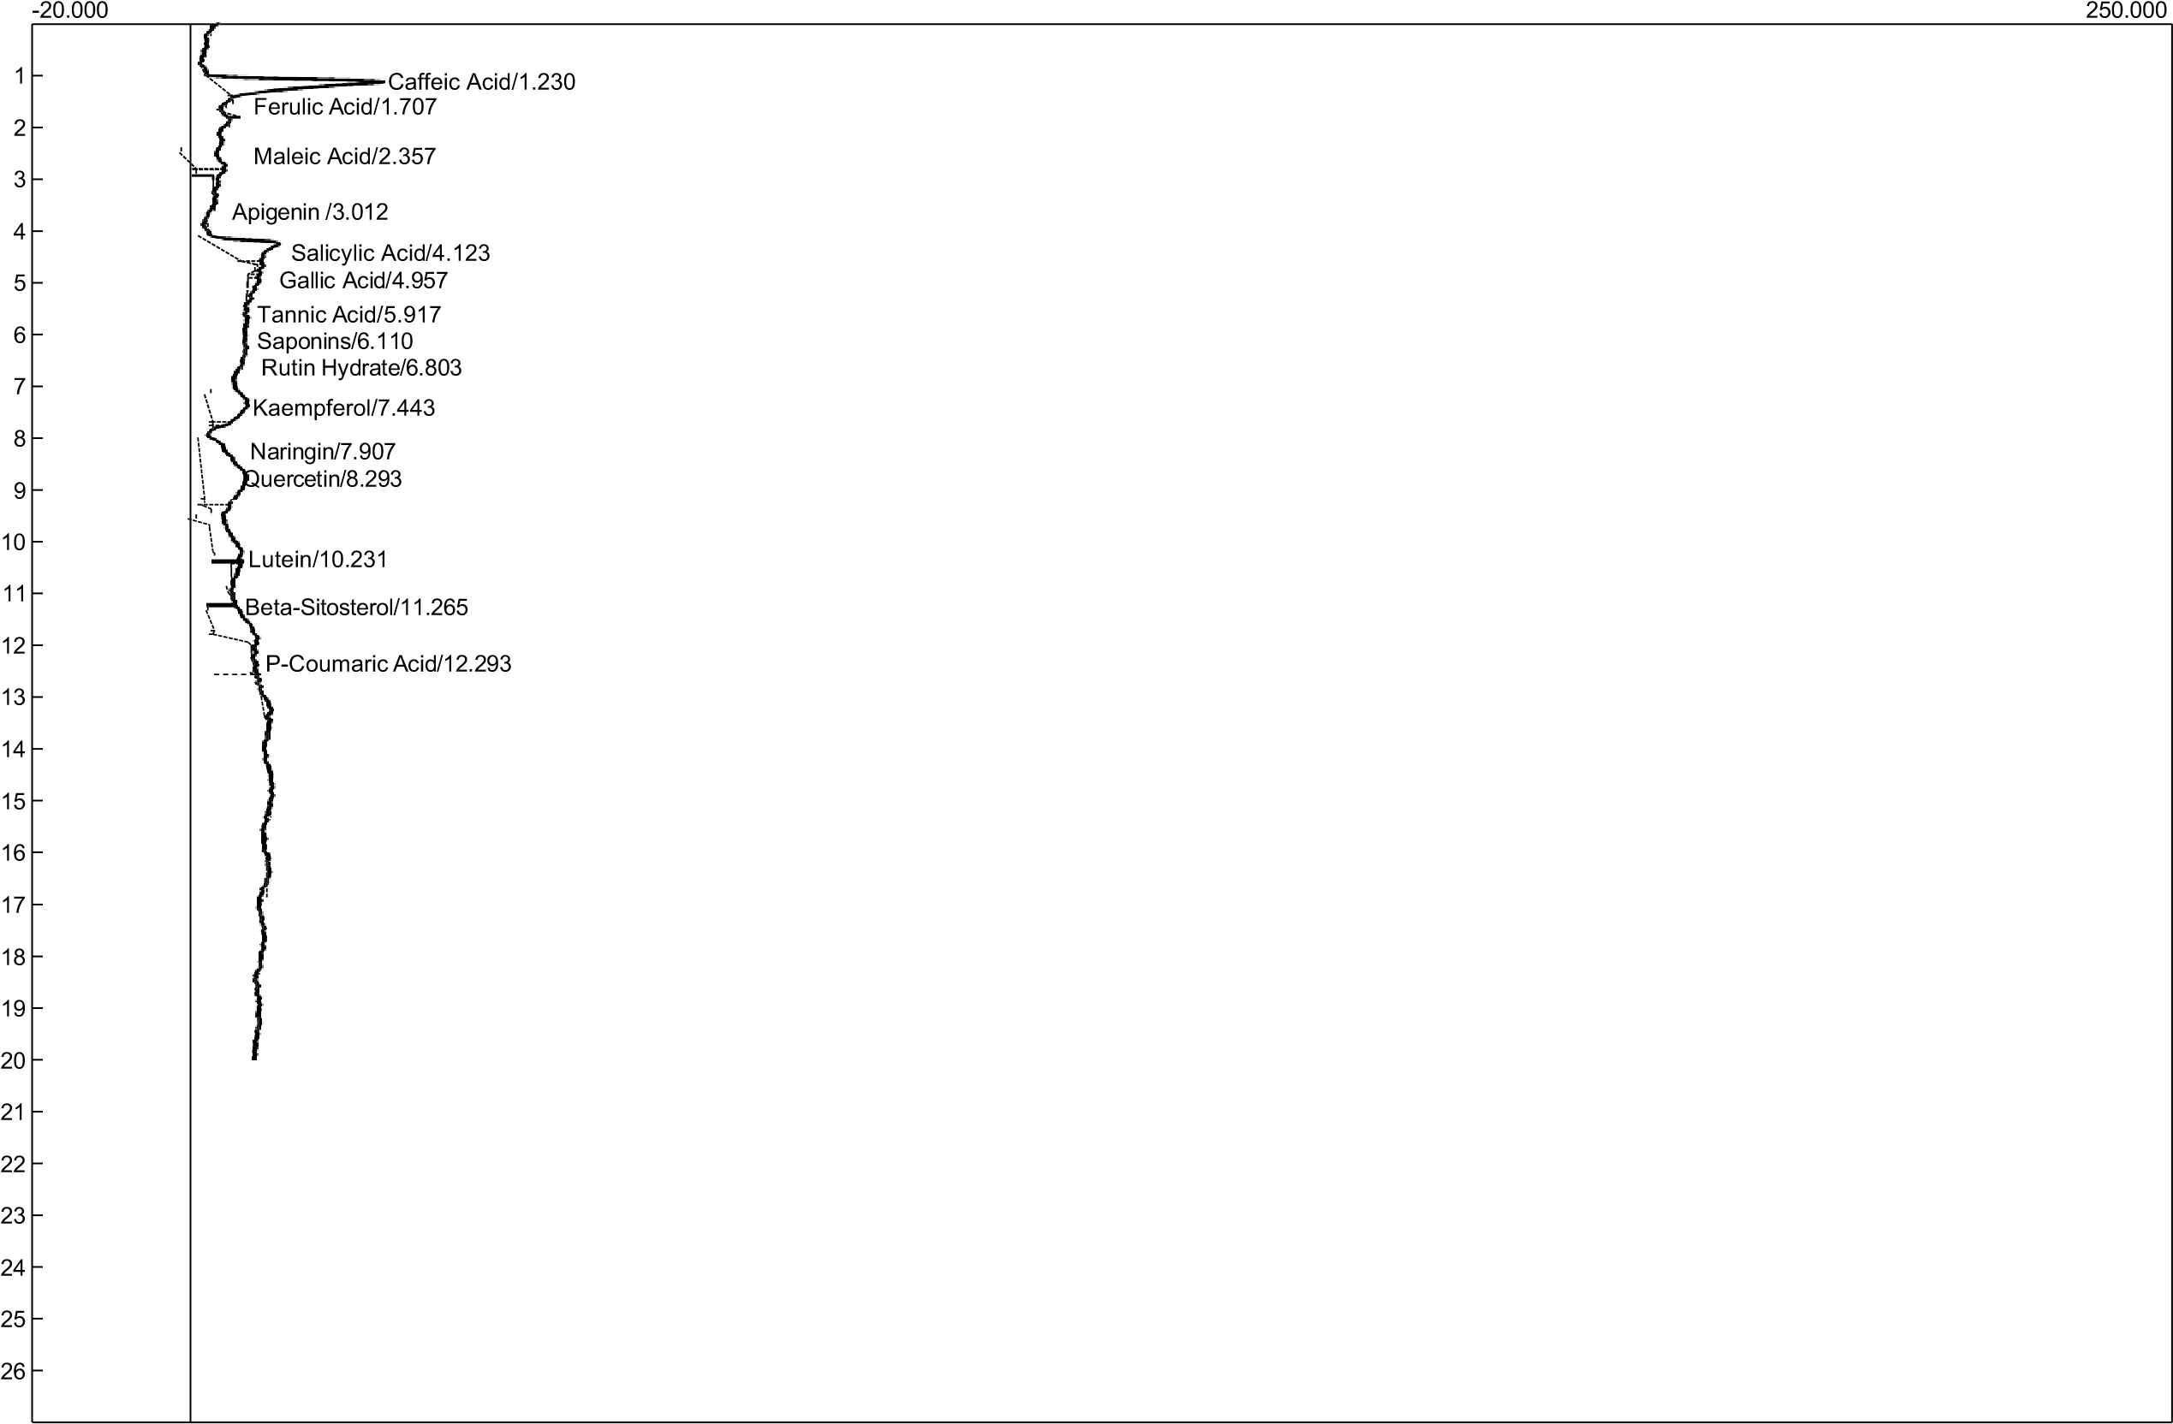

Figure 1c. HPLC-UV Spectra of Pomelo Pulp Extract

Table 3: Identified and Quantified Phenolic Compounds in Pomelo Fruit

Identified Compound | Peels | Pulp | Seeds
Caffeic Acid | 15.40368 ±2.03 | 18.69272 ±0.96 | 1.83196 ±0.08
Ferulic Acid | 1083.43069 ±12.30 | 594.22157 ±36.1 | 18.07229 ±0.97
Maleic Acid | 1790.78229 ±25.60 | 2705.33907 ±27.6 | 19.22228 ±0.15
Apigenin | 1.63143e-2 ±0.00 | 1.60561 ±0.05 | 19.65829 ±0.85
Salicylic Acid | 931.36590 ±7.40 | 84.24252 ±2.45 | 6.67599 ±0.09
Gallic Acid | 5.49593 ±0.05 | 35.83391±0.90 | 1.81266e-2 ±0.02
Tannic Acid | 51.38509±2.82 | 25.60209 ±2.01 | 8.05764 ±0.75
Saponins | 50.454551±1.50 | 29.42596 ±2.56 | 1.83892 ±0.05
Rutin Hydrate | 12.51661 ±2.50 | 14.29507 ±1.00 | 2.90931±0.50
Kaempferol | 19.09378 ±1.00 | 9.17103 ±0.05 | 2.32099 ±0.09
Nairingin | 27.98893 ±2.05 | 3.56695e-1 ±0.00 | 6.06430e-1 ±0.20
Quercetin | 19.07144 ±0.56 | 3.06446e-4 ±0.00 | 1.37037 ±0.06
Lutein | - | 5.74112e-3 ±0.00 | 2.02237e-3 ±0.02
Beta-Sitosterol | - | 3.96695e-1 ±0.00 | 8.05920e-7 ±0.65
p-Coumaric Acid | 2.19739e-2 ±0.00 | 6.30407e-1 ±0.00 | 1.63221e-4 ±0.00

Values are means of three replicates ± standard deviation (SD).

3.2 DISCUSSION
This study investigated the proximate composition, phytochemical constituents, and phenolic compounds of pomelo fruit peels, pulp and seeds. The findings revealed clear differences between the fruit various parts, highlighting their complementary nutritional and phytochemical significance.
These findings align with previous studies showing that citrus pulp serves as a primary source of energy and minerals, whereas the seeds concentrate storage reserves such as oil and fibre [23-25]. The higher lipid fraction of the seed supports its potential for edible oil extraction, as reported in grape seed oil studies by Pu et al. [16, 26]. On the other hand, the higher ash and protein contents of the pulp indicate greater nutritional value for direct consumption, in agreement with the observations of Hasan et al. [24] in Bangladeshi grape varieties. The significantly higher fibre content of the seed also points to its possible application in functional food formulations, consistent with reports that citrus seeds are a valuable source of dietary fibre [27].
Phytochemical analysis further revealed high levels of saponins in both seed and pulp. This is important since saponins are known for their antioxidant, antimicrobial, and cholesterol-lowering properties [28]. Alkaloid content was higher in pulp than in seed, which may contribute to the characteristic bitterness of the grape, similar to the role of bitter flavanones such as naringin in grape pulp reported by Gupta et al. [29]. Oxalates were also higher in pulp compared to seed, which is nutritionally significant as oxalates can limit calcium absorption; this agrees with Sapkota et al. [30], who noted similar accumulation patterns in citrus tissues. Both seed and pulp had identical phytate levels, which is comparable to values reported for citrus bye-products in the literature [26]. Tannin levels were relatively low in all the portions of the fruit, suggesting limited impact on protein digestibility, consistent with findings of Hasan et al. [24].
HPLC profiling of phenolic compounds showed that pulp contained higher concentrations of most phenolics compared to the seed. In the pulp, maleic acid, ferulic acid, tannic acid, kaempferol, rutin, saponins, and quercetin were prominent, along with detectable levels of naringin, caffeic acid, gallic acid, and eugenol. In contrast, the seed contained comparatively lower amounts of phenolics, with apigenin, ferulic acid, maleic acid, and tannic acid being dominant, while most other compounds were present in trace amounts. The dominance of ferulic acid, rutin, kaempferol, and naringin in pulp is consistent with earlier findings that grape pulp is particularly rich in flavanone glycosides and flavonoids, contributing to its antioxidant capacity [24, 29]. The relatively modest phenolic content of the seed compared to the pulp supports the notion that citrus seeds concentrate storage lipids more than phenolics, though the presence of apigenin and tannic acid indicates a contribution to bioactivity.
These results collectively demonstrate that pomelo fruit peel and pulp are rich sources of phenolic antioxidants and nutrients suitable for direct consumption and functional food applications, whereas the seed, with its higher fat, fibre, and saponin content, offers potential for oil extraction and nutraceutical development. The high phenolic content of the pulp corroborates earlier work that associated grape consumption with strong antioxidant activity and potential health benefits [29-30], which could advance their biotechnological applications to the human population.
CONCLUSION
This study has provided new insights into the nutritional and phytochemical potential of the grape by offering a comparative analysis of its pulp and seed. It establishes that the pulp is richer in protein, carbohydrate, ash, and phenolic compounds such as ferulic acid, rutin, kaempferol, and quercetin, thereby confirming its value as a direct source of nutrients and antioxidants. Conversely, the seed was shown to contain higher levels of fat, fibre, and saponins, alongside detectable amounts of bioactive compounds such as apigenin and tannic acid, which highlights its potential as an underutilized resource for oil, fibre, and nutraceutical production.
By documenting the quantitative differences in proximate and phytochemical composition between pulp and seed, this research contributes evidence that supports the complete valorization of grape, reducing fruit waste and creating opportunities for industrial applications. The findings further provide region-specific baseline data on pomelo fruit grown under local conditions, which can serve as a reference point for future nutritional, pharmacological, and industrial studies. In doing so, the work strengthens the scientific foundation for integrating pomelo pulp and seed into food systems, functional products, and pharmaceutical applications, thereby advancing knowledge on sustainable fruit utilization.
However, this study was limited due to a single sourcing of pomelo fruits, which reduces the generalizability of the findings. It couldn’t account for variations due to seasonal factors that could influence the nutritional and phytochemical composition. Therefore, future studies should include a larger and more diverse sample of pomelo fruits from different regions, cultivars, and seasons to improve the generalizability of the findings. Additionally, employing more advanced and sensitive analytical techniques would help achieve a more comprehensive identification of phenolic compounds and other phytochemical constituents.

Disclaimer (Artificial intelligence)
Authors hereby declare that NO generative AI technologies such as Large Language Models (ChatGPT, COPILOT, etc.) and text-to-image generators have been used during the writing or editing of this manuscript.

REFERENCES
- Kumar D, Singh H, Khan MG. Kumari A. (2025). Enhancing consumer's acceptability of Pomelo juice (Citrus grandis Linn.) through blending with sweet orange juice. Agriculture Association of Textile Chemical and Critical Reviews Journal (2025) 511-516.
- Visakh NU, Pathrose B, Narayanankutty A, Alfarhan A and Ramesh V. 2022. Utilization of pomelo (Citrus maxima) peel waste into bioactive essential oils: Chemical composition and insecticidal properties. Insects.13(5):480.
- Kaur S, Panesar PS. Chopra HK. 2023. Citrus processing by-products: an overlooked repository of bioactive compounds. Critical Reviews in Food Science and Nutrition.63(1):67–86.
- Sharma S, Singh B and SrivastavaY. 2025. Evaluation of engineering, physiochemical and nutritional properties of three different varieties of pomelo fruit. Journal of Horticulture and Postharvest Research. 67-88.
- RichaR, Kohli D, Vishwakarma D, Mishra A, Kabdal B, Kothakota A and Naik B. (2023). Citrus fruit: Classification, value addition, nutritional and medicinal values, and relation with pandemic and hidden hunger. Journal of Agriculture and Food Research. 14:100718.
- Xiao L, Ye F, Zhou Y, Zhao G. (2021). Utilization of pomelo peels to manufacture value-added products: A review. Food Chem. 2021, 351, 129247. [CrossRef]
- Xu J, Zhao Z, Liang P, Chen Z, Cai G, Yang H, Lu K, Lin J, Sun Y. (2025). Pomelo (citrus grandis) peel and soybean meal cofermented protein improved immune response and intestinal health, but not growth performance in largemouth bass (micropterus Salmoides). Aquacult. Rep. 2025, 41, 102660. [CrossRef]
- Wang L, Xu H, Yuan F, Pan Q, Fan R, Gao Y. (2015). Physicochemical characterization of five types of citrus dietary fibers. Biocatalysis and Agricultural Biotechnology. 2015, 4, 250–258. [CrossRef]
- Gao K, Liu Y, Liu T, Song X, Ruan R, Feng S, Wang X, Cui X. (2022). OSA improved the stability and applicability of emulsions prepared with enzymatically hydrolyzed pomelo peel insoluble fiber. Food Hydrocoll. 2022, 132, 107806. [CrossRef]
- Gao K, Liu Y, Liu T, Song X, Ruan R, Feng S, Wang X, Cui X. (2022). OSA improved the stability and applicability of emulsions prepared with enzymatically hydrolyzed pomelo peel insoluble fiber. Food Hydrocoll. 2022, 132, 107806. [CrossRef]
- Ni J, Shangguan Y, Jiang, L, He, C, Ma Y, Xiong H. (2023). Pomelo peel dietary fiber ameliorates alterations in obesity-related features and gut microbiota dysbiosis in mice fed on a high-fat diet. Food Chem. X 2023, 20, 100993. [CrossRef] [PubMed]
- Zheng M, Wei Y, Hong J, Li Z, Zhu, Y, Hong T, Jiang Z, Ni H. (2025). Effects of Pomelo Peel-Derived Dietary Fibers on Simulated Intestinal Digestion and Fermentation of Fish. Foods 2025, 14, 1818. https://doi.org/10.3390/ foods14101818
- Singh H, Prasad K and Kumar K. (2022). Pummelo: A Potential Underutilized Nutraceutical Crop for Multiple Health Beneits. International Journal of Plant & Soil Science, 34(16):85-93.
- Sharma S, Singh B and SrivastavaY. (2025). Evaluation of engineering, physiochemical and nutritional properties of three different varieties of pomelo fruit. Journal of Horticulture and Postharvest Research. 67-88.
- Gamonpilas C, Buathongjan C, Kirdsawasd T, Rattanaprasert M, Klomtun M, Phonsatta, N and Methacanon P. (2021). Pomelo pectin and fiber: Some perspectives and applications in food industry. Food Hydrocolloids.120:106981.
- Gupta AK, Yumnam M, Medhi M, Koch P, Chakraborty S and Mishra P. (2021). Isolation and characterization of naringinase enzyme and its application in debittering of Pomelo juice (Citrus grandis): A comparative study with macroporous resin. Journal of Food Processing and Preservation. 45(5):e15380
- AOAC. (2019). Official methods of analysis (21st ed.). Association of Official Analytical Chemists.
- Adeseko CJ, Salawu SO, Sanni DM, Kade 1J. (2022). Nutritional Evaluation, Phenolic Constituents and Free-Radical Scavenging Activity of Peels and Pulp of African Bush Mango (Irvingia gabonensis) Fruit. Journal of Advances in Food Science and Technology. 9(1): 35-44, 2022.
- Harborne JB. (1998). Phytochemical methods. A guide to modern techniques of plant analysis. Chapman and Hall Ltd, London. 1973; 279.
- Day RA, Underwood AL. (1986). Quantitative analysis. 5thedn. Prentice – Hall Publication. 1986;701.
- Marker AOS, Goodchild AV. (1996). Qualification of Tannins, A laboratory Manual (ICRDA). Alleppo Syria. 1996; IV:25.
- Wheeler EL, Ferrel RA. (1971). A method for phytic acid determination in wheat and wheat flour. Cereal Chem. 1971; 48:313-314.
- Nicolosi, E., Deng, Z. N., Gentile, A., La Malfa, S., Continella, G., and Tribulato, E. (2000). Citrus phylogeny and genetic origin of important species as investigated by molecular markers. Theoretical and Applied Genetics, 100(8), 1155–1166.
- Hasan SMK, Rahman MM, Sarker MN, Islam MR, Jahan I. (2024). Exploring the nutraceutical potential: Evaluating the nutritional and bioactive functions of five pomelo fruit varieties in Bangladesh. Heliyon, 10(4), e27794.
- Tocmo R, Pena-Fronteras J, Calumba KF, Mendoza M and Johnson J.J. (2020). Valorization of pomelo (Citrus grandis Osbeck) peel: A review of current utilization, phytochemistry, bioactivities, and mechanisms of action. Comprehensive Reviews in Food Science and Food Safety.19(4):1969-2012.
- Thi C, Linh M, Duc V, Tan D, Xuan H, Ngoc N, Tan N, Tung X, Thi T and Nhi Y. (2024). Effectiveness of sodium alginate-based coating on the preservation of Da xanh pomelo fresh cut. Applied Food Research. 4(1):100426.
- Basumatary B, Nayak PK, Chandrasekar CM, Nath A, Nayak M and Kesavan RK. (2020). Impact of thermo sonication and pasteurization on the physicochemical, microbiological and anti-oxidant properties of pomelo (Citrus maxima) juice. International Journal of Fruit Science. 20(sup3): S2056-73.
- PratikshaKumar V, Naik B, Magwaza LS, Ncama K, Opara UL, McClements DJ and Mishra P. (2023). Current and emerging applications in detection and removal of bitter compounds in citrus fruit juice: A critical review. Food Bioscience.55:102995.
- Gupta AK, Das T, JhaAK, NaikB, Kumar V, Rustagi S and Khan JM. (2024). Encapsulation of debittered pomelo juice using novel Moringa oleifera exudate for enrichment of yoghurt: A techno-functional approach. Food Chemistry. 455:1399 37.
- Kumar A, Manisha G, Sourav M, Monica C and Poonam Y. (2020). Development of rapid and non - destructive technique for the determination of maturity indices of pomelo fruit (Citrus grandis). Journal of Food Measurement and Characterization. 15: 1463-1474..

