Original Research Article

Agronomic Benefits and Contaminant Risks of Municipal Solid Waste Leachate Irrigation: An in-situ analysis

.
ABSTRACT

Municipal solid waste (MSW) leachate is increasingly being explored as a low-cost soil amendment due to its high nutrient content. This study evaluated the effects of MSW leachate (MSWL) application on soil properties and heavy metal accumulation in some cereals and millets. The leachate was characterized by acidic pH and high electrical conductivity, with substantial concentrations of potassium, calcium, and phosphorus. Results indicated enhanced uptake of essential micronutrients such as zinc (Zn) and copper (Cu), with concentrations remaining within FAO/WHO permissible limits. In contrast, toxic metals such as cadmium (Cd) and nickel (Ni) were present at low levels across all crops. However, lead (Pb) concentrations in leaves exceeded recommended limits, while chromium (Cr) showed moderate accumulation, occasionally surpassing reference values. Transfer factor (TF) and bioconcentration factor (BCF) analyses revealed that Zn and Cu were readily translocated to aerial parts, whereas Cr and Ni were largely retained in roots. Crop-specific variations indicated higher accumulation in ragi and restricted uptake in green gram. The findings suggest that MSW leachate can improve soil fertility and plant nutrition, but its application requires careful consideration to mitigate potential risks associated with heavy metal accumulation.

Keywords: Accumulation, Bioconcentration factor, Heavy metals, MSW Leachate, Transfer factor

1. INTRODUCTION

Rapid urbanization has led to a substantial increase in MSW generation worldwide, particularly in rapidly growing cities such as Bengaluru, India (Dutta and Jinsart 2020). The management of MSW through composting has emerged as a sustainable strategy for waste valorization, producing compost that can enhance soil fertility (Manea et al. 2024). However, composting processes also generate leachate—a liquid byproduct rich in dissolved organic matter, nutrients, and potentially toxic contaminants. In recent years, the use of MSWL for agricultural irrigation has gained attention as a low-cost alternative resource for water and nutrient supply.

MSW leachate typically contains significant concentrations of macronutrients such as nitrogen (N), phosphorus (P), and potassium (K), which are essential for plant growth. Its application in agricultural systems may therefore contribute to improved soil fertility, enhanced crop productivity, and reduced dependence on synthetic fertilizers. Previous studies have indicated that organic amendments derived from MSW can improve soil physicochemical properties, including organic carbon content, moisture retention, and microbial activity (Sharma 2022). Such benefits make MSWL a potentially valuable input in sustainable agriculture, particularly in peri-urban farming systems.

Despite these agronomic advantages, concerns remain regarding the presence of heavy metals and other contaminants in MSW-derived products. Leachate generated from heterogeneous waste streams may contain trace metals such as Cd, Pb, Cr, Ni, Cu, and Zn, which can accumulate in soils over time. The repeated application of MSWL may therefore pose risks of soil contamination and subsequent uptake of metals by crops, potentially entering the food chain and posing risks to human health. The soil–plant system plays a critical role in determining the fate and mobility of these metals. Factors such as soil pH, organic matter content, and cation exchange capacity influence metal availability and plant uptake (Uchimiya et al. 2020). The extent of metal transfer from soil to plant is commonly evaluated using indicators such as the BCF and TF, which provide insights into accumulation patterns and internal distribution within plants (Bose and Bhattacharyya 2008). Understanding these dynamics is essential for assessing the safety and sustainability of MSWL use in agriculture.

While several studies have examined the application of MSW compost in soils, limited field-based investigations have focused specifically on the use of MSW leachate and its dual role as a nutrient source and a potential contaminant pathway under real farming conditions. Moreover, comparative assessments between MSWL-amended fields and conventionally managed fields remain scarce, particularly in the Indian context. Therefore, the present study aims to evaluate both the agronomic benefits and environmental risks associated with MSW leachate irrigation in agricultural fields of Bengaluru. Specifically, the objectives are to: (i) assess soil nutrient enrichment following MSWL application, (ii) quantify heavy metal concentrations in leachate, soil, and crops, and (iii) evaluate the extent of metal transfer from soil to plants. By integrating soil and plant analyses under farmer-managed conditions, this study provides a comprehensive assessment of the sustainability of MSWL use in agriculture.

2. methodology

2.1 Study Area and Site Selection

The study was conducted at multiple agricultural sites in the Bengaluru and Tumakuru districts of Karnataka, India, where MSW-derived compost leachate is routinely applied. Leachate samples were collected from six active reception zones at composting facilities (Fig. 1) managed by the Bruhat Bengaluru Mahanagara Palike (BBMP) and the Karnataka Urban Infrastructure Development and Finance Corporation (KUIDFC) in Bengaluru Urban District. These facilities use aerobic windrow composting in enclosed areas with concrete bases to convert organic waste into compost. Leachate and compost rejects are generated as by-products of these processing units. The leachate emanated during the process is collected through the engineered drains into a collection tank. Sampling was conducted once during the post-monsoon season (November–December 2023), when ambient temperatures ranged between 18–28°C and relative humidity was moderate. No temporal variation was assessed, and the results represent conditions specific to the sampling period.

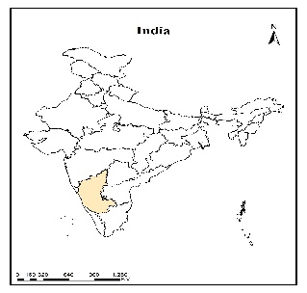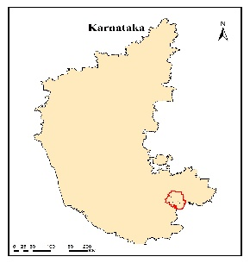
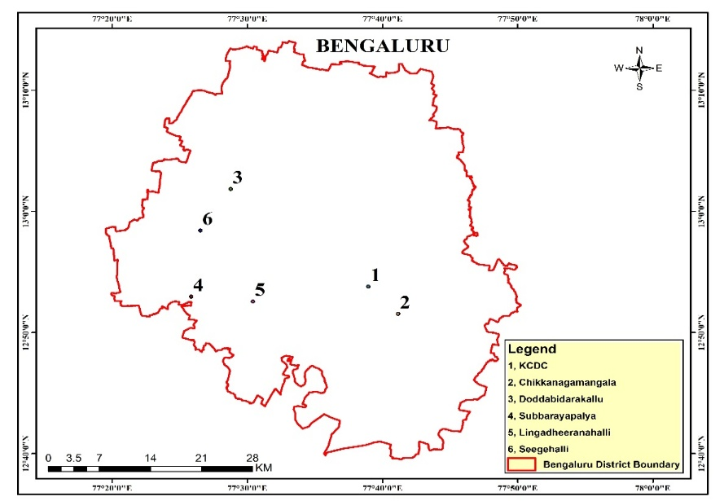

Figure 1: Leachate sampling locations in Bengaluru

To assess field-level impacts, corresponding plant and soil samples were obtained from leachate-amended fields in Tumakuru (Fig. 2) with a documented history of MSW compost leachate application. The study did not involve controlled plot experimentation; instead, it relied on existing farmer-managed systems to reflect real-world agricultural conditions. Leachate was reported to be applied at approximately 20 to 25 thousand liters/acre, and at a 1:10 (leachate: water) ratio based on farmer practice in the study area. Adjacent fields cultivating similar crops under conventional management (chemical fertilizers and/or farmyard manure) were selected as control sites to enable comparative assessment. Three different crop types were collected from Tumkur district, namely, Eleusine coracana (Millet- Ragi), Zea mays (Cereal -Maize), and Vigna radiata (Pulses- Green gram) for the study. All these plant and soil samples were collected once in the month of June 2023.

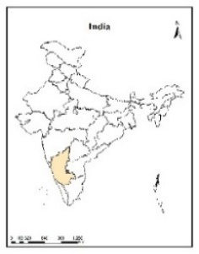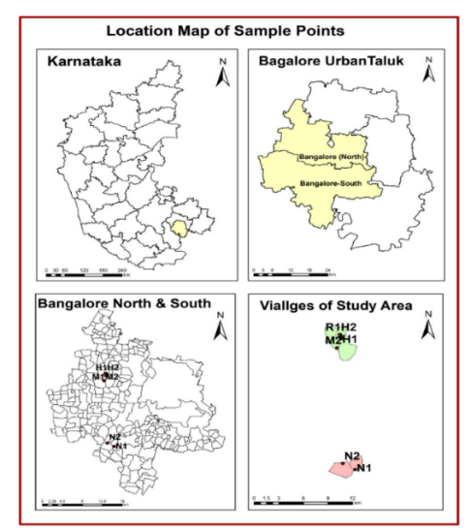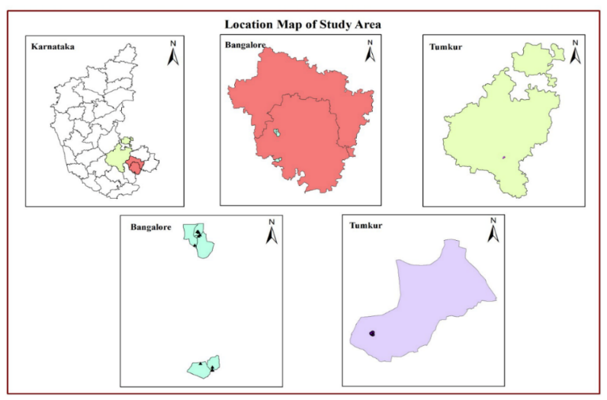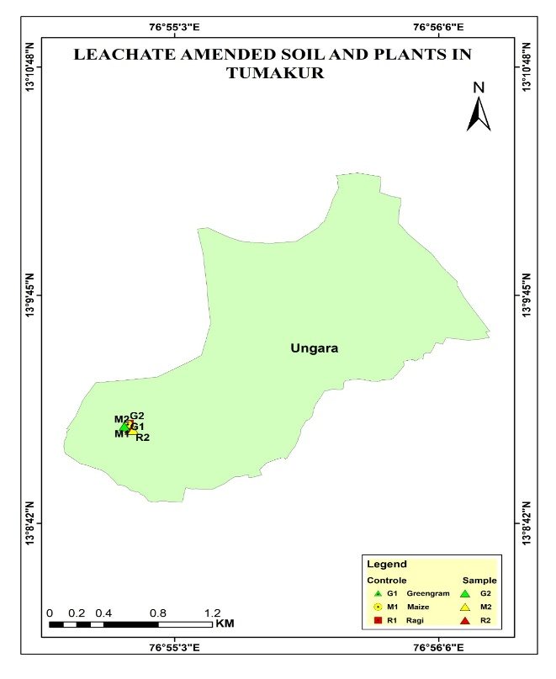

Figure 2: Plant and soil sampling locations in Tumkur

2.2 Experimental Design

A field-based comparative study design was adopted. Two categories of sites were considered:
- MSWL-amended fields (irrigated with MSW leachate at ~1:10 ratio of leachate: water)
- Control fields (irrigated with conventional water sources and fertilization practices)
The study did not involve controlled plot experimentation; instead, it relied on existing farmer-managed systems to reflect real-world agricultural conditions.

2.3 Sample Collection

2.3.1 Leachate

Leachate samples were collected from MSW composting facilities supplying or associated with the selected agricultural fields. Leachate samples were collected from collection tanks and sumps into clean, labelled, thoroughly rinsed bottles. For heavy metal analyses, samples were collected separately in 100 ml pre-cleaned polyethene containers acidified with a few drops of concentrated Nitric acid on site to prevent the precipitation of metals. The samples were kept in an ice box below 5°C, immediately transported to the laboratory, and stored in a refrigerator at 4°C before analysis. Sample collection and preservation were carried out according to the protocols prescribed by the National (BIS) and international standards (APHA 2017).

2.3.2 Soil

Soil samples were collected from both MSWCL-amended and control fields at a depth of 0–20 cm using a stainless-steel auger. One composite soil sample was collected from each field, created from 5 subsamples collected from randomly selected positions to obtain representative samples. The samples were air-dried, homogenized, and sieved (2 mm) before analysis.

2.3.3 Plant

Whole plant samples, together with the associated soil samples, were collected from the selected fields. Plants were uprooted, labelled, and taken to the laboratory for analysis. Plant samples were separated into roots, leaves, and fruits (if present at the time of sample collection), and further subsampled for various analyses. The root samples were thoroughly washed under running tap water to remove the soil particles adhering to the roots. Samples were air-dried at room temperature for two weeks and then ground to a fine powder for analysis.

2.4 Analytical Methods

2.4.1 Physicochemical Analysis of Leachate and Soil

Leachate samples were analysed according to the protocols prescribed by the National (BIS) and International (APHA) standards. pH and EC were recorded on-site during sampling using a digital pH and EC meter. C: N ratio was determined using a CHNS analyzer (Elementar, Vario-Micro cube). 10mg of the leachate samples in tin capsules were combusted in the combustion chamber to their respective oxide forms, which were finally measured using a thermal conductivity detector (TCD) as C, N, H, and S. Potassium (K) was analysed using the flame photometric method (Systronics µ-controller based Flame photometer with Compressor, Type: 128). Phosphorus was quantified by inductively coupled plasma optical emission spectrophotometry (ICP-OES - Thermofischer Scientific ICAP 7000).
Soil pH and EC were measured in 1:2.5 soil: water extracts using a pH and conductivity meter (Jackson 1962). Organic Matter was determined by the Walkley and Black’s wet oxidation method (Jackson 1962). . The C: N ratio was determined using a CHNS analyzer (Marathe and Chavan 2022).
2.4.2 Heavy metal analysis of Leachate, Soil, and Plant samples

Heavy metals (Zn, Cu, Cd, Pb, Ni, and Cr) in leachate were quantified by inductively coupled plasma optical emission spectrophotometry (ICP-OES - Thermofischer Scientific ICAP 7000). Soil micronutrients were extracted with DTPA and quantified as Zn and Cu using AAS and Pb, Cd, Cr, and Ni using ICP-OES. Plant samples were subjected to dry-ashing, wherein 1 g of material was incinerated in a muffle furnace at 550 °C for 5 h. The cooled ash was dissolved in 5 mL of 20% HCl, filtered, and quantitatively transferred to a 50 mL volumetric flask with deionized water. The resulting solution was analyzed for total micronutrient concentrations using ICP-OES.
Negative values obtained after baseline correction were treated as non-detectable (ND). ND values were reported as ‘below detection limit’ and not assigned numerical substitutes.

2.6 Assessment of Metal Transfer

2.6.1 Bioconcentration Factor (BCF) and Translocation Factor (TF)

The transfer of metals from soil to plant was assessed using the BCF, calculated as the ratio of metal concentration in individual plant parts (root, leaf, and fruit) to that in soil (Buscaroli 2017).
$$BCF =\frac{Cparts\left(root,shoot,leaves,grains\right)}{Csoil}$$

Where applicable, the movement of metals within plant parts was evaluated using TF, calculated as the ratio of the heavy metal concentration in the aerial plant to the metal concentration in roots (Buscaroli 2017).

$$TF = \frac{Cparts\left(shoot,leaves,fruit\right)}{Croot }$$

where C_{root}, C_{leaf}​, C_{fruit,} and C_{soil} represent metal concentrations (mg kg⁻¹, dry weight basis) in roots, leaves, fruit, and soil, respectively.
BCF and TF values were calculated only when both soil and plant concentrations were measurable. Where either value was ND, the corresponding BCF/TF was reported as ND or not applicable.

2.7 Statistical Analysis

Data were analyzed using appropriate statistical tools. Descriptive statistics (mean, standard deviation) were computed for all parameters. To assess statistical significance and compare means between the conventional and amended groups, a parametric analysis (Welch’s t-test) was performed. The findings are presented as means ± standard deviations (SD), with p < 0.05 denoting statistical significance. All data were processed using R 4.4.3 and Microsoft Excel 2019. Statistical comparisons were performed only for datasets with measurable values in both treatments. ND cases were excluded from statistical testing and reported descriptively (detectable vs. ND).

2.8 Quality Assurance and Quality Control (QA/QC)

All analyses were conducted following strict QA/QC protocols, including use of analytical grade reagents, calibration with standard solutions, analysis of blanks and replicates, and recovery studies to ensure accuracy and precision.

3. results and discussion

3.1 Characteristics of MSW leachate

The MSWL had a pH of 4.2, indicating a strongly acidic condition, and a very high conductivity of 33 dS/m, reflecting a high concentration of dissolved salts and ions (Table 1). The acidic nature of the leachate may be due to the organic acids formed during the breakdown of biodegradable waste fractions, a phenomenon commonly reported in MSW leachates (Naveen et al., 2017; Kanmani & Gandhimathi, 2013).
Table 1 MSW leachate composition (Values in mg/l unless otherwise stated)

Parameters | Conc. Range | Average | Std. Deviation
pH | 3.8 – 5 | 4.2 | 0.4
EC (ds/cm) | 28.3 – 39.9 | 33.0 | 4.7
Carbon (%) | 3.0 - 4.4 | 3.6 | 0.5
Nitrogen (%) | 0.4 – 0.5 | 0.4 | 0.1
Phosphorus | 292 - 460 | 367 | 60
Potassium | 2635 - 4259 | 3662 | 602
Calcium | 1532 - 3515 | 2379 | 797
Magnesium | 440 – 653 | 541 | 81.6
Iron | 172 – 303 | 247 | 57.5
Manganese | 8.2 -19.3 | 13.7 | 4.1
Zinc | 11.3 – 46.4 | 21.0 | 13.0
Copper | 0.2 – 1.2 | 0.5 | 0.4
Nickel | 0.5 – 1.2 | 0.7 | 0.3
Lead | 0.1 – 0.7 | 0.3 | 0.3
Cadmium | 0.0 - 0.2 | 0.1 | 0.1
Chromium | 0.4 – 0.9 | 0.6 | 0.2

The leachate was found to be rich in nutrients, particularly K, Ca, and P, with measurable levels of N (0.4%) and organic carbon (3.6%). The elevated K concentration suggests that the leachate could serve as a significant source of plant nutrients, especially for potassium-demanding crops. Similar nutrient enrichment in MSW-derived leachates has been reported in previous studies, highlighting their potential agronomic value (Singh et al., 2017).

In addition to macronutrients, the leachate contained appreciable concentrations of micronutrients - Fe, Zn, and Mn, which are essential for plant growth but may pose toxicity risks at elevated levels. Copper concentration was comparatively low (0.5 mg/l), suggesting limited input or lower mobility in the leachate matrix. Trace amounts of heavy metals, Ni (0.7 mg/l), Pb (0.3 mg/l), Cd (0.1 mg/l), and Cr (0.6 mg/l), were also detected. Heavy metals in leachate, despite being present in lower concentrations, could be problematic if they exceed the threshold levels of 5.00, 0.01, 0.10, and 0.20 mg/l, respectively, as indicated by the Guidelines for Water Reuse and Water Quality Standards for Agriculture (Ayers and Westcot, 1985; EPA, 2012). Exceedances were observed for Cd, Cr, and Ni, raising concern that repeated irrigation with such leachate could lead to their gradual accumulation in soils, thereby posing long-term risks to agroecosystem health.

The combined presence of high nutrient loads and trace metals indicates that MSWL has a dual role as both a nutrient source and a potential contaminant. However, in the present study, the leachate was applied at a 1:10 dilution (leachate: water) in accordance with local agricultural practices. Such dilution likely reduces the immediate effects of high salinity and contaminant concentrations on soil and crops. Overall, the characteristics of MSWCL observed in this study are consistent with earlier reports describing leachate as a complex mixture of organic and inorganic constituents with both agronomic benefits and environmental implications (Singh et al 2017; Kanmani and Gandhimathi 2013).

3.2 Soil Properties

Soil physicochemical properties varied significantly between control and amended treatments across ragi, maize, and green gram soils (Table 2), with letters (a, b) denoting significant differences (p < 0.05) within each crop based on Welch’s T-test followed by post-hoc tests.

Table 2: Soil parameters (mean ± SD) for control and MSWL-amended treatments

 | Ragi Soil |  | Maize Soil |  | Green gram Soil
Parameters | Control | Amended | Control | Amended | Control | Amended
Ph | 6.04±0.02a | 6.52±0.02 b | 5.96±0.02 a | 6.61±0.07 b | 6.31±0.06a | 6.88±0.09b
EC (µs/cm) | 141.4±4.1a | 202.1±2.6 b | 117.5±1.6 a | 153.9±2.6 b | 171.2±2.2a | 133.0±2.1b
Moisture (%) | 7.88±0.1a | 8.45±0.09 b | 7.88±0.08 a | 8.45±0.09 b | 7.88±0.09a | 8.45±0.11b
Org matter (%) | 0.85±0.02a | 0.31±0.02 b | 7.880.05 a | 8.45±0.08 b | 0.52±0.06a | 0.67±0.08b
C (%) | 0.71±0.01a | 0.62±0.02b | 0.06±0.002a | 0.47±0.01b | 0.42±0.05a | 0.48±0.06b
N (%) | 0.09±0.002a | 0.10±0.01a | 0.08±0.002a | 0.08±0.01a | 0.07±0.01a | 0.07±0.02a
P (%) | 25.52±0.16a | 34.66±0.08b | 24.42±0.38a | 30.25±0.49b | 26.15±0.21a | 22.69±0.25b
K (%) | 279.44±3.8a | 609.36±4.1b | 191.0±3.4a | 472.16±4.8b | 381.16±5.2a | 298.24±4.5b
Ca (%) | 5.20±0.02a | 3.30±0.002b | 3.50±0.22a | 4.80±0.15b | 4.0±0.7a | 4.30±0.6b
Mg (%) | 2.80±0.01a | 0.20±0.01b | 0.200.02a | 1.20±0.06b | 0.50±0.02a | 0.40±0.06b
Fe (mg/kg) | 26.08±0.16a | 28.62±0.21b | 47.59±0.31a | 28.62±0.16b | 36.68±0.25a | 38.80±0.29b
Mn (mg/kg) | 37.08±0.16a | 51.82±0.24 b | 19.63±0.16a | 40.92±0.31b | 65.65±1.5a | 54.02±1.2b
Zn (mg/kg) | 5.01±0.06a | 11.78±0.1 b | 7.76±0.08a | 10.05±0.16b | 11.89±0.21a | 6.99±0.16b
Cu (mg/kg) | 4.69±0.08a | 11.98±0.17b | 1.79±0.05a | 9.33±0.16b | 6.65±0.19a | 2.85±0.16b
Ni (mg/kg) | 0.42±0.02a | 1.64±0.03b | 0.34±0.01a | 0.17±0.02b | 1.52±0.11a | 0.62±0.21b
Pb (mg/kg) | 3.46±0.08a | 3.50±0.05b | 1.34±0.18a | 0.06±0.002b | 1.88±0.22a | 1.64±0.26b
Cd (mg/kg) | 0.03±0.002a | 0.15±0.02b | 0.08±0.01a | 0.006±0.002b | 0.33±0.12a | 0.04±0.06b
Cr (mg/kg) | 0.08±0.007a | 0.13±0.03b | 0.13±0.04 | ND | 0.12±0.12a | 0.14±0.05b
Letters denote significance at P < .05; same letter = no difference, different letters = significant difference; ND = below detection limit; statistical comparison not applicable

3.2.1 Physico-chemical Properties

Soil pH exhibited a consistent rise across all amended crops, attributable to buffering by organic acids and cation release during mineralization. Electrical conductivity increased in ragi and maize but declined in green gram, suggesting salt accumulation in the former and possible leaching losses in the latter. Moisture content was significantly higher in all amended soils (p < 0.05), reflecting improved water-holding capacity through organic matter inputs (Sharma 2022). Organic matter levels rose in maize and green gram but declined in ragi, likely due to rapid decomposition or sampling variability—an outcome consistent with heterogeneous amendment effects in rainfed Alfisols (Prabhakar et al. 2023).

3.2.2 Nutrient Dynamics

Carbon responses were crop-specific, with a marked increase in maize, while nitrogen remained largely unchanged, indicating limited N mineralization under the MSWL applied conditions. Phosphorus and K generally showed an increase in amended soils in the case of ragi and maize, attributed to solubilization from organic inputs, aligning with finger millet studies using farmyard manure (FYM) at 8 Mg/ha, boosting available P and K by 5.7–6.1% (Prabhakar et al. 2023). However, green gram showed declines in P and K, potentially due to crop-specific fixation or legume residue effects. Ca and Mg responses varied, declining in ragi and increasing in maize, linked to amendment cation exchange capacity (Singh & Singh, 2024).

3.2.3 Heavy Metal Concentrations

Micronutrient and heavy metal concentrations differed significantly between control and amended treatments across ragi, maize, and green gram soils (Table 2). In ragi soils, Fe, Mn, Zn, and Cu levels were markedly higher under amendment compared to controls, corroborating evidence that organic inputs enhance micronutrient availability (Daulta et al. 2023). In maize soils, Fe, Mn, Zn, and Cu concentrations declined under MSWL amendment relative to the control, whereas Pb, Cd, and Cr were reduced or rendered non-detectable (ND), reflecting effective immobilization of toxic metals. In green gram soils, Fe and Cu increased under amendment, whereas Mn and Zn decreased. Notably, Ni, Pb, and Cd concentrations were consistently lower in amended soils, while Cr remained detectable in both treatments (Xu et al. 2022).

The divergent responses across soil types highlight the complex role of amendments in nutrient enrichment and contaminant mitigation. In ragi soils, elevated Fe, Mn, Zn, and Cu levels indicate enhanced nutrient availability, though modest increases in Ni, Pb, Cd, and Cr suggest potential mobilization risks (Wu et al. 2021). In maize soils, declines in micronutrient concentrations, coupled with non-detectable (ND) values for Cr and reduced Pb and Cd levels, highlight the amendment’s effectiveness in limiting heavy metal persistence. Green gram soils exhibited mixed nutrient trends; however, reductions in Ni, Pb, and Cd point to ecological risk mitigation. Overall, toxic metals such as Pb and Cd declined in maize and green gram, likely due to immobilization facilitated by pH elevation and organic complexation. Similar mechanisms have been reported in compost and biochar trials, where Cd and Pb bioavailability were reduced by 20–40% (Irfan et al. 2021).

These changes suggest the MSWL amendment enhances fertility in ragi and maize systems, supporting sustainable nutrient management in soils, but requires crop-specific optimization to avoid nutrient imbalances or metal mobilization in green gram. Future work should quantify yields and long-term C sequestration (Rangaiah et al. 2025).

3.3 Metal uptake by crops

The data on heavy metal concentrations in leaves and roots of ragi, maize, and green gram under control and MSW leachate–amended conditions (Table 3 and Figs. 3 and 4) revealed clear variations across crops, plant parts, and treatments, indicating differential uptake and translocation behavior.

Table 3. Heavy metal concentrations (mg/kg) in leaves and roots of ragi, maize, and green gram
 | Heavy metals |  | Zn | Cu | Ni | Pb | Cd | Cr
Ragi | Leaves | Control | 21.98 | 4.22 | 3.04 | 1.55 | 0.07 | 5.35
Ragi | Leaves | Amended | 40.55 | 5.80 | 2.19 | 1.43 | 0.07 | 4.31
Ragi | Root | Control | 12.23 | 3.56 | 0.96 | 0.08 | ND | 0.57
Ragi | Root | Amended | 22.05 | 3.48 | 0.48 | 0.04 | 0.01 | 1.07
Maize | Leaves | Control | 26.15 | 1.57 | 3.64 | 0.55 | 0.01 | 4.68
Maize | Leaves | Amended | 18.06 | 1.82 | 2.29 | 0.72 | 0.02 | 4.41
Maize | Root | Control | 2.48 | 0.75 | 1.45 | ND | 0.01 | 0.94
Maize | Root | Amended | 6.12 | 1.99 | 1.56 | ND | ND | 0.42
Green gram | Leaves | Control | 24.97 | 3.81 | 3.81 | 1.56 | 0.21 | 1.95
Green gram | Leaves | Amended | 14.51 | 3.39 | 2.62 | 0.49 | 0.12 | 2.12
Green gram | Root | Control | 16.47 | 3.72 | 1.17 | 0.09 | 0.01 | 1.15
Green gram | Root | Amended | 18.59 | 5.22 | 0.63 | 0.30 | 0.002 | 0.72
ND = below detection limit

Fig 3: Heavy metal concentrations in leaves of ragi, maize, and green gram
C – Control; A – Leachate-amended

Fig 4: Heavy metal concentrations in roots of ragi, maize, and green gram
C – Control; A – Leachate-amended

Zinc was the dominant metal in all crops. A significant increase in Zn was observed in ragi under amended conditions in both leaves and roots, indicating enhanced availability and uptake from MSW leachate (Alloway, 2013). In contrast, maize and green gram showed reduced Zn in leaves, possibly due to dilution effects or immobilization. Copper concentrations remained relatively stable across treatments, reflecting its strong association with soil organic matter and regulated plant uptake (Matijevic et al. 2014). Copper also showed slight increases in leaves and roots under amendment (Figs. 3 and 4). The accumulation of Zn and Cu in both tissues reflects their essential role in plant metabolism (Alloway, 2013), and their increased availability due to leachate application. All Zn and Cu concentrations remained within FAO/WHO (50 -100 mg/kg) permissible limits, indicating no immediate toxicity risk (Ali and Ahirwar 2025). A general decrease in Ni levels was observed under amended conditions, particularly in leaves. This suggests reduced bioavailability due to immobilization or ionic competition in the soil–leachate system (Shaheen et al. 2015).

Lead concentration levels in leaves exceeded the FAO/WHO permissible limit (0.3 mg/kg), whereas root concentrations remained low. The higher accumulation in leaves compared to roots indicates that foliar deposition and atmospheric inputs may also significantly contribute to Pb contamination (Xia et al. 2024). A reduction in Pb in green gram leaves under amended conditions suggests immobilization effects (Prasad and Kiran 2017; Aslam et al. 2021). Cadmium concentrations were consistently low, ranging from trace levels in leaves to negligible levels in roots. Most values were within permissible limits, indicating minimal Cd uptake and a minimal influence of MSWL. Slight increases in maize leaves under amendment indicate its relatively higher mobility, whereas reductions in green gram suggest restricted uptake (Janoš et al. 2010). Chromium concentrations exceeded the threshold levels (2.3 mg/kg) in leaves of ragi and maize. The lower concentrations in roots compared to leaves suggest selective uptake and redistribution, although Cr is generally known to be less mobile in plants (Alloway 2013).

3.4 Soil–plant transfer dynamics

The uptake, accumulation, and internal translocation of heavy metals in crops grown under control (conventional agricultural practices) and MSWL–amended conditions were evaluated using bioconcentration factor (BCF_{root} and BCF_{leaf}) and translocation factor (TF_{leaf}). Since the control and amended samples originate from different field systems, the observed variations reflect contrasting soil management regimes rather than direct treatment effects (Table 4).

Table 4: Bio-concentration factor (BCF) and translocation factor (TF) of Ragi, Maize, and Green gram

Crop | Heavy metals -> |  | Zn | Cu | Ni | Pb | Cd | Cr
Ragi | BCF_{root} | Control | 4.38 | 0.90 | 7.20 | 0.45 | 2.56 | 70.56
Ragi | BCF_{root} | Amended | 3.44 | 0.48 | 1.33 | 0.41 | 0.45 | 33.44
Ragi | BCF_{leaf} | Control | 2.44 | 0.76 | 2.28 | 0.02 | NA | 7.56
Ragi | BCF_{leaf} | Amended | 1.87 | 0.29 | 0.29 | 0.01 | 0.08 | 8.30
Ragi | Tfl_{eaf} | Control | 0.56 | 0.84 | 0.32 | 0.05 | NA | 0.11
Ragi | Tfl_{eaf} | Amended | 0.54 | 0.60 | 0.22 | 0.03 | 0.17 | 0.25
Maize | BCF_{root} | Control | 3.37 | 0.88 | 10.78 | 0.41 | 0.17 | 37.13
Maize | BCF_{root} | Amended | 1.80 | 0.20 | 13.07 | 11.48 | 3.03 | NA
Maize | BCF_{leaf} | Control | 0.32 | 0.42 | 4.29 | NA | 0.14 | 7.48
Maize | BCF_{leaf} | Amended | 0.61 | 0.21 | 8.92 | NA | NA | NA
Maize | Tf_{leaf} | Control | 0.09 | 0.47 | 0.40 | NA | 0.87 | 0.20
Maize | Tf_{leaf} | Amended | 0.34 | 1.09 | 0.68 | NA | NA | 0.10
Green gram | BCF_{root} | Control | 2.10 | 0.57 | 2.51 | 0.83 | 0.63 | 16.84
Green gram | BCF_{root} | Amended | 2.08 | 1.19 | 4.26 | 0.30 | 3.01 | 15.55
Green gram | BCF_{leaf} | Control | 1.39 | 0.56 | 0.77 | 0.05 | 0.02 | 9.92
Green gram | BCF_{leaf} | Amended | 2.66 | 1.83 | 1.02 | 0.18 | 0.06 | 5.27
Green gram | Tfl_{eaf} | Control | 0.66 | 0.98 | 0.31 | 0.06 | 0.04 | 0.59
Green gram | Tfl_{eaf} | Amended | 0.18 | 0.54 | 0.39 | 0.38 | 0.55 | 2.49
NA = not applicable (calculation not possible when either numerator or denominator was ND).

In ragi, the BCF_{root} values were markedly higher in control fields for most metals, particularly Cr, Ni, and Zn, compared to leachate-amended fields. This suggests that conventional soils may have higher bioavailable fractions of certain metals, potentially due to long-term fertilizer or manure inputs contributing to metal accumulation and mobility (Alloway 2013). In contrast, the lower BCF_{root} values in leachate-irrigated fields indicate that metal availability may be partially reduced, possibly due to complexation with dissolved organic matter or sorption onto organic constituents present in the leachate (Bolan et al. 2014). The BCF_{leaf} values followed a similar trend, with reduced accumulation in amended fields for Zn, Cu, and Ni, indicating restricted transfer to aerial parts. The consistently lower BCF_{leaf} relative to BCF_{root} confirms that roots serve as the primary accumulation sites, limiting metal movement to shoots. The TF_{leaf} values in ragi were consistently <1 under both field conditions, indicating limited translocation. Moreover, slightly lower TF values in leachate-irrigated fields suggest that metal mobility within the plant is further restricted under leachate irrigation. Overall, ragi exhibits a metal exclusion behavior, with reduced uptake and translocation in leachate-irrigated systems, indicating a relatively safer profile for cultivation under such conditions.

In maize, contrasting patterns were observed between conventional and leachate-irrigated fields. The BCF_{root} values decreased for Zn and Cu in amended fields, but increased sharply for Ni, Pb, and Cd. This suggests that leachate irrigation may enhance the mobility and availability of specific metals, likely through soluble organic complexes that facilitate metal transport in soil (Wei et al. 2021). Chromium concentrations in control plots were detectable, whereas MSWL-amended plots remained below the detection limit (BDL). The BCF_{leaf} values showed selective accumulation, with Ni increasing significantly in leachate-irrigated fields, while Pb and Cd remained negligible or BDL, indicating restricted accumulation in leaves. This highlights metal-specific uptake and internal regulation mechanisms in maize. The TF_{leaf} values increased in leachate-irrigated fields, particularly for Cu and Zn. A TF value greater than 1 for Cu indicates efficient translocation to aerial parts, which may increase the likelihood of metal entry into the food chain (Liu et al. 2023). Thus, maize exhibited a differential response to field conditions, where leachate irrigation enhances the uptake and mobility of certain metals while suppressing others.

Green gram exhibited moderate to increased metal uptake under leachate irrigation. The BCF_{root} values increased or stayed similar for Cu, Ni, and Cd, indicating that organic components in the leachate may boost metal solubility in the rhizosphere. The BCF_{leaf} values increased markedly, particularly for Zn and Cu, reflecting enhanced translocation to aerial tissues. This pattern aligns with legumes and other species, which often display enhanced metal uptake due to active rhizosphere processes and symbiotic relationships. The TF_{leaf} values also rose significantly, particularly for Cr, Cd, and Pb. A TF value over 1 for Cr indicates strong internal mobility, raising concerns about accumulation in edible plant parts. Overall, green gram exhibits a greater tendency for both metal accumulation and translocation under leachate irrigation compared to conventional field conditions.

4. Conclusion

The study provides field-based evidence on the implications of using MSW compost leachate as a liquid amendment in agricultural systems. The results demonstrate that compost leachate can contribute to soil nutrient enrichment and potentially enhance soil fertility. However, the presence of trace metals in the leachate may lead to gradual accumulation in soils and detectable transfer to crops. Although the observed metal concentrations in crops were largely within permissible limits, the variability among sites and crops highlights the need for cautious and regulated application of MSW-derived leachates. Regular monitoring of soil and crop quality is recommended to ensure environmental sustainability and food safety. Future studies involving long-term experimental trials would help further clarify the agronomic benefits and environmental risks associated with the agricultural use of MSW compost leachate

Competing interests

Authors have declared that no competing interests exist.

Disclaimer (Artificial Intelligence)

The authors acknowledge the use of generative artificial intelligence (AI) tools (e.g., ChatGPT) for assistance in language editing, organization, and improving the clarity of the manuscript. The AI tool was not used for data generation, analysis, or interpretation. All scientific content, results, and conclusions presented in this manuscript are solely the responsibility of the authors and have been critically reviewed and validated.

COMPETING INTERESTS DISCLAIMER:
Authors have declared that they have no known competing financial interests OR non-financial interests OR personal relationships that could have appeared to influence the work reported in this paper.

References

- Ali, Saquib, and Rajesh Ahirwar. 2025. “Accumulation of Toxic Metals in Vegetable Crops and Associated Dietary Exposure Risks to Human Health.” Discover Environment 3 (1). https://doi.org/10.1007/s44274-025-00373-w.
- Alloway, Brian J. 2013. Heavy Metals in Soils Trace Metals and Metalloids in Soils and Their Bioavailability. Edited by Brian J. Alloway. Encyclopedia of Toxicology, Fourth Edition: Volume 1-9. 3rd ed. Vol. 9. Blackie Academic & Professional, an imprint of Chapman & Hall. https://doi.org/10.1016/B978-0-12-824315-2.00658-8.
- APHA, AWWA and WEF. 2017. Standard Methods for the Examination of Water and Wastewater. Edited by EUGENE W. RICE RODGER B. BAIRD, ANDREW D. EATON. 23rd ed. Washington DC USA: APHA Press.
- Aslam, Muhammad, Ayesha Aslam, Muhammad Sheraz, Basharat Ali, Zaid Ulhassan, Ullah Najeeb, Weijun Zhou, and Rafaqat Ali Gill. 2021. “Lead Toxicity in Cereals: Mechanistic Insight Into Toxicity, Mode of Action, and Management.” Frontiers in Plant Science 11 (February). https://doi.org/10.3389/fpls.2020.587785.
- Ayers, R. S., Westcot, D. W. 1985. Water for Agr Water Quality for Agriculture. Edited by Food and Agriculture Organization of the United Nations. Food and A. Rome: Food and Agriculture Organization of the United Nations.
- Bolan, Nanthi, Anitha Kunhikrishnan, Ramya Thangarajan, Jurate Kumpiene, Jinhee Park, Tomoyuki Makino, Mary Beth Kirkham, and Kirk Scheckel. 2014. “Remediation of Heavy Metal(Loid)s Contaminated Soils - To Mobilize or to Immobilize?” Journal of Hazardous Materials. Elsevier. https://doi.org/10.1016/j.jhazmat.2013.12.018.
- Bose, Sutapa, and A K Bhattacharyya. 2008. “Heavy Metal Accumulation in Wheat Plant Grown in Soil Amended with Industrial Sludge” 70: 1264–72. https://doi.org/10.1016/j.chemosphere.2007.07.062.
- Buscaroli, Alessandro. 2017. “An Overview of Indexes to Evaluate Terrestrial Plants for Phytoremediation Purposes (Review).” Ecological Indicators. Elsevier B.V. https://doi.org/10.1016/j.ecolind.2017.07.003.
- Daulta, R., M. Prakash, and S. Goyal. 2023. “Metal Content in Soils of Northern India and Crop Response: A Review.” International Journal of Environmental Science and Technology 20 (4): 4521–48. https://doi.org/10.1007/s13762-022-03953-y.
- Dutta, Abhishek, and Wanida Jinsart. 2020. “Waste Generation and Management Status in the Fast-Expanding Indian Cities: A Review.” Journal of the Air and Waste Management Association 70 (5): 491–503. https://doi.org/10.1080/10962247.2020.1738285.
- EPA, Environmet protection Agency. 2012. “EPA Guidlines for Water Reuse U.S. Environmental Protection Agency.” Guidelines for Water Reuse, no. September: 643.
- Irfan, Muhammad, Muhammad Mudassir, Muhammad Jamal Khan, Khadim Muhammad Dawar, Dost Muhammad, Ishaq Ahmad Mian, Waqas Ali, et al. 2021. “Heavy Metals Immobilization and Improvement in Maize (Zea Mays L.) Growth Amended with Biochar and Compost.” Scientific Reports 11 (1): 1–9. https://doi.org/10.1038/s41598-021-97525-8.
- Jackson, M.L. 1962. Soil Chemical Analysis. Englewood Cliffs, New Jersey, USA: Prentice Hall Inc., Englewood Cliffs, New Jersey, USA.
- Janoš, Pavel, Jana Vávrová, Lucie Herzogová, and Vára Pilařová. 2010. “Effects of Inorganic and Organic Amendments on the Mobility (Leachability) of Heavy Metals in Contaminated Soil: A Sequential Extraction Study.” Geoderma 159 (3–4): 335–41. https://doi.org/10.1016/j.geoderma.2010.08.009.
- Kanmani, S., and R. Gandhimathi. 2013. “Assessment of Heavy Metal Contamination in Soil Due to Leachate Migration from an Open Dumping Site.” Applied Water Science 3 (1): 193–205. https://doi.org/10.1007/s13201-012-0072-z.
- Liu, Yang, Ruicai Zhang, Bo Pan, Hao Qiu, Jing Wang, Junyuan Zhang, Xuekui Niu, Liping He, Wenmin Qian, and Willie J G M Peijnenburg. 2023. “Uptake of Heavy Metals by Crops near a Mining Field : Pathways from Roots and Leaves Version : License : Downloaded from : Publisher ’ s Version Licensed under Article 25fa Copyright Act / Law ( Amendment Taverne ) Chemosphere Uptake of Heavy Metals by Cr.” Chemosphere 322: 138215. https://doi.org/10.1016/j.chemosphere.2023.138215.
- Manea, Elena Elisabeta, Costel Bumbac, Laurentiu Razvan Dinu, Marius Bumbac, and Cristina Mihaela Nicolescu. 2024. “Composting as a Sustainable Solution for Organic Solid Waste Management: Current Practices and Potential Improvements.” Sustainability (Switzerland) 16 (15): 1–25. https://doi.org/10.3390/su16156329.
- Marathe, Ninad, and Bhavita P Chavan. 2022. “CHNS Analysis of Soil Samples from Patalganga(Maharashtra, India).” JETIR2203221 Journal of Emerging Technologies and Innovative Research 9 (3): 134–41. www.jetir.orgc134.
- Matijevic, Lana, Davor Romic, and Marija Romic. 2014. “Soil Organic Matter and Salinity Affect Copper Bioavailability in Root Zone and Uptake by Vicia Faba L. Plants.” Environmental Geochemistry and Health 36 (5): 883–96. https://doi.org/10.1007/s10653-014-9606-7.
- Prabhakar, Mathyam, Kodigal A. Gopinath, Uppu Sai Sravan, Golla Srasvan Kumar, Merugu Thirupathi, Gutti Samba Siva, Guddad Meghalakshmi, Nakka Ravi Kumar, and Vinod Kumar Singh. 2023. “Potential for Yield and Soil Fertility Improvement with Integration of Organics in Nutrient Management for Finger Millet under Rainfed Alfisols of Southern India.” Frontiers in Nutrition 10 (October). https://doi.org/10.3389/fnut.2023.1095449.
- Prasad, Majeti Narasimha Vara, and Boda Ravi Kiran. 2017. “Responses of Ricinus Communis L. (Castor Bean, Phytoremediation Crop) Seedlings to Lead (Pb) Toxicity in Hydroponics.” Selcuk Journal of Agricultural and Food Sciences 31 (1): 73–80. https://doi.org/10.15316/sjafs.2017.9.
- Rangaiah, Krishna Murthy, Bhavya Nagaraju, Govinda Kasturappa, Shivakumara Maragondanadibba Nanjundappa, Uday Kumar Sugaturu Narayanaswamy, Sanjay Srivastava, and Pradip Dey. 2025. “Assessment of Fertilizer Prescription Equations, Crop and Soil Performance with Different Nutrient Management Practices for Green Gram (Vigna Radiata) in Southern India’s Alfisols.” Scientific Reports 15 (1): 1–14. https://doi.org/10.1038/s41598-025-04738-2.
- Shaheen, S. M., J. Rinklebe, and M. H. Selim. 2015. “Impact of Various Amendments on Immobilization and Phytoavailability of Nickel and Zinc in a Contaminated Floodplain Soil.” International Journal of Environmental Science and Technology 12 (9): 2765–76. https://doi.org/10.1007/s13762-014-0713-x.
- Sharma, Seema B. 2022. “Trend Setting Impacts of Organic Matter on Soil Physico-Chemical Properties in Traditional Vis -a- Vis Chemical-Based Amendment Practices.” PLOS Sustainability and Transformation 1 (3): 1–17. https://doi.org/10.1371/journal.pstr.0000007.
- Singh, Shubhra, N. Janardhana Raju, and Ch RamaKrishna. 2017. “Assessment of the Effect of Landfill Leachate Irrigation of Different Doses on Wheat Plant Growth and Harvest Index: A Laboratory Simulation Study.” Environmental Nanotechnology, Monitoring and Management 8: 150–56. https://doi.org/10.1016/j.enmm.2017.07.005.
- Singh, Thokchom Biren, and Sagolsem Sumangal Singh. 2024. “Influence of Agricultural Practices on Soil PH, EC, and Organic Matter in Various Agricultural Land in Imphal Valley, Manipur, India.” International Journal of Current Research and Academic Review 12 (7): 1–7. doi: https://doi.org/10.20546/ijcrar.2024.1207.001.
- Uchimiya, Minori, Desmond Bannon, Hiromi Nakanishi, Murray B. McBride, Marc A. Williams, and Toshihiro Yoshihara. 2020. “Chemical Speciation, Plant Uptake, and Toxicity of Heavy Metals in Agricultural Soils.” Journal of Agricultural and Food Chemistry 68 (46): 12856–69. https://doi.org/10.1021/acs.jafc.0c00183.
- Wei, Liang, Qian Ding, Huaming Guo, Wei Xiu, and Zhengcai Guo. 2021. “Forms and Mobility of Heavy Metals/Metalloids in Sewage-Irrigated Soils in the North China Plain.” Journal of Soils and Sediments 21 (1): 215–34. https://doi.org/10.1007/s11368-020-02744-7.
- Wu, Wei, Yu Li, Mingshu Yan, Lechao Yang, Jiali Lei, and Hong Bin Liu. 2021. “Surface Soil Metal Elements Variability Affected by Environmental and Soil Properties.” PLoS ONE 16 (7 July): 1–14. https://doi.org/10.1371/journal.pone.0254928.
- Xia, Ruizhi, Jun Zhou, Yazhu Mi, Hongbiao Cui, Hailong Liu, Kaixin Hu, and Jing Zhou. 2024. “Chemical Fractions of Trace Metals in Atmospheric Wet and Dry Deposition and Contribution to Rice Root and Foliar Uptake.” Plant and Soil 494 (1–2): 285–99. https://doi.org/10.1007/s11104-023-06274-2.
- Xu, Decong, Zhangjun Shen, Changming Dou, Zhiyong Dou, Yang Li, Yi Gao, and Qingye Sun. 2022. “Effects of Soil Properties on Heavy Metal Bioavailability and Accumulation in Crop Grains under Different Farmland Use Patterns.” Scientific Reports 12 (1). https://doi.org/10.1038/s41598-022-13140-1.

