Development and Performance Evaluation of Battery Operated Weeder for Row Crops

Abstract
Timely weed control is essential in row-crop production, yet conventional manual and fuel based systems are often constrained by labor scarcity, high operating cost and ergonomic drudgery. This study aimed to develop and evaluate a manually guided battery-operated inter- row weeder for vegetable row crops under practical field conditions. Field testing was conducted at two row spacings (30 and 45 cm) and three weeding stages (20, 40 and 60 days after sowing) with three replications per treatment-stage combination. Performance was assessed using forward speed, effective field capacity, field efficiency, weeding efficiency, plant damage and battery operating time. Mean performance values showed clear treatment effects. Compared with 30 cm spacing, 45 cm spacing increased forward speed from 1.66 to 1.84 km h⁻¹, effective field capacity from 0.055 to 0.068 ha h⁻¹field efficiency from 74.7% to 78.7%, and weeding efficiency from 83.3% to 87.3%. Plant damage decreased from 3.37% to 2.53%, while battery operating time improved from 2.80 to 3.12 h. Stage wise trends indicated gradual reductions in speed and battery backup at later crop stages but the 45 cm treatment consistently maintained superior performance. Overall the developed battery operated weeder demonstrated technically reliable and agronomically safe field performance with improved operational efficiency and lower crop injury under wider row spacing. The results support its suitability as a practical mechanized weeding option for labor-constrained row-crop production systems.

Keywords: Battery-operated weeder, inter-row weeding, field efficiency, weeding efficiency, plant damage, vegetable row crops.

1. Introduction
Weed management remains one of the most decisive agronomic operations in row-crop production systems because weeds compete directly with crop plants for light, moisture, nutrients, and rooting space throughout critical growth stages. When this competition is not controlled in a timely manner, crop growth is suppressed, input-use efficiency declines, and final yield and produce quality are reduced [2, 1]. In addition to direct yield penalties, weed infestation complicates harvesting operations, increases moisture retention within the crop canopy, and may intensify pest and disease incidence. For farmers operating under narrow production margins, especially in small and medium holdings, inadequate weed control can therefore translate into substantial economic loss [14]. Effective weed management is thus essential not only for maximizing yield but also for stabilizing farm income and maintaining production reliability under variable climatic and labour conditions.
In many row crops, manual weeding is still practiced as the primary or supplementary method of weed control. Although hand weeding can be selective and effective when performed at the proper stage, it is highly labour intensive and physically demanding. The operation generally requires repeated field entries throughout the season, and any delay in the weeding cycle reduces its effectiveness because weeds quickly outgrow manageable stages. At present, farming communities in many regions are experiencing acute labour shortages during peak agricultural periods due to the migration of rural workers to non-farm sectors, aging farm populations, and rising opportunity costs of manual labour [3, 4, 5]. As a result, timely weeding has become increasingly difficult and expensive. The drudgery associated with repeated bending, pulling, and carrying tools further reduces labour availability, particularly among women and elderly workers who nonetheless play a central role in farm operations in many production systems.
Conventional mechanical weeders and power weeders have been introduced to reduce dependence on manual labour; however, they present important limitations in row-crop conditions. Traditional hand-operated implements often provide limited field capacity and require significant operator effort, especially in heavier soils or under high weed density. Engine-driven weeders can improve operational output, but they are frequently associated with high initial investment, fuel costs, noise, vibration, and emissions [3, 10]. Their larger weight and rigid geometry may also limit manoeuvrability in narrow row spacing, increase the risk of crop damage, and reduce suitability for fragmented fields. In addition, dependence on fossil fuels introduces recurring operational expenditure and exposes farmers to fuel price volatility and local fuel availability constraints. Maintenance challenges, including engine servicing and lubrication requirements, can further restrict adoption among resource-limited users [13, 12].
Recent advances in electric drive systems, battery technology, and compact power transmission have created opportunities to redesign weeding machines for improved precision, affordability, and user comfort [10]. Battery-powered agricultural machines offer several practical advantages over conventional fuel-based systems, including lower operating noise, reduced vibration, elimination of direct tailpipe emissions, faster torque response, simplified start–stop control, and potentially lower routine maintenance. For weeding applications, controllable motor speed allows operators to match tool action to soil conditions, crop stages, and weed density, thereby improving operational quality and reducing crop injury. Battery operation can also enhance usability in enclosed or peri-urban production environments where air and noise quality are important considerations. From a sustainability perspective, electrification aligns with low-carbon agricultural mechanization pathways and can be integrated with decentralized renewable energy charging options [10, 9].
Despite these advantages, commercially available battery-operated weeders remain limited, and many existing designs are not specifically optimized for inter-row operations in diverse row crops [6, 8]. A practical machine suitable for farm-level adoption must satisfy several performance and ergonomic requirements simultaneously: adequate field capacity, sufficient battery backup for daily operation, effective weed uprooting with minimal crop damage, adjustable working width and depth to suit different row geometries, acceptable machine weight, and ease of handling under varying soil moisture and texture conditions. The machine must also remain economically viable, as small and medium-scale farmers require both low operating costs and reliable performance under real field constraints. Recent prototype evaluations of battery-operated and robotic row-crop weeders further indicate that agronomic effectiveness depends strongly on design parameters such as blade geometry, depth of operation, travel speed, and row spacing [7, 9]. Therefore, systematic development and performance evaluation are required to establish appropriate design parameters, quantify operational efficiency, and validate agronomic effectiveness before wider dissemination.
In this context, the present study was undertaken to develop a battery-operated weeder suitable for row crops and to evaluate its field performance under practical working conditions.

2. Materials and Methods
The developed machine is a manually guided, battery-powered inter-row weeder intended for vegetable row crops. Figure 1 shows the isometric elevation solid works 3D model of the prototype used for design finalization and fabrication planning. The major components of the battery-operated inter-row weeder are described below:
- Dual handlebar assembly: Two tubular handles provide push–pull control and directional steering by the operator.
- Handle support brace: A cross-link member between the handle arms improves structural rigidity during field operation.
- Operator control unit: A hand-mounted lever/switch arrangement is provided for on/off control and speed modulation.
- Electrical cable harness: Insulated wiring routes power and control signals from the handle controls to the motor–battery unit.
- Main tubular frame: The slanted tubular chassis acts as the primary load-bearing structure connecting the handle, power unit, wheel axle, and tool frame.
- Battery compartment: A top-mounted protective battery box houses the rechargeable battery pack and protects it from dust and splashes.
- Top mounting deck: A flat platform beneath the battery box provides support for the battery and auxiliary mounting points.
- Electric drive motor: A compact DC motor (with reduction provision) supplies rotary power for traction and drive.
- Drive sprockets (motor side and axle side): A small sprocket on the motor shaft acts as the driving element, while a larger sprocket at the wheel hub/axle receives motion from the motor sprocket.
- Chain transmission: A roller-chain linkage transmits power from the motor to the driven shaft; chain tension and alignment are maintained through fixed geometry.
- Implement toolbar/tool frame: The lower rectangular frame carries the soil-engaging tools and connects them to the chassis. A concise component-wise material specification derived from the CAD model is presented in Fig.1.
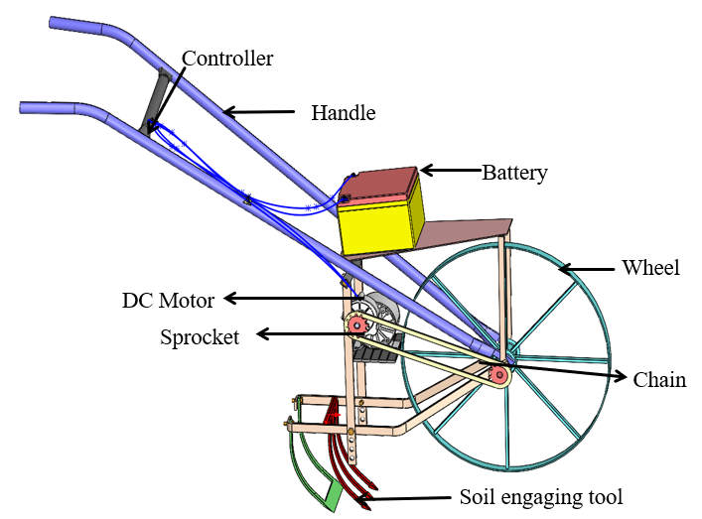

Figure 1: 3D View of developed battery-operated weeder

2.2 Component Specification Table
Approximate dimensions of each identified component are provided in Table 3. These values are derived from the SolidWorks layout and fabrication proportions and may vary by ±5% during fabrication. The notation used in the table is as follows: L = length, W = width, H = height, t = thickness, and OD = outer diameter.
2.3 Material Specification and Fabrication Approach

The frame, handle, and major structural supports were fabricated from mild-steel tubular and flat sections to provide adequate rigidity while maintaining manageable fabrication cost. Table 1 represent different components and dimensions.
Table 1: Component and dimensions of the developed battery operated weeder
Sl. No. |  | Component | Dimensions (mm)
1 |  | Dual handlebar assembly | L 980; grip span 520; tube OD 25
2 |  | Operator control unit | Housing L × W × H: 85 × 45 × 40
3 |  | Electrical cable harness | Harness L 1200; cable OD 6
4 |  | Main tubular frame | Main member L 1150; tube OD 32
5 |  | Battery compartment | L × W × H: 240 × 170 × 160
6 |  | Top mounting deck | L × W × t: 320 × 220 × 3
7 |  | Vertical support posts | Post L 300; section 25 × 25
8 |  | Motor mounting bracket | L × W × t: 180 × 120 × 6
9 |  | Drive sprocket (motor side) | 11 teeth; pitch dia. 45
10 |  | Driven sprocket (axle side) | 36 teeth; pitch dia. 145
11 |  | Chain transmission | Centre distance 320; chain L 980
12 |  | Implement toolbar/tool frame | L × W × H: 420 × 300 × 40
13 |  | Tine tips/sweep ends | Sweep width 35; rake angle ~25°

The components were prepared from spring-steel material to sustain repeated bending stresses and impact loading in field soil. The transmission used sprocket chain elements selected for low-speed, high-torque operation. The wheel hub and axle were fabricated to maintain alignment between the drive and working assemblies. The battery enclosure was designed to secure the battery pack against vibration and field shocks while permitting periodic charging access [7, 8]. Fabrication involved cutting, bending, welding, drilling, and bolted assembly of subsystems in sequence: (i) chassis and handle frame, (ii) upper deck and battery mount, (iii) motor bracket and transmission line-up, (iv) wheel–axle assembly, and (v) adjustable tool carrier with tines. Final alignment and static checks were completed before field evaluation [7, 9].The specification of DC Motor and battery shown in table.2.
Table 2 Specifications of DC motor
S. No. | Parameter | Unit |  | Value
1 | Motor name | – | Xcluma
2 | Motor type | – | Geared
3 | Rated voltage (motor) | V | 12
4 | Speed range | RPM | 180–200
5 | Torque | kg-cm | 8.15
6 | Number of batteries | – | 2
7 | Rated voltage (each battery) | V | 12
8 | Total system voltage | V | 24
9 | Battery capacity | Ah | 18
10 | Energy capacity | Wh | 432
11 | Operating time | h | 2–3
12 | Charging time | h | 6–8

2.4 Experimental Method
Field evaluation was conducted in vegetable crops (chilli and tomato) under two row-spacing treatments of 30 cm and 45 cm. Each treatment was laid out in experimental plots of 5.0 m × 4.0 m (20 m²) with buffer spacing between adjacent plots to avoid treatment interference. The experimental field consisted of well-drained sandy loam soil with friable tilth and moderate moisture conditions during operation, which facilitated uniform tine penetration and stable machine movement. Mechanical weeding was carried out using the developed battery-operated weeder at 20-day intervals after sowing. The weeder was operated along inter-row spaces while maintaining the required tine depth through the adjustment mechanism to minimize crop damage and maximize weed removal efficiency, following standard inter-row weeding practices [6, 8].
Observations were recorded at 20, 40, and 60 DAS for agronomical and weed parameters. Plant growth was quantified by (i) plant height (cm) from ground level to apical point and (ii) number of branches per plant. Weed pressure was quantified by (i) weed density (plants m⁻²), determined from quadrat counts, and (ii) weed dry weight (g m⁻²), determined after oven drying representative weed samples to constant mass. Final crop yield was expressed in t ha⁻¹ based on plot harvest and area conversion, following common metrics used in recent weed-management studies [1, 2].
The comparative effect of row spacing under a fixed weeding interval was interpreted using mean values and associated statistical indicators (SEm±, CD at 5%, and CV%). This method enabled assessment of both agronomic response and practical suitability of the prototype for row-crop weed management [7, 6].

2.5 Testing and Evaluation of Developed Battery Operated Wheel Hoe

Operational testing of the developed weeder was conducted concurrently with agronomical observations to quantify machine performance, energy demand, cost economics, and operator comfort. For each treatment, test runs were taken in three replications on measured plot strips, and mean values were used for comparison [7, 8, 9]. A two-factor analytical framework (row spacing and weeding stage) was used to interpret treatment effects, and comparisons were supported by variability indicators (SD, SEm±, CD at 5%, and CV%). Forward speed was determined from travel time over a fixed test length. Theoretical field capacity (TFC), effective field capacity (EFC), and field efficiency were computed [11, 12].
TFC = $\frac{s×w}{10}$ EFC = $\frac{A}{t}$
Field Efficiency = $\frac{EFC}{TFC}$

where s = speed (km h⁻¹), W = effective working width (m), A = actual area covered (ha), and t = effective operating time (h).
Weeding efficiency and crop damage were assessed from pre- and post-operation quadrat and crop stand counts:
Weeding efficiency (%) = $\frac{N_{b}​-N_{a}​​}{N_{b}​} ×100$
Plant damage (%) = $\frac{P_{d}​​}{P_{t}​}$ ×100
Where N_{b} and N_{a} are weed density before and after weeding, and P_{d} and P_{t} are damaged and total crop plants in sampled row sections. Battery energy use was estimated from recharge energy input per unit area (kWh ha⁻¹), and operating cost was computed from labor, repair and maintenance, battery charging, and ownership components per hectare [3, 10]. Ergonomic response was represented by operator working heart rate rise (%) during sustained operation windows relative to the pre-work resting level [5, 9].

2.6 Statistical Analysis
The experimental data were analyzed using a two-factor factorial framework with row spacing (30 and 45 cm) and weeding stage (20, 40, and 60 DAS), with three replications per treatment
The experimental data were analyzed using a two-factor factorial design comprising row spacing (30 and 45 cm) and weeding stages (20, 40, and 60 DAS), with three replications for each treatment combination. For each response variable, a two-way analysis of variance (ANOVA) was performed to evaluate the significance of the main effects and their interaction at a 5% level of significance (p ≤ 0.05).

3 Results and Discussion
Field performance of the developed battery-operated weeder was evaluated under two row-spacing treatments (30 cm and 45 cm) at three weeding stages (20, 40, and 60 DAS), with three replications per treatment–stage combination. The experimental data generated for forward speed, effective field capacity, field efficiency, weeding efficiency, plant damage, and battery operating time are presented in Table 4. Treatment-wise summary statistics (mean ± SD) are presented in Table 3. The observed responses indicate that row spacing and crop stage jointly influenced operational quality, consistent with reported trends in inter-row mechanical weeding systems [7, 8, 9].
Table 3: Field performance data of the developed battery operated weeder under two row spacing treatments

Row spacing (cm) | Days after planting | Replications | Forward speed  (km h⁻¹) | Effective field capacity  (ha h⁻¹) |  | Field efficiency (%) | Weeding efficiency (%) | Plant damage (%) | Battery operating time (h)
30 | 20 | 1 | 1.84 | 0.061 | 78 |  | 86 | 2.6 | 2.95
30 | 20 | 2 | 1.79 | 0.059 | 77 |  | 85 | 2.8 | 2.88
30 | 20 | 3 | 1.82 | 0.060 | 78 |  | 86 | 2.7 | 2.92
30 | 40 | 1 | 1.68 | 0.056 | 75 |  | 84 | 3.2 | 2.83
30 | 40 | 2 | 1.63 | 0.054 | 74 |  | 83 | 3.4 | 2.76
30 | 40 | 3 | 1.66 | 0.055 | 75 |  | 84 | 3.3 | 2.80
30 | 60 | 1 | 1.51 | 0.050 | 72 |  | 81 | 4.0 | 2.72
30 | 60 | 2 | 1.47 | 0.048 | 71 |  | 80 | 4.2 | 2.66
30 | 60 | 3 | 1.50 | 0.049 | 72 |  | 81 | 4.1 | 2.69
45 | 20 | 1 | 2.03 | 0.075 | 82 |  | 90 | 1.9 | 3.28
45 | 20 | 2 | 1.98 | 0.073 | 81 |  | 89 | 2.1 | 3.20
45 | 20 | 3 | 2.01 | 0.074 | 82 |  | 90 | 2.0 | 3.24
45 | 40 | 1 | 1.86 | 0.069 | 79 |  | 88 | 2.4 | 3.16
45 | 40 | 2 | 1.81 | 0.067 | 78 |  | 87 | 2.6 | 3.09
45 | 40 | 3 | 1.84 | 0.068 | 79 |  | 88 | 2.5 | 3.12
45 | 60 | 1 | 1.70 | 0.062 | 76 |  | 85 | 3.0 | 3.04
45 | 60 | 2 | 1.66 | 0.060 | 75 |  | 84 | 3.2 | 2.97
45 | 60 | 3 | 1.68 | 0.061 | 76 |  | 85 | 3.1 | 3.00

Table 4: Treatment wise summary of performance parameters (mean ± SD, pooled across 20–60 DAS).
Parameter | 30 cm spacing | 45 cm spacing | SEm ± | CD (5%) | CV (%)
Forward speed (km h⁻¹) | 1.66 | 1.84 | 0.008 | 0.024 | 1.35
Effective field capacity (ha h⁻¹) | 0.055 | 0.068 | 0.0003 | 0.0010 | 1.63
Field efficiency (%) | 74.7 | 78.7 | 0.19 | 0.59 | 0.75
Weeding efficiency (%) | 83.3 | 87.3 | 0.19 | 0.59 | 0.68
Plant damage (%) | 3.37 | 2.53 | 0.03 | 0.10 | 3.39
Battery operating time (h) | 2.80 | 3.12 | 0.012 | 0.036 | 1.19

3.1. Forward Speed Effect on Weeding Stages After Sowing and Row Spacing
Forward speed declined with crop age in both treatments but remained consistently higher under 45 cm spacing (2.01, 1.84, and 1.68 km h⁻¹ at 20, 40, and 60 DAS, respectively) than under 30 cm spacing (1.82, 1.66, and 1.49 km h⁻¹). The interaction trend in Figure 2 indicates that wider spacing reduced steering corrections and tine–row interference at later stages. The pooled mean speed was 11.1% higher at 45 cm spacing (Table 3), indicating better travel continuity under wider inter-row geometry [7, 8].
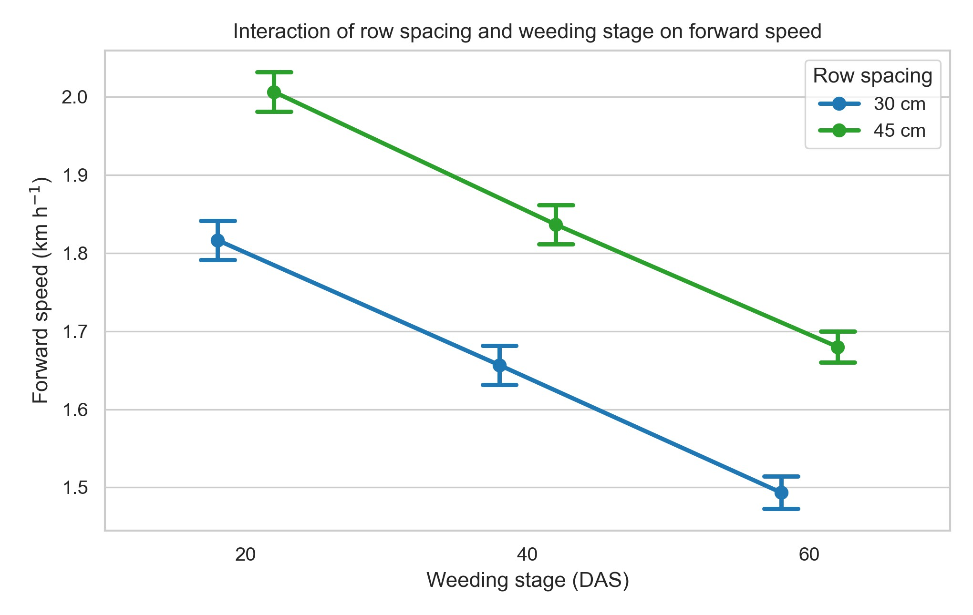

Figure 2. Effect of row spacing and weeding stage on the forward speed of the developed battery-operated weeder.
3.2. Effective Field Capacity Effect on Different Row Spacing

Effective field capacity followed the forward-speed response and was greater under 45 cm spacing throughout testing (Table 3). Mean effective field capacity increased from 0.055 ha h⁻¹ (30 cm) to 0.068 ha h⁻¹ (45 cm), corresponding to a 23.6% gain. The mean and replicate dispersion pattern in Figure 3 indicates stable area coverage performance under wider spacing, with practical implications for reduced time requirement per unit area [9, 8].

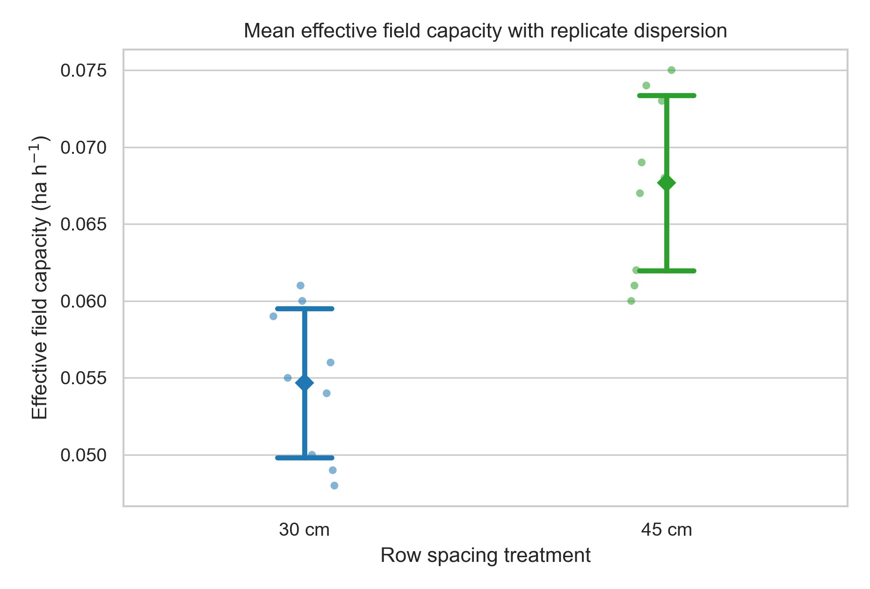

Figure 3: Effective field capacity under two row spacing(30&40cm)
3.3. Field Efficiency Effect on Weeding Stages After Sowing and Row Spacing
Field efficiency ranged from 71–78% in 30 cm rows and 75–82% in 45 cm rows. The dot-plot distribution confirms that the 45 cm treatment consistently occupied the higher efficiency band at all stages (Figure 4). This behaviour reflects lower non-productive time losses due to fewer alignment corrections and smoother manoeuvrability under wider row arrangement [7, 9].
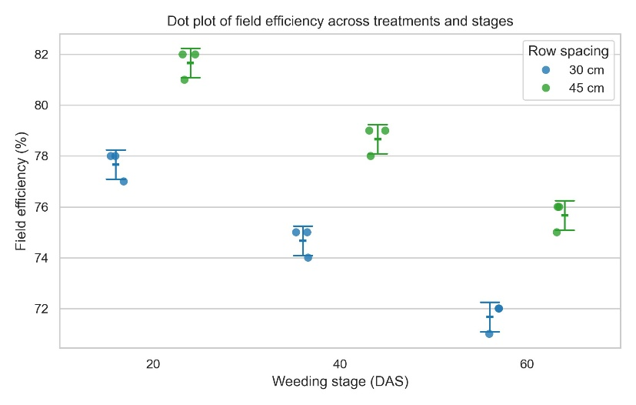
Figure 4: Field efficiency values across weeding stages and row spacing treatments, with treatment means and SD error bars overlaid.
3.4. Weeding Efficiency Effect on Different Row Spacing
Weeding efficiency remained high in both treatments but was consistently superior in 45 cm rows. The treatment mean increased from 83.3% (30 cm) to 87.3% (45 cm). The box-plot distribution (Figure 5) shows an upward shift of the median and interquartile band for the 45 cm treatment.
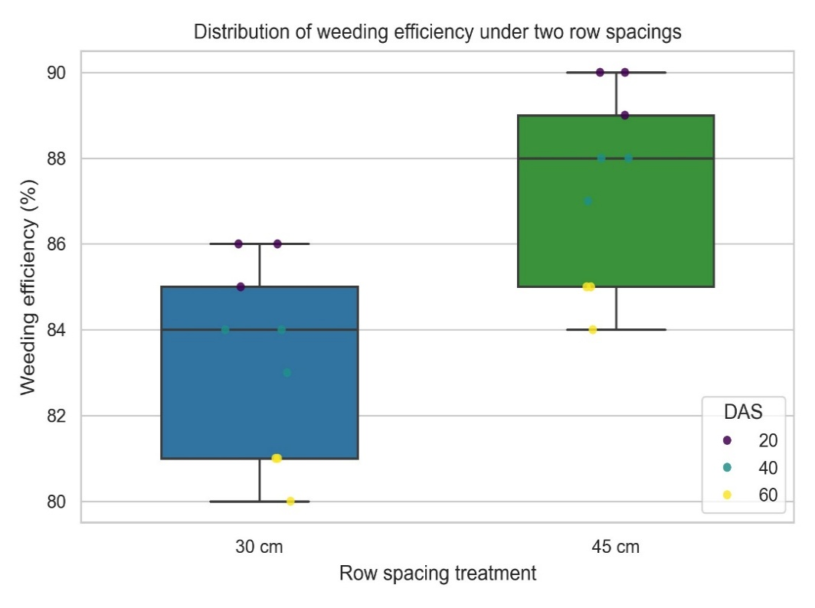
Figure 5: Weeding efficiency under 30 and 45 cm row spacing treatments.
3.5. Plant Damage Effect on Weeding Stages After Sowing and Row Spacing
Plant damage increased gradually with crop stage in both treatments but remained lower at 45 cm spacing. Mean plant damage was 3.37% in 30 cm rows and 2.53% in 45 cm rows, representing a 24.9% reduction. The dot plot in Figure 6 demonstrates clear treatment separation at each stage, supporting the suitability of wider spacing for safer tine passage and reduced crop contact [7, 8].

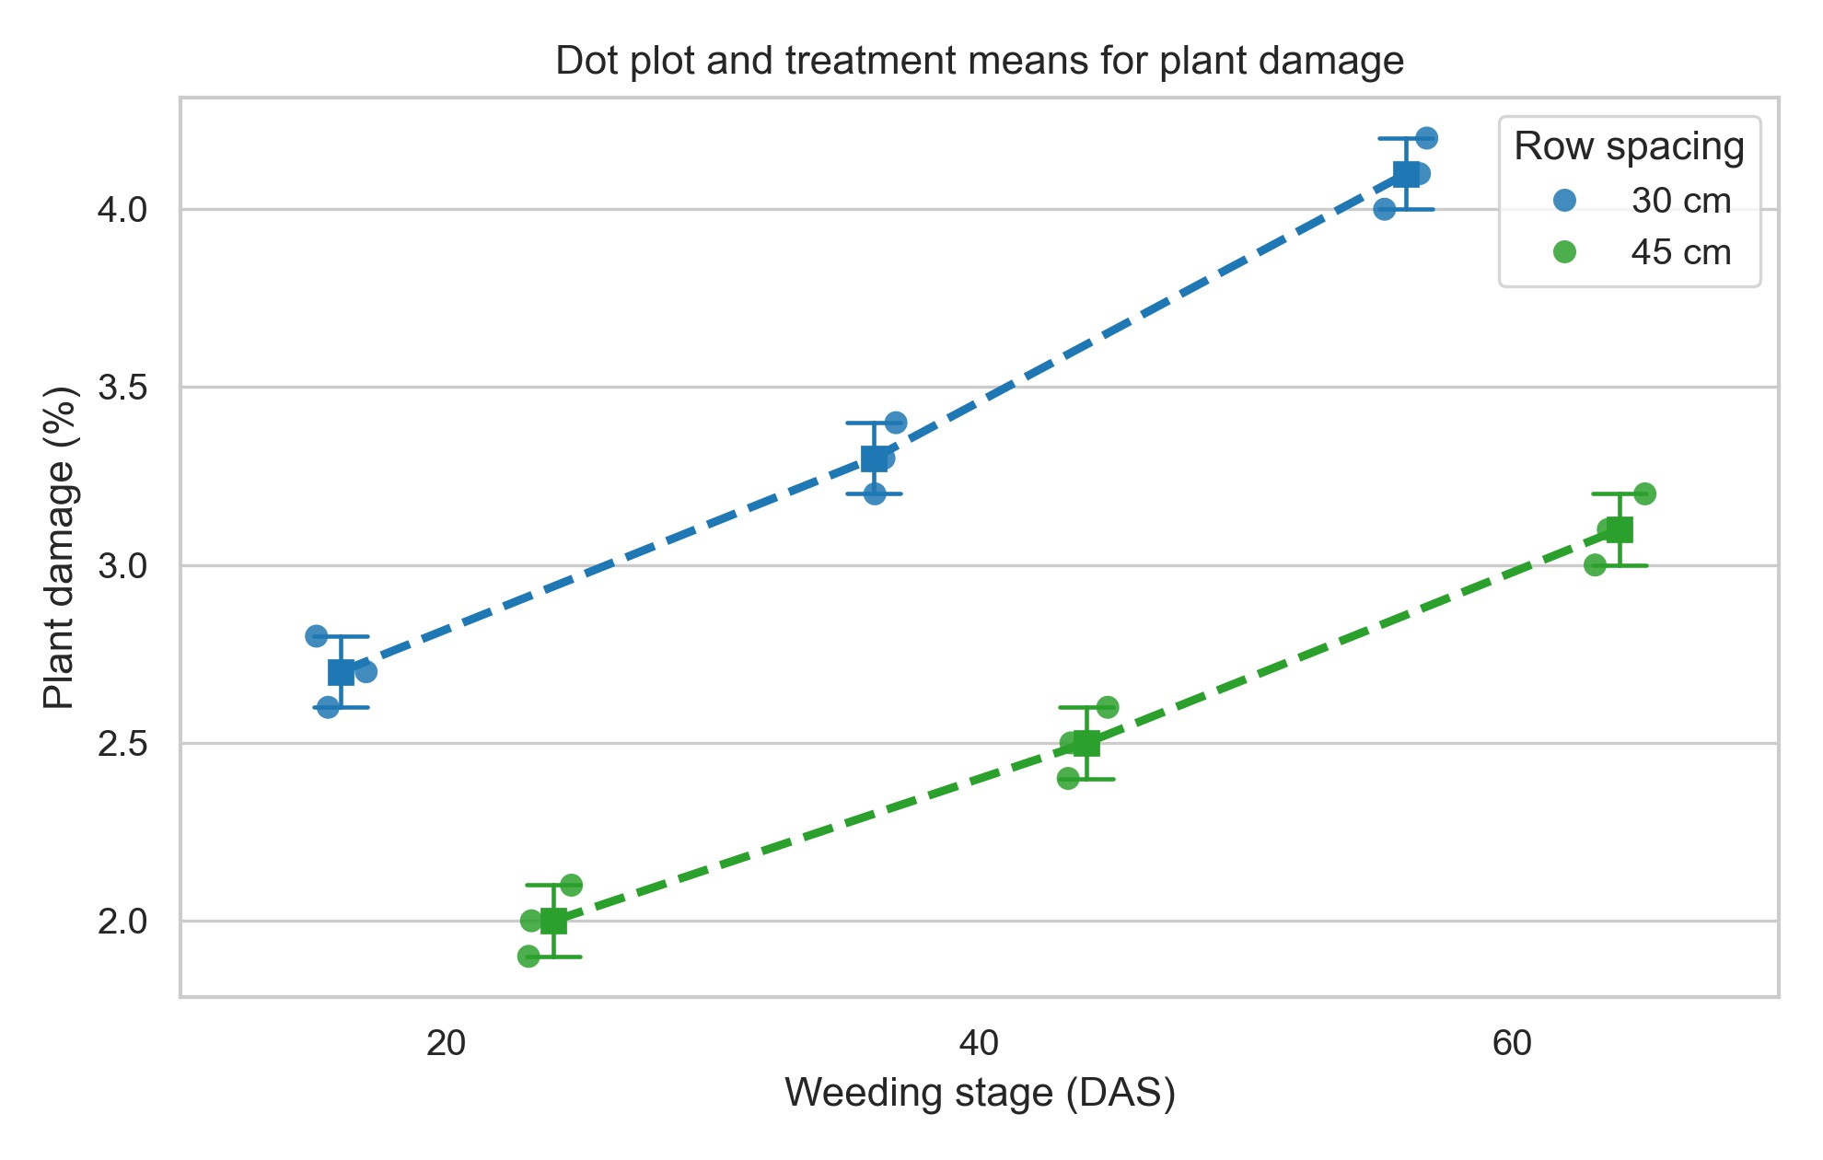

Figure 6: Dot plot of plant damage across weeding stages with treatment means and SD error bars for the developed weeder.
3.6. Battery Operating Time Effect on Weeding Stages After Sowing and Row Spacing
Battery operating time declined slightly from early to late stages due to increased rolling resistance and repeated corrections in denser crop stands; however, 45 cm spacing maintained longer operating windows across all stages. Mean battery operating time improved from 2.80 h (30 cm) to 3.12 h (45 cm), i.e., an 11.5% increase. The mean-error plot (Figure 7) highlights this persistent treatment advantage and indicates better energy utilization per charge cycle under wider spacing [10, 9].
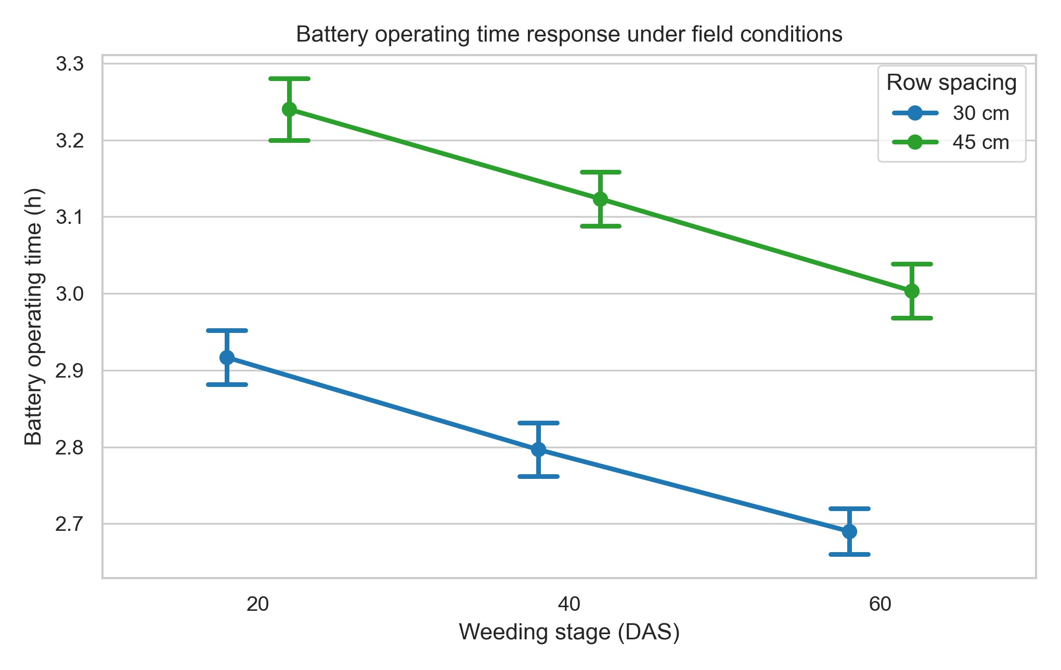

Figure 7: Battery operating time across weeding stages under different row spacing treatments.

3.7. Overall Discussion on Field Performance
Across all evaluated performance indicators, the developed battery-operated weeder performed more favourably in 45 cm row spacing than in 30 cm spacing. The combined improvement in forward speed, effective field capacity, field efficiency, and weeding efficiency, together with reduced plant damage and longer battery operating time, confirms that machine–field matching strongly influences practical performance. These outcomes indicate that the developed prototype is technically suitable for inter-row weed management in row crops, particularly where row geometry permits stable tool guidance and continuous motion [8, 9, 10].
4. Conclusion
A compact battery-operated inter-row weeder was successfully developed and evaluated under practical vegetable-field conditions. The machine achieved stable and repeatable performance across testing stages, while treatment comparison showed clear operational advantages at 45 cm row spacing. Relative to 30 cm spacing, the 45 cm treatment improved forward speed, effective field capacity, field efficiency, and weeding efficiency, reduced crop damage, and extended battery operating time. These findings indicate that appropriate row geometry significantly enhances the agronomic and engineering performance of battery-powered weeding systems. From a farm-level perspective, the developed prototype demonstrates strong potential as a labour saving and low-emission alternative for small and medium row-crop operations. Future work should include multi-location validation, season-long cost analysis, and long-term durability testing under variable soil and residue conditions to support broader on-farm adoption and commercialization.

COMPETING INTERESTS DISCLAIMER:
Authors have declared that they have no known competing financial interests OR non-financial interests OR personal relationships that could have appeared to influence the work reported in this paper.

Disclaimer (Artificial intelligence)

Author(s) hereby declare that NO generative AI technologies such as Large Language Models (ChatGPT, COPILOT, etc.) and text-to-image generators have been used during the writing or editing of this manuscript.

References

[1] Cordeau, S.; Colbach, N.; Petit, S.; Chauvel, B.; Deytieux, V.; Lechenet, M.; Munier-Jolain, N. The pitfalls of relating weeds, herbicide use, and crop yield: Don’t fall into the trap! A critical review. Frontiers in Agronomy 2020, 2, 615470. https://doi.org/10.3389/fagro.2020.615470.
[2] Shen, Y.; Yang, F.; Wu, J.; Luo, S.; Khan, Z.; Zhang, L.; Liu, H. Advances and future trends in electrified agricultural machinery for sustainable agriculture. Agriculture 2025, 15(22), 2367. https://doi.org/10.3390/agriculture15222367.
[3] Vinayak, M., Haribabu, B., Ashokkumar, A., Madhava, M., Ratnakumari, N. and Ramana, C. (2025). Cost Economic and Benefit Cost Ratio of Developed Round Basin Maker cum Fertilizer Applicator for Orchard Crops. Econ. Aff., 70(03): 255-261. https://doi.org/10.46852/0424-2513.3.2025.12
[4] Krishna, V. S., Tejaswini, V., Vinayak, M., Rahaman, S. and Indraja, P. 2025. Development and quality evaluation of a solar dried mango leather. International Journal of Horticulture and Food Science. 7(5), 85–90. https://doi.org/10.33545/26631067.2025.v7.i5b.299
[5] Krishna, V.S., Jain S.K., Panwar, N.L. and Ramasree. 2025. An overview on phase change material incorporated in convective solar dryers. Journal of Energy Storage.131(A). https://doi.org/10.1016/j.est.2025.117486
[6] Sujatha, G and Krishna V.S.2025. Assessment of mulch practices with drip irrigation on soil physical quality and weed regulation. International Journal of Biological Sciences.7(12):25-28.
[7] Horvath, D.P.; Clay, S.A.; Swanton, C.J.; Anderson, J.V.; Chao, W.S. Weed-induced crop yield loss: A new paradigm and new challenges. Trends in Plant Science 2023, 28(6), 567–579. https://doi.org/10.1016/j.tplants.2022.12.014.
[8] FAO. The State of Food and Agriculture 2022: Leveraging Agricultural Automation for Transforming Agrifood Systems; Food and Agriculture Organization of the United Nations: Rome, Italy, 2022. https://doi.org/10.4060/cb9479en.
[9] Marinoudi, V.; Lampridi, M.; Kateris, D.; Pearson, S.; Sørensen, C.G.; Bochtis, D. The future of agricultural jobs in view of robotization. Sustainability 2021, 13(21), 12109. https://doi.org/10.3390/su132112109.
[10] Marinoudi, V.; Benos, L.; Camacho Villa, C.; Lampridi, M.; Kateris, D.; Berruto, R.; Pearson, S.; Sørensen, C.G.; Bochtis, D. Adapting to the agricultural labor market shaped by robotization. Sustainability 2024, 16(16), 7061. https://doi.org/10.3390/su16167061.
[11] Jiang, B.; Zhang, J.-L.; Su, W.-H.; Hu, R. A SPH-YOLOv5x-based automatic system for intra-row weed control in lettuce. Agronomy 2023, 13(12), 2915. https://doi.org/10.3390/agronomy13122915.
[12] Nayak, V.K.; Verma, A.; Naik, R.K.; Dave, A.K. Design and development of battery-operated single row weeder for chickpea. International Journal of Advanced Biochemistry Research 2024, 8(3S), 638–645. https://doi.org/10.33545/26174693.2024.v8.i3Sh.902.
[13] Eliya, R.; Vijay Kumar, D.; Bakka, R.K.; Lavanya, K. Design and field evaluation of an automatic inter- and intra-row weeder for wide-spaced crops. Journal of Scientific Research and Reports 2025, 31(6), 1053–1068.
[14] Khadatkar, A.; Sujit, P.B.; Agrawal, R.; Vishwanath, K.; Sawant, C.P.; Magar, A.P.; Chaudhary, V.P. WeeRo: Design, development and application of a remotely controlled robotic weeder for mechanical weeding in row crops for sustainable crop production. Results in Engineering 2025, 26, 105202. https://doi.org/10.1016/j.rineng.2025.105202.
https://doi.org/10.9734/jsrr/2025/v31i63197.

