An Integrated Assessment of Ecosystem Services and Biodiversity in the Balleyara Department, Niger

ABSTRACT
Plant biodiversity plays a vital role in providing various benefits which affect positively the life of people mostly in dryland region like Niger. Many studies exist about the types of the ecosystems, their floristic composition and their functions but there is scarcity of studies from specific geographic area such as West Africa Sahel. Therefore, the study determined the types of ecosystems, plant diversity and the services they provide to the local population at Department of Balleyara. We used questionnaires and field observations for data collection. The different ecosystem services have been identified through surveys on a sample of 10 villages. In each village, ten (10) persons composed of men and women were questioned, making a total of one hundred (100) people. Descriptive statistics such as percentage was used for the data analysis. The main types of ecosystems identified are aquatic ecosystems and terrestrial ecosystems and plantation of Acacia senegal and Eucalyptus camaldulensis. The 61% of the aquatic ecosystems are permanent and 39% are semi-permanent with an average duration of 6 to 9 months The key ecosystem services identified are firewood, medicine, water, forage, green fertiliser etc. The main woody species used for the fuelwood are Guiera senegalensis (41%), Combretum micranthum (24%), Faidherbia albida (15%) in the Department of Balleyara. The study recorded two exotic tree species (Eucalyptus camaldulensis and Azadirachta indica) which provided diverse ecosystem services. Therefore, the ecosystems of the Department of Balleyara are rich and diversified and can contribute to the wellbeing of the local population regarding to the services they offer. The study provided the ethnobotanical and floristic knowledge which can be used as a reference level for the sustainable management of the ecosystems in the study. The study recommends also the use of ecosystem services to restore peace by reducing resource-driven conflict, fostering cooperation over shared natural assets, and rehabilitating livelihoods in conflicts zone like the Department of Balleyara in Niger.
Keywords: Sahel, Diversity, Ecosystem values, Tillaberi, Republic of Niger.
- INTRODUCTION
Human survival and well-being depend largely on ecosystem services in Sub-Saharan Africa. Indeed, the particularly woody biodiversity of ecosystems is of great importance and has strong socio-economic and cultural potential for the production of food, water, medicines, fuel, forage, clothing, shelter [1], [2], [3]. They also provide ecological services such as carbon sequestration [4], [5], temperature regulation [6] and water cycle [7]. In addition to that, the ecosystem services play a crucial role in climate change adaptation [8], [9], [10] such in agricultural systems [7], [9]. Ecosystem services are central to meeting the United Nations Sustainable Development Goals [11]. Ecosystems are linked to human well-being because of the different uses or services they provide. Ecosystems also have economic value beyond just agricultural production. To determine ecosystem services, the Millennium Ecosystem Assessment (MEA) between 2001 and 2005 carried out a study, which identified 31 ecosystem services and classifies them into four categories: supply services, support services, regulatory services and cultural services. On this basis, it highlights the important role of ecosystems in the production of most of the goods supplied to society [3]. Nevertheless, well-being and poverty alleviation depend on the improvement of ecosystem management with a view to ensuring their conservation and sustainable use. In Sahelian countries like Niger, the climate is characterized by great interannual variability in rainfall, which results in recurrent dry years, which are becoming more and more frequent. Indeed, through studies carried out on biodiversity [12], it clearly appears that the threats that cause the degradation and loss of natural ecosystems still persist and among these causes. This situation is very critical on a global scale, especially since the disappearance of natural ecosystems has reached a rate never observed before [13]. Each year 70,000 to 80,000 hectares (ha) are removed from classified Niger forests under the effects of climate change combined with uncontrolled cutting of trees and especially the expansion of crops on forest land [14]. For [15], the degradation of Niger's ecosystems is mainly due to significant changes in land use following rapid population growth because they increase the demand for crop space, the need for firewood and levies for other purposes and the overexploitation of natural resources. Ecosystems are a source of great importance in dryland region like in Niger because spontaneous and cultivated plant species are of great interest in the diet of populations, particularly during periods of famine and hunger when the wild plant species are used for animal feed, for huma food and in pharmacopoeia [16] . According to [12], in Niger, the studies carried out so far on biodiversity remain fragmentary and the description of ecosystems is not yet effective. Niger is a West Africa Sahelian country where rural and urban population rely on ecosystem services [1], [17], [18].
Knowledge on ecosystem services from West Africa Sahel is scarce in the literature. For instance, there is paucity of research that touches the typology of ecosystems and their services. In addition to that, the present study differs from the previous works by the combination of field observation and questionnaires in rural areas. This study addresses a critical gap in the scientific understanding of dryland ecosystems in the Sahel region, specifically within the Department of Balleyara, Niger. Furthermore, it contributes a valuable case study to the global literature on ecosystem services, particularly from under-researched arid and semi-arid zones in West Africa. The scientific data on typology and diversity of ecosystem services in West Africa Sahel can serve as important means for sustainable ecosystem management. This study tries to determine the type of the ecosystems and their services in the Department of Balleyara, Niger
- MATERIAL AND METHODS
  - Study zone
The study was conducted in the Department of Balleyara in the Tillaberi region in Niger which is in the Sahel agro-ecological zone. The study area is located 98 km northeast of the capital Niamey (Figure 1). The annual rainfall varies between 250 mm to 400 mm. The rainy season lasts 3 to 4 months from June to September. Average temperatures range from 18º^{C} in January to 45º^{C} in April [19].
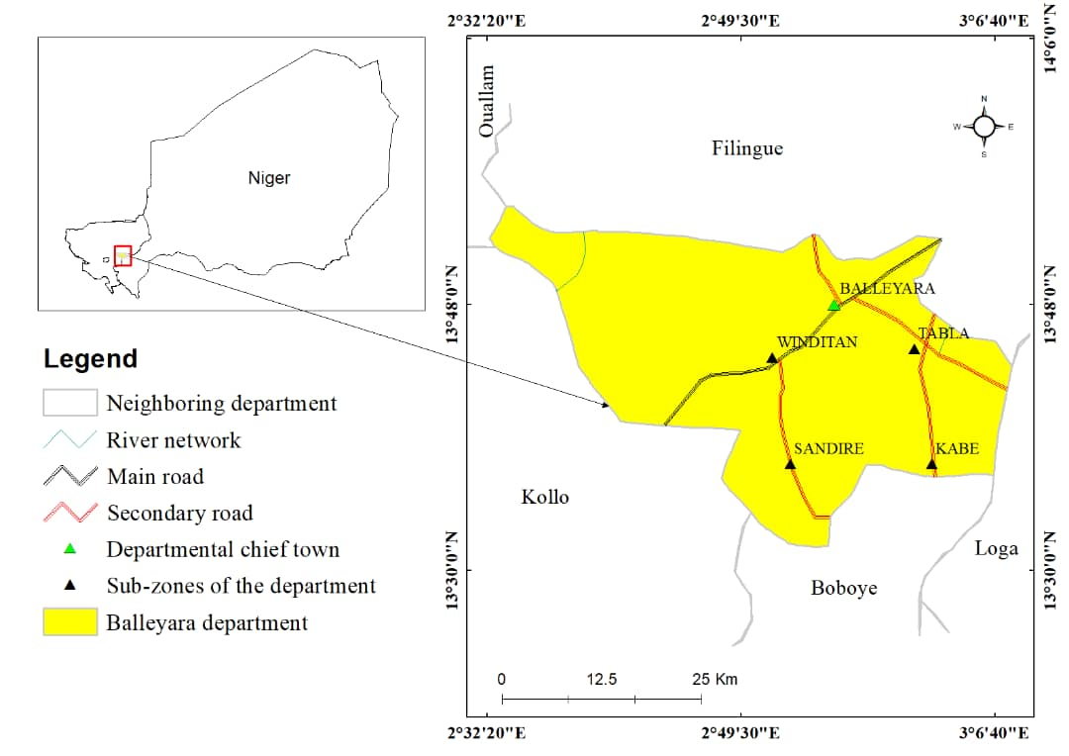
Figure 1. Localisation of study area
The relief of the Department of Balleyara consists largely of the alluvial system, which covers 50.655 hectares (ha) representing 38.54% of the total area, and then come the plateaus 27.79% to the East and West of the Department, the glacis 19.58%, and the slopes 13.04%.
The vegetation types consist of contracted formations with Combretaceae on the plateau. The main plant species recorded are: Guiera senegalensis J.F. Gmel., Combretum micranthum g. Don., Combretum glutinosum Perr. ex DC., Faidherbia albida Del., Balanites aegyptiaca (L.) del..
The Department of Balleyara covers an area of 1,314 km² and is subdivided into five (5) sub-areas which are Balleyara, Winditan, Sandiré, Tabla and Kabé. The population is 129.086 people [20] with a growth rate of 3.1% and an average density of 81.53 inhabitants per km². The main activities of the population are agriculture, animal husbandry, handicrafts and commerce. In addition to rainfed crops, there is a strong development of very favourable vegetable and fruit crops in the valley area. The farming system practiced by the population is transhumant farming which generally concerns large ruminants and sedentary farming which concerns small ruminants and poultry, practiced mainly by women. The artisanal production essentially relates to the transformation of hides and skins by the shoemakers, the products of the forge and the production of natron.
  - Data collection and analysis
In this study, two main approaches were been used for the data collection. A questionnaire used to collect data on the ecosystem services. In order to collect as much information as possible, the representative sample of villages from the study area was selected randomly. In total, through these ten (10) villages were selected and considered as a representative sample of the study area. For the realization of this survey, the accelerated method of participative research (MARP) is applied. Also, the questioning by individual of ten people made up of men and women in each village with a total of one hundred (100) people questioned. The MARP consists in bringing together the villagers and asking them questions. At the next step, we used direct field observations to collect also the data on the ecosystem types and their services for local people. Descriptive statistics such as percentage was used for the data analysis. For example, we calculated the percentage of plant species used in traditional pharmacopoeia, the percentage of main species used as fuelwood, etc. in the Department of Balleyara. We used also the pictures to illustrate types of the ecosystem, functions and threats of the identified ecosystems.
- RESULTS
3.1 Typology of ecosystems
The study identified two categories of ecosystems, which are aquatic and land ecosystems in the Department of Balleyara.
3.1.1 Terrestrial ecosystems
The terrestrial ecosystems consist of agroforestry parklands, gardens, steppe vegetation, tree plantation of Acacia senegal and Eucalyptus camaldulensis. The cultivated ecosystems such as gardens are occupied by market gardening and arboriculture. The cultivated species are sweet potato, tomato, lettuce, cassava, cabbage, onion, potato, carrot, eggplant, pepper, zucchini, melon, chili, Moringa and sugar cane. Figure 3 shows the plots of cabbage on the land Zongo village for sale and household consumption. As for fruit arboriculture, it is practiced in gardens. The establishment of this culture is weak in all the sub-zones, but largely used in the sub-zone of Balleyara, Sandiré and Tabla. The main woody species encountered are the Mango tree, the Jujube tree, the Cashew tree and the Lemon tree with a strong dominance of the Mango tree. These products are intended for sale and offer a very significant additional income for the local population. Arboriculture gardens are strongly represented in the locality of Balleyara (Figure 2).
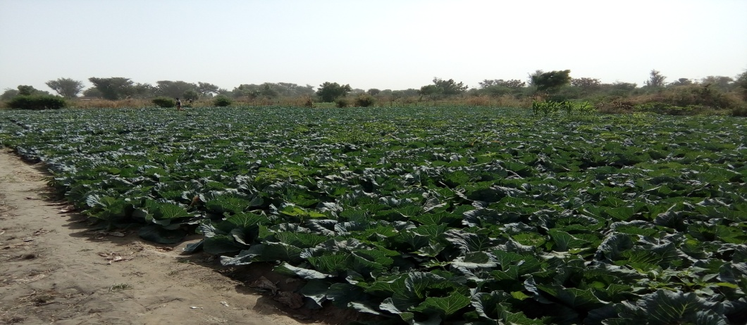
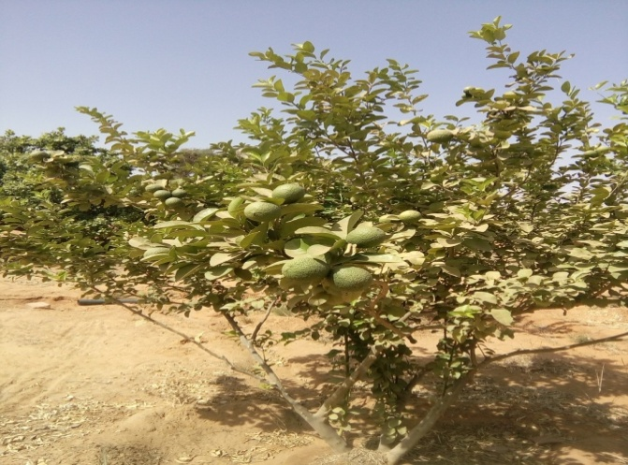

Figure 2: Gardens ecosystems at Balayara village
Agroforestry parklands is one of the identified types of the ecosystem in the Department of Balleyara. Agroforestry parklands in the Department of Balleyara consists of agricultural land use such as farmlands with diverse purpose crops such as tree crop, cereals crop for sale or household consumption. Such ecosystems benefit from the human activities such as Farmer-Managed Natural Regeneration (FMNR) for increasing woody species diversity and vegetation cover for various services in agroforestry parklands (Figure 3).
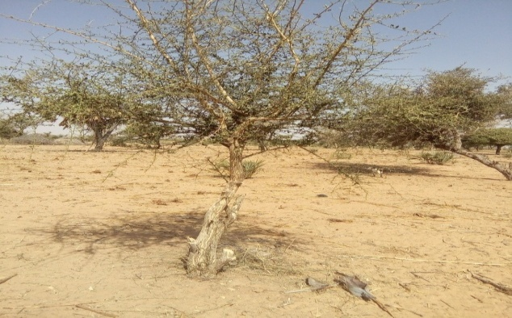
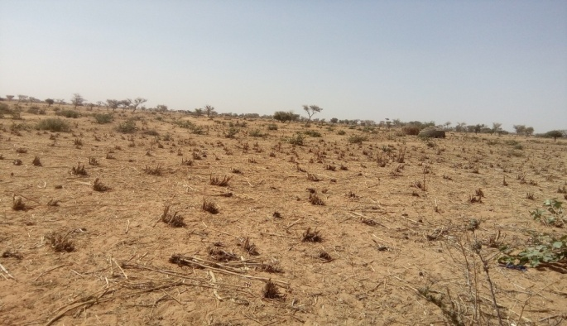

Figure 3: Agroforestry parklands in Balleyara area
Some examples of the typology of the agroforestry parklands based on the dominant tree species, the study has identified agroforestry parklands of Faidherbia albida and Balanites aegyptiaca in the Department of Balleyara (Figure 4 and 5). The agroforestry parklands are land use systems in which famers leave some multiple purpose woody species for the provision of various services such to diversify subsistence production, and to create income, but also to increase the yield of rain-fed crops. This is the case of the agroforestry parklands of Faidherbia albida (Figure 5) and Balanites aegyptiaca; they are almost in all the sub-areas of the Department.
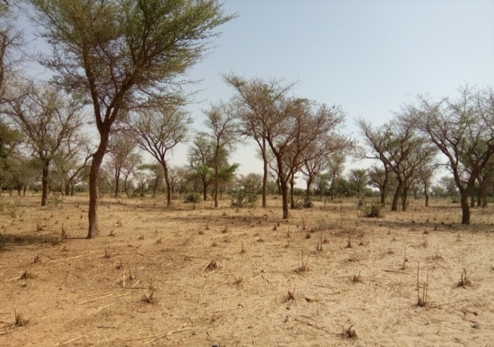

Figure 4: Agroforestry parklands of Faidherbia albida

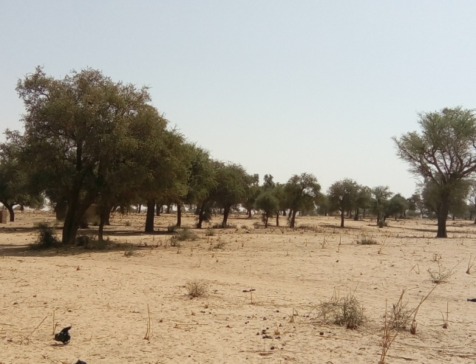
Figure 5: Agroforestry parklands of Balanites aegyptiaca.
3.1.2 Steppes vegetation
As part of terrestrial ecosystem types in the Department of Balleyara in Niger, the steppe vegetation had also been identified in the area. The figure 6 shows the steppe dominated by the grassland and the existence of shrub layers.
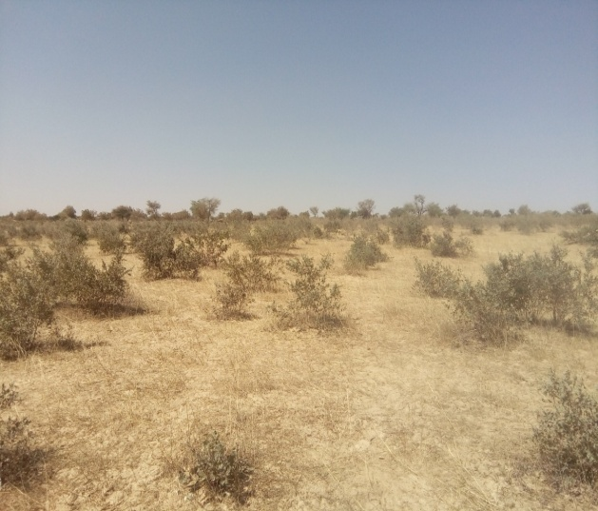
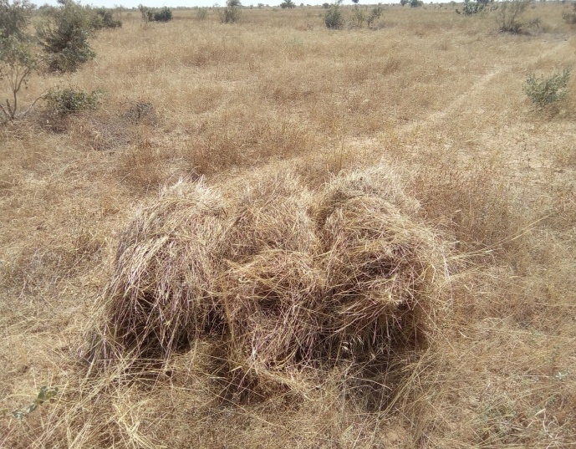
Figure 6. Steppe ecosystem in the study area.
3.1.3 Aquatic ecosystems
Aquatic ecosystem types such as the semi-permanent pond in izagagadan village in the Department of Balleyara (Figure 7). The Department of Balleyara abounds in a significant quantity of pools concentrated in the area of the Dallol valley. The 61% of these ponds are permanent ponds and 39% are semi-permanent ponds with an average duration of 6 to 9 months. However, the majority of these ponds are suffering from the Typha australis invasion, unsustainable agricultural activities, plastic pollution and sanding of the ponds making them unusable.
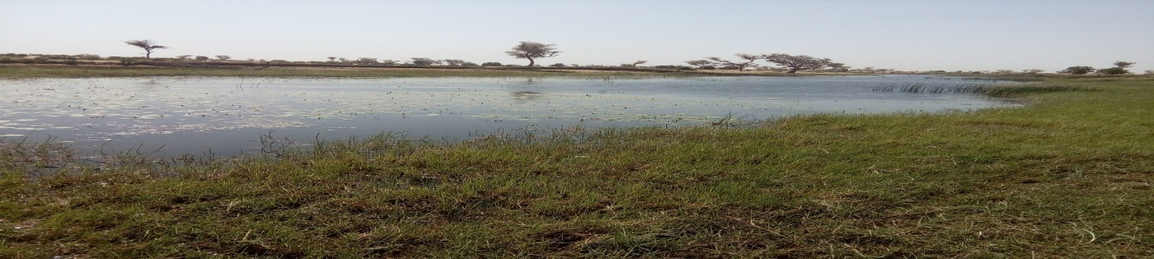
Figure 7. Semi-permanent pond in izagagadan village in the Department of Balleyara
These ponds are used for cropping, fishing, watering animals, making blocks and especially the production of natron. The natron or "gray gold" of Dallol Bosso is currently the only extractive resource in the area. Indeed, in the Dallol Bosso, particularly in the Department of Balleyara the production of natron today attracts several inhabitants. The production of natron appears a priori as a devastating activity of the environment by the excessive use of green wood by the producers of natron, which constitutes a real and constant threat to the vegetation because there are some woody species, which are likely to disappear. These include Acacia nilotica, Faidherbia albida, Combretum nigricans, Combretum glutinosum, Balanites aegyptiaca etc. Thus, the treatment of natron requires a large amount of wood of those tree species (Figure 8).
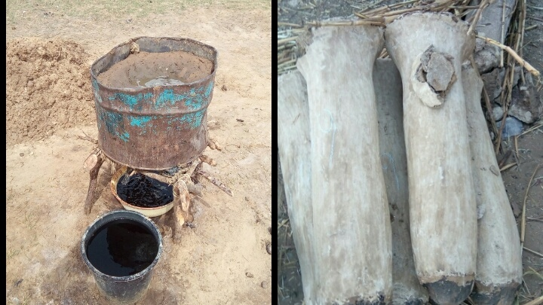
Figure 8. System of Natron production in the Lélé village
3.2 Diversity of ecosystem services
The study highlighted various types of the ecosystem services in the Department of Balleyara is undeniable. These ecosystem services can be summed up as follow:
3.2.1 Food and medicine supply services.
About 85% of those surveyed said they obtained food from plants in these ecosystems during the lean season. While, 75% of those surveyed use plant species as a source of medicine or in the traditional pharmacopoeia. Among the organs of these woody species (Table 1), the leaves are the most used with a percentage of 37%, then the stems with 23%, then the roots with 14%, the fruits and seeds 10% each and finally the bark and tubers 3% each (Table 1). The most used species in the pharmacopoeia are Acacia nilotica and Balanites aegyptiaca with 15% each (Figure 9).
Table 1. Some plant species and their parts used in the pharmacopoeia
Species | Diseases treated | Parts used
Acacia nilotica (L.) Willd. ex Delile | Hemorrhoid | Seed
Acacia nilotica (L.) Willd. ex Delile | Malaria | Root
Acacia nilotica (L.) Willd. ex Delile | Ulcer | Stem
Acacia senegal (L.) Willd. | Diabetes | Stem and leaves
Azadirachta indica A.Juss. | Hemorrhoid | Leaves and Root
Azadirachta indica A.Juss. | Ulcer | Leaves, Seed, Fruit
Combretum micranthum G. Don | Hemorrhoid | Bark, Leaves
Balanites aegyptiaca (L.) Delile | Hemorrhoid | Leaves
Balanites aegyptiaca (L.) Delile | Cardiac problem | Root
Balanites aegyptiaca (L.) Delile | Yellow fever | Fruit, Stem
Borassus aethiopum Mart. | Aphrodisiac | Tuber
Guiera senegalensis J.F. Gmel. | Diarrhea | Root, Leaves
Hyphaene thebaica (L.) Mart. | Vomiting treatment | Leaves, Fruit
Khaya senegalensis A. Juss. | Hemorrhoid | Leaves
Khaya senegalensis A. Juss. | Malaria | Stem
Prosopis africana (Guill. & Perr.) Taub. | Dysentery | Leaves
Prosopis africana (Guill. & Perr.) Taub. | Ulcer | Stem
Tamarindus indica L. | Ulcer | Stem, leaves, seed
Ziziphus mauritiana Lam. | Hemorrhoid | Leaves
Ziziphus mauritiana Lam. | Diarrhea | Stem

Figure 9. Percentage of plant species used in traditional pharmacopoeia in the Department of Balleyara.

3.2.2 Wood supply services
About 100% of the population of the stated, that woody species are used for wood energy in the Department of Balleyara. The main woody species are Guiera senegalensis, Combretum micranthum, Combretum glutinosum, Faidherbia albida, Balanites aegyptiaca as illustrated in the figure 10 that gives the percentages of the main species used as fuelwood on a sample of 1000 bundles of fuelwood. Plant species are used as service wood, for the construction of houses, attics and roofs, etc. The most used species are Eucalyptus camaldulensis, Azadirachta indica, Borassus aethiopum and Guiera senegalensis. The wood is also used in the making of work tools (timber) such as mortars and pestles. For such use, the plant species used are Combretum nigricans, Acacia nilotica, Combretum glutinosum and Faidherbia albida (Figure10).

Figure 10. Percentage of main species used as fuelwood in the Department of Balleyara.
3.2.3 Economic Services
The ecosystems of the Department of Balleyara are an important source of income for the local population through the trade in wood and non-wood forest products including among others: vegetables, production of natron, fodder, fuelwood, wood work and the gathering of forest fruits which is an activity practiced largely by women and young people. The different products are displayed at the weekly markets, however, for the same products, prices vary according to size, but also according to the season. About 95% of people surveyed use forest products as a source of income.
- DISCUSSION
The study highlighted the existence of aquatic and terrestrial ecosystem in the Department of Balleyara. This indicates the diversity of ecosystems of the Department of Balleyara, which is central to the biodiversity conservation and ecosystem services provisions. For instance, the land ecosystems types reported by this study are agroforestry parklands. The existence of agroforestry parklands indicates the practice of agroforestry, which is a best way to the resilience of famers [21], [22]. In addition to that, the practice of the agroforestry in the Department of Balleyara is an indicator of land use management that keeps the woody species in the croplands for various functions such as land restoration and biodiversity conservation. One of the implications of having agroforestry parklands is that they constitute a key land ecosystems characteristics of drylands region to mitigate climate change [23], [24] and to improve household livelihoods [25], [26] and conserve biodiversity [27]. In addition, the result found out the two main types of agroforestry parklands, which are agroforestry parklands, based on Faidherbia albida and Balanites aegyptiaca. This demonstrates that the rural population participate in the typology of agroforestry ecosystems based on the selection of multiple purpose tree species as reported [28], [29]. The agroforestry parklands based on the Faidherbia albida has been already reported as a socio-economic and ecological tree in West Africa Sahel region [28]. These agroforestry parklands based on Faidherbia albida and Balanites aegyptiaca are built parklands based on the benefits that the farmers collect from them [28]. The study also identified the artificial plantations such as Eucalyptus camaldulensis plantations in the Department of Balleyara. This ecosystem type is an indication of the cultivation of Eucalyptus camaldulensis tree for the timber production in the Department. The cultivation of Eucalyptus camaldulensis has been reported in West Africa Sahel region by [30] which constitute a great source of income in the region. Moreover, the cultivation Eucalyptus camaldulensis near or within the wetlands in the Department of Balleyara should be done with great care as Eucalyptus camaldulensis is a very fast-growing tree, native to Australia, often considered an invasive and ecologically harmful species in many parts of the world.
In the area of this study, many ecosystem services such as foods, medicines, firewood, timber, forest product on forest products have been noted. Indeed, the firewood constitute the major source of the energy in the Department of Balleyara. Unfortunately, one of the implications of this finding in Sahel area, is the depletion of the forest resources such as the disappearance of some local woody species [31]. Indeed, the collection of wood for energy purpose is the leading cause of tree biodiversity loss in Niger. In addition to that, woody species are exploited in the Balleyara Department for the public uses.
According the results from this study, another ecosystem service highlighted is the use of woody species for treatment of many diseases in the Department of Balleyara. This confirms the findings of some studies reporting that woody flora is largely used for medicinal purpose in the rural areas in Niger [17], [18].
The study carried out on the typologies and diversity of ecosystem uses in the Department of Balleyara made it possible, on the one hand, to identify the different types of ecosystems and the services they offer to the local population. These ecosystems are distributed according to the toposequence and the pedoclimatic factors of the environment. Thus, on the plateaus develop some relics of contracted formation (tiger bush) and shrubby and grassy steppes. In the valley, thanks to the availability of water and the sandy clay texture of the soil, a relatively dense shrub and tree vegetation develops. According to [32]; the texture conditions the availability of water for vegetation and contributes to the expression of the soil climate, which is sometimes more important for plants than the climate itself. However, given the services it offers, this vegetation is constantly under enormous anthropogenic pressures, notably the excessive cutting of wood, the over-exploitation of cultivated land, the production of natron, overgrazing, etc. These anthropic actions, combined with the effects of climatic deterioration, contribute to a progressive degradation of the ecosystems of the Department of Balleyara.
Faced with the ever-increasing demand for its needs and the inability of natural forests to offer all services, man has developed forms of production of resources for his development. Thus, the plants are cultivated or maintained in the fields for their wood (Lumber, service wood and wood energy), fodder, their fruit (contribution of precious nutrients to humans), medicinal uses or other. This situation is at the origin of many agroforestry parks. The creation of artificial forests also contributes to the protection of these natural stands, especially for the production of lumber.
- CONCLUSION
The scientific information on ecosystems diversity and their services in the Department of Balleyara is therefore important for the sustainable management. The general objective of the work was to the identification of different types of ecosystems and their services in the area. In total, two main categories of ecosystems were noted, which are aquatic and land ecosystems. The two ecosystem types render various and enormous socio-economic and ecological services to the local people in the area. The study also highlighted a diversity of woody species, which also provide multiple services to the people. The results reported the use of exotic tree species in agroforestry in the study area. The outputs of this investigation constitute the baseline level in terms of typology of ecosystems and their services, which are key for ecosystem restoration programmes for a sustainable use of their services in Niger especially at local level. The study offers valuable empirical data that can inform regional conservation strategies and sustainable land management practices in a context of climate change, environmental degradation and terrorist activities.
COMPETING INTERESTS DISCLAIMER:
Authors have declared that they have no known competing financial interests OR non-financial interests OR personal relationships that could have appeared to influence the work reported in this paper.

Disclaimer (Artificial intelligence)

Author(s) hereby declare that NO generative AI technologies such as Large Language Models (ChatGPT, COPILOT, etc.) and text-to-image generators have been used during the writing or editing of this manuscript.

REFERENCES
[1] S. Moussa, “Inventaire des légumineuses des communes d’Aguié et Mayahi : composition systématique, chorologie, types biologiques et importance socioéconomique. Mémoire de Master2, Université de Maradi,Niger, 1-80p.,” 2013. doi: https://www.researchgate.net/publication/304624157.
[2] R. Bommarco, D. Kleijn, and S. G. Potts, “Ecological intensification: Harnessing ecosystem services for food security,” Trends Ecol. Evol., vol. 28, no. 4, pp. 230–238, 2013, doi: 10.1016/j.tree.2012.10.012.
[3] W. Zhang, E. Dulloo, G. Kennedy, A. Bailey, H. Sandhu, and E. Nkonya, Biodiversity and Ecosystem Services. Elsevier Inc., 2019. doi: 10.1016/b978-0-12-812134-4.00008-x.
[4] E. Luedeling and H. Neufeldt, “Carbon sequestration potential of parkland agroforestry in the Sahel,” Clim. Change, vol. 115, no. 3–4, pp. 443–461, 2012, doi: 10.1007/s10584-012-0438-0.
[5] S. Moussa, B. Kyereh, A. Tougiani, S. Kuyah, and S. Mahamane, “West African Sahelian Cities as Source of Carbon Stocks: Evidence from Niger,” Sustain. Cities Soc., vol. 50, p. 101653, Jun. 2019, doi: 10.1016/j.scs.2019.101653.
[6] E. K. Melaas, J. A. Wang, D. L. Miller, and M. A. Friedl, “Interactions between urban vegetation and surface urban heat islands: A case study in the Boston metropolitan region,” Environ. Res. Lett., vol. 11, no. 5, p. 12, 2016, doi: 10.1088/1748-9326/11/5/054020.
[7] X. Liu and B. R. Bakshi, “Ecosystem Services in Life Cycle Assessment while Encouraging Techno-Ecological Synergies,” J. Ind. Ecol., vol. 23, no. 2, pp. 347–360, 2019, doi: 10.1111/jiec.12755.
[8] O. L. Kupika, E. Gandiwa, G. Nhamo, and S. Kativu, “Local ecological knowledge on climate change and ecosystem-based adaptation strategies promote resilience in the Middle Zambezi Biosphere Reserve, Zimbabwe,” Scientifica (Cairo)., vol. 2019, 2019, doi: 10.1155/2019/3069254.
[9] S. I. A. Shah, J. Zhou, and A. A. Shah, “Ecosystem-based Adaptation (EbA) practices in smallholder agriculture; emerging evidence from rural Pakistan,” J. Clean. Prod., vol. 218, pp. 673–684, 2019, doi: 10.1016/j.jclepro.2019.02.028.
[10] M. J. du Toit, S. S. Cilliers, M. Dallimer, M. Goddard, S. Guenat, and S. F. Cornelius, “Urban green infrastructure and ecosystem services in sub-Saharan Africa,” Landsc. Urban Plan., vol. 180, no. June, pp. 249–261, 2018, doi: 10.1016/j.landurbplan.2018.06.001.
[11] J. A. Johnson et al., “Mapping Ecosystem Services to Human Well-being: a toolkit to support integrated landscape management for the SDGs,” Ecol. Appl., vol. 29, no. 8, pp. 1–14, 2019, doi: 10.1002/eap.1985.
[12] A. Mahamane et al., “BIODIVERSITE VEGETALE AU NIGER : ETAT DES CONNAISSANCES ACTUELLES,” Ann. Univ. Lomé (Togo), série Sci. Tome XVIII, pp. 81–93, 2009.
[13] I. Ouédraogo, O. Sambaré, S. Savadogo, and A. Thiombiano, “Perceptions locales des services écosystémiques des aires protégées à l’Est du Burkina Faso,” Ethnobot. Res. Appl., vol. 20, pp. 1–18, 2020, doi: 10.32859/era.20.13.1-18.
[14] B. Soukaradji, A. Abdou, S. Lawali, I. Aboubacar, A. Mahamane, and M. Saadou, “Typologie des exploitations agricoles familiales : cas de la périphérie de la forêt protégée de Baban Rafi du Niger,” Int. J. Biol. Chem. Sci., vol. 11, no. 3, p. 1096, 2017, doi: 10.4314/ijbcs.v11i3.14.
[15] M. Banoin and J.-P. Guengant, “Les systèmes agraires traditionnels nigériens dans l’impasse face à la démographie. In: Floret Christian et Pontanier Roger (eds.),” Jachère systèmes agraires. Atelier Niamey dakar. IRD., pp. 1–14, 1998.
[16] D. Soumana and M. Soulé, “Degradation of Edible Woody Species Consumed during Periods of Food Shortage and Their Preferences among the Local Population in the Sudano- Sahelian Zones of Niger , West Africa Sahel,” J. Agric. Ecol. Res. Int., vol. 25, no. 6, pp. 216–232, 2024, doi: 10.9734/jaeri/2024/v25i6653.
[17] A. J. Mamadou, S. Douma, M. M. Inoussa, S. Moussa, and A. Mahamane, “Diversity , Life Forms , Chorology and Uses of Spontaneous Medicinal Plants in Niamey and Tillabéri Regions , Niger Republic,” J. Appl. Life Sci. Int., vol. 22, no. 4, pp. 1–17, 2020, doi: 10.9734/JALSI/2019/v22i430134.
[18] M. Soumaila, K. Saley, I. M. Maarouhi, and M. Ali, “Diversity of Healing Plants Used in the Traditional Treatment of Malaria in four Municipalities of Niger Diversity of Healing Plants Used in the Traditional Treatment of Malaria in four Municipalities of Niger,” Asian J. Appl. Sci., vol. 05, no. 05, pp. 812–821, 2017, [Online]. Available: www.ajouronline.com
[19] CNEDD, “Troisieme Communication Nationale a la Conference des Parties de la Convention Cadre des Nations Unies sur les Changements Climatiques. 1-157P. https://unfccc.int/sites/default/files/resource/nernc3_0.pdf.,” Niamey, 2016. [Online]. Available: https://unfccc.int/sites/default/files/resource/nernc3_0.pdf
[20] Institut National de la Satistique du Niger (INS), “Le Niger en Chiffres 2016. 1-84p. www.stat-niger.org/statistique/file/.../NigerEnChiffres2016.pdf,” Niamey, 2016. [Online]. Available: www.stat-niger.org/statistique/file/.../NigerEnChiffres2016.pdf
[21] L. Tran and K. Brown, “The importance of ecosystem services to smallholder farmers in climate change adaptation: learning from an ecosystem-based adaptation pilot in Vietnam,” Agrofor. Syst., vol. 93, no. 5, pp. 1949–1960, 2019, doi: 10.1007/s10457-018-0302-y.
[22] F. Adesina and T. O. Odekunle, “Climate Change and Adaptation in Nigeria : Some Background to Nigeria ’ s Climate Change and Adaptation in Nigeria : Some Background to Nigeria ’ s Response - III,” in International Conference on Environmental and Agriculture Engineering, Singapore: AICSIT Press, 2011, pp. 2–10.
[23] S. Reppin and S. Kuyah, “Contribution of agroforestry to climate change mitigation and livelihoods in Contribution of agroforestry to climate change mitigation and livelihoods in Western Kenya,” Agrofor. Syst., vol. 7, no. May, 2019, doi: 10.1007/s10457-019-00383-7.
[24] T. E. Epule, J. D. Ford, S. Lwasa, and L. Lepage, “Climate change adaptation in the Sahel,” Environ. Sci. Policy, vol. 75, no. May, pp. 121–137, 2017, doi: 10.1016/j.envsci.2017.05.018.
[25] E. Haglund, J. Ndjeunga, L. Snook, and D. Pasternak, “Dry land tree management for improved household livelihoods: Farmer managed natural regeneration in Niger,” J. Environ. Manage., vol. 92, no. 7, pp. 1696–1705, 2011, doi: 10.1016/j.jenvman.2011.01.027.
[26] A. M. Ado, P. Savadogo, and H. T. Abdoul-Azize, “Livelihood strategies and household resilience to food insecurity: insight from a farming community in Aguie district of Niger,” Agric. Human Values, vol. 36, no. 4, pp. 747–761, 2019, doi: 10.1007/s10460-019-09951-0.
[27] S. Jose, “Agroforestry for ecosystem services and environmental benefits : an overview,” Agroforestry, vol. 76, pp. 1–10, 2009, doi: 10.1007/s10457-009-9229-7.
[28] A. Mahamane, “Structure, Fonctionnement et Dynamique des Parcs Agroforestiers Dans L’Ouest du Niger,” Universite de Ouagadougou, 1997.
[29] D. A. Chev and R. Taub, “Caractérisation des peuplements ligneux des parcs à Faidherbia albida (Del) A. Chev. et à Prosopis africana (Guill., Perrot et Rich.) Taub. du Centre-Sud Nigérien. 1,” pp. 8890–8906, 2015.
[30] B. Abubakar, S. B. Shamaki, A. Dantani, Z. Y. Gada, and M. A. Gupa, “Modeling Tree Mortality for Eucalyptus camaldulensis ( Dehnh ) Stands in Afaka Forest Reserve , Kaduna-Nigeria,” J. Svientific Res. Reports, vol. 25, no. 1, pp. 1–9, 2019, doi: 10.9734/JSRR/2019/v25i1-230173.
[31] M. . Larwanou and M. Saadou, “Biodiversity of ligneous species in semi-arid to arid zones of southwestern Niger according to anthropogenic and natural factors,” Agric. Ecosyst. Environ., vol. 105, no. 1–2, pp. 267–271, 2005, doi: 10.1016/j.agee.2004.03.004.
[32] H. Le Bourgeois, Thomas Merlier, Adventrop. Les adventices d’Afrique soudano-sahélienne, vol. 2, no. 2. 1995.

