Original Research Article
Effect of bee flora and pollen trap frequency on corbicular pollen collection of Apis mellifera L. colonies

ABSTRACT
Background: Honey bees are vital for agriculture through pollination and production of valuable hive products, with pollen serving as a crucial nutritional resource for colony growth and health. However, increasing interest in pollen harvesting requires optimized trapping practices, as excessive or improper trapping can adversely affect colony development. Despite its economic potential, limited information is available on the effect of pollen trapping frequency under different floral conditions, highlighting the need for studies to optimize pollen production while maintaining colony sustainability.
Aims: The study aims to evaluate the effect of different pollen trapping frequencies on pollen collection (g/colony/day) in Apis mellifera across different floral sources.
Study design: Data were analyzed using three-way analysis of variance (ANOVA), and treatment means were compared using critical difference (CD) at the 5% level of significance.
Place and Duration of Study: The experiments were conducted from January to April during 2023 and 2024 across six locations representing different floral sources, including mustard, multiflora, and Pyrus pashia in Himachal Pradesh, Punjab, and Rajasthan.
Methodology: At each floral source (location), 15 Apis mellifera colonies were selected and equally divided among three trapping frequencies—alternate-day, twice-a-week, and once-a-week—such that each frequency was represented by five colonies per floral source. Front-mounted pollen traps were installed at the hive entrances, and pollen collected in trap trays was recorded weekly and expressed as g/colony/day.
Results: Pollen collection varied significantly with floral source, trapping frequency, and year. The highest pollen collection was recorded under alternate-day trapping in mustard at Haripura, Rajasthan (31.19 g/colony/day and 32.28 g/colony/day in 2023 and 2024, respectively), while the lowest values were observed in Pyrus pashia (16.69 g/colony/day and 17.19 g/colony/day). Across all floral sources, alternate-day trapping consistently resulted in higher pollen collection compared to twice-a-week (25.46 g/colony/day –26.04 g/colony/day in mustard) and once-a-week trapping (21.46 g/colony/day –23.11 g/colony/day). The interaction between floral source and trapping frequency was significant, whereas year-related interactions were non-significant.
Conclusion: The study concludes that both floral source and trapping frequency significantly influence pollen collection, and alternate-day trapping in mustard-based floral ecosystems is most effective for maximizing pollen yield in A. mellifera colonies.

Keywords: Front mounted pollen traps; Seasonal variation; Floral resources; Foraging; Trapping efficiency; pollen yield.

- INTRODUCTION
Honey bees play an essential role in agriculture through pollination and production of valuable hive products such as honey, beeswax, pollen, propolis, royal jelly and bee venom (Thakur and Manzoor 2019). Among these products, bee pollen is considered an important source of proteins, amino acids, vitamins, minerals, and bioactive compounds, essential for brood rearing, colony development, and overall bee health (Keller et al. 2005). A. mellifera colony comprising approximately 15,000 bees requires about 13–18 kg of pollen annually to meet its nutritional needs (Avni et al. 2014). Foraging worker bees collect pollen from flowers, groom and pack it into corbicular loads, and transport it back to the hive, where it is stored in cells and processed into bee bread (Anderson et al. 2014). In addition to its importance for bees, pollen pollen loads collected using traps have multiple applications, including human consumption, cosmetics, and poultry feed (Paray et al. 2021; Topal et al. 2022). Bee-collected pollen is nutritionally superior and valued for its therapeutic properties (Thakur and Nanda 2020). In recent years, pollen harvesting from honey bee colonies has gained considerable attention as an additional income source for beekeepers. However, excessive trapping can deplete in-hive pollen reserves and negatively affect colony growth, highlighting the need for optimized trapping practices (Hoover and Ovinge 2018).
Pollen can be harvested from honey bee colonies by using specially designed pollen traps installed at the hive entrance. These traps dislodge pollen pellets from returning foragers, allowing their collection without significantly disturbing colony activity. Among different trap designs, front-mounted pollen traps are commonly used due to their efficiency and ease of operation (Naveen et al. 2024). Worker bees collect pollen from flowers and transport it to the hive as pollen pellets attached to their hind legs. This pollen serves as the primary protein source for brood rearing and colony development. The quantity of pollen collected by honey bee colonies largely depends on floral availability, climatic conditions, colony strength, and foraging activity (Hoover and Ovinge 2018). Studies have shown that bees preferentially collect pollen from plants with higher protein content and adjust their foraging behavior according to colony nutritional requirements (Ghosh et al. 2020). In addition, surrounding vegetation and seasonal blooming patterns influence the diversity and quantity of pollen collected by colonies (Stoner et al. 2022; Amro et al. 2023).
The frequency of pollen trapping defined as the interval at which pollen traps are operated is a key factor influencing the pollen production potential of colonies, which refers to the total quantity of pollen that can be collected under given environmental and management conditions (McLellan 1974; Kumar and Agrawal 2014; Bhuarya et al. 2023). Several studies have highlighted the importance of optimizing trapping frequency. Naveen et al. (2024) reported that daily trapping resulted in the highest pollen collection rates (167.45 and 157.34 g/colony/day), whereas weekly trapping recorded the lowest yields (13.34 and 12.79 g/colony/day), demonstrating a strong influence of trapping interval on pollen production. Similarly, Dalal et al. (2025) observed that daily trapping in A. mellifera colonies during mustard flowering yielded maximum pollen loads (0.56 kg/colony at Hisar and 1.89 kg/colony at Kaul), with peak daily collections occurring in later weeks of flowering, confirming the effectiveness of higher trapping frequencies.. Therefore, identifying an appropriate trapping frequency is essential to maximize pollen production while maintaining colony health. Floral resources and seasonal variation also play an important role in determining pollen availability. Different flowering plants produce pollen of varying quantity and nutritional quality, and the abundance of floral resources changes with location and season. Migratory beekeeping practices further influence pollen availability by allowing colonies to exploit diverse floral resources across different regions (Dalal et al. 2025).
Despite the increasing interest in pollen production, limited information is available on the effect of pollen trapping frequency under different floral sources and locations in northern India. Understanding this relationship is important for developing efficient pollen harvesting strategies for beekeepers. Therefore, the present study was undertaken to evaluate the effect of different pollen trapping frequencies on pollen production potential of A. mellifera colonies under various floral sources.

2. MATERIAL AND METHODS
The present study was conducted from January to April during 2023 and 2024 at six locations representing diverse floral resources and climatic conditions to quantify pollen collection in A. mellifera colonies under different trapping frequencies. At each location, a total of 15 colonies of uniform strength (approximately eight frames covered with bees) were selected and divided into three treatments of pollen trapping frequencies, namely alternate-day, twice-a-week, and once-a-week trapping, with five colonies (n = 5) assigned to each treatment.
Pollen collection was recorded as g/colony/day under each trapping frequency. Observations were taken weekly, and values for each treatment represent the mean of five colonies. To standardize the data across different trapping schedules, observations within a week were averaged to obtain a single weekly value for each treatment. Monthly mean values were then calculated by averaging four weekly observations. The details of the different floral sources and locations are presented in Table 1.

Table 1. Details of pollen collection at different locations and floral sources
S. No. | Location | State | Floral source | Pollen trapping period
1 | Transit apiary of migratory beekeeper at Haripura | Rajasthan | Brassica spp. (Mustard) | January
2 | Transit apiary of migratory beekeeper at Vijaynagar | Rajasthan | Mustard + multiflora | February
3 | Farmers apiary in NagrotaBagwan | Himachal Pradesh | Pyrus pashia (Wild pear) | February
4 | Bee Research Station, NagrotaBagwan | Himachal Pradesh | Brassica spp. (Mustard) | February- March
5 | Bee Research Station, NagrotaBagwan | Himachal Pradesh | Local multiflora | March- April
6 | Migratory apiary at Hoshiarpur | Punjab | Multiflora | March- April

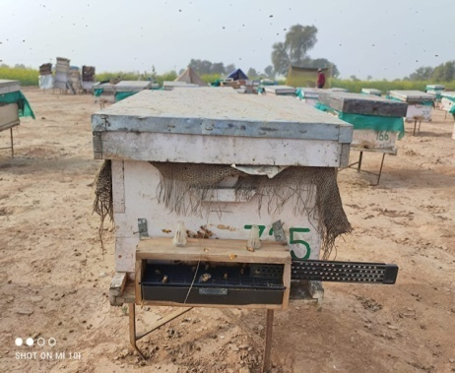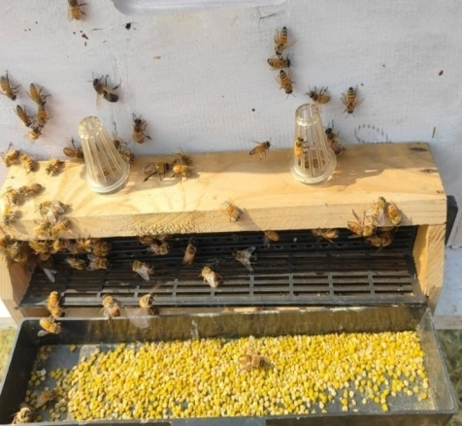

Fig.1. Front –mounted pollen traps installed on beehives

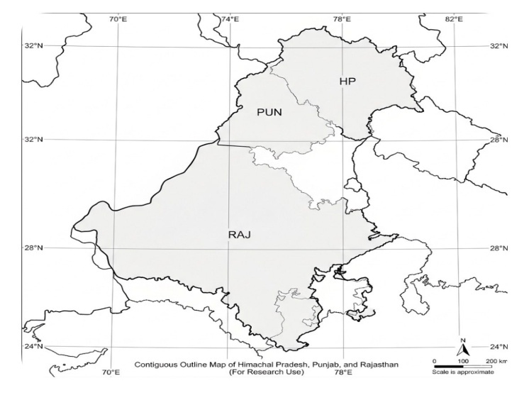

Fig 2. Map representing different pollen collection sites
Front-mounted pollen traps were installed at the hive entrance (Fig. 1.). The trap consisted of a wooden frame fitted with a removable plastic grid having 9 mm diameter holes through which returning foragers were forced to pass, causing the pollen pellets to dislodge and fall into a collection drawer. To allow bees to acclimatize to the trap, plastic strips covering approximately one-fourth of the grid surface were inserted on the first day of installation. After 24 hours, the strips were fully inserted to initiate pollen collection.
To study the effect of trapping frequency on pollen yield, three different pollen collection intervals viz., alternate-day collection, twice-a-week collection, and once-a-week collection were evaluated across all locations Fig 2. The pollen collected from each colony was transferred to clean containers and shade-dried for 48 hours to reduce moisture content. The dried pollen was weighed using a digital precision balance and the pollen yield was expressed as grams per colony per day.
The data were subjected to three-way analysis of variance (ANOVA) to evaluate the effects of year, floral source, and trapping frequency. Weekly observations were considered as replicates (n = 4), and means were compared using critical difference (CD) at the 5% level of significance (p = 0.05).
3. RESULTS AND DISCUSSION
Pollen collection (g/colony/day) in A. mellifera was significantly influenced by floral source, trapping frequency, and year (Table 2). Among floral sources, mustard at Haripura (Rajasthan) recorded the highest pollen collection under alternate-day trapping (31.19 g/colony/day and 32.28 g/colony/day during 2023 and 2024, respectively), followed by mustard and multiflora conditions at Vijaynagar (28.36 g/colony/day and 29.21 g/colony/day). In contrast, the lowest pollen collection was observed in P. pashia (16.69 g/colony/day and 17.19 g/colony/day). The effect of floral source was significant (CD = 0.635), indicating substantial variation in pollen availability across ecosystems. Similar variations in pollen collection due to floral diversity and resource availability have been reported by Kumar and Agrawal (2014) and Dalal et al. (2025).
Higher pollen yield in mustard-based ecosystems may be attributed to mass flowering, high pollen production, and extended blooming periods, which enhance foraging efficiency and reduce search time for foragers. In contrast, sparse flowering and shorter blooming duration in P. pashia limit pollen availability and restrict foraging opportunities. Such differences in floral reward structure have also been documented by Vaudo et al. (2015) and Hoover et al. (2022).
Trapping frequency exerted a significant effect on pollen collection (CD = 0.449), with alternate-day trapping consistently yielding higher values than twice-a-week and once-a-week trapping across all floral sources. For example, in mustard at Haripura, alternate-day trapping (31.19 g/colony/day and 32.28 g/colony/day) was significantly higher than twice-a-week (25.46 g/colony/day and 26.04 g/colony/day) and once-a-week trapping (21.46 g/colony/day and 23.11 g/colony/day) during 2023 and 2024, respectively. This trend is also clearly depicted in Fig. 3 and Fig. 4, where all floral sources follow a similar pattern. These findings are in agreement with earlier studies indicating that increased trapping frequency enhances pollen yield (McLellan 1974; Duff and Furgala 1986; Naveen et al. 2024).
The enhanced pollen collection under frequent trapping can be explained by colony-level regulatory mechanisms. Continuous removal of pollen loads creates a deficit in stored pollen, which stimulates nurse bees to increase brood-feeding demand and associated trophallactic interactions. Elevated brood pheromone levels subsequently promote pollen foraging behavior and increase recruitment of pollen foragers (Webster et al. 1985; Vaudo et al. 2015). Thus, pollen foraging is primarily regulated by internal colony nutritional status rather than external resource availability alone.
Year also showed a significant effect (CD = 0.367), with slightly higher pollen collection in 2024 compared to 2023. However, interactions between year and floral source, year and trapping frequency were non-significant, indicating consistency in treatment effects across years. In contrast, the interaction between floral source and trapping frequency was significant (CD = 1.10), suggesting that the response to trapping frequency depends on floral resource availability. This interaction is also reflected in Fig. 3 and Fig. 4, where the magnitude of decline in pollen collection differs among floral sources, being more pronounced under resource-rich conditions such as mustard compared to P. pashia.
Overall, the results clearly demonstrate that pollen collection in A. mellifera is strongly influenced by floral source and trapping frequency, with mustard-based ecosystems and alternate-day trapping proving most effective for maximizing pollen collection.These findings are consistent with previous reports emphasizing the importance of optimizing trapping frequency to maximize pollen harvest (Rout et al. 2023; Dalal et al. 2025).
However, the present study was limited to pollen collected through traps and did not directly assess total pollen foraging, in-hive pollen reserves, or behavioral dynamics of foragers. Further studies integrating floral resource quantification, colony nutritional status, and behavioral observations are required to better understand the mechanisms governing pollen collection and to optimize trapping strategies under different agro-ecological conditions.
Table 2. Effect of floral sources and trapping frequency on pollen collection by Apis mellifera colonies

Pollen collected (g/colony/day) by Apis mellifera
 |  | 2023 |  |  | 2024
Floral source | Month | Trapping frequency
Floral source | Month | Alternate day | Twice a week | Once a week | Alternate day | Twice a week | Once a week
Mustard Haripura, Rajasthan | January | 31.19* | 25.46 | 21.46 | 32.28 | 26.04 | 23.11
Mustard and multiflora Vijaynagar, Rajasthan | February | 28.36 | 23.17 | 19.83 | 29.21 | 23.65 | 20.32
Pyrus pashia Himachal Pradesh | February | 16.69 | 12.46 | 10.28 | 17.19 | 13.60 | 11.05
Mustard Himachal Pradesh | February- March | 22.06 | 17.41 | 14.17 | 23.65 | 18.11 | 14.86
Multiflora Himachal Pradesh | March –April | 20.22 | 15.16 | 12.49 | 21.10 | 16.39 | 13.61
Multiflora Hoshiarpur, Punjab | March –April | 25.06 | 19.11 | 15.88 | 25.63 | 20.51 | 16.12
* Values represent monthly mean pollen collection (g/colony/day). Each weekly value is the mean of five colonies (n = 5), and monthly means were calculated by averaging four weekly observations.

Table 3: Results of statistical analysis

Factors | C.D.
Year | 0.367
Floral sources | 0.635
Year X floral sources | NS
Trapping frequency | 0.449
Year X trapping frequency | NS
Floral sources X trapping frequency | 1.1
Year X floral sources X trapping frequency | NS
*NS = Non significant

Fig 3. Effect of different pollen trapping frequencies on corbicular pollen collection (g/colony/day) of Apis mellifera across different floral sources during 2023.

Fig 4. Effect of different pollen trapping frequencies on corbicular pollen collection (g/colony/day) of Apis mellifera across different floral sources during 2024.
4. CONCLUSION
The present study demonstrated that pollen collection (g/colony/day), as measured through pollen traps, was significantly influenced by trapping frequency, floral source, and year. Alternate-day trapping consistently resulted in higher pollen collection (31.19 g/colony/day and 32.28 g/colony/day in mustard at Haripura during 2023 and 2024, respectively) compared to twice-a-week and once-a-week trapping across all floral sources. Floral sources also showed significant variation, with higher pollen collection recorded in mustard-based ecosystems and lower values in P. pashia.
The interaction between floral sources and trapping frequency was significant, indicating that the effect of trapping frequency varied depending on the floral environment, while year-related interactions were non-significant, suggesting consistency in trends across years.
However, the study was limited to pollen collected through traps and did not directly assess total pollen foraging, in-hive pollen reserves, or behavioral mechanisms underlying foraging responses.Further research integrating floral resource quantification, colony nutritional status, and foraging behavior is required to better understand the mechanisms influencing pollen collection and to optimize trapping strategies under different agro-ecological conditions.
Disclaimer (Artificial intelligence)

Author(s) hereby declare that NO generative AI technologies such as Large Language Models (ChatGPT, COPILOT, etc.) and text-to-image generators have been used during the writing or editing of this manuscript.

REFERENCES
Amro, A., Mohamed, M.O., & Al Ghamdi, A.(2023). Surveying, identification and characterization for the potential honeybee (Apis mellifera L.) pollen sources in the arid region of Riyadh-Saudi Arabia. Bee Studies, 15(1),1-11.
Anderson, K.E., Carroll, M.J., Sheehan, T.I.M., Mott, B.M., Maes, P. & Corby‐Harris, V. (2014). Hive‐stored pollen of honey bees: many lines of evidence are consistent with pollen preservation, not nutrient conversion. Molecular Ecology, 23(23), 5904-5917.
Avni, D., Hendriksma, H.P., Dag, A., Uni, Z. & Shafir, S. (2014). Nutritional aspects of honey bee-collected pollen and constraints on colony development in the eastern Mediterranean. Journal of Insect Physiology, 69, 65-73.
Bhuarya, N., Painkra, G.P., Painkra, K.L., Bhagat, P.K., Jaiswal, S.K., & Lal, V. (2023). Yield potential of products of Italian honey bee (Apis mellifera L.) in Ambikapur, Surguja district of Chhattisgarh, India. The Pharma Innovation Journal, 12(31), 1516-1519.
Dalal, P.K., Chaudhary, O.P., Yadav, S., & Rathee, M. (2025). Influence of pollen trapping on honey production of Apis melliferaL.(Hymenoptera: Apidae) high strength colony under mustard flowering season. Agricultural Science Digest, 45(3), 178-185.
Duff, S.R., & Furgala, B. (1986). Pollen trapping honey bee colonies in Minnesota. Part I. Effect on amount of pollen trapped, brood reared, winter survival, queen longevity, and adult bee population. American Bee Journal, 126(23), 686–689.
Ghosh, S., Jeon, H., & Jung, C.(2020). Foraging behaviour and preference of pollen sources by honey bee (Apis mellifera) relative to protein contents. Journal of Ecology and Environment, 44(1), 4.
Hoover, S.E., & Ovinge, L.P.(2018). Pollen collection, honey production, and pollination services: managing honey bees in an agricultural setting. Journal of Economic Entomology, 111(4), 1509-1516.
Hoover, S.E., Ovinge, L.P. & Kearns, J.D.(2022). Consumption of supplemental spring protein feeds by western honey bee (Hymenoptera: Apidae) colonies: effects on colony growth and pollination potential. Journal of Economic Entomology, 115(2), 417-429.
Keller, I.K., Fluri, P. & Imdorf, A. (2005). Pollen nutrition and colony development in honey bees-Part II. Bee World, 86(6), 27-34.
Kumar, R., & Agrawal, O.P., 2014. Comparative collection of natural pollen by honey bees in Gwalior & Panchkula (India). Zoology, 3(8).
McLellan, A.R. (1974). Some effects of pollen traps on colonies of honeybees. Journal of Apicultural Research, 13(2), 143-148.
Naveen., Yadav, A.S., & Singh, U.C. (2024). Collection efficiency of fresh pollen under different pollen trapping frequencies by Apis mellifera L. colonies in mustard. Journal of Advances in Biology & Biotechnology, 27(8), 347-358.
Paray, B.A., Kumari, I., Hajam, Y.A., Sharma, B., Kumar, R., Albeshr, M.F., Farah, M.A. & Khan, J.M. (2021). Honeybee nutrition and pollen substitutes: A review. Saudi Journal of Biological Sciences, 28(1), 1167-1176.
Rout, S.K., Sirinivasan, M.R., Saminathan, V.R., Suganthi, A., & Geetha, P. (2023). Harvesting the gold dust: unravelling the pollen production potential of Indian honey bees Apis cerana indica (Fabricius) and optimizing pollen traps in coconut ecosystems. In Biological Forum-An International Journal, 15(8), 520-526.
Stoner, K.A., Nurse, A., Koethe, R.W., Hatala, M.S. & Lehmann, D.M. (2022). Where does honey bee (Apis mellifera L.) pollen come from? A study of pollen collected from colonies at ornamental plant nurseries. Insects, 13(8), 744.
Thakur, R.K., & Manzoor, U. (2019). Diversification of beekeeping for increasing income of farmers. Indian Farmer, 6(11), 607.
Thakur, M. & Nanda, V. (2020). Composition and functionality of bee pollen: A review. Trends in Food Science & Technology, 98, 82-106.
Topal, E., Mărgăoan, R., Bay, V., Takma, Ç., Yücel, B., Oskay, D., Düz, G., Acar, S. & Kösoğlu, M. (2022). The effect of supplementary feeding with different pollens in autumn on colony development under natural environment and in vitro lifespan of honey bees. Insects, 13(7), 588.
Vaudo, A.D., Tooker, J.F., Grozinger, C.M. & Patch, H.M. (2015). Bee nutrition and floral resource restoration. Current opinion in Insect Science, 10, 133-141.
Webster, T.C., Thorp, R.W., Briggs, D., Skinner, J., & Parisian, T. (1985). Effects of pollen traps on honey bee (Hymenoptera: Apidae) foraging and brood rearing during almond and prune pollination. Environmental Entomology, 14(6), 683-686.

