Original Research Article
Effects of Seed Priming with Ginger (Zingiber officinale) and Neem (Azadirachta indica) Extracts on Germination Kinetics, and Moisture Retention of Bambara Groundnut (Vigna subterranea) Under Water Deficit Conditions
Abstract
Seed priming with botanical extracts is a sustainable strategy to enhance crop establishment under water-limited conditions. This study evaluated the effects of ginger (Zingiber officinale) and neem (Azadirachta indica) extracts on the germination kinetics and early vegetative development of two Bambara groundnut (Vigna subterranea L.) genotypes (ZM 1856 and ZM 2656) subjected to moisture stress. A factorial experiment was conducted using varying concentrations of ginger (0–20% w/v) and neem (0–4% w/v). Results revealed highly significant main treatment effects (p < 0.001) for germination index, total dry matter (TDM), and root nodulation. Effect size analysis (η²)) established that botanical treatments exerted the largest functional effects on root nodulation (η²) = 0.55), germination rate (η²= 0.44), and seedling vigour index (SVI; η²= 0.44). Pearson correlation analysis further elucidated these relationships, showing a near-perfect positive correlation between germination rate and SVI (r = 0.97, p < 0.001), and significant positive associations between TDM and both root nodulation (r = 0.52) and leaf efficiency (r = 0.52). However, a notable negative correlation between TDM and germination rate (r = -0.44, p < 0.05) suggests a physiological trade-off between rapid emergence and long-term biomass accumulation under stress. While ginger priming at 10–15% was the most effective for enhancing kinetics, higher neem concentrations (4%) significantly delayed germination. These findings demonstrate that botanical priming, particularly with ginger, triggers a holistic developmental shift that balances rapid establishment with enhanced resource partitioning for drought resilience.
Keywords: Azadirachta indica, botanical bio stimulants, effect size, leaf efficiency, seed vigour index, Zingiber officinale

1. Introduction
Bambara groundnut (Vigna subterranea L. Verdc.) is an indigenous African grain legume, serving as a critical source of nutrition for small-scale farmers in semi-arid regions (Mubaiwa et al., 2018; Majola et al., 2021). Often described as a complete food, bambara groundnuts seed are rich in carbohydrates (63–69%) and protein (18–24%). Despite its potential, with documented yields reaching 3,000 kg/ha, national average yields in countries like Zambia remain significantly lower (Khan et al., 2021) at only 18% of yield potential. This productivity gap is exacerbated by climate change, which has increased the frequency of droughts to once every four to five years (Hamududu and Ngoma, 2019; ZamStats, 2024).
Drought stress is a primary constraint on crop productivity, particularly during germination and seedling establishment, where water deficits can lead to yield losses of up to 40% (Ahluwalia et al., 2021; Seleiman et al. 2021; IAPRI, 2023). Seed priming is a low-cost, pre-sowing intervention that involves partial hydration of seeds to activate pre-germinative metabolism without radicle protrusion. This process can induce phenomena often referred to as stress memory by activating the plant's antioxidant systems and enhancing its ability to cope with future stress events (Wojtyla et al., 2016; Arafa et al. 2021, Johnson and Puthur, 2021).
In recent years, botanical extracts have gained interest as sustainable seed-priming agents. Ginger (Zingiber officinale) rhizome extracts are rich in phenolic compounds and gingerols, which can enhance oxidative stress defence (Ali et al., 2008; Khan et al. 2022,Queslati et al., 2025). Neem (Azadirachta indica) leaf extracts contain bioactive limonoids, such as nimbolide B, which can exhibit hormetic effects—stimulating growth at low concentrations but inhibiting it at higher, potentially allelopathic levels (Noguchi et al., 2014; Naz et al., 2022). This study hypothesized that priming Bambara groundnut seeds with these botanicals would enhance germination, seedling vigour, and physiological resilience to subsequent water stress, with the magnitude of the effect being dependent on both extract concentration and plant genotype.
2. Materials and Methods
2.1 Plant Material and Growth Conditions
Seeds of two Bambara groundnut genotypes: Genotype 1 (ZM 1856) and Genotype 2 (ZM 2656) were obtained from the National Plant Genetic Resources Center, Zambia. The experiment was conducted in a greenhouse at Mulungushi University, Kabwe, Zambia. Plants were grown in 20-litre pots filled with a 1:1:1 mixture of topsoil, sand, and compost. The potting medium was analysed for baseline nutrient content and had a water-holding capacity of 42% (v/v).
2.2 Preparation of Botanical Priming Extracts
Fresh ginger rhizomes and neem leaves were washed, chopped, and blended with distilled water. The resulting slurries were filtered through a muslin cloth to obtain the stock extracts. Priming solutions were prepared by diluting the stock extracts with distilled water to achieve the desired concentrations (w/v): ginger at 0, 5, 10, 15, and 20%; and neem at 0, 1, 2, 3, and 4%. The concentration ranges were chosen based on preliminary range-finding trials and published literature to capture both stimulatory and potential inhibitory effects.
2.3 Seed Priming and Experimental Design
Seeds were surface-sterilized with 1% sodium hypochlorite for 3 minutes and rinsed thoroughly with distilled water. For each treatment, seeds were soaked in 250 ml of the respective priming solution for 24 hours at 25 ± 2°C in the dark. A separate control treatment (G0/N0) consisted of seeds soaked in distilled water only. After priming, seeds were surface-dried under shade for one hour before sowing. Fifteen seeds were sown per pot in an experiment arranged as a randomized complete block design (RCBD) with four replications. The treatment structure was a 2 (genotypes) × 10 (priming treatments: control, five ginger concentrations, four neem concentrations) factorial, resulting in 20 treatment combinations.
2.4 Drought Stress Imposition
All pots were irrigated to 75% of field capacity daily until 15 days after emergence (DAE). Field capacity was determined gravimetrically. At 16 DAE, irrigation was completely withheld to simulate a seedling drought stress event. This stress period was maintained until 30 DAE, at which point plants in the control treatments exhibited permanent wilting (i.e., failure to recover turgor overnight). All physiological measurements and biomass harvests were conducted at this time.
2.5 Data Collection
2.5.1 Germination and Early Seedling Growth
Seed germination was monitored daily for 21 days. A seed was considered germinated when the plumule was visible above the soil surface. The following indices were calculated:
- Germination Rate (GR): Final germination percentage. =Number of seed germinated/Total number of seeds sown (Bewley et al ,2013)
- Mean Germination Time (MGT): MGT = Σ (n × d) / N, where n is the number of seeds germinated on day ‘d’, and N is the total number of germinated seeds. (Ellis and Roberts, 1981)
- Germination Index (GI): GI = Σ (Gt / Dt), where Gt is the number of germinated seeds on day ‘t’ and Dt is the day of culture. This index integrates both speed and completeness of germination. Khandakar and Bradbeer (1983)
- Seed Vigour Index (SVI): SVI = Germination (%) × Seedling Length (cm) (measured at 21 DAS). (Abdul-Baki and Anderson, 1973)
2.5.2 Nodulation and Biomass Allocation
At 30 DAE, plants were carefully harvested. Roots were washed, and all visible nodules were detached and counted. Plants were partitioned into roots and shoots. Samples were oven-dried at 70°C for 72 hours to a constant weight to determine root dry weight (RDW), shoot dry weight (SDW), and total dry matter (TDM = RDW + SDW). The root-to-shoot ratio was calculated as RDW/SDW.
2.5.3 Physiological and Stress Parameters
- Relative Moisture Content (RMC): Leaf discs were collected, and their fresh weight (FW) was recorded. The discs were then floated on distilled water for 24 hours in the dark to obtain the turgid weight (TW), followed by oven-drying to obtain the dry weight (DW). RMC was calculated as: RMC (%) = [(FW - DW) / (TW - DW)] × 100.
- Wilting Score: Visual symptoms of water stress were assessed on a 1–5 scale just before harvest, where 1 = plant fully turgid, and 5 = plant completely wilted and necrotic.
- Leaf Efficiency (LE): Calculated as the ratio of total dry matter (g) to the total number of leaves per plant, providing an estimate of the photosynthetic efficiency of the leaf area.
2.6 Data Analysis
Data were subjected to a two-way analysis of variance (ANOVA) using the Jamovi statistical package (version 2.3). Treatment means were separated using Tukey’s Honestly Significant Difference (HSD) test at p < 0.05. To complement null-hypothesis significance testing, effect sizes were calculated as partial eta squared (η²) to quantify the proportion of variance in a dependent variable attributable to a given factor. Effect sizes were interpreted as small (η² ≥ 0.01), medium (η² ≥ 0.06), or large (η² ≥ 0.14) (Cohen, 1988). Pearson correlation coefficients (r) were calculated to assess the relationships among growth and physiological variables.
3. Results
3.1 Treatment Effects on Germination and Early Establishment
The analysis of variance revealed significant (p < 0.001) main treatment effects on germination rate, seed vigour index, germination index and mean germination time (Table 1). The effect size analysis confirmed that the priming treatments had a large functional effect on germination rate (η² = 0.44) and seed vigour index (η² = 0.44), while genotype exerted a large effect on all traits except the germination index (Table 1). The significant interaction (GxT) indicates that the response to priming was genotype-specific.

Table 1: ANOVA (F-values) and effect sizes (η²) for germination and early growth traits of Bambara groundnut.
Source of Variation | Germination Rate (%) | Seed Vigour Index | Germination Index | Mean Germination Time | Shoot Length (cm)
F-Values
Treatment (T) | 5.02 *** | 5.07 *** | 103.7 *** | 41.22 *** | 1.56 ns
Genotype (G) | 52.05 *** | 58.29 *** | 645.8 *** | 564.8 *** | 33.13 ***
Interaction (G x T) | 1.73 ns | 2.14 * | 66.14 *** | 23.3 *** | 2.44 *
Effect Sizes (η²)
Treatment (T) | 0.44 | 0.44 | 0.42 | 0.31 | 0.20
Genotype (G) | 0.48 | 0.51 | 0.28 | 0.47 | 0.37
Interaction (G x T) | 0.22 | 0.25 | 0.27 | 0.17 | 0.28
*** p < 0.001, ** p < 0.01, * p < 0.05, ns = not significant.
Ginger priming at 10-15% was the most effective treatment for enhancing germination parameters. For genotype ZM 1856, the highest Germination Index (16.8) and fastest Mean Germination Time (5.9 days) were recorded with G15, representing a 50% improvement and 25% reduction over the non-primed control for germination index and mean germination time respectively (GI: 11.2; MGT: 7.9 days). In contrast, ZM 2656 responded best to G10, achieving its maximum GI (13.5) and lowest MGT (7.1 days). Neem treatments generally did not improve germination kinetics and, at higher concentrations (N4), significantly delayed germination in both genotypes (e.g., ZM 1856 MGT of 8.1 days). The Seed Vigour Index (SVI) mirrored these trends, with ZM 1856 showing a high sensitivity to increasing neem concentrations, while ZM 2656 maintained high vigour even at the highest ginger concentration (G20) (Figure 1)

3.2 Effect on Nodulation and Biomass Partitioning
Table 2: ANOVA (F-values) and effect sizes (η²) for biomass and physiological traits of Bambara groundnut under water stress.

Source of Variation | No. Root Nodules | Total Dry Matter | Root: Shoot Ratio | Relative Moisture Content | Wilting Score | Leaf Efficiency
F-Values
Treatment (T) | 7.45 *** | 3.66 *** | 3.97 *** | 66.19 *** | 3.62 *** | 4.01 ***
Genotype (G) | 1.29 ns | 4.16 * | 4.49 * | 291.7 *** | 17.61 *** | 22.15 ***
Interaction (G x T) | 1.6 ns | 0.44 ns | 0.41 ns | 56.9 *** | 1.2 ns | 2.89 **
Effect Sizes (η²)
Treatment (T) | 0.55 | 0.37 | 0.39 | 0.40 | 0.36 | 0.42
Genotype (G) | 0.02 | 0.07 | 0.07 | 0.20 | 0.24 | 0.30
Interaction (G x T) | 0.20 | 0.07 | 0.14 | 0.35 | 0.16 | 0.34
*** p < 0.001, ** p < 0.01, * p < 0.05, ns = not significant.
The number of root nodules per plant was highly responsive to the priming treatments, with a very large effect size (η² = 0.55; Table 2). Ginger treatments significantly enhanced nodulation in both genotypes. For ZM 1856, G10 resulted in 61.1 nodules per plant, nearly double that of the control (32.0). ZM 2656 achieved its maximum nodule count (62.0) at the highest concentration, G20. Neem treatments also increased nodulation compared to the control in some cases (e.g., N1 in ZM 1856), but this effect was less pronounced and consistent than with ginger. (Figure 2)
Biomass accumulation under stress was significantly enhanced by priming. In ZM 1856, the highest total dry matter (TDM) was achieved with G20 (6.47 g plant⁻¹), a 96% increase over the control (3.30 g plant⁻¹). Similarly, in ZM 2656, G20 produced the greatest TDM (5.45 g plant⁻¹), a 63% increase over its control (3.34 g plant⁻¹). The root-to-shoot ratio was also influenced by treatment, with primed plants generally allocating more biomass to roots under stress (e.g., ZM 1856 G20 had an R:S of 0.18 compared to 0.10 in the control), although this trend was not uniform across all treatments. (Figure 4)
3.3 Physiological Responses to Stress
Relative Moisture Content (RMC) and wilting scores, key indicators of plant water status, were significantly improved by priming. The control plants for both genotypes exhibited the lowest RMC (approx. 45%) and the highest wilting scores (4.5). In ZM 1856, the N3 treatment resulted in the highest RMC (82%) and the lowest wilting score (1.0). For ZM 2656, G10, G20, and N4 were the most effective at maintaining RMC (approx. 68%) and reducing wilting (scores of 2.75). (Figure 3)
Leaf efficiency (LE), a measure of biomass produced per leaf, showed a strong genotype-by-treatment interaction (η² = 0.34). ZM 1856 achieved its highest LE at G20 (0.46 g leaf⁻¹), while ZM 2656's LE peaked under N3 (0.68 g leaf⁻¹), significantly outperforming its control (0.41 g leaf⁻¹). This suggests genotype-specific strategies for utilizing the priming agents to enhance photosynthetic efficiency under stress. (Figure 5)
3.4 Interrelationships Among Traits
Pearson correlation analysis revealed strong and meaningful relationships among the measured traits (Figure 6). Germination Rate and Seed Vigour Index were very strongly correlated (r = 0.97, p < 0.001), indicating that treatments promoting germination also produced more vigorous seedlings. Total dry matter (TDM) was significantly and positively correlated with both the number of root nodules (r = 0.52, p < 0.001) and leaf efficiency (r = 0.52, p < 0.001), highlighting the importance of symbiotic nitrogen fixation and photosynthetic efficiency in driving biomass production under stress. (Figure 6)
A significant negative correlation was observed between TDM and both germination rate (r = -0.44, p < 0.001) and SVI (r = -0.37, p < 0.001). This counterintuitive finding suggests a potential trade-off: treatments that maximized rapid and complete germination did not always lead to the highest final biomass under subsequent prolonged stress. This may reflect resource allocation, where early, vigorous growth depletes seed reserves needed for later stress tolerance, or increased competition among seedlings in high-germination treatments. (Figure 6).(Cuares et al. 2024) also established significant negative correlations between germination rate and dry matter content per plant.
4. Discussion
This study demonstrates that seed priming with botanical extracts, particularly ginger, is a highly effective, low-cost intervention for enhancing the drought resilience of bambara groundnut. The use of effect size analysis (η²) was instrumental in moving beyond simple statistical significance to quantify the practical, functional impact of the treatments. The large effect sizes observed for traits such as root nodulation (η² = 0.55), germination rate (η² = 0.44), and seedling vigour (η² = 0.44) indicate that the bioactive compounds in the extracts fundamentally altered key physiological processes during seed imbibition and subsequent seedling development. This aligns with the concept of "stress memory," where a priming event preconditions the plant for a more robust response to future stress (Wojtyla et al., 2016; Liu et al., 2022).
The superior performance of ginger priming, particularly at 10-15%, on germination kinetics and SVI can be attributed to its rich phenolic and gingerol content. These compounds are known to possess strong antioxidant properties, which likely mitigated oxidative damage during the critical phases of imbibition and radicle emergence (Ali et al., 2008; Queslati et al., 2025,). This pre-activation of the cellular defence system would allow for more rapid and uniform mobilization of seed reserves, translating directly into the higher germination rates and vigour indices observed.
The response to neem extracts was more complex and concentration-dependent, consistent with the principle of hormesis (Noguchi et al., 2014,). At lower concentrations (e.g., 1-3%), neem improved nodulation, leaf efficiency, and water status (RMC, wilting) in a genotype-specific manner. This may be due to bioactive limonoids triggering mild stress responses that prime the plant's overall defence and water-conservation pathways (Naz et al., 2022). However, at the highest concentration (4%), the allelopathic potential of these compounds likely began to outweigh any stimulatory benefits, leading to inhibited germination and growth, as seen in ZM 1856. (Galappaththi et a, 2021) also established significant positive responses in seed germination and related traits for rice after seed priming with neem seed extracts.
The strong positive correlation between TDM and both nodulation (r = 0.52) and leaf efficiency (r = 0.52) underscores two critical mechanisms for drought resilience. First, enhanced root nodulation, facilitated by ginger priming, improves biological nitrogen fixation, sustaining nitrogen metabolism even when soil water is limiting (Mohale et al., 2014). Second, higher leaf efficiency indicates that primed plants were able to maintain greater photosynthetic capacity per unit leaf area, a key trait for carbon assimilation under stress (Mateva et al., 2022). The negative correlation between TDM and early germination traits, while seemingly paradoxical, highlights a crucial trade-off. It suggests that the most rapid and complete germination may deplete limited seed resources, leaving less energy for the extensive root growth and osmotic adjustment needed to withstand a prolonged, severe drought event later in the seedling stage. However, this observation is well aligned what (Khairilanwar et al. 2025, 2025; Radwan et al. 2023; Wagan et al. 2025) established in a studies on effects of botanica extracts on germination and germination kinetics. This finding warrants further investigation into the optimal balance between rapid establishment and long-term stress tolerance.
Finally, the significant genotype-by-treatment interactions observed for key traits like SVI, leaf efficiency, and RMC confirm that the benefits of botanical priming are not universal. Genotype ZM 2656 exhibited greater plasticity and responsiveness, particularly to higher concentrations of ginger and to neem, suggesting it possesses a more receptive metabolic network for these phytochemical triggers. This finding is crucial for developing practical recommendations, as it implies that priming protocols may need to be optimized for specific varieties to maximize their effectiveness. Similar studies also observed that response of crops to seed priming is genotype specific (Popović et al. 2020; Wazeer et al. 2025)
5. Conclusions
The large effect sizes observed in this study demonstrate that seed priming with botanical extracts is not merely a statistically significant treatment but a functionally powerful intervention that can fundamentally improve the drought resilience of bambara groundnut. Ginger extract at 10–15% (w/v) emerged as the most consistently effective and broadly applicable treatment, significantly enhancing germination kinetics, seedling vigour, biomass accumulation, and root nodulation. The response to neem extract was more genotype-specific and concentration-dependent, proving highly effective for improving leaf efficiency and water status in the responsive genotype ZM 2656, particularly at 3%. The significant genotype-by-treatment interactions highlight the potential for developing tailored, variety-specific priming protocols.
Based on these findings, we recommend the adoption of seed priming with 10% ginger extract as a low-cost, accessible technology for smallholder farmers to improve Bambara groundnut establishment and yield stability in drought-prone environments. Future research should focus on validating these greenhouse results under field conditions across multiple seasons and locations, and on exploring the synergistic potential of combining ginger and neem extracts in a single priming solution to harness the complementary benefits of both botanicals.
Disclaimer (Artificial intelligence)
Author(s) hereby declare that NO generative AI technologies such as Large Language Models (ChatGPT, COPILOT, etc.) and text-to-image generators have been used during the writing or editing of this manuscript.

References

Abdul-Baki, A. A., & Anderson, J. D. (1973). Vigour determination in soybean seed by multiple criteria. Crop Science, 13(6), 630–633.

Ahluwalia, O., Singh, P. C., & Bhatia, R. (2021). A review on drought stress in plants: Implications, mitigation and the role of plant growth promoting rhizobacteria. Resources, Environment and Sustainability, 5, 100032. https://doi.org/10.1016/j.resenv.2021.100032

Ali, B. H., Blunden, G., Tanira, M. O., & Nemmar, A. (2008). Some phytochemical, pharmacological and toxicological properties of ginger (Zingiber officinale Roscoe): A review of recent research. Food and Chemical Toxicology, 46(2), 409–420. https://doi.org/10.1016/j.fct.2007.09.085

Arafa, S. A., Attia, K. A., Niedbała, G., Piekutowska, M., Alamery, S., Abdelaal, K., Alateeq, T. K., et al. (2021). Seed Priming Boost Adaptation in Pea Plants under Drought Stress. Plants, 10(10), 2201. doi:10.3390/plants10102201.

Bewley, J. D., Bradford, K. J., Hilhorst, H. W. M., & Nonogaki, H. (2013). Seeds: Physiology of Development, Germination and Dormancy. 3rd ed. Springer.

Cohen, J. (1988). Statistical power analysis for the behavioural sciences (2nd ed.). Lawrence Erlbaum Associates.

Cuares, I., Cordova, S., Virgilio Jr., R., Feril, J., & Bagaipo, B. (2024). Comparative Efficacy of Botanical Priming Agents on Germination Kinetics and Post-Transplant Performance of Brassica Rapa: A Correlation Analysis. International Journal of Plant & Soil Science, 36(12), 225–37. doi:10.9734/ijpss/2024/v36i125196.

Ellis, R. H., & Roberts, E. H. (1981). The quantification of ageing and survival in orthodox seeds. Seed Science and Technology, 9(2), 373–409.

Galappaththi, M. O., Jayasuriya, K. M. G. G., & Gama-Arachchige, N. S. (2021). Effect of Priming with Neem Seed Extract on Seeds of Four Traditional Rice Varieties of Sri Lanka; Kaluheenati, Kurulurthuda, Madathawalu and Maa-Wee. Journal of the National Science Foundation of Sri Lanka, 49(4), 525. doi:10.4038/jnsfsr.v49i4.10336.

Hamududu, B. H., & Ngoma, H. (2019). Impacts of climate change on water resources availability in Zambia: Implications for irrigation development. Water, 11(6), 1146. https://doi.org/10.3390/w11061146

Indaba Agricultural Policy Research Institute (IAPRI). (2023). Zambia agriculture status report 2023. IAPRI. https://www.iapri.org.zm

Johnson, R., & Puthur, J. T. (2021). Seed priming as a cost-effective technique for developing plants with cross tolerance to salinity stress. Plant Physiology and Biochemistry, 162, 247–257. https://doi.org/10.1016/j.plaphy.2021.02.034

Khairilanwar, K. A., Yi, S. J., Bakri, M. D. I., Nawi, I. H. M., Azmi, A. A. A. R. R., & Aik, C. K. (2025). Eco-Friendly Nanopriming: Zinc Oxide Nanoparticles derived from Banana Peel Extract for Improved Germination of Chili Seeds. Journal of Seed Science, 47, e202547006. doi:10.1590/2317-1545v47290750.

Khan, M. M. H., Rafii, M. Y., Ramlee, S. I., Jusoh, M., & Al-Mamun, M. (2021). Bambara groundnut (Vigna subterranea L. Verdc): A crop for the new millennium, its genetic diversity, and improvements to mitigate future food and nutritional challenges. Sustainability, 13(10), 5530. https://doi.org/10.3390/su13105530

Khan, S., Ibrar, D., Bashir, S., Rashid, N., Hasnain, Z., Nawaz, M., Al-Ghamdi, A. A., et al. (2022). Application of Moringa Leaf Extract as a Seed Priming Agent Enhances Growth and Physiological Attributes of Rice Seedlings Cultivated under Water Deficit Regime. Plants, 11(3), 261. doi:10.3390/plants11030261.

Khandakar, A. L., & Bradbeer, J. W. (1983). Jute Seed Quality. Bangladesh Agricultural Research Council.

Kunene, S., Gerrano, A. S., & Odindo, A. O. (2025). Drought tolerance assessment of Bambara groundnut (Vigna subterranea L. Verdc) accessions based on morphological and physiological traits. South African Journal of Botany, 184, 880–894.

Liu, X., Quan, W., & Bartels, D. (2022). Stress memory responses and seed priming correlate with drought tolerance in plants: An overview. Planta, 255, 45. https://doi.org/10.1007/s00425-022-03828-z

Majola, N. G., Gerrano, A. S., & Shimelis, H. (2021). Bambara groundnut (Vigna subterranea [L.] Verdc.) production, utilisation and genetic improvement in sub-Saharan Africa. Agronomy, 11(7), 1345. https://doi.org/10.3390/agronomy11071345

Mateva, K. I., Chai, H. H., Mayes, S., & Massawe, F. (2022). Root distribution patterns of Bambara groundnut (Vigna subterranea L. Verdc.) landraces under different water regimes. Frontiers in Plant Science, 13, 760879. https://doi.org/10.3389/fpls.2022.760879

Mohale, K. C., Belane, A. K., & Dakora, F. D. (2014). Symbiotic N nutrition, C assimilation, and plant water relations in Bambara groundnut (Vigna subterranea L. Verdc.) landraces grown in farmers' fields in South Africa. Field Crops Research, 167, 86–94. https://doi.org/10.1016/j.fcr.2014.07.012

Mubaiwa, J., Fogliano, V., Chidewe, C., Bakker, E. J., & Linnemann, A. R. (2018). Utilization of bambara groundnut (Vigna subterranea (L.) Verdc.) for sustainable food and nutrition security in semi-arid regions of Southern Africa. PLOS ONE, 13(10), e0204817. https://doi.org/10.1371/journal.pone.0204817

Naz, H., Akram, N. A., Ashraf, M., Hefft, D. I., & Jan, B. L. (2022). Neem (Azadirachta indica) leaf extract mitigates drought stress in quinoa (Chenopodium quinoa Willd.) through modulating physio-biochemical and antioxidant mechanisms. Saudi Journal of Biological Sciences, 29(3), 1367–1374. https://doi.org/10.1016/j.sjbs.2022.01.035

Noguchi, H. K., Salam, M. A., Oono, O., & Suenaga, K. (2014). Nimbolide B and nimbic acid B, phytotoxic substances in neem leaves with allelopathic activity. Molecules, 19(6), 6929–6939. https://doi.org/10.3390/molecules19066929

Popović, V., Ljubičić, N., Kostić, M., Radulović, M., Blagojević, D., Ugrenović, V., Popović, D., & Ivošević, B. (2020). Genotype × Environment Interaction for Wheat Yield Traits Suitable for Selection in Different Seed Priming Conditions. Plants, 9(12), 1804. doi:10.3390/plants9121804.

Queslati, S., Kthiri, Z., Ben Nasr, S., & Hamdi, H. (2025). Enhancement of seed germination and seedling growth of wheat (Triticum aestivum L.) by ginger (Zingiber officinale) extract priming. Notulae Botanicae Horti Agrobotanici Cluj-Napoca, 53(4), 14869. https://doi.org/10.15835/nbha53414869

Radwan, A. M., Ahmed, E. A., Donia, A. M., Mustafa, A. E., & Balah, M. A. (2023). Priming of Citrullus Lanatus Var. Colocynthoides Seeds in Seaweed Extract Improved Seed Germination, Plant Growth and Performance under Salinity Conditions. Scientific Reports, 13(1), 11884. doi:10.1038/s41598-023-38711-8.

Wagan, M. A., Abro, M., Wagan, G. H., Baloch, M. N., Wahocho, S. A., Chachar, M., et al. (2025). Priming with Moringa Leaf Extract Enhances the Germination and Early Growth of Peas (Pisum Sativum). Journal of Horticulture and Agricultural Sciences, 2(1), 75–82. doi:10.63459/jhas.2025.1.14.

Wazeer, H., Zeidan, A., Allevi, J., Pagano, A., Dueñas, C., Marocco, A., et al. (2025). Seed Priming with Plant Waste Extracts Enhances Maize Drought Tolerance in a Genotype-Specific Manner. Frontiers in Plant Science, 16, 1717255. doi:10.3389/fpls.2025.1717255.

Wojtyla, L., Lechowska, K., Kubala, S., & Garnczarska, M. (2016). Molecular processes induced in primed seeds—increasing the potential to stabilize crop yields under drought conditions. Journal of Plant Physiology, 203, 116–126. https://doi.org/10.1016/j.jplph.2016.04.008

Zambia Statistics Agency (ZamStats). (2024). 2024 Integrated agricultural survey report. Government of the Republic of Zambia.

Figure 1
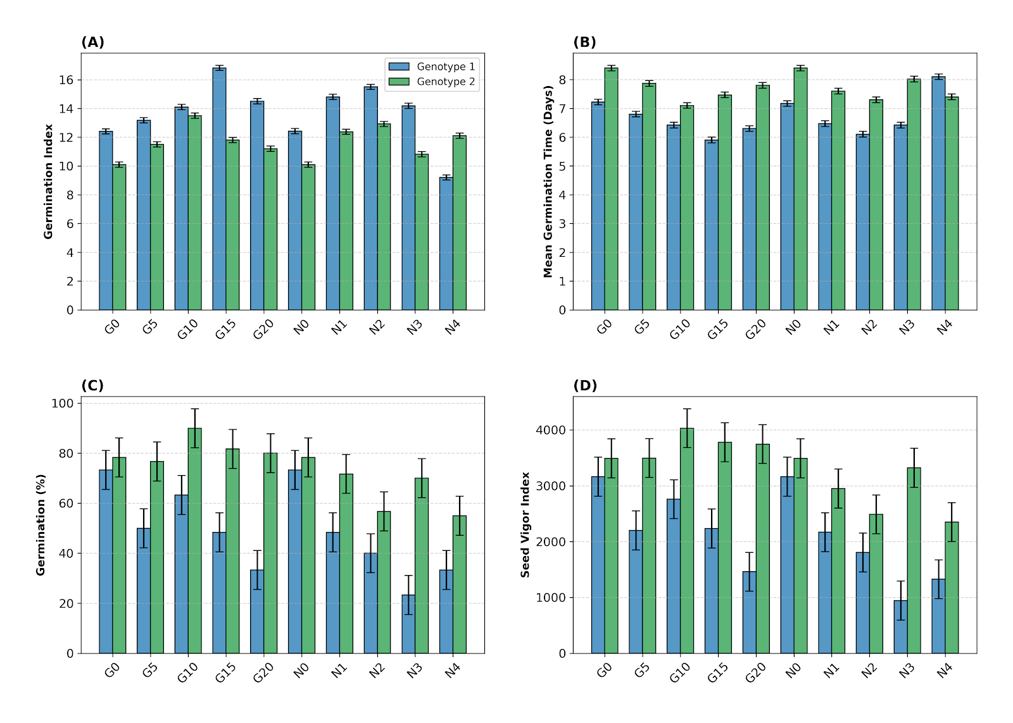
Figure 1: Effect of seed priming with ginger (G) and neem (N) extracts on the germination kinetics of two Bambara groundnut genotypes (ZM 1856 and ZM 2656). (A) Germination Index (GI), which integrates both the speed and completeness of germination. (B) Mean Germination Time (MGT), where lower values indicate faster germination. (C) Final Germination Percentage. (D) Seed Vigour Index (SVI), calculated as germination percentage × seedling length. Control seeds (G0/N0) were primed with distilled water. Data points represent the mean of four replicates, and error bars indicate the standard error of the mean (SEM).

.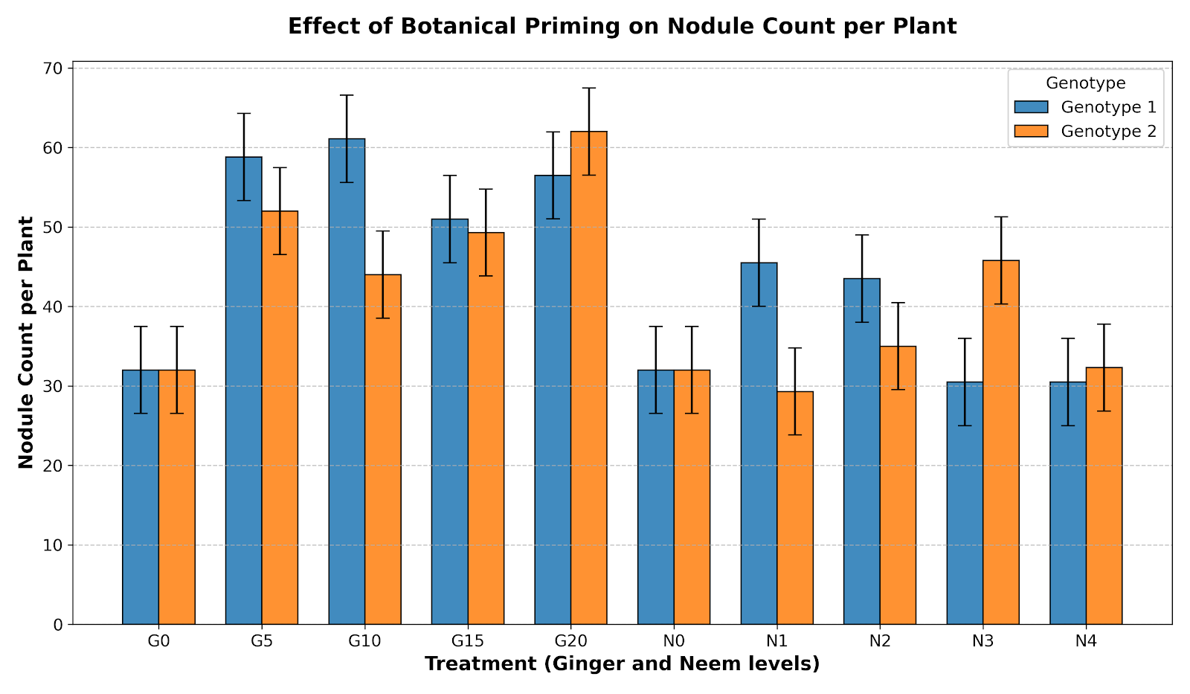
Figure 2: Effect of seed priming with ginger (G) and neem (N) extracts on root nodulation in two Bambara groundnut genotypes (ZM 1856 and ZM 2656) under subsequent water stress. The number of root nodules per plant was counted at 30 days after emergence. Control seeds (G0/N0) were primed with distilled water. Bars represent the mean of four replicates, and error bars indicate the standard error of the mean (SEM). Treatment had a very large and significant effect on nodulation (η² = 0.55, p < 0.001). Ginger treatments, particularly G10 for ZM 1856 and G20 for ZM 2656, resulted in the highest nodule counts, nearly doubling those of the non-primed controls

Figure 3: Effect of seed priming with ginger (G) and neem (N) extracts on the water status of two Bambara groundnut genotypes (ZM 1856 and ZM 2656) subjected to water stress. Measurements were taken at 30 days after emergence, following 14 days of irrigation withdrawal. (A) Relative Moisture Content (RMC) expressed as percentage point increase over the non-primed control (orange bars). The absolute RMC of control plants was approximately 45% for both genotypes (baseline set to 0 in the figure). Bars represent the mean improvement in RMC (n = 4, ±SEM). The highest RMC improvement for ZM 1856 was observed under G15 (∼8 percentage points), while for ZM 2656, the greatest improvement was under G10 (∼7 percentage points). (B) Visual wilting scores (blue bars), where a lower score indicates less severe stress symptoms (1 = turgid, 5 = completely wilted). Control plants for both genotypes recorded the highest wilting scores (4.5).

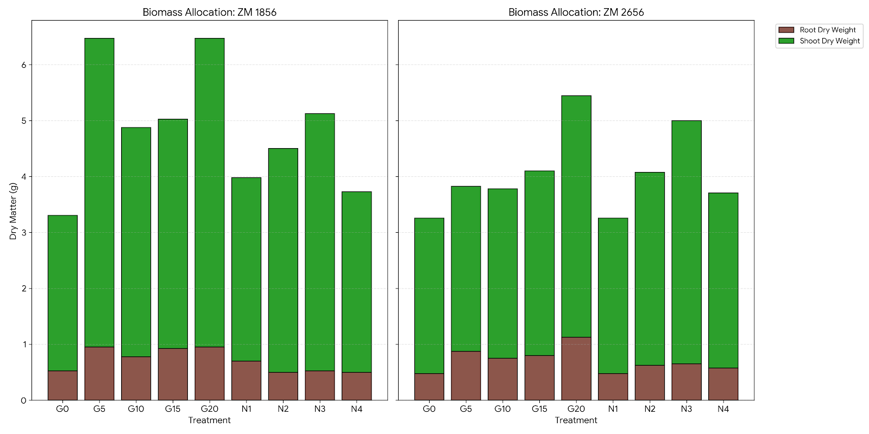
Figure 4: Effect of seed priming with ginger (G) and neem (N) extracts on biomass accumulation and partitioning in two Bambara groundnut genotypes (ZM 1856 and ZM 2656) under water stress. Plants were harvested at 30 days after emergence. Stacked bars represent the mean total dry matter (TDM) per plant, partitioned into root dry weight (RDW; brown/dark segments) and shoot dry weight (SDW; green/light segments). Control seeds (G0/N0) were primed with distilled water. Error bars (if included) would represent the SEM for TDM. Ginger at 20% resulted in the highest TDM for both genotypes, representing a 96% and 63% increase over their respective controls for ZM 1856 and ZM 2656.

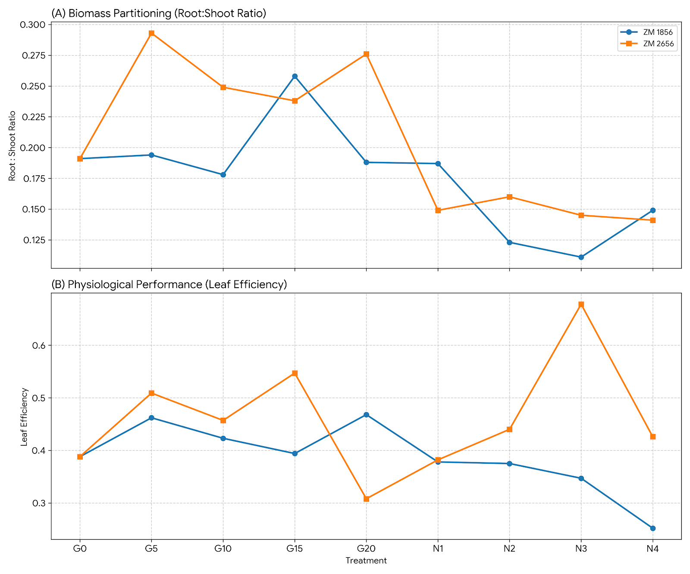
Figure 5: Effect of seed priming with ginger (G) and neem (N) extracts on physiological efficiency traits in two Bambara groundnut genotypes (ZM 1856 and ZM 2656) under water stress. (A) Root-to-shoot ratio, indicating biomass partitioning between below-ground and above-ground organs. (B) Leaf efficiency, calculated as total dry matter per leaf, serving as a proxy for photosynthetic efficiency. Control seeds (G0/N0) were primed with distilled water. Data points represent the mean of four replicates, and error bars indicate the standard error of the mean (SEM). A significant genotype × treatment interaction was observed for leaf efficiency (p < 0.01), with ZM 1856 performing best at G20 and ZM 2656 peaking at N3.

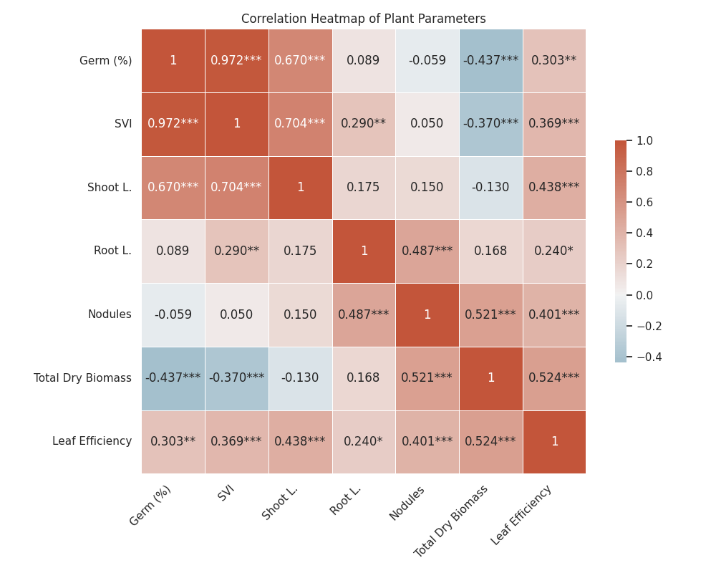
Figure 6: Pearson correlation matrix heatmap illustrating the interdependencies among germination, growth, and physiological traits of Bambara groundnut genotypes under botanical seed priming and subsequent water stress. The colour scale indicates the strength and direction of the correlation coefficient (r), ranging from +1.0 (dark red; strong positive correlation) to -1.0 (dark blue; strong negative correlation). Significance levels are indicated as *** p < 0.001, ** p < 0.01, * p < 0.05. The matrix highlights the very strong positive correlation between Germination % and Seed Vigour Index (r = 0.97), and the significant positive correlations of total dry matter with both root nodules (r = 0.52) and leaf efficiency (r = 0.52). A notable negative correlation is observed between total dry matter and germination % (r = -0.44).

