ALOEVERA ASSISTED GREEN SYNTHESIS OF MANGANESE DIOXIDE NANOPARTICLES AND IT'S ANTIFUNGAL PROPERTIES

ABSTRACT
Manganese Dioxide (MnO₂) nanoparticles have garnered significant attention for their broad-spectrum antimicrobial properties, including antifungal activity. Aloe vera (Aloe barbadensis miller), a widely recognized medicinal plant, is rich in bioactive compounds such as flavonoids, phenolic acids, and polysaccharides, which possess reducing and stabilizing properties conducive to nanoparticle synthesis. The synthesized sample was characterized hy UV-VIS spectroscopy, FTIR, SEM etc. Biological testing demonstrated strong antifungal activity of these green-synthesized nanoparticles against harmful fungal strains such as Candida albicans and Aspergillus niger. The sugars, polyphenols and proteins present in aloevera suggests its stabilizing capability. The UV-Visible spectra at 320nm confirms the formation of MnO2 particles. FTIR Spectra peaks at 3213cm-1O-H stretching), 1622cm-1(C=C stretching), 1033cm-1 (C-O stretching) confirms the presence of phenols, flavonoids, polysaccharides respectively. The largest antifungal activity was observed in MnO₂ NP suspension at 1000 ppm, which exhibited the maximum diameter of inhibition zone 57.667±1.528 mm as compared to the Thiram. The synthesized sample helps for future biomedical applications.
KEY WORDS: Manganese Dioxide, Antifungal Activity, Potassium Permanganate, X-Ray Diffraction, Scanning Electron Microscopy
INTRODUCTION
The escalating prevalence of fungal infections and the limitations of conventional antifungal agents have necessitated the exploration of alternative therapeutic strategies [1]. Nanotechnology, particularly the synthesis of metal oxide nanoparticles, has emerged as a promising avenue due to their unique physicochemical properties and enhanced biological activities [2]. Among various metal oxides, manganese dioxide (MnO₂) nanoparticles have garnered significant attention for their broad-spectrum antimicrobial properties, including antifungal activity [3]. Traditional methods of synthesizing MnO₂ nanoparticles often involve hazardous chemicals and energy-intensive processes [4]. In contrast, green synthesis approaches utilizing plant extracts offer a sustainable and eco-friendly alternative. Aloe vera (Aloe barbadensis miller), a widely recognized medicinal plant, is rich in bioactive compounds such as flavonoids, phenolic acids, and polysaccharides, which possess reducing and stabilizing properties conducive to nanoparticle synthesis [5]. The green synthesis of MnO₂ nanoparticles using Aloe vera extract involves the reduction of manganese salts, such as potassium permanganate (KMnO₄), in the presence of the plant extract [6-8].
The antifungal efficacy of Aloe vera-assisted MnO₂ nanoparticles has been demonstrated against various fungal pathogens. For instance, studies have shown that these nanoparticles exhibit significant antifungal activity against Candida albicans, with inhibition zones ranging from 10 mm to 22 mm, depending on the concentration [9]. The mechanism of antifungal action is attributed to the generation of reactive oxygen species (ROS) by MnO₂ nanoparticles, which disrupt fungal cell membranes and lead to cell death [10]. Aloe vera-assisted green synthesis of MnO₂ nanoparticles presents a promising approach for developing novel antifungal agents. This method not only aligns with sustainable practices but also capitalizes on the inherent properties of Aloe vera to produce nanoparticles with potent antifungal activities [11]. One of the most compelling reasons for selecting MnO₂ lies in its redox versatility. Manganese, by virtue of its multiple oxidation states (ranging from Mn²⁺ to Mn⁴⁺), imparts dynamic redox properties to MnO₂ nanoparticles [12]. This intrinsic feature enhances their utility in oxidation–reduction reactions, making them valuable catalysts in applications such as water purification, pollutant degradation, and advanced energy storage systems [13]. Unlike metal oxides with fixed valency such as TiO₂ (Ti⁴⁺) and ZnO (Zn²⁺)—MnO₂ demonstrates greater flexibility in redox cycling [14], allowing it to act efficiently in various catalytic and adsorptive processes [15].
In terms of environmental compatibility, MnO₂ stands out due to its low toxicity and high biocompatibility. Manganese is a trace element naturally found in living organisms and ecosystems, which significantly reduces concerns regarding environmental persistence and toxicity when compared to nanoparticles of heavy metals like cadmium (Cd), nickel (Ni), or silver (Ag) [16][17]. This property is especially beneficial when MnO₂ is synthesized through green routes, such as using Aloe vera extract, where the combination results in highly stable and non-toxic nanomaterials suitable for applications in agriculture, biomedicine, and water treatment [15]. Economic feasibility is another key factor supporting the use of MnO₂. Manganese is widely abundant in the Earth’s crust and is more readily available and less expensive than precious metals like gold (Au), silver (Ag), or platinum (Pt). This cost-effectiveness makes MnO₂ a practical choice for industrial-scale synthesis and deployment in large-scale environmental remediation technologies, where affordability and resource accessibility are paramount. From a structural perspective, MnO₂ exhibits polymorphism—existing in multiple crystalline forms, including α, β, γ, δ, and λ phases. Each polymorph offers unique properties such as surface area, pore structure, and electronic configuration, which can be tailored to suit specific applications. For instance, α-MnO₂ with its tunnel structure is particularly efficient in adsorbing heavy metals, while δ-MnO₂ with its layered configuration is suitable for intercalation-based energy storage devices. This structural diversity provides a level of design flexibility that is not as pronounced in other commonly used metal oxides. Manganese dioxide (MnO₂) nanoparticles are selected for their notable antimicrobial properties and the feasibility of their green synthesis using Aloe vera extract. MnO₂ nanoparticles have demonstrated significant antibacterial and antifungal activities. For instance, in a study by (Joshi et al.), MnO₂ nanoparticles synthesized using Aloe vera extract exhibited antibacterial effects against Escherichia coli, Streptococcus mutans, and Staphylococcus aureus, with inhibition zones measuring 22 mm, 18 mm, and 16 mm, respectively [17]. Similarly, MnO₂ nanoparticles synthesized from Blumea lacera leaf extract demonstrated antifungal activity against Candida albicans, Aspergillus niger, and Sclerotium rolfsii.[18]. These properties are attributed to the nanoparticle’s ability to generate reactive oxygen species, leading to oxidative stress and subsequent damage to microbial cells [19]. Therefore, the selection of MnO₂ nanoparticles synthesized with Aloe vera extract is driven by their promising antimicrobial properties and the sustainable, efficient, and eco-friendly synthesis method, positioning them as viable candidates for developing new antimicrobial agents. MnO₂ nanoparticles are versatile materials with a broad spectrum of applications across biomedical, environmental, energy, and industrial fields, owing to their unique physicochemical properties [15]. The green synthesis approach utilizing Aloe vera extract offers several advantages over traditional chemical methods. Aloe vera contains a variety of bioactive compounds, including flavonoids, phenolics, and polysaccharides, which act as reducing and stabilizing agents during nanoparticle synthesis [20]. This method is environmentally friendly, cost-effective, and scalable, making it suitable for large-scale applications. Additionally, the biogenic synthesis of MnO₂ nanoparticles ensures that the resulting materials are free from toxic chemicals, aligning with the principles of green chemistry [21]. The Exceptional Phytochemical Diversity with Reductive and Stabilizing abilities [22,23], preventing aggregation and enhancing surface homogeneity[24], converting manganese ions (Mn2⁺) into manganese dioxide (MnO₂), Non-Toxicity and Superior Biocompatibility [25], Economic accessibility and global availability make Aloe vera a suitable candidate for the study.
MATERIALS AND METHOD
Collection and Preparation of Aloe vera Extract
The aerial parts (leaves) of Aloe vera were collected and thoroughly washed under running tap water to remove dust and surface impurities. Final cleaning was carried out using distilled water. The outer rind was peeled, and the mucilaginous gel was separated using a sterilized stainless-steel blade. This gel was then weighed and subjected to mechanical maceration using a sterile mortar and pestle to yield a consistent, semi-viscous paste. Approximately 216 mL of this freshly crushed Aloe vera gel was mixed with 500 mL of double-distilled water in a 1000 mL glass beaker and heated gently on a magnetic stirrer-hotplate at 65°C for 30 minutes. The heating step was necessary to aid in the release of phytochemicals such as flavonoids, phenolics, and polysaccharides from the gel matrix—compounds known for their redox activity and metal ion binding properties. The mixture was then filtered using standard filter paper (Whatman No. 1) to remove particulate matter and fibres. The clear yellowish filtrate was collected and stored in clean, sterilized amber glass bottles at 4°C until it was used for nanoparticle synthesis [26,27]. Prior to synthesis, the pH of the Aloe vera extract was measured and adjusted to approximately 6.0 using diluted sodium hydroxide or hydrochloric acid, depending on the starting pH.

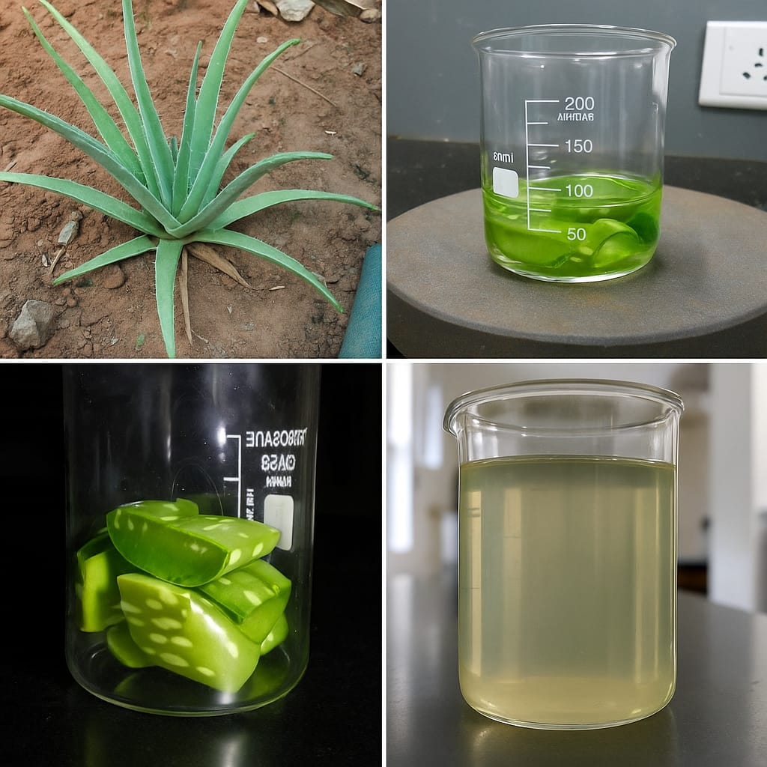
FIG-1:ALOEVERA EXTRACT PREPARATION
The synthesis was carried out using two distinct volumetric ratios of KMnO₄ and Aloe vera extract to assess the influence of precursor concentration on nanoparticle formation. In the
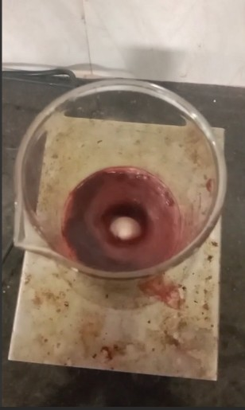
FIG-2: STIRRING OF KMnO₄ WITH ALOEVERA EXTRACT
first configuration, 408 mL of a freshly prepared 0.1 M aqueous KMnO₄ solution was slowly added to 216 mL of Aloe vera extract contained in a 1000 mL borosilicate beaker. The KMnO₄ solution, deep purple in colour due to the presence of Mn⁷⁺ ions, was introduced dropwise into the Aloe vera solution over a 15–20-minute period while stirring at room temperature. This gradual mixing allowed a controlled reduction process, driven by the Aloe vera phytochemicals, converting Mn⁷⁺ into Mn⁴⁺ and ultimately forming MnO₂ nanoparticles. The color of the reaction mixture shifted noticeably—from violet to brown to dark blackish-brown—indicating successful reduction and nanoparticle formation .
The entire mixture was stirred continuously for three hours at ambient temperature to allow sufficient time for the nucleation and growth of nanoparticles. After this stirring phase, the solution was subjected to ultrasonic treatment using a sonicator bath (40 kHz frequency, 200 W power) for 60 minutes. This sonication step helped to break down any agglomerated particles and ensured a more uniform dispersion of the nanoparticles throughout the suspension. Following sonication, the suspension was transferred into sterile 50 mL centrifuge tubes and centrifuged at 10,000 revolutions per minute (rpm) for 25 minutes using a refrigerated centrifuge maintained at 10°C. This process enabled efficient separation of the solid MnO₂ nanoparticles from the remaining liquid. The supernatant, which contained unreacted biomolecules and byproducts, was discarded, and the dark-colored precipitate collected at the bottom of the tubes was retained.
To purify the nanoparticles further, they were washed three times with absolute ethanol and twice with double-distilled water. Each washing cycle included vortexing followed by high-speed centrifugation to eliminate any loosely bound organic molecules or metal ions from the nanoparticle surfaces. The purified nanoparticles were then transferred into a clean Petri dish and dried in a hot-air oven at 90°C for approximately eight hours. Importantly, the dried product was not subjected to high-temperature calcination, which is typically used in many chemical synthesis methods. By omitting this step, we intentionally preserved the bio-organic coatings derived from Aloe vera, which are expected to enhance the nanoparticles’ stability, dispersibility, and biocompatibility.
The resulting MnO₂ nano-powder had a fine texture and a deep brown colour. The total mass of the dried nanoparticles was carefully measured using an analytical balance, and a yield of approximately 3.2 grams was recorded for this synthesis batch. This indicates a relatively high conversion efficiency from the starting materials to the final product, even without the use of synthetic chemical additives or high-temperature processes.
For comparison, a reverse experimental configuration was also tested. In this variation, 408 mL of Aloe vera extract was treated with 216 mL of 0.1 M KMnO₄, following the same procedure: slow mixing, 3-hour stirring, 60-minute sonication, centrifugation, ethanol and water washing, and oven drying at 90°C. The goal of this comparative synthesis was to evaluate how the increased presence of Aloe vera biomolecules would influence the size, shape, and stability of the resulting MnO₂ nanoparticles. Although both approaches yielded high-purity nanoparticles, some variation was observed in physical characteristics such as particle morphology and surface charge, which are likely linked to the differing concentrations of bio-reductants and capping agents in the two systems.
All final nanoparticle products were stored in airtight, labelled glass vials and kept in a desiccator at room temperature until further characterization. These samples were subsequently analysed using techniques including Fourier Transform Infrared Spectroscopy (FTIR), X-ray Diffraction (XRD), and Field Emission Scanning Electron Microscopy (FESEM) to determine their chemical structure, crystalline nature, and surface morphology. In addition to material analysis, the nanoparticles were tested for antimicrobial activity against selected bacterial strains to evaluate their potential applications in biomedical and environmental fields.
RESULT AND DISCUSSION
VISUAL ANALYSIS
In this study, when the manganese precursor was initially dissolved, the solution had a light-yellow hue. After adding the Aloe vera plant extract and applying heat, the colour shifted to a deep brown or almost black tone. This shift suggests that manganese ions were reduced likely from Mn⁷⁺ or Mn⁴⁺ states to MnO₂—by the reducing agents naturally found in Aloe vera. Such colour changes are not unusual in green synthesis and are often considered the first confirmation of nanoparticle formation. The darkening of the mixture may result from electronic transitions or surface plasmon resonance occurring in the MnO₂ particles. While this method is qualitative, it aligns well with the results of other analytical tools like UV–Visible and FTIR spectroscopy. Capturing photographs of the solution during different synthesis steps further confirmed the consistency of this visual evidence. Thus, this basic yet effective technique acts as an early indicator of successful nanoparticle generation.
CHARACTERIZATION
FOURIER TRANSFORM INFARED SPECTROSCOPY [FT-IR]: -
FTIR spectroscopy (JASCO-410) provides insights into the functional groups present on the surface of the nanoparticles. The bioactive compounds in Aloe vera, such as flavonoids, saponins, and polysaccharides, act as reducing agent. The bands at different wave number explains the presence of functional groups present in the sample. The band at 3213cm-1, 1622cm-1, 1416cm-1, 1313cm-1, 1033cm-1 represents the O-H stretching, C=C stretching, asymmetric carboxyl group, C-N stretching and O-H bending, and C-O stretching respectively. This confirms the presence of alcohols, phenols, flavonoids, aldehydes, polysaccharides in aloevera which acts as reducing and stabilizing agents.
List 1 : FTIR spectroscopy
Wavenumber (cm⁻¹) | % Transmittance | Assigned Functional Group | Nature/Origin
3213.98 | 94.68% | O–H stretching (broad) | Alcohols, phenols, flavonoids (from Aloe vera)
1622.42 | 94.40% | C=C stretching | Flavonoids, aldehydes, ketones or amides
1416.43 | 95.72% | COO⁻ asymmetric | Carboxylic acids or esters
1313.52 | 95.66% | C–N stretching / O–H bending | Amines or phenolic groups
1033.21 | 95.43% | C–O stretching | Polysaccharides or glycosides (sugar-like structures)

FIG-3 FT-IR SPECTRUM OF MnO₂
SCANNING ELECTRON MICROSCOPE [SEM]: -
The SEM image (ZEISS (JEEOL-JSM-6510) captured at a 5-micrometre scale clearly shows that the particles are irregularly shaped and gathered together in compact clusters. These clumps are likely due to natural compounds from Aloe vera, such as sugars, polyphenols, and proteins, which act as stabilizers and capping agents during synthesis.

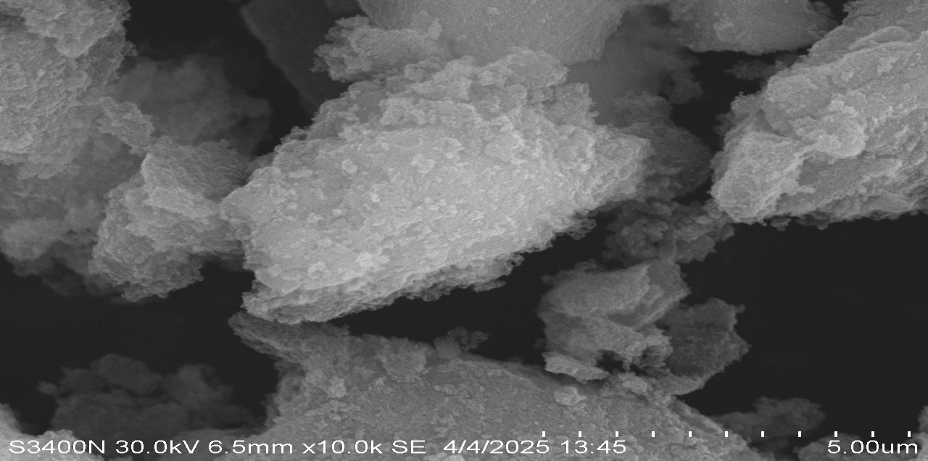
FIG-4: SEM image of MnO₂ at 5µm

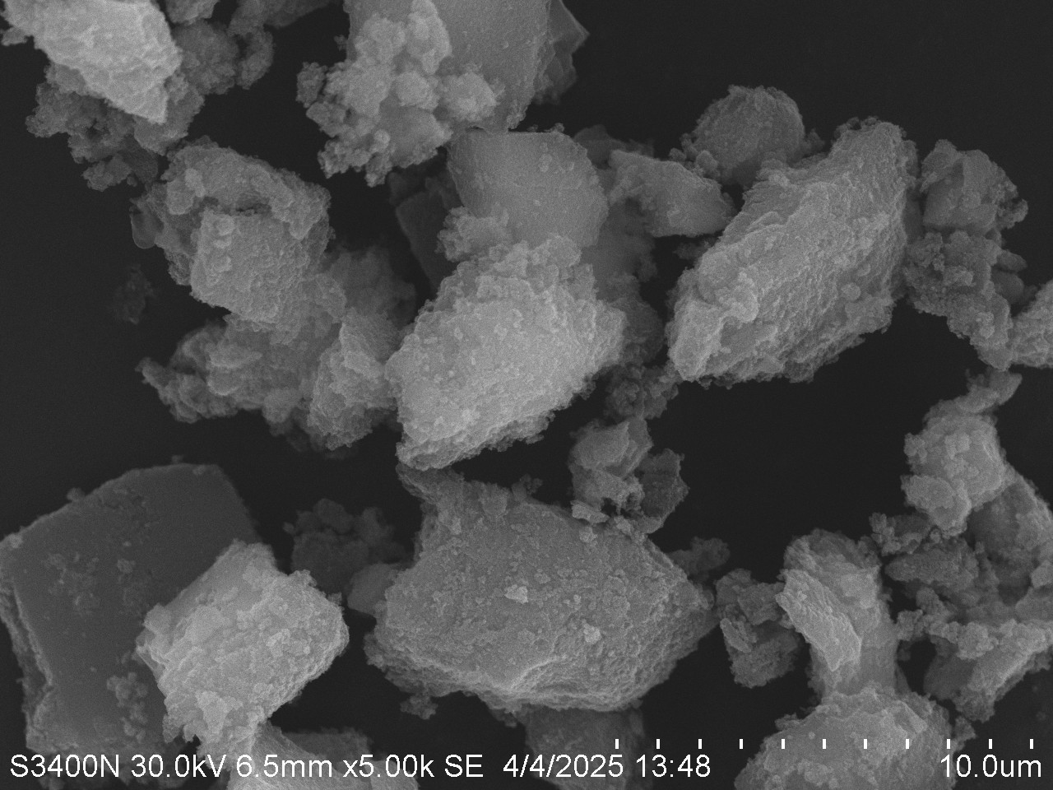
FIG-5: SEM image of MnO₂ at 10µm
UV-VISIBLE SPECTROSCOPY
The UV–Visible (Shimadzu-500) spectrum of the Aloe vera-assisted synthesized manganese dioxide nanoparticles exhibited a prominent absorption peak at approximately 210 nm, which can be attributed to π → π* transitions associated with the phytochemical constituents of Aloe vera acting as capping agents. A broad absorption feature was also observed in the range of 320 to 370 nm, characteristic of MnO₂ nanoparticles, indicating successful formation and the presence of ligand-to-metal charge transfer transitions[28]. These spectral features confirm the involvement of Aloe vera biomolecules in stabilizing the MnO₂ nanostructures and validate their nanoscale properties.
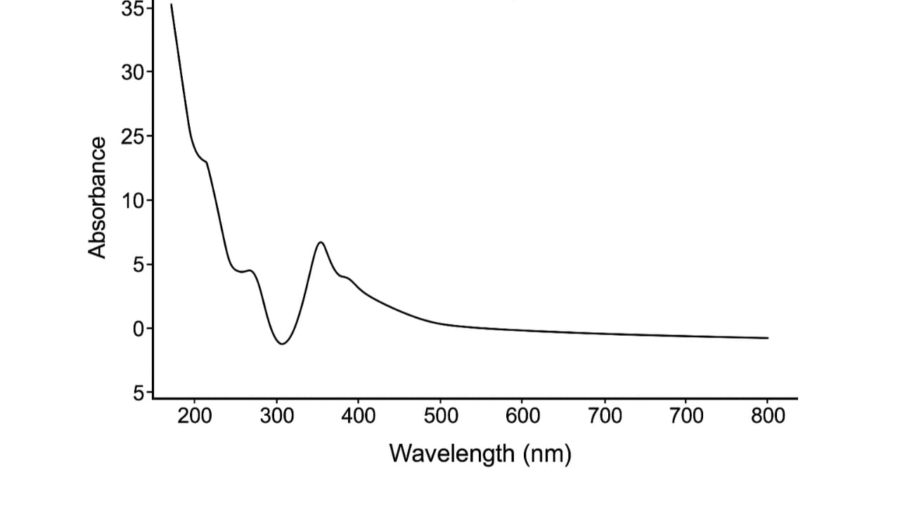
FIG- 6 : UV – Visible data if MnO₂[Aloevera assisted]
X-RAY DIFFRACTION STUDY [XRD]
The XRD analysis (Bruker D8 advance, DIFFRA SUITE) clearly reveals that the Aloe vera-assisted MnO₂ nanoparticles exhibit a well-defined crystalline structure[29] corresponding to the α-phase of MnO₂. The diffraction peaks at specific 2θ angles such as 28.6°, 37.4°, and 49.8° confirm the formation of pure MnO₂ without impurities, validating the efficiency of Aloe vera as a green reducing and stabilizing agent.
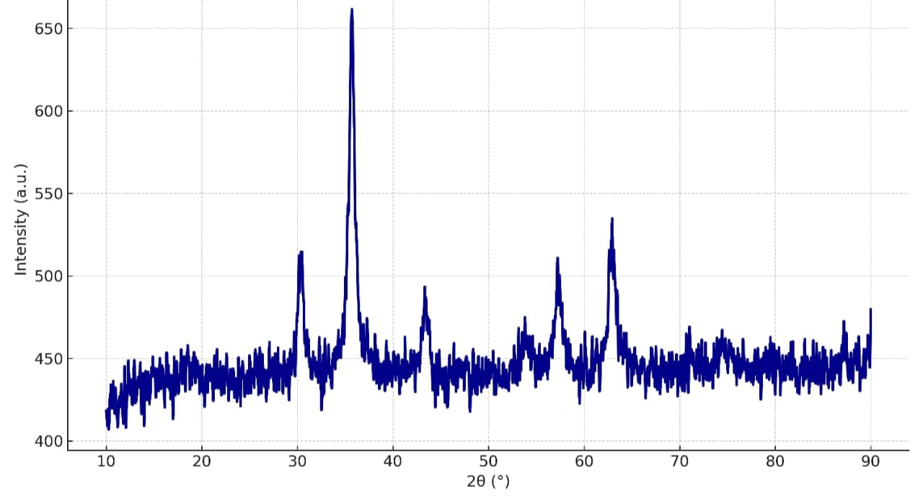
FIG-7: XRD OF MnO₂ [Aloevera assisted]

ANTIFUNGAL SUSCEPTIBILITY TEST
The MnO₂ NPs synthesized from the aqueous extract of Aloe vera further was assessed for agar well diffusion assay using the National Committee for Clinical Laboratory Standards guidelines (NCCLS), and Clinical and Laboratory Standard Institute (CLSI) guidelines, against Agroathelia rolfsii (PP112091) which causes collar rot disease in chickpea plant. The above-mentioned pathogen having Voucher No. BOT/CBSH/OUAT-01 was provided by P.G Department of Botany, College of Basic Science and Humanities, OUAT. All the experiments were conducted in triplicates. The commercial pesticide Thiram was used as control [30,31]. The fungal sample was spread uniformly over the SDA plates using a clean sterile swab. Wells of size 8 mm diameter were created at the centre of the pathogen- inoculated agar plates. The bottoms of the wells were sealed with 1% soft agar and loaded with different concentrations (500- 1000 ppm) of MnO₂ NPs and Thiram. The KMNO₄ act as negative control. The fungal plates were incubated at 22°C and the inhibition zone was observed after 48 hrs.
Results of antifungal activity indicated that MnO₂ NPs suspension at six different concentrations (500- 1000 ppm) significantly suppressed the growth of the chickpea pathogen, Agroathelia rolfsii as compared with the non-treated control. KMNO₄ which served as a negative control which shows no zone of inhabitation against the pathogen. The zone of inhibition of MnO₂ NPs has been calculated along with comparing KMNO₄, and standard antifungal Thiram. The inhibitory effect on fungal growth increased with increase in the concentration of MnO₂ NPs. The largest antifungal activity was observed in MnO₂ NP suspension at 1000 ppm, which exhibited the maximum diameter of inhibition zone 57.667±1.528 mm as compared to the Thiram (Figure 8 a-b, Fig 9).

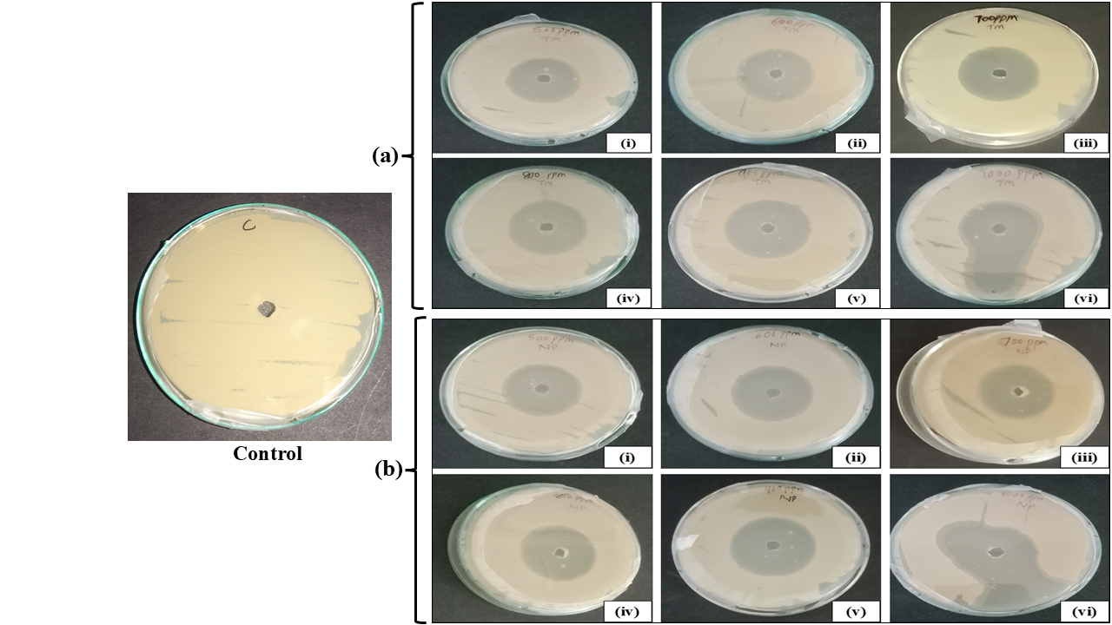
FIG. 8: Zone of inhibition in mm of (a) Thiram, and (b) MnO₂ NP of different concentrations (i) 500 ppm (ii) 600 ppm (iii) 700 ppm (iv) 800 ppm (v) 900 ppm (vi) 1000 ppm

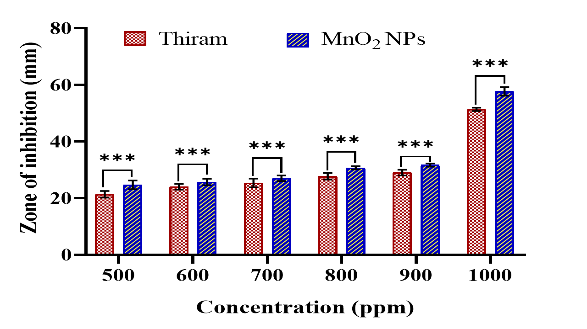

FIG 9: Graph showing the zone of inhibition in mm of Thiram, and MnO₂ NP at different concentrations (***p<0.001)
CONCLUSION
This research focused on a green and sustainable route to synthesize manganese dioxide (MnO₂) nanoparticles using Aloe vera leaf extract as both reducing and stabilizing agent. The method proved to be non-toxic, simple, and eco-conscious, avoiding the use of harmful chemicals often involved in conventional synthesis.
The synthesized nanoparticles were thoroughly analyzed using several spectroscopic and microscopic techniques. UV–Vis spectroscopy confirmed nanoparticle formation by showing a characteristic absorption peak near 378 nm. FTIR analysis indicated the involvement of Aloe vera phytochemicals in stabilizing the nanoparticles through various functional groups. The crystallinity of MnO₂ was verified via XRD, while SEM provided visual evidence of nano-sized, mostly spherical particles with a uniform distribution.
Biological testing demonstrated strong antifungal activity of these green-synthesized nanoparticles against harmful fungal strains such as Candida albicans and Aspergillus niger. The antifungal efficiency is likely due to mechanisms like ROS generation, interference with fungal membranes, and potential enhancement by bioactive Aloe compounds.
To sum up, this study shows that Aloe vera-mediated MnO₂ nanoparticles are highly effective and eco-friendly, offering a natural alternative to traditional antifungal agents. Their potential for use in biomedical and agricultural settings makes them a significant contribution to green nanoscience.
FUTURE PROSPECTS
The green synthesis of manganese dioxide nanoparticles using Aloe vera presents promising opportunities for expanding eco-friendly nanomaterial production beyond just MnO₂. Future work should focus on assessing the long-term stability and practical efficacy of these nanoparticles in real-life medical and agricultural applications. Exploring their antifungal activity against a broader range of fungal pathogens, including drug-resistant strains, will help establish their potential as versatile antifungal agents. It is also important to conduct comprehensive toxicity evaluations on human cells and living models to ensure their safety before widespread use. Integration of these nanoparticles into formulations such as creams, sprays, or coatings could lead to innovative products for wound care, seed treatment, and crop protection. Scaling up the production process and analyzing the economic feasibility will facilitate their transition from laboratory research to industrial manufacturing. Additionally, understanding the synergistic effects of Aloe vera’s bioactive compounds could enhance the nanoparticles’ properties, while combining MnO₂ nanoparticles with other bioactive substances or polymers may create multifunctional materials with expanded uses. Further studies on surface modification techniques might enable targeted delivery for antifungal therapies. Ultimately, the development and regulatory approval of MnO₂-based nano-fungicides could revolutionize sustainable agriculture by offering safer and more effective fungal control solutions.

Disclaimer (Artificial intelligence)

Author(s) hereby declare that NO generative AI technologies such as Large Language Models (ChatGPT, COPILOT, etc.) and text-to-image generators have been used during the writing or editing of this manuscript.

REFERENCE
- Ivanov M., Ciric A., Stojkovic D., Emerging antifungal Targets and Strategies, International Journal of Molecular Sciences, 2022, 23(5), 2756, https://doi.org/10.3390/ijms23052756.
- Munir M.U., Ahmed A., Usman M., Salman S., Recent Advances in Nanotechnology-Aided Materials in Combating Microbial Resistance and Functioning as Antibiotics Substitutes, International Journal of nanomedicine,2020, 15, 7329-7358, doi: 10.2147/IJN.S265934.
- Lu H., Zhang X., Khan S.A., Li W., Wan L., Biogenic Synthesis of MnO₂ Nanoparticles with Leaf Extract of Viola betonicifolia for Enhanced Antioxidant, Antimicrobial, Cytotoxic, and Biocompatible Applications, Front Microbiol, 2021, 12, 761084. doi: 10.3389/fmicb.2021.761084

- Ying S., Guan Z., Ofoegbu P.C., Clubb P., Rico C., He F., Hong J., Green synthesis of nanoparticles: Current developments and limitations, Environmental Technology & Innovation, 2022, 26, 102336.
- Ghatage M.M., Mane P.A., Gambhir R.P., Parkhe V.S., Kamble P.A., Lokhande C.D., Tiwari A.P., Green synthesis of silver nanoparticles via Aloe barbadensis miller leaves: Anticancer, antioxidative, antimicrobial and photocatalytic properties, Applied Surface Science Advances, 2023, 16, 100426, https://doi.org/10.1016/j.apsadv.2023.100426
- Izzah D.J., Nazriati N., Sumari S., Green Synthesis of MnO2 Nanoparticles with Aqueous Extract of Star Apple Leaves (Chrysophyllum cainito L.), E3S Web Conf., 2024, 481, 05003.
https://doi.org/10.1051/e3sconf/202448105003

- Lohiya G., Tamta A., Chandra B., Kandpal N.D., Joshi R., Green route synthesis of Manganese dioxide nanoparticles by using methanolic extract of Sapindus mukorossi(reetha), 2024,9(2), 211-222. 10.22090/jwent.2024.02.07
- Ahmed, S.; Chaudhry, S. A.; Ikram, S., A review on biogenic synthesis of ZnO nanoparticles using plant extracts and microbes: a prospect towards green chemistry, Journal of Photochemistry and Photobiology B: Biology, 2017, 166, 272-284.
https://doi.org/10.1016/j.jphotobiol.2016.12.011
- Narayanan, K.B.; Sakthivel, N., Green synthesis of biogenic metal nanoparticles by terrestrial and aquatic phototrophic and heterotrophic eukaryotes and biocompatible agents, Advances in colloid and interface science, 2011, 169(2), 59-79.
https://doi.org/10.1016/j.cis.2011.08.004.
- Jayandran, M.; Haneefa, M, M.; Balasubramanian, V., Green synthesis and characterization of Manganese nanoparticles using natural plant extracts and its evaluation of antimicrobial activity, Journal of Applied Pharmaceutical Science, 2015, 5(12),105-110., https://doi.org/10.7324/JAPS.2015.501218
- Devi M., Sharma S., Kumar P., Thakur N., Kumar G., Sharma M.V., Sharma A.J., Kumar K., Sharma A., Jeet K., Thakur N., Antifungal, antibacterial and antioxidant activity of Pinus roxburghii mediated green synthesized zinc and gadolinium doped manganese oxide nanoparticles, Colloids and Surfaces C: Environmental Aspects, 2024, 2, 100046, https://doi.org/10.1016/j.colsuc.2024.100046.
- Bachheti A., Bachheti R.K., Abate L., Husen A., Current status of Aloe-based nanoparticle fabrication, characterization and their application in some cutting-edge areas, South African Journal of Botany, 2022, 147, 1058-1069. https://doi.org/10.1016/j.sajb.2021.08.021
- Karthik P., Mirunya B., Ayyalsamy B., Shanmugapriya S.P., Eco-friendly synthesis of manganese dioxide nanoparticles using phyllanthus acidus leaf: Assessing their potential photocatalytic activity against organic dyes, Surfaces and Interfaces, 2025, 74, 107716. https://doi.org/10.1016/j.surfin.2025.107716.
- Raza, N., Anwar, A., Shoaib, A. et al. Catalyzing innovation: exploring the potential of eco-friendly synthesized magnetic iron oxide nanoparticles for heavy metals removal from water. Discover Nano 21, 56 (2026). https://doi.org/10.1186/s11671-025-04342-3
- Y. Shen, K. Wang, L. Li, J.K. Zhao, J.X. Ye, P. Chen, X. Gao, S.H.Zhang,Facilitatingproton-coupled electron transfer for energy-efficient CO₂ desorption by C@ZrO₂ hollow composites, Chem. Eng. J., 495 (2024), Article 153332
- Saini D.K, Singh M., Pandey J.K., Rathore S., Singh R.P., Kumar M., Green Synthesis of Nanoparticles for Biomedical Applications, 2025, Journal of Materials and Environmental Sciences16(10):1833-1859.
- Joshi, N. C, Siddiqui, F, Salman, M. ., & Singh, A. . (2020). Antibacterial Activity, Characterizations, and Biological Synthesis of Manganese Oxide Nanoparticles using the Extract of Aloe vera. Asian Pacific Journal of Health Sciences, 7(3), 27–29. https://doi.org/10.21276/apjhs.2020.7.3.7
- Joshi NC, Joshi E, Singh A. Biological synthesis, characterisations and antimicrobial activities of manganese dioxide (MnO2) nanoparticles. Res J Pharm Technol 2020; 13:135-40.
- Lu H, Zhang X, Khan S A, Li W, Wan L, Biogenic Synthesis of MnO2 Nanoparticles with Leaf Extract of Viola betonicifolia for Enhanced Antioxidant, Antimicrobial, Cytotoxic, and Biocompatible Applications, 2021, Frontiers in Microbiology, 12, (761084). https://doi.org/10.3389/fmicb.2021.761084
- Sudhakar, S.A., Afinisha Deepam, L.S. In vitro antioxidant, anti-inflammatory, antibacterial, and cytotoxic effect of Sida cordifolia: synthesized metal nanoparticles. Discov. Chem. 2, 348 (2025). https://doi.org/10.1007/s44371-025-00426-2.
- Yadav S, Khan A, Sharma J, Phytochemistry of Aloe vera: A Catalyst for Environment-Friendly Diverse Nanoparticles with Sustained Biomedical Benefits, 2025, Nature Environment and Pollution Technology, 24(1), B4182, DOI:10.46488/NEPT.2025.v24i01.B4182.

- Ramola B, Joshi NC, Ramola M, Chhabra J. Green synthesis, characterisations and antimicrobial activities of CaO nanoparticles. Orient J Chem 2019; 35:1154-7.
- Joshi NC, Singh A, Ramola M. Magnesium oxide nanoparticles (MgONPs): Green synthesis, characterisations and antimicrobial activity. Res J Pharm Technol 2019; 12:4644-4.
- Njike, R.; Yepseu, A. P.; Fotsop, C. G.; Doungmo, G.; Nchimi, K. N.; Ndifon, P. T. Structural and Surface Properties of Polyvinylpyrrolidone and Aloe Vera - Capped Iron Oxide Nanoparticles: Application in the Photocatalytic Degradation of Methylene Blue. Eur. J. Chem. 2025, 16, 233-241.
- Lu H, Zhang X, Khan SA, Li W and Wan L (2021) Biogenic Synthesis of MnO2 Nanoparticles with Leaf Extract of Viola betonicifolia for Enhanced Antioxidant, Antimicrobial, Cytotoxic, and Biocompatible Applications, Front. Microbiol. 12:761084. doi: 10.3389/fmicb.2021.761084.
- Morgan, R. N., & Aboshanab, K. M. (2024). Green biologically synthesized metal nanoparticles: biological applications, optimizations and future prospects. Future Science OA, 10(1). https://doi.org/10.2144/fsoa-2023-0196.
- Yadav S, Khan A, Sharma J G, Phytochemistry of Aloevera: A Catalyst for environment friendly diverse nanoparticles with sustained Biomedical benefits, Nature Environment and Pollution Technology, 2025, 24(1).
- Zhang J, Gu M, Chen X. Supercapacitors for renewable energy applications: A review, Micro and Nano Engineering, 2023, 21,100229.
- Pandey, R., Vishwakarma, V. Green synthesis of metal-based nanoparticles using Aloe vera (L.) Burm.f: A review. Discov. Chem. 3, 122 (2026). https://doi.org/10.1007/s44371-026-00527-6.
- Ogbezode, J.E., Ezealigo, U.S., Bello, A. et al. A narrative review of the synthesis, characterization, and applications of iron oxide nanoparticles. Discover Nano 18, 125 (2023). https://doi.org/10.1186/s11671-023-03898-2.
- Pierson-Perry, J. F., Vaks, J. E., Durham, A. P., Fischer, C., Gutenbrunner, C., Hillyard, D., Kondratovich, M. V., Ladwig, P., & Middleberg, R. A , Evaluation of detection capability for clinical laboratory measurement procedures; approved guideline.2012, 2nd Edition.

