Role of Weed Hosts in the Epidemiology of Chilli Leaf Curl Virus (ChiLCV) in Chilli Ecosystems

Abstract
Chilli (Capsicum annuum L.) is an economically important spice and vegetable crop widely cultivated in tropical and subtropical regions. However, its productivity is severely constrained by several viral diseases, among which chilli leaf curl disease caused by begomoviruses is considered one of the most destructive. The present study investigated the role of weed hosts in the epidemiology of chilli leaf curl virus (ChiLCV) in chilli-growing ecosystems around Bengaluru, Karnataka, India. Field surveys were conducted during the 2023–2024 cropping season in major chilli-producing regions including Kolar, Chikkaballapura, and Bengaluru districts. Several weed species growing within and around chilli fields were collected and examined for begomovirus-like symptoms such as leaf yellowing, upward curling, puckering, mosaic patterns, and plant stunting. Molecular detection using coat protein gene-specific primers confirmed the presence of ChiLCV in multiple weed hosts. The results indicated that several weed species act as potential reservoirs of ChiLCV and may facilitate virus survival and dissemination through the whitefly vector Bemisia tabaci. These findings highlight the epidemiological importance of weed hosts in the persistence and spread of chilli leaf curl virus. Effective weed management in and around chilli fields, together with appropriate vector control strategies, is therefore essential for reducing virus inoculum sources and minimizing the incidence of chilli leaf curl disease.
Keywords: Begomovirus, chilli leaf curl virus, weed hosts, epidemiology, PCR detection, Bemisia tabaci

Introduction
Chilli (Capsicum annuum L.), belonging to the family Solanaceae, is one of the most important spice and vegetable crops cultivated worldwide due to its culinary, nutritional, medicinal, and economic significance (Dhaliwal et al., 2014; FAO, 2021; Sakthivel et al., 2025). The crop is extensively grown in tropical and subtropical regions, and India is among the leading producers and exporters of chilli globally. Chilli contributes significantly to agricultural income, employment generation, and the spice industry. However, the productivity and quality of chilli are frequently threatened by a range of biotic stresses, including diseases caused by fungi, bacteria, nematodes, and viruses, which lead to substantial yield and economic losses (Jagdale & Ghosh, 2019).
Among the viral diseases affecting chilli, chilli leaf curl disease has emerged as one of the most destructive constraints to chilli cultivation in several parts of the world, particularly in Asia and Africa (Kenyon et al., 2014; Kumar et al., 2011). The disease is caused by begomoviruses belonging to the family Geminiviridae, which possess circular single-stranded DNA genomes encapsidated within characteristic twinned icosahedral particles (Nawaz-ul-Rehman & Fauquet, 2009; Brown et al., 2015). Begomoviruses are transmitted by the whitefly Bemisia tabaci in a persistent circulative manner and are responsible for numerous economically important plant diseases in tropical and subtropical agricultural systems (Bedford et al., 1994; Varma & Malathi, 2003). In chilli plants, infection by chilli leaf curl virus (ChiLCV) results in characteristic symptoms such as upward curling of leaves, puckering, vein thickening, yellowing, reduction in leaf size, and severe stunting of plants, which ultimately lead to significant yield losses and poor fruit quality (Kumar et al., 2011; Kenyon et al., 2014).
The epidemiology of begomoviruses is strongly influenced by interactions among the virus, host plants, insect vectors, and environmental factors. One of the most important components influencing disease dynamics is the presence of alternate host plants in agroecosystems (Varma & Malathi, 2003; Rojas et al., 2005). Begomoviruses are known to possess a broad host range, infecting numerous cultivated crops as well as wild plant species belonging to diverse botanical families (Kenyon et al., 2014). These alternate hosts play a crucial role in the survival, maintenance, and dissemination of viruses in crop production systems.
Weeds growing in and around agricultural fields often act as reservoirs for plant viruses and contribute significantly to the persistence of viral diseases in cropping systems (Seal et al., 2006; Mishra et al., 2022). Many weed species can harbor begomoviruses without exhibiting severe symptoms, allowing the virus to persist unnoticed for extended periods. These weeds also provide suitable habitats for the whitefly vector Bemisia tabaci, facilitating continuous virus acquisition and transmission to susceptible crops. Several weed species such as Parthenium hysterophorus, Ageratum conyzoides, Sida spp., and Euphorbia spp. have been reported to host begomoviruses and play a significant role in the epidemiology of chilli leaf curl disease (Roy et al., 2023; Mishra et al., 2022).
The ability of begomoviruses to infect multiple host plants is further enhanced by their high genetic variability and evolutionary adaptability. Molecular diversity in begomoviruses arises through mutation, recombination, and interactions with satellite molecules such as betasatellites and alphasatellites (Shingote et al., 2022). These evolutionary mechanisms enable begomoviruses to expand their host range, adapt to new environmental conditions, and overcome host resistance. Consequently, understanding the diversity of host plants associated with ChiLCV is essential for understanding its epidemiology and for developing effective management strategies.
Advances in molecular detection techniques such as polymerase chain reaction (PCR) have significantly improved the detection and characterization of begomoviruses from both cultivated crops and alternate host plants (Briddon et al., 2003; Khan & Khan, 2017). PCR-based detection enables accurate identification of virus reservoirs and helps in understanding the role of weed hosts in the persistence and spread of plant viruses in agricultural ecosystems. Identification of virus-infected weeds is therefore crucial for understanding disease epidemiology and for designing integrated management strategies aimed at reducing virus inoculum sources.
Considering the significant role of alternate host plants in the epidemiology of begomoviruses, it is essential to investigate the weed flora associated with chilli ecosystems and their potential role as virus reservoirs. Understanding the interaction between weed hosts, virus populations, and insect vectors is fundamental for developing effective disease management strategies. Therefore, the present study was undertaken to identify weed species associated with chilli cultivation and to evaluate their potential role as reservoirs of chilli leaf curl virus (ChiLCV) in chilli ecosystems of the Bengaluru region.
Materials and Methods
Survey of Chilli Ecosystems
Field surveys were conducted during the chilli growing season (2023–2024) in major chilli-producing regions surrounding Bengaluru, Karnataka, India, including Kolar, Chikkaballapura, and Bengaluru districts. The surveyed areas were located approximately between 12.77°–13.22° N latitude and 77.37°–77.78° E longitude. Several chilli fields and surrounding habitats such as field bunds, irrigation channels, and uncultivated lands were systematically inspected to record the presence of weed flora and virus-like symptoms associated with begomovirus infection. Field survey approaches for identifying virus reservoirs in crop ecosystems have been widely used in epidemiological studies of plant viral diseases (Kumar et al., 2016; Roy et al., 2023).
Collection of Weed Samples
During the field survey, both symptomatic and asymptomatic weed plants growing within and around chilli fields were collected for further investigation. Various weed species belonging to different families were observed within the chilli ecosystem. The weed hosts collected during the survey included Parthenium hysterophorus, Amaranthus viridis, Hibiscus vitifolius, Solanum nigrum, Sida acuta, Portulaca oleracea, Boerhavia erecta, Cassia tora, Stachytarpheta jamaicensis, Alternanthera sessilis, Euphorbia geniculata, Malvastrum coromandelianum, Achyranthes aspera, Ageratum conyzoides, Chenopodium murale, Solanum americanum, Mirabilis jalapa, Sida carpinifolia, Synedrella nodiflora, Acalypha indica, Commelina benghalensis, and Aeschynomene indica.
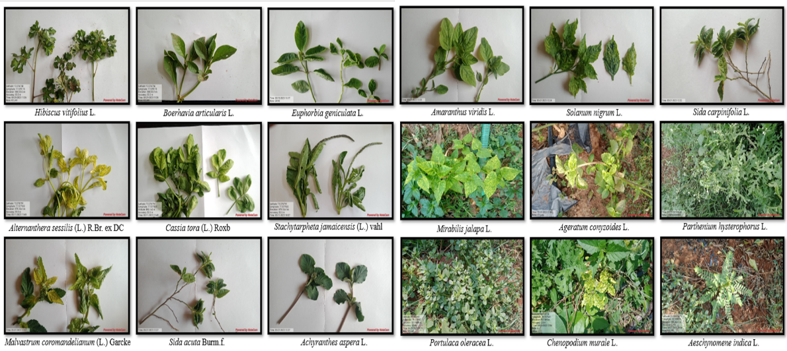
All collected samples were carefully labeled with location details and transported to the laboratory under cooled conditions for further symptom observation and molecular analysis. Similar sampling procedures for identifying alternative hosts of begomoviruses have been reported in earlier epidemiological studies (Mishra et al., 2022; Shingote et al., 2022). Representative weed samples collected during the survey are presented in Figure 1.

Fig. 1. Typical begomovirus-like symptoms observed on weed host plants in chilli ecosystems in and around Bengaluru.
Symptom Observation
The collected weed samples were carefully examined for the presence of virus-like symptoms associated with begomovirus infection. Observed symptoms included leaf yellowing, upward curling, puckering, mosaic patterns, vein thickening, and plant stunting. These symptoms are commonly associated with begomovirus infections in several host plants (Kenyon et al., 2014; Thakur et al., 2018). Symptom characteristics were recorded and documented for each weed species.
DNA Extraction
Total genomic DNA was extracted from leaf tissues of collected weed samples using the CTAB (cetyltrimethylammonium bromide) method as described by Doyle and Doyle (1990). The extracted DNA was purified and subsequently used as template for molecular analysis.
PCR Detection of Chilli Leaf Curl Virus
Detection of chilli leaf curl virus (ChiLCV) in weed samples was carried out using polymerase chain reaction (PCR) with coat protein gene-specific primers. PCR-based detection is widely used for the identification of begomoviruses in infected plants due to its sensitivity and specificity (Briddon et al., 2003; Khan & Khan, 2017). The PCR reactions were performed using extracted genomic DNA as template under standard amplification conditions. The amplified products were analyzed by agarose gel electrophoresis and visualized under UV illumination using a gel documentation system. The presence of specific DNA bands corresponding to the expected amplicon size confirmed the presence of ChiLCV in the tested weed samples (Madhu Kiran et al., 2021).
Results and Discussion
Symptomatology of Begomovirus Infection in Weed Hosts
Field surveys conducted in major chilli-growing areas of Kolar, Chikkaballapura, and Bengaluru districts revealed the presence of diverse weed flora growing within and around chilli fields. Several of these weed species exhibited symptoms typically associated with begomovirus infection. The commonly observed symptoms included leaf yellowing, upward curling, puckering, mosaic patterns, and stunted growth of plants. Such symptoms are characteristic of infections caused by begomoviruses, including chilli leaf curl virus (ChiLCV) (Kenyon et al., 2014; Thakur et al., 2018).
Among the surveyed weeds, species such as Parthenium hysterophorus, Sida acuta, Solanum nigrum, Alternanthera sessilis, Euphorbia geniculata, Ageratum conyzoides, and Malvastrum coromandelianum frequently exhibited virus-like symptoms. The occurrence of these symptoms in weed hosts indicates the possible presence of begomoviruses in the chilli ecosystem. Similar symptom patterns have been reported in several weed hosts infected by begomoviruses in vegetable cropping systems, suggesting that these plants may act as alternate hosts for the virus (Seal et al., 2006; Shingote et al., 2022).
The distribution of weed species showing begomovirus-like symptoms across different survey locations is summarized in Table 1. The widespread occurrence of symptomatic weeds in chilli fields and surrounding habitats such as field bunds and uncultivated areas indicates that these plants may contribute to the persistence of virus inoculum in the cropping environment. Previous studies have also reported that weeds growing near cultivated crops serve as important reservoirs for begomoviruses and play a crucial role in disease epidemiology (Varma & Malathi, 2003; Roy et al., 2023).
Table 1. Weed hosts showing begomovirus-like symptoms in chilli ecosystems around Bengaluru
District | Taluk | Weed species | Family | Observed symptoms
Kolar | Srinivaspur | Parthenium hysterophorus | Asteraceae | Yellowing, curling, mosaic
Kolar | Srinivaspur | Amaranthus viridis | Amaranthaceae | Yellowing
Kolar | Srinivaspur | Hibiscus vitifolius | Malvaceae | Curling
Kolar | Srinivaspur | Solanum nigrum | Solanaceae | Yellowing, curling
Kolar | Srinivaspur | Sida acuta | Malvaceae | Yellowing, curling
Chikkaballapura | Chinthamani | Alternanthera sessilis | Amaranthaceae | Yellowing, curling
Chikkaballapura | Chinthamani | Euphorbia geniculata | Euphorbiaceae | Curling, puckering
Chikkaballapura | Chinthamani | Malvastrum coromandelianum | Malvaceae | Yellowing, curling
Chikkaballapura | Chinthamani | Ageratum conyzoides | Asteraceae | Yellowing, curling
Chikkaballapura | Chikkaballapura | Solanum americanum | Solanaceae | Yellowing, curling
Kolar | Srinivaspura | Sida carpinifolia | Malvaceae | Yellowing
Kolar | Mulbagal | Acalypha indica | Euphorbiaceae | Yellowing, curling
Bengaluru Urban | Bengaluru North | Cassia tora | Fabaceae | Yellowing, curling

Molecular Detection of ChiLCV in Weed Samples
To confirm the presence of chilli leaf curl virus in weed hosts, PCR amplification was performed using ChiLCV coat protein gene-specific primers. PCR analysis produced specific amplification products corresponding to the expected size in several weed samples. The amplified DNA fragments were resolved through agarose gel electrophoresis and visualized under UV illumination.
The detection of virus-specific DNA fragments confirmed the presence of ChiLCV in several weed hosts present in chilli ecosystems. Weed species such as Parthenium hysterophorus, Sida acuta, Solanum nigrum, Ageratum conyzoides, Alternanthera sessilis, and Euphorbia geniculata showed positive amplification for ChiLCV, indicating that these species can harbor the virus and potentially act as reservoirs of infection.
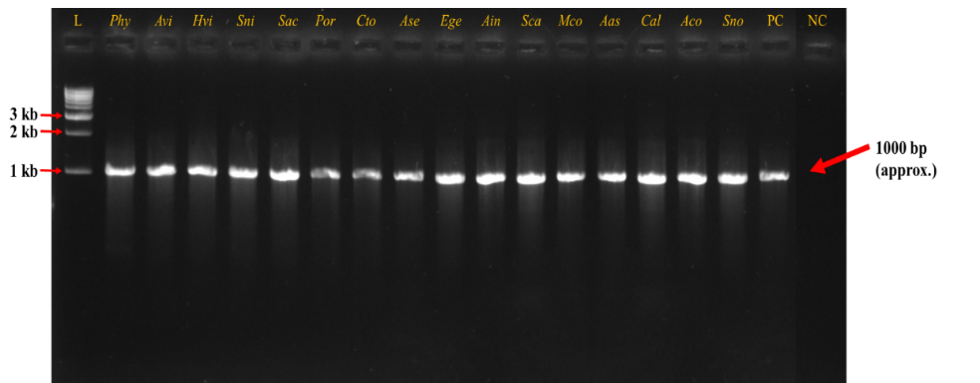
The PCR amplification results for ChiLCV detection in weed samples are presented in Figure 2. Molecular detection using PCR has been widely used for the identification and confirmation of begomoviruses in infected host plants due to its high sensitivity and reliability (Briddon et al., 2003; Khan & Khan, 2017). Similar molecular detection of chilli leaf curl virus in alternative host plants has been reported in earlier studies, confirming that weeds play an important role in maintaining virus populations in agricultural ecosystems (Madhu Kiran et al., 2021; Mishra et al., 2022).
Fig. 2. PCR amplification of ChiLCV coat protein gene in weed samples collected from different locations.
L – DNA ladder; PC – Positive control; NC – Negative control.
Phy – Parthenium hysterophorus; Avi – Amaranthus viridis; Hvi – Hibiscus vitifolius; Sni – Solanum nigrum; Sac – Sida acuta; Por – Portulaca oleracea; Cto – Cassia tora; Ase – Alternanthera sessilis; Ege – Euphorbia geniculata; Ain – Aeschynomene indica; Sca – Sida carpinifolia; Mco – Malvastrum coromandelianum; Aas – Achyranthes aspera; Cal – Calyptocarpus vialis; Aco – Ageratum conyzoides; Sno – Synedrella nodiflora.
The presence of ChiLCV in weed hosts highlights the epidemiological significance of these plants in maintaining virus populations within chilli production systems. Several previous studies have reported that weeds can harbor begomoviruses and serve as important sources of inoculum for virus transmission in crop ecosystems (Seal et al., 2006; Shingote et al., 2022).
Role of Weed Hosts in ChiLCV Epidemiology
Weed plants growing within and around chilli fields play a significant role in the epidemiology of begomoviruses. These plants often remain present throughout the year and can harbor viruses without exhibiting severe symptoms. As a result, weeds serve as persistent reservoirs of infection and contribute to the survival of the virus during non-cropping periods (Varma & Malathi, 2003; Mishra et al., 2022).
The whitefly Bemisia tabaci, which is the primary vector responsible for the transmission of begomoviruses, feeds on infected weed hosts and subsequently transmits the virus to healthy chilli plants. The continuous movement of whiteflies between weeds and cultivated crops facilitates the spread of chilli leaf curl disease in chilli-growing regions (Bedford et al., 1994; Roy et al., 2023).
The presence of diverse weed hosts surrounding chilli fields therefore increases the probability of virus transmission and disease outbreaks. Effective management of weed flora around chilli cultivation areas is essential for reducing virus reservoirs and minimizing the spread of ChiLCV. Integrated disease management strategies that include weed removal, vector control, and cultivation of resistant varieties may help reduce the incidence and impact of chilli leaf curl disease (Thakur et al., 2018; Shingote et al., 2022).
Conclusion
The present study demonstrated that several weed species associated with chilli ecosystems in and around Bengaluru harbor chilli leaf curl virus (ChiLCV). Field observations of characteristic begomovirus-like symptoms, together with PCR-based molecular detection, confirmed that weed species such as Parthenium hysterophorus, Ageratum conyzoides, Sida acuta, Euphorbia geniculata, and Alternanthera sessilis act as potential reservoirs of ChiLCV. The presence of these infected weed hosts within and around chilli fields indicates their important role in maintaining virus populations and facilitating the spread of the disease through the whitefly vector, Bemisia tabaci.
These findings highlight the epidemiological significance of weed hosts in the persistence and transmission of chilli leaf curl virus in chilli-growing regions (Figure 3). Therefore, effective weed management practices combined with vector control strategies are essential components of integrated disease management for reducing the incidence and spread of chilli leaf curl disease in chilli cultivation systems.
Disclaimer (Artificial intelligence)
Author(s) hereby declare that NO generative AI technologies such as Large Language Models (ChatGPT, COPILOT, etc.) and text-to-image generators have been used during the writing or editing of this manuscript.
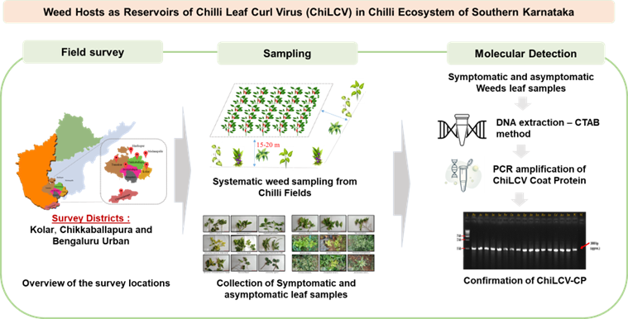Fig 3. Workflow illustrating survey locations, weed host sampling, symptom observation, and PCR detection of ChiLCV in chilli ecosystems.

References

Bedford, I. D., Briddon, R. W., Brown, J. K., Rosell, R. C., & Markham, P. G. (1994). Geminivirus transmission and biological characterization of Bemisia tabaci populations. Annals of Applied Biology, 125(2), 311–325.
Briddon, R. W., Bull, S. E., Mansoor, S., Amin, I., & Markham, P. G. (2003). Universal primers for the PCR-mediated amplification of DNA β. Molecular Biotechnology, 20, 315–318.
Brown, J. K., Zerbini, F. M., Navas-Castillo, J., Moriones, E., Ramos-Sobrinho, R., Silva, J. C., & Varsani, A. (2015). Revision of begomovirus taxonomy based on pairwise sequence comparisons. Archives of Virology, 160(6), 1593–1619.
Dhaliwal, M. S., Jindal, S. K., & Dhaliwal, P. S. (2014). Chilli: Production, processing and value addition. Indian Journal of Horticulture, 71(3), 403–408.
Doyle, J. J., & Doyle, J. L. (1990). Isolation of plant DNA from fresh tissue. Focus, 12, 13–15.
FAO. (2021). FAOSTAT statistical database. Food and Agriculture Organization of the United Nations.
Jagdale, S. S., & Ghosh, D. K. (2019). Viral diseases of chilli: A review. International Journal of Current Microbiology and Applied Sciences, 8(4), 1915–1925.
Kenyon, L., Kumar, S., Tsai, W. S., & Hughes, J. (2014). Virus diseases of peppers. Plant Disease, 98(1), 1–17.
Khan, M. S., & Khan, J. A. (2017). Molecular characterization of a begomovirus infecting chilli in India. Virus Genes, 53(3), 472–480.
Kumar, R. Kumar, V., Kadiri, S., & Palicherla, S. R. (2016). Epidemiology and diagnosis of chilli leaf curl virus in central India, a major chilli growing region. Indian Phytopathol, 69(4s), 61-64.
Kumar, S., Singh, A. K., & Singh, M. (2011). Chilli leaf curl virus: A major threat to chilli production. Archives of Phytopathology and Plant Protection, 44(10), 1–12.
Mishra, M., Verma, R. K., Pandey, V., Srivastava, A., Sharma, P., Gaur, R., & Ali, A. (2022). Role of diversity and recombination in the emergence of chilli leaf curl virus. Pathogens, 11(5), 529.
Nawaz-ul-Rehman, M. S., & Fauquet, C. M. (2009). Evolution of geminiviruses and their satellites. FEBS Letters, 583(12), 1825–1832.
Rojas, M. R., Hagen, C., Lucas, W. J., & Gilbertson, R. L. (2005). Exploiting chinks in the plant's armor: evolution and emergence of geminiviruses. Annu. Rev. Phytopathol., 43(1), 361-394.
Roy, B., Venu, E., Kumar, S., Dubey, S., Lakshman, D., Mandal, B., & Sinha, P. (2023). Leaf Curl Epidemic Risk in Chilli as a Consequence of Vector Migration Rate and Contact Rate Dynamics: A Critical Guide to Management. Viruses 2023, 15, 854.
Sakthivel, M., Nath, R., Marimuthu Elangovan, S. S., & Anithaa, V. (2025). Field evaluation of fungicides and bio-products for management of Fusarium wilt in chilli (Capsicum annum L.). Plant Archives, 25(1), 2124-2132.
Seal, S. E., VandenBosch, F., & Jeger, M. J. (2006). Factors influencing begomovirus evolution and their increasing global significance: implications for sustainable control. Critical reviews in plant sciences, 25(1), 23-46.
Shingote, P. R., Wasule, D. L., Parma, V. S., Holkar, S. K., Karkute, S. G., Parlawar, N. D., & Senanayake, D. M. J. B. (2022). An overview of chili leaf curl disease: Molecular mechanisms, impact, challenges, and disease management strategies in Indian subcontinent. Frontiers in Microbiology, 13, 899512.
Thakur, H., Jindal, S. K., Sharma, A., & Dhaliwal, M. S. (2018). Chilli leaf curl virus disease: a serious threat for chilli cultivation. Journal of Plant Diseases and Protection, 125(3), 239-249.
Varma, A., & Malathi, V. G. (2003). Emerging geminivirus problems: a serious threat to crop production. Annals of applied biology, 142(2), 145-164.

