Ameliorative Effects of Moringa oleifera on Perinatal Lead-Induced Systemic and Developmental Toxicity in Wistar Rats

Abstract
Lead is a persistent environmental contaminant with no biological role and is known to produce systemic toxicity, particularly during pregnancy and early developmental stages. The present study evaluated the effects of perinatal exposure to lead acetate on maternal growth, offspring development, haematological indices, blood lead concentration, and essential mineral status in Wistar rats, and examined the potential protective role of Moringa oleifera. Eighteen pregnant rats were randomly divided into three groups (n = 6): control, lead acetate treated (0.8% in drinking water), and lead acetate with Moringa oleifera supplementation (400 mg/kg body weight). Treatments were administered from gestation day 5 to postnatal day 21, and the data were analyzed using one-way ANOVA. Lead exposure resulted in significant reductions in maternal body weight gain, pup body weight at birth and during lactation, litter size, and survival of pups. Haematological evaluation revealed decreased haemoglobin concentration, total erythrocyte count, and packed cell volume in both dams and pups, indicating lead-induced anaemia. Blood lead concentration was markedLy increased in exposed animals, while the levels of essential minerals including calcium, iron, zinc, and copper were reduced compared with the control group. Supplementation with Moringa oleifera significantly improved growth performance, haematological parameters, and mineral levels and reduced blood lead concentration compared with the lead-treated group, although values did not completely return to normal levels. These findings indicate that perinatal lead exposure causes significant systemic and developmental toxicity, while dietary supplementation with Moringa oleifera provides partial protective effects against lead-induced alterations.
Keywords: Lead toxicity, Moringa oleifera, perinatal exposure, haematology, mineral imbalance.

1. Introduction
Lead (Pb) is a non-essential heavy metal widely distributed in the environment and recognized as a major toxicant affecting both humans and animals. Its environmental persistence, non-biodegradable nature, and extensive industrial use contribute to continuous exposure through contaminated water, soil, food, and atmospheric emissions (Masih et al., 2020). Once absorbed, lead accumulates in blood, liver, kidneys, bone, and nervous tissue and interferes with multiple biochemical and metabolic pathways (Jaishankar et al., 2014).
Among exposed populations, pregnant females and developing offspring represent the most vulnerable groups. Lead readily crosses the placental barrier and is also excreted through milk, resulting in combined prenatal and postnatal exposure. Developmental exposure has been associated with reduced maternal weight gain, fetal growth retardation, low birth weight, impaired litter outcomes, and increased neonatal mortality (Aprioku and Siminialayi, 2013; Dhir and Dhand, 2010; Gargouri et al., 2016). These adverse effects are attributed to oxidative stress, metabolic disruption, placental dysfunction, and altered maternal behavior.
Lead toxicity also produces marked Haematological disturbances. It inhibits key enzymes of heme biosynthesis, including δ-aminolevulinic acid dehydratase and ferrochelatase, disrupts iron utilization, and increases erythrocyte fragility, resulting in anemia characterized by reduced haemoglobin concentration, erythrocyte count, and packed cell volume (Masso-Gonzalez and Antonio-Garcia, 2009; Jassim and Hassan, 2011; Aladaileh et al., 2020).
In addition to hematotoxicity, lead disrupts essential mineral homeostasis by competing with biologically important elements such as calcium, iron, zinc, and copper. This displacement alters enzymatic activity, cellular signaling, and metabolic balance, thereby amplifying systemic toxicity (Ouyang et al., 2019). Altered mineral status further contributes to anemia, impaired growth, and metabolic dysfunction during pregnancy and early development.
Nutritional and plant-based interventions have gained increasing attention as supportive strategies against heavy metal toxicity. Moringa oleifera, a widely cultivated medicinal plant, is rich in antioxidants, flavonoids, vitamins, and essential minerals and has demonstrated protective effects against oxidative and heavy metal–induced damage in experimental studies. Its nutritional density and potential metal-binding phytochemicals suggest a possible ameliorative role in systemic lead toxicity (Helal et al., 2020; Ejike et al., 2023).
2. Methodology
2.1 Location and study period
The study was conducted in the Department of Veterinary Pathology with animals housed in the Central Laboratory Animal House under controlled environmental conditions. The study duration was six months
2.2 Experimental animals and grouping
Female Wistar rats (approximately 12 weeks old, 180–200 g) were procured from a certified breeder. After acclimatization, mating was performed in a 1:1 ratio. Pregnancy was confirmed by vaginal plug and smear examination and designated as gestation day 0.
2.3 Experimental design
List 1 : Eighteen pregnant Wistar rats (180–200 g) were divided into three groups (n=6)
Group | Treatment | Number of animals
I | Control | 06
II | Lead acetate @ of 0.8% in drinking water | 06
III | Lead acetate at the dose rate of 0.8% in drinking water + Moringa oleifera @ of 400 mg/kg | 06
Treatment was given from gestation day 5 to postnatal day 21. Animals were maintained under standard laboratory conditions and ethical guidelines
2.4 Growth and offspring parameters
Maternal body weights were recorded weekly. Pup body weights were recorded on postnatal days 0, 7, 14, and 21. Litter size, litter weight, live and dead pups per group, and per dam were recorded.
2.5 Haematology
Blood samples were collected in heparinized tubes. Hb, TEC, and PCV were measured using an automated analyzer.
2.6 Estimation of blood mineral levels
Blood mineral concentrations were estimated simultaneously with blood lead levels using inductively coupled plasma mass spectrometry (ICP-MS) following microwave-assisted wet acid digestion. Whole blood samples collected in anticoagulant-coated tubes were stored under refrigerated conditions until analysis. For digestion, a 1 ml of whole blood was transferred into acid-washed digestion vessels, and concentrated nitric acid was added along with hydrogen peroxide as an oxidizing agent. Samples were allowed to undergo pre-digestion at room temperature to control excessive reaction and were then subjected to controlled heating in a digestion assembly until a clear, colorless solution was obtained, indicating complete destruction of the organic matrix. After digestion, samples were cooled and diluted to a 10 ml final volume using double-distilled deionized water. The digested solutions were transferred into acid-washed polypropylene tubes and maintained at low temperature until instrumental analysis. Multi-element calibration standards covering the expected analytical range were prepared from certified reference standards, and calibration curves were generated prior to sample analysis (Welna et al., 2011).
Mineral elements analyzed included calcium (Ca), iron (Fe), zinc (Zn), and copper (Cu). Instrument calibration was verified using quality control standards and reagent blanks to ensure analytical accuracy and to correct for background signal. Samples were analyzed in batch mode with calibration verification after defined intervals to maintain instrument stability. All measurements were carried out under validated operating conditions using manufacturer-recommended parameters for plasma power, gas flow, and detection mode.
Elemental concentrations obtained from the instrument output were corrected for dilution factors and expressed in mg/dL for data presentation. Internal quality control procedures, including blank runs and standard checks, were applied throughout the analytical sequence to ensure precision and reproducibility of mineral estimation
Supplementary Material
Pregnant Wistar rats in groups I and II were provided with a commercially available pelleted diet containing wheat, alfalfa, soybean, vitamins, and minerals. Rats in group III received feed supplemented with Moringa oleifera leaf powder at a dose rate of 400 mg/kg body weight/day.
Moringa oleifera leaves were obtained from the Department of Horticulture, Jawaharlal Nehru Krishi Vishwa Vidyalaya (JNKVV), Jabalpur, India, air-dried, and finely powdered before incorporation into the feed. The required quantity of Moringa powder was mixed thoroughly with powdered rat feed to achieve the desired dose, and 10 g pellets were prepared and air-dried for 24 hours.
To ensure uniform intake of 0.8% lead acetate supplemented drinking water and enriched feed, animals were subjected to overnight fasting (8:00 PM–8:00 AM). Each rat received one enriched pellet (10 g) daily along with 30 g of normal feed. The dose of Moringa oleifera was adjusted weekly based on the average body weight of the animals, and the quantity incorporated during feed preparation was rounded to the nearest 10 mg to avoid under-dosing.
Moringa oleifera leaves are rich in antioxidants, flavonoids, vitamins, and essential minerals such as calcium, iron, zinc, and copper. The dose of 400 mg/kg body weight used in the present study was selected based on previous experimental studies demonstrating protective effects of Moringa oleifera against heavy metal–induced toxicity in experimental animals (Helal et al., 2020; Ejike et al., 2023).
2.7 Statistical analysis
Data were expressed as Mean ± SE. Statistical analysis was performed using one-way analysis of variance (ANOVA) followed by Tukey’s post-hoc multiple comparison test to determine differences between experimental groups. Differences were considered statistically significant at p ≤ 0.05.
3. Results
3.1 Maternal body weight
Control dams showed steady gestational and lactational weight gain. Lead-treated dams showed progressive suppression of weight gain beginning mid-gestation and extending through lactation. The Moringa group showed significantly improved weight gain compared with lead only animals.
Table 1. Mean weekly body weight (g) of dams
 | Weekly body weight (Mean ± SE)
 | Gestation |  |  |  |  | Lactation
 | Week 0 | Week I | Week II | Week III | Week IV |  | Week V | Week VI
I | 200.50ª± 4.42 | 203.67ª± 5.22 | 210.83ª± 6.26 | 219.83ª± 8.62 | 239.50ª± 6.07 |  | 239.83ª± 5.97 | 247.00ª± 4.67
II | 202.00ª± 1.93 | 204.50ª± 1.89 | 206.50ª± 2.13 | 203.50ª± 4.42 | 195.83^{c}± 3.51 |  | 199.33^{c}± 4.62 | 195.83^{c}± 1.83
III | 198.17ª± 1.82 | 196.67ª± 1.98 | 199.33ª± 7.85 | 194.50ª± 12.45 | 206.67^{b}± 7.18 |  | 211.67^{b}± 8.37 | 227.33^{b}± 4.01
Means with different superscripts in row differ significantly (p≤0.05)
3.1.2 Weekly body weight gain of dams
Weekly body weight gain of dams differed significantly among experimental groups across the gestation and lactation period. Control group dams showed consistent positive weight gain throughout the study, with the highest gain observed during late gestation. In contrast, lead-treated dams exhibited reduced and fluctuating weight gain, with negative weight gain recorded during certain intervals, indicating loss of body mass during exposure.
Dams receiving Moringa oleifera supplementation along with lead acetate showed moderated fluctuations and significantly improved weight gain during later weeks compared with the lead-only group, although values did not reach control levels. This indicates partial restoration of growth performance with nutritional supplementation. The observed Mean ± SE values are mentioned in table 2 and figure 1
Table 2: Mean weekly body weight gain (g) of dams of different groups
 | (Body weight gain) (Mean ± SE}
Group | Week 1 | Week 2 | Week 3 | Week 4 | Week 5 | Week 6
I | 3.17ᵃ ± 1.87 | 7.17ᵃ ± 2.10 | 9.00ᵃ ± 3.34 | 19.67ᵃ ± 7.13 | 0.33ᵃ ± 8.21 | 7.17ᵇ ± 2.27
II | 2.50ᵃ ± 2.11 | 2.00ᵃ ± 2.25 | −3.00ᵃ ± 4.82 | −7.67ᶜ ± 3.86 | 3.50ᵃ ± 4.32 | −3.50ᶜ ± 3.96
III | −1.50ᵃ ± 1.52 | 2.67ᵃ ± 6.99 | −4.83ᵃ ± 7.79 | 12.17ᵇ ± 7.68 | 5.00ᵃ ± 4.77 | 15.67ᵃ ± 7.61
Means with different superscripts in row differ significantly (p≤0.05)

Figure 1: Weekly body weight [Mean ± SE} (g) of dams of different groups

3.2 Pup body weight
Lead exposure produced significant growth retardation at birth and throughout lactation. Differences widened with age. Moringa supplementation produced statistically significant improvement at all intervals but remained below control. The observed Mean ± SE values are mentioned in table 3 and figure 2
Table 3. Mean pup body weight (g)
Group | Body weight (Mean ± SE)
Group | Day 0 | Day 7 | Day 14 | Day 21
I | 04.98ᵃ ± 0.06 | 14.99ª ± 0.18 | 27.27ª ± 0.20 | 37.50ª ± 0.70
II | 03.79ᶜ ± 0.13 | 10.48^{c} ± 0.27 | 15.55^{c} ± 0.45 | 25.23^{c} ± 0.94
III | 04.24ᵇ ± 0.11 | 13.06^{b} ± 0.34 | 21.63^{b} ± 0.56 | 30.69^{b} ± 1.08
Means with different superscripts in row differ significantly (p≤0.05)
3.2.1 Weekly body weight gain of pups
Weekly body weight gain of pups showed a clear group-wise pattern. Control pups demonstrated progressive and significantly higher weekly weight gain throughout the postnatal observation period. Lead-exposed pups showed significantly reduced weekly weight gain at all intervals, confirming persistent growth retardation following perinatal exposure.
Pups from the Moringa oleifera supplemented group showed significantly higher weekly weight gain compared with the lead-only group at all weeks, indicating partial improvement in postnatal growth performance, although gains remained lower than control pups. Body size comparison shown in figure 3 and figure 4. The observed Mean ± SE values are mentioned in table 4.
Table 4: Mean weekly body weight gain (g) of pups of different groups
 | (Body weight gain) (g) Mean ± SE}
Group | Week 1 | Week 2 | Week 3
I | 8.95ᵃ ± 0.38 | 9.43ᵃ ± 1.25 | 11.08ᵃ ± 0.87
II | 7.45ᶜ ± 0.32 | 6.59ᵇ ± 0.50 | 7.51ᶜ ± 0.74
III | 8.77ᵇ ± 0.56 | 8.76ᵇ ± 0.43 | 10.07ᵇ ± 0.69
Means with different superscripts in row differ significantly (p≤0.05)

Figure 2: Weekly body weight [Mean ± SE] (g) of pups of different groups

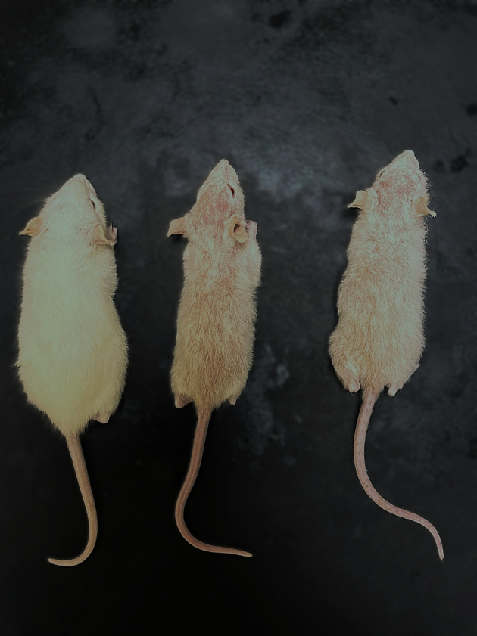
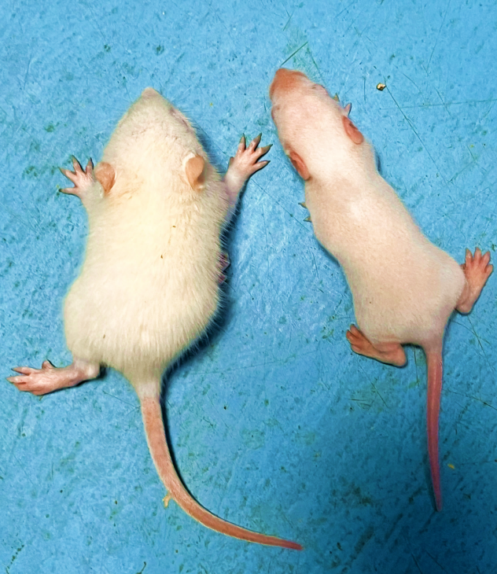
B
A
A
A
C
A
A
A
B
A
Fig. 4. (A) Group I pup with normal appearance, (B) Group II pup, and (C) Group III pup exhibiting a leaner body and reduced hair density compared to group I at PND 15
Fig. 3. (A) group I pup with normal hair development and (B) group II pup with leaner body and delayed hair development at PND 8

3.3 Offspring parameters
A significant variation in offspring parameters was observed among the experimental groups. The lead-treated group showed a significant reduction in litter weight and litter size at birth compared with the control group. In addition, the number of live pups per dam was significantly lower and the number of dead pups per dam was significantly higher in the lead-exposed group. Dams exposed to lead acetate also showed a higher frequency of pup loss and pup-eating behavior compared with controls during the early postnatal period.
The Moringa oleifera supplemented group demonstrated significant improvement in litter weight, litter size, and number of live pups per dam, along with reduced pup mortality compared with the lead-only group. However, these values remained statistically different from the control group, indicating partial but not complete recovery of offspring survival parameters. The observed Mean ± SE values are mentioned in table 5
Table 5. Offspring parameters
Group | No. of dams | Litter Weight (Mean ± SE) | Litter size at birth (Mean ± SE) | Total live pups/group | Live pups/dam (Mean ± SE) | Total dead pups/group | Dead pups/dam (Mean ± SE)
I | 6 | 40.60ᵃ ± 1.13 | 08.17ᵃ ± 0.40 | 49 | 08.17ᵃ ± 0.40 | 00 | 00.00ᵇ ± 0.00
II | 6 | 24.83ᶜ ± 1.62 | 06.50ᵇ ± 0.43 | 39 | 03.00ᶜ ± 0.58 | 21 | 03.50ᵃ ± 0.72
III | 6 | 27.80ᵇ ± 1.07 | 07.33ᵃᵇ ± 0.21 | 44 | 04.83ᵇ ± 0.48 | 15 | 2.50ᵃ ± 0.62
Means with different superscripts in row differ significantly (p≤0.05)
3.4 Haematology — dams and pups
Haematological evaluation revealed significant group-wise differences in erythrocytic indices in both dams and pups. In the lead-treated group, haemoglobin (Hb), total erythrocyte count (TEC), and packed cell volume (PCV) were significantly reduced compared with the respective control group values, indicating Haematological suppression following lead exposure.
Both lead-exposed dams and pups showed statistically lower Hb concentration, TEC, and PCV values relative to controls. In contrast, the Moringa oleifera supplemented group showed significantly higher Hb, TEC, and PCV values compared with the lead-only group in both dams and pups. However, these parameters remained significantly lower than control values, indicating partial restoration of erythrocytic indices with supplementation. The observed Mean ± SE values are mentioned in table 6 and 7
Table 6. Haematological examination in dams
Parameter | (Mean ± SE)
Parameter | Group I | Group II | Group III
Hb (g/dL) | 14.84ª ± 0.18 | 09.50^{c} ± 0.34 | 13.01^{b} ± 0.42
TEC (x10⁶/µl) | 08.05ª ± 0.12 | 05.22^{c} ± 0.30 | 07.24^{b} ± 0.12
PCV (%) | 44.18ª ± 0.53 | 30.42^{c} ± 0.87 | 38.53^{b} ± 0.71
Means with different superscripts in column differ significantly (p≤0.05)
Table 7. Haematological examination in pups
Parameter | (Mean ± SE)
Parameter | Group I | Group II | Group III
Hb (g/dL) | 13.90ᵃ ± 0.31 | 08.47ᶜ ± 0.34 | 11.82ᵇ ± 0.25
TEC (x10⁶/µl) | 07.08ᵃ ± 0.10 | 04.37ᶜ ± 0.14 | 05.91ᵇ ± 0.12
PCV (%) | 41.16ᵃ ± 0.40 | 29.00ᶜ ± 1.03 | 34.23ᵇ ± 0.90
Means with different superscripts in column differ significantly (p≤0.05)
3.5 Blood lead and mineral levels
Blood lead concentration showed a significant increase in both dams and pups of the lead-treated group as compared with their respective control groups. The elevation confirmed substantial systemic absorption and maternal–offspring transfer of lead during gestation and lactation. In the Moringa oleifera supplemented group, both dams and pups showed a statistically significant reduction in blood lead concentration compared with the lead-only group; however, the values remained significantly higher than controls.
Analysis of essential mineral concentrations revealed significant alterations in both dams and pups following lead exposure. Lead-treated animals showed reduced blood levels of calcium, iron, zinc, and copper compared with controls, indicating disturbance of mineral homeostasis associated with systemic lead toxicity. The reduction was more pronounced in the lead-only group, while the Moringa oleifera supplemented group demonstrated partial restoration of these mineral levels in both dams and pups compared with the lead-treated group.
Overall, the findings in both maternal and offspring samples indicate that perinatal lead exposure increases circulating lead burden and concurrently disrupts essential mineral balance, whereas dietary Moringa oleifera supplementation partially mitigates these alterations but does not completely normalize the values. Elemental concentrations were corrected for dilution factors and expressed as µg/dL or mg/dL depending on the element analyzed.
Prior to analysis, the ICP-MS instrument was calibrated using multi-element standard solutions for all elements included in the study. Calibration curves were generated for each element to ensure accurate quantification. As a representative example, the calibration curve for lead (Pb) is shown in Figure 5. The observed Mean ± SE values are mentioned in table 8 and 9.
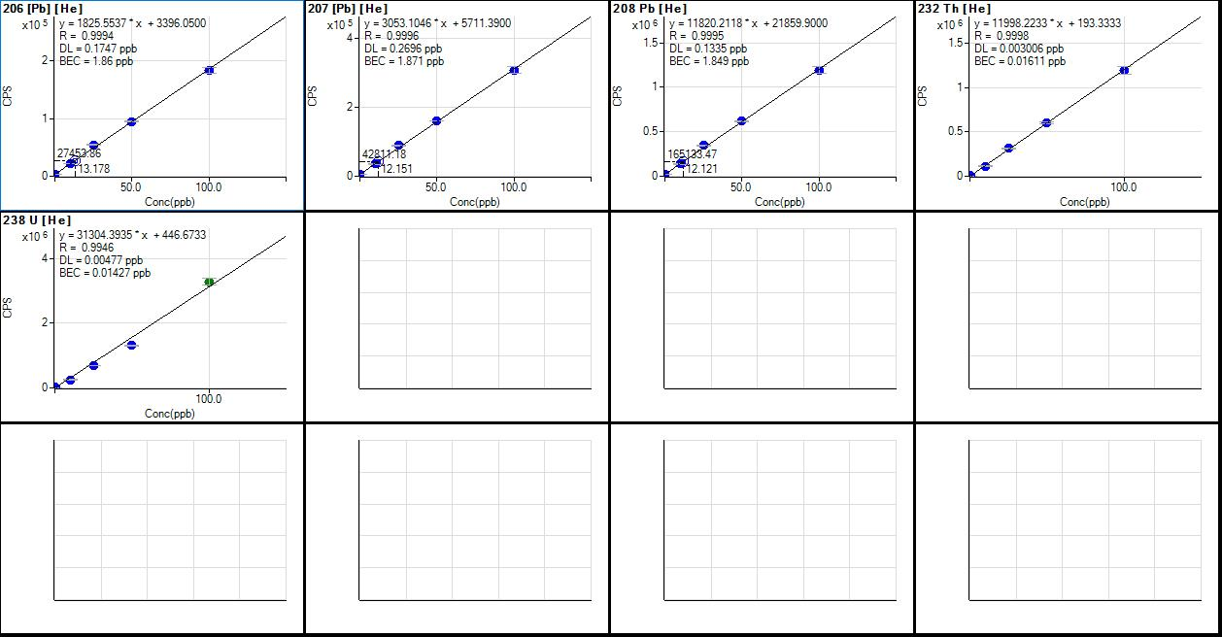
Figure 5: Standard calibration curve of lead (Pb) obtained by inductively coupled plasma–mass spectrometry (ICP-MS).
Table 8: Mean blood lead and mineral level (µg/dL or mg/dL) in dams of different groups
Parameter | (Mean ± SE)
Parameter | Group I | Group II | Group III
Lead (µg/dL) | 001.90^{c} ± 0.01 | 005.690ª ± 0.07 | 004.778^{b} ± 0.03
Calcium (mg/dL) | 010.07ª ± 0.05 | 008.30^{b} ± 0.04 | 008.46^{b} ± 0.03
Copper (µg/dL) | 109.67ª ± 0.33 | 087.96^{c} ± 0.41 | 089.51^{b} ± 0.35
Zinc (µg/dL) | 093.00ª ± 0.46 | 063.57^{b} ± 1.54 | 068.37^{b} ± 1.64
Iron (µg/dL) | 153.03ª ± 0.54 | 126.39^{c} ± 0.85 | 134.14^{b} ± 1.29
Means with different superscripts in column differ significantly (p≤0.05)
Table 9: Mean blood lead and mineral level (µg/dL or mg/dL) in pups of different groups
Parameter | (Mean ± SE)
Parameter | Group I | Group II | Group III
Lead (µg/dL) | 001.780^{c} ± 0.018 | 005.104ª ± 0.029 | 003.45^{b} ± 0.032
Calcium (mg/dL) | 010.13ª ± 0.04 | 007.54^{b} ± 0.07 | 008.31^{b} ± 0.04
Copper (µg/dL) | 115.42ª ± 1.85 | 93.31^{c} ± 0.66 | 106.31^{b} ± 1.61
Zinc (µg/dL) | 081.99ª ± 0.93 | 049.39^{c} ± 0.12 | 056.55^{b} ± 3.06
Iron (µg/dL) | 145.26ª ± 0.93 | 120.34^{c} ± 0.89 | 130.87^{b} ± 0.91
Means with different superscripts in columns differ significantly (p≤0.05)
4. Discussion
The present study demonstrates that perinatal exposure to lead acetate produces marked systemic and developmental toxicity in pregnant Wistar rats and their offspring, characterized by reduced maternal body weight gain, impaired pup growth, adverse litter parameters, Haematological depression, elevated blood lead burden, and disruption of essential mineral balance. Dietary supplementation with Moringa oleifera produced significant but partial amelioration across most measured parameters, indicating its supportive protective role.
Maternal body weight and weekly body weight gain were significantly reduced in lead-exposed dams, particularly during later gestation and lactation. Episodes of negative weight gain observed in exposed animals indicate a catabolic physiological state and metabolic stress during exposure. Similar reductions in maternal weight gain following gestational lead exposure have been reported previously (Aprioku and Siminialayi, 2013; Gargouri et al., 2016; Aglan et al., 2021). These effects are commonly attributed to reduced feed and water intake, gastrointestinal dysfunction, impaired nutrient absorption, and altered metabolic efficiency associated with heavy metal toxicity (Marchlewicz et al., 2004; Elrasoul et al., 2020). The improvement in maternal weight gain observed in the Moringa oleifera supplemented group suggests nutritional and antioxidant support that may enhance metabolic resilience under toxic stress.
Offspring growth parameters in the present study showed clear evidence of developmental toxicity. Lead-exposed pups had significantly lower birth weight and reduced weekly weight gain throughout the postnatal observation period. Growth retardation following perinatal lead exposure has been widely documented (Dhir and Dhand, 2010; Hossain et al., 2016; Aglan et al., 2021). Placental transfer of lead, oxidative stress, endocrine disruption, and altered maternal care behavior are considered major contributing mechanisms. The partial restoration of pup growth and weekly weight gain in the Moringa supplemented group is consistent with reports that nutritional and antioxidant supplementation can mitigate heavy metal–induced developmental suppression (Helal et al., 2020; Ejike et al., 2023).
Litter parameters further supported reproductive and neonatal toxicity in the lead-treated group, as evidenced by reduced litter size, decreased litter weight, increased pup mortality, and higher incidence of maternal cannibalism. Comparable reductions in litter size and survival following gestational lead exposure have been reported by Teijon et al. (2006), Aprioku and Siminialayi (2013), and Dhir and Dhand (2010). Lead crosses the placental barrier and accumulates in reproductive tissues and placenta, where it induces oxidative and degenerative changes that contribute to implantation failure, fetal loss, and weak neonates. Lead-induced neurobehavioral alterations in dams may also impair maternal care and increase pup mortality and cannibalism (Numan and Stolzenberg, 2009; Taroco et al., 2015). The partial improvement in litter outcomes observed with Moringa oleifera supplementation supports its protective nutritional and antioxidant role, although the persistence of subnormal values indicates incomplete reversal of toxic effects.
Haematological findings in both dams and pups revealed significant reductions in haemoglobin, total erythrocyte count, and packed cell volume in the lead-exposed group, indicating lead-induced anemia. These findings are in agreement with earlier reports describing hematotoxic effects of lead exposure (Masso-Gonzalez and Antonio-Garcia, 2009; Jassim and Hassan, 2011; Ilesanmi et al., 2022). Lead interferes with heme biosynthesis by inhibiting key enzymes, including δ-aminolevulinic acid dehydratase and ferrochelatase, and promotes erythrocyte membrane damage and hemolysis (Aladaileh et al., 2020). The significant improvement in Haematological indices in the Moringa supplemented group may be attributed to its high iron and micronutrient content and antioxidant phytochemicals that support erythropoiesis and reduce oxidative damage to blood cells (Gopalakrishnan et al., 2016; Abubakar et al., 2020). However, incomplete normalization suggests that supplementation provides supportive rather than complete Haematological protection under continued toxic exposure.
Blood lead concentrations were markedly elevated in exposed animals, confirming effective systemic absorption and transfer during gestation and lactation, consistent with previous experimental findings (Antonio et al., 2003; Rahman et al., 2018). The significant reduction in blood lead levels in the Moringa oleifera supplemented group suggests a potential role in reducing lead bioavailability or enhancing elimination. This effect may be related to plant phytochemicals with metal-binding capacity and improved antioxidant defense, as reported in earlier studies of plant-based interventions in heavy metal toxicity (Helal et al., 2020; Ejike et al., 2023, Radi et al., 2023).
An important additional finding of the present study was the disruption of essential mineral balance in lead-exposed animals, including reductions in calcium, iron, zinc, and copper levels. Lead is known to compete with and displace essential divalent cations, particularly calcium and iron, thereby altering enzymatic function and metabolic regulation (Ouyang et al., 2019). Iron depletion contributes directly to impaired haemoglobin synthesis, while altered calcium and zinc balance affects multiple cellular processes. The partial restoration of mineral levels observed in the Moringa supplemented group is likely related to its high mineral content and improved nutritional status, which may help counteract lead-induced mineral displacement (Melebary and Elnaggar 2023).
Taken together, the findings of the present study indicate that perinatal lead exposure produces a broad spectrum of systemic and developmental toxic effects involving growth suppression, reproductive impairment, Haematological depression, elevated toxic metal burden, and mineral imbalance. Moringa oleifera supplementation produced consistent partial amelioration across these domains, supporting its role as a beneficial nutritional adjunct. However, the persistence of significant differences from control values across most parameters indicates that nutritional supplementation alone cannot fully counteract substantial lead exposure and should be viewed as supportive rather than curative (Ejike et al., 2023).
Importance of the Study
Lead exposure remains a significant environmental health concern because of its persistence and its ability to disrupt multiple physiological systems, particularly during pregnancy and early developmental stages. Perinatal exposure can adversely affect maternal health, fetal and postnatal growth, hematological status, and mineral homeostasis in the developing offspring. Understanding these systemic effects is important for evaluating the broader biological impact of lead toxicity during critical periods of development. The present study provides experimental evidence on the influence of perinatal lead exposure on maternal and offspring growth performance, hematological parameters, blood lead burden, and essential mineral balance in Wistar rats. In addition, the study examines the potential protective role of Moringa oleifera, a nutritionally rich plant known for its antioxidant and mineral content, as a supportive dietary intervention against lead-induced toxicity. The findings contribute to a better understanding of developmental lead toxicity and highlight the possible role of natural nutritional strategies in reducing heavy metal–associated health risks.
5. Conclusion
The present study demonstrates that perinatal exposure to lead acetate in Wistar rats results in significant systemic and developmental toxicity as reflected by reduced maternal body weight gain, decreased pup growth and weekly weight gain, impaired litter parameters, increased pup mortality, Haematological depression, elevated blood lead concentration, and reduction in essential blood mineral levels. These findings indicate that gestational and lactational lead exposure adversely affects growth performance, offspring survival, blood profile, and mineral homeostasis in both dams and pups.
Dietary supplementation with Moringa oleifera produced significant improvement in maternal and pup growth indices, litter outcomes, Haematological parameters, and blood mineral status, along with a measurable reduction in blood lead burden compared with lead-only exposed animals. However, since most measured parameters did not completely return to control levels, the protective effect should be regarded as partial.
Overall, the results support the role of Moringa oleifera as a supportive nutritional intervention for mitigating lead-induced alterations in growth, Haematological, and mineral parameters, while emphasizing that exposure reduction remains the primary requirement for effective prevention.

Future Scope
Future studies may focus on understanding the long-term effects of early life lead exposure and nutritional intervention on later stages of growth, reproduction, and overall health. Further research is also needed to investigate the biological mechanisms responsible for lead-induced alterations in haematological parameters and mineral balance. Detailed studies on oxidative stress markers, antioxidant systems, and gene expression may help explain how Moringa oleifera exerts its protective effects and support its potential use as a nutritional approach to reduce heavy metal toxicity.

Acknowledgement
The authors are thankful to the Department of Veterinary Pathology, College of Veterinary Science and Animal Husbandry, Nanaji Deshmukh Veterinary Science University (NDVSU), Jabalpur, Madhya Pradesh, India, for providing the necessary facilities and support to carry out the present research work.
Authors’ Contributions
Dr. Mayur Temghare conducted the experimental work, collected and analyzed the data, performed the literature review, and prepared the initial draft of the manuscript. Dr. Amita Dubey conceptualized and supervised the study, provided scientific guidance, and critically reviewed and edited the manuscript. Both authors read and approved the final manuscript.
Ethical Approval
The experimental protocol entitled “Histochemical study on lead acetate induced neurotoxicity and amelioration with Moringa oleifera in pregnant and perinatal rats” was approved by the Institutional Animal Ethics Committee (IAEC), College of Veterinary Science and Animal Husbandry, Nanaji Deshmukh Veterinary Science University (NDVSU), Jabalpur, Madhya Pradesh, India, vide Proposal No. 05/IAEC/AS/Vety./2025 in the IAEC meeting held on 31.07.2025. A total of 18 rats were sanctioned for the study for a period of six months, and all experimental procedures were conducted in accordance with the CPCSEA guidelines, Government of India.

Disclaimer (Artificial intelligence)

Author(s) hereby declare that NO generative AI technologies such as Large Language Models (ChatGPT, COPILOT, etc.) and text-to-image generators have been used during the writing or editing of this manuscript.
References
Abubakar, K., Mailafiya, M.M., Chiroma, S.M., Danmaigoro, A., Zyoud, T.Y., Abdul Rahim, E. and Abu Bakar Zakaria, M.Z. (2020). Ameliorative effect of curcumin on lead‐induced haematological and hepatorenal toxicity in a rat model. Journal of Biochemical and Molecular Toxicology, 34(6): 22483.
Aglan, H.S., Safar, M.M., Ain‐Shoka, A.A.M., Kandil, A.M., Gebremedhn, S., Salilew‐Wondim, D., Schellander, K. and Tesfaye, D. (2021). Developmental toxicity of lead in rats after gestational exposure and the protective role of taurine. Journal of Biochemical and Molecular Toxicology, 35(8): 22816.
Aladaileh, S.H., Khafaga, A.F., Abd El-Hack, M.E., Al-Gabri, N.A., Abukhalil, M.H., Alfwuaires, M.A. and Abdelnour, S. (2020). Spirulina platensis ameliorates the sub chronic toxicities of lead in rabbits via anti-oxidative, anti-inflammatory and immune stimulatory properties. Science of the Total Environment, 701(1): 134879.
Antonio, M.T., Corredor, L. and Leret, M.L. (2003). Study of the activity of several brain enzymes like markers of the neurotoxicity induced by perinatal exposure to lead and/or cadmium. Toxicology Letters, 143(3): 331-340.
Aprioku, J.S. and Siminialayi, I.M. (2013). Maternal lead exposure and pregnancy outcome in wistar albino rats. Journal of Toxicology and Environmental Health Sciences, 5(10): 185-193.
Dhir, V. and Dhand, P. (2010). Toxicological approach in chronic exposure to lead on reproductive functions in female rats (Rattus norvegicus). Toxicology International, 17(1): 1.
Ejike, O.C., Florence, O.C., Friday, E.A., Chukwuemeka, O.E., Ukamaka, I.A., Micheal, O.C. and Emmanuel, D.C. (2023). Exploring the therapeutic potential of moringa oleifera in lead poisoning: an investigation of its effects on blood lead levels and oxidative stress in rats. International Journal of Clinical and Biomedical Research, 9(2): 1–6.
Elrasoul, A.S.A., Mousa, A.A. orabi, S.H., Mohamed, M.A.E.G., Gad-Allah, S.M., Almeer, R. and Eldaim, M.A.A. (2020). Antioxidant, anti-inflammatory and anti-apoptotic effects of Azolla pinnata ethanolic extract against lead-induced hepatotoxicity in rats. Antioxidants, 9(10): 1014.
Gargouri, M., Saad, H.B., Amara, I.B., Magn, C. and El Feki, A. (2016). Spirulina exhibits hepatoprotective effects against lead induced oxidative injury in newborn rats. Cellular and Molecular Biology, 62(10): 85-93.
Gopalakrishnan, L., Doriya, K. and Kumar, D.S. (2016). Moringa oleifera: A review on nutritive importance and its medicinal application. Food Science and Human Wellness, 5(2): 49–56.
Helal, H.A., El-Tahan, N.R. and Abd El-Rasheed, F.E.S. (2020). Effect of Moringa oleifera (Moringa) on cadmium and lead mixture in rats’ body. Journal of Home Economics, 30(4): 475-490.
Hossain, S., Bhowmick, S., Jahan, S., Rozario, L., Sarkar, M., Islam, S., Basunia, M.A., Rahman, A., Choudhury, B.K. and Shahjalal, H. (2016). Maternal lead exposure decreases the levels of brain development and cognition-related proteins with concomitant upsurges of oxidative stress, inflammatory response and apoptosis in the offspring rats. Neurotoxicology, 56(16): 150-158.
Ilesanmi, O.B., Adeogun, E.F., Odewale, T.T. and Chikere, B. (2022). Lead exposure-induced changes in Haematology and biomarkers of hepatic injury: protective role of Trevo supplement. Environmental Analysis, Health and Toxicology, 37(2):1-7.
Jaishankar, M., Tseten, T., Anbalagan, N., Mathew, B.B. and Beeregowda, K.N. (2014). Toxicity, mechanism and health effects of some heavy metals. Interdisciplinary Toxicology, 7(2): 60.
Jassim, H.M. and Hassan, A.A. (2011). Changes in some blood parameters in lactating female rats and their pups exposed to lead: effects of vitamins C and E. Iraqi Journal of Veterinary Sciences, 25(1): 1-7.
Melebary SJ and Elnaggar MHR. Impact of Moringa oleifera leaf extract in reducing the effect of lead acetate toxicity in mice. Saudi J Biol Sci. 2023 Jan, 30(1):103507.
Marchlewicz, M., Wiszniewska, B., Gonet, B., Baranowska-Bosiacka, I., Safranow, K., Kolasa, A. and Rac, M.E. (2007). Increased lipid peroxidation and ascorbic acid utilization in testis and epididymis of rats chronically exposed to lead. Biometals, 20(1): 13-19.
Masih, A.P., Baqri, S.S.R., Rajesh, G., Bajpai, K.G. and Abbas, S.S. (2020). Reassessing the implications of lead toxicity on the environment and its consequences on human health. Electronic Journal of Biology, 16(1): 144–152.
Masso-Gonzalez, E.L. and Antonio-Garcia, M.T. (2009). Natural antioxidants protect against lead-induced damage during pregnancy and lactation in rat's pups. Ecotoxicology and Environmental Safety, 72(8): 2137-2142.
Numan, M. and Stolzenberg, D.S. (2009). Medial preoptic area interactions with dopamine neural systems in the control of the onset and maintenance of maternal behavior in rats. Frontiers in Neuroendocrinology, 30(1): 46-64.
Ouyang, L., Zhang, W., Du, G., Liu, H., Xie, J., Gu, J. and Fan, G. (2019). Lead exposure-induced cognitive impairment through RyR-modulating intracellular calcium signaling in aged rats. Toxicology, 419: 55-64.
Radi, A. A., Abdel-Wahab, D. A., Hamada, A. M. and Farghaly, F. A. (2023). The impact of humic acid and moringa treatments on enhancing arsenic tolerance in broccoli plants: modulation of sulphur components and enzymatic antioxidant defense. Journal of Soil Science and Plant Nutrition, 23(4), 6721-6737.
Rahman, A., Al-Awadi, A. A. and Khan, K. M. (2018). Lead affects vitamin D metabolism in rats. Nutrients, 10(3): 264.
Taroco, G., de Genova Gaya, L., Resende, D.R., dos Santos, I.C. and Madureira, A.P. (2015). Environmental and dam effects on cannibalism in Wistar rat litters. acta scientiarum. Biological Sciences, 37(2): 225-229.
Teijon, C., Olmo, R., Blanco, D., Romero, A. and Teijon, J.M. (2006). Low doses of lead: effects on reproduction and development in rats. Biological Trace Element Research, 111: 151-165.
Welna, M., Szymczycha Madeja, A. and Pohl, P. (2011). Quality of the trace element analysis: sample preparation steps. Wide Spectra of Quality Control, 1: 1-16.

