ISOLATION AND SCREENING OF MARINE ACTINOMYCETES FROM MANGROVE SOIL FOR BIOACTIVE COMPOUND PRODUCTION

ABSTRACT:
The mangrove ecosystem is a largely unexplored source for actinomycetes with the potential to produce biologically active secondary metabolites. The present study addressed the physico-chemical properties of mangrove soil and screening of potent actinomycete isolates for bioactive compound production. The mangrove soil was collected from coastal regions of Andhra Pradesh, India, and tested for physical properties, colour, odour, and water-holding capacity; pH and electrical conductivity; and chemical properties, such as Carbon, Potassium, Phosphorus, Zinc, Iron, and copper contents. The findings highlighted that mangroves are rich in organic matter and nutrients, providing an ideal habitat for actinomycete formation. A potent Actinomycetes isolated and selective media, Strach casein agar, International Streptomycin Project media (ISP₂), and Actinomycetes isolation agar media (AIA), and identified as Streptomyces enissocaesilis based on cultural, morphological, biochemical, and molecular characteristics. The primary screening was performed using an antibiotic sensitivity assay on Gram-positive and Gram-negative bacterial strains, demonstrating that significant inhibitory activity indicates the antimicrobial properties of the bioactive compound produced by Streptomyces enissocaesilis.
Keywords: Mangrove soil, Physico-chemical properties, Marine actinomycetes, Streptomyces enissocaesilis, crude extracts, antimicrobial activity.
1. Introduction
Mangrove soils are commonly found in wetlands and are often anoxic, though not always sulfidic [1]. These soils typically contain less than 35% sand, 40% silt, and 45% clay [2]. Due to waterlogged conditions that slow plant decomposition, mangrove soils are rich in organic matter, which supports the structure, composition, and productivity of mangrove forests by providing nutrients [3]. Although many mangrove soils have low nutrient levels, nutrient levels vary widely across habitats and even within individual stands [4]. Most are somewhat acidic, which is regulated by bacterial activity and naturally occurring clays. While some mangrove soils are both highly reduced and rich in sulfur, this is not a consistent feature across all mangrove environments [5]. Nutrient availability is one of the key factors affecting mangrove structure. Nitrogen (N) and phosphorus (P), which are essential for plant growth and ecosystem function, are often deficient in mangrove soils [6]. Additionally, soils host a rich and varied microbial life that varies widely depending on soil type [7]. The vital aspect of the research involves the marine mangrove soil's physiological, chemical, and biological properties and its enzyme activities [8]. Actinomycetes are Gram-positive, filamentous bacteria known for producing biologically active compounds, such as antibiotics, anticancer agents, and enzymes [9]. Species of the genus Streptomyces are known to be of great importance in the discovery of natural products among them. The use of mangrove-derived actinomycetes has emerged as an area of interest in recent years because of their ability to adapt to salty and stressful conditions that, in most cases, lead to novel and structurally diverse metabolites [10]. Hence, the current study aims to investigate the physico-chemical properties of mangrove soil and isolate potent actinomycetes capable of producing bioactive compounds with pharmaceutical and biotechnological applications.
2. MATERIALS AND METHODS
2.1. Collection of Mangrove soil
The Mangrove soil was collected from the Krishnapatnam coastal region, Andhra Pradesh, India. The sample was collected at a depth of 3-10 cm and placed in sterile plastic bags, and transferred to the Department of Virology at Sri Venkateswara University for further research.
2.2. Physical Properties of mangrove soil
The collected mangrove soil was air-dried at room temperature and sieved (<2 mm) to determine its quantity, size, shape, mineral, and physical characteristics [1].
Soil texture: Soils are made up of three different-sized particles – sand, silt, and clay, and they all fit into one category called "soil texture" [11]. To determine soil texture, 100 grams of dry soil was combined with 100 ml of distilled water and left to stand for 24 hours
Porosity of soil: The way large numbers of soil particles aggregate together affects thickness and porosity; dense soil volumes have less air and water that can flow through them. Therefore, the more stable and fertile the soil is, the more carbon it will store [12].
Colour: The color of the soil varies depending on the mangroves; topsoil is medium to dark brown, and darker soil is considered richer in organic matter, meaning it is likely to deliver more nutrients to plants [13].
Permeability and density: Soil permeability measures the ease with which air and water flow through the soil, providing a consistent water supply while promoting deep root growth. Bulk density is the weight per cubic metre of soil and reflects its porosity; soils that are loose and porous tend to have a lower bulk density than soils that are compacted and tighter [14].
Water Holding Capacity: The water-holding capacity (WHC) of soil varies with soil texture. Soil texture's capacity to physically retain water against gravity is known as its "water-holding capacity" [15]. The mangrove soil (5g) was transferred to a test tube, and water was added dropwise. The soil's water absorption was then observed and measured.
2.3. Chemical Properties
Soil Salinity: Salinity affects the distribution of plant species and soil microbial activity. 1 gram of soil was mixed with 5 millilitres of distilled water, agitated until 95% of the salts dissolved, and then allowed to settle. The solution was measured with an electrical conductivity meter [16].
pH: Five grams of soil were mixed with distilled water, and the mixture was measured for pH using a pH meter [17].
Organic matter: The soil's organic matter measures the amount of plant and animal waste in the soil. Both micronutrients, such as iron, copper, and zinc, and macronutrients, such as phosphorus and nitrogen, may be found in soil organic matter [18].
2.4. Biological Properties
2.4.1 Isolation of marine microorganism (Actinobacteria)
The marine soil was air-dried at room temperature for 3-5 days, aseptically ground with a mortar and pestle, and dried at 50 °C for 1 hour in a dry oven to reduce bacterial and mould populations [19]. For isolating marine Actinobacteria, 1 gram of the soil was serially diluted in a sterile tube with 50% seawater, then 100 microliters from each dilution were spread on Petri plates onto selective media: Starch Casein Agar media (SCA), Actinomycetes isolation agar media (AIA), and Nutrient agar media (NAM). The plates were incubated at room temperature for up to 4 weeks to promote actinomycete growth. Later, the Actinomycetes colonies were sub cultured onto Actinomycetes isolation agar (AIA) and incubated at room temperature for 7-14 days to obtain pure isolates. The isolated actinobacteria strains were stored in International Streptomyces Project-2 (ISP-2) agar slants [1]. The isolates were examined for macroscopic, microscopic, and cultural characteristics, as well as for biochemical tests, for further identification.
2.4.2. Cultural Characteristics of Actinomycetes
The actinobacterial isolates were grown on the ISP2 agar medium after incubation at 28 °C for 7-14 days. The cultural characteristics (macroscopic and morphological) were studied using standard procedures. The colour, aerial mycelium, and soluble pigment production were determined according to the National Bureau of Standards /Inter-Society Color Council color system. Nonomura’s key and Bergey’s manual were utilized for taxonomic identification traits, such as using carbon and nitrogen sources of Actinobacterial species [20]. Finally, the strain was identified by 16S DNA sequencing.
2.4.3. Biochemical tests for Actinomycetes
After preliminary screening, the actinomycete isolates that tested positive were selected for biochemical testing, such as starch hydrolysis, Gelatine liquefaction, Casein hydrolysis, H₂S production, and sugar fermentation [21].
Starch Hydrolysis: The ability to degrade starch was tested by inoculating the isolate onto starch agar (Starch, peptone, beef extract, agar, distilled water) and incubating for 2-3 days. A known volume of iodine solution was poured onto the medium to detect starch hydrolysis and observe the hydrolyzed zone around the colony [22].
Gelatin Liquefaction: Gelatinase production by the isolates was assessed by inoculating cultures into a nutrient gelatin medium and incubating for 5-7 days. The positive result indicates a loss of the medium's gel-forming properties even at 4 °C [23].
Casein Hydrolysis: The isolates' ability to produce extracellular caseinase was detected using skim milk agar (Skim milk powder, agar, distilled water). The presence of a clear halo zone surrounding the growth indicated a positive result [24].
H₂S Production: The utilization of sulfur-containing amino acids for H₂S Production was detected using sulphide indole motility agar (Peptone, Beef extract, Ferrous ammonium sulfate, sodium thiosulfate, agar medium). The formation of black precipitate at the inoculated area indicated the reaction between ferrous ions and hydrogen sulfide to give ferrous sulfate [25].
Sugar fermentation: The fermentation of sucrose, glycerol, and maltose, producing acid and gas, was tested using sugar fermentation broth. The purified isolates were inoculated into a broth medium containing the respective sugar sources. Formation of acid was indicated by a change in the medium's color from red to yellow, and the accumulation of bubbles in the inverted Durham tube was indicative of gas production [25].
2.5 Screening of Actinomycetes isolates for Bioactive Compounds production
The Actinomycetes culture was screened for the ability to produce bioactive compounds. The culture was inoculated into ISP2 medium containing 50% seawater in a sterile flask and incubated at 28 °C on a rotary shaker (120 rpm) for 5 days. After 5 days, the broth was filtered, and the filtrate was used to test antimicrobial activity. The overnight bacterial cultures of E. coli, Klebsiella pneumonia, Staphylococcus aureus, and Bacillus subtilis were used as test organisms. The microorganisms were spread uniformly on an agar plate, and wells were bored into the agar surface, then filled with the culture filtrate, and the plates were incubated at 37°C for 24 to 48 hrs [8].
3. RESULTS AND DISCUSSION
3.1. Physico-chemical properties of mangrove soil
The present research work assessed the physical, chemical, and biological properties of mangrove [9]. The soil was dark brown and had a normal odour, indicating organic content. It exhibited a heterogeneous texture, with sand as the dominant layer, followed by silt and clay. The water retention capacity was average, providing the appropriate moisture to support microbial activity.
Table 1 Physical properties of mangrove soil
S. No | Parameters | Results
1. | Color | Dark brown
2. | Odor | Normal
3. | Water holding capacity (WHC) | 1.2 mL per 5 g of soil

The results indicated that soil pH was alkaline at 7.6 (Table 2). Soil pH affects nutrient availability and biological activity, and can range from acidic to alkaline in tropical mangroves [10]. The electrical conductivity depends on soil type and organic matter content, with the highest EC of 2.075 dS/cm in mangrove soil. EC in coastal soil changes with the seasons due to rainfall and evaporation [26]. Organic carbon in mangrove soil was 0.24%. Similarly, Ishfaq et al. (2025) reported <1% organic carbon in mangrove soil, a nutrient-poor soil [27]. Phosphorus was variable, with subsoil mangrove phosphorus of 50 kg/ha. Average available potassium was 161 kg/ha. Available sulfur was 60.57 ppm. Micronutrients were low in zinc (0.41 ppm) but relatively higher in Mn (1.69 ppm), iron (14.7 ppm), and copper (0.1 ppm) in mangrove soil (Table 2). Studies indicated that copper, iron, manganese, zinc, and magnesium are both nutrients and toxins in mangroves [27,28,29]. This study supports the importance of micronutrients in mangrove vegetation.
Table 2. Chemical Properties of Mangrove Soil
S. No | Parameters | Value
1. | pH | 7.6
2. | Electrical Conductivity (dS/m) | 2.09
3. | Carbon (kg/ha) | 0.24
4. | Potassium (kg/ha) | 161
5. | Zinc (kg/ha) | 0.41
6. | Manganese (kg/ha) | 1.69
7. | Phosphorus (kg/ha) | 50
8. | Iron (kg/ha) | 14.17
9. | Copper (kg/ha) | 0.01

3.2. Morphological (Micro and macroscopic) characteristics and Biochemical Test:
The actinomycetes were grown on Starch Casein agar (SCA), Actinomycetes isolation agar (AIA), and Nutrient agar (NAM) [1]. The aerial mycelium formed branched, spore-bearing hyphae with loop-like shapes and a gold-yellow colour (Figure 1), as observed under the microscope. The isolate was clearly polymorph, with colonies completely covered by aerial mycelium, and it formed a clear zone around the colony (Table 3) [8]. These morphological characters closely agree with the findings of Goodfellow (1998) and Hoshino (2004), [30,31]. In the carbon assimilation test, the isolate showed positive test for starch and gelatin liquefaction and casein hydrolysis, and also the sugar fermentation test mentioned in Table 3.

Fig. 1. Morphological Characteristics and Biochemical Test of Actinomycetes
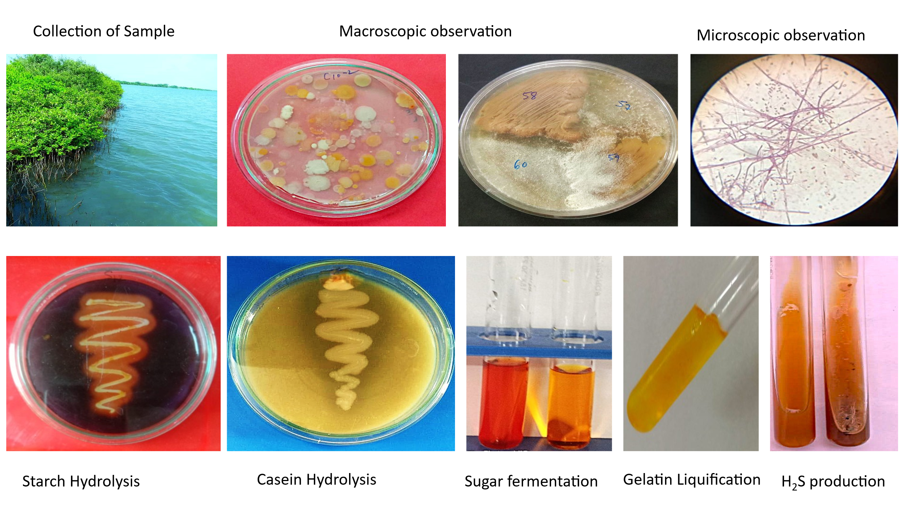
Table 3: Morphological Characteristics and Biochemical Tests for Marine Actinomycetes

S. No | Characteristics of Isolated Actinomycetes | Results
1. | Colony colour | Golden yellow
2. | Colony appearance | Mycelial (cottony)
3. | Sporulation of aerial mycelia | Long chains
4. | Motility | Nonmotile
5. | Gram’s staining | Gram+ve
6. | Starch hydrolysis | +ve
7. | Gelatin liquification | +ve
8. | Casein hydrolysis | +ve
9. | H₂S production | +ve
10. | Sugar Fermentation | +ve

3.3. Identification of Actinomycetes
The 16S rRNA sequence reported in the NCBI GeneBank, compared with sequences in the genomic database, showed Streptomyces sps as the closest match [21]. The phylogenetic tree was generated using the neighbour-joining method and is shown in Fig. 2. The database was deposited in NCBI GenBank with an accession number PX426347. Based on the cultural, morphological, physiological, and molecular analysis, the species was identified as Streptomyces enissocaesilis PX426347 [37&38]

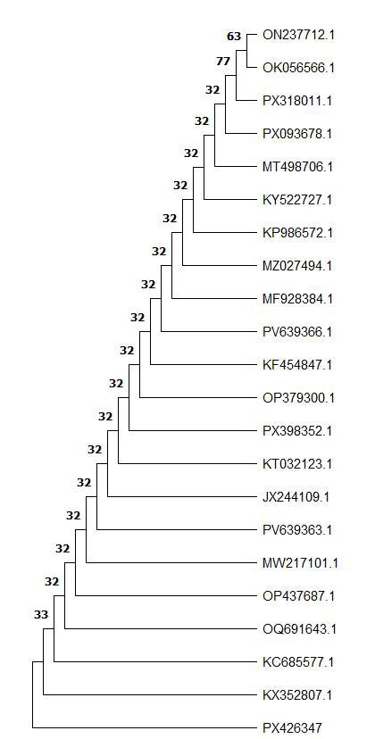
Figure 2: Phylogenetic tree of isolated actinomycetes
3.3. Screening of actinomycetes by antimicrobial activity
A morphologically distinct strain with clear zones around the colonies was observed in the starch-casein medium after 5 days of incubation (Figure 1). These strains were screened for bioactive compound production; both exhibited strong antimicrobial activity against Gram-negative bacteria. E. coli, Klebsiella, and Gram-positive bacteria, Staphylococcus aureus, and Bacillus subtilis were used as test organisms, as shown in Table 4. Streptomyces is used as a standard antibiotic [32]. These results were correlated with the bioactive compounds of Nocardia alba and Streptomyces species; similar findings were reported by Janardan and YJ Rao [8,9].

Table 4: Antibiotic sensitivity test
S. No | Bacterial cultures | Zone of inhibition (cm)
1. | Staphylococcus aureus | 1.5
2. | Bacillus subtilis | 3.0
3. | Escherichia coli | 0.5
4. | Klebsiella | 0.7
5 | Standard Antibiotic | 1.2

The morphological and chemical characterisation of Actinomycete species is mainly based on the colour of aerial and substrate mycelia and soluble pigments, the shape and ornamentation of the spore surface, and the stability of the genus, which is Streptomyces [22]. Furthermore, physiological characteristics such as the temperature range for growth, the degradation of Starch Gelatine, the fermentation of sugars, and the reduction of nitrates are considered to be characteristic of Actinomycetes [33]. The presence of a wide range of enzymatic activities suggests the potential to produce bioactive secondary metabolites. These results confirm earlier observations that mangrove-derived Streptomyces species are valuable sources of new bioactive compounds with pharmaceutical and industrial applications [34,35& 36].
4. CONCLUSION
Marine environments are particularly complex and host a diverse array of life forms that inhabit conditions with extreme variations in pressure, salinity, and temperature. Owing to this nature, marine microorganisms have developed exceptional metabolic and physiological capabilities to survive in such intense habitats, leading them to produce metabolites that terrestrial microorganisms cannot. Extensive research on marine natural products over the past four decades has revealed that marine actinomycetes are the most prolific sources of novel and diverse metabolites. In the present study, marine actinomycete Streptomyces enissocaesilis (PX426347) was isolated from mangrove soil and screened for its ability to produce bioactive compounds. The crude bioactive compound has shown good antimicrobial properties, and further research is underway to produce it in large quantities, purify and characterise it, and make it industrially relevant.

Acknowledgements: The corresponding author is thankful to the Sri Venkateswara University authorities for providing financial support under RUSA Phase- II to carry out the faculty research project No. UGC-III (7)/RP/RUSA/2025.
Disclaimer (Artificial Intelligence)
The author (s) hereby declare that no generative AI technologies, such as Large Language Models (Chat GPT, COPILOT, etc.) and text-to-image generators, have been used during the writing or editing of this manuscript.
REFERENCES
- Alongi, D. M., G. Wattayakom, J. Pfitzner, F. Tirendi, I. Zagorskis, G. J. Brunskill, A. Davidson, and B. F. Clough. 2001. Organic carbon accumulation and metabolic pathways in sediments of mangrove forests in southern Thailand. Mar. Geol. 179: 85-103. https://doi.org/10.1016/S0025-3227(01)00195-5
- Sah, K.D., A.K. Sahoo, S.K Gupta and S.K Banerjee, 1989. Mangrove vegetations of Sunderbans and their effect on physicochemical and nutrient status of the soils. Proc. Indian Nut. Sci. Acad. Pact B: Boil. Sci., 55: 125 -132 23.
- Reef, R., I.C. Feller and C.E. Lovelock, 2010.Nutrition of mangroves. Tree Physiol. 30: 1148-1160.21. Reich, P.B., and J. Oleksyn, 2004.Global patterns of plant leaf N and P in relation to temperature and latitude. Proc. Natl. Acad. Sci., USA., 101: 11001-11006. https://doi.org/10.1073/pnas.0403588101
- Chowdhury, R., Sutradhar, T., Begam, M.M., Mukherjee, C., Chatterjee, K., Basak, S.K. and Ray, K., 2019. Effects of nutrient limitation, salinity increase, and associated stressors on mangrove forest cover, structure, and zonation across the Indian Sundarbans. Hydrobiologia, 842(1), pp.191-217. https://doi.org/10.1007/s10750-019-04036-9
- Asif, M.R., Ye, B. and Ye, C., 2025. Acid sulfate soils: formation, identification, environmental impacts, and sustainable remediation practices. Environmental Monitoring and Assessment, 197(4), p.484. https://doi.org/10.1007/s10661-025-13919-5
- Lovelock, C.E., Feller, I.C., Ball, M.C., Engelbrecht, B.M. and Ewe, M.L., 2006. Differences in plant function in phosphorus‐and nitrogen‐limited mangrove ecosystems. New Phytologist, 172(3), pp.514-522. https://doi.org/10.1111/j.1469-8137.2006.01851.x
- Ferreira, T.O., Otero, X.L., de Souza Júnior, V.S., Vidal-Torrado, P., Macías, F. and Firme, L.P., 2010. Spatial patterns of soil attributes and components in a mangrove system in Southeast Brazil. Journal of Soils and Sediments, 10, pp.995-1006. https://doi.org/10.1007/s11368-010-0224-4
- Janardhan, A., Kumar, A.P., Viswanath, B., Saigopal, D.V.R. and Narasimha, G., 2014. Production of bioactive compounds by actinomycetes and their antioxidant properties. Biotechnology research international, 2014(1), p.217030. https://doi.org/10.1155/2014/217030.
- Rao, Y.J. and Narasimha, G., 2021. Isolation and screening of marine actinobacteria for their antimicrobial compounds. Pharmacognosy Research, 13(1).
- Edadhala, S.R. and Golla, N., 2026. Bioprospects of Marine Microbes for Plant Growth Promotion and Disease Control. In Harnessing Microbial Resources for Sustainable Agriculture (pp. 89-128). Singapore: Springer Nature Singapore. https://doi.org/10.1007/978-981-95-4817-0_6
- Schad, P., 2016. The international soil classification system WRB (2014). Novel methods for monitoring and managing land and water resources in Siberia, pp.563-571. https://doi.org/10.1007/978-3-319-24409-9_25.
- Hao, X., Ball, B.C., Culley, J.L.B., Carter, M.R. and Parkin, G.W., 2008. Soil density and porosity. Soil sampling and methods of analysis, 2, pp.743-759. https://doi.org/10.1007/978-3-319-24409-9_25
- Millar, C.E. and Turk, L.M., 2002. Fundamentals of soil science. Daya Books.
- Elhakim, A.F., 2016. Estimation of soil permeability. Alexandria Engineering Journal, 55(3), pp.2631-2638. https://doi.org/10.1016/j.aej.2016.07.034
- Saraswathi, V.S., Johnson, M., and Kumaraguru, A., 2021. Review of the water holding capacity of soil across the tropical and subtropical forests in India. Indian Journal of Ecology, 48(3), pp.641-648.
- Hardie, M. and Doyle, R., 2012. Measuring soil salinity. Plant salt tolerance: methods and protocols, pp.415-425. https://doi.org/10.1007/978-1-61779-986-0_28
- Pazi, A.M.M., Gandaseca, S.E.C.A., Rosli, N.O.R.A.I.N.I., Hamzah, A.H., Tindit, A.E. and Nyangon, L.A.U.R.N.A.2016. Soil pH and carbon at different depths in three zones of mangrove forest in Sarawak, Malaysia. The Malaysian Forester, 79(1-2), pp.164-173.
- Alongi, D.M., 2021. Macro and micronutrient cycling and crucial linkages to geochemical processes in mangrove ecosystems. Journal of Marine Science and Engineering, 9(5), p.456. https://doi.org/10.3390/jmse9050456
- Dunn, P.H., Barro, S.C., and Poth, M., 1985. Soil moisture affects the survival of microorganisms in heated chaparral soil. Soil Biology and Biochemistry, 17(2), pp.143-148. https://doi.org/10.1016/0038-0717(85)90105-1
- Nonomura, H., 1974. The key for classification and identification of 458 species of the Streptomyces included in the International Streptomyces Project. J. Ferment. Technol., 52, pp.78-92.
- El Karkouri, A., Assou, S.A. and El Hassouni, M., 2019. Isolation and screening of actinomycetes producing antimicrobial substances from an extreme Moroccan biotope. Pan African Medical Journal, 33(1). doi: 10.11604/pamj.2019.33.329.19018
- Attimarad, S.L., Ediga, G.N., Karigar, A.A., Karadi, R., Chandrashekhar, N., and Shivanna, C.2012. Screening, isolation, and purification of antibacterial agents from marine actinomycetes. International Current Pharmaceutical Journal, 1(12), pp.394-402. https://doi.org/10.3329/icpj.v1i12.12448
- Bouzahouane, H., Ayari, A., Touarfia, M. and Sedrati, F., 2026. Isolation and antimicrobial potential of actinomycetes associated with the marine gastropod Bolinus brandaris from the Algerian coast. Euro-Mediterranean Journal for Environmental Integration, 11(2), p.91. https://doi.org/10.1007/s41207-025-01060-1.
- Gautham S. A., Shobha, K.S., Onkarappa, R., and TR, P.K., 2008, Isolation, Characterisation and Antimicrobial Potential of Streptomyces Species from Western Ghats of Karnataka, India.
- Finna, P., Usman, P., Wahyu, P.N., and Aulia, A., 2019, May. Isolation and identification of bacteria and actinomycetes isolated from wilting banana plants (Musa sp.). In IOP Conference Series: Materials Science and Engineering (Vol. 532, No. 1, p. 012028). IOP Publishing. DOI 10.1088/1757-899X/532/1/012028
- Rai, A.K., Basak, N., and Sundha, P., 2021. Chemistry of salt-affected soils. Managing salt-affected soils for sustainable agriculture, pp.128-148.
- Ishfaq, M., Tam, N.F.Y., Lang, T., Hussain, M. and Zhou, H., 2025. Nitrogen-Phosphorus conservation and trade-offs in mangroves. Plant and soil, pp.1-20. https://doi.org/10.1007/s11104-024-07130-7.
- Andrade, E., Miyazawa, M., Pavan, M.A., Oliveira, E.L. 2005. Re-evaluation of Manganese Solubility as Affected by Soil Sample Preparation in the Laboratory. Braz.Arch.Bio.Technol.; 48:643-646. https://doi.org/10.1590/S1516-89132005000500017
- Mac Farlane G.R., Pulkownik, A., and Burchett, M.D. 2003. Accumulation and distribution of heavy metals in the grey mangrove, Avicennia marina (Forsk.) Vierh. Biological indication potential. Environ Poll.; 123:139-151. https://doi.org/10.1016/S0269-7491(02)00342-1
- M. Goodfellow, “Nocardia and related genera,” in Topley and Wilson’s Microbiology and Microbial Infections, A. Balows and B. I. Duerden, Eds., pp. 463–489, Arnold, London, UK, 1998.
- Y. Hoshino, A. Mukai, K. Yazawa et al., “Transvalencin A, a thiazolidine zinc complex antibiotic produced by a clinical isolate of Nocardia transvalensis: I. Taxonomy, fermentation, isolation and biological activities,” Journal of Antibiotics, vol. 57, no. 12, pp. 797–802, 2004. https://doi.org/10.7164/antibiotics.57.797
- Hasan, N.H.N., Abdullah, M.D.D. and Saidin, J.B., 2024. Antimicrobial and enzymatic activities of mangrove-associated actinomycetes. Malaysian Applied Biology, 53(3), pp.219-228. https://doi.org/10.55230/mabjournal.v53i3.2864
- Meenakshi, S., Hiremath, J., Meenakshi, M.H., and Shivaveerakumar, S., 2024. Actinomycetes: Isolation, Cultivation, and their Active Biomolecules. Journal of Pure & Applied Microbiology, 18(1). DOI:10.22207/jpam.18.1.48
- Xu, B.L., Wang, Y.Y. and Dong, C.M., 2023. Study on marine actinomycetes and analysis of their secondary metabolites. Life Res, 6(4), p.18. DOI: https://doi.org/10.53388/LR20230018
- Akshatha & Kalyani 2022, Evaluation of Mangrove Soil Streptomyces spp. Exhibiting Culture and Biochemical Variation for Determination of Antibacterial Activity J Pure Appl Microbiol. 2022;16(4):2458-2476. doi: 10.22207/JPAM. 16.4.06.
- Sengupta S, Pramanik A, Ghosh A, Bhattacharyya M. Antimicrobial activities of actinomycetes isolated from unexplored regions of Sundarbans mangrove ecosystem. BMC Microbiol. 2015 21;15:170. doi: https://doi.org/10.1186/s12866-015-0495-4

