Assessment of Fungicide Compatibility with Native Trichoderma Isolates from the Rhizosphere of Kiwifruit (Actinidia Deliciosa A. Chev.)

ABSTRACT

Kiwi (Actinidia Deliciosa A. Chev.), an introduced fruit crop in Jammu & Kashmir, India, is affected by a number of diseases, particularly root diseases that reduce its yield potential significantly. The present investigation was conducted during the months of July-September 2025 using rhizospheric soil samples collected from kiwifruit orchards in Pulwama and Baramulla districts of Jammu and Kashmir, India. The study aimed to isolate native Trichoderma spp. from kiwifruit rhizosphere soils and evaluate their compatibility with commonly used fungicides under in vitro conditions. Sixteen Trichoderma isolates were obtained using the serial dilution technique on Potato Dextrose Agar (PDA) and purified through single spore/hyphal tip methods. Based on rapid radial and profuse mycelial growth, and early sporulation at 25 ± 1 °C, two fast growing isolates, TAR-2 (Trichoderma Arihal isolate 2) and TWA-3 (Trichoderma Warpora isolate 3), were selected for compatibility studies. Fungicide compatibility was assessed using the poisoned food technique. Results revealed significant variation in growth inhibition among fungicides. Carbendazim 50 % WP (0.1 %) and Carbendazim 12 % + Mancozeb 63 % WP (0.2 %) exhibited near-complete inhibition (>99 %) of both isolates, indicating strong incompatibility. In contrast, Mancozeb 75 % WP (0.3 %) and Metalaxyl 35 % WS (0.1 %) showed negligible inhibition (<1 %), demonstrating high compatibility. Copper oxychloride 50 % WP (0.3 %) and Fosetyl-Al 80 % WP (0.1 %) caused moderate, concentration-dependent reductions in mycelial growth but did not completely suppress colony development, suggesting partial compatibility. Statistical analysis confirmed significant differences among treatments at the 5 % level of significance. The findings highlighted that non-benzimidazole fungicides such as Mancozeb, Metalaxyl, Copper oxychloride, and Fosetyl-Al can be safely integrated with selected Trichoderma isolates in integrated disease management (IDM) programmes for kiwifruit. Conversely, Carbendazim-based formulations should be avoided when applying these biocontrol agents. The study reinforced the importance of selecting fungicides that are compatible with beneficial rhizospheric microorganisms for sustainable orchard management.

Keywords: Kiwifruit; Trichoderma; rhizosphere; Compatibility; integrated disease management

- INTRODUCTION

Kiwifruit (Actinidia deliciosa A. Chev.) has become a valuable fruit crop in India due to its excellent nutritional benefits, high vitamin C levels, and growing consumer demand [1]. In India, the commercial farming of kiwifruit has primarily spread across temperate and sub-temperate areas like Himachal Pradesh, Uttarakhand, Arunachal Pradesh, and Jammu and Kashmir, where the climate and soil conditions are ideal for its cultivation and yield [2]. In Jammu and Kashmir, the cultivation of kiwifruit has seen significant growth in recent years, especially in district Baramulla and Pulwama, which provided the optimum altitude, temperature, and soil conditions for the successful development of orchards. The Horticulture Department of Kashmir has established kiwifruit nurseries and orchards in districts such as Baramulla and Pulwama, indicating institutional recognition of their suitability for commercial cultivation, while local farmers report that the climatic conditions of the valley support the growth and productivity of this crop [3].

Despite its expanding cultivation, kiwifruit orchards in these regions often face constraints related to soil health and rhizospheric dynamics, which may adversely affect plant growth, nutrient availability, and overall orchard productivity. Addressing such constraints through environmentally compatible and sustainable approaches is therefore essential for maintaining long-term productivity of kiwifruit under temperate agro-ecosystems. One such potential non-chemical alternative is the use of microorganisms as biological control agents for the eco-friendly and sustainable management of plant diseases [4]. In this context, native rhizospheric microorganisms, particularly Trichoderma spp., have gained considerable attention due to their ability to improve overall plant health [5].

Trichoderma is a well-established plant growth-promoting fungus (PGPF), capable to increase and boost plant growth and development and combat a variety of plant diseases. It demonstrates significant antagonistic effects against soil borne pathogens. Moreover, Trichoderma can trigger both localized and systemic resistance in plants, thereby enhancing their defence systems against pathogens [27]. Its effectiveness, environmental safety, cost-efficiency, and sustainability make Trichoderma a widely recommended eco-friendly biological control method, especially in situations where chemical control options are scarce or when there is a need for residue-free and organically grown crops [6]. Although, Trichoderma has shown similar or even higher efficiency than fungicides in specific conditions, yet the total replacement of fungicides by Trichoderma is far. Under high disease pressure, reliance on biological control alone may be insufficient, necessitating the use of fungicides for effective disease suppression. Consequently, fungicides should not be regarded as alternatives to Trichoderma but rather as complementary components of an integrated disease management strategy. The combined and judicious use of fungicides with Trichoderma-based biocontrol agents can improve disease control efficiency while reducing excessive chemical inputs, thereby promoting environmental sustainability and safeguarding human health [7].

Henceforth, to create an effective disease management strategy, it is essential to thoroughly understand how potential biocontrol agents interact with commonly used agrochemicals. For sustainable agriculture, it is vital to ensure that biocontrol agents work well with current plant protection strategies, including fungicides, insecticides, and herbicides, as this compatibility is key to managing diseases and promoting plant growth. Integrating compatible biocontrol agents with fungicides can enhance the efficiency of disease control, leading to more successful management of soil-borne diseases. Moreover, the combined use of microbial antagonists and synthetic fungicides helps to minimize the risk of resistance development in pathogens while reducing the overall dependence on chemical fungicide applications [8,9].

- MATERIALS AND METHODS

2.1 Isolation and maintenance of Trichoderma isolates

The Trichoderma isolates were isolated from rhizospheric soil samples of kiwifruit taken from two districts viz., Baramulla and Pulwama. From each district, three locations were selected as described in Table 1 and isolation was done by serial dilution technique [10]. One gram of soil sample was weighed and transferred into test tube containing 10 ml sterilized distilled water (dilution 10⁻¹) under aseptic conditions of laminar air flow. From 10⁻¹ dilution, make further dilutions of 10⁻² and 10⁻³ in the test tubes. 0.1 ml suspension was poured from dilution 10⁻³ into Petri plates containing 15-20 ml of Potato Dextrose Agar (PDA). These Petri plates were incubated at 25±1°C in BOD incubator for one week. These plates were monitored daily for microbial growth and individual colonies were transferred to new petri plates containing PDA medium. Purification was done by single spore or hyphal tip method [11]. The Trichoderma isolates were sub-cultured to obtain pure cultures and assessed for vigorous and rapid growth under in vitro conditions on Potato dextrose agar (PDA) at 25±1ºC.

Table 1. Details of Trichoderma isolates collected from different locations of district Pulwama and Baramulla

District | Locations | Isolates | Coding
Pulwama | Arihal | TAR-1, TAR-2 and TAR-3 | Trichoderma Arihal isolate 1, Trichoderma Arihal isolate 2 and Trichoderma Arihal isolate 3
Pulwama | Karimabad | TK-1, TK-2, TK-3 and TK-4 | Trichoderma Karimabad isolate 1, Trichoderma Karimabad isolate 2 and Trichoderma Karimabad isolate 3
Pulwama | Aidigam | TAI-1 and TAI-2 | Trichoderma Aidigam isolate 1 and Trichoderma Aidigam isolate 2
Baramulla | Warpora | TWA-1, TWA-2 and TWA-3 | Trichoderma Warpora isolate 1, Trichoderma Warpora isolate 2 and Trichoderma Warpora isolate 3
Baramulla | Pattan | TPA-1 and TPA-2 | Trichoderma Pattan isolate 1 and Trichoderma Pattan isolate 2
Baramulla | Nowpora | TN-1 and TN-2 | Trichoderma Nowpora isolate 1 and Trichoderma Nowpora isolate 2

2.2 Fungicides for compatibility assay with Trichoderma isolates
The compatibility test of fast growing Trichoderma isolates with the fungicides was evaluated by the food poison technique [12]. Stock solutions of each fungicide were prepared separately according to their respective test concentrations as described in Table 2. The required concentrations were obtained by appropriate dilution with sterilized distilled water. To achieve a 0.1 % concentration, 0.1 g of fungicide was dissolved in 100 ml of sterile distilled water. Similarly, for a 0.2 % concentration, 0.2 g was dissolved in 100 ml, and for a 0.3 % concentration, 0.3 g was dissolved in 100 ml of sterile distilled water. The solutions were thoroughly mixed to ensure even dissolution before being added to the culture medium.

Table 2. List of fungicides and their concentrations

Fungicides | Trade Name | Chemical Name | Formulation | Concentration (%)
- Carbendazim | Bavistin | Methyl benzimidazol-2-ylcarbamate | 50 % WP | 0.1
- Mancozeb | Dithane M-45 | Manganese ethylenebis (dithiocarbamate) (polymeric) complex with zinc salt | 75 % WP | 0.3
- Carbendazim + Mancozeb | SAAF | Carbendazim: Methyl benzimidazol-2-ylcarbamate + Mancozeb: Manganese ethylenebis (dithiocarbamate) (polymeric) complex with zinc salt | 12 % + 63 % WP | 0.1
- Copper oxychloride | Blitox | Copper oxychloride | 50 % WP | 0.3
- Metalaxyl | Ridomil | Methyl N-(methoxyacetyl)-N-(2,6-xylyl)-DL-alaninate | 35 % WS | 0.1
- Fosetyl-Al | Aliette | Aluminium tris (O-ethyl phosphonate) (Aluminium tris-O-ethyl phosphonate) | 80 % WP | 0.1

2.3 Compatibility of Trichoderma isolates with fungicides
The compatibility of six fungicides with selected fast growing Trichoderma isolates was evaluated under in vitro conditions by poisoned food technique as described by Grower and Moore [12]. 50 ml of fungicide suspension at double the desired concentration were prepared by adding an appropriate amount of sterilized distilled water to the standard stock solution. This suspension was then thoroughly mixed with an equal volume of double-strength molten sterilized PDA medium in 100 ml Erlenmeyer flasks under aseptic conditions to obtain the required final concentration. After thorough mixing, 20 ml of poisoned food, thus prepared, was poured in 90 mm diameter Petri plate. A mycelial disc of 3 mm diameter, taken from 7-day-old pure culture of the test fungus, with the help of sterilized cork borer, was aseptically placed in the centre of solidified poisoned PDA. One such mycelial disc on non-poisoned PDA served as check. Three replications were maintained for each concentration including check. The Petri plates were incubated at 25±1°C and observation on mean radial growth was measured in terms of diameter of mycelial growth in Petri plate at the time when fungus in the control plate attained maximum growth of 90 mm. The percent inhibition in growth due to various fungi-toxicant treatments at different concentrations was computed by the formula of Vincent [13]:

$Percent growth inhibition=$Growth in control - Growth in treatment x 100
Mycelial growth in control

2.4 Statistical Analysis
Statistical analysis of the experimental data was carried out using a Completely Randomized Design (CRD). According to Gomez and Gomez [14], standard statistical techniques were used to determine the significance of the differences displayed by the experimental treatments. To identify the least significant difference between the treatments, the crucial difference (CD) in the experiment has been investigated.

3 RESULTS AND DISCUSSION

3.1 Selection of Promising Trichoderma Isolates

Sixteen Trichoderma isolates were recovered from the rhizospheric soils of kiwifruit orchards in the district Pulwama and Baramulla. From the isolates obtained, Trichoderma Arihal isolate 2 (TAR-2) and Trichoderma Warpora isolate 3 (TWA-3) exhibited rapid and robust radial growth on the PDA medium, were chosen for further investigation. These two isolates exhibited swift colony formation, abundant mycelial growth, and early sporulation compared to the others at 25±1ºC under in vitro conditions. These results were in close agreement with Veena et al. [15] who reported that out of 50 isolates of Trichoderma, Trichoderma isolate GT-9, Trichoderma isolate GT-38 and Trichoderma isolate GT-28 completed full plate of 90 mm diameter on potato dextrose media within 4-5 days of incubation, thereby confirming the robust growth of these Trichoderma isolates. Similarly, Dugassa et al. [16] recorded growth of Trichoderma isolates within 5 days of incubation.

3.2 Compatibility of TAR-2 and TWA-3 isolate with fungicides

The in vitro evaluation of fungicides against the TAR-2 and TWA-3 isolates revealed significant variation in percent growth inhibition (Table 3). In case of the TAR-2 isolate, Carbendazim (0.1 %) recorded the highest growth inhibition (99.77 ± 0.08 %), followed by Carbendazim + Mancozeb (0.1 %) with 99.44 ± 0.22 % inhibition. Both treatments were significantly different from each other and exhibited an incompatible reaction (negative response), indicating strong inhibitory effects on the TAR-2 isolate.

A similar trend was observed for the TWA-3 isolate, where Carbendazim (0.1 %) resulted in the highest mycelial inhibition (99.98 %), followed by Carbendazim + Mancozeb (0.1 %) with 99.64 % inhibition. These treatments were also significantly different from each other and showed incompatibility with the TWA-3 isolate, confirming their highly suppressive effect on fungal growth. Carbendazim at 0.1 % concentration caused near-complete inhibition of more than 99 % against both isolates (TAR-2 and TWA-3), which can be attributed to its benzimidazole mode of action that disrupts β-tubulin assembly in fungal cells, resulting in mitotic arrest and inhibition of mycelial growth. The strong incompatibility observed in the present study was in agreement with earlier reports demonstrating complete growth inhibition of Trichoderma spp. at concentrations ranging from 500–2000 ppm, particularly in T. harzianum and T. viride [17].

The combination fungicide Carbendazim 12 % + Mancozeb 63 % WP also exhibited very high inhibitory activity of 99–100 % against both TAR-2 and TWA-3 isolates. This pronounced inhibition is primarily attributable to the systemic action of Carbendazim, a benzimidazole fungicide that interferes with β-tubulin polymerization and cell division, while Mancozeb, a multisite contact fungicide, contributes additional protective toxicity through enzyme inactivation and disruption of metabolic processes. In combination, the systemic mitotic inhibition caused by Carbendazim appears to predominate, resulting in near-complete suppression of mycelial growth despite the comparatively broader but less specific action of Mancozeb. These results were in close conformity with Kumari et al. [18], who reported the incompatible nature of Carbendazim 50 % WP and Carbendazim 12 % + Mancozeb 63 % WP with Trichoderma asperellum at 0.1 % concentration. Similarly, Ajith et al. [5] observed incompatibility of multiple Trichoderma isolates, including SMV (T. viride), SDKd (T. longibrachiatum), GMV (T. harzianum), PSV (T. harzianum), and CPV (T. asperellum), with Carbendazim 50% WP and Carbendazim 12% + Mancozeb 63% WP at two concentrations of 0.1% and 0.15% respectively. From a practical point of view, the findings implied that combining or applying Carbendazim-based fungicides in close succession with Trichoderma-based biocontrol products should be avoided, as such practices would greatly diminish the survival and biocontrol effectiveness of the beneficial agent in the field.

In contrast, Mancozeb and Metalaxyl exhibited negligible mycelial inhibition against both isolates, thereby indicating their compatibility with the tested Trichoderma isolates. In the TAR-2 isolate, Mancozeb recorded 0.16 % mycelial growth inhibition, followed by Metalaxyl with 0.05 % inhibition. These two treatments were statistically different from each other and also differed significantly from the highly inhibitory fungicides. A comparable response was recorded in the TWA-3 isolate, wherein Metalaxyl showed 0.20 % mycelial growth inhibition, followed by Mancozeb with 0.05 % inhibition. Both treatments differed significantly from one another as well as from the strongly inhibitory treatments, confirming their minimal impact on the growth of the isolate. These results were similar to Kumari et al. [18], who observed that Metalaxyl 35 SD, Mancozeb 75 WP at concentrations of 250 ppm, 500 ppm and 750 ppm, were highly compatible, facilitating the vigorous growth of Trichoderma even at higher concentrations. The observed pattern of reduced mycelial growth with increasing fungicide levels emphasizes the critical need to select fungicides that are compatible with Trichoderma in integrated disease management programs. Similar results were also observed by Elshahawy et al. [19] who reported that ten isolates of Trichoderma spp. proved to be compatible with fungicides Thiophanate-methyl, Mancozeb, Metalalaxyl + Mancozeb, Pencycuron and Flutolanil at the concentrations ranging from 50- 800 ppm.

Table 3 Compatibility assay of TAR-2 and TWA-3 isolate with fungicides
Fungicide | Concentration (%) | TAR-2 (Growth inhibition (%) ± SE) | TWA-3 (Growth inhibition (%) ± SE) | Reaction**
Fosetyl-Al 80% WP | 0.1 | 61.23 ± 0.65^{c*} | 50.46 ± 0.08^{c*} | +
Carbendazim 12 % + Mancozeb 63 % WP | 0.1 | 99.44 ± 0.22ª | 99.64 ± 0.03^{b} | -
Mancozeb 75 % WP | 0.3 | 00.05 ± 0.05^{f} | 00.05 ± 0.12^{f} | +
Metalaxyl 35 % WS | 0.1 | 00.16 ± 0.48e | 00.20 ± 0.15e | +
Copper oxychloride 50 % WP | 0.3 | 33.43 ± 0.22^{d} | 25.23 ± 0.07^{d} | +
Carbendazim 50 % WP | 0.1 | 99.77 ± 0.08^{b} | 99.98 ± 0.03ª | -
Control (90 mm) | - | - | - | -
CD | - | 0.05 | 0.15 | -
*Means superscripted with similar letter (s) do not differ significantly
**+ sign indicates Compatibility and – sign indicates Incompatibility

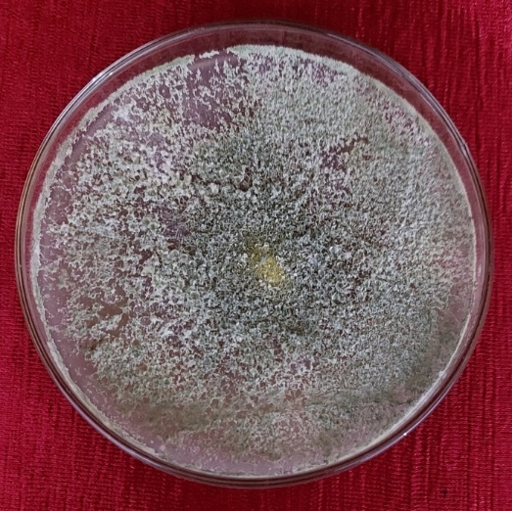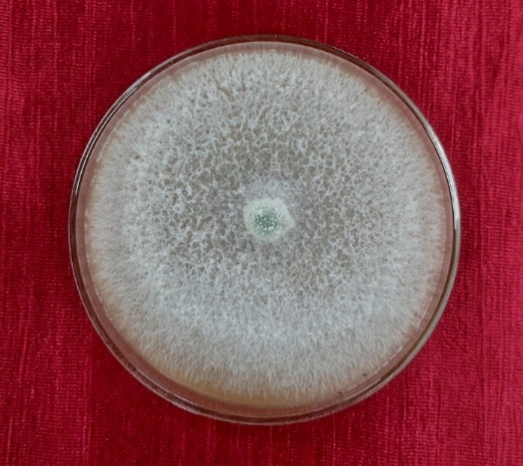
a b

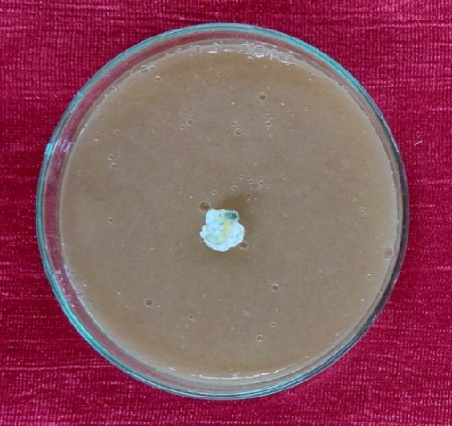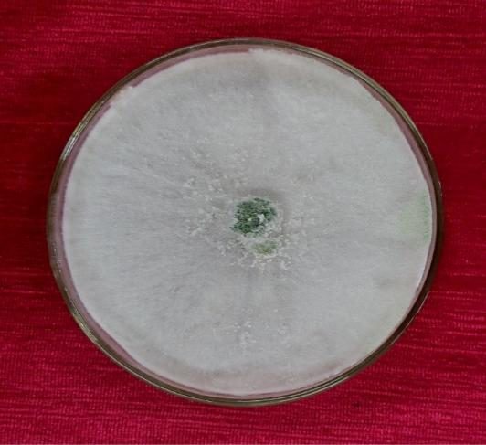
c d

Plate 1. Compatibility assay of fungicides against TAR-2 isolate with representing a- control, b-Mancozeb treated, c- Carbendazim + Mancozeb treated and d- Metalaxyl treated.
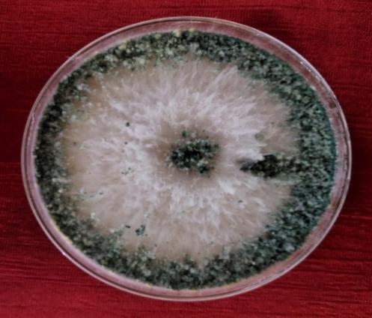
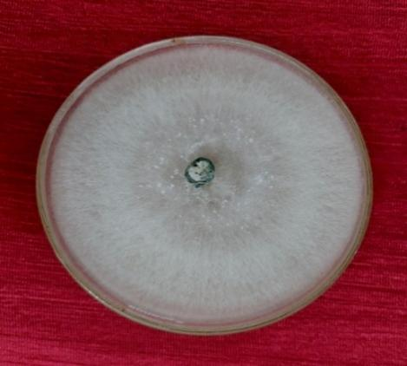
a b

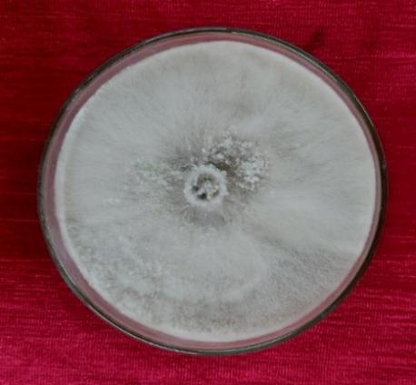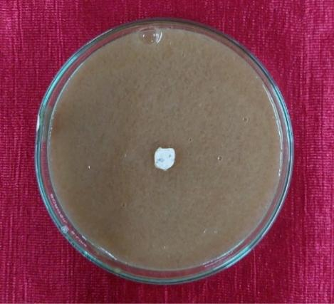
c d

Plate 2. Compatibility assay of fungicides against TWA-3 isolate with a- control, b-Mancozeb treated, c- Metalaxyl treated and d-Carbendazim + Mancozeb treated

Apart from the other fungicides evaluated, Copper oxychloride (0.3 %) and Fosetyl-Al (0.1 %) exhibited partial inhibitory effects on the mycelial growth of the TAR-2 isolate, with 33.43 % and 61.23 % growth inhibition, respectively. Despite this reduction in radial growth, neither treatment resulted in complete suppression of colony development, and appreciable mycelial growth was sustained throughout the incubation period. Therefore, both fungicides were considered as compatible with the TAR-2 isolate under in vitro conditions.

A similar pattern was observed in the TWA-3 isolate, where Copper oxychloride (0.3 %) and Fosetyl-Al (0.1 %) resulted in 25.23 % and 50.46 % inhibition of mycelial growth, respectively. Despite a noticeable decline in radial growth, complete inhibition was not achieved, and sustained colony development was recorded during incubation. Therefore, both fungicides were regarded as compatible with the TWA-3 isolate under in vitro conditions.

These results were consistent with recent findings where copper-based fungicides, particularly copper oxychloride, exhibited moderate inhibitory effects on Trichoderma spp. but did not completely arrest growth. Trichoderma isolates maintained compatibility with copper oxychloride under in vitro conditions, even showing low inhibition rates at tested concentrations of 500-1000 ppm [20, 21, 22, 23]. Such tolerance reinforces the potential for integrating copper-based fungicides with Trichoderma-based biocontrol agents in integrated disease management programs.

The present findings also corroborated earlier reports demonstrating the relative compatibility of fosetyl-Al with Trichoderma spp. under in vitro conditions. Poudel et al. [24] observed sustained radial growth of Trichoderma in media amended with fosetyl-Al without complete inhibition. Likewise, Korkom and Ünal [25] reported measurable tolerance of native Trichoderma isolates to fungicides used against soilborne pathogens. Furthermore, Sirikamonsathien et al. [26] confirmed that Trichoderma strains remained viable and functionally active in the presence of fosetyl-Al. These studies collectively support the present observation that fosetyl-Al permits continued colony development and is suitable for integration with Trichoderma-based biocontrol agents in integrated disease management programmes.

4 CONCLUSION

The study demonstrated that fungicide compatibility varies significantly among tested fungicides, when applied with Trichoderma isolates TAR-2 and TWA-3. Carbendazim (50% WP) and its combination with Mancozeb (12% + 63% WP) exhibited near-complete mycelial inhibition (>99%), confirming their incompatibility with the selected isolates. In contrast, Mancozeb (75% WP) and Metalaxyl (35% WS) showed negligible inhibition (<1%), while Copper oxychloride (50% WP) and Fosetyl-Al (80% WP) caused only moderate growth reduction without complete suppression.

These findings indicate that non-benzimidazole fungicides particularly Mancozeb and Metalaxyl are compatible with the evaluated Trichoderma isolates and may be integrated into kiwifruit disease management programmes. Conversely, Carbendazim-based formulations should be avoided or temporally separated to maintain the biocontrol efficacy of Trichoderma spp. in orchard systems.

CONFLICT OF INTEREST

The authors declare that there are no competing interests regarding the publication of this paper. The research was conducted without any commercial or financial relationships that could be construed as a potential conflict of interest.

DISCLAIMER (ARTIFICIAL INTELLIGENCE)

Author(s) hereby declare that generative AI technologies such as Large Language Models, etc have been used during writing or editing of manuscripts. This explanation will include the name, version, model, and source of the generative AI technology and as well as all input prompts provided to the generative AI technology.

Details of the AI usage are given below:

1. ChatGPT- Used this technology to reduce number of words in some of the paragraphs in the manuscript. All the sentences which obtained in chatGPT technology is reframed after generation (not used as such) to retain meaningfulness and completeness of the sentence.

REFERENCES

- He X, Fang J, Chen X, Zhao Z, Li Y, Meng Y, Huang L. Actinidia chinensis Planch.: A review of chemistry and pharmacology. Front Pharmacol. 2019;10:1236.
- Verma MK, Sharma OC, Mir JI, Raja WH, Nabi SU. Current status and potential of temperate fruit crops for livelihood and nutritional security in India. Indian J Plant Genet Resour. 2024;37:387–403.
- National Horticulture Board. Horticultural crop profile: Kiwifruit. Ministry of Agriculture and Farmers’ Welfare, Government of India; 2023. Available from: https://nhb.gov.in
- Chaithra M. Biological and molecular identification of Trichoderma isolates collected from different sources and analyses of their antagonistic potentiality against plant pathogens. MSc Thesis. University of Agricultural Sciences, Bangalore; 2019.
- Ajith CR, Pankaja NS, Supriya S, Mahadeva J, Umashankar Kumar N, Sunitha M. Compatibility assessment of native non-rhizospheric Trichoderma isolates with various fungicides. J Adv Biol Biotechnol. 2024;27(9):988–999.
- Wedajo B. Compatibility studies of fungicides with combination of Trichoderma species under in vitro conditions. Virol Mycol. 2015;4:149.
- Ferreira FV, Musumeci MA. Trichoderma as biological control agent: Scope and prospects to improve efficacy. World J Microbiol Biotechnol. 2021;37:1–17.
- Kulkarni S, Sagar SD. Trichoderma- A potential biofungicide of the millennium. Bulletin, Department of Plant Pathology, U A S, Dharwad. 2007;1-20.
- Asad SA, Mechanisms of action and biocontrol potential of Trichoderma against fungal plant diseases- a review, Ecological Complexity. 2022;49.
- Johnson LZ. Effect of antibiotics on the numbers of bacteria and fungi isolated from soil by dilution plate method. Phytopathology. 1957;47:630.
- Brown W. Two mycological methods: A method of isolation of a single strain of fungi by cutting a hyphal tip. Ann Bot. 1924;38:404.
- Grower RK, Moore JD. Toximetric studies of fungicides against brown rot organism Sclerotinia fruticola and Sclerotinia laxa. Indian Phytopathol. 1962;15:876–880.
- Vincent JM. Distortion of fungal hyphae in the presence of certain inhibitors. Nature. 1947;159(4051):850.
- Gomez KA, Gomez AA. Statistical procedures for agricultural research. 2nd ed. New York: John Wiley and Sons; 1984.
- Veena GA, Padmodaya B, Devi R, Manjula K, Naidu G. Evaluation of efficacy of antagonistic Trichoderma isolates against Sclerotium rolfsii under in vitro conditions. Int J Chem Stud. 2019;7(4):3002–3008.
- Dugassa A, Alemu T, Woldehawariat Y. In vitro compatibility assay of indigenous Trichoderma and Pseudomonas species and their antagonistic activities against black root rot disease (Fusarium solani) of faba bean (Vicia faba L.). BMC Microbiol. 2021;21(1):115.
- Patel JV, Singh A. Compatibility of Trichoderma spp. with fungicides and efficiency against Rhizoctonia solani. Int J Chem Stud. 2020;8:2254–2257.
- Kumari N, Yadav DL, Bochalya RK, Sharma S, Meena CB, Gautam C. Compatibility of Trichoderma asperellum with different fungicides. J Adv Microbiol. 2025;25(8):1–7.
- Elshahawy IE, Haggag KH, Abd-El-Khair H. Compatibility of Trichoderma spp. with seven chemical fungicides used in the control of soil borne plant pathogens. Res J Pharm Biol Chem Sci. 2016;7(1):1772–1785.
- Budha CB, Shrestha SM, Manandhar HK, Baidya S. In vitro compatibility of some native isolates of Trichoderma spp. with commonly used pesticides. J Plant Prot Soc. 2022:114–122.
- Aydın YK, Ünal SS. Determining the tolerance of native Trichoderma species to fungicides used in control of soilborne fungal diseases. Turk J Agric Food Sci Technol. 2025;13(1):2440–2445.
- Karhade BG, Ingle RW, Pillai TS, Nakle AA, Dhawane AG, Anjana AJ, Mahure SR. Compatibility of Trichoderma asperellum with selected fungicides, insecticides and weedicides. Int J Adv Biochem Res. 2025;9(7):1044–1048.
- Khore TT, Holkar SR, Sadakal OU, Gaikwad SC, Kokani NK. Compatibility analysis of Trichoderma koningii with selected systemic fungicides under laboratory conditions. Int J Adv Biochem Res. 2025;9(11S):1277–1281.
- Poudel S, Pun LB, Paudel R, Pokharel S, Khanal P. Compatibility study of Trichoderma sp. with chemical fungicides commonly used by Nepalese farmers under in vitro condition. Int J Appl Biol. 2024;8(1).
- Korkom Y, Ünal SS. Determining the tolerance of native Trichoderma species to fungicides used in control of soilborne fungal diseases. Turk J Agric Food Sci Technol. 2025;13(S1):2440–2445.
- Sirikamonsathien T, Kenji M, Dethoup T. Potential of endophytic Trichoderma in controlling Phytophthora leaf fall disease in rubber (Hevea brasiliensis). Biol Control. 2023;179:105175.
- I.Linta, Hima, V. M., Sainamole, K. P., & Sajeesh, P. K. (2024). Compatibility of Indigenous Trichoderma spp. with Selected Fungicides and Insecticides. International Journal of Plant & Soil Science, 36(11), 545–553. https://doi.org/10.9734/ijpss/2024/v36i115169

