Review Article
Postharvest Chemical Treatments for Extending Shelf Life and Preserving Fruit Quality

Abstract
Fruits are highly perishable and often lose quality soon after harvest due to rapid ripening, moisture loss and microbial decay. These postharvest losses reduce both the nutritional value and marketability of fruits, affecting both farmers and consumers. Globally, postharvest losses in fruits are estimated to range between 20% and 50%, with higher percentages reported in tropical and developing regions. To mitigate these challenges, various postharvest management strategies have been developed, among which chemical treatments and edible coatings have gained considerable attention. Chemical treatments, including calcium chloride, calcium lactate, ethylene inhibitors such as 1-methylcyclopropene (1-MCP) and natural plant-based antimicrobials, play a crucial role in delaying senescence and maintaining fruit firmness. Calcium salts help strengthen cell wall structure and reduce enzymatic softening, while ethylene inhibitors suppress ripening processes by blocking ethylene action. Natural plant extracts and organic acids exhibit antimicrobial properties that help control postharvest pathogens and reduce spoilage. Edible coatings represent an eco-friendly and sustainable alternative to synthetic packaging materials. These coatings are composed of biodegradable materials such as polysaccharides (e.g., starch, chitosan, alginate), proteins (e.g., whey protein, gelatin) and lipids (e.g., waxes, fatty acids). When applied to fruit surfaces, edible coatings form a thin, semi-permeable barrier that regulates gas exchange, reduces water loss, delays oxidative reactions and limits microbial contamination. Moreover, edible coatings can serve as carriers for functional additives such as antioxidants, antimicrobials and nutraceutical compounds, further enhancing their protective effect. Together, these technologies play an important role in reducing postharvest losses, improving storage stability and supporting food and nutrition security.
Keywords: Postharvest loss, shelf life, edible coatings, chemical treatment, ripening, 1-MCP, polyamines
Introduction
Fruits constitute a fundamental component of a balanced human diet. Fruits provide essential micronutrients such as vitamin C, vitamin A, folates, potassium, dietary fibre and a wide range of phytochemicals that are useful for human body (Schreiner et al., 2013). These micronutrients support immune functions and reduce the risk of chronic diseases (Wallace et al., 2020). Increased consumer awareness regarding nutrition and lifestyle-related disorders has driven a consistent rise in global fruit demand over the past three decades. However, alongside alongside production growth, postharvest loss (PHL) continues to undermine the availability, quality and economic value of fruits (Kitingoja & Kader, 2015).
Postharvest loss refers to the measurable quantitative and qualitative deterioration in fruits occurring between harvest and final consumption (Kader, 2005). These losses may occur during harvesting, handling, transportation, storage, processing and retail marketing. Unlike cereal grains, fruits are highly perishable due to their high moisture content (70–95%), soft texture and active metabolic processes. As a result, fruits are particularly vulnerable to rapid deterioration once detached from the plant. Globally, postharvest losses in fruits are estimated to range between 20% and 50%, with higher percentages reported in tropical and developing regions (FAO, 2019). In developing economies, limited cold chain infrastructure, inadequate packaging, poor road connectivity and traditional marketing systems contribute significantly to these losses (Kitinoja & Kader, 2015).
India presents a paradoxical scenario: it is one of the largest fruit producers in the world, yet it suffers from substantial postharvest inefficiencies. India is the second largest producer of fruits and vegetables after China. According to the Ministry of Food Processing Industries (MoFPI, 2022), postharvest losses in fruits in India range between 15% and 25%, depending on the crop and stage of the supply chain (Fig 1). This reflects a huge economic loss and reduced nutritional security for a growing population. Therefore, a systematic understanding of fruit production patterns and the major causes of postharvest losses is essential for developing effective mitigation strategies.
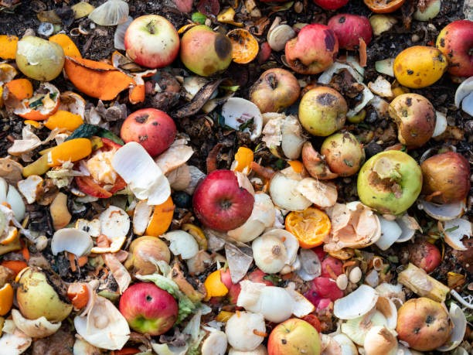
Fig 1. Postharvest loss in fruit
Research Objective
This review aims to:
- Analyze the major physiological, microbial and infrastructural causes of postharvest losses in fruits.
- Critically evaluate the mechanisms, advantages and limitations of postharvest chemical treatments.
- Examine edible coating technologies and recent nano-enabled advancements.
- Provide a comparative framework to assess the effectiveness and commercial applicability of different treatments.
Methodology of the Review
This review aims to provide a comprehensive and systematic overview of postharvest chemical treatments and edible coatings used to extend the shelf life and preserve the quality of fruits. The methodology for this bibliographic review involved a structured search of peer-reviewed literature from scientific databases, including Scopus, Web of Science, PubMed and Google Scholar. The search was conducted using keywords such as "postharvest losses," "fruit shelf life," "edible coatings," "1-MCP," "calcium chloride," "polyamines," "chitosan" and "nano-emulsions."
Inclusion criteria were: (i) original research articles and review papers published in English, (ii) studies focusing on the application of postharvest chemicals or edible coatings on whole fruits, and (iii) research reporting on quality parameters such as firmness, weight loss, microbial decay, and sensory attributes. Exclusion criteria were: (i) studies on processed fruit products (e.g., juices, jams), (ii) articles not available in full-text, and (iii) papers focusing solely on pre-harvest treatments. The search was focused on literature published between 2000 and 2024 to ensure the inclusion of the most recent advances, though seminal older papers were also considered.
Postharvest Interventions for Quality Preservation
Effective postharvest management plays a crucial role in preserving fruit quality from harvest to consumption. Since fruits remain metabolically active even after harvest, they are highly susceptible to rapid ripening, moisture loss, microbial decay and physiological deterioration. In this context, postharvest chemical treatments and edible coatings have emerged as important technological interventions to minimize losses and maintain quality during storage and marketing (Mahajan et al., 2014; Maurya et al., 2024).
Postharvest chemical treatments such as calcium salts, ethylene inhibitors (e.g., 1-MCP), salicylic acid, fungicides and nitric oxide donors help regulate physiological processes by slowing respiration, delaying ethylene action, strengthening cell walls and suppressing microbial growth (Singh et al., 2022). These treatments contribute to maintaining firmness, reducing decay incidence, preserving nutritional quality and extending marketable life (Chen et al., 2021). When applied at appropriate concentrations and under recommended conditions, they significantly enhance storage stability and reduce quantitative and qualitative losses (Palou et al., 2016).
Edible coatings, on the other hand, provide a biodegradable and eco-friendly approach to postharvest preservation (Flores-López et al., 2016). By forming a thin protective layer on the fruit surface, edible coatings act as semi-permeable barriers that reduce moisture loss, modify internal gas exchange and limit microbial contamination. This controlled internal environment slows ripening and senescence while maintaining texture, appearance and nutritional value (Fig 2). Together, postharvest chemical treatments and edible coatings serve as complementary strategies in modern postharvest management systems (Yousuf et al., 2018; Singh et al., 2023). Their integration with proper harvesting, grading, packaging, and cold chain management can substantially reduce postharvest losses, enhance fruit quality, improve economic returns for farmers and strengthen overall food and nutrition security (Porat et al., 2018).
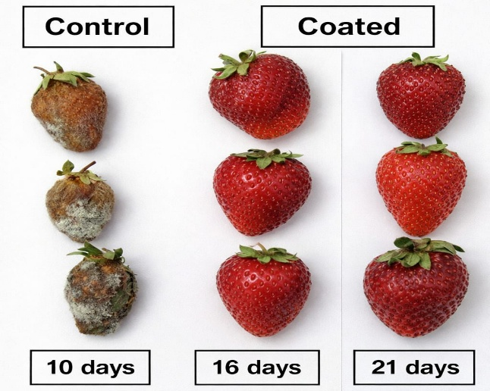
Fig 2. Effect of edible coating on quality of strawberry (Elsabee & Abdou 2013)

Fruit Production Status in India
India has emerged as a global leader in horticultural production. According to the National Horticulture Board (NHB, 2023), India produces approximately 108–110 million tonnes of fruits annually, accounting for nearly 12–13% of global fruit production.
Major Fruit Crops
The principal fruit crops grown in India include: Mango, Banana, Citrus, Papaya, Guava and Pomegranate
Among these:
- Mango contributes nearly 40–45% of global mango production (APEDA, 2023).
- Banana is the leading fruit in terms of production volume.
- Citrus fruits occupy significant area in states such as Maharashtra and Punjab.
Major fruit-producing states include Maharashtra, Andhra Pradesh, Uttar Pradesh, Gujarat, Karnataka, Tamil Nadu, and Madhya Pradesh (NHB, 2023).
Despite this impressive production base, India’s fruit export share remains relatively low compared to its production capacity. One of the primary reasons is postharvest quality deterioration and inadequate infrastructure (APEDA, 2023).
Magnitude of Postharvest Loss in Fruits
Postharvest loss includes:
- Quantitative loss – reduction in weight and volume
- Qualitative loss – deterioration in appearance, texture, nutritional value and safety
A nationwide assessment conducted by NABCONS under the Ministry of Food Processing Industries reported fruit losses ranging from 4.6% to 15.9% at different stages of the supply chain (NABCONS, 2022). Postharvest loss in major fruit crops like guava, apple etc. are listed in Fig 3.
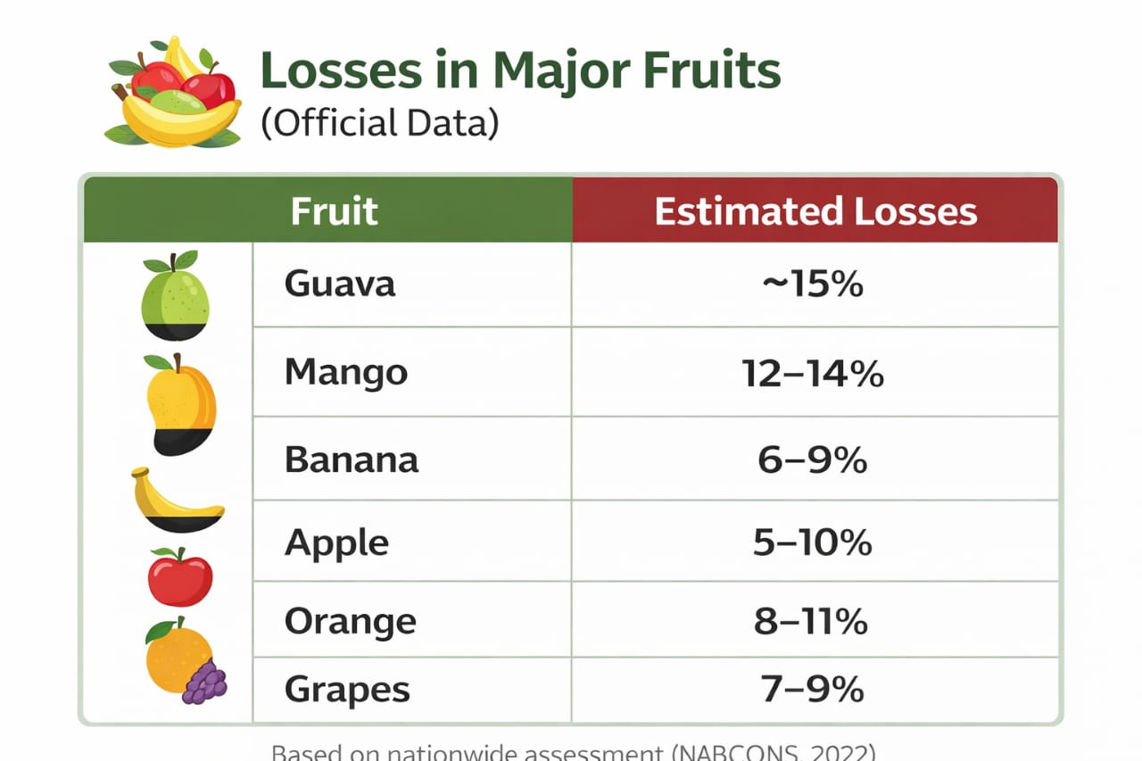
Fig 3. Postharvest loss in major fruit crops as per NABCONS, 2022

Similarly, Jha et al. (2015) estimated that postharvest losses in mango can reach 20% in poorly managed supply chains. These losses are highest at: Farm level (harvesting stage), wholesale markets and retail handling. The absence of precooling facilities and improper packaging aggravates deterioration during transit.
Causes of Postharvest Loss in Fruits
Postharvest losses in fruits result from interconnected biological, physiological, mechanical, environmental and infrastructural factors. Understanding the critical stages where these losses occur is essential for targeted interventions. The primary causes, which often act synergistically, are illustrated in Fig 4 and discussed below.
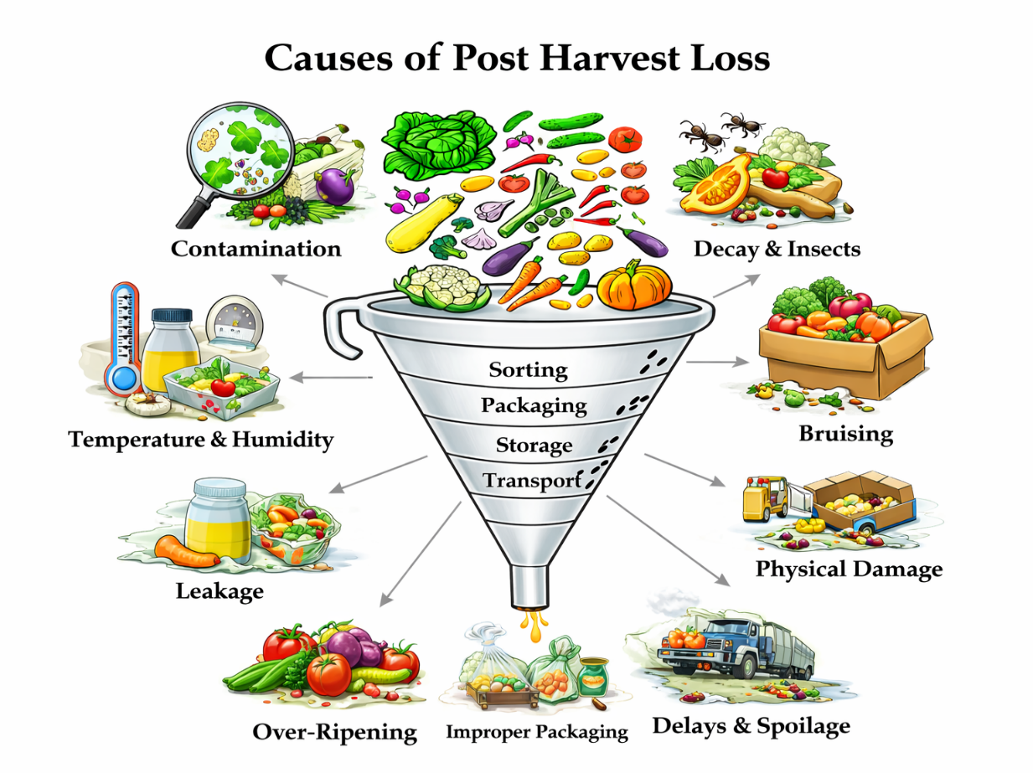
Fig 4. Causes of Postharvest Losses

Physiological Causes
Fruits remain living tissues after harvest and continue metabolic activities such as respiration, transpiration and ripening (Wills et al., 2016).
Respiration
Respiration involves the breakdown of stored carbohydrates to produce energy. High respiration rates accelerate senescence and shorten shelf life. Climacteric fruits like mango and banana exhibit a sharp rise in respiration and ethylene production during ripening (Giovannoni, 2004).
Transpiration
Water loss due to transpiration causes shriveling, loss of firmness and reduction in market weight. High temperature and low relative humidity increase transpiration rates (Kader, 2005).
Ethylene-Induced Ripening
Ethylene plays a crucial role in fruit ripening. Improper storage leading to ethylene accumulation accelerates over-ripening and spoilage (Zhang et al., 2018).
Microbial and Biological Causes
Microorganisms such as fungi and bacteria are major contributors to fruit decay. Common postharvest pathogens include: Colletotrichum gloeosporioides (anthracnose in mango), Penicillium spp. (citrus rot), Botrytis cinerea (grey mold). Microbial infection usually begins at injury sites and spreads rapidly under warm and humid conditions (Sharma et al., 2009). Poor sanitation and delayed marketing further increase infection rates.
Mechanical Damage
Mechanical injuries are common during harvesting, sorting, grading and transportation. Bruising, impact damage and compression injuries disrupt fruit tissues and increase susceptibility to microbial invasion (Jha et al., 2015). Studies by ICAR (2019) demonstrated that improved harvesting tools and cushioning materials significantly reduce mechanical injury in mango and banana supply chains.
Environmental Factors
Temperature is the most critical factor influencing postharvest life. High temperature increases respiration and microbial activity, while extremely low temperatures may cause chilling injury in tropical fruits (Kader, 2005). India faces major challenges due to insufficient cold storage infrastructure. According to the Ministry of Agriculture & Farmers Welfare (2023), the existing cold storage capacity is inadequate for perishable horticultural produce, leading to avoidable losses during peak harvest seasons.
Infrastructural and Supply Chain Constraints
- Postharvest management requires:
- Precooling facilities
- Cold storage units
- Controlled atmosphere storage
- Refrigerated transportation
However, smallholder farmers often lack access to these facilities. Kitinoja & Kader (2015) reported that lack of cold chain integration in developing countries results in 30–40% losses in perishable commodities. Market-level losses are exacerbated by: Poor packaging materials, Overstacking, Prolonged display without refrigeration
India-Specific Challenges
Several structural issues intensify fruit losses in India:
- Fragmented supply chains
- Dominance of intermediaries
- Limited farmer training in postharvest handling
- Inadequate grading and standardization
The Government of India has initiated schemes such as: Mission for Integrated Development of Horticulture (MIDH), Pradhan Mantri Kisan SAMPADA Yojana and Integrated Cold Chain and Value Addition Infrastructure Scheme. These initiatives aim to strengthen postharvest infrastructure and reduce losses (MoFPI, 2022).
Postharvest Chemical Strategies for Shelf Life Extension and Quality Preservation of Fruits
Freshly harvested horticultural products quickly lose their freshness, affecting their market value. Consequently, the horticultural industry has been exploring new methods to control ripening and prolong shelf life (Mahajan et al., 2014). Traditional techniques like cold storage and modified atmosphere storage are employed to extend the shelf life of horticultural products. In recent years, the use of post-harvest chemicals (e.g., calcium salts, salicylic acid, potassium permanganate) and edible coatings (such as starch, chitosan, lipid or nano-emulsions) has emerged as a more effective and sustainable approach (Dhall, 2013). These treatments not only delay ripening and senescence but also maintain fruit firmness, reduce microbial growth and preserve sensory quality (Singh et al., 2022). Compared to conventional storage, they are cost-effective, eco-friendly and enhance consumer safety while significantly extending shelf life and reducing wastage.
Postharvest Chemicals for Shelf Life Enhancement of Fruits
To maintain quality after harvest, fruits require careful handling because they continue to respire, ripen, and undergo physiological changes even after being detached from the plant. Postharvest chemical treatments are widely used to slow down these natural processes, reduce microbial decay and extend storage life without significantly affecting nutritional value. Below is a detailed explanation of the major postharvest chemicals commonly used to enhance shelf life of fruits, along with a comparative analysis of their advantages and disadvantages (Table 1).
Table 1: Postharvest Chemical Treatments for Shelf Life Extension
Treatment Category | Examples | Mechanism of Action | Advantages | Limitations
Ethylene Inhibitors / Modulators | 1-MCP, Potassium permanganate (KMnO4), AVG | 1-MCP blocks ethylene receptors; KMnO4 oxidizes ethylene; AVG inhibits ethylene biosynthesis, thereby delaying ripening and respiration | Delays ripening; maintains firmness; extends shelf life; reduces respiration rate | High cost; requires controlled conditions; uneven exposure risk; regulatory restrictions
Calcium-Based Treatments | Calcium chloride (CaCl2), Calcium lactate | Forms calcium pectate in cell walls; strengthens middle lamella; reduces enzymatic softening | Improves firmness; reduces physiological disorders; enhances storage stability | Surface injury or bitterness at high concentration; requires precise dosage control
Antimicrobial / Disinfectant Treatments | Sodium hypochlorite, Chlorine dioxide, Ozone | Oxidative destruction of microbial cell walls and enzymes; reduces surface microbial load | Controls postharvest pathogens; reduces decay; relatively low cost | Residue concerns (chlorine); equipment cost (ozone); worker safety considerations
Fungicides | Carbendazim, Thiabendazole | Inhibits fungal growth by interfering with cell division and metabolic processes | Effective control of fungal diseases; reduces storage decay losses | Residue and toxicity concerns; resistance development; export regulatory limitations
Growth Regulators | Gibberellic acid (GA3), Salicylic acid | Modulates hormonal balance; reduces ethylene synthesis; enhances antioxidant defense mechanisms | Delays senescence; reduces chilling injury; maintains nutritional quality | Over-application may cause physiological imbalance; crop-specific response variability
Nitric Oxide (NO) Donors | Sodium nitroprusside (SNP) | Acts as signaling molecule; reduces oxidative stress; suppresses ethylene production | Enhances antioxidant enzyme activity; delays senescence; reduces chilling injury | Requires controlled dosage; potential toxicity at high levels
Organic Acids / Natural Compounds | Oxalic acid, Citric acid, Ascorbic acid | Lowers surface pH; inhibits microbial growth; enhances antioxidant capacity | Relatively safe; reduces decay; maintains quality attributes | May alter taste; limited long-term protective effect
Polyamines | Putrescine, Spermidine | Stabilizes cell membranes; inhibits ethylene biosynthesis; delays senescence | Maintains firmness; reduces membrane degradation; extends storage life | Cost considerations; concentration-sensitive effects

Detailed Review of Key Chemical Treatments
1. Ethylene Inhibitors and Modulators
1-Methylcyclopropene (1-MCP)
1-MCP is one of the most effective postharvest chemicals used for climacteric fruits such as mango, banana, apple, papaya and guava. It works by blocking ethylene receptors in fruit tissues, thereby preventing ethylene from triggering ripening processes. It is widely used in commercial storage facilities because even very low concentrations are effective (Watkins, 2006). Blankenship and Dole (2003) reported that 1-MCP application at 1 μL L⁻¹ significantly delayed ripening and softened 'Tommy Atkins' mangoes during cold storage, maintaining firmness and reducing ethylene production compared with untreated fruits. Ayala-Zavala et al. (2008) observed that 1-MCP treatment prolonged storage life of papaya by up to 14–18 days at 12°C by lowering respiration rate and slowing colour changes.
Aminoethoxyvinylglycine (AVG)
AVG is an inhibitor of ethylene biosynthesis. It works by blocking the enzyme ACC synthase, which is crucial for ethylene production. Pre-harvest sprays of AVG (e.g., ReTain®) are commercially used in apples to delay harvest drop and maintain postharvest quality, but its postharvest application is less common than 1-MCP (Jobling, 2000)
Potassium Permanganate (KMnO₄)
Potassium permanganate acts as an ethylene absorbent. It oxidizes ethylene gas present in storage environments, reducing its concentration. This results in slow ripening, reducing premature softening and improving storage life in packaged fruits. It is commonly used in sachets inside storage containers or packaging (Singh & Pareek, 2017). Fatima et al. (2023) showed that mangoes stored with KMnO₄ retained firmness and acidity longer than untreated fruits.
2. Calcium-Based Treatments
Calcium Chloride (CaCl₂) and Calcium Lactate
Calcium strengthens cell walls by forming calcium pectate, which enhances tissue firmness and reduces enzymatic breakdown. It maintains fruit firmness, reduces physiological disorders, delays softening and improves storage stability. Calcium chloride dips are commonly used in mango, apple, citrus, and pomegranate. Gao et al. (2020) found that dipping papaya fruits in 2% CaCl₂ solution delayed ripening, reduced ethylene production and maintained firmness compared to control fruits during 21 days of storage. Singh et al. (2018) reported that CaCl₂ application in mango reduced physiological weight loss and maintained pulp firmness during 30 days of storage. Calcium lactate is similar but often preferred due to lower risk of surface injury in some fruits (Martin-Diana et al., 2007).
3. Antimicrobial and Antifungal Chemicals
Sodium Hypochlorite, Carbendazim and Thiabendazole
These are used as disinfectant washes or fungicides to control postharvest diseases. Upadhyay et al. (2005) found that washing fruits with 100–200 ppm NaOCl reduced surface fungal contamination and delayed spoilage in citrus and mango. Rathore & Parsad (2019) observed that sodium hypochlorite treatments reduced postharvest decay in guava by lowering microbial load. Palou et al. (2008) reported that thiabendazole treatment effectively reduced Penicillium decay in citrus fruits stored at low temperatures. Sivakumar et al. (2010) showed that carbendazim reduced anthracnose incidence in mangoes when applied in combined treatment with calcium.
4. Growth Regulators
Gibberellic Acid (GA₃) and Salicylic Acid (SA)
GA₃ delays senescence and reduces physiological disorders, mainly by maintaining green color in citrus and delaying rind aging (El-Otmani et al., 2000). Salicylic acid enhances antioxidant activity and reduces ethylene production. Amanullah et al. (2017) observed that SA treatment in guava fruits reduced physiological weight loss and maintained ascorbic acid content during 12 days of storage. Baswal et al. (2020) reported that SA application in kinnow mandarins improved firmness, reduced decay and maintained better quality during 75 days of cold storage.
5. Nitric Oxide Donors
Nitric oxide treatments are gaining attention for their ability to regulate ripening and reduce oxidative stress. Zhang et al. (2022) demonstrated that NO donor treatments delayed senescence, reduced ethylene production and improved antioxidant enzyme activity in papaya during storage. Li et al. (2019) showed that exogenous NO reduced chilling injury and maintained firmness in banana stored at low temperature.
6. Oxalic Acid
Oxalic acid treatments help in maintaining firmness and reducing decay by inhibiting the activity of degradative enzymes like polygalacturonase (Zheng et al., 2007).
7. Polyamines (Putrescine, Spermidine)
Polyamines regulate cell membrane stability and delay senescence. Tariq et al. (2018) showed that putrescine treatments in mango increased membrane integrity, reduced ethylene evolution and maintained firmness during storage. Singh et al. (2021) reported that spermidine reduced chilling injury and extended shelf life in banana stored at low temperatures.
8. Melatonin
Emerging as a potent postharvest treatment, melatonin acts as a signaling molecule to regulate reactive oxygen species (ROS), delay senescence and induce disease resistance. Gao et al. (2020) reported that melatonin treatment delayed postharvest senescence and regulated ROS metabolism in peach fruit.
9. Ozone (O₃)
Gaseous or aqueous ozone is used as an antimicrobial agent to sanitize fruit surfaces and degrade ethylene in storage rooms. It leaves no residue, making it an environmentally friendly alternative to traditional fungicides (Horvitz & Cantalejo, 2014).
Edible Coatings: An Emerging Sustainable Approach 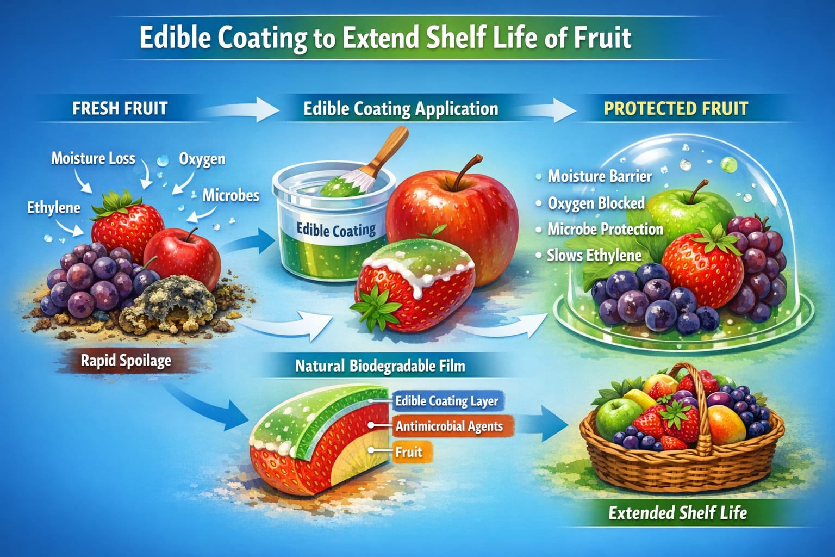
Fig 5. Working mechanism of edible coatings

These coatings are made of biodegradable natural polymers, are applied as thin layers on food surfaces to enhance quality, prolong shelf life and minimize postharvest losses (Flores-López et al., 2016). This coating reduces oxygen entry and carbon dioxide loss, thereby slowing respiration and ethylene production, which delays ripening (Fig 5). It also minimizes moisture loss, reducing shrinkage and weight loss during storage. It also creates a barrier that protects against microbes and decay (Yousuf et al., 2018).
Edible coatings can be applied using several practical methods depending on the type of fruit, coating material, and scale of operation (Tavassoli-Kafrani et al., 2016). The dipping method is the most common technique, where fruits are immersed in the coating solution for a specific time and then removed and dried, ensuring complete surface coverage. In the spraying method, the solution is sprayed onto the fruit using manual or automated sprayers, which helps form a thin and uniform layer while reducing material wastage. The brushing method involves manually applying the coating with a brush and is mainly suitable for small-scale or laboratory studies. Electrostatic spraying improves adhesion by charging the droplets, allowing better and more uniform deposition on the fruit surface. In the fluidized bed method, small fruits are suspended in an air stream while the coating is sprayed, ensuring even coverage. The foam application method uses a foamed coating solution to reduce liquid usage and enhance uniformity. In the casting method, a film is first prepared separately and then wrapped around the product. The panning method, commonly used in confectionery, coats products by rotating them in a pan while adding the coating gradually. Layer-by-layer deposition involves applying multiple thin layers sequentially to improve barrier properties. Finally, vacuum impregnation allows the coating solution to penetrate surface pores under reduced pressure, providing enhanced internal protection and extending shelf life (Fig 6).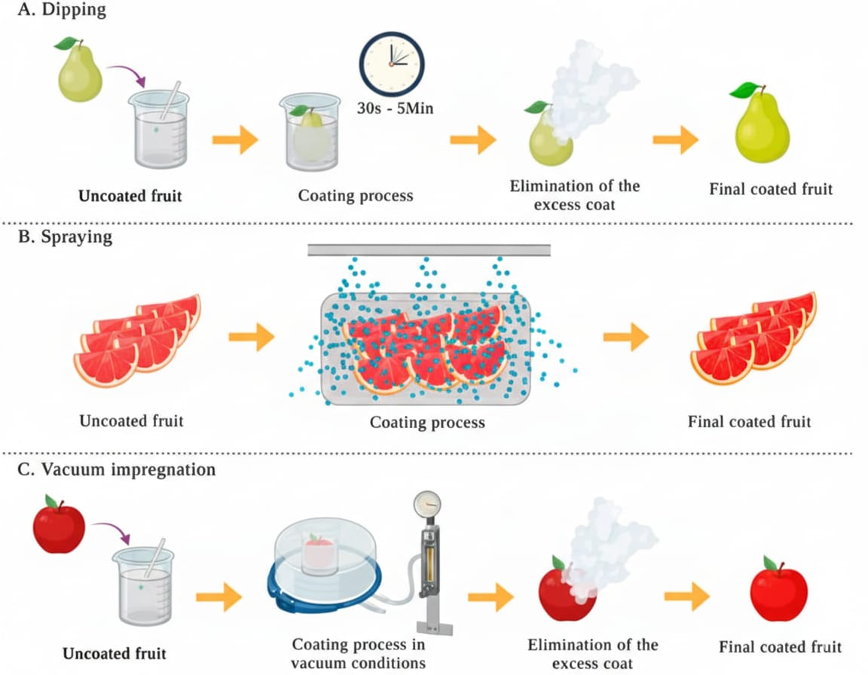
Fig 6. Schematic representation of the processes used for the coating application on fruits and vegetables. (A) dipping; (B) spraying; (C) vacuum impregnation. (Perez-Vazquez et. al 2023)

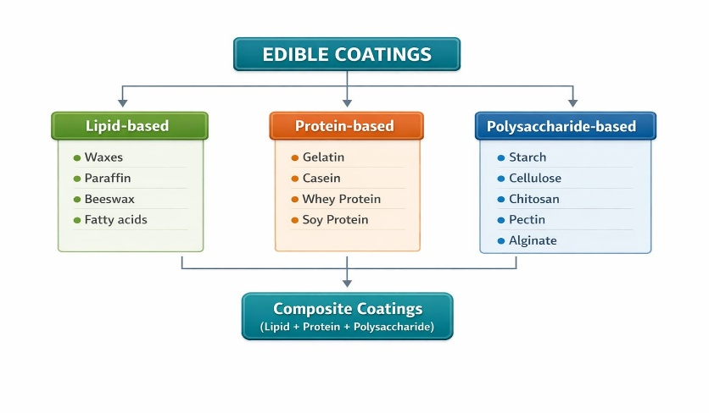
Fig 7. Classification of edible coatings

Types of Edible Coatings : on the basis of materials used, edible coatings are classified into three main categories: polysaccharide-based, protein-based, and lipid-based coatings (Fig 7).
- Polysaccharide-Based Coatings
Examples: Chitosan, Alginate, Pectin, Starch, Cellulose derivatives
Mechanism of Action: Form a semi-permeable barrier that reduces oxygen (O₂) influx and carbon dioxide (CO₂) efflux. They also reduce respiration rate and provide antimicrobial action, especially chitosan.
Advantages: Biodegradable, good gas barrier properties, antimicrobial activity and delay ripening.
Limitations: Poor moisture barrier, may require cross-linking and have limited mechanical strength.
2. Protein-Based Coatings
Examples: Whey protein, Casein, Soy protein, Zein, Gelatin
Mechanism of Action: Form a dense protein matrix that regulates gas exchange, improves structural integrity and acts as a carrier for active compounds.
Advantages: Good gas barrier, improves texture, enhances nutritional value.
Limitations: Sensitive to moisture, potential allergenicity, limited water resistance.
3. Lipid-Based Coatings
Examples: Beeswax, Carnauba wax, Fatty acids, Acetylated monoglycerides
Mechanism of Action: Create a hydrophobic layer that reduces water vapor transmission, minimizing transpiration and shriveling.
Advantages: Excellent moisture barrier, improves gloss and appearance, reduces weight loss.
Limitations: May affect flavor, greasy texture, limited gas permeability.
4. Composite Coatings
Examples: Polysaccharide + Lipid combinations; Protein + Polysaccharide combinations
Mechanism of Action: Combine moisture and gas barrier properties, providing synergistic antimicrobial and mechanical effects.
Advantages: Balanced barrier properties, improved mechanical strength, multifunctional protection.
Limitations: Complex formulation and higher production cost.
5. Nano-Enhanced / Encapsulated Coatings
Examples: Nanoemulsified essential oils, ZnO nanoparticles, encapsulated antioxidants
Mechanism of Action: Provide controlled release of active compounds, improved surface coverage and enhanced antimicrobial efficiency.
Advantages: Extended antimicrobial action, improved stability, enhanced shelf life.
Limitations: Regulatory concerns, higher cost, need for safety validation.
The different kinds of coating materials available for postharvest management are shown in Fig 8.
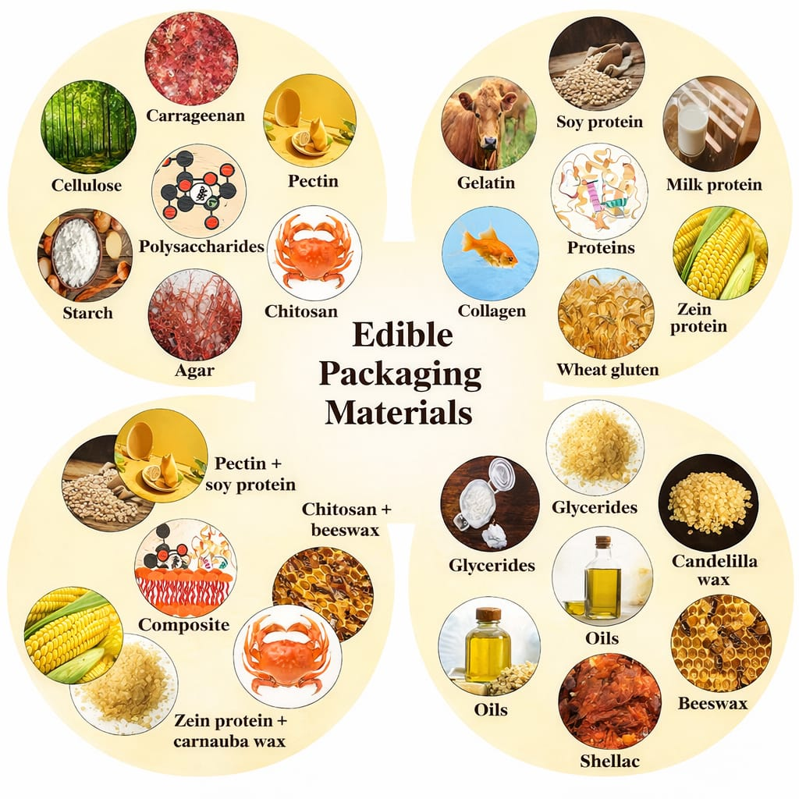
Fig 8. Different edible packaging materials (Kumar et. al 2025)

Research Evidence:
Ali et al. (2011) reported that chitosan + Aloe vera composite coating significantly extended the shelf life of papaya up to 21 days by reducing weight loss, delaying ripening and maintaining firmness during storage. Adetunji et al. (2012) showed that Aloe vera gel coatings effectively reduced physiological weight loss and helped retain ascorbic acid content in pineapple fruits, thereby preserving nutritional quality during storage. Zhang and Quantick (1997) demonstrated that chitosan coating reduced pericarp browning and decay incidence in litchi fruits by forming a semi-permeable barrier that slowed respiration, moisture loss and oxidative changes. Menezes and Athmaselvi (2016) reported that coated sapota fruits exhibited lower weight loss, better firmness retention and delayed ripening compared to uncoated fruits under ambient storage conditions. Dulta et al. (2022) found that alginate–chitosan composite coatings enriched with ZnO nanoparticles significantly reduced decay percentage and respiratory rate in oranges during 20 days of storage, indicating enhanced antimicrobial and barrier properties. Rosman et al. (2024) observed reduced disease incidence and minimized weight loss in ZnO nanoparticle-coated mangoes, highlighting the potential of nano-enhanced edible coatings for improving postharvest quality and extending shelf life.
Conclusion
India is one of the world’s largest fruit producers, yet a major part of production is lost between harvest and final consumption as postharvest losses. This reduce the effective availability of fruits for domestic consumption and export. Losses ranging between 15–25% are common across major fruit crops. The primary causes include physiological deterioration, microbial infection, mechanical injury, environmental stress and infrastructural deficiencies. The available research confirms that both postharvest chemical treatments and edible coatings possess significant potential to minimize quantitative and qualitative losses in fruits. This review has systematically organized the advantages and disadvantages of key treatments, providing a clear framework for comparison. The inclusion of recent advances, such as polyamines, AVG, 1-MCP, NO, melatonin and ozone, alongside nanoemulsion coatings, highlights the dynamic and evolving nature of this field. The proper and regulated application of these technologies can enhance storage stability, improve marketability, increase farmer profitability and contribute meaningfully to food and nutrition security by ensuring that more high-quality fruits reach consumers. Future research should focus on optimizing concentration levels, validating consumer safety, scaling up nano-coating technologies for commercial adoption, and developing integrated management strategies that combine the strengths of both chemical and coating approaches.

Disclaimer (Artificial intelligence)

Author(s) hereby declare that NO generative AI technologies such as Large Language Models (ChatGPT, COPILOT, etc.) and text-to-image generators have been used during the writing or editing of this manuscript.

References
Adetunji, C. O., Fawole, O. B., Arowora, K. A., Nwaubani, S. I., & Oloke, J. K. (2012). Effects of edible coatings from aloe vera gel on quality and postharvest physiology of pineapple fruit during storage. Journal of Food Science and Technology, 49(6), 806–813.
Agricultural and Processed Food Products Export Development Authority (APEDA). (2023). Agricultural and processed food products export data 2022–23. Ministry of Commerce & Industry, Government of India. https://apeda.gov.in
Ali, A., Maqbool, M., Ramachandran, S., & Alderson, P. G. (2011). Gum arabic as a novel edible coating for enhancing shelf-life and improving postharvest quality of tomato fruit. Postharvest Biology and Technology, 58(1), 42–47.
Amanullah, S., Malik, A. U., Khan, A. S., Shahid, M., & Rajwana, I. A. (2017). Salicylic acid reduces physiological weight loss and maintains quality of guava fruit during storage. Journal of Food Processing and Preservation, 41(6), Article e13251.
Ayala-Zavala, J. F., Wang, S. Y., Wang, C. Y., & González-Aguilar, G. A. (2008). Effect of 1-methylcyclopropene (1-MCP) on the overall quality of fresh-cut papaya. Postharvest Biology and Technology, 47(3), 316–322.
Baswal, A. K., Dhaliwal, H. S., & Mahajan, B. V. C. (2020). Effect of salicylic acid on quality and storage life of kinnow mandarin under cold storage. Scientia Horticulturae, 261, Article 108950.
Blankenship, S. M., & Dole, J. M. (2003). 1-Methylcyclopropene: A review. Postharvest Biology and Technology, 28(1), 1–25.
Chen, Y., Grimplet, J., David, K., Castellarin, S. D., Terol, J., Wong, D. C. J., Luo, Z., & Schaffer, R. (2021). Ethylene receptors and related proteins in climacteric and non-climacteric fruits. Plant Science, 313, Article 111089.
Dhall, R. K. (2013). Advances in edible coatings for fresh fruits and vegetables: A review. Critical Reviews in Food Science and Nutrition, 53(5), 435–450.
Dulta, K., Chauhan, P., & Kumar, R. (2022). Alginate–chitosan composite coatings enriched with ZnO nanoparticles for improving postharvest quality of orange fruits. Food Packaging and Shelf Life, 31, Article 100781.
El-Otmani, M., Coggins, C. W., Jr., Agustí, M., & Lovatt, C. J. (2000). Plant growth regulators in citriculture: World current uses. Critical Reviews in Plant Sciences, 19(5), 395–447.
Elsabee, M. Z., & Abdou, E. S. (2013). Chitosan based edible films and coatings: A review. Materials Science and Engineering: C, 33(4), 1819–1841.
Fatima, T., Ahmad, S., & Khan, M. A. (2023). Effect of potassium permanganate on storage quality and shelf life of mango fruit. Journal of Food Science and Technology, 60(5), 1632–1640.
Flores-López, M. L., Cerqueira, M. A., de Rodríguez, D. J., & Vicente, A. A. (2016). Perspectives on utilization of edible coatings and nano-laminate coatings for extension of postharvest storage of fruits and vegetables. Food Engineering Reviews, 8(3), 292–305.
Food and Agriculture Organization of the United Nations. (2019). The state of food and agriculture 2019: Moving forward on food loss and waste reduction. FAO. https://www.fao.org
Gao, H., Zhang, Z., Chai, H., Cheng, N., Yang, Y., Wang, D., & Cao, W. (2020). Melatonin treatment delays postharvest senescence and regulates reactive oxygen species metabolism in peach fruit. Postharvest Biology and Technology, 166, Article 111197.
Giovannoni, J. J. (2004). Genetic regulation of fruit development and ripening. The Plant Cell, 16(Suppl 1), S170–S180.
Horvitz, S., & Cantalejo, M. J. (2014). Application of ozone for the postharvest treatment of fruits and vegetables. Critical Reviews in Food Science and Nutrition, 54(3), 312–339.
Indian Council of Agricultural Research (ICAR). (2019). Post-harvest management of horticultural crops: Annual report. ICAR, New Delhi.
Jha, S. N., Vishwakarma, R. K., Ahmad, T., Rai, A., & Dixit, A. K. (2015). Report on assessment of quantitative harvest and post-harvest losses of major crops and commodities in India. ICAR – Central Institute of Post-Harvest Engineering & Technology (CIPHET).
Jobling, J. (2000). A review of the effects of ReTain® (AVG) on apple quality and storage. Sydney Postharvest Laboratory Information Sheet. https://www.postharvest.com.au/Information_Sheets/ReTain_Review.PDF
Kader, A. A. (2005). Increasing food availability by reducing postharvest losses of fresh produce. Acta Horticulturae, 682, 2169–2176.
Kitinoja, L., & Kader, A. A. (2015). Measuring postharvest losses of fresh fruits and vegetables in developing countries. The Postharvest Education Foundation.
Kumar, L., Tyagi, P., Lucia, L., & Pal, L. (2025). Innovations in edible packaging films, coatings, and antimicrobial agents for applications in food industry. Comprehensive Reviews in Food Science and Food Safety, 24(4), Article e70217.
Li, L., Li, C., & Li, J. (2019). Nitric oxide alleviates postharvest senescence of horticultural crops: A review. Scientia Horticulturae, 246, 825–833.
Mahajan, P. V., Caleb, O. J., Singh, Z., Watkins, C. B., & Geyer, M. (2014). Postharvest treatments of fresh produce. Philosophical Transactions of the Royal Society A: Mathematical, Physical and Engineering Sciences, 372(2017), Article 20130309.
Martin-Diana, A. B., Rico, D., Frías, J. M., Barat, J. M., Henehan, G. T. M., & Barry-Ryan, C. (2007). Calcium for extending the shelf life of fresh whole and minimally processed fruits and vegetables: A review. Trends in Food Science & Technology, 18(4), 210–218.
Menezes, T. P., & Athmaselvi, K. A. (2016). Effect of edible coatings on shelf life and quality of sapota fruit. Journal of Food Science and Technology, 53(1), 482–490.
Ministry of Agriculture & Farmers Welfare, Government of India. (2023). Agricultural statistics at a glance 2022–23. Government of India. https://agricoop.nic.in
Ministry of Food Processing Industries, Government of India. (2022). Annual report 2021–22. Government of India. https://mofpi.gov.in
NABARD Consultancy Services (NABCONS). (2022). Study on assessment of post-harvest losses of fruits and vegetables in India. Ministry of Food Processing Industries, Government of India.
National Horticulture Board. (2023). Horticultural statistics at a glance 2022–23. Ministry of Agriculture & Farmers Welfare, Government of India. https://nhb.gov.in
Palou, L., Smilanick, J. L., & Crisosto, C. H. (2016). Evaluation of food additives as alternative or complementary chemicals to conventional fungicides for the control of major postharvest diseases of stone fruit. Journal of Food Protection, 79(4), 642–649.
Palou, L., Smilanick, J. L., Crisosto, C. H., & Mansour, M. F. (2008). Effect of thiabendazole treatment on decay development of citrus fruit during storage. Postharvest Biology and Technology, 47(2), 226–233.
Perez-Vazquez, A., Barciela, P., Carpena, M., & Prieto, M. A. (2023). Edible coatings as a natural packaging system to improve fruit and vegetable shelf life and quality. Foods, 12(19), Article 3570.
Porat, R., Lichter, A., Terry, L. A., Harker, R., & Buzby, J. (2018). Postharvest losses of fruit and vegetables during retail and in consumers' homes: Quantifications, causes, and means of prevention. Postharvest Biology and Technology, 139, 135–149.
Rathore, A., & Parsad, V. (2019). Effect of sodium hypochlorite on postharvest decay and quality of guava. Journal of Food Science and Technology, 56(4), 1896–1903.
Rosman, N. F., Hassan, Z., & Rahman, R. A. (2024). Zinc oxide nanoparticle-based edible coating reduces postharvest disease and maintains quality of mango fruit. Postharvest Biology and Technology, 205, Article 112541.
Schreiner, M., Korn, M., Stenger, M., Holzgreve, L., & Altmann, M. (2013). Current understanding and use of quality characteristics of horticulture products. Scientia Horticulturae, 163, 63–70.
Sharma, R. R., Singh, D., & Singh, R. (2009). Biological control of postharvest diseases of fruits and vegetables by microbial antagonists: A review. Biological Control, 50(3), 205–221.
Singh, R., Kumar, D., & Singh, A. (2021). Spermidine reduces chilling injury and improves postharvest quality of banana during cold storage. Scientia Horticulturae, 283, Article 110071.
Singh, S. P., & Pareek, S. (2017). Potassium permanganate as an ethylene absorbent to improve storage life of guava fruit. Journal of Food Science and Technology, 54(5), 1213–1221.
Singh, V., Singh, A. K., & Kumar, P. (2018). Effect of calcium chloride treatments on postharvest quality of mango. Indian Journal of Horticulture, 75(3), 456–462.
Singh, V., Singh, P., & Singh, A. K. (2022). Postharvest handling and diseases control in fruits: A review. Pharma Innovation Journal, 11(3), 2225–2232.
Sivakumar, D., Jiang, Y., & Yahia, E. M. (2010). Maintaining mango fruit quality during storage by combining calcium and fungicide treatments. Postharvest Biology and Technology, 55(2), 73–79.
Tariq, A., Malik, A. U., & Khan, A. S. (2018). Putrescine application maintains membrane integrity and delays ripening in mango fruit. Journal of Food Processing and Preservation, 42(3), Article e13543.
Tavassoli-Kafrani, E., Shekarchizadeh, H., & Masoudpour-Behabadi, M. (2016). Development of edible films and coatings from alginates and carrageenans. Carbohydrate Polymers, 137, 360–374.
Upadhyay, R. K., Ahmad, S., & Singh, R. (2005). Effect of sodium hypochlorite treatments on postharvest quality of mango and citrus fruits. Journal of Food Science and Technology, 42(6), 463–467.
Wallace, T. C., Bailey, R. L., Blumberg, J. B., Burton-Freeman, B., Chen, C. O., Crowe-White, K. M., Drewnowski, A., Hooshmand, S., Johnson, E., Lewis, R., Murray, R., Shapses, S. A., & Wang, D. D. (2020). Fruits, vegetables, and health: A comprehensive narrative, umbrella review of the science and recommendations for enhanced public policy to improve intake. Critical Reviews in Food Science and Nutrition, 60(13), 2174–2211.
Watkins, C. B. (2006). The use of 1-methylcyclopropene (1-MCP) on fruits and vegetables. Biotechnology Advances, 24(4), 389–409.
Wills, R. B. H., McGlasson, W. B., Graham, D., & Joyce, D. C. (2016). Postharvest: An introduction to the physiology and handling of fruit and vegetables (6th ed.). CABI Publishing.
Yousuf, B., Qadri, O. S., & Srivastava, A. K. (2018). Recent developments in shelf-life extension of fresh-cut fruits and vegetables by application of different edible coatings: A review. LWT - Food Science and Technology, 89, 198–209.
Zhang, D., & Quantick, P. C. (1997). Effects of chitosan coating on enzymatic browning and decay during postharvest storage of litchi fruit. Postharvest Biology and Technology, 12(2), 195–202.
Zhang, Y., Chen, K., Zhang, S., & Ferguson, I. (2018). The role of salicylic acid in postharvest fruit preservation: A review. Postharvest Biology and Technology, 143, 152–160.
Zhang, Y., Li, S., Chen, K., & Ferguson, I. (2022). Nitric oxide treatment delays senescence and enhances antioxidant defense in papaya fruit. Postharvest Biology and Technology, 188, Article 111870.
Zheng, X., Tian, S., Gidley, M. J., Yue, H., & Li, B. (2007). Effects of exogenous oxalic acid on ripening and decay incidence in mango fruit during storage at room temperature. Postharvest Biology and Technology, 45(2), 281–284.
Singh , A., Singh , B. K., Barman , K., & Singh , A. K. (2023). Effect of Pre-Storage Edible Coating on Post Harvest Quality of Guava Fruits cv. Lalit Under Ambient Condition. International Journal of Environment and Climate Change, 13(11), 1136–1148. https://doi.org/10.9734/ijecc/2023/v13i113263
Maurya, H. K., Lata, R., Mitra, D. S., Sundar, S., & Yadav, G. C. (2024). A Review on Advanced Preservation Techniques for Post-harvest Quality Maintenance of Fruits and Vegetables. International Journal of Plant & Soil Science, 36(11), 186–197. https://doi.org/10.9734/ijpss/2024/v36i115133

