Original Research Article
Assessing genetic variations for pod yield and its component traits in okra (Abelmoschus esculentus L. Moench.)

.
ABSTRACT

Aim: Bhindi (Abelmoschus esculentus L. Moench) is an important commercial vegetable crop cultivated in tropical, subtropical, and warmer temperate regions. It is a highly nutritious crop used as vegetable in the human diet. However, despite its economic significance and wide adaptability, okra productivity in India remains relatively low due to the various limitations. Genetic variability is the foundation of any successful breeding program, as it determines the potential to select and improve desirable traits. The present study aims to assess the genetic variations for key quantitative traits over the environments.

Plant materials and experimentations:The present investigation comprised of 49 okra genotypes. The experiments were conducted in RBD under two different environmental conditions during kharif 2024. Nine quantitative traits were recorded to assess the genetic variations.

Results: The present experiment demonstrated the significant variability for the traits under study. The trait relationship study revealed that the traits like pod yield per plant and number of primary branches were positively correlated with number of pods per plant. Likewise, leaf length was positively correlated with leaf width and stem diameter. Petiole length was positively correlated with leaf width. The PCA analysis demonstrated that PC1 showed strong positive loadings for traits such as stem diameter, leaf length, leaf width, petiole length, and plant height. In PC2, stem diameter and plant height were positively associated.

Conclusions: The sufficient variability was found in okra genotypes for all the traits under study. The grouping pattern of these genotypes demonstrated it potential to include in breeding programmes for crop improvement.

Keywords: Bhindi, Genetic parameters, Association analysis, PCA, Wild relatives

1. INTRODUCTION

Bhindi (Abelmoschus esculentusL. Moench.) belongs to the family Malvaceae, is one of the important commercial vegetable crops. It is grown in tropical, subtropical, and some warmer parts of the temperate region. It is one of the most ediblevegetable crops and popular for its green, tender fruitsgrown throughout India during the summer and rainy seasons (Solankey et al. 2013). This crop is known by a different name in different places like bhindi, Vendakkai, Gumbo, Okra, lady’s finger. etc. (Joshi et al. 2020; Sharma et al. 2022). The crop is valued for its tender green fruits with high nutritional profile. Okra pods are a good source of vitamins (A, B, C, and K), dietary fiber, and antioxidants, calcium, phosphorus, potassium, magnesium, etc. making them an essential component of daily diets (Hamon 1988; Koechlin 1989; Abdou et al.2022; Sami et al., 2013).The lignocellulosic fibres derived from okra stems are being explored as sustainable raw materials for the paper and textile sectors. Moreover, the development of processed okra products, such as dehydrated flakes, powders, and canned pods, enhances shelf life, adds value, and opens new avenues for agribusiness and export (Petropoulos et al. 2022). It also has various known medicinal value, which augment the importance of this crop (Andualem, 2023; ElKhalifa et al., 2021). Despite its commercial importance and adaptability, the average productivity of okra in India remains low, primarily due to limited varieties and various stresses under emerging climate change, which required more attention (Ranga and Darvhankar 2022).Genetic variability is the foundation for any successful breeding program, as it determines the potential for selecting and improving desirable traits (Behera 2025). Assessing the genetic variability and characterizing the genetic pool for incorporation in breeding programmes will help to broaden the genetic base of the crop. Harnessing the potential of wild relatives are also important due to its higher adoptability to wider range of environments along with stress tolerance nature. Crop wild relatives serve as a valuable reservoir of genetic diversity and are used further for breeding programs for the development of stress resilience varieties. Keeping the facts under consideration, the present study was planned to assess the genetic variability among 69 okra genotypes including its wild relatives with a focus on yield and its component traits. The promising genotypes identified in this study will facilitate the breeding of superior genotypes and contribute to the sustainability of okra production systems.

2. material and methods
2.1 PLANT MATERIALS AND FIELD EXPERIMENTATIONS

The present experiment was undertaken with 49 diverse okra genotypes (Table-1). The experiments were conducted at the Field Experimentation Block, College of Agriculture, Banda University of Agriculture and Technology, Banda (80°34'30" E to 81°34'30" E longitude and 24°53' N to 25°55'N latitude), India. The experimente were performed in two environments as in field condition (E1) and in green shade net house (E2) during Kharif 2024. The experiments were performed in randomized block design (RBD) with two replications. Each genotype was sown in paired row of 4m and plant geometry was kept as 60 x 30 cm. All the package of practices were adopted to raise the healthy crop.
Table 1. List of okra genotypes used in present study

S.No. | Variety name | S.No. | Variety name
1 | BUOH-1 | 26 | BUOL 1
2 | BUOH-2 | 27 | BUOL 2
3 | BUOH-3 | 28 | BUOL 3
4 | BUOH-4 | 29 | BUOL 4
5 | BUOH-5 | 30 | BUOL 5
6 | BUOH-6 | 31 | BUOL 6
7 | BUOH-7 | 32 | BUOL 7
8 | BUOH-8 | 33 | BUOL 8
9 | A. Moschatus | 34 | BUOL 9
10 | A. Tetraphyllus | 35 | BUOL 10
11 | Kashi chaman | 36 | BUOL 11
12 | Kashi Pragati | 37 | BUOL 12
13 | BUOG-001 | 38 | BUOL 13
14 | BUOG-002 | 39 | BUOL 14
15 | BUOG-003 | 40 | BUOL 15
16 | BUOG-004 | 41 | BUOL 16
17 | BUOG-005 | 42 | BUOL 17
18 | Radhika | 43 | BUOL 18
19 | Jaani | 44 | BUOL 19
20 | Kammudha | 45 | BUOL 20
21 | NS- 7772 | 46 | BUOL 21
22 | Mrityunjay | 47 | BUOL 22
23 | Mastani | 48 | BUOL 23
24 | Pusa Sawani | 49 | Himachal local (Local Collection)
25 | Super green

2.2 DATA RECOEDING

The phenotypic data were recorded from five random plants per genotype in each replications under both environmental conditions except days to flowering and maturity. Total of nine quantitative traits i.e. stem node of 1st flower opening (SNFFO), stem diameter (SD), days to 1st flowering (DF), days to 50% flowering (DFF), sinus depth of terminal lobe (STDL), leaf length (LL), leaf width (LW), petiole length (PetL), plant height (PH), number of branches per plant (NBP), number of pods per plant (NPP), pod yield per plant (PP). DF, DFF and DM were computed on field basis.

2.3 STATISTICAL ANALYSIS

The data were analyzed by standard packages of R software version 4.5.2.

3. results

3.1 ASSESSING GENETIC VARIABILITY

The pooled analysis of variance (ANOVA) demonstrated that mean differences for each trait were highly significant for all quantitative characters (Table-2). The analysis reveals significant variation among genotypes, environments, and their interactions for most of the studied traits, indicated the presence of substantial genetic variability and environmental influence. Highly significant genotype effects for traits such as SD, DF, DFF, SDTL, LL, LW, PetL, PH, and PPP were also recorded. The environment showed highly significant effects for almost all traits, particularly PH, and PPP.

Table 2. Analysis of variance for yield and its component traits in okra
 | Genotypes | Environment | Genotype x Environments | Residuals
Degree of freedom (df) | 48 | 1 | 48 | 98
Stem node of first flower opening (SNFFO) | 4.85 | 0.13 | 2.56** | 1.07
Stem diameter (SD) | 14.35 | 58.32** | 12.7** | 0.87
Days to first flowering (DF) | 94 | 6332** | 50** | 2
Days to 50% flowering (DFF) | 93 | 6853** | 43** | 3
Sinus depth of terminal lobe (SDTL) | 32.15 | 191.03** | 4.27** | 0.32
Leaf length (LL) | 22.12 | 298.45** | 7.49** | 0.29
Leaf width (LW) | 38 | 405.4** | 11.9** | 0.5
Petiole length (PetL) | 45.96 | 289.24** | 16.8** | 0.39
Plant height (PH) | 1797 | 184857** | 787** | 30
Number of branches per plant (NBP) | 2.2 | 62.86** | 1.79* | 1.11
Number of pods per plant (NPP) | 8.03 | 1.84 | 4.73** | 2.15
Pod yield per plant (PPP) | 1760 | 37807** | 1659** | 637
* P<0.05’ ** P<0.01 level of significance

The wide range of variations were recorded under field and net house conditions for almost all the traits (Figure-1). The trait SNFFO recorded a mean 10.68, varied with the range from 8.05 (BUOL-19) to 14.32 (Himachal local) (Table-1). SD ranged from 9.08 (BUOL-10) to 17.35 (Kashi chaman). The DF ranged form a minimum of 38.50 (BUOG005) to a maximum of 52.75 (A. tetraphyllus). DFF averaging 51.32 and spanning from 44.50 (Kashi pragati) to 73 (A. moschatus). For the trait SDTL ranged found from 8.36 (A. moschatus) to 19.3 (BUOL-23). The ranged from 11.78 (BUOH-8) to 22.08 (BUOG005) found for trait LL. The trait LW ranged form a minimum of 14.65 (BUOL-5) to 26.05 (BUOL-23). The PetL was recorded lower 9.60 for genotype (Mrityunjay) and higher 24.58 for genotype (BUOL-23). The trait PH was ranged form 26.50 (Radhika) to 66.00 (Kashi pragati). The mean value was recorded 1.15 for the trait NPB and the maximum value was recorded 3.75. NPP ranged from a minimum of 7.75 (BUOL-3) to a maximum of 16.00 (A. tetraphyllus) with average value of 9.75. PPP varied with the minimum value 102.06 g (BUOH-3) and maximum value 198.37 g (BUOG001).
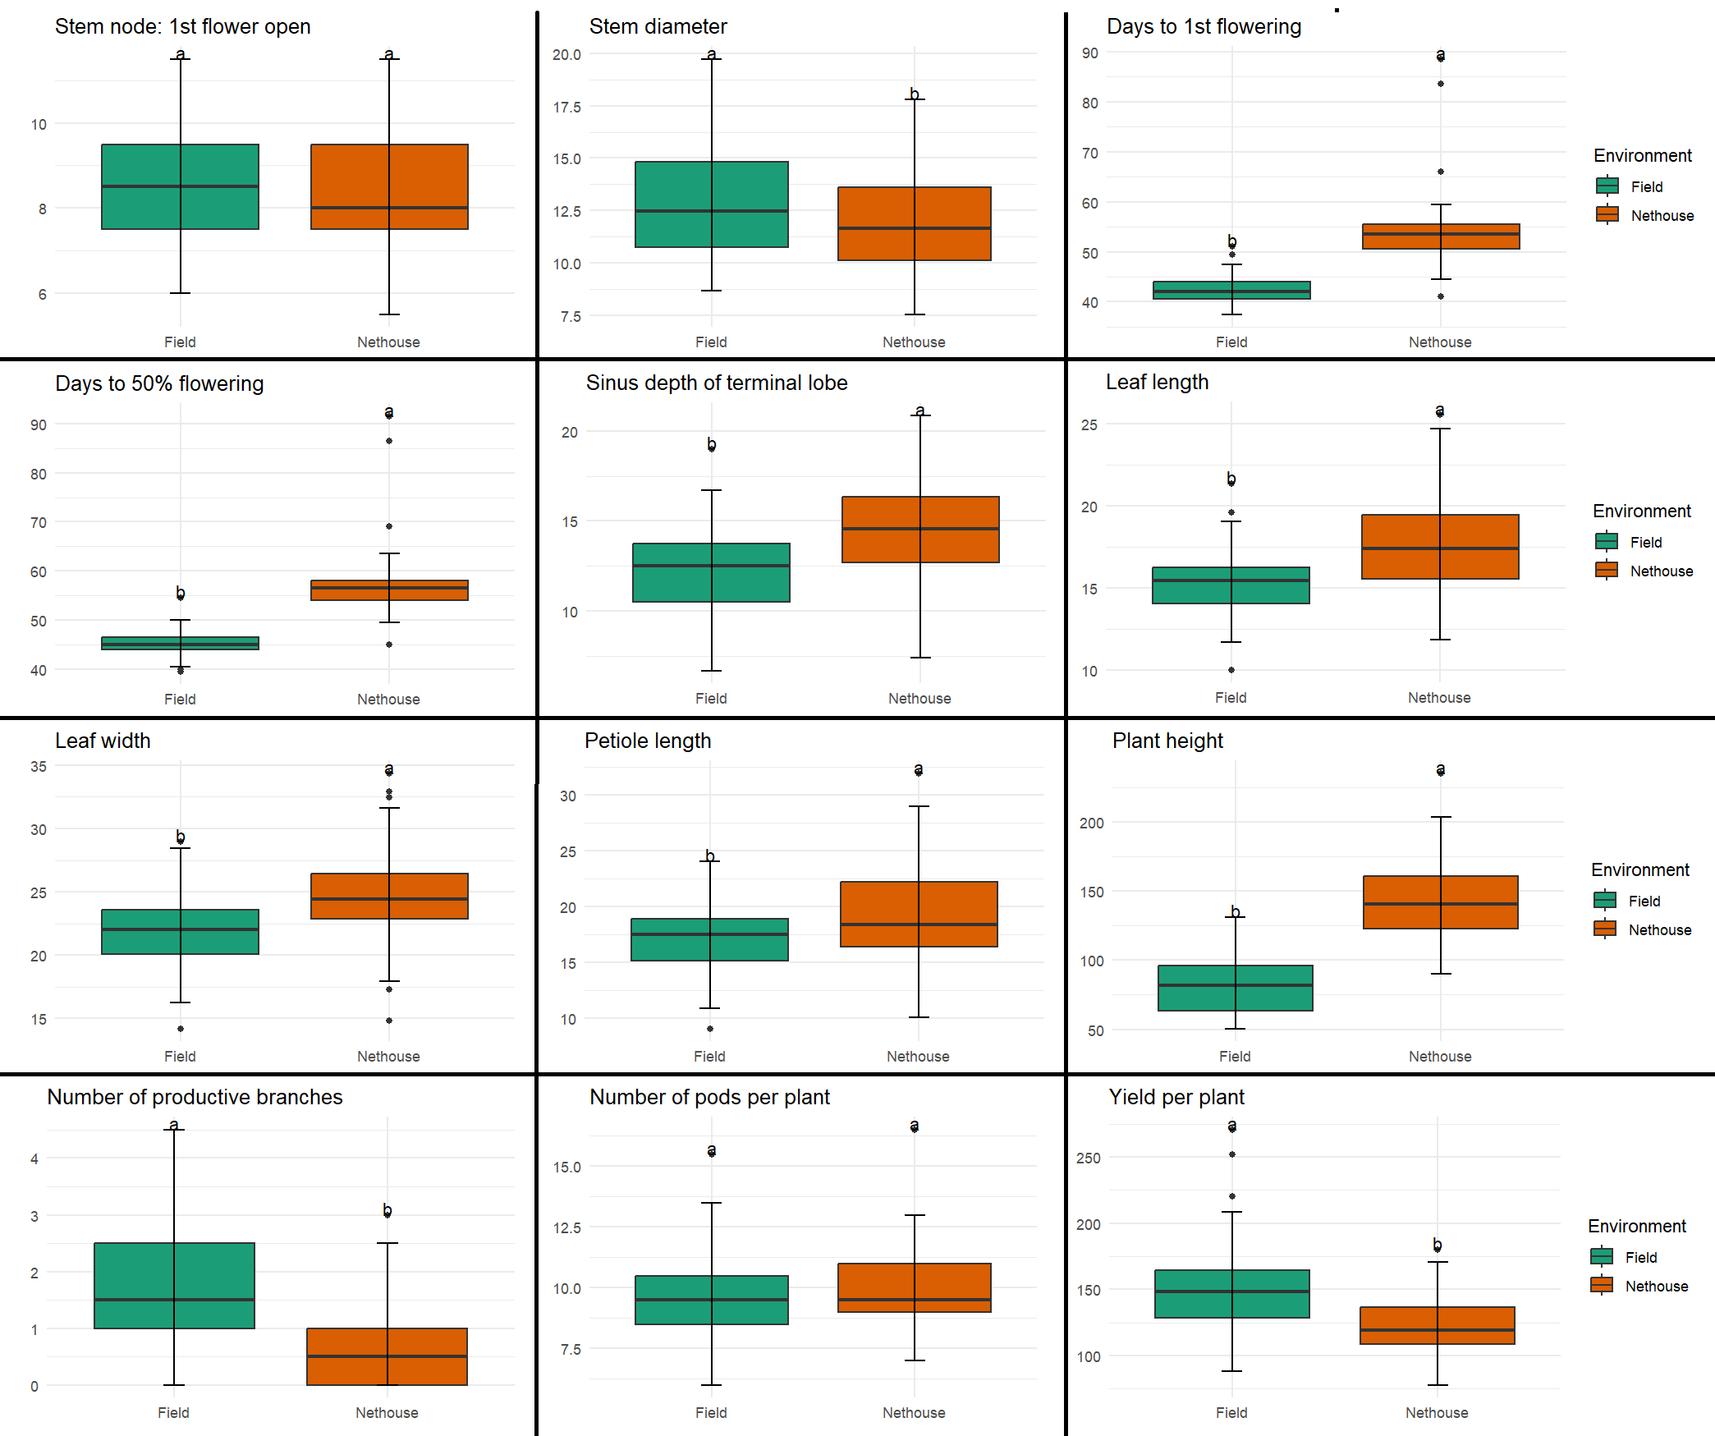
Figure-1. Boxplot analysis for environmental effects between field and net house conditions;

3.2 GENETIC PARAMETERS

Based on the pooled mean of 49 okra genotypes, the Table-3 displays the mean, range, PCV and GCV for 13 quantitative characters (Table-2). The higher PCV and GCV were recorded for the traits like SD, SDTL, PetL, NPB and PPP, while lower values were found for DF and DFF. The broad-sense heritability across all traits, with values ranging from 32.3% for PPP to 99.3% for PetL. The genetic advance as a percentage of the mean polled data ranged between 14.14% (PPP) and 48.58% (PetL). The traits i.e. SDTL, PetL and PH showed high GCV, PCV, h²bs coupled with high GAM.

Table 3. The range, mean and estimates of genetic variability based on pooled adjusted means in okra
Traits | Min | Max | Mean | CV | CD | GCV(%) | PCV(%) | h²bs | GAM(%)
SN:FFO | 8.05 | 14.32 | 10.68 | 15.37 | 2.01 | 15.46 | 18.48 | 70.01 | 26.65
SD | 9.08 | 17.35 | 12.45 | 15.06 | 1.88 | 19.91 | 21.52 | 85.67 | 37.97
DF | 38.5 | 52.75 | 43.99 | 6.87 | 2.93 | 14.54 | 14.77 | 96.99 | 29.5
DFF | 44.5 | 73 | 51.32 | 9.31 | 3.46 | 13.21 | 13.57 | 94.79 | 26.5
SDTL | 8.36 | 19.3 | 13.74 | 16.27 | 1.1 | 22.72 | 22.9 | 98.48 | 46.45
LL | 11.78 | 22.08 | 16.54 | 14.07 | 1 | 18.21 | 18.35 | 98.54 | 37.25
LW | 14.65 | 26.05 | 19.55 | 11.41 | 1.37 | 15.86 | 16.01 | 98.08 | 32.35
PetL | 9.6 | 24.58 | 18.47 | 18.16 | 1.15 | 23.66 | 23.75 | 99.3 | 48.58
PH | 26.5 | 66 | 42.09 | 25.54 | 10.19 | 19.51 | 20.03 | 94.94 | 39.17
NPB | 1.00 | 3.75 | 1.15 | 63.9 | 1.92 | 11.02 | 42.07 | 50.56 | 47.96
NPP | 7.75 | 16 | 9.75 | 14.38 | 2.89 | 14.04 | 19.69 | 50.85 | 20.63
PPP | 102.06 | 198.37 | 136.54 | 15.2 | 49.05 | 12.08 | 21.25 | 32.3 | 14.14

3.3 CORRELATION ANALYSIS

Correlation analysis was performed to determine the most effective traits for selection (Figure-2). The trait DF was positively and significantly correlated with DFF (0.71), while negative significant correlation was demonstrated with SDTL (-0.38) and LL (-0.33). DFF was positively and significantly correlated with NPP (0.36), SNFFO (0.32) and PPP (0.29), while trait SDTL (-0.49) was significantly correlated in negative direction. The traits PPP (0.50) and NPB (0.30) were positively correlated with NPP. SDTL was significantly positively correlated with LL (0.75) and LW (0.44). LL was positively correlated with LW (0.40) and SD (0.31). PetL (0.61) was positively correlated with LW. SNFFO was significantly positive correlated with the trait SD (0.71).

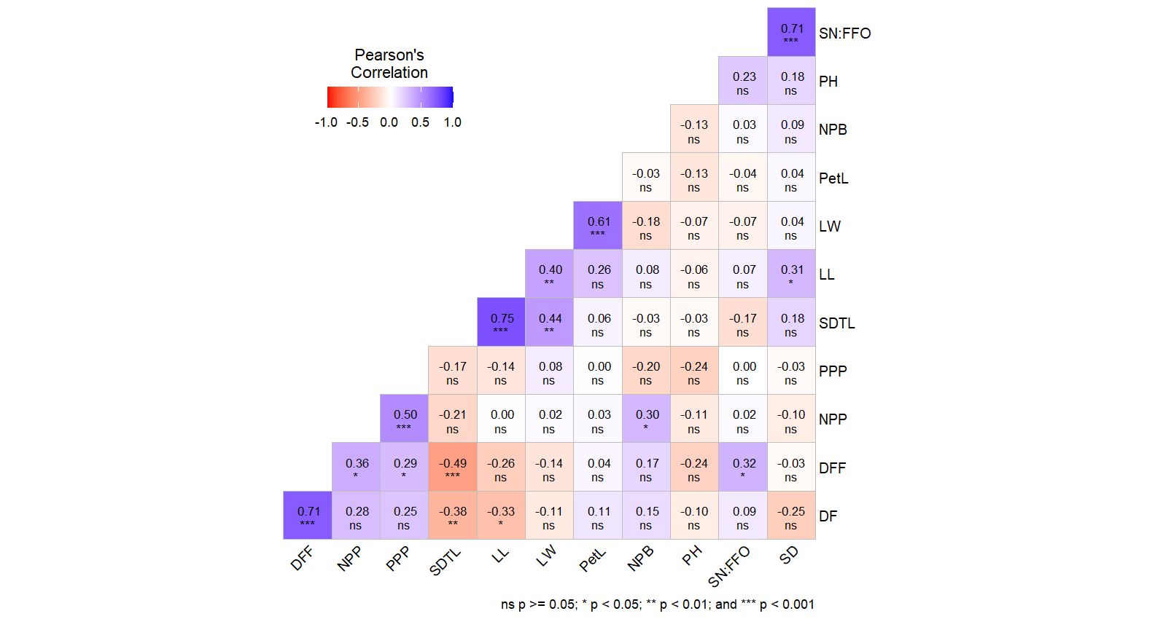
Figure-2. Pearson’s correlation matrix illustrating the strength and direction of relationships among different traits
3.4 PRINCIPAL COMPONENT ANALYSIS

Principal component analysis was performed using the pooled adjusted mean values (Table-4). The first five principal components together explained nearly 77.52% of the total variability observed in the quantitative traits, with PC1 and PC2 contributing 25.2% and 16.6%, respectively (Table-3). Thus, consideration of the first two principal components substantially simplifies the dataset while retaining most of the essential information. PC1 showed strong positive loadings for traits such as SD, SDTL, LL, LW, PetL and PH whereas the traits SNFFO, DF, DFF, NPB, NPP and PPP exhibited negative loadings on this component. In PC2, SNFFO, SD and PH were positively associated, whereas the traits DF, DFF, SDTL, LL, LW, PetL, NPB, NPP, and PPP were negatively associated.

Table-4. Relative proportion of variance and traits explained by principal component analysis in the evaluated okra collection
Principal component | PC1 | PC2 | PC3 | PC4 | PC5
Eigenvalue | 3.02 | 1.99 | 1.88 | 1.29 | 1.13
Proportion of variance | 25.15 | 16.58 | 15.63 | 10.74 | 9.41
Cumulative proportion | 25.15 | 41.73 | 57.36 | 68.11 | 77.52
SN:FFO | -0.10 | 0.12 | 0.91 | 0.18 | 0.01
SD | 0.29 | 0.08 | 0.86 | 0.03 | -0.13
DF | -0.73 | -0.28 | 0.05 | 0.05 | 0.31
DFF | -0.76 | -0.29 | 0.31 | 0.00 | 0.18
SDTL | 0.80 | -0.25 | -0.02 | -0.23 | -0.16
LL | 0.69 | -0.42 | 0.26 | -0.28 | -0.09
LW | 0.46 | -0.69 | -0.01 | 0.32 | 0.14
PetL | 0.19 | -0.67 | 0.04 | 0.30 | 0.49
PH | 0.17 | 0.47 | 0.26 | 0.31 | 0.08
NPB | -0.17 | -0.08 | 0.22 | -0.84 | 0.27
NPP | -0.47 | -0.47 | 0.12 | -0.28 | -0.38
PPP | -0.42 | -0.44 | 0.00 | 0.25 | -0.68

The PCA illustrated that the circle depicting the contribution and interrelationships of various traits to the first two principal components. Traits represented by longer vectors, such as PH, SDTL and LW have a greater influence on these components, whereas traits located near the origin, like NPB contribute less. Traits that are closely aligned (e.g., PH, SD, SDTL and LW) exhibit positive correlations, while those oriented in opposite directions (e.g., DF and DFF compared to SDTL and LW) indicate negative associations. Overall, the results suggest that plant structural attributes and yield-related traits are key determinants of genetic variability in the studied genotypes.

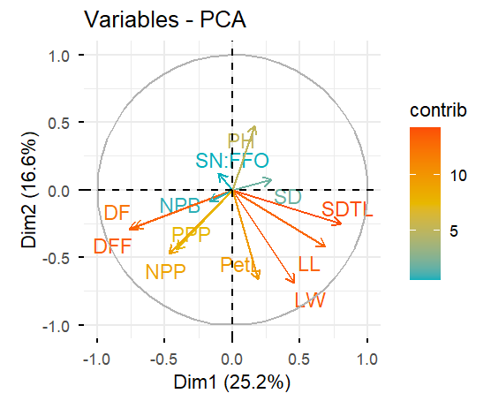
Figure-3. PCA biplot demonstrating the relative proportion of variance and traits explained by principal component analysis in the okra collection

The heat map showing variation in performance across genotypes for several traits (Figure-4). The rows represent individual genotypes while the columns corresponding to the traits. The colour scale ranges from light yellow (indicating lower values) to dark red (indicating higher values) as shown by the legend (0-210). Genotypes displaying darker red or orange shades exhibit higher trait expression, whereas lighter shades reflect lower values.

3.4 GENETIC DIVERSITY ANALYSIS

The column dendrogram classifies genotypes into major clusters and sub-clusters according to their similarity, reflecting both genetic resemblance and divergence among entries. Based on analysis, all the genotypes were grouped into two major group. The group-1 consisted of 12 genotypes whereas group-2 comprised of 37 genotypes forming a largest cluster. Both wild relatives like T. Moschatus and T. Tetraphyllus were fell into different clusters representing the presence of wide genetic variations.
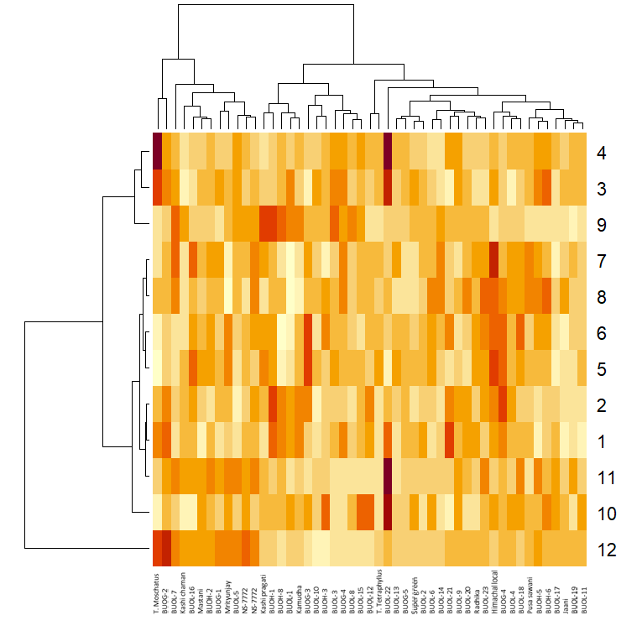
Figure-4. Heat map across genotypes for several traits

4. DISCUSSION

Genetic variability forms the basis of any effective crop improvement programme, as it determines the scope for selection and genetic gain. The magnitude of variability is commonly evaluated using the Genotypic Coefficient of Variation, Phenotypic Coefficient of Variation, heritability and genetic advance. GCV measures variation attributable purely to genetic causes, whereas PCV reflects total observation variation, including both genetic and environmental influences. When the difference between PCV and GCV is narrow, environmental on minimal and phenotypic selection becomes more reliable. Heritability estimates the proportion of phenotypic variance governed by genetic factors and indicates the degree to which traits can be transmitted from one generation to the next. However, heritability alone does not ensure selection success; it must be interpreted along with genetic advance, which predicts the expected improvement under selection. A combination of high heritability and high genetic advance suggests predominance of additive gene action and effectiveness of direct selection, while high heritability coupled with low genetic advance indicates non-additive gene effects and limited response to simple selection. Collectively, these parameters assist breeders in identifying traits with genuine improvement potential and in formulating efficient breeding strategies.
In the present multi-environment evaluation of okra higher PCV and GCV values were observed for structural and yield related traits such as stem diameter, sinus depth of terminal lobe, petiole length, number of productive branches and yield per plant. In contrast, lower estimates were recorded for phenological traits including days to first flowering and days to 50% flowering. This trend indicates differences in genetic control and environmental responsiveness among traits, which is critical for designing breeding strategies. The presence of high PCV and GCV for yield and growth traits suggests substantial inherent genetic variability within the okra germplasm, offering considerable scope for selection and improvement (Mohammed, 2020; Mohammed et al., 2022; Reddy et al., 2022; Ranga et al., 2021). Similar finding has been documented by several researchers (Kumar et al., 2020; Kenaw, 2021; Yadav, 2024), who reported high variability for fruit yield per plant and number of branches per plant, confirming the existence of ample genetic diversity for yield components in okra genotypes.
Estimates of broad sense heritability for the studied traits indicated strong genetic control over their expression. Heritability represents the proportion of total phenotypic varianceattributable to genetic variable (Imani et al., 2021). High heritability estimates for yield per plant imply that a major proportion of the observed variation is genetically governed and less affected by environmental fluctuations, thereby enhancing the efficiency of phenotypic selection. Comparable results have been reported in okra, where high heritability for yield and related attributes was observed (Awasthi et al., 2022; Keerthana et al., 2025), indicating stable genetic regulation. Furthermore, high genetic advance expressed as a percentage of the mean for traits such as field per plant and petiole length suggests the likelihood of substantial improvement through selection. The combination of high heritabilityand high genetic advance indicates the predominance of additive gene effects (Johnson et al. 1955), confirming that these traits are amenable to direct selection and capable of producing meaningful genetic gain (Komolafe et al., 2023 and Kute et al., 2023).
Correlation analysis plays a crucial role in understanding the relationships among field and its component traits. It facilitates identification of characters that are strongly associated with yield, enabling indirect selection for complex traits. In the present investigation, days to first flowering exhibited a strong positive and significant correlation with days to 50% flowering. This association is biologically logical, as both traits are regulated by closely related developmental mechanisms controlling floral initiation and progression. Consistent positive correlations between this phenological traits have been reported in earlier studies (Nbeaa et al., 2023 and Komolafe et al., 2022; Shinde et al., 2023), indicating that genotypes flowering earlier also reach 50% flowering earlier. Sush synchronization suggests shared genetic control and implies that selection for early flowering will simultaneously reduce the time to 50% flowering.
A positive correlation was also observed between days to 50% flowering and number of pods per plant, suggesting that relatively late flowering genotypes tend to produce more pods. This relationship may result from extended vegetative growth, leading to greater assimilate accumulation and enhanced reproductive capacity (El-Shaieny and Bashandy, 2022; Haribhai, 2023; Komolafe et al., 2022). Similar associations between flowering duration and yield components have been reported (Komolafe et al., 2022; Wakchaure et al., 2023; Abhilash et al., 2024), indicating that later flowering genotypes often exhibit improved vegetative vigor and higher fruit numbers. Moreover, the positive association between number of productive branches and number of pods per plant highlights the importance of branching pattern in determining yield potential. Increased branching provides more sites for flower initiation and pod development, thereby contributing directly to higher productivity.
Principal component analysis serves as an important multivariate statistical tool for reducing data dimensionality while retaining maximum variation. In crop improvement research, PCA identifies the most influential traits contributing to genetic divergence among genotypes. By transforming correlated variables into a smaller set of uncorrelated principal components, it simplifies interpretation and aids in the identification of superior genotypes. In the present study on okra, the first principal component showed strong positive loadings for stem diameter, sinus depth of terminal lobe, leaf length, leaf width, petiole length and plant height indicating that vegetative growth traits contributed substantially to total genetic variation. Similar studies in okra have reported(Saleem et al., 2023; Murtadha et al., 2023; Mohammed et al., 2022; Ranga et al., 2022; Vennila et al., 2024) high positive loadings for plant height and stem girth in the first principal component, emphasizing the dominant role of vegetative parameters in genotype differentiation and variability assessment.

4. Conclusion

The sufficient variability was found in okra genotypes for all the traits under study. The PCA indicated the sufficient variations explained by the traits under study and also used as indirect selection. The grouping pattern of these genotypes demonstrated it potential to include in breeding programmes for crop improvement. The two wild relatives also grouped in different groups indicated that these genotypes can be used in breeding programme for widening the genetic base for yield improvement and other adoptive traits.

Disclaimer (Artificial intelligence)
Author(s) hereby declare that NO generative AI technologies such as Large Language Models (ChatGPT, COPILOT, etc.) and text-to-image generators have been used during the writing or editing of this manuscript.

References

Abdou, R., Zango, O., Toudou, A. , Agbo So, T. and Bakasso, Y. (2022). Agro Morphological Characterization and Evaluation of Three Okra [Abelmoschus esculentus (L.) Moench] Varieties from Zinder (Niger) for Yield and Other Variability Components. Agricultural Sciences, 13, 321-329. doi: 10.4236/as.2022.133022.
Abhilash, P. V., Talekar, N., Delvadiya, I. R., & Anvesh, S. (2024). Exploring multivariate associations of yield and yield-associated traits in okra (Abelmoschus esculentus (L.) Moench) accessions in the Northwestern Region of India. Journal of Applied and Natural Science, 16(1), 94.
Andualem, M. (2023). Nutritional and Antinutritional Characteristics of Okra (Abelmoschus esculentus (L.) Moench) Accessions Grown in Pawe District, Northwestern Ethiopia. International Journal of Agriculture and Biosciences, 12(1), 18–21.
Awasthi, S., Singh, D. P., Lal, B., Singh, P., Upadhyay, A., Singh, P. K., ... & Kumar10, A. (2022). Assessment of Genetic Variability, Heritability and Genetic Advance of Okra Genotypes (Abelmoschus esculentus L. Moench). Assessment, 53(04), 7501-7512.
Behera, A. (2025). Assessment of genetic variability and trait association in okra (Abelmoschus esculentus L. Moench). Journal of Advances in Biology & Biotechnology, 28(6), 10-9734.
Elkhalifa, A. B. O., Alshammari, E., Adnan, M., Alcantara, J. C., Awadelkareem, A. M., Eltoum, N. E., Mehmood, K., Panda, B. P., & Ashraf, S. A. (2021). Okra (Abelmoschus esculentus) as a potential dietary medicine with nutraceutical importance for sustainable health applications. Molecules, 26(3), 696.
El-Shaieny, A. A. H., &Bashandy, T. (2022). Effect of planting dates on growth, yield and physiological traits of okra (Abelmoschus esculentus L. Moench.), and field evaluation for heat tolerance. Journal of Plant Production, 13(5), 141-150.
Hamon, S. (1988). Organisationévolutive du genre Abelmoschus (gombo): Coadaptation et évolution de deux espèces de gombocultivéesen Afrique de l’Ouest (A. esculentus et A. caillei). ORSTOM. https://horizon.documentation.ird.fr/exldoc/pleins_textes/divers10-06/25056.pdf
HARIBHAI, P. D. (2023). EFFECT OF DIFFERENT SOWING TIME AND PLANTING DISTANCE ON GROWTH, YIELD AND QUALITY OF OKRA (Abelmoschus esculentus (L.) Moench).
Imani, A., Amani, G., Shamili, M., Mousavi, A., Hamed, R., Rasouli, M., & José Martínez-García, P. (2021). Diversity and broad sense heritability of phenotypic characteristic in almond cultivars and genotypes. International Journal of Horticultural Science and Technology, 8(3), 281-289.
Johnson, H. W., Robinson, H. F., & Comstock, R. (1955). Estimates of genetic and environmental variability in soybeans.
Joshi U, Rana D K, Singh V (2020). Characterization study based on the morphology of various okra [Abelmoschus esculentus (L.) Moench.] genotypes. J Emerg Techn Inn Res 7(5): 701- 710.
Keerthana, S., Dubey, N., Delvadiya, I. R., Patel, D. D., & Ginoya, A. V. (2025). Combining Ability and Gene Action Studies for Fruit Yield and its Component Traits in Okra [Abelmoschus esculentus (L.) Moench]. Indian Journal of Agricultural Research, 59(4).
Kenaw Girmay, W. (2021). VARIATION IN GROWTH AND FRUIT YIELD OF OKRA [Abelmoschus esculentus (L.) Moench] AT DIRE DAWA, EASTERN ETHIOPIA (Doctoral dissertation, Haramaya university).
Koechlin, J. (1989). Les gombosafricains (Abelmoschus spp.) : Étude de la diversitéenvue de l’amélioration (Thèse de doctorat). Institut National Agronomique Paris-Grignon, France. https://core.ac.uk/download/pdf/39914000. pdf
Komolafe, R. J., Ariyo, O. J., & Alake, C. O. (2022). Correlation and path coefficient analysis of fruit yield attributes in forty genotypes of okra (Abelmoschus esculentus). Agricultural Research, 11(1), 15-23.
Komolafe, R. J., Ariyo, O. J., Alake, C. O., &Oduwaye, O. A. (2023). Genetic variability, heritability, genetic advance, association between fruit yield and yield components of okra (Abelmoschus esculentus L. Moench) accessions grown in two different years. Israel Journal of Plant Sciences, 70(3-4), 182-194.
Kumar, Y., Singh, V. B., Gautam, S. K., Kumar, V., & Singh, V. (2020). Studies on genetic variability, heritability and genetic advance for fruit yield and its contributing traits in okra [Abelmoschus esculentus L. Moench]. The Pharma Innovation Journal, 9(10), 351-354.
Kute, K. G., Zate, D. K., Ghadage, A. P., Mitkari, S. B., & Deshmukh, S. D. (2023). Estimating genetic variability, heritability, and genetic advance for yield and yield contributing traits in okra (Abelmoschus esculentus [L.] Moench) genotype. J. Appl. Psychol. Pharma Innov, 12(2), 2864-2870.
Mohammed Abdela, J. (2020). PHENOTYPIC DIVERSITY, GENETIC VARIATION AND ASSOCIATION OF MORPHO-AGRONOMIC AND BIOCHEMICAL TRAITS IN OKRA [Abelmoschus esculentus (L.) Moench] GENOTYPES IN ETHIOPIA (Doctoral dissertation, Haramaya university).
Mohammed, J., Mohammed, W., & Shiferaw, E. (2022). Performance and genetic variability of okra (Abelmoschus esculentus (L.) Moench) genotypes in Ethiopia for agromorphology and biochemical traits. Advances in Agriculture, 2022(1), 5521151.
Mohammed, J., Mohammed, W., & Shiferaw, E. (2022). Phenotypic diversity assessment of okra (Abelmoschus esculentus (L.) Moench) genotypes in Ethiopia using multivariate analysis. Scientifica, 2022(1), 3306793.
Murtadha, M. A., Adetoro, S., & Shittu, K. A. (2023). Multivariate analysis of seed yield and morphological characters of Okra (Abelmoschus esculentus L. Moench) accessions. Agricultural Science & Technology (1313-8820), 15(2).
Nbeaa, R. A., Abo-Trabi, B., & Ahmad, E. (2023). Phenotypic Correlation and Path Coefficient and Relative Importance Studies in Okra Abelmoschus esculentus (L.) Moench. Basrah Journal of Agricultural Sciences, 36(1), 50-59.
Petropoulos S A, Fernandes A, Barros L and Ferreira I C F R (2022). The genus Abelmoschus: A r e v iew o n t h e p h y t o c h emistr y a n d pharmacology. Phytochem Rev 21: 1-28.
Ranga AD and Darvhankar MS. 2022. Diversity analysis of phenotypic traits in okra (Abelmoschus esculentus L. Moench), Journal of Horticultural Science, 17(1): 63- 72.
Ranga, A. D., Chaudhary, A., &Darvhankar, M. S. (2022). Diversity analysis of phenotypic traits in okra (Abelmoschus esculentus L. Moench). Journal of Horticultural Sciences, 17(1), 63-72.
Ranga, A. D., Kumar, S., &Darvhankar, M. S. (2021). Variability among different yield and yield contributing traits of Okra (Abelmoschus esculentus L. Moench) genotypes. Electronic Journal of Plant Breeding, 12(1), 74-81.
Reddy, J. P., Anbanandan, V., & Kumar, B. S. (2022). Genotypic, phenotypic variability and evaluation of okra [Abelmoschus esculentus (L.) Moench] genotypes for yield components. Journal of applied and natural science, 14(1), 180.
Saleem, A. M., Ziaf, K., Amjad, M., Shakeel, A., Ghani, M. A., & Noor, A. (2023). Assessment of genetic diversity among okra genotypes through PCA and correlation analysis for fruit tenderness, and morphological and yield traits. Pak. J. Bot, 55(2), 555-562.
Sami, R., Lianzhou, J., Yang, L., & Jing, J. (2013). Evaluation of fatty acid and amino acid compositions in okra (Abelmoschus esculentus) grown in different geographical locations. BioMed Research International, 2013, 574283.
Sharma V, Singh S and Yadav R (2022). Assessment of genetic diversity in okra using molecular markers. Indian J Genet Plant Breed 82(1): 89-96.
Shinde, S. L., Zate, D. K., Gavade, S. S., Zate, A. K., & Shinde, J. V. (2023). Correlation analysis for fruit yield and its related traits in okra (Abelmoschus esculentus (L.) Moench). The Pharma Innovation Journal, 12(1), 215-220.
Solankey SS, Singh AK, Singh RK (2013) Genetic expression of heterosis for yield and quality traits during different growing seasonsin okra (Abelmoschus esculentus). Indian J Agr Sci 83(8):815–819
Vennila, S., Elangaimannan, R., LubnaArshiya, S., &Sudhasha, S. (2024). Study on genetic divergence, association between morphological traits and path analysis among different okra (Abelmoschus esculentus L. Moench) genotypes. Vegetos, 1-9.
Wakchaure, G. C., Minhas, P. S., Kumar, S., Khapte, P. S., Dalvi, S. G., Rane, J., & Reddy, K. S. (2023). Pod quality, yields responses and water productivity of okra (Abelmoschus esculentus L.) as affected by plant growth regulators and deficit irrigation. Agricultural Water Management, 282, 108267.
Yadav, Y. S., Kaur, H., &Korake, S. R. (2024). Analysis of Genetic Variability and Correlation Studies on Fruit Yield and Its Component Characters in Okra (Abelmoschus esculentus L.). Journal of Scientific Research and Reports, 30(8), 977-986.

