Original Research Article
Defence Responses in Rice against Bipolaris oryzae, the causal agent of Brown Spot Disease: A Comprehensive Review

Abstract
Brown spot disease caused by Bipolaris oryzae remains a persistent threat to global rice production, with potential yield losses of up to 90%. This review consolidates current knowledge on the pathogen’s biology, epidemiology and host-pathogen interactions, with particular emphasis on structural, biochemical, hormonal and genetic defence mechanisms in rice. Both pre-existing and induced defence responses are discussed, including callose deposition, accumulation of phytoalexins and phenolic compounds, activation of antioxidant enzymes, detoxification of pathogen toxins, hormone mediated resistance and R gene-mediated resistance. This review was prepared through a comprehensive analysis of research articles retrieved from databases such as PubMed, Scopus and Google Scholar, covering vast number of studies. Recent advances in molecular studies, including gene expression profiling and quantitative trait loci (QTL) identification have further elucidated resistance mechanisms against brown spot disease. A comprehensive understanding of these defence pathways is essential for developing durable resistance strategies through breeding and biotechnological approaches. Insights into these mechanisms can guide future breeding and biotechnological approaches for durable resistance.
Keywords: Bipolaris oryzae, defence responses, R gene mediated resistance
1. Introduction
Rice (Oryza sativa L.) serves as the primary dietary staple for nearly two-thirds of the global population [1]. India has the largest area under rice cultivation (42.75 Mha), is the second largest producer (105 MT) and contributes 22.34 per cent towards global rice production [2]. Many pests and diseases affect rice crop. Major diseases causing heavy economic loss in rice are rice blast (Pyricularia oryzae), brown spot (Bipolaris oryzae), narrow leaf spot (Cercospora janseana), bacterial leaf blight (Xanthomonas oryzae), sheath blight (Rhizoctonia oryzae), sheath rot and (Sarocladium oryzae) [3].
Among the major diseases causing heavy economic loss in rice, brown spot of rice caused by Bipolaris oryzae (Breda De Haan) remains one of the most destructive diseases in rice and is prevalent in all the rice growing countries in the world [4]. The disease has been first reported from Japan in 1900’s [5]. Brown leaf spot disease is also known as sesame leaf spot, helminthosporiose or fungal blight. It leads to severe destruction of the crop and enormous yield losses (up to 90 per cent) [6], particularly when the leaf spotting phase assumes epiphytotic proportions [7, 8]. First report of this disease in India was from Madras in 1919 by Sundararaman. Since then, the disease is known to occur in all rice growing States of the country [9].
The most prominent symptoms of the disease are found on leaves and glumes. Symptoms are also noticed on coleoptile, leaf sheaths, panicle branches and rarely on roots. The disease appears first as minute brown dots which are dark brown or purplish in colour, later becoming cylindrical or oval to circular (resembling sesame seed) [10]. The spots are surrounded by yellow halo and the spots coalesce to form large patches and the leaf dries up in the later stages [11]. The disease also affects grains and infected grains show eye - spot symptoms and reduced seed quality [12].

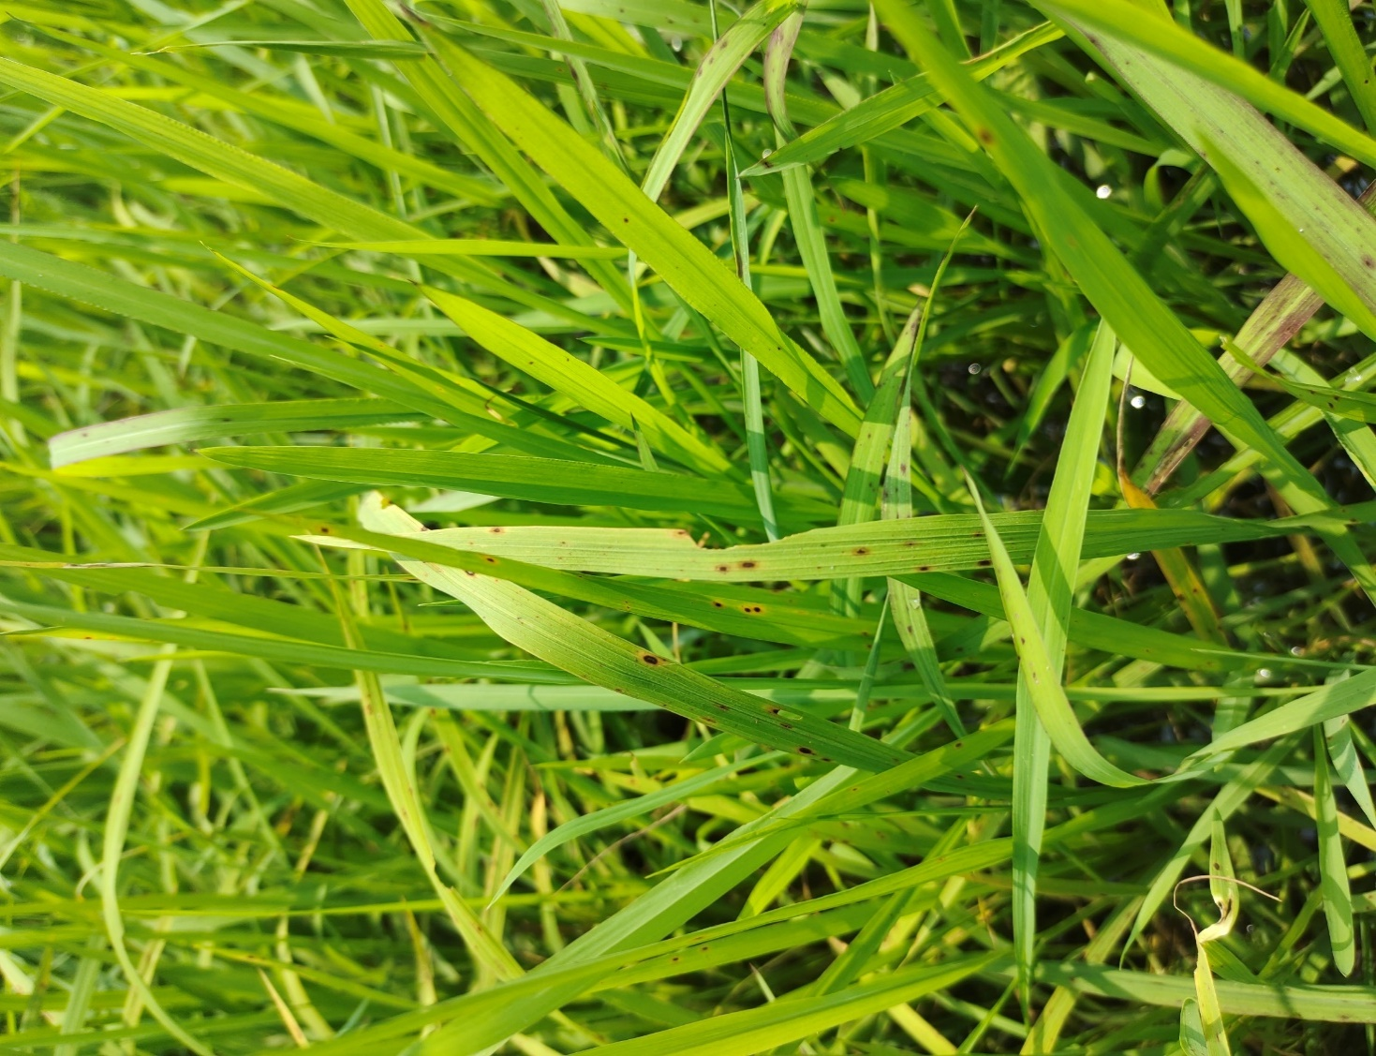

Fig.1 Symptoms of brown spot in rice leaves
2. Bipolaris oryzae- Epidemiology and impact on rice
Bipolaris oryzae (anamorph; syn. Drechslera oryzae) and its teleomorph (Cochliobolus miyabeanus) belong to the phylum Ascomycota. The anamorphic stage of the fungus produces fluffy, aerial, dark greenish grey cottony mycelium. The conidiophores are solitary or occur in small groups and are olivaceous in colour. Conidia are multicellular, olivaceous brown, typically curved, broader at the middle or just above the middle and taper towards rounded ends. Conidia usually germinate bipolarly at maturity and may initiate multiple infection points [13]. The teleomorph produces globose to depressed perithecia with dark yellowish-brown pseudoparenchymatous wall [14]. The asci are cylindrical to fusiform. Ascospores are filamentous or long cylindrical, hyaline or pale olive green and often coiled together [15].
2.1 Epidemiology
Primary infections are predominantly seed-borne, whereas secondary infections arise from wind-dispersed inoculum originating from infected crop residues, including rice straw and stubble [12,13,16,17]. In addition, soil and certain weed species have been identified as potential reservoirs of inoculum. The pathogen is capable of overwintering in infected seeds and plant debris. Infected grains typically exhibit brown, velvety lesions associated with abundant conidiophores and conidia. Notably, the fungus can remain viable in seeds for more than four years [6]. Optimal environmental conditions for conidial germination (25–30 °C) and hyphal growth (27–30 °C) correspond closely with the temperature range that favours infection and lesion development [18,19]. Temperature in the range of 25-30º C is ideal for disease development. Relative humidity (RH) of more than 89% is required for successful infection. However, it has been reported that dry soil conditions predispose plants to disease more than wet soil. High atmospheric humidity and low soil moisture inhibit the uptake of silicon (Si) and potassium (K) by the plants and reduce the SiO₂ and K₂O content of leaves, and hence increase the susceptibility of brown spot. Shaded conditions enhance disease development [9]. Increasing leaf wetness periods in rice canopies generally leads to increased lesion densities [20]. Host susceptibility of plant tissues increases with their age [21].

2.2 Pathogenesis
The pathogen penetrates the host epidermis through infection pegs that develop from appressoria. Certain amino acids present in rice leaf exudates—such as aspartic acid, glutamic acid, alanine, and methionine—stimulate fungal growth and facilitate colonisation of leaf tissues. The pathogen has been detected in both the seed coat and the endosperm. Transmission of Bipolaris oryzae from infected kernels to seedlings has been reported to range between 57% and 77% under experimental conditions using sand, blotter, and tube agar methods. Infected seedlings exhibit symptoms on the coleoptiles and roots within 7–14 days, followed by the appearance of lesions on the first leaf after approximately 3–4 weeks. In severe cases, infection ultimately results in wilting and death of the affected seedlings [22].

3. Plant defence mechanisms
General defence mechanisms in plants are of two types - structural and biochemical [23, 24]. They can again be classified into two. Preinfectional/ preexisting and induced/ post-infectional [25].

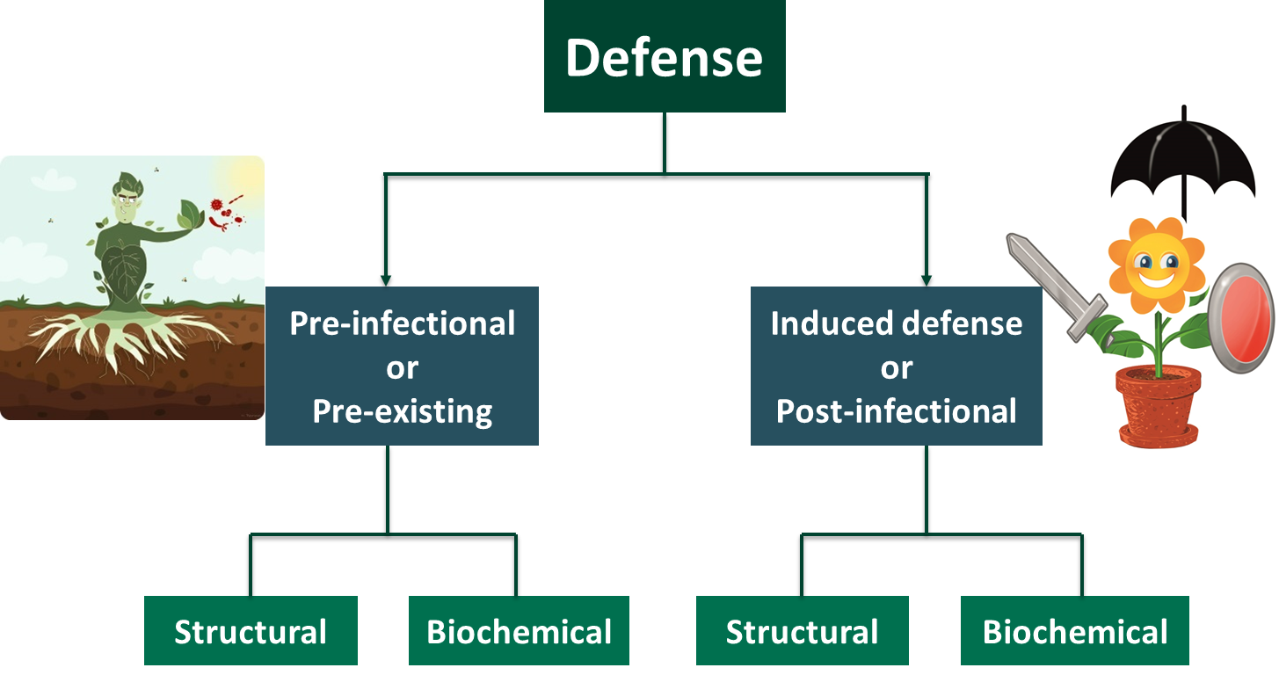

Fig 2. General defence mechanism in plants

4. Defence responses in rice against Bipolaris oryzae
Host resistance represents one of the most effective and environmentally sustainable strategies for disease management. Resistance in plants is regulated by a complex network of molecular and biochemical processes that determine the continuum between susceptibility and resistance [26]. Therefore, a comprehensive understanding of host resistance mechanisms, along with the biochemical interactions between host and pathogen, is essential for identifying and developing effective and durable resistant genotypes [27].
Rice employs various defence mechanisms against Bipolaris oryzae such as the deposition or accumulation of callose as a structural defence mechanism, activation of defence enzymes like β-1,3-glucanase and peroxidase, accumulation of H₂O₂, callose and polyphenolic substances [28], upregulation of genes involved in salicylic acid, jasmonic acid and ethylene signaling pathways [29]. Tryptophan pathway plays a crucial role in defence responses by producing serotonin, which is incorporated into cell walls and suppresses fungal growth [30]. However, the effectiveness of these defence mechanisms varies among rice varieties, with some showing higher resistance than others [28,29]. These mechanisms are further discussed in detail because understanding these defence responses can contribute to developing resistant rice varieties.
4.1. Induced structural defence response in rice against Bipolaris oryzae
Callose accumulation
Callose is a β-(1,3)-D-glucan polysaccharide present in multicellular green algae as well as in higher plants. It is deposited between the plasma membrane and the existing cell wall at sites of pathogen invasion. This pathogen-induced callose deposition acts as both a chemical and physical defence mechanism, reinforcing the plant cell wall and thereby contributing significantly to the plant’s defence response against invading pathogens [31].
Callose is involved in multiple aspects of plant growth and development such as pollen development, pollen tube development, biotic and abiotic stress response, sieve pore development and regulation, plasmodesmata regulation and cell plate formation [32]. Overexpression of callose synthase in Arabidopsis leads to enlarged callose deposits and complete penetration resistance to powdery mildew [33]. In tobacco, systemic acquired resistance to tobacco mosaic virus is associated with increased callose deposition around lesions [34]. Similarly, tomato plants resistant to Fusarium wilt exhibit higher rates of callose deposition in paravascular parenchyma cells compared to susceptible plants [35].
Pathogen elicitor-induced signalling associated with plant innate immune responses stimulates increased callose deposition at sites of pathogen attack, as well as at plasmodesmata and within vascular tissues. The formation of callose-rich papillae at infection sites acts as a structural barrier, thereby restricting pathogen penetration and subsequent colonisation. Enhanced callose accumulation at plasmodesmata promotes their closure, which limits pathogen entry and impedes its spread between cells. Furthermore, increased callose deposition within vascular tissues, particularly in phloem sieve tubes, may serve as an additional defence mechanism by inhibiting the long-distance movement of pathogens within the plant [31].
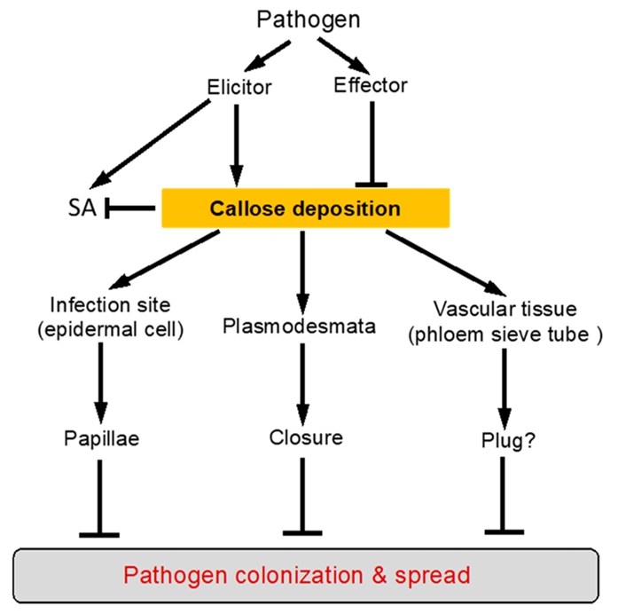

Fig 3. Induction and roles of defence related callose deposition (Wang et al.,2021)
Pathogen-induced callose deposition in plants is regulated through two principal signalling pathways.

(A) Pathogen-associated molecular pattern (PAMP)-induced callose deposition is mediated by pattern-recognition receptors (PRRs) and is promoted by factors such as indole glucosinolates (IGSs), reactive oxygen species (ROS), and the RNA interference regulatory protein Argonaute1 (AGO1). In addition, abscisic acid (ABA) enhances PAMP-induced callose deposition, particularly under conditions of low sucrose concentration.
(B) Pathogen-induced callose deposition at plasmodesmata (PD) is mediated through the salicylic acid (SA)-dependent signalling pathway. Salicylic acid plays a critical role in pathogen-induced plasmodesmatal closure and the associated accumulation of callose. This process requires the activity of key defence-related genes, including Enhanced Disease Resistance 1 (EDS1) and Nonexpressor of Pathogenesis-Related Genes 1 (NPR1), both of which contribute to the regulation of callose formation [31].The accumulation of callose in less compatible and compatible interactions of rice infected by Bipolaris oryzae were studied [28]. They used two isolates of B. oryzae, that is, an avirulent isolate K2 and virulent isolate B5. Callose accumulation were studied in leaf samples collected at 12, 24, 48, 72, 96, 120 and 144 hai (hours after inoculation). They concluded that callose deposition was observed as a response to infection, occurring to a higher degree in the less compatible than in the compatible interaction between rice and B. oryzae, thus potentially indicating a role in defence.
4.2 Induced chemical defence responses in rice against Bipolaris oryzae
4.2.1 Toxic materials produced in rice in response to infection
A. Phytoalexins
Phytoalexins are low molecular weight, antimicrobial compounds, synthesised de novo as a result of infection. “Phyton” means plant and “alexin means “ward off”. The term phytoalexins was coined by Muller and Borger in 1941 [36]. The ability to quickly accumulate high levels of phytoalexins, particularly during hypersensitive responses, appears to be a key trait in resistant rice varieties for restricting pathogen growth and conferring disease resistance [37].
Rice plants synthesise a diverse range of phytoalexins in response to pathogen invasion and environmental stress. Until recently, the flavonoid sakuranetin was considered the only identified phenolic phytoalexin in rice. However, subsequent studies have revealed additional defence-related phenolic compounds with antimicrobial properties. These include N-p-coumaroylserotonin (CouSer), N-feruloyltryptamine (FerTrp), and N-feruloylserotonin (FerSer), which have been isolated from rice leaves infected by fungal pathogens such as those responsible for rice blast and rice brown spot diseases [38].

The stress-induced production of sakuranetin and phenylamide phytoalexins in rice involves the activation of several metabolic pathways. Among these, the shikimate pathway plays a crucial role as an early biosynthetic route for aromatic amino acids in plants under stress conditions. This pathway synthesises chorismate, a key intermediate in the formation of aromatic amino acids, from phosphoenolpyruvate, thereby contributing to the biosynthesis of defence-related secondary metabolites [39].
B. Polyphenols
Rice plant employs various polyphenols as defence enzymes against brown spot disease caused by Bipolaris oryzae. These include increasing the activity of enzymes such as catalase, peroxidase, polyphenol oxidase and phenylalanine ammonia-lyase, as well as higher concentrations of phenolic compounds and lignin [28, 40]. Resistant rice genotypes exhibit higher accumulation of these defence-related enzymes compared to susceptible varieties [28]. There are over 8000 polyphenolic compounds, all of which are derived from a common precursor, phenylalanine, which is produced via the shikimic acid pathway and has been chemically modified for specific functions [41]. The major groups of polyphenols include phenolic acids, flavonoids and isoflavonoids, lignans, and stilbenes. Polyphenols aid in plant defence by accumulating in various tissues where they may neutralize free radicals produced in response to environmental stressors, or by increasing plant toxicity and unpalatability to herbivores and other organisms [42].
Total phenol and soluble protein content in rice leaves negatively correlate with disease incidence, suggesting their role in resistance [43].
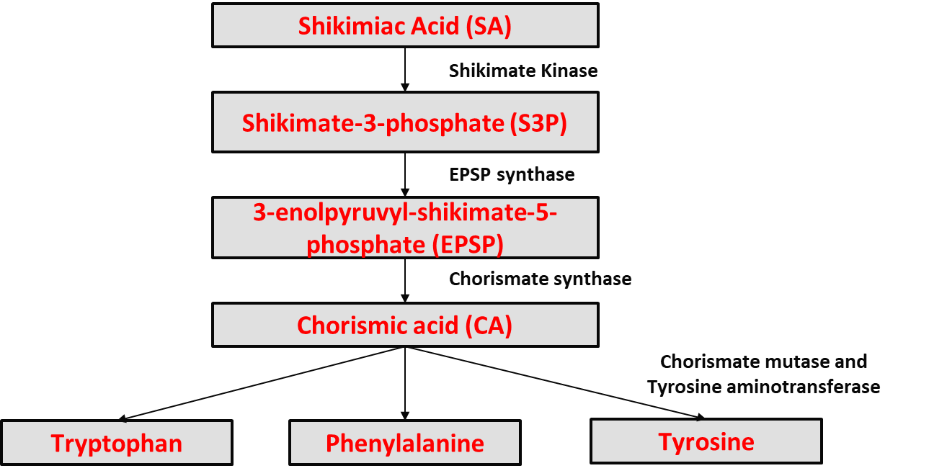
Fig 4. Polyphenols produced via shikimic acid pathway
The accumulation of polyphenols in less compatible and compatible interactions of rice infected by Bipolaris oryzae were studied [29]. They reported that polyphenol accumulation had an inhibitory effect on B. oryzae during the early stages of infection, especially in the less compatible interaction.
4.2.2 Defence through induced synthesis of proteins
Tryptophan mediated resistance against brown spot
Tryptophan and its derivatives play a crucial role in rice resistance against brown spot disease. Red light-induced resistance to B. oryzae involves the Trp pathway, with tryptophan decarboxylase inhibition suppressing this resistance [44]. Trp pathway is upregulated during B. oryzae infection, leading to increased serotonin production, which contributes to physical defences in rice leaves. Serotonin is one of the most important secondary metabolites from tryptophan, and has been implicated in several important physiological and developmental functions of the plant [30].
Tryptophan biosynthesis originates from the shikimate pathway which is in common with the biosynthesis of phenylalanine and Tyrosine, and branches off from the shikimate pathway at chorismate. The first important step is the formation of anthranilate from chorismate by anthranilate synthase (AS). Then, anthranilate is converted to indole 3 glycerol phosphate, which is then converted to tryptophan. Serotonin is formed from tryptophan by tryptophan decarboxylase [45].
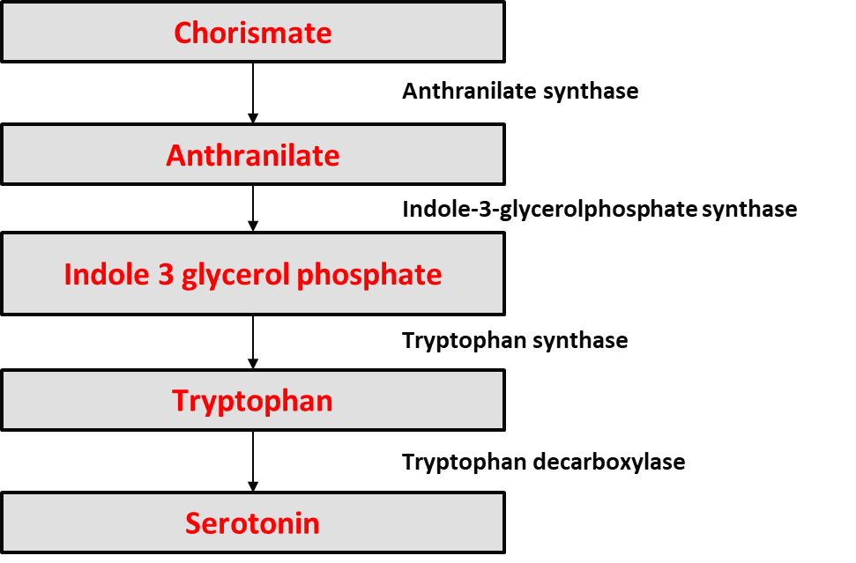
Fig 5. Tryptophan biosynthesis pathway
The involvement of the tryptophan pathway in the defence responses of rice was investigated [30]. They searched for Trp pathway-derived secondary metabolites in rice leaves infected by the rice brown spot fungus Bipolaris oryzae. They reported an increase in the activity of anthranilate, indole and tryptophan which were induced by B. oryzae infection. Furthermore, in the B. oryzae-inoculated leaves, tryptamine and serotonin increased markedly in infected leaves which induced resistance to the plant.
They also compared a resistant rice cultivar (Asahi) and a susceptible mutant (Sekiguchi lesion, sl) in response to B. oryzae infection. The sl mutant lacked serotonin production and failed to deposit brown material at infection sites, leading to increased susceptibility. Serotonin-deficient mutant exhibited enhanced susceptibility, confirming its defensive role.
4.2.3 Defence through induced synthesis of enzymes
The most commonly studied defence compounds that act as first line of defence are mitogen activated protien kinases (MAPKs), peroxidase (POD), and phenylalanine ammonia lyase (PAL) [46,47]. Together with the introduction and buildup of other pathogenesis-related (PR) proteins, like β-1,3-Glucanase, Catalase, Superoxide dismutases and polyphenol oxidase, these compounds contribute to systemic acquired resistance (SAR) by accumulating profusely at the site of infection [29].
A. Reactive oxygen species (ROS)
Reactive oxygen species (ROS) are highly reactive free radicals capable of inducing oxidative cellular damage and cell death [48]. Despite their potentially harmful effects, ROS play important regulatory roles in numerous biological processes, including plant growth, cell cycle regulation, programmed cell death, hormone signalling, and responses to both biotic and abiotic stresses [49]. In plant–pathogen interactions, ROS production represents one of the earliest cellular responses following pathogen recognition [50]. The rapid accumulation of ROS at this stage is commonly referred to as the oxidative burst.
ROS are capable of interacting with cellular components such as proteins, DNA, and membrane lipids, which can lead to increased electrolyte leakage, accelerated senescence, and ultimately cell death. Under normal metabolic conditions, plant cells generate several types of ROS, including the superoxide radical (O₂⁻), hydrogen peroxide (H₂O₂), hydroxyl radical (OH), and nitric oxide (NO). However, under stress conditions, plants can produce a rapid burst of ROS, predominantly composed of H₂O₂ [51].
Resistant rice genotypes often exhibit elevated activities of antioxidative enzymes, including superoxide dismutase (SOD), catalase (CAT), and peroxidase (POX), which play key roles in both the generation and detoxification of ROS, thereby contributing to enhanced defence responses against pathogen infection [40].
B. Hydrogen peroxidases
It is well-documented that H₂O₂ plays a central role in responses to both abiotic and biotic stresses in plants [52]. This molecule seems to be a “master hormone” that controls a variety of stress responses and physiological adjustments, including the ROS/hormonal homeostasis in the cell. At a low concentration, H₂O₂ acts as a signaling molecule and at high concentrations provokes cellular death. It has been reported that there was an increase in hydrogen peroxide concentration after exposure to stress due to pathogen attack [53]. Hydrogen peroxide upregulation of a metallothionein gene, OsMT2c, from O. sativa has been reported [54].
The infection biology and involvement of hydrogen peroxidase in defence responses of rice cv. MTL189 infected by B. oryzae [28]. H₂O₂ accumulation and localization was demonstrated with 0.05% DAB (diaminobenzidine). Reddish-brown staining indicated accumulation of H₂O₂. In the less compatible interaction, H₂O₂ accumulation was seen as irregular reddish-brown staining in the epidermis and mesophyll and the penetration of B. oryzae was strongly inhibited. They concluded that the inhibition is due to the accumulation of H₂O₂. In the compatible interaction, H₂O₂ accumulation was significantly lower and the conidia was able to germinate. They confirmed the involvement of hydrogen peroxidase in defence responses of resistant rice var. infected by B. oryzae.
4.2.4 Defence through detoxification of pathogen toxins
The effect of the host specific toxin ‘ophiobolin’ produced by H. oryzae on the activities of phenol content, and peroxidase and phenylalanine-ammonia lyase activities in rice leaves were studied by [55] and reported that this toxin suppresses phenol metabolism in rice plants and aids pathogen colonization.
When the virulent isolate of the brown spot pathogen was inoculated on rice seedlings, the phenolic content, peroxidase and phenylalanine-ammonia lyase activities increased 24 hours after inoculation. They suggested that resistant cultivars possess gene transcripts against ophiobolin which may detoxify the host specific toxin.
Genetic transformation of rice cultivar BRS Taim with a chitinase gene from Metarhizium anisopliae showed reduced fungal development, indicating that chitinase can enhance resistance against B. oryzae [56]. The transformation resulted in a 1.53% efficiency, with resistance observed against specific fungal isolates.
4.2.5 Hormone mediated resistance in rice against Bipolaris oryzae
Abscisic acid
Emerging evidence indicates that Abscisic acid (ABA) is prominently involved in the regulation and integration of pathogen defence responses [57].
Exogenous ABA application leads to the upregulation of defence-related genes, which are crucial for mounting an effective response against fungal infections [58]. Studies have shown that ABA assays can effectively differentiate between resistant and susceptible rice varieties against brown spot disease, confirming ABA's role in enhancing resistance [59]. While ABA generally promotes resistance to brown spot, it can also have complex effects depending on the pathogen and environmental context, sometimes leading to increased susceptibility in other scenarios [60].
Pretreatment of rice with ABA renders leaves more resistant to C. miyabeanus attack. ABA-mediated repression of pathogen-induced Ethylene action was identified as a core resistance mechanism [57]. In addition, they provide novel evidence regarding the role of the ABA-inducible MAPK gene OsMPK5 as a pivotal regulator of this ABA/ ET cross talk. They reported that supplying plants with 0.1 mM ABA 3 days prior to inoculation induced high levels of protection, as shown by dramatic decreases in size, type, and number of brown spot lesions in ABA-supplied leaves
4.2.6 R gene mediated resistance in rice against B. oryzae
More than 40 rice PRR and R genes have been identified and functionally characterized. Recent studies have advanced the understanding of rice resistance against B. oryzae. Genome-wide association studies identified three candidate genes (OsExo70F3, OsBSR820, and Osmed30) that enhance resistance when overexpressed or silenced [61]. Transcriptome analysis revealed the importance of early response genes, particularly those involved in cell wall modification and hormone signalling pathways while the Pi5-mediated resistance against Magnaporthe oryzae requires two coiled-coil-nucleotide-binding-leucine-rich repeat genes [62], the defence mechanism against B. oryzae appears more complex. Expression analysis of defence-related genes in Thai rice varieties suggested that salicylic acid, jasmonic acid, and ethylene signaling pathways may not play a major role in resistance against B. oryzae [29].
The gene bsr1, a single recessive gene, is responsible for resistance to brown spot caused by B. oryzae in rice, identified through marker-assisted selection and demonstrated in a near-isogenic line with improved yield and disease resistance. They introduced a chromosomal segment including a quantitative trait locus (QTL) for BS resistance, qBSfR11, derived from the BS-resistant local resource ‘Tadukan’, into the genetic background of the high-yielding but susceptible ‘Mienoyume’. Resistance is controlled by a single recessive gene in a 1.3-Mbp region. They named this gene bsr1 (brown spot resistance 1). [63]
A new major locus on chromosome 3 linked to brown spot resistance in rice was identified, between markers RM15749 and RM15689. with OsRBSq3 being a potential target for marker-assisted selection and functional studies [64].
These findings provide valuable insights for future research on brown spot disease resistance in rice.
5. Silicon mediated resistance in rice against B. oryzae
Silicon (Si) is one of the most abundant elements in the lithosphere and has a positive impact on plant health by effectively mitigating biotic and abiotic stresses. It also enhances plant resistance against insect pests and fungal, bacterial and viral diseases [65]. Silicon-mediated resistance is effective regardless of manganese levels in the plant, which is beneficial in areas with varying soil manganese content [66]. At the molecular level, silicon amendment alters the expression of numerous genes in rice, even without pathogen challenge, suggesting an active role in plant metabolism and defence responses [67]. Silicon's protective effects extend beyond fungal pathogens to insect pests as well. In rice plants treated with silicon, resistance to the Asiatic rice borer (Chilo suppressalis) is increased, resulting in reduced borer penetration, weight gain, and stem damage, while prolonging larval development [68].
[65] studied the effect of silicon (Si) on the resistance of rice grains to brown spot disease and reported that rice grain resistance to brown spot is increased by application of silicon. Plants from cv. Oochikara and its mutant, defective in the Lsi1 transporter (lsi1 mutant), were grown in hydroponic culture either with Si (+Si; 2 mM) or without Si (-Si). In the presence of Si, brown spot severity was reduced by 88% in grains from cv. Oochikara (65.5 to 8.1) and by 53% in grains from lsi1 mutant (77.0 to 35.6). Brown spot severity was 77% lower for grains of cv. Oochikara than for the lsi1 mutant, both plant types were grown in the presence of Si.
Table 1. Major defence mechanisms in rice against Bipolaris oryzae
Type of Defence | Defence Mechanism | Key Molecules / Components | Functional Role in Resistance to B. oryzae | References
Structural (Pre existing) | Cuticular and epidermal barrier | Cutin, waxes | Prevents initial pathogen adhesion and penetration | Garroum et al., 2021
Structural (Pre existing) | Silicon deposition | SiO₂ | Reinforces cell walls and reduces appressorial penetration | Dallagnol et al., 2014
Structural (Pre existing) | Lignified cell walls | Lignin | Restricts pathogen spread within tissues | Lee et al., 2019
Structural (Induced) | Callose deposition | β-1,3-glucan | Forms papillae at infection sites, blocking fungal entry | Chen and Kim, 2009
Structural (Induced) | Hypersensitive response (HR) | Localized programmed cell death | Limits pathogen colonization | Thuy et al., 2023
Phytoalexin Production | Diterpenoid phytoalexins | Momilactones, phytocassanes | Direct antifungal activity against B. oryzae | Koga et al.,1995; Cho and Lee,2015
Phytoalexin Production | Flavonoid phytoalexins | Sakuranetin | Inhibits fungal growth | Hasegawa et al., 2014
Defence-Related Enzymes | Peroxidase (POX) | H₂O₂-dependent enzymes | Lignification and oxidative burst | Hiraga et al., 2001
Defence-Related Enzymes | Polyphenol oxidase (PPO) | Quinone formation | Toxic to pathogen cells | Thuy et al., 2023
Defence-Related Enzymes | Superoxide dismutase (SOD) | Converts O₂⁻ to H₂O₂ | Regulates ROS balance | Wang et al., 2018
Defence-Related Enzymes | Catalase (CAT) & APX | H₂O₂ scavenging enzymes | Protect host tissues from oxidative damage | Anjum et al., 2016
Reactive Oxygen Species (ROS) | Oxidative burst | O₂⁻, H₂O₂ | Direct antimicrobial action and defence signaling | O’Brien et al., 2012
Hormonal Regulation | Salicylic acid (SA) pathway | PR proteins | Activates systemic acquired resistance | Ganesan et al., 2001
Pathogenesis-Related (PR) Proteins | β-1,3-glucanases (PR-2) | Glucan hydrolysis | Weakens fungal structure | Balasubramanian et al., 2012
Genetic Resistance | Resistance (R) genes | NBS-LRR proteins | Effector recognition and ETI activation | Matsumoto et al., 2021
Genetic Resistance | Quantitative trait loci (QTLs) | Polygenic resistance regions | Provides partial and durable resistance | Mizobuchi et al., 2016
Systemic Defence | Systemic acquired resistance (SAR) | SA-mediated signaling | Long-term broad-spectrum resistance | Gao et al., 2015
Systemic Defence | Induced systemic resistance (ISR) | JA/ET-mediated priming | Enhanced defensive readiness | Van der Ent et al., 2009

6. Conclusion
Brown spot in rice is a significant disease caused by Bipolaris oryzae and managing it sustainably is crucial. Rice plant deploys various defence responses against the disease. These responses include the accumulation of callose, toxic substances such as phytoalexins and polyphenols, induced synthesis of proteins and enzymes, as well as the detoxification of pathogen toxins. Additionally, hormone-mediated resistance and R gene-mediated resistance play vital roles in the plant's defence mechanisms. Understanding and studying these intricate defence responses can provide valuable insights, ultimately enhancing our ability to effectively manage the disease. Molecular mechanisms underlying defence responses in rice against B. oryzae should be studied thoroughly.
Furthermore, studies should be conducted to probe into the cross talk between various defence responses involved against B. oryzae. With the advent of omics approaches such as genomics, transcriptomics, proteomics, metabolomics etc. and high throughput sequencing, future research should focus to develop durable and broad-spectrum resistance against brown spot disease.

Disclaimer (Artificial intelligence)

Author(s) hereby declare that NO generative AI technologies such as Large Language Models (ChatGPT, COPILOT, etc.) and text-to-image generators have been used during the writing or editing of this manuscript.

References
- Adarsh, S., Ameena, M., Joy, M. and Beena, R., 2025. Impact of Growth Media and Piriformospora indica Colonisation on Seedling Growth Characters of Rice (Oryza sativa L.). Journal of Experimental Agriculture International, 47(10), pp.193-199.
- Gouda, B., Narendrappa, T., Chethana, B., & Kumar, M. 2020. Status and Distribution of Rice Grain Discolouration in Different Ecosystems in Karnataka, India. International Journal of Current Microbiology and Applied Sciences, 9, 796-805. https://doi.org/10.20546/ijcmas.2020.905.088.
- Sen, S., Chakraborty, R. and Kalita, P. 2020. Rice-not just a staple food: A comprehensive review on its phytochemicals and therapeutic potential. Trends Food Sci. Technol. 97: 265-285.
- Kaboré, K. H., Kassankogno, A. I. and Tharreau, D. 2025. Brown spot of rice: Worldwide disease impact, phenotypic and genetic diversity of the causal pathogen Bipolaris oryzae, and management of the disease. Plant Pathol. 74(4): 908-922. DOI:10.1111/ppa.14075
- Bhutia, T.P., Rao, Y.D., Kharel, P., Rai, P., Rana, M. and Srivastava, S., 2025. A comprehensive review on brown spot disease of rice: etiology, epidemiology, management strategies and future directions. Plant Science Today, 12(1), pp.1-13.
- Pantha, P. and Yadav, D.R. 2016. Assessment of Seed Infestation Level of Brown Spot (Bipolaris Oryzae) in Different Rice Genotypes under Natural Epiphytotic Conditions. Int. J. Appl. Sci. Biotechnol. 4(3): 294–297. DOI: https://doi.org/10.3126/ijasbt.v4i3.15354.
- Agbowuro, G. O., Afolabi, M. S., Olamiriki, E. F. and Awoyemi, S. O. 2020. Rice blast disease (Magnaporthe oryzae): A menace to rice production and humanity. Int. J. Pat. Res. 4(3): 32-39. DOI: 10.9734/ijpr/2020/v4i330114

- Sudhasha, S., Balabaskar, P. and Eswaran, A. 2022. Aerobiological dynamics of Bipolaris oryzae in the rice agroecosystem and its impact on rice brown spot disease severity. Crop Res. 57(5): 433-441. DOI: 10.31830/2454-1761.2022.892
- Quintana, L., Gutiérez, S., Arriola, M., Morinigo, K. and Ortiz, A. 2017. Rice brown spot Bipolaris oryzae (Breda de Haan) shoemaker in Paraguay. Trop. Plant Res. 4(3): 419-420. DOI:10.22271/tpr.2017.v4.i3.055
- Sanchote, S. and Van Ba, V. 2005. Seed borne and transmission of Bipolaris oryzae, the causal pathogen of brown spot of rice. In Proceedings of 43rd Kasetsart University Annual Conference, Thailand, 1-4 February, 2005. Subject: Plants 1: (163-172).
- Sato, H., Ando, I., Hirabayashi, H., Takeuchi, Y., Arase, S., Kihara, J., Kato, H., Imbe, T. and Nemoto, H. 2008. QTL analysis of brown spot resistance in rice (Oryza sativa L.). Breed. Sci. 58(1): 93-96. DOI:10.1270/jsbbs.58.93
- Ou. S. H. 1985. Rice Diseases. 2nd ed. Common Wealth Mycological Institute. Kew, Surrey, England. 1: 61-96.
- Kumar, A., Solanki, I.S., Akhtar, J. and Gupta, V. 2016. Morpho-molecular diversity of Bipolaris oryzae causing brown spot of paddy. Indian J. Agric. Sci. 86(5): 615-20. DOI:10.56093/ijas.v86i5.58274
- Jang, S. H., Kim, S., Kim, S., Chung, H. and Park, S. Y. 2024. Optimization of conditions for conidial production in Bipolaris oryzae isolated from rice. Res. Plant Dis. 30(3): 229-235.
- Sharma, S. K. and Maheshwari, S. K. 1982. Efficacy of fungicides for the control of brown spot. Intern. Rice Res. Newsl. 7: 17-18
- Damicone, J. P. 1992. Rice diseases in Mississippi: A guide to identification. Cooperative Extension Service, Mississippi State University.
- Sherf, A. F., Page, R. M., Tullis, E. C. and Morgan, T. L. 1947. Studies on factors affecting the infectivity of Helminthosporium oryzae.
- Dasgupta, M. K. and S. B. Chattopadhyay. 1977. Effect of different doses of N and P on the susceptibility of rice to brown spot caused by Helminthosporium oryzae. J. Plant Dis. Prot. 84(5): 276-285.
- Luo, W. H. 1996. Simulation and measurement of leaf wetness formation in paddy rice crops. Wageningen: PhD Thesis, Wageningen Agricultural University.
- Padmanabhan, S. Y. and Ganguly, D. 1954. Relation between the age of rice plant and its susceptibility to Helminthosporium and blast diseases. In Proceedings/Indian Academy of Sciences Springer India. 39(2):44-50.
- Kaboré, K. H., Kassankogno, A. I. and Tharreau, D. 2025. Brown spot of rice: Worldwide disease impact, phenotypic and genetic diversity of the causal pathogen Bipolaris oryzae, and management of the disease. Plant Pathol. 74(4): 908-922. DOI:10.1111/ppa.14075
- Hammerschmidt, R. and Schultz, J. C. 1996. Multiple defences and signals in plant defence against pathogens and herbivores. Phytochemical diversity and redundancy in ecological interactions. (1): 121-154
- Dickison, W.C., 2000. Integrative plant anatomy. Elsevier. Academic Press, San Diego, 533 p.
- Rithesh, L. 2020. Defence mechanisms and disease resistance in plant-pathogen interactions. Plant Sci. Arch. 5(4) DOI: https://doi.org/10.51470/PSA.2020.5.4.01
- Knepper, C. and Day, B. 2010. From perception to activation: The molecular-genetic and biochemical landscape of disease resistance signalling in plants. The Arabidopsis book/ (ASPB) (8): 12.
- Ashfaq, B., Arshad, H. M. I., Atiq, M., Yousaf, S., Saleem, K., and Arshad, A. 2021. Biochemical profiling of resistant phenotypes against Bipolaris oryzae causing brown spot disease in rice. Front. Agron. 3: 675895.
- Debona, D., Fortunato, A. A., Araújo, L., Rodrigues, A. L. and Rodrigues, F. A., 2018. Rice defence responses to Bipolaris oryzae mediated by a strobilurin fungicide. Trop. Plant Pathol. 43(5): 389-401. DOI:10.1007/s40858-018-0220-6
- Thuy, T. T. T., Lübeck, M., Smedegaard-Petersen, V., de Neergaard, E., and Jørgensen, H. J. 2023. Infection biology of Bipolaris oryzae in rice and defence responses in compatible and less compatible interactions. Agron. 13(1): 231.
- Songkumarn, P., Chaijuckam, P., Tongsri, V. and Guerrero, J. J. G. 2019. Expression analysis of defence related genes in rice response to Bipolaris oryzae, the causal agent of rice brown spot. Appl. Sci. Eng. Pro. 12(2): 104-115. DOI: 10.14416/j.asep.2019.05.001
- Ishihara, A., Hashimoto, Y., Tanaka, C., Dubouzet, J. G., Nakao, T., Matsuda, F., Nishioka, T., Miyagawa, H., and Wakasa, K. 2008. The tryptophan pathway is involved in the defence responses of rice against pathogenic infection via serotonin production. Plant J. 54(3): 481-495. DOI: 10.1111/j.1365-313X.2008.03441.x
- Wang, Y., Li, X., Fan, B., Zhu, C., and Chen, Z. 2021. Regulation and function of defence-related callose deposition in plants. Int. J. Mol. Sci. 22(5): 2393. DOI: 10.3390/ijms22052393
- Chen, X. Y. and Kim, J. Y. 2009. Callose synthesis in higher plants. Plant Signal. Behav. 4(6): 489-492. DOI: 10.4161/psb.4.6.8359
- Ellinger, D., Naumann, M., Falter, C., Zwikowics, C., Jamrow, T., Manisseri, C., Somerville, S. C. and Voigt, C. A. 2013. Elevated early callose deposition results in complete penetration resistance to powdery mildew in Arabidopsis. Plant physiol. 161(3): 1433-1444. DOI: 10.1104/pp.112.211011
- Shimomura, T. 1979. Stimulation of callose synthesis in the leaves of Samsun NN tobacco showing systemic acquired resistance to Tobacco mosaic virus. Jpn. J. Phytopathol. 45(3): 299-304.
- Beckman, C. H., Mueller, W. C., Tessier, B. J. and Harrison, N. A. 1982. Recognition and callose deposition in response to vascular infection in Fusarium wilt-resistant or susceptible tomato plants. Physiol. Plant Pathol. 20(1): 1-10.
- Singh, R.S. 2018. Introduction to Principles of Plant Pathology (5th Ed.). Scientific International (Pvt.) Ltd. New Delhi. 402p.
- Hasegawa, M., Mitsuhara, I., Seo, S., Okada, K., Yamane, H., Iwai, T. and Ohashi, Y. 2014. Analysis on blast fungus-responsive characters of a flavonoid phytoalexin sakuranetin; accumulation in infected rice leaves, antifungal activity and detoxification by fungus. Mol. 19(8): 11404-11418. DOI: 10.3390/molecules190811404
- Cho, M. H. and Lee, S. W. 2015. Phenolic phytoalexins in rice: biological functions and biosynthesis. Int. J. Mol. Sci. 16(12): 29120-29133. DOI: 10.3390/ijms161226152
- Park, H. L., Lee, S. W., Jung, K. H., Hahn, T. R., and Cho, M. H., 2013. Transcriptomic analysis of UV-treated rice leaves reveals UV-induced phytoalexin biosynthetic pathways and their regulatory networks in rice. Phytochem. 96(1): 57-71. DOI: 10.3390/molecules191118139
- Dorneles, K. R., Refatti, J. P., Pazdiora, P. C., de Avila, L. A., Deuner, S. and Dallagnol, L. J. 2020. Biochemical defences of rice against Bipolaris oryzae increase with high atmospheric concentration of CO₂. Physiol. Mol. Plant Pathol. 110:101484.
- Pandey, K. B. and Rizvi, S. I., 2009. Plant polyphenols as dietary antioxidants in human health and disease. Oxid. Med. Cell. Longev. 2(1):270-278. DOI: 10.4161/oxim.2.5.9498
- Stiller, A., Garrison, K., Gurdyumov, K., Kenner, J., Yasmin, F., Yates, P., and Song, B. H. 2021. From fighting critters to saving lives: polyphenols in plant defence and human health. Int. J. Mol. Sci. 22(16): 8995. DOI: 10.3390/ijms22168995
- Bisen, K. A., Biswas, S.K., Kumar, V., Lal, K., Kumar, R. and Kumar, N. 2015. Biochemical changes in relation to brown leaf spot (Drechslera oryzae) resistance in different rice genotypes. J. Plant Stud. 4(2). DOI:10.5539/jps.vv4n2p81
- Parada, R.Y., Mon‐nai, W., Ueno, M., Kihara, J. and Arase, S. 2015. Red‐light‐induced resistance to brown spot disease caused by Bipolaris oryzae in rice. J. Phytopathol. 163(2): 116-123. DOI:10.1111/jph.12288
- Li, M., Tadfie, H., Darnell, C. G. and Holland, C. K., 2023. Biochemical investigation of the tryptophan biosynthetic enzyme anthranilate phosphoribosyltransferase in plants. J. Biol. Chem. 299(10). DOI: 10.1016/j.jbc.2023.105197
- Geetha, N. E., Amruthesh, K. N., Sharathchandra, R. G., and Shetty, H. S. (2005). Resistance to downy mildew in pearl millet is associated with increased phenylalanine ammonia-lyase activity. Funct. Plant Biol. 32, 267–275. DOI: 10.1071/FP04068
- Eliahu, N., Igbaria, A., Rose, M. S., Horwitz, B. A., and Lev, S. (2007). Melanin biosynthesis in the maize pathogen Cochliobolus heterostrophus depends on two mitogen-activated protein kinases, Chk1 and Mps1, and the transcription factor Cmr1. Eukaryot. Cell 6: 421–429. DOI: 10.1128/EC.00264-06
- Nandini Yadav, N. Y. and Samir Sharma, S. S. 2016. Reactive oxygen species, oxidative stress and ROS scavenging system in plants. J. Chem. Pharm. Res. 2016, 8(5): 595-604.
- O’Brien, J. A., Daudi, A., Butt, V. S., and Bolwell, G. P. 2012. Reactive oxygen species and their role in plant defence and cell wall metabolism. Planta. 236: 765-779. DOI: 10.1007/s00425-012-1696-9
- Dey, N., Roy, U. K., Aditya, M. and Bhattacharjee, S. 2020. Defensive strategies of ROS in programmed cell death associated with hypertensive response in plant pathogenesis. Ann. Syst. Biol. 3: 1-9. DOI:10.17352/asb.000004
- Mansoor, S., Ali Wani, O., Lone, J. K., Manhas, S., Kour, N., Alam, P., Ahmad, A. and Ahmad, P. 2022. Reactive oxygen species in plants: from source to sink. Antioxidants 11(2):225. DOI: 10.3390/antiox11020225
- Hieno, A., Hushuna Ara, N. and Yamamoto, Y. Y., 2019. H₂O₂-mediated biotic and abiotic stress responses in plants. In Redox Homeostasis in Plants: From Signalling to Stress Tolerance Cham: Springer International Publishing (19-42). DOI: 10.1007/978-3-319-95315-1_2
- T. S. Gechev and J. Hille. 2005. Hydrogen Peroxide as a Signal Controlling Plant Programmed Cell Death. J. Cell Biol. 168(1): 17-20. DOI:10.1083/jcb.200409170.
- Liu, J., Zou, Y., Jin, B., Zhang, K. and Park, J.H., 2019. Hydrogen peroxide production from solar water oxidation. ACS Energy Lett. 4(12): 3018-3027.
- Vidhyasekaran, P., Borromeo, E. S. and Mew, T. W. 1992. Helminthosporium oryzae toxin suppresses phenol metabolism in rice plants and aids pathogen colonization. Physiol. Mol. Plant Pathol. 41(5): 307-315. DOI:10.1016/0885-5765(92)90018-Q
- Rey, M. D. S., Beneman, D.D.P., Pinto, L.D.S., Silva, F.D., Braga, E.J.B., Moura, A.B., Pierobom, C.R. and Peters, J.A., 2012. Induction of resistance in rice against Bipolaris oryzae Breda de Hann by constitutive expression of achitinase gene.
- Vleesschauwer, D. D., Yang, Y., Vera Cruz, C., and Höfte, M. 2010. Abscisic acid-induced resistance against the brown spot pathogen Cochliobolus miyabeanus in rice involves MAP kinase-mediated repression of ethylene signaling. Plant Physiol. 152(4): 2036-2052.
- Liao, X., Li, M., Liu, B., Yan, M., Yu, X., Zi, H., Liu, R. and Yamamuro, C. 2018. Interlinked regulatory loops of ABA catabolism and biosynthesis coordinate fruit growth and ripening in woodland strawberry. Proceedings of the National Academy of Sciences, 115(49): 11542-11550.
- Lacorte-Apostol, V., Aguilar, E. A. and Leung, H., 2019. Disease resistance screening protocol against rice (Oryza sativa L.) brown spot (Bipolaris oryzae Shoem.) and blast (Magnaporthe oryzae Hebbert Barr) diseases using abscisic acid (ABA) assay. The International Society for Southeast Asian Agricultural Sciences. 25(2): 14-22
- Xie, K., Li, L., Zhang, H., Wang, R., Tan, X., He, Y., Hong, G., Li, J., Ming, F., Yao, X. and Yan, F. 2018. Abscisic acid negatively modulates plant defence against rice black‐streaked dwarf virus infection by suppressing the jasmonate pathway and regulating reactive oxygen species levels in rice. Plant Cell Environ. 41(10): 2504-2514. DOI: 10.1111/pce.13372
- Cao, F.Y., Lee, G.H., Zeng, Y., Lee, A.R., Park, S.Y., Jang, S.G., Cho, L.H., Kim, S.T., Lee, J. and Kwon, S.W. 2025. Genome-Wide Identification and Functional Characterization of Brown Spot Resistance Genes in Rice (Oryza sativa L.). J. Agric. Food Chem. 73(22): 14089-14098. DOI: 10.1021/acs.jafc.4c12145
- Lee, S. K., Song, M. Y., Seo, Y. S., Kim, H. K., Ko, S., Cao, P. J., Suh, J. P., Yi, G., Roh, J. H., Lee, S. and An, G. 2009. Rice Pi5-mediated resistance to Magnaporthe oryzae requires the presence of two coiled-coil–nucleotide-binding–leucine-rich repeat genes. Genetics. 181(4): 1627-1638. DOI: 10.1534/genetics.108.099226
- Matsumoto, K., Ota, Y., Yamakawa, T., Ohno, T., Seta, S., Honda, Y., Mizobuchi, R., and Sato, H. 2021. Breeding and characterization of the world’s first practical rice variety with resistance to brown spot (Bipolaris oryzae) bred using marker-assisted selection. Breed. Sci. 71(4): 474-483. DOI: 10.1270/jsbbs.21023
- Zhao, D.D., Chung, H., Farooq, M., Kim, N.G., Choi, S.Y., Kim, S., Kim, S.M., Lee, J.H., Du, X.X. and Kim, K.M., 2026. Unveiling key genetic loci and candidate genes for brown spot disease resistance in rice based on QTL analysis. Scientific Reports, 16(1), p.3925.
- Dallagnol, L. J., Rodrigues, F. A., Mielli, M. V., and Ma, J. F. 2014. Rice grain resistance to brown spot and yield are increased by silicon. Trop. Plant Pathol. 39: 56-63. DOI:10.1590/S1982-56762014005000003
- Islam, W., Tayyab, M., Khalil, F., Hua, Z., Huang, Z., & Chen, H. 2020. Silicon-mediated plant defense against pathogens and insect pests.. Pesticide biochemistry and physiology, 168, 104641 . https://doi.org/10.1016/j.pestbp.2020.104641.
- Brunings, A. M., Datnoff, L. E., Ma, J. F., Mitani, N., Nagamura, Y., Rathinasabapathi, B. and Kirst, M. 2009. Differential gene expression of rice in response to silicon and rice blast fungus Magnaporthe oryzae. Ann. Appl. Biol. 155(2): 161-170.
- Hou, M. and Han, Y., 2010. Silicon-mediated rice plant resistance to the Asiatic rice borer (Lepidoptera: Crambidae): Effects of silicon amendment and rice varietal resistance. J. Econ. Entomol. 103(4): 1412-1419. DOI: 10.1603/ec09341
- Garroum, I., Bidzinski, P., Daraspe, J., Mucciolo, A., Humbel, B.M., Morel, J.B. and Nawrath, C., 2016. Cuticular defects in Oryza sativa ATP-binding cassette transporter G31 mutant plants cause dwarfism, elevated defence responses and pathogen resistance. Plant and Cell Physiology, 57(6), pp.1179-1188.
- Lee, M.H., Jeon, H.S., Kim, S.H., Chung, J.H., Roppolo, D., Lee, H.J., Cho, H.J., Tobimatsu, Y., Ralph, J. and Park, O.K., 2019. Lignin‐based barrier restricts pathogens to the infection site and confers resistance in plants. The EMBO journal, 38(23), p.EMBJ2019101948.
- Koga, J., Shimura, M., Oshima, K., Ogawa, N., Yamauchi, T. and Ogasawara, N., 1995. Phytocassanes A, B, C and D, novel diterpene phytoalexins from rice, Oryza sativa L. Tetrahedron, 51(29), pp.7907-7918.
- Hiraga, S., Sasaki, K., Ito, H., Ohashi, Y. and Matsui, H., 2001. A large family of class III plant peroxidases. Plant and Cell Physiology, 42(5), pp.462-468.
- Wang, Y., Branicky, R., Noë, A. and Hekimi, S., 2018. Superoxide dismutases: Dual roles in controlling ROS damage and regulating ROS signaling. Journal of Cell Biology, 217(6), pp.1915-1928.
- Anjum, N.A., Sharma, P., Gill, S.S., Hasanuzzaman, M., Khan, E.A., Kachhap, K., Mohamed, A.A., Thangavel, P., Devi, G.D., Vasudhevan, P. and Sofo, A., 2016. Catalase and ascorbate peroxidase—representative H2O2-detoxifying heme enzymes in plants. Environmental science and pollution research, 23(19), pp.19002-19029.
- Ganesan, V. and Thomas, G., 2001. Salicylic acid response in rice: influence of salicylic acid on H2O2 accumulation and oxidative stress. Plant Science, 160(6), pp.1095-1106.
- Balasubramanian, V., Vashisht, D., Cletus, J. and Sakthivel, N., 2012. Plant β-1, 3-glucanases: their biological functions and transgenic expression against phytopathogenic fungi. Biotechnology letters, 34(11), pp.1983-1990.
- Mizobuchi, R., Fukuoka, S., Tsushima, S., Yano, M. and Sato, H., 2016. QTLs for resistance to major rice diseases exacerbated by global warming: brown spot, bacterial seedling rot, and bacterial grain rot. Rice, 9(1), p.23.
- Gao, Q.M., Zhu, S., Kachroo, P. and Kachroo, A., 2015. Signal regulators of systemic acquired resistance. Frontiers in plant science, 6, p.228.
- Van der Ent, S., Van Wees, S.C. and Pieterse, C.M., 2009. Jasmonate signaling in plant interactions with resistance-inducing beneficial microbes. Phytochemistry, 70(13-14), pp.1581-1588.
370 pp
7: 17-18
fungicides for the control of brown spot.

Intern. Rice Res.
Newsl.
Ou, S.H. (1985). Rice Diseases 2nd edn. CMI, Kew, England,
Sharma, S.K. and Maheshwari, S.K. (1982). Efficacy of

