Case report

Clinico-Pathological Findings of Transitional Cell Carcinoma in a Beagle Dog: A case report

Abstract
An 11 year old male beagle dog was presented to the Department of Veterinary Surgery and Radiology, Institute of Veterinary Science and Animal Husbandry, SOA (Deemed to be University) with a history of stranguria, pollakiuria and hematuria since 1 month. Survey radiography was performed and pneumocystography was done by infusing air via a sterile urinary catheter. After removal of the catheter, a biopsy sample of the intraluminal mass to the tip of the catheter was subjected to cytological examination. A urine sample was also collected after aseptic catheterization of the bladder and a direct wet mount examination was performed. A Giemsa stained smear was prepared from the mass, air dried and fixed with methanol. Radiograph of the abdomen showed a mildly distended urinary bladder with soft tissue opacity within the lumen of the bladder.Cytological examination revealed presence of cluster of round to polygonal transitional epithelial cells exhibiting marked pleomorphism with anisocytosis and anisokaryosis. The early detection of transitional cell carcinoma plays a pivotal role in guiding appropriate treatment strategies, slowing disease progression and improving pet survival and quality of life.
Key words. Canine, TCC, Radiography, Cytology
- Introduction
Canine transitional cell carcinoma (TCC) also known as urothelial carcinoma is a malignant tumour arising from the transitional epithelium lining of the urinary tract (Iwasaki et al., 2019). This tumour represents about 1.5 to 2% of all canine cancer (Norris et al., 1992; Mutsaerset al., 2003). The tumour is aggressive invading the wall of the urinary bladder and frequently spreads to the regional lymph nodes (Iwasaki et al., 2019; Bradbury et al., 2021). Beside the risk of metastasis, transitional cell carcinoma also predisposes animals to urinary tract infection (UTI) that are often resistant to antibiotic treatment (Christopher et al., 2015). Breeds with a known predisposition to transitional cell carcinoma in dogs include Scottish Terriers, West Highland white terriers and Shetland sheepdogs (Glickman et al., 1989; Mutsaers et al., 2003). Among certain breeds of dogs studies show that Scottish Terriers have higher risk for bladder tumours (Norris et al., 1992). A higher incidence of TCC has been observed in female and neutered dogs with additional risk factors including obesity, history of recurrent urinary tract infections and exposure to pesticides or lawn herbicides (Glickman et al., 2004; Knapp et al., 2014). The clinical signs of TCC are non-specific and include hematuria, dysuria, pollakiuria, stranguria and urinary obstruction (Norris et al., 1992; Bradbury et al., 2021). The study report on the occurrence of transitional cell carcinoma in a beagle dog.

- Case presentation
  - Case history and clinical observation
An 11 year old male beagle dog weighing 20 kg was presented to the Department of Veterinary Surgery and Radiology, Institute of Veterinary Science and Animal Husbandry, SOA (Deemed to be University) with a history of stranguria and hematuria since 1 month. Pneumocystography was done by infusing 100 mL air (@5ml/kg b.wt) via a sterile urinary catheter (No.10 infant feeding tube). After removal of the catheter, a biopsy sample of the intraluminal mass to the tip of the catheter was subjected for cytological examination. A urine sample was also collected after aseptic catheterization of the bladder and a direct wet mount examination was also carried out. A Giemsa stain was done from the intraluminal mass, smear was prepared and air dried and fixed with methanol and put for staining with a working solution of Giemsa stain (2 part Giemsa: 8 part distilled water). Dipstick urinalysis showed haematuria and proteinuria.
Survey radiograph of the abdomen showed a mildly distended urinary bladder with soft tissue opacity within the lumen of the bladder (Figure 1). Pneumocystography revealed a radio opaque, irregular mass attached to the urinary bladder mucosa at the trigone obstructing the neck of the bladder. Polypoid growths were also observed throughout the bladder mucosa (Figure 2). Direct wet mount examination of urine sample revealed cluster of neoplastic transitional cells (Figure 3). Cytological examination showed clusters of neoplastic, round to polygonal cells with moderately abundant basophilic cytoplasm (Figure 4) and marked cellular atypical including anisocytosis, anisokaryosis, nuclear pleomorphism and hyperchromasia (Figure 5).

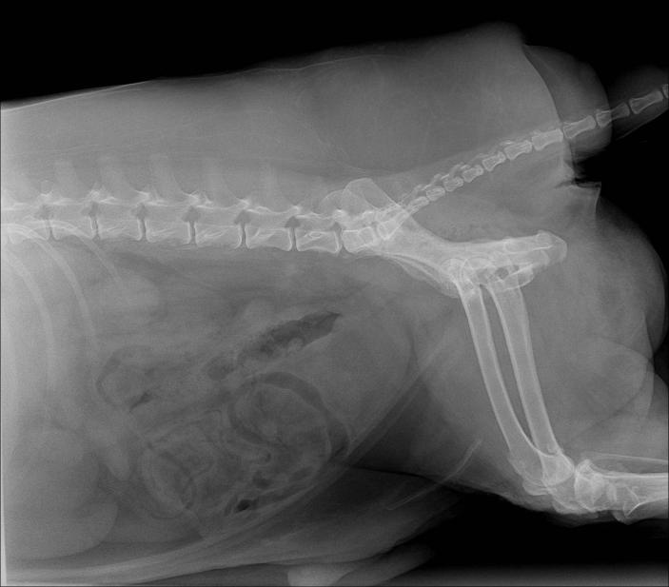
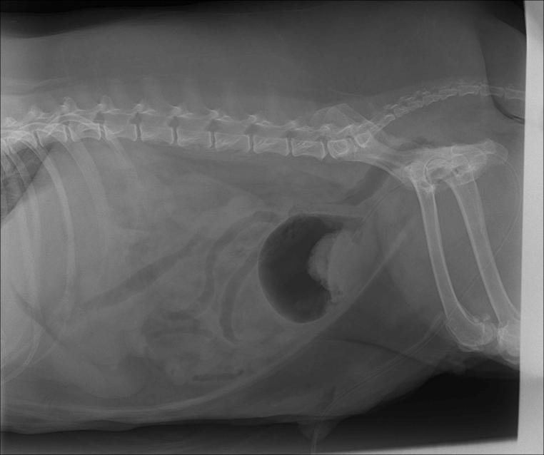

Figure 2: Lateral abdominal radiograph with pneumocystography (negative contrast-100 mL air via urinary catheter) showing irregular soft tissue mass at the trigone and neck of the bladder
Figure 1: Lateral abdominal radiograph showing mildly distended urinary bladder with soft tissue opacity in the lumen

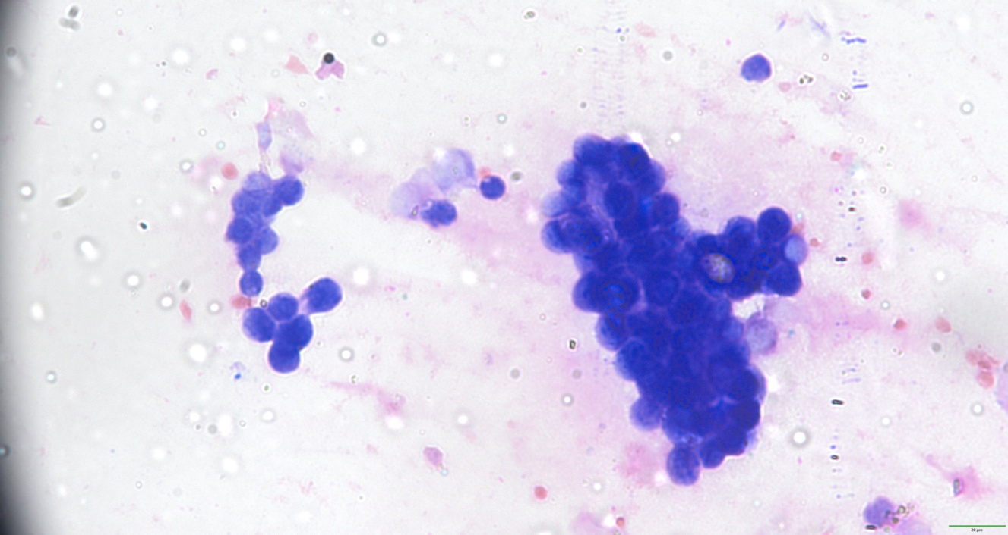
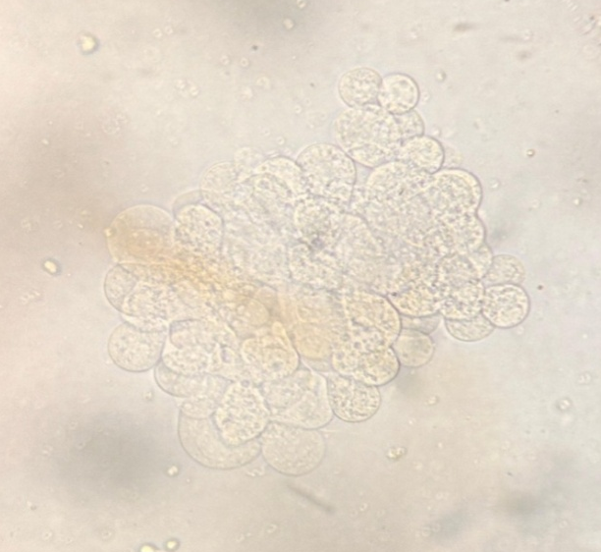

Figure 3: Urine sediment – TCC- Cluster of neoplastic transitional cells x 1000
Figure 4: Urine cytology – Cluster of hyperchromic neoplastic transitional cells. Giemsa, 400x

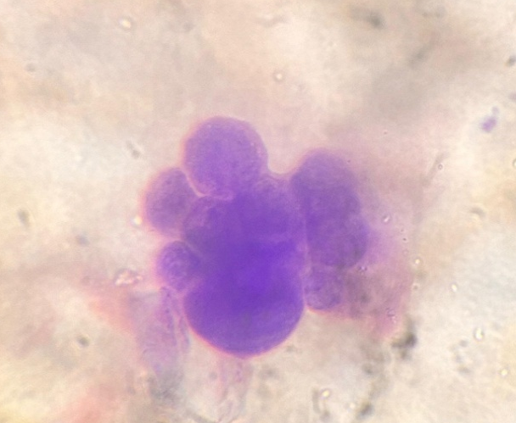

Figure 5: Urine cytology – Cluster of neoplastic transitional cells with nuclear pleomorphism. Giemsa, 1000x

- Discussion
Transitional cell carcinoma (TCC) accounts for 1.5-2% of all canine cancers and it is the most common type of urinary tract cancer in dogs (Withrow, 2013). TCC is typically located in the bladder's trigone region and accounts for 90% of all bladder malignancies (Henry, 2003). In the present study, an 11 year old beagle dog was presented with a history of stranguria, pollakiuria and hematuria since 1 month which is the most common complaint on presentation in cases of TCC (Martinez et al., 2003).
In India, data exists for the incidence of certain breeds of dogs such as the German Shepherd, Labrador, Dachshund, Pug, Dalmatian and Rottweiler (Subapriya et al., 2025). However, only a few cases have reported in a Beagle breed of dog (Parmar et al., 2021). Subapriya and his co-worker reported higher incidence occur in male dog compared with female which support our findings. The study report on the occurrence of 11 year old dog and these findings are in agreement with those of Knapp et al. (2000) who reported a mean diagnostic age of 11.1 years for TCC. Chu et al. (2025) reported that metronomic chemotherapy has emerged as a promising alternative or adjunctive treatment of canine TCC.
4. Conclusion
The present study reports the occurrence of transitional cell carcinoma in a beagle dog characterized by radio-opaque irregular mass attached to the urinary bladder mucosa at the trigone and obstructing the neck of the bladder as diagnosed through radiography, direct microscopy of urine and cytological examination. The presence of TCC can be estimated ahead of time by a positive voided urine cytology test. Clinical evaluation including non-invasive imaging techniques such as contrast enhanced radiological evaluation and cytological examination offers significant advantages over more invasive methods potentially saving a patient's life and increasing the chance of survival.

Ethical Approval
Animal Ethic committee approval has been collected and preserved by the author(s)

COMPETING INTERESTS DISCLAIMER:
Authors have declared that they have no known competing financial interests OR non-financial interests OR personal relationships that could have appeared to influence the work reported in this paper.

Disclaimer (Artificial intelligence)

Author(s) hereby declare that NO generative AI technologies such as Large Language Models (ChatGPT, COPILOT, etc.) and text-to-image generators have been used during the writing or editing of this manuscript.

References
Bradbury, M. L., Mullin, C. M., Gillian, S. D., Weisse, C., Bergman, P. J., Morges, M. A., & Clifford, C. A. (2021). Clinical outcomes of dogs with transitional cell carcinoma receiving medical therapy, with and without partial cystectomy. The Canadian Veterinary Journal, 62(2), 133.
Christopher, M.,Fulkerson, C. M., & Knapp, D. W. (2015). Management of transitional cell carcinoma of the urinary bladder in dogs: a review. The Veterinary Journal, 205(2), 217-225.
Chu, K. T., Nekouei, O., & Giuliano, A. (2025). Treatment outcomes of dogs with transitional cell carcinoma. Frontiers in Veterinary Science, 12, 1486786.
Glickman, L. T., Schofer, F. S., McKee, L. J., Reif, J. S., & Goldschmidt, M. H. (1989). Epidemiologic study of insecticide exposures, obesity, and risk of bladder cancer in household dogs. Journal of Toxicology and Environmental Health, Part A Current Issues, 28(4), 407-414.
Glickman, L. T., Raghavan, M., Knapp, D. W., Bonney, P. L., & Dawson, M. H. (2004). Herbicide exposure and the risk of transitional cell carcinoma of the urinary bladder in Scottish Terriers. Journal of the American Veterinary Medical Association, 224(8), 1290-1297.
Henry, C. J. (2003). Management of transitional cell carcinoma. Veterinary Clinics: Small Animal Practice, 33(3): 597-613.
Iwasaki, R., Shimosato, Y., Yoshikawa, R., Goto, S., Yoshida, K., Murakami, M., and Mori, T. (2019). Survival analysis in dogs with urinary transitional cell carcinoma that underwent whole‐body computed tomography at diagnosis. Veterinary and Comparative Oncology, 17(3), 385-393.
Knapp, D. W., Glickman, N. W., DeNicola, D. B., Bonney, P. L., Lin, T. L., & Glickman, L. T. (2000). Naturally-occurring canine transitional cell carcinoma of the urinary bladder A relevant model of human invasive bladder cancer. In Urologic oncology: Seminars and original investigations, 5 (2), 47-59.
Knapp, D. W., Ramos-Vara, J. A., Moore, G. E., Dhawan, D., Bonney, P. L., &Young, K. E. (2014). Urinary bladder cancer in dogs, a naturally occurring model for cancer biology and drug development. ILAR journal, 55(1), 100-118.
Martinez, I., Mattoon, J. S., Eaton, K. A., Chew, D. J., and DiBartola, S. P. (2003). Polypoid cystitis in 17 dogs (1978–2001). Journal of Veterinary Internal Medicine, 17(4), 499-509.
Mutsaers, A. J., Widmer, W. R., and Knapp, D. W. (2003). Canine transitional cell carcinoma. Journal of Veterinary Internal Medicine, 17(2), 136-144.
Norris, A. M., Laing, E. J., Valli, V. E., Withrow, S. J., Macy, D. W., Ogilvie, G. K., and Jacobs, R. M. (1992). Canine bladder and urethral tumors: a retrospective study of 115 cases (1980–1985). Journal of Veterinary Internal Medicine, 6(3), 145-153.
Parmar, J. J., Parikh, P. V., Panchal, M. T., Ghodasara, D. J., and Bhanderi, B. B. (2021). Clinico-diagnosis and surgico-therapeutic management of lower urinary tract disorders in dogs. Indian Journal of Animal Research, 55(11), 1315-1322.
Parmar, J. J., Parikh, P. V., Shah, A. I., and Dabhi, P. B. (2021). Retrospective analysis of lower urinary tract disorders in dogs: Study of five years. Indian Journal of Animal Research, 55(8), 941-945.
Subapriya, S., Vairamuthu, S., Ramesh, S., Jayanthy, C., Gopalakrishnan, A. and Kavitha, S. (2025).Transitional Cell Carcinoma (TCC) in dogs: Incidence and Cytological diagnosis of 45 cases in Chennai.AMA,56(6), 20945-20952.
Withrow, S.J. (2013). “Tumors of the urinary system” In S. J. Withrow & E. G. MacEwen (Eds.), Small animal clinical oncology, 5th Edn, Philadelphia, Elsevier Saunders, pp. 572.

