Original Research Article
SPATIAL VARIABILITY AND DELINEATION OF SOIL PHYSICAL AND CHEMICAL PROPERTIES OF THE VELLAR BASIN USING GEOSPATIAL TECHNIQUES

ABSTRACT
Understanding the spatial variability of soil physical and chemical properties is critical for sustainable land management and precision agriculture. This study assessed the spatial variability of selected soil properties, including pH (1:2.5), electrical conductivity (EC, dS m⁻¹), soil organic carbon (SOC %), available nitrogen (N, kg ha⁻¹), phosphorus (P, kg ha⁻¹), potassium (K, kg ha⁻¹), and texture across 280 sampling sites in the Vellar River Basin, Tamil Nadu, India, at 0–30 cm soil depth. Soil data were analyzed using both classical statistics and geostatistical techniques, including semivariogram modelling and ordinary kriging interpolation. The results indicated that pH, OC, and macronutrients exhibited strong spatial dependence (nugget/sill ratio = 0.05–0.24), whereas EC and texture fractions showed moderate spatial dependence, reflecting the combined influence of intrinsic soil factors and local heterogeneity. Kriging based spatial prediction maps revealed clear patterns of variability, identifying zones with higher and lower nutrient and organic carbon concentrations. The study demonstrates that geostatistical approaches, particularly semivariogram modeling and kriging, provide reliable tools for characterizing soil spatial variability and can support site-specific nutrient management and sustainable soil management practices in river basin.
Keywords: Soil spatial variability, Geostatistics, Kriging, Vellar river Basin

- INTRODUCTION
Soil is inherently heterogeneous and its properties vary across space due to the combined effects of climate, parent material, topography, biological activity, and anthropogenic management. This spatial variability significantly influences soil processes such as water movement, nutrient cycling, and crop productivity. Understanding the spatial distribution of soil physical and chemical properties is essential for sustainable land management and precision agriculture (Webster & Oliver, 2007; Minasny and McBratney, 2016). Among soil physical properties, soil texture are critical determinants of soil hydraulic behaviour, porosity, permeability, and nutrient retention capacity. Although soil texture is generally considered a relatively stable property, several studies have reported substantial spatial variability even within small agricultural fields due to erosion, deposition, and landscape position (Cambardella et al., 1994; Álvarez-Herrera et al., 2025). Spatial characterization of texture is essential because clay-rich zones tend to retain more nutrients and water, whereas sandy soils exhibit higher infiltration but lower nutrient holding capacity. Soil pH, electrical conductivity (EC), organic carbon (OC), and available macronutrients (nitrogen, phosphorus, and potassium) are more dynamic and strongly influenced by land use and management practices. Soil pH regulates nutrient solubility and microbial activity, while EC indicates soluble salt concentrations, which are critical in irrigated and semi-arid regions. Soil organic carbon plays a central role in aggregate stability, carbon sequestration, and nutrient cycling (Minasny et al., 2013). Available N, P, and K directly determine crop productivity and fertilizer efficiency. Numerous studies have demonstrated that these chemical properties often exhibit moderate to high spatial variability due to uneven fertilizer application and cropping patterns (Velamala & Pant, 2024; Zerin et al., 2025; Subhash et al., 2025).
Traditional statistical analyses assume independence among observations however, soil properties typically exhibit spatial autocorrelation. Geostatistics offers a rigorous framework to quantify this spatial dependence through semi-variogram modeling and kriging interpolation (Goovaerts, 1997; Isaaks and Srivastava, 1989). The semivariogram describes how similarity between observations decreases with increasing distance and its parameters nugget, sill, and range provide insight into the degree and scale of spatial dependence. According to Cambardella et al. (1994) the nugget-to-sill ratio is commonly used to classify spatial dependence as strong, moderate, or weak. Recent research has increasingly integrated geostatistics with GIS and digital soil mapping approaches to enhance spatial prediction accuracy. For instance, Álvarez-Herrera et al. (2025) reported structured spatial variability of soil texture fractions under plantation systems using ordinary kriging. Similarly, Velamala and Pant (2024) mapped the spatial distribution of pH, EC, OC, and available NPK under India Soil Health Card project, identifying management zones based on kriging outputs. Zerin et al. (2025) demonstrated that environmental and land-use drivers significantly influence spatial dependence of soil physicochemical properties across agro-industrial landscapes. Furthermore, machine learning combined with geostatistics has improved soil organic carbon prediction accuracy in heterogeneous environments (Parvizi & Fatehi, 2025).
The identification of spatial patterns in soil fertility indicators enables site-specific nutrient management, which reduces excessive fertilizer application and minimizes environmental degradation. Mapping EC and salinity also supports reclamation planning in salt-affected soils. Therefore, geostatistical assessment of soil texture and fertility parameters provides essential information for optimized sampling strategies, and sustainable land use planning. In this context, the present study aims to evaluate the spatial variability of soil physical properties (texture and soil separates) and chemical properties (pH, EC, OC, N, P, and K) using semivariogram analysis and kriging interpolation techniques. The outcomes are expected to support targeted soil management and improve decision-making in agricultural systems
2. MATERIALS AND METHODS
2.1. Study area
Vellar river basin is one of the seventeen river basins in Tamil Nadu. Geographically the river basin extends from 11°13′ N to 12°00′ N latitude and from 78°13′ E to 79°47′ E Longitude (Figure 1). The Vellar River basin is formed by the confluences of three tributaries. The first, the Anaimaduvu River, travels through the Salem district from west to southeast after rising 1,122 meters from the Velanguttu Hills. The second is the Thumbal River, which rises 772 meters from the Thumbal Hills. In the Salem district, the river called as Kallar near Idayaptti village and joins the Anaimaduvu River located at Ramanatham village. The third tributary, the Singpuram River, originates from the Tengar, Jamputtu and Perumal hills in Attur taluk of Salem district. It joins the Karall and Anaimaduvu rivers Vaithi Kavendhanputhur. From here, the river flows as the Vasishta River up to Kalpaganur, after which it is known as the Vellar River. The Vellar river basins are divided into seven sub-basins, Upper Vellar, Swethanadhi, Chinaar, Anaivari Odai, Gomukhinadhi, Manimukthanadhi and lower Vellar. The total geographical area of the Vellar river basin is 7504.35 km2, covering 40 blocks across 22 taluk and parts of 8 disrtrict of Tamil Nadu Such as Dharamapuri, Salem, Namakal, Trichy, Perambular, Ariyalur, Villupuram, Kallakurichi and Cuddalore.

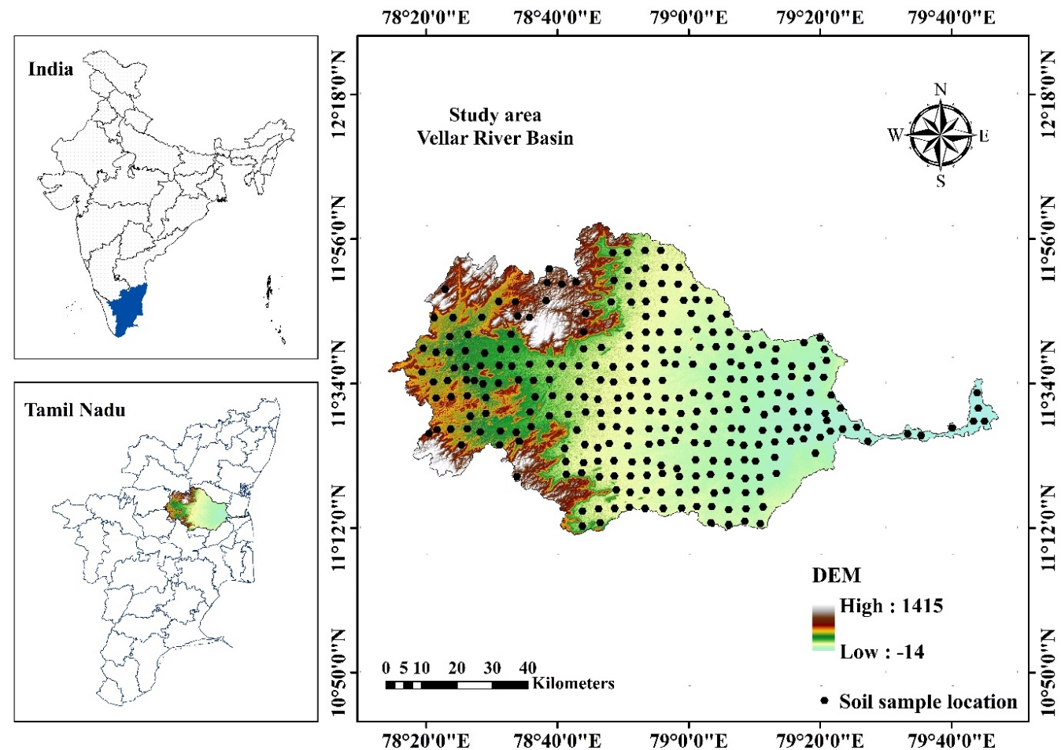
Figure 1. Study area and sample collection location
2.2. Soil sample collection and analysis
The grid sampling approach was used to collect 280 soil samples from the study area. The samples from the study area were collected from the disturbed surface soil (0–30 cm). There were 3500 m distance between each soil sample. However, slight variations in sampling distance occurred in certain locations due to observable differences in soil colour and texture, which required minor adjustments to ensure representative sampling. The soil samples were first air dried to remove the moisture. After drying, the samples were screened through a 2mm sieve to ensure uniform particle size and eliminate any big debris. These sieved samples were then kept in airtight containers to maintain their integrity and avoid contamination or moisture infiltration. After air-drying and sieving, the samples were ground to a fine consistency. The ground samples were extensively mixed in order to produce a representative fraction. The combined samples was then quartered in order to minimize its bulk. This procedure entailed splitting the sample into four equal parts, removing two opposing quarters, and combining the remaining two quarters. This process was repeated as needed until the sample size was decreased to around 500 grams, ensuring a representative and manageable sample for further investigation. The samples were examined for pH, Electrical conductivity, organic carbon, particle size analysis, and available nitrogen, available Phosphorus, available potassium using standard analytical procedures (Table 1).

Table 1. Methods of soil analysis
S. No. | Parameter | Methodology | Authors

Physical properties
1. | Textural analysis | International Pipette Method | G.J. Bouyoucos
B. Physico-chemical properties
2. | Soil reaction (pH) | 1: 2.5 soil water suspension with pH meter | Jackson (1973)
3. | Electrical conductivity  (dS m⁻¹) | 1: 2.5 soil water suspension with electrical conductivity bridge | Jackson (1973)

C. Chemical properties
4. | Organic Carbon  (g kg⁻¹) | Chromic acid Wet Digestion method | Walkley and Black (1934)
5. | Available N (Kg ha⁻¹) | Alkaline Permanganate method | Subbiah and  Asija (1956)
6. | Available P (Kg ha⁻¹) | Ascorbic acid modification of the molybdate blue color method (0.5M NaHCO_{3,} pH 8.5) | Watanabe and Olsen (1965)
7. | Available K (Kg ha⁻¹) | Flame photometer method | Standford and English (1949)

2.3. Spatial variability map preparation
The criteria maps were generated using ArcGIS 10.4. These thematic layers were subsequently reclassified based on soil rating and nutrient classification standards. Soil pH was categorized into acidic (<6.5), neutral (6.5-7.5) and alkaline (>7.5) classes. Soil electrical conductivity (EC) was classified as <1 dS/m (normal), 1–2 dS/m (critical for germination), 2–4 dS/m (critical for growth of sensitive crops), and >4 dS/m (injurious to most crops). Soil organic carbon (SOC) and available macronutrients—nitrogen (N), phosphorus (P), and potassium (K)—were classified into low, medium, and high categories based on standard soil fertility ratings. Soil organic carbon was categorized as low (<0.5%), medium (0.5–0.75%), and high (>0.75%). Available nitrogen was classified as low (<240 kg ha⁻¹), medium (240–480 kg ha⁻¹), and high (>480 kg ha⁻¹). Available phosphorus was grouped as low (<11 kg ha⁻¹), medium (11–22 kg ha⁻¹), and high (>22 kg ha⁻¹), while available potassium was classified as low (<110 kg ha⁻¹), medium (110–280 kg ha⁻¹), and high (>280 kg ha⁻¹).
2.4. Geo-statistics and spatial variability
Geostatistical method is a spatial distribution and variability analysis method that was developed from classical statistics (Shit et al., 2016). The prediction of the spatial variability at non sampling sites using geo-statistics requires a theoretical semivariogram. Semivariance is defined as half of the estimated square difference between sample values in a given distance (lag) (Trangmar et al., 1985). A semivariogram was used to quantify spatial patterns in regionalized variables and was used to analyse spatial variations. These values were then used to calculate critical input parameters for kriging spatial interpolation (Krige, 1951; Matheron, 1963). A semivariogram is a measure of the response variable's covariance between two points in space. The variance is assumed to be a function of the distance between the two points only. After that, the estimated semivariograms are used to fit a semivariogram model (Zhang et al., 2010). A semivariogram displays the change in the semivariance between soil samples as the distance between them increases. Semi variogram can be calculated by using following equation
$$γ\left(h\right)=\frac{1}{2|N(h)}+\sum_{N(h)}{\left(Z\left(x_{i}\right)-Z(x_{j)}\right)}$$
Where, N (h) is the number of pairs separated by distance h, Z (xi) and Z (xj) are the values when the variable Z is at the xi and xj positions, respectively. The soil properties displayed differences in their spatial dependence, as determined by their semivariograms. Semi variance ideally increases with the distance between sample locations, or lag distance (h), to a more or less constant value (the sill or total semi variance) at a given separation distance, called the range of spatial dependence. Samples separated by distances closer than the range are related spatially, and those separated by distances greater than the range are not spatially related. Semivariogram ranges depend on the spatial interaction of soil processes affecting each property at the sampling scale used (Trangmar et al., 1986). The semivariance at h = 0 is called the nugget variance (Webster, 1985). To determine the best-fitting model, several semivariogram functions, including spherical, exponential, Gaussian, and circular models, were evaluated for each soil parameter. The selection of the appropriate model was based on cross-validation statistics, particularly the root means square error (RMSE). For each soil property, the model that produced the lowest RMSE was considered the best fit to the experimental semivariogram. Accordingly, circular, exponential, Gaussian, and spherical models were selected for different soil parameters based on their superior prediction accuracy.
$Circular model: γ (h) = C_{0}+C\left[1-\frac{2}{π} arccoc (h/a) +\frac{2}{π} (h/a) \sqrt{1-{(h/a)}^{2}}\right], for h<a; =C_{0}+C, for h≥a$ ----------------------1
$$Spherical model: γ (h) = C_{0}+ C \left[1.5(h/a)-0.5({h/a)}^{3}\right], for h < a; =C_{0}+C, for h ≥ a)----2$$
$$Exponential model: γ (h) = C_{0}+ C (1-e^{-h/a})--------3$$
$$Gaussian model: γ (h) = C_{0}+ C (1-e^{-h/a})^{2}--------4$$
where, C₀ is the nugget, C₁ is the partial sill, and a is the range of spatial dependence to reach the sill (C₀ + C₁). The nugget/sill ratio, i.e. C₀/ (C₀ + C₁) and the range are the parameters which characterize the spatial structure of a soil property. The range defines the distance over which the soil property values are correlated with each other. A low value of C₀/ (C₀ + C₁) and a high range generally indicate that high precision of the property can be obtained by kriging (Cambardella et al., 1994). According to Chien et al. (1997) spatial dependence (C₀/(C₀+C)) can be classified as strong, moderate, or weak, with values of 25%, 25%–75%, and >75%, respectively.
2.5. Kriging
Kriging was employed to estimate soil properties at unsampled locations using observed sample data and spatial autocorrelation structure. Kriging is a geostatistical interpolation technique that incorporates the distance and directional relationships among sample points and models spatial variability using a semivariogram (Matheron, 1963; 1971). Unlike deterministic interpolation methods, Kriging provides statistically optimal and unbiased predictions by minimizing estimation variance. In this study, ordinary Kriging (OK) was used to interpolate soil physico-chemical properties. Ordinary Kriging assumes a constant but unknown local mean within the search neighbourhood and is widely applied in soil science due to its robustness and reliability (Isaaks and Srivastava, 1989). The best-fitted semivariogram model was selected for each soil parameter to describe spatial dependence prior to interpolation.
$$Z(X_{0})=a_{0}+\sum_{n=1}^{n}{λ_{i}Z(X_{i})}$$
where:
Z(x0) is the estimated value at an unsampled location 𝑥0,
𝜆𝑖 are the weights assigned to each observed value (𝑥𝑖) at location 𝑥𝑖,
𝑛 is the number of observed locations.
The weights (λi​) are calculated such that the estimation variance is minimized while satisfying the unbiasedness condition (i.e., the sum of weights equals one). The soil physico-chemical data were converted into a point shapefile and interpolated using ordinary Kriging in ArcGIS 10.4. The resulting Kriged surfaces provide continuous spatial representations of soil properties across the study area. The Kriging variance (prediction error) was analysed to evaluate interpolation uncertainty and to identify areas where predictions may be less reliable due to sparse sampling or weak spatial correlation. Ordinary Kriging is considered a best linear unbiased predictor (BLUP) for spatially correlated variables (Webster and Oliver, 2007). It is particularly suitable for soil property mapping in cases of sparse and randomly distributed sampling points, and it reduces the influence of outliers through spatial weighting rather than simple averaging (Triantafilis et al., 2001; Meul and Van Meirvenne, 2003).
3. RESULT & DISCUSSION
3.1. Descriptive statistics of soil properties
Descriptive statistical parameters of all the soil physical and chemical variables of the Vellar river basin are presented in Table 2. For each soil sample, properties including pH (1:2.5 H₂O), electrical conductivity (EC), soil organic carbon (SOC), available nitrogen (Av. N), available phosphorus (Av. P), available potassium (Av. K), and particle size fractions (sand, silt and clay) were determined. The descriptive parameters such as mean, minimum, maximum, standard deviation, coefficient of variation, skewness and kurtosis were computed to assess the central tendency and dispersion of the soil datasets. The soil pH ranged from 5.4 to 9.6, with a mean value of 7.7 and a median of 7.6, indicating neutral to moderately alkaline soil reaction in the study area. The standard deviation was 0.9, reflecting low variability. The skewness value (0.1) indicates nearly symmetrical distribution, while the kurtosis value (-0.6) suggests a platykurtic nature. Electrical conductivity (EC) varied from 0.1 to 7.6 dS m⁻¹, with a mean value of 1.5 dS m⁻¹. The standard deviation was 1.6, indicating moderate variability. The skewness value of 2.0 shows a positively skewed distribution, suggesting the presence of higher EC values in a few samples. The kurtosis value (3.8) indicates a leptokurtic distribution. Soil organic carbon (SOC) ranged from 0.1 to 27.0%, with a mean value of 0.8%. The standard deviation was 2.0, indicating high variability. The skewness value (11.7) reveals a highly positively skewed distribution, while the kurtosis value (143.4) indicates an extremely leptokurtic distribution, suggesting the presence of extreme outliers. Available nitrogen ranged from 97 to 510 kg ha⁻¹, with a mean value of 226.2 kg ha⁻¹. The standard deviation was 85.4 kg ha⁻¹, showing considerable variability. The skewness value (1.0) indicates moderate positive skewness, and the kurtosis value (0.4) suggests a slightly leptokurtic distribution. Available phosphorus varied between 5 and 126 kg ha⁻¹, with a mean value of 40.8 kg ha⁻¹. The standard deviation was 23.0 kg ha⁻¹, indicating moderate variability. The distribution was moderately positively skewed (0.8) with near-normal kurtosis (0.1). Available potassium ranged from 57 to 540 kg ha⁻¹, with a mean value of 224.6 kg ha⁻¹. The standard deviation was 90.1 kg ha⁻¹, indicating high variability. The skewness value (1.0) shows moderate positive skewness, while the kurtosis value (0.6) indicates slight leptokurtic distribution. With respect to soil texture, sand content ranged from 15 to 82%, with a mean value of 52.3%. The standard deviation was 13.2%, indicating moderate variability. The skewness value (0.0) indicates symmetrical distribution, and the kurtosis (-0.7) suggests a platykurtic distribution. Silt content varied from 1 to 34%, with a mean value of 11.8%. The standard deviation was 6.2%, indicating moderate variability. The skewness value (0.8) shows moderate positive skewness, and the kurtosis (0.2) indicates near-normal distribution. Clay content ranged from 9 to 69%, with a mean value of 35.9%. The standard deviation was 12.2%, indicating moderate variability. The skewness value (0.2) indicates near-symmetrical distribution, while the kurtosis value (-0.3) suggests a slightly platykurtic nature.
Table 2. Descriptive statistics of soil parameters of Vellar river basin of Tamil Nadu.
 | pH | EC  dS m⁻¹ | SOC  % | Av.N  kg ha⁻¹ | Av.P  kg ha⁻¹ | Av.K  kg ha⁻¹ | Sand  % | Silt  % | Clay  %
Minimum | 5.4 | 0.1 | 0.1 | 97.0 | 5.0 | 57.0 | 15.0 | 1.0 | 9.0
Maximum | 9.6 | 7.6 | 27.0 | 510.0 | 126.0 | 540.0 | 82.0 | 34.0 | 69.0
Mean | 7.7 | 1.5 | 0.8 | 226.2 | 40.8 | 224.6 | 52.3 | 11.8 | 35.9
Median | 7.6 | 0.9 | 0.5 | 202.0 | 36.0 | 201.0 | 53.0 | 10.5 | 35.0
Mode | 7.3 | 0.1 | 0.4 | 199.0 | 22.0 | 145.0 | 65.0 | 7.0 | 28.0
Standard Error | 0.1 | 0.1 | 0.1 | 5.1 | 1.4 | 5.4 | 0.8 | 0.4 | 0.7
Standard Deviation | 0.9 | 1.6 | 2.0 | 85.4 | 23.0 | 90.1 | 13.2 | 6.2 | 12.2
Sample Variance | 0.8 | 2.5 | 3.8 | 7287.5 | 529.2 | 8111.3 | 175.2 | 38.9 | 148.8
Kurtosis | -0.6 | 3.8 | 143.4 | 0.4 | 0.1 | 0.6 | -0.7 | 0.2 | -0.3
Skewness | 0.1 | 2.0 | 11.7 | 1.0 | 0.8 | 1.0 | 0.0 | 0.8 | 0.2
Range | 4.2 | 7.5 | 26.9 | 413.0 | 121.0 | 483.0 | 67.0 | 33.0 | 60.0

3.2. Semivariogram of soil parameters of Vellar river basin
Semi-variogram models were determined by the respective RMSE values of measured and predicted soil parameters. The soil parameter values of the vellar river basin were more or less similar to the normal distribution, thus meeting the condition of the stationary process in geostatistical analysis. The main application of geostatistics in soil science has been the estimation and mapping of soil chemical properties in unsampled areas. The semivariogram models and spatial variability maps of the soil properties of the Vellar region are presented in Figure 2 and 3. Different theoretical models were fitted to each soil parameter based on the best fit obtained from semivariogram analysis. The spatial variability maps (Figs. 2 and 3) of the soil properties of the Vellar region, showing the different classes along with their corresponding area in km² and percentage (%), are presented in Table 4.
Table 3. Semivariogram of soil parameters of Vellar river basin
Soil parameters | Model | Nugget | Partial  Sill | Sill | Nugget/Sill Ratio | RMSE | Spatial dependency
pH (1:2.5) | Circular | 0.49 | 1.98 | 2.47 | 0.20 | 0.992 | Strong
EC(dS m⁻¹) | Circular | 1.05 | 1.40 | 2.45 | 0.43 | 0.939 | Moderate
SOC % | Exponential | 3.87 | 16.18 | 20.05 | 0.19 | 0.990 | Strong
Av.N kg ha⁻¹ | Gaussian | 451.14 | 3889.89 | 4341.03 | 0.10 | 1.014 | Strong
Av.P kg ha⁻¹ | Spherical | 344.84 | 2130.27 | 2475.11 | 0.14 | 0.992 | Strong
Av.K kg ha⁻¹ | Circular | 257.13 | 4888.41 | 5145.54 | 0.05 | 0.991 | Strong
Sand (%) | Circular | 120.95 | 49.57 | 170.52 | 0.71 | 0.992 | Moderate
Silt (%) | Gaussian | 26.43 | 19.46 | 45.89 | 0.58 | 0.990 | Moderate
Clay (%) | Gaussian | 53.28 | 90.78 | 144.06 | 0.37 | 0.990 | Moderate
* EC – Electrical conductivity, SOC – Organic carbon, Av.N-Available nitrogen, Av.P-Available phosphorus and Av.K-Available potassium and RMSE - Root Mean Square Error,
3.3. Soil pH
The soil pH (1:2.5) was best fitted with the Circular model. The nugget value was 0.49, indicating the presence of micro-level variability and measurement error. The partial sill and sill values were 1.98 and 0.87, respectively. The nugget/sill ratio was 0.24, indicating strong spatial dependency of soil pH in the study area. The RMSE value of pH was 0.992, suggesting good prediction accuracy. The pH of the soil < 6.5 (acidic) was occupied for about 233.7 km², neutral pH (6.5-7.5) was occupied for about 3203 km² and pH > 7.5 (saline/alkaline) was occupied for about 3796.1 km²
3.4. Electrical conductivity
Electrical conductivity (EC) was also best described by the Circular model, with a nugget value of 1.05. The partial sill and sill values were 1.40 and 2.45, respectively. The nugget/sill ratio was 0.75, indicating moderate spatial dependency. The RMSE value for EC was 0.939, showing satisfactory model performance. In the spatial variability map, the soil EC normal range (<1 dS m⁻¹) was occupied by about 3900.4 km², whereas the EC range of 1–2 dS m⁻¹ (critical for germination) covered about 2000.7 km². The EC range of 2–4 dS m⁻¹ (critical for growth of sensitive crops) was distributed over 946.3 km², and the EC values above 4 dS m⁻¹ (injurious to most crops) occupied about 385.9 km².
3.5. Organic carbon
Soil organic carbon (SOC %) followed the Exponential model, with a nugget value of 3.87, partial sill of 16.18 and sill of 4.05. The nugget/sill ratio (0.23) indicated strong spatial dependency. The RMSE value was 0.990, confirming reliable prediction. In the spatial variability map, the OC of the soil <5 g kg⁻¹ was occupied by about 2441.3 km². OC ranged from 5–7.5 g kg⁻¹ and >7.5 g kg⁻¹ was about 4760.1 km² and 31.7 km² in the study area, respectively.
3.6. Available nitrogen
Available nitrogen (Av. N kg ha⁻¹) was best fitted with the Gaussian model. The nugget, partial sill and sill values were 451.14, 3889.89 and 4341.03, respectively. The nugget/sill ratio was 0.11, indicating strong spatial dependency. The RMSE value was 1.014, suggesting acceptable model accuracy. In the spatial variability map, the available nitrogen (N) of the soil less than 280 kg ha⁻¹ (low) was occupied at about 3989.5 km². The class of 280–480 kg ha⁻¹ (medium) of soil was occupied about 3243.6 km² in the study area.
3.7. Available phosphorus
Available phosphorus (Av. P kg ha⁻¹) followed the Spherical model with a nugget value of 344.84, partial sill of 2130.27 and sill of 558.14. The nugget/sill ratio was 0.16, indicating strong spatial dependency. The RMSE value was 0.992. In the spatial variability map, available phosphorus less than 11 kg ha⁻¹ (low) was occupied by about 81.5 km²; 11–22 kg ha⁻¹ (medium) was occupied about 765.8 km², and >22 kg ha⁻¹ (high) of soil was occupied about 6385.8 km² in the study area.
3.8. Available potassium
Available potassium (Av. K kg ha⁻¹) was best fitted by the Circular model, with nugget, partial sill and sill values of 257.13, 4888.41 and 5145.54, respectively. The nugget/sill ratio was 0.05, indicating very strong spatial dependency. The RMSE value was 0.991. In the spatial variability map, available potassium (K) of the soil less than 110 kg ha⁻¹ (low) was occupied about 21.7 km². The class of 110–280 kg ha⁻¹ (medium) was occupied about 6217.4 km². The class of >280–480 kg ha⁻¹ (high) of soil was occupied about 994.1 km² in the study area.

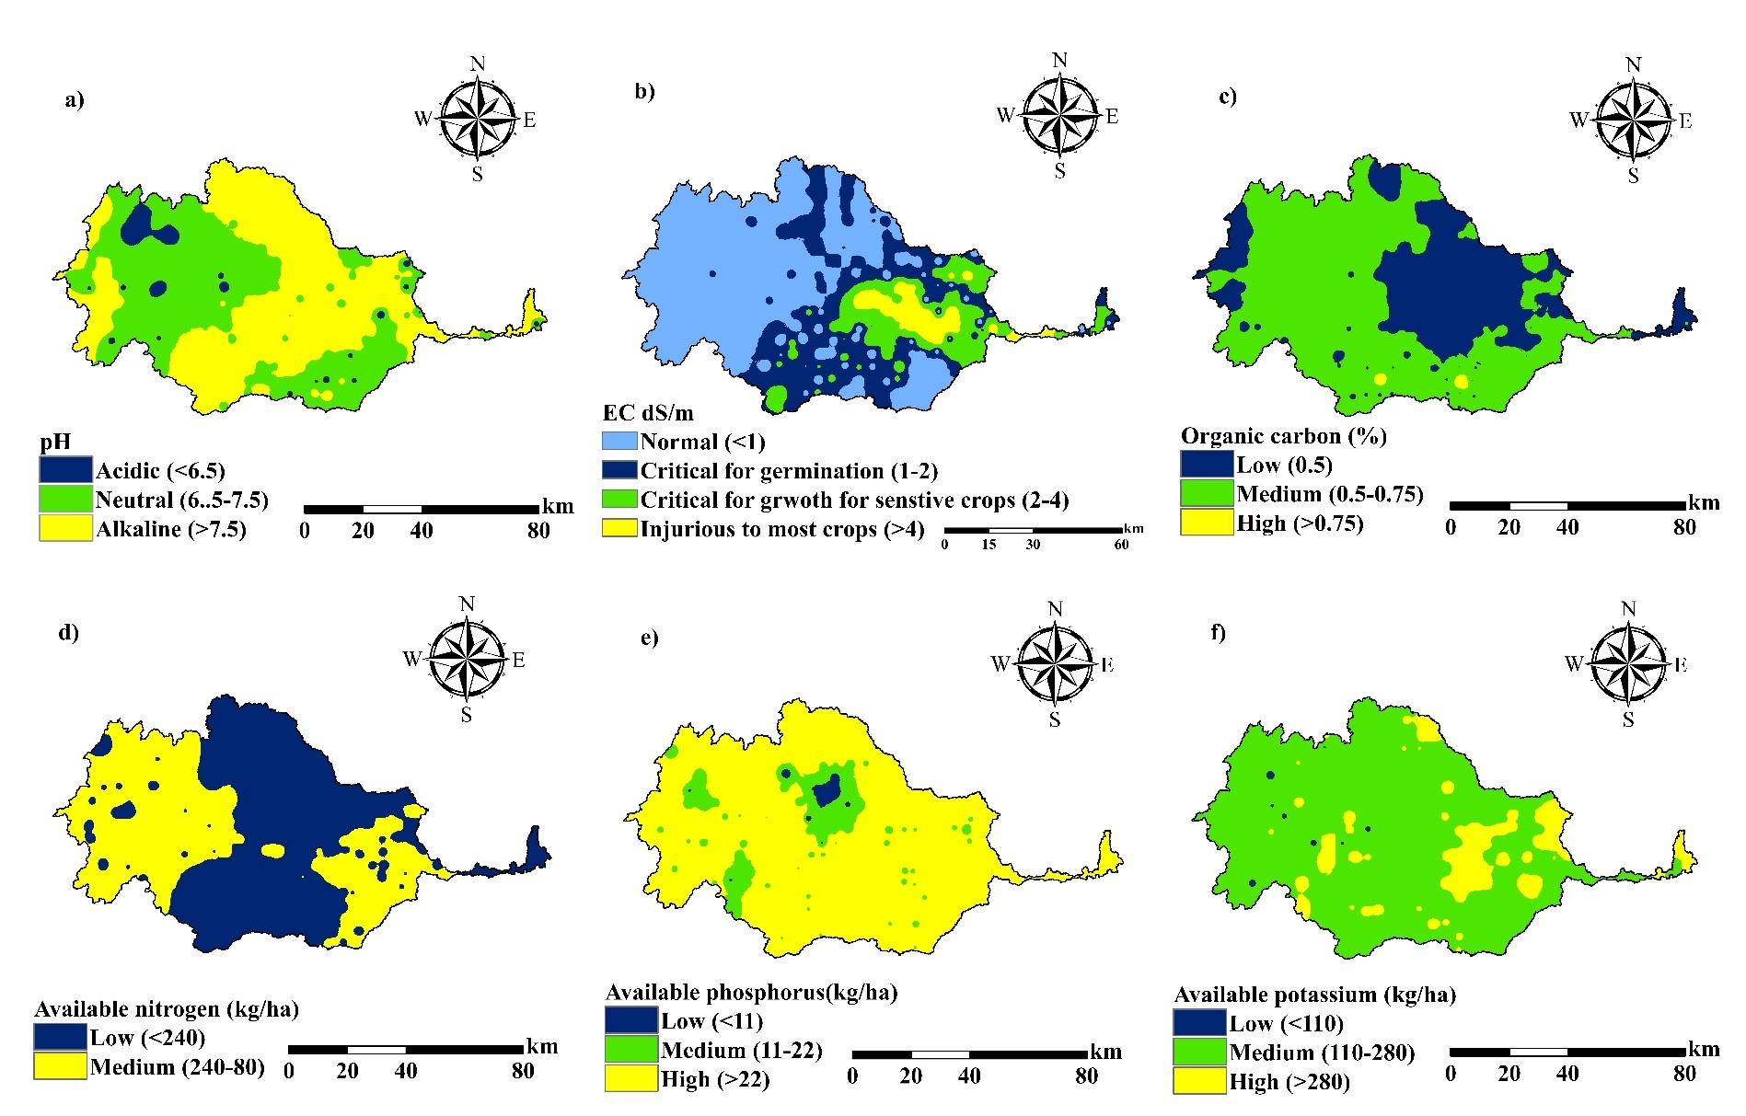
Fig 2. Spatial variability map of a) pH, b) Electrical conductivity, c) Organic carbon, d) Available Nitrogen, d) Available phosphorous and e) Available potassium
Table 4. Spatial variability of soil properties and their corresponding area (km²) and percentage (%) in the Vellar river basin.
SI.No | Class/Rating | Area in km² | Percentage of area
1 | pH
1 | Acidic (<6.5) | 233.7 | 3.2
1 | Neutral (6.5-7.5) | 3203.4 | 44.3
1 | Saline/Alkaline (>7.5) | 3796.1 | 52.5
2 | EC (dS m⁻¹)
2 | Normal (<1) | 3900.4 | 53.9
2 | Critical for Germination (1-2) | 2000.7 | 27.7
2 | Critical for Growth of the Sensitive Crops (2-4) | 946.3 | 13.1
2 | Injurious to most crops (>4) | 385.9 | 5.3
3 | Organic carbon (g kg⁻¹)
3 | Low (<5) | 2441.3 | 33.8
3 | Medium (5-7.5) | 4760.1 | 65.8
3 | High (>7.5) | 31.7 | 0.4
4 | Available nitrogen (kg ha⁻¹)
4 | Low <280 | 3989.5 | 55.2
4 | Medium 280-480 | 3243.6 | 44.8
5 | Available phosphorus (kg ha⁻¹)
5 | Low <11 | 81.5 | 1.1
5 | Medium 11-22 | 765.8 | 10.6
5 | High >22 | 6385.8 | 88.3
6 | Available potassium (kg ha¹)
6 | Low <110 | 21.7 | 0.3
6 | Medium 110-280 | 6217.4 | 86.0
6 | High >280 | 994.1 | 13.7
7 | Texture class
7 | Clay | 1272.8 | 17.6
7 | Sandy Clay | 2006.3 | 27.7
7 | Sandy Clay Loam | 3441.1 | 47.6
7 | Clay Loam | 335.9 | 4.6
7 | Sandy Loam | 177.1 | 2.4

3.9. Soil texture
Among the soil texture fractions, sand (%) followed the Circular model with a nugget value of 120.95, partial sill of 49.57 and sill of 170.52. The nugget/sill ratio was 0.70, indicating moderate spatial dependency. The RMSE value was 0.992. Silt (%) and clay (%) were best fitted with the Gaussian model. For silt, the nugget, partial sill and sill values were 26.43, 19.46 and 45.89, respectively, with a nugget/sill ratio of 0.57, indicating moderate spatial dependency and RMSE of 0.990. For clay, the nugget, partial sill and sill values were 53.28, 90.78 and 144.06, respectively, with a nugget/sill ratio of 0.36, indicating moderate spatial dependency and RMSE of 0.990. The soil of the Vellar region occupies five major textural classes, namely clay (C), sandy clay (SC), sandy clay loam (SCL), clay loam (CL) and sandy loam (SL). The spatial variability of the soil texture is presented in Table 4 and Fig. 3. From the soil textural map, sandy clay loam was the dominant textural class, occupying about 3441.1 km², followed by sandy clay covering 2006.3 km². Clay soils occupied about 1272.8 km², whereas clay loam and sandy loam occupied relatively smaller areas of about 335.9 km² and 177.1 km², respectively, in the study area.
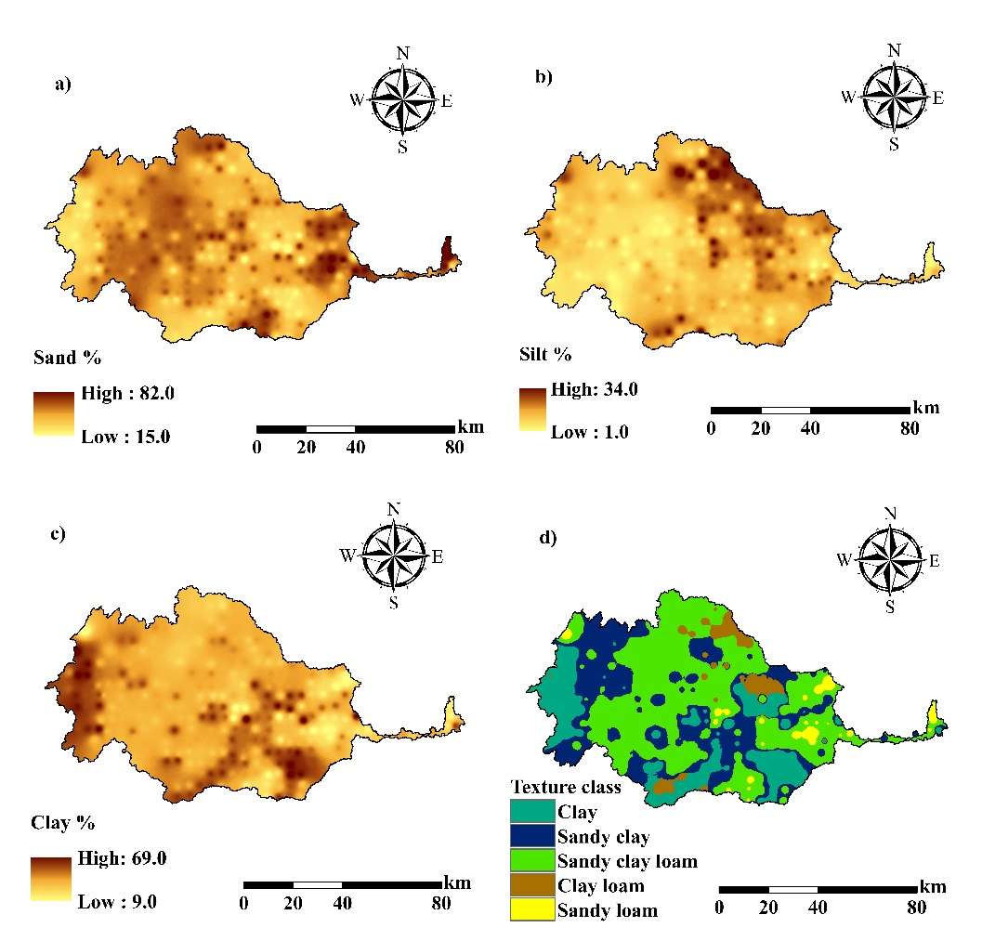
Fig. 3. Spatial variability map of soil separates and texture

4. Conclusion
The study revealed significant spatial variability in soil properties across the study area. Geostatistical analysis using semivariogram models effectively quantified this spatial variability, identifying the best-fitting models for each soil parameter and revealing the range and degree of spatial dependence. Based on these patterns, distinct management zones were delineated, reflecting inherent gradients in soil fertility and texture. The semivariogram-based characterization provides a robust, data-driven framework for precision agriculture, enabling targeted, site-specific interventions, optimizing nutrient use efficiency, reducing input costs, and supporting sustainable crop production.

Disclaimer (Artificial intelligence)

Author(s) hereby declare that NO generative AI technologies such as Large Language Models (ChatGPT, COPILOT, etc.) and text-to-image generators have been used during the writing or editing of this manuscript.

Reference
Álvarez-Herrera, J. G., Jaime-Guerrero, M., & Fernández-Pérez, C. J. (2025). Spatial variability and geostatistical modeling of soil physical properties under Eucalyptus globulus plantations. Geomatics, 5(3), 41. https://doi.org/10.3390/geomatics5030041
Bouyoucos, G. J. (1962). Hydrometer method improved for making particle size analyses of soils. Agronomy Journal, 54, 464–465.
Cambardella, C. A., Moorman, T. B., Novak, J. M., Parkin, T. B., Karlen, D. L., Turco, R. F., & Konopka, A. E. (1994). Field-scale variability of soil properties in central Iowa soils. Soil Science Society of America Journal, 58(5), 1501–1511. https://doi.org/10.2136/sssaj1994.03615995005800050033x
Chien, Y. J., Lee, D. Y., Guo, H. Y., & Houng, K. H. (1997). Geostatistical analysis of soil properties of mid-west Taiwan soils. Soil Science, 162, 291–298.
Cressie, N. (1993). Statistics for spatial data (Rev. ed.). John Wiley & Sons.
Goovaerts, P. (1997). Geostatistics for natural resources evaluation. Oxford University Press.
Isaaks, E. H., & Srivastava, R. M. (1989). An introduction to applied geostatistics. Oxford University Press.
Jackson, M. L. (1973). Soil chemical analysis (1st ed.). Prentice Hall of India Pvt. Ltd.
Krige, D. G. (1951). A statistical approach to some basic mine valuation problems on the Witwatersrand. Journal of the South African Institute of Mining and Metallurgy, 52, 119–139.
Matheron, G. (1963). Principles of geostatistics. Economic Geology, 58, 1246–1266.
Meul, M., & Van Meirvenne, M. (2003). Kriging soil texture under different types of nonstationarity. Geoderma, 112(3–4), 217–233. https://doi.org/10.1016/S0016-7061(02)00308-7
Minasny, B., & McBratney, A. B. (2016). Digital soil mapping: A brief history and some lessons. Geoderma, 264(B), 301–311. https://doi.org/10.1016/j.geoderma.2015.07.017
Minasny, B., McBratney, A. B., Malone, B. P., & Wheeler, I. (2013). Digital mapping of soil carbon. In D. L. Sparks (Ed.), Advances in agronomy (Vol. 118, pp. 1–47). Elsevier. https://doi.org/10.1016/B978-0-12-405942-9.00001-3
Olsen, S. R., Cole, C. V., Watanabe, F. S., & Dean, L. A. (1954). Estimation of available phosphorus in soils by extraction with sodium bicarbonate (USDA Circular No. 939).
Parvizi, Y., & Fatehi, S. (2025). Geospatial digital mapping of soil organic carbon using machine learning and geostatistical methods in different land uses. Scientific Reports, 15, 4449. https://doi.org/10.1038/s41598-025-88062-9
Shit, P. K., Bhunia, G. S., & Maiti, R. (2016). Spatial analysis of soil properties using GIS based geostatistics models. Modeling Earth Systems and Environment, 2, 107.
Stanford, S., & English, L. (1949). Use of flame photometer in rapid soil tests for K and Ca. Agronomy Journal, 41, 446–445.
Subbiah, B. V., & Asija, G. L. (1956). A rapid procedure for determination of available nitrogen in soils. Current Science, 25, 259–260.
Subhash, M., Sinha, N. K., Kumar, J., Mohanty, M., Sahoo, R. N., Jayaraman, S., Kumar, N., Rani, A., Thakur, J. K., Mandal, A., Kumar, D., Mishra, R., & Prabhakar, M. (2025). Spatial variability of soil physicochemical properties in soybean–wheat belts in Vertisols of central India. Scientific Reports, 15(1), 33830. https://doi.org/10.1038/s41598-025-03540-4
Trangmar, B. B., Yost, R. S., & Uehara, G. (1986). Application of geostatistics to spatial studies of soil properties. Advances in Agronomy, 38, 45–94.
Triantafilis, J., Odeh, I. O. A., & McBratney, A. B. (2001). Five geostatistical models to predict soil salinity from electromagnetic induction data across irrigated cotton. Soil Science Society of America Journal, 65(3), 869–878. https://doi.org/10.2136/sssaj2001.653869x
Velamala, R. R., & Pant, P. K. (2024). Modeling the spatial variability of soil nutrients: A case from Soil Health Card Project, India. International Journal of Environment and Geoinformatics, 11(3), 90–105. https://doi.org/10.30897/ijegeo.1465671
Webster, R. (1985). Quantitative spatial analysis of soil in the field. Advances in Soil Science, 3, 1–70.
Webster, R., & Oliver, M. A. (2007). Geostatistics for environmental scientists (2nd ed.). John Wiley & Sons. https://doi.org/10.1002/9780470517277
Walkley, A., & Black, I. A. (1934). An examination of the Degtjareff method for determining soil organic matter and a proposed modification of the chromic acid titration method. Soil Science, 37, 29–38.
Zerin, R. I., Ara, I., Ali, S., Hossain, K., Javed, A., Ratna, S. N., & Kabir, A. (2025). Geostatistical modeling of soil physicochemical properties and environmental drivers in agro-industrial landuse systems in Bangladesh. Geomatica. https://doi.org/10.1016/j.geomat.2025.100075
Zhang, Z., Yu, X., Qian, S., & Li, J. (2010). Spatial variability of soil nitrogen and phosphorus of a mixed forest ecosystem in Beijing, China. Environmental Earth Sciences, 60, 1783–1792

