Indigofera tinctoria L.: A Comprehensive Review on Botany, Phytochemistry, Agronomy and Pharmacological Perspectives
Abstract
Indigofera tinctoria Linn. (true indigo) is a multipurpose leguminous plant valued for both its natural dye and wide spectrum of medicinal properties. The present review compiles and synthesizes available information on its taxonomy, distribution, traditional significance, phytochemical composition, agronomy, and pharmacological potential. The plant is widely distributed in tropical and subtropical regions and has long been used in Ayurvedic and traditional systems of medicine, particularly for liver disorders and epilepsy. Agronomic studies indicate that proper nutrient management and pre-sowing seed treatments can markedly enhance germination, biomass yield, and dye productivity. Phytochemical investigations reveal the presence of diverse bioactive constituents that collectively contribute to its therapeutic efficacy. Overall, I. tinctoria represents an economically and pharmacologically important species with substantial potential for sustainable dye production and therapeutic applications.
Keywords: Agronomic practices, medicinal properties, taxonomy, true indigo
Indigofera tinctoria Linn., commonly known as the true indigo plant, is a medicinally and commercially important dye-yielding plant (Marquiafavel et al., 2009). The natural indigo dye extracted from this plant produces a deep blue colour. Because of its significant trading value, it was known as “Blue gold”. It has a rich history and has been significantly utilized in various systems of medicine. Indigo leaves are popular as hepatoprotective in traditional medicine. Various therapeutic benefits of this plant have been attributed to its leaves and roots. It is a native of Asia distributed in South Asia, South East Asia, Western America, and Africa (Senasri et al., 2022). It grows in Pakistan, China, Thailand, and other countries of the East. It is seen throughout India and is cultivated in Uttarakhand, Andhra Pradesh, Tamil Nadu, and Kerala (Sarada, 2004; Mary et al., 2020).
I. tinctoria, mentioned in various Ayurvedic texts, is a significant medicinal plant known by several Sanskrit names, including Nilini, Neeli, Tooni, Kala, Dola, Neelika, Ranjani, Shriphali, Tuccha, Gramina and Madhuparnika. In other languages it is known by: English- Indian indigo; Chinese- Mu lan; Arabic- Nilaj; French- Indigotier; Spanish- Indigo; German- Faerber, Indigostrauch; Thai- Kram; Indonesia - Tarum or Nila; China- qing dai; Hindi- Nili; Bengali- Nila; Marathi- Nili; Gujarati- Gali; Tamil- Avuri, Neeli, Nilam; Kannada – Karunili; Telugu- Aviri, Nilichettu; Malayalam- Neela amari; Sanskrit-Nilini, Ranjani, Nilika, Neelam, Aklika, Asita, Bhadra (Thomas, 2000; Seidmann, 2005; Aobchey et al., 2007; Handayani and Mualimin, 2013; Ozawa, 2020; Kushwaha, 2022). Among other names, it is commonly referred to as Klitika, Kalkeshi or Neelpuspa in various regions (Datiles and Acevedo, 2014; Kushwaha, 2022).
The genus name Indigofera is a latin word which means “blue colour bearing” (Khan et al., 2008). Indigofera belongs to Plantae kingdom, Spermatophyta Phylum, Angiospermae Subphylum, Rosanae super order, Fabales order, Fabaceae Family and Faboideae Subfamily. There are more than 700 species, that grows well in tropical ecosystem (Mishra et al., 2020). Some of the important species are I. tinctoria, I. suffruticosa, I. parviflora, I. aspalathoides, I. arrecta, I. spicata, I. cordifolia, I. heterentha, I. oblongifolia, I. emarginella, I. pulchra, I. mysorens etc (Rahman et al., 2018; Gerometta et al., 2020). The natural indigo colour can be produced from different species of Indigofera like I. tinctoria, I. arrecta, I. suffruticosa, and I. longiracemosa (Arista et al., 2024). I. tinctoria is considered as the most important species for sustainable indigo production (Zhang et al., 2019). It is botanically recognized under various synonyms like Anila tinctoria var. normalsi (Kuntze), I. anil var. orthocarpa (DC.), I. bergii (Vatke), I. cinerascens (DC.), I. houer (Forssk.), I. indica (Lam.), I. oligophylla (Baker.), I. orthocarpa (DC.) O. Berg & C. F. (Schmidt.), I. sumatrana (Gaertn.), I. tinctoria (Blanco.) and I. tulearensis (Drake.), respectively. The chromosome number is 2n = 16 (Duke, 1981).
Until the 19th century, the only natural indigo dye available in all nations was "Indigo" dye pigment. In many tropical parts of the world, the plant I. tinctoria is more prevalent than any other plant species used to make natural dyes. Although each species in the genus Indigofera has unique traits and dye-making techniques, all colours share a common chemical composition. The green leaves and stems do not contain the indigo dyestuff; instead, it is created by hydrolysis after harvest (Khan et al., 2008). Indigotin, a naturally occurring component of many Indigofera species, is the source of indigo coloring (Arista et al., 2024).

Origin and Spread
Exact origins of I. tinctoria are not well-documented. Notably, indigo dye derived from various species of Indigofera, primarily I. tinctoria, has been discovered on artifacts from an Egyptian mummy dating back to 2300 BC, as well as in Inca burial sites (MacLeod, 1997; Armitage, 2008). The earliest references to Nilini are found in the Charaka Samhita, Sushruta Samhita, and Astanga Hridaya. In the Nighantus, it is described in the Kaiyadeva Nighantu, Dhanvantari Nighantu, Bhava Prakash Nighantu, and Raja Nighantu (Kushwaha, 2022). The use of indigo in India traces back to the Indus Valley Civilization, which flourished between 2500 and 1500 BC (Sebastian et al., 2024). Ancient evidence suggests that indigo was among the earliest dyes used for coloring textiles, highlighting its cultural and economic value.
Over time, its significance continued to grow, particularly with the rise of textile trade. I.tinctoria (formerly known as I. sumatrana) was introduced to Bengal, India, in the mid-1700s for large-scale dye production. It is believed to have arrived either from Malabar or directly from Malaya, marking a key development in the commercial cultivation of indigo in colonial India. From Bengal, it was subsequently transported to the West Indies (University of Calcutta, 1902). In Tamil Nadu, it is affectionately known as “Neela Aatha” or the “Blue Goddess” and is predominantly cultivated in the Villupuram region (Sebastian et al., 2024).
Plant Botany
Indigo plant is a fast growing highly branched annual, biennial or perennial shrub which grows up to a height of 1-2 m (Dhanasekaran and Sekar, 2020). It is having an erect roundish and solid stem which is green in colour at the young stage and turns to reddish brown on maturity. Leaves are imparipinnate, stipulate and petiolate having pulvinus leaf base. The leaflets are arranged in pairs opposite each other, with an entire margin, an obovate shape that tapers to a rounded tip, and a bluish-green colour. The upper surface of the leaflet is glabrous and lower surface is covered with small hairs (Khan et al., 2008). Plants will bloom 60-90 days after germination. Inflorescence is an axillary raceme with many flowers, pinkish petals and bell shaped calyx. The flowers are complete, exhibiting zygomorphic and irregular characteristics, and they are bisexual with a hypogynous structure. They are pedicellate, featuring five gamosepalous sepals. The fruit is a cylindrical dehiscent pod that is slightly curved at the tip and contains very small square to oblong shaped seeds (about 3-15 seeds per pod) with a hard outer coating. As the pod matures, its color transitions from green to light yellow and eventually to brown (Khan et al., 2008; Chikmawati et al., 2018). The pharmacognostic study of I. tinctoria L. leaves revealed distinct macroscopic characteristics such as 9–13 opposite oblanceolate leaflets with a mucronate apex and cuneate base, along with diagnostic microscopic features including a wavy lamina in transverse section, prominent vascular bundles with thick-walled xylem, a phloem arc, sclerenchymatous bands, and anamocytic stomata (Venkatachalam, 2018).
Since it is a pulse crop, it has the ability to form root nodules which enables a symbiotic relationship with nitrogen-fixing bacteria. Rhizobium indigoferae is a nitrogen fixing bacteria that forms root nodules in indigo plant (Sedimann, 2005).
Important constituents
Numerous bioactive substances, such as flavonoids, saponins, tannins, steroidal terpenes, phenols, and anthraquinones, are abundant in the leaf extract of I. tinctoria (Renukadevi and Sultana, 2011). Alkaloids represent an important group of bioactive constituents in Indigofera species. Sivasankari et al. (2014) documented the occurrence of indicine in I. tinctoria, identifying it as a pharmacologically significant alkaloid. Preliminary phytochemical screening of the leaf powder indicated the presence of flavonoids, glycosides, tannins, terpenoids, mucilage, and saponins (Venkatachalam, 2018). Rahman et al. (2018) further emphasized the presence of indigotin (indigo), a 2, 2′-bis-indole alkaloid commonly distributed in I. tinctoria, I. suffruticosa, and I. truxillensis.
The presence of compounds such as indirubin and indigtone has been identified in the plant (Motamarri et al., 2012). Mishra et al. (2020) reported that GC–MS analysis of the ethanol leaf extract of I. tinctoria identified 26 phytochemical compounds through NIST library (National Institute of Standards and Technology, NIST version 5.7.1) matching, and preliminary qualitative screening confirmed the presence of alkaloids, flavonoids, tannins, phenols, saponins, glycosides, and terpenoids. In-silico evaluation using PASS and related databases indicated that these bioactive constituents exhibit diverse therapeutic potentials including anti-inflammatory, antidiabetic, antimicrobial, antioxidant, antiviral, and antineoplastic activities. These substances support the plant's therapeutic qualities and possible uses in conventional medicine. Numerous investigations have verified the existence of these phytochemicals, underscoring their importance in relation to health advantages.
Table 1: Bioactive compounds and Phytochemical Properties of I. tinctoria
Constituents | Phytochemical Properties | Reference
Flavonoids | Antioxidant | Cintya and Hutagalung, 2024
Saponins | Antimicrobial and anti-inflammatory | Swaminathan,2018
Tannins | Astringent, wound-healing | Adjeroh, 2020
Steroidal Terpenes | Anti- inflammatory, hepatoprotective | Mishra et al., 2019
Phenols and Anthraquinones | Antioxidant, antimicrobial | Ariyatun et al., 2022; Mishra et al., 2020
Alkaloids | Antimicrobial, Analgesic | Kumar et al., 2017
Glycosides | Antioxidant, therapeutic dye precursor activity | Somrug et al., 2021

Climate and Soil
The Indian indigo thrives in both hilly and plain regions and needs enough of sunlight. In areas with an average annual temperature of 23⁰C and 500–1500 mm of rainfall, indigo grows at elevations between 0 and 1000 -1250 meters. It can wither under extreme heat and hot winds, and cannot withstand prolonged rain, significant flooding and waterlogging, strong winds, or hailstorms (Seidemann, 2005). As long as sufficient soil moisture is maintained and it can tolerate temperatures of up to 40°C. Sandy loam soils are most suitable for its cultivation, and even seaside sandy soils provide a favourable environment for its growth. It is inappropriate to use clayey soil where water logging is likely to occur (Thomas et al., 2000).
Budiastuti et al. (2022) reported that shading duration and light intensity significantly affected growth and indican content in I. tinctoria, with early shading at 50% light promoting better growth and mid-growth shading at 10% light producing the highest indican content (843.33 ppm). Optimal cultivation of indigo requires well-drained loam soils with a slightly acidic to neutral pH (6.0–7.5). Thorough land preparation, including deep tillage, helps improve soil aeration and conserve adequate moisture. Incorporation of organic inputs such as compost or green manure further enriches soil nutrients, supporting healthy plant development and improved productivity (Rao et al., 2025).
A study conducted by Duan et al. (2024) reported that the suitable distribution of I. tinctoria is mainly influenced by temperature, precipitation, and elevation, with current habitats concentrated in southern China and future climate scenarios (SSP126 and SSP585) predicting a gradual northeastward shift in its suitable areas.
Propagation
I. tinctoria is cultivated by seed propagation, which frequently entails presoaking the seeds. Usually, seed germination takes four days or less. Commercial cultivation is constrained by several seed-related limitations, including seed dormancy, poor seed quality and germination, uneven germination, weak seedling establishment, and susceptibility to pests and diseases. In indigo, the hard seed coat acts as a physical barrier to germination, and the thickness of the integument further influences seedling emergence and early growth (Somrug et al., 2021). The integration of microbial pre-treatments with physical or chemical methods used to overcome dormancy can markedly improve seed and seedling performance (Taylor and Harman, 1990).
A study conducted by Neema et al. (2018) demonstrates that physical dormancy in I. tinctoria seeds can be effectively overcome by chemical scarification, with a quick dip in concentrated sulfuric acid producing the highest germination (76%), making it the most efficient pre-sowing treatment. Mechanical scarificaion using sand and hot water dip for one second was also found to be effective in overcoming seed dormancy.
Manuring
Sindhu et al. (2016) conducted a study at the AICRP (All India Coordinated Research Project) on Medicinal and Aromatic Plants, Kerala Agricultural University, and reported that the combined application of farm yard manure @ 10 Mg ha⁻¹ + Azospirillum @ 2 kg ha⁻¹ produced the highest pooled herbage yield (5691 kg ha⁻¹) and maximum benefit–cost ratio (3.51), which was statistically on par with coir pith compost @ 4 Mg ha⁻¹ (5542 kg ha⁻¹) and vermi compost @ 3 Mg ha⁻¹ + Azospirillum (5304 kg ha⁻¹). Field experiments showed that applying NPK fertilizer significantly increased the fresh weight of I. tinctoria at 11 weeks after planting. There was also a strong positive relationship between fresh and dry weight (0.91) and a moderate correlation with specific leaf weight (0.60), indicating that proper fertilization improves plant growth and supports sustainable natural dye production (Arista et al., 2024).
Harvesting
The optimal harvesting stage is at full flowering, usually 90–120 days after sowing, when the leaves contain the highest concentration of indigo (John and Angelini, 2009). Stevense (2023) reported that manual harvesting is the predominant practice in Indigofera cultivation because it facilitates selective removal of mature leaves and reduces potential injury to the plants. In I. tinctoria, harvesting at the brown pod stage (18–20 weeks) increased indigo blue yield from 1.57 to 3.20 g/kg fresh leaves, with indigo content in paste reaching 18.02 g/kg. Additionally, cultivation under 100% sunlight improved yield from 1.74 to 2.47 g/kg fresh leaves, while early morning harvesting (6:00 a.m.) produced the highest yield at 1.61 g/kg (Thosaikham and Sakong, 2024).
Pharmacological properties of I. tinctoria

I. tinctoria proved to possess antioxidant activity, hepatoprotective activity, anticancer activity, antiseizure activity, antidyslipidemic activity and antibacterial activity.

Renukadevi and Sultana (2011) reported that the leaf extract of I. tinctoria exhibited significant antioxidant activity, with an IC₅₀ value of 51.66 μg/mL. The antioxidant potential of I. tinctoria has been widely investigated using different solvent extracts. According to Singh et al. (2015) and Mishra (2020), hydroethanolic extracts of I. tinctoria exhibited comparatively stronger antioxidant activity than ethanol extracts, as evidenced by lower IC₅₀ values in multiple radical scavenging assays. Anasuya and Manian (2013) reported that the ethyl acetate extract of I. tinctoria leaves showed strong antioxidant activity, including high DPPH and nitric oxide scavenging ability and lipid peroxidation inhibition (87–96%). Furthermore, the ethyl acetate, methanol, and aqueous extracts were found to contain higher levels of phenolics and tannins and demonstrated notable antihemolytic and metal-chelating activities. Similarly, Srinivasan et al. (2016) reported that the aqueous extract of I. tinctoria contained high levels of total phenolics (267.2 ± 2.42 mg/g), flavonoids (75.43 ± 3.36 mg/g), and total antioxidants (349.11 ± 8.04 mg/g). At 250 μg/mL, significant free radical scavenging activity was observed against DPPH (52.08%), nitric oxide (23.12%), and superoxide anion radicals (26.79%) (p < 0.05 versus ascorbic acid). HPTLC fingerprinting confirmed the presence of phenols, flavonoids, saponins, and terpenoids, supporting the extract’s antioxidant potential.
Leaves of I. tinctoria have traditionally been used in the management of liver disorders, and this therapeutic claim has been experimentally validated. Muthulingam et al. (2010) done an in vivo study and reported that paracetamol administration induced significant hepatic injury in experimental rats, characterized by altered biochemical parameters and histopathological damage. Treatment with aqueous extract of I. tinctoria at doses of 250 and 500 mg/kg significantly restored serum biochemical markers and improved liver histoarchitecture. These findings indicate a protective role of the extract against chemically induced hepatotoxicity. According to Benny et al. (2021), the hepatoprotective effect is primarily attributed to the bioactive compound indigtone.
In an in vitro study, purified indirubin (30 mM) from Indigofera tinctoria inhibited the growth of MCF-7 breast cancer cells by approximately 42% within 24 hours, demonstrating its significant anticancer potential (Aobchey et al., 2007). The cytotoxic activity of the I. tinctoria leaf extract was assessed in vitro against the NCI-H69 lung cancer cell line, and cell viability decreased progressively with increasing extract concentration (Renukadevi and Sultana, 2011).
In an in vivo study, the methanolic extract of I. tinctoria showed safe and significant anti-seizure activity in experimental models by delaying seizures, reducing their severity, and completely preventing death in treated animals (Kumar et al., 2009). Garbhapu et al. (2011) reported that the ethanolic extract of I. tinctoria was effective in controlling and treating various types of seizures. I. tinctoria is traditionally used by indigenous communities in India for the treatment of epilepsy, with the whole plant and unspecified plant parts reported for this purpose (Jain and Verma, 2016).
The lipid-lowering potential of I. tinctoria has been reported in high-fat diet–induced dyslipidemic models. Puri et al. (2007) demonstrated that administration of the chloroform fraction (250 mg/kg body weight) significantly reduced plasma triglycerides by 52% (P < 0.001), total cholesterol by 29% (P < 0.05), glycerol by 24%, and free fatty acids by 14% in hamsters. Additionally, high-density lipoprotein (HDL) levels increased by 9%, and the HDL-C/TC ratio improved by 52%, indicating enhanced cardioprotective potential. These results support the traditional use of I. tinctoria in cardiovascular health management. Compounds such as indirubin and indigtone found in the leaf extract of the indigo plant have been traditionally used in the treatment of hydrophobia (Muthulingam et al., 2010).
The antibacterial efficacy of I. tinctoria leaf extracts has been evaluated in vitro against a range of clinically relevant pathogens. Renukadevi and Sultana (2011) reported that the ethanol leaf extract exhibited significant activity against Gram-positive bacteria, including B. pumilus, Staphylococcus aureus, and Streptococcus pyogenes, producing inhibition zones of 16–17 mm. Furthermore, Vijayan et al. (2012) reported that the methanolic leaf extract displayed potent antibacterial activity with low minimum inhibitory concentration (MIC) values against methicillin-sensitive Staphylococcus aureus (0.125 μg/mL), methicillin-resistant S. aureus (0.25 μg/mL), Enterococcus spp. (0.125–0.5 μg/mL), Streptococcus spp. (0.125–0.25 μg/mL), and anaerobic bacteria (1–2 μg/mL).
Conclusion
I. tinctoria is a historically significant dye-yielding plant that also possesses considerable medicinal potential. The presence of diverse phytochemicals underpins its broad spectrum of biological activities, including antioxidant, hepatoprotective, anticancer, antidyslipidemic, and antibacterial effects. Experimental evidence strongly supports many of its traditional uses, particularly in liver protection and seizure management. From an agronomic perspective, appropriate seed treatments, nutrient management, and optimal harvesting stages are critical for maximizing germination, biomass, and indigo yield. With integrated research and sustainable cultivation practices, I. tinctoria holds strong promise as both a natural dye resource and a valuable medicinal plant for future pharmaceutical and industrial applications.
Future prospects
Despite encouraging pharmacological findings, most studies remain at the in vitro and animal levels, highlighting the need for advanced toxicological studies, molecular investigations, and well-designed clinical trials. Agronomic improvements, including advanced seed priming, integrated nutrient management, and development of high-indican genotypes, can enhance yield and dye quality. With coordinated multidisciplinary research, I. tinctoria can emerge as an important sustainable industrial and medicinal crop.
Disclaimer (Artificial intelligence)
Author(s) hereby declare that NO generative AI technologies such as Large Language Models (ChatGPT, COPILOT, etc.) and text-to-image generators have been used during the writing or editing of this manuscript.
Acknowledgment
We are thankful to Kerala Agricultural University for providing all the required facilities from the university.
Reference
Adjeroh, L. A. (2020). Phytochemical screening and medicinal properties of tannin-rich plants. Journal of Medicinal Plants Research, 14(6), 289–296. https://doi.org/10.5897/JMPR2020.6892
Anusuya, N., & Manian, S. (2013). Antioxidant and free radical scavenging potential of different solvent extracts of Indigofera tinctoria L. leaves. International Journal of Pharmacy and Pharmaceutical Sciences, 5(1), 142–147.
Arista, N. I. D., Aziz, S. A., & Kurniawati, A. (2024). Natural dye of Indigofera tinctoria for textile industry. Journal of Environmental Science and Sustainable Development, 7(1), 578–598.
Ariyatun, A., Rahmawati, D., & Sari, M. P. (2022). Antioxidant and antimicrobial activity of phenolic and anthraquinone compounds from medicinal plants. International Journal of Pharmaceutical Sciences and Research, 13(4), 1765–1772. https://doi.org/10.13040/IJPSR.0975-8232.13(4).1765-72
Armitage, A. M. (2008). Herbaceous perennial plants: A treatise on their identification, culture, and garden attributes. Stipes Publishing.
Benny, N. R., Sonia, N. S., & Sreekala, G. S. (2021). Hepatoprotective medicinal plants: Traditional knowledge to scientific evidences—A review. Journal of Pharmacognosy and Phytochemistry, 10, 285–288.
Budiastuti, M.T.S., Setyaningrum, D., Purnomo, D., Pujiasmanto, B. and Manurung, I.R. (2022). The Critical Period of Production of the Secondary Metabolite Indican in (Indigofera tinctoria L.) on Light Intensity. Indian Journal of Agricultural Research, 56(5).
Chikmawati, T., Ariyanti, N. S., & Ramli, M. (2018). Morphological characterization of dye-producing tom java (Indigofera tinctoria L.) in three islands of Indonesia. Malaysian Applied Biology, 47(3).
Cintya, H., & Hutagalung, C. M. (2024). Phytochemical investigation and antioxidant activity of ethanolic extract, n-hexane and ethyl acetate fraction of salaon leaves (Indigofera tinctoria Linn.). IOP Conference Series: Earth and Environmental Science, 1302(1), 012082.
Datiles, M. J., & Acevedo-Rodríguez, P. (2014). Indigofera tinctoria (true indigo). CABI Compendium. https://doi.org/10.1079/cabicompendium.28613
Dhanasekaran, D., & Sekar, K. (2020). Integrated nutrient management studies on biomass, dye yield and quality of indigo (Indigofera tinctoria L.). Plant Archives, 20(2), 3899–3901.
Duan J, Liu J and Huang Z (2024) Predicting the distribution pattern changes of dye plant habitats caused by climate change. Front. Plant Sci. 15:1364481. doi: 10.3389/fpls.2024.1364481
Duke, J. A. (1981). Handbook of legumes of world economic importance. Plenum Press.
Garbhapu, A., Yalavarthi, P., & Koganti, P. (2011). Effect of ethanolic extract of Indigofera tinctoria on chemically induced seizures and brain GABA levels in albino rats. Iranian Journal of Basic Medical Sciences, 14(4), 318.
Gerometta, E., Grondin, I., Smadja, J., Frederich, M., & Gauvin-Bialecki, A. (2020). A review of traditional uses, phytochemistry and pharmacology of the genus Indigofera. Journal of Ethnopharmacology, 253, 112608.
Handayani, P. A., & Mualimin, A. A. (2013). Pewarna alami batik dari tanaman nila (Indigofera) dengan katalis asam. Jurnal Bahan Alam Terbaharukan, 2(1), 1–6. https://doi.org/10.15294/jbat.v2i1.2909
Jain, V., & Verma, S. K. (2016). Folkloric use of plants for treatment of epilepsy in India. Journal of Traditional and Folk Practices, 2(1), 120–134.
John, P., & Angelini, L. G. (2009). Indigo—Agricultural aspects. In Handbook of natural colorants (p. 75).
Khan, A. B. M. M. M., Prodhan, A. K. M. A., Howlader, M. H. K., & Fakir, M. S. A. (2008). Morphological variation in three Indigofera spp. Journal of Agroforestry and Environment, 2, 7–12.
Kumar, S., Sharma, A., & Verma, R. (2017). Alkaloids from medicinal plants: Pharmacological properties and therapeutic applications. Asian Journal of Pharmaceutical and Clinical Research, 10(3), 45–52.
Kumar, S. A., Mohan, M. E., Gandhimathi, R., & Amuda, P. (2009). Study on the anti-seizure activity of methanolic extracts of Indigofera tinctoria (L). Pharmacologyonline, 1, 1341–1351.
Kushwaha, A. K. (2022). A review on Nilini: An important Ayurvedic medicinal plant. Journal of Advanced Applied Scientific Research, 4(4), 84–87.
MacLeod, M. J. (1997). Dyes. In H. Selin (Ed.), Encyclopaedia of the history of science, technology, and medicine in non-western cultures (pp. 251–252). Kluwer Academic.
Marquiafável, F. S., Ferreira, M. D. S., & de Pádua Teixeira, S. (2009). Novel reports of glands in Neotropical species of Indigofera L. Flora, 204, 189–197. https://doi.org/10.1016/j.flora.2008.01.012
Mary, J. F., Senthil Kumar, M., Dinesh Kumar, T., Divya, R., Nandakumar, M., & Pooja, B. (2020). Ethnobotanical and pharmacological review on Indigofera tinctoria. International Research Journal of Pharmaceutical and Applied Sciences, 10(1), 1–6.
Mishra, P., Dash, D., & Sahoo, S. (2019). Terpenoids and steroids from medicinal plants and their biological activities. Pharmacognosy Reviews, 13(25), 12–20. https://doi.org/10.4103/phrev.phrev_38_18
Mishra, D.N., Gomare, K.S. and Sheelwant, S.V. (2020). GC-MS Analysis and phytochemical screening of Indigofera tinctoria (Linn.) leaf extract characterizing its medicinal use. International Journal of Ayurvedic Medicine, 11(2), pp.289-299.
Mishra, R., Pandey, A., & Singh, R. (2020). Anthraquinones as bioactive compounds: A review of their pharmacological potential. Journal of Pharmacognosy and Phytochemistry, 9(5), 2105–2112.
Motamarri, N. Saraswathi, M. Karthikeyan, S. Rajasekar, and V. Gopal. "Indigofera tinctoria Linn-a phytopharmacological review." (2012): 164-169.
Muthulingam, M., Mohandoss, P., Indra, N., & Sethupathy, S. (2010). Antihepatotoxic efficacy of Indigofera tinctoria (Linn.) on paracetamol induced liver damage in rats. International Journal of Pharma and Biomedical Research, 1(1), 13–18.
Neema, M., Aparna, V., Krishna Prakash, K. P., & Reghunath, B. R. (2018). Pre-sowing seed treatments for Indian indigo (Indigofera tinctoria). International Journal of Innovative Horticulture, 7(1), 54–55.
Ozawa, K., Mori, D., Hatanaka, A., Sawano, T., Nakatani, J., Ikeya, Y., Nishizawa, M., & Tanaka, H. (2020). Comparison of the anti-colitis activities of qing dai/indigo naturalis constituents in mice. Journal of Pharmacological Sciences, 142(4), 148–156.
Puri, A., Khaliq, T., Rajendran, S. M., Bhatia, G., Chandra, R., & Narender, T. (2007). Antidyslipidemic activity of Indigofera tinctoria. Journal of Herbal Pharmacotherapy, 7(1), 57–64.
Rahman, T. U., Zeb, M. A., Liaqat, W., Sajid, M., Hussain, S., & Choudhary, M. I. (2018). Phytochemistry and pharmacology of genus Indigofera: A review. Records of Natural Products, 12(1), 1–13.
Rao, P.S., Fatima, N., Siddiqui, M., Habib, K., Mohasin, M., Haq, W., Chinyo, M., Zaidi, H., Shah, Y.A., Mazeed, A. and Siddiqui, S., 2025. Indigofera tinctoria: the blue gold of India’s sustainable future. Discover Sustainability, 6(1), pp.1-21.
Renukadevi, K. P., & Sulthana, S. S. (2011). Determination of antibacterial, antioxidant and cytotoxicity effect of Indigofera tinctoria on lung cancer cell line NCI-H69. International Journal of Pharmacology, 7(3), 356–362.
Sarada, S. (2004). Evaluation of neelayamari (Indigofera tinctoria L.) for yield and glycoside content under open and shade conditions (MSc thesis). Kerala Agricultural University.
Sebastian, S., et al. (2024). Exploring and documenting the environmentally safe traditional indigo (Indigofera tinctoria L.) cultivation heritage in India. Fresenius Environmental Bulletin, 1449.
Sindhu, P. V., Kanakamany, M. T., & Beena, C. (2016). Effect of organic manures and biofertilizers on herbage yield, quality and soil nutrient balance in Indigofera tinctoria cultivation. Journal of Tropical Agriculture, 54(1), 16–16.
Singh, R., Sharma, S., & Sharma, V. (2015). Comparative and quantitative analysis of antioxidant and scavenging potential of Indigofera tinctoria Linn. extracts. Journal of Integrative Medicine, 13(4), 269–278.
Sivasankari, B., Anandharaj, M., & Gunasekaran, P. (2014). An ethnobotanical study of indigenous knowledge on medicinal plants used by the village peoples of Thoppampatti, Dindigul district, Tamil Nadu, India. Journal of Ethnopharmacology, 153, 408–423.
Somrug, S., Charoenwongpaiboon, T., & Inta, A. (2021). Glycosides and natural dye compounds in Indigofera species: Phytochemical and functional significance. Plants, 10(9), 1896. https://doi.org/10.3390/plants10091896
Srinivasan, S., Wankhar, W., Rathinasamy, S., & Rajan, R. (2016). Free radical scavenging potential and HPTLC analysis of Indigofera tinctoria Linn (Fabaceae). Journal of Pharmaceutical Analysis, 6(2), 125–131.
Swaminathan, R. (2018). Saponins and their role in plant defense and human health. International Journal of Green Pharmacy, 12(2), 85–92.
Taylor, A. G., & Harman, G. E. (1990). Concepts and technologies of selected seed treatments. Annual Review, 28, 321–339.
Thomas, J. (2000). Agronomic practices for aromatic and medicinal plants.
Thosaikham, W., & Sakong, P. (2024). Effects of cultivation factors on indigo dye yield in Indigofera plants. Trends in Sciences, 21(8), 7854.
Venkatachalam, D., 2018. Pharmacognostic investigations and preliminary phytochemical studies of Indigofera tinctoria Linn. methods, Int. J Pharmacog.13, p.14.
Vijayan, M., Jacob, K., & Govindaraj, Y. (2012). Antibacterial activity and mutagenicity of leaves of Indigofera tinctoria Linn. Journal of Experimental and Integrative Medicine, 2(3), 263–269.
Zhang, L., Wang, L., Cunningham, A. B., Shi, Y., & Wang, Y. (2019). Island blues: Indigenous knowledge of indigo-yielding plant species used by Hainan Miao and Li dyers on Hainan Island, China. Journal of Ethnobiology and Ethnomedicine, 15(1). https://doi.org/10.1186/s13002-019-0314-3
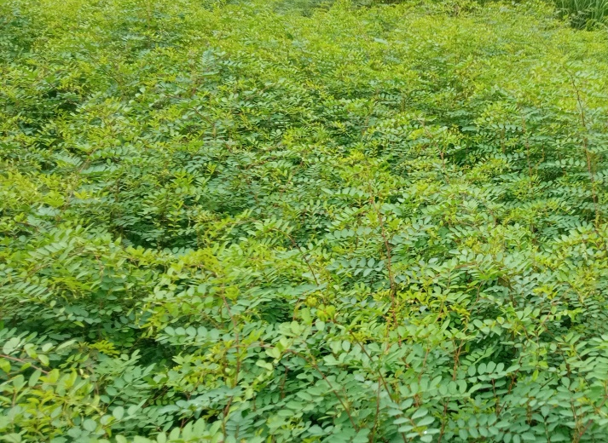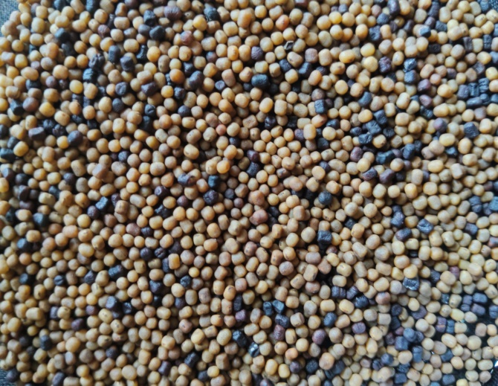
Fig 1. I. tinctoria plants Fig 2. Seeds of I. tinctoria
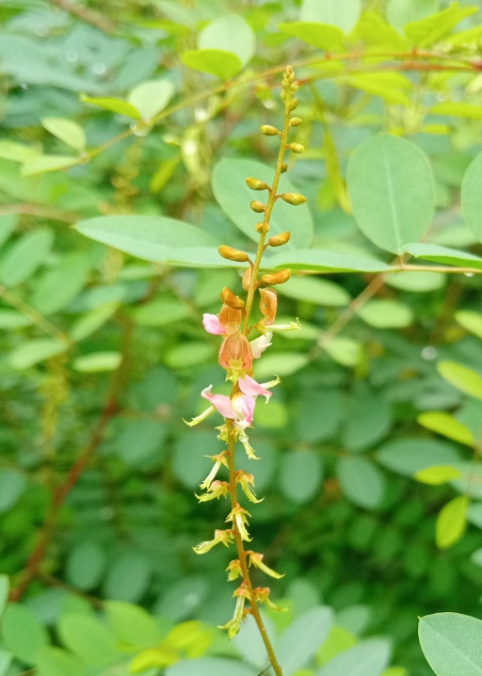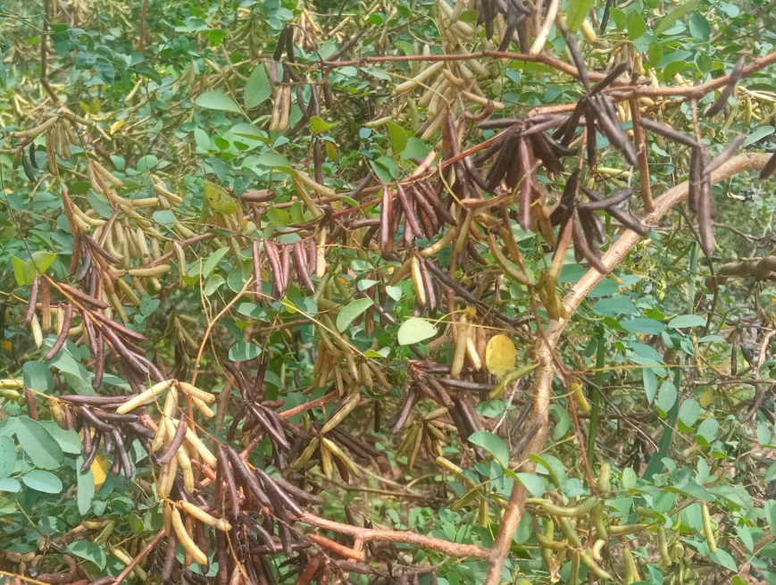
Fig 3. Inflorescence of I. tinctoria Fig 4. Pods of I. tinctoria
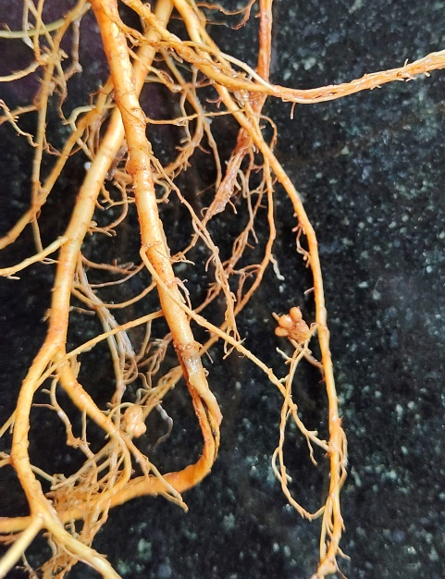
Fig 5. Root nodules of I. tinctoria

