Evaluating Soil Fertility and Nutrient Status in Vaishali District, Bihar: Influencing Factors and Sustainable Agricultural Implications

Abstract
Soil fertility and nutrient status play a vital role in sustaining agricultural productivity and ensuring food security, particularly in intensively cultivated regions like Vaishali District of Bihar, India. However, variability in soil nutrients influenced by environmental conditions, cropping practices, and management strategies necessitates systematic assessment to support sustainable soil management and improved crop production. The present study assessed soil fertility and nutrient status in Vaishali district of Bihar, to identify constraints affecting sustainable agriculture. Soil samples were analyzed for physicochemical properties and nutrient availability using standard methods. The soils were alkaline in reaction, with pH ranging from 8.00 to 8.69) and were non-saline in nature with EC value ranging from 0.18 to 0.89 dS m⁻¹. Organic carbon content ranged from 0.45 to 0.70%, indicating medium fertility status. Available nitrogen was low (174–218 kg ha⁻¹), whereas phosphorus (22–42 kg ha⁻¹) and potassium (191–272 kg ha⁻¹) were in the medium range. Sulphur (14–27 kg ha⁻¹) and micronutrients, including Zn, B, Fe, Mn, and Cu, were found to be generally sufficient. However, alkaline soil conditions may reduce micronutrient bioavailability. The results highlight nitrogen as the primary limiting nutrient and emphasize the need for integrated nutrient management to sustain soil fertility and agricultural productivity.
Keywords: Soil fertility, Nutrient status, Alkaline soils, Integrated nutrient management, Sustainable agriculture.

INTRODUCTION
Soil fertility and nutrient status are crucial for achieving sustainable agriculture, especially in regions like Vaishali District in Bihar, India. This area is vital for agriculture, providing livelihoods for many farmers. Understanding the factors influencing soil fertility and nutrient availability is essential to improve crop production and ensure food security (Kumar, 2023; Shahi et al., 2020). The soil in Vaishali is diverse, containing various chemical properties which are influenced by geographical and climatic conditions (Singh et al., 2022). Recent studies show significant variability in macronutrient distribution across the agricultural soils in the district, which underscores the need for a detailed assessment (Singh et al., 2026).
Assessing soil fertility involves evaluating physical and chemical traits, such as pH, organic matter, and nutrient concentrations (Kumar, 2025; Ahamad et al., 2021). These factors affect the availability of essential nutrients like nitrogen, phosphorus, and potassium, which are vital for plant growth. In Vaishali, inadequate nutrient management practices and socio-economic factors can lead to low productivity (Singh et al., 2025). The nutrient index approach offers a systematic way to assess soil fertility across various agroecosystems, including those in Vaishali (Akhtar et al., 2025).
Moreover, the impact of crop types and farming practices plays a significant role in soil health. Continuous cropping and specific crops can deplete essential nutrients, thereby reducing soil fertility (Mandal et al., 2022). For instance, sugarcane cultivation in nearby districts has shown to affect soil carbon pools, which are critical for maintaining overall soil health (KUDI, 2022). Different studies emphasize the necessity of tailored nutrient management strategies to enhance soil fertility and improve crop yield sustainably (Singh et al., 2023; Choudhary et al., 2020).
Climate impact is another factor that influences soil health. Changes in weather patterns can affect land suitability for agriculture, thus altering the nutrient dynamics within the soil (Sekhar et al., 2022). The Ganga River's proximity also impacts nutrient transport and availability in Vaishali's soils, highlighting the need for localized studies to assess these influences (Pal et al., 2024). Geographic Information System (GIS) and other spatial modelling techniques have been utilized effectively to map soil nutrient status, thereby aiding in better management practices (Kashiwar et al., 2023).
Multiple factors are at play in determining the fertility of agricultural soils in Vaishali District. The socio-economic context, combined with environmental elements, creates a complex landscape for farmers (Mandal et al., 2022). Planners and policymakers must understand these dynamics to formulate effective strategies that promote sustainable agricultural practices. The sustainable management of soil nutrients will not only enhance food production but will also contribute to environmental protection and resilience against climate change (Sarkar & Das, 2025).
Collaboration among researchers, local farmers, and government bodies is critical in implementing scientific approaches to soil fertility assessments. Continuous education and adaptation of best practices in nutrient management are essential to optimize crop yields while ensuring sustainability (Singh et al., 2025). Therefore, a comprehensive understanding of the soil fertility and nutrient status in Vaishali District will inform agricultural practices, leading to improved crop productivity and sustainability in the region (Kumar et al., 2023; Shahi et al., 2020). The road ahead requires a concerted effort towards integrating traditional knowledge with modern scientific approaches to achieve long-term agricultural sustainability in Vaishali District, Bihar (Mandal et al., 2022).
2. MATERIAL AND METHODS
The present investigation was conducted in Vaishali district of Bihar, India, situated in the middle Gangetic alluvial plains. The experimental site is located in a fertile alluvial tract under an intensive rice–wheat–vegetable cropping system, influencing nutrient availability within the effective crop root zone. The region experiences a sub-tropical climate with hot summers, moderate monsoonal rainfall, and cool winters (Muhr et al., 1965).
2.1 SOIL SAMPLING
Surface soil samples were collected from agricultural fields of Vaishali district at a depth of 0–30 cm following standard soil sampling procedures (Jackson, 1973). Prior to sampling, surface debris and crop residues were removed. Twelve subsamples were collected randomly from each field and thoroughly mixed to prepare one composite soil sample for analysis. The samples were air-dried under shade, gently crushed, and passed through a 2-mm sieve for further laboratory analysis (Jackson, 1973).

2.1.1 SOIL PHYSICO-CHEMICAL ANALYSIS
Soil pH was determined in a 1:2.5 soil–water suspension using a digital pH meter following standard procedures (Jackson, 1973). Electrical conductivity (EC) was measured in the same soil extract using a conductivity meter and expressed as dS m⁻¹ to assess soil salinity status (Jackson, 1973). Organic carbon (OC) content of the soil samples was estimated by the Walkley and Black wet oxidation method and expressed as a percentage (Walkley & Black, 1934).
2.1.2 AVAILABLE MACRONUTRIENT ANALYSIS
Available nitrogen (N) content of the soil was determined by the alkaline potassium permanganate method and expressed as kg ha⁻¹ (Subbiah & Asija, 1956). Available phosphorus (P₂O₅) was estimated using Olsen’s sodium bicarbonate extraction method and expressed as kg ha⁻¹ (Olsen et al., 1954). Available potassium (K₂O) was determined by extraction with neutral normal ammonium acetate followed by flame photometric analysis and expressed as kg ha⁻¹ (Jackson, 1973). Available sulphur (S) content was estimated using the calcium chloride extraction method and expressed in ppm (Chesnin & Yien, 1951).
2.1.3 MICRONUTRIENT ANALYSIS
Available micronutrients including zinc (Zn), iron (Fe), manganese (Mn), and copper (Cu) were extracted using DTPA solution and their concentrations were determined using an atomic absorption spectrophotometer (Lindsay & Norvell, 1978). Available boron (B) was determined using the hot water extraction method and expressed in ppm (Muhr et al., 1965).
2.1.4 SOIL FERTILITY RATING AND INTERPRETATION
The analytical results obtained were compared with established critical limits and fertility rating standards to classify soil properties and nutrient status into low, medium, and high/sufficient categories (Muhr et al., 1965). Based on these ratings, the overall fertility status of soils in Vaishali district was evaluated.
2.2 STATISTICAL ANALYSIS
The soil analytical data were tabulated and summarized using descriptive statistical methods. Mean values were used to interpret the fertility status of the soils with respect to macro- and micronutrient availability (Jackson, 1973).

3. RESULT AND DISCUSSION
The soils of Vaishali district exhibited an alkaline reaction, with soil pH ranging from 8.00 to 8.69 (Table 1). Such alkalinity is characteristic of the Indo-Gangetic Plains, where calcareous alluvial soils commonly dominate and influence nutrient dynamics under intensive cropping systems (Brady & Weil, 2016). High soil pH is known to reduce the availability of micronutrients such as zinc and iron due to precipitation and reduced solubility (Tisdale et al., 2013). Electrical conductivity varied from 0.18 to 0.89 dS m⁻¹, indicating that the soils are non-saline and free from salinity-related constraints to crop growth, as values below 1.0 dS m⁻¹ are generally considered safe for most crops (Richards, 1954).
Soil organic carbon content ranged between 0.45 and 0.70 %, placing the soils in the medium organic carbon category as per standard soil fertility rating guidelines (ICAR, 2011). This level reflects moderate organic matter status, which may not be sufficient to sustain long-term soil fertility without regular organic inputs, particularly under intensive cultivation practices (Lal, 2015).
Available nitrogen ranged from 174 to 218 kg ha⁻¹, classifying the soils as low in nitrogen and identifying it as the primary limiting nutrient in the district. Low nitrogen status is a common feature of intensively cultivated alluvial soils due to rapid mineralization and leaching losses (Subbiah & Asija, 1956). Available phosphorus (P₂O₅) content varied from 22 to 42 kg ha⁻¹, while available potassium (K₂O) ranged from 191 to 272 kg ha⁻¹, both falling under the medium fertility class according to established soil test rating criteria (Muhr et al., 1965; ICAR, 2011). These nutrient levels suggest balanced but potentially declining reserves under continuous cropping without adequate replenishment.
Secondary nutrient analysis showed that available sulphur ranged from 14 to 27 kg ha⁻¹, exceeding the commonly accepted critical limit of 10 mg kg⁻¹ for most crops (Chaudhary & Biswas, 2007). Micronutrient concentrations were also within adequate ranges, with zinc varying from 0.88 to 3.70 mg kg⁻¹, boron from 0.64 to 1.39 mg kg⁻¹, iron from 6.86 to 11.62 mg kg⁻¹, manganese from 7.68 to 11.78 mg kg⁻¹, and copper from 0.56 to 9.96 mg kg⁻¹. These values exceed critical deficiency limits suggested for Indian soils (Lindsay & Norvell, 1978; Katyal & Rattan, 2003). However, under alkaline soil conditions, the bioavailability of zinc and iron may decline due to reduced solubility and increased adsorption (Alloway, 2008).
Overall, the soils of Vaishali district are characterized by alkaline, non-saline conditions with medium organic carbon, low nitrogen, moderate phosphorus and potassium, and sufficient secondary and micronutrients. These findings underscore the importance of adopting integrated nutrient management strategies to maintain soil fertility and sustain agricultural productivity under intensive cropping systems (ICAR, 2011; Lal, 2015).

Table 1. Soil fertility status of soils of Vaishali district, Bihar
S. No. | Soil parameters | Range | Mean value | Normal range | Fertility status
1 | pH | 8.00 – 8.69 | 8.45 | 6.5 – 7.5 | Alkaline
2 | EC (dS m⁻¹) | 0.18 – 0.89 | 0.44 | < 1.0 | Non-saline
3 | Organic Carbon (%) | 0.45 – 0.70 | 0.57 | 0.50 – 0.75 | Medium
4 | Available Nitrogen (kg ha⁻¹) | 174 – 218 | 195.09 | 280 – 560 | Low
5 | Available Phosphorus (P₂O₅) (kg ha⁻¹) | 22 – 42 | 33.18 | 23 – 57 | Medium
6 | Available Potassium (K₂O) (kg ha⁻¹) | 191 – 272 | 228.27 | 144 – 337 | Medium
7 | Available Sulphur (kg ha⁻¹) | 14 – 27 | 19.18 | > 10 | Sufficient
8 | Zinc (mg kg⁻¹) | 0.88 – 3.70 | 2.05 | > 0.78 | Sufficient
9 | Boron (mg kg⁻¹) | 0.64 – 1.39 | 0.98 | > 0.50 | Sufficient
10 | Iron (mg kg⁻¹) | 6.86 – 11.62 | 8.47 | > 7.0 | Sufficient
11 | Manganese (mg kg⁻¹) | 7.68 – 11.78 | 9.90 | > 3.0 | Sufficient
12 | Copper (mg kg⁻¹) | 0.56 – 9.96 | 1.66 | > 0.94 | Sufficient

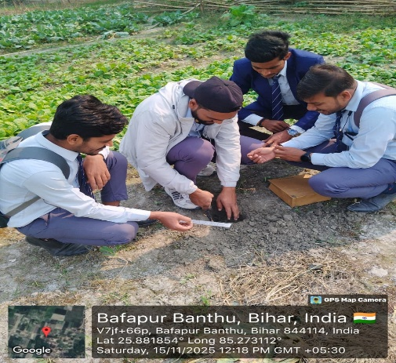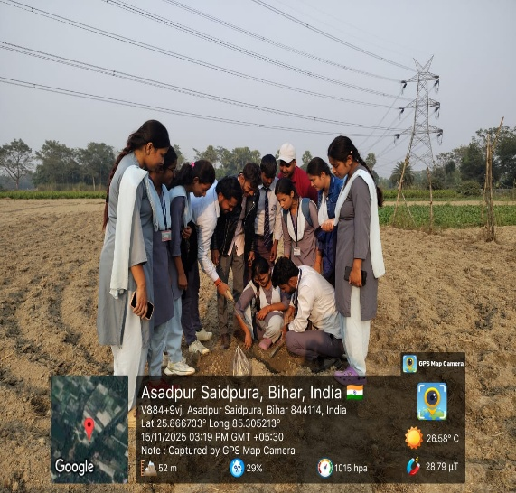
Fig 1 : Soil Sample Collection Fig 2 : Soil Sample Collection

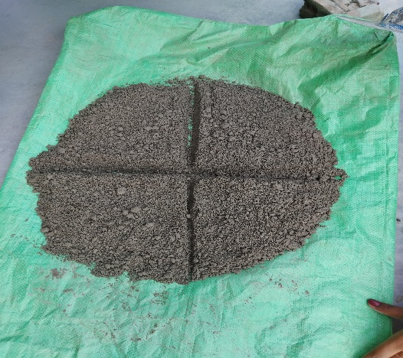
Fig 3 : Quartering Method

CONCLUSION
Soils of Vaishali district are alkaline and non-saline with moderate organic carbon. Available nitrogen is the major limiting nutrient, while phosphorus, potassium, sulphur, and micronutrients are largely sufficient. Site-specific and integrated nutrient management, with emphasis on nitrogen and organic matter enhancement, is essential for sustainable crop production.

Disclaimer (Artificial intelligence)

The authors would like to clarify that generative AI tools were used only for minor language editing and grammatical refinement. No AI tools were used for data analysis, interpretation, or generation of scientific content.

Refrences
Ahamad, A., Gupta, A. K., & Kumar, D. (2021). Soil fertility evaluation using nutrient index approach. Journal of Krishi Vigyan, 10(1), 276–282.
Akhtar, J., Dutta, S., Ray, B., Chowdhury, A., Raigar, B. L., Mondal, S., & Kumar, A. (2025). Soil fertility status and its relation with soil physico-chemical properties in Samastipur district of Bihar, India. Asian Journal of Soil Science and Plant Nutrition, 11(2), 362–373.
https://www.researchgate.net/profile/Subhajit-Dutta-14/publication/392967216
Alloway, B. J. (2008). Zinc in soils and crop nutrition (2nd ed.). International Zinc Association (IZA) & International Fertilizer Industry Association (IFA).
Brady, N. C., & Weil, R. R. (2016). The nature and properties of soils (15th ed.). Pearson Education.
Central Statistical Office, Bihar. (n.d.). Statistical profile of Bihar.
https://krishikosh.egranth.ac.in/server/api/core/bitstreams/c15f9439-de9b-4bf9-bc5f-6e84cb2cd2f8/content
Chaudhary, S. K., & Biswas, P. P. (2007). Sulphur status and its management in Indian soils. Indian Journal of Fertilisers, 3(5), 23–34.
Chesnin, L., & Yien, C. H. (1951). Turbidimetric determination of available sulphur. Soil Science Society of America Proceedings, 15, 149–151.
Choudhary, C. D., Vimal, B. K., Shambhavi, S., & Kumar, R. (2020). Natural resource management and land use planning. In Sustainable agriculture (pp. 335–364). Apple Academic Press.
https://www.taylorfrancis.com/chapters/edit/10.1201/9780429325830-19
Indian Council of Agricultural Research. (2011). Handbook of agriculture (6th ed.). ICAR.
Jackson, M. L. (1973). Soil chemical analysis. Prentice Hall of India Pvt. Ltd.
Kashiwar, S. R., Kundu, M. C., & Dongarwar, U. R. (2023). GIS-based spatial mapping of soil nutrient status of Pauni block of Maharashtra, India. Annals of Plant and Soil Research, 25(3), 446–454.
https://www.researchgate.net/profile/Manik-Kundu/publication/373686956
Katyal, J. C., & Rattan, R. K. (2003). Secondary and micronutrients: Research gaps and future needs. Fertiliser News, 48(4), 9–14.
Kudi, B. (2022). Impact of sugarcane cultivation on soil carbon pools and soil health in Samastipur district of Bihar (Doctoral dissertation, Dr. Rajendra Prasad Central Agricultural University, Pusa).
https://krishikosh.egranth.ac.in/bitstreams/1f4df8ef-511c-4e94-9ef5-727d931dfc24/download
Kumar, A. (2023). Assessment of soil fertility status in Paroo and Saraiyan blocks of Muzaffarpur district of Bihar using GPS and GIS. SSRN.
https://papers.ssrn.com/sol3/papers.cfm?abstract_id=4667958
Kumar, A. (2025). Nutrient index value as a tool for evaluating soil fertility in diverse agroecosystems of Indo-Gangetic plains of India.
https://www.academia.edu/download/125643047
Kumar, A., Chattopadhyay, S., & Meena, S. K. (2023). Soil fertility assessment of sugarcane growing villages in Samastipur district of Bihar. Environment and Ecology, 41(2), 759–764.
https://hal.science/hal-04676939/
Kumari, M. R., Kumar, S. P. D., Kumar, M., & Kumar, M. G. (n.d.). Ecological assessment of available nitrogen in the soils of Vaishali region and its impact on productivity of Brassica nigra and Sinapis alba.
https://www.researchgate.net/profile/Surendra_Prasad8/publication/396209001
Lal, R. (2015). Restoring soil quality to mitigate soil degradation. Sustainability, 7(5), 5875–5895. https://doi.org/10.3390/su7055875
Lindsay, W. L., & Norvell, W. A. (1978). Development of a DTPA soil test for zinc, iron, manganese, and copper. Soil Science Society of America Journal, 42(3), 421–428. https://doi.org/10.2136/sssaj1978.03615995004200030009x
Lindsay, W. L., & Norvell, W. A. (1978). Development of a DTPA soil test for zinc, iron, manganese, and copper. Soil Science Society of America Journal, 42(3), 421–428. https://doi.org/10.2136/sssaj1978.03615995004200030009x
Mandal, V. P., Aishwarya, & Kumar, P. (2022). Characterization and appraisal of crop-based farming system for sustainable agricultural development. In Agriculture, livestock production and aquaculture: Advances for smallholder farming systems (pp. 99–112). Springer.
https://doi.org/10.1007/978-3-030-93258-9_6
Mandal, V. P., Rehman, S., Ahmed, R., Masroor, M. D., Kumar, P., & Sajjad, H. (2020). Land suitability assessment for optimal cropping sequences in Katihar district of Bihar, India using GIS and AHP. Spatial Information Research, 28(5), 589–599.
https://doi.org/10.1007/s41324-020-00315-z
Muhr, G. R., Datta, N. P., Sankarasubramoney, H., Dever, F., & Donahue, R. L. (1965). Soil testing in India. U.S. Agency for International Development.
Muhr, G. R., Datta, N. P., Sankarasubramoney, H., Dever, F., & Lelyveld, I. J. (1965). Soil testing in India (2nd ed.). U.S. Agency for International Development & Indian Council of Agricultural Research.
Olsen, S. R., Cole, C. V., Watanabe, F. S., & Dean, L. A. (1954). Estimation of available phosphorus in soils by extraction with sodium bicarbonate. United States Department of Agriculture Circular No. 939.
Pal, S., Singh, S. K., Singh, P., Pal, S., & Kashiwar, S. R. (2024). Spatial pattern of groundwater arsenic contamination in Patna, Saran and Vaishali districts of Gangetic plains of Bihar, India. Environmental Science and Pollution Research, 31(41), 54163–54177.
https://doi.org/10.1007/s11356-022-25105-y
Richards, L. A. (Ed.). (1954). Diagnosis and improvement of saline and alkali soils (USDA Agriculture Handbook No. 60). United States Department of Agriculture.
Sarkar, D., & Das, R. (2025). Regional soil health assessments: Eastern India. In Soil health and sustainability in India (p. 128). https://books.google.com/books?id=FCRoEQAAQBAJ
Sekhar, S., Dutta, S., Sahana, M., Areendran, G., & Raj, K. (2022). Assessing impact of climate variability on potential agricultural land suitability in Nalanda district, Bihar. In Climate change, disaster and adaptations (pp. 131–149). Springer.
https://doi.org/10.1007/978-3-030-91010-5_11
Shahi, V. B., Dutta, S. K., Majumdar, K., & Tomar, A. (2020). Study on nutrient management in high yield wheat system in Bihar using nutrient expert tool. International Journal of Agricultural Invention, 5(2), 288–295. http://agriinventionjournal.com/index.php/ijai/article/view/314
Singh, K. K., Kumar, A., Singh, S. K., Prasad, R., Gupta, S. K., & Kumari, S. (2025). Improving soil fertility and wheat (Triticum aestivum) productivity through precision nutrient management in North Bihar, India. Research Perspective on Biological Science, 2, 133–145.
https://hal.science/hal-05047948/
Singh, S. K., Pal, S., Singh, P., Tiwari, S., Kashiwar, S. R., & Kumar, A. (2022). Spatial variability of soil chemical properties in Patna, Vaishali and Saran districts adjoining the Ganga River, Bihar, India. International Journal of Bio-resource and Stress Management, 13(3), 283–291.https://hal.science/hal-04676836/
Singh, S. K., Tagung, T., Kashiwar, S. R., Kumar, A., Tiwari, S., Singh, A. K., & Singh, K. K. (2023). Assessment of soil fertility status in Paroo and Saraiyan blocks of Muzaffarpur district of Bihar using GPS and GIS. International Journal of Plant & Soil Science, 35(17), 89–101.
https://hal.science/hal-04676942/
Singh, S. K., Yadav, S., Kumar, A., Singh, K. K., Kumari, S., Meena, S., & Singh, A. K. (2026). Variability and distribution of macronutrients in calcareous soils of Vaishali district, Bihar, India. Journal of Advances in Biology & Biotechnology, 29(1), 948–961. https://www.researchgate.net/profile/Ajeet-Kumar-53/publication/400187192
Subbiah, B. V., & Asija, G. L. (1956). A rapid procedure for the estimation of available nitrogen in soils. Current Science, 25, 259–260.
Subbiah, B. V., & Asija, G. L. (1956). A rapid procedure for the estimation of available nitrogen in soils. Current Science, 25, 259–260.
Tisdale, S. L., Nelson, W. L., Beaton, J. D., & Havlin, J. L. (2013). Soil fertility and fertilizers: An introduction to nutrient management (8th ed.). Pearson.
Walkley, A., & Black, I. A. (1934). An examination of the Degtjareff method for determining soil organic matter and a proposed modification of the chromic acid titration method. Soil Science, 37(1), 29–38. https://doi.org/10.1097/00010694-193401000-00003

