Original Research Article
Analysis of genetic parameters, correlation and path analysis for yield in F₄ population of Wheat (Triticum aestivum L.)

ABSTRACT
Wheat (Triticum aestivum L.) is a globally important staple cereal with a complex allohexaploid genome that provides substantial genetic variability for yield improvement under diverse agro-climatic conditions. However, enhancing grain yield remains challenging due to its polygenic nature and strong environmental influence, necessitating systematic evaluation of genetic parameters and trait associations in segregating populations. The present investigation was conducted to assess genetic variability, heritability, character association, and path coefficient analysis for yield and its component traits in an F₄ segregating population of bread wheat (Triticum aestivum L.). A total of 42 genotypes (37 F₄ lines and 5 checks) were evaluated during Rabi 2021–22 using an Augmented Block Design. Observations were recorded on fourteen quantitative traits, and statistical analyses were performed to estimate genotypic and phenotypic coefficients of variation (GCV and PCV), broad-sense heritability, genetic advance, correlation coefficients, and direct and indirect effects on grain yield. Analysis of variance revealed significant differences among genotypes for key traits including days to 50% heading, days to maturity, and plant height, indicating adequate genetic variability. PCV values were higher than GCV for all traits, suggesting environmental influence on trait expression. The highest PCV was recorded for biological yield per plant (19.65%), while plant height exhibited the highest GCV (12.40%). High heritability was observed for days to maturity (86.31%), chlorophyll content (78.81%), ear weight (78.51%), and plant height (71.97%). Plant height also showed high genetic advance as percent of mean (21.7%), indicating predominance of additive gene action. Correlation analysis revealed that biological yield per plant (0.9125) and test weight (0.6639) were positively and significantly associated with grain yield per plant at the genotypic level, whereas harvest index showed significant negative association (−0.6455). Path coefficient analysis demonstrated that biological yield per plant exerted the highest positive direct effect (1.6684) on grain yield, followed by harvest index (0.8050), number of grains per ear (0.1807), and days to maturity (0.1518). The low residual effect (0.1235) indicated that the studied traits sufficiently explained yield variation. Overall, biological yield per plant and test weight emerged as reliable selection indices for improving grain yield in wheat breeding programs.

Keywords: Heritability, Genetic advance, Coefficient analysis, Covariance, Path analysis.

- INTRODUCTION
Wheat (Triticum aestivum L.) is among the most widely cultivated cereal crops globally and constitutes a primary staple for over one-third of the world’s population. It is a member of the family Poaceae and the genus Triticum (Mourad et al., 2019). Renowned for its broad adaptability, high yield potential, and pivotal role in international grain trade, wheat is often referred to as the “king of cereals.” Bread wheat is an allohexaploid species (2n = 6x = 42) containing three distinct sub-genomes (AABBDD), a genomic structure that resulted from natural hybridisation and successive polyploidization events (Sears, 1952).
The A, B, and D genomes are derived from Triticum urartu, Aegilops speltoides, and Aegilops tauschii, respectively (Brenchley et al., 2012). This complex genomic architecture provides a broad genetic base for variability and adaptability under diverse agro-climatic conditions. Globally, wheat production reached approximately 776.7 million tonnes during 2020–21, with China and India being the leading producers (FAO, 2022). However, fluctuations in climatic conditions, emerging biotic and abiotic stresses, and changing input efficiencies pose serious challenges to sustainable wheat production. The grain is primarily composed of 55–75% carbohydrates and 10–20% storage proteins (Gillies et al., 2012), making it a major source of calories and plant protein. Therefore, enhancing grain yield and yield stability remains a central objective of wheat breeding programs.
Grain yield in wheat is a complex polygenic trait influenced by multiple component characters and their interactions with the environment. Effective selection for yield improvement requires comprehensive knowledge of genetic variability, heritability, genetic advance, and the nature of association among yield-contributing traits. Genetic variability provides the basic foundation for crop improvement, while heritability estimates indicate the proportion of phenotypic variance attributable to genetic causes (Hanson et al., 1956; Johnson et al., 1955). The combined assessment of heritability and genetic advance helps determine whether additive or non-additive gene action predominates, thereby guiding appropriate breeding strategies.
Correlation analysis is a fundamental biometrical tool for quantifying the strength and direction of associations among traits (Al Jibouri et al., 1958). However, correlation alone cannot differentiate between direct and indirect contributions of traits to a particular character. Path coefficient analysis, as introduced by Dewey and Lu (1959), addresses this limitation by partitioning correlation coefficients into direct and indirect effects, thereby enabling the identification of traits that exert the most significant influence on grain yield. Numerous studies have highlighted the critical role of biological yield, test weight, and other yield components in enhancing wheat productivity (Ibrahim, 2019; Goregaonkar et al., 2022; Hassani et al., 2022; Sood et al., 2021).
In segregating generations such as F₄ populations, considerable genetic variability still exists due to recombination and segregation of alleles. Evaluating such populations is essential for identifying superior recombinants and understanding the inheritance pattern of yield-related traits. Since yield expression in advanced segregating generations reflects cumulative gene effects, estimation of genetic parameters at this stage provides reliable information for effective selection. Therefore, the present study was conducted to evaluate genetic variability, genotypic and phenotypic coefficients of variation, broad-sense heritability, genetic advance, and character associations for fourteen quantitative traits in an F₄ population of bread wheat. Furthermore, path coefficient analysis was performed to quantify the direct and indirect contributions of individual traits to grain yield per plant. The primary objective of this investigation was to identify key yield-contributing traits that could serve as reliable selection criteria in wheat breeding programmes aimed at enhancing grain yield.

- MATERIAL AND METHODS

2.1 Experimental Site and Plant Material
The present investigation was conducted during the Rabi season of 2021–22 at the Research Farm, Department of Genetics and Plant Breeding, School of Agriculture, Lovely Professional University, Phagwara, Punjab, India. The experimental site falls under subtropical climatic conditions characterized by cool winters, which are favorable for wheat cultivation. The experimental material consisted of 42 genotypes of bread wheat (Triticum aestivum L.), comprising 37 F₄ segregating lines derived from different cross combinations and five check varieties. The details of the genotypes along with their respective checks are presented in List 1.

List 1: Genotypes and corresponding check varieties
S.no | List of genotypes | List of check varieties
1. | DBW90 ×MP3382 | IC 534755
2. | DBW93 ×MP3382 | IC 82296
3. | DBW-107×MP3382 | IC 107910
4. | DBW110×MP 3382 | IC 104586
5. | RUJ4037×MP3382 | IC 107910

2.2 Experimental Design and Crop Management
The experiment was conducted using an Augmented Block Design (Federer, 1956) comprising four blocks. Each block contained 15 plots, including 10 test genotypes and 5 repeated check varieties. Individual plots consisted of three rows, each 2 m in length, with an inter-row spacing of 22.5 cm and an intra-row spacing of 5 cm. The check varieties were randomized within each block to allow for appropriate adjustment of treatment effects. All recommended agronomic practices for wheat cultivation under irrigated conditions were uniformly applied to ensure optimal crop growth. Fertiliser application, irrigation scheduling, weed management, and plant protection measures were implemented in accordance with standard agronomic guidelines.

2.3 Traits Recorded
Observations were recorded on five randomly selected, competitive plants from each genotype within every block. Data were collected for fourteen quantitative traits, including: days to 50% heading, days to maturity, plant height (cm), number of tillers per plant, number of productive tillers per plant, spike length (cm), number of spikelets per ear, ear weight (g), number of grains per ear, test grain weight (g), biological yield per plant (g), grain yield per plant (g), harvest index (%), and chlorophyll content (%). The harvest index was calculated as the ratio of grain yield to biological yield, expressed as a percentage.

2.4 Statistical Analysis
Statistical analyses were carried out using R Studio for variance and genetic parameter estimation, while correlation and path analysis were conducted using INDOSTAT version 9.3 software.
Analysis of variance appropriate for the Augmented Block Design was performed as per Federer (1956) to test the significance of differences among genotypes for all the traits studied. Genotypic coefficient of variation (GCV) and phenotypic coefficient of variation (PCV) were estimated following the method described by Burton (1952) and Burton and Devane (1953). Broad-sense heritability (h²) and genetic advance were calculated according to the procedures outlined by Hanson et al. (1956) and Johnson et al. (1955), respectively.
Genotypic and phenotypic correlation coefficients among yield and yield component traits were computed using the method proposed by Al Jibouri et al. (1958) to determine the magnitude and direction of association. Path coefficient analysis was performed following Dewey and Lu (1959) to partition correlation coefficients into direct and indirect effects and to identify traits exerting maximum influence on grain yield per plant.

- RESULT AND DISCUSSION
3.1 Analysis of Variance
The analysis of variance (Table 1) revealed the presence of significant genetic variability among the forty-two genotypes evaluated for the fourteen traits under study. The treatment effects (eliminating blocks) were significant for days to 50% heading, days to maturity, and plant height, indicating substantial variability among genotypes for these traits. Block effects were significant for plant height, number of grains per ear, grain yield per plant, and harvest index, suggesting environmental heterogeneity across blocks for these characters. The significant variation observed among genotypes confirms the existence of exploitable genetic variability in the F₄ population, which is essential for effective selection. Similar observations have been reported by Ibrahim (2019), Hassani et al. (2022), and Goregaonkar et al. (2022), emphasizing the importance of evaluating segregating populations to identify superior recombinants.

3.2 Genetic Variability (GCV and PCV)
Estimates of genotypic coefficient of variation (GCV) and phenotypic coefficient of variation (PCV) indicated that PCV values were consistently higher than corresponding GCV values for all traits (Table 2 and Fig. 1), demonstrating the influence of environmental factors on trait expression. The highest PCV was recorded for biological yield per plant (19.65%), followed by number of tillers per plant (18.90%), number of productive tillers per plant (18.23%), test grain weight (15.61%), and plant height (14.62%). The highest GCV was observed for plant height (12.40%) and test grain weight (10.15%), suggesting substantial inherent genetic variability for these traits. Moderate GCV values were observed for number of grains per ear and ear weight, indicating reasonable scope for selection. The close magnitude between GCV and PCV for days to maturity suggests relatively low environmental influence on this trait. Similar findings have been reported by Avinashe et al. (2017) and Ozukum et al. (2019).
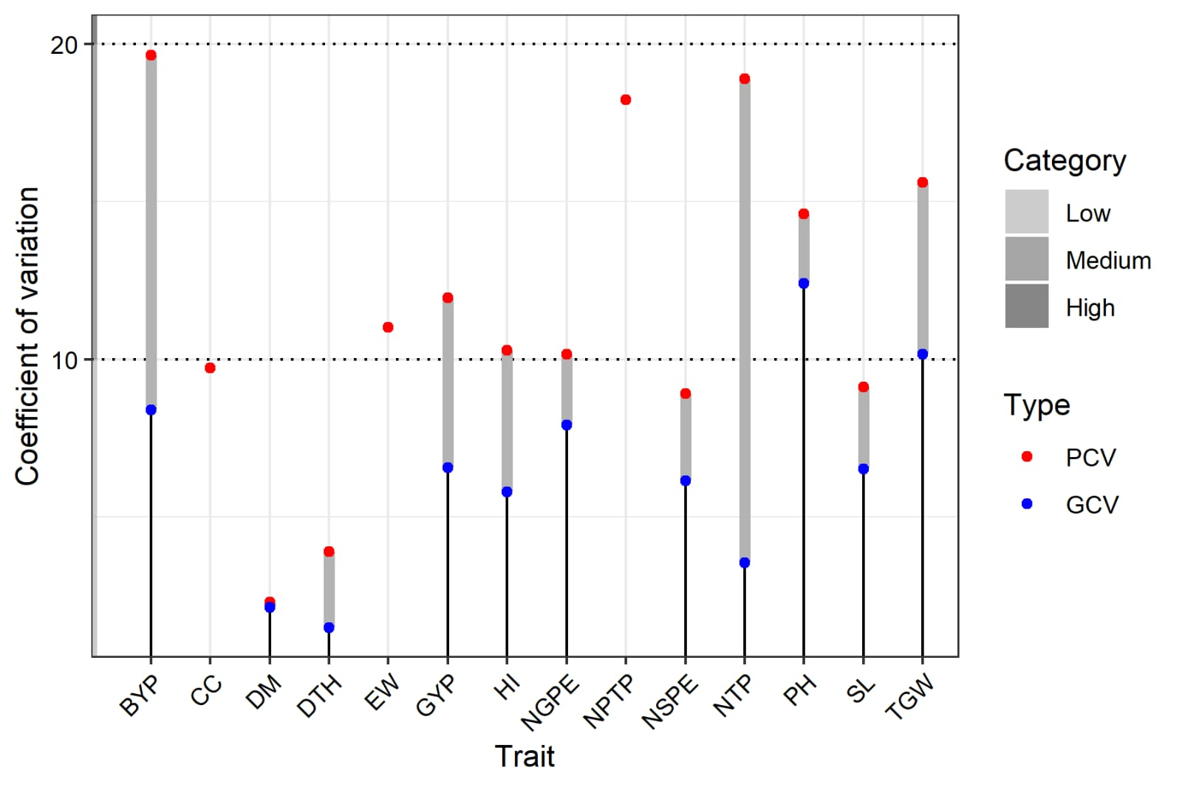
Fig. 1. Coefficient of variation for 14 traits under study

3.3 Heritability and Genetic Advance
Broad-sense heritability estimates (Table 2 and Fig. 2) ranged from 3.51% for number of tillers per plant to 86.31% for days to maturity. High heritability was recorded for days to maturity (86.31%), chlorophyll content (78.81%), ear weight (78.51%), and plant height (71.97%). Moderate heritability was observed for number of grains per ear, spike length, number of spikelets per ear, test grain weight, and number of productive tillers per plant. Low heritability was recorded for harvest index, grain yield per plant, biological yield per plant, days to 50% heading, and number of tillers per plant.
Genetic advance as a percentage of the mean (Table 2 and Fig. 3) was highest for plant height (21.7%), followed by chlorophyll content (13.65%), test grain weight (13.62%), ear weight (12.87%), and number of grains per ear (12.70%). The combination of high heritability and high genetic advance observed for plant height suggests the predominance of additive gene action, indicating that direct selection for this trait would be highly effective. In contrast, traits such as days to maturity and chlorophyll content, although exhibiting high heritability, showed comparatively lower genetic advance, implying a greater influence of non-additive gene effects or environmental factors. These observations are consistent with previous reports by Kaur et al. (2019), Khan Hassan (2017), and Singh et al. (2026).
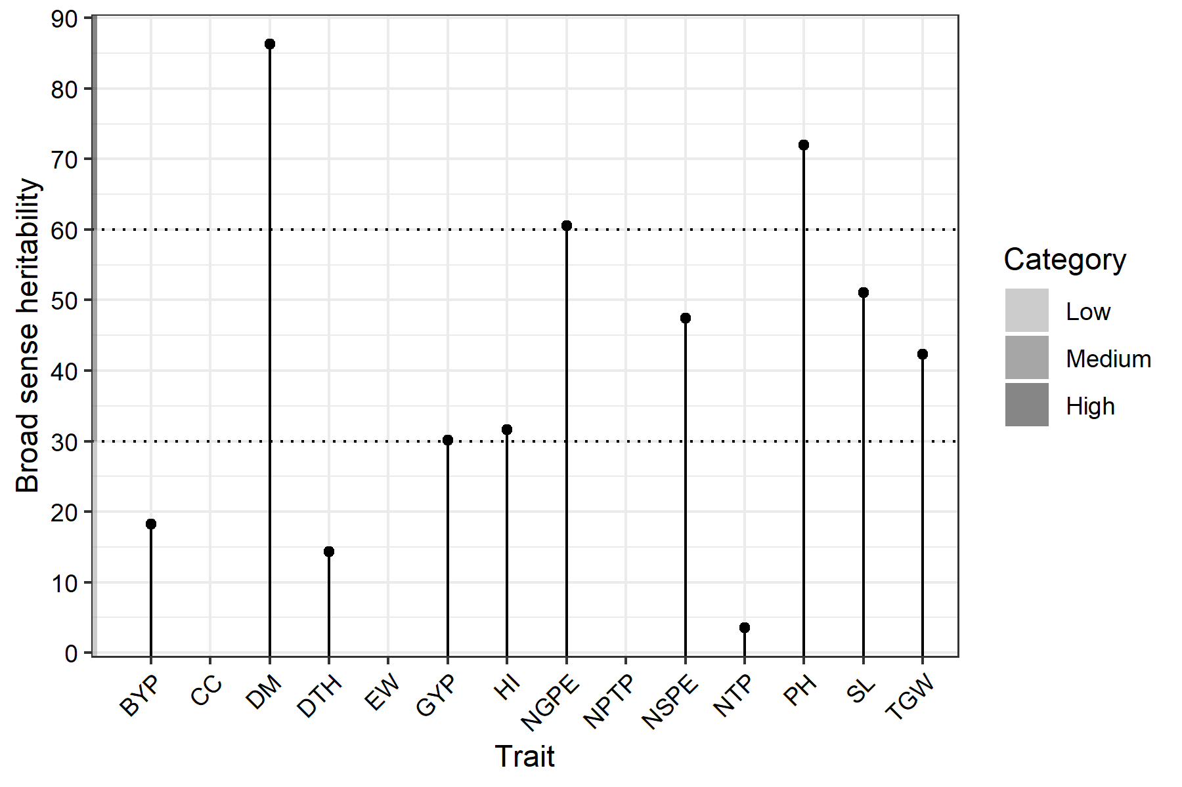
Fig. 2. Variation in broad sense heritability among the traits studied
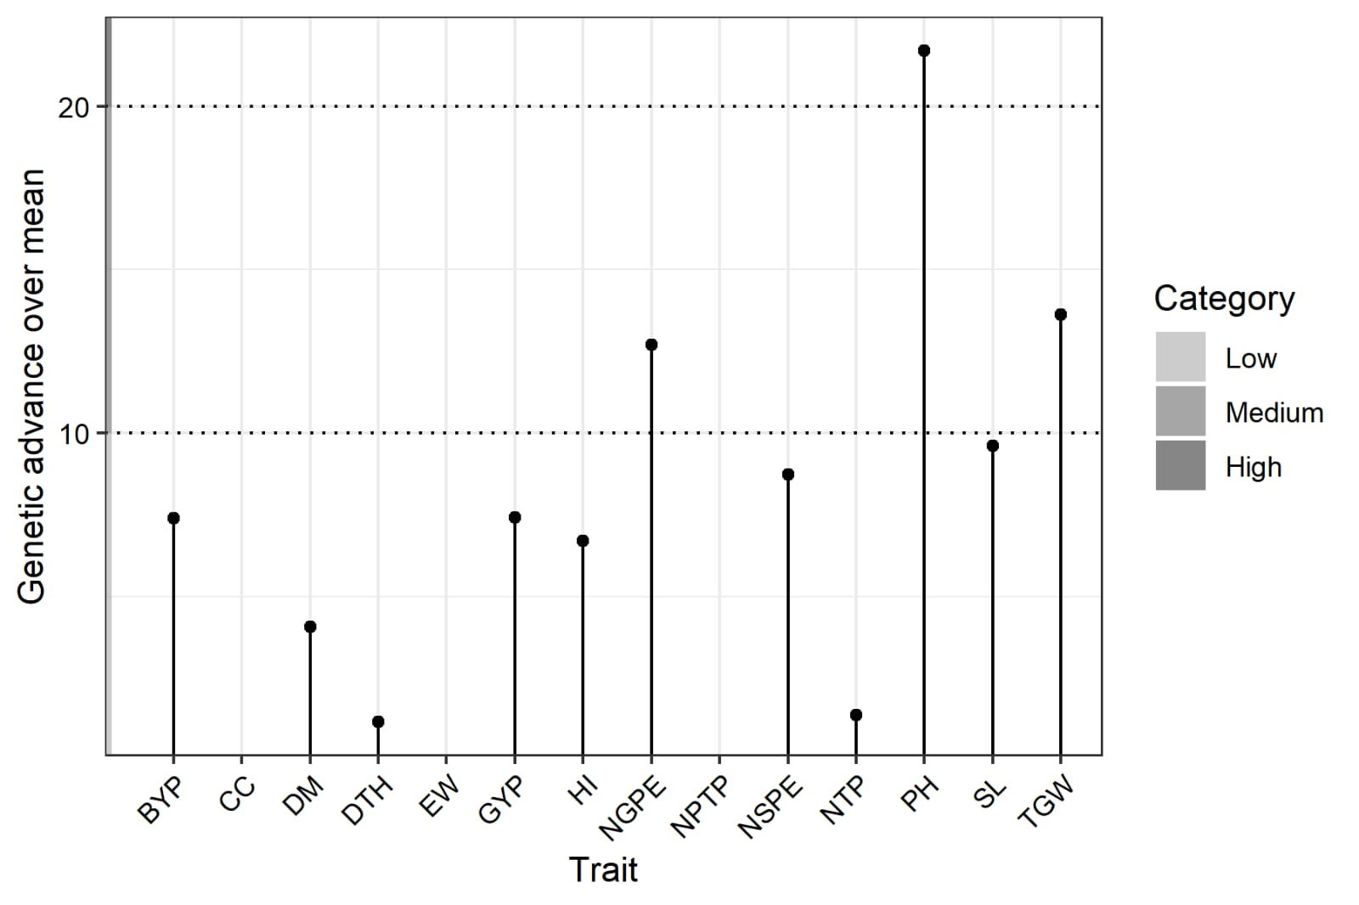
Fig. 3. Genetic advance of 14 traits under study

3.4 Correlation Analysis
Correlation coefficient analysis (Table 3) indicated that biological yield per plant had a strong positive and highly significant association with grain yield per plant at both the genotypic (r = 0.9125) and phenotypic (r = 0.9043) levels. Test grain weight also exhibited a significant positive correlation with grain yield, with genotypic and phenotypic values of 0.6639 and 0.6550, respectively. Conversely, harvest index displayed a significant negative correlation with grain yield (r = −0.6455 at the genotypic level and −0.5931 at the phenotypic level). These findings indicate that biological yield and test grain weight are key contributors to grain yield in the examined F₄ wheat population, whereas harvest index may exert an opposing influence.
Positive and significant associations were also observed between days to 50% heading and days to maturity, number of tillers per plant and number of productive tillers per plant, and spike length with number of grains per ear. The strong positive association between number of spikelets per ear and number of grains per ear further indicates coordinated inheritance of these yield components. Similar relationships have been reported by Mecha et al. (2017), Patel et al. (2020), and Singh et al. (2021).

3.5 Path Coefficient Analysis
Path coefficient analysis (Table 4 and Fig. 4) was employed to partition the correlation coefficients into direct and indirect effects, thereby identifying traits with the greatest influence on grain yield per plant. Among the traits studied, biological yield per plant exhibited the highest positive direct effect on grain yield (1.6684), followed by harvest index (0.8050), number of grains per ear (0.1807), days to maturity (0.1518), and days to 50% heading (0.1284). The substantial direct effect of biological yield per plant underscores its critical role as a primary determinant of grain yield and highlights its importance as a target trait in wheat improvement programmes.
Negative direct effects were observed for number of spikelets per ear, number of productive tillers per plant, test grain weight, and ear weight, although some of these traits exhibited positive indirect effects through other characters. The residual effect (0.1235) was low, indicating that the majority of variability in grain yield was explained by the traits included in the model. Similar findings have been reported by Rajput (2018), Pooja et al. (2018), and Moulali et al. (2022), highlighting the usefulness of path analysis in identifying reliable selection criteria.
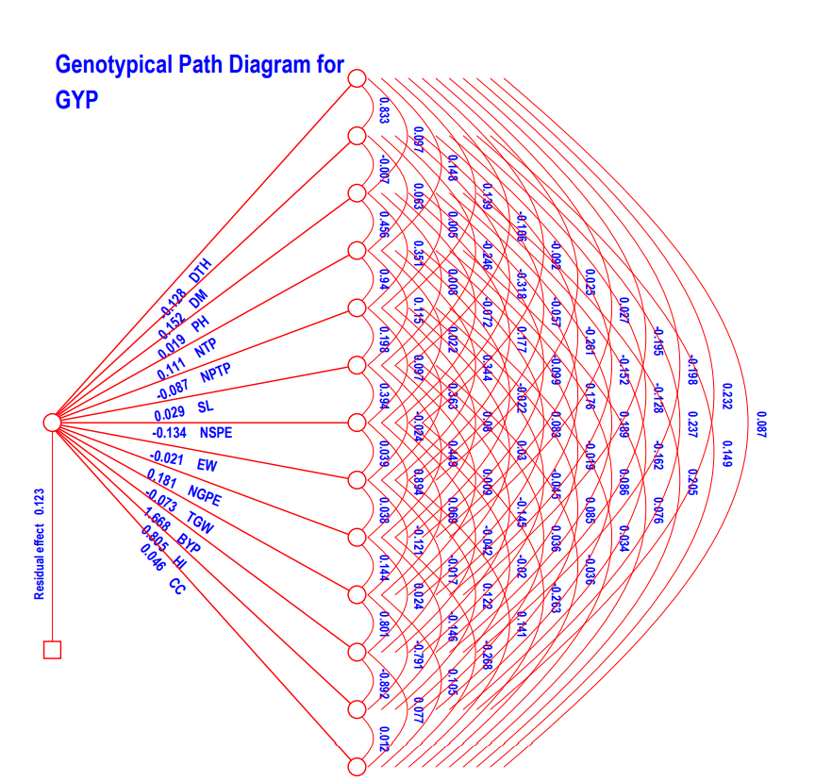
Fig. 4. Genotypic Path coefficient analysis diagram for grain yield per plant.

- CONCLUSION
The present study revealed substantial genetic variability among the F₄ segregating wheat genotypes for yield and its associated traits, indicating the presence of sufficient genetic diversity for effective selection. Analysis of variance confirmed significant genotypic differences for key phenological and morphological characters. The magnitude of phenotypic coefficient of variation exceeded genotypic coefficient of variation for all traits, reflecting environmental influence; however, appreciable genetic variability was observed particularly for plant height and test grain weight. High heritability estimates for days to maturity, chlorophyll content, ear weight, and plant height suggest strong genetic control over these traits. Notably, plant height exhibited high heritability coupled with high genetic advance as percent of mean, indicating predominance of additive gene effects and suitability for direct phenotypic selection. Correlation analysis demonstrated that biological yield per plant and test grain weight had strong positive and significant associations with grain yield, while harvest index showed a negative association. Path coefficient analysis further clarified these relationships by revealing that biological yield per plant exerted the highest positive direct effect on grain yield, followed by harvest index and number of grains per ear. The relatively low residual effect indicated that the traits studied adequately explained the variability in grain yield. From a breeding perspective, biological yield per plant and test grain weight can serve as reliable selection indices for improving grain yield in segregating generations. Future research should focus on multilocation evaluation to assess genotype × environment interactions and yield stability. Integration of molecular markers, genomic selection approaches, and quantitative trait locus (QTL) mapping would facilitate precise identification of genomic regions controlling key yield traits. Such integrated breeding strategies will accelerate the development of high-yielding, stable, and climate-resilient wheat cultivars.

DISCLAIMER (ARTIFICIAL INTELLIGENCE)

Author(s) hereby declare that NO generative AI technologies such as Large Language Models (ChatGPT, COPILOT, etc.) and text-to-image generators have been used during the writing or editing of this manuscript.

REFERENCES

Al‐Jibouri, H., Miller, P. A., & Robinson, H. F. (1958). Genotypic and environmental variances and covariances in an upland Cotton cross of interspecific origin 1. Agronomy journal, 50(10), 633-636.
Avinashe, H. A., Dubey, N., & Shukla, R. S. (2017). Genetic analysis for economic traits in wheat under timely and very late sown conditions. International journal pure and applied bioscience, 5(5), 157-162.
Brenchley, R., Spannagl, M., PfeifeR, M., Barker, G. L. A., D’Amore, R., Allen, A. M., ... Hall, N. (2012). Analysis of the bread wheat genome using whole-genome shotgun sequencing. Nature, 491, 705-710.
Burton, G. W., and Devane, D. E. (1953). Estimating heritability in tall fescue (Festucaarundinacea) from replicated clonal material 1. Agronomy journal, 45(10), 478-481.
Burton, G.W., Quantitative inheritance of grasses. In: Proceedings 6th International Grassland Congress. 1952; 1:273-283.
Chaudhary, V., Kumar, S., Singh, S., Prasad, J., Jeena, A. S., & Upreti, M. C. (2020). Variability, character association and path analysis in wheat (Triticum aestivum L.). Journal of Pharmacognosy and Phytochemistry, 9(3), 1859-1863.
Dewey, D.I., and Lu, K.H. (1959). A Correlation and Path Coefficient Analysis of Components of Crested Wheatgrass Seed Production. Agronomy Journal, 51, 515-518
FAO. (2022). Food Outlook – Biannual Report on Global Food Markets. Rome. https://doi.org/10.4060/cb9427en
Federer, W.T. (1956). Augmented (or hoonuiaku) designs. Hawaiian Planters’ Record LV;(2):191-208.
Gillies, S.A., Futardo, A., Henry, R.J. (2012). Gene expression in the developing aleurone and starchy endosperm of wheat. Plant Biotechnology Journal, 10, 668-679.
Goregaonkar, P., Avinashe, H. A., and. Dubey, N. (2022). Studies on correlation and path analysis in segregating population of Bread Wheat (Triticum aestivum L.) Agriculture Mechanization in Asia, Volume 53, Issue 05, May 2022.
Hanson, W., D.Robinson, H. F., and Comstock, R. E. (1956). Biometrical studies of yield segregating population Korean lespandeza. Agron. J., 48, 268-272.
Mourad, A. M., Alomari, D.Z., Alqudah, A.M. (2019). Recent advances in wheat (Triticum spp.) breeding. In: Al-Khayri M, Jain SM, Johnson DV, editors. Advances in Plant Breeding Strategies: Cereals Vol. 5. New York (NY): Springer International Publishing; p. 559–593.
Hassani, İ., Nimbal, S., Singh, V., & Noori, A. (2022). Genetic Variability Analysis and Correlation Studies of Bread Wheat (Triticum aestivum L.) Genotypes. Ekin Journal of Crop Breeding and Genetics, 8(2), 139-145.
Ibrahim, A.U. (2019). Genetic variability, Correlation and Path analysis for Yield and yield components in F6 generation of Wheat (Triticum aestivum Em. Thell.). IOSR Journal of Agriculture and Veterinary Science., 12(1), 17-23.
Johnson, H. W., Robinson, H. F., & Comstock, R. E. (1955). Genotypic and phenotypic correlations in soybeans and their implications in selection 1. Agronomy journal, 47(10), 477-483.
Kaur, S., Avinashe, H. A., Dubey, N., Kalubarme, S., & Kumar, M. (2019). Assessment of genetic variability and association analysis for yield and yield attributing traits in bread wheat (Triticum aestivum L.). Plant Archives, 19(1), 1261-1267.
Khan, S. A., and Hassan, G. (2017). Heritability and correlation studies of yield and yield related traits in bread wheat. Sarhad Journal of Agriculture, 33(1), 103-107.
Kumar, A. (2020). Genetic variability and character association in wheat.
Mecha, B., Alamerew, S., Assefa, A., Assefa, E., & Dutamo, D. (2017). Correlation and path coefficient studies of yield and yield associated traits in bread wheat (Triticum aestivum L.) genotypes. Advances in Plants & Agriculture Research, 6(5), 226-235.
Moulali, S., Hulle, A., Dubey, N., Avinashe, H., Sachan, S. (2022). Genetic parameters studies in segregation population of bread wheat (Triticum aestivum L.). Agricultural Mechanization in Asia, 53(06), June 2022.
Mourad, A.M., Alomari, D.Z., Alqudah, A.M. (2019). Recent advances in wheat (Triticum spp.) breeding. In: Al-Khayri M, Jain SM, Johnson DV, editors. Advances in Plant Breeding Strategies: Cereals Vol. 5. New York (NY): Springer International Publishing; p. 559–593.
Ozukum.W., Avinashe, H.A., Dubey, N., Kalubarme.s., Kumar.M. (2019). Correlation and path coefficient analysis in bread wheat (Triticum aestivum. L). Plant Archives, 19(2), 3033-3038.
Patel, D. P., Kulkarni, G. U., Ghadage, N. C., & Sharma, L. K. (2020). Correlation and Path analysis for Seed Yield in Bread Wheat (Triticum aestivum L.). Indian Journal of Pure & Applied Biosciences, 8(5), 524-530.
Pooja, C., Singh, V., & Yadav, S. (2018). Path coefficient and correlation studies of yield and yield associated traits in diverse genotypes of bread wheat (Triticum aestivum L.). International Journal of Chemical Studies, 6, 73-76.
Rajput, R. S. (2018). Correlation, path analysis, heritability and genetic advance for morphophysiological character on bread wheat (Triticum aestivum L.). Journal of Pharmacognosy and phytochemistry, 7(2), 107-112.
Saini, M. (2017). Shweta. Genetic variability, heretability, correlation co-efficient and path analysis of yield and yield contributing traits in bread wheat (Triticum aestivum L.). International Journal of Plant Sciences, 12(2), 173-180.
Sears, E.R. (1952). Homoeologous chromosomes in Triticum aestivum. Genetics 37, 624.
Singh, A., Pandey, J., Singh, S., Singh, R. P., & Singh, R. K. (2021). Correlation and path coefficient analysis for yield and yield attributing traits in advanced bread wheat (Triticum aestivum L.) Lines. The Pharma Innovation Journal, 10(8), 482-488.
Sood, T., Basandrai, D., Rana, V., & Basandrai, A. K. (2021). Genetic diversity analysis for various agromorphological, yield and yield related traits in wheat (Triticum aestivum L.). Himachal Journal of Agricultural Research, 46(2), 136-144.
Verma, S.P., Pathak, V.N., and Verma, O.P. (2019). Interrelationship between Yield and its Contributing Traits in Wheat (Triticum aestivum L.). International Journal of Current Microbiology and Applied Sciences,8(2), 3209-3215.
Wahidy, S., and Lavanya, G.R. (2016). Genetic variability for seed yield and its component characters in wheat (Triticum aestivum L.) International Journal of Multidisciplinary Research and Development, 3(7), 21-23.
Singh, C. P., Kumar, S., Vikram, P., Mandal, R. K., & Kumari, M. (2026). Genetic Variability and Heritability in Bread Wheat (Triticum aestivum L.) Germplasm Across Sowing Environments. International Journal of Environment and Climate Change, 16(1), 410–420. https://doi.org/10.9734/ijecc/2026/v16i15243

Source | Df | X1 | X2 | X3 | X4 | X5 | X6 | X7 | X8 | X9 | X10 | X11 | X12 | X13 | X14
Block (ignoring Treatments) | 3 | 9.4 ns | 4.02 ns | 517.56 ** | 0.62 ns | 1.16 ns | 0.45 ns | 1.67 ns | 0.13 ns | 33.06 * | 6.59 ns | 3.28 ** | 45.37 ns | 31.79 * | 17.96 ns
Treatment (eliminating Blocks) | 41 | 35.92 * | 13.62 ** | 250.55 ** | 2.68 ns | 1.4 ns | 0.52 ns | 1.66 ns | 0.04 ns | 15.24 ns | 35.63 ns | 0.62 ns | 26.51 ns | 6.05 ns | 12.75 ns
Treatment: Check | 4 | 73.63 ** | 11.07 ** | 1055.05 ** | 4.57 ns | 3.18 ns | 0.33 ns | 0.47 ns | 0.09 ns | 4.72 ns | 43.94 ns | 0.57 ns | 25.56 ns | 5.58 ns | 4.49 ns
Treatment: Test and Test vs. Check | 37 | 31.85 * | 13.9 ** | 163.57 ** | 2.47 ns | 1.2 ns | 0.54 ns | 1.79 ns | 0.04 ns | 16.37 ns | 34.73 ns | 0.63 ns | 26.61 ns | 6.1 ns | 13.64 ns
Error | 12 | 11.49 | 1.21 | 40.93 | 1.49 | 1.58 | 0.26 | 0.95 | 0.08 | 0.52 | 18.04 | 1.58 | 0.95 | 0.26 | 29.24
CV | _ | 3.53 | 0.84 | 7.51 | 17.46 | 22.86 | 6.45 | 6.52 | 16.04 | 6.36 | 11.59 | 9.85 | 6.52 | 8.61 | 13.65
Table 1: Analysis of variance for yield and yield attributing traits in bread wheat

ns P > 0.05; * P <= 0.05; ** P <= 0.01
X1: Days to 50% heading, X2: Days to maturity, X3: Plant height, X4: Number of tillers per plant, X5: number of productive tillers per plant, X6: spike length X7: Number of spikelets per ear, X8: Ear weight, X9: Number of grains per ear, X10: Test weight, X11: Grain yield per plant, X12: Biological yield per plant, X13: Harvest index, X14: Chlorophyll content.

Table 2: Genetic Variability parameters for yield and yield attributing traits in bread wheat.
Trait | Range | Minimum | Mean | GCV | PCV | Heritability (h²) (%) | Genetic Advance | Genetic Advance Mean %
Trait | Maximum
Days to 50% Heading | 104.75 | 86.00 | 94.28 | 1.47 | 3.88 | 14.33 | 1.08 | 1.15
Days to Maturity | 134.75 | 125.00 | 129.73 | 2.13 | 2.29 | 86.31 | 5.29 | 4.08
Plant Height | 107.94 | 54.14 | 82.68 | 12.4 | 14.62 | 71.97 | 17.94 | 21.7
Number of Tillers per Plant | 10.60 | 4.60 | 6.58 | 3.54 | 18.9 | 3.51 | 0.09 | 1.37
Number of Productive Tillers per Plant | 8.60 | 3.80 | 5.25 | 2.84 | 18.23 | 40.76 | 1.62 | 7.65
Spike Length | 9.84 | 6.70 | 8.04 | 6.52 | 9.12 | 51.07 | 0.77 | 9.61
Number of Spikelets Per Ear | 18.00 | 12.00 | 15.1 | 6.14 | 8.92 | 47.44 | 1.32 | 8.73
Ear Weight | 2.08 | 1.45 | 1.79 | 7.81 | 11.02 | 78.51 | 1.65 | 12.87
Number of Grains Per ear | 52.40 | 32.40 | 43.01 | 7.91 | 10.17 | 60.53 | 5.46 | 12.7
Test Grain Weight | 47.90 | 24.70 | 35.8 | 10.15 | 15.61 | 42.28 | 4.88 | 13.62
Biological Yield Per plant | 38.88 | 19.08 | 26.58 | 8.39 | 19.65 | 18.22 | 1.96 | 7.39
Grain Yield Per plant | 9.14 | 5.63 | 7.23 | 6.55 | 11.94 | 30.12 | 0.54 | 7.42
Harvest Index | 32.71 | 21.75 | 27.62 | 5.78 | 10.28 | 31.62 | 1.85 | 6.7
Chlorophyll Content | 45.47 | 30.65 | 39.6 | 6.38 | 9.73 | 78.81 | 2.61 | 13.65

Table 3: Genotypic and Phenotypic correlation of coefficient among 14 traits in bread wheat.
 |  | X1 | X2 | X3 | X4 | X5 | X6 | X7 | X8 | X9 | X10 | X11 | X12 | X13 | X14
X1 | G | 1.000 | 0.8329** | 0.0972 | 0.1477 | 0.1388 | -0.1056 | -0.0915 | 0.0250 | 0.0265 | -0.1948 | -0.1984 | 0.2325 | 0.0871 | -0.1080
 | P | 1.000 | 0.8352** | 0.0801 | 0.1446 | 0.1443 | -0.0986 | -0.0844 | 0.0260 | 0.0257 | -0.1838 | -0.2020 | 0.2343 | 0.0904 | -0.1098
X2 | G |  | 1.000 | -0.0071 | 0.0633 | 0.0054 | -0.2464 | -0.3183* | -0.0565 | -0.2609 | -0.1518 | -0.1278 | 0.2371 | 0.1492 | 0.0363
 | P |  | 1.000 | -0.0264 | 0.0639 | 0.0146 | -0.2366 | -0.3083* | -0.0433 | -0.2595 | -0.1391 | -0.1316 | 0.2360 | 0.1492 | 0.0273
X3 | G |  |  | 1.000 | 0.4559** | 0.3508* | 0.0077 | -0.0716 | 0.1772 | -0.0987 | 0.1764 | 0.1894 | -0.1625 | 0.2050 | 0.1950
 | P |  |  | 1.000 | 0.4365** | 0.3307* | -0.0006 | -0.0689 | 0.1363 | -0.0938 | 0.1605 | 0.1876 | -0.1531 | 0.2051 | 0.1948
X4 | G |  |  |  | 1.000 | 0.9396** | 0.1149 | 0.0223 | 0.3444* | -0.0215 | 0.0833 | -0.0188 | 0.0860 | 0.0760 | 0.0525
 | P |  |  |  | 1.000 | 0.9360** | 0.1200 | 0.0249 | 0.3509* | -0.0195 | 0.0776 | -0.0235 | 0.0679 | 0.0587 | 0.0278
X5 | G |  |  |  |  | 1.000 | 0.1981 | 0.0971 | 0.3633* | 0.0796 | 0.0303 | -0.0455 | 0.0852 | 0.0343 | -0.0020
 | P |  |  |  |  | 1.000 | 0.2064 | 0.1088 | 0.3529* | 0.0836 | 0.0250 | -0.0604 | 0.0738 | 0.0223 | -0.0352
X6 | G |  |  |  |  |  | 1.000 | 0.3936** | -0.0244 | 0.4494** | 0.0086 | -0.1453 | 0.0364 | -0.0357 | -0.1854
 | P |  |  |  |  |  | 1.000 | 0.3969** | -0.0201 | 0.4498** | 0.0063 | -0.1533 | 0.0310 | -0.0412 | -0.1977
X7 | G |  |  |  |  |  |  | 1.000 | 0.0394 | 0.8942** | 0.0687 | -0.0418 | -0.0201 | -0.2633 | -0.1085
 | P |  |  |  |  |  |  | 1.000 | 0.0162 | 0.8916** | 0.0566 | -0.0614 | -0.0211 | -0.2627 | -0.1362
X8 | G |  |  |  |  |  |  |  | 1.000 | 0.0380 | -0.1208 | -0.0166 | 0.1218 | 0.1409 | 0.0634
 | P |  |  |  |  |  |  |  | 1.000 | 0.0266 | -0.0996 | 0.0005 | 0.0927 | 0.1159 | 0.0631
X9 | G |  |  |  |  |  |  |  |  | 1.000 | 0.1438 | 0.0243 | -0.1464 | -0.2678 | -0.0810
 | P |  |  |  |  |  |  |  |  | 1.000 | 0.1357 | 0.0160 | -0.1468 | -0.2682 | -0.0919
X10 | G |  |  |  |  |  |  |  |  |  | 1.000 | 0.8015** | -0.7907** | 0.1051 | 0.6639**
 | P |  |  |  |  |  |  |  |  |  | 1.000 | 0.7967** | -0.7696** | 0.1121 | 0.6550**
X11 | G |  |  |  |  |  |  |  |  |  |  | 1.000 | -0.8924** | 0.0765 | 0.9125**
 | P |  |  |  |  |  |  |  |  |  |  | 1.000 | -0.8710** | 0.0811 | 0.9043**
X12 | G |  |  |  |  |  |  |  |  |  |  |  | 1.000 | 0.0119 | -0.6455**
 | P |  |  |  |  |  |  |  |  |  |  |  | 1.000 | 0.0305 | -0.5931**
X13 | G |  |  |  |  |  |  |  |  |  |  |  |  | 1.000 | 0.1795
 | P |  |  |  |  |  |  |  |  |  |  |  |  | 1.000 | 0.1968

*, ** = Significant at 5% and 1% probability levels, respectively.

X1: Days to 50% heading, X2: Days to maturity, X3: Plant height, X4: Number of tillers per plant, X5: number of productive tillers per plant, X6: spike length X7: Number of spikelets per ear, X8: Ear weight, X9: Number of grains per ear, X10: Test weight, X11: Biological yield per plant, X12: Harvest index, X13: Chlorophyll content, X14: Grain yield per plant. [G – genotypic coefficient of correlation, P – Phenotypic Coefficient of Correlation]

Table 4: Path Coefficient analysis showing direct and indirect effect on dependable trait in bread wheat.

 | X1 | X2 | X3 | X4 | X5 | X6 | X7 | X8 | X9 | X10 | X11 | X12 | X13 | X14
X1 | 0.1284 | -0.1069 | -0.0125 | -0.0190 | -0.0178 | 0.0136 | 0.0117 | -0.0032 | -0.0034 | 0.0250 | 0.0255 | -0.0298 | -0.0112 | -0.1080
X2 | 0.1264 | 0.1518 | -0.0011 | 0.0096 | 0.0008 | -0.0374 | -0.0483 | -0.0086 | -0.0396 | -0.0230 | -0.0194 | 0.0360 | 0.0226 | 0.0363
X3 | 0.0018 | -0.0001 | 0.0186 | 0.0085 | 0.0065 | 0.0001 | -0.0013 | 0.0033 | -0.0018 | 0.0033 | 0.0035 | -0.0030 | 0.0038 | 0.1950
X4 | 0.0163 | 0.0070 | 0.0504 | 0.1105 | 0.1039 | 0.0127 | 0.0025 | 0.0381 | -0.0024 | 0.0092 | -0.0021 | 0.0095 | 0.0084 | 0.0525
X5 | -0.0121 | -0.0005 | -0.0305 | -0.0817 | -0.0870 | -0.0172 | -0.0084 | -0.0316 | -0.0069 | -0.0026 | 0.0040 | -0.0074 | -0.0030 | -0.0020
X6 | -0.0031 | -0.0072 | 0.0002 | 0.0034 | 0.0058 | 0.0293 | 0.0115 | -0.0007 | 0.0132 | 0.0003 | -0.0043 | 0.0011 | -0.0010 | -0.1854
X7 | 0.0122 | 0.0426 | 0.0096 | -0.0030 | -0.0130 | -0.0527 | -0.1338 | -0.0053 | -0.1196 | -0.0092 | 0.0056 | 0.0027 | 0.0352 | -0.1085
X8 | -0.0005 | 0.0012 | -0.0037 | -0.0073 | -0.0077 | 0.0005 | -0.0008 | -0.0211 | -0.0008 | 0.0026 | 0.0004 | -0.0026 | -0.0030 | 0.0634
X9 | 0.0048 | -0.0471 | -0.0178 | -0.0039 | 0.0144 | 0.0812 | 0.1616 | 0.0069 | 0.1807 | 0.0260 | 0.0044 | -0.0264 | -0.0484 | -0.0810
X10 | 0.0143 | 0.0111 | -0.0129 | -0.0061 | -0.0022 | -0.0006 | -0.0050 | 0.0088 | -0.0105 | -0.0732 | -0.0587 | 0.0579 | -0.0077 | 0.6639
X11 | -0.3310 | -0.2133 | 0.3160 | -0.0313 | -0.0759 | -0.2425 | -0.0697 | -0.0277 | 0.0405 | 1.3372 | 1.6684 | -1.4888 | 0.1277 | 0.9125
X12 | 0.1872 | 0.1909 | -0.1308 | 0.0692 | 0.0686 | 0.0293 | -0.0162 | 0.0981 | -0.1178 | -0.6365 | -0.7183 | 0.8050 | 0.0096 | -0.6455
X13 | 0.0040 | 0.0069 | 0.0095 | 0.0035 | 0.0016 | -0.0017 | -0.0122 | 0.0065 | -0.0124 | 0.0049 | 0.0036 | 0.0006 | 0.0464 | 0.1795
Residual effect = 0.1235

X1: Days to 50% heading, X2: Days to maturity, X3: Plant height, X4: Number of tillers per plant, X5: number of productive tillers per plant, X6: spike length X7: Number of spikelets per ear, X8: Ear weight, X9: Number of grains per ear, X10: Test weight, X11: Biological yield per plant, X12: Harvest index, X13: Chlorophyll content, X14: Grain yield per plant.

