Original Research Article

Enzymatic Hydrolysis of Sunflower Protein Isolate using Alcalase: Optimization by Response Surface Methodology

.
ABSTRACT

The aim of the study was to optimize the hydrolysis conditions for obtaining sunflower protein hydrolysate (SPH). The hydrolysate was evaluated for its degree of hydrolysis (DH) and functional properties, including water holding capacity (WHC), oil holding capacity (OHC), emulsion capacity (EC), emulsion stability (ES), foaming capacity (FC), and foaming stability (FS). Three independent variables viz., pH (7, 8, 9) (X₁), temperature (45°C, 50°C, 55°C) (X₂), and hydrolysis time (30, 60, 90 min.) (X₃) were examined. Each variable was studied at three levels, coded as −1, 0, and +1. Response Surface Methodology (RSM) using a Box–Behnken design was applied to evaluate the effects of these variables on the measured responses. The ideal conditions for hydrolysing sunflower protein isolate were determined as pH of 7.9, temperature of 54 °C, and a hydrolysis time of 81.0 minutes. The RSM-generated model predicted a DH of 4.32 %, WHC of 1.71 g/g, OHC of 1.70 g/g, EC of 44.43 %, ES of 36.27 %, FC of 121.29 % and FS of 97.02 %. The experimental results closely matched the expected values, confirming the validity of the model. When compared to unhydrolyzed protein, sunflower protein hydrolysates (SPH) showed increased OHC, FC and FS, while decreased WHC, ES and EC. The results suggest that the modified SPH protein could be utilized as ingredient to improve the functional properties of the food products.

Keywords: Alcalase, Degree of hydrolysis, Functional properties, Response surface methodology, Sunflower protein isolate, Sunflower protein hydrolysate

1. INTRODUCTION

The growing global population, combined with increasing environmental concerns, has intensified the need for sustainable protein sources to meet future nutritional demands (Henchion et al., 2017; Poore et al., 2018). Conventional animal-based proteins, including meat and dairy products, are associated with significant environmental impacts, such as high greenhouse gas emissions, intensive land and water use, and biodiversity loss (Springmann et al., 2018; Aiking et al., 2011).As a result, there is an urgent need to diversify protein sources beyond traditional sources(Boland et al., 2013).

Alternative proteins derived from plants, microorganisms, and agro-industrial by-products offer promising opportunities to develop sustainable and nutritionally adequate food systems (Ritala et al., 2016; Tso et al., 2021).Their production typically requires fewer natural resources and generates a lower environmental footprint compared to animal-based proteins, aligning with global sustainability goals (Willett et al., 2019).

Sunflower meal, a by-product generated after oil extraction from sunflower seeds (Helianthus annuus L.), represents one of the most abundant agro-industrial residues produced worldwide (Slavov, 2017). The crude fiber content in the residual press cake ranges from 12 to 32%, crude protein from 20 to 44%, and residual oil from 1 to 15%, depending on the extraction method (Petraru et al., 2021). Oilseed cakes are abundant in carbohydrates and proteins, which are essential nutrients for animal growth and energy production. Currently, the primary market for sunflower press cake is in animal feed production, as it is suitable for feeding both mono gastric animals and ruminants (Yegorov et al., 2019). Moreover, sunflower press cake also offers a significant (though not complete) range of essential amino acids, dietary fibers, vitamins, minerals, antioxidants, and phytochemicals (Girotto et al., 2024). Despite these advantages, the direct incorporation of sunflower meal into human foods is limited by factors such as high fiber content, presence of antinutritional factors and variability in functional properties (Adeleke et al., 2020; Petraru et al., 2021). Specifically, sunflower meal proteins often exhibit low solubility and poor emulsifying capacity, which restrict their application in many food formulations. These functional limitations reduce their effectiveness in products such as beverages, sauces, or emulsified meat analogs.

In our earlier study, we developed a sunflower protein isolate and discovered that pH and salt concentration were the most critical factors influencing protein content and yield. By optimizing these two parameters, we achieved a protein content exceeding 85% and a yield above 24% during the preparation of the sunflower protein isolate (Veena et al., 2026).

Enzymatic hydrolysis has been frequently used to alter the functional and physiochemical properties of oilseed proteins. Enzymatic hydrolysis is noted for its mild reaction conditions, ease of control, and minimal nutrient damage during the process (Feng and Xiong, 2003). Common enzymes used in sunflower protein hydrolysis include trypsin, pepsin, alcalase, papain, bromelain, neutral protease, papain, complex protease, and other microbial proteases. Understanding the relationship between the physical, chemical, structural characteristics and functional properties of protein hydrolysates which are prepared by hydrolysis of protein isolates by enzymatic treatment is essential to improve and utilize hydrolysates as food ingredients (Luo et al. 2014). Moreover, many potential applications of hydrolysates require well-defined and reproducible peptides(Ren et al., 2016).Several factors such as pH, hydrolysis substrate, temperature, enzyme concentration, time, and enzyme-to-substrate ratio affect the quality and quantity of soy protein hydrolysate (Yongsheng et al, 2015). Different enzymes act on various sites of the protein, and they may impart distinct functional properties, making it crucial to control the hydrolysis conditions. Response surface methodology (RSM) is considered effective for optimizing and monitoring food processes (Wangtueai and Noomhorm 2009; Rostammiry et al., 2017). Therefore, optimizing extraction conditions is critical not only for improving protein yield and purity but also for enhancing the techno-functional properties of the recovered proteins, such as solubility and emulsification potential, which are essential for broadening their use in human nutrition (Becze et al., 2025).

The sunflower de-oiled meal, by-product from the oil Industry is usually used in the cattle feed, despite its high nutrient content. There is a need to utilize this by-product for value addition in food products. In the present study the de-oiled sunflower cake is high protein content in the cake attracts the researchers to isolate and use in protein rich products. Further, hydrolysis of the protein improves the functional property of the protein, thereby improving the functional characteristics of the product. Utilizing the protein hydrolysate in food products not only increase the content of nutrients and also improve the functional properties of the product, which ultimately increase the acceptability of the product.

In this study, protein was isolated from de-oiled sunflower cake, and Response Surface Methodology (RSM) was employed to evaluate the effects of pH, temperature, and hydrolysis time on the degree of hydrolysis and the functional properties of the sunflower protein hydrolysate prepared using Alcalase. The research also focused on determining the optimal hydrolysis conditions for producing a protein hydrolysate with improved functional characteristics.

2. material and methods

2.1 Sunflower de-oiled cake and Chemicals

Sunflower de-oiled cake (cold press) was purchased from Ganga Oil Mill, Bhuvaneshwarinagar, Bengaluru, Karnataka, India. The de-oiled cake was tray dried in a hot air convection drier at 50 ºC for 5 h, pulverized into flour, passed through 44 mesh (typical sieve size 350 µm) and stored in an airtight container at 4 °C (Dabbour et al., 2022). Analytical grade (AR) chemicals from SDFCL (SD Fine-Chem Limited), Mumbai, India were used for the experiments. Alcalase (≥0.75 AU/g) derived from Bacillus licheniformis (Sigma-Aldrich, St. Louis, MO, USA) was used to hydrolyze sunflower protein isolate.

2.2 Preparation of Sunflower Protein Isolate
Sunflower protein isolate (SPI) was extracted from sunflower de-oiled cake/meal by employing a slightly altered version of the technique described by Shchekoldina and Aider (2012). The extraction involved using a 9 % sodium chloride solution, maintaining a meal-to-solvent ratio of 1:10, and adjusting the pH to 9.0 with 1N NaOH. This process was carried out at 30°C for one hour. The mixture was then centrifuged at 5000xg for 30 minutes. Protein precipitation was achieved at a pH of 3.5 using 1.0 N HCl, followed by another centrifugation at 5000xg for 30 minutes. The resulting SPI was rinsed with water, followed by adjusting its pH to 7.0 using 1N NaOH and then vacuum oven dried. The final powder was stored in an airtight container at -18°C until for further use.
2.3 Preparation of Sunflower Protein Hydrolysate
Sunflower protein hydrolysate (SPH) was prepared from SPI through an enzymatic hydrolysis process. Three levels of pH (7, 8, 9) temperature (45, 50, 55°C) and hydrolysis time (30, 60, 90 minutes) were selected for the SPI dispersions (5%, w/v) and evaluated to study the effect of hydrolysis process variables on DH (%) and functional properties. Alcalase was added to the protein solution at enzyme-to-substrate ratio of 1:500. The pH was maintained using a 2N NaOH solution, followed by incubation at required temperature in a water bath. The degree of hydrolysis was calculated in terms of added NaOH to obtain the desired DH < 5%. Upon completion of hydrolysis, the enzyme was inactivated by heating the protein solution to 90°C for 10 minutes and the samples were allowed to cool to room temperature. The resulting hydrolysates were vacuum dried and preserved at -18°C until further use (Yin et al., 2008).
2.4 Degree of hydrolysis
The DH was assessed using the pH-stat technique (Qin et al., 2021) and calculated based on the following formula.
$DH \left(\%\right)=\frac{C x V}{α x M_{p} x h_{tot}} x 100$(1)

Where C, concentration of NaOH, mol/L; V, volume of NaOH consumed, mL; htot, the number of millimoles of peptide bonds per gram of raw protein,7.5 mmol/g. Mp, Protein quality, g; α, represents the average degree of dissociation of the α-amino acid groups and expressed as:

$α=\frac{{10}^{pH-pK}}{1+ {10 }^{pH-pK}}$(2)
Where, pH and pK are values at which the hydrolysis was done.

2.6 Water holding capacity and Oil holding capacity

WHC and OHC of SPH were measured using the method reported by Shchekoldina and Aider (2014) with slight modification. Ten milliliters of distilled water were mixed with one gram of protein hydrolysate, and the mixture was agitated for five minutes. The mixture was then left to stand for 30 minutes before being centrifuged at 4500xg for 30 minutes. After removing the supernatant, the tubes were inclined at a 45° angle for 25 minutes to allow any remaining liquid to drain from the protein sediment.

Similar procedure was followed for oil holding capacity wherein distilled water was replaced with sunflower oil as solvent.

The water and oil holding capacities were calculated as follows:

$$WHC \left(g/gof protein\right)= \frac{M_{2}-M_{1}}{M} (3)$$
Where,
M₂ is the mass of the tube with the protein hydrolysate and absorbed water
M₁ the mass of the tube with protein hydrolysate
M is the mass of the protein hydrolysate

$$OHC \left(g/gof protein\right)= \frac{M_{2}-M_{1}}{M} (4)$$
Where,
M₂ is the mass of the tube with the protein hydrolysate and absorbed oil
M₁ the mass of the tube with protein hydrolysate
M is the mass of the protein hydrolysate

2.7 Emulsion Capacity & Emulsion Stability

The method of Lawal et al. (2012) was adopted with slight modification to evaluate the sunflower protein hydrolysate’s EC and ES. Five millilitres of a 2% (w/v) protein solution was mixed with an equivalent amount of soybean oil. The resulting emulsion was centrifuged at 3500xg for a duration of five minutes. Measurements were taken of the emulsified layer's height as well as the total contents within the tube.

EC was calculated as:

$$EC \left(\%\right)=\frac{Height of emulsified layer }{ Height of total content in tube} x 100 (5)$$

ES was determined by heating the emulsion at 80°C for 30 min before centrifuging at 3500xg for 5 minutes and was calculated as:

$$ES \left(\%\right)=\frac{Height of emulsified layer}{Hieight of the total content in tube} x 100 (6)$$

2.8 Foaming Capacity & Foaming Stability

SPH was evaluated for FC and FS using the method described by Fekria et al. (2012). A protein solution with a concentration of 3% w/v was vigorously whipped in a mixer blender for 5 minutes. The entire mixture was then transferred into a measuring cylinder, and the foam volume was recorded immediately. Foaming volume V₀ and V₆₀ at 0 minute and 60minute were recorded. Changes in foam volume were then measured at 15-minute intervals up to 60 minutes to determine foam stability over time. The formula was as follows

$$FC \left(\%\right)= \frac{V_{2}-V_{1}}{V_{1}} X 100 (7)$$
Where, V₂ is the volume after whipping and V₁ is the volume before whipping

$$FS \left(\%\right)=\frac{V_{60}}{V_{1}} X 100 (8)$$
2.9 Experimental design

Response Surface Methodology (RSM) with a Box-Behnken Design (BBD) was used to maximize the enzymatic degradation of sunflower protein isolate using alcalase. According to the Design-Expert, Version 13.0.5.0 software (Stat-Ease, Inc. U.S.A.), this approach had 17 experimental runs. Three independent variables: pH (X₁), temperature (X₂) and hydrolysis time (X₃), each tested at three levels indicated by actual and coded values (-1, 0, +1), to determine the best combination of these factors as shown in Table 1. The responses evaluated included the DH, WHC, OHC, EC, ES, FC and FS. Analysis of variance (ANOVA) was applied to evaluate the statistical significance of individual factors and their contributions to the response. These levels were chosen based on preliminary experiments. The design included 17 experiments with 5 replications at the centre points of the coded variables to calculate the error sum of squares and assess the lack of fit of the developed regression equation between the responses and independent variables.

The variables were coded according to formula 1,

$$X_{i}=\frac{x_{i}-{\overline{x}}_{i}}{∆x_{i}} (9)$$

Where $X_{i }$ is the coded value of an independent variable, $x_{i}$ is the real value of an independent variable, ${\overline{x}}_{i}$ is the real value of an independent variable at the central point, $Δx_{i}$ is the step change

Table 1. Coded levels of the independent variables used in the Box Behnken Design

Variable | Coded variable | Levels
Variable | Coded variable | -1 | 0 | +1
pH | X₁ | 7 | 8 | 9
Temperature (°C) | X₂ | 45 | 50 | 55
Hydrolysis time (min.) | X₃ | 30 | 60 | 90

2.10 Statistical analysis

A multiple regression analysis was performed to fit the experimental data to a second-order polynomial model, as shown in Equation (10). This quadratic model was selected because it effectively describes the linear, interaction, and quadratic effects of the independent variables on the response within the experimental domain. The model incorporates linear terms to evaluate the individual influence of each factor, interaction terms to assess the combined effects of variables, and squared terms to account for curvature in the response surface.

The general form of the second-order polynomial equation is expressed as:
$$Y_{i}= β_{0 }+β_{1 }X_{1}+β_{2 }X_{2}+β_{3 }X_{3}+β_{11 }X_{1}^{2}+β_{22 }X_{2}^{2}+β_{33 }X_{3}^{2 }+β_{12 }X_{1}X_{2}+β_{13 }X_{1}X_{3}+β_{23}X_{2}X_{3} (10)$$

Where, $Y_{i}$is the predicted response for DH (Y₁), WHC (Y₂₎, OHC (Y₃), EC (Y₄), ES (Y₅), FC (Y₆) and FS (Y₇) of SPH. The parameter β₀ represents the estimated response value at the design's central point, while β₁, β₂, and β₃ are the linear terms. Interaction effects are indicated by β₁₂, β₁₃, and β₂₃, and the squared effects are represented by β₁₁, β₂₂, and β₃₃. Each experiment was performed three times in a random order. Optimization of the fitted polynomials was done using a graphical technique (Myers & Montgomery, 2002). The hydrolysis conditions were optimized in triplicate. Experimental and predicted responses were compared. The fitted polynomial equation was expressed as surface and contour plots Mune Mune et al., 2014). The experimental design was evaluated using Design Expert software (Version 13.0.5.0, Stat-Ease, Inc.) with the RSM-BBD design. ANOVA provided parameters such as lack of fit, coefficient of determination (R²) and F-tests, which helped assess to evaluate the model's adequacy (He et al., 2018).

3. results and discussion

3.1 Fitting the mathematical model
The several multiple regression equations that were formulated to connect the predicted outcomes (Y₁, Y₂, Y_{3,} Y₄, Y₅, Y₆, and Y₇) with three factors: pH, temperature, and hydrolysis time are presented in Table 2. The regression coefficients (Table 3) were determined using the least squares approach and the backward elimination method was applied to pinpoint the most appropriate set of variables for the regression model (Myers & Montgomery, 2002). The significance of the model coefficients was evaluated through an analysis of variance (Table 3). The results showed that the effect of pH on EC of the protein hydrolysate was non-significant (P>0.05), whereas, the effect on DH, WHC, OHC, ES, FC and FS were significant at P<0.05. The co-efficient of determinations (R²) of the model was >0.91. According to Man et al. (2010), model is adequate when R² > 0.75. Lack of fit measures the failure of a model to represent the data in the experimental domain at points that are not included in the regression. As shown in Table 3, the lack of fit for all fitted models was non-significant (P>0.05). Therefore, the quadratic model adequately represented the data for all the responses. Jamil et al. (2016) also reported that an in-significant lack of fit was preferable for the enzymatic hydrolysis. Furthermore, the high R² values indicate that a substantial proportion of the variability in the response variables can be explained by the model. This suggests that the quadratic model is robust and reliable for predicting the outcomes of DH and functional properties (Gowda et al., 2024).
Table 2: Box Behnken Design for the preparation of protein hydrolysate with three variables and its responses

Exp no. | Coded variable level |  |  | Responses
Exp no. | X₁ | X₂ | X₃ | DH Y₁(%) | WHC Y₂  (g of water/g) | OHC Y₃  (g of oil /g) | EC Y₄  (%) | ES Y₅  (%) | FC Y₆  (%) | FS Y₇  (%)
1 | +1 | 0 | -1 | 3.98 | 0.39 | 1.85 | 35.00 | 38.46 | 125.00 | 94.00
2 | +1 | -1 | 0 | 5.21 | 0.36 | 1.69 | 41.27 | 39.00 | 128.00 | 93.00
3 | 0 | +1 | -1 | 3.12 | 1.42 | 1.92 | 34.50 | 37.00 | 124.00 | 93.10
4 | 0 | -1 | +1 | 4.61 | 1.14 | 1.72 | 38.00 | 29.00 | 125.00 | 93.00
5 | 0 | 0 | 0 | 3.53 | 1.19 | 1.64 | 42.50 | 36.36 | 120.00 | 97.00
6 | +1 | +1 | 0 | 6.52 | 0.32 | 1.57 | 38.00 | 44.50 | 124.00 | 95.60
7 | 0 | 0 | 0 | 3.52 | 1.20 | 1.62 | 42.72 | 36.44 | 119.00 | 95.00
8 | 0 | +1 | +1 | 4.80 | 1.10 | 1.77 | 45.85 | 36.12 | 123.80 | 98.25
9 | 0 | 0 | 0 | 3.55 | 1.20 | 1.62 | 42.30 | 36.72 | 120.00 | 97.00
10 | 0 | 0 | 0 | 3.52 | 1.14 | 1.70 | 42.10 | 37.73 | 118.00 | 95.00
11 | 0 | 0 | 0 | 3.54 | 1.19 | 1.61 | 41.98 | 36.52 | 121.00 | 95.00
12 | -1 | 0 | -1 | 1.86 | 1.86 | 1.80 | 35.00 | 34.15 | 116.00 | 95.00
13 | 0 | -1 | -1 | 2.45 | 1.10 | 1.80 | 44.57 | 35.00 | 126.50 | 94.00
14 | -1 | -1 | 0 | 3.12 | 1.25 | 1.30 | 39.50 | 34.98 | 116.00 | 92.20
15 | -1 | +1 | 0 | 2.70 | 1.60 | 1.61 | 39.05 | 36.00 | 116.00 | 92.98
16 | -1 | 0 | +1 | 3.00 | 1.29 | 1.60 | 37.50 | 28.47 | 114.00 | 93.00
17 | +1 | 0 | +1 | 6.79 | 0.78 | 1.87 | 38.00 | 35.00 | 124.00 | 98.50

Table 3. Coefficients and analysis of variance for the fitted models
 | DH | WHC | OHC | EC | ES | FC | FS
β₀ | 3.532 | 1.184 | 1.638 | 42.32 | 36.754 | 119.6 | 95.80
β₁ | 1.4775ª | -0.51875ª | 0.08375ª | 0.1525^{c} | 2.9075 ª | 4.875 ª | 0.99 ª
β₂ | 0.21875ª | 0.07375ª | 0.045ª | -0.7425ª | 1.955 ª | -0.9625 ª | 0.96625 ª
β₃ | 0.97375ª | -0.0575ª | -0.05125ª | 1.285ª | -1.99 ª | -0.5875^{c} | 0.83125ª
β₁₂ | 0.4325ª | -0.0975ª | -0.1075ª | -0.705ª | 1.12 ª | -1.0^{b} | 0.455^{c}
β₁₃ | 0.4175ª | 0.24ª | 0.055ª | 0.125^{c} | 0.53^{c} | 0.25^{c} | 1.625 ª
β₂₃ | -0.12ª | -0.09ª | -0.0175^{c} | 4.48ª | 1.28 ª | 0.325c | 1.5375 ª
β₁₁ | 0.509ª | -0.20575ª | -0.059ª | -3.61ª | 0.8155 ª | -1.8375 ª | -0.90875^{b}
β₂₂ | 0.3465ª | -0.09575ª | -0.0365ª | 0.745ª | 1.0505 ª | 3.2375 ª | -1.44625 ª
β₃₃ | -0.1335ª | 0.10175ª | 0.201ª | -2.335ª | -3.5245 ª | 1.9875 ª | 0.23375^{c}

Sum of squares
 | df | DH | WHC | OHC | EC | ES | FC | FS
Model | 9 | 28.65ª | 2.78ª | 0.3364ª | 182.66ª | 199.99ª | 278.90ª | 54.63ª
Lack of fit | 3 | 0.0016^{c} | 0.0059^{c} | 0.0005^{c} | 0.3521^{c} | 1.82^{c} | 0.3475^{c} | 0.6037^{c}
Pure error | 4 | 0.0007 | 0.0025 | 0.0053 | 0.3568 | 1.26 | 5.20 | 4.80
Total | 16 | 28.65 | 2.79 | 0.3421 | 182.66 | 203.08 | 284.45 | 60.03
R² |  | 0.9999 | 0.9970 | 0.9832 | 0.9961 | 0.9848 | 0.9805 | 0.9100
Adj. R² |  | 0.9998 | 0.9931 | 0.9615 | 0.9912 | 0.9653 | 0.9554 | 0.7943
Pred. R² |  | 0.9991 | 0.9649 | 0.9537 | 0.9662 | 0.8466 | 0.9519 | 0.7142
CV % |  | 0.468 | 3.18 | 1.70 | 0.798 | 1.85 | 0.734 | 0.9268
ªSignificant at P< 0.05; ^{b}Significant at P< 0.1; ^{c}Non-significant

3.2 Response surface plotting

3.2.1 Degree of Hydrolysis
The three-dimensional response surface plots illustrating the influence of the independent variables, namely pH (A), temperature (B) and hydrolysis time (C) on the DH (%), are depicted in Fig. 1(a). Table 3 shows the interaction of AB, BC and AC independent variables were significant (P <0.05) on the DH (%), which ranged from 1.86 -6.79%. It is clear that with increase in pH (from 7 to 9) DH (%) increases linearly (P < 0.05). At lower temperature between 45 to 50°C, the DH was lower and increased at elevated temperature of 55 °C). The increase in the DH could be attributed to optimal temperature of the enzyme. Recently, Ramakrishna et al. (2025) also found increased degree of hydrolysis in protein hydrolysates prepared from Atlantic salmon processing discards using alcalase. Based on the result presented, the model for DH (%) of SPH had a significant (P< 0.05) coefficient variation (R²) value (0.99). An R² value greater than 0.80 is desirable in order to obtain a good lack of fit model (Joglekar and May, 1987). The contour plot projected below the 3D surface exhibits curved and closely spaced contour lines, which further supports the presence of a strong interactive effect between the factors. The distribution of design points above and below the surface suggests a good agreement between the experimental and predicted values, indicating that the model adequately fits the data. Response surface demonstrates that higher pH and temperature conditions favour alcalase activity, thereby maximizing the DH of sunflower protein.

RSM generates the response surface regression equation for DH (%) that can be expressed as follows:

$$Y_{1}= +3.53+1.48*A+0.2188*B+0.9737*C+0.4325*AB+0.4175*AC-0.1200*BC+0.5090*A^{2}+0.3465*B^{2}-0.1335*C^{2} (11)$$

3.2.2 Water Holding Capacity
Protein WHC was positively affected by temperature (P< 0.05), while pH and hydrolysis time had a weak effect. The interaction between pH and hydrolysis time had significant effect (P < 0.05), while interactions between pH & temperature and temperature & hydrolysis time had negative effect (Table 3) on WPC. From the Fig. 1(b), it is clear that pH has a negative effect on WHC, while as temperature increases from 45 to 53°C, there is increase effect and it decreases at elevated temperature and higher hydrolysis time of 90 minutes. This decline in WHC at higher pH and temperature may be attributed to structural changes in the hydrolysed protein, such as reduced availability of hydrophilic groups or increased protein aggregation, which limit its ability to retain water (Wouters et al., 2016). In addition, oven drying used in this study probably affected the texture of SPH, then their ability to bind water (Mune Mune et al., 2014). On contrary limited enzymatic hydrolysis improved water holding capacity in rapeseed protein isolate as it exposes ionizable polar amino acids, such as aspartic and glutamic acids, which are abundant in rapeseed protein isolates (Vioque et al., 2000).
RSM generates the response surface regression equation for WHC (%) that can be expressed as follows:

$Y_{2}= +1.18-0.5188*A+0.0738*B-0.0575*C-0.0975*AB+0.2400*AC-0.0900* BC-0.2057*A^{2}-0.0957*B^{2}+0.1017*C^{2}$ (12)

3.2.3 Oil Holding Capacity
The pH and temperature had a significant effect on OHC (P< 0.05), while hydrolysis time had a negative effect (Table 3). Interaction between pH and hydrolysis time had a significant effect (P< 0.05), while, temperature and hydrolysis time was non-significant. It is clear that Fig. 1(c) that the effect of pH and temperature on OHC at a constant hydrolysis time (60 minutes). This enhancement in OHC at elevated pH and temperature may be attributed to increased exposure of hydrophobic amino acid residues and the formation of more open or flexible hydrolysed protein structures that can entrap oil more effectively (Wouters et al., 2016). The digestion of proteins exposes nonpolar side chains that bind hydrocarbon moieties of oil, contributing increased oil absorption (Vioque et al., 2000). The response surface analysis demonstrates that both pH and temperature positively influenced the OHC of the SPH, with optimal values obtained at higher levels of both factors (pH 8.5 and 52 ºC).
RSM generates the response surface regression equation for OHC (%) that can be expressed as follows:

${ Y}_{3}= +1.64+0.0837*A+0.0450*B-0.0513*C-0.1075*AB+0.0550*AC-0.0175* BC-0.0590*A^{2}-0.0365*B^{2}+0.2010*C^{2}$(13)

3.2.4 Emulsion Capacity

Hydrolysis time had a positive effect, while temperature had significant negative effect (P< 0.05) on EC. However, the pH did not affect the EC of the protein hydrolysate (Table 3).Interaction between temperature and hydrolysis time had significant effect (P< 0.05). The quadratic effect of the all the three parameters were found to be significant (P<0.05).From Fig. 1(d), it is noted that EC increased with increasing pH (P< 0.05), reaching higher values at moderately alkaline conditions (7.0-8.5), indicating enhanced protein solubility and interfacial activity. Temperature also showed a positive effect up to a moderate level, beyond which a slight decline was observed, possibly due to structural alterations or partial denaturation of proteins. Hydrolysis time has a positive effect on EC, as time prolongs there is increase in emulsion capacity. Generally, the hydrolysates are surface active materials and can stabilize the oil -in-water emulsions because of their exposed hydrophilic and hydrophobic groups (Yin et al., 2008). It is reported that increased DH (%) resulted in decreased EC and ES at higher levels. Similar results were obtained with rapeseed protein hydrolysates (Vioque et al., 2000), as hydrolysis progresses, smaller peptides are generated leads to loss of the structure of protein. Thus, reducing emulsion stability and are less efficient in reducing interfacial tension.

RSM generates the response surface regression equation for EC (%) that can be expressed as follows:

${ Y}_{4}= +42.32+0.1525*A-0.7425*B+1.29*C-0.7050*AB+0.1250*AC+4.48*BC-3.61*A^{2}+0.7450*{ B}^{2}-2.33*C^{2}$ (14)

3.2.5 Emulsion Stability
The interaction effect of pH, temperature and hydrolysis time on ES is shown in Table 3. From the Fig. 1(e), it is evident that both pH and temperature had significant (P< 0.05) linear effect on ES while as hydrolysis time proceeds beyond 60 minutes, decreasing effect was observed in ES. The maximum ES values were observed at the higher pH range, confirming pH as a major influencing factor. With the increasing pH the surface charge of the droplets rise gradually, the increase of electrostatic repulsion between the droplets helped to maintain ES. As temperature increased toward the mid-range (approximately 50–55°C), ES improved, which may be attributed to partial thermal unfolding of proteins, facilitating better adsorption at the oil water interface. However, excessive temperature did not result in a proportional increase in ES, suggesting an optimum temperature range for stability enhancement. Similar observations were reported for cowpea protein isolate (Mune Mune et. al (2014) and oat bran protein concentrate (Guan et. al. (2007) for stating increased quantity of small peptides after enzymatic digestion and less globular structure results in less stable protein layers around the oil droplets that offers less resistance to coalescence thereby decreases the ES.
RSM generates the response surface regression equation for ES (%) that can be expressed as follows:

$Y_{5}= +36.75+2.91*A+1.96*B-1.99*C+1.12*AB+0.5300*AC+1.28*BC+ 0.8155*A^{2}+1.05*B^{2}-3.52*C^{2}$(15)

3.2.6 Foaming Capacity

FC was significantly (P< 0.05) affected by pH and temperature, while hydrolysis time did not had any effect (Table 3). The interaction effect was non-significant. The quadratic effect of the all the three parameters on FC were significant (P<0.05). Fig. 1(f) shows the effect of pH and temperature on FC at a constant hydrolysis time (60 minutes). Results indicate that hydrolysis improved FC. Adjusting pH to higher pH improved the FC due to increased concentration of soluble protein which affects the surface tension of the air bubbles and surrounding liquids. After limited enzymatic hydrolysis, the amphiphilic peptides were produced. The decrease of molecular weight would lead to a more flexible and stable interfacial layer, which also contributed to the improvement of foam activity. Also it is associated with the level of flexibility of proteins which diffuses faster into the air-water interface to wrap the particles of air which will ultimately increase the foam capacity (Deng et al., 2011; Priatni et al., 2019). The plot demonstrates that optimal foaming capacity is obtained by a synergistic combination of pH and temperature rather than by either factor alone, confirming the suitability of RSM for identifying optimal processing conditions.

RSM generates the response surface regression equation for FC (%) that can be expressed as follows:

${ Y}_{6}= +119.60+4.88*A-0.9625*B-0.5875*C-1.00*AB+0.2500*AC+0.3250* BC-1.84*A^{2}+3.24*B^{2}+1.99*C^{2}$(16)

3.2.7 Foaming Stability

All the three variables (pH, temperature, hydrolysis time) significantly affected FS (P< 0.05). Interaction between variables pH & hydrolysis time and temperature & hydrolysis time had significant effect (P< 0.05) on ES, while pH and temperature had no effect (Table 3). From the Fig. 1(g), it is clear that as pH increases from 7 to 8, foaming stability initially increased with rising pH and temperature, reaching a maximum at intermediate levels of both variables. At lower pH values (pH 7.0–7.5), foaming stability remains comparatively low, reflecting insufficient electrostatic repulsion and protein–protein interactions required to maintain a stable interfacial film. As pH approaches alkaline conditions (pH 8.0–8.5), a notable improvement in stability is observed, likely due to enhanced protein solubility and partial unfolding, which facilitates the formation of flexible and cohesive foam lamellae. Similarly, increasing temperature from 45°C to around 50–52 °C contributes positively to foaming stability. However, as hydrolysis time increased, FS increased. This is due to intermolecular electrostatic attraction resulting a maximum pH value that increases the stiffness and thickness of protein adsorbed on interface between air and water. Compared with longer peptides, the small peptides that were generated during hydrolysis could adsorb more air in the air-liquid interface and increase the foamability of the solution. (Jin et al., 2020). Similar findings were reported by Priatni et al. (2019) for kidney bean protein hydrolysate.

RSM generates the response surface regression equation for FS (%) that can be expressed as follows:

${ Y}_{7}= +95.80+0.9900*A+0.9663*B+0.8313*C+0.4550*AB+1.63*AC+1.54*BC- 0.9088A^{2}-1.45*B^{2}+0.2338*C^{2}$ (17)

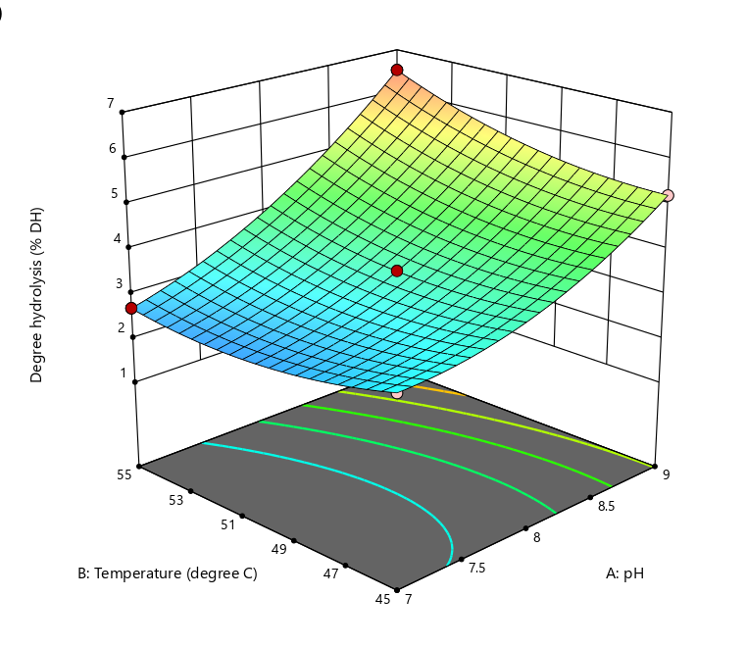 | 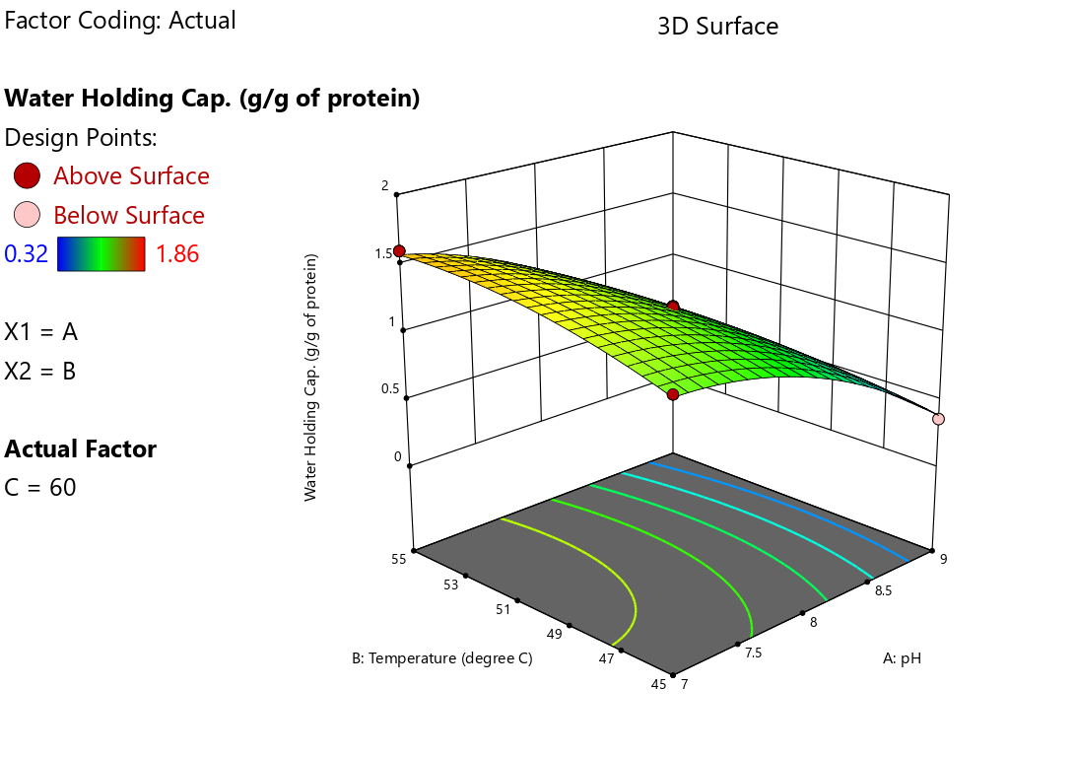
a  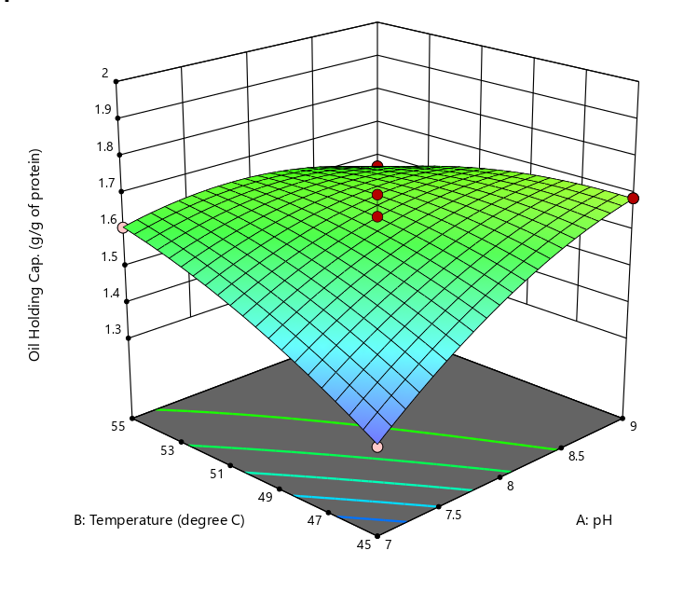  c | b
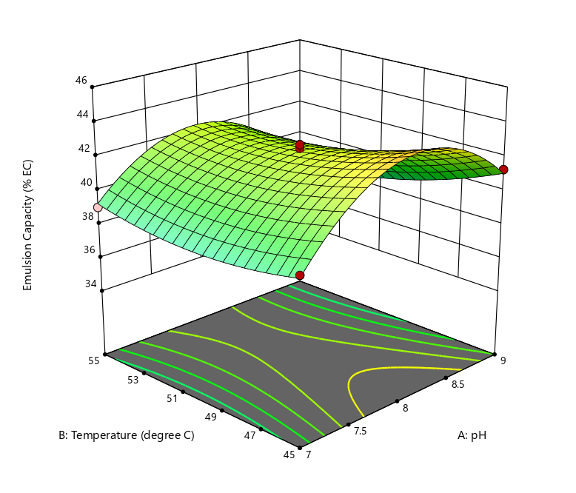 | 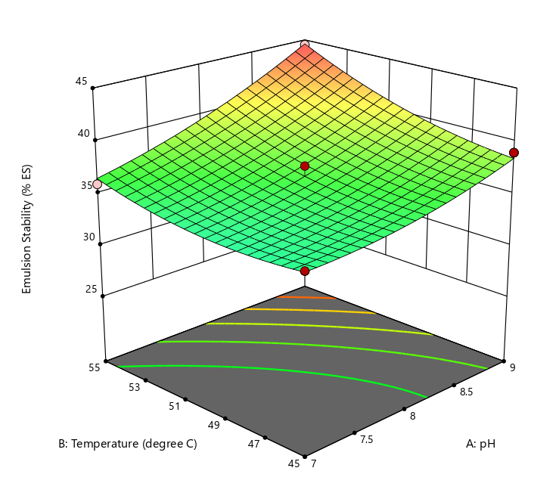
d | e
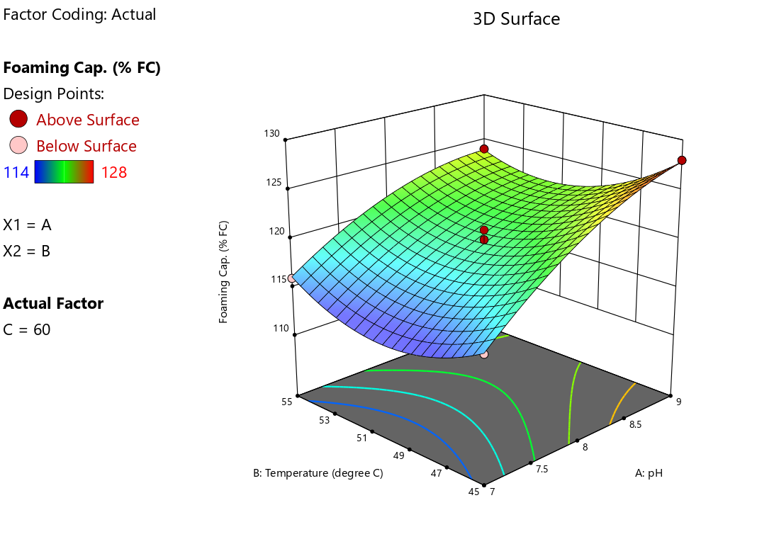 | 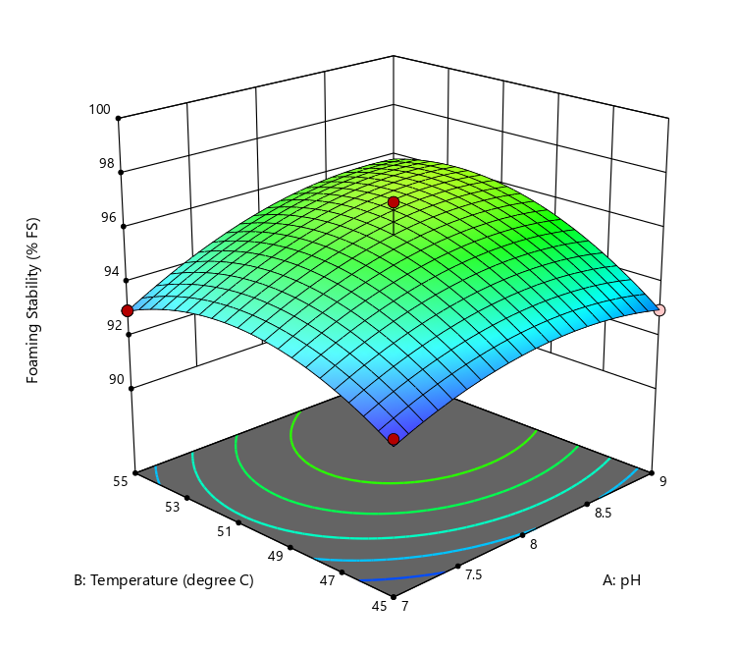
f | g
Figure 1. The effect of pH, temperature and hydrolysis time on degree of hydrolysis (a), water holding capacity (b), oil holding capacity (c), emulsion capacity (d), emulsion stability (e), foaming capacity (f) and foaming stability (g) of sunflower protein hydrolysate

3.3 OPTIMIZATION
The optimal hydrolysis condition was determined using design expert software by maximizing WHC, OHC, EC, ES and FS while minimizing FC and keeping the DH % in target 4.325. The optimized condition was pH of 7.93, a temperature of 54 °C and a hydrolysis time of 81 minutes. This hydrolysis condition was selected based on the desirability value of 0.661. The experimental results matched the predicted values. The extraction conditions determined by RSM were accurate, reliable, and practical (Xu et al., 2013). The regression model equation helped predict how the three variables affected the seven responses. Furthermore, the optimization of hydrolysis conditions revealed pH, temperature, and hydrolysis duration as crucial factors affecting the hydrolysis process. The notable interactions among these variables highlight the complexity involved in optimizing enzymatic hydrolysis to attain the desired functional properties (Gowda et al., 2024). Similar observations were made by Kanu et al., 2009 for defatted sesame flour with enhanced foaming and oil holding capacities. Table 4 shows the optimal conditions and the predicted responses.

Table 4. Optimum conditions, predicted and experimental values of responses at optimum condition

Optimum conditions |  | Coded levels | Actual levels
pH |  | -0.07 | 7.93
Temperature |  | 0.80 | 53.94°C (~54°C)
Hydrolysis time |  | 0.70 | 80.92 min (~81 min)
Responses | Predicted values | Experimental value*
 |  | Mean | Range
DH (%) | 4.325 | 4.451 | 4.43-4.47
WHC(g/g of protein) | 1.71 | 1.698 | 1.68-1.714
OHC (g/g of protein) | 1.700 | 1.735 | 1.72-1.745
EC (%) | 44.430 | 44.452 | 44.30-44.606
ES (%) | 36.271 | 35.987 | 35.96-36.011
FC (%) | 121.290 | 122.10 | 121.95-122.25
FS (%) | 97.025 | 97.52 | 97.3-97.74
*Mean of three determinations

4. Conclusion

The present study was carried out to investigate the effect of pH, Temperature and Hydrolysis time on the DH (%) and functional properties of the SPH. RSM has been successfully applied for optimization of functional properties during preparation of SPH, depending on pH, temperature and hydrolysis time. The experimental design and statistical analysis showed that the second order polynomial model was appropriate to fit experimental data and study the influence of hydrolysis conditions on the functional properties. The results indicated that the Independent variables and the interaction of each independent variables affected the DH and functional properties of the hydrolysate. The alcalase enzyme effectively breaks the sunflower protein molecule and enhancing the functional properties of the hydrolysate. The findings of the study suggest the potential use of Sunflower defatted meals for isolation of protein and to prepare the hydrolysate using Alcalase with enhanced functional properties. The use of alcalase not only improves the functional properties of SPI and also facilitate the production of bioactive peptides for application in functional food products and nutraceuticals. Further research is needed to explore the incorporation of alcalase-derived hydrolysates into food products and evaluate their effects on sensorial, stability and consumer acceptability.

Consent (whereever applicable)

Ethics approval and consent to participate: It is declared that the data and facts provided in the manuscript belong solely to the authors only, and authors are liable for originality, authenticity, and validity. The authors also declare that results are presented clearly, honestly, and without fabrication, falsification, or inappropriate data manipulation.

Abbreviations:

Sunflower de-oiled cake (SDC)
Sunflower Protein Isolate (SPI)
Sunflower Protein Hydrolysate (SPH)
Water Holding Capacity (WHC)
Oil Holding Capacity (OHC)
Emulsion Capacity (EC)
Emulsion Stability (ES)
Foaming Capacity (FC)
Foaming Stability (FS)
Response Surface Methodology (RSM)
Box-Behnken (BBD)

Disclaimer (Artificial intelligence)

Author(s) hereby declare that NO generative AI technologies such as Large Language Models (ChatGPT, COPILOT, etc.) and text-to-image generators have been used during the writing or editing of this manuscript.

References

- Adeleke, B.S., &Babalola, O.O. (2020). Oilseed crop sunflower (Helianthus annuus) as a source of food: Nutritional and health benefits. Food Sci. Nutr., 8, 4666–4684.
- Aiking, H. (2011). Future protein supply. Trends Food Sci. Technol., 22, 112–120.
- Boland, M.J., Rae, A.N., Vereijken, J.M., Meuwissen, M.P., Fischer, A.R., Van Boekel, M.A., Hendriks,W.H.(2013). The future supply of animal-derived protein for human consumption. Trends Food Sci. Technol., 29, 62–73.
- Becze, A., Senila, M., Senila, L., Dordai, L., Cadar, O., Fuss-Babalau, V.L., Roman, M., Levei, L., Uiuiu, P., Naghiu, M.O. (2025). Optimization of Protein Extraction from Sunflower Meal Using Taguchi Design and Regression Modelling for Human Nutrition Applications. Foods,14, 2415. https:// doi.org/10.3390/foods14142415
- Dabbour, M., Sami, R., Mintah, B. K., He, R., Wahia, H., Khojah, E., Petkoska, A. T., & Fikry, M. (2022). Effect of Drying Techniques on the Physical, Functional, and Rheological Attributes of Isolated Sunflower Protein and Its Hydrolysate. Processes, 10(1), 13. https://doi.org/10.3390/Pr10010013
- Deng Q, Wang L, Wei F, Xie B, Huang F, Huang W, Shi J, Huang Q, Tian B, Xue S. Functional properties of protein isolates, globulin and albumin extracted from Ginkgo biloba seeds. Food Chem.124:1458–1465. doi: 10.1016/j.foodchem.2010.07.108
- Feng, J. and Xiong, Y.L. (2003). Interaction and functionality of mixed myofibrillar and enzyme hydrolysed soy proteins. J. Food Sci,68(3): 803-809.
- Fekria, A.M., Isam, A.M.A., Suha, O.A.,and Elfadil, E.B. (2012). Nutritional and functional characterization of defatted seed cake flour of two Sudanese groundnut (Arachis hypogaea) cultivars.Int. Food Res. J. 19 (2): 629-637.
- Giratto, F., Merlino, M., Giovanelli, G., Condurso, C., and Piazza, L. (2024). Unveiling the potential of micronized dehulled sunflower press-cake: a breakthrough in sustainable plant based protein rich sport beverages. International journal of Food Science and Technology,59: 4784-4796.
- Gowda, P., Ambawat, S., Ramesh, V., and Khatak, A. (2024). Optimization of papain hydrolysis conditions to enhance antioxidant activity in de-oiled garden cress (L. sativum) seed protein: response surface methodology approach and hydrolysate characterization. Biomass Conversion and Biorefineryhttps://doi.org/10.1007/s13399-024-06286-7.
- Guan, X., Yao, H., Chen, Z., Shan, L., and Zhang, M. (2007). Some functional properties of oat bran concentrate modified by trypsin. Food Chemistry, 101: 163-170.
- He, D., Zhang Z., Li, H., Xia, Y., Li, X and Chen, T. (2018). Optimizing functional properties of perilla protein isolate using the response surface methodology. Food Sci. Technol. 38(2): 348-355.
- Henchion, M., Hayes, M., Mullen, A., Fenelon, M., and Tiwari, B. (2017). Future protein supply and demand: Strategies and factors influencing a sustainable equilibrium. Foods, 6, 53.
- Jamil NH, Halim NRA, Sarbon NM. (2016). Optimization of enzymatic hydrolysis condition and functional properties of eel (Monopterus sp..) protein using response surface methodology (RSM). Int Food ResJ.23:1–9
- Jin, F., Wang, Y.Tang, H., Joe.M Regenstein, Wang, W. (2020) Limited hydrolysis of dehulled walnut (Juglans regia L.) proteins using trypsin: Functional properties and structural characteristics. LWT-Food Science and Technology 133: 110035
- Joglekar, A.M. and May, A.T. (1987). Product Excellence through Design of Experiments. Cereal Foods World,32, 857-868.
- Luo, Y., Pan, K. and Zhong, Q. (2014). Physical, chemical and biochemical properties of casein hydrolyzed by three proteases: Partial characterizations. Food Chem.155, 146–154.
- Lawal, O.S, Adebowale, K.O., and Adebowale, Y.A. (2012). Functional properties of native and chemically modified protein concentrates from bambara groundnut,Food Res. Int.40 :1003–1011.
- Man, H. L., Behera, S. K., & Park, H. S. (2010). Optimization of operational parameters for ethanol production from korean food waste leachate. International Journal of Environmental Science and Technology, 7(1):157-164.
- Myers, R.H and Montgomery, D.C. (2002). Response surface methodology: process and product optimization using design experiments (2nd ed.) New York: Wiley
- MuneMune, M. A., Minka, S. R., andMbome, I. L. (2014). Optimising functional properties during preparation of cowpea protein concentrate. Food Chemistry,154, 32-37. PMid:24518312. http:// dx.doi.org/10.1016/j.foodchem.2013.12.108.
- Petraru, A., Ursachi, F., and Amariei, S. (2021). Nutritional characteristics assessment of sunflower seeds, oil and cake. Perspective of using sunflower oil cakes as a functional ingredient. Plants, 10, 2487.
- Kanu, P.J., Kanu, J.B., Sandy, E.H., Kandeh, J.B.A., Mornya, P.M.P and Huiming, Z. (2009). Optimization of Enzymatic hydrolysis of defatted sesame flour by different proteases and their effect on the functional properties of the resulting protein hydrolysates. American Journal of Food Technology, 4(6): 226-240.
- PriatniSri., Adinda Amelia., Oulan Efendi., KosasihWawan and Rohmatussolihat.(2019). production and Characterization of spray dried protein hydrolysate from kidney bean (Phaseolus L. Vulgaris) prepared by enzymatic hydrolysis. www.icmets.org pp 26-35.
- Poore, J., Nemecek, T. (2018). Reducing food’s environmental impacts through producers and consumers. Science, 360, 987–992.
- Qin, N., Bao, X and Li, H. (2021). Structure and functional properties of sunflower seed protein as affected by enzymatic hydrolysis combined with macroporous resin adsorption decolorization. Intl.J of food Properties, 24(1):1574-1587.
- Ramakrishnan, V., Goyali, J., Dave, D., & Shahidi, F. (2025). Optimized Production and Bioactivitiesof Protein Hydrolysates from Atlantic Salmon Processing Discards. Processes, 13(6), 1823.
- Ren, J., Song, C.L., Zhang, H.Y., Kopparapu, N.K. and Zheng, X.Q. (2016). Effect of hydrolysis degree on structural and interfacial properties of sunflower protein isolates. Journal of Food processing and Preservation ISSN 1745-4549.
- Rostammiry, L., Saeidiasl, MR., Safari, R and Javadian, R. (2017). Optimization of the enzymatic hydrolysis of soy protein isolate by alcalase and trypsin. Biosci.,Biotech.Res.Asia, 14(1), 193-200.
- Ritala, A., Hakkinen, S.T., Toivari, M., Wiebe, M.G. (2017). Single cell protein—State-of-the-art, industrial landscape and patents 2001–2016. Front. Microbiol.8, 2009.
- Shchekoldina, T., and Aider, M. (2012). Production of low chlorogenic and caffeic acid containing sunflower meal protein isolate and its use in functional wheat bread making. Journal of Food Science and technology, 51: 2331-2343.
- Shchekoldina, T & Aider, M. (2014). Production of low chlorogenic and caffeic acid containing sunflower meal protein isolate and its use in functional wheat bread making. Journal of Food Science and technology,51: 2331-2343.
- Springmann, M., Clark, M., Mason-D’Croz, D., Wiebe, K., Bodirsky, B.L., Lassaletta, L., de Vries, W., Vermeulen, S.J., Herrero, M., Carlson, K.M. (2018). Options for keeping the food system within environmental limits. Nature, 562, 519–525.
- Slavov, A. (2017). Protein hydrolysates from sunflower meal as a source of bioactive peptides. Trends Food Sci. Technol. 63, 60–70.
- Tso, R. and Forde, C.G. (2021). Unintended consequences: Nutritional impact and potential pitfalls of switching from animal- to plant-based foods. Nutrients, 13, 2527.
- Veena, R., Sharath, R., Ramesh, B.N., Manjunatha, M and Ramesh, V. (2026). Extraction and evaluation of Functional and Colour properties of Protein Isolate from sunflower seed de-oiled Cake. Eur. J.Nutr. Food.Saf., 18 (1): 34-47.
- Vioque, J., Sánchez-Vioque, R., Clemente, A., Pedroche, J and Francisco Millán, F. (2000). Partially Hydrolyzed Rapeseed Protein Isolates with Improved Functional Properties. JAOCS, 77 (4): 447-450
- Wouters, A. G. B., Rombouts, I., Fierens, E., Brijs, K., & Delcour, J. A. (2016). Relevance of the functional properties of enzymatic plant protein hydrolysates in food systems. ComPrehensive Reviews in Food Science and Food Safety, 15, 786–800.
- Wangtueai, S and Noomhorm, A. (2009). Processing optimization and characterization of gelatin from lizardfish (Saunda spp.) scales, LWT-Food Science and Technology, 42(4): 825-834.
- Willett, W., Rockstrom, J., Loken, B., Springmann, M., Lang, T., Vermeulen, S., Garnett, T., Tilman, D., DeClerck, F., Wood, A. (2019). Food in the Anthropocene: The EAT–Lancet Commission on healthy diets from sustainable food systems. Lancet, 393, 447–492
- Xu, Q., Shen, Y., Wang, H., Zhang, N., Xu, S., & Zhang, L. (2013). Application of response surface methodology to optimise extraction of flavonoids from fructus soPhorae. Food Chemistry, 138(4), 2122-2129. PMid:23497866.
- Yegorov, B., Turpurova, T., Sharabaeva, E & Bondar, Y. (2019). Prospects of using by-products of sunflower oil production in compound feed industry. Food science and Technology,13
- Yin, S. W., Tang, C. H., Cao, J. S., Hu, E. K., Wen, Q. B., & Yang, X. Q. (2008). Effects of limited enzymatic hydrolysis with trypsin on the functional properties of hemp (Cannabis sativa L.) protein isolate. Food Chemistry, 106: 1004–1013.
- Yongsheng, M., Xianhui, S., and Lintong, W. (2015). Study on Optimal Conditions of AlcalaseEnzymatic Hydrolysis of Soybean Protein Isolate. Advance Journal of Food Science andTechnology, 9(2): 154-158.

