Exploring Allelic Variation between Rice Parental Lines via SSR-Based Genotyping

Abstract
Rice productivity is increasingly threatened by climate change–induced water scarcity, necessitating the integration of molecular tools to improve breeding efficiency. The present study aimed to explore genome-wide allelic variation between two contrasting rice parental lines, HUR-917 and IR18A1145, through SSR-based genotyping to identify informative polymorphic markers for drought-related breeding applications. A total of 584 SSR markers distributed across the 12 rice chromosomes were screened using PCR amplification, and amplified products were resolved via agarose gel electrophoresis. Alleles were scored based on fragment size differences, and polymorphism percentage was calculated to assess genetic divergence between the parental lines. Out of the 584 markers screened, 158 exhibited clear polymorphisms, corresponding to a polymorphism rate of 25.68%. Chromosome 3 showed the highest number of polymorphic loci (18), while chromosome 8 exhibited the highest polymorphism frequency (32.65%). Dinucleotide repeat motifs predominated among the polymorphic markers, reflecting substantial allelic variability between the two parents. The moderate level of polymorphism indicates sufficient genetic divergence to enable effective parental differentiation and genomic tracking in downstream breeding programs. The identified polymorphic SSR markers provide a robust molecular resource for parental characterization and future marker-assisted breeding targeting drought-associated genomic regions, thereby supporting the development of resilient rice cultivars adapted to water-limited environments.
Keywords: SSR markers, Parental polymorphism, Rice (Oryza sativa), Allelic variation, Repeat motifs
Introduction
Rice is a primary staple food for a large proportion of the global population, particularly among economically vulnerable communities, where it serves as a major source of daily caloric intake. Ensuring sustainable rice production is critical for maintaining food and nutritional security. In the context of climate variability and evolving dietary demands, the development of rice varieties with improved resilience and enhanced nutritional quality has become increasingly important. (Alam et al., 2024; Nawaz et al., 2022). Rice farming has always been largely dependent on ample water supplies, notably in lowland irrigated systems. Future rice production depends heavily on water-limited habitats, such as rainfed lowland and upland environments, due to rising rivalry for freshwater, climate change-driven rainfall variability, and an upsurge of drought-prone areas (Swami et al., 2012). Projections of rising sea levels and climate instability further underscore the need for sustainable crop improvement strategies (Fahad et al., 2019).
Rice is inherently sensitive to water deficit and reduced irrigation sometimes results in substantial yield losses (Tuong & Bouman, 2003). Declining groundwater reserves, expanding urban water demands, and climatic variability are progressively constraining production (Serraj et al., 2011). Improving rice productivity in water-limited environments is a strategic priority, as these systems occupy a large proportion of rice-growing areas but consistently produce lower yields due to water stress (Hussain et al., 2022). Sustainable yield increases must originate from improved adaptation to water shortage instead of gaining from greater water inputs, because there is limited opportunity for greater irrigation. Integrating drought-tolerant cultivars with optimized agronomic practices has been identified as a viable pathway for sustaining productivity under warming and drying climatic conditions (Cheng et al., 2025).
Conventional breeding has historically relied on phenotypic selection to identify drought-tolerant cultivars. This approach is often limited by its intensive labour requirements and low selection efficiency (Mapari et al., 2024). A primary limitation of phenotypic selection is the low heritability of grain yield under moisture stress, coupled with high genotype-by-environment (GxE) interactions that make visual assessments unreliable across varying field conditions. Environmental heterogeneity and unpredictable drought patterns further complicate precise phenotyping (Anilkumar et al., 2023). The capacity to maximize output in a number of backdrops may be limited when phenotypic selection alone unintentionally favours drought avoidance strategies like early blooming over true physiological tolerance (Guadarrama‐Escobar et al., 2024). The time-consuming nature of traditional selection also prevents the rapid development of varieties needed to keep pace with global food demand.
The integration of molecular markers has substantially enhanced breeding efficiency by enabling early, environment-independent identification of desirable alleles (Rezk et al., 2024). Genetic discoveries that reveal precise genes linked to significant traits enable targeted breeding efforts (Singha et al., 2024). These tools are essential for diverse applications, including genome mapping, varietal fingerprinting, and the assessment of genetic diversity within populations (Mondal et al., 2014; Naaz et al., 2022). SSRs, also known as microsatellites, are among the most popular and reliable molecular markers used in rice research, consisting of short DNA motifs, typically 1–6 base pairs long, that are repeated in tandem and distributed densely throughout the eukaryotic genome (Rahman et al., 2012; Styer et al., 2024). The co-dominant nature of SSRs enables the detection of both alleles at a specific locus, allowing for the clear differentiation between homozygous and heterozygous individuals (Gonzaga et al., 2015). Marker-assisted selection (MAS) using Simple Sequence Repeat (SSR) markers provides a high-precision alternative, enabling breeders to identify desirable allelic variations as early as the seed or seedling stage, regardless of environmental stressors (Mapari et al., 2024). By exploring allelic variation via SSR-based genotyping, researchers can identify specific quantitative trait loci (QTLs) for grain yield under drought (qDTYs), bridging the performance gap left by phenotypic selection alone (Bordeos et al., 2025; Gaballah et al., 2021).
The parental polymorphism survey serves as the foundational genomic evaluation in MAS and QTL introgression programs for rice (Gull et al., 2025). The systematic identification of allelic variations is essential for monitoring the inheritance of specific traits and concurrently recovering the genetic background of the elite recurrent parent. The main aim of a polymorphism survey is to establish a molecular framework that distinguishes the donor parent (DP) from the recurrent parent (RP) throughout the 12 rice chromosomes (Badri et al., 2022).
Polymorphism confirmation is critical because MAS relies entirely on the statistical association between a molecular marker and a phenotypic trait (Sharma et al., 2025). A marker is ineffective for differentiating between the donor and recurrent alleles in segregating populations if it is monomorphic (Ray et al., 2025). Parental polymorphism provides information on i) Differentiating Genotypes ii) Gene Pyramiding Accuracy iv) Quickening Recurrent Parent Genome (RPG) Recuperation iv) Elimination of linkage Drag.
Drought-tolerant donor genotypes and elite susceptible cultivars differ substantially in genetic architecture and physiological response. Elite cultivars are optimized for high yield under favourable conditions but often exhibit limited stress-adaptive diversity (Dos Santos et al., 2022). In contrast, drought-tolerant donors possess traits such as deeper root systems, improved water-use efficiency, and enhanced stress-responsive mechanisms, enabling superior performance under moisture deficit (Kumari et al., 2021). Strategic combination of these contrasting parental types facilitates the introgression of resilience traits into high-yielding backgrounds, supporting climate-resilient crop development (Farooq et al., 2024).
In this framework, systematic assessment of allelic variation between contrasting parental lines is a critical first step in molecular breeding. The present study investigates genome-wide allelic diversity between two rice parental lines using SSR-based genotyping. By conducting a comprehensive polymorphism survey across all 12 rice chromosomes, this research aims to identify informative and polymorphic SSR markers capable of differentiating the parental genomes. The resulting molecular dataset provides a foundational resource for precise parental selection and future marker-assisted breeding strategies targeting drought-related genomic regions.
Materials and Methods
Experimental Site and Plant Materials
The current study was carried out at two distinct sites: the ICAR-National Rice Research Institute (ICAR-NRRI), Cuttack, Odisha, India, and the Agricultural Research Farm, Institute of Agricultural Sciences, Banaras Hindu University, Varanasi, Uttar Pradesh, India. Rabi 2022–23 marked the beginning of the field experiment crop season at the ICAR National Rice Research Institute (NRRI), Cuttack. Table 1 summarizes the characteristics of the parental lines HUR-917, designated as the recurrent parent based on its agronomic performance, and IR18A1145, selected as the drought donor due to its confirmed drought tolerance in preliminary evaluations (Figure 1).
DNA Extraction
Young, tender, and healthy leaf tissues were harvested separately from individual genotypes at the 25-30 days seedling stage for genomic DNA isolation. Genomic DNA was isolated following the CTAB (cetyltrimethylammonium bromide) method. Leaf samples were finely chopped and homogenized using 100 µl of CTAB extraction buffer in a Geno-grinder set at 1000 rpm for 10 minutes. Each tube received an additional 700 µl of extraction buffer, and it was then incubated for 30 minutes at 65 °C. After adding an equal quantity of chloroform: isoamyl alcohol (24:1) to the lysate, it was centrifuged for 15 minutes at 12,000 rpm. After transferring the supernatant to a new 1.5 ml tube, 800 µl of cold isopropanol was added in order to precipitate the DNA. The following day, the samples were centrifuged at 12,000 rpm for 18 minutes at 24 °C after being gently inverted and incubated overnight at -20 °C. After draining the supernatant and adding about 200 μl 70% ethanol to the particle without disturbing the DNA pellet, the particle was centrifuged once more for ten minutes at 24⁰C and 100,000 rpm. The pellet was allowed to air dry overnight at room temperature before being dissolved in 50–100 μl of 1X TE buffer. DNA purity was assessed using the Nanodrop assay.
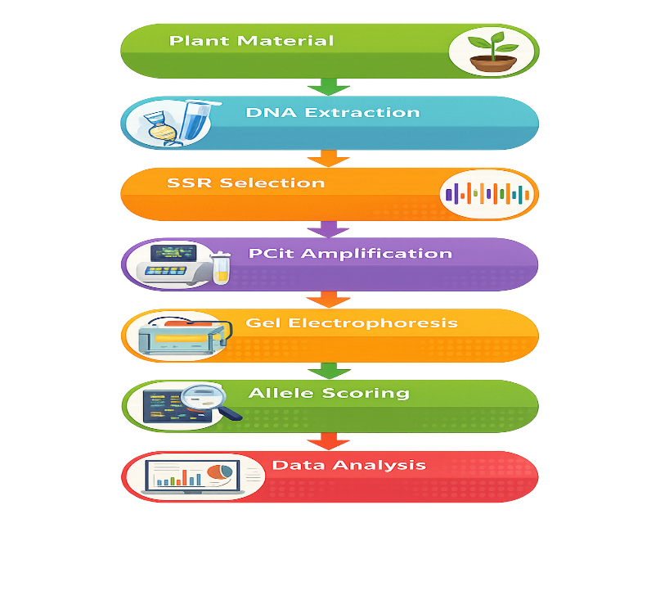
Figure 1: Workflow of Experimental Methodology
Table 1: Pedigree, agronomic features and description of parental rice genotypes
Characteristics | HUR 917  (Recurrent Parent) | IR18A1145  (Donor Parent)
Parentage | Selection from Dehradun Basmati selection-13 | IRRI-156/IR11A293
Source | BHU, Varanasi  Elite Cultivar | IRRI-ISARC  IRRI Advanced line
Yield (q/ha) | 45-50 | 40-45
Days to maturity (Days) | 135-140 | 120-125 days
Grain type | Medium Slender grain, aromatic | Long slender grain, Non-aromatic
Plant height (cm) | 90-95cm | 100-110cm
Resistance/Tolerance | Drought Susceptible | Moderately tolerant to Drought

Marker Selection & PCR Amplification
PCR amplification was performed in an Eppendorf thermal cycler using 680 SSR markers covering all 12 chromosomes in rice in a 10 µl reaction volume containing 1 µl template DNA (100 ng/µl), 0.5 µl each of forward and reverse primers, 4 µl of 2× Emerald Takara master mix, and 4 µl nuclease-free water. The thermal profile consisted of an initial denaturation at 94 °C for 5 min, followed by 35 cycles of denaturation at 94 °C for 1 min, annealing at 55 °C for 1 min, and extension at 72 °C for 1 min, with a final extension at 72 °C for 7 min and hold at 4 °C. Amplified products were resolved on 2.5% agarose gel electrophoresis. Ten microliters of PCR product, along with 2 µl of a 100 bp DNA ladder, were loaded and run at 100 V for approximately 1.5 hours. Bands were visualized under UV light using a Bio-Rad Gel Doc EZ Imager, and banding patterns were scored relative to the 100 bp ladder.
Allele Scoring and Data Analysis
The amplified SSR fragments were examined under ultraviolet light after electrophoretic separation to see if distinct and repeatable bands were formed. To prevent experimental bias, only distinct and reliably amplified bands were taken into account for the score. The size of each band was calculated by comparing its migration distance to a molecular weight reference of a 100 bp DNA ladder. For every marker–genotype combination, alleles were documented in base pairs. Different allele sizes between the two parental lines at a particular SSR location were regarded as polymorphic for the purposes of assessing parental polymorphism, whilst equal allele sizes were regarded as monomorphic. When necessary, a binary data matrix was created by designating "1" for the presence of particular alleles and "0" for their absence. The ratio of polymorphic markers to all screened markers, multiplied by 100, was used to determine the percentage of polymorphism. Foreground and background selection in marker-assisted breeding are two examples of downstream applications where markers with obvious polymorphism were given priority after being determined to be informative. Ambiguous or weak bands were removed from the final dataset to ensure reliability, and scoring was performed twice separately to verify consistency. Allelic variation, marker informativeness, and total parental genomic difference at drought-associated loci were then summarized using the assembled allele dataset. The percentage of polymorphism was calculated by using the formula:
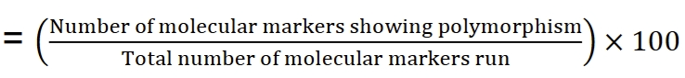
Marker data were visualized using R software (version 4.4.1; R Core Team, 2024) with the packages ggplot2 (Wickham, 2016), dplyr (Wickham et al., 2023). Based on the physical positions of markers provided in the row and column data matrix, GGT produced a visualisation of the distribution of 158 polymorphic markers along the chromosome length according to their physical positions (cM).
Results & discussion
Overview of Marker Screening and Amplification Success
The genomic landscape of the parental rice lines was evaluated using a comprehensive suite of 584 SSR markers distributed across all 12 chromosomes. The distribution of markers was strategically mapped, with the highest concentration of surveyed loci on chromosome 2 (>60 markers) and the lowest on chromosome 7 (approximately 38 markers). The distribution of these polymorphic markers was not uniform across the 12 chromosomes (Figure 2, Figure 3), with chromosome 3 exhibiting the highest number of polymorphic SSRs at 18 markers. In contrast, chromosomes 4 and 7 recorded the lowest, each possessing only 9 polymorphic markers. This high density of polymorphic markers mirrors findings by Tushara et al. (2024), where Chromosome 3 was also found to be the most polymorphic (36.7%). In terms of percentage, chromosome 8 displayed the highest polymorphism rate at 32.65%, followed by chromosome 11 at 32.56% and chromosome 3 at 32.14%. Conversely, the lowest polymorphism percentage was observed on chromosome 4, yielding a rate of only 18.75%, followed by chromosome 2 at 22.95%. This contrasts sharply with other genetic backgrounds, where Chromosome 4 was identified as the most polymorphic (e.g., 40.96% in Habde et al., 2020). In absolute terms, chromosome 3 provided the highest number of scorable polymorphic markers (18), which is particularly significant given the presence of the drought-related locus qDTY_{3.2} in this region.
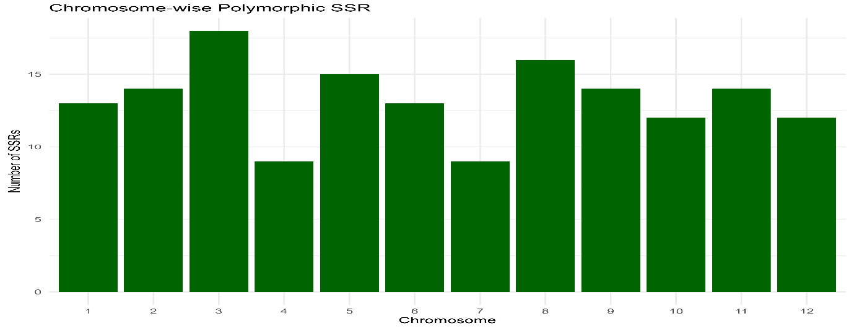
Figure 2: Chromosome-wise distribution of polymorphic SSR markers between the parental lines
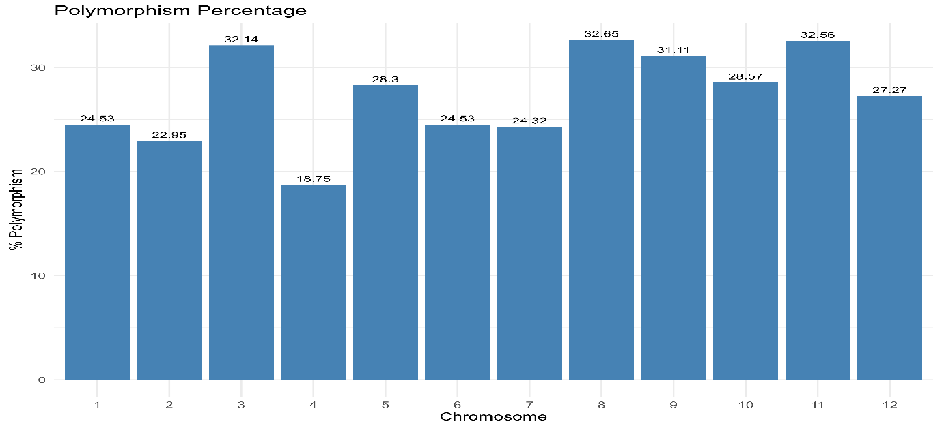
Figure 3: Percentage polymorphism of SSR markers across rice chromosomes
The identified polymorphism rate of 25.68% is highly comparable to the 28.2% reported in studies involving BPT5204/RP2068-18-3-5 and the 29.02% observed between Rajendra kasturi and URG-30 (Tushara et al., 2024). The rate in this study is significantly higher than the 17.65% and 17.1% rates recorded in populations where both parents were strictly indica lines (Ishwarya Lakshmi et al., 2021; Singh et al., 2022). This indicates that although both HUR-917 and IR18A1145 likely originate from an indica background, they exhibit adequate allelic variation, possibly attributable to HUR-917’s descent from Dehradun Basmati selections, to support a vigorous breeding effort. However, this diversity remains lower than studies involving traditional landraces, such as the cross between Jyothi and Chuvannamodan, which exhibited an average polymorphism of 40.86% (Francies et al., 2023).
Marker Amplification Efficiency and Band Clarity
The screening process yielded an amplification efficiency of 100%, as every one of the 584 markers surveyed was successfully amplified and subsequently categorized as either monomorphic (426 markers) or polymorphic (158 markers) [Figure 4, Table 2]. This total success rate in PCR amplification is a significant indicator of high genomic DNA quality, suggesting the extracted template was free from inhibitory phenolic compounds or polysaccharides often found in rice tissues. Furthermore, the universal success of the RM-series primers across the genome highlights exceptional primer specificity; the forward and reverse sequences (e.g., RM243 on chromosome 1 and RM511 on chromosome 12) demonstrated high affinity for their target flanking regions without yielding non-specific background noise.
Anomalies: Null Alleles and Ambiguous Bands
Visual records indicate the presence of null alleles in specific lanes where no visible PCR product was formed despite successful amplification in neighbouring lanes (Figure 4). These null alleles typically suggest a mutation or deletion at the primer binding site in one parent, which can itself serve as a useful, though dominant, polymorphism. These null alleles can effectively serve as dominant markers to differentiate genotypes, a strategy also explored in the development of submergence-tolerant varieties (Hidayatun et al., 2021). Additionally, some ambiguous bands or "stuttering" were observed, characterized by faint shadow bands adjacent to the primary allele. This phenomenon is a known characteristic of SSRs, particularly those with dinucleotide repeat motifs such as the (AT)47 motif in RM10855, where Taq polymerase may slip during the replication of long repetitive stretches (Majhi et al., 2022). This underscores the imperative of employing high-resolution electrophoresis for precise scoring, especially for Class I SSRs, which are recognized for their hypervariability yet susceptibility to such abnormalities (Habde et al., 2020). While technically a lack of amplification, these often function as dominant polymorphisms that can still differentiate genotypes, a strategy also observed in surveys for submergence tolerance (e.g., marker RM317) (Hidayatun et al., 2021).

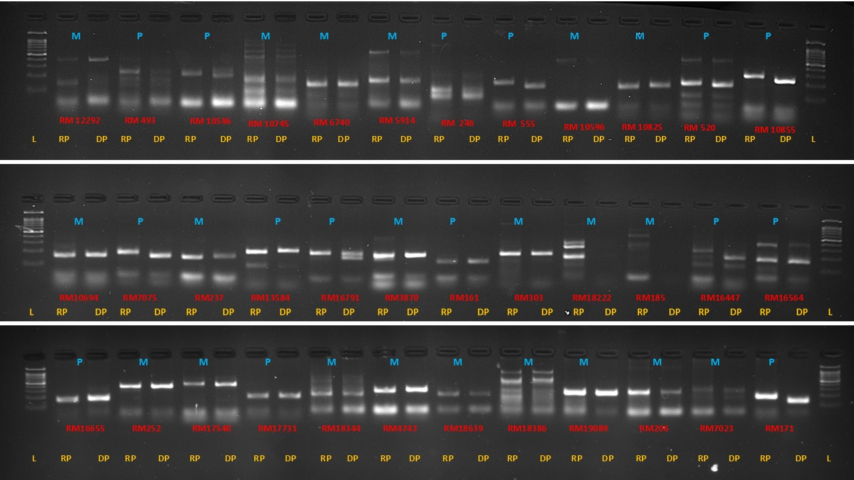
Figure 4: Representation of the polymorphism and monomorphism of the SSR markers between the two parents, HUR-917 (recurrent) and IR18A1145 (donor). M: Monomorphic, P: polymorphic. RP: Recurrent Parent, DP: Donor Parent, L: 100bp Ladder.
Table 2: Chromosome-wise distribution and polymorphism efficiency of SSR markers between HUR-917 and IR18A1145
Marker Name | Chr No. | Product Size(bp) | Position (cM) | FORWARD | REVERSE | Repeat Motif
RM1329 | 1 | 151 | 18.8 | GAGCTCAATCGAATCTAGACC | ATTGACATTCCTTTGCTTTG | (AG)20
RM493 | 1 | 211 | 79.7 | TAGCTCCAACAGGATCGACC | GTACGTAAACGCGGAAGGTG | (CTT)9
RM10855 | 1 | 355 | 57.65 | CCAAACAAGATGTAGTGGGAACATCC | CAAGATGATCAGTGGGCTATTCTTGG | (AT)47
RM572 | 1 | 159 | 69.9 | CGGTTAATGTCATCTGATTGG | TTCGAGATCCAAGACTGACC | (TC)14
RM12292 | 1 | 449 | 177.14 | ATGAGACGATGAAAGCCTCAAGC | GTGGGACAAGCAAATTGAAACG | (TA)38
RM10596 | 1 | 263 | 38.89 | CAACAACCTGGCAGAGAATTTCG | CTGCACGTGATGTCAGAGTTCG | (TA)31
RM11069 | 1 | 279 | 79.39 | GGTACAATGAAGCTTGGCAACG | CGGTGGAGTAGAACCACGAAGC | (GA)47
RM10695 | 1 | 294 | 45.01 | CCTTCGACTCCATGAAACAAACG | TCTCTTTGCCCTAACCCTATGTCC | (AAT)23
RM10793 | 1 | 123 | 51.52 | GACTTGCCAACTCCTTCAATTCG | TCGTCGAGTAGCTTCCCTCTCTACC | (ATAG)7
RM10694 | 1 | 194 | 44.96 | TTTCCCTGGTTTCAAGCTTACG | AGTACGGTACCTTGATGGTAGAAAGG | (AC)18
RM319 | 1 | 134 | 150.5 | ATCAAGGTACCTAGACCACCAC | TCCTGGTGCAGCTATGTCTG | (GT)10
RM3604 | 1 | 153 | 26.8 | ATGTCAGACTCCGATCTGGG | TCTTGACCTTACCACCAGGC | (GA)13
RM7075 | 1 | 155 | 73.1 | TATGGACTGGAGCAAACCTC | GGCACAGCACCAATGTCTC | (ACAT)13
RM6942 | 2 | 271 | 57.9 | ACTAGAAAAATGCCCGTGCG | TTTGAGACGATCGAACTCCC | (TTA)44
RM5706 | 2 | 195 | 109.3 | AGTGCGCTACTACTCGGTCC | GTATCATTTCGTCGAACGGG | (AAT)21
RM12309 | 2 | 472 | 0.5 | AAAGGTACGGTGGCCCAAACTCG | ATGGCAGGCAGGAAGTTCATCG | (AT)39
RM13584 | 2 | 286 | 97.88 | TCCATCTTCACAATCAGCAACC | CCCTGTAACAATGTTGAGAACACC | (AT)41
RM7288 | 2 | 146 | 42.4 | GAGCGAGCTATACCACCGTGACC | ATCGCGTCCAAGAAAGGTGTCG | (ATCT)9
RM13910 | 2 | 188 | 123.17 | GAGCGAGCTATACCACCGTGACC | ATCGCGTCCAAGAAAGGTGTCG | (AG)29
RM13477 | 2 | 129 | 89.85 | ACGGAGAAGGCGAGGAGGATGG | ATGGCGCCTGCTACGACTGTCC | (GGA)7
RM555 | 2 | 223 | 34.7 | TTGGATCAGCCAAAGGAGAC | CAGCATTGTGGCATGGATAC | (AG)11
RM236 | 2 | 191 | 10.8 | GCGCTGGTGGAAAATGAG | GGCATCCCTCTTTGATTCCTC | (CT)18
RM12548 | 2 | 340 | 16.65 | AGTTAGGGAAGCTGGTGCATGG | ATTATATCGCGAACGAGCAAGAGG | (AT)46
RM279 | 2 | 174 | 17.3 | GCGGGAGAGGGATCTCCT | GGCTAGGAGTTAACCTCGCG | (GA)16
RM207 | 2 | 118 | 191.2 | CCATTCGTGAGAAGATCTGA | CACCTCATCCTCGTAACGCC | (CT)25
RM110 | 2 | 156 | 6.9 | TCGAAGCCATCCACCAACGAAG | TCCGTACGCCGACGAGGTCGAG | (GA)15
RM213 | 2 | 139 | 186.4 | ATCTGTTTGCAGGGGACAAG | AGGTCTAGACGATGTCGTGA | (CT)17
RM426 | 3 | 150 | 157.3 | ATGAGATGAGTTCAAGGCCC | AACTCTGTACCTCCATCGCC | (CA)10
RM16238 | 3 | 196 | 148.64 | GCAGCGCATCATTGTATTAAGG | GGACACTAAATCAGAAACCCATGC | (ATT)24
RM14931 | 3 | 476 | 52.9 | GCTTCACGCACATATTGCCTTCC | ATCCTCCCACTCCCAAATTATCTCC | (AC)67
RM14735 | 3 | 295 | 38.34 | AATTAACTAGTGAGCACCCGATGG | CGGTCACAAAGTGCCAGTACC | (AT)42
RM15404 | 3 | 160 | 92.17 | TTTGGCAAGGCTATCTTCTCTGG | GGAGAGCCGAAACTATTTGATTGG | (AT)39
RM3525 | 3 | 179 | 136.5 | ACACTCTCAGCTCATCAAGACC | GGGCAAGTGGTCAAATCTTG | (CT)33
RM14698 | 3 | 365 | 34.68 | TAGATCGTCTTTGTCGTAGAGC | TAGTCACGAAGCTATGTGTTGC | (TA)39
RM520 | 3 | 247 | 191.6 | AGGAGCAAGAAAAGTTCCCC | GCCAATGTGTGACGCAATAG | (AG)10
RM15583 | 3 | 174 | 103.19 | CCCAAATAGTCACCAGCATTATCG | TTGCCTGTGCAACCTTATGAACC | (TA)44
RM2334 | 3 | 155 | 115.6 | CATGCATCTGATCTGATTAT | TGTGAAGAGTACAAGTAGGG | (AT)25
RM227 | 3 | 106 | 156.3 | ACCTTTCGTCATAAAGACGAG | GATTGGAGAGAAAAGAAGCC | (CT)10
RM15326 | 3 | 248 | 85.25 | TGAATCTACCGCTCTACTTGTGG | AAACAGTGCATCCTTCTTGTGG | (TA)29
RM15035 | 3 | 371 | 59.74 | TTCGTGATCGGTCATCCATCC | AGATTCATATGCTGCGCTGTTACC | (TA)45
RM16153 | 3 | 264 | 143.5 | TGGTTGTGGTATAGCACGGTAAGC | TGACCCAAGGAGATACTAGGTTGC | (TG)56
RM15203 | 3 | 477 | 69.34 | ATGGTGAGACGACAGAACAGATGC | GACGCGCTTTGTGTTTCTTGG | (AT)40
RM231 | 3 | 182 | 15.7 | CCAGATTATTTCCTGAGGTC | CACTTGCATAGTTCTGCATTG | (CT)16
RM15791 | 3 | 86 | 117.88 | AGTAAGTTTGCCGCGGAGGAAGC | CTCCTTGTCGATCACCACCATCG | (GAG)8
RM16033 | 3 | 152 | 134.34 | TACCTTATCCCGATTGCTCAAGG | TAAGAGAAAGCCTTCCCGACTCC | (GAC)7
RM16791 | 4 | 279 | 73.57 | GGCTGCTTCAGAGCGTTTGTAGG | AAATACGCCATCAAGTTGCACACC | (ATA)12
RM16913 | 4 | 391 | 80.52 | GTGTACGTGTTGGCTCTCTGTACG | GATGTTGCTTGTGCTGCAACC | (TAT)51
RM16655 | 4 | 138 | 55.8 | CCTTGGAAGCTGGAACTTCACC | GGCTCTTAGGTTAGATCCCACACG | (CGG)7
RM16447 | 4 | 310 | 19.63 | CGGGTCTGTCTTTCAGTTTGC | AGTGGCGTACTTGCTCTACTGC | (AT)30
RM16569 | 4 | 351 | 39.62 | ATAGACTTCACCCGGTACAACG | CTGGTATCGACATCGGCTAGG | (AT)31
RM518 | 4 | 171 | 25.5 | CTCTTCACTCACTCACCATGG | ATCCATCTGGAGCAAGCAAC | (TC)15
RM335 | 4 | 104 | 21.5 | GTACACACCCACATCGAGAAG | GCTCTATGCGAGTATCCATGG | (CTT)25
RM17620 | 4 | 423 | 139.44 | ACCATCTCGTATTTGGCTCATCC | AACATGCACTGGATGATCTCTCG | (TA)34
RM5320 | 4 | 137 | 87.1 | CCTGAGCTGTACAAGCAAAC | CAGATTCTTGGGAGAAATCC | (TC)12
RM5844 | 5 | 195 | 37.5 | TGACTAACGTGGCATCCATG | GCTAGGAGCCATTGTCGAAG | (ATA)22
RM440 | 5 | 169 | 92.7 | CATGCAACAACGTCACCTTC | ATGGTTGGTAGGCACCAAAG | (CTT)22
RM17710 | 5 | 168 | 0.19 | GACGAGGCAGGCGATGATAAGG | CAGCACCTCAAGCGTCCTAACC | (AAG)15
RM18157 | 5 | 117 | 32.63 | TCATATGGAGCAGTCAGAAACAGC | TGTTTGAGAATCACAGCTCTCTCG | (AC)11
RM18913 | 5 | 487 | 98.77 | CAAGATCTTTGCAACTGAGGAAGG | TTGCTACTTCGTGTTGTCACTCTACG | (AT)27
RM18413 | 5 | 180 | 64.33 | AAGACATACCGCATGAGAATGG | AGCTCTCTCCTCAGTCTCTCACG | (TC)13
RM3476 | 5 | 132 | 97.72 | GATTCTCGTCGTAATCAAGA | ATCCACGGTTAAGATAAATG | (CT)22
RM122 | 5 | 227 | 1.28 | GAGTCGATGTAATGTCATCAGTGC | GAAGGAGGTATCGCTTTGTTGGAC | (GA)7A(GA)2A(GA)11
RM5970 | 5 | 120 | 101.5 | CCCATCTGGTTCACCTTCAC | AGGAGCAGCCTTTTGTCTTC | (CAT)8
RM592 | 5 | 270 | 31.4 | TCTTTGGTATGAGGAACACC | AGAGATCCGGTTTGTTGTAA | (ATT)20
RM1386 | 5 | 197 | 81.95 | TATTCAAGGTTGGCTGCCTC | CAATCACTCCATGGCTGATG | (AG)42
RM3853 | 5 | 138 | 31.5 | ATGTGCCCTTATACAAGGCC | GTGAGCTCATAGAGCAGCCC | (GA)24
RM3870 | 5 | 193 | 91.2 | TACATCTCCGGCGTTTACAC | CCAAGGTTGAAACAGGAAGC | (GA)32
RM421 | 5 | 234 | 137.2 | AGCTCAGGTGAAACATCCAC | ATCCAGAATCCATTGACCCC | (AGAT)6
RM6360 | 5 | 230 | 115.7 | GCTCGGATCAATCGAGCTC | TTTCCAGCAAGATCGACGC | (GAA)11
RM469 | 6 | 105 | 2.2 | AGCTGAACAAGCCCTGAAAG | GACTTGGGCAGTGTGACATG | (AG)15
RM510 | 6 | 122 | 20.8 | AACCGGATTAGTTTCTCGCC | TGAGGACGACGAGCAGATTC | (GA)15
RM20378 | 6 | 288 | 99.69 | ATGTCCTTCTTCGAGATTGCTTCG | AGAGCCCAACATATAGCGGATGC | (AT)13
RM276 | 6 | 149 | 40.3 | CTCAACGTTGACACCTCGTG | TCCTCCATCGAGCAGTATCA | (AG)8A3(GA)33
RM6273 | 6 | 199 | 0.53 | TGCCTTCGCACTCCAGTC | GACGAGAAGATCCTTGTCGG | (CTC)11
RM6734 | 6 | 197 | 29.1 | TGAGCAGTCTGCAGATGACC | GCTTGGACTTGGAGTCTTGG | (TAT)20
RM19985 | 6 | 191 | 68.8 | AGCAGATATCACACACAGCATTGG | GGAGCTTCATTTGTGATGAACCTAGC | (TA)29
RM19469 | 6 | 296 | 16.6 | TTCCTTTCCTTGGGTCATATCC | ATCGAGTCAGAGAGTGGCTTGG | (GA)36
RM19771 | 6 | 281 | 37.02 | AACCAATGCACACTTCTTCTGTGC | CAACTGTAGAGGTTGGAATGATCTGC | (AT)47
RM204 | 6 | 169 | 25.1 | CACGACGACGACGAGCAGCAGC | GCTCGAGGGAGAGCGACCTGCC | (CT)44
RM162 | 6 | 211 | 108.3 | AACTGCCAGCAAAACCAGG | ATCGTGGGTAGTGTGTGTGT | (AC)20
RM253 | 6 | 141 | 37 | TCCTTCAAGAGTGCAAAACC | GCATTGTCATGTCGAAGCC | (GA)25
RM20377 | 6 | 279 | 99.68 | GTGTGTGATGTGCATGTTTCTGC | CATGTGATGCCCTGTAGGAACC | (CT)33
RM336 | 7 | 154 | 94.5 | CTTACAGAGAAACGGCATCG | GCTGGTTTGTTTCAGGTTCG | (CTT)18
RM432 | 7 | 187 | 43.5 | TTCTGTCTCACGCTGGATTG | AGCTGCGTACGTGATGAATG | (CATC)9
RM8044 | 7 | 113 | 99.16 | AGTACTTGTCTCCTTAGCAG | CAATATTCACTCAACTCTCA | (CTT)18
RM6326 | 7 | 222 | 99.16 | TAGCTTGGTTCGGTCAAACC | ACCAGATTGTTAGCAACCCG | (CTT)18
RM20775 | 7 | 181 | 0.21 | GGTGTTCATCTTTGTTGAGTCAGG | AGGATACAGCGCACCAGATTAGC | (AT)45
RM21693 | 7 | 462 | 79.96 | GCACAGACCAGAACTTTCTTCG | TGGCGAGTGTAGATGTAATTGG | (AT)44
RM5847 | 7 | 194 | 81.05 | TGAGATGAGAGATAGACTCC | AACAGATGAAGGCTATTTTA | (ATA)16
RM21521 | 7 | 267 | 65.51 | TACTCGAGCAGGCAGAGCAACC | AGCATAGTCATCCAACCGAGACAGC | (AT)40
RM3456 | 7 | 161 | 49.42 | CGTCGACCATCTCTCCCTC | TGGGGAGCAAAGGAAAGC | (CT)20
RM152/OSR34 | 8 | 151 | 9.4 | CGAATCGAATCCAAGGCGG | CTGGATTCCTCATCGCCTT | (GGC)10
RM80 | 8 | 142 | 103.7 | TTGAAGGCGCTGAAGGAG | CATCAACCTCGTCTTCACCG | (TCT)25
RM1109 | 8 | 198 | 72.2 | TCAAAATCACGTGTATGTAAGC | TTTACAAAGGACAGAGGGC | (AG)12
RM23345 | 8 | 228 | 98.69 | GAGATCCTGCACATCTTTGAGACC | TGTGCCACGAAACAAATCTAGGC | (TA)27
RM22273 | 8 | 282 | 3.48 | AGTGACAGCATCAGCATGTTGTTTGG | TTAAGCTGGCACTGCACTTGAAGG | (TA)35
RM22523 | 8 | 437 | 20.94 | CGTGCTTAATTACCTGGCTTCG | GCACGTATTCACAGCTAGCAACC | (TA)48
RM22459 | 8 | 119 | 16.1 | ACCACCGCGACTTCAGTTCTCC | CGGAGGTGTTGGTGGAAGAGG | (CTT)11
RM22688 | 8 | 424 | 36.3 | CTTCGATCTCTTGCCTGGATACC | CCATTTCGTTGGGTTTCAGTCC | (ATT)28
RM23060 | 8 | 126 | 78.88 | CAGCAGCTGCCTCAGTGTCACC | AACGTTGTCGGTGAAGGTCCATCC | (CAT)14
RM8271 | 8 | 225 | 45.8 | TCTTGAGAAATCTGCCATTC | ACTGATGTGCATTTCGTC | (AG)32
RM502 | 8 | 266 | 121.8 | GCGATCGATGGCTACGAC | ACAACCCAACAAGAAGGACG | (TG)10
RM404 | 8 | 236 | 69 | CCAATCATTAACCCCTGAGC | GCCTTCATGCTTCAGAAGAC | (GA)33
RM256 | 8 | 127 | 101.5 | GACAGGGAGTGATTGAAGGC | GTTGATTTCGCCAAGGGC | (CT)21
RM5353 | 8 | 177 | 96.6 | ACCCTCGATCTCCTAGGCTG | TCTACTCCAAACCCATTGCC | (TC)13
RM7356 | 8 | 158 | 78.5 | CCAAGGACACATATGCATGC | GCAATTCATGGCGCTGTTC | (CTAT)6
RM444 | 9 | 162 | 3.3 | GCTCCACCTGCTTAAGCATC | TGAAGACCATGTTCTGCAGG | (AT)12
RM285 | 9 | 205 | 1.8 | CTGTGGGCCCAATATGTCAC | GGCGGTGACATGGAGAAAG | (GA)12
RM24337 | 9 | 442 | 62.13 | CCATTCTACTCTCTGCCTACCAACC | CCTCCATCCCAATATACCTATCATCC | (AT)19
RM24594 | 9 | 240 | 79.11 | CTGGTGAACGACTTGGACTTGC | ACAATCAGCCAGACGCTTATTCC | (AT)35
RM245 | 9 | 150 | 112.3 | ATGCCGCCAGTGAATAGC | CTGAGAATCCAATTATCTGGGG | (CT)14
RM23911 | 9 | 269 | 29.52 | TGCCTGCACTTATCTCTTGATGC | GATGAACCTAAAGGGCAGTTTCC | (TG)13
RM215 | 9 | 148 | 99.4 | CAAAATGGAGCAGCAAGAGC | TGAGCACCTCCTTCTCTGTAG | (CT)16
RM24240 | 9 | 169 | 56.24 | ATGCAACCTCCTCCATCATAAGG | TGCTGCTCCTACCTCACTCACC | (GA)15
RM23744 | 9 | 308 | 11.94 | CTTAATACTCCGACGTAACAGTGG | CCTGACTAAATGGAGCTTCTTCC | (CT)37
RM24071 | 9 | 153 | 43 | TACTGAAGGCCAAGGAAGAGGTAGC | GAGACTATGGTGTGGCGTCAATGG | (GT)20
RM24542 | 9 | 266 | 74.48 | ATCCACAAGAGCACCGATGAGG | TGACCTGGTAGTGGTGAGTGTGC | (TA)51
RM7424 | 9 | 210 | 60.8 | GGCCATGATGCAGCAGCAGA | CACTCGCAGCAGCAGCCG | (GGAT)6
RM242 | 9 | 225 | 73.3 | GGCCAACGTGTGTATGTCTC | TATATGCCAAGACGGATGGG | (CT)26
RM201 | 9 | 158 | 81.2 | CTCGTTTATTACCTACAGTACC | CTACCTCCTTTCTAGACCGATA | (CT)17
RM25661 | 10 | 479 | 77.58 | TCTCTACCTGGCGTCCACTAGTTCG | AGGTGGACGTGCTCGATCTGC | (TA)37
RM184 | 10 | 219 | 58.3 | ATCCCATTCGCCAAAACCGGCC | TGACACTTGGAGAGCGGTGTGG | (CA)7
RM171 | 10 | 328 | 55 | AACGCGAGGACACGTACTTAC | ACGAGATACGTACGCCTTTG | (GATG)5
RM216 | 10 | 146 | 17.6 | GCATGGCCGATGGTAAAG | TGTATAAAACCACACGGCCA | (CT)18
RM222 | 10 | 213 | 11.3 | CTTAAATGGGCCACATGCG | CAAAGCTTCCGGCCAAAAG | (CT)18
RM269 | 10 | 182 | 69.6 | GAAAGCGATCGAACCAGC | GCAAATGCGCCTCGTGTC | (GA)17
RM6364 | 10 | 163 | 0.27 | GTTCATTTCGTCCTTCTCGG | TCTCGATTCTTCCTTCTCCG | (GAA)13
RM25051 | 10 | 387 | 18.14 | GGTAACAAGGTTGATCGTGTGC | AGATGAGGTGTCGCCTTACCC | (AT)22
RM25207 | 10 | 210 | 38.6 | TCACAGGGATATCTCATTCACAGC | ACGTGTCACACATACAAGTGATGC | (TA)35
RM25735 | 10 | 386 | 82.01 | AGGCAGGCAAGCAGTAGTTTCG | ATCAAGATCAGGAGCCGCAAGG | (AAG)25
RM25404 | 10 | 264 | 58.79 | GCAACGGTTCTCCTTCCACTACC | CCATGATAGCGTTAGCCATAAACG | (AT)35
RM4477 | 10 | 114 | 103.1 | AGTAAACATGTCTTCGGGAT | CAGTGCATATTCCACTGGTA | (TA)20
RM26362 | 11 | 232 | 32.88 | ATCCGTCCTAGAATACTTGTCG | CATCCGTCCTAAATTAGTAGCC | (ATT)10
RM21 | 11 | 157 | 85.7 | ACAGTATTCCGTAGGCACGG | GCTCCATGAGGGTGGTAGAG | (GA)18
RM330 | 11 | 177 | 60.9 | CAATGAAGTGGATCTCGGAG | CATCAATCAGCGAAGGTCC | (CAT)5
RM27132 | 11 | 488 | 100.25 | GAATCAAGGATAGACACGAAGG | TCTAAGTTCTACCACCACAACC | (AT)42
RM26860 | 11 | 265 | 78.84 | TGGCTCCATGATTGAAGTTTGC | GGTCTCAATAAGAGGGCAAGATATGG | (AT)31
RM26616 | 11 | 277 | 58.24 | GTGGAGGACGGTGATGGAGAAGC | ATTTCTTGACCGCCGCTGATTCC | (AT)45
RM26459 | 11 | 194 | 41.69 | TAACCTATATCCCGCAGCAAAGC | TATGGGATCTGTACCCGTCATGC | (TA)43
RM26550 | 11 | 273 | 49.87 | GGGAAACATGGAAGAACACTCTAGC | CAAGCATTTGCAGCATTCAAGG | (AT)40
RM7283 | 11 | 183 | 37.37 | GGGGCATATAACGCAAACAC | ATTTTAGGAGGCTCACGTGG | (ATCT)13
RM286 | 11 | 110 | 1.57 | GGCTTCATCTTTGGCGAC | CCGGATTCACGAGATAAACTC | (GA)16
RM120 | 11 | 173 | 41.7 | CACACAAGCCCTGTCTCACGACC | CGCTGCGTCATGAGTATGTA | (GA)9TAG(ATC)4
RM144 | 11 | 237 | 123.2 | TGCCCTGGCGCAAATTTGATCC | GCTAGAGGAGATCAGATGGTAGTGCATG | (ATT)11
RM536 | 11 | 243 | 55.1 | TCTCTCCTCTTGTTTGGCTC | ACACACCAACACGACCACAC | (CT)16
RM332 | 11 | 183 | 27.9 | GCGAAGGCGAAGGTGAAG | CATGAGTGATCTCACTCACCC | (CTT)5-12-(CTT)14
RM19 | 12 | 226 | 20.9 | CAAAAACAGAGCAGATGAC | CTCAAGATGGACGCCAAGA | (ATC)10
RM235 | 12 | 124 | 102.8 | AGAAGCTAGGGCTAACGAAC | TCACCTGGTCAGCCTCTTTC | (CT)24
RM12 | 12 | 184 | 109.1 | TGCCCTGTTATTTTCTTCTCTC | GGTGATCCTTTCCCATTTCA | (GA)21
RM5364 | 12 | 148 | 48.98 | GTATTACGCTCGATAGCGGC | GTATCCTTTCTCGCAATCGC | (TC)13
RM28472 | 12 | 330 | 94.25 | GCTATGAACCTGTACACATGTAGG | GAGCACCATAACAATCAGTTGC | (GA)15
RM270 | 12 | 108 | 91.3 | GGCCGTTGGTTCTAAAATC | TGCGCAGTATCATCGGCGAG | (GA)13
RM28157 | 12 | 497 | 71.27 | GCTTAATTTCTGACAGACCAGTGC | GATCTAAACACAGCCTTCCTTGG | (TTA)36
RM27840 | 12 | 508 | 32.82 | TTTGCGTGCTAGGGAGATTAGC | CATTATGTACTTACTCCCTCCCTTCC | (TAT)37
RM27638 | 12 | 294 | 16.55 | AGATTCCCATCCGTTAGGAAAGC | GATGCACATGCACTTGTAGTTCC | (AT)43
RM28089 | 12 | 260 | 63.16 | GGGAGGACACCTGTGTAAGTAGG | GGTTCAAATGAGACCCAATTCC | (ATC)12
RM28048 | 12 | 93 | 57.81 | TTCAGCCGATCCATTCAATTCC | GCTATTGGCCGGAAAGTAGTTAGC | (CGC)8
RM511 | 12 | 130 | 59.8 | CTTCGATCCGGTGACGAC | AACGAAAGCGAAGCTGTCTC | (GAC)7
SSR Reliability: Codominance and Locus Specificity
The reliability of the identified polymorphic markers (ranging from 18.75% on chromosome 4 to 32.65% on chromosome 8) is fundamentally rooted in their locus specificity and codominant inheritance. Unlike dominant markers, the codominant nature of SSRs allows for the clear differentiation of homozygous and heterozygous states in segregating populations. This specificity is underscored by the unique primer sequences and defined product sizes (e.g., RM1329 at 151 bp and RM24987 at 767 bp) provided in the genomic database. These attributes make the 158 polymorphic markers identified in this study highly dependable tools for marker-assisted selection (MAS).
Analysis of the genetic structure of these polymorphic markers revealed a diverse range of repeat motifs, with a significant prevalence of dinucleotide repeats. The observed polymorphism level of approximately 27% serves as a critical molecular proxy for the genetic divergence between HUR-917 and IR18A1145. In rice breeding, the rate of polymorphism is directly linked to genetic distance; a moderate-to-high rate indicates that the two parents are sufficiently distinct to allow for the effective tracking of genomic segments. Frequently observed dinucleotide sequences included (AG)n, (AT)n, (TA)n, (GA)n, and (CT)n, exemplified by markers like RM243 (AG)18 and RM10855 (AT)47. This genetic distance is the foundation of breeding utility, as it ensures that the donor line (IR18A1145) can contribute unique alleles for drought tolerance that are absent in the elite background (HUR-917).
In addition to dinucleotide repeats, a proportion of trinucleotide (e.g., (AAT)n, (GAA)n, (ATT)n) and tetranucleotide repeats (e.g., (ATAG)n, (GATG)n) were also observed. Trinucleotide repeats are often associated with coding regions because their expansion or contraction does not disrupt the reading frame, while dinucleotide repeats are more frequently located in non-coding or intergenic regions. The presence of both motif classes suggests that polymorphism is distributed across functional and non-functional genomic regions, increasing the likelihood that some markers are linked to regulatory or adaptive loci relevant to drought tolerance.
The observed polymorphism level (~27%) indicates moderate genetic divergence between the two parental lines. In marker-assisted breeding, polymorphism rate serves as an indirect estimate of genetic distance. A moderate-to-high polymorphism frequency suggests that the parents possess sufficient genomic differentiation to allow clear discrimination of donor and recurrent alleles in segregating populations. This level of divergence is advantageous: it is high enough to enable efficient tracking of introgressed segments but not so extreme as to introduce excessive linkage drag or incompatibility issues.
Furthermore, variation in repeat number among motifs (e.g., long stretches such as (AT)47 in RM10855) increases allelic variability because longer repeat arrays tend to exhibit greater mutation rates. Markers with higher repeat numbers generally show increased polymorphic information content (PIC), enhancing their ability to distinguish parental genotypes. This structural characteristic contributes to their suitability for background selection and QTL tracking.
Chromosomal distribution of the polymorphic markers across all 12 rice chromosomes confirms genome-wide coverage. Even distribution is critical in marker-assisted programs because it ensures comprehensive monitoring of donor segment introgression and recurrent parent genome recovery. Clusters of polymorphic loci near known drought-related genomic regions further enhance their breeding value, as closely linked markers reduce recombination risk and improve selection precision.
From a population genetics perspective, the predominance of highly mutable dinucleotide repeats and moderate polymorphism frequency suggest that HUR-917 and IR18A1145 share a common cultivated rice background but differ sufficiently at multiple loci to reflect adaptive divergence. The drought-tolerant donor likely harbours unique allelic configurations in stress-responsive regions, while the elite recurrent parent maintains alleles associated with agronomic performance. The identified polymorphic SSRs therefore function as molecular anchors for distinguishing these contrasting genomic contributions.
Codominant SSRs exhibit differences in amplicon size, in contrast to dominant markers, which simply show whether a band is present or absent (Meshram et al., 2021). Such markers are particularly valuable in marker-assisted breeding programs, where they can facilitate precise tracking of target genomic regions and efficient recovery of elite parental background (Chukwu et al., 2022). The preference for SSR codominance is echoed across multiple studies, including those targeting Brown Planthopper (BPH) resistance (Ishwarya Lakshmi et al., 2021), heat stress tolerance in NERICA cultivars (Ravikiran et al., 2020), and the development of triple stress-tolerant versions of Improved White Ponni (Muthu et al., 2020).
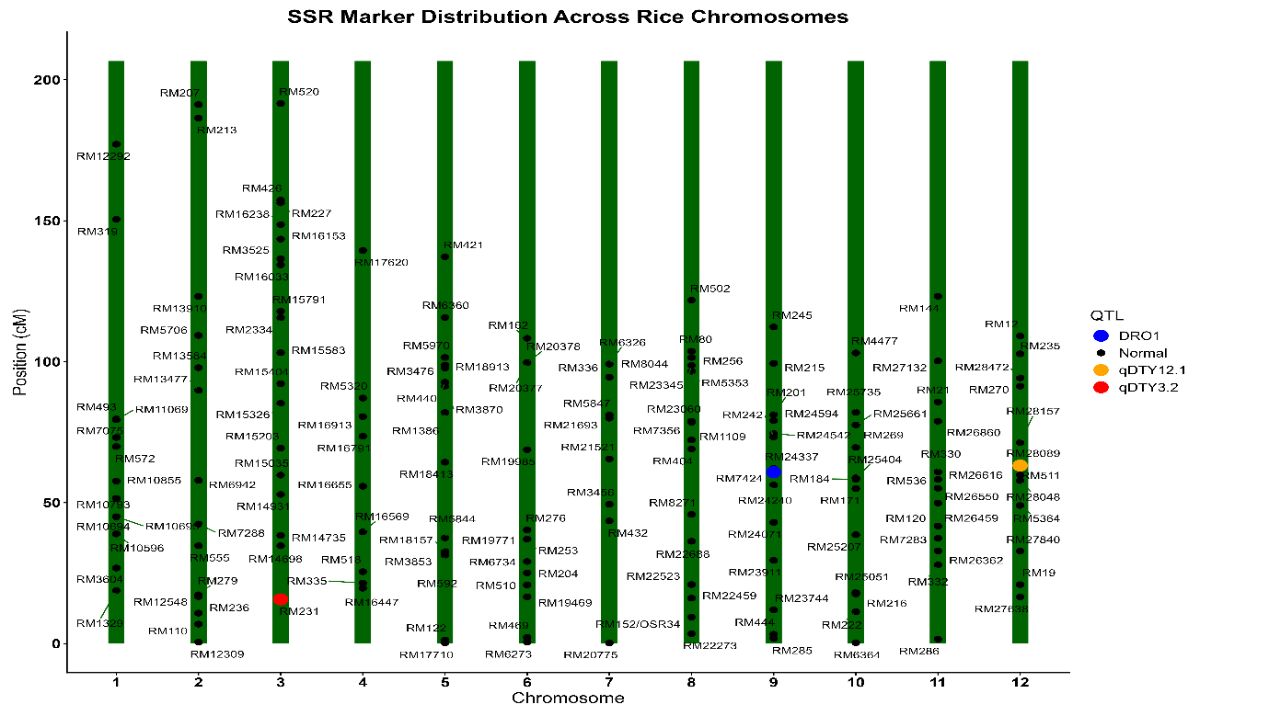
Figure 5: Linkage map of polymorphic marker
The observed polymorphism rate is consistent with expectations for a cross between an elite cultivar and an advanced donor line. While both lines belong to Oryza sativa, their differing selection histories, one for yield stability in favourable conditions and the other for physiological resilience under stress, typically result in significant genomic variation at loci governing abiotic stress response. A polymorphism rate exceeding 25% is generally considered sufficient for high-precision marker-assisted backcrossing (MABC), confirming that HUR-917 and IR18A1145 constitute an ideal parental pair for the development of next-generation, drought-resistant rice varieties.
The identification of 158 polymorphic markers significantly strengthens downstream QTL mapping and the development of Near-Isogenic Lines (NILs). High-resolution mapping requires a dense set of markers to define the boundaries of introgressed segments (Figure 5). These findings have profound implications for MAS, as they provide a dense, reliable set of tools for discriminating between parental genotypes. Furthermore, the proximity of specific polymorphic markers to documented drought-tolerance loci such as RM231 near qDTY_{3.2}, RM242 near DRO1, and RM511 near qDTY_{12.1} is critical for the targeted development of drought-tolerant rice varieties. This high level of polymorphism allows breeders to efficiently track and combine multiple beneficial alleles, enhancing rice resilience in water-stressed environments.
Conclusion
This study successfully characterized genome-wide allelic variation between the rice parental lines HUR-917 and IR18A1145 using SSR-based genotyping. Screening of 584 SSR markers across all 12 chromosomes identified 158 polymorphic markers, corresponding to a polymorphism rate of 25.68%, indicating moderate genetic divergence between the two parents. The predominance of dinucleotide repeat motifs and the chromosome-wise distribution of polymorphic loci confirm adequate genome coverage for effective parental differentiation. The identified polymorphic SSR markers provide a reliable molecular framework for distinguishing the parental genomes and selecting informative loci for downstream applications. These findings carryout the research objective of establishing a comprehensive parental polymorphism profile and generate a validated marker resource that can support future QTL tracking and marker-assisted breeding targeting drought-related genomic regions.
Ethical Approval
The work described in this manuscript does not require experiments on live animals. However, the project was evaluated and approved by the national ethics committee before the start of research activities.
Disclaimer (Artificial Intelligence)
The author (s) hereby declare that no generative AI technologies such as Large Language Models (ChatGPT, COPILOT, etc.) and text-to-image generators have been used during the writing or editing of this manuscript.
Competing Interests
The authors have declared that no competing interests exist.
References
Alam, M., Lou, G., Abbas, W., Osti, R., Ahmad, A., Bista, S., Ahiakpa, J.K. and He, Y. (2024). Improving rice grain quality through ecotype breeding for enhancing food and nutritional security in Asia–Pacific region. Rice, 17(1), 47.
Nawaz, A., Rehman, A. U., Rehman, A., Ahmad, S., Siddique, K. H., & Farooq, M. (2022). Increasing sustainability for rice production systems. Journal of Cereal Science, 103, 103400.
Swamy, B. M., & Kumar, A. (2012). Sustainable rice yield in water short drought prone environments: conventional and molecular approaches. Irrigation systems and practices in challenging environments. INTECH Publishers, Croatia, 149-168.
Fahad, S., Adnan, M., Noor, M., Arif, M., Alam, M., Khan, I.A., Ullah, H., Wahid, F., Mian, I.A., Jamal, Y. and Basir, A. (2019). Major constraints for global rice production. In Advances in rice research for abiotic stress tolerance, 1-22. Woodhead Publishing.
Tuong, T. P., & Bouman, B. A. (2003). Rice production in water-scarce environments.
Serraj, R., McNally, K. L., Slamet-Loedin, I., Kohli, A., Haefele, S. M., Atlin, G., & Kumar, A. (2011). Drought resistance improvement in rice: an integrated genetic and resource management strategy. Plant Production Science, 14(1), 1-14.
Hussain, T., Hussain, N., Tahir, M., Raina, A., Ikram, S., Maqbool, S., Fraz Ali, M. and Duangpan, S. (2022). Impacts of drought stress on water use efficiency and grain productivity of rice and utilization of genotypic variability to combat climate change. Agronomy, 12(10), 2518.
Cheng, A., Lau, J.Y., Mazumdar, P., Baisakh, N., Harikrishna, J.A., Osman, N., Mispan, M.S., Zain, N.A.M., Sethuraman, G. and Kongchum, M. (2025). Innovation in drought-resilient agriculture: The rise of aerobic rice system. Heliyon, 11(12).
Mapari, A. R., & Mehandi, S. (2024). Enhancing crop resilience: advances and challenges in marker-assisted selection for disease resistance. J. Adv. Biol. Biotechnol, 27(7), 569-580.
Anilkumar, C., Sah, R.P., Beena, R., Azharudheen TP, M., Kumar, A., Behera, S., Sunitha, N.C., Pradhan, S.K., Reshmi Raj, K.R., C, P. and Marndi, B.C. (2023). Conventional and contemporary approaches for drought tolerance rice breeding: Progress and prospects. Plant Breeding, 142(4), 418-438.
Guadarrama‐Escobar, L.M., Hunt, J., Gurung, A., Zarco‐Tejada, P.J., Shabala, S., Camino, C., Hernandez, P. and Pourkheirandish, M. (2024). Back to the future for drought tolerance. New Phytologist, 242(2), 372-383.
Rezk, A. A., Mohamed, H. I., & El-Beltagi, H. S. (2024). Genetic variability and diversity analysis in Oryza sativa L. genotypes using quantitative traits and SSR markers. Saudi Journal of Biological Sciences, 31(3), 103944.
Singha, L., Bhattacharyya, P., Sharma, P.K., Bisane, R.D., Krishna, V.A., Singh, A., Lal, J.P. and Singh, S.K. (2024). Genome-Assisted Breeding and Genome-Wide Association Studies for Rice Improvement. In Climate-Smart Rice Breeding (125-149). Singapore: Springer Nature Singapore.
Mondal, T. K., & Ganie, S. A. (2014). Identification and characterization of salt responsive miRNA-SSR markers in rice (Oryza sativa). Gene, 535(2), 204-209.
Naaz, S., Pandey, V., & Yadav, H. K. (2022). Evaluation of genetic diversity in rice (Oryza sativa L. ssp. Indica) accessions using SSR marker. Vegetos, 35(4), 961-968.
Rahman, M. M., Rasaul, M. G., Hossain, M. A., Iftekharuddaula, K. M., & Hasegawa, H. (2012). Molecular characterization and genetic diversity analysis of rice (Oryza sativa L.) using SSR markers. Journal of crop improvement, 26(2), 244-257.
Gonzaga, Z. J., Aslam, K., Septiningsih, E. M., & Collard, B. C. (2015). Evaluation of SSR and SNP markers for molecular breeding in rice.
Bordeos, A., Henry, A., Pocsedio, A., Dixit, S., Lai, M. H., & Leung, H. (2025). qDTY introgression to improve the drought tolerance of Taiwanese japonica rice variety Tainan 11. Journal of Crop Improvement, 1-26.
Gaballah, M. M., Fiaz, S., Wang, X., Younas, A., Khan, S. A., Wattoo, F. M., & Shafiq, M. R. (2021). Identification of genetic diversity among some promising lines of rice under drought stress using SSR markers. Journal of Taibah University for Science, 15(1), 468-478.
Gull, M., Shikari, A.B., Khan, G.H., Sofi, P.A., Ahanger, M.A., Reddy, B.S., Jukanti, A., Zargar, S.M., Mohiddin, F.A., Wani, S.H. and Ashraf, S. (2025). Marker assisted introgression of blast resistance genes into Heritage Red Rice Landrace “Zag” of Western Himalayan Kashmir. Physiological and Molecular Plant Pathology, 139, 102820.
Badri, J., Lakshmidevi, G., JaiVidhya, L.R.K., Prasad, M.S., Laha, G.S., Lakshmi, V.J., Isetty, S.R., Padmashree, R., Balakrishnan, D., Varanasi, Y.V.P. and Jukanti, A.K. (2022). Multiparent-derived, marker-assisted introgression lines of the elite Indian rice cultivar,‘Krishna Hamsa’show resistance against bacterial blight and blast and tolerance to drought. Plants, 11(5), 622.
Sharma, S., Shukla, S., Mishra, R., Sanu, K., Mishra, G., Paliwal, S., Chauhan, S. and Mishra, N. (2025). Marker assisted selection-a crucial technique to facilitate modern plant breeding. Advances in Plant Biotechnology, 1, 188-207.
Ray, B. P., Nath, U. K., Azad, A. K., Rohman, M. M., & Hassan, L. (2025). Development of submergence tolerance introgression lines (ILs)-F 5 using major Sub1QTL on chro9 from BRRI dhan52 in rice (Oryza sativa L.) through Marker-Assisted Selection (MAS).
Dos Santos, T. B., Ribas, A. F., de Souza, S. G. H., Budzinski, I. G. F., & Domingues, D. S. (2022). Physiological responses to drought, salinity, and heat stress in plants: a review. Stresses, 2(1), 113-135.
Kumari, V.V., Roy, A., Vijayan, R., Banerjee, P., Verma, V.C., Nalia, A., Pramanik, M., Mukherjee, B., Ghosh, A., Reja, M.H. and Chandran, M.A.S. (2021). Drought and heat stress in cool-season food legumes in sub-tropical regions: Consequences, adaptation, and mitigation strategies. Plants, 10(6), 1038.
Farooq, M., Wahid, A., Zahra, N., Hafeez, M. B., & Siddique, K. H. (2024). Recent advances in plant drought tolerance. Journal of Plant Growth Regulation, 1-33.
R Core Team (2024). R: A language and environment for statistical computing. R Foundation for Statistical Computing, Vienna, Austria. https://www.R-project.org/
Wickham H (2016). ggplot2: Elegant Graphics for Data Analysis. Springer.
Wickham H, François R, Henry L, Müller K (2023). dplyr: A Grammar of Data Manipulation. R package.
Tushara, M., Krishnaveni, B., Radhika, K., Roja, V., Lakshmi, V. J., & Kumar, A. A. (2024). SSR based parental polymorphism survey for marker assisted backcross breeding in rice (Oryza sativa L.). THE ANDHRA AGRICULTURAL JOURNAL, 71(3), 303-311.
Ishwarya Lakshmi, V. G., Sreedhar, M., Lakshmi, V. J., Gireesh, C., & Vanisri, S. R. S. (2021). Parental polymorphism survey using genome-wide SSR markers for brown planthopper resistance in rice. The Pharma Innovation, 10(6), 622-629.
Singh, S.K., Majhi, P.K., Anandan, A., Korada, M., Habde, S.V., Khaire, A.R., Singh, D.K., Jayasudha, S., Singh, A. and Bhagvan, A.P., 2022. Microsatellites based parental polymorphism survey for moisture stress in Rice (Oryza sativa L.) between the parental genotypes HUR-1309 and CR Dhan 801. Emergent Life Sciences Research, 8, 248-258.
Francies, R. M., Mathew, D., & Beena, R. (2023). Evaluation for Parental Polymorphism and Identification of Microsatellites Linked to Drought Tolerance in Rice (Oryza sativa L.). Int. J. Plant Soil Sci, 35(22), 275-284.
Hidayatun, N., Nafisah, & Utami, D. W. (2021, November). Polymorphism parental survey in three Indonesia improved varieties to support development of new submergence tolerant varieties. In IOP Conference Series: Earth and Environmental Science (Vol. 911, No. 1, p. 012012). IOP Publishing.
Majhi, P.K., Singh, S.K., Anandan, A., Khaire, A.R., Korada, M., Habde, S.V., Singh, D.K., Bhagvan, A.P., Jayasudha, S. and Singh, A., 2022. Parental polymorphism survey for evaluation and selection of contrasting parents for drought tolerance in rice (Oryza sativa L.) by using SSR markers. Int J Environ Clim, 12(11), pp.2507-2519.
Habde, S., Singh, S. K., Mounika, K., Khaire, A., Singh, D. K., & Majhi, P. K. (2020). Study of allelic variation at genome wide SSR loci in parents of mapping population for high grain zinc in rice (Oryza sativa L.).
Meshram, P., Bhandarkar, S., Banerjee, S., Saxena, R.R., Sah, R.P., Parikh, M., Rana, D.K. and Nair, S.K., 2021. Parental polymorphic survey for BPH resistant genes in rice (Oryza sativa L.). The Pharma Innovation, 10(6), pp.1224-1230.
Chukwu, S.C., Rafii, M.Y., Oladosu, Y., Okporie, E.O., Akos, I.S., Musa, I., Swaray, S., Jalloh, M. and Al-Mamun, M. (2022). Genotypic and phenotypic selection of newly improved putra rice and the correlations among quantitative traits. Diversity, 14(10),812.
Ravikiran, K.T., Gopala Krishnan, S., Vinod, K.K., Dhawan, G., Dwivedi, P., Kumar, P., Bansal, V.P., Nagarajan, M., Bhowmick, P.K., Ellur, R.K. and Bollinedi, H. (2020). A trait specific QTL survey identifies NL44, a NERICA cultivar as a novel source for reproductive stage heat stress tolerance in rice. Plant Physiology Reports, 25(4), 664-676.
Muthu, V., Abbai, R., Nallathambi, J., Rahman, H., Ramasamy, S., Kambale, R., Thulasinathan, T., Ayyenar, B. and Muthurajan, R. (2020). Pyramiding QTLs controlling tolerance against drought, salinity, and submergence in rice through marker assisted breeding. PloS one, 15(1), e0227421.

