Efficient and Cost-Effective DNA Extraction methods from Pearl millet leaves without use of liquid nitrogen and phenol

Abstracts
DNA extraction is a very tedious process for different plant species because of the presence of secondary metabolites and huge amounts of phenol that create the difficulty of DNA isolation. In molecular biology, DNA isolation is a very crucial step and has applications viz. gene amplification, DNA restriction digestion, and gene cloning. A simple, cost-effective, and efficient method is required for the isolation of genomic DNA of Bajra. The present work uses relatively rapid, simple, cost-effective, time-saving methods for DNA isolation from both old and young leaves of Bajra genotypes without using liquid nitrogen in the extraction buffer. Using this method, a high quality and quantity of genomic DNA were obtained from 1.0 g of both old and young leaves. The total genomic DNA was extracted and amplified by employing SSR markers, which produced reproducible results. This protocol resolves the basic problems of DNA degradation, RNA contamination, and low DNA yield due to binding and/or co-precipitation with starches and complex polysaccharides.
Keywords: DNA; PCR; Grasses, DNA extraction, and marker-assisted selection (MAS)
Introduction
Pearl millet (Pennisetum glaucum L.) is a major cereal crop predominantly cultivated in the arid and semi-arid regions of Asia and Africa. In India, bajra (pearl millet) ranks as the fourth most widely grown food crop after rice, wheat, and maize. It is a small-grained C4 plant belonging to the family Poaceae (Gramineae) and the subfamily Panicoideae. Pearl millet is a diploid (2n = 2x = 14), cross-pollinated, high-tillering, and polymorphic species with a short life cycle, an outbreeding nature, and a large genome of approximately 1.76 Gb [1]. Compared with other cereal grains (Figure 1), pearl millet possesses notable nutritional properties, serving as an excellent source of both inorganic and organic nutrients, and providing a cost-effective source of dietary energy.
Total nucleic acid isolation is a prerequisite step in the evaluation of genetic diversity, marker-assisted selection (MAS), genetic purity analysis, quantitative trait loci (QTL) analysis, confirmation of transgenics, and germplasm identification in modern breeding programs. High-throughput molecular studies like MAS, QTL mapping, and other genomic analyses often necessitate processing hundreds to thousands of samples, requiring rapid and cost-effective DNA isolation protocols. Several researchers [2, 3, 4, 5, 6] have explained DNA isolation protocols are mostly used in plant biotechnology and/or plant molecular biology, but available different methods are comparatively expensive, use hazardous chemicals, are time-consuming, involve multiple steps, require expensive enzymes, and use liquid nitrogen for grinding the samples [5, 7, 8].
Various research (3-7) has defined DNA isolation techniques playing a key role in molecular biology and plant biotechnology. Many DNA isolation methods are available, but they are relatively costly, involve hazardous reagents, are time-consuming, require multiple procedural steps, even utilize expensive enzymes, and often depend on liquid nitrogen for sample grinding.
The cetyl-trimethyl-ammonium bromide (CTAB) is the most commonly used surfactant in DNA isolation and includes the lysis of the cell wall and cell membrane, which releases the genetic material into the extraction buffer. CTAB protocols are very famous methods for plant DNA isolation, including other organisms such as bacteria, fungi, nematodes, and animals [9, 10, 11, 12]. Though CTAB protocols have been widely used and effective for isolating total genomic DNA from various plant species, they are time-consuming, laborious, simple, and cost-effective, especially in resource-limited laboratories [6, 13, 14, 15]. Some protocols have been informed to reduce the DNA isolation steps but required a larger amount of plant tissue samples, phenol, beta-mercaptoethanol, and liquid N₂ [16]. The modified CTAB isolation protocols employ a high concentration of salts to remove polysaccharides because a huge quantity of polysaccharide in samples is problematic at the time of the PCR reaction.
A number of protocols are available and are being developed for extraction of genomic DNA from plants. While diverse plants contain different amounts of DNA, high-quality nucleic acids are a requirement for marker-assisted selection, biotechnological applications, and molecular biology practices such as DNA restriction digestion, gene cloning, PCR amplification, DNA fingerprinting, Southern blotting, etc. Different total genomic DNA isolation methods have been developed for pearl millets [23, 24]. The extraction of high-molecular-weight, high-quality genomic DNA from pearl millet is particularly challenging due to the plant’s high content of polysaccharides, polyphenols, and other secondary metabolites, which can interfere with PCR amplification. Existing protocols for cereal crops such as rice, wheat, and maize [17, 18, 19] often yield relatively low nucleic acid concentrations. Therefore, a reliable protocol for isolating genomic DNA from both young and mature leaf tissues, applicable to a wide range of plant species irrespective of genome complexity, is required. The objective of the present study was to develop a simple, efficient, and rapid method for DNA extraction under standard laboratory conditions, enabling the processing of large numbers of samples from small amounts of tissue.

Material and Methods
Materials
In the current study, we used the Bajra [Pennisetum glaucum (L.) R. Br.] plant material of the youngest (Figure 2) stage, topmost miner-developed leaf grown in field conditions for the isolation of DNA. All leaf samples were collected from pearl millet plants grown in field conditions, 15 days to 3 months old. The collected leaf samples were wrapped in aluminum foil and kept at environmental temperature or on an ice pack.
Primers
Isolated genomic DNA was amplified with SSR markers and specific primers (Table 1.0).
Table 1.0 List of four SSR primer pairs utilized for amplification of pearl millet genomic DNA extracted from five entries used in the study.
Primers | Forward | Reverse
IPES0034 | CCACAGGAGGAAAGAACACC | AGCACCGTGAACACAACAAC
IPES0012 | TCAAATGCACGCCTAAGAAA | TCACCCGAAATGTCACAAGA
ICMP3028 | ACGATTCTTCGTCGTTCCAG | ATACGATACGCGCGAGCTAC
ICMP3013 | TGTGGGAGAGAGGAGAGTCC | CGCGAGATGATGTGTGGT

Reagents
- 1M Tris-HCl (prepared using 7.88 g Tris-HCl dissolved in 45 ml deionized water & pH 8.0 adjusted using 2N HCl and/or 3M NaOH solution, makeup the 60 ml volume with double distilled water).
- 0.5M EDTA (pH 8.0) (prepared using 9.34 g of EDTA dissolved in 40 ml de-ionized water and 50 ml final volume makeup with de-ionoized water).
- The 3M NaOH and 2N HCl solution was used to adjust the pH to 8.0.
- The 2.0 M NaCl (23.16 g NaCl added into 70 ml of de-ionized water and adjudged the final volume to 100 mL with de-ionized water);
- 3% CTAB (3 g CTAB dissolved into 100 ml de-ionized water);
- 2 % PVP (2 g PVP dissolved into 100 ml de-ionized water)
- 70% ethanol (70 ml absolute ethanol mixed with 30 ml de-ionized water.
- The 3X extraction buffers was prepared by using 3 % (w/v) CTAB solutions 2.5 % PVP, 1MTris-HCl (pH8.0), 0.5M EDTA (pH 8.0), and 2.05M NaCl (Table-2). Another solution chloroform: isoamyl alcohol (24:5) (CI) (Table 3), stock and working solution of 50X TAE (Tris-acetate- EDTA) buffer were prepared as Table 4.0, and 1X TE buffer (Table 5) their composition and preparation are available.
DNA extraction procedure
The young leaves were collected from 30 to 35 days old plants raised in the field, wrapped in aluminium foil and kept immediately in a box containing ice. 0.5-1.0-gram fresh young leaves (Figure 2) sample were grind in mortar and pastel in 1000 µl 3X preheated extraction buffer and 1000 µl extraction buffer added after grind the samples.
Table 2: Composition (only for 100ml) and Preparation of 3X CTAB extraction Buffer.
Reagent | Weight in gram | Stock Solution | Final Concentration in 100 ml | 100 ml preparation
NaCl | 12.0 | 5.13 M | 2.05 M | 40 ml
EDTA | 4.65 | 0.5 M | 20 mM | 10 ml
Tris-HCl | 3.94 | 1.0 M | 100 mM | 10 ml
PVP | 2.5 (w/v) | --- | 2.5 % | 2.5 g
CTAB | 3 (w/v) | --- | 3 % | 3.0 g
Double Distilled Water |  | --- | --- | 40 ml*
Final Volume |  |  |  | 100 ml
*Water amount more or less as required to maintain 100 ml final volume.

Table 3: Composition of fresh Chloroform: Isoamyl alcohol (24: 5)
S.N. | Reagents | - preparation
 | Chloroform | 82.76 ml
 | Isoamyl alcohol | 17.24 ml
Total |  | 100.0 ml
*Note store in refrigerators at -4 ℃
Table 4: preparation of the 50X and 1X TAE Buffer
S.N. | Reagent | 2 Litre 50X Buffer | 1 litre 1 X TAE Buffer
 | Tris Base (pH 8.0) | 484.80 g | 20.0 ml TAE + 980.0 ml double distilled water DDH₂O
 | Glacial Acetic Acid | 114.60 ml | 20.0 ml TAE + 980.0 ml double distilled water DDH₂O
 | EDTA (0.5M) at pH 8.0 | 200.00 ml | 20.0 ml TAE + 980.0 ml double distilled water DDH₂O

Table 5: Composition and Preparation of the 1X TE Buffer
S. N. | Reagents | Stock Solution (M) | Final Concentration (mM) | 250 ml preparation
 | Tris-HCl (pH 8.0) | 1.0 | 10 mM | 2.5 ml
 | EDTA (pH 8.0) | 0.5 | 1.0 | 0.5 ml
 | dd H2O | ---- | --- | 247 ml
Final volume |  |  |  | 250 ml

The homogenized mixture was transferred to a 2.0 ml Eppendorf centrifuged tube, and the content was mixed gently by swirling and inverting the tube and incubated at 65°C in a water bath for 45 min to 1 hour with occasional mixing at 10 to 15 min intervals. The tube was taken as supernatant, and an equal volume of chloroform:isoamyl alcohol (24:5) was added [22, 23, 24, 25]. The content was mixed by an inversion tube and centrifuged at 10,000 rpm for 10 min. The clear supernatant aqueous layer was transferred to new tubes and re-extracted with an equal volume of CI and centrifuged at 10,000 rpm for 10 min. The supernatant was transferred into new tubes; 2/3 volume of isopropanol was added and mixed gently by inverting the Eppendorf tube and placed at -20 ˚C for 40 min. Genomic DNA was pelleted by centrifuging at 10,000 rpm for 10 min, and the pellet was washed with 400 µl 70% ethanol and centrifuged at 10,000 rpm for 5 min. The DNA pelleted was air-dried and dissolved in 30 µl TE buffer by gentle tapping, and isolated genomic DNA was stored at -20°C for further use.

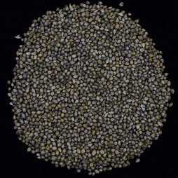  Baif Bajra | 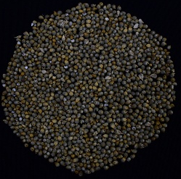  Giant Bajra | 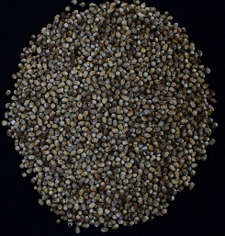  Moti Bajra | 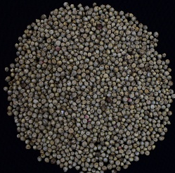  Nutrifeed Bajra | 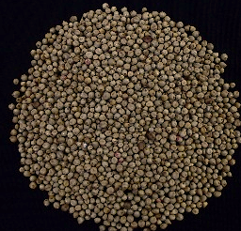  Rajko
Figure 1: Depicted the picture of selected seed of Bajra varieties.
Determination of isolated DNA quality purity and yield,
The concentration of extracted nucleic acids (ng/µL) was measured at 260 nm and 280 nm using a Nanodrop spectrophotometer, and DNA purity was estimated from the A260_{260}260​/A280_{280}280​ ratio (Table 6). Assessing DNA quality is essential to determine its suitability for PCR amplification. To evaluate the integrity of the isolated genomic DNA from young leaf tissues of the genotypes under study, samples were subjected to agarose gel electrophoresis. For this purpose, 3 µL of DNA was mixed with 1/8th volume of 6X DNA gel loading dye and loaded onto a 0.8% agarose gel containing ethidium bromide (EtBr) in a submarine horizontal electrophoresis unit filled with 1X TAE buffer. Electrophoresis was conducted at 50 V for 35 minutes. The gel was subsequently visualised under UV light, with DNA fragments appearing as fluorescent bands due to intercalation of EtBr between the nitrogenous bases. The presence of a single, sharp, high-molecular-weight band without smearing indicated successful extraction of high-quality DNA with minimal degradation and uniform fragment size.
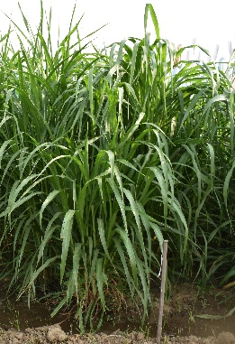  Baif Bajra | 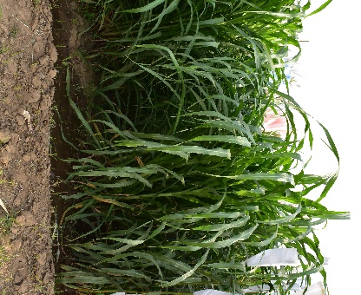  Giant Bajra | 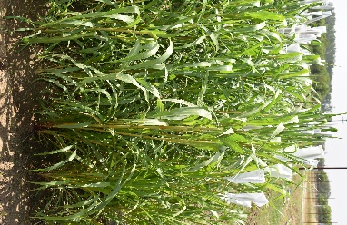  Moti Bajra | 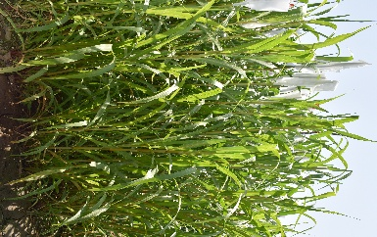  Nutrifeed Bajra | 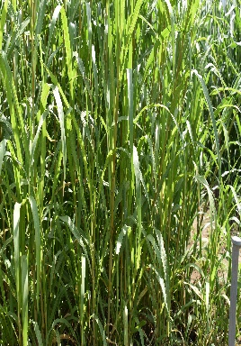  Rajko
Figure 2: Different varieties of pearl millets samples were used for Genomic DNA isolation.
Table 6 Quality determination of DNA by the spectrophotometer
Sl. No | Pedigree | A260 | A280 | A260/A280 Ratio | DNA Concentration (ng/ml)
1 | Baif Bajra | 0.040 | 0.022 | 1.818 | 100.0
2 | Gaint Bajra | 0.043 | 0.023 | 1.869 | 107.5
3 | Nutrifeed Bajra | 0.039 | 0.021 | 1.857 | 104.8
4 | Moti Bajra | 0.042 | 0.022 | 1.909 | 109.0
5 | Rajko | 0.039 | 0.020 | 1.950 | 108.5
Separation of amplified genomic DNA through agarose gel electrophoresis
Amplification of DNA was carried out using the standard protocol of polymerase chain reaction (PCR) adjusted to laboratory conditions. The amplification was carried out in a thermal cycler using 15 μl of reaction mixture (Table 7). The reaction mixture was prepared by varying the components involved in the composition of the reaction mixture. The primer vials were centrifuged before and after the addition of 1X TE buffer to the vials. After dilution the concentration of each primer stock solution was obtained as 100 μM. The diluted primers were stored at -20°C.
Table 7: Composition of PCR reaction mixture (15 μl)
Sl. No. | Components | Volume (μl)
1 | Water (Protese and Nuclease free) | 3.5
2 | 5X PCR Buffer | 3.0
3 | MgCl₂ (10 mM) | 1.6
4 | dNTPs (200 μM) | 3.0
5 | Primer F (5 μM) | 0.8
6 | Primer R (5 μM) | 0.8
7 | Taq DNA polymerase (1 unit) | 0.8
8 | Template DNA (Diluted1 : 9 (DNA:H2O)) | 1.5
 | Total | 15.0 µl
Polymerase chain reaction (PCR) was performed using three pairs of forward and reverse simple sequence repeat (SSR) primers targeting microsatellite loci. Amplification was carried out in a thermocycler under a programme optimised for this purpose. The PCR products were resolved on a 2.0% agarose gel containing ethidium bromide. Products with the expected size of over 100 bp were electrophoresed at 70 V for 1 hour, then visualised and documented using a gel documentation system. The fragment sizes were estimated by comparison with a 100 bp DNA ladder.
Result and Discussion
High-quality genomic DNA was successfully extracted from the young leaves of five pearl millet (Pennisetum glaucum) genotypes and amplified using four SSR markers: IPES0034, IPES0012, ICMP3013, and ICMP3028. Amplified products were observed in all tested samples, with only minor variations in band intensity. Following PCR amplification, IPES0034 produced fragments ranging from 250 to 270 bp, IPES0012 from 200 to 230 bp, ICMP3013 from 150 to 180 bp, and ICMP3028 from 170 to 180 bp, with allelic size differences of 20, 30, 30, and 10 bp, respectively (Figure 4) [24, 25]. This study demonstrates a simple, cost-effective, and reproducible procedure for PCR amplification of pearl millet genomic DNA, which is also applicable to other plant species.
Genomic DNA samples prepared from five pearl millet (Pennisetum glaucum) genotypes—lane 1: Baif Bajra, lane 2: Giant Bajra, lane 3: Nutrifeed Bajra, lane 4: Moti Bajra, and lane 5: Rajko Bajra (Figure 3)—were subjected to PCR amplification using the SSR primers IPES0034, IPES0012, ICMP3013, and ICMP3028. All DNA samples produced clear, sharp, and reproducible PCR products with the respective primers (Figure 4). Although various plant DNA isolation and purification protocols exist, superior results have been consistently obtained using CTAB-based methods [1, 5, 7, 16, 19, 20]. In the present study, a minor modification of the CTAB method was employed to isolate genomic DNA without the use of liquid nitrogen, β-mercaptoethanol, or phenol. A high salt concentration (2.05 M NaCl) was used to efficiently extract genomic DNA, as NaCl facilitates the removal of glycoproteins, proteins, and carbohydrates associated with DNA. Additionally, polyvinylpyrrolidone at high concentrations forms hydrogen bonds with phenolic compounds, preventing contamination of genomic DNA by these secondary metabolites [16, 17, 18, 19, 21, 23].
There are several advantages in using a genomic DNA extraction protocol that is suitable for polymerase chain reaction (PCR) genotyping, which can be employed for the recognition of alleles in diverse genetic, breeding, and biotechnological approaches, viz., marker-assisted selection (MAS), quantitative trait loci (QTL), genetic mapping, transgenic screening, and mutant introgression [13, 18, 21, 24]. All four microsatellite markers show very good amplification and polymorphism with the DNA extracted through this method. Therefore, this method should be recognized as a good, rapid, and inexpensive method for DNA extraction from pearl millet leaves.
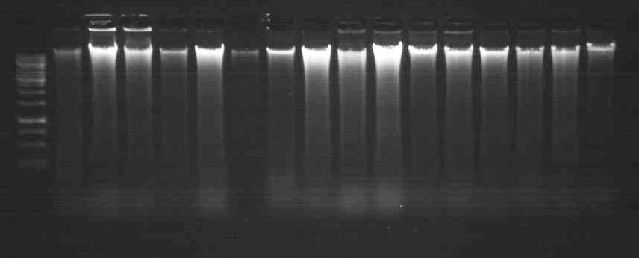
Figure 3: Genomic DNA isolated from five different varieties (1. Baif Bajra 2. Gaint Bajra 3. Nutrifeed Bajra 4. Moti Bajra 5) isolated from young leaves of Pearl millet.

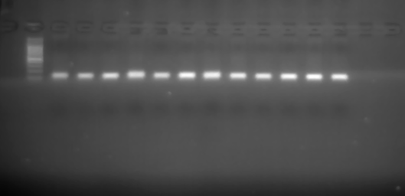  M 1 2 3 4 5  A  100 bp  1.5 Kb | 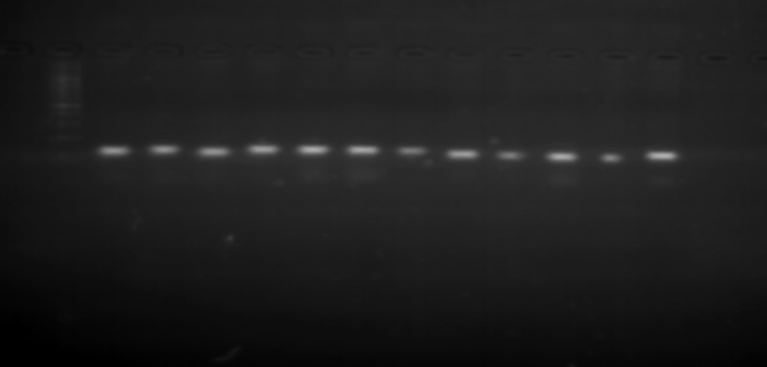  M 1 2 3 4 5  B  100 bp  1.5 Kb
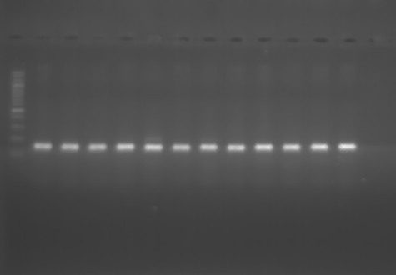  100 bp  M 1 2 3 4 5  C  1.5 Kb | 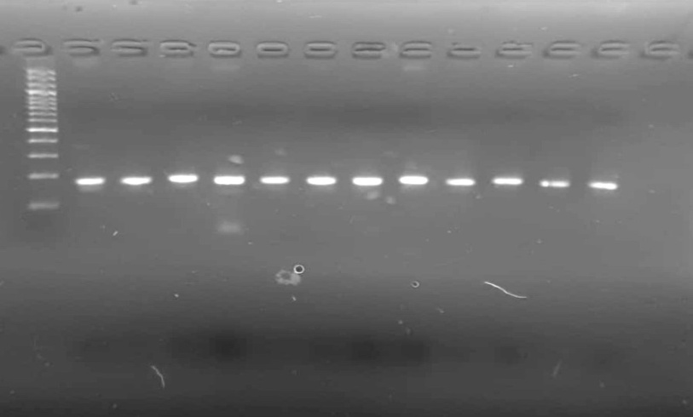  D  M 1 2 3 4 5  1.5 Kb  100 bp

Figure 4: Amplification of genomic DNA with selected four different primers A. IPES0034 B. IPES0012 C. ICMP3013 D. ICMP3028 with M= Marker and selected five genotypes 1. Baif Bajra 2. Gaint Bajra 3. Nutrifeed Bajra 4. Moti Bajra and 5. Rajko respectively.
Conclusions
In summary, the procedure for pearl millet's total genomic DNA extraction described here could be a trusted and reliable protocol to work well for analysis without using liquid nitrogen, 2-mercaptoethanol, and phenols. High salt (NaCl) concentration causes proteins to denature and aggregate, making it easier to separate from DNA. NaCl provides positively charged ions (Na⁺) that prevent DNA strands from repelling each other (DNA strands are negatively charged due to the phosphate backbone).
Disclaimer (Artificial intelligence)
Author(s) hereby declare that NO generative AI technologies such as Large Language Models (ChatGPT, COPILOT, etc.) and text-to-image generators have been used during the writing or editing of this manuscript.

REFERENCES
- Varshney, R. K., Shi, C., Thudi, M., Mariac, C., Wallace, J., Qi, P., et al. (2017). Pearl millet genome sequence provides a resource to improve agronomic traits in arid environments. Nat. Biotechnol. 35, 969. doi: 10.1007/s00122-011-1580-1.
- Jena, K. K., and Mackill, D. J. (2008). Molecular markers and their use in marker‐assisted selection in rice. Crop science, 48(4): 1266-1276.
- Murray, M. G., and Thompson, W. F. (1980). Rapid isolation of high molecular weight plant DNA. Nucleic acids Res. 8: 4321-4325.
- Doyle, J. J. and Doyle, J. L. (1987). A rapid DNA isolation procedure for small quantities of fresh leaf tissue. Phytochem. Bull. 19: 11-15.
- Ahmadikhah, A. (2009). Rapid mini-prep DNA extraction method in rice (Oryza sativa). African journal of Biotechnology. 8(2).
- Ferdous, J., Hanafi, M. M., Rafii, M. Y., and Muhammad, K. (2012). A quick DNA extraction protocol: Without liquid nitrogen in ambient temperature. African Journal of Biotechnology. 11(27): 6956-6964.
- Sajib, A. A., Bhuiya, M. A. I., and Huque, R. (2017). A simple, efficient and rapid method for good quality DNA extraction from rice grains. Rice Science. 24(2): 119-122.
- Sharma R., John, S. J., Damgaard, D. M., and McAllister, T. A. (2003). Extraction of PCR-quality plant and microbial DNA from total rumen contents. BioTechniques 34: 92-97. 96-97.
- Caccavo, F., Lonergan, D. J., Lovely, D. R., Davis, M., Stolz, J. F., and Mclnerney, M. J. (1994). Geobacter sulfurreducens sp-nov, a hydrogen-oxidizing and acetate-oxidizing dissimilatory metal-reducing microorganism. Appl. Environ. Microbiol. 60: 3752-3759.
- Thuan, N. T. N., Bigirimana, J., Roumen, E., Straeten, D. V. D., and Hofte, M. (2006). Molecular and pathotype analysis of the rice blast fungus in North Vietnam. Eur. J. Plant Pathol. 114: 381-396.
- Mondino, E. A., Covacevich, F., Studdert, G. A., Pimentel, J. P., and Berbara, R. L. (2015). Extracting DNA of nematodes communities from Argentine Pampas agricultural soils. Anais da Academia Brasileira de Ciências, 87: 691-697.
- Shahjahan, R. M., Hughes, K. J., Leopold, R. A. and DeVault, J. D. (1995). Lower incubation temperature increases yield of insect genomic DNA isolated by the CTAB method. Biotechniques, 19: 332-334.
- Kumar, P., Kirti, S., Rani, R., & Singh, P. (2023). A Simplified, Efficient and Rapid DNA Extraction Protocol from Rice Grains and Leaf. International Journal of Plant & Soil Science, 35(21), 517-524. https://doi.org/10.9734/IJPSS/2023/v35i214005.
- Kang, H. W., Cho, Y. G., Yoon, U. H., and Eun, M. Y. (1998). A rapid DNA extraction method for RFLP and PCR analysis from a single dry seed. Plant Mol. Biol. Rep. 16: 90.
- Allen, G. C., Vergara, M. A. F., Krasnyanski, S., Kumar, S., and Thompson, W. F. (2006). A modified protocol for rapid DNA isolation from plant tissue using cetyltrimethylammonium bromide. Nature protocols 1: 2320-2325.
- Tussell, R. T., Ramayo, A. Q., Herrera, R. R., Saavedra, A. L. Brito, D. P. (2005). A fast simple and reliable high yielding method for DNA extraction from different plant species. Mol. Biol. 31: 137-139.
- Clark, K. A., and Krysan, P. J. (2007). Protocol: an improved high-throughput method for generating tissue samples in 96-well format for plant genotyping (Ice-Cap 2.0). Plant methods, 3(1), 1-8.
- Kumar, R., Kumar, P., Singh, B., Gangwar, L.K., Tomar, H., Tiwari, U., and Kumar, M. (2024). Molecular characterization of pea (Pisum sativum) genotypes by utilization of RAPD markers. Agriculture Association of Textile Chemical and Critical Reviews Journal. 212-220. https://doi.org/10.21276/AATCCReview.2024.12.04.212.
- Chunwongse, J., Martin, G. B. and Tanksley, S. D. (1993). Pre-germination genotypic screening using PCR amplification of half-seeds. Theor. Appl. Genet. 86: 694-698.
- Kang, T. J., and Yang, M. S. (2004). Rapid and reliable extraction of genomic DNA from various wild-type and transgenic plants. BMC Biotech. 4: 20.
- Suman, S. K., Kumar, M., Sharma, V. K., and Kumar, R. (2020). A modified and efficient CTAB genomic DNA extraction method from maize leaf for PCR analysis. Journal of Pharmacognosy and Phytochemistry, 9(4): 3418-3420.
- Kumar, P., Kirti S., Kiran, Gangwar, R. P. C. (2023). In vitro studies in Gymnema sylvestre (Gudmar)-A high value medicinal plant. In vitro, AMA, 54(04).
- Ambawat, S., Satyavathi, C. T., Meena, R. C., Meena, R., Khandelwal, V., Singh, S., & Geela, R. (2021). DNA Fingerprint of pearl millet hybrids [Pennisetum glaucum (L.) R. BR.] using SSR markers. The Pharma Innovation Journal, 10, 07-13.
- Nweke, O., Osuji, C., Mairo, I. H., & Onyenekwe, P. C. (2014). A simple and rapid leaf genomic DNA extraction method for pearl millet (Pennisetum glaucum LR Br). Journal of Applied Biotechnology, 2(2), 75-81.
- Zidani, S., Ferchichi, A., & Chaieb, M. (2005). Genomic DNA extraction method from pearl millet (Pennisetum glaucum) leaves. African Journal of Biotechnology, 4(8), 862-866.

