Multivariate analysis of genetic divergence in lentil (Lens culinaris Medik.) based on D² and Principal Component Analysis

ABSTRACT-
Evaluating genetic diversity is essential for successful crop improvement and the efficient use of genetic resources. The present investigation was carried out on a set of forty-two lentil (Lens culinaris Medik.) genotypes (including 2 checks , IPL-316 and JL-3) to evaluate genetic divergence using multivariate approaches, namely Mahalanobis D² statistics and Principal Component Analysis (PCA) during rabi 2024-25 at seed breeding farm, JNKVV, Jabalpur. Forty-two lentil genotypes were grouped into seven clusters. Biological yield per plant shows maximum contribution towards genetic diversity while days to flower initiation shows minimum. Maximum intra cluster distance was shown by Cluster IV (D² = 349.87) while Cluster III and VII (3614.10) showed highest inter cluster value. Maximum genotypes were under cluster II (20 genotypes). Cluster VI and VII observed high cluster mean values for most of the yield attributing traits. Only five of the thirteen Principal components (PCs) had an Eigen value greater than one, explained 72.148% of total variability among lentil genotypes. Genotypes MPL 94, PL 4, IC 315944, LH 82-6, PL 32, IC 283384, SUBRITA and MPL 4 were found diverse based on D² statistics and principal component analysis.
Keywords: Lentil, Genetic diversity, Mahalanobis D², Principal Component Analysis, cluster analysis
Introduction-
Lentil (Lens culinaris Medik.) is an annual, self-pollinating, cool-season pulse crop characterized by its lens-shaped seeds, diploid chromosome number (2n = 14), and a genome size of approximately 4 Gbp [20]. The crop was first domesticated in the Fertile Crescent [8] [26], with its origin traced to the Near East. It is amongst the leading pulse crop grown in India, account for approximately 9% of the total area under pulse cultivation and contribute an equivalent percentage to Rabi pulse production. Canada and India are the leading contributors [29]. In India, lentil ranks as the fifth most important pulse crop after pigeon pea, chickpea, mungbean and urdbean.
In India, lentils are cultivated on approximately 14 lakh hectares, producing 13 lakh tones, with an average productivity of 926 kilograms per hectare [3]. Lentil is a nutritionally valuable legume crop that plays a crucial role in food and nutritional security. Its seeds are rich in macronutrients, containing approximately 25% protein, 60% carbohydrates, and 11–12% dietary fiber [2]. Beyond its macronutrient profile, lentil is an excellent source of essential micronutrients, with reported concentrations of, zinc manganese and copper [17], [28].
Owing to its high nutritional and economic value, lentil has gained considerable interest from the scientific community still low seed yield and production is an existing problem. Lentil production is constrained by several biological reasons such as narrow genetic base, small genome size and small flower size hampers hybridization efforts [7]. Therefore, there is a need to evaluate the variability and diversity in the existing genetic population and develop new varieties to increase the production. Genetic variability along with genetic divergence are the main interests of any plant breeder to develop desirable varieties. The varieties that are developed from diverse parents are likely to show high heterotic effects as well as a large range of segregation. The information about the genetic diversity present in a population helps in identifying superior donors from the germplasm for hybridization. Similarly, Principal Component Analysis (PCA) is another powerful multivariate technique that reduces the dimensionality of trait data, facilitating interpretation of genetic variation and identification of superior genotypes. Thus the goal of this investigation was to identify the diverse parents for lentil breeding programs.
MATERIAL AND METHODS

The Experimental material consist of forty two lentil genotypes including two checks from JNKVV, Jabalpur; IIPR, Kanpur and RVSKVV, Gwalior. The experiment took place during the Rabi season of 2024-25 at the Seed breeding farm, College of Agriculture, Jawaharlal Nehru Krishi Vishwa Vidyalaya, Jabalpur, Madhya Pradesh in Randomized Complete Block Design with two replications. Each genotype had been sown in 2 meters row while plant to plant distance was 8-10 cm and row to row distance was 45cm. From each replication, five plants were chosen to record observations on various traits, namely days to flower initiation, days to maturity, plant height (cm), pod length (cm), number of branches per plant, number of nodes per plant, number of pod clusters per plant, number of pods per plant, number of seeds per pod, 100-seed weight (g), biological yield per plant (g), harvest index (%), and seed yield per plant (g). Statistical analysis was performed using Windostat version 9.1. For the divergence analysis, the transformed and uncorrelated means of the characters were utilized to compute the D² statistic following Mahalanobis’ method. (1936) [18,19]. The populations were classified into distinct clusters using Tocher’s method, as outlined by Rao (1952) [23]. After the formation of the clusters, the average inter and intra-cluster distances were calculated. The average intra and inter-cluster D2 values were estimated as per the procedure given by Singh and Chaudhary (1979) [25]. Principal Component Analysis based on Pearson’s correlation matrix cluster analysis and a scree plot was performed using a demo version of XLSTAT.

3. RESULTS AND DISCUSSION
Mahalanobis D² statistic
The traits that contributed the most to the overall genetic diversity among these was biological yield per plant (64.23%), which was followed by the number of nodes per plant (11.50%), harvest index (7.08%), the number of pods per plant (5.23%). Other characteristics showed comparatively smaller contributions, including the seed yield per plant (4.07%), number of pods per plant (2.67%), pod length and number of branches per plant (1.74%). Other traits such as 100 seed weight (0.81%), plant height (0.70%), number of seeds per pod and days to maturity (0.12%) shows negligible contribution. Significantly, days to flower initiation had no effect on genetic divergence. The proportionate contributions of the thirteen quantitative traits under study to the genetic divergence are shown in Table 1 and Fig. 1.
Rank | Source | Times Ranked 1st | Contribution %
1. | Biological yield per plant | 553 | 64.23%
2. | Number of nodes per plant | 99 | 11.50%
3. | Harvest index | 61 | 7.08%
4. | Number of pod clusters per plant | 45 | 5.23%
5. | Seed Yield per plant | 35 | 4.07%
6. | Number of pods per plant | 23 | 2.67%
7. | Pod length | 15 | 1.74%
8. | Number of branches per plant | 15 | 1.74%
9. | 100 seed weight | 7 | 0.81%
10. | Plant Height | 6 | 0.70%
11. | Days to Maturity | 1 | 0.12%
12. | Number of seeds per pod | 1 | 0.12%
13. | Days to flower initiation | - | 0.00%
Table 1: Contribution (%) of different traits towards divergence

Fig 1: Contribution (%) of different traits towards divergence
Intra and Inter Cluster Distance
Forty-two lentil genotypes were grouped into seven clusters based on divergence studies. Cluster II was the largest of the clusters, with twenty genotypes. Cluster I, which contained eight genotypes, followed Cluster III, which contained six genotypes and cluster IV contained five genotypes. In contrast, Clusters V, VI and VII each have a single genotype. The genotypes distributions into many groups are displayed in Fig. 2 and Table 2
Table 2: Distribution of lentil genotypes in different clusters
Cluster Number | Number of genotypes | Name of genotypes
I | 8 | RVL 13-5, VL 103, IC 267659, MPL 17, SUBRITA, IC 321535, MPL 80
II | 20 | ASHA, L1719, MPL 33, PL 406, IC 268245, IC 331541, IC 328451, IC 396043, IPL 316, IC 384469, IC 268329, IC 283384, MPL-105, MPL-61, IC 355621, IPL 406, MPL 101, IC 406706, RANJAN, MPL 47
III | 6 | PL 4, LH 82-6, IPL 315, MPL 15, IC 331545, PL 32
IV | 5 | PL 63, IC 385825, MPL 13, MPL 4, VL 156
V | 1 | MPL 94
VI | 1 | JL3
VII | 1 | IC 315944

Fig 2: Distribution of number of lentil genotypes in different clusters using D²
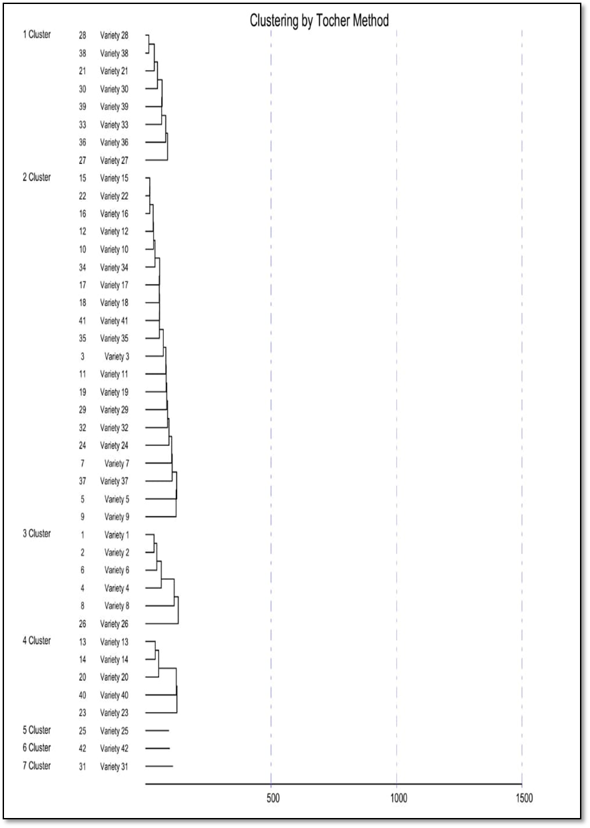
The intra-cluster distance ranged was 0.00 to 349.87. The clusters with the most divergence were clusters IV, III, II and I while remaining clusters exhibited zero values for intra-cluster distance. The highest intra-cluster D² value was observed in Cluster IV (D² = 349.87), followed by clusters III (D² = 314.67), clusters II (D² = 248.84) and cluster I (D² = 217.28). These clusters were poly-genotypic, while the other three clusters were mono-genotypic, indicating no intra-cluster divergence in those clusters.
For inter cluster the highest divergence was found between lines of Cluster III and VII (3614.10), followed by II and VII (1939.23) and Cluster VI and VII (1896.83) etc. In contrast minimum inter cluster distance were observed between clusters like cluster I and IV (387.93), Cluster II and VI (513.46) and Cluster II and III (586.71). Cluster I (217.28) was most closely related to Cluster IV (387.93) and most distantly related to Cluster III (1817.12).Cluster II (248.84) had the smallest inter-cluster distance of 513.46 with Cluster VI and the highest distance of 1939.23 with Cluster VII. Cluster III (314.67) was closest to Cluster II with a distance of 586.71, but it was farthest from Cluster VII, recording the maximum distance of 3614.10. Cluster IV (349.87) had its minimum distance (387.93) with Cluster I and maximum (1600.76) with Cluster III. For Cluster V (0.00) the least distance was observed with Cluster VI (626.54) and the highest with Cluster III (1640.91). Cluster VI (0.00) showed its closest relationship with Cluster II at 513.46 and the highest divergence with Cluster VII at 1896.83. Lastly, Cluster VII was nearest to Cluster I (683.29) and farthest from Cluster III (3614.10). Table 3 presents the D² mean values within and between clusters for forty-two genotypes which were classified into seven clusters based on D² values. The results obtained align well with previous studies in lentil diversity by [15], [9], [16], [10], [5], [14], [4] and [6].
Table 3: Inter and Intra Cluster D² value for different clusters
Clusters | I | II | III | IV | V | VI | VII
I | 217.28 | 753.31 | 1817.12 | 387.93 | 628.50 | 910.83 | 683.29
II |  | 248.84 | 586.71 | 689.25 | 747.46 | 513.46 | 1939.23
III |  |  | 314.67 | 1600.76 | 1640.91 | 1185.39 | 3614.10
IV |  |  |  | 349.87 | 626.54 | 1084.18 | 1133.17
V |  |  |  |  | 0.00 | 1032.27 | 699.49
VI |  |  |  |  |  | 0.00 | 1896.83
VII |  |  |  |  |  |  | 0.00

Fig 3: Cluster Diagram
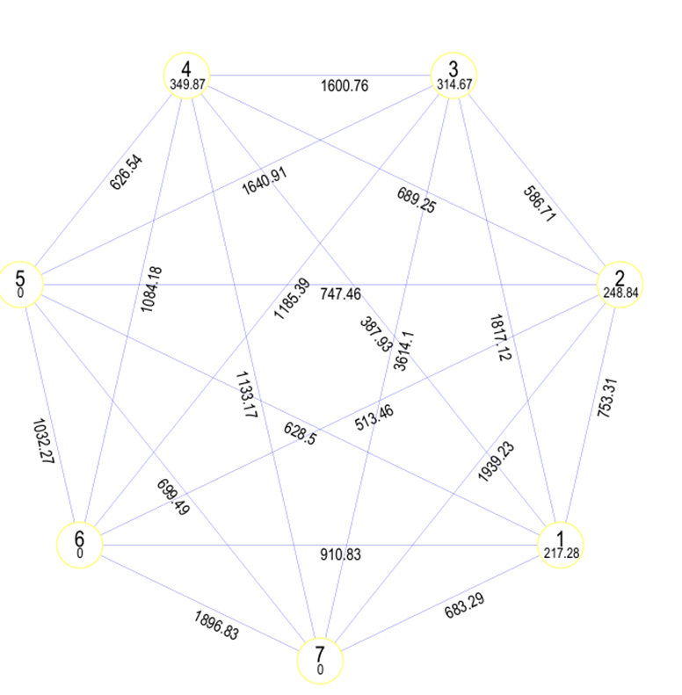 ANOVA for Dispersion
The analysis of variance (ANOVA) of the dispersion matrix was performed to determine the multivariate significance of varietal differences across the studied traits. The results revealed a highly significant variation among the 42 genotypes, with a sum of squares of 2.3217 × 10⁵ and a mean square of 5.6628 × 10³ for the "Varieties" source. In contrast, the "Error" component had a negligible mean square of 2.0277 × 10⁻¹², indicating that the observed variability is primarily due to genetic differences rather than environmental. The F-ratio of 9999 and the associated probability value of 0.00000 (highly significant) confirm the presence of statistically significant multivariate differences among genotypes. These findings validate the suitability of the dataset for further multivariate analyses such as Wilks’ Lambda test and clustering, aimed at exploring genetic divergence and identifying promising genotypes for breeding programs.
Table 4: ANOVA for dispersion
Source of Variations | d. f. | Sum of Squares | Mean Squares | F Ratio | Probability
Varieties | 41 | 2.3217E05 | 5.6628E03 | 9.999E03 | 0.00000 ***
Error | 40 | 8.1109E-11 | 2.0277E-12
Total | 81 | 2.3217E05 | 2.8664E03

Cluster mean for yield and its component traits of lentil genotypes
Cluster VI showed high cluster mean values for most of the yield attributing traits that are plant height, pod length, number of branches per plant, number of pod cluster per plant, number of pods per plant, number of seed per pod, 100 seed weight, harvest index, seed yield per plant. Similarly cluster VII showed high cluster mean values for traits such as number of branches per plant, number of pod cluster per plant, number of pods per plant, number of seed per pod, 100 seed weight, biological yield per plant, seed yield per plant. Thus genotypes from these clusters should be selected showing high cluster mean values for yield attributing traits. These findings are consistent with reports by [27], [14] and [6].
Table 5: Cluster mean for yield and its component traits of lentil genotypes
Clusters | DTF | DM | PH | PL | NBPP | NNPP | NPCPP | NPPP | NSPP | 100 SW | BYPP | HI | DTF
Cluster I | 60.94 | 100.81 | 49.44 | 1.23 | 3.71 | 11.46 | 23.88 | 50.57 | 1.74 | 2.97 | 10.71 | 30.18 | 3.23
Cluster II | 59.40 | 100.45 | 46.68 | 1.32 | 4.11 | 11.54 | 21.37 | 44.64 | 1.67 | 3.14 | 7.90 | 42.67 | 3.36
Cluster III | 58.17 | 99.42 | 44.45 | 1.13 | 3.72 | 11.26 | 13.97 | 30.19 | 1.68 | 2.54 | 5.30 | 44.76 | 2.36
Cluster IV | 61.60 | 100.40 | 49.30 | 1.50 | 4.15 | 15.15 | 25.72 | 53.30 | 1.68 | 3.21 | 10.30 | 34.71 | 3.64
Cluster V | 59.50 | 100.00 | 44.84 | 1.20 | 5.20 | 15.20 | 22.90 | 48.40 | 1.90 | 4.50 | 10.79 | 45.44 | 4.90
Cluster VI | 59.50 | 100.00 | 40.32 | 1.86 | 4.70 | 9.65 | 24.40 | 52.40 | 2.00 | 4.63 | 9.65 | 49.74 | 4.80
Cluster VII | 60.00 | 98.50 | 47.86 | 1.06 | 4.70 | 12.30 | 28.80 | 60.60 | 1.90 | 4.35 | 13.27 | 36.10 | 4.79

Principal Component Analysis
Forty-two genotypes of lentils were analysed quantitatively using PCA in the current study program. Only five of the thirteen Principal components (PCs) had an Eigen value greater than one, indicating variation among the variables being examined. It showed that these five PCs under investigation varied by around 72.148%. PC1 (22.272) had the highest variability, followed by PC2 (16.076), PC3 (13.399), PC4 (11.747) and PC5 (8.926). Eigen values, % variance, and cumulative % are mentioned in Table 6. The semi-curved line beyond the fifth principal component showed only minimal variation, indicating that the majority of variation was concentrated in PC1. Hence, selecting genotypes based on the traits grouped under PC1 would be most desirable, as illustrated in Fig. 4.

Table 6: Principal Components of different traits
S. Number | Traits | Principal components | Eigen values | Variability % | Cumulative %
1. | Days to flowering | PC1 | 2.850 | 22.272 | 22.272
2. | Days to maturity | PC2 | 2.090 | 16.076 | 38.348
3. | Plant height | PC3 | 1.742 | 13.399 | 51.747
4. | Pod length | PC4 | 1.492 | 11.747 | 63.221
5. | Number of branches per plant | PC5 | 1.160 | 8.926 | 72.148
6. | Number of nodes per plant | PC6 | 0.885 | 6.807 | 78.955
7. | Number of pod clusters per plant | PC7 | 0.815 | 6.269 | 85.224
8. | Number of Pods per plant | PC8 | 0.571 | 4.389 | 89.613
9. | Number of seeds per pod | PC9 | 0.504 | 3.875 | 93.488
10. | 100 seed weight | PC10 | 0.382 | 2.936 | 96.424
11. | Biological yield per plant | PC11 | 0.335 | 2.576 | 99.000
12. | Harvest index | PC12 | 0.113 | 0.871 | 99.871
13. | Seed yield per plant | PC13 | 0.017 | 0.129 | 100.000

Fig 4: Scree Plot between Eigen Value and Principal Components
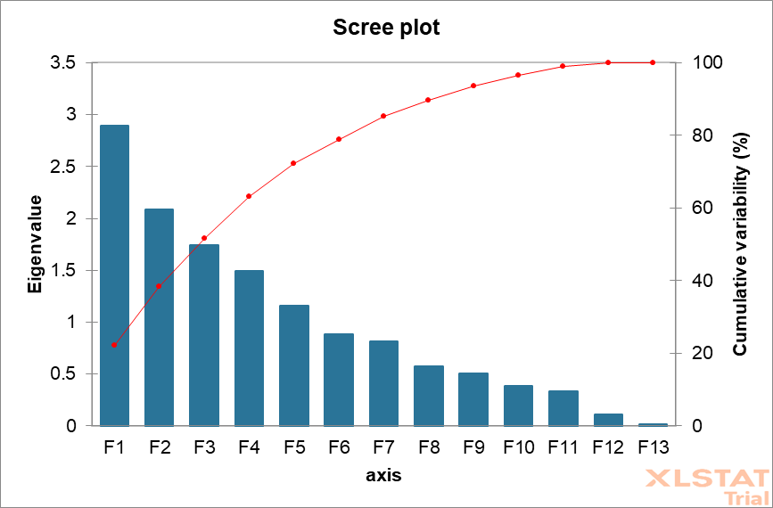

The genotype PL 32 recorded the highest PC1 score, indicating its overall superiority in the number of branches per plant and number of nodes per plant. Other genotypes with notable PC1 scores included MPL 4, IPL 406, IC 283384, IC 315944, SUBRITA, IC 331541, IC 406706 and JL 3 also showing considerable influence from these traits.
PC2 was mainly governed by the harvest index, IC 331545 showed the highest PC2 score, prominent genotypes in PC2 included LH 82-6, RANJAN, MPL 15, MPL 101, PL 24 and IC 268245.
The highest PC3 score was observed in MPL 105, reflecting it’s associated with the number of pod clusters per plant and number of pods per plant. Genotypes such as IC 331541, SUBRITA, VL 103, IC 328451, ASHA, IC 283384 and MPL 33 also showed strong association under PC3.
The genotype MPL 47 had the highest PC4 score, highlighting its excellence in by seed yield per plant and biological yield per plant. Other genotypes with high PC4 scores included IC 283384, PL 32 and MPL 4.
PC5 characterized by pod length, plant height and number of seeds per pod. IC 321535 emerged with the highest PC5 score, other genotypes include IC 384469, IC 396043 and IPL 315.
Similar results were found by [22], [1], [12], [24], [21] and [13] for quantitatitive traits under investigation.
Table 7: Rotated Matrix results of different traits (> 0.25)
Traits | PC1 | PC2 | PC3 | PC4 | PC5
Traits | Number of branches per plant | Harvest index | Number of pod clusters per plant | Seed yield per plant | Pod length
Traits | Number of nodes per plant |  | Number of pods per plant | Biological yield | Plant height
Traits |  |  |  |  | Number of seeds per pod

Table 8: Promising genotypes on the basis of scores of Principal Components
PC 1 | PC 2 | PC 3 | PC 4 | PC 5
MPL 4 | PL 24 | VL 103 | MPL 47 | IC 384469
IC 283384 | LH 82-6 | IC 331541 | MPL 4 | IC 321535
IPL 406 | RANJAN | SUBRITA | MPL 13 | IC 396043
PL 32 | MPL 15 | MPL 105 | PL 32 | IPL 315
IC 315944 | MPL 101 | IC 328451
SUBRITA | IC 331545 | ASHA
IC 331541 | IC 268245 | IC 283384
IC 406706 |  | MPL 33

Conclusion
According to the D² statistics, crossing the genotypes of cluster IV would result in transgressive segregants, and in order to broaden the genetic base of lentils, it would be beneficial to cross the genotypes of cluster III and cluster VII. Cluster VI exhibited the highest mean scores for harvest index, seed yield per plant, number of branches per plant, pod length, number of pod clusters per plant, number of pods per plant, number of seeds per pod, and 100 seed weight. As a result, genotypes belonging to this cluster have potential as donor parents for crossbreeding programs, where their distinct traits can be utilized to improve other desired traits and seed yield. The genotypes that were found diverse based on D² studies were as follows MPL 94, PL 4, IC 315944, LH 82-6 and PL 32.
According to PCA, four genotypes IC 283384, SUBRITA, PL 32 and MPL 4 were found promising as they fall in more than one PC. The most important traits that were identified were number of branches per plant, number of nodes per plant, number of pods per plant, number of seeds per pod, number of pod clusters per plant, harvest index, biological yield per plant, seed yield per plant, plant height and pod length.

Disclaimer (Artificial intelligence)
Option 1:
Author(s) hereby declare that NO generative AI technologies such as Large Language Models (ChatGPT, COPILOT, etc.) and text-to-image generators have been used during the writing or editing of this manuscript.

REFERENCES
- Ahmad, N. S., Moradi, N., Rafaat, J. G., & Mohammed, D. J. (2021). Genetic Variability and Heritability Estimates of Agronomic Traits in Lentil (Lens culinaris Medik.). Romanian Agricultural Research, 38(2), 1-20. https://www.incda-fundulea.ro/rar/rar38.html
- Akter, S., Jahan, I., Hossain, M. A., & Hossain, M. A. (2020). Variability for agromorphological traits, genetic parameters, correlation and path coefficient analyses in Lentil (Lens culinaris Medik.). Research in Plant Biology, 10(3), 1-7. https://doi.org/10.25081/ripb.2020.v10.6237
- Annual Report (2022-23). Directorate of Pulses Development, Department of Agriculture, Cooperation and Farmers Welfare.
- Ansari MA, Singh P and Kumar V. 2023. Genetic diversity analysis of lentil (Lens culinaris) genotypes using Mahalanobis D² statistics. Journal of Plant Genetics 15(1): 45–54.
- Cardoso FR, Brasileiro LO, Ragassi CF, Carvalho ADF, Silva PP, Vieira JV and Nascimento WM. 2021. Morpho-agronomic characterization and genetic divergence in lentil genotypes. Horticultura Brasileira 39(2): 169–177.
- Dhokade, R., Gupta, P., Pathak, S., Barela, A., & Charke, V. (2024). Evaluating Genetic Diversity and Analyzing Yield-Related Traits for Selection Criteria in Lentil (Lens culinaris Medik). *Ecology, Environment and Conservation*, *30*(Nov Suppl.Issue), S251-S254. .
- Erskine, W., Tufail, M., Russell, A., Tyagi, M. C., Rahman, M. M., & Saxena, M. C. (1994). Current and future strategies in breeding lentil for resistance to biotic and abiotic stresses. Euphytica, 73(2), 127–135. https://doi.org/10.1007/BF00027189
- Ford, R., Rubeena, Redden, R. J., Materne, M. M., & Taylor, P. W. J. (2007). Lentil. In C. Kole (Ed.), Genome mapping and molecular breeding in plants: Pulses, sugar and tuber crops (Vol. 3, pp. 91–108). Springer. https://doi.org/10.1007/978-3-540-34516-9_5
- Gaad, D., Laouar, M., Gaboun, F., & Abdelguerfi, A. (2018). Collection and agro morphological characterization of Algerian accessions of lentil (Lens culinaris). Biodiversitas, 19(1), 183-193. https://doi.org/10.13057/biodiv/d190125
- Gaur, R., Kumar, S., & Tyagi, S. D. (2020). Study of genetic diversity under varied environments in lentil (Lens culinaris Medik.). Journal of Pharmacognosy and Phytochemistry, 9(5), 255–257. https://www.phytojournal.com/archives/2020/vol9issue5/PartE/9-5-10-900.pdf
- Guerra-García, A., Rojas-Barrera, I. C., Ross-Ibarra, J., Papa, R., & Piñero, D. (2022). The genomic signature of wild-to-crop introgression during the domestication of scarlet runner bean (Phaseolus coccineus L.). Evolution Letters, 6(4), 295-307. https://doi.org/10.1002/evl3.285
- Hussain, S. A., Iqbal, M. S., Akbar, M., Arshad, N., Munir, S., Ali, M. A., Masood, H., Ahmad, T., Shaheen, N., Tahir, A., Khan, M. A., Ilyas, M. K., & Ghafoor, A. (2022). Estimating genetic variability among diverse lentil collections through novel multivariate techniques. PLOS ONE, 17(6), e0269177. https://doi.org/10.1371/journal.pone.0269177
- Kefelegn, N., Benor, S., Haile, G., Fikre, A., & Barbetti, M. J. (2025). Agro-morphological characterization and comparative performance of Ethiopian and exotic lentil (Lens culinaris Medik) germplasm. Genetic Resources and Crop Evolution, 72(4), 4491-4506. https://doi.org/10.1007/s10722-024-02204-y
- Khatun, H., Reza Emi, F., Mijanur Rahman, M., Khairul Hasan, A., Anwar Hossain, M., & Amir Hossain, M. (2022). PHENOTYPIC AND GENETIC VARIABILITY AND GENETIC DIVERGENCE IN LENTIL (Lens culinaris Medik.) GERMPLASM. Functional Plant Breeding Journal, 4(1), 35-52. https://doi.org/10.35418/2526-4117/v4n1a5
- Koul, P. M., Sharma, V., Rana, M., Chahota, R. K., Kumar, S., & Sharma, T. R. (2017). Analysis of genetic structure and interrelationships in lentil species using morphological and SSR markers. 3 Biotech, 7(1), 1–11. https://doi.org/10.1007/s13205-017-0683-z
- Kumar, A. (2019). Genetic Diversity of Yield Attributing Components and Seed Yield in Lentil (Lens culinaris Medik.). Current Journal of Applied Science and Technology, 33(2), 1-6. https://doi.org/10.9734/cjast/2019/v33i230056
- Kumar, J., Thavarajah, D., Kumar, S., Sarker, A., & Singh, N. P. (2018). Analysis of genetic variability and genotype × environment interactions for iron and zinc content among diverse genotypes of lentil. Journal of Food Science and Technology. https://doi.org/10.1007/s13197-018-3285-9
- Mahalanobis, P. C. (1936). On the generalized distance in statistics. *Proceedings of the National Institute of Sciences of India*, *2*(1), 49-55. http://hdl.handle.net/10263/6765
- Mahalanobis PC. A statistical study at Chinese head measurement. Journal of Asiatic Society of Bengal 1936. 25(3):301- 77.
- Ogutcen, E., Ramsay, L., von Wettberg, E. B., & Bett, K. E. (2018). Capturing variation in Lens (Fabaceae): Development and utility of an exome capture array for lentil. Applications in Plant Sciences, 6(7), e01165. https://doi.org/10.1002/aps3.1165
- Pavithra, S., Sarkar, A., Roy, S. K., & Bhattacharya, P. M. (2023). Principal component analysis and genetic correlation studies in Lens culinaris Medik. Electronic Journal of Plant Breeding, 14(3), 1198–1205. https://doi.org/10.37992/2023.1403.097
- Perera D, Fernando L and Silva K. 2017. Principal component analysis of agronomic traits in lentil (Lens culinaris Medik.) genotypes. Tropical Plant Research 4(1): 23–31.
- Rao CR (1952) Advanced statistical methods in biometric research.
- Sharma, R., Chaudhary, L., Kumar, M., Yadav, R., Devi, U., Amit, & Kumar, V. (2022). Phenotypic diversity analysis of Lens culinaris Medik. accessions for selection of superior genotypes. Sustainability, 14(10), 5982. https://doi.org/10.3390/su14105982
- Singh RK, Chaudhary BD (1979) Biometrical methods in quanti- tative genetic analysis. Kalyani publishers, New Delhi, India, pp 303.
- Sonnante, G., Hammer, K., & Pignone, D. (2009). From the cradle of agriculture a handful of lentils: History of domestication. Rendiconti Lincei. Scienze Fisiche e Naturali, 20(1), 21–37. https://doi.org/10.1007/s12210-009-0002-7
- Tomar, S., Sharma, S., Thakur, S., Pathak, N., & Tiwari, P. (2022). The Nature of Diversity in Yield Influencing Traits of Lentil Genotypes. International Journal of Plant & Soil Science, 34(23), 1665-1671. https://doi.org/10.9734/ijpss/2022/v34i232589
- Tziouvalekas M, Tsaliki E, Papastylianou P and Tampakaki AP. 2022. Micronutrient concentrations in lentil (Lens culinaris Medik.) seeds: Implications for human nutrition and biofortification. Journal of Cereal Science 105: 103490.
- Zeroual, A., Baidani, A., & Idrissi, O. (2022). Drought stress in lentil (Lens culinaris, Medik) and approaches for its management. Horticulturae, 9(1), 1. https://doi.org/10.3390/horticulturae9010001

