Original Research Article
Comparative studies of Caladium Bicolor Stem and Leaf Biomass extract as corrosion inhibitor for mild steel in acidic media

Abstract
This study presents a comparative investigation into the corrosion inhibiting properties of extracts derived from the stem and leaves of Caladium tricolor (wild cocoyam) in acidic media. The primary objective was to evaluate and compare the efficacy of these plant parts in mitigating metal corrosion, offering a potential green alternative to conventional synthetic inhibitors. The extracts were obtained through the solvent extraction process, and their performance was tested in two acidic environments: 0.5 M H₂SO₄ and 0.5 M HCl. The gravimetric method was employed, providing a direct measure of metal degradation over time. The results obtained demonstrate that both Caladium tricolor stem extract (CSE) and leaves extract (CLE) possess significant corrosion inhibiting properties in the tested media. The findings indicate a clear dependency of inhibition efficiency on both the concentration of the extract and the duration of exposure. Specifically, the inhibition efficiency for CSE ranged impressively from 50% to 99% across concentrations varying from 5 ml to 20 ml in both acidic solutions. Conversely, the CLE exhibited an efficiency range of 27.63% to 94.55% under the same concentration gradient. The stem extract (CSE) achieved its maximum inhibition efficiency of 98.92% at the highest tested concentration of 20 ml after 24 hours of immersion in 0.5 M H₂SO₄. In contrast, the leaves extract (CLE) attained its highest efficiency of 94.55% also at a 20 ml concentration, but required a longer immersion period of 72 hours and achieved this peak in 0.5 M HCl. These comparative results suggest that while both extracts are effective, the stem extract may offer superior and faster protection in a sulfuric acid environment.

Keywords: Corrosion, Inhibition, Caladium bicolour, acid, mild-steel, Coupon, Gravimetric.

- Introduction
Mild steel has found application in various industries, making it one of most widely used type of steel. Its ductility, weldability, machinability, affordability, and magnetic properties makes it useful in building gates, fence, machinery parts, pipelines, cookware and so on. Despite its wide application, mild steel’s integrity just like most metals, is often compromised by corrosion[1,2]. Corrosion, generally defined as wearing away or deterioration of metal surfaces is a naturally occurring phenomenon caused by reactions or chemical attacks from the surrounding environmental conditions.
In order to stem this deterioration, Corrosion (steel in particular)as well as its inhibition have gained enormous attention from different researchers [3 - 8]. In recent times, attention has been given to the use of natural inhibitors of plant origin which have been reported to exhibit excellent inhibition properties [9 - 13]. The importance of this research area is due to the fact these inhibitors of natural origin are generally environmentally acceptable and eco-friendly [14]. Other advantages of corrosion inhibitors of plant origin include low-cost, their biodegradability and availability [1,15].
Natural products yield and their corrosion inhibition efficiency depend greatly on the plant part used. Another importance factor is the corrosion inhibiting specificity of these compounds. While one compound or extract may be effective in a certain medium for a particular metal, it may be ineffective in another medium for the same metal [1,16]. Nevertheless, most synthetic organic inhibitors today are known for their hazardous effects, hence the need for inhibitors of plant origin which are non-tocic, cheap, and environmentally safe.
These inhibitors of natural origin are either extracted or synthesized from medicines, aloe vera leaves, aromatic herbs, spices and so on. Moringa oleifera leaf extract was studied as a potential source of green inhibitor for aluminum alloy in acidic medium of 0.5M HCl using thermometric and gravimetric techniques at temperatures of 30°C and 60°C. Results obtained from their study showed that Moringa oleifera is an effective corrosion inhibitor for aluminum alloy in the acidic medium. They also reported that Inhibition efficiency decreased with temperature but increases with extract concentration. [17]. Al-Turkustani et al. studied the corrosion inhibition efficiency of alcoholic and water extracts of the Medicago Sative plant to control corrosion of mild steel in 2.0 M H₂SO₄ medium[18], they found that both alcoholic and water extracts served as mixed inhibitors. They further suggested that, chemical adsorption as a result of charge transfer between mild steeland the inhibitor’s molecules substrate seems to be the major corrosion inhibition mechanism.
The main aim of this present study is to investigate the anti-corrosion effect of wild cocoyam (Caladium tricolour) plant extracts (stem and leaf) in acidic media at different temperatures. The authors then compared the corrosion inhibition efficiency of Caladium tricolour Stem Extract (CSE) to that of Caladium bicolour Leaf Extract (CLE) in acidic media (0.5M H₂SO₄, and 0.5M HCl).

- MATERIALS AND METHODS
2.1 Material Collection and Preparation
Caladium bicolor Collection and Extraction
Biomass extract of Caladium tricolor was used for this study. Its stems and leaves used were obtained locally, washed, cut into pieces and dried to a constant weight under sun, and then ground to fine powder. The CSE and CLE were obtained by solvent extraction.
Preparation of Molar Acid Solutions
Stock solutions of 0.5M H₂SO₄, and 0.5M HCl was prepared respectively using serial dilution principle.
Preparation of the coupon
Mild steel sheets were used for the study. Each sheet was of 0.5mm in thickness and were mechanically press cut into 3cm x 3cm and 1cm x 2cm coupons. Although the coupons were used without additional polishing, they were howevergiven surface treatment by degreased in absolute ethanol, dried in acetone, and stored in desiccators free from moisture before being used in this study.
2.2 Experimental Method
Gravimetric Measurement Method
The prepared and weighed mild steel coupons 3cm x 3cm were immersed in beakers containing 250 ml of the test solutions with and without the addition of CSE and CLE of concentrations ranging from 5 to 20ml inhibitor concentrations in 0.5 M H₂SO₄ and 0.5 M HCl as the metal strips were suspended in the beakers using glass rods and hooks.
The coupons were then retrieved at 24-hours interval progressively until 120hours (i.e the coupons were removed from the solution after 24 hours, then 48 hours, 72 hours 96 hours and finally 120 hours). The coupons were washed appropriately with fresh water to remove any corrosion product and finally with acetone. The washed couponswere then dried, and reweighed. The differences in weight of the coupons before and after immersion in different test solutions were taken as the weight loss, which was then used to calculate the corrosion rate using the formula
CR= (∆W x 87600)/DAt ………………………………………………………………(1)[9]
Where CR = Corrosion Rate (mm/yr), ∆W = change in weight (g). D = Density of the coupon (g/cm³), A = area of exposed surface of the coupon (cm²) and t = time of immersion (h).
The inhibitor efficiency was at each concentration of biomass samples calculated by comparing the corrosion rate in the absence (CRo) and presence (CR1) using the relationships;
% IE = (CRo -CRi)/CRo X 100 (2)[9]
where, CRo = corrosion rate of mild steel in blank corrodent, CRi = corrosion rate of mild steel in presence of the inhibitor.
The degree of surface coverage was calculated from the corrosion rate CRo .

- RESULTS
3.1 Gravimetric Results: To establish the effects of exposure time and the concentration of the extracts on corrosion inhibition of the test coupons immersed in 0.5 M HCl and 0.5 M H₂SO₄ solutions, the coupons were subjected to weight loss test.
Weight loss in H₂SO₄
The weight loss of the coupons under uninhibited (blank) and inhibited (with CSE and CLE) conditions in 0.5 M of H₂SO₄ are shown in Table 1 while the graphical representations are presented in Figures 1a and1 b.
Table 1: Calculated values of weight loss for mild steel in 0.5 M H₂SO₄ in the absence and presence of caladium tricolor extract (CSE and CLE).

Time  Concentration (CSE) | 24h | 48h | 72h | 96h | 120h
Blank | 0.85 | 1.94 | 2.52 | 2.50 | 3.02
5ml | 0.43 | 0.78 | 0.88 | 0.33 | 2.09
10ml | 0.19 | 0.60 | 0.98 | 0.43 | 0.32
15ml | 0.08 | 0.24 | 0.83 | 0.30 | 0.26
20ml | 0.12 | 0.14 | 0.57 | 1.09 | 1.29
Concentration (CLE)  Blank | 0.85 | 1.94 | 2.54 | 2.50 | 3.02
5ml | 0.56 | 0.57 | 1.60 | 1.60 | 2.00
10ml | 0.49 | 0.31 | 1.34 | 1.34 | 1.55
15ml | 0.29 | 0.12 | 1.10 | 1.10 | 1.00
20ml | 0.10 | 0.30 | 0.63 | 1.33 | 0.36

Figure 1(a):Graph of weight loss(g) against time(hours) with and without CSE in 0.5 M H₂SO₄

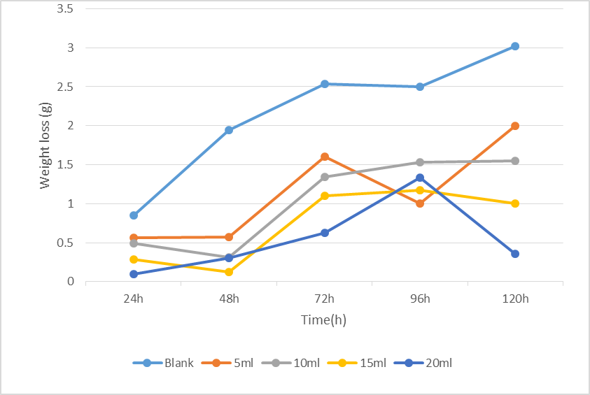
Figure 1(b) A graph of weigh loss (g) against time (hours) with and without CLE in 0.5 M H₂SO₄
Weight loss in HCl
The weight loss of the coupons under uninhibited (blank) and inhibited (with CSE and CLE) conditions in 0.5 M of HCl are shown in Table 2 while the graphical representations are presented in Figure 2.
Table 2: Calculated values of weight loss for mild steel in 0.5 M HCl in the absence and presence of caladium tricolor extract (CSE and CLE).
Time  Concentration (CSE) | 24h | 48h | 72h | 96h | 120h
Blank | 0.10 | 0.11 | 0.39 | 0.33 | 0.53
5ml | 0.02 | 0.02 | 0.06 | 0.01 | 0.05
10ml | 0.05 | 0.03 | 0.06 | 0.06 | 0.05
15ml | 0.02 | 0.07 | 0.05 | 0.06 | 0.04
20ml | 0.01 | 0.03 | 0.05 | 0.07 | 0.05
Concentration (CLE)  Blank | 0.10 | 0.11 | 0.39 | 0.33 | 0.53
5ml | 0.03 | 0.05 | 0.03 | 0.04 | 0.06
10ml | 0.03 | 0.04 | 0.04 | 0.05 | 0.06
15ml | 0.02 | 0.04 | 0.04 | 0.06 | 0.08
20ml | 0.02 | 0.03 | 0.05 | 0.06 | 0.10

Figure 2: (a) A graph of weigh loss (g) against time (hours) with and without CSE in 0.5 M HCl
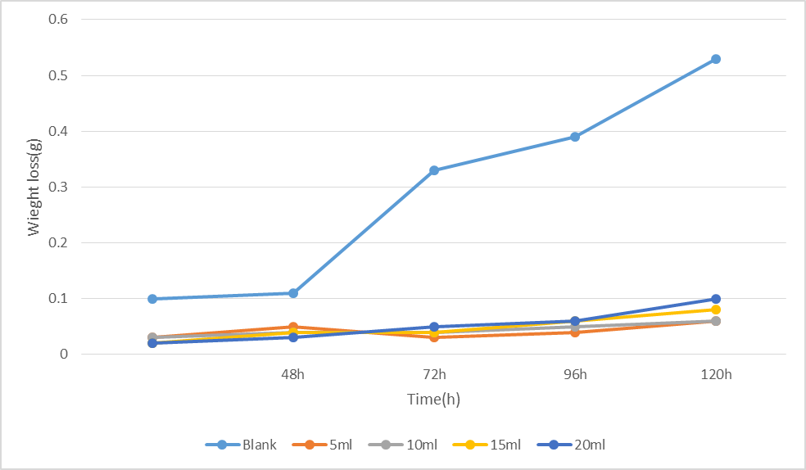

Figure 2 (b) A graph of weigh loss (g) against time (hours) with and without CLE in 0.5 M HCl

Corrosion rate in Sulphuric Acid (H₂SO₄)
The calculated data for corrosion rate of mild steel in 0.5 M H₂SO₄ under uninhibited(blank) and inhibited conditions are presented in Table 3, while Figures 3a and 3b shows the graphical representation of the corrosion rate of mild steel in 0.5M H₂SO₄ under blank and inhibited(with CSE and CLE) conditions.
Table3: Calculated values of corrosion rate and inhibitor efficiency for mild steel in 0.5M H₂SO₄ in the absence and presence of caladium tricolor extracts from weight loss measurement.

CORROSSION RATE(MM/YR) |  |  |  |  |  | INHIBITOR EFFICIENCY (%)
Time Concentrations | 24h | 48h | 72h | 96h | 120h | 24h | 48h | 72h | 96h | 120h
H₂SO₄
CSE  Blank | 49.96 | 55.32 | 47.69 | 34.56 | 32.43
5ml | 24.52 | 22.60 | 17.55 | 4.71 | 24.75 | 50.92 | 59.15 | 63.20 | 86.37 | 24.61
10ml | 11.00 | 16.69 | 18.92 | 6.11 | 3.43 | 77.98 | 69.83 | 60.33 | 82.32 | 89.42
15ml | 4.68 | 6.70 | 16.18 | 4.26 | 2.94 | 90.63 | 87.89 | 60.07 | 87.67 | 90.93
20ml | 0.54 | 3.93 | 11.68 | 15.94 | 14.95 | 98.92 | 92.90 | 75.51 | 53.88 | 53.90
CLE  Blank | 49.96 | 55.32 | 47.69 | 34.56 | 32.43
5ml | 31.25 | 16.67 | 31.00 | 13.91 | 0.56 | 36.94 | 69.87 | 34.40 | 59.75 | 31.02
10ml | 28.21 | 9.15 | 26.30 | 0.85 | 21.55 | 43.08 | 83.46 | 44.85 | 37.64 | 45.08
15ml | 8.30 | 3.32 | 20.91 | 0.71 | 25.01 | 95.09 | 94.00 | 56.15 | 27.63 | 63.58
20ml | 5.70 | 8.72 | 11.65 | 0.73 | 19.70 | 88.50 | 84.24 | 75.57 | 43.00 | 87.26

Figure 3(a) A graph of corrosion rate (mm/yr) against time (hours) with and without CSE in 0.5 M H₂SO₄
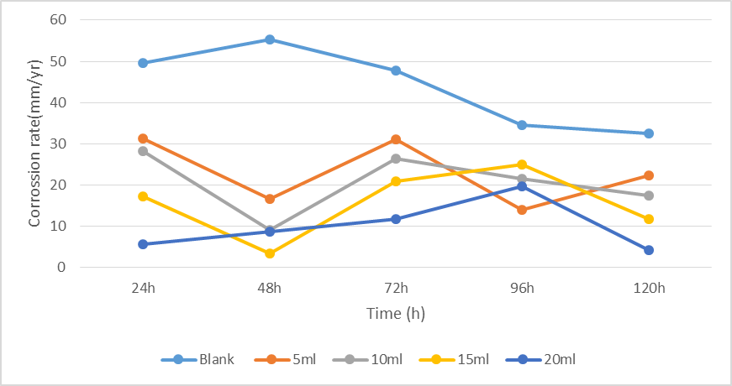
Figure 3(b) A graph of corrosion rate (mm/yr) against time (hours) with and without CLE in 0.5 M H₂SO₄

Corrosion rate in Hydrochloric Acid (HCl)
The calculated data for corrosion rate of mild steel in 0.5 M HCl under uninhibited(blank) and inhibited conditions are presented in Table 4, while Figures 4a and 4b shows the graphical representation of the corrosion rate of mild steel in 0.5M HCl under blank and inhibited (with CSE and CLE) conditions.

Figure 4(a) A graph of corrosion rate (mm/yr) against time (hours) with and without CSE in 0.5 M HCl

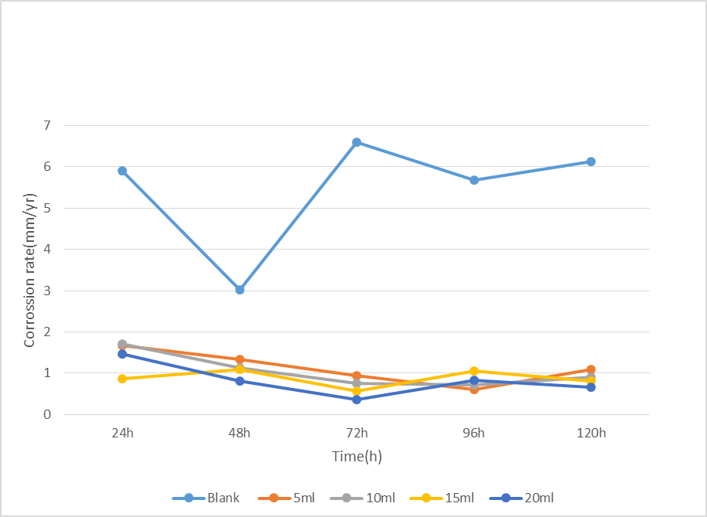

Figure 4(b) A graph of corrosion rate (mm/yr) against time (hours) with and without CLE in 0.5 M HCl

Table 4: Calculated values of corrosion rate and inhibitor efficiency for mild steel 0.5MHCl in the absence and presence of caladium tricolor extracts from weight loss measurement.
CORROSSION RATE(MM/YR) |  |  |  |  |  | INHIBITOR EFFICIENCY (%)
Time Concentrations | 24h | 48h | 72h | 96h | 120h | 24h | 48h | 72h | 96h | 120h
HCl
CSE  Blank | 5.91 | 3.02 | 6.60 | 5.68 | 6.12
5ml | 1.54 | 0.95 | 2.10 | 1.85 | 1.86 | 73.92 | 68.54 | 68.18 | 67.37 | 69.61
10ml | 1.30 | 0.87 | 1.92 | 1.17 | 1.08 | 77.98 | 71.19 | 70.90 | 79.32 | 82.42
15ml | 0.84 | 0.70 | 1.45 | 1.04 | 0.92 | 85.63 | 76.82 | 78.00 | 81.67 | 84.93
20ml | 0.07 | 0.26 | 0.65 | 0.80 | 0.95 | 98.95 | 91.39 | 90.15 | 85.88 | 84.47
CLE  Blank | 5.91 | 3.02 | 6.60 | 5.68 | 6.12
5ml | 1.69 | 1.34 | 0.94 | 0.60 | 1.09 | 71.57 | 55.26 | 85.76 | 89.43 | 82.19
10ml | 1.70 | 1.13 | 0.76 | 0.72 | 0.90 | 71.24 | 62.17 | 88.48 | 88.55 | 85.29
15ml | 0.86 | 1.10 | 0.57 | 1.05 | 0.81 | 85.45 | 63.16 | 91.36 | 82.92 | 86.76
20ml | 1.47 | 0.82 | 0.36 | 0.83 | 0.67 | 75.13 | 72.37 | 94.55 | 86.62 | 89.05

- Discussion
Table 1 and Table 2 presents calculated values of weight loss (∆W) of mild steel in the absence and presence of different concentration of caladium tricolor leaves extracts (CSE and CLE) in 0.5M H₂SO₄ and 0.5M HCL at different time interval. Figures 1 and Figure 2 represents the graphical representation of weight loss against time for mild steel in 0.5M H₂SO₄ and 0.5M HCL without and with caladium tricolor leaves extract (CSE and CLE). The two tables clearly show a reduction in weight loss of the metal coupons in the presence of the inhibitor compared to the blank solution.
These Figures reveals that weight loss of the metal coupon increases with increase in the period of contact with the acidic media but decreases with increasing concentration of Caladium Tricolor extracts (CSE and CLE), indicating that caladium tricolor extracts inhibited the corrosion of mild steel at all concentrations in solutions of HCL and H₂SO₄. It is also clear that caladium tricolor leaves extracts inhibited corrosion at all concentrations. These results obtained are in tandem with works [19-21] where leave extracts of different origin inhibited corrosion with increase in concentration.
While both CSE and CLE inhibit corrosion in acid medium, weight loss of coupons in the presence of CSE as inhibitor is generally low (although with some flunctuations) compared to that of coupons in which CLE is used as inhibitor.
The synergistic combination of all the phytochemical constituents such as saponins, flavonoids, terpenes/steroids and carbohydrates [22] could be responsible for the passivity and hence very good inhibition in the test medium observed that as the concentration of caladium tricolor leaves extract (inhibitor) in 0.5M H₂SO₄ and 0.5M HCL increases, the weight loss of mild steel decreases.

Corrosion Rate and Inhibitor Efficiency
Tables 3 and 4 present the calculated values of corrosion rate and inhibition efficiency for mild steel in 0.5 M H₂SO₄ and 0.5 M HCl, respectively, in both the absence and presence of Caladium tricolor leaf extracts (CSE and CLE). The results indicate that the corrosion rate of mild steel increases with prolonged exposure time but decreases significantly with increasing concentrations of the inhibitor. This trend confirms the effectiveness of the plant extracts in mitigating corrosion of mild steel in both acidic media.
Furthermore, the inhibition efficiency of Caladium tricolor extracts was observed to increase progressively with increasing inhibitor concentration. This behaviour is characteristic of effective corrosion inhibitors, as higher concentrations enhance surface coverage and protective film formation on the metal substrate [23–25]. The observed trend thus substantiates the potential of Caladium tricolor extracts as efficient, eco-friendly corrosion inhibitors in both 0.5 M HCl and 0.5 M H₂SO₄ environments.
Notably, the extracts exhibited significant inhibitory performance at all tested concentrations. This effect may be attributed to the adsorption of active phytochemical constituents present in the leaf extract onto the mild steel surface, forming a protective barrier that limits metal dissolution. Supporting evidence for this adsorption mechanism was provided by the observed change in colour of the metal coupons following immersion and subsequent rigorous cleaning. The persistence of this colour change suggests the formation of a stable adsorbed layer on the metal surface, which is consistent with previously reported findings by Helen et al. [26]. Collectively, these results highlight the strong adsorption capacity and corrosion inhibition potential of Caladium tricolor extracts in acidic environments.
Though both CSE and CLE inhibited corrosion, result shows that CSE is more efficient in both 0.5M H₂SO₄ and 0.5 M HCl. In H₂SO₄, CSE has the highest inhibitor efficiency (98.92%) when its concentration is 20 ml for coupon exposed to acidic medium for 24hours, while the maximum inhibitor efficiency of CLE in H₂SO₄ is 94.50%. This is further supported by the result obtained in HCL in which the maximum inhibitor efficiency of CSE is 98.92% while that of CLE is 94.55%. This shows that both CSE and CLE are more efficient in HCl than in H₂SO₄.
Adsorption Considerations
To characterize the mode of adsorption of both CSE and CLE on mild steel in 0.5 M H₂SO₄ acid and 0.5M HCl solution, Surface coverage data calculated from inhibition efficiency were employed in determining the adsorption characteristics of the inhibitors. The adsorption isotherms gives an in depth information on adsorption mechanisms. Hence, the surface coverage (θ ) data obtained from gravimetric data for CSE and CLE in both media were fitted to various adsorption isotherms and langmuir isotherm gave a better fitting considering the R² values obtained for the four systems. For the Langmuir’s isotherm, plots of C/θ against C were plotted, linear plots were obtained and values of slope, R², and K are indicated in Table 5 below.
Table 5: : Linear regression parameters for Langmuir
SYSTEM | SLOPE | K | R²
CSE/H₂SO₄ | 0.7199 | 1.6346 | 0.9976
CLE/H₂SO₄ | 1.076 | 7.8309 | 0.9778
CSE/HCL | 0.901 | 3.2626 | 0.9588
CLE/HCL | 1.25 | 14.164 | 0.9743

- (b)

c (c) (d)
Figure5. Plots of Langmuir adsorption isotherms for (a) CSE/H₂SO₄ (b) CLE/H₂SO₄
(c) CSE/HCl (d) CLE/HCl.

From Table 5, the calculated values of Kads for CLE in both H₂SO₄ and HCl is 7.8309 and 14.164 respectively and this suggests that adsorption of CLE on the mild steel substrate was better than CSE confirming reports by Kabuka et al, [27] that plant stem often contain a higher concentration of specific, "heavy" secondary metabolites (like tannins, saponins, and specific alkaloids) compared to leaves, which are usually richer in chlorophyll, pigments, and lighter compounds. These pigments and lighter compounds could be assumed to be responsible for the enhanced inhibition efficacy.
- Conclusion
This work evaluated the use of caladium tricolor extracts as corrosion inhibitors for mild steel in acidic media (0.5M H₂SO₄ and 0.5M HCL) using gravimetric measurements. From the results and discussion in this work, the following were observed;
- Weight loss varies in the absence and presence of different concentrations of CSE and CLE in 0.5M H₂SO₄ and 0.5M HCL at different time interval and there were clearly reduction in weight loss of metal coupon in the presence of these in inhibitor compared to the blank solution.
- The corrosion rate for the mild steel samples was lower in the presence of the extracts compared to the acid solution without inhibitor. The corrosion rate decreases as the concentration of CSE and CLE increases, indicating that the rate of corrosion is dependent on the amount of inhibitor present.
- The inhibition efficiencies of the plant extracts increased with increase in extract concentration but varied with increase in immersion time. Type of acid, time, and acid concentration play a vital role in inhibition efficiency of the inhibitor. It has been observed that adsorption of inhibitor on mild steel in HCL environment is more spontaneous than in H₂SO₄ environment, leading to better inhibiting properties of inhibitor in HCl environment.
- Caladium tricolor leaf extract (CLE) exhibited better adsorption and inhibition efficiency than Caladium tricolor stem extract.
From the above findings, the caladium leaves extract could be confidently used in metal pickling and acid descaling processes.
Disclaimer (Artificial intelligence)

Author(s) hereby declare that NO generative AI technologies such as Large Language Models (ChatGPT, COPILOT, etc.) and text-to-image generators have been used during the writing or editing of this manuscript.

REFERENCES

- Karattu Veedu, K., Peringattu Kalarikkal, T., Jayakumar, N., & Gopalan, N. K. (2019). Anticorrosive Performance of Mangifera indica L. Leaf Extract-Based Hybrid Coating on Steel. ACS Omega, 4(6), 10176-10184. https://doi.org/10.1021/acsomega.9b00632
- Ogunleye, O. O., Arinkoola, A. O., Eletta, O. A., Agbede, O. O., Osho, Y. A., Morakinyo, A. F., & Hamed, J. O. (2020). Green corrosion inhibition and adsorption characteristics of Luffa cylindrica leaf extract on mild steel in hydrochloric acid environment. Heliyon, 6(1), e03205. https://doi.org/10.1016/j.heliyon.2020.e03205
- Al-Senani, G. M. (2020). Synthesis of ZnO-NPs Using a Convolvulus arvensis Leaf Extract and Proving its Efficiency as an Inhibitor of Carbon Steel Corrosion. Materials (Basel), 13(4). https://doi.org/10.3390/ma13040890
4. Cui, M., Yu, Y., & Zheng, Y. (2021). Effective Corrosion Inhibition of Carbon Steel in Hydrochloric Acid by Dopamine-Produced Carbon Dots. Polymers (Basel), 13(12). https://doi.org/10.3390/polym13121923
5. Hoai Vu, N. S., Hien, P. V., Mathesh, M., Hanh Thu, V. T., & Nam, N. D. (2019). Improved Corrosion Resistance of Steel in Ethanol Fuel Blend by Titania Nanoparticles and Aganonerion polymorphum Leaf Extract. ACS Omega, 4(1), 146-158. https://doi.org/10.1021/acsomega.8b02084
6. Martins, G. R., Guedes, D., Marques de Paula, U. L., de Oliveira, M., Lutterbach, M. T. S., Reznik, L. Y., Servulo, E. F. C., Alviano, C. S., Ribeiro da Silva, A. J., & Alviano, D. S. (2021). Acai (Euterpe oleracea Mart.) Seed Extracts from Different Varieties: A Source of Proanthocyanidins and Eco-Friendly Corrosion Inhibition Activity. Molecules, 26(11). https://doi.org/10.3390/molecules26113433
7. Valdez-Salas, B., Vazquez-Delgado, R., Salvador-Carlos, J., Beltran-Partida, E., Salinas-Martinez, R., Cheng, N., & Curiel-Alvarez, M. (2021). Azadirachta indica Leaf Extract as Green Corrosion Inhibitor for Reinforced Concrete Structures: Corrosion Effectiveness against Commercial Corrosion Inhibitors and Concrete Integrity. Materials (Basel), 14(12). https://doi.org/10.3390/ma14123326
8. Verma, C., Quraishi, M. A., Alfantazi, A., & Rhee, K. Y. (2021). Corrosion inhibition potential of chitosan based Schiff bases: Design, performance and applications. Int J Biol Macromol, 184, 135-143. https://doi.org/10.1016/j.ijbiomac.2021.06.049
9. Anyiam, C.K., Ogbobe, O., Oguzie, E.E. et al. Corrosion inhibition of galvanized steel in hydrochloric acid medium by a physically modified starch. SN Appl. Sci. 2, 520 (2020). https://doi.org/10.1007/s42452-020-2322-2
10. Anyiam, C.K., Ogbobe, O., Oguzie, E.E. et al. Synergistic Study of Modified Sweet Potato Starch and KI for Corrosion Protection of Mild Steel in Acidic Media. J Bio Tribo Corros 6, 70 (2020). https://doi.org/10.1007/s40735-020-00362-x
11. Nwanonenyi, S.C., Obasi, H.C., Oguzie, E.E. et al. Inhibition and Adsorption of Polyvinyl Acetate (PVAc) on the Corrosion of Aluminium in Sulphuric and Hydrochloric Acid Environment. J Bio Tribo Corros 3, 53 (2017). https://doi.org/10.1007/s40735-017-0114-z
12. Dehghani, A., Bahlakeh, G., & Ramezanzadeh, B. (2019). Green Eucalyptus leaf extract: A potent source of bio-active corrosion inhibitors for mild steel. Bioelectrochemistry, 130, 107339. https://doi.org/10.1016/j.bioelechem.2019.107339
13. Ehsani, A., Mahjani, M. G., Hosseini, M., Safari, R., Moshrefi, R., & Mohammad Shiri, H. (2017). Evaluation of Thymus vulgaris plant extract as an eco-friendly corrosion inhibitor for stainless steel 304 in acidic solution by means of electrochemical impedance spectroscopy, electrochemical noise analysis and density functional theory. J Colloid Interface Sci, 490, 444-451. https://doi.org/10.1016/j.jcis.2016.11.048
14. Kamaruzzaman, W., Fekeri, M. F. M., Nasir, N. A. M., Hamidi, N., Baharom, M. Z., Adnan, A., Shaifudin, M. S., Abdullah, W. R. W., Wan Nik, W. M. N., Suhailin, F. H., Matori, K. A., Kien, C. S., Zaid, M. H. M., & Ghazali, M. S. M. (2021). Anticorrosive and Microbial Inhibition Performance of a Coating Loaded with Andrographis paniculata on Stainless Steel in Seawater. Molecules, 26(11). https://doi.org/10.3390/molecules26113379
15. Wang, Q., Tan, B., Bao, H., Xie, Y., Mou, Y., Li, P., Chen, D., Shi, Y., Li, X., & Yang, W. (2019). Evaluation of Ficus tikoua leaves extract as an eco-friendly corrosion inhibitor for carbon steel in HCl media. Bioelectrochemistry, 128, 49-55. https://doi.org/10.1016/j.bioelechem.2019.03.001
16. Okafor, P. C., Ikpi, M. E., Uwah, I. E., Ebenso, E. E., Ekpe, U. J., & Umoren, S. A. (2008). Inhibitory action of Phyllanthus amarus extracts on the corrosion of mild steel in acidic media. Corrosion Science, 50(8), 2310-2317. https://doi.org/https://doi.org/10.1016/j.corsci.2008.05.009
17. Nnanna, A. L., & Owate, I. O. (2014). An Interesting and efficient green corrosion Inhibitor for Aluminium from Extracts of Monriga Oleifa in acidic Solution. African Journals Online, 13.
18. Al-Turkustani, A. M., Arab, S. T., & Al-Qarni, L. S. S. (2011). Medicago Sative plant as safe inhibitor on the corrosion of steel in 2.0M H2SO4 solution. Journal of Saudi Chemical Society, 15(1), 73-82. https://doi.org/https://doi.org/10.1016/j.jscs.2010.10.008
19. Njoku, V. O., Oguzie, E. E., obi, C., & Ayuk, A., A. (2014). Baphia nitida Leaves Extract as a Green Corrosion Inhibitor for the Corrosion of Mild Steel in Acidic Medium. Advances in Chemistry, 10.
20. Vu, N. S. H., Hien, P. V., Man, T. V., Hanh Thu, V. T., Tri, M. D., & Nam, N. D. (2017). A Study on Corrosion Inhibitor for Mild Steel in Ethanol Fuel Blend. Materials (Basel), 11(1). https://doi.org/10.3390/ma11010059
21. Zheng, X., Gong, M., Li, Q., & Guo, L. (2018). Corrosion inhibition of mild steel in sulfuric acid solution by loquat (Eriobotrya japonica Lindl.) leaves extract. Sci Rep, 8(1), 9140. https://doi.org/10.1038/s41598-018-27257-9
22. Essien, E.E., Jacob, I.E., & Thomas, P.S. (2015). Phytochemical Composition, Antimicrobial and Antioxidant Activities of Leaves and Tubers of Three Caladium Species. International Journal of Medicinal Plants and Natural Products (IJMPNP) Volume 1, Issue 2, July - September 2015, PP 24-30 www.arcjournals.org
23. Camacho-Mendoza, R. L., Gutierrez-Moreno, E., Guzman-Percastegui, E., Aquino-Torres, E., Cruz-Borbolla, J., Rodriguez-Avila, J. A., Alvarado-Rodriguez, J. G., Olvera-Neria, O., Thangarasu, P., & Medina-Franco, J. L. (2015). Density Functional Theory and Electrochemical Studies: Structure-Efficiency Relationship on Corrosion Inhibition. J Chem Inf Model, 55(11), 2391-2402. https://doi.org/10.1021/acs.jcim.5b00385

24. Oukhrib, R., Abdellaoui, Y., Berisha, A., Abou Oualid, H., Halili, J., Jusufi, K., Ait El Had, M., Bourzi, H., El Issami, S., Asmary, F. A., Parmar, V. S., & Len, C. (2021). DFT, Monte Carlo and molecular dynamics simulations for the prediction of corrosion inhibition efficiency of novel pyrazolylnucleosides on Cu(111) surface in acidic media. Sci Rep, 11(1), 3771. https://doi.org/10.1038/s41598-021-82927-5
25. Ryl, J., Brodowski, M., Kowalski, M., Lipinska, W., Niedzialkowski, P., & Wysocka, J. (2019). Corrosion Inhibition Mechanism and Efficiency Differentiation of Dihydroxybenzene Isomers Towards Aluminum Alloy 5754 in Alkaline Media. Materials (Basel), 12(19). https://doi.org/10.3390/ma12193067
26. Helen, L., Rahim, A., Saad, B., Saleh, P., & Raja, B. (2014). Aquilaria Crassna Leave Extract - a Green Corrosion Inhibitor fpr Mild Steel in 1 M HCL Medium. International Journal of Electrochemical Science, 9, 830-846
27. Kabuka,R., Mudenda, S., Kampamba, M., Chulu, M., Chimombe, T. and Hikaambo, C.T.(2022)
Phytochemical Analysis of Leaf, Stem Bark, and Root Extracts of Cassia abbreviata Grown in Zambia. Pharmacology & Pharmacy, 13, 119-128. https://doi.org/10.4236/pp.2022.135009

