Physico-chemical characterisation of flotation iron tailings for potential industrial valorisation

Abstract
The mining company makes efforts to reduce the storage of huge amounts of waste, such as tailings, through reprocessing or using these unwanted materials as a marketable product. Nevertheless, the evaluation of these tailings is crucial for environmental sustainability and economic profit before their utilisation as raw material. The study aims to evaluate the physicochemical and mineralogical characteristics of iron-copper tailing collected at a depth of 2 m from a mining site in Türkiye by performing particle size, mineralogical, and chemical analyses. Representative samples were prepared through drying, grinding, homogenisation, and sieving prior to analysis. Comprehensive characterisation was performed, including determination of moisture content, pH, particle size distribution, mineralogical composition, and chemical properties. Mineralogical analyses were conducted using microscopic examination and X-ray diffraction techniques. The mineralogical analysis of the iron-copper tailing sample shows the presence of bornite, chalcopyrite, magnetite as primary sulfide minerals, and secondary sulfides are chalcocite-covellite and digenite. The mineralogical and chemical content analyses demonstrate that magnetite is abundant in the iron tailing. For the chemical analyses, the results show that the iron tailing sample contains chemical oxides, and a significant amount of silica and iron was determined in the iron-copper tailing, demonstrating that it is possible to use this type of tailing as an additive in cement production.
Keywords: Iron tailing, characterisation, mineralogical, chemical composition.

Introduction
Mining, mineral processing, and metallurgical processes generally produce two products, namely valuable products and wastes (unwanted products) (Zaid et al., 2025). For instance, the challenge of mining and industrial activities results in a large volume of waste due to the consequent decrease in high-grade ore reserves over the last few decades. Globally, over 100 billion tons of mining waste are generated per year (Makhathini et al., 2023; Whitworth et al., 2024). Mining activities are a potential source of environmental degradation, in particular through the destruction of arable land and the contamination of soil, surface, and groundwater (Coulıbaly et al., 2021). According to Lottermoser (2010), mining, beneficiation, and extraction of metallic ores with an average grade of approximately 0.5% produce 10,000 Mt of tailings, whereas 1230 Mt of tailings were produced from the production of 2460 t of gold with an average grade of approximately 2 ppm. China generates 1.5 tons of iron ore tailings for each ton of iron ore concentrate (Xu et al., 2019). Tailings, which are a mixture of non-economical crushed rock and processing fluids generated from a mill, washery or concentrator during mineral processing, are the main waste stream (Whitworth et al., 2024). Figure 1 illustrates the production of wastes by millions of tons worldwide (Vieira et al., 2021).
The waste produced in high volume may represent a serious problem for the environment because these wastes contain metals that are considered toxic and can cause several diseases in humans at high concentrations. Once heavy metals are released into the environment, they persist for long periods and accumulate in various ecological compartments. Increasing industrialisation, urbanisation, and consumption of goods have created a global challenge for waste generation (Kumar et al., 2023; Dubey et al., 2024). Inappropriate waste disposal is also an important parameter of metal contamination, and when these toxic metals are released into the atmosphere and interact with rainfall, they can cause substantial threats to the environment (Briffa et al., 2020; Masindi & Muedi, 2018; Musilova et al., 2016).
Efforts have been made by mining companies and the industry to stabilise these metals before disposal or recover metals with appropriate methods. To achieve better environmental, social, and economic outcomes, separation processes such as hydrometallurgy, pyrometallurgy, and bio-hydrometallurgy are employed to recover metal from wastes (Havlik et al., 2010; Hoque & Philip, 2011; Joo et al., 2015; Lee & Pandey, 2012; Syed, 2006). In terms of environmental protection and energy conservation, hydrometallurgy and bioleaching processes outperform the pyrometallurgical technique significantly (Joulié et al., 2014).
On the other hand, the hydrometallurgy and bioleaching processes may have major limitations throughout the recovery process. Longer recovery techniques (e.g., reduction leaching, solvent extraction, selective precipitation, or a combination of these) can substantially increase costs and complicate the recycling process in hydrometallurgical technologies (Chen et al., 2015; Lin & Chiu, 2015). The characterisation method can also pose challenges for mining companies, and it is important to know the characteristics of the tailings.
The present study includes the mechanical preparation (drying, grinding, homogenization), followed by performing the mineralogical analyses through the use of a microscope and X-ray diffractometer. Chemical analyses were conducted to determine chemical contents and metal concentrations.
Materials and Methods
Sample Collection and Preparation
The tailings samples were collected from the iron-copper ore mining company at a 2-meter depth, as shown in Figure 2. As the tailings samples contain a mixture of water and solid waste, mechanical preparation is necessary to get a representative sample. The different steps of this method are drying, grinding, homogenization, and sieving (See Figure 3). For instance, the collected iron tailing samples were first dried using the oven within 48 hours at 60 °C. In order to get the appropriate size, the iron tailings were ground by a rod mill and divided by a splitter riffle. In the characterisation of any sample, the representative sample is crucial; therefore, the iron tailings were homogenised using the coning and quartering method.

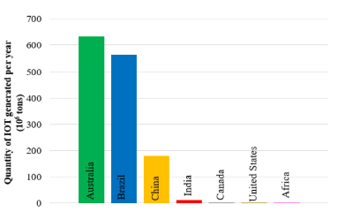
Figure 1. Tonnage of iron tailings produced annually in different countries (Vieira et al., 2021).
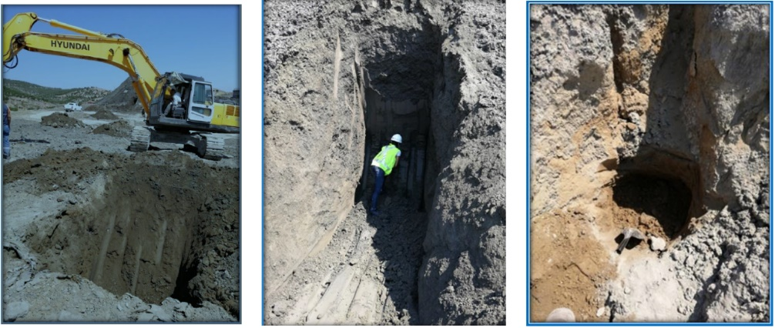
Figure 2. Iron tailings sampled from the mining site
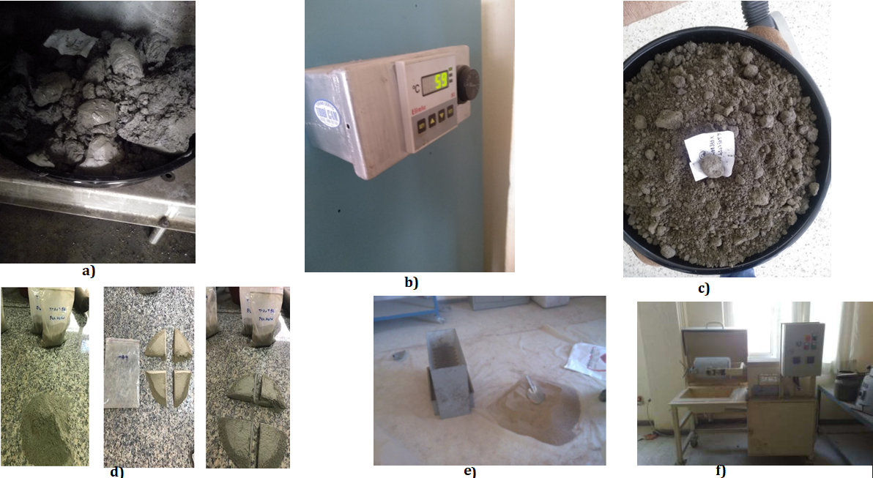
Figure 3. Mechanical preparation of the sample. (a), sample collected from the mining site, (b), samples drying at 60 °C, (c), dried sample, (d), homogenization and collection of representative samples, (e), samples division with a riffle splitter, (f), grinding the sample to a size less than 100 µm with a rod mill.

The different steps of the characterisation method include the determination of moisture content and pH, the analysis of particle size distribution and mineralogical composition using the X-ray diffraction method, and the test of chemical composition and metal content. Figure 4 illustrates the performed analyses in this study.
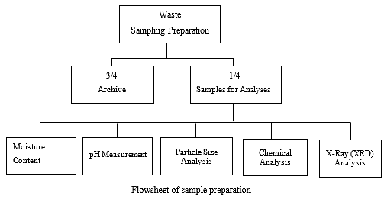
Figure 4. Flow chart of different analyses

Mineralogical Analyses of Tailing Sample
Mineralogical characterisation tests were performed by examining polished and thin sections using microscopic and X-ray diffraction methods at the Department of Geology, Dokuz Eylul University, Türkiye.
Moisture Content, pH, and Particle Size Distribution Tests
The test for moisture content was conducted by weighing the accurate weight of waste samples in the dry oven at 105 °C for 24 h. Afterwards, the dry samples were cooled in a desiccator, and the content was weighed with the precision balance (model Radwag). The moisture value was obtained by computing the difference between the initial weight (wet) and the dry weight of the sample. For instance, the RADWAG device (model MAC 210/WH) was used for the determination of water content and to compare the results obtained by the gravimetry method.
The determination of pH was conducted using a pH meter (model: Orion 4 Star) following the same procedure as USEPA (2004).
The Horiba LA-950 laser scattering analyser is utilised to obtain the particle size distribution of the iron tailing sample.
Chemical Composition and Metal Concentrations Tests
These tests were conducted in agreement with the previous study (Chapiou et al., 2022).
The major element tests were conducted with ground iron tailing (sample with particle sizes <100 μm). To accomplish that, 0.25 g of each sample was mixed thoroughly with 3 g of lithium tetracarbonate in the platinum crucible. The crucible and the mixture were put in the furnace for melting at 1100 °C within one and a half hours. After melting, the crucibles containing a mixture of waste sample and lithium tetracarbonate were cooled in a desiccator, and they were transferred to a 400 ml beaker, followed by the addition of 10% of 100 mL HCl. The mixture contents were heated until boiling in order to dissolve all elements. Thus, the solutions were poured into a flask and filled to 250 ml through the addition of de-ionised water, and the solution was analysed with an atomic absorption spectrometer (Perkin Elmer, model PinAAcle 500).
The iron tailing samples were digested by the CEM microwave (Model: Mars 6240/50, power: 400-1800) digestion system. This device is currently the most popular digestion system for acid leaching of heavy metals from solid samples and can heat up to forty samples in one run. To perform the leaching test, 10 ml HNO₃, 5ml HF, and 5ml of de-ionised water (2:1:1 ratio) were added to four TFM vessel liners containing 0.2g of waste sample (fly ash, iron-copper tailing, copper slag, and Pb-Zn mine waste) separately. Thus, the vessels are closed with the standard cover and are loaded in the CEM microwave. Before running the digestion, the temperature of the CEM microwave is adjusted to 200 °C within 15 minutes for ramping, and the same temperature (200 °C) is kept for 10 minutes, and then 50 °C in 15 minutes for cooling. After cooling, the leachate solution was put into a volumetric flask and filled to 250 ml volume using de-ionised water. The final step is the determination of heavy metal concentration in the leachate solution by inductively coupled plasma (ICP, model: Varian 710-ES ICP-OES).
Results and Discussions
Mineralogical Analyses
The purpose of the mineralogical method was to identify metallic minerals in the iron tailing sample. However, the analysis conducted using an optical microscope is very difficult to obtain findings related to the alteration of minerals and gangue. Therefore, the X-ray diffraction was also used to identify valuable minerals, gangue, alteration, and disseminated minerals.
Previous works have shown that the analysis of XRD is considered the most concise and useful technique for identifying the mineral composition in soil or powder samples (Bish, 1994; Holder & Schaak, 2019). As shown in Figure 5, the presence of certain minerals (chalcopyrite, magnetite, and hematite) was observed through the microscopic analysis. On the other hand, the results of X-ray analyses reveal that the iron tailing sample contains chalcopyrite and magnetite as primary sulfide minerals, and secondary sulfides are digenite (Figure 6). Similarly, has mentioned that the iron-copper skarn deposit in Ayvalik-Türkiye, the main valuable minerals are magnetite and chalcopyrite.

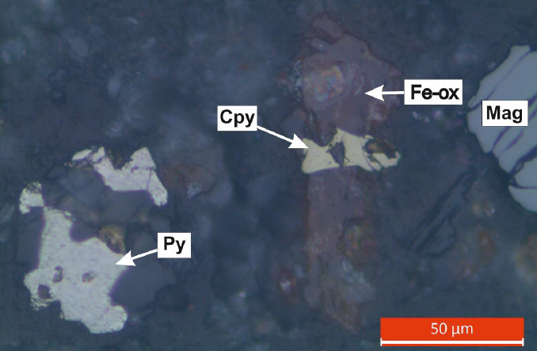
Figure 5. Image of mineralogical analysis of iron tailing

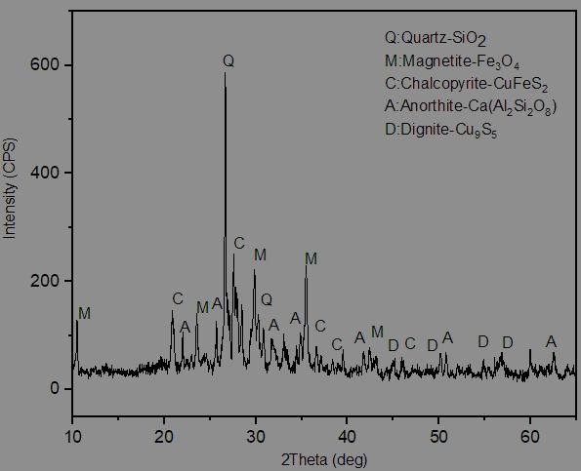
Figure 6. XRD pattern of iron-copper flotation tailing sample.

Physicochemical Properties
As seen in Figure 7, the curve of size distribution shows that 80% of particles are below 97.61μm, 30% of particles are under 16μm, and the median is 36.13μm.
The moisture content is about 22 per cent. The measured pH of the tailing sample after transferring to deionised water (1:10) in accordance with the USEPA procedure (2004) for pH measurement of soil and waste is 8.03.

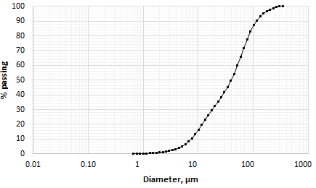
Figure 7. Size distribution of the iron tailing sample.
The results of chemical analyses in Table 1 indicated that iron tailing sample contains chemical oxides and are presented in order SiO₂ (45.83%); Fe₂O₃ (16.99%); CaO (11.99%); Al₂O₃ (8.95%); MgO (5.77%); K₂O (2.86%); Na₂O (1.46%); SO₃ (0.43%); TiO₂ (0.25%); MnO (0.19%) and loss of ignition (5.14%). In addition, high chemical oxide contents of ferric oxide and silicate were found in iron tailings, which can be used as raw materials in cement production. Our results are in agreement with the previous study that has shown the utilisation of iron tailings for the production of building materials such as bricks, ceramic tiles, cement, or concrete (Das et al., 2000; Kuranchie et al., 2015; Li et al., 2010).

Table 1. Percentage of chemicals in the tailing sample
Major elements
SiO₂ | 45.83
Al₂O₃ | 8.95
Fe₂O₃ | 16.99
CaO | 11.90
MgO8 | 5.77
Na₂O | 1.46
K₂O | 2.86
MnO | 0.19
TiO₂ | 0.25
SO₃ | 0.43
Table 2 presents the metal grades (%) in the tailing sample. From this table, it was observed that high concentrations of valuable metals were observed from two intervals of dimensions (i.e., ˗150+ 75 µm; and ˗75+38 µm). Particularly, the concentration of Fe is greater than that of any other metal. However, the concentration of Cu is higher than the maximum concentration of heavy metals for disposal to landfill. In the European Council, the limit concentration of Cu is 50-140 mg/kg (Beyer, 1990; Eijerick et al., 2006).
Table 2. Percentage of metal contents in iron tailing
Particle Size  (µm) | Weight  (%) | Cu  (%) | Fe  (%) | Mo  (%) | Au  (ppm) | Ag  (ppm) | Fe₂O₃  (%) | MoS₂  (%)
+300  ˗300+150  ˗150+75  ˗75+38  ˗38 | 2.76 | 0.20 | 1.94 | 0.02 | 1.63 | 2.90 | 17.06 | 0.03
+300  ˗300+150  ˗150+75  ˗75+38  ˗38 | 7.38 | 0.11 | 7.25 | 0.02 | ˂0.2 | 2.40 | 10.36 | 0.03
+300  ˗300+150  ˗150+75  ˗75+38  ˗38 | 17.93 | 0.09 | 9.65 | 0.03 | ˂0.2 | 2.80 | 13.79 | 0.05
+300  ˗300+150  ˗150+75  ˗75+38  ˗38 | 21.04 | 0.08 | 13.58 | 0.04 | ˂0.2 | 3.40 | 19.40 | 0.07
+300  ˗300+150  ˗150+75  ˗75+38  ˗38 | 50.99 | 0.14 | 12.31 | 0.02 | 0.2 | 2.6 | 17.59 | 0.03
 | 100.00

Conclusion
The characterisation of iron tailings provided important information on the characteristics of the tailing sample. Based on the findings, the study concludes:
- The mineralogical and chemical content analyses demonstrate that magnetite is abundant in the iron tailing.
- According to the particle size [75-38 µm], the results of chemical analyses show a high concentration of iron (13.58%) in the sample.
- This type of tailing sample can be sold to the cement company at a low price. Indeed, the iron-copper tailing is considered the commercially marketable product.
- The concentration of copper exceeds the permissible concentration for waste disposal, which could have a negative effect on the environment.

Disclaimer (Artificial intelligence)

Author(s) hereby declare that NO generative AI technologies such as Large Language Models (ChatGPT, COPILOT, etc.) and text-to-image generators have been used during the writing or editing of this manuscript.

References
Beyer, W. N. (1990). Evaluating soil contamination (Vol. 90, Issue 2). US Department of the Interior, Fish and Wildlife Service.
Bish, D. L. (1994). Quantitative x-ray diffraction analysis of soils. Quantitative Methods in Soil Mineralogy, 1988, 267–295. https://doi.org/10.2136/1994.quantitativemethods.c9
Briffa, J., Sinagra, E., & Blundell, R. (2020). Heavy metal pollution in the environment and their toxicological effects on humans. Heliyon, 6(9), e04691. https://doi.org/10.1016/j.heliyon.2020.e04691
Chapiou, M., Garba, S., Kaya, E., & Seyrankaya, A. (2022). Use of Monocalcium Phosphate Monohydrate for Chemical Immobilization of Heavy Metals Ions in Copper Smelting Slags Monokalsiyum Fosfat Monohidrat Kullanımı ile Bakır İzabe Cürufundaki Ağır Metal İyonlarının Kimyasal İmmobilizasyonu. 24(72), 973–981. https://doi.org/10.21205/deufmd.2022247225
Chen, X., Chen, Y., Zhou, T., Liu, D., Hu, H., & Fan, S. (2015). Hydrometallurgical recovery of metal values from sulfuric acid leaching liquor of spent lithium-ion batteries. Waste Management, 38(1), 349–356. https://doi.org/10.1016/j.wasman.2014.12.023
Das, S. K., Kumar, S., & Ramachandrarao, P. (2000). Exploitation of iron ore tailing for the development of ceramic tiles. Waste Management, 20(8), 725–729.
Eijerick, D. A. G. H., Prang, P. A. A. V. A. N. S., & Yfte, A. N. D. V. A. N. H. (2006). Models and Risk Characterization AMBIENT COPPER CONCENTRATIONS IN AGRICULTURAL AND NATURAL EUROPEAN SOILS : AN OVERVIEW. 25(3), 858–864.
Havlik, T., Orac, D., Petranikova, M., Miskufova, A., Kukurugya, F., & Takacova, Z. (2010). Leaching of copper and tin from used printed circuit boards after thermal treatment. Journal of Hazardous Materials, 183(1–3), 866–873. https://doi.org/10.1016/j.jhazmat.2010.07.107
Holder, C. F., & Schaak, R. E. (2019). Tutorial on Powder X-ray Diffraction for Characterizing Nanoscale Materials. ACS Nano, 13(7), 7359–7365. https://doi.org/10.1021/acsnano.9b05157
Hoque, M. E., & Philip, O. J. (2011). Biotechnological recovery of heavy metals from secondary sources-An overview. Materials Science and Engineering C, 31(2), 57–66. https://doi.org/10.1016/j.msec.2010.09.019
Joo, S. ho, Shin, S. M., Shin, D. ju, & Wang, J. P. (2015). Development of recycling technology to recover valuable metals from lithium primary and ion batteries. Proceedings of the Institution of Mechanical Engineers, Part B: Journal of Engineering Manufacture, 229, 212–220. https://doi.org/10.1177/0954405414567521
Joulié, M., Laucournet, R., & Billy, E. (2014). Hydrometallurgical process for the recovery of high value metals from spent lithium nickel cobalt aluminum oxide based lithium-ion batteries. Journal of Power Sources, 247, 551–555. https://doi.org/10.1016/j.jpowsour.2013.08.128
Kuranchie, F. A., Shukla, S. K., Habibi, D., & Mohyeddin, A. (2015). Utilisation of iron ore tailings as aggregates in concrete. Cogent Engineering, 2(1), 1083137.
Lee, J. chun, & Pandey, B. D. (2012). Bio-processing of solid wastes and secondary resources for metal extraction - A review. Waste Management, 32(1), 3–18. https://doi.org/10.1016/j.wasman.2011.08.010
Li, C., Sun, H., Bai, J., & Li, L. (2010). Innovative methodology for comprehensive utilization of iron ore tailings: Part 1. The recovery of iron from iron ore tailings using magnetic separation after magnetizing roasting. Journal of Hazardous Materials, 174(1–3), 71–77.
Lin, S. S., & Chiu, K. H. (2015). An evaluation of recycling schemes for waste dry batteries - A simulation approach. Journal of Cleaner Production, 93, 330–338. https://doi.org/10.1016/j.jclepro.2015.01.045
Lottermoser, B. (2010). Chapter 1. Mine Wastes. Characterization, Treatment and Environmental Impacts. In Mine Wastes.
Masindi, V., & Muedi, K. L. (2018). Environmental Contamination by Heavy Metals. Heavy Metals. https://doi.org/10.5772/intechopen.76082
Musilova, J., Arvay, J., Vollmannova, A., Toth, T., & Tomas, J. (2016). Environmental Contamination by Heavy Metals in Region with Previous Mining Activity. Bulletin of Environmental Contamination and Toxicology, 97(4), 569–575. https://doi.org/10.1007/s00128-016-1907-3
Oyman, T. (2010). Geochemistry , mineralogy and genesis of the Ayazmant Fe – Cu skarn deposit in Ayvalik ,. Ore Geology Reviews, 37(3–4), 175–201. https://doi.org/10.1016/j.oregeorev.2010.03.002
Syed, S. (2006). A green technology for recovery of gold from non-metallic secondary sources. Hydrometallurgy, 82(1–2), 48–53. https://doi.org/10.1016/j.hydromet.2006.01.004
United States Environmental Protection Agency (USEPA). (1992). Test methods for evaluating solid waste, laboratory manual physical/chemical methods. Office of Solid Waste and Emergency.
United States Environmental Protection Agency (USEPA). (2004). Method 9045D: revision 4, soil and waste pH: test methods for evaluating solid waste. Physical/chemical Methods Washington, D.C.
Vieira, S. S., Teixeira, A. P. C., & Lago, R. M. (2021). Iron Ore Tailings: Characterization and Applications. 32(10), 1895–1911.
Xu, D.-M., Zhan, C.-L., Liu, H.-X., & Lin, H.-Z. (2019). A critical review on environmental implications, recycling strategies, and ecological remediation for mine tailings. Environmental Science and Pollution Research, 26(35), 35657–35669.
Coulıbaly, S. L., Zahui, F. M., Mangoua-Allali, L. C., Cherif, A., & Coulibaly, L. (2021). Artisanal Mining Practice and Physical Impacts on the Environment in the Ity-Floleu Gold Region, Côte d’Ivoire. International Journal of Environment and Climate Change, 11(11), 17–31. https://doi.org/10.9734/ijecc/2021/v11i1130513
Kumar, V., Tyagi, S. J., Kumar, K., & Parmar, R. S. (2023). Heavy metal-induced pollution in the environment through waste disposal. International Journal of Research Publication and Reviews, 4(7), 1205-1210.
Dubey, D. K., Agarwal, S., Yadav, M. P., Goswami, A., & Ravat, A. (2024). The study of the effects of improper hazardous waste disposal on ecosystems. Indian Journal of Science and Research, 4(2), 130-136.
Whitworth, A. J., Forbes, E., Verster, I., Jokovic, V., Awatey, B., & Parbhakar-Fox, A. (2022). Review on advances in mineral processing technologies suitable for critical metal recovery from mining and processing wastes. Cleaner Engineering and Technology, 7, 100451.
Makhathini, T. P., Bwapwa, J. K., & Mtsweni, S. (2023). Various options for mining and metallurgical waste in the circular economy: A review. Sustainability, 15(3), 2518. https://doi.org/10.3390/su15032518
Zaid, O., Ahmed, M., Yosri, A. M., & Alshammari, T. O. (2025). Evaluating the impact of mine tailings wastes on the development of sustainable Ultra High Performance Fiber Reinforced concrete. Scientific Reports, 15(1), 6285.https://doi.org/10.1038/s41598-025-88683-0

