Effects of Cannabidiol and Tetrahydrocannabinol on Behavioral and Neurochemical Alterations in Experimental Parkinson’s Disease

Abstract:
Parkinson’s disease (PD) is a progressive and debilitating neurodegenerative disorder that predominantly affects the substantia nigra (SN) and the locus coeruleus. In rodent models, administration of reserpine has been shown to induce motor dysfunction alongside impairments in memory, cognition, and emotional regulation. The study aims to investigate the modulatory effects of cannabidiol and tetrahydrocannabinol on neurobehavioral, neurochemical, and histoarchitectural changes in a reserpine-induced Parkinson’s disease mouse model. Forty-two adult mice (25–32 g and 8–10 weeks old) of either sex were randomly divided into seven groups (n = 6). Parkinsonian-like symptoms were induced through intraperitoneal administration of reserpine (0.5 mg/kg) once daily for ten days. Twenty-four hours after the last reserpine injection, mice received intraperitoneal treatments of cannabidiol (30 mg/kg or 60 mg/kg), tetrahydrocannabinol (4 mg/kg or 6 mg/kg), or a combination of CBD (60 mg/kg) and THC (6 mg/kg) for fourteen consecutive days. The data from each group were analysed using one-way analysis of variance (ANOVA), followed by Tukey’s post-hoc test for multiple comparisons. Treatment with CBD at 30 mg/kg and 60 mg/kg showed a significant reduction (P < 0.001) in open arm avoidance (71.75 ± 0.85 % and 68.50 ± 1.66 % respectively) compared to the reserpine-only group (96.25 ± 3.75 %). The study concludes that cannabidiol and tetrahydrocannabinol modulate neurobehavioral, neurochemical and histoarchitectural changes in reserpine-induced Parkinson’s disease in mice by reducing anxiety, improving cognition, increasing serotonin levels in the brain and reducing neuronal damage. Further molecular investigations are required to determine alterations in gene and protein expression related to monoamine neurotransmission, oxidative stress, and neuroinflammatory processes in Parkinson’s disease. Additionally, future research should explore the long-term effects of chronic administration of cannabidiol (CBD) and tetrahydrocannabinol (THC) in the management of non-motor symptoms associated with Parkinson’s disease.

Keywords: Parkinson's disease, Cognitive change, Cannabidiol, Tetrahydrocannabinol, serotonin changes, Reserpine-induced

- Introduction
Parkinson’s disease (PD) is the second most prevalent neurodegenerative disorder, following Alzheimer’s disease (Kouli et al., 2018). It is a progressive and debilitating neurological condition that primarily affects the substantia nigra (SN) and the locus coeruleus. The disease often begins with subtle prodromal manifestations, such as hyposmia, and gradually progresses to pronounced impairments in motor function (Kumar et al., 2024). Beyond its characteristic motor symptoms, Parkinson’s disease also involves widespread non-motor disturbances, including anxiety, dizziness, constipation, pain, cognitive decline, and depressive symptoms, which considerably complicate disease management (Comi et al., 2014). Emerging evidence indicates that the underlying pathophysiological alterations may precede the onset of motor symptoms and encompass a range of non-motor features, such as sleep disturbances, depression, and cognitive impairment (Schrag et al., 2015).
The disease may originate in the peripheral autonomic nervous system or olfactory bulb, spreading to the central nervous system and eventually affecting the substantia nigra (Kouli et al., 2018). This progression explains early non-motor symptoms such as rapid eye movement sleep disorders, hyposmia, and constipation. Research indicates that symptoms like depression, tremor, constipation, fatigue, balance issues, and urinary dysfunction five years prior to diagnosis are strong predictors of PD (Schrag et al., 2015). As PD advances, motor symptoms such as tremor, rigidity, bradykinesia, and postural instability worsen, and complications from long-term levodopa therapy, including dyskinesias, non-motor fluctuations, and psychosis, become more challenging to manage (Kouli et al., 2018).
Reserpine, a pharmacological model of Parkinson’s disease (PD), acts as an inhibitor of vesicular monoamine transporter type 2 (VMAT2) (Bernstein et al., 2014). Its administration leads to depletion of monoamines in nerve terminals by impairing their vesicular storage and release. This reduction in monoamine levels results in hypolocomotion and muscular rigidity (Fernandes et al., 2012). In rodent models, reserpine induces not only motor impairments but also deficits in memory, cognition, and emotional behaviour (Santos et al., 2013). Its administration partially replicates the pathogenesis of PD, producing akinesia and rigidity that resemble key clinical features of the disorder (Fernandes et al., 2012; Telega et al., 2024). Furthermore, reserpine elicits several non-motor manifestations relevant to the prodromal stages of PD, including sleep disturbances, anxiety, depressive-like behaviour, and gastrointestinal dysfunction (Leal et al., 2016). Consequently, it is widely employed as an experimental model to investigate disease progression and the neurochemical alterations associated with PD (Leal et al., 2016).
For several decades, considerable scientific attention has been directed towards the role of the endocannabinoid system in the physiological regulation of conditions such as pain, nausea and vomiting, seizures, neuroprotection, anxiety, and multiple sclerosis (Fraguas-Sánchez and Torres-Suárez, 2018). The Cannabis sativa plant contains over 100 phytocannabinoids, which are categorised into 11 chemical classes (Corroon and Phillips, 2018). Among these, Δ9-tetrahydrocannabinol (Δ9-THC), a psychoactive compound, and cannabidiol (CBD), a non-intoxicating constituent, are the most extensively investigated (Abrams, 2018). Cannabinoid-containing products may be administered via several routes. Inhalation methods include smoking, water pipes, and vapour-based techniques such as vaporisation, dabbing, and nebulisation (Kocis and Vrana, 2020). Oral administration is also common, with cannabinoids delivered in the form of capsules, oils, solutions, or tinctures. Furthermore, they can be incorporated into food products, such as baked goods and confectionery, or infused into beverages (Corroon and Phillips, 2018). The aim of this research work was to investigate the modulatory effects of cannabidiol and tetrahydrocannabinol on neurobehavioral, neurochemical, and histoarchitectural changes in a reserpine-induced Parkinson’s disease mouse model.
2.0 Materials and Methods

2.1 Source of Materials
Cannabis sativa (National Drug Law Enforcement Agency, Kaduna State Command), Cannabidiol (Releaf Pharmaceuticals, South Africa), Tetrahydrocannabinol (extracted from cannabis sativa in the Department of Pharmacognosy, ABU Zaria), Reserpine (Shanghai Ideal Medical Tech. Co., Ltd, China; CAS No. 50-55-5), Ethyl acetate, Tween 80, ELISA kits (Wuhan Fine Biotech Co., Ltd, China) and Methylated spirit.

2.2 Instruments and equipment
Animal feed, plastic cages, hand gloves, hand towels, cotton wool, distilled water, face mask, feeders, markers, sawdust, stop watch, plain bottles, syringes and needles, water and weighing balance, dissecting kits and dissecting board.

2.3 Experimental animals
A total of forty-two (42) adult mice of either sex weighing between 25-32g, of ages between 8 to 10 weeks were used for the study. They were sourced from the Animal house, Department of Human Physiology, Ahmadu Bello University Zaria. Mice were fed with standard diet and allowed free access to drinking water.

2.3 Extraction of Δ⁹-tetrahydrocannabinol (THC)
Tetrahydrocannabinol (THC) was extracted from the dried cannabis sativa plant in the Department of Pharmacognosy, Ahmadu Bello University (ABU), Zaria, following a protocol adapted from WO2016/179247 A1. The process involved solvent extraction, phase separation, purification, and decarboxylation. Initially, the plant material was soaked in heptane for one hour at room temperature to dissolve Δ⁹-tetrahydrocannabinolic acid (THC-A). The extract was filtered through Celite to remove plant debris, then combined with an aqueous sodium chloride (NaCl) solution and adjusted to a high pH using sodium hydroxide (NaOH). This facilitated phase separation, where the middle oily layer, enriched with THC-A, was collected. Further washing and extraction using tert-butyl methyl ether (TBME) converted any remaining THC-A into its sodium salt, followed by acidification with hydrochloric acid (HCl) to regenerate THC-A. Purification was achieved by dissolving the crude THC-A in pentane and treating it with activated carbon. The pentane was then evaporated, yielding purified THC-A (97–99% purity). Decarboxylation was performed by dissolving the purified THC-A in ethanol and heating it at 90°C under a nitrogen atmosphere for 40 minutes, converting THC-A into Δ⁹-THC. The final product was extracted using pentane, dried over sodium sulphate (Na₂SO₄), and concentrated under vacuum, resulting in Δ⁹-THC with a purity of 92–94%, giving rise to a THC-rich extract.

2.4 Dose selection of cannabidiol and tetrahydrocannabinol
The doses of cannabidiol and tetrahydrocannabinol used in this study were selected based on a preliminary study and adopted LD₅₀ values from previous studies. The intraperitoneal LD₅₀ of THC in mice has been reported as approximately 454.5 mg/kg (Phillips et al., 1971). For cannabidiol, a reliable intraperitoneal LD₅₀ in mice has not been firmly established. However, studies report its low acute toxicity, with lethal doses rarely observed within the ranges used in experimental studies (Huestis et al., 2019). In our preliminary study, various doses of CBD (15, 30, and 60 mg/kg) and THC (2, 4, and 6 mg/kg) were evaluated through neurobehavioural assessments including the open field test, elevated plus maze, forced swim test, novel object recognition, and histological examination of the substantia nigra pars compacta. The doses of 60 mg/kg CBD and 6 mg/kg THC produced the most potent effects, followed by 30 mg/kg CBD and 4 mg/kg THC. Based on these findings, together with the reported LD₅₀ values, these doses were selected for use in the present study.

2.5 Animal groupings
Mice were divided randomly into 7 groups of 6 each as follows;

GROUP 1 (Normal Control): Distilled water (10 ml/kg i.p) (Aigbe et al., 2014)
GROUP 2: Reserpine only (Park et al., 2018)
GROUP 3: Reserpine + Cannabidiol (30 mg/kg i.p)
GROUP 4: Reserpine + Cannabidiol (60 mg/kg i.p)
GROUP 5: Reserpine + Tetrahydrocannabinol (4 mg/kg i.p)
GROUP 6: Reserpine + Tetrahydrocannabinol (6 mg/kg i.p)
GROUP 7: Reserpine + Cannabidiol (60 mg/kg i.p) + Tetrahydrocannabinol (6 mg/kg i.p)

2.6 Study design

2.6.1 Induction of Parkinson’s disease-like symptoms
In this study, induction of Parkinson’s disease-like symptoms was carried out by the administration of reserpine intraperitoneally at a dose of 0.5 mg/kg once per day for a period of 10 days, according to the procedure described by Park et al. (2018).

2.6.2 Preparation and administration of cannabidiol and tetrahydrocannabinol-rich extract
Cannabidiol was prepared by dispersing 1 mL of CBD oil in 19 mL of distilled water with 1 mL of Tween 80 to aid solubility. Tetrahydrocannabinol was prepared by dissolving 100 mg of THC-rich extract in 99 mL of distilled water and 1 mL of Tween 80. The solutions were stored appropriately until use. Twenty-four hours after the last day of reserpine administration, cannabidiol (30 mg/kg and 60 mg/kg), tetrahydrocannabinol (4 mg/kg and 6 mg/kg) and a combination of both (CBD: 60 mg/kg and THC: 6 mg/kg) were administered every day, intraperitoneally for a period of fourteen (14) days to their respective groups.

2.6.3 Neurobehavioural assessment
Following the fourteen (14) days administration of CBD and THC-rich extract, behavioural assessments commenced 24 hours after the final dose and were conducted for a period of two days, with one test per day: elevated plus maze for anxiety-like behaviour, and the novel object recognition test for working memory.
2.6.3.1 Elevated plus maze test
Anxiety was assessed using elevated plus maze (EPM) test as described by Komada et al. (2008). The elevated plus maze apparatus consisted of a "plus" shaped maze elevated above the floor with two oppositely positioned closed arms, two oppositely positioned open arms, and a centre area. Mice were allowed to explore an elevated platform (55 cm above the floor) consisting of the two opposing open (25 × 5 cm), and the two opposing closed arms (25 × 5 cm) with 15cm high wooden walls, for a total of 5 minutes. Mice were placed individually in the centre of the platform facing a closed arm. The behaviour of each mouse was recorded. Arm entries were defined as crossing of the centre point (located at approximately two thirds of the mouse body) into the arm. Percentage time spent in the open arms, arm entries and distance travelled were recorded. Index of open arm avoidance was calculated as:
Index of open arm avoidance = 100- [% time in open arm + % entries into open arm]
2
2.6.3.2 Novel object recognition test
The novel object recognition test (NORT) apparatus consisted of a rectangular arena constructed from opaque plastic, measuring 42 cm × 52 cm, with walls 40 cm in height (as illustrated in Plate 1). Mice were initially placed in the arena for a duration of 5 minutes during the sample phase, in which they were exposed to two identical objects. Upon completion of this phase, the animals were returned to their home cages for an inter-trial interval of 5 minutes (± 15 seconds). During the testing phase, the mice were reintroduced into the arena for 3 minutes, where one of the familiar objects was substituted with a novel object differing in both colour and shape. Following each trial, the arena and objects were thoroughly cleaned with 70% ethanol to eliminate potential olfactory cues. Exploratory behaviour was operationally defined as the mouse sniffing, gnawing, or touching the object with its nose, or orienting its head towards the object at a distance of less than 1.0 cm. The duration of time spent exploring both the familiar and novel objects was recorded. Successful recognition memory was indicated by a greater duration of exploration directed towards the novel object relative to the familiar one. The discrimination ratio was calculated as the time spent exploring the novel object divided by the total time spent exploring both objects, multiplied by 100 (Sivakumaran et al., 2018).
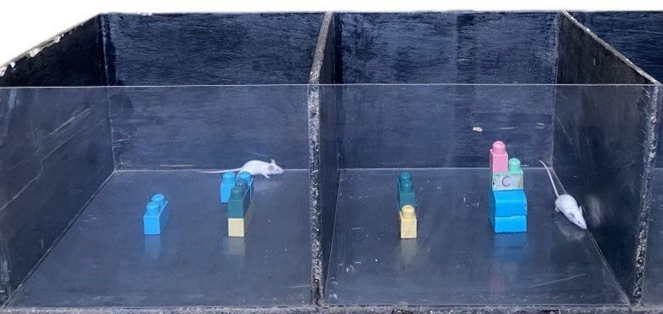
Plate 1: Assessment of working memory using NORT apparatus (Snapped by candidate, 2024)
2.6.4 Euthanasia
At the end of the experiment, mice were anaesthetized using the open-drop method, wherein each mouse was placed individually in a sealed chamber containing cotton wool as an absorbent material, soaked with ethyl acetate (Loru et al., 2010). This ensured controlled inhalation anaesthesia prior to brain extraction for further analysis. The study design is shown on table 1.

2.6.5 Neurochemical Assessment
At the end of the experiment, the animals were sacrificed. Brain of each animal was harvested and a sagittal dissection of the brain was carried out. The right half was homogenised in phosphate buffer solution, pH 7.4 and molar concentration, 0.1 M. The total homogenate was centrifuged for 5 minutes at 5,000 × g, and the supernatants were used to assess for dopamine and serotonin concentration.

Table 1: Study design
Activities | Duration | Days of Experiment
Acclimatisation | 7 days | Day 1-7
Induction of Parkinson’s-like symptoms | 10 days | Day 8-17
CBD and THC administration | 14 days | Day 18-31
Neurobehavioural assessment | 2 days | Day 32-33
Euthanasia and tissue collection | 1 day | Day 34
Neurochemical and histological assessment | 7 days | Day 35-41

2.7 Data Analysis
Data was analysed using Statistical Product and Service Solutions (SPSS) version 23.0 while GraphPad Prism version 10.2.0 (windows) was used for data visualisation. The data from each group were analysed using one-way analysis of variance (ANOVA), followed by Tukey’s post-hoc test for multiple comparisons. Data obtained were expressed as mean ± S.E.M and values of P$<$ 0.05 were considered statistically significant.

3.0 Results and Discussion
Figure 1: Effect of Cannabidiol and Tetrahydrocannabinol on Open Arm Avoidance Index using Elevated Plus Maze in Reserpine-induced Parkinson’s disease in mice. Res = Reserpine, CBD = Cannabidiol, THC = Tetrahydrocannabinol, *** = P < 0.001 (ANOVA).
In the Elevated Plus Maze test for anxiety (Figure 1), there was a significant increase (P < 0.001) in the index of open arm avoidance (%) in the reserpine-only treated group (96.25 ± 3.75 %) compared to the normal control group (67.25 ± 1.44 %). Treatment with CBD at 30 mg/kg and 60 mg/kg showed a significant reduction (P < 0.001) in open arm avoidance (71.75 ± 0.85 % and 68.50 ± 1.66 % respectively) compared to the reserpine-only group (96.25 ± 3.75 %). THC treated groups (4 mg/kg and 6 mg/kg) also significantly decreased (P < 0.001) the anxiety index (61.25 ± 4.13 % and 69.25 ± 5.63 % respectively) compared to the reserpine-only group. The combination of CBD and THC at doses of 60 mg/kg and 6 mg/kg respectively, resulted in an open arm avoidance index of 70.25 ± 0.85 %, which was comparable to the normal control group (67.25 ± 1.44 %) and significantly lower (P < 0.001) than the reserpine group.

Figure 2: Effect of Cannabidiol and Tetrahydrocannabinol on Working Memory using Novel Object Recognition Test in Reserpine-induced Parkinson’s model in mice. Res = Reserpine, CBD = Cannabidiol, THC = Tetrahydrocannabinol, n = 6, * = P < 0.05, ** = P < 0.01 and *** = P < 0.001 (ANOVA).
A significant decrease (P < 0.001) in the preference score (%) was observed in the reserpine-only treated group (28.00 ± 16.17 %) compared to the normal control group (83.00 ± 4.70 %). However, treatment with CBD (30 mg/kg and 60 mg/kg) resulted in a significant increase (P < 0.01 and P < 0.05 respectively) in the preference score (74.25 ± 3.77 % and 64.00 ± 2.08 % respectively) compared to the reserpine-only group. THC (4 mg/kg and 6 mg/kg) treated groups also showed significant increase (P < 0.001) with values of 79.50 ± 3.97 % and 83.50 ± 5.81 % respectively, compared to the reserpine-only group. Treatment with combination CBD and THC at doses of 60 mg/kg and 6 mg/kg respectively, indicated a significant increase (P < 0.001) in the preference score (79.75 ± 0.48 %) compared to reserpine-only group, but a decrease was observed compared to normal control group, although it was not significant (Figure 2.)
Figure 3: Effect of Cannabidiol and Tetrahydrocannabinol on Brain Serotonin Concentration in Reserpine-induced Parkinson’s disease in mice. Res = Reserpine, CBD = Cannabidiol, THC = Tetrahydrocannabinol, n = 6, * = P < 0.05 and ** = P < 0.01 (ANOVA).

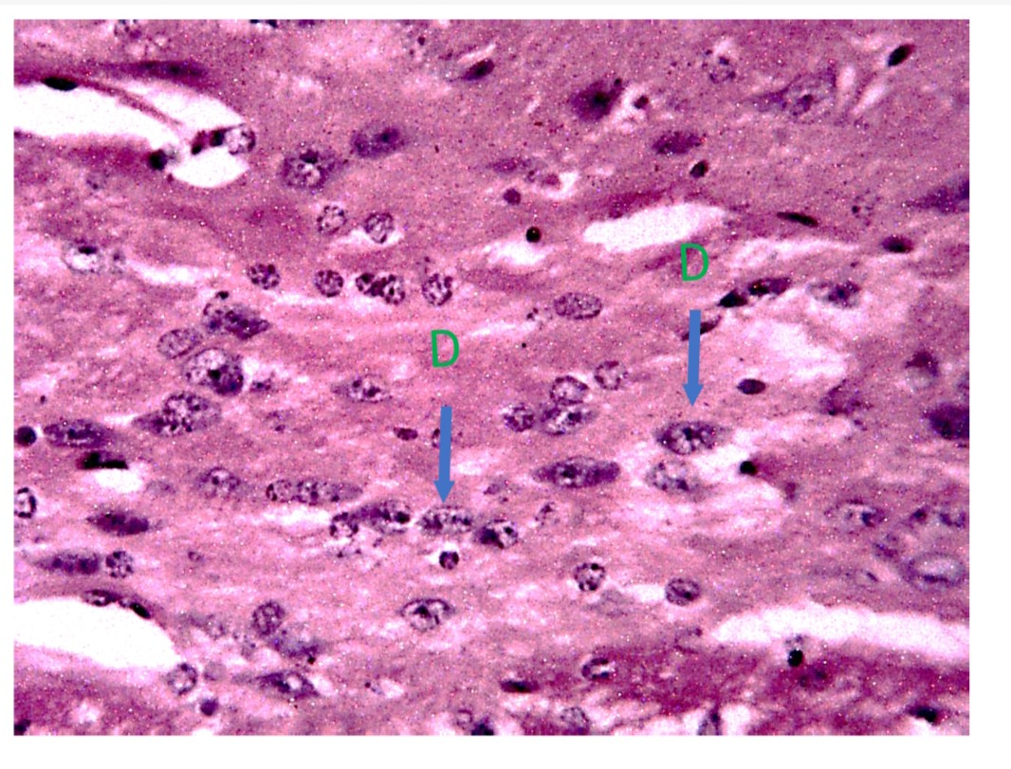
Plate 2: A section of the substantia nigra pars compacta of the control group treated with distilled water (10 ml/kg) showing relatively normal histoarchitectural feature: Dopaminergic neurone (D), (H and E x400).
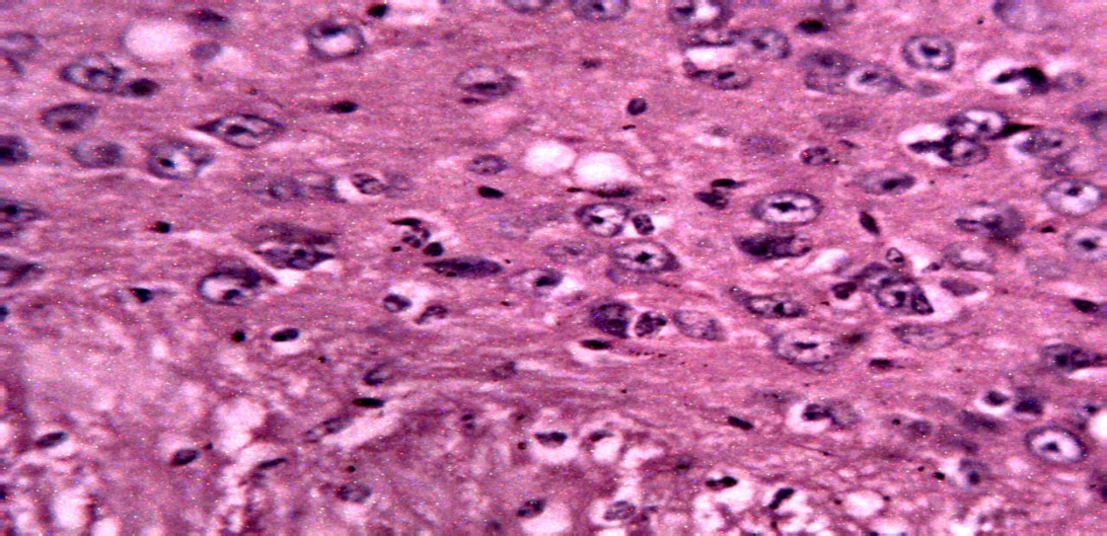
P
V
Plate 3: A section of the substantia nigra pars compacta treated with reserpine only showing relative histoarchitectural distortion: Reticulata (R); Pyknosis (P); Vacuolation (V) (H and E x400).
R

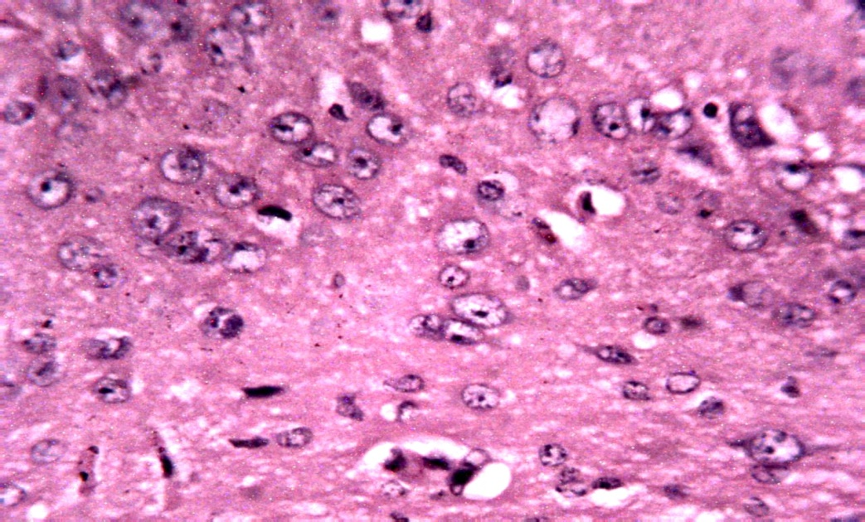
V
P
K

Plate 4: A section of the substantia nigra pars compacta treated with reserpine + CBD (30 mg/kg) showing relative histoarchitectural distortion: Pyknosis (P); Karyorrhexis (K); Vacuolation (V) (H and E x400).
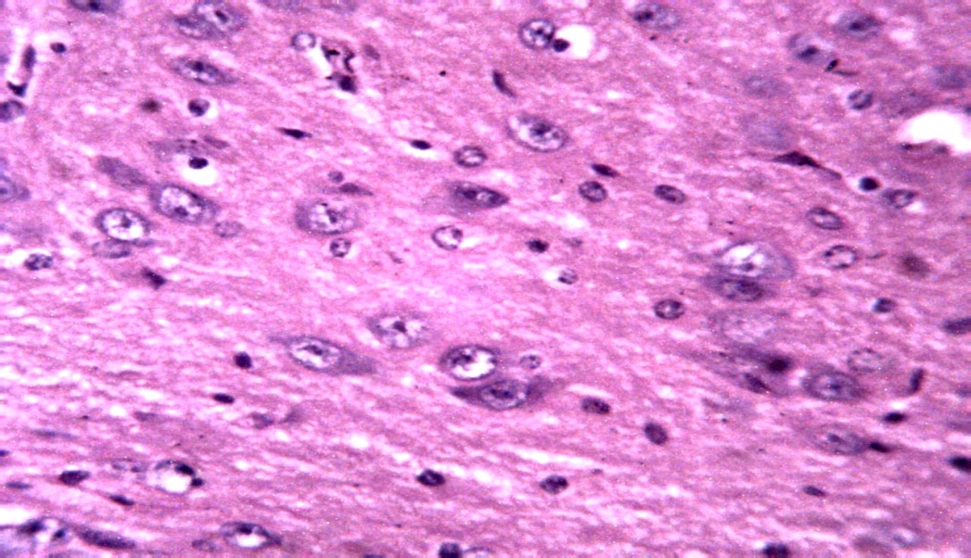
V
P

Plate 5: A section of the substantia nigra pars compacta treated with reserpine + CBD (60 mg/kg) showing relative histoarchitectural distortion: Pyknosis (P); Vacuolation (V) (H and E x400).

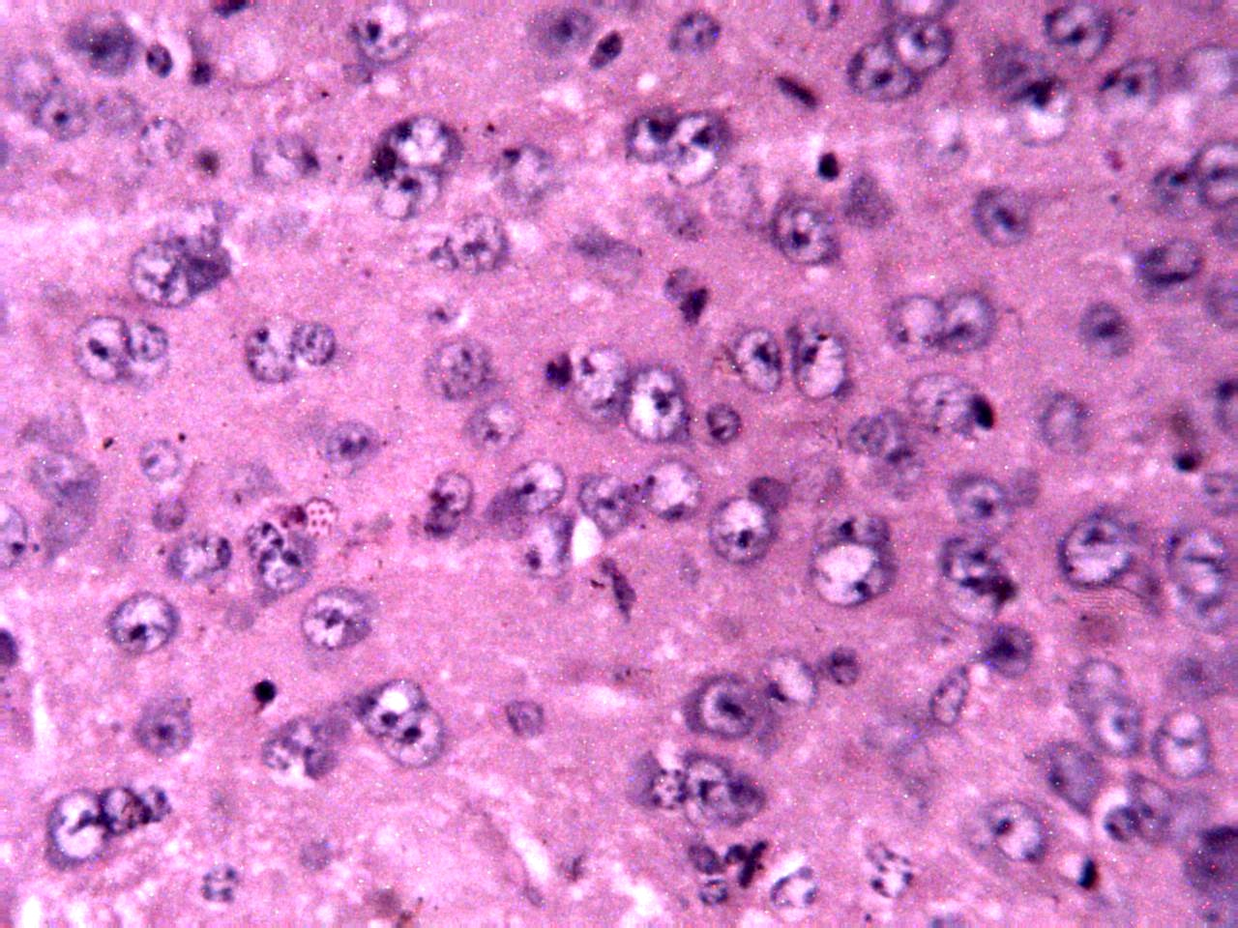
V
D
P
Plate 6: A section of the substantia nigra pars compacta treated with reserpine + THC (4 mg/kg) showing relative histoarchitectural distortion: Dopaminergic neurone (D); Pyknosis (P); Vacuolation (V) (H and E x400).

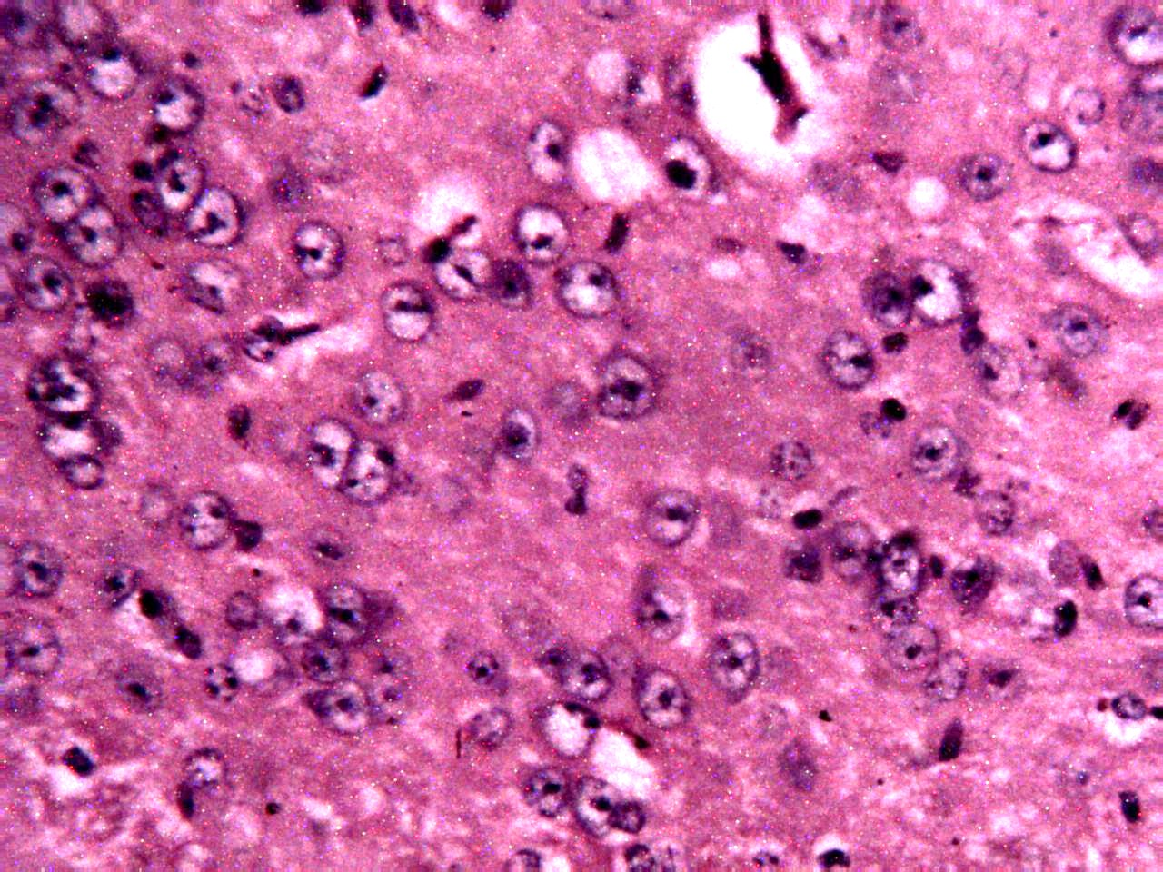
D
V
P
Plate 7: A section of the substantia nigra pars compacta treated with reserpine + THC (6 mg/kg) showing relative histoarchitectural distortion: Dopaminergic neurone (D); Pyknosis (P); Vacuolation (V) (H and E x400).

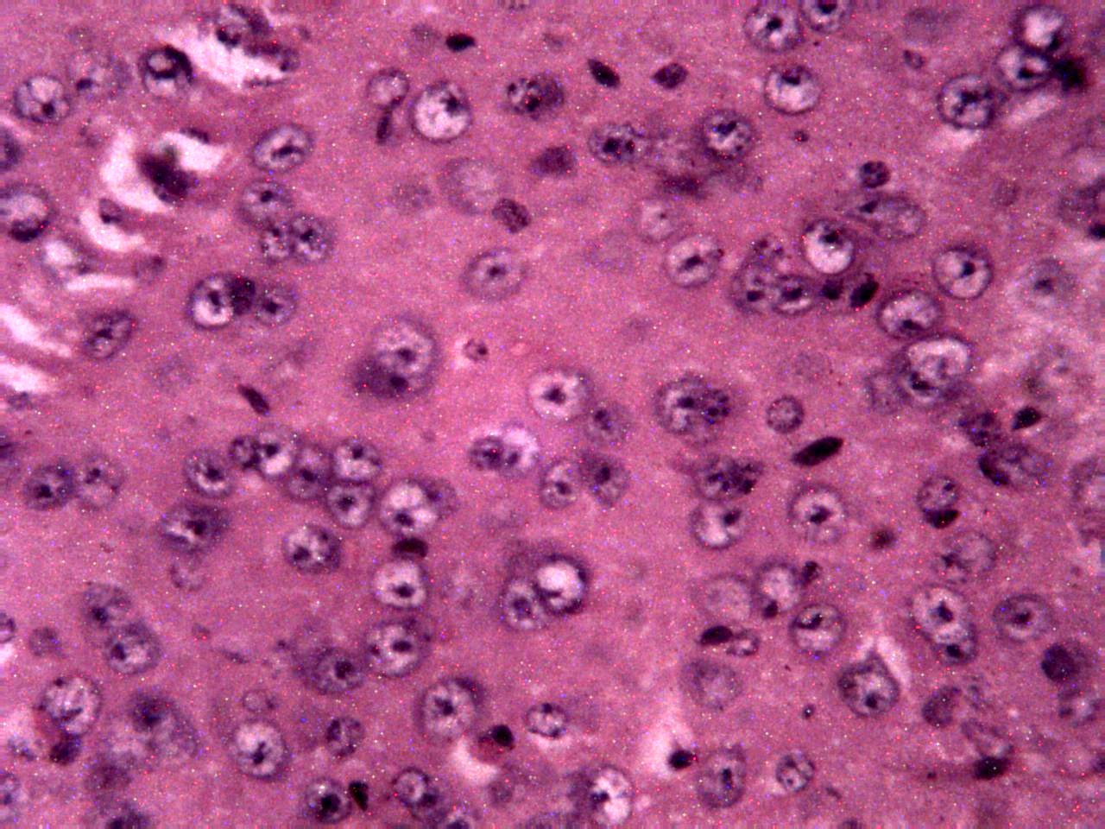
D
D
Plate 8: A section of the substantia nigra pars compacta treated with reserpine + CBD (60 mg/kg) + THC (6 mg/kg) showing relatively normal histoarchitectural feature: Dopaminergic neurone (D), (H and E x400).

3.1 Effects of Cannabidiol and Tetrahydrocannabinol on Anxiety using Elevated Plus Maze Test
In this study, we examined the effects of cannabidiol and tetrahydrocannabinol on anxiety in a reserpine-induced Parkinson’s disease model in mice. The observed increase in open arm avoidance caused by reserpine administration which is indicative of heightened anxiety, may be attributed to reserpine’s ability to deplete monoamines such as dopamine and serotonin, which are essential for regulating emotional and stress-related behaviours (Santos et al., 2013; Leal et al., 2016). Previous studies have shown that reserpine-induced monoamine depletion led to a decrease in the distance travelled in inner zone of the open field arena of open field test, indicating an anxiogenic effect (Park et al., 2018; Leal et al., 2019).
Previous studies showed that CBD at different doses produced an anxiolytic effect by increasing the open arm entries in the elevated plus-maze test (Schiavon et al., 2016). Similarly, in the present study, treatment with CBD reduced the open arm avoidance index, suggesting an anxiolytic effect. CBD's anxiolytic properties have been attributed to its modulation of serotonergic (5-HT1A) receptors and inhibition of FAAH (fatty acid amide hydrolase), leading to enhanced endocannabinoid signalling (Bih et al., 2015; Huestis et al., 2019; Naya et al., 2023). In contrast, in a previous study conducted by Naya et al., (2023), CBD exhibited a bell-shaped, dose response curve with the anxiolytic effects observed when administered with lower doses (2.5, 5.0 and 10.0 mg/kg), but not upon administration of higher dose, indicating a biphasic effect.
3.2 Effects of Cannabidiol and Tetrahydrocannabinol on Working Memory using Novel Object Recognition Test
The novel object recognition test is a commonly used behavioural assay for the investigation of various aspects of cognition. This test is based on the animal’s tendency to discriminate between a familiar and a novel object, where a high preference score is an indicator for adequate cognitive function (Cohen and Stackman-Jr., 2015). Some brain regions involved in cognition such as the hippocampal formation and prefrontal cortex are innervated by serotonergic afferent from the raphe complex and dopaminergic afferents originating in the mesocorticolimbic pathway (González-Burgos and Feria-Velasco, 2008). Reserpine depletes monoamines such as serotonin, dopamine and noradrenaline, which are crucial for normal cognitive functioning (Santos et al., 2013). In the present study, the decrease in the preference score observed due to reserpine administration may be related to these neurochemical changes. This finding is consistent with previous studies reporting that reserpine induces deficits in tasks requiring discrimination or recognition, due to its impact on neurotransmitter systems (Leal et al., 2019; Pereira, et al., 2020). In this study, administration of CBD, THC-rich extract and their combination improved preference score of novel object recognition test, demonstrating their potential cognitive-enhancing effects. CBD's neuroprotective and pro-cognitive properties have been attributed to its ability to modulate endocannabinoid signalling, enhance neurogenesis, and reduce oxidative stress and neuroinflammation in brain regions like the hippocampus, which are critical for memory and learning (García-Gutiérrez et al., 2020). Where the observed effect of THC could be due to its biphasic effect. At low doses, THC has the capacity to increase ACh levels by inhibiting AChE and prevent AChE-induced Aβ aggregation, thus improving memory and cognition (Calabrese and Rubio-Casillas, 2018). Our findings are in agreement with the study of Peres at al. (2016) which demonstrated that CBD was able to attenuate the reserpine-induced memory deficit in rats and that of Setlow et al. (2023) and Haghparast et al. (2023) which showed THC’s ability to enhance working memory in aged rats. Previous studies suggest that the combination of THC and CBD may offer a more effective therapeutic profile compared to the use of either cannabinoid alone (Stella, 2023).
3.3 Effects of cannabidiol and tetrahydrocannabinol on brain serotonin concentration
The finding that reserpine administration reduced brain serotonin concentration aligns with the ability of reserpine to deplete serotonin and other monoamines. This result is similar to the findings of Ahmed-Farid et al. (2021) who showed that reserpine administration significantly reduced the level of serotonin and other monoamines in the brain when used as a model of PD. Administration of CBD restored serotonin levels, suggesting its potential to modulate serotonergic pathways. This aligns with findings that CBD can ameliorate anxiety-like behaviours and restore impaired serotonergic transmission (De Gregorio et al., 2019). The THC-rich extract also elevated serotonin levels, with the lower dose yielding slightly greater effects, aligning with THC’s bimodal effect. This finding is in agreement with the work of Gobbi & Debonnel (2007), who demonstrated that low doses of THC increased serotonin levels, while higher doses led to a significant drop in serotonin levels. The combination of CBD and THC produced the most pronounced restoration of serotonin levels. This combination may enhance therapeutic outcomes by combining the anxiolytic properties of both compounds while mitigating potential adverse effects (Martin et al., 2021). This is consistent with the role of cannabinoids in modulating the serotonergic system, which is involved in mood regulation and depression (Jenny et al., 2010). Therefore, it appears that CBD and THC exerted their anxiolytic and antidepressant effects by increasing serotonin concentration in the brain. The presence of nonmotor features of PD has been associated with decreased serotonin concentration.

3.4 Effects of Cannabidiol and Tetrahydrocannabinol on the Histoarchitecture of the Substantia Nigra Pars Compacta of the Basal Ganglia
Plate 2 and 8 showed a relatively normal histoarchitectural feature with presence of normal dopaminergic neurones (having a large nuclei and prominent nucleoli) in the substantia nigra pars compacta of the basal ganglia. However, treatment with reserpine resulted in a distorted histoarchitecture with vacuolation, pyknosis and loss of dopaminergic neurones (Plate 3). Interestingly, treatment with CBD (30 mg/kg and 60 mg/kg) and THC (4 mg/kg and 6 mg/kg), showed moderate loss of dopaminergic neurones with decreased vacuolation and pyknosis (Plate 4, 5, 6, and 7).
In the current study, presence of intact dopaminergic neurones in plate 2, suggests absence of neurodegeneration, as expected in a healthy control group, which served as a baseline. Reserpine-only treated group demonstrated hallmark features of reserpine-induced neurodegeneration, including pyknosis, karyorrhexis, vacuolation and severe loss of dopaminergic neurones, which reflect apoptosis and cellular stress in the substantia nigra pars compacta (Plates 3). These findings align with previous studies which demonstrated that reserpine administration resulted in dopaminergic neuronal damage and apoptosis (Li et al., 2022). Limited neuroprotection was observed with CBD, while the lower dose showed karyorrhexis (nuclear fragmentation), suggesting ongoing and severe neuronal damage coupled with moderate loss of dopaminergic neurones and decrease in pyknosis and vacuolation, the higher dose offered more improvement in the histoarchitectural integrity showing more decreased pyknosis and vacuolation with presence of more dopaminergic neurones. Similarly, in a previous study conducted by Muhammad et al. (2022), C. elegans treated with CBD showed a diminished dopaminergic neurone degeneration induced by 6-hydroxydopamine (6-OHDA). Treatment with the THC-rich extract also resulted in the preservation of dopaminergic neurones, demonstrating limited neuroprotection, with features such as pyknosis and vacuolation persisting.
4.0 Conclusion and Recommendation
4.1 Conclusion
In conclusion, Cannabidiol and tetrahydrocannabinol were found to modulate neurobehavioral, neurochemical, and histoarchitectural changes in reserpine-induced Parkinson’s disease in mice. These effects were reflected in the reduction of anxiety-like behaviours, improvement in cognitive performance, increased serotonin levels in the brain, and a noticeable reduction in neuronal damage. The findings suggest that both CBD and THC, whether administered individually or in combination, may play a beneficial role in alleviating the neuropsychiatric and cognitive disturbances associated with Parkinson’s disease. Importantly, the combined treatment appeared to offer enhanced effects in some parameters, pointing to possible synergistic interactions between the two compounds. This highlights their potential as complementary therapeutic agents in the management of Parkinson’s disease beyond the traditional focus on motor symptoms. However, careful consideration of dosing remains essential, as the balance between therapeutic benefit and potential adverse effects is likely to be dose-dependent.
4.2 Recommendation
Molecular studies should be conducted to ascertain changes in gene and protein expression associated with monoamine neurotransmission, oxidative stress, and neuroinflammation in Parkinson's disease and also further studies should investigate the long-term effects of chronic CBD and THC administration in managing non-motor symptoms of PD.
Ethical Approval
Animal Ethic committee approval has been collected and preserved by the author(s)
Disclaimer (Artificial intelligence)

Author(s) hereby declare that NO generative AI technologies such as Large Language Models (ChatGPT, COPILOT, etc.) and text-to-image generators have been used during the writing or editing of this manuscript.
References

- Abrams, D. I. (2018). The therapeutic effects of Cannabis and cannabinoids: An update from the National Academies of Sciences, Engineering and Medicine report. European Journal of Internal Medicine, 49, 7-11.
- Bih, C. I., Chen, T., Nunn, A. V., Bazelot, M., Dallas, M. and Whalley, B. J. (2015). Molecular Targets of Cannabidiol in Neurological Disorders. Neurotherapeutics, 12, 699–730.
- Calabrese, E. J., and Rubio‐Casillas, A. (2018). Biphasic effects of THC in memory and cognition. European Journal of Clinical Investigation, 48(5), 12920.
- Cohen, S. J., and Stackman Jr., R. W. (2015). Assessing rodent hippocampal involvement in the novel object recognition task. A review. Behavioural Brain Research, 285, 105–117.
- Comi, C., Magistrelli, L., Oggioni, G. D., Carecchio, M., Fleetwood, T., Cantello, R., Mancini, F., Mauro, A., Pacchetti, C., Panzacchi, A., Riboldazzi, G., Romito, L. M., Sances, G., Sandrini, G., and Antonini, A. (2014). Peripheral nervous system involvement in Parkinson's disease: Evidence and controversies. Parkinsonism & Related Disorders, 20(12), 1329–1334.
- Corroon, J. and Phillips, J. A. (2018). A Cross-Sectional Study of Cannabidiol Users. Cannabis and cannabinoid research, 3(1), 152-161.
- Fernandes, V. S., Santos, J. R., Leão, A. H. F. F., Medeiros, A. M., Melo, T. G., Izídio, G. S., Cabral, A., Ribeiro, R. A., Abílio, V. C., Ribeiro, A. M., and Silva, R. H. (2012). Repeated treatment with a low dose of reserpine as a progressive model of Parkinson’s disease. Behavioural Brain Research, 231(1), 154–163.
- Fraguas-Sánchez, A. I. and Torres-Suárez, A. I. (2018). Medical use of cannabinoids. Drugs, 78(16), 1665-1703.
- Gonzalezburgos, I. and Feriavelasco, A. (2008). Serotonin/dopamine interaction in memory formation. Progress in Brain Research, 172, 603–623.
- Haghparast, E., Sheibani, V., Komeili, G., Chahkandi, M., and Rad, N. S. (2023). The effects of chronic marijuana administration on 6-ohda-induced learning & memory impairment and hippocampal dopamine and cannabinoid receptors interaction in male rats. Neurochemical Research, 48(7), 2220–2229.
- Henry, J. P., Sagne, C., Botton, D., Isambert, M. F., and Gasnier, B. (1997). Molecular pharmacology of the vesicular monoamine transporter. In Advances in Pharmacology (Vol. 42, pp. 236-239). Academic Press.
- Huestis, M. A., Solimini, R., Pichini, S., Pacifici, R., Carlier, J. and Busardò, F. P. (2019). Cannabidiol adverse effects and toxicity. Current neuropharmacology, 17(10), 974-989.
- Kocis, P. T., and Vrana, K. E. (2020). Delta-9-Tetrahydrocannabinol and Cannabidiol Drug-Drug Interactions. Medical cannabis and cannabinoids, 3(1), 61–73.
- Komada, M., Takao, K., and Miyakawa, T. (2008). Elevated plus maze for mice. Journal of Visualised Experiments, 22, 1088.
- Kouli, A., Torsney, K. M. & Kuan, W. L. (2018). Parkinson’s disease, aetiology, neuropathology, and pathogenesis. Exon Publications, 3-26.
- Kumar, L., Malhotra, M., Sharma, A., Singh, A. P., and Singh, A. P. (2024). A Holistic Approach to Parkinson's Disease: Integrating Advances in Pathophysiology, Diagnosis, and Therapy. Journal of Drug Delivery & Therapeutics, 14(5).
- Leal, P. C., Lins, L. C. R. F., De-Gois, A. M., Marchioro, M. and Santos, J. R. (2016). Commentary, evaluation of models of Parkinson’s disease. Frontiers in Neuroscience, 10, 283.
- Li, Y., Yin, Q., Wang, B., Shen, T., Luo, W., and Liu, T. (2022). Preclinical reserpine models recapitulating motor and non-motor features of Parkinson’s disease, Roles of epigenetic upregulation of alpha-synuclein and autophagy impairment. Frontiers in Pharmacology, 13, 944376.
- Loru, L., Sassu, A., Fois, X., and Pantaleoni, R. A. (2010). Ethyl acetate: A possible alternative for anaesthetizing insects. Annales de La Société Entomologique de France (N.S.), 46(3–4), 422–424.
- Muhammad, F., Liu, Y., Wang, N., Zhao, L., Zhou, Y., Yang, H., and Li, H. (2022). Neuroprotective effects of cannabidiol on dopaminergic neurodegeneration and α-synuclein accumulation in C. elegans models of Parkinson’s disease. NeuroToxicology, 93, 128–139.
- Naya, N., Kelly, J., Corna, G., Golino, M., Abbate, A., and Toldo, S. (2023). Molecular and Cellular Mechanisms of Action of Cannabidiol. Molecules (Basel, Switzerland), 28(16), 5980.
- Park, B.-K., Kim, Y. R., Kim, Y. H., Yang, C., Seo, C.-S., Jung, I. C., Jang, I.-S., Kim, S.-H., and Lee, M. Y. (2018). Antidepressant-like effects of gyejibokryeong-hwan in a mouse model of reserpine-induced depression. BioMed Research International, 2018, 1–12.
- Pereira, A. G., Poli, A., Matheus, F. C., da Silva, L. D. B., Fadanni, G. P., Izídio, G. S., Latini, A., and Prediger, R. D. (2020). Temporal development of neurochemical and cognitive impairments following reserpine administration in rats. Behavioural Brain Research, 383, 112517
- Peres, F. F., Levin, R., Suiama, M. A., Diana, M. C., Gouvêa, D. A., Almeida, V., Santos, C. M., Lungato, L., Zuardi, A. W., Hallak, J. E. C., Crippa, J. A., D’Almeida, V., Silva, R. H., & Abílio, V. C. (2016). Cannabidiol prevents motor and cognitive impairments induced by reserpine in rats. Frontiers in Pharmacology, 7, 343.
- Phillips, R. N., Turk, R. F. and Forney, R. B. (1971). Acute toxicity of Δ9-tetrahydrocannabinol in rats and mice. Proceedings of the Society for Experimental Biology and Medicine, 136(1), 260-263.
- Santos, J. R., Cunha, J. A. S., Dierschnabel. A. L., Campêlo, C. L. C., Leão, H. F. F. and Silva, A. F. (2013). Cognitive, motor and tyrosine hydroxylase temporal impairment in a model of parkinsonism induced by reserpine. Behavioural Brain Research, 253, 68–77.
- Schiavon, A. P., Bonato, J. M., Milani, H., Guimarães, F. S., and de Oliveira, R. M. W. (2016). Influence of single and repeated cannabidiol administration on emotional behaviour and markers of cell proliferation and neurogenesis in non-stressed mice. Progress in Neuro-Psychopharmacology and Biological Psychiatry, 64, 27-34.
- Schrag, A., Horsfall, L., Walters, K., Noyce, A. and Petersen, I. (2015). Prediagnostic presentations of Parkinson’s disease in primary care, A case-control study. The Lancet Neurology, 14(1), 57–64.
- Setlow, B., Zequeira, S., Gazarov, E., and Bizon, J. (2023). Effects of acute and chronic cannabis/cannabinoids on cognitive function across the lifespan. Innovation in Aging, 7(Supplement_1), 11–11.
- Stella, N. (2023). THC and CBD, Similarities and differences between siblings. Neuron, 111(3), 302-327.
- Telega, M. L., Berti, R., Blazhenets, G., Domogalla, L.-C., Steinacker, N., Omrane, M. A., Meyer, P. T., Coenen, V. A., Eder, A.-C., and Döbrössy, M. D. (2024). Reserpine-induced rat model for depression, Behavioural, physiological and PET-based dopamine receptor availability validation. Progress in Neuro-Psychopharmacology and Biological Psychiatry, 133, 111013.

