Case report
Postpartum Paraplegia a tragic event caused by an undiagnosed spinal Schwannoma following Cesarean Section: A Case Report with Literature Review

Abstract:
Background and Aim: Undiagnosed spinal cord tumors may be underlying cause responsible for a fatal event of paraplegia post cesarean section following spinal anesthesia. Intradural extramedullary spinal cord tumors undergo expansion and acute cord compression due to hemorrhage, hypervolemia, pressure and hormonal changes of pregnancy. Commonly Schwannoma and Ependymoma have been accidentally diagnosed in postpartum women suffering with neurological complaints with no previous medical or surgical co-morbidity.
Aim of the presentation is to promote awareness among clinicians to expedite MRI and surgery in case of sudden paraplegia indicating acute compression by a space occupying spinal cord lesion unveiling in pregnancy.
Presentation of the case: Presenting a case who suffered tragic paraplegia post cesarean section, underwent laminectomy with excision of the spinal tumor mass. Histopathology reported this lesion as ‘Schwannoma’. She was managed postoperatively with intense physiotherapy but continues to be paraplegic. A review of literature on spinal cord tumors and hematoma with management plan is described.
Discussion: Expansion or hemorrhage triggered by pregnancy changes or leak of cerebrospinal fluid impairs venous drainage to cause sudden acute spinal cord compression resulting in onset of paraplegia. Pregnancy compression of Inferior vena cava increases the venous engorgement in the spinal canal thereby further increasing the cord compression. Gold standard diagnostic modality is MRI. Urgent resort to surgical intervention of removing the mass has favorable prognostic outcome.
Conclusion: To avoid a permanent sequela of cord compression by the expanding spinal cord tumor adequate knowledge of this subject needs to be updated and disseminated among neurosurgeons, obstetricians and anesthesiologists for patient safety environment.

Key words: schwannoma, paraplegia, cesarean section, spinal anesthesia, Intradural extramedullary tumors, neurologic complications.

Introduction:
Spinal cord tumors like Schwannoma, Ependymoma and meningioma are very rare tumors; they occur most commonly in the cervicothoracic region of the spine. The largest group (25%) are contributed by intradural extramedullary Schwannomas (Hussain T et al., 2023). Schwannoma is a benign, slow growing nerve sheath tumor arising from Schwann cells which can present as acute paraplegia after delivery. Schwannoma are composed of spindle cells that represent two growth patterns: Antoni type A and Antoni type B. Antoni type A pattern have elongated cells and constitute Verocay bodies whereas Antoni type B pattern is less compact and prone to cystic degeneration. Astrocytoma, Hemangioblastoma, lipoma and Neurofibroma constitute other cord tumors. Acute spinal cord compression precipitated by lumbar puncture can result in sudden loss of sensation or paralysis (Hilton DA et al., 2014).
These tumors can cause symptoms like pain, numbness, tingling based on their location. A red flag sign of acute neurological motor and sensory deficit occurs when something presses the bundle of nerves. Timely surgical excision is the treatment of choice as it preserves nerve function although in rare cases nerves can be damaged during removal (Schwartz TH., 2000).
An insult of spinal coning can be triggered by sudden decompression by spinal anesthesia and CSF (Cerebro spinal fluid) drainage. Sometimes lumber puncture may cause epidural venous engorgement impeding the venous drainage from the spinal cord below the tumor mass (Hollis PH et al., 1986). Due to limited epidural space any increase in volume of the tumor may result in neurological deficits and permanent neural damage unless relieved surgically with immediate effect. Similarly, any complaint of weakness in arms and legs needs immediate medical attention in spinal cord injuries post trauma. Spinal cord tumors in the thoracic vertebrae (T2 through T12) can inflict injury to the connection between the brain and the legs resulting in critical event of paraplegia, which exactly was the sequence of events in our case report. The tumor location and size are accurately assessed by MRI (Magnetic Resonance imaging) and CT scan (Ozawa H et al., 2012).
Case presentation:
Para 4, 34 years with previous two low birth weight normal vaginal deliveries (2.2 and 2.4 kgs) was admitted in Nizwa hospital, Oman for induction of labor for Intrauterine growth retardation. Induction of labor was done with Foley’s indwelling catheter at 39.6 weeks. Labor progressed to 3-4cms, thereafter resorted to Caesarean section under spinal anesthesia for acute fetal distress. Caesarean and anesthesia were both uneventful. She delivered a live male baby 2280 gms with Apgar score of 8 and 9 at one and 5 minutes respectively at 0900 hours. After seven hours during routine post operative ambulation, she was complaining of absent sensation in both legs and unable to urinate. Urinary catheter was reinserted. Fourteen hours post cesarean section she was noticed to be completely paraplegic and hypotensive. Neurosurgeons requested urgent dorsal/lumbar spine MRI as on examination they detected weakness in both limbs with absent bilateral sensations. Power 0/5 in all myotomes of both lower limbs. Sensory level D4DTRs absent in both knees and ankles. Planters down going bilaterally. Upper limbs with brisk reflexes bilaterally with no sensory or motor deficit.
MRI of whole spine reported a large intra-spinal extra medullary lesion from C6/7 to D3 level causing compression of the anterior aspect of the cord with intra-medullary abnormal signal (edema/Malacia), the possibility of hematoma is considered. The mass measures 8x15x55 mm in its maximum dimensions, respectively. It shows intermediate T1, intermediate T2 and high STIR signals with no significant post contrast enhancement. Lesion is compressing the anterior aspect of the cord at such levels with intramedullary faint high T2 signal. MRI reported as spinal tumor at the C6/7 to D3level (figures: 1 & 2).
She was operated by neurosurgeons within 24 hours. Operation performed was excision of the lesion (C7-D2) as Laminectomy /Laminoplasty for spinal intradural (Extramedullary) Tumors/lesions in Cervical thoracic region. Laminectomy of D1, D2, D7 and lower part of C6 followed by excision of left anterolateral space occupying lesion, greenish in color? organized hematoma versus tumor and tissue was send for urgent histopathological examination. (figures: 3 &4). Histopathology reported Spinal cord (D6) Excision biopsy as Schwannoma - spindle cell lesion. Lesion is biphasic composed of Antoni A areas with compact fascicular arrangement of elongated spindle cells with Verocay bodies and Antoni B areas with looser cystic background and rounded cells. No increased mitotic activity is seen. Focal hyalinized blood vessels are noted. Extensive hemorrhage is noted within the lesion. Separate fragments of adipose tissue are seen. Immunotoxins: The Tumor cells are positive for S-100 and SOX10 and negative for EMA, GFAP, CD99 and AE1/AE3.
Post operative intense physiotherapy was started. She stayed in hospital for 3 weeks and has not gained lower limb motor or sensory power as of now and continues to be paraplegic till to date. She was discharged by multiple disciplinary teams after arranging a social help, physiotherapy and a home visit physical rehabilitation support.

Discussions:
Catastrophic neurological deficit eight hours after spinal anesthesia was recorded in a Thia hospital with uneventful cesarean section with undiagnosed thoracolumbar intradural extramedullary tumor (Sakaroonchai J et al., 2019). A similar scenario of sudden neurological event postpartum due to spinal cord tumor in cervico-thoracic region damaging the connection between brain and the legs happened in our case. Review of the subject explored multiple reasons for occurrence of this lethal complication which was quiescent, unnoticed, symptomless probably for long time and now accidentally discovered in the postpartum period. Pregnancy related hormonal changes, increased hypervolemia can expand the growth of intradural tumors. Increased abdominal pressure during pregnancy compresses the inferior vena cava causing venous engorgement in the spinal cord in addition to the removal of cerebrospinal fluid during anesthesia impairing the venous drainage and worsening the cord constriction (Quintana AN el al., 2021).
Hemorrhage can cause acute neurological insult and despite prompt treatment results in permanent deficit. (Shi S et al., 2025) reported multiple cases with hemorrhage in ependymomas particularly after obstetric anesthesia in clinically symptom -free women, similar to our case scenario with MRI diagnosis of large intra-spinal extra medullary lesion from C6/7 to D3 level. Initially suspected to be hematoma but later confirmed by histopathology as schwannoma.
Other causes of paraplegia and neurological complications documented in various researches can be vertebral canal hematoma, epidural abscess, arachnoiditis, trauma, transient neurological syndrome following obstetric central neuraxial anesthesia (Andrés L et al., 2013).
Sudden acute spinal cord compression can be inflicted by direct needle injury or cord trauma, epidural hematoma, spinal cord infarction, cauda equina syndrome or compression paraplegia and injection of toxic substances. (Kowe D et al., 2012; Nu H et al., 2023).
Rare case of anterior artery syndrome was highlighted by (ZaphirtosV et al., 2015) as the causative reason for permanent neurological suffering after neuraxial anesthesia for a primary elective cesarean delivery in a 32-year woman as motor block persisted for 9 hours and MRI failed to detect any spinal cord compression or lesion.
In many cases history of numbness in both legs may be elicited before surgery progressing to paraplegia post cesarean section unheeded by the medical teams. Circumstances where neurological deficits do not resolve other causes for post spinal paraplegia attributed to spinal cord infection, arachnoiditis or epidural abscess may be considered (Bamrah JS et al., 2025).
Schwannomas are typically intradural extramedullary lesions composed of soft tissue arising from the nerve sheath with limited detection by CT scan which is neither sensitive nor specific but is often the first investigation. It is useful in assessing the bony changes adjacent to the tumor. MRI has good predictable characteristics especially in T2 representing heterogeneously hyperintense Antoni type A and relatively low Antoni type B pattern with high cystic degenerative areas (Ibdah MG et al., 2024).
Complete neurological recovery was possible in (Jayaprakasan P et al., 2025) case report of a 28 years 34+4 weeks pregnancy diagnosed with schwannoma in third trimester, labor was induced as preterm with immediate Neuro-surgical intervention resulting in complete recovery (S Khalid et al., 2021) contrary to our case as there were no recorded neurological complaints in the antenatal visits, a complete surgical resection of the tumor mass failed to achieve any neurological improvement. This clearly highlights the importance of antenatal awareness, vigilance and high index of suspicion with any evidence of neurological complaints in pregnancy unnoticed by most clinicians (Kawaguchi K et al., 2020)

Conclusion:
This is a rare devastating complication emphasizing the need for high clinical suspicion in cases of persistent progressive weakness during pregnancy which should not be disregarded as timely intervention is critical to prevent irreversible damage Early identification, diagnosis and surgery can minimize the risk of severe neurological deficit following acute spinal cord compression. A complete history and neurological examination are mandatory prior to spinal or epidural anesthesia in order not to overlook existing neurological complaints prior to regional anesthesia. The neurological symptoms should correct within hours of spinal or epidural anesthesia, falling which urgent MRI may be recommended for prompt surgical intervention if needed.
The authors declare that they have no competing interests and did not use AI or AI technologies in the writing process.

Consent
As per international standards or university standards, patient(s) written consent has been collected and preserved by the author(s).

Ethical Approval:

As per international standards or university standards written ethical approval has been collected and preserved by the author(s).
Disclaimer (Artificial intelligence)
Author(s) hereby declare that NO generative AI technologies such as Large Language Models (ChatGPT, COPILOT, etc.) and text-to-image generators have been used during the writing or editing of this manuscript.

References:
- Hussain T, Ghosh I, Gerber C, BasuA, Tiwari M. Post-partum paraplegia following spinal anesthesia report of two rare cases. Journal of surgical case reports 2023 ;3: 1-3.https//doi.org/10.1093/jscr/rjado81. Case report.
- Hilton DA, Hanemann CO. Schwannomas and their Pathogenesis. Brain Pathol2014;25;24(3): 205-220.doi:10.1111/bpa.12125.
- Schwartz TH, McCormick PC. Intramedullary ependymomas: clinical presentation, surgical treatment strategies and prognosis. J Neurooncol. 2000; 47:211–8.
- Hollis PH, Malis LI, Zapulla PA. Neurological deterioration after lumbar puncture below complete spinal subarachnoid block. J Neurosurg 1986. 64(2):253-256
- Ozawa H, Onoda Y, Aizawa T, Nakamuna T, koakutsu T, Itoi E. Natural history of intradural extramedullary spinal cord tumors. Acta Neural Belg2012;112(3):265-70. Doi: 10.1007/s13760-0048-7.Epub 2012 Feb18.
- Sakaroonchai J, Kunawudhi A, Arunaku P.Paraplegia Following Obstetric Spinal Anesthesia: A Case Report. Biomed J Sci & Tech 2019;19(2): 14229-31.doi: 10.26717/BJSTR.2019.19.003280.
- Quintana AN, Guragain R, Dean S, Moore A, Lee L. Spinal ependymoma identified following spinal anesthesia for cesarean delivery. Cureus. 2021;13: e12558.
- Shi S, Liang Y, Cheng A, Nang J et al. Acute paraplegia following epidural anesthesia for cesarean delivery due to asymptomatic spinal cord ependymoma hemorrhage. A case report and Literature review. Medicine 2025; 104:28.
- Andrés L, Julián BL, Juan F. Paraplegia after epidural anesthesia. Pract Neurol 2013. 13(3):188-191.
- 10.Kowe D et al. Neurological complications in the patient receiving obstetric anesthesia. Neurol Clin2012; 30:823-833. http://dx.doi.org/10.1016/j.ncl.2012.06.004
- 11.Nu H, Huange X. Spontaneous spinal epidural hematoma (SSEH) after cesarean section under epidural anesthesia:A case report. Heliyon9 (2023);1-5. e2855.
- 12.ZaphirtosV, Mckeen D.M, Macaulay B et al. Persistent paralysis after spinal anesthesia for cesarean section delivery. Journal of Clinical Anesthesia 2015;27(10:68-72. https://doi.org/10.1016/j.jclinane.2014.08.003.
- 13.Bamrah JS,Keshri V, Joshi D, Bamania S. Spinal adhesive arachiaditis mimicking a spinal tumor: A case report. Cureus2025;17(7): e87638.doi:10.7759/cureus.87638.
- 14.Ibdah MG,Baraghithi N, karaja LA,Awida H, et al. Spinal schwannoma: Limitations of CT imaging. Radiol Case Rep.2024;19(12): 6068-6071.doi: 10.1016/j.radcr.2024.08.122.
- 15.Jayaprakasam P, Saraswathi JN, Choudhary AK. A Multidisciplinary approach to managing pregnancy-associated spinal schwannoma: case report of neurological and obstetric challenges with surgical management. Case reports in clinical practice 2025;10(3):109-113. Doi: 10.18502/crcp. v10i3.20310
- Khalid S, Kelly R, Ashkan K. Management of spinal schwannoma: A comprehensive review.J NeurosurgSci2021;65(3):345-56.
- Kawaguchi K,Akeda K, Takegami N, Kurata T, Toiyabe K,Keda T, et al. cervical schwannoma in the early stage of pregnancy a case report. BMC Surg.2020.20;20(1): 245.https://doi.org/101186/s 12893-020-00903-8.

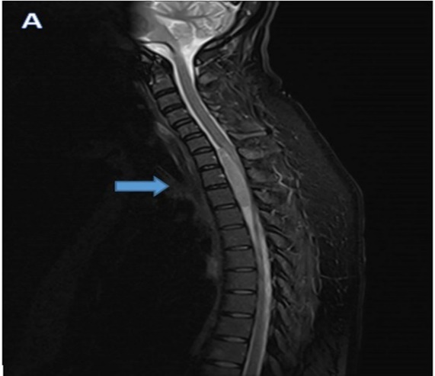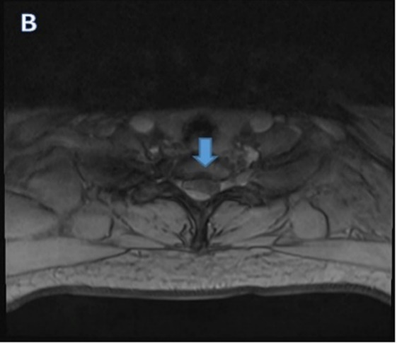
figure 1: Initial MRI (A&B) done post cesarean shows intra-spinal mass lesion (8x15x 55mm in APxTS x CC) extending from C7 to T3 levels markedly compressing the cord at such levels.

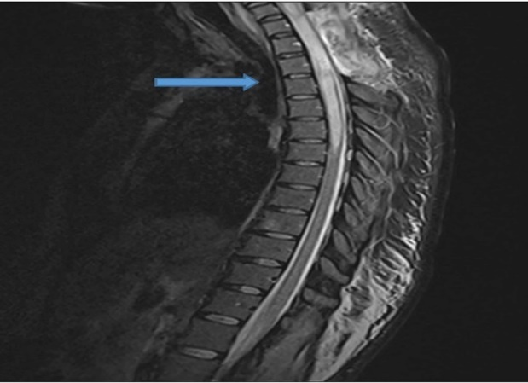

figure 2: MRI done later shows total resolution of the previous intra-spinal mass lesion with newly developed long intra-medullary segment of high signal with the cord extending from C5/6 to the level of T6 vertebra, consistent with cord Malacia.

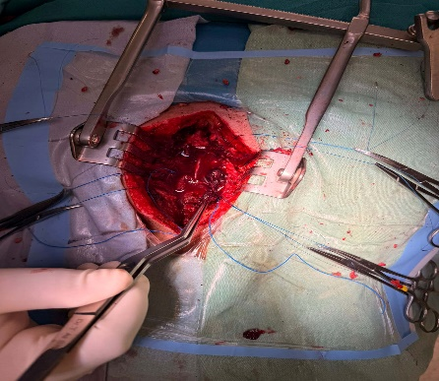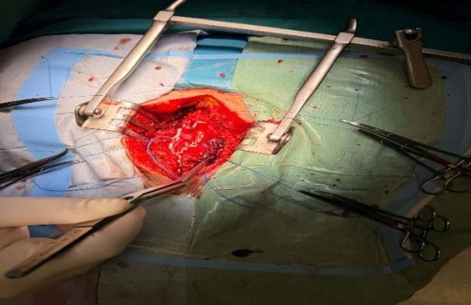
figure: 3 & 4 Intraoperative images of spinal schwannoma

