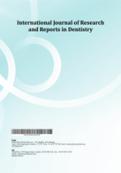
International Journal of Research and Reports in Dentistry

Volume XXX, Issue XX, Page XX-XX, 20YY; Article no.IJRRD.153077

Surgical Management of a Mandibular Odontogenic Keratocyst Using Enucleation and 5-Fluorouracil: A Case Report

Authors’ Name……………………………………………………

Affiliations……………………………………………………….………………

Authors’ contributions

This work was carried out in collaboration among all authors. All authors read and approved the final manuscript.

Article Information

DOI: 10.9734/IJRRD/2026/XXXXX

Open Peer Review History:
This journal follows the Advanced Open Peer Review policy. Identity of the Reviewers, Editor(s) and additional Reviewers, peer review comments, different versions of the manuscript, comments of the editors, etc are available here:

Received: DD/MM/20YY
………… Article
Published: DD/MM/20YY

Abstract

Background: Odontogenic Keratocyst (OKC) is a developmental cyst known for its locally aggressive behavior and high recurrence rates. Traditional surgical management ranges from conservative enucleation to radical resection. The use of chemical adjuvants is critical to reducing recurrence while maintaining jaw function.
Case Report: A 34-year-old female presented with pus discharge in the lower right posterior mandible. Clinical and radiographic examination revealed a large radiolucency in the right mandible (region 41-48). Fine Needle Aspiration Cytology (FNAC) and subsequent biopsy confirmed the diagnosis of an Odontogenic Keratocyst. The patient was managed with cystic enucleation and chemical curettage using 5-Fluorouracil (5-FU) ointment. Post-operative follow-up at 3 months showed satisfactory clinical healing with no neurosensory deficits. Radiographic evaluation confirmed progressive bone regeneration at the surgical site, with no evidence of recurrence.

Keywords: Odontogenic keradtocyst; 5-Fluorouracil; enucleation; mandibular cyst; oral surgery.

1. Introduction

The Odontogenic Keratocyst (OKC) is a unique entity in oral and maxillofacial surgery due to its aggressive growth and tendency to recur (Blanas et al., 2000; Speight & Takata, 2018). OKCs often remain asymptomatic until they reach a significant size or become secondarily infected, leading to symptoms such as pain or discharge (Barua et al., 2023). Radiographic evaluation typically shows a well-defined radiolucency that can involve a large portion of the mandible. Accurate diagnosis relies on clinical findings, imaging, and histopathological confirmation through FNAC and biopsy (Ledderhof et al., 2017a).

The primary challenge in treating OKCs is the elimination of satellite or "daughter" cysts in the cyst wall, which are responsible for high recurrence rates (Philipsen, 1956). Historically, Carnoy’s solution was the gold standard for chemical curettage; however, its neurotoxic effects have led surgeons to seek safer alternatives (Borghesi et al., 2018). Recent clinical evidence supports the use of 5-Fluorouracil (5-FU) as a topical antimetabolite that effectively targets residual epithelial cells with significantly less morbidity and risk of nerve injury (Madras & Lapointe, 2008; Kaczmarzyk et al., 2012).

2. Case Presentation

A 34-year-old female patient presented to the department of Oral and Maxillofacial surgery Pacific Dental College and Hospital, Udaipur, Rajasthan, India with a chief complaint of pus discharge in her lower right back tooth region for one month. Her medical and personal histories were non-contributory.

Clinical examination and a preoperative Orthopantomogram (OPG) as given in Fig. 1 revealed a well-defined radiolucency in the right mandible extending from the 32 to 48 region, associated with impacted teeth 33 and 43. Cone Beam Computed Tomography (CBCT) as given in Fig. 2 further revealed bone resorption in the 43-48 region. The axial view as given in Fig. 3 showed mild Bucco-lingual expansion of the bone. Fine Needle Aspiration Cytology (FNAC) and an initial biopsy report as given in Fig. 4 suggested a Keratinized Odontogenic cyst.

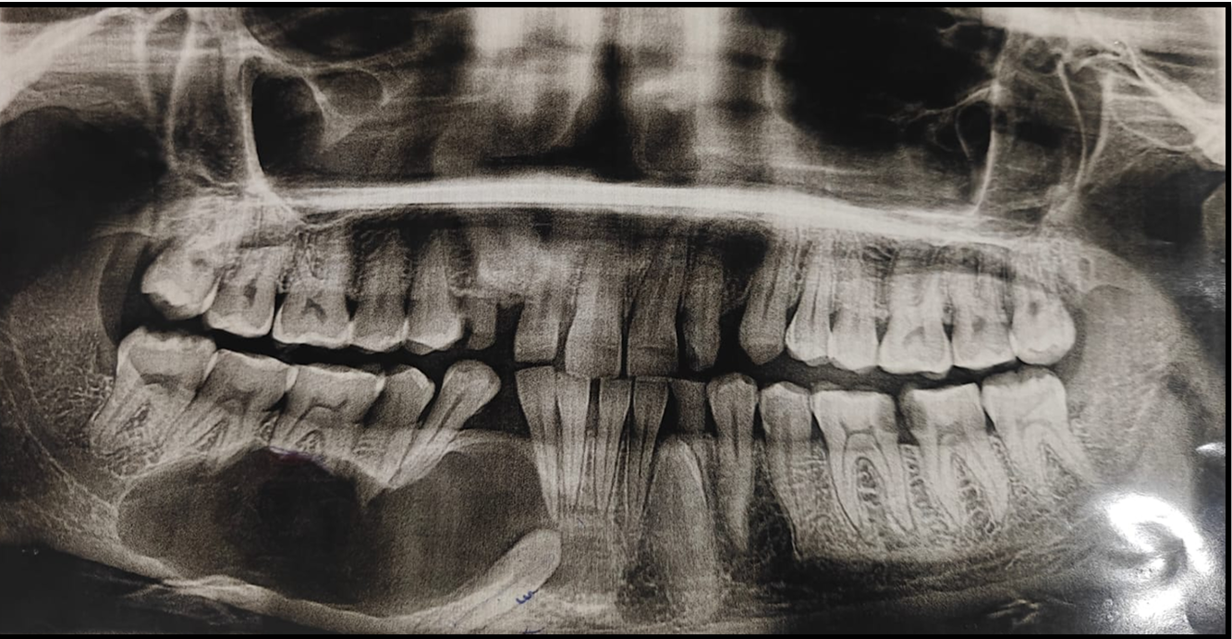

Fig. 1. Preoperative OPG showing a well-defined radiolucency in Right Mandible extending from 32-48 region associated with impacted 33,43

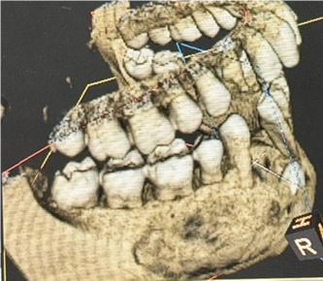

Fig. 2. 3D CT scan of Cyst
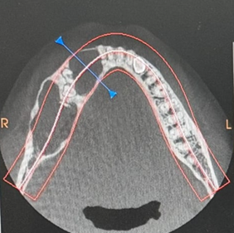

Fig. 3. CT scan Axial View

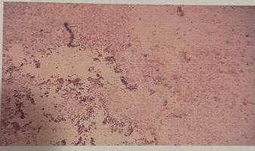

Fig. 4. Report shows OKC

The surgical procedure was performed under local anesthesia. A crevicular incision was made, supplemented by an anterior releasing incision from the 41 region as given in Fig. 5. A mucoperiosteal flap was elevated to expose the site of pathology as given in Fig. 6. Surgical enucleation of the cyst was performed, and the bony socket was thoroughly irrigated as given in Fig. 7. Chemical cauterization was initially performed with Carnoy’s solution as given in Fig. 8.

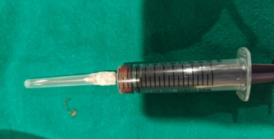

Fig. 5. FNAC Specimen

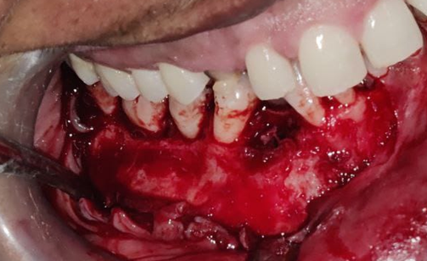

Fig. 6. Crevicular Incision given and an Anterior releasing incision given from 41 region followed by Mucoperiosteal Flap elevation and exposure of site of pathology
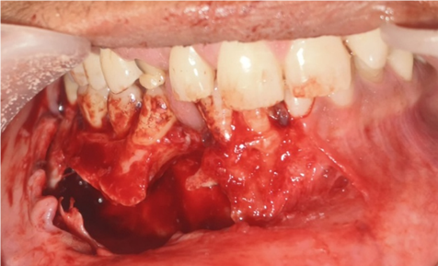

Fig. 7. Surgical enucleation and bony socket irrigated and chemical cauterization done with Carnoy’s solution

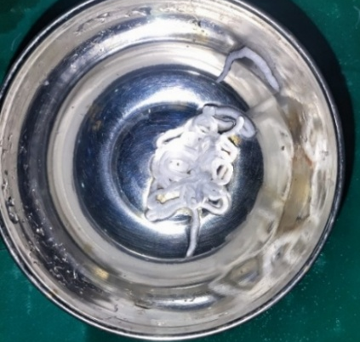

Fig. 8. Fluorouracil ointment

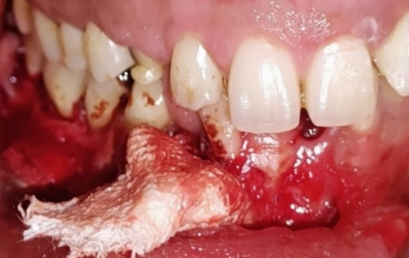

Fig. 9. 5-Fluorouracil coated gauze

To further minimize the risk of recurrence, 5-Fluorouracil (5-FU) ointment as given in Fig. 9 was applied. A 5-FU coated gauze was packed into the bony cavity as given in Fig. 10 for a duration of 24 hours. Interdental sutures were then placed from the 41 to 48 region as given in Fig. 11. The surgical specimen, measuring 2x2 cm as given in Fig. 12, was sent for a formal histopathological examination. The final biopsy report as given in Fig. 13 confirmed the diagnosis of an Odontogenic Keratocyst. To manage the large defect and facilitate healing, an obturator was fabricated and placed as given in Fig. 14.

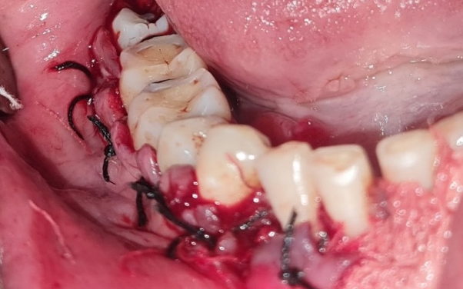

Fig. 10. Interdental sutures placed in 41-48 region
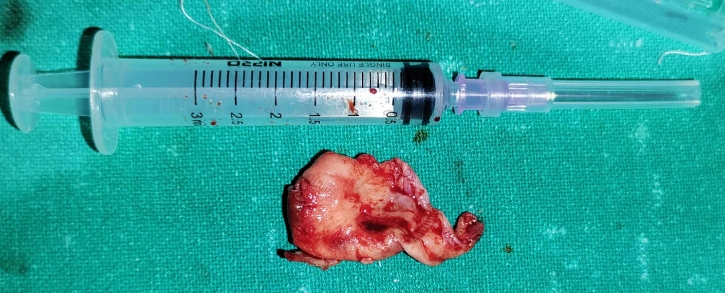

Fig. 11. Biopsy Specimen 2x2cm in size sent for histopathological examination

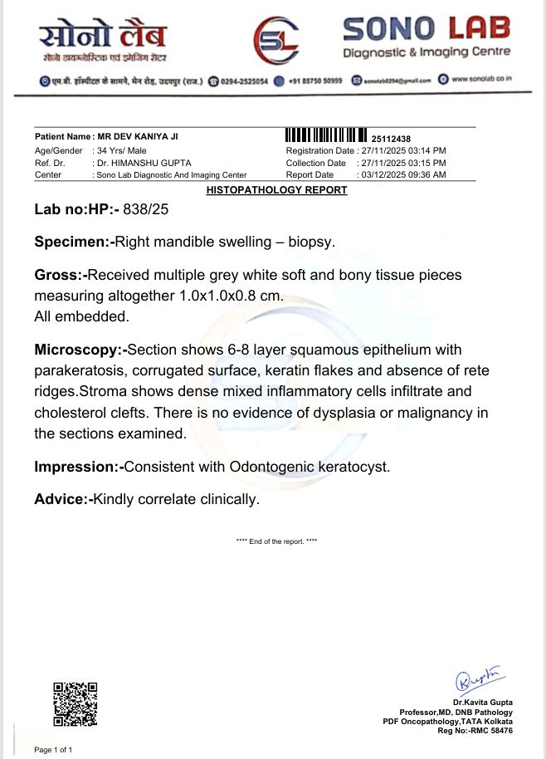

Fig. 12. Biopsy report reveals Odontogenic Keratocyst

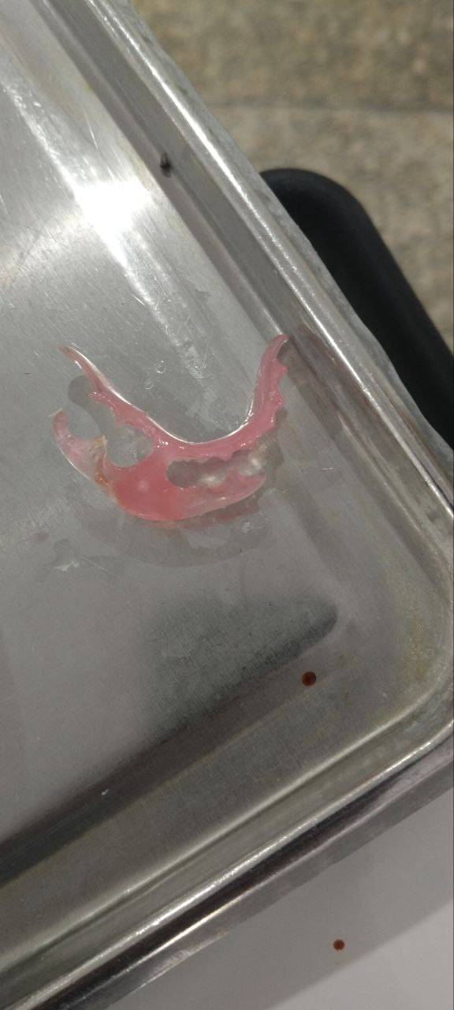

Fig. 13. Obturator Fabricated

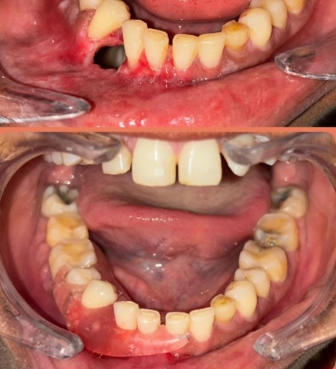

Fig. 14. Obturating closing Bony Defect

Clinical and Radiographic Evaluation: Intraoral examination confirmed discharge in the posterior mandible. A preoperative orthopantomogram (OPG) revealed a large radiolucent lesion in the right mandible involving the 41 to 48 tooth region. Fine Needle Aspiration Cytology (FNAC) was performed, providing clinical evidence of an Odontogenic Keratocyst.

Surgical Procedure: Under appropriate anesthesia, a full-thickness mucoperiosteal flap was raised through a standard incision. The cystic lesion was enucleated, and thorough curettage was performed on the bony walls. To address potential microscopic remnants, 5-Fluorouracil (5-FU) ointment was applied to the surgical site. The area was then packed with ribbon gauze and the flap was sutured.

Follow-up: A biopsy specimen was sent for histopathological examination, which confirmed the diagnosis of OKC. The patient was monitored at multiple intervals (1st, 2nd, and 3rd follow-up visits). Clinical healing was satisfactory, with no signs of neurosensory deficit or immediate recurrence.

3. Discussion

The management of Odontogenic Keratocysts (OKC) remains one of the most debated topics in oral and maxillofacial surgery due to the lesion's high recurrence rate and locally aggressive growth pattern. Originally recognized as a developmental cyst, its categorization has fluctuated between a cyst and a tumor (Keratocystic Odontogenic Tumor) in WHO classifications, reflecting its unique neoplastic-like characteristics, such as high mitotic activity and the presence of PTCH gene mutations (Philipsen, 1956; Madras & Lapointe, 2008; El-Naggar et al., 2017).

The high recurrence rate of OKC, historically reported between 2.5% and 62%, is primarily attributed to the thin, friable epithelial lining that is difficult to enucleate in one piece, and the presence of "daughter" or satellite cysts within the fibrous capsule or adjacent bone (Kaczmarzyk et al., 2012). Historically, aggressive treatments such as radical resection were favored to ensure complete eradication; however, these lead to significant morbidity, including facial deformity, loss of teeth, and the need for complex reconstructive surgery (Casino et al., 2023).

To bridge the gap between conservative enucleation and radical resection, chemical adjuvants have been employed. Carnoy’s solution (consisting of absolute alcohol, chloroform, glacial acetic acid, and ferric chloride) was the traditional choice. However, the FDA’s ban on chloroform due to its carcinogenic potential led to the development of "Modified Carnoy’s Solution," which many studies suggest is less effective (Ecker et al., 2016). Furthermore, Carnoy’s solution is non-selective and can lead to bone necrosis or permanent damage to the inferior alveolar nerve if the lesion is in close proximity to the mandibular canal (Al-Moraissi et al., 2017).

The shift toward 5-Fluorouracil (5-FU) represents a milestone in "targeted" medicinal surgery for OKCs. As an antimetabolite and pyrimidine analog, 5-FU interferes with DNA synthesis by inhibiting thymidylate synthase (Singh et al., 2022; Farooq et al., 2022). In the context of an OKC, 5-FU specifically targets the rapidly proliferating odontogenic epithelial cells (Johnson et al., 2013). When applied topically following enucleation, it induces apoptosis in any remaining microscopic remnants or satellite cysts (Dashow et al., 2015; Ledderhof et al., 2017a; Lone et al., 2020; Mishra et al., 2023).

Clinical studies by Dashow et al. (2015) and Ledderhof et al. (2017b) have demonstrated that 5-FU achieves recurrence rates comparable to or better than Carnoy’s solution (approximately 0–10%) without the associated risks of nerve paresthesia or extensive sequestrum formation (Singh et al., 2022; Ledderhof et al., 2017b). In the present case, the application of a 5-FU soaked gauze for 24 hours allowed for a localized, high-concentration delivery of the drug. This protocol ensured that the medication reached the peripheral bone without systemic toxicity, which is consistent with the lack of neurosensory deficits observed in our 3-month follow-up.

Furthermore, the observation of bone regeneration in this patient’s follow-up OPG highlights another advantage: unlike more caustic agents, 5-FU appears to be better tolerated by the surrounding osteoblasts, facilitating a more rapid and robust healing of the bony defect (Balamurugan, 2019). While this case shows excellent short-term results, the known late-recurrence patterns of OKC—sometimes occurring 10 years post-operatively—necessitate a long-term clinical and radiographic surveillance protocol.

4. Conclusion

This case highlights that conservative enucleation combined with 5-Fluorouracil is an effective management strategy for large Mandibular Odontogenic Keratocysts. This approach minimizes surgical morbidity and prevents neurosensory deficits while providing a robust mechanism to reduce recurrence. Long-term follow-up remains essential.

Consent

As per international standards or university standards, patient(s) written consent has been collected and preserved by the author(s).

Ethical Approval

As per international standards or university standards written ethical approval has been collected and preserved by the author(s).

Disclaimer (Artificial Intelligence)

Author(s) hereby declare that NO generative AI technologies such as Large Language Models (ChatGPT, COPILOT, etc) and text-to-image generators have been used during writing or editing of this manuscript.

Competing Interests

Authors have declared that they have no known competing financial interests OR non-financial interests OR personal relationships that could have appeared to influence the work reported in this paper.

References

Al-Moraissi, E. A., et al. (2017). What surgical treatment has the lowest recurrence rate? Journal of Craniomaxillofacial Surgery, 45(1), 131–144.
Balamurugan, R. (2019). 5-Fluorouracil: Trend setter in the management of OKC. Journal of Case Studies and Clinical Trials, 1.
Barua, C., et al. (2023). The role of 5-fluorouracil in preventing recurrence after enucleation. Cureus, 15(9), e44777.
Blanas, N., Freund, B., Schwartz, M., & Furst, I. M. (2000). Systematic review of the treatment and prognosis of the odontogenic keratocyst. Oral Surgery, Oral Medicine, Oral Pathology, Oral Radiology, and Endodontics, 90(5), 553–558. https://doi.org/10.1067/moe.2000.110814.
Borghesi, A., et al. (2018). Odontogenic keratocyst: Imaging features of a benign lesion with an aggressive behavior. Insights into Imaging, 9(5), 883–897.
Casino, A. J., et al. (2023). Refined topical 5-fluorouracil technique. Journal of Oral and Maxillofacial Surgery, 81(1), 95–100.
Dashow, J. E., et al. (2015). Significantly lower recurrence rates in KCOTs treated with Carnoy's solution or 5-fluorouracil. Journal of Oral and Maxillofacial Surgery, 73(11), 2132–2135.
Ecker, J., et al. (2016). Current role of Carnoy's solution in treating keratocystic odontogenic tumours. Journal of Oral and Maxillofacial Surgery, 74(2), 278–282.
El-Naggar, A. K., et al. (2017). WHO Classification of Head and Neck Tumours (4th ed.). Geneva: WHO.
Farooq, S., et al. (2022). Management of OKCs using topical 5-fluorouracil: A comparative study. Journal of Pharmacy & Negative Results, 13(10), 6566. https://doi.org/10.47750/
Johnson, N. R., et al. (2013). Management of the OKC: A systematic review. Journal of Oral and Maxillofacial Surgery, 71(1), 31–37.
Kaczmarzyk, T., et al. (2012). A systematic review of the recurrence rate for keratocystic odontogenic tumour. International Journal of Oral and Maxillofacial Surgery, 41(6), 756–767.
Ledderhof, N. J., et al. (2017a). Topical 5-fluorouracil is a novel targeted therapy for the KCOT. Journal of Oral and Maxillofacial Surgery, 75(3), 514–524.
Ledderhof, N. J., et al. (2017b). Topical 5-Fluorouracil for the treatment of OKCs. Journal of Oral and Maxillofacial Surgery, 75(9), 1915–1924.
Lone, P. A., et al. (2020). Topical 5-fluorouracil application in management of OKCs. Journal of Oral Biology and Craniofacial Research, 10(4), 404–406.
Madras, J., & Lapointe, H. (2008). Keratocystic odontogenic tumour: Reclassification of the odontogenic keratocyst from cyst to tumour. Journal of the Canadian Dental Association, 74(2), 165–165h.
Mishra, S., et al. (2023). Comparative evaluation of topical 5-FU and modified Carnoy’s solution. Annals of Dental Specialty, 11(2), 100–108.
Philipsen, H. P. (1956). Om keratocyster (kolesteatom) i kaeberne. Tandlaegebladet, 60, 963–980.
Singh, A. K., Khanal, N., Chaulagain, R., Bhujel, N., & Singh, R. P. (2022). How effective is 5-Fluorouracil as an adjuvant in the management of odontogenic keratocyst? A systematic review and meta-analysis. British Journal of Oral and Maxillofacial Surgery, 60(6), 746-754.
Speight, P. M., & Takata, T. (2018). New tumour entities in the 4th edition WHO Classification. Virchows Archiv, 472(3), 331–339.

Disclaimer/Publisher’s Note: The statements, opinions and data contained in all publications are solely those of the individual author(s) and contributor(s) and not of the publisher and/or the editor(s). This publisher and/or the editor(s) disclaim responsibility for any injury to people or property resulting from any ideas, methods, instructions or products referred to in the content.

© Copyright (2026): Author(s). The licensee is the journal publisher. This is an Open Access article distributed under the terms of the Creative Commons Attribution License (http://creativecommons.org/licenses/by/4.0), which permits unrestricted use, distribution, and reproduction in any medium, provided the original work is properly cited.

