Case Report

Surgical Management of a Mandibular Odontogenic Keratocyst Using Enucleation and 5-Fluorouracil: A Case Report

.
ABSTRACT

Abstract Background: Odontogenic Keratocyst (OKC) is a developmental cyst known for its locally aggressive behavior and high recurrence rates. Traditional surgical management ranges from conservative enucleation to radical resection. The use of chemical adjuvants is critical to reducing recurrence while maintaining jaw function.
Case Report: A 34-year-old female presented with pus discharge in the lower right posterior mandible. Clinical and radiographic examination revealed a large radiolucency in the right mandible (region 41-48). Fine Needle Aspiration Cytology (FNAC) and subsequent biopsy confirmed the diagnosis of an Odontogenic Keratocyst. The patient was managed with cystic enucleation and chemical curettage using 5-Fluorouracil (5-FU) ointment. Post-operative follow-up at 3 months showed satisfactory clinical healing with no neurosensory deficits. Radiographic evaluation confirmed progressive bone regeneration at the surgical site, with no evidence of recurrence.

Keywords: (Odontogenic Keratocyst, 5-Fluorouracil, Enucleation, Mandibular Cyst, Oral Surgery)

- INTRODUCTION
The Odontogenic Keratocyst (OKC) is a unique entity in oral and maxillofacial surgery due to its aggressive growth and tendency to recur. OKCs often remain asymptomatic until they reach a significant size or become secondarily infected, leading to symptoms such as pain or discharge. Radiographic evaluation typically shows a well-defined radiolucency that can involve a large portion of the mandible. Accurate diagnosis relies on clinical findings, imaging, and histopathological confirmation through FNAC and biopsy. ⁹
The primary challenge in treating OKCs is the elimination of satellite or "daughter" cysts in the cyst wall, which are responsible for high recurrence rates.¹ Historically, Carnoy’s solution was the gold standard for chemical curettage; however, its neurotoxic effects have led surgeons to seek safer alternatives.⁴ Recent clinical evidence supports the use of 5-Fluorouracil (5-FU) as a topical antimetabolite that effectively targets residual epithelial cells with significantly less morbidity and risk of nerve injury.²,⁵

- Case Presentation
A 34-year-old female patient presented to the department of Oral and Maxillofacial surgery Pacific Dental College and Hospital, Udaipur, Rajasthan,India with a chief complaint of pus discharge in her lower right back tooth region for one month. Her medical and personal histories were non-contributory.
Clinical examination and a preoperative Orthopantomogram (OPG) as given in Figure 1 revealed a well-defined radiolucency in the right mandible extending from the 32 to 48 region, associated with impacted teeth 33 and 43. Cone Beam Computed Tomography (CBCT) as given in Figure 2 further revealed bone resorption in the 43-48 region. The axial view as given in Figure 3 showed mild Bucco-lingual expansion of the bone. Fine Needle Aspiration Cytology (FNAC) and an initial biopsy report as given in Figure 4 suggested a Keratinized Odontogenic cyst.
The surgical procedure was performed under local anesthesia. A crevicular incision was made, supplemented by an anterior releasing incision from the 41 region as given in Figure 5. A mucoperiosteal flap was elevated to expose the site of pathology as given in Figure 6. Surgical enucleation of the cyst was performed, and the bony socket was thoroughly irrigated as given in Figure 7. Chemical cauterization was initially performed with Carnoy’s solution as given in Figure 8.
To further minimize the risk of recurrence, 5-Fluorouracil (5-FU) ointment as given in Figure 9 was applied. A 5-FU coated gauze was packed into the bony cavity as given in Figure 10 for a duration of 24 hours. Interdental sutures were then placed from the 41 to 48 region as given in Figure 11. The surgical specimen, measuring 2x2 cm as given in Figure 12, was sent for a formal histopathological examination. The final biopsy report as given in Figure 13 confirmed the diagnosis of an Odontogenic Keratocyst. To manage the large defect and facilitate healing, an obturator was fabricated and placed as given in Figure 14.

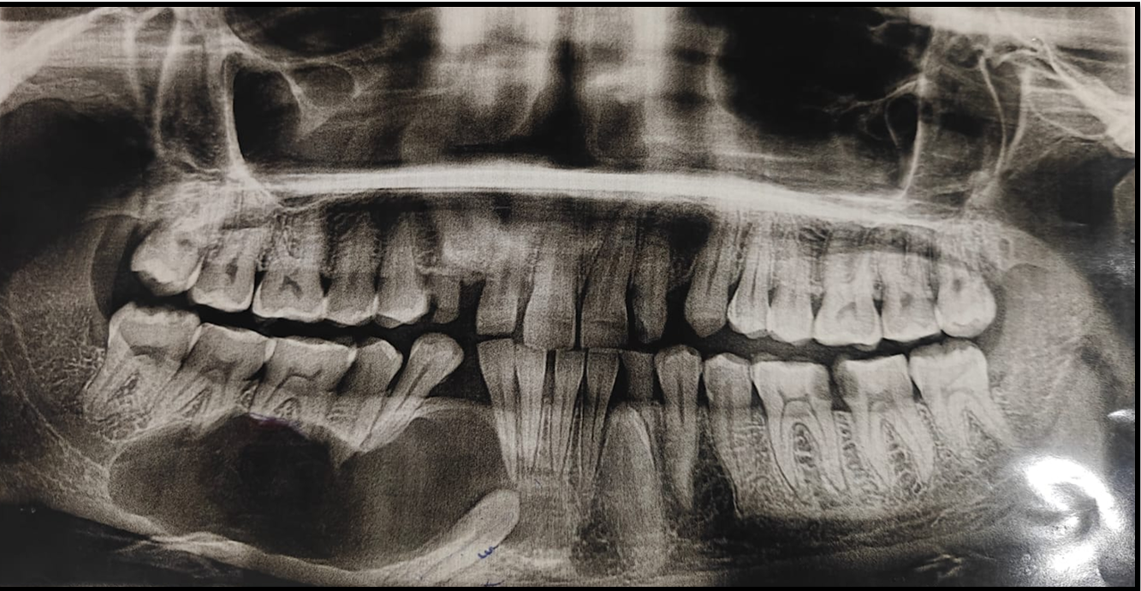
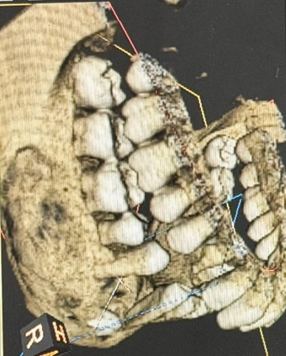
Figure No 1: Preoperative OPG showing a well-defined radiolucency in Right Mandible extending from 32-48 region associated with impacted 33,43.
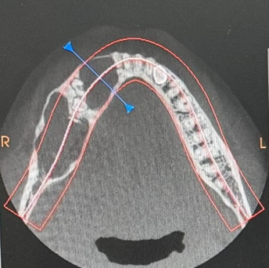

Figure No 2: 3D CT scan of Cyst Figure No 3: CT scan Axial View

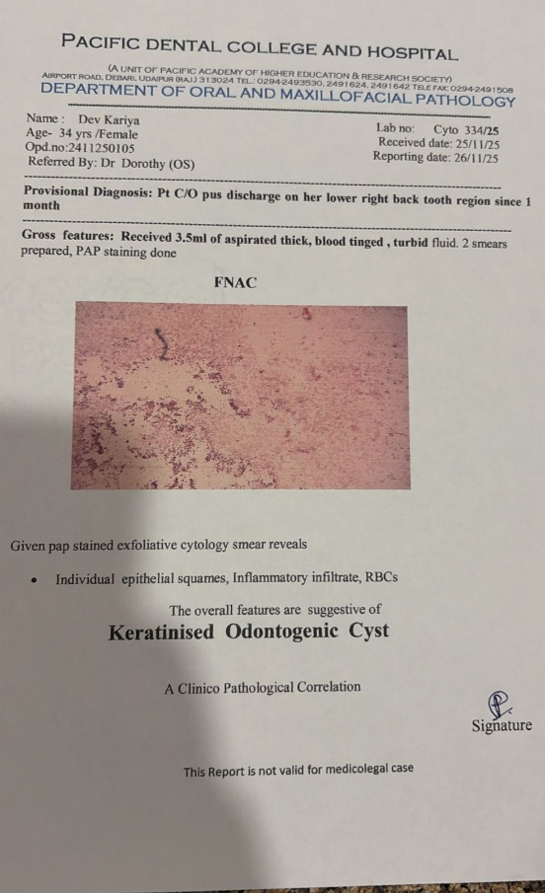
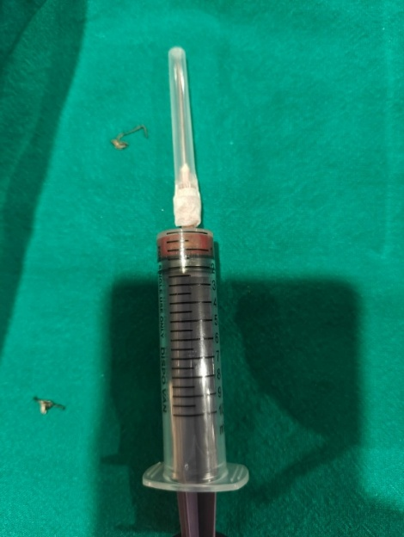
Figure No 5: FNAC Specimen
Figure No 4: Report shows OKC

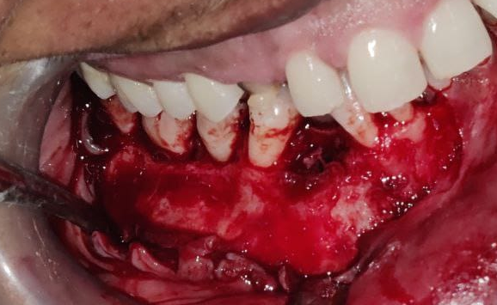

Figure No 6: Crevicular Incision given and an Anterior releasing incision given from 41 region followed by Mucoperiosteal Flap elevation and exposure of site of pathology.

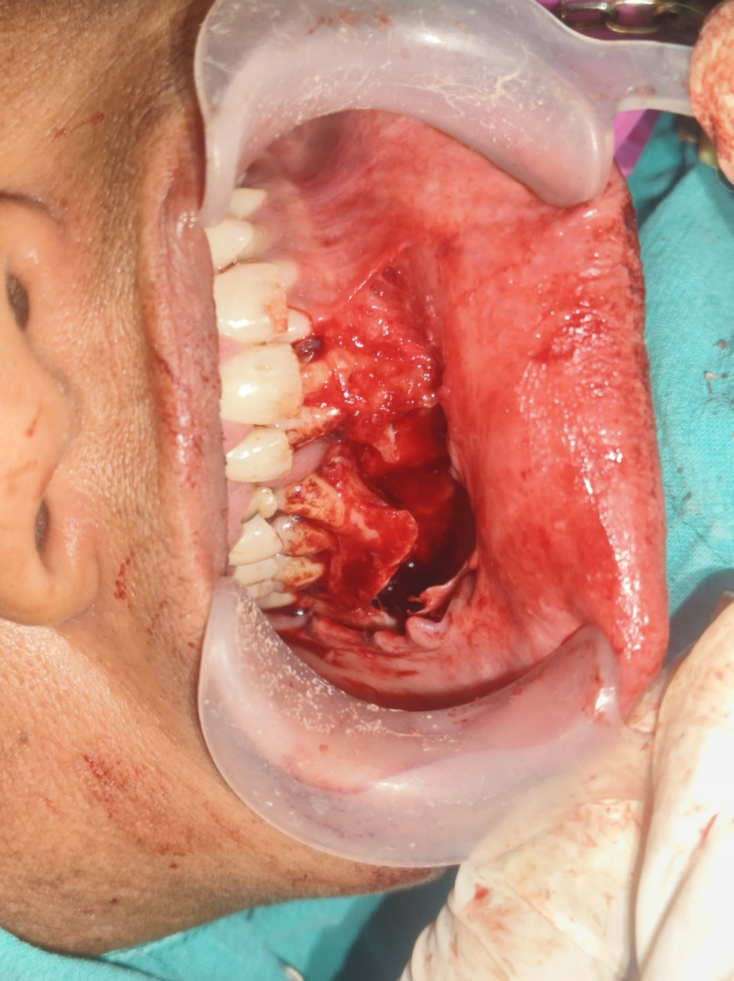
Figure No 7: Surgical enucleation and bony socket irrigated and chemical cauterization done with Carnoy’s solution

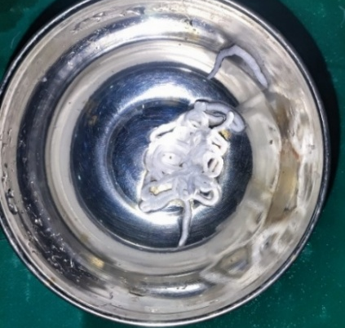
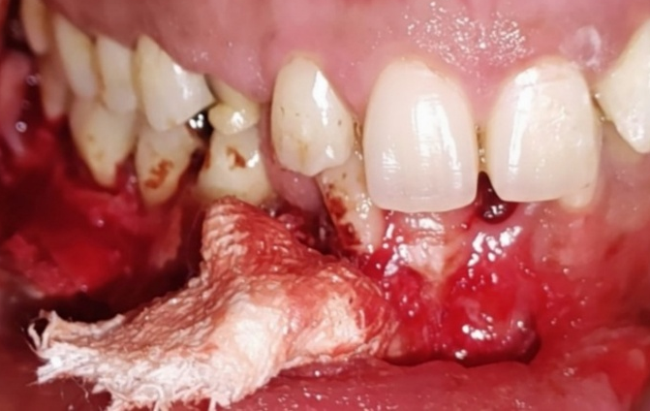 Fig No 8: Fluorouracil ointment Fig No 9: 5-Fluorouracil coated gauze

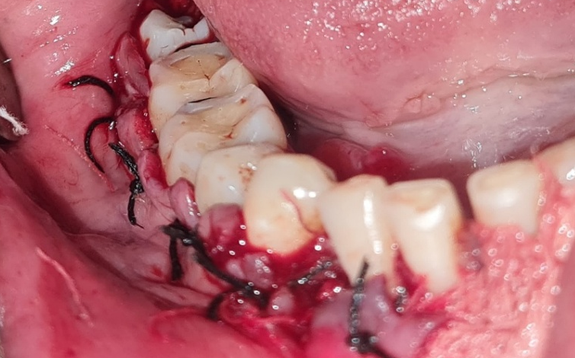

Figure No 10- Interdental sutures placed in 41-48 region

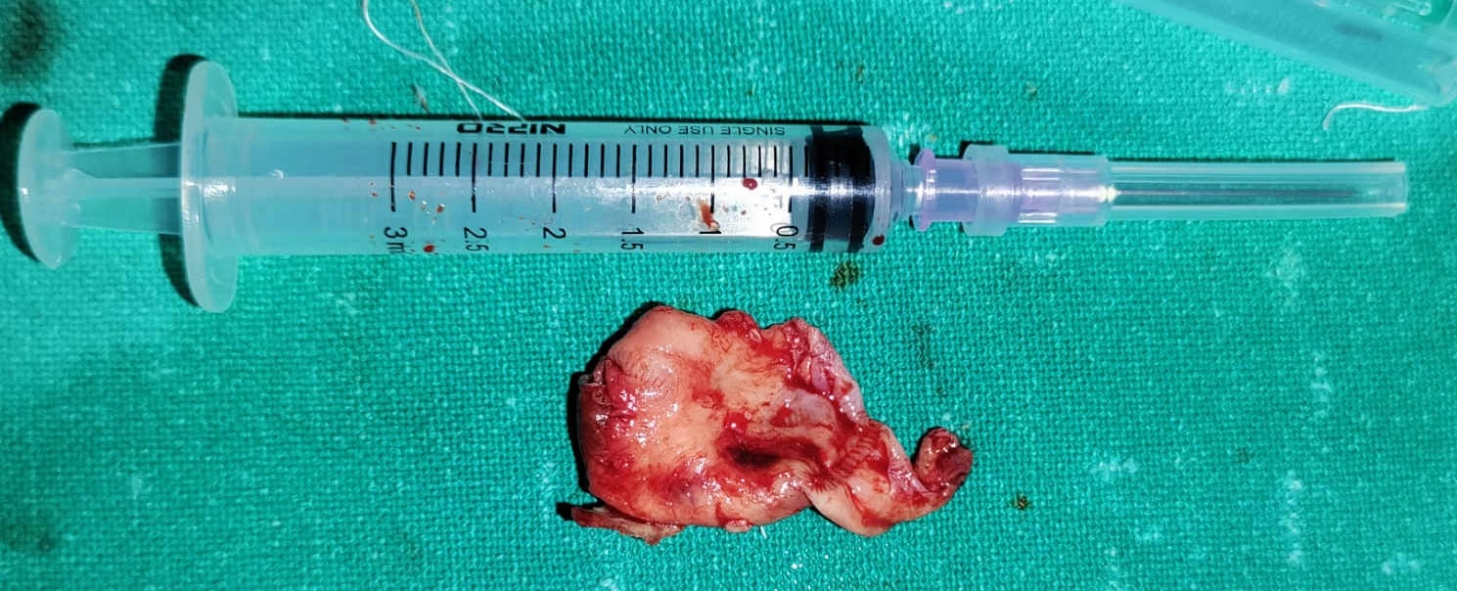
Fig No 11: Biopsy Specimen 2x2cm in size sent for histopathological examination

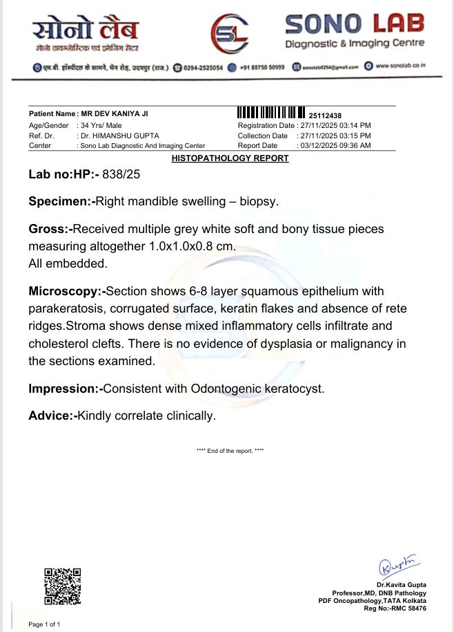

Fig No 12- Biopsy report reveals Odontogenic Keratocyst

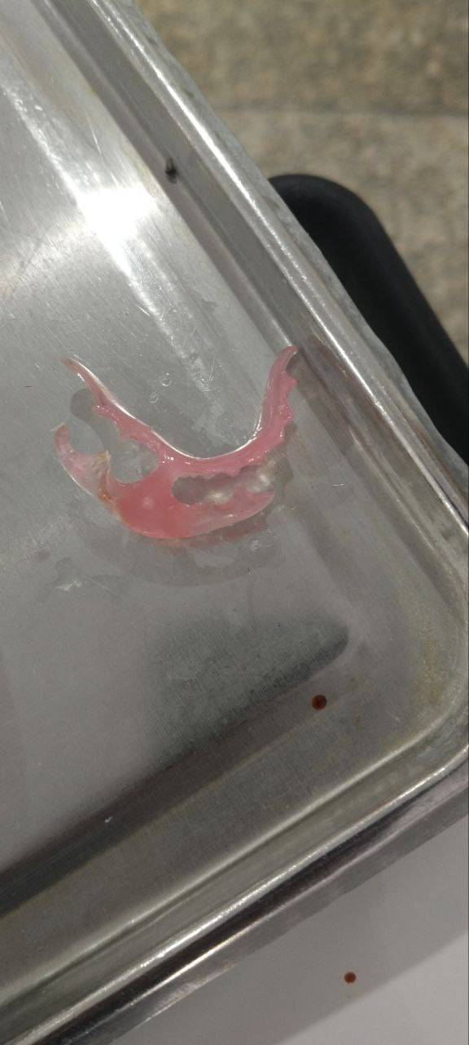 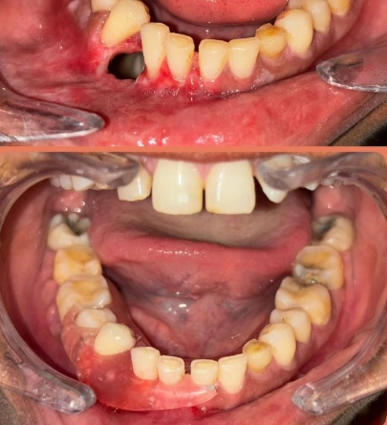Figure No 13: Obturator Fabricated Figure No 14: Obturating closing Bony Defect

Clinical and Radiographic Evaluation: Intraoral examination confirmed discharge in the posterior mandible. A preoperative orthopantomogram (OPG) revealed a large radiolucent lesion in the right mandible involving the 41 to 48 tooth region. Fine Needle Aspiration Cytology (FNAC) was performed, providing clinical evidence of an Odontogenic Keratocyst.
Surgical Procedure: Under appropriate anesthesia, a full-thickness mucoperiosteal flap was raised through a standard incision. The cystic lesion was enucleated, and thorough curettage was performed on the bony walls. To address potential microscopic remnants, 5-Fluorouracil (5-FU) ointment was applied to the surgical site. The area was then packed with ribbon gauze and the flap was sutured.
Follow-up: A biopsy specimen was sent for histopathological examination, which confirmed the diagnosis of OKC. The patient was monitored at multiple intervals (1st, 2nd, and 3rd follow-up visits). Clinical healing was satisfactory, with no signs of neurosensory deficit or immediate recurrence.

- Discussion
The management of Odontogenic Keratocysts (OKC) remains one of the most debated topics in oral and maxillofacial surgery due to the lesion's high recurrence rate and locally aggressive growth pattern. Originally recognized as a developmental cyst, its categorization has fluctuated between a cyst and a tumor (Keratocystic Odontogenic Tumor) in WHO classifications, reflecting its unique neoplastic-like characteristics, such as high mitotic activity and the presence of PTCH gene mutations.¹⁻³
The high recurrence rate of OKC, historically reported between 2.5% and 62%, is primarily attributed to the thin, friable epithelial lining that is difficult to enucleate in one piece, and the presence of "daughter" or satellite cysts within the fibrous capsule or adjacent bone.⁵ Historically, aggressive treatments such as radical resection were favored to ensure complete eradication; however, these lead to significant morbidity, including facial deformity, loss of teeth, and the need for complex reconstructive surgery.
To bridge the gap between conservative enucleation and radical resection, chemical adjuvants have been employed. Carnoy’s solution (consisting of absolute alcohol, chloroform, glacial acetic acid, and ferric chloride) was the traditional choice. However, the FDA’s ban on chloroform due to its carcinogenic potential led to the development of "Modified Carnoy’s Solution," which many studies suggest is less effective.⁶ Furthermore, Carnoy’s solution is non-selective and can lead to bone necrosis or permanent damage to the inferior alveolar nerve if the lesion is in close proximity to the mandibular canal.¹¹
The shift toward 5-Fluorouracil (5-FU) represents a milestone in "targeted" medicinal surgery for OKCs. As an antimetabolite and pyrimidine analog, 5-FU interferes with DNA synthesis by inhibiting thymidylate synthase.⁷ In the context of an OKC, 5-FU specifically targets the rapidly proliferating odontogenic epithelial cells. When applied topically following enucleation, it induces apoptosis in any remaining microscopic remnants or satellite cysts.⁸,⁹
Clinical studies by Dashow et al. and Ledderhof et al. have demonstrated that 5-FU achieves recurrence rates comparable to or better than Carnoy’s solution (approximately 0–10%) without the associated risks of nerve paresthesia or extensive sequestrum formation.⁷,¹³ In the present case, the application of a 5-FU soaked gauze for 24 hours allowed for a localized, high-concentration delivery of the drug. This protocol ensured that the medication reached the peripheral bone without systemic toxicity, which is consistent with the lack of neurosensory deficits observed in our 3-month follow-up.
Furthermore, the observation of bone regeneration in this patient’s follow-up OPG highlights another advantage: unlike more caustic agents, 5-FU appears to be better tolerated by the surrounding osteoblasts, facilitating a more rapid and robust healing of the bony defect.¹⁴ While this case shows excellent short-term results, the known late-recurrence patterns of OKC—sometimes occurring 10 years post-operatively—necessitate a long-term clinical and radiographic surveillance protocol.

- Conclusion: This case highlights that conservative enucleation combined with 5-Fluorouracil is an effective management strategy for large Mandibular Odontogenic Keratocysts. This approach minimizes surgical morbidity and prevents neurosensory deficits while providing a robust mechanism to reduce recurrence. Long-term follow-up remains essential.

Competing interests:
Authors have declared that no competing interests exist.

ETHICAL CLEARANCE: No ethical clearance needed in case report

COMPETING INTERESTS DISCLAIMER:
Authors have declared that they have no known competing financial interests OR non-financial interests OR personal relationships that could have appeared to influence the work reported in this paper.
Disclaimer (Artificial intelligence)

Author(s) hereby declare that NO generative AI technologies such as Large Language Models (ChatGPT, COPILOT, etc.) and text-to-image generators have been used during the writing or editing of this manuscript.

References

- Philipsen HP. Om keratocyster (kolesteatom) i kaeberne. Tandlaegebladet. 1956;60:963–980.
- Madras J, Lapointe H. Keratocystic odontogenic tumour: reclassification of the odontogenic keratocyst from cyst to tumour. J Can Dent Assoc. 2008;74(2):165–165h.
- El-Naggar AK, et al. WHO Classification of Head and Neck Tumours. 4th ed. Geneva: WHO; 2017.
- Borghesi A, et al. Odontogenic keratocyst: imaging features of a benign lesion with an aggressive behavior. Insights Imaging. 2018;9(5):883–897.
- Kaczmarzyk T, et al. A systematic review of the recurrence rate for keratocystic odontogenic tumour. Int J Oral Maxillofac Surg. 2012;41(6):756–767.
- Ecker J, et al. Current role of Carnoy's solution in treating keratocystic odontogenic tumours. J Oral Maxillofac Surg. 2016;74(2):278–282.
- Singh M, et al. 5-Fluorouracil: A new frontier in the management of odontogenic keratocyst. J Maxillofac Oral Surg. 2017;16(2):141–144.
- Dashow JE, et al. Significantly lower recurrence rates in KCOTs treated with Carnoy's solution or 5-fluorouracil. J Oral Maxillofac Surg. 2015;73(11):2132–2135.
- Ledderhof NJ, et al. Topical 5-fluorouracil is a novel targeted therapy for the KCOT. J Oral Maxillofac Surg. 2017;75(3):514–524.
- Blanas N, et al. Systematic review of the treatment and prognosis of the OKC. Oral Surg Oral Med Oral Pathol. 2000;90(5):553–558.
- Al-Moraissi EA, et al. What surgical treatment has the lowest recurrence rate? J Craniomaxillofac Surg. 2017;45(1):131–144.
- Lone PA, et al. Topical 5-fluorouracil application in management of OKCs. J Oral Biol Craniofac Res. 2020;10(4):404–406.
- Ledderhof NJ, et al. Topical 5-Fluorouracil for the Treatment of OKCs. J Oral Maxillofac Surg. 2017;75(9):1915-1924.
- Balamurugan R. 5-Fluorouracil: Trend setter in the management of OKC. J Case Stud Clin Trials. 2019;1.
- Speight PM, Takata T. New tumour entities in the 4th edition WHO Classification. Virchows Arch. 2018;472(3):331–339.
- Farooq S, et al. Management of OKCs using topical 5-fluorouracil: A comparative study. J Pharm Negat Results. 2022;13(10):6566.
- Mishra S, et al. Comparative evaluation of topical 5-FU and modified Carnoy’s solution. Annals Dent Spec. 2023;11(2):100–108.
- Casino AJ, et al. Refined topical 5-fluorouracil technique. J Oral Maxillofac Surg. 2023;81(1):95–100.
- Barua C, et al. The role of 5-fluorouracil in preventing recurrence after enucleation. Cureus. 2023;15(9):e44777.
- Johnson NR, et al. Management of the OKC: A systematic review. J Oral Maxillofac Surg. 2013;71(1):31-37.

APPENDIX

Figure No 1

Figure No 2 Figure No 3

Figure No 5
Figure No 4

Figure No 6
Figure No 7

Fig No 8 Fig No 9

Figure No 10

Fig No 11

Fig No 12

Figure No 13 Figure No 14

Annexures:

1. Figure No 1: Preoperative OPG showing a well-defined radiolucency in Right Mandible extending from 32-48 region associated with impacted 33,43.
2.Figure No 2: 3D CT scan of Cyst
3.Figure No 3: CT scan Axial View
4.Figure No 4: Report shows OKC
5.Figure No 5: FNAC Specimen
6.Figure No 6: Crevicular Incision given and an Anterior releasing incision given from 41 region followed by Mucoperiosteal Flap elevation and exposure of site of pathology.
7.Figure No 7: Surgical enucleation and bony socket irrigated and chemical cauterization done with Carnoy’s solution
8.Fig No 8: Fluorouracil ointment
9.Fig No 9: 5-Fluorouracil coated gauze
10.Figure No 10- Interdental sutures placed in 41-48 region
11.Fig No 11: Biopsy Specimen 2x2cm in size sent for histopathological examination
12.Fig No 12- Biopsy report reveals Odontogenic Keratocyst
13.Figure No 13: Obturator Fabricated
14.Figure No 14: Obturating closing Bony Defect

