Case Report

Surgical Management of a Mandibular Odontogenic Keratocyst Using Enucleation and 5-Fluorouracil: A Case Report

.
ABSTRACT

Abstract Background: Odontogenic Keratocyst (OKC) is a developmental cyst known for its locally aggressive behavior and high recurrence rates. Traditional surgical management ranges from conservative enucleation to radical resection. The use of chemical adjuvants is critical to reducing recurrence while maintaining jaw function. Post-operative follow-up at 3 months showed satisfactory clinical healing with no neurosensory deficits. Radiographic evaluation confirmed progressive bone regeneration at the surgical site, with no evidence of recurrence.
Case Report: A 34-year-old female presented with pus discharge in the lower right posterior mandible. Clinical and radiographic examination revealed a large radiolucency in the right mandible (region 41-48). Fine Needle Aspiration Cytology (FNAC) and subsequent biopsy confirmed the diagnosis of an Odontogenic Keratocyst. The patient was managed with cystic enucleation and chemical curettage using 5-Fluorouracil (5-FU) ointment.

Keywords: (Odontogenic Keratocyst, 5-Fluorouracil, Enucleation, Mandibular Cyst, Oral Surgery)

- INTRODUCTION

The Odontogenic Keratocyst (OKC) is a unique entity in oral and maxillofacial surgery due to its aggressive growth and tendency to recur. OKCs often remain asymptomatic until they reach a significant size or become secondarily infected, leading to symptoms such as pain or discharge.
Radiographic evaluation typically shows a well-defined radiolucency that can involve a large portion of the mandible. Accurate diagnosis relies on clinical findings, imaging, and histopathological confirmation through FNAC and biopsy. The primary challenge in treating OKCs is the elimination of satellite or "daughter" cysts in the cyst wall, which are responsible for high recurrence rates.
Historically, Carnoy’s solution was the gold standard for chemical curettage; however, its neurotoxic effects have led surgeons to seek safer alternatives. Recent clinical evidence supports the use of 5-Fluorouracil (5-FU) as a topical antimetabolite that effectively targets residual epithelial cells with significantly less morbidity and risk of nerve injury.

- Case Presentation
A 34-year-old female patient presented with a chief complaint of pus discharge in her lower right back tooth region for one month. Her medical and personal histories were non-contributory.

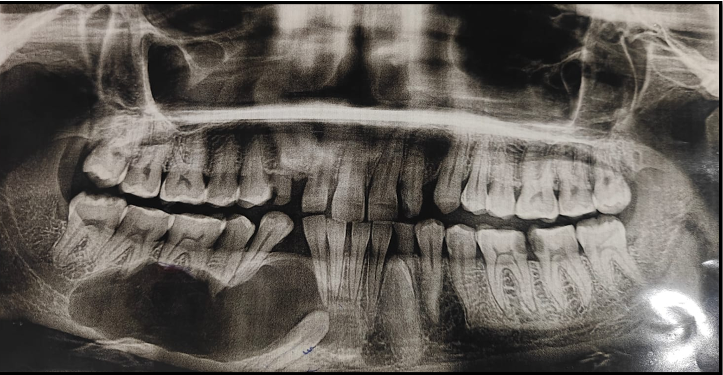
Fig No 1: Preoperative OPG showing a well-defined radiolucency irt Right Mandible extending from 32-48 region associated with impacted 33,43.
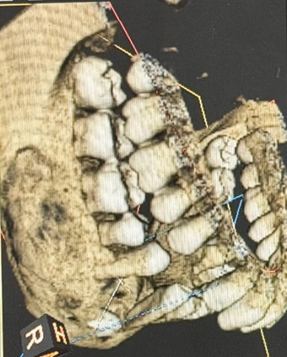
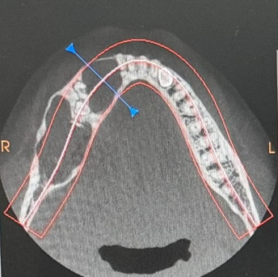

Fig no 2: CBCT reveals bone resorption irt 43-48 region with impacted 43,33 and Axial view showing mild Bucco-lingual expansion of bone

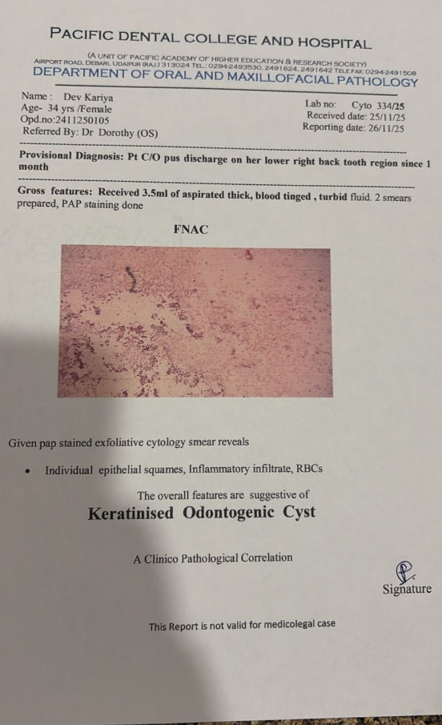
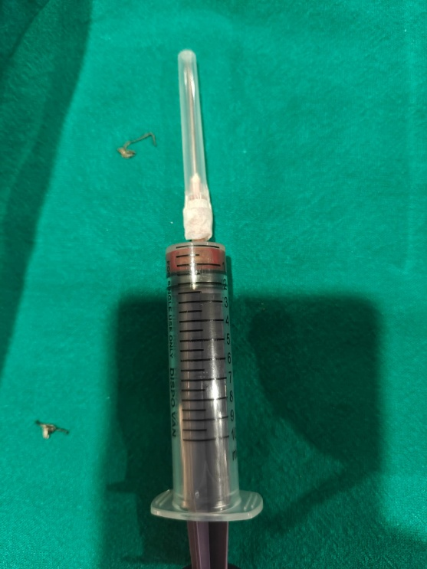


Fig no 3- FNAC specimen reveals Specimen with Biopsy report revealing Keratinised Odontogenic cyst

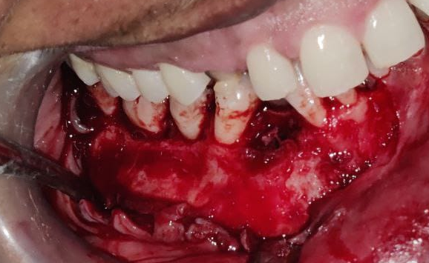

Fig No 4 – Crevicular Incision given and an Anterior releasing incision given from 41 region followed by Mucoperiosteal Flap elevation and exposure of site of pathology.

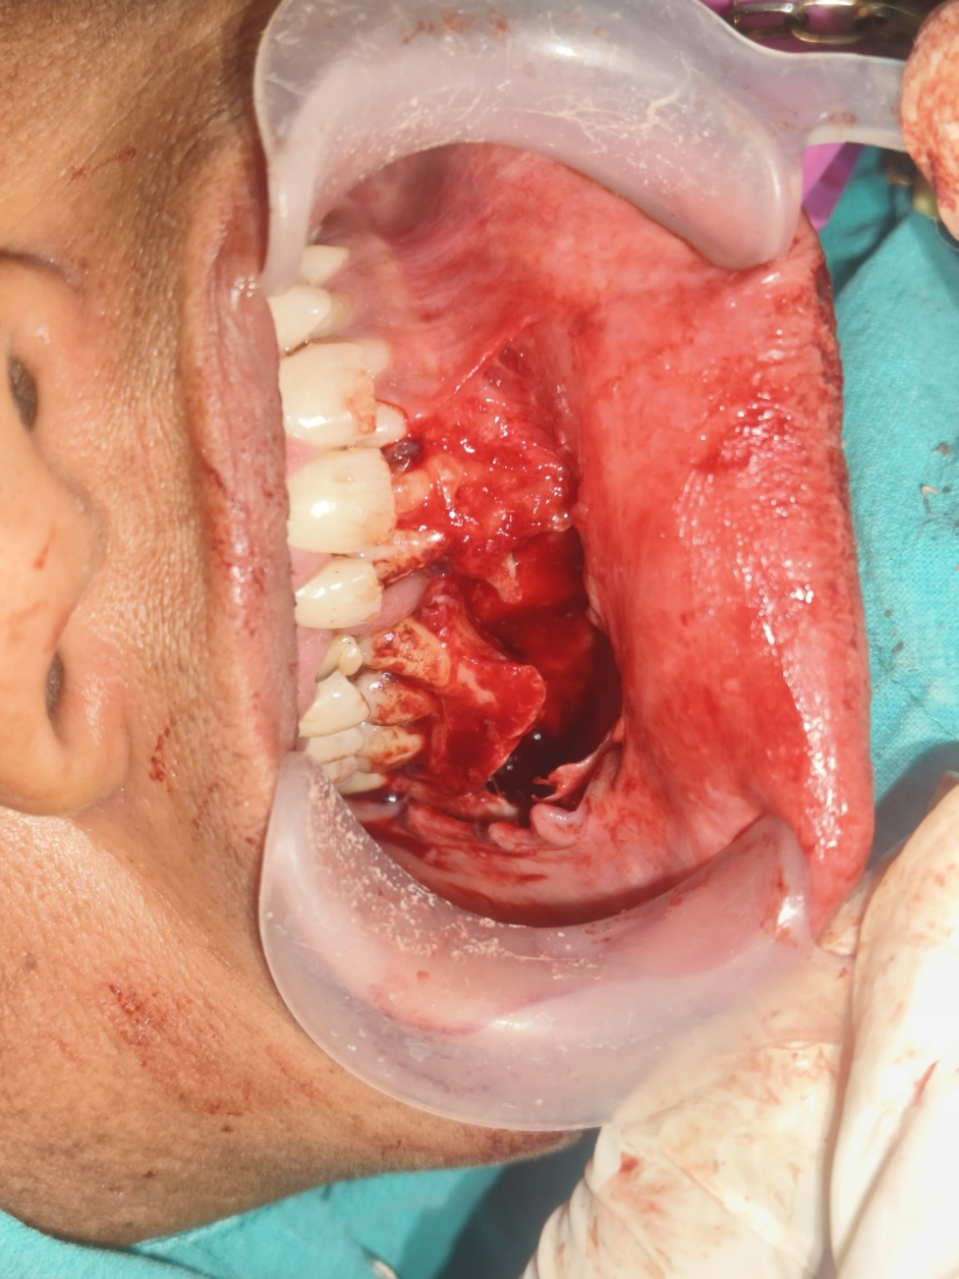
Fig No 5 - Surgical enucleation and bony socket irrigated and chemical cauterization done with Carnoy’s solution

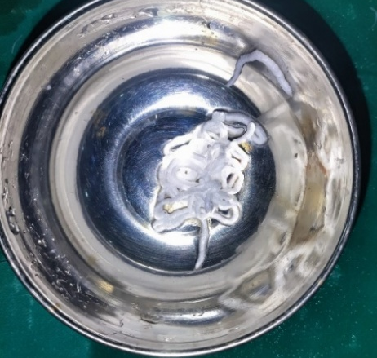
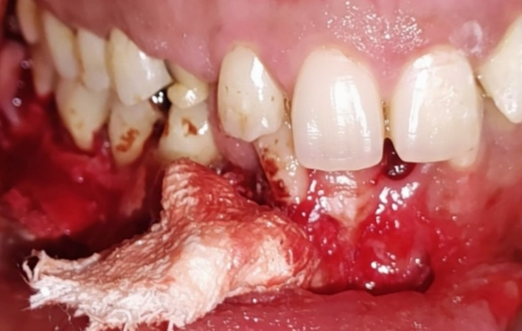
Fig No 6a.– 5- Fluorouracil ointment Fig No6b. – 5-Fluorouracil coated gauze packed into cavity
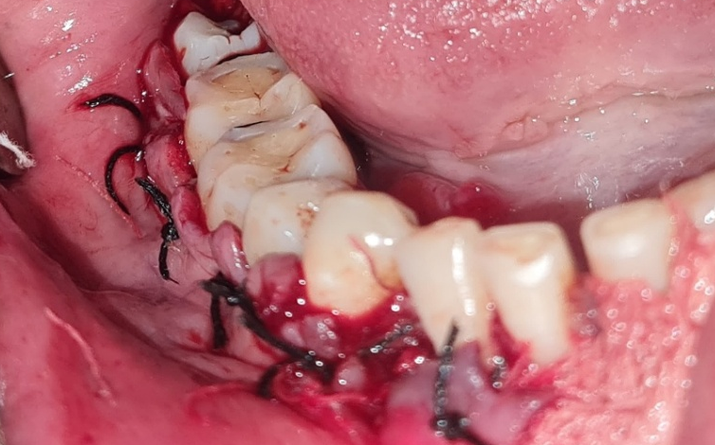

Fig No 7- Interdental sutures placed irt 41-48 region

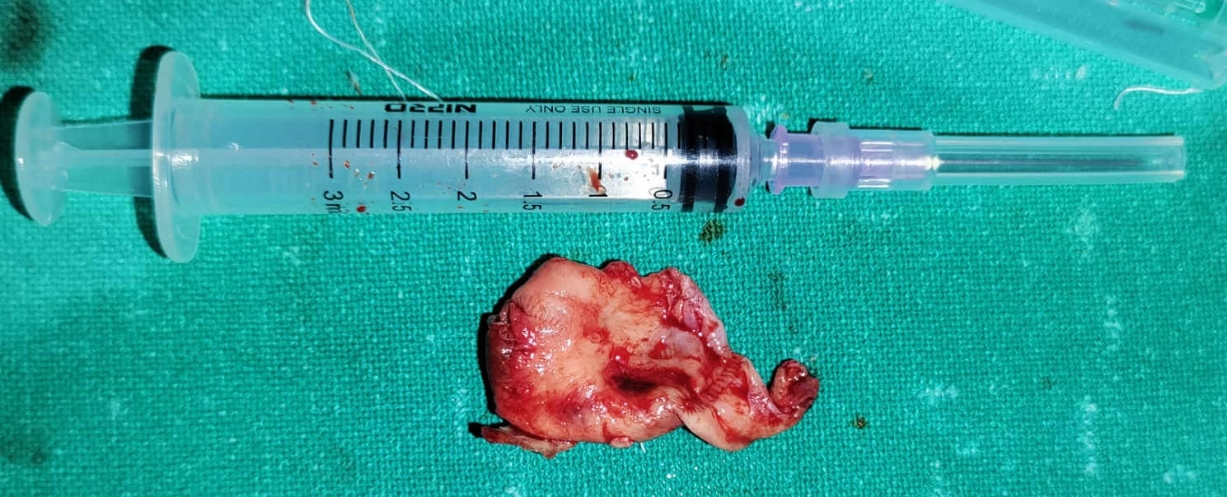
Fig No 8 – Biopsy Specimen 2x2cm in size sent for histopathological examination

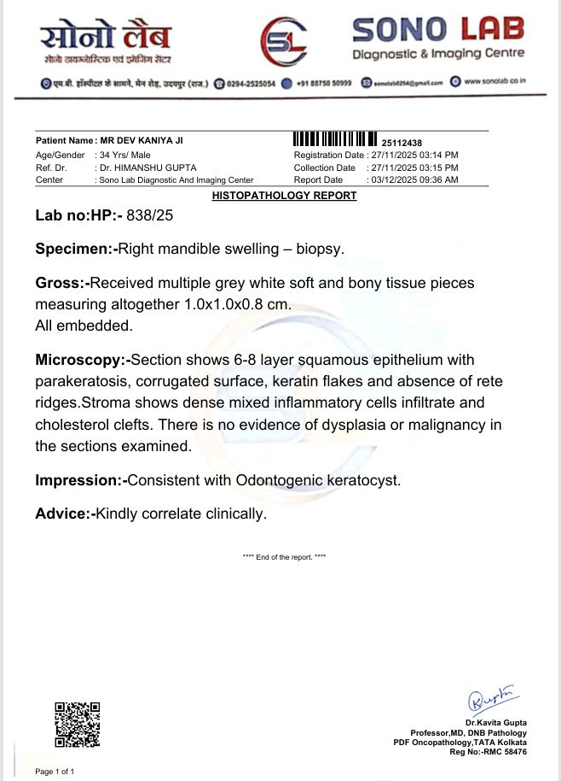

Fig No 9- Biopsy report reveals Odontogenic Keratocyst

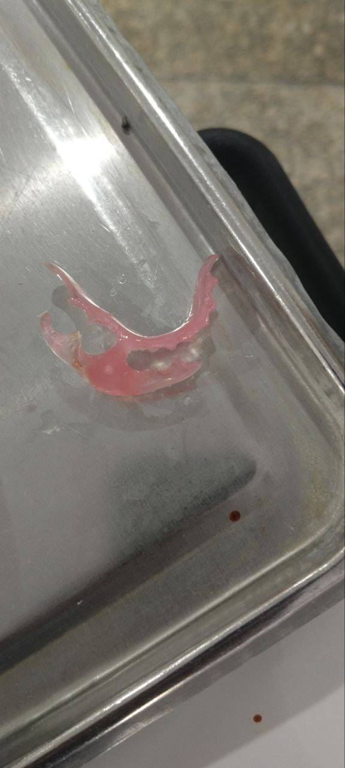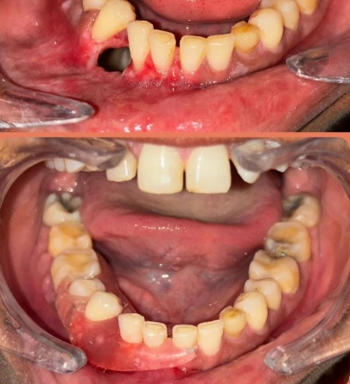
Fig No 10- Obturator Fabricated and Placed to close the Bony Defect

Clinical and Radiographic Evaluation: Intraoral examination confirmed discharge in the posterior mandible. A preoperative orthopantomogram (OPG) revealed a large radiolucent lesion in the right mandible involving the 41 to 48 tooth region. Fine Needle Aspiration Cytology (FNAC) was performed, providing clinical evidence of an Odontogenic Keratocyst.
Surgical Procedure: Under appropriate anesthesia, a full-thickness mucoperiosteal flap was raised through a standard incision. The cystic lesion was enucleated, and thorough curettage was performed on the bony walls. To address potential microscopic remnants, 5-Fluorouracil (5-FU) ointment was applied to the surgical site. The area was then packed with ribbon gauze and the flap was sutured.
Follow-up: A biopsy specimen was sent for histopathological examination, which confirmed the diagnosis of OKC. The patient was monitored at multiple intervals (1st, 2nd, and 3rd follow-up visits). Clinical healing was satisfactory, with no signs of neurosensory deficit or immediate recurrence.

- Discussion: Management of the Odontogenic Keratocyst (OKC) remains one of the most debated topics in maxillofacial surgery. Because OKCs originate from the dental lamina, they possess a thin, friable lining that is notoriously difficult to remove entirely by enucleation alone. The high recurrence rate associated with simple enucleation has historically pushed surgeons toward more radical treatments.
In this case, the lesion involved a significant portion of the right mandible (41-48). To avoid radical resection—which can lead to facial deformity, loss of teeth, and significant psychological impact—the authors chose a conservative approach supplemented with 5-Fluorouracil (5-FU). 5-FU acts as an antimetabolite, interfering with DNA synthesis and inducing apoptosis in the remaining cystic epithelial cells that may be left behind in the bony crypts or satellite cysts.
Unlike traditional chemical adjuvants such as Carnoy’s solution, which contains chloroform and can cause osseous necrosis or permanent nerve damage, 5-FU has not been associated with neurotoxicity. This makes it an ideal choice for lesions in close proximity to the inferior alveolar nerve. Recent literature suggests that 5-FU provides a recurrence rate comparable to or lower than Carnoy’s solution (approximately 0–18%) without the associated morbidity.
However, as noted during the peer-review process, the scientific community recognizes that while the short-term safety of 5-FU is superior, further longitudinal research is essential. Most recurrences of OKC occur within the first 2 to 5 years, but late-stage relapses have been documented over a decade later. Therefore, the successful clinical outcome and healing observed during our follow-up visits reinforce the effectiveness of this multimodal approach in the short term, but long-term vigilance is mandatory. Future studies should focus on standardized protocols for 5-FU application—including optimal concentration and duration of contact—to fully establish its safety profile and definitive impact on late-stage recurrence risks.

- Conclusion: Mandibular Odontogenic Keratocysts represent a significant surgical challenge, requiring a thorough diagnostic workup and a strategic intervention that balances the necessity of minimizing recurrence with the goal of preserving vital anatomical structures. This case highlights that enucleation supplemented with 5-Fluorouracil (5-FU) is a valid, conservative management strategy that provides favorable clinical outcomes and promotes rapid bone healing with minimal patient morbidity.

Unlike more caustic agents, the use of 5-FU topical application allows for the targeted elimination of residual epithelial remnants without compromising the integrity of the inferior alveolar nerve or causing extensive bone necrosis. However, it is important to acknowledge that while initial results are promising, the scientific literature still requires more comprehensive data regarding the long-term safety of chemical adjuvants and the precise incidence of late-stage relapse.
Because OKCs are known for their potential to recur several years post-surgery, a rigorous long-term follow-up protocol is mandatory for all patients treated with this multimodal approach. Further prospective studies and randomized controlled trials are needed to refine application protocols and definitively establish 5-FU as a gold-standard alternative to more radical resections. In conclusion, while conservative management with 5-FU appears to be a safe and effective bridge between simple enucleation and radical surgery, clinical vigilance remains the cornerstone of successful long-term management.

Competing interests:
Authors have declared that no competing interests exist.

COMPETING INTERESTS DISCLAIMER:
Authors have declared that they have no known competing financial interests OR non-financial interests OR personal relationships that could have appeared to influence the work reported in this paper.
Disclaimer (Artificial intelligence)

Author(s) hereby declare that NO generative AI technologies such as Large Language Models (ChatGPT, COPILOT, etc.) and text-to-image generators have been used during the writing or editing of this manuscript.

References
- Johnson NR, Batstone MD, Savage NW. Management and recurrence of keratocystic odontogenic tumor: a systematic review. Oral Surg Oral Med Oral Pathol Oral Radiol. 2013;116(4):e271-e276.
- Ribeiro-Júnior O, et al. The use of 5-fluorouracil in the treatment of odontogenic keratocysts: A systematic review. J Oral Maxillofac Surg. 2021;79(7):1462-1471.
- Ledderhof NJ, et al. Topical 5-Fluorouracil is a safe and effective adjuvant therapy for the treatment of odontogenic keratocysts. J Oral Maxillofac Surg. 2017;75(8):1686-1696.
- Borghesi A, et al. Odontogenic keratocyst: imaging features of a benign, but aggressive lesion. Insights Imaging. 2018;9(5):883-894.
- Madras J, Lapointe H. Keratocystic odontogenic tumour: reclassification of the odontogenic keratocyst from cyst to tumour. J Can Dent Assoc. 2008;74(2):165-165h.
- Dashow, J. E., et al. (2015). "5-Fluorouracil is associated with a decreased recurrence rate of odontogenic keratocyst." Journal of Oral and Maxillofacial Surgery.
- Kaczmarzyk, T., et al. (2018). "Odontogenic Keratocyst—An Updated Review of Pathogenesis and Management." Dental and Medical Problems.
- Al-Moraissi, E. A., et al. (2017). "What is the most effective conservative management for keratocystic odontogenic tumors? A systematic review and meta-analysis." International Journal of Oral and Maxillofacial Surgery.
- Dandhi, B. S., et al. (2022). "Management of Odontogenic Keratocyst with 5-Fluorouracil: A Case Report and Review of Literature." Journal of Maxillofacial and Oral Surgery.
- Knudsen, T. B., et al. (2023). "Recurrence rates of odontogenic keratocysts after various treatments: A 10-year retrospective study." Journal of Stomatology, Oral and Maxillofacial Surgery.
- Chirapathomsakul, D., et al. (2022). "Comparison of recurrence rates of odontogenic keratocyst treated with enucleation with or without adjuvant therapies: A systematic review and meta-analysis." Journal of Stomatology, Oral and Maxillofacial Surgery.
- Stoelinga, P. J. W. (2019). "The management of odontogenic keratocysts: A review of the literature and the state of the art." Journal of Oral and Maxillofacial Surgery, Medicine, and Pathology.
- Upadhyay, S., et al. (2023). "Topical 5-Fluorouracil as an Adjuvant in the Management of Odontogenic Keratocyst: A Case Series and Review." Cureus.
- Geelani, S. S., et al. (2024). "Evaluating the Efficacy of 5-Fluorouracil in Reducing Recurrence Rates of Odontogenic Keratocysts: A Prospective Study." International Journal of Maxillofacial Research.
- Chrcanovic, B. R., & Gomez, R. S. (2019). "Management of odontogenic keratocyst: an overview of systematic reviews." Oral and Maxillofacial Surgery Clinics of North America.
- Srivastava, S., et al. (2021). "A Review of 5-Fluorouracil as an Adjuvant Treatment for Odontogenic Keratocysts: Current Status and Future Perspectives." Oral Surgery, Oral Medicine, Oral Pathology, Oral Radiology.
- Didehban, K., et al. (2022). "Adjuvant Therapies for the Management of Odontogenic Keratocyst: A Systematic Review." Journal of Clinical and Experimental Dentistry.
- Dioguardi, M., Quarta, C., Sovereto, D., Caloro, G. A., Ballini, A., Aiuto, R., Martella, A., Lo Muzio, L., & Di Cosola, M. (2024). Factors and management techniques in odontogenic keratocysts: A systematic review. European Journal of Medical Research, 29(1), 287.
- Cordeiro JFB, et al. Conservative Decompression in the Management of Odontogenic Keratocysts: Case Report. Journal of Cancer and Tumor International. 2024;14(4):65–72.
- Rosa, S., Hammerschmidt, A., Prohny, J. P. S., Schussel, J. L., Wastner, B. D. F., & Sassi, L. M. (2024). Surgical treatment of odontogenic keratocyst in the mandible: A case report. Oral Surgery, Oral Medicine, Oral Pathology and Oral Radiology, 137(6), e198.

APPENDIX

Figure1

Figure 2 Figure 2

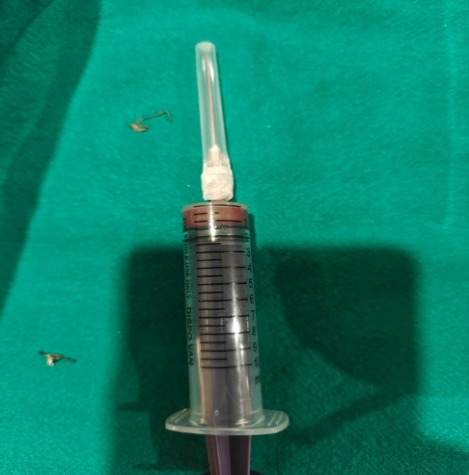
Fig no 3- FNAC specimen reveals Specimen with Biopsy report revealing Keratinised Odontogenic cyst

Fig No 4

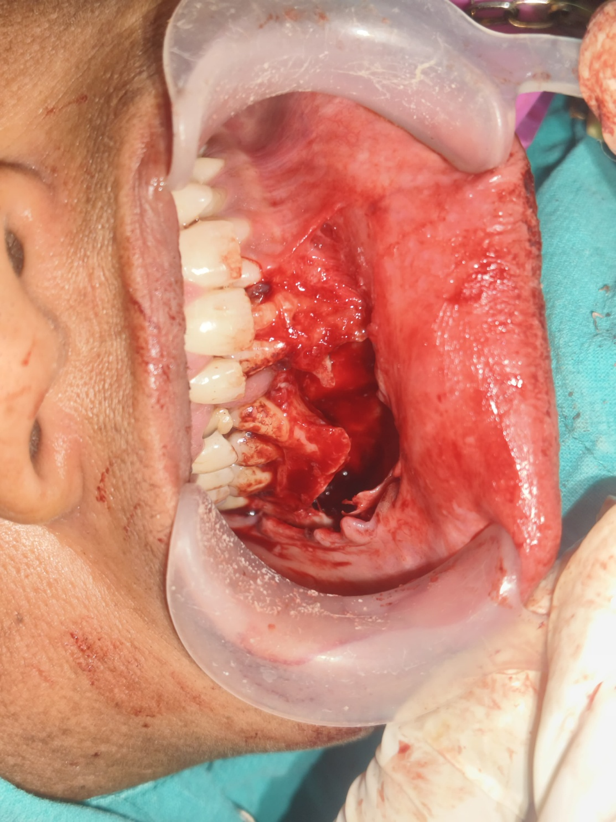
Fig No 5
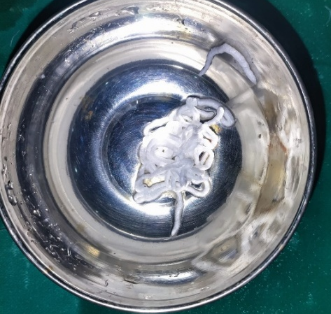
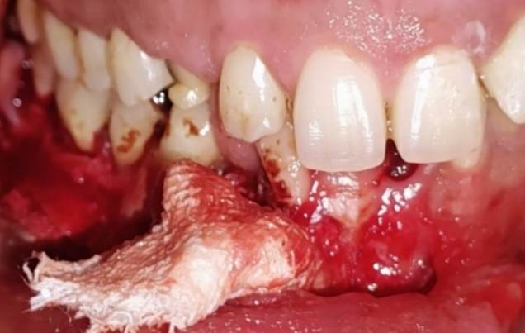
Fig No 6a Fig No 6b
Fig No 7
Figure No 8

Figure No 9

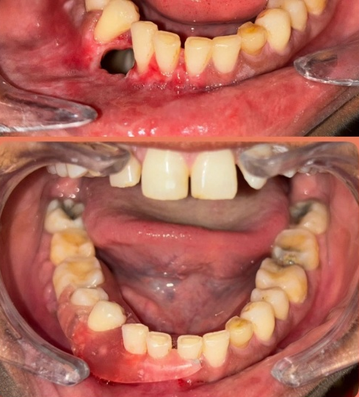
Figure No 10

Figure Legends
- Figure 1: Preoperative OPG showing a well-defined radiolucency irt Right Mandible extending from 32-48 region associated with impacted 33,43.
- Figure 2: CBCT reveals bone resorption irt 43-48 region with impacted 43,33 and Axial view showing mild Bucco-lingual expansion of bone

- Figure 3: FNAC specimen reveals Specimen with Biopsy report revealing Keratinised Odontogenic cyst
- Figure 4: Crevicular Incision given and an Anterior releasing incision given from 41 region followed by Mucoperiosteal Flap elevation and exposure of site of pathology.

- Figure 5: Surgical enucleation and bony socket irrigated and chemical cauterization done with Carnoy’s solution
- Figure 6a: 5- Fluorouracil ointment
- Figure 6b: 5-Fluorouracil coated gauze packed into the bony cavity
- Figure 7: Interdental sutures placed irt 41-48 region
- Figure 8: Biopsy Specimen 2x2cm in size sent for histopathological examination
- Figure 9: Biopsy report reveals Odontogenic Keratocyst
- Figure 10: Obturator Fabricated and Placed to close the Bony Defect

