Short Research Article

First report of Pantoea ananatis causing bacterial leaf blight of rice in Northeast India

ABSTRACT
Aims: This study aimed to document, isolate, and characterize the causal agent of an emerging bacterial leaf blight condition in rice (Oryza sativa L.) observed in Northeast India.
Study design: Field surveys were conducted from 2024 to 2026 across multiple farmers’ fields in the Lower, Upper, and Central Brahmaputra valley zones of Assam to assess disease incidence using a zig-zag sampling pattern.
Place and duration of study: Surveys revealed an unfamiliar blight characterized by water-soaked lesions and glume discolouration, with disease incidence ranging from 18% to 42% across the surveyed districts. The causal bacterium was isolated on nutrient agar and subjected to comprehensive morphological, biochemical, and pathogenicity testing, followed by molecular identification via 16S rRNA gene sequencing.
Results: The pathogen was identified as Pantoea ananatis (~99.6% sequence identity). It was Gram-negative, motile, and produced bright yellow, convex colonies. Pathogenicity was confirmed by clip inoculation of rice seedlings (cv. Ranjit), which consistently reproduced identical symptoms, thereby fulfilling Koch’s postulates.
Conclusion: This is the first confirmed report of P. ananatis causing bacterial leaf blight in rice from Assam, Northeast India, significantly expanding the known geographic distribution of this pathogen. Given the risk of seed-borne transmission, these findings underscore the urgent need to integrate molecular seed health testing and enhanced diagnostic surveillance into regional phytosanitary programs to effectively manage and control this emerging disease in rice agroecosystems

Keywords: Bacterial blight, emerging diseases, Oryza sativa, Pantoea
1. INTRODUCTION
Rice (Oryza sativa L.) remains central to the food and livelihood security of over half of the global population. India, the world’s second-largest producer, accounts for nearly 21% of global rice output, producing over 130 million tons annually (Bora et al., 2025; Sharma and Bora, 2025; Fukagawa and Ziska, 2019). The northeastern region, characterized by diverse agro-ecosystems, high rainfall, and humid subtropical conditions, is a key rice-producing area. However, these conditions also favor the proliferation of bacterial pathogens.
Leaf blight in rice typically manifests as progressive yellowing, necrotic streaks, or scorched lesions along the leaf blades, ultimately resulting in localized or complete collapse of leaf tissues. Extensive research over the decades has consistently identified Xanthomonas oryzae pv. oryzae (Xoo) as the principal causal agent of this economically significant disease, often responsible for yield reductions of up to 50% (Bakade et al., 2021). In recent years, however, particularly over the last two decades, Pantoea species have gained recognition as emerging pathogens in rice agroecosystems. Once considered primarily opportunistic, these bacteria are now increasingly documented as both primary and secondary causal agents of leaf blight across several rice-producing regions worldwide (Doni et al., 2019). A notable example is the widespread leaf blight outbreak reported in Malaysia between 2016 and 2018, where Pantoea spp. were conclusively implicated as the etiological agents (Azizi et al., 2019). Collectively, these findings highlight a shifting pathogen landscape in rice fields, underscoring the need to reassess disease surveillance strategies and broaden diagnostic approaches beyond the traditionally dominant Xoo.
The most recognized phytopathogenic Pantoea spp. are P. ananatis, P. agglomerans and P. stewartii that affect economically important crops including vegetables, cereals and fruits (Coutinho and Venter, 2009; Morin, 2014). Over the years, Pantoea species have been identified as significant bacterial pathogens responsible for severe damage to rice crops globally, leading to substantial economic losses. Recent reports indicate that outbreaks associated with this genus account for over 80% of plant disease incidences (Azizi et al., 2020; Kini et al., 2019). The genus Pantoea (family Erwiniaceae) comprises Gram-negative, facultative anaerobes inhabiting soil, water, plants, and seeds. While some strains are symbiotic or endophytic, others cause serious diseases in maize, rice, onion, eucalyptus, and millet (Doni et al., 2019; Andriani et al., 2025).
P. agglomerans, first described in rice from Japan, is now recognized globally as a versatile phytopathogen capable of infecting multiple hosts and surviving in diverse environments-associated with rice leaf blight and glume discoloration in Japan (Azegami et al., 1983), bacterial leaf blight disease in Korea (Lee et al., 2010) and germplasm of rice seeds (Rangel et al., 2018). In India, the pathogen was first detected in southern India recently from Tamil Nadu (Logeshwari et al.,2023).
Northeastern India is considered a secondary center of origin for cultivated rice and hosts numerous landraces with unique genetic diversity. The occurrence of an emerging bacterial disease in this region warrants early characterization to prevent its spread. This study was undertaken to (i) document and describe the symptoms of the newly observed bacterial blight and glume discoloration, (ii) isolate and characterize the causal organism morphologically and biochemically, (iii) confirm its pathogenicity on rice, and (iv) identify it at the molecular level using 16S rRNA gene sequencing.
2. material and methods
2.1 Sample collection, isolation and culture of the pathogen
Symptomatic rice leaf and grain samples exhibiting typical blight symptoms, including yellowing, orange-brown necrotic streaks, and scorched lesions along the leaf blades, were collected during field surveys conducted in the 2025 kharif season across four major rice-growing districts of Assam, India viz., Goalpara, Assam, India (25.960967°N, 90.933054°E), Jorhat, Assam, India (26.576523°N, 94.180477°E), Nagaon, Assam, India (26.575764°N, 93.281091°E) and Golaghat, Assam, India (26.646114°N, 93.787360°E). A total of 16 rice fields (four fields per district) were surveyed for disease occurrence. In each field, five random quadrats (1 m² each) were assessed following a zig-zag sampling pattern. Disease incidence was calculated as the percentage of infected plants relative to the total number of plants assessed per quadrat.
At the time of sampling, disease incidence ranged from 18–42% across surveyed locations, with the highest incidence recorded in Golaghat district (mean 39.6%) and the lowest in Goalpara (mean 21.3%). A total of 64 symptomatic samples (leaf and grain tissues) were collected (approximately 4 samples per field) in sterile polyethylene bags and transported to the laboratory under chilled conditions. Out of these, 52 samples showing clear advancing lesion margins were processed for pathogen isolation.
For cultural and morphological characterization, tissue segments (5–7 mm) from the lesion margins were surface-sterilized with 1% sodium hypochlorite for 1 min and rinsed thrice with sterile distilled water. Samples were macerated in 0.5 mL sterile water, and 50 µL of the suspension was streaked onto nutrient agar (NA) and tryptic soy agar (TSA) medium. Plates were incubated at 28 ± 2°C for 48 h. From the processed samples, 37 bacterial isolates showing consistent colony morphology were obtained after purification through repeated streaking.
The isolates were coded based on district origin and sample number as follows: PAS-1 to PAS-8 (Goalpara), JRT-1 to JRT-10 (Jorhat), CB-1 to CB-9 (Nagaon), and GLT-1 to GLT-10 (Golaghat). Representative isolates from each district (PAS-3, JRT-1, CB-4, and GLT-1) were selected for detailed cultural, morphological, biochemical, and molecular characterization. Distinct bright yellow, convex colonies were sub-cultured and purified by streak plating. Cultures were stored at 4°C for further use.
2.2 Morphological and biochemical characterization
Colony morphology was documented using a light microscope by gram staining. Biochemical assays were conducted using the HiAssorted Biochemical Kit (HiMedia, India) following manufacturer’s instructions. Tests included catalase, oxidase, and citrate utilization. Results were interpreted after 24-48 h incubation.
2.3 Pathogenicity assay
Healthy rice seedlings (cv. Ranjit) were grown in sterilized soil in 10-inch pots under controlled greenhouse conditions (28 °C, 85% RH, 12 h light:12 h dark). A bacterial suspension (10⁸ CFU mL⁻¹) was prepared from 48 h-old cultures. The concentration was adjusted using a spectrophotometer to an OD₆₀₀ of 0.1, corresponding to approximately 10⁸ CFU mL⁻¹, as standardized previously for Pantoea spp. inoculation (Kini et al., 2019). Clip inoculation was performed using sterilized scissors dipped in the bacterial suspension, cutting 2 cm of leaf tips (Bora et al., 2025). Control plants were mock-inoculated with sterile distilled water. Each treatment (inoculated and control) was applied to three independent pots (replicates), with 10 plants per pot (total plants per treatment = 30). At each sampling time (7, 14 and 28 dpi), lesion lengths were recorded from 10 randomly selected leaves per pot (one leaf per plant), for each individual isolate. This was done for all the isolates collected from the different infected rice fields of Assam. The bacterium was re-isolated from symptomatic leaf tissues by streaking onto nutrient agar. Colonies exhibiting identical bright yellow, convex morphology were purified and subjected to Gram staining and biochemical characterization. Molecular identification was performed through amplification and sequencing of the 16S rRNA gene.
2.4 Molecular identification and phylogenetic analysis
Genomic DNA was extracted using the cetyltrimethylammonium bromide (CTAB) method. PCR amplification of the 16S rRNA gene was performed with universal primers 27F (5’-AGAGTTTGATCATGGCTCAG-3’) and 1492R (5’-AAGGAGGTGATCCAACCGCA-3’) (Mondal et al., 2011). Reaction conditions (50 μL volume): 5 μL 10× buffer, 5 μL dNTPs (200 μM each), 0.5 μL of (50 μM) of each primer forward and reverse, 1 μL Taq polymerase (1U/ μL), 5 μL template DNA and 33 μL of sterile MilliQ water (Thermo Fisher Scientific, India). The PCR program: initial 95 °C for 5 min; 35 cycles of 94 °C for 45 s, 55 °C for 45 s, 72 °C for 90 s; and final extension at 72 °C for 10 min, followed by Sanger Sequencing at Bioserve, Hyderabad, India.
Sequences were compared using BLASTn in the NCBI GenBank database. Highly homologous sequences were aligned using Muscle(https://www.ebi.ac.uk/Tools/msa/muscle/). The evolutionary relationships were reconstructed using the Maximum Likelihood Method described by Yang (2007). The best-supported topology is shown in the Results section. Bootstrap support values, derived from 1000 replicates, are displayed alongside the corresponding branches to indicate the proportion of replicate trees in which the taxa grouped together. The phylogenetic tree is scaled, with branch lengths expressed in the same units as the calculated evolutionary distances. These distances were estimated using the Maximum Livelihood method and are reported as evolutionary distances were calculated using Kimura 2-parameter. The dataset comprised 20 nucleotide sequences. Ambiguous sites were excluded through pairwise deletion, resulting in a final alignment. Evolutionary analyses were conducted in MEGA11 (https://www.megasoftware.net/).
2.5 Statistical analysis
Lesion length data were expressed as mean ± standard error (SE). For each treatment, the mean lesion length per pot (average of ten leaves) was calculated, and these pot means (n = 3 replicates per treatment) were used for statistical analysis to avoid pseudo-replication. Data were analyzed using one-way analysis of variance (ANOVA) to determine significant differences among treatments at each sampling time point. When the ANOVA indicated significant effects, Tukey’s Honestly Significant Difference (HSD) test was applied for multiple comparisons among treatment means at p ≤ 0.05 using IBM SPSS Statistics version 21.
3. results and discussion
3.1 Symptomatology
Field observations revealed that symptoms began as small, water-soaked spots along leaf margins and tips, which later expanded into elongated yellow to orange-brown streaks (Fig. 1A). Severely affected leaves exhibited necrosis and desiccation from the apex downward. Infected panicles bore discolored grains with shriveled or spotted glumes (Fig. 1B).
3.2 Morphological and biochemical characteristics
Isolates on NA produced bright yellow, shiny colonies (1-3 mm diameter) that were circular, smooth-edged, and raised on nutrient agar. The colonies exhibited non-mucoid, a typical cultural trait of Pantoea species (Fig. 2A). The isolate was Gram-negative and motile (Fig. 3). Biochemical profiling confirmed catalase positive, oxidase negative and citrate utilization. Pantoea sp. typically produces yellow, smooth, non-mucoid colonies with a glossy appearance. Colonies remain firm, non-viscous, and less pigmented.
3.3 Pathogenicity assay
Inoculated rice seedlings developed distinct water-soaked lesions within 7 days post-inoculation (dpi), which progressively expanded into light yellow to orange-brown necrotic lesions along the leaf margins by 14 dpi (Fig. 2B–C; Table 1). At 14 dpi, the mean lesion length in inoculated plants was 6.84 ± 0.72 cm, whereas no visible lesions were observed in control plants (0.00 cm). Likewise, in 28 dpi, the mean lesion length in inoculated plants was 11.025 ± 0.57 cm, and no disease progression in mock inoculated control plants. Pathogenicity assays were conducted using ten biological replicates per treatment and repeated twice. Statistical analysis was performed using one-way ANOVA followed by Tukey’s HSD test. Lesion length in inoculated plants differed significantly among treatments according to one-way ANOVA followed by Tukey’s HSD test (p ≤ 0.05).
The bacterium was consistently re-isolated from symptomatic tissues of inoculated plants, exhibiting identical colony morphology and biochemical characteristics to the original isolate, thereby fulfilling Koch’s postulates.
3.4 Molecular identification
Sanger sequence analysis revealed close identity (>99.75%) with Pantoea ananatis strain WHRI 5854. The sequence was deposited in NCBI GenBank under accession number PX980608 (Pantoea ananatis AS4GLT-1), PX472780 (Pantoea sp. PAS-3), PX623262 (Pantoea ananatis ASJRT01), and PX623265 (Pantoea sp. CBVZ01). Phylogenetic analysis grouped the isolate within the P. ananatis (Fig. 3).
Table 1: Lesion length (cm) in rice cv. Ranjit following inoculation with different Pantoea strains compared with sterile water control at different days post-inoculation (dpi).
Days post-inoculation (dpi) | Treatment / Strain | Lesion length (cm) ± SE
7 dpi | Control (Sterile water) | 0.00 ± 0.00
 | Pantoea ananatis AS4GLT | 2.86 ± 0.28
 | Pantoea sp. PAS-3 | 2.94 ± 0.31
 | Pantoea ananatis ASJRT01 | 3.02 ± 0.34
 | Pantoea sp. CBVZ01 | 2.91 ± 0.29
14 dpi | Control (Sterile water) | 0.08 ± 0.09
 | Pantoea ananatis AS4GLT | 6.72 ± 0.65
 | Pantoea sp. PAS-3 | 6.84 ± 0.72
 | Pantoea ananatis ASJRT01 | 7.01 ± 0.70
 | Pantoea sp. CBVZ01 | 6.79 ± 0.66
28 dpi | Control (Sterile water) | 0.12 ± 0.11
 | Pantoea ananatis AS4GLT | 10.91 ± 0.58
 | Pantoea sp. PAS-3 | 11.27 ± 0.63
 | Pantoea ananatis ASJRT01 | 11.04 ± 0.61
 | Pantoea sp. CBVZ01 | 10.88 ± 0.57
Data represent mean lesion length ± standard error (SE) of 30 leaves per treatment (10 leaves per replicate, three replicates).
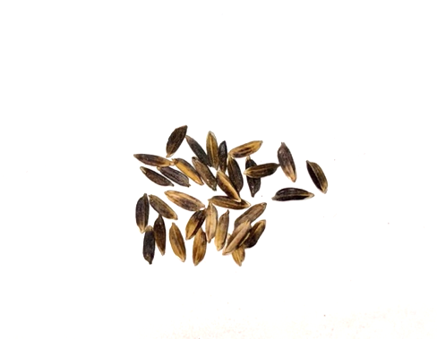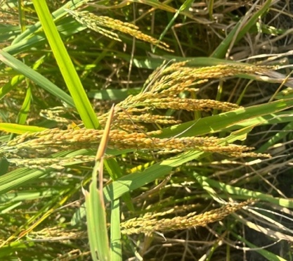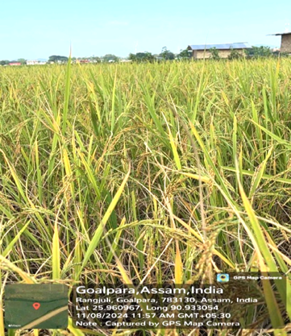
B
A

Fig. 1. Rice leaves showing (A) water-soaked, light brown lesions typical of bacterial blight and (B) glume discoloration on affected grains
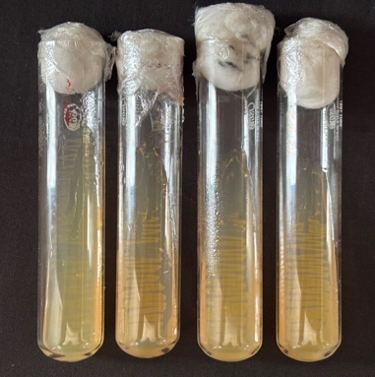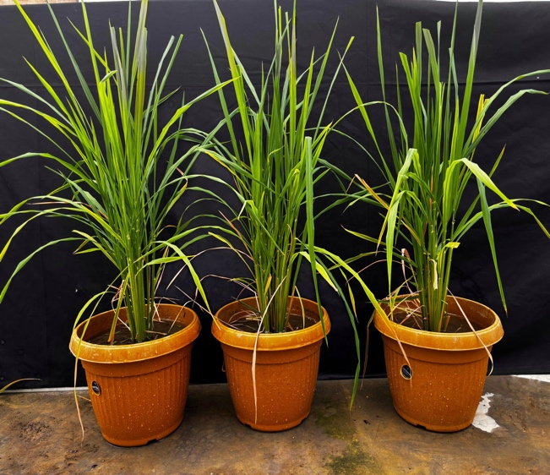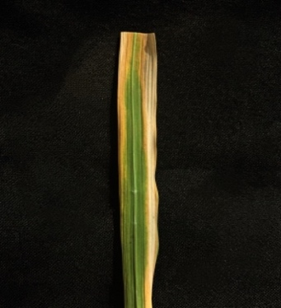
A
C

B

Fig. 2. (A) Yellow, convex colonies of all 4 strains of Pantoea spp. on nutrient agar slants after 48 h. (B-C) Inoculated rice leaf showing necrotic lesion 10 days post-inoculation.
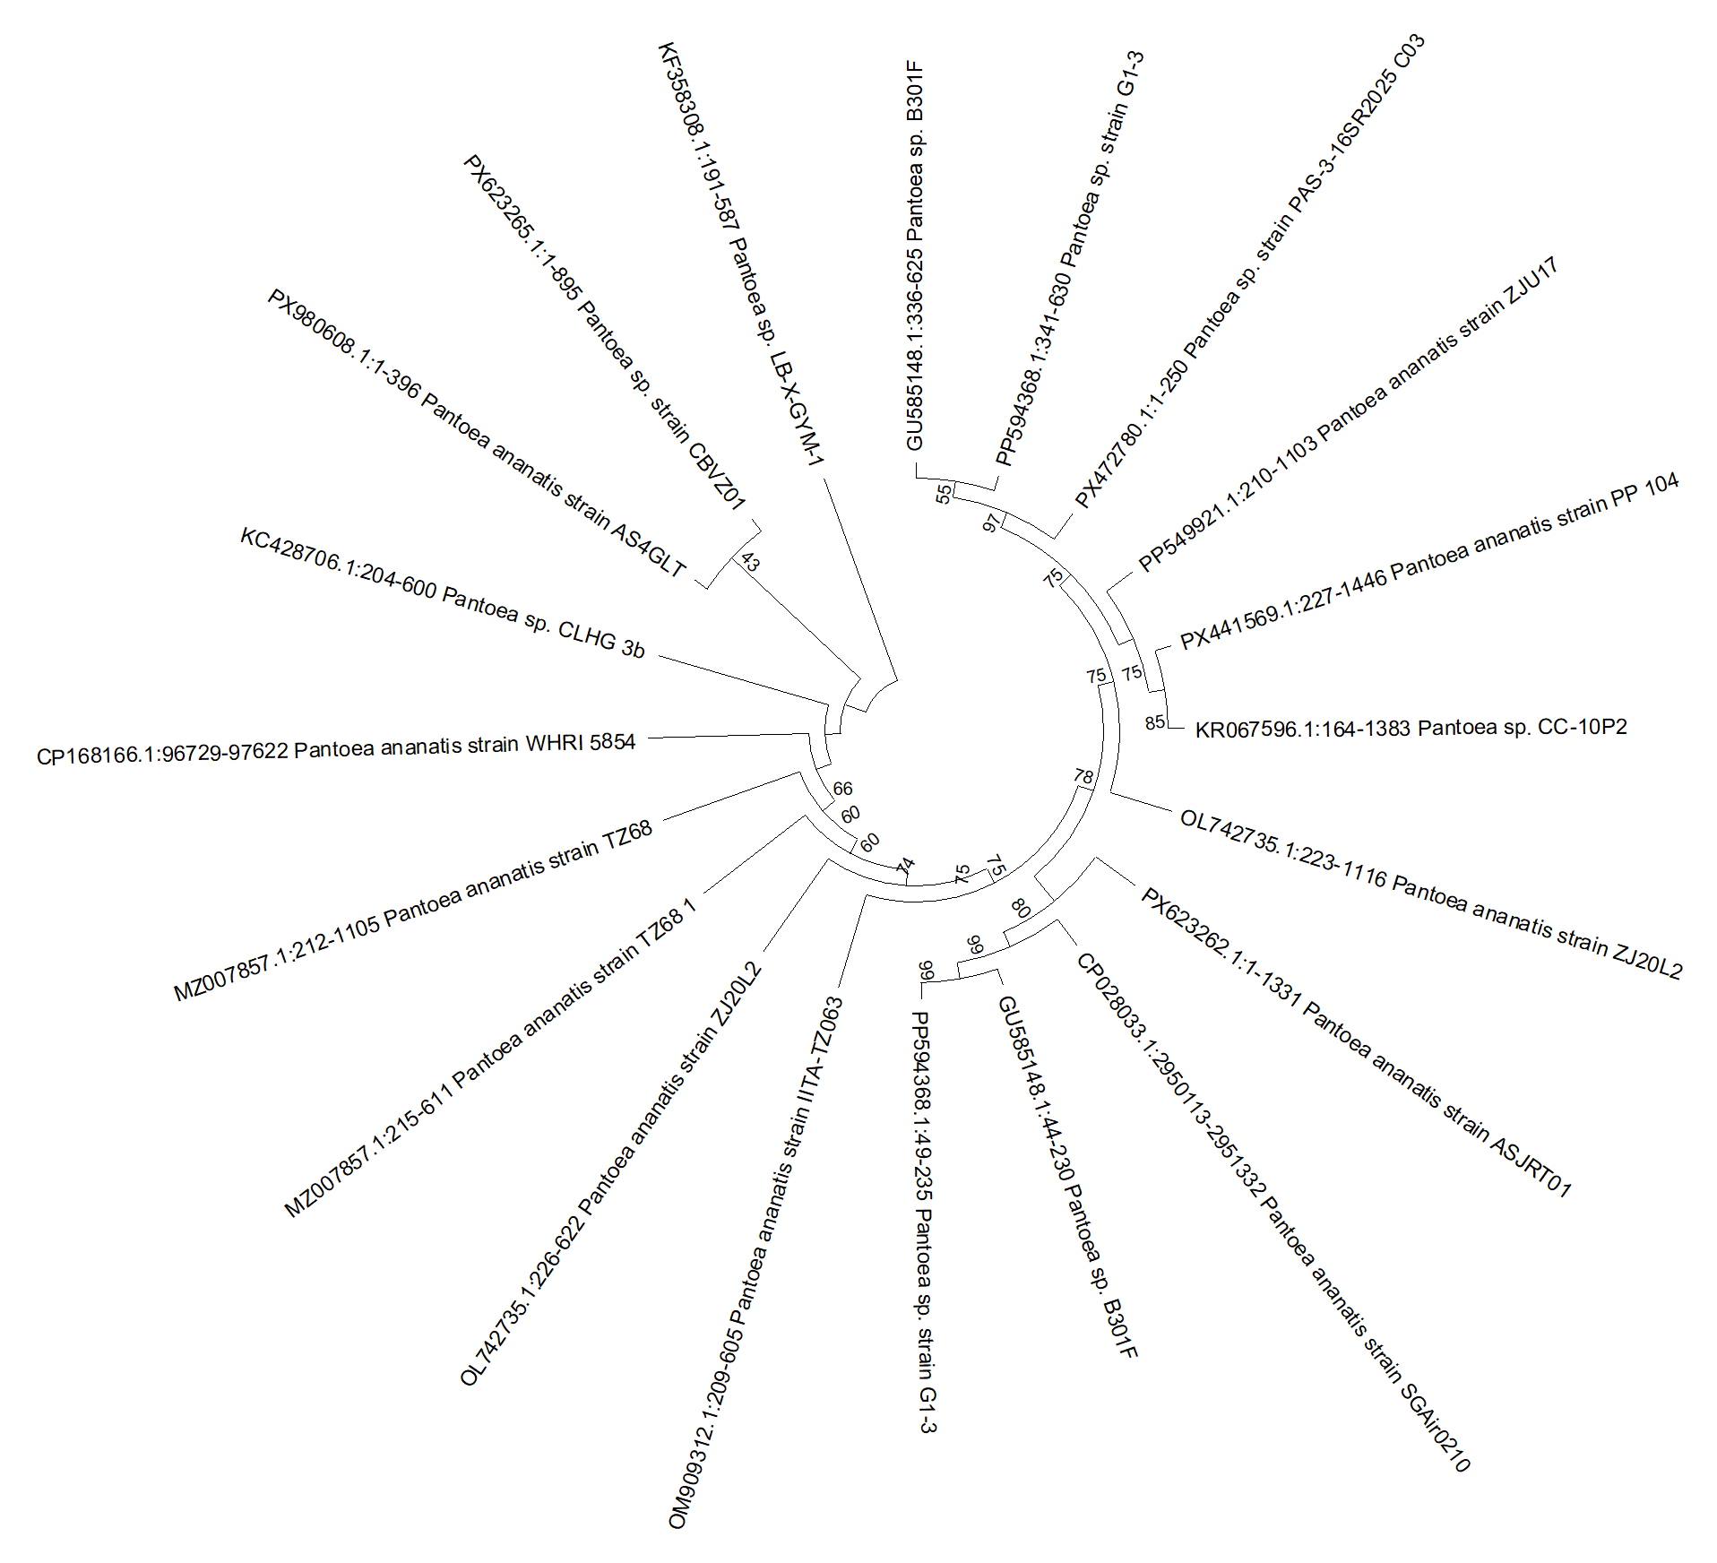
Fig. 3. Phylogenetic tree constructed from16S rRNA sequences from the bacterial strain recovered from the Assam, India, and other Pantoea species in GenBank.
4. DISCUSSION
Globally, Pantoea species have transitioned from being regarded as incidental epiphytes to recognized phytopathogens with broad host ranges (Pedrozo et al., 2025). Their ecological plasticity, facilitated by horizontal gene transfer and the acquisition of virulence-associated gene clusters (Dahiya et al., 2024), enables them to colonize both monocots and dicots, persisting as epiphytes or endophytes before transitioning to pathogenicity under favourable conditions (Coutinho and Venter, 2009; Doni et al., 2019).
Our findings align with reports from Korea, Malaysia and Venezuela, where Pantoea species were recovered from surface-sterilized seeds and developing grains, confirming internal seed transmission (Lee et al., 2010; Azizi et al., 2019; González et al., 2015). This endophytic colonization of embryo tissues is a critical factor, as it promotes early seedling infection and enables dissemination through the informal seed exchange systems prevalent in Assam. Consequently, molecular seed health testing and pathogen-free certification must become core components of regional biosecurity strategies to prevent localized outbreaks from becoming endemic (Lee et al., 2010; Gonzalez et al., 2015).
Furthermore, our isolate exhibited vigorous motility and rapid colonization under humid greenhouse conditions. This behaviour mirrors reports by Coutinho and Venter (2009), suggesting that the humid microclimate of Northeast India during the monsoon season (mean RH > 80%) likely enhances these motility-driven infection processes, accounting for the severe leaf blight and glume discolouration observed in our field surveys (Mondal et al., 2011).
The emergence of P. ananatis in the Northeast Indian rice ecosystem represents a significant shift in the pathogen landscape. While Xanthomonas oryzae pv. oryzae (Xoo) has long been the dominant bacterial pathogen of rice in India, the rising incidence of Pantoea suggests a more complex, multi-pathogen system. Unlike Xoo, which is traditionally associated with specific leaf blight symptoms, P. ananatis adds an extra layer of complexity by causing both leaf blight and grain discolouration. This expansion beyond traditional agents underscores the urgent need to reassess disease surveillance strategies and broaden diagnostic approaches in the region.
The establishment of this pathogen is likely fostered by continuous rice cultivation and overlapping cropping cycles, which maintain a "green bridge" for bacterial inoculum. Furthermore, the widespread reliance on high-yielding but susceptible cultivars like ‘Ranjit’ in this region likely facilitates rapid pathogen establishment. In contrast to reports from Southern India where Pantoea stewartia was recently identified, our study confirms P. ananatis as the primary agent in Northeast India (Vinodhini et al., 2017). This geographic and species-specific differentiation highlights the need for region-specific epidemiological models to understand how distinct Pantoea strains interact with local rice germplasm.
5. Conclusion
The present study confirms Pantoea ananatis as the causal agent of bacterial leaf blight of rice (Oryza sativa L.) in Northeast India, representing the first documented report of this pathogen from the region. The identification was supported by symptomatologic observations, morphological and biochemical characterization, pathogenicity assays fulfilling Koch’s postulates, and molecular analysis of the 16S rRNA gene. Earlier reports of Pantoea-associated leaf blight in rice were largely restricted to southern India (Logeshwari et al., 2023); thus, the current finding expands the known geographic distribution of the pathogen within the Indian subcontinent.
The occurrence of P. ananatis in the rice-growing ecosystems of Northeast India is of considerable phytosanitary significance, given the region’s humid climatic conditions, extensive rice cultivation, and rich diversity of indigenous germplasm. The potential seed-borne nature of the pathogen highlights the need for strengthened diagnostic surveillance and the incorporation of molecular detection tools into seed health certification and phytosanitary monitoring programs.
Furthermore, the emergence of this pathogen emphasizes the importance of focused research on its epidemiology, transmission dynamics, and host–pathogen interactions within the rice ecosystems of the region. Future disease management strategies should prioritize systematic screening of local rice germplasm for resistance and the development of integrated disease management approaches to minimize the risk of pathogen establishment and spread.

Disclaimer (Artificial intelligence)

Author(s) hereby declare that NO generative AI technologies such as Large Language Models (ChatGPT, COPILOT, etc.) and text-to-image generators have been used during the writing or editing of this manuscript.

References
- Andriani, L. T., Poromarto, S. H., & Purwanto, E. (2025). Characterization and biocontrol of Pantoea ananatis, the causal agent of rice bacterial leaf blight in Malang, Indonesia. Biodiversitas: Journal of Biological Diversity, 26(4).
- Azegami, K. (1983). Bacterial palea browning: a new disease of rice caused by Erwinia herbicola. Bulletin of the National Institute of Agricultural Sciences, 37, 1–12.
- Azizi, M. M. F., Ismail, S. I., Ina-Salwany, M. Y., Hata, E. M., & Zulperi, D. (2020). The emergence of Pantoea species as a future threat to global rice production. Journal of Plant Protection Research, 60(3), 327–335.
- Azizi, M. M. F., Zulperi, D., Rahman, M. A. A., Abdul-Basir, B., Othman, N. A., Ismail, S. I., et al. (2019). First report of Pantoea ananatis causing leaf blight disease of rice in Peninsular Malaysia. Plant Disease, 103(8), 2122.
- Bora, P., Chetia, S. K., Sharma, A., Ahmed, S. S., Sharma, P., & Bhattacharyya, A., et al. (2025). Microbial biocontrol agents engineer plant biometrics and host response against Xanthomonas oryzae pv. oryzae in rice. Microbiology Research, 16(7), 151. https://doi.org/10.3390/microbiolres16070151
- Bakade, R., Ingole, K. D., Deshpande, S., Pal, G., & Patil, S. S., et al. (2021). Comparative transcriptome analysis of rice resistant and susceptible genotypes to Xanthomonas oryzae pv. oryzae identifies novel genes to control bacterial leaf blight. Molecular Biotechnology, 63, 719–731.
- Coutinho, T. A., & Venter, S. N. (2009). Pantoea ananatis: an unconventional plant pathogen. Molecular Plant Pathology, 10(3), 325–335. https://doi.org/10.1111/j.1364-3703.2009.00542.x
- Dahiya, P., Kumar, P., Rani, S., Dang, A. S., & Suneja, P. (2024). Comparative genomic and functional analyses for insights into Pantoea agglomerans strains adaptability in diverse ecological niches. Current Microbiology, 81(8), 254.
- Doni, F., Suhaimi, N. S. M., Mohamed, Z., Ishak, N., & Mispan, M. S. (2019). Pantoea: a newly identified causative agent for leaf blight disease in rice. Journal of Plant Diseases and Protection, 126(6), 491–494. https://doi.org/10.1007/s41348-019-00244-6
- Fukagawa, N. K., & Ziska, L. H. (2019). Rice: importance for global nutrition. Journal of Nutritional Science and Vitaminology, 65(S2), S2. https://doi.org/10.3177/jnsv.65.S2
- González, A. D., Franco, M. A., Contreras, N., Galindo-Castro, I., Jayaro, Y., & Graterol, E. (2015). First report of Pantoea agglomerans causing rice leaf blight in Venezuela. Plant Disease, 99(4), 552.
- Kini, K., Dossa, R., Dossou, B., Mariko, M., Koebnik, R., & Silué, D. (2019). A semi-selective medium to isolate and identify bacteria of the genus Pantoea. Journal of General Plant Pathology, 85(6), 424–427. https://doi.org/10.1007/s10327-019-00862-w
- Lee, H. B., Hong, J. P., & Kim, S. B. (2010). First report of leaf blight caused by Pantoea agglomerans on rice in Korea. Plant Disease, 94(11), 1372. https://doi.org/10.1094/PDIS-05-10-0374
- Logeshwari, R., Gopalakrishnan, C., Naveena, S., & Manonmani, S. (2023). First report of rice bacterial leaf blight and grain discolouration caused by Pantoea agglomerans in India. New Disease Reports, 47(1).
- Mondal, K. K., Mani, C., Singh, J., Kim, J. G., & Mudgett, M. B. (2011). A new leaf blight of rice caused by Pantoea ananatis in India. Plant Disease, 95(12), 1582.
- Morin, A. (2014). Pantoea. In: Encyclopedia of Food Microbiology (pp. 1623–1630). https://doi.org/10.1016/B978-0-12-384730-0.00245-7
- Pedrozo, R., de Paula, S., Flasco, M., Dalla Lana, F., Jia, Y., & Nicolli, C. (2025). New Threats to Rice Production: Emerging Pathogens and their Impact.
- Rangel, P. H. N., Mello, R. N., Rocha, G. A., & Cunha, M. G. (2018). Detection of Pantoea agglomerans in germplasm rice accessions (Oryza sativa) in Brazil. Plant Disease, 102(1), 237.https://doi.org/10.1094/PDIS-06-17-0905-PDN
- Sharma, A., & Bora, P. (2025). Engineering synthetic microbial communities to restructure the phytobiome for plant health and productivity. World Journal of Microbiology and Biotechnology, 41(7), 228.
- Vinodhini, J., Kannan, R., Sankareswari, R. U., Akila, R., & Pillai, M. A. (2017). Characterization of new bacterial leaf blight of rice caused by Pantoea stewartii subsp. indologenes in southern districts of Tamil Nadu. International Journal of Environment, Agriculture and Biotechnology, 2(6), 239027.
- Yang, Z. (2007). PAML 4: phylogenetic analysis by maximum likelihood. Molecular biology and evolution, 24(8), 1586-1591.

