“Genetic variability and character association for fruit yield and its attributing traits in Bottle gourd (Lagenaria siceraria (Mol.) Standl.)”

Abstract
The present investigation was carried out during the summer season of the year 2024-25 in the experiment field of Department of Vegetable Science at Pt. KLS College of Horticulture and Research Station, Rajnandgaon (C.G.), under Mahatma Gandhi University of Horticulture & Forestry, Durg (C.G.). The experiment was laid under Randomized Block Design (RBD) with three replications and the experimental material consisting of eighteen genotypes of Bottle gourd. Eighteen bottle gourd genotypes were growth, flowering and yield traits. Analysis of variance revealed that mean sum of squares due to genotypes was highly significant for all characters. Among eighteen genotypes, the genotype BOGVAR-10 was noted for 1st germination (5.16 days). The genotype BOGVAR-3 was noted for earliness in 50% germination (8.37 days). The maximum plant height (1.88 m) in 60 DAS was recorded in BOGVAR-8 and maximum plant height (6.03 m) in 90 DAS in the same genotype. The genotype BOGVAR-14 was also noted for early days taken to first male flower (27.14) and first female flower appears (30.00) DAT. The genotype BOGVAR-3 was also recorded the earliest node for first male flower (3.46) and first female flower (8.23). Maximum number of fruits per plant (14.42) was recorded in BOGVAR-3. The genotype BOGVAR-3 was noted for days taken to 1st fruit harvest 41.43 DAT. Maximum fruit length (57.42 cm) was recorded in BOGVAR-18. Maximum fruit diameter (13.24 cm) and average fruit weight (1784.26 g) was recorded in BOGVAR-4. Maximum fruit yield per plant (12.76 kg) and fruit yield per hac. (383.90 q) was recorded in BOGVAR-8.
Keywords: Bottle gourd, genotype, earliness, fruit yield.
Introduction
Bottle gourd (Lagenaria siceraria (Mol.) Standl.) belongs to the family Cucurbitaceae, having chromosome number 2n=22. Bottle gourd is believed to have originated in Southern Africa and subsequently spread to Asia and other tropical regions. It goes by several names, including ghia, lauki, calabash, and white-flowered gourd. The Latin terms "lagena" (bottle) and "sicera" (drinking utensil) are the source of the names "lagenaria" and "siceraria" (Suman et al., 2023). The fruit is used for a variety of purposes, tender fruits are used as vegetables and for preparing sweet dishes, raita and pickles. It is one of the most important cucurbitaceous vegetables cultivated in India. It is a monoecious, diploid, climbing or prostrate plant, solitary flowers and strictly cross pollinated due to its monoecious nature (Kumar et al., 2019). Lagenaria siceraria is commonly grown in both rainy and summer seasons and tropical regions in the world, its fruits are available in the market throughout the year. The fruits are variable in shape and size, Pear shaped, Globular, Cylindrical, Lengthened Cylindrical and Elongate depending upon the variety. Numerous health benefits are reported in bottle gourd including its anti-cancerous, cardio protective, diuretic, aphrodisiac etc. Its medicinal value extends to its use in treating pain, ulcers, fever, bronchial disorders, and reducing cholesterol, triglyceride, and low-density lipoproteins. (Suman et al., 2023). Therefore, the present study was undertaken to evaluate the genetic variability among bottle gourd genotypes for yield and yield-related traits under field conditions.
Materials and Methods
The investigation was conducted during the summer season of the year 2024-25 at the field of Vegetable Science at Pt. KLS College of Horticulture and Research Station, Rajnandgaon (C.G.), under Mahatma Gandhi University of Horticulture & Forestry Durg, (C.G.). The soil in the experimental field has a clayey texture, low nitrogen availability, high phosphorus availability and medium potassium and soil Ph 7.1. The experiment comprised of eighteen genotypes of bottle gourd viz., BOGVAR-1, BOGVAR-2, BOGVAR-3, BOGVAR-4, BOGVAR-5, BOGVAR-6, BOGVAR-7, BOGVAR-8, BOGVAR-9, BOGVAR-10, BOGVAR-11, BOGVAR-12, BOGVAR-13, BOGVAR-14, BOGVAR-15, BOGVAR-16, BOGVAR-17 and BOGVAR-18. The experiment was laid under Randomized Block Design (RBD) with three replications at 2×1.5 m row to row and plant to plant spacing. All the recommended cultural practices were adopted to raise a healthy crop. Data were recorded on three randomly selected plants with respect to character viz., Days taken to 1st germination, days taken to 50% germination, plant height (m), days taken to 1st male flower appears, days taken to 1st female flower appears, node at which 1st male flower appears, node at which 1st female flower appears, number of fruits per plant, days taken to 1st fruit harvest, fruit length (cm), fruit diameter (cm), average fruit weight (g), fruit yield /plant (kg) and fruit yield /hac. (q). Analysis of variance (ANOVA) was performed following the procedure described by Gomez and Gomez for Randomized Block Design.
Result and discussions
The mean values of different growth and yield parameters with respect to genotypes are presented in table 1. The analysis of variance revealed that mean sum of squares due to genotypes were highly significant for all characters. Significant mean sum of squares due to fruit yield and attributing characters revealed existence of considerable variability in material studied for improvement for various traits. These findings are in general agreement with the findings of Kumar et al. (2012) and Bhardwaj et al. (2013).

The first seed germination occurred in an average of 8.26 days, ranging from 5.16 to 11.19 days. BOGVAR-10 recorded the first seed germination after 5.16 days, while BOGVAR-6 recorded a delayed first seed germination after 11.19 days. The earliest days to 50% seed germination were recorded between 8.37 days and 17.69 days, with an overall mean of 12.20 days. BOGVAR-3 had the earliest 50% seed germination (8.37 days), whereas BOGVAR-6 had the delayed 50% seed germination (17.69 days). The average height of the 60 DAS plants is 1.52 meters, with a range of 1.15 to 1.88 meters. BOGVAR-8 had the highest plant height (1.88 m) at 60 DAS, while BOGVAR-1 had the lowest (1.15 m). BOGVAR-8 had the highest plant height at 90 DAS (6.03 m), whereas BOGVAR-6 had the lowest plant height (3.44 m). The 90 DAS plant height ranges from 3.44 m to 6.03 m, with an overall mean of 4.49 m. The time taken for the first male flowers to appear ranged from 27.14 DAT to 44.41 DAT. The genotype BOGVAR-14 had the earliest day to first male flower appearance (27.14 DAT), while the genotype BOGVAR-7 had the longest day to first male flower appearance (44.41 DAT). The range of days taken for the first female flower to appear was 30.00 DAT to 49.83 DAT. The significantly earliest days for the appearance of the 1st female flower were recorded in BOGVAR-14 (30.00 DAT), and the maximum days to the 1st female flower appearance was recorded in the genotype BOGVAR-7 (49.83 DAT). The first male flower appeared at nodes ranging from 3.46 to 4.86. The genotype BOGVAR-2 (4.86) had the highest node at which the first male flower appeared, while BOGVAR-3 (3.46) had the earliest node at which the first male flower appeared. The range of nodes at which the first female flower appears is 8.23 to 11.55. The genotype BOGVAR-13 (11.55) had the largest node at which the first female flower occurs, while BOGVAR-3 (8.23) had the earliest node at which the first female flower appears. The maximum number of fruits per plant ranged between 6.53 and 14.42, with an overall mean of 9.55 fruits per plant. The genotype BOGVAR-3 (14.42) had the greater number of fruits per plant, while the genotype BOGVAR-7 (6.53) had the lowest number of fruits per plant. The average number of days taken to the 1st fruit harvest was 52.17 DAT, with a range of 41.43 DAT to 67.69 DAT. The genotype BOGVAR-3 was recorded at the early harvesting (41.43 DAT), while the genotype BOGVAR-7 showed the longest time to 1st fruit harvest (67.69 DAT). The fruit lengths ranged from 15.31 to 57.42 cm, with a mean of 33.85 cm. The genotype BOGVAR-18 had the longest fruit length (57.42 cm), while the genotype BOGVAR-3 had the shortest fruit length (15.31 cm). The fruit diameters have varied from 5.36 to 13.24 cm, with an average of 7.38 cm. The genotype BOGVAR-4 had the largest fruit diameter (13.24 cm), whereas the genotype BOGVAR-18 had the smallest fruit diameter (5.36 cm). The average fruit weight ranged from 896.11 g to 1784.26 g, with an overall mean of 1097.90 g. The genotype BOGVAR-7 had the highest average fruit weight (1784.26 g), while BOGVAR-6 had the lowest average fruit weight (896.11 g). The fruit yield per plant ranged between 6.56 kg and 12.76 kg, with an overall mean of 9.23 kg. The genotype BOGVAR-8 had the highest fruit yield per plant (12.76 kg), while genotype BOGVAR-6 had the lowest fruit yield per plant (6.56 kg). The fruit yield per hectare has ranged between 196.80 q and 383.90 q, with an overall mean of 277.80 q. The genotype BOGVAR-8 (383.90 q) has the highest fruit yield per hectare, while the genotype BOGVAR-6 (196.80 q) has the lowest fruit yield per hectare.

Fig-1 Different genotypes of Bottle gourd
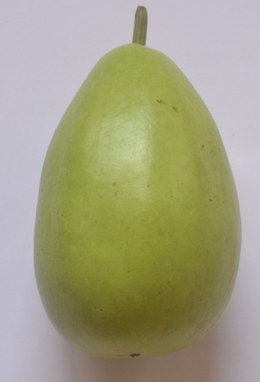
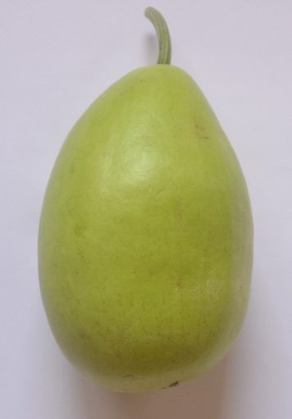

BOGVAR - 2

BOGVAR - 1

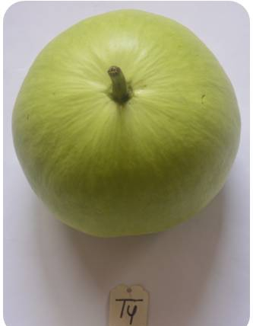
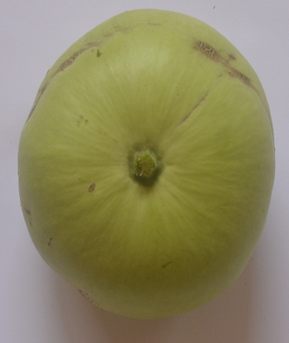

BOGVAR - 4

BOGVAR - 3

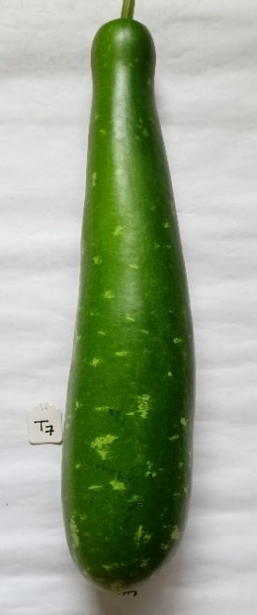
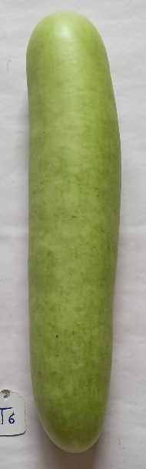
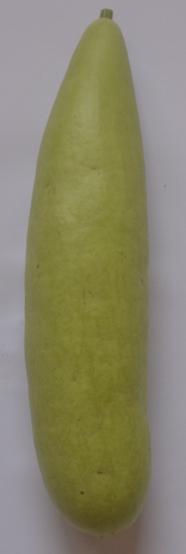

BOGVAR - 5

BOGVAR - 7

BOGVAR - 6

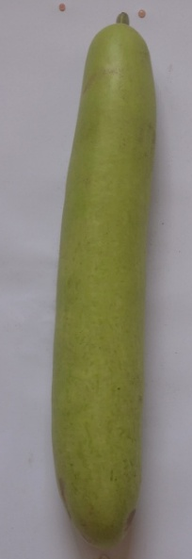
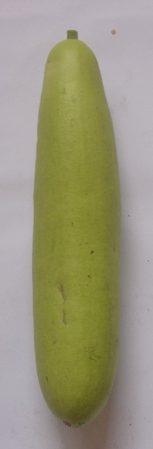

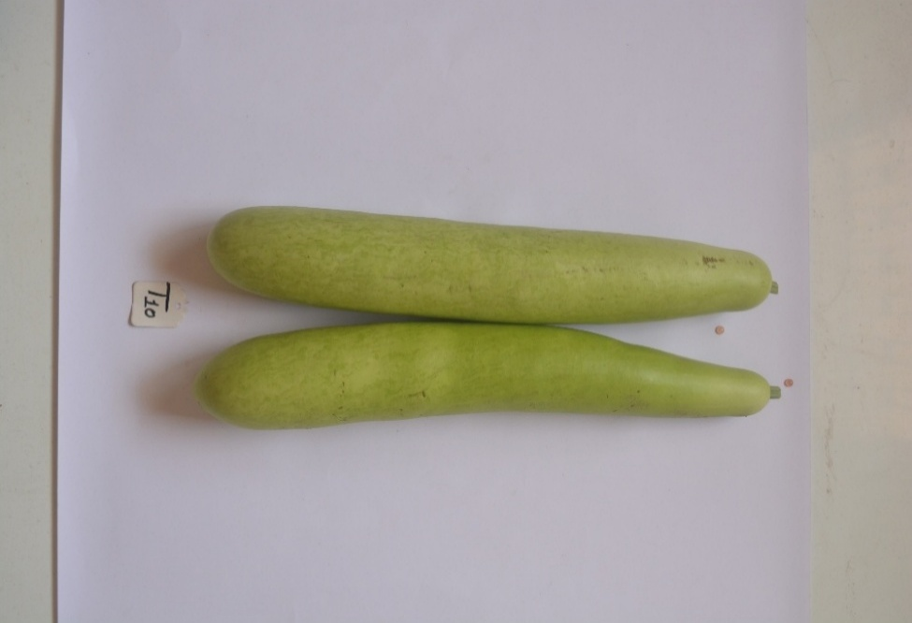

BOGVAR - 10

BOGVAR - 9

BOGVAR - 8

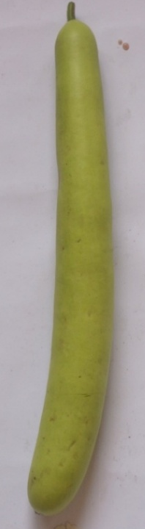
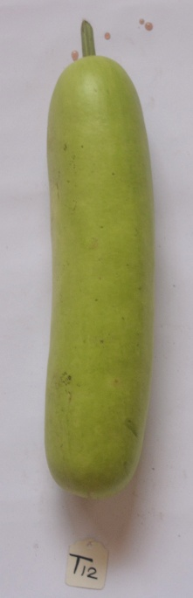
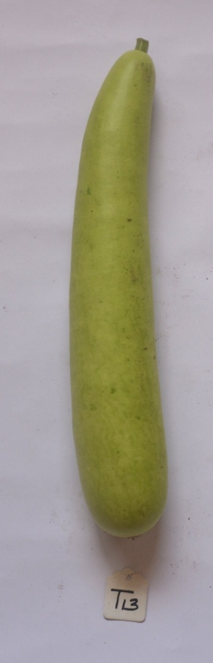
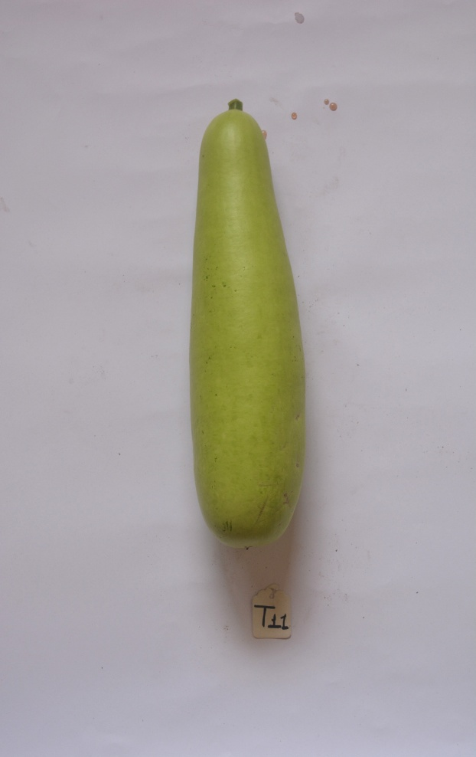

BOGVAR - 14

BOGVAR - 12

BOGVAR - 13

BOGVAR - 11

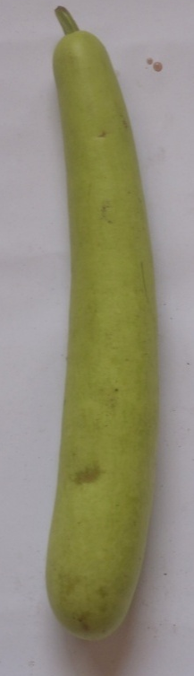
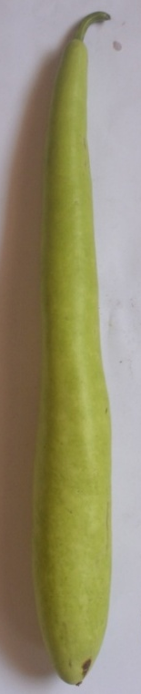
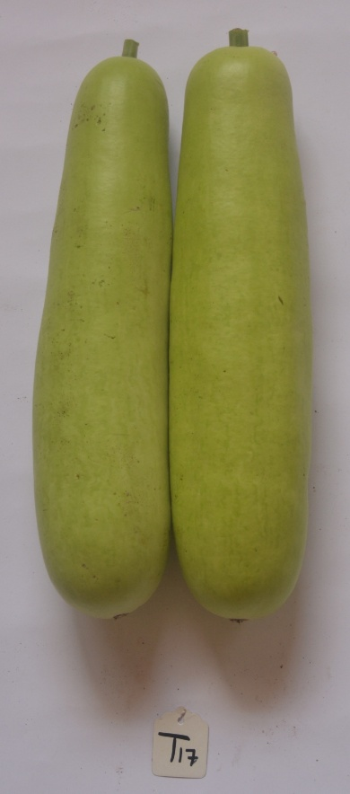
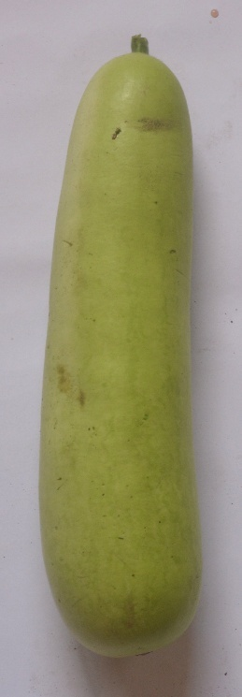

BOGVAR - 18

BOGVAR - 17
BOGVAR - 16

BOGVAR - 15

Table -1 Mean performance for fruit yield and its components in bottle gourd
Treatment | Days taken to 1st Germi-nation | Days taken to 50% Germi-nation | Plant height (m) |  | Days taken to 1st Male flower appears | Days taken to 1st Female flower appears | Node at which 1st Male flower appears | Node at which 1st Female flower appears | Number of fruits per plant | Days taken to 1st fruit harvest | Fruit length (cm) | Fruit diameter (cm) | Average fruit weight (g) | Fruit  yield/  plant  (kg) | Fruit yield /hac. (q)
Treatment | Days taken to 1st Germi-nation | Days taken to 50% Germi-nation | 60 DAS | 90 DAS
BOGVAR - 1 | 7.79 | 12.03 | 1.15 | 4.23 | 32.67 | 36.67 | 4.27 | 9.06 | 9.09 | 53.23 | 21.80 | 10.83 | 1138.72 | 8.97 | 269.00
BOGVAR - 2 | 8.81 | 13.85 | 1.47 | 4.17 | 33.05 | 37.67 | 4.86 | 9.54 | 8.17 | 52.27 | 22.83 | 11.14 | 1163.01 | 8.36 | 250.70
BOGVAR - 3 | 5.18 | 8.37 | 1.73 | 5.96 | 27.29 | 30.11 | 3.46 | 8.23 | 14.42 | 41.43 | 15.31 | 12.12 | 897.00 | 10.80 | 324.00
BOGVAR - 4 | 8.58 | 12.10 | 1.27 | 4.05 | 38.29 | 41.33 | 4.27 | 8.92 | 8.09 | 54.21 | 19.23 | 13.24 | 1071.63 | 7.87 | 236.10
BOGVAR - 5 | 7.60 | 10.78 | 1.35 | 3.89 | 34.21 | 42.23 | 4.42 | 9.75 | 7.60 | 57.93 | 31.20 | 6.99 | 927.73 | 7.52 | 225.50
BOGVAR - 6 | 11.19 | 17.69 | 1.38 | 3.44 | 39.24 | 43.82 | 4.85 | 10.11 | 8.04 | 62.03 | 31.48 | 5.96 | 896.11 | 6.56 | 196.80
BOGVAR - 7 | 9.60 | 12.09 | 1.32 | 4.31 | 44.41 | 49.83 | 4.72 | 10.88 | 6.53 | 67.69 | 47.05 | 6.29 | 1784.26 | 9.53 | 286.00
BOGVAR - 8 | 6.74 | 10.15 | 1.88 | 6.03 | 29.50 | 32.56 | 4.22 | 9.77 | 13.24 | 49.48 | 37.85 | 5.93 | 1038.53 | 12.76 | 383.90
BOGVAR - 9 | 8.66 | 11.47 | 1.66 | 4.58 | 31.89 | 35.45 | 4.62 | 9.22 | 10.59 | 52.81 | 36.72 | 6.03 | 914.40 | 10.10 | 303.10
BOGVAR - 10 | 5.16 | 8.55 | 1.63 | 5.45 | 27.62 | 30.67 | 4.14 | 9.12 | 11.01 | 47.15 | 35.28 | 5.89 | 1083.40 | 10.85 | 328.17
BOGVAR - 11 | 7.44 | 9.92 | 1.54 | 4.16 | 30.34 | 33.00 | 4.83 | 10.65 | 9.84 | 53.57 | 33.50 | 6.76 | 992.49 | 8.23 | 247.00
BOGVAR - 12 | 7.38 | 13.33 | 1.81 | 4.91 | 29.23 | 32.55 | 4.53 | 9.66 | 11.12 | 50.40 | 34.08 | 6.39 | 1043.41 | 10.70 | 321.00
BOGVAR - 13 | 7.45 | 13.21 | 1.66 | 4.29 | 29.33 | 31.78 | 4.32 | 11.55 | 10.40 | 48.24 | 38.53 | 5.76 | 1039.96 | 9.10 | 276.57
BOGVAR - 14 | 7.55 | 13.56 | 1.43 | 5.08 | 27.14 | 30.00 | 3.77 | 8.70 | 9.89 | 43.72 | 42.28 | 5.65 | 1242.67 | 10.77 | 326.10
BOGVAR - 15 | 10.01 | 13.43 | 1.25 | 4.38 | 33.17 | 37.78 | 4.30 | 10.77 | 8.89 | 49.82 | 39.51 | 5.72 | 1151.20 | 9.85 | 299.67
BOGVAR - 16 | 11.08 | 15.45 | 1.64 | 3.64 | 27.95 | 30.67 | 3.78 | 9.54 | 8.08 | 49.62 | 31.19 | 6.32 | 1081.24 | 7.45 | 227.17
BOGVAR - 17 | 11.12 | 13.20 | 1.68 | 3.99 | 34.17 | 39.33 | 3.63 | 8.60 | 9.33 | 51.26 | 34.12 | 6.45 | 958.56 | 7.67 | 230.20
BOGVAR - 18 | 7.33 | 10.43 | 1.57 | 4.26 | 30.13 | 36.22 | 4.24 | 9.02 | 7.48 | 54.23 | 57.42 | 5.36 | 1337.88 | 8.98 | 269.50
GM | 8.26 | 12.20 | 1.52 | 4.49 | 32.20 | 36.20 | 4.29 | 9.62 | 9.55 | 52.17 | 33.85 | 7.38 | 1097.90 | 9.23 | 277.80
CD (p=0.05) | 0.99 | 1.48 | 0.20 | 0.69 | 3.57 | 4.12 | 0.57 | 1.22 | 1.33 | 5.54 | 3.62 | 1.44 | 131.88 | 1.67 | 49.41
SEm± | 0.35 | 0.52 | 0.07 | 0.24 | 1.24 | 1.43 | 0.20 | 0.42 | 0.46 | 1.93 | 1.26 | 0.50 | 45.89 | 0.58 | 17.19
SEd | 0.49 | 0.73 | 0.10 | 0.34 | 1.76 | 2.03 | 0.28 | 0.60 | 0.65 | 2.73 | 1.78 | 0.71 | 64.89 | 0.82 | 24.31
C.V. (%) | 7.24 | 7.32 | 7.92 | 9.20 | 6.68 | 6.85 | 7.96 | 7.64 | 8.39 | 6.40 | 6.45 | 11.72 | 7.24 | 10.93 | 10.72

Conclusion
The results from the present investigation concluded that Bottle gourd Genotype BOGVAR-8 recorded maximum fruit yield/plant (12.76 kg) and fruit yield/hectare (383.90 q), was superior among all the genotypes.
References
Bhardwaj, D. R., Singh, A. and Singh, U. 2013. Genetic variability of bottle gourd (Lagenaria siceraria (Mol.) Standl.) by multivariate analysis. Published in Proc. of National Symposium on Abiotic and Biotic Stress management in Vegetable Crops. Ind. Soc. Veg. Sci. pp., 370.
Bhatt, R., Raghav, M., Singh, J.P., Verma, S.K., Srivastava, R.M. and Maurya, S.K. 2022. Studies of genetic variability in bottle gourd (Lagenaria siceraria (Mol.) Standl). The Pharma Innovation, 11(9): 778-783.
Bhavanasi, S., Bahadur, V., Kerketta, A. and Prasad. V.M. 2022. Performance of Bottle Gourd (Lagenaria siceraria L.) Genotypes for Growth, yield and quality. International Journal of Plant and Soil Science, 34(23): 239-244.
Garande, V.K., Palghadmal, U.B., Padgaonkar, D.R., Sonawane, P.N., Dhumal, S.S. and Pawar R.D. 2017. Performance of Bottle Gourd Selections under Sub-Montane Zone of Maharashtra, India. International Journal of Current Microbiology and Applied Sciences, 6(11): 3011-3017.
Gomez, A.K. and Gomez, A.A. 1984. Statistical Procedures for Agricultural Research. Second Edition, A Wiley-international Publication, New York, p. 20-30.
Harika, M., Gasti, V.D., Shantapra, T., Mulge, R., Shirol, A.M., Mastiholi, A.B. and Kulkarni, M.S. 2012. Evaluation of bottle gourd genotypes (Lagenaria siceraria (Mol.) Standl.) for various horticultural characters. Karnataka J. Agric. Sci., 25(2): 241-244.
Kumar, A., Singh, B., Kumar, V., Singh, M. K. and Singh, K. V. 2012. Correlation and path coefficient analysis for certain metric traits in bottle gourd (Lagenaria siceraria (Mol.) Standl.) using line × tester analysis. Annals Horti., 5(1): 90-94.
Kumar, L., Trivedi, J., Sharma, D. and Dixit, A. 2019. Performance of bottle gourd genotypes for earliness and yield under Chhattisgarh conditions. International Journal of Chemical Studies, 7(4): 2326-2328.
Singh, R., Singh, B., Prakash, S., Kumar, M., Kumar, V., Chand, P. and Vaishali. 2021. Genetic variability, heritability and genetic advance in bottle gourd (Lagenaria Siceraria (Mol.) Standl.). Annals of Horticulture, 14 (1): 72-78.
Suman, A., Jha, A., Shivam., Mishra, A., Kumawat, A. 2023. Analysis of genetic variability, heritability and genetic advance for yield and yield-associated traits for bottle gourd (Lagenaria siceraria (Mol.) Standl.). International Journal of Research in Agronomy, 7(8): 35-38.
Thakur, P., Sharma, D., Vishan,V. K., Dash, S.P. 2015. Evaluation of bottle gourd (Lagenaria siceraia (Mol.) Standl.) genotypes. Plant Archives, 15(2):1037-1040.
Venkatraman, M., Anbarasi, D. And Haripriya, K. 2024. Evaluation of genetic variability, heritability and genetic advance in thirty-five bottle gourd (Lagenaria siceraria) varieties for yield and yield related traits. Plant Archives 24(1):1203-1210.
Visen, V.K., Sharma, D., Thakur, P. 2015. Performance of bottle gourd genotypes for earliness and yield under Chhattisgarh plains. Trends in Biosciences., 8(18) :4823-4826.

