Original research article

Calculation of rice water requirements using the FAO -CROPWAT 8.0 model within the framework -of hydro-agricultural development of the Agricultural Development Centre (CDA) of the urban commune of Diffa

Abstract
This agrohydrological study An analytical study conducted at the Agricultural Development Center (CDA) in the Diffa commune (Diffa region , Niger ) aimed to analyze the interactions between soil physical properties, climatic parameters, and irrigated rice farming data in order to estimate water requirements and optimize irrigation planning using the CROPWAT 8.0 model. The climatic and edaphic data used cover a dry season. Soil properties (clay-loam texture, water retention capacity, percolation) were characterized to assess their influence on water dynamics, while climatic parameters (temperature, relative humidity, wind, sunshine) were used to calculate the reference evapotranspiration (ET0). Rice farming parameters, with a transplant carried out on February 25, were integrated into the model to estimate crop evapotranspiration ( ETc ), effective rainfall, and net and gross irrigation requirements. The results show that, despite good water retention capacity, significant losses through percolation (423.5 mm) reduce the potential efficiency of irrigation. Evaporative demand is particularly high between April and June, with temperatures exceeding 45°C, while the annual effective rainfall (288.4 mm) covers only a small portion of the water requirements. Total evapotranspiration ( ETc ) reaches 1,178.3 mm for only 16.3 mm of available rainfall, and the net irrigation requirement is estimated at 1,506.8 mm, or 15,068 m³/ha, confirming the near-total dependence of rice cultivation on irrigation. These results highlight that the productivity of irrigated rice in Diffa depends above all on controlled water management, requiring optimization of leveling, reduction of losses by percolation and rigorous irrigation planning in order to guarantee the sustainability of rice cultivation in a Sahelian context.
Keywords: Cropwat, rice cultivation, water requirements, irrigation and differentiation
- INTRODUCTION
The Sahel is a vast transitional region between the Sahara Desert to the north and the Sudanese savanna to the south (Houérou, HN (2006)). Niger is one of the Sahelian countries; this region covers a large part of its territory and is characterized by a semi-arid to arid climate, with low and irregular rainfall, varying between 200 and 600 mm per year (Mahamane, L., Saadou, M., and Nonguierma, A. (2005)). These climatic conditions make agriculture vulnerable and highly dependent on weather patterns.
Faced with these conditions beyond our control, irrigated agriculture is a fundamental pillar of food security and socio-economic development in this region. In this context, irrigated rice farming represents a strategic opportunity to improve food production.
In the Diffa region, the perimeter of the Agricultural Demonstration Center (CDA), located in the municipality of Diffa, in southeastern Niger, encompasses five (5) of the sixteen (16) agricultural zones (ZA) developed in this region. The CDA/CBLT hydro-agricultural development program was implemented to promote sustainable and resilient agriculture.
Rice cultivation is the main activity practiced in hydro-agricultural developments (AHA) (Boukar et al., 2024). It is practiced individually, both outside and inside urban areas. Producers in the Diffa region carry out two rice production cycles, one during the rainy season and the other during the dry season.
Irrigation is almost entirely gravity-fed, relying exclusively on the waters of the Komadougou River and Lake Chad. This dependence on surface water, primarily used for irrigation, complicates production and impacts rice yields. In some cases, flooding of the pumping station forces the interruption of cultivation until the water recedes.
Rice cultivation is a crop highly dependent on water (Musset, 1942). Faced with increasing rainfall variability due to climate change, irrigation water needs are becoming increasingly unstable and uncontrollable for producers, who, in most cases, practice imprecise irrigation. This can have a considerable impact on yields and water production at pumping stations. However, the scarcity of water resources due to climate change, competition between sectors, and evolving rainfall patterns necessitate new water management strategies ( Fageria , 2007).
Water management in these irrigated areas remains a major challenge. The irrigation regime—that is, the quantity, frequency, and distribution of irrigation water—directly influences rice growth, development, and yield. Insufficient irrigation can lead to water stress, yield losses, poor water resource management, and low irrigation efficiency. Conversely, optimized irrigation not only increases productivity but also conserves water resources, which are particularly precious in arid and semi-arid zones.
However, faced with the growing challenges of climate change, water resource variability, and population pressure, it is imperative to identify the most efficient and water-saving irrigation practices. Calculating the water requirements of this area is therefore crucial to ensuring the sustainability of rice cultivation.
Cropwat software, which is software developed by the FAO (Food and Agriculture Organization of the United Nations), designed to assist in irrigation planning and the assessment of crop water requirements, will be used (Wade et al., 2000).
The general objectives of this article are to model, using CROPWAT 8.0 software, crop water requirements (CWR) and irrigation planning (SI) in the rice paddies of the study area.
This research aims to fill this scientific gap by proposing a solution for effective water management in this region. It is part of a strategy to optimize water management, enhance existing hydro-agricultural infrastructure, and strengthen the resilience of rice production systems.

- MATERIALS AND METHODS
2.1 Site presentation:
This study was conducted within the framework of the hydro-agricultural development of the CBLT/CDA in the urban commune of Diffa. The city is located in the far southeast of Niger, on the banks of the Komadougou River , near Yobe , on the border with Nigeria, but also close to Lake Chad and the borders with Chad and northern Cameroon.
The region enjoys a dry tropical climate, characterized by a long dry season from November to May, during which temperatures remain very high and rainfall is almost nonexistent. The rainy season, short and concentrated from June to September, brings significant rainfall only in July and August. The ombrothermic curve clearly illustrates this strong seasonality, with hot and dry conditions predominating for most of the year.
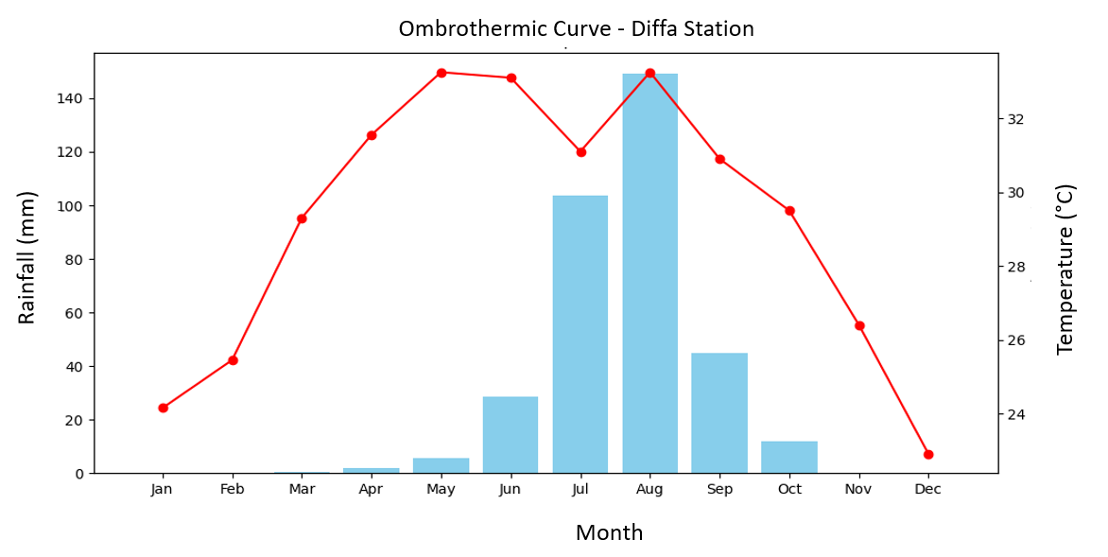
Figure 1: Ombrothermic curve of climate data for the region for the period from 2000 to 2020 (Data source: Diffa Station)

2.2 Particle size analysis and determination of soil texture
The soil texture study was carried out on 24 experimental plots using composite sampling at a depth of 0 to 20 cm. This depth corresponds to the surface horizon most influenced by cultivation practices, biological processes and water and nutrient exchanges, making it a determining layer for the analysis of soil fertility and water dynamics ( Hartemink et al., 2020).
For each plot, five soil subsamples were taken according to a systematic scheme including the four corners and the center of the plot, as illustrated in Figure 2. This composite sampling method reduces local spatial variability and provides a sample representative of the soil's physicochemical properties (Gee and Or, 2002).
The collected subsamples were then mixed and homogenized to create a representative composite sample for each plot. The samples were placed in labeled plastic bags and then transported to the laboratory of the INRAN Regional Center for Agronomic Research for analysis.
In the laboratory, the samples were air-dried and then sieved through a 2 mm sieve to remove coarse fragments and organic debris. Particle size analysis was performed using the sedimentation method based on Stokes' law, allowing the relative proportions of sand, silt, and clay to be determined. The results were then used to determine the soil texture class using the FAO textural triangle (Hillel, 2004).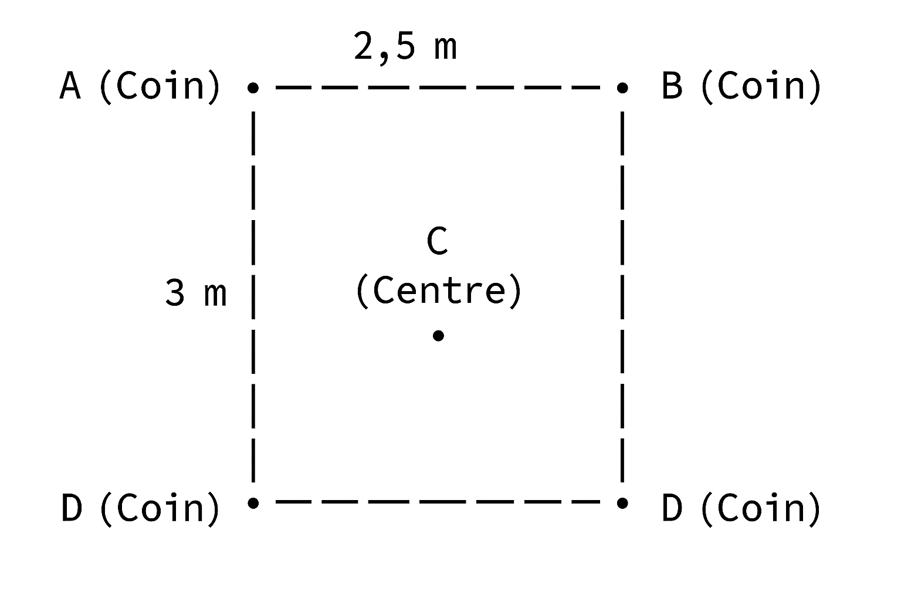
Figure 2 : Sampling plan on a plot
2.2 Climate data in CROPWAT 8.0
Meteorological data from 2000 to 2020 were collected and processed according to the requirements of CROPWAT 8.0 software. Average monthly data were calculated from daily data collected over 20 years at the Diffa meteorological station. This data includes monthly averages of minimum and maximum temperatures, precipitation, relative humidity, wind speed, and sunshine. For each month from January to December, the values are integrated into the system, as illustrated in Figure 3 for minimum and maximum temperatures, relative humidity, wind speed, and sunshine, and in Figure 4 for precipitation.
From the input data, the system calculated the reference evapotranspiration (ET₀ ) using the normalized Penman -Monteith FAO56 formula .
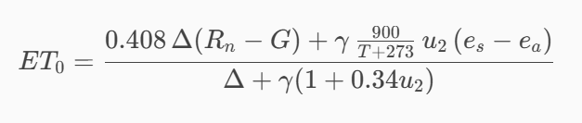
- ET ₀ : reference evapotranspiration (mm/day); e ₛ : saturation vapor pressure (kPa)
- R ₙ : net radiation at the surface of the vegetation cover (MJ/m²/day);
- G: heat flux in the ground (MJ/m²/day)
- T: average daily air temperature at 2 m (°C)
- u₂ : wind speed at 2 m (m/s)

- eₐ: actual vapor pressure (kPa)
- (eₛ - eₐ ) : vapor pressure deficit (kPa)
- Δ : slope of the vapor pressure – temperature curve (kPa/°C)
- γ : psychrometric constant (kPa/°C)
Figures 3 and 4 present the data processed and entered into the software in the Climate/ETO tabs and the precipitation for the period from 2000 to 2020 of the Diffa meteorological station.
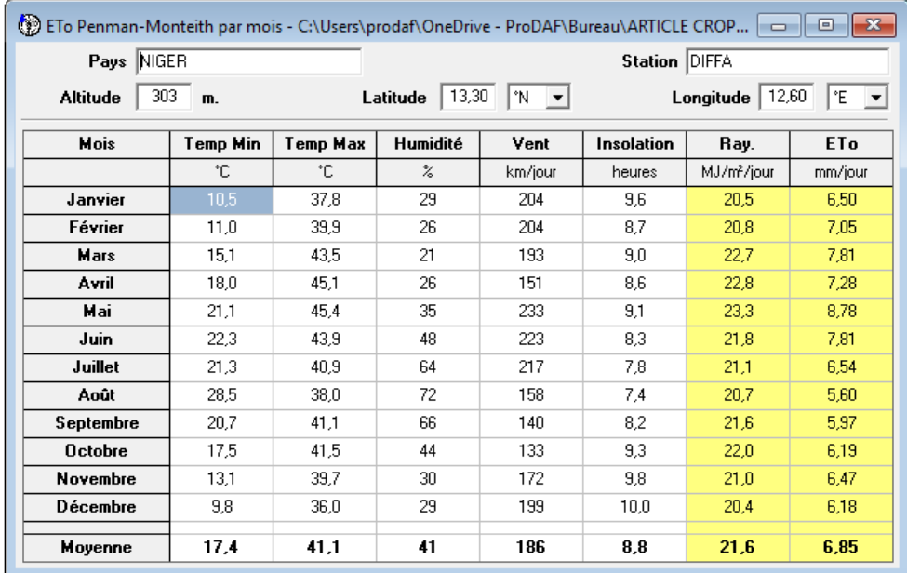
Figure 3: Introduction of monthly averages of minimum and maximum temperatures, relative humidity, wind speed and sunshine in CROPWAT 8.0.
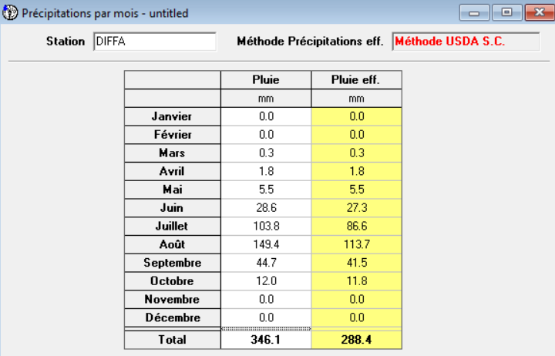
Figure 4: Input of precipitation data into CROPWAT 8.0 software
2.3 Soil data in CROPWAT 8.0
The methodology for defining soil parameters is based on the use of FAO reference technical data (Irrigation and Drainage Bulletin No. 56), adapted to the clay-loam texture of the soil in the study area. To simulate water management, a water retention capacity (WRC) of 150 mm/m² was used, combined with an infiltration rate of 20 mm/day and a percolation rate of 2.7 mm/day. These reference values are confirmed by the work of S. Valet (1993), who demonstrated that the fine sedimentary soils of Niger have a high capacity for storing available water due to their richness in silt and clay. More specifically, S. Valet confirmed that the structure of these soils, although compact, allows for stable water reserves, thus limiting losses through deep drainage while maintaining prolonged available moisture for crops. This methodological approach ensures scientific consistency between international standards and the physical characteristics of Sahelian sedimentary soils.
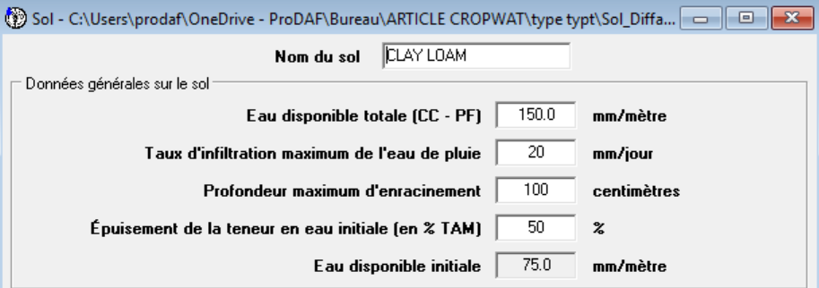
Figure 5: Input of soil data into CROPWAT 8.0 software

2.4 Crop Data CROPWAT 8.0
The parameterization of soil properties in the CROPWAT 8.0 model is based on the integration of physical characteristics determined from particle size analysis and reference data from FAO Irrigation and Drainage Bulletin No. 56.
Given the dominant clay-loam texture identified in the study area, the soil moisture parameters were defined as follows:
- Water retention capacity (WRC): 150 mm/m
- Infiltration rate: 20 mm/day
- Deep percolation rate: 2.7 mm/day
These values correspond to the hydrodynamic characteristics of fine sedimentary soils in Sahelian regions, which generally exhibit a moderate to high capacity for storing water available to plants.
Valet's work (1993) showed that the alluvial soils of Niger, rich in silt and clay, have a relatively compact structure but are capable of efficiently retaining water in the root zone, thus limiting losses by deep drainage while ensuring prolonged water availability for crops.
2.5 Crop settings in CROPWAT 8.0
The crop parameterization in the CROPWAT 8.0 model is based on the use of crop coefficients ( Kc ) proposed by the FAO (Allen et al., 1998), corresponding to the different phases of crop development:
- initial phase
- development phase
- mid-season phase
- end-of-season phase
In this study, standard crop coefficients (wet conditions) were used as a reference, then adjusted according to the specific climatic conditions of the Diffa region.
In accordance with FAO methodological recommendations, a climatic correction of the mid-season crop coefficient ( Kc) mid ) was applied to take into account local atmospheric conditions, characterized by:
- a minimum relative humidity of 21%
- an average wind speed of 2.36 m/s
Applying the climate correction formula made it possible to adjust the Kc value mid to 1.35, reflecting an increase in the evaporative demand of the atmosphere in the arid conditions of Diffa.
This adjusted value is consistent with observations made in Sahelian environments. Indeed, Boureima et al. (2022) already recommend the use of crop coefficients higher than the standard values (1.25) for Sahelian zones characterized by high evaporative demand.
The integration of these adjusted coefficients into the model allows for a more realistic estimate of crop water requirements, particularly during the mid-season phase, a period during which the crop reaches its maximum leaf development and exhibits a high sensitivity to water stress.

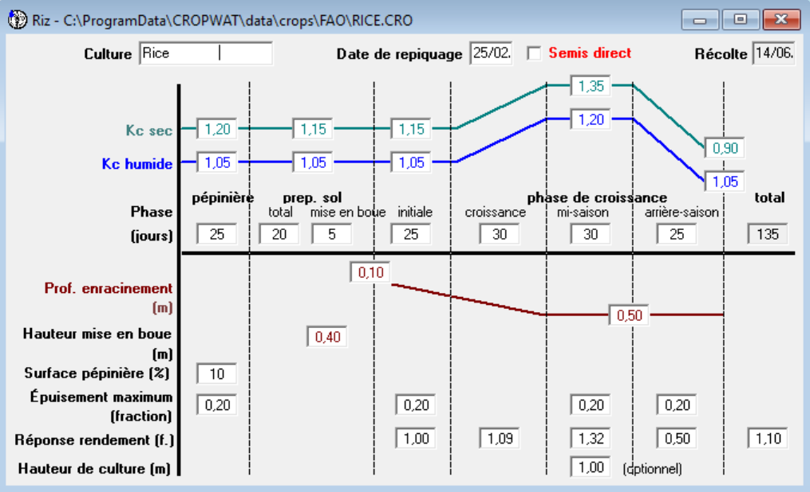
Figure 6: Data entry on crops (rice) in CROPWAT 8.0 software
- RESULTS AND DISCUSSION
3.1 Soil Texture and USDA Classification
Laboratory particle size analysis shows that the soil sample is composed of 38.60% sand, 33.72% silt, and 27.68% clay. Integrating these proportions into the USDA textural triangle classifies this soil as clay loam. The representative point of the sample is indeed located at the intersection of these segments (red dot in Figure 7), thus confirming its classification within this textural category. According to Jabro et al. (2024), clay loam soils -exhibit favorable hydric and structural properties, including good water retention capacity and balanced porosity, making them particularly well-suited to irrigated crops. Therefore, the point's position within the "clay loam" polygon of the textural triangle, as observed in the image, scientifically validates the agronomic interpretation and confirms the suitability of this soil for the study area.
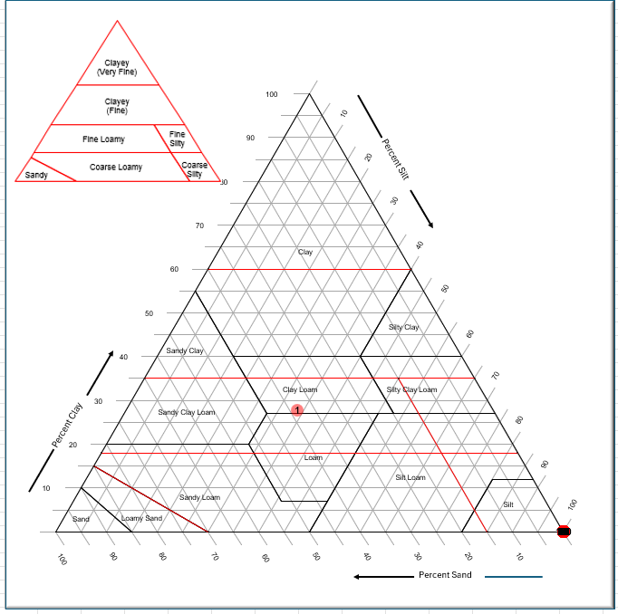
Figure 7: Representation of the soil sample on the USDA textural triangle
3.2 Reference evapotranspiration (ETo)
Climate data from the Diffa station reveal strong seasonal variability. Minimum temperatures average between 10.5°C in January and 28.5°C in August, while maximum temperatures peak at around 45°C between April and May. Humidity generally remains low, between 21% and 72%, with peak values in August. Wind speeds fluctuate around 160 to 230 km/day, decreasing significantly towards the end of the year. Sunshine is generally high, on the order of 8 to 9.6 hours per day, corresponding to an average annual solar radiation of 21.6 MJ/m²/day. Reference evapotranspiration (ET0) is highest in May (8.78 mm/day) and lowest in January (6.50 mm/day), with an annual average of approximately 6.85 mm/day, reflecting a high evaporative demand typical of the Sahelian climate.
ET0 , defined as the evapotranspiration of a reference surface and not of a water surface ( Calanca et al., 2011), allows for a direct assessment of atmospheric evaporative demand. In this climatic context, only a fraction of infiltrated rainwater remains available in the root zone, thus constituting effective precipitation; the rest is lost through runoff or percolation.

3.3 Effective Rain
Rainfall data from the Diffa station reveal a highly contrasting Sahelian regime, characterized by a long dry season and a short rainy season. From January to April, rainfall is almost nonexistent, before a slight increase in May (5.5 mm) and especially in June (28.6 mm). The rainy season reaches its peak in July (103.8 mm) and particularly in August (149.4 mm), which are the two wettest months of the year. Rainfall decreases rapidly from September (44.7 mm) and becomes very low again in October (12 mm), before ceasing completely in November and December. In total, the year recorded 346.1 mm of rainfall, of which 288.4 mm was effective rainfall, corresponding to the water actually available to crops according to the USDA method.
crops after deducting losses through runoff, evaporation and deep percolation (Dhouib, M., 2023). According to Madi, Meddi and Abdesselam (2018), effective rainfall corresponds to the fraction of rainfall that remains stored in the root zone and contributes directly to plant evapotranspiration, thus constituting a central element of water fluxes in the soil-plant-atmosphere system.

3.4 Water requirements of crops (rice)
The results of the CROPWAT 8.0 simulation show that rice cultivation in Diffa, with a sowing date set for February 25th, exhibits a particularly high water demand throughout its growth cycle. Total evapotranspiration ( ETc ) reaches 1178.3 mm, reflecting the intensity of evaporative demand in this hot and dry Sahelian context. Effective rainfall remains limited to 16.3 mm for this period, covering only a small portion of the total needs. Consequently, the net irrigation requirement reaches 1506.8 mm, confirming a near-total dependence on irrigation to meet the crop's water requirements. This marked imbalance between effective rainfall and evaporative demand underscores the need for rigorous water management in the hydro -agricultural infrastructure of the city of Diffa, where rice remains a very water-intensive crop and particularly vulnerable to climate variability.
The total water requirements of rice over its entire growth cycle, simulated using the -FAO's CropWat model for the agro-climatic conditions of Diffa, amount to 1506.8 mm. These requirements include evapotranspiration ( ETc ), the water depth required to maintain submersion, and losses due to percolation, after deducting effective rainfall.

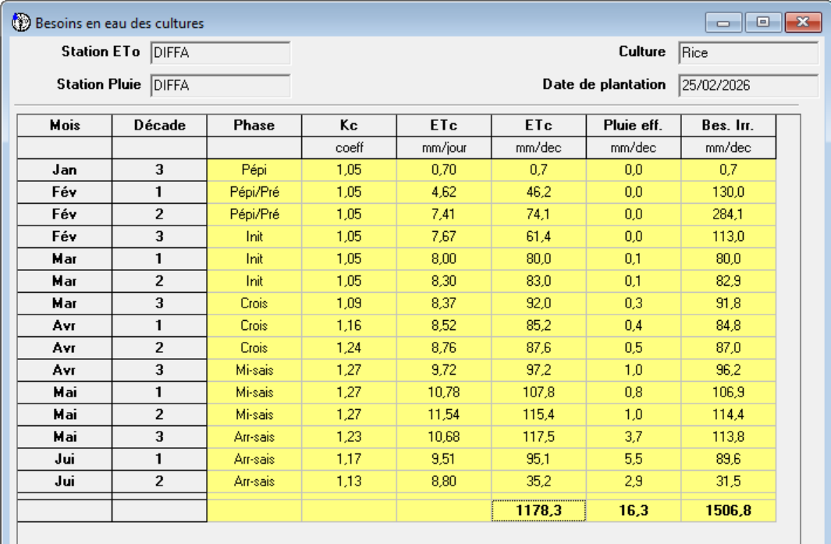
Figure 8: Presentation of rice water requirements
3.5 Irrigation program (actual irrigation volumes applied in the field)
The rice irrigation program simulated using CROPWAT 8.0 highlights the high dependence of this crop on irrigation under the agro-climatic conditions of Diffa. The data indicate a total gross irrigation of 2,460.2 mm, of which 1,722.1 mm was actually used by the crop, while percolation losses reached 423.5 mm, revealing significant infiltration into the clay-loam soil -. Effective rainfall remained low at the beginning of the season (16.8 mm over the entire cycle), contributing little to offsetting actual evapotranspiration. The actual water consumption by the crop (1,017.9 mm) and the actual irrigation requirements (1,001.1 mm) underscore that irrigated rice cultivation in Diffa requires rigorous and continuous water management to maintain its availability and meet the high water demands imposed by the region's hot and dry climate.
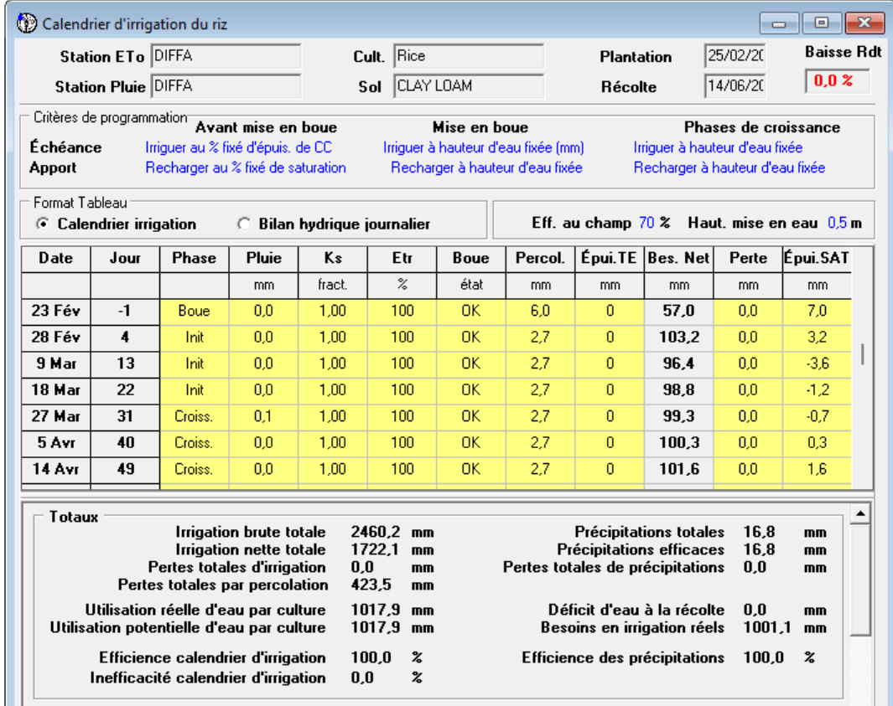
Figure 9: Results of rice paddy irrigation programming on the site

- DISCUSSIONS
Particle size analysis classifies the studied soil as a clay loam according to the USDA textural triangle (38.6% sand, 33.72% silt, 27.68% clay). This texture generally provides high water retention capacity and relatively balanced porosity, which are favorable for irrigated crops when properly managed (Jabro et al., 2024). However, the cumulative percolation observed on the site (448.7 mm) indicates that practical factors, such as imperfect grading, cracking under dry conditions, irrigation intensity, and water depth management, may reduce the expected textural advantage. In rice cultivation, effective soil compaction, maintenance of dikes and levees, and precise leveling (ideally using a laser) are known methods for limiting percolation and homogenizing the water table, in accordance with the properties of this type of soil (Oke et al., 2025). These results show that texture alone does not guarantee optimal water management and highlight the need for an integrated approach combining land management and irrigation monitoring.
Climate data observed between 2000 and 2020 indicate a marked seasonality in evaporation (ETo), with peaks of 6.78 to 8.78 mm/day during the hot period (April-June), when maximum temperatures exceed 45°C and sunshine reaches 8.8 hours/day. This high atmospheric demand increases irrigation needs, particularly during the critical rice growth phase. Total annual rainfall (346.1 mm) shows a highly contrasting distribution, with over 80% concentrated between July and September, reflecting the typical climate of the central Sahel ( Hiernaux et al., 2006). The portion usable by crops (288.4 mm, or 83% of the total) confirms that rainfall alone is insufficient to meet rice needs during the dry season, necessitating controlled irrigation .
Simulations of rice water requirements ( ETc = 1178.3 mm over the complete cycle) show a considerable gap between effective rainfall (16.3 mm) and total demand, resulting in a net irrigation requirement of 1506.8 mm. The most demanding phases coincide with mid-season (April-June), when crop coefficients ( Kc ) reach 1.21–1.27 and daily ETc exceeds 10 mm/day. These results confirm that, under the agro-climatic conditions of Diffa, irrigated rice production depends almost exclusively on the water supply provided by the infrastructure, and that any variation in availability can significantly affect crop performance ( Dancette et al., 2000; Etchanchu et al., 2025).
The observed irrigation program involves high initial water inputs to accumulate water in the soil, followed by continuous irrigation during the growing season. Measured values indicate a total gross irrigation of 2,460.2 mm, resulting in a net irrigation of 1,722.1 mm and percolation losses of 423.5 mm in the clay-loam soil. This percolation, expected in this soil type, highlights the need for careful management of irrigation frequency and depth to limit losses and avoid water stress, especially during periods of high demand.
A critical interpretation of the results suggests that, despite favorable soil texture, operational conditions (leveling, dike maintenance, irrigation intensity and regularity) have a predominant impact on water use efficiency. Furthermore, distinguishing between values observed in the field (rainfall, percolation, applied irrigation), assumed parameters ( Kc coefficients ), and values generated by simulations ( ETc , net irrigation, water requirements) is essential to avoid erroneous conclusions and enhance methodological transparency.
CONCLUSION
The results of the CROPWAT 8.0 simulation show that irrigated rice cultivation in the Diffa region takes place in a climatic environment characterized by high atmospheric water demand, resulting in a total evapotranspiration ( ETc ) requirement of 1,178.3 mm for a cycle beginning on February 25th. This value represents the amount of water necessary for the proper physiological functioning of one hectare of rice throughout its cycle. Applied to a cultivated area of one hectare, this water demand corresponds to a total volume of approximately 11,783 m³, illustrating the scale of the needs in a Sahelian context marked by extreme temperatures and high evaporation. Despite an annual rainfall of 346.1 mm, of which 288.4 mm are theoretically effective, only a small fraction coincides with the most demanding growth phases of the rice, exacerbating the water deficit between natural resources and crop needs. Irrigation requirements amount to 1,506.8 mm over the entire production cycle. Based on this calculated irrigation requirement (1,506.8 mm), the volume of water needed for an experimental plot of 7.5 m² was estimated at 11.32 m³ for the entire growth cycle. This significant volume of water required reflects the severe climatic constraints affecting irrigated rice cultivation in Diffa and underscores the central role of the water balance in understanding the functioning and vulnerability of rice-growing systems in the Sahelian zone.
Disclaimer (Artificial intelligence)

Author(s) hereby declare that NO generative AI technologies such as Large Language Models (ChatGPT, COPILOT, etc.) and text-to-image generators have been used during the writing or editing of this manuscript.

COMPETING INTERESTS
The authors declare that they have no financial or non-financial conflicts of interest, nor any personal relationships that could have influenced the work presented in this article.
REFERENCES
Ali, MH, & Mubarak, S. (2017). Efficient methods for estimating rainfall for field crops: overview, analysis, and new formulation. Asian Research Journal of Agriculture, 7 (1), 1–12. https://doi.org/10.9734/ARJA/2017/36812

Allen, RG, Pereira, LS, Raes, D., & Smith, M. (1998). Crop evapotranspiration: Guidelines for calculating crop water requirements (FAO Irrigation and Drainage Paper No. 56) . Food and Agriculture Organization of the United Nations (FAO).

Bacci11, M. (2016). Chapter 4: Variabilities and climate change and their impacts on rainfed crops in the Tillabéri region , Niger. In M. Bacci11 & K. Gaptia Lawan ( Eds .), Climate risks and adaptation in the Tillabéri region , Niger (p. 99).

Boukar, MCM, Issa, S., Kellou , KKB, Saley, MD, Wang, K., Bagana, MMC, … & Ali, M. (2024). Characterization of UV-absorbing mycosporin -like amino acids in the freshwater cyanobacterium Nostoc calcicola . International Journal of Biotechnology, 28 (5), 16–25.

Calanca , P., Smith, P., Holzkämper , A., & Ammann, C. (2011). Reference evapotranspiration and its application in agrometeorology. Swiss Agricultural Research, 2 (4), 176–183.

Information Exchange Centre, TAAT. (2021). Climate-smart agricultural technologies for the Sahel and the Horn of Africa (Technical Report Series 009). Gates Open Res , 5(162), 162.

Dancette , C., et al. (2000). The main irrigated rice farming systems in the PSI intervention area. In For the sustainable development of irrigated agriculture in the Sudan-Sahelian Zone (pp. 34–46). PSI CORAF/CIRAD/IRD.

Etchanchu , J., Demarty , J., Dezetter , A., Farhani, N., Thiam, P.B., Allies, A., Bodian, A., Boulet, G., Chahinian, N., Diop, L., Mainassara , I., Ndiaye, P.M., Ollivier, C., Olioso, A., & Roupsard , O. (2025). Multiscale analysis of existing actual evapotranspiration products in the agropastoral Sahel. Journal of Hydrology, 651 , 132585. https://doi.org/10.1016/j.jhydrol.2024.132585

Fageria , NK (2007). Green management in crop production. Journal of Plant Nutrition, 30 (5), 691–719.
FAO. (1998). Crop evapotranspiration – Guidelines for calculating crop water requirements (Irrigation and Drainage Paper No. 56).

Gee, GW, & Or, D. (2002). 2.4 Particle size analysis. In Soil analysis methods: Part 4 Physical methods (Vol. 5, pp. 255–293).

Hartemink , AE, Zhang, Y., Bockheim, JG, Curi, N., Silva, SHG, Grauer-Gray, J., Lowe, DJ, & Krasilnikov , P. (2020). Variation in soil horizons: a review. Advances in Agronomy . https://doi.org/10.1016/bs.agron.2019.10.003

Hiernaux , P., & Le Houérou, HN (2006). The roads of the Sahel. Drought, 17 (1–2), 51–71.
Jabro, J., Stevens, W., Iversen, W., Sainju , U., Allen, B., Dangi, S., & Chen, C. (2024). Soil water retention curves and pore size distribution in a clay loam under different tillage systems. Land, 13 (12), 1987. https://doi.org/10.3390/land13121987

LE, EDSD. (2016). Guide on the environmental characterization of sites in the context of environmental and human health risk assessment (Vol. 1, guidelines).

Madi, M., Meddi, M., & Abdesselam, B. (2018). Rational management of rainwater and water flows in the soil-plant-atmosphere system of the upper Cheliff basin, Algeria. IAV Hassan II, 6 (4).

Mahamane, L., Saadou, M., & Nonguierma, A. (2005). Determination of the degree of bioclimatic aridity of seven localities in the department of Tillabéri (southwest Niger): classification into bioclimatic zones. Sécheresse, 16 (2), 107–114.

Musset, R. (1942). Rice in the world. Journal of traditional agriculture and applied botany, 22 (247), 151–180.
Oke, A., Atengdem, PB, Zemadim, B., & Cofie, O. (2025). Land preparation for irrigated rice cultivation in West Africa. International Water Management Institute (IWMI) , 4 p.

Valet, S. (1993). Study of soils and agricultural suitability of land in Niger . ORSTOM/IRD technical reports.

Wade, M., Legoupil, JC, & Poussin, JC (2000). Tools to facilitate discussion, negotiation and decision-making for the effective management of hydro-agricultural developments. PSI-CORAF.

Yonaba, R., Tazen , F., Cissé, M., Adjadi Mounirou, L., Belemtougri , A., Ouedraogo, V.A., Koïta , M., Niang, D., Karambiri, H., & Yacouba, H. (2023). Trends, sensitivity and estimation of daily reference evapotranspiration (ET₀ ) from limited climate data: regional focus on Burkina Faso in the West African Sahel. Theoretical and Applied Climatology , 153 , 947–974. https://doi.org/10.1007/s00704-023-04507-z

