Genetic Variability and Temperature Stress Response of Indian Mustard (Brassica juncea L.) under Early and Timely Sowing Environment in Doon Valley
ABSTRACT
Aims: The study evaluates genetic variability in response to temperature stress under early- and timely-sown conditions in the Doon Valley, Uttarakhand, India.
Study Design: The field tests employed an Augmented Randomized Complete Block Design (ARCBD) featuring two sowing conditions in pots.
Place and Duration of Study: The study took place at the Jigyasa University campus in the Doon Valley, Uttarakhand, India, during the 2023–24 Rabi season.
Methodology: 100 genotypes of Indian mustard were planted in pots using an Augmented Randomised Complete Block Design. The pots were placed in two different sowing environments: early and timely sowing. In five blocks, 95 of the 100 Indian mustard genotypes were planted as test treatments and 5 as check treatments. All blocks were treated identically in both sowing settings. Along with temperature, data on morphological, phenological, yield, and physiological traits were regularly recorded. After harvesting, statistical tests were performed to examine PCV, GCV, ECV, hBS, and GAM.
Results: The study indicated significant genetic variability among 100 Indian mustard genotypes studied under early (ES) and timely sowing (TS) environments in the Doon Valley. Treatment-adjusted and block-adjusted ANOVA indicated highly significant (P ≤ 0.01) differences for most morphological, yield, and physiological traits in both environments. Silique per plant (SPP), seed yield per plant (SYP), oil yield per plant (OYP), harvest index (HI), and membrane stability index (MSI) exhibited high genotypic (GCV > 20%) and phenotypic (PCV > 20%) coefficients of variation coupled with high heritability (>80%) and high genetic advance (>40%), indicating strong additive gene action. Early sowing conditions maintained uniformity, whereas timely sowing showed comparatively higher variability (CV up to 7.08% for SYP). Oil content (%) remained non-significant in ANOVA and showed low GCV (0.48%) under ES, indicating limited genetic variability, though improved expression was observed under TS. Physiological traits such as MSI and RWC demonstrated significant variability, confirming differential thermo-tolerance among genotypes.
Conclusion: The findings confirm the presence of available genetic variability for yield and stress-related traits under both sowing environments. Traits such as SPP, SYP, OYP, HI, SMS, and MSI exhibited high heritability and genetic advance, suggesting the significance of additive gene action and suitability for direct selection. Early sowing effectively distinguished genotypes under mild heat stress, while timely sowing reflected greater phenotypic expression under temperature variation. Oil content showed comparatively narrow variability, indicating the need for targeted breeding approaches. Overall, multi-environment evaluation proved essential for identifying stable, high-yielding, and temperature-resilient genotypes suitable for climate-adaptive mustard breeding programs in the Doon Valley.
Keywords: Genetic Diversity; Temperature Stress; Early and Timely Sowing; Genetic Advance; Genetic Heritability.

1.0 INTRODUCTION
Indian mustard (Brassica juncea L.) is one of the most important oilseed crops cultivated in India It occupies a dominant position among rapeseed–mustard crops due to its higher yield potential, better oil quality, and suitability to varied soil and climatic conditions (Misra et al., 2008). Despite its adaptability, Indian mustard productivity is highly sensitive to environmental factors, particularly temperature and sowing time, which strongly influence growth, phenology, and yield realization. India is the 3rd-largest producer of these oilseeds, accounting for 14% of worldwide production after Canada and China (Misra et al., 2008). In India, mustard oilseed crops are the most widely cultivated and economically important after soybeans (Misra et al., 2008). According to reports published by ICAR-Indian Institute of Rapeseed-Mustard Research, during FY 2023-24, Indian mustard was cultivated in 30.3% of the total oilseed area and contributed 33.2% of the overall oilseed yield in India. Rapeseed mustard recorded a high yield of 13.2 million tonnes (131.4 lakh tonnes) in FY 2023-24, exceeding the previous FY yield of 12.64 million tonnes (126.43 lakh tonnes), making it the largest oilseed-producing crop in India. During the same FY, the productivity of Indian mustard reached approximately 1443 kg/ha, exceeding the previous FYs' oilseed productivity of approximately 1314 kg/ha in India. Among all mustard-producing states in India, Rajasthan retains its top position, contributing approximately 45-49%, after Haryana (12.44%), Madhya Pradesh (11.32%), Uttar Pradesh (10.60%), and West Bengal (7.53%). Overall, approximately 74% of India's mustard-producing region is irrigated, helping to maintain a consistent yield even under unfavourable environmental conditions (ICAR–IIRMR, 2023–24).
Indian mustard (Brassica juncea L.) exhibits wide genetic variability for phenological, morphological, physiological, and yield-related traits, which forms the foundation for genetic improvement under varying sowing environments (Misra et al., 2008; Singh et al., 2018). Temperature patterns related to sowing time play a significant role in determining growth, phenology, and yield realization in Indian mustard. Early and timely sowing environments expose the crop to different temperatures during seedling establishment and reproductive phases, thereby influencing physiological stability and yield expression. Exposure to increased temperatures, even at early growth stages, has been reported to reduce population survival, membrane stability, and seedling vigour, indicating that temperature stress is not confined only to terminal stages (Ram et al., 2014). Early exposure to high temperature can adversely affect seedling survival and physiological stability, indicating stage-specific heat sensitivity (Ram et al., 2014).
Although extensive research has focused on terminal heat stress under late vs timely sowing conditions, comparatively limited attention has been given to temperature stress experienced during early vs timely sowing, particularly under region-specific agro-climatic conditions such as the Doon Valley (Sharma et al., 2013; Patidar et al., 2020). Early sowing often exposes Indian mustard to elevated temperatures during seedling establishment, whereas timely sowing governs thermal exposure during the flowering and seed-filling stages (Ram et al., 2014; Pandey et al., 2024). Most previous studies have emphasized yield attributes alone, with limited integration of physiological stress indicators and genetic parameters to explain genotype performance under temperature fluctuations (Chugh et al., 2022; Ramya Sree et al., 2022). The absence of integrated studies that combine genetic variability, physiological stability, and sowing-time-induced temperature stress limits effective identification of stable and resilient genotypes.
Therefore, the present study was conducted to
- Studies genetic variability in morphological, phenological, yielding, & physiological traits.
- Quantify the influence of temperature variations on trait expressions & physiological stability.
- Estimate heritability & genetic advance for key traits associated with yield & temperature tolerance.
- Identify stable and temperature-resilient Indian mustard genotypes suitable for cultivation and breeding programs under early- and timely-sown environments in the Doon Valley.

2.0 MATERIAL AND METHOD
The field trial of the study was conducted on the Jigyasa University campus in Dehradun, Uttarakhand, India, during the Rabi season of 2023-24. 100 genotypes of Indian mustard were sourced from various adequate sources. 100 genotypes of Indian mustard were sown in an augmented randomized complete block design (ARCBD) as test and check treatments in two sowing environments: early sowing on 26th September 2023 and timely sowing on 26th October 2023. Out of 100 genotypes of Indian mustard, 95 were sown as test treatments and 5 as check treatments. All test treatments were divided into five blocks. Each block contains nineteen genotypes with five checks, as shown in Table 1.
The same agronomic practices were applied on all blocks to maintain uniformity in early and timely sowing. All trait data on morphology, phenology, yield, and physiology, along with temperature, were recorded in accordance with the guidelines. The experimental data were analyzed using an augmented randomized complete block design (ARCBD), employing treatment- and block-adjusted ANOVA, descriptive statistics, and genetic variability parameters (PCV, GCV, heritability, and genetic advance) computed using the augmentedRCBD package in R.
Table 1: List of Test and Check Treatments Evaluated in a Five-Block Design at ARCBD
 | Block 1 | Block 2 | Block 3 | Block 4 | Block 5
Test Treatments | Ashirwad  Arawali  Brijraj  Bhagirathi  BR-40  CS-52  CS-54  CS-56  CS-60  DRMR-1165.40  DRMR-IJ-31  DRMR-150-35  DRMR-59  DRMR-2136  DRMR-2017-15  EC-165232  EC-765954  EC-765563  EC-206754 | EC-520747  EC-491596  EC-764646  EC-491779  EC-765856  EC-33571  EC-765451  EC-399318  EC-206723  EC-766061  EC-765865  EC-491579  EC-481011  EC-482983  EC-765800  EC-765459  Gujrat Mustard-1  Gujrat Mustard-2  Gujrat Mustard-3 | PR-21  PR-19  PBR-210  PM-28  Pusa Bold  Pusa Mahak  Patan Mustard  PM-25  PM-26  PM-29  PM-27  PM-22  PM-24  PM-30  Pusa Vijay  Pusa 6012  RH-119  RH-749  RCC-4 | JD-6  Jawahar Mustard-3  Jawahar Mustard-2  Jawahar Mustard-1  Jagannath  Krishna  Laxmi  Maya  NRCDR-601  NDRE-4  NRCHB-101  NRCDR-2  Pusa Tarak  Pusa Jaykishan  PR-20  Pusa Agarni  PM-32  PM-21  PM-725 | RH-819  RGN-73  RH-30  RH-725  RB-50  Radhika  RGN-48  RH-406  RH-781  RH-0116  RH-1235  RB-24  RH-1230  Saurabh  Shivalik  Shivani  Vasundhara  Vaibhav  Vardan
Check Treatment | Kanti  Kranti  Pusa Bahar  Varuna  Geeta | Kanti  Kranti  Pusa Bahar  Varuna  Geeta | Kanti  Kranti  Pusa Bahar  Varuna  Geeta | Kanti  Kranti  Pusa Bahar  Varuna  Geeta | Kanti  Kranti  Pusa Bahar  Varuna  Geeta

3.0 WEEKLY TEMPERATURE PATTERN ANALYSIS (SEP 2023-MAR 2024)
The weekly temperature pattern recorded from September 2023 to March 2024 showed a highly variable temperature profile, characterized by early-season heat stress, mid-season low-temperature exposure, and late-season rising temperatures, which collectively create different stress conditions for Indian mustard.
The weekly temperature data (Table 2) indicates significant variation in both mean and actual temperatures during the crop growth period of Indian mustard from late September 2023 to mid-March 2024. During the early season (Weeks 1–5; late September to late October), the crop was exposed to relatively high maximum mean temperatures, ranging from 35.00 to 35.29°C, with minimum mean temperatures remaining above 15°C. Actual maximum temperatures during this period occasionally exceeded 37°C, indicating the prevalence of early-season heat stress, particularly during seedling emergence and early vegetative growth. Similar early-stage heat stress has been reported to impair seedling establishment, membrane stability, and early vigour in Indian mustard, with substantial genotypic differences in survival and physiological resilience (Ram et al., 2014; Sharma et al., 2013).
A gradual decline in temperature was observed from early November onward (Weeks 6–10). Maximum mean temperatures decreased steadily from 31.00°C to 24.29°C, while minimum mean temperatures declined from 15.43°C to 11.57°C. This transitional phase provided relatively favourable temperatures for vegetative growth and canopy development. The coldest period occurred from mid-December to late January (Weeks 12–17), when maximum mean temperatures ranged from 11.86–15.14°C and minimum mean temperatures from 4.71–6.86°C, with actual minimum temperatures falling to 3–5°C. This phase represents the winter stress period, which is critical for phenological events such as the initiation of flowering and early reproductive development. Earlier studies have demonstrated that low-temperature exposure during these stages prolongs crop duration, alters assimilate partitioning, and interacts strongly with genotype to influence yield stability (Meena et al., 2013). From late January onwards (Weeks 18–25), a progressive rise in temperature was evident. Maximum mean temperatures increased from 16.14°C in late January to 30.83°C by mid-March, while minimum mean temperatures rose from 5.71°C to 12.86°C. Actual maximum temperatures reached 30–31°C during February and March, indicating the onset of terminal heat conditions during pod development and seed filling.
The high temperature variation observed during the cropping season aligns closely with earlier reports emphasizing that heat stress is stage-specific, and tolerance at the seedling stage does not necessarily translate into tolerance during reproductive or grain-filling stages (Azharudheen et al., 2013). Overall, the recorded temperature pattern substantiates the relevance of conducting genetic variability and stress-response studies under early and timely sowing environments, as differential exposure to early heat, winter cold, and terminal heat provides a robust framework for discriminating genotypes based on thermo-tolerance, yield stability, and adaptive potential. This integrated climatic context strongly supports the approach of combining yield attributes, physiological traits, and stress indices to effectively select heat-resilient Indian mustard genotypes, as studied by Patidar et al. (2020), Gupta et al. (2023), and Chugh et al. (2022).

Table 2: Weekly Mean and Actual Temperature Variation (September 2023 – March 2024)
Week N. | Date Range | Max. Mean (°C) | Min. Mean (°C) | Max. Actual (°C) | Min. Actual (°C)
1 | 26 Sep – 02 Oct 2023 | 35.14 | 22.00 | 26.00 | 19.00
2 | 03 – 09 Oct 2023 | 35.29 | 21.00 | 37.00 | 20.00
3 | 10 – 16 Oct 2023 | 35.00 | 20.29 | 37.00 | 16.00
4 | 17 – 23 Oct 2023 | 30.14 | 16.43 | 32.00 | 16.00
5 | 24 – 30 Oct 2023 | 32.57 | 15.57 | 34.00 | 14.00
6 | 31 Oct – 06 Nov 2023 | 31.00 | 15.43 | 32.00 | 13.00
7 | 07 – 13 Nov 2023 | 28.86 | 14.00 | 31.00 | 12.00
8 | 14 – 20 Nov 2023 | 29.00 | 12.71 | 31.00 | 12.00
9 | 21 – 27 Nov 2023 | 26.00 | 11.71 | 28.00 | 9.00
10 | 28 Nov – 04 Dec 2023 | 24.29 | 11.57 | 26.00 | 9.00
11 | 05 – 11 Dec 2023 | 24.71 | 8.71 | 27.00 | 7.00
12 | 12 – 18 Dec 2023 | 22.29 | 7.00 | 23.00 | 6.00
13 | 19 – 25 Dec 2023 | 22.57 | 6.57 | 25.00 | 5.00
14 | 26 Dec 2023 – 01 Jan 2024 | 15.14 | 8.86 | 22.00 | 7.00
15 | 02 – 08 Jan 2024 | 11.86 | 6.86 | 16.00 | 6.00
16 | 09 – 15 Jan 2024 | 13.00 | 4.71 | 15.00 | 3.00
17 | 16 – 22 Jan 2024 | 13.14 | 4.86 | 17.00 | 3.00
18 | 23 – 29 Jan 2024 | 16.14 | 5.71 | 22.00 | 4.00
19 | 30 Jan – 05 Feb 2024 | 20.00 | 9.86 | 23.00 | 9.86
20 | 06 – 12 Feb 2024 | 23.00 | 6.86 | 25.00 | 5.00
21 | 13 – 19 Feb 2024 | 26.43 | 9.14 | 30.00 | 7.00
22 | 20 – 26 Feb 2024 | 26.00 | 10.43 | 28.00 | 8.00
23 | 27 Feb – 04 Mar 2024 | 26.43 | 12.43 | 30.00 | 10.00
24 | 05 – 11 Mar 2024 | 26.57 | 10.00 | 31.00 | 9.00
25 | 12 – 18 Mar 2024 | 30.83 | 12.86 | 31.00 | 10.00
Source: https://www.accuweather.com/en/in/sherpur/3008767/weather-forecast/3008767

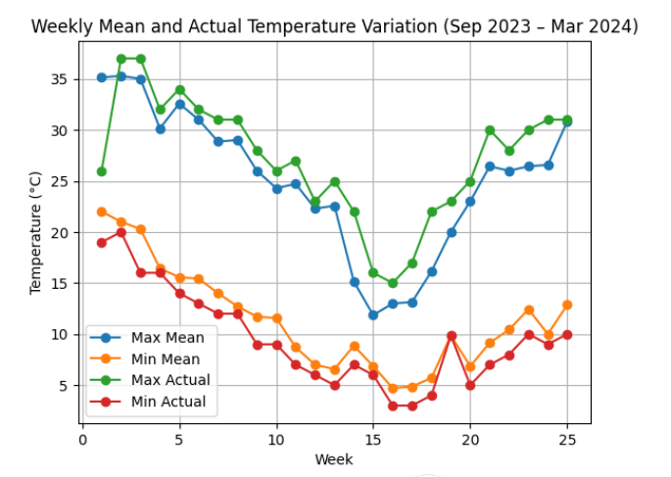
Fig.1: The graph indicates the weekly variation of temperature from the last week of September 2023 to the 3rd week of March 2024. Both the mean and actual maximum temperatures exhibited a declining trend from the end of September, reaching their lowest values during mid-winter (week 14-16), followed by a gradual increase in late February and March. The same trend was observed for minimum temperatures, with the lowest values recorded during the winter weeks.

4.0 RESULTS AND DISCUSSION
4.1 Statistical Analysis of Test Treatments
The statistical analysis of traits of genotypes of Indian mustard sown under early and timely environments exhibits very close mean performance; however, the coefficient of variance (CV), critical differences (CD), standard error (SE) and standard deviation (SD) showed comparatively significant differences, suggesting differential sensitivity to the environment.
Plant height (PH) showed nearly similar mean values under ES (104.24 cm) and TS (103.83 cm), though TS exhibited a higher coefficient of variation (CV = 3.80%) than ES (CV = 1.73%), indicating slightly greater environmental influence under timely sowing. A similar trend was observed for the length of the main shoot (LMS), where mean values remained stable in both environments, but TS recorded higher CV and CD values, suggesting greater variation in genotypic performance. Branching traits (PB and SB) displayed marginally higher CV under TS, indicating greater variability in branch expression under timely sown conditions. Yield-related traits such as silique per plant (SPP) and silique on main shoot (SMS) showed almost identical mean values across environments, but TS consistently exhibited higher CV and CD values, indicating a stronger role of environmental interaction in determining yield components. Survival percentage at both 20 and 30 DAS remained comparable between ES and TS; however, higher CV and CD under TS suggest greater variability in early establishment when sowing coincides with optimal seasonal transitions. Phenological traits, including days to initiation of flowering (DIF), days to 50% flowering (DFF), and days to maturity (DM), showed slightly higher variability under TS, reflecting sensitivity to temperature and photoperiod fluctuations. Seed yield per plant (SYP), oil content (OC), oil yield per plant (OYP), and 1000-seed weight (TSW) exhibited nearly identical means under both sowing conditions. Nonetheless, higher CV and CD values under TS indicate comparatively greater genotypic dispersion for economic traits. Physiological parameters such as relative water content (RWC), membrane stability index (MSI), and percent excised leaf water loss (PELWL) also showed higher variability under TS, suggesting increased physiological responsiveness under timely sowing.
Overall, the results indicate that early sowing provided relatively greater uniformity, whereas timely sowing enhanced phenotypic expression but with higher variability, emphasizing the importance of sowing time in stabilizing performance and identifying superior genotypes under contrasting environments.
Table 3: Comparative statistical analysis of traits of early and timely sown genotypes of Indian mustard (Brassica juncea L.)
Traits | Sowing Environment | Mean | Range | CV | CD@5% | SE | SD
PH  (cm) | ES | 104.24 | 79.51–124.71 | 1.73 | 4.61 | 0.88 | 8.8
PH  (cm) | TS | 103.83 | 82.74–121.45 | 3.8 | 10.13 | 0.87 | 8.75
LMS (cm) | ES | 36.33 | 20.36–53.96 | 4.35 | 4.01 | 0.59 | 5.9
LMS (cm) | TS | 36.26 | 20.45–52.75 | 5.23 | 4.82 | 0.59 | 5.92
PB (Nos) | ES | 4.69 | 3.05–7.57 | 8.62 | 1.07 | 0.09 | 0.93
PB (Nos) | TS | 4.7 | 2.96–7.49 | 9.86 | 1.22 | 0.09 | 0.93
SB (Nos) | ES | 5.86 | 3.17–8.76 | 11.22 | 1.72 | 0.12 | 1.19
SB (Nos) | TS | 5.87 | 3.15–8.96 | 11.84 | 1.82 | 0.12 | 1.23
SPP (Nos) | ES | 134.03 | 70.60–202.20 | 1.67 | 5.63 | 3.13 | 31.3
SPP (Nos) | TS | 134.26 | 71.48–209.94 | 2.67 | 9.05 | 3.13 | 31.33
SMS  (Nos) | ES | 28.84 | 15.20–40.20 | 5.68 | 4.1 | 0.61 | 6.09
SMS  (Nos) | TS | 28.66 | 14.98–40.85 | 5.36 | 3.85 | 0.61 | 6.12
PS@20 DAS | ES | 78.34 | 50.46–100.58 | 2.02 | 4.04 | 1.04 | 10.41
PS@20 DAS | TS | 78.46 | 48.20–104.25 | 2.58 | 5.17 | 1.07 | 10.72
PS@30 DAS | ES | 59.52 | 47.97–84.21 | 2.49 | 3.75 | 0.86 | 8.56
PS@30 DAS | TS | 59.24 | 46.00–83.21 | 3.21 | 4.81 | 0.88 | 8.82
DIF (Nos) | ES | 47.9 | 36.80–54.96 | 3.07 | 3.72 | 0.31 | 3.1
DIF (Nos) | TS | 47.9 | 36.45–55.18 | 4.32 | 5.24 | 0.34 | 3.38
DFF (Nos) | ES | 59.4 | 53.36–66.16 | 2.52 | 3.79 | 0.35 | 3.53
DFF (Nos) | TS | 59.55 | 51.17–69.04 | 3.33 | 5.04 | 0.41 | 4.06
DM (Nos) | ES | 162.14 | 156.52–165.52 | 1.2 | 4.97 | 0.22 | 2.2
DM (Nos) | TS | 161.63 | 150.43–170.87 | 3.17 | 13.04 | 0.54 | 5.38
SS (Nos) | ES | 13.3 | 10.00–18.00 | 7.76 | 2.67 | 0.19 | 1.86
SS (Nos) | TS | 13.31 | 9.56–18.00 | 7.74 | 2.66 | 0.19 | 1.88
SYP (g) | ES | 6.5 | 3.41–10.47 | 6.19 | 1.02 | 0.15 | 1.48
SYP (g) | TS | 6.52 | 3.26–11.06 | 7.08 | 1.17 | 0.15 | 1.55
OC  (%) | ES | 38.44 | 36.80–40.94 | 2.26 | 2.23 | 0.1 | 0.98
OC  (%) | TS | 38.53 | 35.46–41.22 | 3.61 | 3.56 | 0.13 | 1.34
OYP (g) | ES | 2.5 | 1.30–3.96 | 7.59 | 0.48 | 0.06 | 0.58
OYP (g) | TS | 2.49 | 1.34–4.01 | 7.34 | 0.47 | 0.06 | 0.57
TSW (g) | ES | 3.59 | 2.98–4.62 | 6.37 | 0.58 | 0.04 | 0.36
TSW (g) | TS | 3.6 | 2.84–4.63 | 7.4 | 0.68 | 0.04 | 0.38
BYP (g) | ES | 33.63 | 25.97–45.91 | 4.59 | 3.94 | 0.38 | 3.84
BYP (g) | TS | 33.59 | 25.66–46.60 | 6.25 | 5.34 | 0.38 | 3.84
HI (%) | ES | 19.35 | 10.70–31.50 | 6.28 | 3.09 | 0.39 | 3.93
HI (%) | TS | 19.41 | 11.15–30.32 | 7.54 | 3.72 | 0.39 | 3.93
PELWL (%) | ES | 29.52 | 17.30–38.01 | 4.96 | 3.64 | 0.43 | 4.27
PELWL (%) | TS | 29.61 | 17.32–38.87 | 5.16 | 3.8 | 0.43 | 4.35
RWC (%) | ES | 87.46 | 71.93–96.75 | 1.44 | 3.22 | 0.46 | 4.58
RWC (%) | TS | 86.97 | 71.18–100.86 | 3.43 | 7.64 | 0.5 | 4.95
MSI (%) | ES | 11.18 | 5.59–19.31 | 9.51 | 2.84 | 0.3 | 3.03
MSI (%) | TS | 11.22 | 5.40–19.52 | 10.71 | 3.21 | 0.31 | 3.09
PH- Plant Height  LMS- Length of Main Shoot  PB- Primary Branch  SB- Secondary Branch  SPP- Silique per Plant  SMS- Silique on Main Shoot  PS@20 DAS- Percent Survival at 20 Day of Sowing  PS@30 DAS- Percent Survival at 30 Day of Sowing  DIF- Days to Initiation of Flower  DFF- Days to 50% Flowering  SS- Seed/Silique  SYP- Seed Yield/Plant  OC-Oil Content Percentage  OYP-Oil Yield/Plant |  |  |  | TSW-1000-Seed Weight  BYP- Biological Yield/Plant  HI- Harvest Index  PELWL-Percent Excised Leaf Water Loss  RWC- Relative Water Content  MSI-Membrane Stability Index  ES-Early Sowing  TS- Timely Sowing  CV- Coefficient of Variance  CD- Critical Difference  SE- Standard Error  SD- Standard Deviation

4.2 Analysis of Variance (ANOVA)

4.2.1 ANOVA—Treatment Adjusted (RCBD) under early and timely showing

The treatment-adjusted ANOVA under early and timely sowing conditions provides a robust framework to partition genotypic effects from block and environmental variability, enabling precise detection of genetic differences among Indian mustard genotypes across sowing environments. Such an approach is essential when evaluating traits under temperature-sensitive environments where micro-environmental variation can obscure true genotypic performance (Patidar et al., 2020). The significant treatment effects (eliminating blocks) reported for most traits under both early and timely sowing indicate the presence of substantial exploitable genetic variability, a prerequisite for effective selection and genetic improvement in Indian mustard (Gupta et al., 2023; Kumari et al., 2018). Significant block effects (ignoring treatments) observed for several traits justify the adoption of RCBD, as field heterogeneity is common in multi-trait agronomic experiments. Adjusting for block effects improves experimental precision and reliability of treatment comparisons (Kumari et al., 2018). The generally low residual (error) mean squares for most traits suggest good experimental control and high reliability of the observed treatment differences, confirming that the detected significance is primarily attributable to genetic variation rather than random error (Kumar et al., 2020). Furthermore, significant Test vs Check contrasts underline the superiority or divergence of test genotypes relative to standard checks, validating the usefulness of the evaluated germplasm for identifying promising genotypes under contrasting sowing environments (Chugh et al., 2022). Overall, the treatment-adjusted RCBD-based ANOVA under early and timely sowing effectively demonstrates that genotype performance in Indian mustard is strongly influenced by sowing environment, and that multi-environment evaluation is indispensable for identifying stable, high-yielding, and stress-resilient genotypes (Patidar et al., 2020; Sharma et al., 2013).

The ANOVA results indicated substantial genetic variability among Indian mustard genotypes under both early sowing (ES) and timely sowing (TS) conditions. Treatment effects (eliminating blocks) were highly significant (P ≤ 0.01) for most traits in both environments. Plant height (PH) showed significant variation under ES (78.48) and TS (86.91). Similar trends were observed for length of main shoot (36.07 and 36.51), primary branches (1.22 and 1.16), and secondary branches (1.61 and 1.68) under ES and TS, respectively. Yield-contributing traits exhibited strong treatment effects. Silique per plant (SPP) recorded very high mean squares under ES (1216.65) and TS (1229.13). Seed yield per plant (SYP) was also significant under both environments (2.36 in ES and 2.51 in TS). Oil yield per plant (OYP) showed significant variation in both ES (0.37) and TS (0.36), while oil content (OC) remained non-significant under both conditions, indicating limited genetic variation for oil percentage. Phenological traits such as days to initial flowering (DIF) and days to 50% flowering (DFF) were highly significant, whereas days to maturity (DM) was non-significant under TS, suggesting relatively stable maturity across genotypes in timely sowing. Physiological traits related to stress tolerance also differed significantly. Harvest index (HI) showed significant variation under ES (17.35) and TS (17.55). PELWL, RWC, and MSI were highly significant in both environments, confirming variability in water retention and membrane stability traits. For example, RWC treatment mean square was 23.35 (ES) and 26.61 (TS), while MSI recorded 12.64 and 12.81, respectively. Error mean squares were generally low for most traits (e.g., 0.16 for SYP under ES and 0.21 under TS), indicating good experimental precision. Overall, the presence of significant treatment effects for most morphological, yield, and physiological traits under both sowing environments confirms adequate genetic variability among genotypes, while non-significance of oil content suggests comparatively narrow variation for this trait.

Table 4: Treatment Adjusted (RCBD) ANOVA of traits of genotypes of Indian mustard under early and timely showing

Trait | Sowing Environment | Block (ignoring treatments) (df = 4) | Treatment (eliminating blocks)  (df = 99) | Check  (df = 4) | Test + Test vs Check  (df = 95) | Error (Residual)  (df = 16)
PH (cm) | ES | 340.41 ** | 78.48 ** | 269.72 ** | 70.43 ** | 3.28
PH (cm) | TS | 387.34** | 86.91** | 332.54** | 76.57** | 15.85
LMS (cm) | ES | 39.64 ** | 36.07 ** | 104.54 ** | 33.19 ** | 2.49
LMS (cm) | TS | 36.27** | 36.51** | 123.38** | 32.85** | 3.58
PB (Nos) | ES | 0.88 ** | 1.22 ** | 7.77 ** | 0.94 ** | 0.18
PB (Nos) | TS | 0.94* | 1.16** | 7.60** | 0.89** | 0.23
SB (Nos) | ES | 3.46 ** | 1.61 ** | 8.37 ** | 1.32 ** | 0.46
SB (Nos) | TS | 3.41** | 1.68** | 8.63** | 1.39* | 0.51
SPP (Nos) | ES | 1050.12 ** | 1216.65 ** | 8769.20 ** | 898.65 ** | 4.9
SPP (Nos) | TS | 1268.62** | 1229.13** | 8993.44** | 902.21** | 12.67
SMS (Nos) | ES | 10.80 * | 48.46 ** | 331.10 ** | 36.56 ** | 2.6
SMS (Nos) | TS | 11.94** | 48.95** | 351.01** | 36.23** | 2.3
PS @ 20 DAS | ES | 143.59 ** | 112.65 ** | 262.99 ** | 106.32 ** | 2.52
PS @ 20 DAS | TS | 146.87** | 120.51** | 254.59** | 114.86** | 4.12
PS @ 30 DAS | ES | 39.25 ** | 85.25 ** | 361.31 ** | 73.62 ** | 2.17
PS @ 30 DAS | TS | 36.53** | 91.50** | 413.13** | 77.96** | 3.57
DIF (Nos) | ES | 5.76 ns | 15.23 ** | 166.54 ** | 8.85 ** | 2.14
DIF (Nos) | TS | 11.62 ns | 17.28** | 191.74** | 9.94* | 4.24
DFF (Nos) | ES | 1.56 ns | 13.65 ** | 26.54 ** | 13.11 ** | 2.21
DFF (Nos) | TS | 2.20 ns | 17.16** | 27.01** | 16.75** | 3.92
DM (Nos) | ES | 6.98 ns | 4.74 ns | 13.06 * | 4.39 ns | 3.81
DM (Nos) | TS | 18.19 ns | 29.10 ns | 48.12 ns | 28.29 ns | 26.27
SS (Nos) | ES | 3.64 * | 4.99 ** | 45.90 ** | 3.27 ** | 1.1
SS (Nos) | TS | 2.97 ns | 4.97** | 45.53** | 3.26** | 1.09
SYP (g) | ES | 1.00 ** | 2.36 ** | 7.64 ** | 2.14 ** | 0.16
SYP (g) | TS | 1.39** | 2.51** | 7.60** | 2.30** | 0.21
OC (%) | ES | 0.80 ns | 1.38 ns | 1.89 ns | 1.36 ns | 0.77
OC (%) | TS | 3.17 ns | 1.88 ns | 2.04 ns | 1.88 ns | 1.95
OYP (g) | ES | 0.12 * | 0.37 ** | 1.35 ** | 0.33 ** | 0.04
OYP (g) | TS | 0.12* | 0.36** | 1.21** | 0.32** | 0.03
TSW (g) | ES | 0.11 ns | 0.15 ** | 0.83 ** | 0.12 * | 0.05
TSW (g) | TS | 0.11 ns | 0.17* | 0.89** | 0.14 ns | 0.07
BYP (g) | ES | 5.04 ns | 17.76 ** | 110.79 ** | 13.84 ** | 2.39
BYP (g) | TS | 5.98 ns | 17.84** | 105.44** | 14.16** | 4.4
HI (%) | ES | 11.76 ** | 17.35 ** | 81.08 ** | 14.67 ** | 1.47
HI (%) | TS | 10.28** | 17.55** | 85.42** | 14.70** | 2.13
PELWL (%) | ES | 8.04 * | 29.22 ** | 274.89 ** | 18.88 ** | 2.05
PELWL (%) | TS | 8.29* | 29.76** | 280.42** | 19.21** | 2.23
RWC (%) | ES | 7.23 * | 23.35 ** | 88.80 ** | 20.59 ** | 1.61
RWC (%) | TS | 19.56 ns | 26.61** | 82.65** | 24.25* | 9.03
MSI (%) | ES | 18.39 ** | 12.64 ** | 83.17 ** | 9.67 ** | 1.25
MSI (%) | TS | 14.65** | 12.81** | 82.52** | 9.88** | 1.59
** = Significant at 1% level (P ≤ 0.01)
* = Significant at 5% level (P ≤ 0.05)
NS = non-significant

4.2.2 ANOVA – Block Adjusted (RCBD) under early and timely Sowing

The block-adjusted analysis of variance (RCBD) under early sowing conditions clearly demonstrates the effectiveness of the experimental design in separating genotypic effects from block-related environmental variability. Early sowing often exposes Indian mustard to high temperature stress during seedling establishment, leading to heterogeneous field responses; therefore, adjustment for block effects is essential to obtain unbiased estimates of treatment performance (Ram et al., 2014; Azharudheen et al., 2013). Significant differences among test genotypes further confirm that the evaluated breeding material possesses wide variability for growth, yield-attributing, and physiological traits under early sowing. Such variability has been associated with differential heat tolerance and early-stage adaptability in mustard genotypes (Sharma et al., 2013; Pandey et al., 2024). The test vs check contrast provides critical insight into the relative superiority or inferiority of test entries compared with standard cultivars. Significant test-check differences under early sowing indicate that certain test genotypes perform distinctly better than checks under high-temperature conditions prevalent during early establishment, supporting their potential use as donor parents for heat tolerance breeding (Chugh et al., 2022; Ram et al., 2014). The significance of block effects (eliminating treatments) for several traits highlights the presence of spatial variability in the experimental field, which is common under early sowing due to uneven soil temperature and moisture conditions. This justifies the use of RCBD and block adjustment to improve experimental precision (Kumari et al., 2018). The relatively low error (residual) mean squares observed after block adjustment indicate good experimental control and high reliability of the estimated treatment effects. This confirms that the observed variability is primarily genetic rather than experimental noise, enhancing confidence in selection decisions under early sowing environments (Kumar et al., 2020). Overall, the block-adjusted ANOVA under early sowing effectively captures genotypic differences under temperature-stress conditions, reinforcing the importance of evaluating Indian mustard genotypes under early sowing to identify heat-tolerant, stable, and high-performing genotypes suitable for climate-resilient breeding programmes (Patidar et al., 2020; Ramya Sree et al., 2022).

The ANOVA indicated clear differences among genotypes for most characters under both early (ES) and timely sowing (TS). Treatment mean squares were significant at 1% level for plant height (92.12 in ES; 102.04 in TS), length of main shoot (37.52 and 37.85), siliquae per plant (1258.57 and 1279.03), and seed yield per plant (2.39 and 2.56). Similar trends were observed for harvest index (17.79 and 17.94) and biological yield (17.90 and 18.07). Check effects were comparatively high for siliquae per plant (8769.20 in ES; 8993.44 in TS) and harvest index (81.08 and 85.42), indicating noticeable contrast between check and test entries. Oil yield per plant also differed significantly (0.37 in ES; 0.36 in TS). Days to maturity showed non-significant variation in both environments, while oil content remained non-significant (1.40 in ES; 2.00 in TS), suggesting limited variability for these traits. Residual mean squares were low for seed yield (0.16 in ES; 0.21 in TS) and oil yield (0.04 in ES; 0.03 in TS), reflecting acceptable experimental precision. Overall, most growth, yield, and physiological traits exhibited significant variation across genotypes in both sowing conditions, whereas oil content and maturity were relatively stable.

Table 5: Block Adjusted (RCBD) ANOVA of traits of genotypes of Indian mustard under early and timely showing

Trait | Sowing Environment | Treatment (ignoring blocks)  (df = 99) | Check  (df = 4) | Test  (df =94) | Test vs Check  (df = 1) | Block (eliminating treatments) (df = 4) | Error (Residual) (df = 16)
PH (cm) | ES | 92.12 ** | 269.72 ** | 80.16 ** | 505.54 ** | 2.94 ns | 3.28
PH (cm) | TS | 102.04** | 332.54** | 85.41** | 742.77** | 13 ns | 15.85
LMS (cm) | ES | 37.52 ** | 104.54 ** | 35.04 ** | 2.97 ns | 3.74 ns | 2.49
LMS (cm) | TS | 37.85** | 123.38** | 34.58** | 3.47 ns | 2.98 ns | 3.58
PB (Nos) | ES | 1.24 ** | 7.77 ** | 0.73 ** | 23.33 ** | 0.25 ns | 0.18
PB (Nos) | TS | 1.19** | 7.60** | 0.71** | 20.22** | 0.35 ns | 0.23
SB (Nos) | ES | 1.74 ** | 8.37 ** | 1.26 * | 20.46 ** | 0.27 ns | 0.46
SB (Nos) | TS | 1.80** | 8.63** | 1.31* | 20.50** | 0.41 ns | 0.51
SPP (Nos) | ES | 1258.57 ** | 8769.20 ** | 937.31 ** | 1414.05 ** | 12.70 ns | 4.9
SPP (Nos) | TS | 1279.03** | 8993.44** | 952.49** | 1116.45** | 33.46 ns | 12.67
SMS (Nos) | ES | 48.80 ** | 331.10 ** | 35.68 ** | 152.84 ** | 2.50 ns | 2.6
SMS (Nos) | TS | 49.20** | 351.01** | 35.46** | 134.19** | 5.62 ns | 2.3
PS @ 20 DAS | ES | 118.34 ** | 262.99 ** | 112.73 ** | 66.89 ** | 2.91 ns | 2.52
PS @ 20 DAS | TS | 126.28** | 254.59** | 121.13** | 96.83** | 3.96 ns | 4.12
PS @ 30 DAS | ES | 86.51 ** | 361.31 ** | 74.34 ** | 131.31 ** | 7.87 * | 2.17
PS @ 30 DAS | TS | 92.79** | 413.13** | 78.68** | 138.42** | 4.55 ns | 3.57
DIF (Nos) | ES | 15.43 ** | 166.54 ** | 8.46 ** | 66.24 ** | 0.74 ns | 2.14
DIF (Nos) | TS | 17.59** | 191.74** | 9.96* | 37.98** | 4.02 ns | 4.24
DFF (Nos) | ES | 13.66 ** | 26.54 ** | 12.64 ** | 58.84 ** | 1.24 ns | 2.21
DFF (Nos) | TS | 17.09** | 27.01** | 16.66** | 18.33* | 3.88 ns | 3.92
DM (Nos) | ES | 4.96 ns | 13.06 * | 4.51 ns | 14.60 ns | 1.56 ns | 3.81
DM (Nos) | TS | 29.71 ns | 48.12 ns | 29.21 ns | 2.19 ns | 3.09 ns | 26.27
SS (Nos) | ES | 5.11 ** | 45.90 ** | 3.03 * | 37.06 ** | 0.70 ns | 1.1
SS (Nos) | TS | 5.06** | 45.53** | 3.05* | 31.86** | 0.69 ns | 1.09
SYP (g) | ES | 2.39 ** | 7.64 ** | 2.19 ** | 1.09 * | 0.11 ns | 0.16
SYP (g) | TS | 2.56** | 7.60** | 2.36** | 1.26* | 0.19 ns | 0.21
OC (%) | ES | 1.40 ns | 1.89 ns | 0.80 ns | 55.87 ** | 0.35 ns | 0.77
OC (%) | TS | 2.00 ns | 2.04 ns | 1.75 ns | 25.90** | 0.22 ns | 1.95
OYP (g) | ES | 0.37 ** | 1.35 ** | 0.34 ** | 0.00 ns | 0.03 ns | 0.04
OYP (g) | TS | 0.36** | 1.21** | 0.33** | 0.00 ns | 0.01 ns | 0.03
TSW (g) | ES | 0.16 ** | 0.83 ** | 0.13 * | 0.02 ns | 0.03 ns | 0.05
TSW (g) | TS | 0.17* | 0.89** | 0.14 ns | 0.00 ns | 0.05 ns | 0.07
BYP (g) | ES | 17.90 ** | 110.79 ** | 14.13 ** | 1.22 ns | 1.49 ns | 2.39
BYP (g) | TS | 18.07** | 105.44** | 14.55** | 0.17 ns | 0.30 ns | 4.4
HI (%) | ES | 17.79 ** | 81.08 ** | 15.28 ** | 0.64 ns | 0.94 ns | 1.47
HI (%) | TS | 17.94** | 85.42** | 15.25** | 1.03 ns | 0.63 ns | 2.13
PELWL (%) | ES | 29.49 ** | 274.89 ** | 15.70 ** | 344.63 ** | 1.42 ns | 2.05
PELWL (%) | TS | 29.96** | 280.42** | 15.83** | 356.34** | 3.46 ns | 2.23
RWC (%) | ES | 23.48 ** | 88.80 ** | 19.63 ** | 124.11 ** | 3.99 ns | 1.61
RWC (%) | TS | 27.17** | 82.65** | 23.11* | 186.61** | 5.70 ns | 9.03
MSI (%) | ES | 13.36 ** | 83.17 ** | 7.84 ** | 252.56 ** | 0.48 ns | 1.25
MSI (%) | TS | 13.37** | 82.52** | 8.05** | 236.11** | 0.94 ns | 1.59
** = Significant at 1% level (P ≤ 0.01)
* = Significant at 5% level (P ≤ 0.05)
NS = non-significant

4.3 Genetic Variability Analysis

The comparative assessment of genetic variability parameters under early sowing (ES) and timely sowing (TS) environments revealed substantial differences in the magnitude of variability, heritability, and expected genetic advance for growth, phenological, yield, and physiological traits of Indian mustard. In general, PCV values were slightly higher than corresponding GCV values for most traits under both sowing environments, indicating the influence of environmental factors on trait expression. However, the relatively narrow differences between PCV and GCV for many traits suggest a predominant role of genetic factors, particularly under early sowing. In general, the phenotypic coefficient of variation (PCV) exceeded the genotypic coefficient of variation (GCV) for most traits under both early and timely sowing, indicating the influence of environmental factors on trait expression. However, relatively small differences between PCV and GCV for key traits suggest a strong genetic control and reliable phenotypic expression, particularly under timely sowing conditions (Singh et al., 2018; Kumari et al., 2018).

4.3.1 Growth and Morphological Traits

Plant height (PH) exhibited low GCV and PCV under both ES and TS conditions, coupled with high heritability (81.44–95.90%) and moderate GAM, indicating limited variability but reliable inheritance. This suggests that PH is under strong genetic control with moderate scope for improvement through selection. Length of main shoot (LMS), primary branches (PB), and secondary branches (SB) showed moderate GCV and PCV along with high heritability and high GAM in both environments, indicating the predominance of additive gene action and good response to selection, particularly under early sowing where GAM values were marginally higher. Earlier studies have consistently emphasized that traits with high heritability and high GAM are reliable selection criteria for genetic improvement in Indian mustard (Kumar et al., 2020; Devi et al., 2024).

4.3.2 Yield Contributing Traits

Silique per plant (SPP) and silique on main shoot (SMS) recorded high GCV and PCV under both sowing conditions, along with very high heritability (>92%) and high GAM (>39%), clearly indicating the presence of substantial exploitable genetic variability. These traits are primarily governed by additive gene effects and can be effectively improved through direct selection irrespective of sowing time. Percent survival at 20 and 30 DAS also showed moderate GCV/PCV with high heritability and high GAM, suggesting that early seedling survival is genetically controlled and selection under stress-prone early sowing could be effective.

4.3.3 Phenological Traits

Days to initiation of flowering (DIF) and days to 50% flowering (DFF) exhibited low GCV and PCV under both environments, despite showing moderate to high heritability. However, the low GAM values indicate limited scope for genetic improvement through selection, implying greater influence of non-additive gene action and environmental factors on these traits. Days to maturity (DM) showed very low GCV, PCV, heritability, and GAM, clearly indicating strong environmental influence and minimal genetic variability, making selection for this trait less effective under both sowing environments.

4.3.4 Yield and Yield Efficiency Traits

Seed yield per plant (SYP) and oil yield per plant (OYP) displayed high GCV and PCV, high heritability (>89%), and high GAM (>42%) under both ES and TS conditions. These results highlight the presence of substantial additive genetic variance and confirm that these traits are highly amenable to improvement through selection. Biological yield per plant (BYP) and harvest index (HI) showed moderate to high variability, high heritability, and moderate to high GAM, indicating good selection potential, particularly under early sowing where stress conditions may help in identifying superior genotypes.

4.3.5 Quality and Physiological Traits

Oil content (OC) showed very low GCV, heritability, and GAM under early sowing, indicating strong environmental influence and poor response to selection in this environment. In contrast, under timely sowing, OC exhibited high heritability and high GAM, suggesting that optimum growing conditions favor the expression of genetic variability for oil content. Physiological traits such as relative water content (RWC) showed low GCV and GAM but high heritability under ES, indicating stability but limited improvement scope. Conversely, membrane stability index (MSI) recorded high GCV, PCV, heritability, and GAM under both environments, confirming its importance as a reliable physiological trait for selection under temperature stress conditions. Earlier studies indicated that traits showing high heritability but low GAM indicate the involvement of non-additive gene effects and greater environmental modulation, suggesting the need for alternative breeding approaches such as hybridization or multi-environment testing (Devi et al., 2024; Singh et al., 2018).

Overall, early sowing conditions generally enhanced the expression of genetic variability and heritability for several yield and stress-related traits, suggesting that early sowing imposes mild stress that helps in discriminating genotypes more effectively. Traits showing high heritability coupled with high GAM under both environments, such as SPP, SYP, OYP, SMS, HI, and MSI, are predominantly governed by additive gene action and can be targeted for effective selection in breeding programs aimed at improving yield and stress tolerance in Indian mustard.

Table 6: Comparative Genetic Variability Analysis of Early and Timely Sown Genotypes of Indian Mustard (Brassica juncea L.)

Traits | Sowing Environment | Mean | GCV | PCV | ECV | hBS | GAM
PH | ES | 104.24 | 8.41 | 8.59 | 1.74 | 95.9 | 16.99
PH | TS | 103.83 | 8.03 | 8.9 | 3.83 | 81.44 | 14.95
LMS | ES | 36.33 | 15.7 | 16.29 | 4.34 | 92.89 | 31.23
LMS | TS | 36.26 | 15.35 | 16.22 | 5.22 | 89.63 | 29.98
PB | ES | 4.69 | 15.88 | 18.22 | 8.93 | 75.96 | 28.56
PB | TS | 4.7 | 14.77 | 17.95 | 10.2 | 67.72 | 25.08
SB | ES | 5.86 | 15.25 | 19.12 | 11.53 | 63.62 | 25.09
SB | TS | 5.87 | 15.26 | 19.52 | 12.16 | 61.16 | 24.63
SPP | ES | 134.03 | 22.78 | 22.84 | 1.65 | 99.48 | 46.88
SPP | TS | 134.26 | 22.83 | 22.99 | 2.65 | 98.67 | 46.79
SMS | ES | 28.84 | 19.94 | 20.71 | 5.59 | 92.71 | 39.62
SMS | TS | 28.66 | 20.09 | 20.77 | 5.29 | 93.53 | 40.08
PS@20 DAS | ES | 78.34 | 13.4 | 13.55 | 2.03 | 97.76 | 27.33
PS@20 DAS | TS | 78.46 | 13.79 | 14.03 | 2.59 | 96.6 | 27.95
PS@30 DAS | ES | 59.52 | 14.27 | 14.49 | 2.48 | 97.08 | 29.01
PS@30 DAS | TS | 59.24 | 14.63 | 14.97 | 3.19 | 95.46 | 29.49
DIF | ES | 47.9 | 5.25 | 6.07 | 3.05 | 74.7 | 9.36
DIF | TS | 47.9 | 4.99 | 6.59 | 4.3 | 57.4 | 7.8
DFF | ES | 59.4 | 5.43 | 5.98 | 2.51 | 82.47 | 10.18
DFF | TS | 59.55 | 5.99 | 6.85 | 3.33 | 76.45 | 10.81
DM | ES | 162.14 | 0.52 | 1.31 | 1.2 | 15.52 | 0.42
DM | TS | 161.63 | 1.06 | 3.34 | 3.17 | 10.06 | 0.69
SS | ES | 13.3 | 10.45 | 13.09 | 7.89 | 63.71 | 17.2
SS | TS | 13.31 | 10.51 | 13.12 | 7.86 | 64.15 | 17.37
SYP | ES | 6.5 | 21.89 | 22.74 | 6.16 | 92.67 | 43.48
SYP | TS | 6.52 | 22.48 | 23.55 | 7.04 | 91.07 | 44.25
OC | ES | 38.44 | 0.48 | 2.33 | 2.28 | 4.18 | 0.2
OC | TS | 38.53 | 20.54 | 3.43 | 3.63 | 87.65 | 34.87
OYP | ES | 2.5 | 21.94 | 23.21 | 7.59 | 89.3 | 42.77
OYP | TS | 2.49 | 21.81 | 23.01 | 7.34 | 89.82 | 42.64
TSW | ES | 3.59 | 7.73 | 10.02 | 6.38 | 59.47 | 12.29
TSW | TS | 3.6 | 7.54 | 10.57 | 7.41 | 50.91 | 11.1
BYP | ES | 33.63 | 10.18 | 11.17 | 4.6 | 83.05 | 19.15
BYP | TS | 33.59 | 9.48 | 11.35 | 6.25 | 69.72 | 16.33
HI | ES | 19.35 | 19.2 | 20.2 | 6.27 | 90.36 | 37.65
HI | TS | 19.41 | 18.66 | 20.12 | 7.53 | 86.01 | 35.7
PELWL | ES | 29.52 | 12.51 | 13.42 | 4.85 | 86.94 | 24.07
PELWL | TS | 29.61 | 12.45 | 13.44 | 5.05 | 85.89 | 23.81
RWC | ES | 87.46 | 4.85 | 5.07 | 1.45 | 91.81 | 9.6
RWC | TS | 86.97 | 4.32 | 5.53 | 3.45 | 60.95 | 6.95
MSI | ES | 11.18 | 22.97 | 25.05 | 9.99 | 84.1 | 43.47
MSI | TS | 11.22 | 22.67 | 25.3 | 11.23 | 80.29 | 41.9
Classification Criteria:
GCV / PCV: Low: < 10%, Moderate: 10–20%, High: > 20%
Heritability (h², broad sense): Low: < 30%, Moderate: 30–60%, High: > 60%
Genetic Advance as a Percentage of Mean (GAM): Low: < 10%, Moderate: 10–20%, High: > 20%
PH- Plant Height  LMS- Length of Main Shoot  PB- Primary Branch  SB- Secondary Branch  SPP- Silique per Plant  SMS- Silique on Main Shoot  PS@20 DAS- Percent Survival at 20 Day of Sowing  PS@30 DAS- Percent Survival at 30 Day of Sowing  DIF- Days to Initiation of Flower  DFF- Days to 50% Flowering  SS- Seed/Silique  SYP- Seed Yield/Plant  OC-Oil Content Percentage  OYP-Oil Yield/Plant |  |  |  | TSW-1000-Seed Weight  BYP- Biological Yield/Plant  HI- Harvest Index  ELWL-Percent Excised Leaf Water Loss  RWC- Relative Water Content  MSI-Membrane Stability Index  ES-Early Sowing  TS- Timely Sowing  GCV- Genotypic Coefficient of Variation  PCV- Phenotypic Coefficient of Variation  ECV- Environmental Coefficient of Variation  hBS- Broad Sense Heritability  GAM- Genetic Advance as Percent of Mean

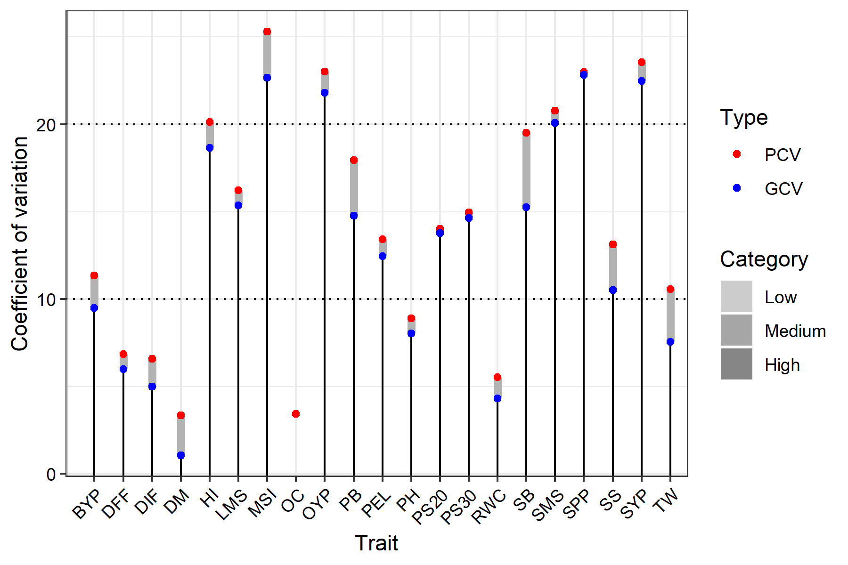

Fig.2: The graph indicates the gravity of variation of PCV and GCV across the TS condition. In general, PCV values were slightly higher than GCV values across all traits, suggesting that environmental factors influence their expression. Among all traits, MSI, OYP, SPP, SYP, and SMS exhibited high PCV and GCV, suggesting significant genetic variation.

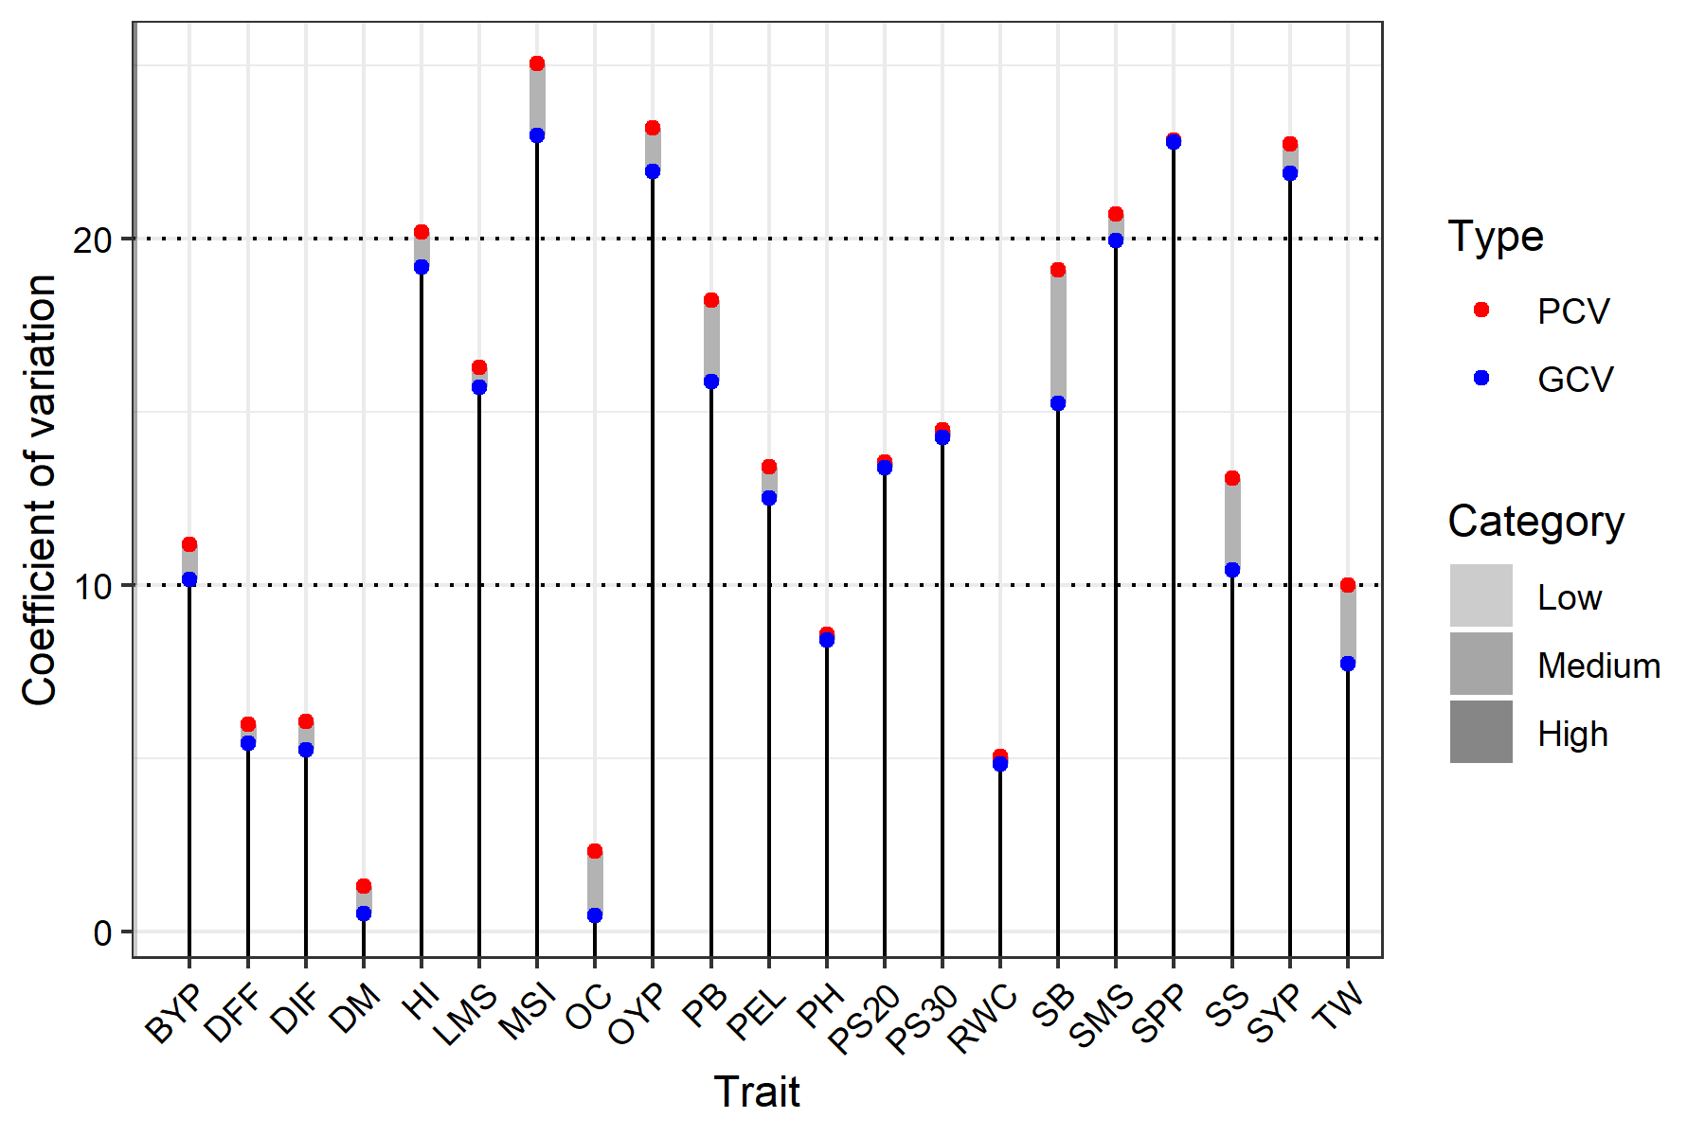

Fig.3: The graph indicates the gravity of variation of PCV and GCV across the ES condition. In general, PCV values were slightly higher than GCV values across all traits, suggesting that environmental factors influence their expression. Among all traits, MSI, OYP, SPP, SYP, and SMS exhibited high PCV and GCV, suggesting significant genetic variation.

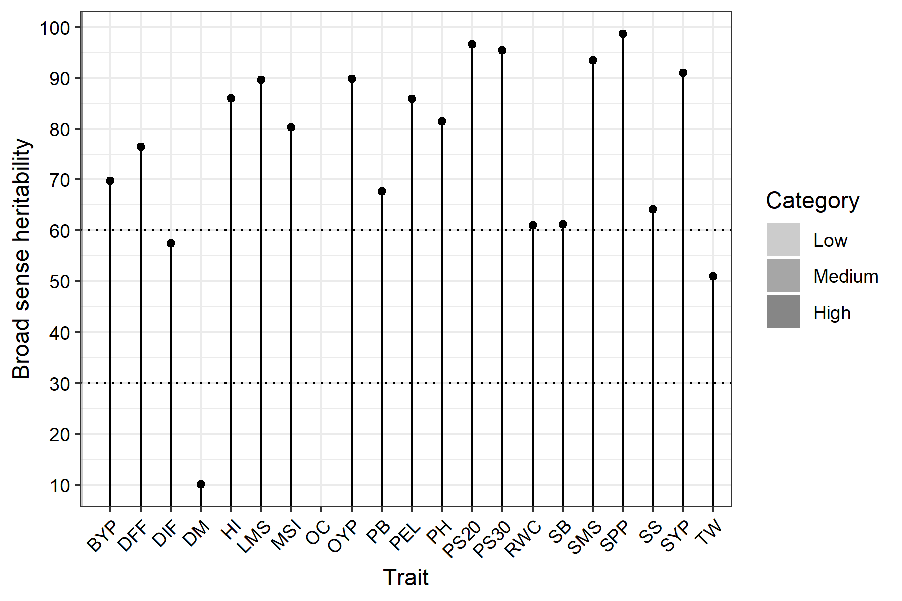

Fig. 4: The graph indicates the level of hBS (Broad Sense Heritability) across all traits in the TS condition. High hBS was observed in LMS, OYP, PS@20 and 30, SMS, SPP, and SYP, suggesting strong genetic control, minimal environmental influence and stable environmental adaptation.

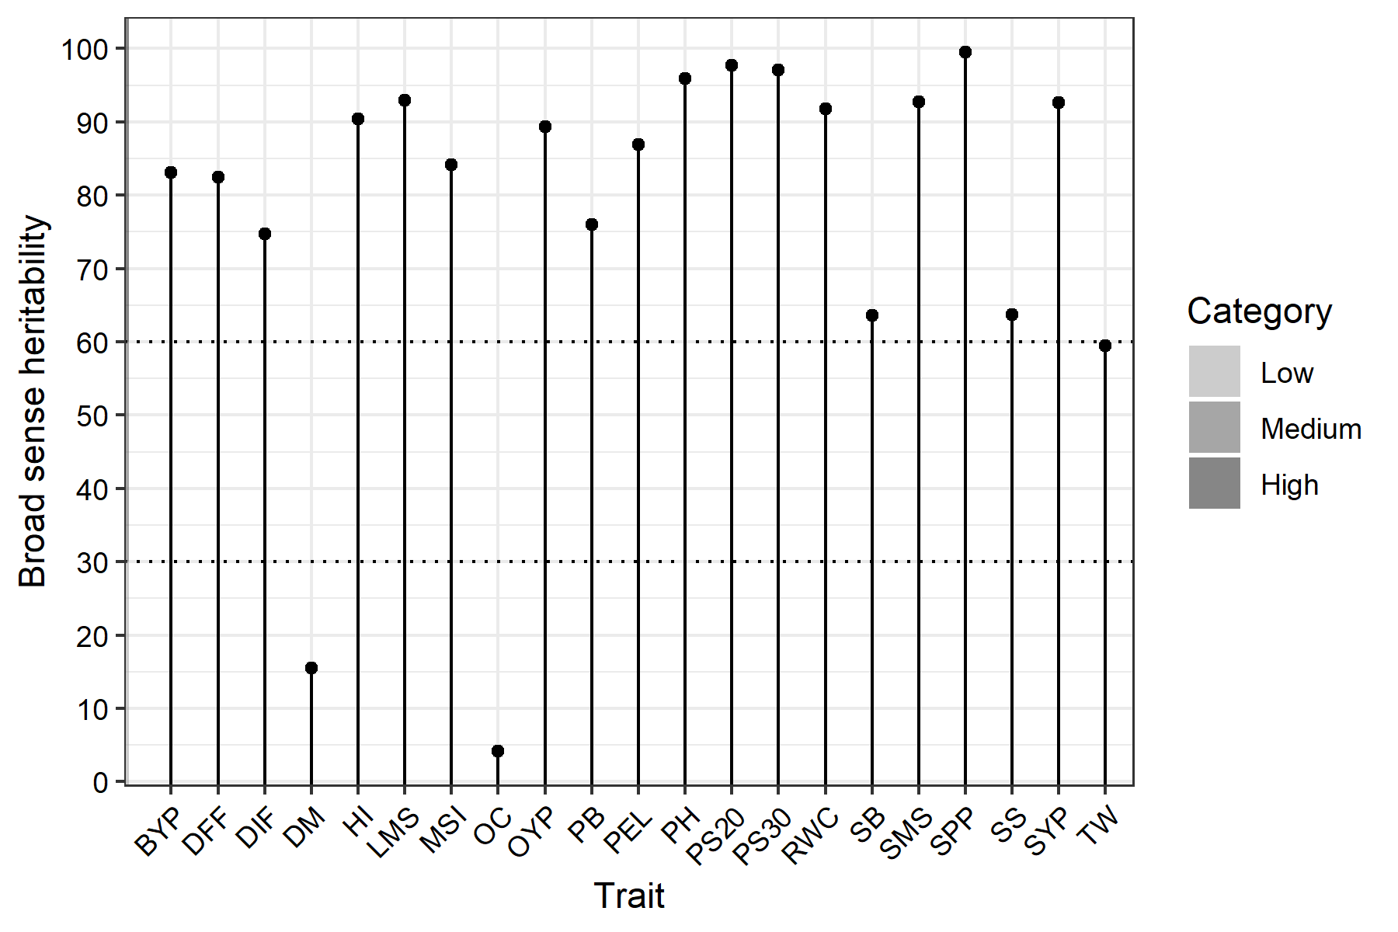

Fig. 5: The graph indicates the level of hBS (Broad Sense Heritability) across all traits in the ES condition. High hBS was observed in LMS, HI, PH, OYP, PS@20 and 30, RWC, SMS, SPP, and SYP, suggesting strong genetic control, minimal environmental influence, and stable environmental adaptation.

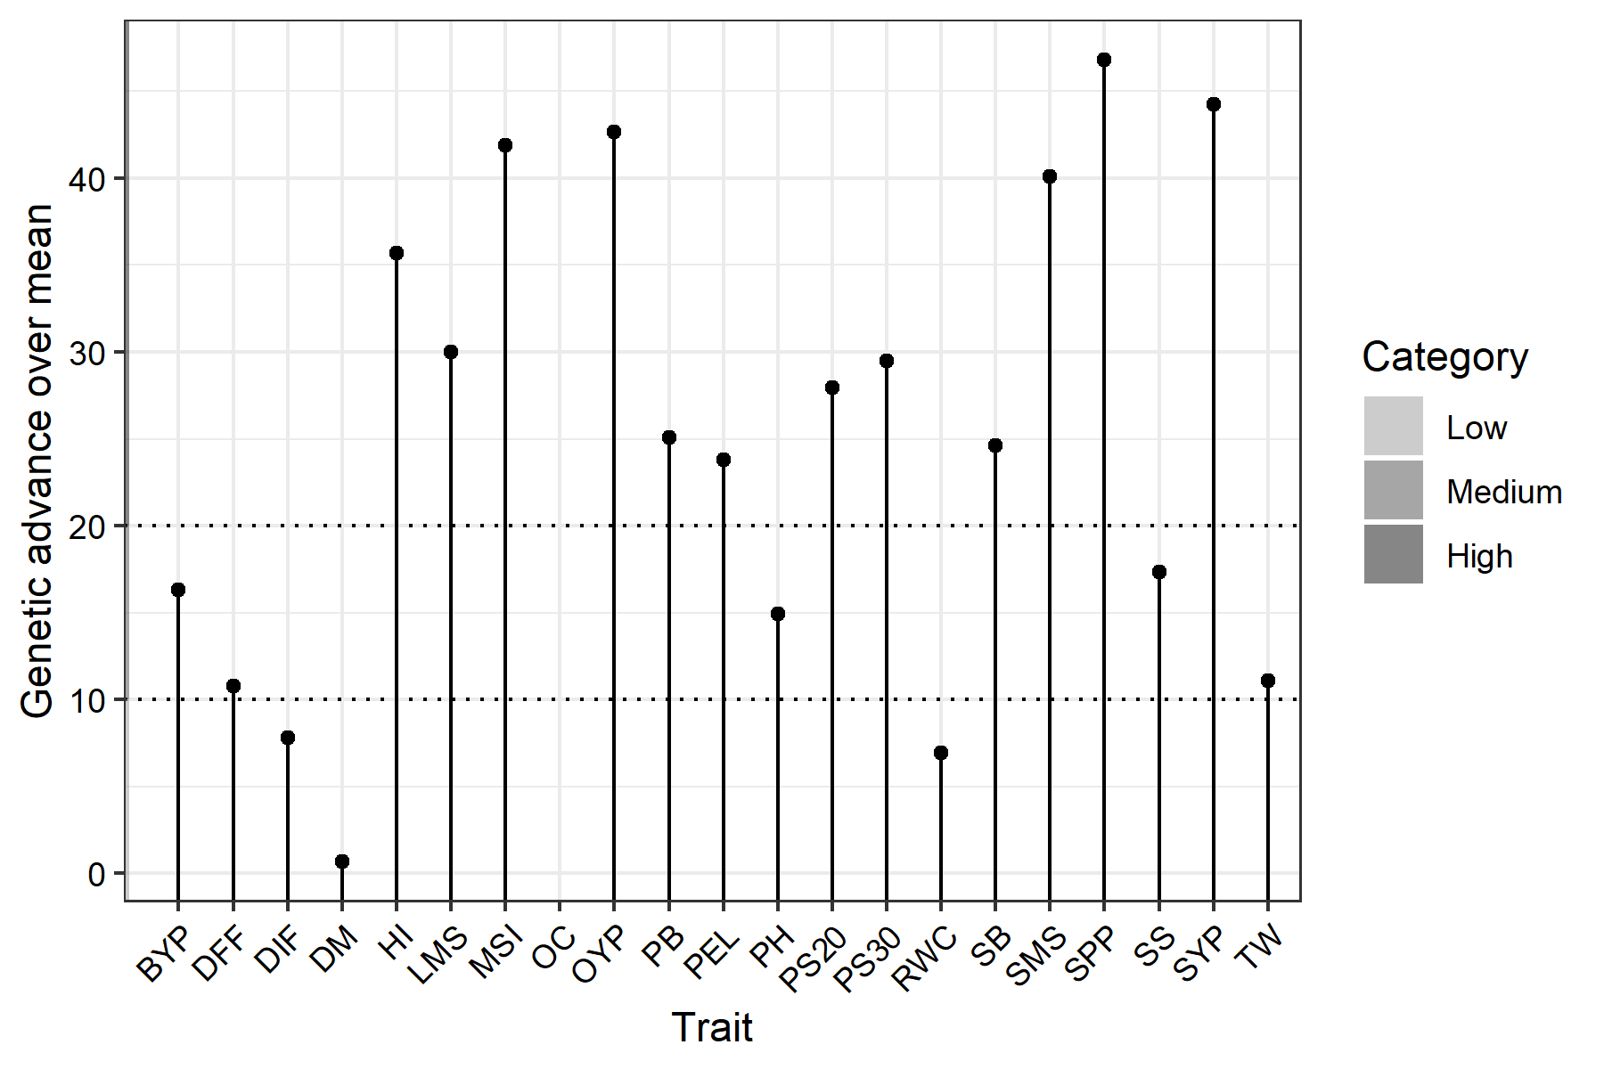

Fig.6: The indicates GAM (Genetic Advance Over Mean) across all traits in TS. High GAM was observed in HI, LMS, MSI, OYP, SMS, SB, SPP, and SYP, suggesting the dominance of additive gene action, which is an indicator of effective trait responses during selection and minimal environmental influence.

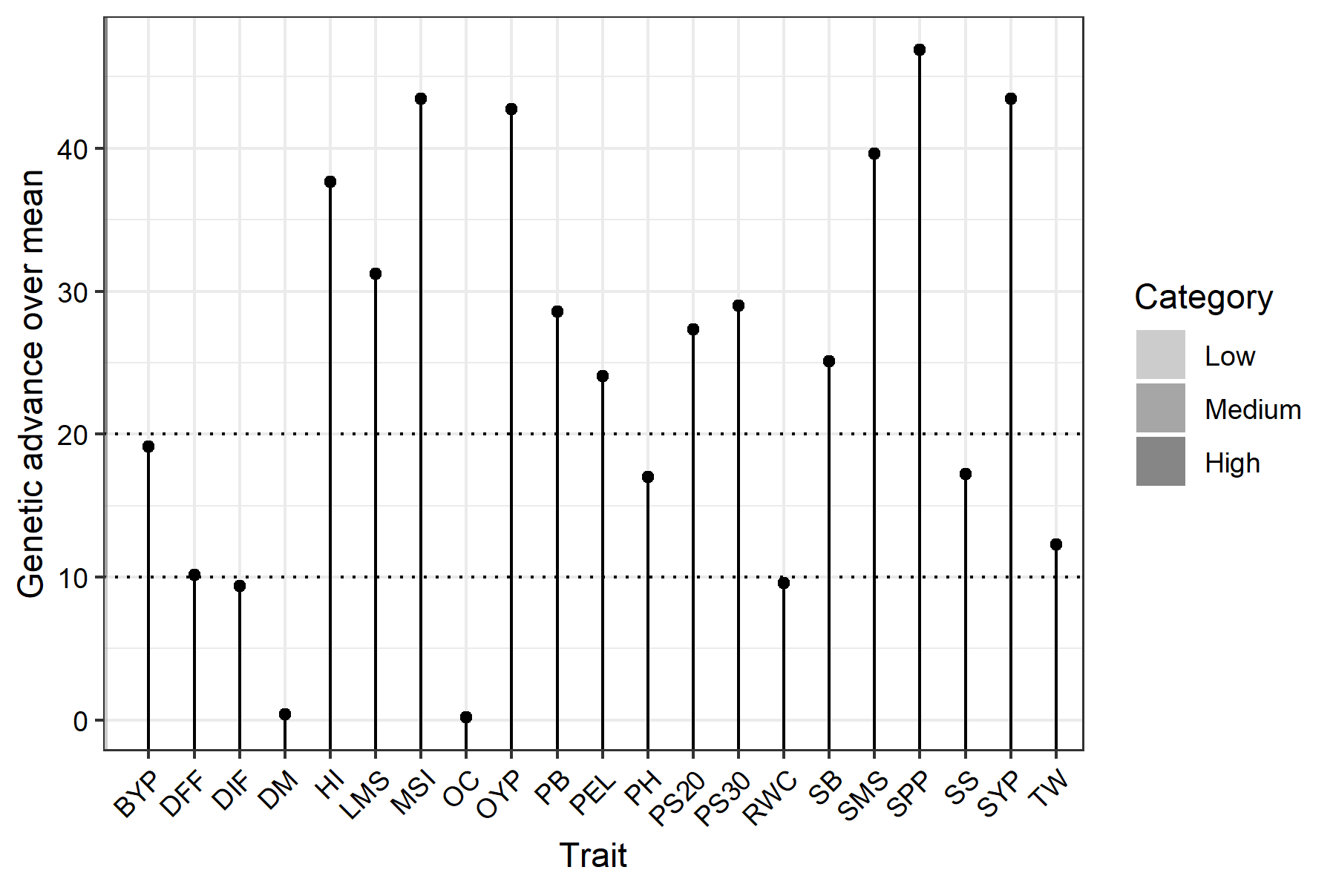

Fig.7: The indicates GAM (Genetic Advance Over Mean) across all traits in ES. High GAM was observed in HI, LMS, MSI, OYP, SMS, SPP, and SYP, suggesting the dominance of additive gene action, which is an indicator of effective trait responses during selection and minimal environmental influence.

4.4 Check Treatment Statistics

Five check treatments (Kanti, Kranti, Varuna, Pusa Bahar & Geeta) were sown at random in each block along with the test treatments. To serve as a benchmark for performance evaluation under ES and TS. Below are comparative statistical analyses of morphological, phenological, yield, and physiological traits.

4.4.1 Morphological Traits

The comparative statistical analysis of morphological traits under ES and TS conditions showed minor differences between the two environments across all check treatments. Overall, TS resulted in slightly higher mean values for PH, LMS, PB, SB, SPP, and SMS. Among the check treatments, Kanti consistently recorded the highest values for most morphological traits, followed by Pusa Bahar and Varuna; Kranti recorded the lowest values. The low standard error (SE) observed in both sowing environments indicated good experimental precision.

Table 7: Comparative Statistical Analysis of Morphological Traits of Check Treatment (5 replications) under early and timely sowing (ES Vs TS)

Plant Height | ES (Early Sowing) |  |  |  | TS (Timely Sowing)
Treatment | Means | SE | Min | Max | Means | SE | Min | Max
GEETA | 105.47 | 0.92 | 103 | 108 | 104.68 | 1.49 | 99.9 | 108.42
KANTI | 115.53 | 0.92 | 113 | 118 | 118.05 | 1.64 | 113.25 | 121.57
KRANTI | 98.07 | 0.71 | 96 | 100 | 98.09 | 1.67 | 91.92 | 101.58
PUSA BAHAR | 115.07 | 0.71 | 113 | 117 | 115.15 | 2.01 | 111.18 | 122.7
VARUNA | 111.07 | 0.71 | 109 | 113 | 112.28 | 1.88 | 106.95 | 116.4
Length of Main Shoot | ES (Early Sowing) |  |  |  | TS (Timely Sowing)
Treatment | Means | SE | Min | Max | Means | SE | Min | Max
GEETA | 31.8 | 0.86 | 29 | 34 | 31.31 | 0.51 | 30.15 | 32.9
KANTI | 43 | 0.71 | 41 | 45 | 43.84 | 0.81 | 41.15 | 45.25
KRANTI | 33 | 0.71 | 31 | 35 | 33 | 0.8 | 30.32 | 34.53
PUSA BAHAR | 38 | 0.71 | 36 | 40 | 37.32 | 1.08 | 35.07 | 41.34
VARUNA | 34 | 0.71 | 32 | 36 | 33.85 | 0.87 | 30.7 | 35.51
Primary Branches | ES (Early Sowing) |  |  |  | TS (Timely Sowing)
Treatment | Means | SE | Min | Max | Means | SE | Min | Max
GEETA | 4.2 | 0.19 | 3.6 | 4.7 | 4.14 | 0.22 | 3.45 | 4.74
KANTI | 7.57 | 0.25 | 6.9 | 8.2 | 7.49 | 0.28 | 6.62 | 8.11
KRANTI | 5.33 | 0.17 | 4.9 | 5.8 | 5.28 | 0.18 | 4.76 | 5.85
PUSA BAHAR | 6.14 | 0.16 | 5.6 | 6.5 | 6.08 | 0.18 | 5.47 | 6.56
VARUNA | 5.35 | 0.19 | 4.8 | 5.8 | 5.3 | 0.25 | 4.77 | 6.06
Secondary Branches | ES (Early Sowing) |  |  |  | TS (Timely Sowing)
Treatment | Means | SE | Min | Max | Means | SE | Min | Max
GEETA | 4.71 | 0.3 | 3.8 | 5.5 | 4.71 | 0.26 | 3.9 | 5.51
KANTI | 8.04 | 0.33 | 7.1 | 9 | 8.21 | 0.39 | 7.33 | 9.35
KRANTI | 7.39 | 0.27 | 6.7 | 8.1 | 7.21 | 0.29 | 6.6 | 7.95
PUSA BAHAR | 6.59 | 0.24 | 6 | 7.2 | 6.67 | 0.16 | 6.24 | 7.04
VARUNA | 7.43 | 0.3 | 6.6 | 8.2 | 7.4 | 0.4 | 6.36 | 8.58
Silique/Plant | ES (Early Sowing) |  |  |  | TS (Timely Sowing)
Treatment | Means | SE | Min | Max | Means | SE | Min | Max
GEETA | 180.6 | 1.5 | 177 | 185 | 182.12 | 3.13 | 172.99 | 189.44
KANTI | 137 | 1.14 | 134 | 140 | 140.42 | 0.95 | 138.58 | 143.66
KRANTI | 70.6 | 0.93 | 68 | 73 | 71.48 | 1.18 | 69.14 | 75.47
PUSA BAHAR | 140.8 | 0.86 | 138 | 143 | 141.01 | 1.78 | 137.35 | 146.89
VARUNA | 101 | 1.14 | 98 | 104 | 100.57 | 1.26 | 97.17 | 104.21
Silique on Main Shoot | ES (Early Sowing) |  |  |  | TS (Timely Sowing)
Treatment | Means | SE | Min | Max | Means | SE | Min | Max
GEETA | 29.8 | 0.86 | 27 | 32 | 30.33 | 0.85 | 28.07 | 32.74
KANTI | 36 | 0.71 | 34 | 38 | 36.07 | 0.9 | 33.41 | 38.59
KRANTI | 15.2 | 0.58 | 14 | 17 | 14.98 | 0.52 | 13.56 | 16.35
PUSA BAHAR | 29 | 0.71 | 27 | 31 | 29.06 | 0.91 | 27.28 | 32.44
VARUNA | 21 | 0.71 | 19 | 23 | 20.51 | 0.58 | 19.18 | 22.14

4.4.2 Phenological Traits

The comparative statistical analysis of phenological traits under ES and TS conditions showed minor differences between the two environments across all check treatments. Overall, TS resulted in slightly higher mean values for DIF and DFF. DM showed minimal differences between ES and TS, suggesting a stable maturity duration across both sowing environments. Among checks, Varuna performed well in DIF, whereas Kranti took the longest time to reach flowering and maturity.

Table 8: Comparative Statistical Analysis of Phenological Traits of Check Treatment (5 replications) under early and timely sowing (ES Vs TS)

Days to Initial Flowering | ES (Early Sowing) |  |  |  | TS (Timely Sowing)
Treatment | Means | SE | Min | Max | Means | SE | Min | Max
GEETA | 44.6 | 0.51 | 43 | 46 | 44.89 | 0.93 | 42.13 | 47.02
KANTI | 50 | 0.71 | 48 | 52 | 50.64 | 0.91 | 48.14 | 53.79
KRANTI | 51 | 0.71 | 49 | 53 | 51.32 | 1.34 | 48.43 | 55.33
PUSA BAHAR | 48.4 | 0.51 | 47 | 50 | 49.59 | 0.44 | 48.4 | 50.79
VARUNA | 36.8 | 0.58 | 35 | 38 | 36.45 | 0.72 | 34.58 | 38.73
Days to 50% Flowering | ES (Early Sowing) |  |  |  | TS (Timely Sowing)
Treatment | Means | SE | Min | Max | Means | SE | Min | Max
GEETA | 59 | 0.71 | 57 | 61 | 59.37 | 0.41 | 58.46 | 60.48
KANTI | 55.8 | 0.58 | 54 | 57 | 57.1 | 0.67 | 55.16 | 59.12
KRANTI | 60 | 0.71 | 58 | 62 | 60.79 | 0.93 | 57.35 | 62.82
PUSA BAHAR | 59.2 | 0.58 | 58 | 61 | 60.55 | 1.34 | 56.61 | 63.86
VARUNA | 54.8 | 0.58 | 53 | 56 | 55.41 | 0.8 | 53.69 | 57.4
Days to Maturity | ES (Early Sowing) |  |  |  | TS (Timely Sowing)
Treatment | Means | SE | Min | Max | Means | SE | Min | Max
GEETA | 158.8 | 0.86 | 156 | 161 | 157.46 | 2.47 | 152.52 | 165.01
KANTI | 160.8 | 0.58 | 159 | 162 | 160.41 | 2.29 | 153.16 | 165.52
KRANTI | 163 | 1.14 | 160 | 166 | 165.96 | 1.92 | 160.42 | 170.35
PUSA BAHAR | 162.2 | 0.8 | 160 | 164 | 162.16 | 1.87 | 156.35 | 167.8
VARUNA | 161.8 | 0.58 | 160 | 163 | 160.6 | 1.77 | 156.18 | 164.81

4.4.3 Yield Traits

The comparative statistical analysis of yield traits for the check treatment under ES and TS conditions showed minor differences between the two sowing environments. TS exhibited improved SYP, OYP, and TSW across most check treatments, whereas OC and BYP were comparable across both environments. Among check treatments, Varuna performed well for SYP, OC, OYP and TSW, followed by Kanti, whereas Krant exhibited lower SYP. Low SE indicated good experimental precision.

Table 9: Comparative Statistical Analysis of Yield Traits of Check Treatment (5 replications) under early and timely sowing (ES Vs TS)

Seed/Silique | ES (Early Sowing) |  |  |  | TS (Timely Sowing)
Treatment | Means | SE | Min | Max | Means | SE | Min | Max
GEETA | 11.6 | 0.51 | 10 | 13 | 11.81 | 0.64 | 9.57 | 13.23
KANTI | 15 | 0.45 | 14 | 16 | 14.52 | 0.36 | 13.46 | 15.41
KRANTI | 17 | 0.45 | 16 | 18 | 17.01 | 0.46 | 15.69 | 18.42
PUSA BAHAR | 11.4 | 0.4 | 10 | 12 | 11.24 | 0.38 | 9.95 | 12.25
VARUNA | 18 | 0.45 | 17 | 19 | 18 | 0.33 | 17.05 | 18.66
Seed Yield/Plant | ES (Early Sowing) |  |  |  | TS (Timely Sowing)
Treatment | Means | SE | Min | Max | Means | SE | Min | Max
GEETA | 6.49 | 0.14 | 6.2 | 6.9 | 6.57 | 0.18 | 6.25 | 7.18
KANTI | 6.94 | 0.19 | 6.4 | 7.4 | 6.88 | 0.23 | 6.08 | 7.42
KRANTI | 4.43 | 0.18 | 4 | 4.9 | 4.44 | 0.18 | 4.04 | 5.01
PUSA BAHAR | 5.83 | 0.16 | 5.3 | 6.2 | 5.82 | 0.12 | 5.44 | 6.14
VARUNA | 7.69 | 0.18 | 7.2 | 8.2 | 7.71 | 0.27 | 7.13 | 8.48
Oil Content % | ES (Early Sowing) |  |  |  | TS (Timely Sowing)
Treatment | Means | SE | Min | Max | Means | SE | Min | Max
GEETA | 39.44 | 0.31 | 38.5 | 40.3 | 40.06 | 0.66 | 37.91 | 41.23
KANTI | 40.18 | 0.42 | 39 | 41.2 | 39.82 | 0.54 | 38.23 | 41.35
KRANTI | 40.14 | 0.47 | 39 | 41.4 | 38.73 | 0.56 | 37.43 | 40.42
PUSA BAHAR | 39.48 | 0.35 | 38.7 | 40.4 | 39.18 | 0.36 | 38.26 | 40.2
VARUNA | 40.94 | 0.26 | 40 | 41.5 | 40.27 | 0.66 | 38.35 | 42.15
Oil Yield/Plant | ES (Early Sowing) |  |  |  | TS (Timely Sowing)
Treatment | Means | SE | Min | Max | Means | SE | Min | Max
GEETA | 2.55 | 0.07 | 2.38 | 2.78 | 2.53 | 0.06 | 2.31 | 2.64
KANTI | 2.79 | 0.1 | 2.54 | 3.05 | 2.75 | 0.09 | 2.44 | 2.98
KRANTI | 1.78 | 0.09 | 1.57 | 2.02 | 1.83 | 0.1 | 1.6 | 2.1
PUSA BAHAR | 2.3 | 0.06 | 2.14 | 2.5 | 2.26 | 0.06 | 2.06 | 2.39
VARUNA | 3.15 | 0.08 | 2.96 | 3.4 | 3.13 | 0.06 | 3 | 3.29
1000-Seed Weight | ES (Early Sowing) |  |  |  | TS (Timely Sowing)
Treatment | Means | SE | Min | Max | Means | SE | Min | Max
GEETA | 3.28 | 0.09 | 3 | 3.5 | 3.27 | 0.09 | 2.91 | 3.47
KANTI | 3.3 | 0.11 | 3 | 3.6 | 3.28 | 0.11 | 2.97 | 3.58
KRANTI | 3.8 | 0.11 | 3.5 | 4.1 | 3.84 | 0.16 | 3.37 | 4.22
PUSA BAHAR | 3.46 | 0.07 | 3.2 | 3.6 | 3.42 | 0.07 | 3.27 | 3.63
VARUNA | 4.24 | 0.09 | 4 | 4.5 | 4.24 | 0.12 | 3.85 | 4.54
Biological Yield/Plant | ES (Early Sowing) |  |  |  | TS (Timely Sowing)
Treatment | Means | SE | Min | Max | Means | SE | Min | Max
GEETA | 35.4 | 0.67 | 33.2 | 37.2 | 34.97 | 0.74 | 32.07 | 36.27
KANTI | 38.56 | 0.66 | 36.9 | 40.1 | 37.7 | 0.86 | 35.57 | 40.09
KRANTI | 34.26 | 0.73 | 32.4 | 36 | 34.01 | 1.18 | 31.15 | 37.46
PUSA BAHAR | 25.97 | 0.61 | 24.1 | 27.4 | 25.66 | 0.44 | 24.62 | 26.73
VARUNA | 35.17 | 0.65 | 33.5 | 36.9 | 35.17 | 0.84 | 32.44 | 37.37
Harvest Index | ES (Early Sowing) |  |  |  | TS (Timely Sowing)
Treatment | Means | SE | Min | Max | Means | SE | Min | Max
GEETA | 19.78 | 0.56 | 18 | 21.2 | 19.98 | 0.77 | 17.46 | 21.73
KANTI | 18.18 | 0.44 | 17.1 | 19.4 | 18.22 | 0.59 | 16.55 | 20.19
KRANTI | 12.83 | 0.56 | 11.5 | 14.3 | 12.62 | 0.66 | 11.09 | 14.39
PUSA BAHAR | 23.01 | 0.45 | 21.5 | 24 | 23.16 | 0.25 | 22.54 | 23.79
VARUNA | 22.11 | 0.6 | 20.7 | 23.8 | 21.98 | 0.63 | 19.88 | 23.68

4.4.4 Physiological Traits

A comparative statistical analysis of physiological traits across the check treatments of ES and TS revealed only minor differences between the two sowing environments. Most physiological traits exhibited stable mean values in ES and TS. Among checks, Pusa Bahar had the highest PELWL, while Kanti and Varun showed the highest RWC and MSI. PS at 20 & 30 improved in TS for most check treatments. SE values showed reliable measurements.

Table 10: Comparative Statistical Analysis of Physiological Traits of Check Treatment (5 replications) under early and timely sowing (ES Vs TS)

PELWL | ES (Early Sowing) |  |  |  | TS (Timely Sowing)
Treatment | Means | SE | Min | Max | Means | SE | Min | Max
GEETA | 23.78 | 0.68 | 21.6 | 25.4 | 23.49 | 0.88 | 20.62 | 25.79
KANTI | 26.9 | 0.47 | 25.8 | 28.1 | 27 | 0.67 | 24.62 | 28.38
KRANTI | 22.51 | 0.67 | 20.8 | 24.1 | 22.63 | 0.78 | 20.87 | 24.51
PUSA BAHAR | 37.28 | 0.62 | 35.7 | 38.9 | 37.46 | 0.44 | 36.05 | 38.52
VARUNA | 17.3 | 0.63 | 15.2 | 18.9 | 17.32 | 0.67 | 15.57 | 19.15
RWC | ES (Early Sowing) |  |  |  | TS (Timely Sowing)
Treatment | Means | SE | Min | Max | Means | SE | Min | Max
GEETA | 86.36 | 0.77 | 83.9 | 88.4 | 85.69 | 1.24 | 82.85 | 89.61
KANTI | 96.22 | 0.62 | 94.2 | 97.5 | 95.63 | 0.63 | 93.58 | 97.46
KRANTI | 91.38 | 0.64 | 89.8 | 93.2 | 92.43 | 1.54 | 87.28 | 95.5
PUSA BAHAR | 89.34 | 0.62 | 87.3 | 91 | 88.45 | 1.83 | 83.02 | 94.2
VARUNA | 85.89 | 0.56 | 84 | 87.1 | 87.25 | 0.84 | 85.14 | 89.69
MSI | ES (Early Sowing) |  |  |  | TS (Timely Sowing)
Treatment | Means | SE | Min | Max | Means | SE | Min | Max
GEETA | 9.19 | 0.4 | 7.9 | 10.2 | 9.24 | 0.37 | 8.27 | 10.43
KANTI | 17.77 | 0.34 | 16.8 | 18.6 | 17.73 | 0.44 | 16.3 | 19.08
KRANTI | 16.74 | 0.59 | 15.2 | 18.2 | 16.55 | 0.75 | 14.47 | 18.68
PUSA BAHAR | 11.22 | 0.38 | 9.9 | 12 | 11.04 | 0.39 | 9.94 | 11.97
VARUNA | 17.95 | 0.57 | 16.4 | 19.5 | 17.93 | 0.65 | 16.01 | 19.87
PS @ 20 DAS | ES (Early Sowing) |  |  |  | TS (Timely Sowing)
Treatment | Means | SE | Min | Max | Means | SE | Min | Max
GEETA | 84.07 | 0.69 | 82 | 86 | 85.11 | 1.08 | 82.71 | 88.2
KANTI | 83.09 | 0.82 | 80.5 | 85 | 83.52 | 0.36 | 82.31 | 84.31
KRANTI | 83.07 | 0.71 | 81 | 85 | 82.2 | 0.91 | 80.69 | 85.4
PUSA BAHAR | 83.07 | 0.71 | 81 | 85 | 84.06 | 1.17 | 81.57 | 87.76
VARUNA | 67.13 | 0.67 | 65 | 69 | 67.94 | 0.77 | 65.64 | 69.56
PS @ 30 DAS | ES (Early Sowing) |  |  |  | TS (Timely Sowing)
Treatment | Means | SE | Min | Max | Means | SE | Min | Max
GEETA | 50.8 | 0.86 | 48 | 53 | 50.27 | 1.18 | 46.89 | 54.26
KANTI | 51.1 | 0.71 | 49 | 53 | 50.3 | 0.74 | 47.83 | 52.38
KRANTI | 66.53 | 0.92 | 64 | 69 | 67.61 | 0.52 | 66.36 | 69.13
PUSA BAHAR | 50.7 | 0.8 | 48 | 52.5 | 49.77 | 0.88 | 46.46 | 51.37
VARUNA | 66.23 | 0.76 | 64 | 68 | 65.7 | 0.88 | 62.87 | 68.11

Across all check treatments, ES and TS showed only minor differences. TS got an advantage by improving morphological traits. Among check treatments, Kanti performed well across most morphological traits; Varuna performed best for SYP, OC, OYP, TSW, and DIF, whereas Kranti performed longer for DIF and DM. Pusa Bahar performed well for PELWL, while Kanti and Varuna performed well for RWC and MSI. Overall, the low SE indicated good experimental precision and reliability.

5.0 CONCLUSION

Based on the comprehensive study of 100 Indian mustard genotypes under early (26 September 2023) and timely (26 October 2023) sowing environments in the Doon Valley, Uttarakhand, India, the present investigation clearly indicated that sowing-time–induced temperature variation significantly influences genetic expression, physiological stability, and yield realization in Indian mustard (Brassica juncea L.).

The recorded weekly temperature pattern confirmed that early sowing exposed the crop to elevated temperatures (>35°C) during seedling establishment.

Both treatment-adjusted and block-adjusted RCBD ANOVA, indicated highly significant (P ≤ 0.01) differences among genotypes for most morphological, yield, and physiological traits under both sowing environments The low residual mean squares confirmed high experimental precision and reliability of genotype comparisons. Similar observations regarding the importance of multi-environment evaluation in mustard have been reported by Patidar et al. (2020) and Gupta et al. (2023). Oil content (OC) and days to maturity (DM) exhibited comparatively narrow variability, indicating relative stability across environments, a trend also noted in earlier studies (Kumari et al., 2018).

The comparative genetic variability analysis revealed that PCV values were slightly higher than GCV values for most traits, indicating moderate environmental influence. However, the narrow PCV–GCV differences for key traits suggest strong genetic control (Singh et al., 2018).

Traits such as Silique per plant (SPP), Silique on main shoot (SMS), Seed yield per plant (SYP), Oil yield per plant (OYP), Harvest index (HI), Membrane stability index (MSI) exhibited high GCV (>20%), high heritability (>80%), and high GAM (>40%). This indicates predominance of additive gene action and strong selection potential, consistent with findings of Kumar et al. (2020) and Devi et al. (2024). These traits can therefore serve as reliable selection indices for improving both yield and thermo-tolerance. Physiological parameters such as MSI, RWC, and PELWL showed significant variation under both environments, confirming genetic differences in temperature resilience. MSI, in particular, recorded high GCV, high heritability, and high GAM under both sowing conditions, making it a robust physiological marker for heat tolerance. Earlier studies have emphasized the importance of membrane stability and water retention in conferring thermo-tolerance in mustard (Ram et al., 2014; Azharudheen et al., 2013).
Early sowing enhanced genotypic discrimination for several stress-related traits, suggesting that mild early-season heat stress provides a natural screening environment for identifying resilient genotypes.

Among the check treatments, Varuna and Kanti consistently performed superior for seed yield, oil yield, and related traits under both environments.

The study conclusively establishes that:
- Substantial exploitable genetic variability exists among Indian mustard genotypes under both early and timely sowing.
- Yield and stress-related traits (SPP, SYP, OYP, HI, MSI) are predominantly governed by additive gene action and are highly amenable to selection.
- Early sowing serves as an effective screening environment for identifying thermo-tolerant and physiologically stable genotypes.
- Oil content shows environmental modulation, with better genetic expression under timely sowing.
- Integrated evaluation of morphological, physiological, and yield traits is essential for breeding climate-resilient mustard cultivars.
In conclusion, the findings provide a strong scientific basis for developing high-yielding, temperature-resilient Indian mustard genotypes suitable for the agro-climatic conditions of the Doon Valley and similar environments under changing climate scenarios, aligning with earlier recommendations by Shekhawat et al. (2012), Patidar et al. (2020), and Chugh et al. (2022).

Disclaimer (Artificial Intelligence)

The author(s) hereby declare that NO generative AI technologies such as Large Language Models (ChatGPT, COPILOT, etc.) and text-to-image generators have been used during the writing or editing of this manuscript.

REFERENCES

- Misra, A. K., Rana, J. C., Yadav, S., Bhat, K. V., & Prakash, S. (2008). Status, utilization and priorities of oilseed Brassica germplasm. Plant Genetic Resources: Characterization and Utilization, 6(1), 1–14.
- ICAR–Indian Institute of Rapeseed-Mustard Research (IIRMR). (2024). Annual report 2023–24. Bharatpur, Rajasthan, India.
- Sharma, P., & Sardana, V. (2014). Screening of Indian mustard (Brassica juncea) for thermo-tolerance at seedling and terminal stages. Journal of Oilseed Brassica, 5.
- Chugh, P., Sharma, P., Sharma, R., & Singh, M. (2022). Study on heat stress indices and their correlation with yield in Indian mustard genotypes under diverse conditions. Indian Journal of Genetics and Plant Breeding, 82(2), 186–192.
- Meena, D. R., Chauhan, J. S., Singh, M., Singh, K. H., & Meena, M. L. (2013). Genetic variation and correlations among physiological characters in Indian mustard (Brassica juncea L.) under high temperature stress. Indian Journal of Genetics and Plant Breeding, 73(1), 101–104.
- Gupta, A., Chauhan, S., Tyagi, S. D., & Singh, S. (2023). Genetic variability, heritability, genetic advance and cluster analysis in Indian mustard (Brassica juncea L.) under timely and late sown conditions. International Journal of Plant & Soil Science, 35(19), 292–301.
- Gupta, D., Punia, S., Gothwal, D., Ram, M., Mittal, G., & Kumar, A. (2023). Evaluation of heat tolerance genotypes in Indian mustard (Brassica juncea L.) based on heat susceptibility index. Biological Forum – An International Journal, 15(11), 230.
- Ahmed, F., Ahmed, I. M., Mokarroma, N., Begum, F., & Jahan, A. (2019). Physiological and yield responses of rapeseed/mustard genotypes to high temperature stress. Bangladesh Agronomy Journal, 22(1).
- Devi, S. A., Barua, P. K., & Phukan, A. (2024). Assessment of genetic variability for seed yield and related traits in Indian mustard (Brassica juncea L.). Journal of Experimental Agriculture International, 46(4), 48–55.
- Kannaujiya, T., Chaudhary, A. K., Nath, S., Mishra, G., Gupta, R., & Vimal, S. (2022). Genetic diversity analysis in Indian mustard (Brassica juncea L.). Biological Forum – An International Journal, 14(2), 1571–1574.
- Kumari, A., & Kumari, V. (2018). Genetic variability and divergence studies for seed yield and component characters in Indian mustard (Brassica juncea L.). International Journal of Current Microbiology and Applied Sciences, 7(7), 3376–3388.
- Kumar, A. (2018). Effect of different sowing dates on yield and yield attributes of Indian mustard (Brassica juncea L.) genotypes. International Journal of Pure & Applied Bioscience, 6(2), 848–853.
- Kumar, V., Malik, V. K., Singh, N. P., Sharma, P. K., & Malik, V. K. (2014). Genetic divergence analysis in Indian mustard (Brassica juncea). Annals of Biology, 30(2).
- Lodhi, B., Thakral, N. K., Avtar, R., & Singh, A. (2014). Genetic variability, association and path analysis in Indian mustard (Brassica juncea). Journal of Oilseed Brassica, 5(1).
- Pandey, B., Yadav, R., Ramawat, N., Vishwakarma, H., & Pandey, S. (2024). Optimization of sowing dates in Indian mustard (Brassica juncea L.) to combat yield losses caused by high temperature at reproductive stage. Plant Science Today, 11(1), 81–92.
- Patel, P. B., Patel, P. J., Patel, J. R., & Patel, P. C. (2021). Elucidation of genetic variability and inter-relationship studies for seed yield and quality traits in Indian mustard (Brassica juncea L.). Electronic Journal of Plant Breeding, 12(2), 589–596.
- Perween, S., Kumar, A., Chakraborty, M., Ahmad, E., Mahto, C., & Barnwal, M. (2024). Assessment of genetic variability and diversity in Indian mustard (Brassica juncea L.) under timely and late sown conditions. Journal of Advances in Biology & Biotechnology, 27(10), 331–341.
- Ram, B., Meena, H. S., Singh, V. V., Singh, B. K., & Singh, D. (2014). High temperature stress tolerance in Indian mustard (Brassica juncea). Journal of Oilseed Brassica, 5(2).
- Ram, B., Singh, V. V., Singh, B. K., Kumar, A., & Singh, D. (2015). Comparative tolerance and sensitive response of Indian mustard genotypes to high temperature stress. SABRAO Journal of Breeding and Genetics, 47(3).
- Saleem, N., Ahmad Jan, S., Jawaad Atif, M., Khurshid, H., Ali Khan, S., Abdullah, M., Jahanzaib, M., Ahmed, H., Ullah, S. F., Iqbal, A., Naqi, S., Ilyas, M., Ali, N., & Rabbani, M. A. (2017). Multivariate based variability within diverse Indian mustard (Brassica juncea L.) genotypes. Open Journal of Genetics, 7(2), 69–83.
- Aggarwal, G., Edhigalla, P., Walia, P., Jindal, S., & Sandal, S. S. (2024). A method for screening salt stress tolerance in Indian mustard (Brassica juncea). Scientific Reports, 14(1).
- Ankit Dhillon, Kumar, N., Singh, M., Jogender, Annu, & Shreya. (2025). Genetic variability in Indian mustard for salt stress tolerance at seedling stage. Journal of Oilseed Brassica, 16(1), 81–87.
- Aziz, M. A., Chakma, R., Ahmed, M., Rahman, A. K. M. M., & Roy, K. (2011). Effect of sowing dates on growth, development and yield of mustard in hilly areas. Journal of Experimental Biosciences, 2(1).
- Tiwari, A., Kumar, A., Singh, D., Tripathi, P., Singh, S., Singh, S., & Kumar, A. (2025). Genetic variability and improvement in Indian mustard (Brassica juncea L.). Journal of Advances in Biology & Biotechnology, 28(10), 591–606.

- Chakraborty, S., Kumar, A., Kishore, C., Kumar, A., Kumar, R. R., & De, N. (2021). Genetic variability and character association studies in Indian mustard (Brassica juncea L.). International Journal of Environment and Climate Change, 11(11), 100–105.

- Aravind, J., Mukesh Sankar, S., Wankhede, D. P., & Kaur, V. (2023). augmentedRCBD: Analysis of augmented randomised complete block designs (R package version 0.1.7). CRAN.

- A., Kumar, V., & Nagarjun, P. (2025). Unlocking the Genetic Potential of Indian Mustard: A Review on Advances in Breeding Approaches. Agricultural Science Digest.

- Bhandari, D., & Singh, A. (2023). Genetic Divergence in Leafy Mustard Germplasm. Indian Journal of Agricultural Research.

- Choudhary, R., Singh, J., Barela, A., Patel, T., & Yadav, P. K. (2025). Assessment of Genetic Variability and Heritability in Indian Mustard Genotypes. Journal of Advances in Biology & Biotechnology.

- Dwivedi, S., & Mishra, R. (2020). Study of Yield Contributing Characters of Mustard. International Journal of Current Microbiology and Applied Sciences.

- Kumar, A., Chauhan, R., & Singh, K. P. (2020). Genetic variability, heritability and genetic advance among Indian mustard genotypes. Annals of Plant and Soil Research.

