Perifoveal Exudative Vascular Anomalous Complex (PEVAC) in high myopia: Avoiding the diagnostic pitfall of myopic choroidal neovascularization
Abstract
Background: Perifoveal Exudative Vascular Anomalous Complex (PEVAC) is a rare retinal disorder involving a perifoveal aneurysmal lesion, often mistaken for myopic choroidal neovascularization, requiring accurate diagnosis for proper treatment.
Purpose: To report a rare case of Perifoveal Exudative Vascular Anomalous Complex (PEVAC) in a highly myopic patient and to highlight the role of multimodal imaging in avoiding the diagnostic pitfall of myopic choroidal neovascularization (mCNV).
Case presentation: A 59-year-old male with anisometropic high myopia (LE spherical equivalent: -9.75 D, axial length: 26.96 mm) presented with a three-month history of progressive metamorphopsia and vision loss in the left eye. Fundus examination revealed a juxtafoveal yellowish punctiform lesion, microhemorrhages, and a superior circinate pattern of lipid exudates. While initial clinical suspicion leaned toward mCNV, multimodal imaging provided a definitive correction. Structural OCT identified a 196 µm intraretinal aneurysmal dilation within the outer plexiform layer. OCT-Angiography (OCT-A) localized a prominent high-flow signal within the deep capillary plexus (DCP), confirming the diagnosis of PEVAC. Due to the foveal proximity (569 µm) and the characteristic resistance of PEVAC to anti-VEGF (vascular endothelial growth factor) therapy, image-guided focal laser photocoagulation (Navilas®) was performed.
Results: At the 6-month follow-up, best-corrected visual acuity improved from 20/40 to 20/25 (16/20). Imaging confirmed the complete resorption of circinate exudates, resolution of intraretinal cystic spaces, and visible collapse of the aneurysmal complex.
Conclusion: PEVAC is a critical differential diagnosis for exudative maculopathy in high myopes. Distinguishing it from mCNV through multimodal imaging is essential to prevent unnecessary anti-VEGF injections. Image-guided laser photocoagulation remains a highly effective and precise treatment for lesions near the fovea.
Keywords:
Myopic choroidal neovascularization (mCNV), Exudative maculopathy, Multimodal imaging, Optical coherence tomography (OCT), OCT-Angiography (OCT-A), Navigated laser photocoagulation, Peripapillary intrachoroidal cavitation (ICCR)

- Introduction
Perifoveal Exudative Vascular Anomalous Complex (PEVAC) is a rare clinical entity first described by Querques et al. in 2011 [1]. Typically occurring in adult or elderly patients, it is characterized by an isolated, idiopathic perifoveal aneurysmal anomaly, often originating from the deep capillary plexus (DCP) and typically associated with cystic intraretinal fluid, hard exudates, and microhemorrhages [2,3]. While PEVAC is primarily a diagnosis of exclusion—requiring the ruling out of local or systemic vasculopathies like diabetes or hypertension—cases associated with pathological myopia have been increasingly described [4,5,6]. In such eyes, the diagnosis presents a formidable clinical challenge, as macular exudation and hemorrhages are traditionally attributed to myopic choroidal neovascularization (mCNV). Distinguishing these two entities is critical: whereas mCNV necessitates urgent anti-VEGF therapy, PEVAC is typically refractory to such treatments and responds more effectively to focal laser photocoagulation [2,7,8].
We report a unique case of a 59-year-old highly myopic patient presenting with progressive metamorphopsia and vision loss related to an exudative and hemorrhagic macular lesion. This clinical context initially led us to suspect mCNV. However, multimodal imaging revealed an isolated PEVAC coexisting with peripapillary intrachoroidal cavitations (ICCR). This diagnostic correction guided a more appropriate management strategy (image-guided focal laser photocoagulation) which spared the patient from unnecessary, ineffective invasive procedures [8,9,10].
- Presentation of case
A 59-year-old male with anisometropic high myopia presented with a three-month history of progressive metamorphopsia and vision loss in the left eye (LE). He had no history of systemic hypertension, diabetes, or other vasculopathies. Best-corrected visual acuity (BCVA) was 20/20 in the right eye (RE) (refraction: -6.00 D) and 20/40 in the LE (refraction: -9.75 D). Axial lengths were 25.68 mm (RE) and 26.96 mm (LE), respectively.
Fundus examination revealed a tilted optic disc with a peripapillary atrophy ring in both eyes. In the superior juxtafoveal area of the left eye, a yellowish punctiform lesion was noted, surrounded by a subtle reddish halo and retinal microhemorrhages, with an associated superior circinate pattern of lipid exudates (Fig. 1). While the initial presentation raised suspicion for myopic choroidal neovascularization (mCNV), multimodal imaging provided a definitive correction.
Fluorescein angiography (FA) showed a well-defined, "light-bulb" hyperfluorescent retinal lesion with minimal late-stage leakage, inconsistent with the classic "lacy" pattern of CNV (Fig. 2). Structural OCT identified a 196 µm oval, intraretinal aneurysmal dilation located within the outer plexiform layer, 569 µm from the fovea. The lesion exhibited a highly reflective wall, a hyporeflective lumen, and marked posterior shadowing. Juxtafoveal intraretinal cystic spaces were present without associated subretinal fluid or pigment epithelial detachment (PED) (Fig. 3). Notably, peripapillary intrachoroidal cavitations (ICCR) were observed surrounding the optic nerve head, presenting as hyporeflective voids beneath the intact retinal pigment epithelium (RPE) (Fig. 4).
OCT-Angiography (OCT-A) localized a prominent high-flow aneurysmal complex within the deep capillary plexus (DCP) (Fig. 5). These multimodal imaging findings confirmed the diagnosis of perifoveal exudative vascular anomalous complex (PEVAC). Given the foveal proximity and the characteristic resistance of these vascular exudative lesions to anti-VEGF therapy, we opted for image-guided focal laser photocoagulation using the Navilas® system. This allowed for precise targeting of the aneurysm while sparing the foveal center. At the 6-month follow-up, BCVA improved to 20/25 (16/20), with complete resorption of the circinate exudates, resolution of the intraretinal cysts, and visible collapse of the aneurysmal complex on structural OCT (Fig. 6).
- Discussion:
The diagnosis of PEVAC in highly myopic eyes presents a formidable clinical challenge, as macular exudation and hemorrhages are traditionally attributed to myopic choroidal neovascularization (mCNV). However, these two entities possess fundamentally different pathophysiologies, imaging signature and therapeutic requirements. In our highly myopic patient—who presented with progressive metamorphopsia and vision loss—the clinical features initially mimicked the exudative signature of mCNV. As demonstrated here, multimodal imaging was the indispensable tool required to correct this initial suspicion, allowing for definitive differentiation from mCVN.
Fluorescein angiography (FA) revealed a focal, "light-bulb" hyperfluorescence with minimal late-stage leakage, a pattern distinct from the classic "lacy" or "occult" leakage characteristic of active mCNV [1, 3]. Structural OCT provided the crucial clue by localizing the 196 µm oval lesion within the retinal layers, specifically the outer plexiform layer (OPL), rather than the subretinal space. This anomaly exhibited the pathognomonic "triad" of a hyperreflective wall, a hyporeflective lumen, and marked posterior shadowing, features typical of capillary macroaneurysms rather than neovascular membranes [2, 5, 6]. This intraretinal morphology contrasts sharply with mCNV, which typically appears as a subretinal hyperreflective lesion disrupting the ellipsoid zone and retinal pigment epithelium (RPE). Furthermore, OCT-Angiography (OCT-A) localized a high-flow aneurysmal complex specifically within the deep capillary plexus (DCP) [3, 4]. This localization is a critical diagnostic marker; whereas mCNV originates from the choriocapillaris and extends through Bruch’s membrane, PEVAC is a primary retinal vascular anomaly [2, 6].
While PEVAC was initially described as an idiopathic entity in otherwise healthy eyes [1], our case aligns with the "expanded spectrum" of PEVAC described by Sacconi et al., who noted that highly myopic eyes may be predisposed to these anomalies due to mechanical stress and subsequent vascular remodeling [2, 5]. A notable feature of this case was the coexistence of peripapillary intrachoroidal cavitations (ICCR). ICCRs represent a focal stretching of the sclera where the choroid has detached or thinned significantly, typically seen in highly myopic eyes with posterior staphylomas. While the direct link between ICCR and PEVAC has not been established, both reflect the extreme mechanical strain and vascular remodeling inherent in the highly myopic posterior pole [11].
The management of PEVAC remains a subject of debate, as these lesions are notoriously refractory to anti-VEGF injections [2, 3, 6]. Because PEVAC is an anatomical vascular abnormality rather than an active neovascular process, VEGF inhibition is largely ineffective, as has been documented in recent case series by Arruabarrena et al. [8]. While some cases remain stable [4, 5], those with progressive exudative vision loss, like our patient, require focal photoablation. Traditional focal laser photocoagulation is justified for lesions located more than 1000 µm from the foveal center but carries a high risk of "laser scar creep" or accidental foveal damage for those closer to the central avascular zone [12]. In this context, the use of the Navilas® system proved transformative [9]. By utilizing image-guided, digitally tracked photocoagulation, we achieved precise closure of the aneurysmal complex, resulting in the complete resorption of circinate exudates and the improvement of BCVA to 20/25 (16/20), while maintaining a strict safety margin from the fovea. This outcome reinforces that thermal ablation, rather than intravitreal therapy, should be the primary consideration for symptomatic PEVAC cases, and that image-guided navigated laser photocoagulation provides a precise, safe, and highly effective therapeutic alternative to traditional thermal laser for managing vision-threatening PEVAC in close foveal proximity [7, 8, 9, 10].
Conclusion:
PEVAC represents a frequently overlooked differential diagnosis for exudative maculopathy in highly myopic eyes. While the clinical presentation often mimics mCNV, multimodal imaging—specifically structural OCT and OCT-A — allows for accurate diagnosis. Recognizing this entity prevents the misuse of anti-VEGF therapy, to which PEVAC is characteristically refractory, and directs treatment towards focal photoablation. As demonstrated in this case, Image-guided focal laser photocoagulation (Navilas®) represents a precise therapeutic alternative to traditional thermal laser, providing a safe and highly effective treatment for lesions in close foveal proximity.
Figures and legends:
Figure 1: Mosaic ultra widefield color retinography (left) and magnified fundus inset (right) demonstrating a characteristic myopic fundus with a tilted optic disc, peripapillary atrophy, and a posterior staphyloma. In the superior juxtafoveal region, a discrete yellowish punctiform lesion is visible, surrounded by a focal reddish halo and associated microhemorrhages. A prominent superior circinate pattern of hard lipid exudates is present, suggesting chronic vascular leakage.
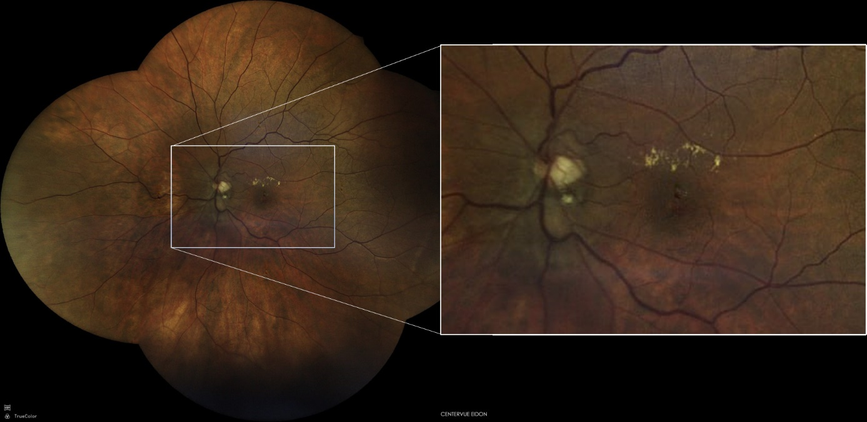
Figure 2: Late-phase fluorescein angiography (FA) demonstrating a focal "light-bulb" hyperfluorescent lesion in the superior juxtafoveal region with minimal leakage (blue arrow). This pattern lacks the classic "lacy" appearance of mCNV.
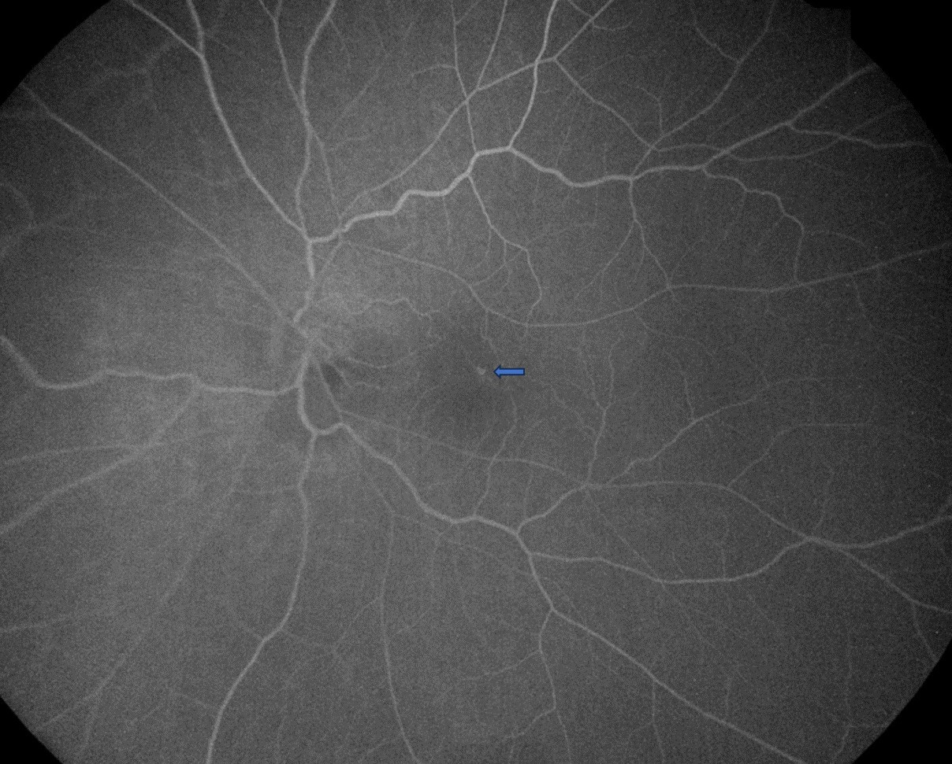

Figure 3: Structural SD-OCT B-scan through the lesion revealing a large (196 µm) intraretinal aneurysmal dilation located within the outer plexiform layer (OPL), situated 569 µm from the foveola. The complex exhibits the pathognomonic triad: a hyperreflective wall, a hyporeflective lumen, and distinct posterior shadowing. Note the surrounding intraretinal cystic spaces and the absence of subretinal fluid or sub-RPE hyperreflective material, distinguishing this from mCNV.
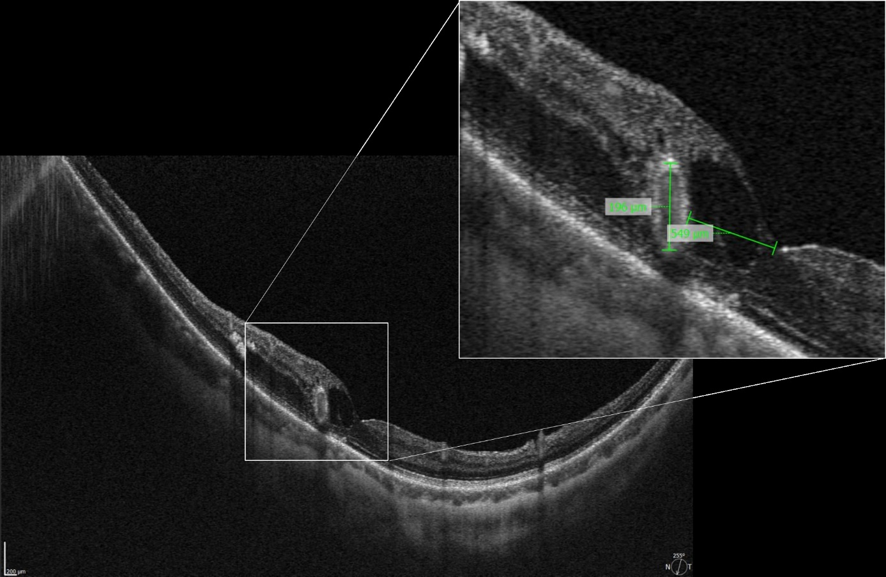

Figure 4: Structural SD-OCT scan through the PEVAC lesion and the optic disc demonstrating an intrachoroidal cavitation (ICCR) (blue asterisk). It appears as a characteristic peripapillary, hyporeflective, "lacuna-like" void located beneath the intact retinal pigment epithelium (RPE) and anterior to the posteriorly outbowing sclera. This finding highlights the focal peripapillary scleral-choroidal dissociation occurring in this highly myopic eye.
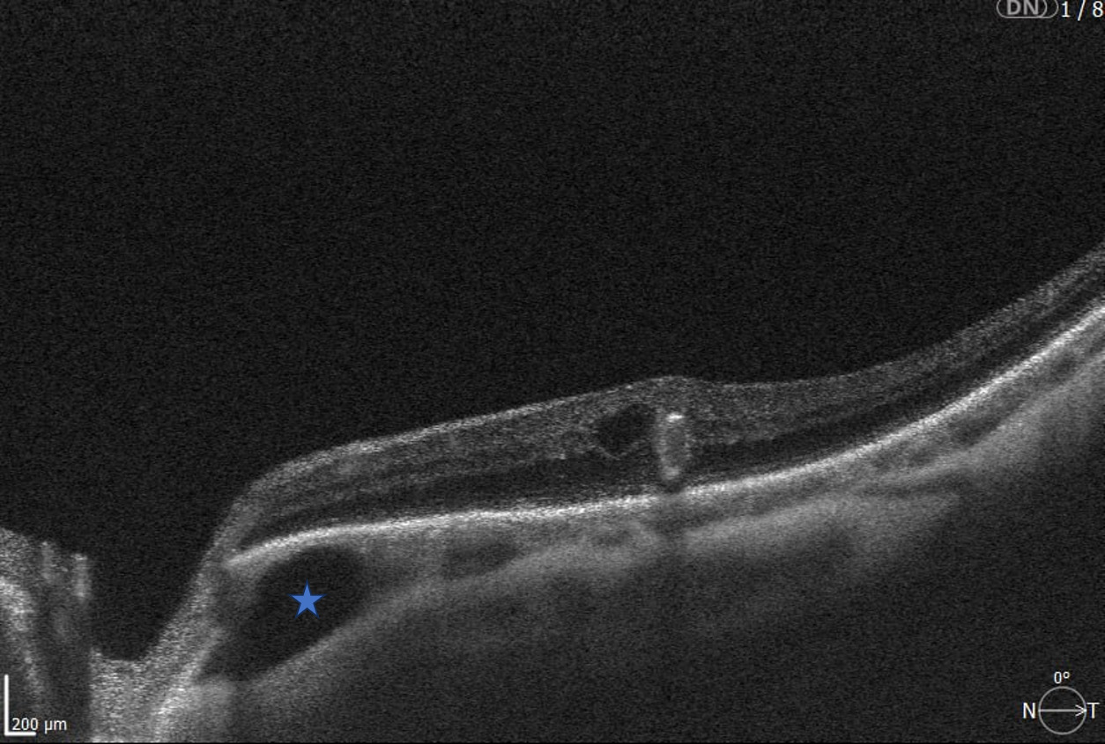

Figure 5: Multimodal OCT-Angiography (OCT-A) Analysis. (A) En face OCT-A slab of the superficial capillary plexus (SCP) showing normal vascular architecture. (B) En face slab of the deep capillary plexus (DCP) revealing a prominent, well-defined high-flow aneurysmal complex (red arrow). (C) Cross-sectional B-scan with flow overlay (colored OCT-A), demonstrating that the high-flow signal is localized strictly within the intraretinal layers (DCP), corresponding to the PEVAC lesion. The absence of flow beneath the retinal pigment epithelium (RPE) in this cross-section confirms the lack of a choroidal neovascular component, providing the definitive differentiation from mCNV.
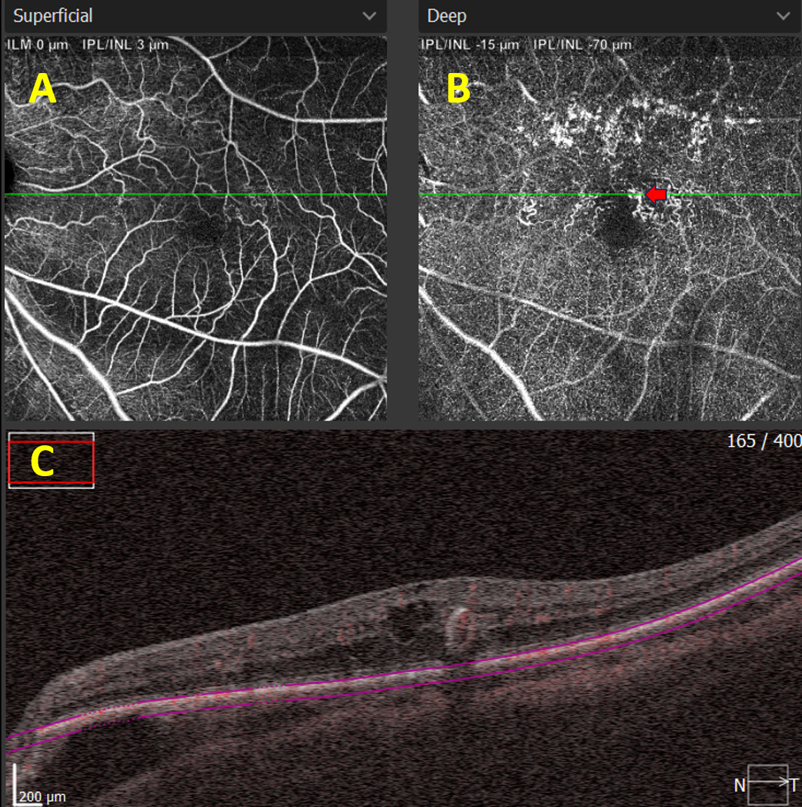
Figure 6: Post-treatment outcomes 6 months after image-guided focal laser. (Left) Color fundus retinography demonstrating the complete resorption of the superior circinate lipid exudates. (Right) Structural SD-OCT B-scan showing the complete resolution of the intraretinal cystic spaces and the visible collapse of the aneurysmal complex.
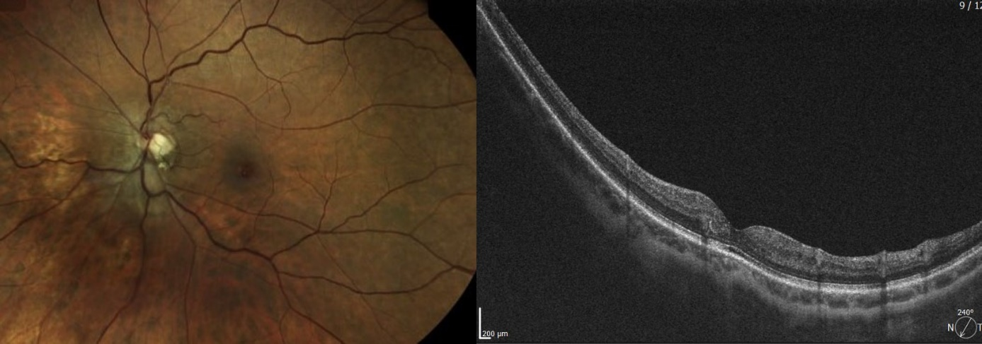
Abbreviations:
AL: Axial length
BCVA: Best-corrected visual acuity
D: Diopters
DCP: Deep capillary plexus
FA: Fluorescein angiography
ICCR: Peripapillary intrachoroidal cavitation
LE: Left eye
mCNV: Myopic choroidal neovascularization
OCT: Optical coherence tomography
OCT-A: Optical coherence tomography angiography
OPL: Outer plexiform layer
PED: Pigment epithelial detachment
PEVAC: Perifoveal exudative vascular anomalous complex
RE: Right eye
RPE: Retinal pigment epithelium
SCP: Superficial capillary plexus
SD-OCT: Spectral-domain optical coherence tomography
VEGF: Vascular endothelial growth factor

Disclaimer (Artificial intelligence)

Author(s) hereby declare that NO generative AI technologies such as Large Language Models (ChatGPT, COPILOT, etc.) and text-to-image generators have been used during the writing or editing of this manuscript.

Acknowledgements
The authors would like to thank the Ophthalmology Department of the Avicenne Military Hospital for the institutional support and the advanced imaging infrastructure provided for the documentation of this case. The authors also wish to express their sincere gratitude to Dr. Mohamed Bennani, a renowned medical retina specialist, for his kind contribution and technical expertise in the performance of the Navilas® laser treatment.
Authors’ Contributions
EHAL: Conceptualization of the case report; primary clinician involved in the diagnosis and management; performed the navigated laser treatment; drafted and revised the manuscript.
SA: Contributed to the specialized interpretation of multimodal imaging; provided critical intellectual content and clinical expertise in the management of high myopia complications.
IE: Conducted the literature review; assisted in the initial drafting of the case presentation and clinical history.
FB: Acquisition and analysis of structural OCT and OCT-Angiography data; prepared the high-resolution imaging plates.
SB: Provided a critical review of the diagnostic steps and supervised the medical record documentation.
FEA: Senior supervision and validation of the clinical approach; provided final approval of the manuscript version for publication.
All authors have read and approved the final version of this manuscript.
Consent
The patient has provided written informed consent for the publication of this case report and accompanying images.
Ethical approval
All authors hereby declare that all experiments have been examined and approved by the appropriate ethics committee and have therefore been performed in accordance with the ethical standards laid down in the 1964 Declaration of Helsinki.
References:
1. Querques G, Kuhn D, Massamba N, Leveziel N, Querques L, et al. Perifoveal exudative vascular anomalous complex. J Fr Ophtalmol. 2011;34:559.e1-4.
2. Sacconi R, Freund KB, Yannuzzi LA, Dolz-Marco R, Souied E, et al. The Expanded Spectrum of Perifoveal Exudative Vascular Anomalous Complex. Am J Ophthalmol. 2017;184:115-125.
3. Venkatesh R, Yadav NK, Bavaharan B, Prabhu V, Sinha S. Multimodal imaging in perifoveal exudative vascular anomalous complex. Indian J Ophthalmol. 2019.
4. Forte P, Paques M, Cattaneo J, Dupas B, Castro-Farias D, et al. Perifoveal vascular anomalous complex and telangiectatic capillaries: An overview of two entities potentially sharing a common pathophysiology. Surv Ophthalmol. 2025;70:369-379.
5. Sacconi R, Borrelli E, Bandello F, Querques G. Perifoveal exudative vascular anomalous complex in a highly myopic eye. Eur J Ophthalmol. 2020.
6. Mrejen S, Le HM, Nghiem-Buffet S, Tabary S, Quentel G, et al. Insights into perifoveal exudative vascular anomalous complex. Retina. 2020;40:80-86.
7. Chen Q, Wang BJ, Gao YZ, Wu X, Zhang M. Management of perifoveal exudative vascular anomalous complex with laser treatment: a case report. Int J Ophthalmol. 2025;18:965-968.
8. Arruabarrena C, Liaño G, Hernáez-Leonato JM, Martínez-Sánchez M, Cañas-Martín J, et al. Selective focal laser therapy as the primary treatment for exudative perifoveal vascular anomalous complex (ePVAC): case series and literature review. Ophthalmic Surg Lasers Imaging Retina. 2023;54:43-49.
9. Remolí-Sargues L, Montero-Hernández J, Monferrer Adsuara C, Castro Navarro V, Cervera-Taulet E. Perifoveal exudative vascular anomalous complex treated with navigated retina laser. J Fr Ophtalmol. 2022;45:e9-e11.
10. Savastano MC, Fossataro C, Gravina G, Coccimiglio F, Rizzo C, et al. Management of perifoveal exudative vascular anomalous complex. Retin Cases Brief Rep. 2025;19:714-720.
11. Ehongo A, Bacq N. Peripapillary Intrachoroidal Cavitation. J Clin Med. 2023;12:4712.
12. Dupas B, Castro-Farias D, Girmens JF, Eginay A, Couturier A, et al. Photocoagulation or sham laser in addition to conventional anti-VEGF therapy in macular edema associated with TelCaps due to diabetic macular edema or retinal vein occlusion (TalaDME): a study protocol for a multicentric, French, two-group, non-commercial, active-control, observer-masked, non-inferiority, randomized controlled clinical trial. Trials. 2024;25:273.

