Preventable Pulmonary Embolism Post-TKR: A Case Study Highlighting the Need for Pharmacist-Led Discharge Counseling on NSAID-Anticoagulant Interactions

.
ABSTRACT

Background and Aim: VTE is a serious risk after knee replacement surgery. Poor pain management and unsupervised NSAID use may lead patients to skip anticoagulants, increasing clot risk. This case study explores the consequences of unsupervised consumption of over-the-counter (OTC) medications in a patient following total knee replacement (TKR). It specifically focuses on how interruption of prescribed thromboprophylaxis contributed to the development of venous thromboembolism (VTE).
Presentation of Case: A 67-year-old woman with a history of type 2 diabetes mellitus and hypertension underwent an elective right total knee replacement procedure. After discharge, she was prescribed oral apixaban (2.5 mg twice daily) as part of her thromboprophylaxis regimen. To manage postoperative pain, the patient independently consumed multiple doses of diclofenac obtained over the counter. She experienced epigastric discomfort, dizziness, and mild bleeding from the surgical site. Concerned about these symptoms, she missed scheduled doses of apixaban and significantly reduced her level of physical activity. Within three days, she was presented with calf swelling, tachycardia, and decreased oxygen saturation, with diagnostics confirming right popliteal deep vein thrombosis (DVT) and segmental pulmonary embolism (PE).

Discussion: This case highlights the risks associated with unsupervised OTC medication use. Diclofenac, when taken together with anticoagulant therapy, can increase the possibility of bleeding complications. The patient’s fear of bleeding led to non-adherence to anticoagulant therapy, while reduced mobility further increased the likelihood of thrombus formation. Together, these factors created a clinical situation that facilitated the development of VTE.

Conclusion: This case emphasizes that uncontrolled use of OTC analgesics may lead to significant drug interactions. Effective patient education at discharge, proper medication review, and the involvement of clinical pharmacists are important measures to reduce the risk of such complications.

Keywords: Total Knee Replacement; Venous Thromboembolism; Deep Vein Thrombosis; Pulmonary Embolism;
Over-the-counter NSAIDs; Medication Adherence; Drug-Drug Interactions; Clinical Pharmacist.

1. INTRODUCTION
Venous thromboembolism (VTE), which includes deep vein thrombosis (DVT) and pulmonary embolism (PE), is a serious complication that can occur after total knee replacement (TKR). The development of VTE is mainly related to Virchow’s triad, which includes endothelial injury, venous stasis, and a hyper-coagulable state. To reduce this risk, clinical guidelines recommend the use of pharmacological thromboprophylaxis along with early mobilization after surgery.
However, the success of these preventive measures depends largely on patient adherence to treatment. Postoperative pain may lead some patients to use OTC analgesics without medical advice. Non-steroidal anti-inflammatory drugs (NSAIDs) such as diclofenac or ibuprofen are commonly used for pain relief, but they may cause gastrointestinal irritation and increase the risk of bleeding, particularly when taken with anticoagulant therapy. Because of these effects, some patients may stop or skip their anticoagulant medication, which can create a temporary pro-thrombotic state during recovery. Pain management outside the hospital is therefore an important but often overlooked factor in postoperative care.
2. Presentation of Case
A 67-year-old woman was admitted to the orthopedic department for elective right total knee replacement due to advanced osteoarthritis. She had a history of progressive knee pain, stiffness, and limited mobility for nearly nine years. Her medical history included type 2 diabetes mellitus for twelve years and hypertension for ten years. She was taking metformin 500 mg twice daily, glimepiride 2 mg once daily, amlodipine 5 mg once daily, telmisartan 40 mg once daily.
The patient underwent right total knee replacement under spinal anesthesia. According to hospital protocol, pharmacological thromboprophylaxis with low-molecular-weight heparin was started after surgery. Before discharge, she was advised to continue oral anticoagulant therapy and encouraged to begin early mobilization and physiotherapy.
Two days after discharge, the patient experienced severe pain and swelling at the operated knee. Without consulting her physician, she took diclofenac, an OTC NSAID, for pain relief while continuing the anticoagulant medication. Within 24 hours, she developed epigastric discomfort, dizziness, and mild oozing from the surgical wound. Because she was worried about bleeding, she skipped one dose of her anticoagulant and significantly reduced her physical activity.
Three days later, she presented to the emergency department with increasing pain and swelling of the operated leg, along with calf tenderness, shortness of breath, and mild chest discomfort.
On examination, the right calf was swollen and tender. Her heart rate was 110 beats per minute and oxygen saturation on room air was 89%. Laboratory investigations showed elevated D-dimer levels. Doppler ultrasonography confirmed acute thrombosis in the right popliteal vein, and computed tomography pulmonary angiography revealed segmental pulmonary embolism.
A diagnosis of concurrent DVT and PE following total knee replacement was made. The patient was immediately treated with therapeutic low-molecular-weight heparin, oxygen therapy, and supportive care. Oral anticoagulant therapy was restarted under close monitoring. Diclofenac was discontinued and paracetamol was prescribed for pain management.
The patient was counseled regarding strict adherence to anticoagulant therapy, avoidance of self-medications particularly NSAID and the importance of early mobilization and regular follow-up. Her condition gradually improved so she was discharged in stable condition.
3. discussion
Postoperative management following TKR requires a precise balance between pharmacological thromboprophylaxis and effective analgesia to facilitate early mobilization. This case highlights how the unsupervised use of OTC NSAIDs can compromise these clinical objectives, leading to severe thromboembolic complications.

The Impact of Unsupervised NSAID Use
NSAIDs are frequently utilized in orthopedic recovery to reduce opioid reliance but their use without medical oversight can be hazardous. In this patient, the self-administration of diclofenac induced gastrointestinal distress and surgical site oozing. Rather than acting as a direct mechanistic cause of thrombosis, these bleeding-related symptoms shifted the patient’s focus toward pain relief at the expense of anticoagulation. This led to the critical interruption of apixaban therapy and a concurrent reduction in physical activity.

Synergistic Risks and Patient Perception
The combination of NSAIDs and anticoagulants significantly elevates hemorrhage risks through synergistic effects on the coagulation cascade and platelet function. Diclofenac inhibits cyclo-oxygenase (COX-1), reducing thromboxane A2 synthesis and platelet aggregation. When coupled with Factor Xa inhibition, the risk of hospital-diagnosed bleeding doubles (Hazard Ratio 2.09). Recent 2024–2025 registry data indicates that diclofenac specifically carries a high adjusted hazard ratio of 3.30. Furthermore, these risks extend beyond the gastrointestinal tract to include respiratory and intracranial sites, aligning with the systemic symptoms observed in this case.

The Role of Mobilization and Adherence
Early mobilization is essential for maintaining venous circulation and preventing stasis. When patients experience unexpected side effects like wound oozing, they may perceive anticoagulants as "non-essential" or dangerous, leading to therapy cessation. In this instance, the simultaneous interruption of medication and decreased movement created a pro-thrombotic environment, facilitating the development of DVT which subsequently progressed to PE.

Clinical Implications and the Pharmacist's Role
This case underscores the necessity of integrated clinical pharmacist services (CPS). Research indicates that pharmacist involvement as a core multidisciplinary team member can improve physician compliance with VTE guidelines by up to 25% and reduce the incidence of VTE events from 17% to 9%. Furthermore, pharmacist-led monitoring can reduce major bleeding events by half through rigorous medication reviews and structured discharge counseling.
4.CONCLUSION
Current guidelines (ACCP) recommend avoiding systemic NSAIDs in patients receiving anticoagulants and using safer alternatives whenever possible. If required, the lowest effective dose for a short duration should be chosen. Robust patient education is crucial to help patients distinguish between symptomatic relief and life-sustaining prophylactic therapy. Structured medication reviews and clinical pharmacist-led discharge counseling are the key to ensure strict adherence to anticoagulation and prevent the dangers of unsupervised self-medication. Implementing these collaborative strategies helps in reducing thromboembolic risks and improving safety outcomes in orthopedic surgery.
Consent
Written informed consent was obtained from the patient for the publication of this case report. A copy is available for review by the Editorial Office. The study was conducted in accordance with the principles outlined in the declaration of Helsinki, and patient confidentiality and anonymity were maintained throughout the documentation and reporting process.

Disclaimer (Artificial intelligence)
Author(s) hereby declare that NO generative AI technologies such as Large Language Models (ChatGPT, COPILOT, etc.) and text-to-image generators have been used during the writing or editing of this manuscript.

References
- Hilliard I, Stead TS, Banerjee A, Hua Y, Ganti L. Mind the clot: Predictors of pulmonary embolism after total knee arthroplasty- An analysis of 150,119 cases. Orthop Rev (Pavia). 2025;17:143769. doi:10.52965/001c.143769
- Galli M, Andreotti F, Capodanno D, et al. NSAID use and risk of bleeding in patients receiving antithrombotic therapy: a nationwide cohort study. Eur Heart J Qual Care Clin Outcomes. 2025;11(1):23-32. doi:10.1093/ehjqcco/qcaf076
- Petersen SR, Bonnesen K, Grove EL, Pedersen L, Schmidt M. Bleeding risk using non-steroidal anti-inflammatory drugs with anticoagulants after venous thromboembolism: a nationwide Danish study. Eur Heart J. 2024;45(44):4667-4677. doi:10.1093/eurheartj/ehae736
- Douketis JD, Spyropoulos AC. Perioperative management of patients taking direct oral anticoagulants: a review. JAMA. 2024;332(10):825-834. doi:10.1001/jama.2024.12708
- Anderson DR, Morgano GP, Bennett C, et al. American Society of Hematology 2019 guidelines for management of venous thromboembolism: prevention of VTE in surgical hospital patients. Blood Adv. 2019;3(23):3898-3944.
- Zhai Z, Kan Q, Li W, et al. VTE risk profiles and prophylaxis in medical and surgical inpatients: the identification of Chinese hospitalized patients' risk profile for venous thromboembolism (DissolVE-2)-a cross-sectional study. Chest. 2019;155(1):114-126. doi:10.1016/j.chest.2018.09.020
- Li Y, Wang H, Geng S, et al. Impact of clinical pharmacist services on physicians' guideline compliance and prognosis of patients for venous thromboembolism prophylaxis in ICU. Int J Clin Pharmacol Ther. 2017;55(7):589-596. doi:10.5414/CP202810
- Lanas A, Chan FKL. Peptic ulcer disease. The Lancet. 2017;390(10094):613-624.
- Encke A, Haas S, Kopp I. The Prophylaxis of Venous Thromboembolism. Dtsch Arztebl Int. 2016;113(31-32):532-538. doi:10.3238/arztebl.2016.0532
- Moore N, Pollack C, Butkerait P. Adverse drug reactions and drug–drug interactions with over-the-counter NSAIDs. Ther Clin Risk Manag. 2015;11:1061-1075.
- Falck-Ytter Y, Francis CW, Johanson NA, et al. Prevention of VTE in orthopedic surgery patients: Antithrombotic Therapy and Prevention of Thrombosis, 9th ed: American College of Chest Physicians Evidence-Based Clinical Practice Guidelines. Chest. 2012;141(2 Suppl):e278S-e325S.
- Sostres C, Gargallo CJ, Arroyo MT, Lanas A. Adverse effects of non-steroidal anti-inflammatory drugs (NSAIDs, aspirin and coxibs) on upper gastrointestinal tract. Best Pract Res Clin Gastroenterol. 2010;24(2):121-132. doi:10.1016/j.bpg.2009.11.005
- Bhatt DL, Scheiman J, Abraham NS, et al. ACCF/ACG/AHA 2008 expert consensus document on reducing the gastrointestinal risks of antiplatelet therapy and NSAID use. J Am Coll Cardiol. 2008;52(18):1502-1517.
- Osterberg L, Blaschke T. Adherence to medication. N Engl J Med. 2005;353(5):487-497.
- Laporte JR, Ibañez L, Vidal X, et al. Upper gastrointestinal bleeding associated with the combined use of low-dose aspirin or anticoagulants with non-aspirin non-steroidal anti-inflammatory drugs. Drug Saf. 2004;27(6):411-420.
- Wells PS, Anderson DR, Rodger M, et al. Derivation of a simple clinical model to categorize patients probability of pulmonary embolism: increasing the models utility with the SimpliRED D-dimer. Thromb Haemost. 2000;83(3):416-420. doi:10.1055/s-0037-1613830

TABLES:

Table.1: Medication Timeline with Missed Doses Leading to Thromboembolic Event

Phase | Day | Time | Drug | Dose | Route | Status | Remarks
Post-TKR | Day 0 | 8 AM | Enoxaparin | 40 mg | SC | Given | Post-op prophylaxis
Post-TKR | Day 1 | 8 AM | Enoxaparin | 40 mg | SC | Given
Post-TKR | Day 2 | 8 AM | Enoxaparin | 40 mg | SC | Given
Post-TKR | Day 3 | 8 AM | Enoxaparin | 40 mg | SC | Given
Post-TKR | Day 4 | 8 AM | Enoxaparin | 40 mg | SC | Given
Routine | Daily | 8 AM | Metformin | 500 mg | PO | Given | DM
Routine | Daily | 8 AM | Glimepiride | 1 mg | PO | Given | DM
Routine | Daily | 9 AM | Amlodipine | 5 mg | PO | Given | HTN
Routine | Daily | 9 AM | Telmisartan | 40 mg | PO | Given | HTN
Home | Day 5 | 8 AM | Apixaban | 2.5 mg | PO | Given | Discharge Rx
Home | Day 5 | 8 PM | Apixaban | 2.5 mg | PO | Given
Home | Day 6 | 8 AM | Apixaban | 2.5 mg | PO | Missed | Fear of bleeding
Home | Day 6 | 9 AM | Diclofenac | 50 mg | PO | Self taken | OTC
Home | Day 6 | 3 PM | Diclofenac | 50 mg | PO | Self taken
Home | Day 6 | 9 PM | Diclofenac | 50 mg | PO | Self taken
Home | Day 7 | - | Apixaban | 2.5 mg | PO | Not taken | Wound ooze
Home | Day 8 | - | Anticoagulant | - | - | Not taken | Immobilization
DVT/PE | Day 1 | 8 AM | Enoxaparin | 60 mg | SC | Given | Therapeutic dose
DVT/PE | Day 1 | 8 AM | Oxygen | 4 L/min | Inhalation | Given | SpO2 89%
DVT/PE | Day 1 | 9 AM | Pantoprazole | 40 mg | IV | Given | GI protection
DVT/PE | Day 1 | 10 AM | Paracetamol | 650 mg | PO | Given | Pain
DVT/PE | Day 1 | 8 PM | Enoxaparin | 60 mg | SC | Given
DVT/PE | Day 2-4 | 8 AM & 8 PM | Enoxaparin | 60 mg | SC | Given | BD
DVT/PE | Day 5 | 8 AM | Apixaban | 10 mg | PO | Given | Treatment dose
DVT/PE | Day 5 | 8 PM | Apixaban | 10 mg | PO | Given
DVT/PE | Day 6-11 | 8 AM & 8 PM | Apixaban | 10 mg | PO | Given | 7 days
DVT/PE | Day 12 onward | 8 AM & 8 PM | Apixaban | 5 mg | PO | Given | Maintenance

Figures:

Fig.1: Clinical Risk Transition Across Perioperative Anticoagulation Phases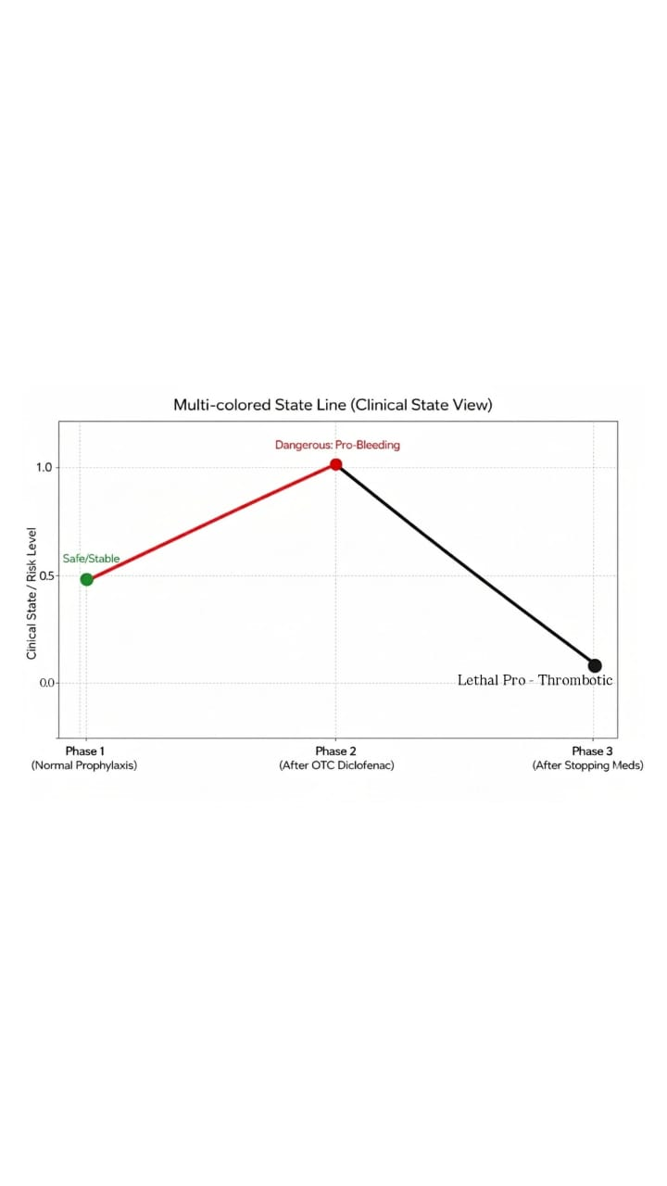

Fig.2: Clinical Presentation of Acute Pulmonary Embolism: Tachycardia and Hypoxemia Distribution
