Climate Change Trends and their Impact on Cropping Pattern in Cold Desert of India

ABSTRACT
Climate change is altering temperature, precipitation, and biodiversity, impacting water resources, food security, and livelihoods. India’s agriculture, especially in the Himalayan cold arid region of Leh and Kargil, faces short growing seasons, scarce water, and extreme conditions, forcing farmers to adapt to changing climate patterns. This investigation examines the impact of climate change on agricultural output within Leh, Ladakh, an area characterized by its frigid, arid plateau environment in northern India. Climate data were processed using CLIMPACT2 software, utilizing temperature and precipitation records from 1970 to 2022 obtained from the India Meteorological Department and local observation points. To evaluate climate trends, the investigators utilized nonparametric Mann-Kendall tests, including the Modified Mann-Kendall test, and Sen's slope estimator, to examine eleven separate climate indices. The authors found statistically significant increases in temperature, with minimum temperatures increasing more than maximum temperatures (+0.0169 °C/yr vs. +0.0162 °C/yr), decreasing frost days (on average, -0.457 days/yr), and increased GDD (>3.19 GDD units), which has increased the length of the frost-free period. Despite higher heat accumulation, growing season length (GSL) showed no significant increase, largely due to delayed snowmelt. Crop-area data (2001–2020) from the Ladakh Autonomous Hill Development Council (LAHDC) revealed declines in traditional barley and wheat cultivation but a 25–30 % expansion in high-value fruits and vegetables. Strong correlations (p < 0.01) were observed between accumulated heat (r = 0.82) and frost-free days (r = -0.78) and crop diversification. Focus-group interviews with farmers confirmed greenhouse production as a key adaptation strategy.
Keywords: Adaptation strategy, climate change, climate trends, growing season

INTRODUCTION
Climate change is changing global environment and affecting the communities that depend on them for sustenance. The increase in the average global temperature is shifting biodiversity by changing the distribution of species (Parmesan & Yohe, 2003), accelerating glacial melt (Kulkarni et al., 2007)), and changing precipitation patterns (Sunil Kumar, 2018). These climate-related changes threaten the availability of water for human populations, food security, and regional economies. In evaluating the effect of climate change, temperature and precipitation are the two variables most often cited. Since global-scale climate change trends provide a general picture of climate change's impact, they must be supplemented with studies conducted at a regional scale to design and implement appropriate adaptation strategies for vulnerable populations (Kripalani et al., 2003; Laepple & Huybers, 2014).

India has a wide variety of climates and is predominantly dependent on agriculture, which increases its susceptibility to the effects of climate change. Studies have shown temperature increases and changes in precipitation across much of the country (Kothawale & Rupa Kumar, 2005 and Dash et al., 2007). The Himalayan region, India’s most geologically active zone, is warming at rates comparable to the global average (Archer & Fowler, 2004; Bhutiyani et al., 2007) and experiencing marked reductions in snowfall (Basistha et al., 2009). This region of the country, which has a cold arid climate and consists of approximately 7.1 million hectares of land, is primarily located within Ladakh, Lahaul-Spiti, and northern Uttarakhand. Nearly 87.4% of the area in the cold arid region is comprised of Leh and Kargil districts. Despite being between 2,900 and 5,900 meters above sea level, this region has winter temperatures below freezing point (-30 degrees Celsius), intense solar radiation, strong winds, and large diurnal temperature swings.
Leh, Ladakh's agriculture faces many obstacles viz., short growing seasons, poor soil and very little water. The average annual precipitation is less than 50 millimetres; predominantly as snow. Farmers are adjusting to this by trying to grow more high elevation Apples, vegetables, etc. However, they are also encountering additional challenges (increased temperatures, changing precipitation patterns, and water). Thus, it is important that resource-poor communities implement resource-specific strategies. This study therefore analysed climatic trends in Leh and their influence on cropping systems in this cold-arid environment.
MATERIALS AND METHODS

Study area
Ladakh a union territory in the Indian Himalayas lies at a high altitude between Tethyan and High Himalayas to its south and the Karakoram range to its north and includes both districts of Leh and Kargil (Fig. 1). In this study, we focus on Leh (34.5 ⁰N, 77.5 ⁰E, 4617 m asl) which has been classified as a cold arid desert because of its rugged topography, very low precipitation, and high elevation (2900-5900 m AMSL). It is hyper arid and receives very little rainfall (less than 100 mm), and almost all precipitation occurs during the winter as snow. This snow is used as the major water source for irrigation (Mayewski et al., 1980). In addition to receiving very little precipitation, temperature ranges from -15 degrees Celsius in winter to +25 degrees Celsius in summer with diurnal variation often exceeding 20 degrees Celsius (Chevuturi et al., 2018). There too the winds are very strong (5-10 m/s), solar radiation is intense (up to 1000 W/m²), and evapotranspiration rates are high which causes erosion and loss of soil moisture leading to reduced productivity of agriculture (Joshi et al., 2018). This area has extremely little natural vegetation and is above the tree line, the only natural vegetation present consists of xerophytic shrubs and grasses such as Caragana versicolor and Artemisia spp.

The core of subsistence-based agriculture is a brief frost-free growing season ranging from 90 to 120 days and irrigation channels fed by snowmelt, referred as locally as zings (Kaur & Kalra, 2016). Soils from sandy and gravelly loams on alluvial fans to sandy and silty clay loams on the plains of the Indus River are characterised by low fertility and low organic matter (0.5–1%) (Meena et al., 2023). Frost weathering and glacial retreat shape the geomorphology, causing sediment deposition and recurrent river blockages. Agricultural productivity is significantly influenced by temperature thresholds during the short cropping period, irrigation availability and snowmelt. Table 1 summarises the agricultural and demographic profile of Leh.
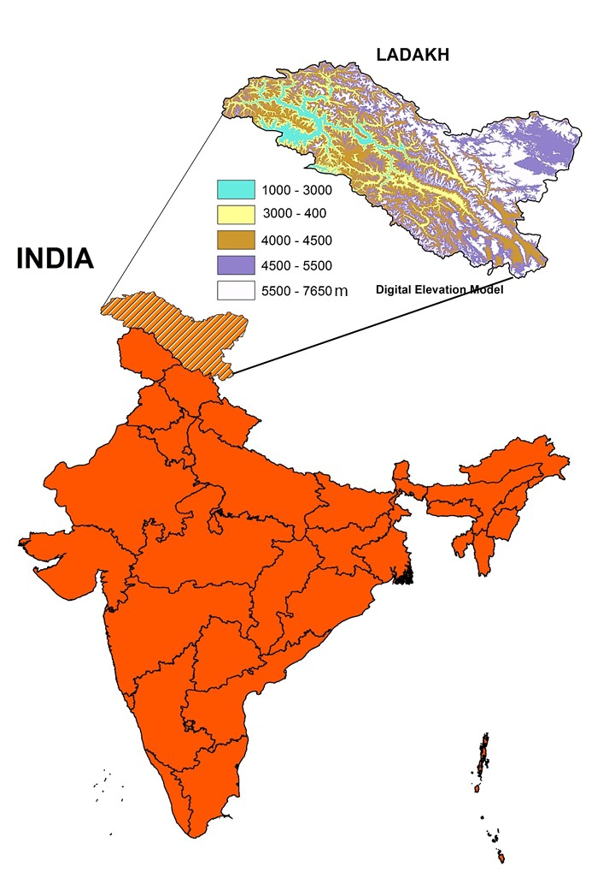
Fig. 1. Location of the study area
Table 1: Agricultural and Demographic Profile of Leh, Ladakh
Particular | Area/Detail | Details
Total geographical area | 45,110 km²
Altitude | 2,900–5,900 m
Blocks | 16
Villages | 113
Population | 133,487 | Male (59%), Female (41%)
Literacy rate | 77.2%
Area under forest | 29 km² | Willow, Poplar, Seabuckthorn
Total cropped area | 10,223 ha | Wheat (24%), barley (36%), pulses (1.2%), vegetables (6.2%), oilseeds (0.7%), fodder (22%)
Gross area irrigated | 10,223 ha | Snowmelt-fed irrigation channels (zings)

Climatological Data and Climate Indices
Daily gridded data at a spatial resolution of 1° × 1° for maximum, minimum temperature as well as precipitation from 1970 to 2022 were obtained from India Meteorological Department (IMD) which is suitable for mountainous area with sparse data. To ensure its accuracy in high-altitude settings with complicated topography, these datasets were augmented by station-based observations from Leh's IMD weather station. These datasets were subjected to stringent quality control by the use of normal meteorological procedures, which also includes checks for missing values, outliers and temporal consistency (Alexander & Herold, 2016). Later, RHtestsV4 program was used to evaluate homogeneity to detect and address potential breakpoints that might cause by station relocations or instrumentation adjustments.
CLIMPACT2, which is a software program created by the Expert Team on Climate Change Detection and indicators (ET-SCI) of the World Meteorological Organization, was used to calculate climate indicators (Alexander & Herold, 2016). Eleven temperature-related factors which is relevant to agricultural productivity were selected to evaluate extreme climate occurrences and variability in growing season (Table 2). Frost Days (FD, days with TN < 0°C), Summer Days (SU, days with TX > 25°C), Growing Degree Days (GDD), Growing Season Length (GSL), Warm Spell Duration Index (WSDI), and Cold Spell Duration Index (CSDI) were among them. GDD, was calculated (with a base temperature of 5°C) for crops such as wheat and barley in cold-arid regions (Bhat, 1981). After accounting for elevation-specific temperature regimes, GSL was defined as the interval between the last spring frost (TN < 0°C) and the first fall frost (Yue & Hashino, 2003). Data was aggregated at the district level for spatial consistency.
Table 2: Climate Indices
Indices Name | Long Indices | Definition | Units
TXm | Mean TX | Mean daily maximum temperature | °C
TNm | Mean TN | Mean daily minimum temperature | °C
DTR | Daily temperature range | Mean difference between daily TX and TN | °C
FD | Frost days | Number of days when TN < 0°C | Days
TNtm2 | Daily mean temperature < -2°C | Number of days when TN < -2°C | Days
CSDI | Cold spell duration index | Number of days contributing to cold period (≥6 consecutive days with TN < 10th percentile) | Days
WSDI | Warm spell duration index | Number of days contributing to a warm period (≥6 consecutive days with TX > 90th percentile) | Days
Tmge5 | Daily mean temperature ≥ 5°C | Number of days when TM ≥ 5°C | Days
SU | Summer days | Number of days when TX > 25°C | Days
GDD | Growing degree days | Heat accumulation above 5°C for plant growth | Degree days
GSL | Growing season length | Period between last spring frost and first autumn frost | Days

Trend Detection Method
Two non-parametric statistical techniques such as Mann–Kendall (MK) test and the Sequential Mann–Kendall (SQMK) test were used to examine long-term trends in climate indices and temperature data. These techniques were used for their ability to handle missing data and non-normal distributions, both of which are common in climatic time series. Sen's slope estimator was then used to measure the magnitude of trends and the Modified Mann–Kendall (MMK) test was used to addressed autocorrelation. R software (version 4.2.3) was employed for all studies, utilising the "trend" and "modifiedmk" packages.
The test statistic S is calculated as:

$S=\sum_{i=1}^{n-1}{\sum_{j=i+1}^{n}{sgn(x_{j}}}-x_{i }$) $where, sgn(x_{j}-x_{i})=\left\{\begin{aligned}+1(x_{j}-x_{i})>0 \\ 0{(x}_{j}-x_{i)}=0 \\ -1(x_{j}-x_{i})<0\end{aligned}\right.$

A standardised Z-value is used to examine the statistical significance of the trend at a 95% confidence level.
Autocorrelation in the time series was taken into consideration using the Modified Mann-Kendall (MMK) test, developed by Hamed and Rao (1998) as Mann-Kendall (MK) test assumes independence among observations. The variance of the MK statistic in the MMK test is modified using the Effective Sample Size (ESS), which accounts for lag-1 autocorrelation in the time series. Since serial correlation is a common feature in climate datasets, this correction reduces the likelihood of incorrectly detecting a significant trend.
Sen's slope estimator was used to calculate the trend's size (Sen, 1968) which is the median of all potential pairwise slopes between time-series data points:
$Q_{i}=\frac{x_{j}-x_{k}}{j-k}$ for all j>k

This method provides a robust estimate of the rate of change in temperature or climate indices.
The Sequential Mann–Kendall (SQMK) test (Sneyers, 1990) was used to detect the onset of statistically significant trends in climate indices. It computes a forward sequence u(t) and a backward sequence u′(t) from the original and reversed time series, respectively. The test statistic t is the cumulative sum of preceding ranks
$$t=\sum_{i=1}^{n}{n_{i}}$$
This is standardized as
$$u\left(t\right)=\frac{t-E(t)}{\sqrt{Var(t)}}$$

Where E(t) and Var(t) are the expected value and variance of t, computed using standard formulas:
$$E\left(t\right)= \frac{n\left(n-1\right)}{4}, Var\left(t\right)= \frac{n(n-1)(2n+5)}{72}$$

When u(t) exceeds the ±1.96 threshold, then the trend is deemed significant. The crucial turning point is located where u(t) and u't overlap (Gupta and Mishra, 2022). This method was used to determine when temperature trends (TXm, TNm) and indicators (GDD, FD) started to show statistically significant changes in the climate.

When combined, these methods ensure accurate trend identification while accounting for autocorrelation, non-normality, and temporal change points. As a result, the effects of climate trends on cropping patterns in Leh, Ladakh, are thoroughly examined.

Crop Pattern Change Analysis
The sources from which crop-wise area data was gathered during 2001 and 2020 includes The Ladakh Autonomous Hill Development Council (LAHDC) Statistical Handbook, the Office of the Financial Commissioner (Jammu & Kashmir), and the Deputy Commissioner's Office (Leh district). The main crops covered by these datasets are the following-Barley, wheat, pulses (like rajma), oilseeds (like mustard), vegetables (like carrots and cabbages), fruits (like apples) and fodder (like alfalfa). Data were cross-checked with agricultural census reports to check the accuracy and consistency, and if required any gaps were filled up by interpolating missing years (LAHDC, 2021).
Data compilation and analysis were done using MS Excel (version 16.65) to assess the long-term trends along with inter-annual variability. Visualisation was made by using line graphs and percentage change computations for crop area allocation trends. Correlation analyses (Pearson's r) were used to examine the relationships between climate indices (like FD and GDD) as well as changes in crop area and significance was tested at p < 0.05. Furthermore, any links between warming trends and modifications in cropping patterns were assessed by qualitatively interpreting these trends and the results of the climate index. Thirty farmers from five villages namely Leh, Chuchot, Phyang, Stok, and Saboo took part in focus groups in 2022 to record local adaptation tactics, such as moving to greenhouse-based vegetable production and validate quantitative results (Gaur et al., 2024a). These discussions followed a semi-structured format, ensuring representation of diverse farm sizes and gender perspectives.

RESULTS

General Warming Trends and Monthly Variability

Since 1970 major changes have been observed in average annual maximum (20.52°C) and minimum temperatures (7.77°C) in Leh. Summer averages as high as 26.41°C (TXm) and 13.83°C (TNm) and winter lows of 14.60°C and 2.69°C. There was statistically significant warming during February (Z = 3.26, p < 0.01), March (Z = 2.65, p < 0.01), and August (Z = 3.41, p < 0.001), indicating that increasing temperatures were accelerating at the end of winter and through the transition to the summer monsoon. These trends mirror the general pattern of warm weather seen throughout much of the northwestern Himalaya, where there have been reports of a delayed onset of winter and an earlier arrival of spring (Bhutiyani et al., 2015). The Sequential Mann-Kendall (SQMK) test methodology showed statistically significant trends of warming for TNm (+0.0169°C/year, p <0.001) and TXm (+0.0162°C/year, p =0.003), with warming trends becoming detectable around the years 1990 and 2000 respectively (Fig. 3(a), 3(b) and fig.2(a), 2(b).
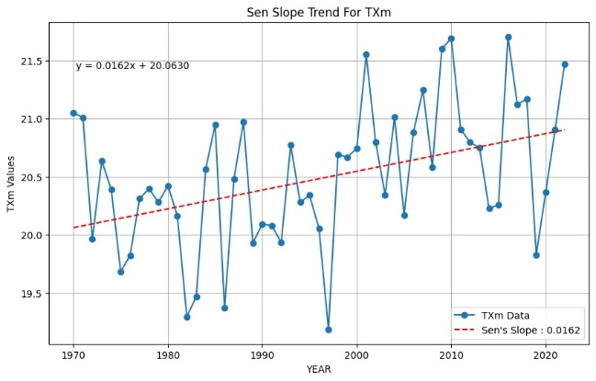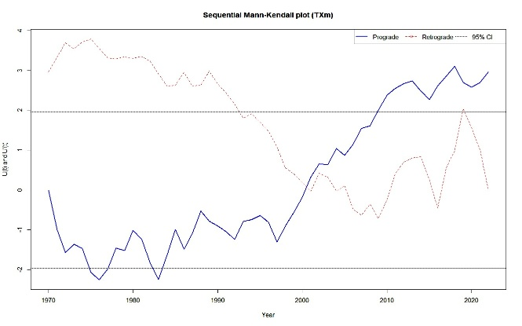
Fig.2(a): Linear trend of Sen slope of Mean Maximum Temperature (TXm) from 1970 to 2022; Fig.2(b): Sequential Mann- Kendall plot indicating change point
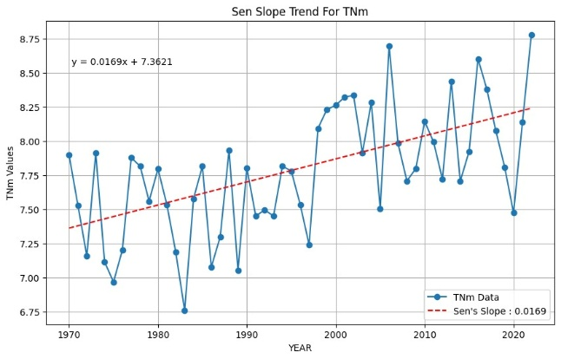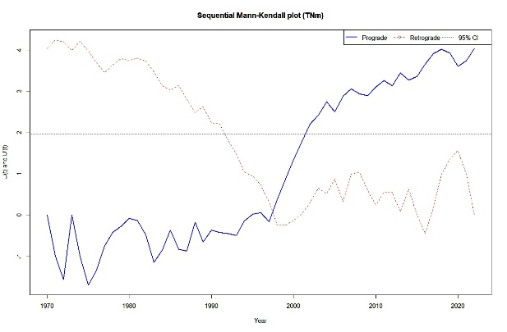
Fig.3(a): Linear trend of Sen slope of Mean Minimum Temperature (TNm) from 1970 to 2022; Fig.3(b): Sequential Mann- Kendahl plot indicating change point
The trend of asymmetric warming described in this paper has significant implications for agriculture. Consistent with the work of Hatfield & Prueger (2015), our study suggests that global warming will result in a greater rate of increase in TNm, relative to TXm, over the course of the twenty-first century due to the influence of reduced snow cover on heat retention and, therefore, accelerated freezing and melting of ice and snow (Sigdel et al., 2022; Jinxia et al., 2024). In addition, our findings support previous studies that have shown how elevated snowmelt (Bilal et al., 2024) and retreating glaciers (Rashid et al., 2020) will pose a significant threat to water resources that are essential for agriculture in this arid region where agriculture is primarily dependent on two sources of irrigation: snowmelt and glacial meltwater. These continuing changes in seasonal warming will also significantly impact irrigation and agriculture in other mountainous regions worldwide, such as the Upper Indus basin (Archer & Fowler, 2004), the Swiss Alps (Beniston, 1997), and Nagaoka, Japan (Yue & Hashino, 2003).

Diurnal Temperature Range (DTR)
A small but non-significant yearly decrease (-0.0017°C per year) in Diurnal Temperature Range has occurred mostly because of an increase in overnight temperature increases as shown in Fig. 4(a). This result is likely due to a higher amount of atmospheric moisture and increased daytime cloud cover which inhibit the rate of thermal energy loss during the night due to radiation (Mall et al., 2020; Yadav et al., 2021). Uneven warming impact is seen by month specifically through vegetation health and soil moisture retention as DTR is reduced. Consequently, decline in DTR can potentially exacerbate land degradation as night time temperatures remain elevated, further limiting the capacity of arid lands to maintain its soil moisture through the cooler night time period (Lobell et al., 2007). It is also possible that microclimatic means and mechanisms will be responsible for altering the growing environment for certain traditional crops such as barley that are sensitive to fluctuations in temperature.
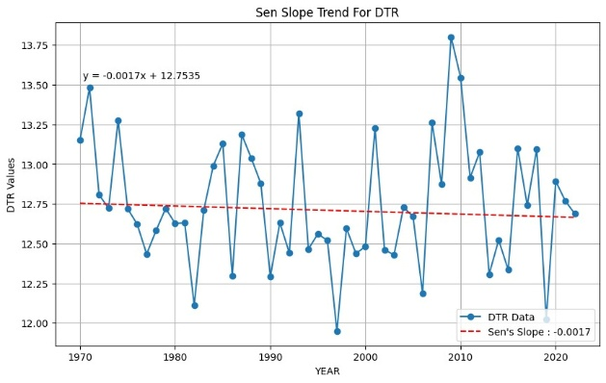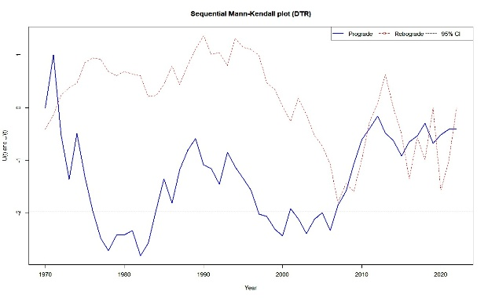
Fig. 4(a): Linear trend of Sen slope of Daily Temperature Range (DTR) from 1970 to 2022
Fig. 4(b): Sequential Mann- Kendahl plot indicating change point

Heat Accumulation and Warm Extremes

The heat accumulation indicators all show strong increases over time. For example, the number of summer days (SU) has increased by +0.333 days per year (p=0.005), the Warm Spell Duration Index (WSDI) has also increased at +0.181 days/year (p=0.031), the number of days with temperatures above 5 degrees (TMge5) has increased to +0.322 days/year (p=0.007), and Growing Degree Days (GDD) have increased by +3.19 units/year (p=0.005), as illustrated in Fig. 5(a), Fig. 6(a), Fig. 7(a), Fig. 8(a). SQMK analysis shows that there have been substantial shifts since approximately 1985 for GDD fig. 8(b) and 2005 for TMge5 fig. 7(b), which represent longer thermal growing seasons and more frequent heat events. These results are consistent with recent studies in the Gandaki region of Nepal (Shrestha et al., 2024) and the Western Himalayas (Sharma et al., 2023), where warming winters and an earlier spring have increased heat accumulation.

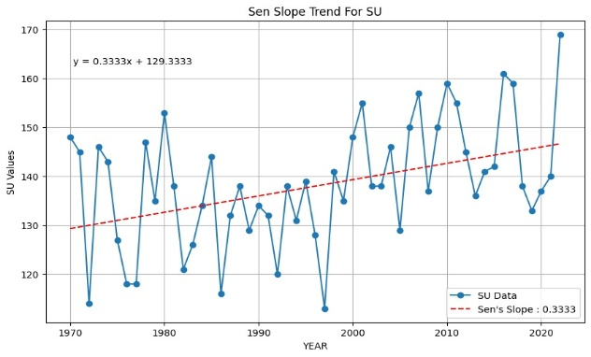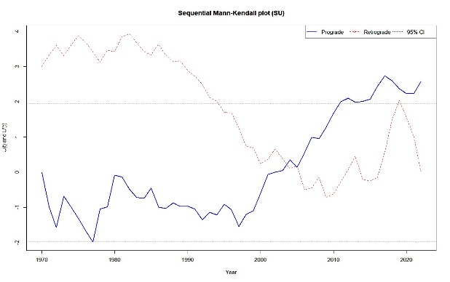
Fig. 5(a): Linear trend of Sen slope of Number of Summer Days (SU)from 1970 to 2022
Fig. 5(b): Sequential Mann Kendahl plot indicating change point
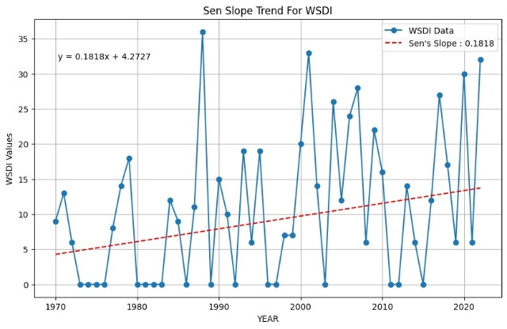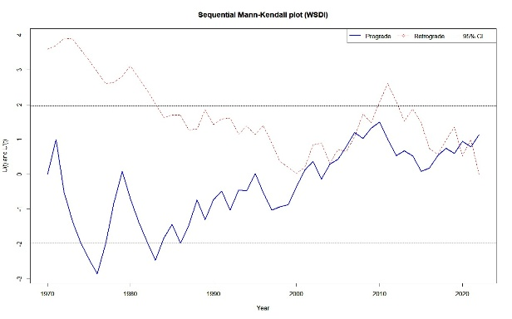
Fig. 6(a): Linear trend of Sen slope of Warm spell duration index (WSDI) from 1970 to 2022
Fig. 6(b): Sequential Mann Kendahl plot indicating change point

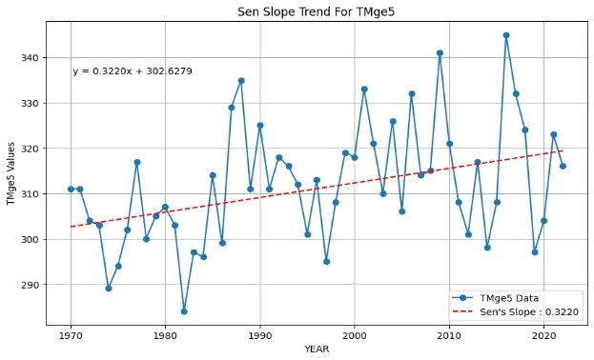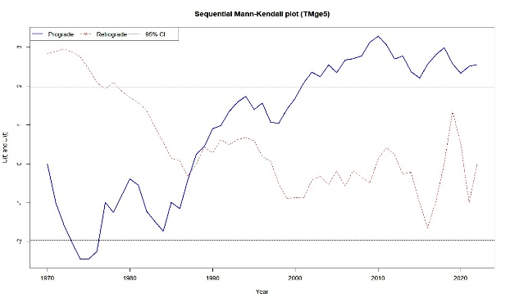
Fig. 7(a): Linear trend of Sen slope of Number of days when TM (daily mean temperature) ≥ 5 °C (TMge5) from 1970 to 2022
Fig. 7(b) Sequential Mann- Kendahl plot indicating change point

There is still concern about the increased heat-related risks brought on by prolonged warm spells to heat-sensitive crops like wheat, even though this increase in GDD and TMge5 offers the opportunity to diversify high-value crops like fruits and vegetables (particularly at higher elevations) (Zampieri et al. 2017). Increased in rates of evapotranspiration are additional impact of rising temperatures, which worsen already-existing water shortages in regions that need more water-efficient irrigation techniques (Kaur & Kalra 2016).
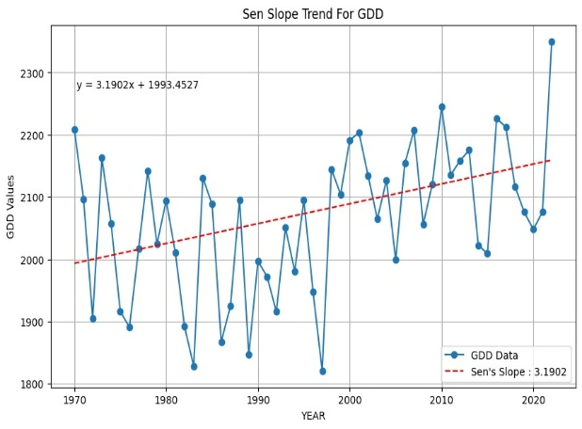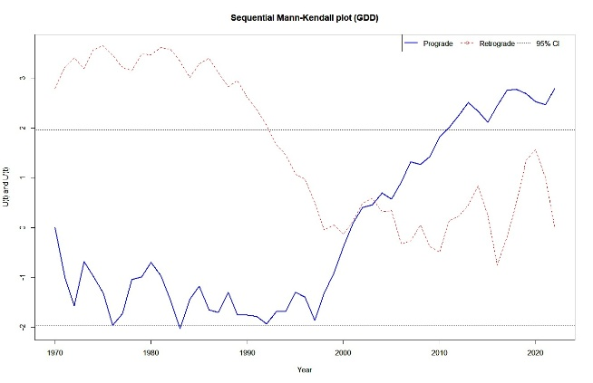
Fig. 8(a): Linear trend of Sen slope of Growing degree days (GDD) from 1970 to 2022
Fig. 8(b): Sequential Mann- Kendahl plot indicating change point

Cold Extremes

Estimations of the frequency of extreme cold events indicate a significant decline: Frost Days (FD) at a rate of –0.457 days/year (p < 0.000001), TN < –2°C, as TNltm2 by–0.315 days/year (p = 0.0025) and Cold Spell Duration Index (CSDI) by –0.277 days/year (p = 0.000013); respectively, Figs. 9a, 10a and 11a. SQMK analyses results suggest that these trends started after 1980 Figs. 9b, 10b and 11b are in line with reports of generally milder winters in the Central Karakoram Mountains and the Kashmir Himalaya (Yue & Hashino, 2003). Changes in Arctic Oscillation patterns are partly responsible for these decreases, as they have reduced the amount of cold air intrusions into southern Asia (Sharma et al., 2023). As a result, while the decrease in the number of frost days and the frost-free period may have a positive effect on crops such as vegetables, the reduction of chilling hours needed for producing temperate fruits (e.g., apples) could result in lower yields and quality of those crops (Luedeling, 2012).
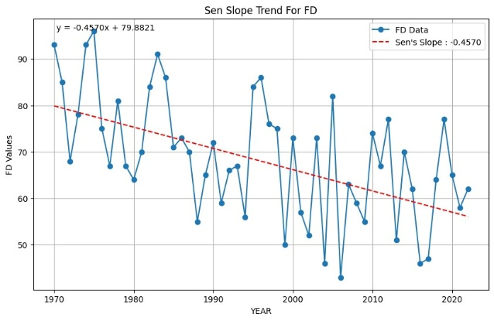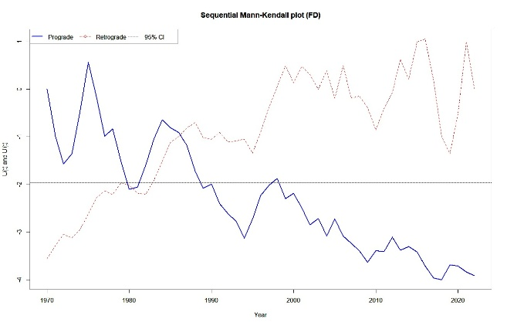
Fig. 9(a): Linear trend of Sen slope of Frost Days (FD) from 1970 to 2022
Fig. 9(b): Sequential Mann- Kendahl plot indicating change point

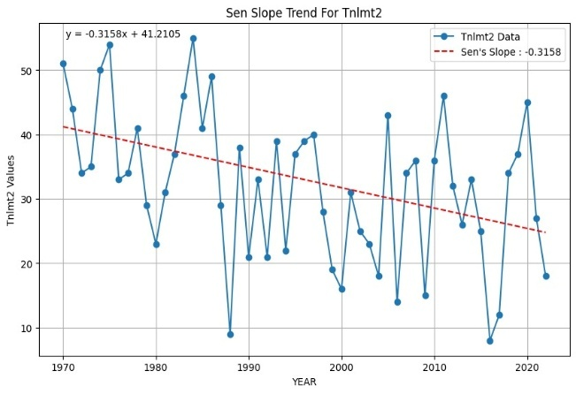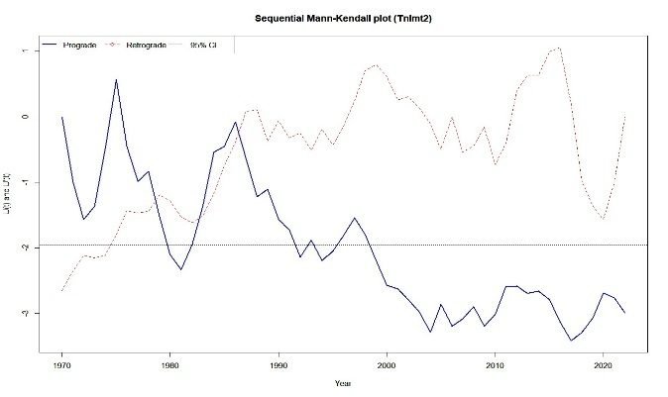
Fig. 10(a): Linear trend of Sen slope of Tnlmt2 from 1970 to 2022
Fig. 10(b): Sequential Mann- Kendahl plot indicating change point

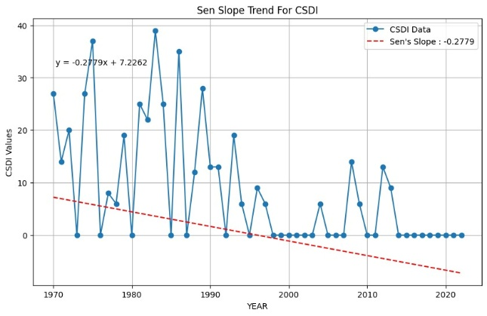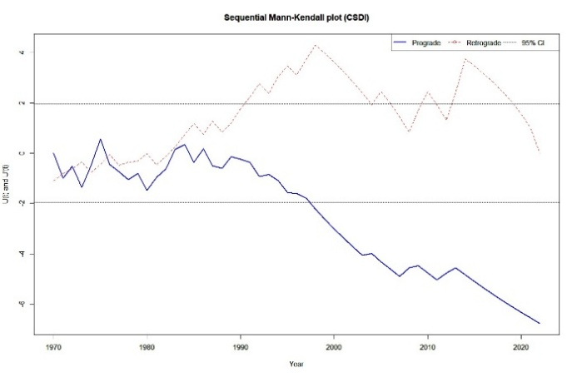

Fig. 11(a): Linear trend of Sen slope of Cold spell duration index (CSDI) from 1970 to 2022
Fig. 11(b): Sequential Mann- Kendahl plot indicating change point

Growing Season Length (GSL)

While there is an increase in heat accumulation in the area, the Growing Season Length shows no significant trend (p > 0.10) (Fig 12(a)) – this is like what researchers found in Kinnaur, Himachal Pradesh (Yue & Hashino, 2003). The ability to extend the growing season is limited due to non-thermal factors like delayed snowmelt, risk of early spring frost and moisture stress in late summer. Further compressing both sowing and harvesting windows by neutralizing any thermal gain is caused by the region’s rugged topography and low soil-water retention capability. For example, the late melting of the snow could cause a delay of 2-3 weeks in sowing while the rapid drying of the soil during the summer can require the harvest to occur before it is fully mature thus shortening the effective length of time available for growing crops (Kaur & Kalra, 2016).

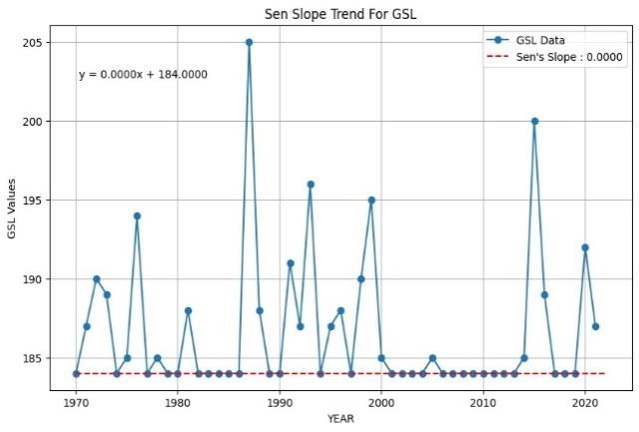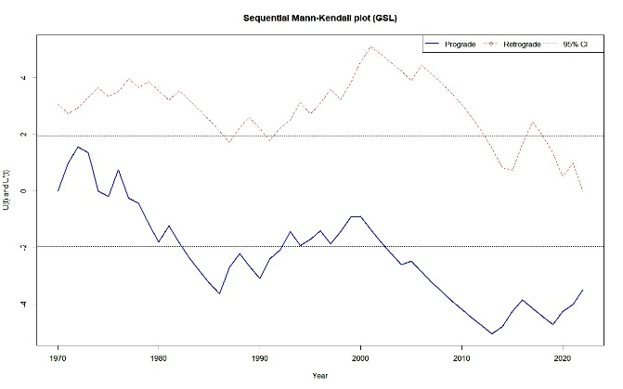
Fig.12(a): Linear trend of Sen slope of Growing season length (GSL) from 1970 to 2022
Fig.12(b): Sequential Mann- Kendahl plot indicating change point

Barley: Barley was once a significant crop in the region, but its production has substantially decreased since then, with only a partial recovery noted after the year 2013 (Fig. 13). Warmer growing temperatures and increased pest pressure, especially due to infestations of aphids, have decreased the viability of barley. The ability to develop new, strong and pest-resistant genetic varieties of barley is necessary to support the agricultural viability of barley production (Bhat, 1981).

Fig. 13. Trends in Barley Cultivated Area (2001-02 to 2019-20)
Wheat: The area of wheat crop in the region has been variable over the years (Fig. 14), due to the fact that between 2010 and 2011 (when wheat was an important crop), the area of wheat planted reduced, in part, because of altering precipitation patterns and the diversion of all farmers' wheat supplying for subsidized prices under the Public Distribution System by the government (Hussain et al., 2018)). Demand has continued to support the partial recovery of area planted in wheat since 2015 (mainly due to farmers switching to planting shorter season varietals). However, water will continue to constrain growth.

Fig. 14. Trends in Wheat Cultivated Area (2001-02 to 2019-20)
Fruits and Vegetables: Both fruit and vegetable production has increased (Fig. 15) approximately 25% and 30%, respectively, since 2008 due in part to fewer frost days, increased greenhouse production, and increased ability to access markets (Gaur, 2026). Apples, carrots and cabbages would now benefit from increased amount of time with warm temperatures compared to earlier periods, but the limited availability of water will limit further expansion in fruit and vegetable production.

Fig. 15. Trends in Fruits and Vegetables Cultivated Area (2001-02 to 2019-20)
Fodder: There has been a 15% increase in the area of fodder grown since 2011 (Fig. 16), mainly due to the increase in milk and meat industry and the need for cattle and sheep feed (Tewari et al., 2016). To maintain stable production of fodder, improved irrigation and soil conservation continue to be necessary.

Fig. 16. Trends in Fodder Cultivated Area (2001-02 to 2019-20)
Oilseeds and Pulses: Oilseeds have increased by approximately 10% since the pre-2007 period (Fig. 17) in the area planted due to weather variability after then, oilseeds provide great potential for agricultural production under warmer weather conditions in the future. However, the area planted to pulses has stabilized since a rapid decline due to a great increase in the demand for organic pulses and rajmas caused by the increase in the population from 2010-2011(Chuskit et al., 2024).

Fig. 17. Trends in Oilseeds Cultivated Area (2001-02 to 2019-20)
These shifts are closely associated with a decrease in frost days (r = -78, p < 0.01) and an increase in GDD (r = 0.82, p < 0.01). They represent how agriculture has adapted to changes in climate. Achieving this success has been difficult due to many challenges such as water shortages, soil degradation, and pest pressures that require the next generation of crop varieties to be resilient, (i.e., drip irrigation, mulching, integrated pest management, etc (IPCC 2022).

Socio-Economic and Ecological Implications
Since 2020, farmers have switched to high-value crops including fruits and vegetables, which has increased their income and caused vegetable sales to rise by 20% annually (LAHDC, 2021). But, compared to cereals, vegetables require 30–40% more irrigation (Kaur & Kalra, 2016), which exacerbates the scarce water supply. Ladakh's agricultural industry's sustainability and future is alarming under melting of glacier rapidly and an over-use on groundwater (Rashid et al., 2020). Two key risks associated with the increased use of marginal areas for agricultural production are- Desertification and soil erosion (Joshi et al., 2018). Sustainable development ideas seek to strike a balance between economic gains and conservation by promoting water-efficient technology and carefully considered land use. balance of conservation and economic advantages.

Adaptive strategies:

Adaptive strategies must be comprehensive, integrating scientific innovation, traditional knowledge and policy support so as to ensure sustainability in this cold arid region. These strategies include:
Climate-Resilient Varieties: Crop varieties which are drought-adapted, heat-tolerant and pest-resistant should be developed to counter warming trends and increasing pest pressures, such as aphid infestations that cause harm to barley (Bhat, 1981). Moreover, research organisations should focus on breeding programs for crops like wheat and barley. Further, traits which are typical of warmer areas such as early maturation and resilience to fungal infections should also be included. Farmer-led seed banks can boost genetic diversity and resilience by conserving and distributing locally adapted cultivars (Gaur, 2026).
Water Management: It is essential to address water scarcity by scaling up the present water-efficient technologies, such as drip irrigation and rainwater harvesting in order to combat the effects exacerbated by accelerated snowmelt and glacial retreat (Kaur & Kalra, 2016). And 40–60% of water use can be reduced by drip irrigation as compared to traditional flood irrigation. Supplemental irrigation can be given by rainwater harvesting systems (Gaur et al., 2024b). In case of remote areas, committees like community-based water management ensure fair distribution and maintenance.
Greenhouse Technologies: Increase in the use of greenhouses lengthens the growing seasons and shields crops from harsh temperature and early frosts (Gaur et al., 2024a). By using inexpensive solar-powered greenhouses designed for Ladakh's high solar radiation, vegetable harvests can be increased by 30–50%. In order to increase the adoption rate subsidies and training programs for farmers on building and maintaining greenhouses, especially for female farmers who predominate in the horticultural industry can be conducted.
Soil Conservation: Implementation of mulching, contour farming and agroforestry practices helps in the mitigation of soil erosion and thereby enhances water retention in Ladakh’s fragile ecosystems (Joshi et al., 2018). Moreover, evaporation can be reduced by 20% by incorporation of organic mulches, such as straw or seabuckthorn residue which then improve soil organic matter (Meena et al., 2023). Runoff can be reduced by contour bunding on sloping lands, hence preserving the topsoil. Lastly, integration of native species like willow into agroforestry systems can further stabilize soils as well as provide fodder and supports both agriculture and livestock.
Policy Support: Promotion should be made from the government side for providing subsidies for sustainable technologies like drip irrigation kits and greenhouse materials under government policies to strengthen market linkages for high-value crops like apples and vegetables (LAHDC, 2021). Establishment of cooperatives can enhance farmers’ bargaining power, ensuring better prices and linkage to urban markets in Leh and beyond. Moreover, trainings on climate-smart agricultural should be conducted by the extension services by integrating traditional practices like crop rotation with recent techniques. And policies should be inclusive of incentives for practising organic farming, leveraging Ladakh’s organic certification to capture premium markets (Chuskit et al., 2024).
Community-Based Adaptation: Engagement of local communities is required for planning fosters resilience by incorporating indigenous technical knowledge like traditional water-sharing systems (zings) and crop diversification practices (Saxena et al., 2025). Participatory research and women-led self-help groups focused on seed saving and greenhouse management can empower marginalized voices and strengthen collective resilience.
Climate Monitoring and Early Warning Systems: Localized weather stations can be established for detection of early warning systems for extreme events, such as flash floods or late frosts consequently enhancing preparedness and harvesting schedules leading to reduction in crop losses. And collaboration with IMD and local universities can ensure easy data accessibility for farmers.
Ecosystem-Based Adaptation: Sustainable land-use policies can enhance protection of Ladakh’s fragile wetlands and pastures through maintaining ecosystem services, such as water regulation and soil fertility (Sharma et al., 2020). Further, the risk pose by desertification can be reduced by restoration of degraded lands with the use of native vegetation which will support long-term agricultural sustainability.
CONCLUSION:
With warming trends altering cropping patterns and agricultural methods, this study highlights the significant impact of climate change on Ladakh's agriculture. By allowing diversification into high-value fruits and vegetables, rising minimum temperatures (+0.0169°C/year), decreased frost days (-0.457 days/year) and enhanced heat accumulation (+3.19 GDD units/year) have prolonged frost-free periods. However, these opportunities are limited by the lack of major GSL extension, water shortages and soil restrictions. While fodder and pulse production demonstrate adaptive resilience, declines in traditional crops like wheat and barley are a reflection of economic and environmental constraints.
Climate change is significantly reshaping agricultural systems in Ladakh by extending frost-free periods and creating opportunities for crop diversification, while simultaneously imposing constraints through water scarcity, soil limitations, and declining performance of traditional crops. The observed shifts highlight both the vulnerability and adaptive capacity of this cold arid region. Ensuring long-term sustainability will require an integrated approach that combines climate-resilient crop development, efficient water and soil management, greenhouse technologies, supportive policies, and community-driven adaptation. Strengthening climate monitoring and promoting ecosystem-based practices will further enhance resilience, enabling Ladakh’s agriculture to adapt effectively to ongoing and future climatic challenges.

Availability of Data and Materials: The daily gridded temperature and precipitation datasets (1970–2022) used in this study are publicly available from the India Meteorological Department (IMD) at https://www.imdpune.gov.in. Station-level meteorological data for Leh were obtained from the IMD Leh Observatory and are available from the corresponding author upon reasonable request due to institutional data-sharing policies. Crop area statistics (2001–2020) were sourced from the Statistical Handbooks of the Ladakh Autonomous Hill Development Council (LAHDC) and the Office of the Financial Commissioner (Jammu & Kashmir), which are available in the public domain. All climate indices were computed using the open-source CLIMPACT2 software (World Meteorological Organization, ET-SCI), accessible at https://climpact-sci.org. The R scripts used for statistical analyses (trend detection and correlation tests) are available from the corresponding author on reasonable request.
Funding: Department of Science and Technology, Ministry of Science and Technology, India (DST/CCP/NMSHE/MRDP/208/2021)

Disclaimer (Artificial intelligence):

Author(s) hereby declare that generative AI technologies such as Large Language Models (ChatGPT) has been used for editing the text of this manuscript.

References
- Alexander, L. V., & Herold, N. (2016). ClimPACT2: Indices and software. World Meteorological Organization.
- Archer, D. R., & Fowler, H. J. (2004). Spatial and temporal variations in precipitation in the Upper Indus Basin. Hydrology and Earth System Sciences, 8(1), 47–61. DOI: 10.5194/hess-8-47-2004
- Basistha, A., Arya, D. S., & Goel, N. K. (2009). Analysis of historical changes in rainfall in the Indian Himalayas. International Journal of Climatology, 29(4), 555–572. DOI: 10.1002/joc.1706
- Beniston, M. (1997). Variations of snow depth and duration in the Swiss Alps over the last 50 years: Links to changes in large-scale climatic forcings. Climatic Change, 36, 281–300. DOI: 10.1023/A:1005310214361
- Bhat, K. L. (1981). Barley cultivation in Ladakh. Seeds and Farms, 7(11), 25–28.
- Bhutiyani, M. R. (2015). Climate change in the Northwestern Himalayas. In R. Joshi, K. Kumar, & L. Palni (Eds.), Dynamics of climate change and water resources of Northwestern Himalaya (pp. xxx–xxx). Springer. DOI: 10.1007/978-3-319-13743-8_8
- Bhutiyani, M. R., Kale, V. S., & Pawar, N. J. (2007). Long-term trends in maximum, minimum and mean annual air temperatures across the Northwestern Himalaya during the twentieth century. Climatic Change, 85, 159–177. DOI: 10.1007/s10584-006-9196-1
- Bilal, H., Siwar, C., Mokhtar, M. B., Lahlou, F.-Z., Kanniah, K. D., & Al-Ansari, T. (2024). Snow runoff modelling in the upper Indus River Basin and its implication to energy water food nexus. Ecological Modelling, 498, 110871. https://doi.org/10.1016/j.ecolmodel.2024.110871
- Chevuturi, A., Dimri, A. P., & Thayyen, R. J. (2018). Climate change over Leh (Ladakh), India. Theoretical and Applied Climatology, 131(1–2), 531–545. DOI: 10.1007/s00704-016-1989-1
- Chuskit, R., Dolma, K., Katiyar, A. K., Chaurasia, O. P., & Stobdan, T. (2024). Opportunities and constraints in garden pea production in Ladakh. Journal of Food and Agriculture Research, 5(2), 121–139. DOI: 10.47509/JFAR.2025.v05i02.04
- Dash, S. K., Jenamani, R. K., Kalsi, S. R., & Panda, S. K. (2007). Some evidence of climate change in twentieth-century India. Climatic Change, 85(3), 299–321. DOI: 10.1007/s10584-007-9305-9
- Gaur, Mahesh K. (2026). Land resources and agricultural economy of Ladakh, India: A case study of Leh District. In M. S. Rathore, T. Pratap, & L. S. Rathore (Eds.), Desert ecosystems: Rescripting development paradigms (pp. 299–330). Springer. DOI: 10.1007/978-3-032-20237-9_15
- Gaur, Mahesh K., Goyal, R. K., Kanwar, M. S., Chichaghare, A., & Raghuvanshi, M. S. (2024a). Traditional ecological knowledge and natural resource management in the cold desert of Leh-Ladakh, India. Ecofeminism and Climate Change, 5(2), 81–88. DOI: 10.26480/efcc.02.2024.81.88
- Gaur, Mahesh K., Goyal, R. K., Kanwar, M. S., Singh, N., Choudhary, V., & Chichaghare, A. (2024b). Prospects and challenges for biodiversity in the anthropogenic-induced cold arid landscape of Ladakh, India. Japan Journal of Research, 5(6), 1–15. DOI: 10.33425/2690-8077.1123
- Gupta, A., & Mishra, A. (2022). Trend analysis and change point detection of annual and seasonal precipitation time series over Varanasi District, Uttar Pradesh. In B. Phartiyal et al. (Eds.), Climate change and environmental impacts: Past, present and future perspective. Springer. DOI: 10.1007/978-3-031-13119-6_15
- Hamed, K. H., & Rao, A. R. (1998). A modified Mann–Kendall trend test for autocorrelated data. Journal of Hydrology, 204(1–4), 182–196. DOI: 10.1016/S0022-1694(97)00125-X
- Hatfield, J. L., & Prueger, J. H. (2015). Temperature extremes: Effect on plant growth and development. Weather and Climate Extremes, 10, 4–10. DOI: 10.1016/j.wace.2015.08.001
- Hussain, S., Khan, A. A., Shakoor, A., Goheer, A., Qadir, T., Khan, M. M., & Hussain, Z. (2018). Effect of cold and heat stress on different stages of wheat: A review. Journal of Global Innovations in Agricultural and Social Sciences, 6(4), 123–128. https://doi.org/10.22194/JGIASS/7.842
- IPCC. (2022). Climate change 2022: Impacts, adaptation and vulnerability. Cambridge University Press. DOI: 10.1017/9781009325844
- Jinxia, L., Zhao, W., He, B., & Jiang, G. (2024). Asymmetric warming impacts on vegetation growth across the Tibetan Plateau. GIScience & Remote Sensing, 61(1), Article 2348257. DOI: 10.1080/15481603.2024.2348257
- Joshi, R., Sambhav, K., & Singh, S. P. (2018). Near surface temperature lapse rate for treeline environment in western Himalaya. Tropical Ecology, 59, 197–209.
- Kaur, L., & Kalra, R. K. (2016). Water management strategies for sustainable agriculture. Indian Journal of Ecology, 43(2), 580–589.
- Kendall, M. G. (1975). Rank correlation methods (4th ed.). Charles Griffin.
- Kothawale, D. R., & Rupa Kumar, K. (2005). Recent changes in surface temperature trends over India. Geophysical Research Letters, 32(18), L18714. DOI: 10.1029/2005GL023528
- Kripalani, R. H., Kulkarni, A., Sabade, S. S., & Khandekar, M. L. (2003). Indian monsoon variability in a global warming scenario. Natural Hazards, 29, 189–206. DOI: 10.1023/A:1023695326825
- Kulkarni, A. V., Bahuguna, I. M., Rathore, B. P., Singh, S. K., Randhawa, S. S., Sood, R. K., & Dhar, S. (2007). Glacial retreat in Himalaya using Indian remote sensing satellite data. Current Science, 92(1), 69–74. https://www.jstor.org/stable/24096824
- Laepple, T., & Huybers, P. (2014). Global and regional variability in marine surface temperatures. Geophysical Research Letters, 41(7), 2528–2534. DOI: 10.1002/2014GL059345
- LAHDC. (2021). Statistical handbook of Leh District. Ladakh Autonomous Hill Development Council.
- Lobell, D. B., Bonfils, C., & Duffy, P. B. (2007). Climate change uncertainty for daily temperatures. Geophysical Research Letters, 34, Article L18714. DOI: 10.1029/2006GL028726
- Luedeling, E. (2012). Climate change impacts on winter chill. Scientia Horticulturae, 144, 218–229. DOI: 10.1016/j.scienta.2012.07.011
- Mall, R. K., Chaturvedi, M., Singh, N., Bhatla, R., Singh, R. S., Gupta, A., & Niyogi, D. (2020). Asymmetric change in diurnal temperature range in India. International Journal of Climatology, 41(4), 2597–2610. DOI: 10.1002/joc.6978
- Mann, H. B. (1945). Nonparametric tests against trend. Econometrica, 13(3), 245–259. DOI: 10.2307/1907187
- Mayewski, P. A., Jeschke, P. A., & Pregent, G. (1980). Himalayan glacier fluctuations and monsoon record. Arctic and Alpine Research, 12(2), 171–182. DOI: 10.2307/1550514
- Meena, M., Varshini, M. P., Reethika, D., & Nath, D. (2023). Soil management and sustainable agriculture. In Advances in soil science (pp. 255–265). Bright Sky Publications.
- Parmesan, C., and Yohe, G. (2003). A globally coherent fingerprint of climate change impacts. Nature, 421(6918), 37–42. https://doi.org/10.1038/nature01286
- Rashid, I., Majeed, U., Aneaus, S., & Pelto, M. (2020). Linking the Recent Glacier Retreat and Depleting Streamflow Patterns with Land System Changes in Kashmir Himalaya, India. Water, 12(4), 1168. https://doi.org/10.3390/w12041168
- Saxena, A., Jan, B., Namghyal, D., Dar, K. A., Bhat, T. A., Dar, S. R., & Rashid, A. (2025). Blending traditional knowledge of farmers in agriculture with modern scientific technologies in Kashmir and Ladakh. In C. L. Acharya, R. Chaudhary, P. Gurumurthy, & A. S. Rao (Eds.), Blending Indian farmers' traditional knowledge in agriculture with modern scientific technologies. Springer. https://doi.org/10.1007/978-981-96-1020-4_11
- Sen, P. K. (1968). Estimates of the regression coefficient based on Kendall’s tau. Journal of the American Statistical Association, 63(324), 1379–1389. https://doi.org/10.1080/01621459.1968.10480934
- Sharma, N., Saini, R., Sreehari, K., Pathaikara, A., Punde, P., & Attada, R. (2023). Hydrological extremes in Western Himalayas—Trends and factors. In M. Mokhtari (Ed.), Natural hazards – New insights. IntechOpen. DOI: 10.5772/intechopen.109445
- Sharma, S., Gosavi, V. E., Kanwal, K. S., Agnihotri, V., Chandra Sekar, K., Arya, S. C., & Rawal, R. S. (2020). High altitude wetlands in the Indian Himalaya. G. B. Pant National Institute of Himalayan Environment, Kosi - Katarmal, Almora.
- Shrestha, P., KC, A., Karki, D. K., Shrestha, N., Bharati, A., & Giri, S. (2024). Climate change impacts on agriculture in Nepal. Journal of Multidisciplinary Research Advancements, 2(2), 130–137. DOI: 10.3126/jomra.v2i2.73080
- Sigdel, K. P., Ghimire, N. P., Pandeya, B., & Dawadi, B. (2022). Precipitation and temperature extremes in Himalaya. Atmosphere, 13(11), Article 1866. DOI: 10.3390/atmos13111866
- Sneyers, R. (1990). On the statistical analysis of series of observations. World Meteorological Organization.
- Sunil Kumar. (2018). Impact of climate change on water resources in India. International Journal of Current Microbiology and Applied Sciences, Special Issue-7, 3853–3858.
- Tewari, J. C., Pareek, K., Raghuvanshi, M. S., Kumar, P., & Roy, M. M. (2016). Fodder production system in Ladakh. MOJ Ecology & Environmental Sciences, 1(1), 22–28. DOI: 10.15406/mojes.2016.01.00005
- Wang, X. L., & Feng, Y. (2013). Climate research division atmospheric science and technology directorate science and technology branch, environment canada toronto, ontario, canada. Ontario, Canada, 17.
- Yadav, J. S., Tiwari, S. K., Misra, A., Rai, S. K., & Yadav, R. K. (2021). High-altitude meteorology of Indian Himalaya. Environmental Monitoring and Assessment, 193(10), Article 654. DOI: 10.1007/s10661-021-09418-y
- Yue, S., & Hashino, M. (2003). Temperature trends in Japan. Theoretical and Applied Climatology, 75(1), 15–27. DOI: 10.1007/s00704-002-0717-1

Zampieri, M., Ceglar, A., Dentener, F., & Toreti, A. (2017). Wheat yield loss due to extreme events. Environmental Research Letters, 12(6), Article 064008. DOI: 10.1088/1748-9326/aa723b

