Statistical Assessment of Rainfall Trends, Variability and Drought Vulnerability in Haryana, India (1980-2024)

Abstract
Rainfall variability and drought occurrence pose significant challenges to water resources, agriculture, and livelihoods in semi-arid regions of India. This study examines the spatio-temporal characteristics of rainfall and drought across Haryana using long-term district-level rainfall data for the period 1981–2024. Mean annual rainfall, standard deviation, coefficient of variation, skewness, and kurtosis were employed to assess rainfall magnitude, variability, and distributional behaviour. Long-term trends were analysed using the non-parametric Mann–Kendall test and Sen’s slope estimator, while drought characteristics were evaluated using the 12-month Standardized Precipitation Index (SPI-12).
The results reveal a distinct east–west and north-east to south-west rainfall gradient, with the highest mean annual rainfall recorded in Yamunanagar (1095 mm), Panchkula (1077 mm), and Ambala (949 mm), while the western districts remain comparatively drier. Rainfall variability shows marked spatial heterogeneity, with relatively more stable rainfall regimes in the wetter north-eastern districts and moderate to high variability across several central, western, and southern districts. Trend analysis indicates predominantly increasing but statistically non-significant rainfall trends across most districts, including Yamunanagar, Panchkula, Ambala, Karnal, and Kurukshetra, whereas only a few western and southern districts show significant increases. SPI-based analysis demonstrates that mild droughts are frequent throughout Haryana, while moderate to extreme droughts are more concentrated in the drought-prone western districts such as Sirsa, Fatehabad, and Hisar. The findings suggest that spatial variability and rainfall distribution characteristics, rather than long-term trends alone, are the primary determinants of drought vulnerability, underscoring the need for district-specific climate adaptation and water-management strategies under increasing climatic uncertainty.
Keywords: Haryana, Rainfall, Trends, Variability, Man-Kendal, Sen Score, SPI.
…………………………………………………………………………………………………..

Introduction
Climate change is one of the most significant global challenges confronting human society today. It is manifested through rising global temperatures, changes in precipitation regimes, and the increasing frequency of extreme climatic events. The Intergovernmental Panel on Climate Change (IPCC, 2021) has highlighted that the last four decades have successively been the warmest on record, with significant regional disparities in warming intensity and precipitation variability. For developing countries such as India, where agriculture, water resources, and rural livelihoods are highly climate-sensitive, even minor shifts in climatic parameters have substantial socio-economic implications.
India’s climatic diversity is governed by its monsoon system, which delivers nearly 80% of the annual rainfall during a few months of the year. Small alterations in monsoon timing, intensity, or distribution can cause devastating impacts, including droughts, floods, and yield reductions in staple crops. The north-western states of India, including Haryana, lie in the Indo-Gangetic Plains, which serve as the country’s food bowl, producing large surpluses of wheat and rice. Haryana alone contributes significantly to the central pool of food grains, making its climatic stability critical for national food security. However, this region is increasingly vulnerable to groundwater depletion, heat stress, and rainfall variability, all of which threaten long-term agricultural sustainability.
Haryana experiences a subtropical climate characterized by hot summers, a monsoon season, and cool winters. Rainfall is largely dependent on the southwest monsoon and varies significantly between districts, with northern districts such as Ambala and Yamuna Nagar receiving higher precipitation compared to western and southern districts like Sirsa, Hisar, and Mahendragarh. Rising minimum temperatures have also been reported in many parts of Haryana, leading to increased evapotranspiration and stress on water resources. District-level analysis of rainfall trends thus becomes crucial for understanding localized impacts of climate change.
Trend analysis of climatic parameters is often conducted using parametric techniques, which assume normality and independence of data. However, climatic time series frequently exhibit skewness, outliers, and autocorrelation. To overcome these limitations, non-parametric tests such as the Mann–Kendall (MK) test and Sen’s slope estimator have been widely adopted. These methods are robust, distribution-free, and effective in detecting monotonic trends and quantifying their magnitude. By applying these tools to long-term rainfall and temperature data, the present study aims to provide a comprehensive district-wise climate profile for Haryana covering the period 1981–2023.
Study Area
Haryana, located in the northwestern part of India (Fig. 1) between 27°39' N to 30°55' N latitude and 74°27' E to 77°36' E longitude, which covers a total geographical area of 44,212 sq. km, which is approximately 1.34% of the country’s landmass. The state is landlocked, bordered by Himachal Pradesh and Punjab to the north, Rajasthan to the south and west, and the river Yamuna to the east, which forms a natural boundary with Uttar Pradesh and Uttarakhand while also surrounding Delhi on three sides. Its diverse topography includes the Shiwalik Hills in the northeast, the Aravalli Range in the south, and vast fertile alluvial plains in the center.
Fig. 1 Map of Study Area
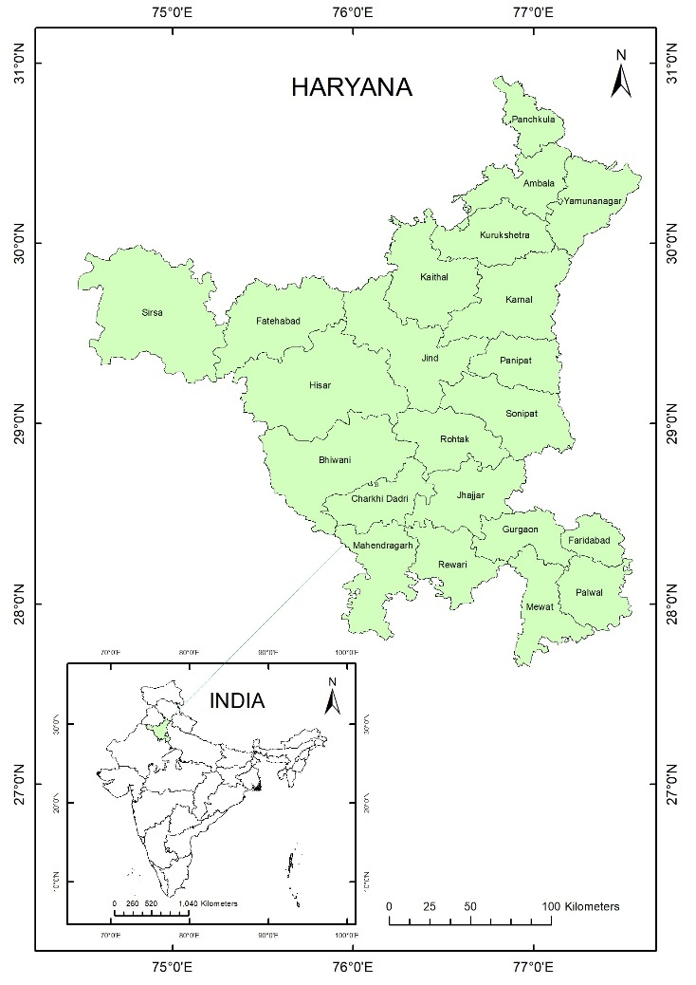
The climate is primarily subtropical dry continental, characterized by hot summers reaching up to 45°C and cold winters, with varying precipitation across its arid and semi-arid zones. 80% of the total annual precipitation occurs during the monsoon months from July to September. Hydrologically, the state is drained by the perennial Yamuna and seasonal rivers like the Ghaggar, Markanda, and Sahibi. As of 2026, Haryana is administratively organized into six revenue divisions—Ambala, Faridabad, Gurugram, Hisar, Karnal, and Rohtak—which encompass 22 primary districts including industrial hubs like Gurugram and Faridabad, as well as agrarian centers like Sirsa and Karnal.
Objectives
Long-term rainfall anomalies operating over multiple climatic cycles have produced distinct spatial patterns in annual rainfall and associated drought conditions across the state. Accordingly, the present study aims to analyse district-wise long-term rainfall trends for the period 1981–2024, evaluate trends in minimum, maximum and mean temperatures, assess annual rainfall variability, and examine drought characteristics using SPI-based analysis in order to comprehensively understand the spatial and temporal dimensions of climate variability and drought vulnerability in Haryana.
Literature Review
The study of climatic trends has progressed from the development of foundational statistical tools to applied regional and global climate assessments. Early contributions by Mann (1945) introduced a non-parametric approach for detecting monotonic trends in time-series data, which was subsequently refined through rank-correlation theory by Kendall (1975). Sen (1968) further advanced trend analysis by proposing a slope estimator that quantifies the magnitude of detected trends. Together, these methods form the methodological backbone of climatic and hydrological trend analysis due to their robustness against non-normality, outliers and skewed data distributions. With the expansion of long-term climatic datasets, methodological limitations such as serial correlation gained attention. Yue et al. (2002) demonstrated that autocorrelation can bias Mann–Kendall results, while Yue and Wang (2004) proposed effective sample size corrections to improve statistical reliability. These refinements strengthened the application of non-parametric trend detection in climate research.
In India, applied climate-trend studies increased markedly during the early 2000s, driven by growing concerns over monsoon variability and rising temperatures. Mall et al. (2006) highlighted the vulnerability of India’s water resources to climate change, particularly in irrigation-dependent regions. Evidence of widespread warming, especially increases in minimum temperatures, was documented by Dash et al. (2007). Regional studies revealed strong spatial heterogeneity in rainfall trends; for example, Basistha et al. (2009) and Kumar and Jain (2011) reported region-specific rainfall variability in the Himalaya and north-western India. At the national scale, Jain and Kumar (2012) confirmed significant warming trends, while rainfall changes remained uneven and location-dependent. During the 2010s, research increasingly focused on the Indo-Gangetic Plains, particularly Punjab and Haryana, due to their agricultural importance. Studies such as Kaur, Vatta, and Sidhu (2015) documented farmers’ perceptions of increasing temperature stress and rainfall uncertainty, while Singh and Dhiman (2015) linked climatic variability in Haryana to declining agricultural productivity. These findings emphasized the sensitivity of wheat–rice systems to rising temperatures, particularly nighttime warming.
Recent global assessments, notably the IPCC AR5 (2014) and AR6 (2021), provide strong evidence of accelerated warming and increased hydro-climatic variability in South Asia. Indian observational studies align with these findings, indicating faster increases in minimum temperatures and growing rainfall extremes. Research by Roxy et al. (2017) and Sahana et al. (2019) further highlighted changes in monsoon behavior and the rising influence of extreme rainfall events. Since 2020, district-level analyses using high-resolution datasets have expanded. Studies such as Basha et al. (2020) and Kumar et al. (2021) applied Mann–Kendall and Sen’s slope methods across India, revealing strong spatial contrasts in climatic trends. Recent climate–agriculture studies (Singh et al., 2022; Chaudhary & Mehta, 2023) emphasize that even modest warming, when combined with rainfall variability and groundwater stress, significantly increases vulnerability in Haryana.
The literature converges on three key conclusions: (1) rainfall variability in India is highly heterogeneous and often dominates over long-term trends; (2) temperature increases, particularly in minimum temperatures, are statistically significant across northern India; and (3) in Haryana, warming combined with uncertain rainfall poses growing risks to agriculture and water resources. These findings underline the necessity of applying robust non-parametric methods such as the Mann–Kendall test and Sen’s slope estimator at the district scale—an approach adopted in the present study to address a critical regional research gap.
Data Sources and Methodology
The present study is based on a comprehensive statistical analysis of long-term climatic data to evaluate rainfall variability, trends, and drought characteristics across all districts of Haryana. Mean monthly precipitation data for the period 1981–2024 were obtained from the India Meteorological Department (IMD) and compiled into a unified district-wise dataset. Monthly rainfall values were aggregated to annual totals to capture interannual variability over more than four decades, encompassing multiple climatic cycles.
Rainfall variability was assessed using mean annual rainfall, standard deviation (SD), coefficient of variation (CV), skewness, and kurtosis. The CV was used as the primary indicator of relative rainfall variability and classified into low (CV < 20%), moderate (20–30%), and high variability (> 30%) following established climatological standards (Conrad & Pollak, 1950; Hare, 1983; Subash & Gangwar, 2014). Standard deviation quantified absolute interannual fluctuations, while skewness and kurtosis were used to assess asymmetry and the influence of extreme rainfall events. Long-term rainfall trends were analysed using the Mann–Kendall (MK) test, a non-parametric rank-based method widely applied to climatic time series (Mann, 1945; Kendall, 1975). The positive values indicate increasing rainfall and negative values indicate decreasing rainfall over time. Statistical significance was evaluated using the p-value at the 5% significance level (α = 0.05), with p < 0.05 indicating a statistically significant trend and p ≥ 0.05 indicating a non-significant trend.
To quantify the magnitude of detected trends, Sen’s slope estimator was applied to annual rainfall series (Sen, 1968). Positive Sen’s slope values represent increasing rainfall rates (mm year⁻¹), while negative values indicate declining rainfall trends. Based on the combined interpretation of Kendall’s Tau, Sen’s slope, and p-values, rainfall trends were categorised as significant increasing, significant decreasing, non-significant increasing, or non-significant decreasing. Drought characteristics were further examined using the Standardized Precipitation Index (SPI) at a 12-month time scale (SPI-12) to capture long-term moisture conditions relevant to agricultural and hydrological droughts (McKee et al., 1993; WMO, 2012). SPI values were classified into drought severity classes ranging from mild to extreme drought, and district-wise drought frequencies were computed. The integrated interpretation of rainfall variability measures, MK–Sen trend results, decadal rainfall behaviour, and SPI-based drought assessment provides a comprehensive framework for understanding spatio-temporal rainfall dynamics and drought vulnerability across Haryana.
Result and Discussion
Spatial Patterns of Annual Rainfall
The spatial pattern of rainfall in Haryana exhibits a pronounced east–west and north-east to south-west gradient in both magnitude and variability (Fig. 2). The north-eastern and eastern districts, namely Yamunanagar (1095 mm), Panchkula (1077 mm), Ambala (949 mm), Kurukshetra (756 mm) and Karnal (699 mm), receive the highest mean annual rainfall in the state (Table 1). These districts also show comparatively lower coefficients of variation, along with relatively lower skewness and moderate kurtosis, indicating a more stable monsoonal rainfall regime. The influence of the Shivalik foothills and early monsoon onset contributes to this higher and more reliable rainfall distribution.
Table: 1 Annual Rainfall Characteristics: 1980-2024
Sr. No | District | Mean Annual Rainfall (mm) | Maximum Annual Rainfall (mm) | Minimum Annual Rainfall (mm) | S.D. (mm) | C.V. (%) | Skewness | Kurtosis
1 | Ambala | 949.09 | 1694.70 | 279.97 | 409.37 | 43.13 | -0.43 | -1.05
2 | Bhiwani | 499.93 | 855.10 | 246.88 | 132.71 | 26.55 | 0.13 | -0.08
3 | Charki dadri | 562.83 | 962.16 | 295.41 | 147.46 | 26.20 | 0.28 | -0.14
4 | Faridabad | 749.10 | 1112.16 | 399.45 | 174.79 | 23.33 | 0.11 | -0.79
5 | Fatehabad | 445.78 | 717.85 | 152.93 | 133.52 | 29.95 | -0.37 | -0.39
6 | Gurugram | 659.78 | 1032.38 | 317.62 | 170.71 | 25.87 | 0.15 | -0.83
7 | Hisar | 490.61 | 828.16 | 173.14 | 142.47 | 29.04 | -0.19 | -0.29
8 | Jhajjar | 612.95 | 984.17 | 314.80 | 164.69 | 26.87 | 0.16 | -0.80
9 | Jind | 576.95 | 928.49 | 212.95 | 179.43 | 31.10 | -0.12 | -0.86
10 | Kaithal | 620.23 | 990.23 | 238.16 | 217.64 | 35.09 | -0.36 | -1.13
11 | Karnal | 699.44 | 1252.67 | 278.86 | 263.82 | 37.72 | -0.13 | -0.94
12 | Kurushetra | 756.12 | 1329.08 | 250.05 | 312.13 | 41.28 | -0.37 | -1.14
13 | Mahendragarh | 564.69 | 880.57 | 287.57 | 141.88 | 25.13 | 0.17 | -0.53
14 | Mewat | 693.09 | 1066.52 | 370.38 | 178.08 | 25.69 | 0.28 | -0.79
15 | Palwal | 711.11 | 1052.33 | 425.18 | 169.74 | 23.87 | 0.25 | -0.92
16 | Panchkula | 1076.96 | 1793.72 | 295.69 | 472.15 | 43.84 | -0.57 | -1.04
17 | Panipat | 725.53 | 1241.06 | 300.47 | 225.76 | 31.12 | 0.12 | -0.52
18 | Rewari | 629.63 | 973.24 | 330.11 | 163.29 | 25.93 | 0.20 | -0.83
19 | Rohtak | 548.71 | 928.11 | 219.31 | 168.71 | 30.75 | 0.07 | -0.61
20 | Sirsa | 366.70 | 587.02 | 149.56 | 98.66 | 26.90 | -0.08 | -0.11
21 | Sonipat | 662.26 | 1043.95 | 271.26 | 193.07 | 29.15 | 0.01 | -0.68
22 | YamunaNagar | 1095.21 | 1942.63 | 305.42 | 489.80 | 44.72 | -0.46 | -0.94
Source: Computed By Author

Moving towards the central belt of Haryana, districts such as Panipat (726 mm), Palwal (711 mm), Mewat (693 mm), Sonipat (662 mm), Gurugram (660 mm), Kaithal (620 mm), Jhajjar (613 mm) and Jind (577 mm) record moderate mean annual rainfall. These districts exhibit moderate to high rainfall variability, accompanied by positive skewness, suggesting that rainfall distribution is increasingly dominated by below-average rainfall years with occasional high-rainfall events. Kurtosis values in this zone indicate the growing influence of rainfall extremes, reflecting a transitional climatic regime between the humid east and the arid west.
Fig. 2 Annual Rainfall Patterns: 1981-2024
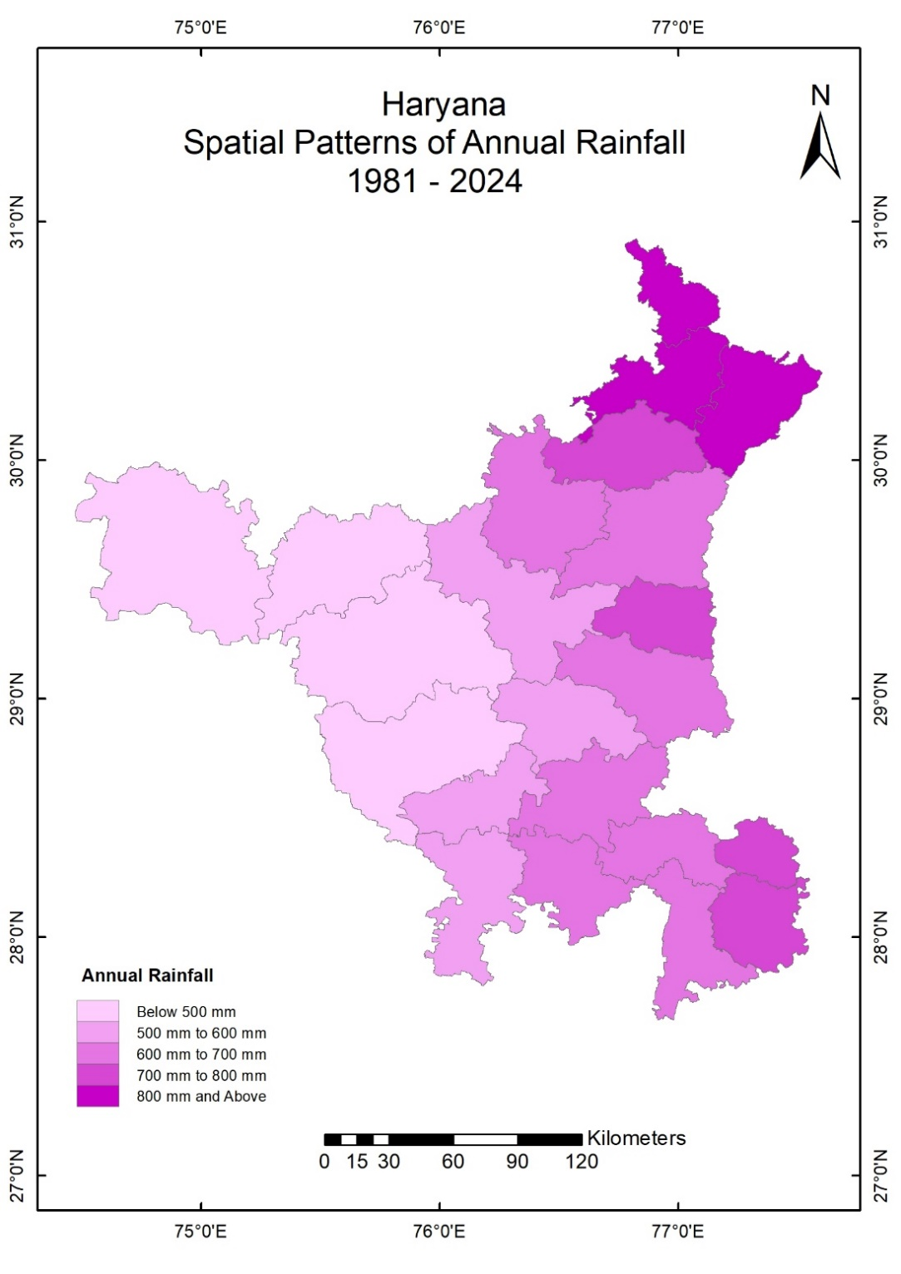
The western and south-western districts of Haryana, including Sirsa (367 mm), Fatehabad (446 mm), Hisar (491 mm), Bhiwani (500 mm), Rohtak (549 mm), Charkhi Dadri (563 mm), Mahendragarh (565 mm) and Rewari (630 mm), form the low-rainfall, high-variability zone of the state. These districts show mean annual rainfall well below the state average, coupled with high coefficients of variation (Table 1) exceeding 30%, strong positive skewness, and predominantly leptokurtic rainfall distributions. This statistical combination reflects a rainfall regime characterised by frequent low-rainfall years interspersed with sporadic but intense rainfall events, making these districts highly susceptible to meteorological droughts as well as short-duration extreme rainfall.
Overall, the spatial rainfall pattern derived from mean rainfall, variability, skewness and kurtosis indicates that rainfall in Haryana is highly uneven and non-normally distributed. The eastern districts benefit from higher and relatively stable rainfall, whereas western Haryana experiences erratic and uncertain rainfall conditions. The dominance of positive skewness across most districts implies that rainfall deficits are more frequent than excess rainfall, while positive kurtosis values highlight the increasing role of extremes. This spatial structure provides a strong statistical basis for understanding drought vulnerability, groundwater stress and agricultural risk across Haryana, and supports the use of non-parametric trend analysis and SPI-based drought assessment in the region.
Rainfall Variability
Rainfall variability was assessed using the coefficient of variation (CV), which expresses the standard deviation (SD) as a percentage of mean annual rainfall. Following established climatological standards, rainfall variability was classified as low variability (CV < 20%), moderate variability (CV = 20–30%), and high variability (CV > 30%), a classification widely adopted in rainfall variability studies (Conrad and Pollak, 1950; Hare, 1983; Subash and Gangwar, 2014). This classification provides a robust framework for identifying spatial differences in rainfall stability and climatic risk, while SD, skewness and kurtosis further describe the magnitude, asymmetry and extremeness of rainfall variability.
The district-wise rainfall variability pattern in Haryana, as revealed by standard deviation, coefficient of variation, skewness and kurtosis, indicates strong spatial contrasts in rainfall stability and extremeness. The north-eastern districts exhibit comparatively high rainfall amounts but also show substantial interannual variability. The high rainfall variability category (CV > 30%) is dominated by districts experiencing marked interannual rainfall uncertainty.
Prominent among these are Yamunanagar, with a mean annual rainfall of 1095 mm, records a standard deviation of 490 mm and a CV of 44.7%, while Panchkula (SD = 472 mm; CV = 43.8%) and Ambala (SD = 409 mm; CV = 43.1%) display similar high variability (Fig. 3 & Fig. 4). Despite high rainfall, these districts show negative skewness values such as −0.46 in Yamunanagar, −0.57 in Panchkula and −0.43 in Ambala, indicating a higher frequency of above-average rainfall years. Their negative kurtosis values (around −1.0) suggest relatively flat distributions, implying that although variability is high, rainfall extremes are spread over time rather than being sharply peaked.
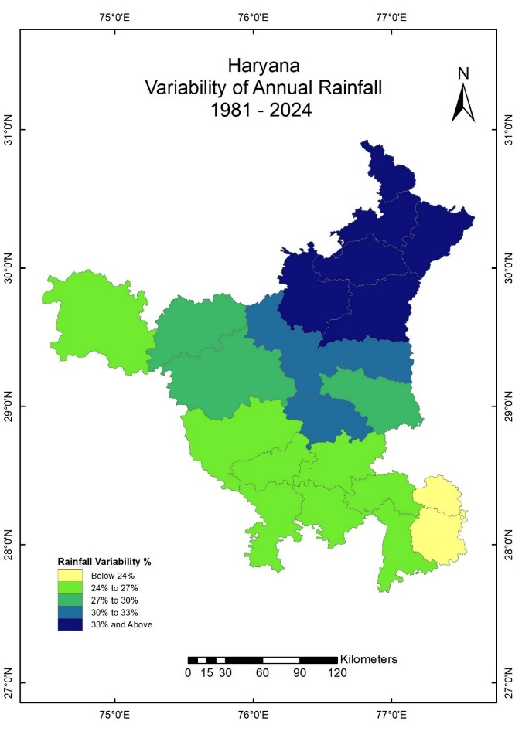
Fig. 3 Variability of Annual Rainfall(1981-2024) Fig. 4 Rate of Rainfall Variability (1981-2024)
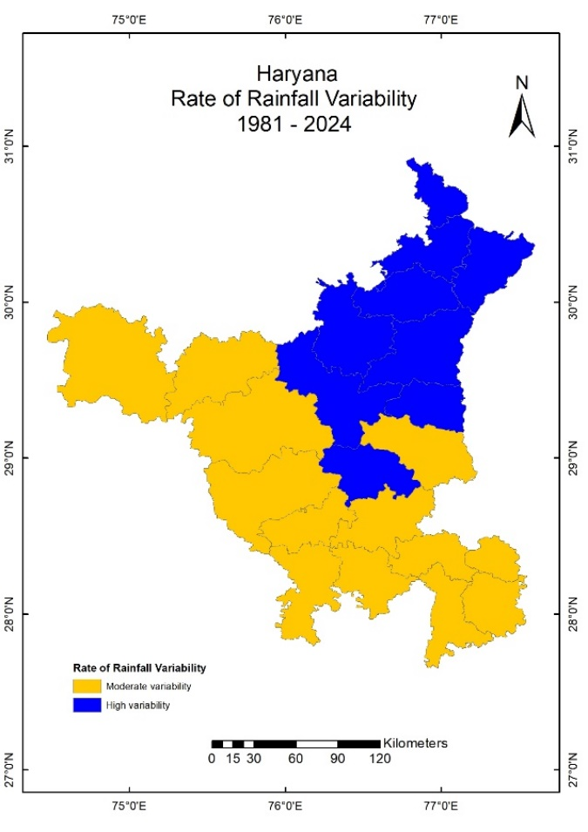
In the central districts of Haryana, rainfall variability is moderate to high, reflecting transitional climatic conditions. Panipat (SD = 226 mm; CV = 31.1%), Jind (SD = 179 mm; CV = 31.1%) and Rohtak (SD = 169 mm; CV = 30.7%) show noticeable interannual fluctuations. Kaithal (SD = 218 mm; CV = 35.1%), Karnal (SD = 264 mm; CV = 37.7%) and Kurukshetra (SD = 312 mm; CV = 41.3%) exhibit even higher variability. Skewness values in this belt range from −0.36 in Kaithal and Kurukshetra to +0.12 in Panipat, indicating mixed rainfall behaviour with both deficit and surplus years. Kurtosis values, mostly between −0.5 and −1.1, suggest moderately flat rainfall distributions, pointing to the growing influence of rainfall extremes without excessive concentration in a few years.
The western and south-western districts display comparatively lower rainfall amounts but distinctly high rainfall instability. Sirsa, the driest district with a mean annual rainfall of 367 mm, shows a standard deviation of 99 mm and a CV of 26.9%, while Hisar (SD = 142 mm; CV = 29.0%), Fatehabad (SD = 134 mm; CV = 29.9%), Bhiwani (SD = 133 mm; CV = 26.5%) and Charkhi Dadri (SD = 147 mm; CV = 26.2%) reflect moderate variability under arid conditions. Skewness values in these districts are close to zero or slightly negative, such as −0.08 in Sirsa and −0.19 in Hisar, indicating frequent low-rainfall years with limited surplus events. Kurtosis values near zero, such as −0.11 in Sirsa and −0.29 in Hisar, imply relatively uniform rainfall distributions with fewer extreme peaks, reinforcing the dominance of persistent dryness rather than episodic extremes.
Overall, the rainfall variability analysis demonstrates that districts with higher mean rainfall also experience higher absolute variability, as reflected by large standard deviations in Yamunanagar, Panchkula and Ambala, while western districts experience instability primarily through rainfall scarcity rather than extremes. The coexistence of high CV values, negative skewness in high-rainfall districts, and moderate to low kurtosis across most districts confirms that rainfall in Haryana is highly irregular, non-normally distributed and spatially heterogeneous. These statistical characteristics explain the contrasting drought and flood vulnerabilities across the state.
Rainfall Trend Analysis using Mann–Kendall Test and Sen’s Slope (MK & Sen Trend)
The rainfall trend analysis reveals two dominant and contrasting trend categories across Haryana, namely Increasing–Non-significant and Increasing–Significant, which together highlight the nature of long-term rainfall change in the state. Notably, no district exhibits a statistically significant decreasing trend, indicating the absence of a strong long-term rainfall decline across Haryana during the study period.
Districts classified (Fig. 5) under the Increasing–Non-significant trend include Yamunanagar, Panchkula, Ambala, Karnal, Kurukshetra, Panipat, Sonipat, Gurugram, Jhajjar, Rewari and Mewat. On the trend map, these districts form a continuous belt extending from the north-eastern to the central parts of Haryana. In these districts, Kendall’s and Sen’s slope values are positive, indicating an upward tendency in rainfall; however, the associated p-values exceed the 0.05 significance level, classifying these trends as statistically non-significant. Spatially, this pattern suggests that although rainfall is increasing in tendency, the change is weak, irregular and masked by strong interannual variability. These districts therefore do not exhibit a consistent long-term shift in rainfall, and rainfall variability (Fig 6) continues to dominate over directional change.

Table: 2 Rainfall Trend Analysis in Haryana (1980-2024)
Sr. No | District | Kendall  (MK Test) | p-value | Sen’s Slope (mm/year) | Trend | Significance (α=0.05)
1 | Ambala | 0.163 | 0.119 | 5.630 | Increasing | Non-significant
2 | Bhiwani | 0.249 | 0.017 | 3.624 | Increasing | Significant
3 | Charki dadri | 0.203 | 0.052 | 3.374 | Increasing | Non-significant
4 | Faridabad | 0.220 | 0.035 | 3.597 | Increasing | Significant
5 | Fatehabad | 0.249 | 0.017 | 3.163 | Increasing | Significant
6 | Gurugram | 0.159 | 0.129 | 3.398 | Increasing | Non-significant
7 | Hisar | 0.228 | 0.029 | 3.310 | Increasing | Significant
8 | Jhajjar | 0.186 | 0.075 | 3.396 | Increasing | Non-significant
9 | Jind | 0.180 | 0.086 | 3.874 | Increasing | Non-significant
10 | Kaithal | 0.190 | 0.069 | 4.624 | Increasing | Non-significant
11 | Karnal | 0.180 | 0.086 | 4.993 | Increasing | Non-significant
12 | Kurushetra | 0.188 | 0.072 | 5.454 | Increasing | Non-significant
13 | Mahendragarh | 0.195 | 0.063 | 3.563 | Increasing | Non-significant
14 | Mewat | 0.173 | 0.097 | 3.337 | Increasing | Non-significant
15 | Palwal | 0.220 | 0.035 | 4.077 | Increasing | Significant
16 | Panchkula | 0.116 | 0.266 | 4.746 | Increasing | Non-significant
17 | Panipat | 0.169 | 0.106 | 4.470 | Increasing | Non-significant
18 | Rewari | 0.165 | 0.115 | 2.919 | Increasing | Non-significant
19 | Rohtak | 0.173 | 0.097 | 3.756 | Increasing | Non-significant
20 | Sirsa | 0.357 | 0.001 | 3.614 | Increasing | Significant
21 | Sonipat | 0.159 | 0.129 | 3.982 | Increasing | Non-significant
22 | YamunaNagar | 0.152 | 0.145 | 5.366 | Increasing | Non-significant
Source: Computed By Author

The Increasing–Significant trend category is confined to a limited number of spatially scattered districts, namely Sirsa, Hisar, Fatehabad, Bhiwani, Palwal and Faridabad. These districts display positive Kendall’s Tau values, positive Sen’s slope estimates and p-values below 0.05, confirming the presence of a statistically robust long-term increase in rainfall. On the trend map, these districts appear as isolated pockets rather than a continuous region, highlighting the spatially uneven nature of rainfall intensification across Haryana. The concentration of significant increasing trends in these districts indicates that rainfall enhancement is localized, possibly influenced by district-specific climatic or land–atmosphere interactions, rather than reflecting a uniform statewide shift in monsoon behaviour. When viewed spatially, the dominance of Increasing–Non-significant trends over Increasing–Significant trends clearly indicates that rainfall change in Haryana is largely governed by variability rather than uniform intensification.
Fig. 5 Trends of Annual Rainfall Fig. 6 Rate of Change of Annual Rainfall
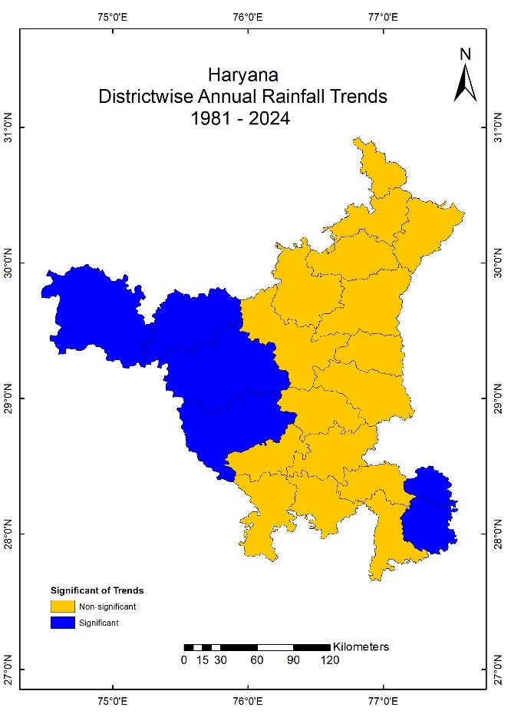
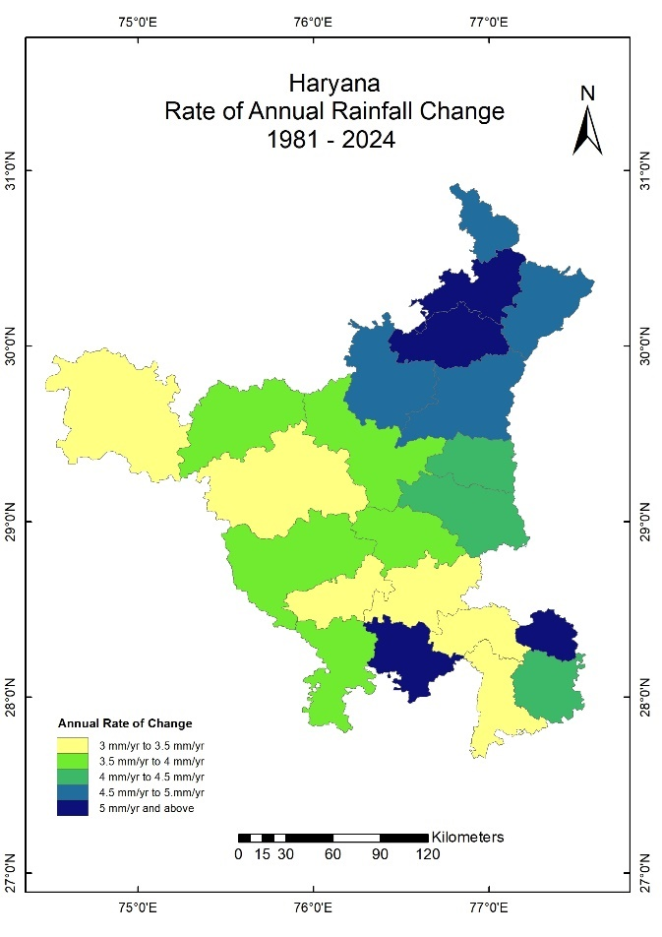
The trend map shows that most districts are characterised by weak increasing tendencies lacking statistical significance, while only a few districts exhibit a consistent and statistically reliable rise in rainfall. This spatial configuration suggests that future rainfall behaviour in Haryana is likely to remain uncertain, with interannual variability and extreme events playing a more decisive role than gradual long-term change.
Draught Analysis
The SPI Drought Classes analysis provides a comprehensive assessment of drought characteristics across Haryana by classifying annual SPI-12 values into distinct drought severity classes, namely mild drought (incipient dryness), moderate drought, severe drought and extreme drought. This classification enables a detailed understanding of the temporal frequency, spatial distribution and severity of drought events across districts during the study period (1981–2024).
The results (Table 3) indicate that mild drought conditions (SPI between −0.99 and 0.0) are the most frequent drought class across almost all districts of Haryana. These mild drought years occur repeatedly in both eastern and western districts, suggesting that rainfall deficiency of low intensity is a recurring climatic feature rather than an occasional anomaly. The widespread occurrence of mild droughts reflects frequent departures from normal rainfall conditions, even in districts that otherwise receive moderate to high annual rainfall. This highlights that rainfall variability, rather than absolute rainfall amount, plays a key role in shaping drought occurrence.
Table: 3 Frequency of Draught (SPI) in Haryana: 1981-2024
Sr. No. | District | Mild drought | Moderate drought | Severe drought | Extreme drought | Total drought years
1 | Ambala | 5 | 3 | 8 | 0 | 44
2 | Bhiwani | 15 | 5 | 1 | 2 | 44
3 | Charki dadri | 15 | 4 | 1 | 2 | 44
4 | Faridabad | 15 | 3 | 3 | 1 | 44
5 | Fatehabad | 7 | 4 | 4 | 1 | 44
6 | Gurugram | 14 | 6 | 1 | 1 | 44
7 | Hisar | 11 | 4 | 3 | 1 | 44
8 | Jhajjar | 14 | 4 | 3 | 1 | 44
9 | Jind | 9 | 5 | 3 | 1 | 44
10 | Kaithal | 7 | 3 | 6 | 1 | 44
11 | Karnal | 5 | 6 | 5 | 0 | 44
12 | Kurushetra | 4 | 4 | 8 | 0 | 44
13 | Mahendragarh | 16 | 5 | 0 | 2 | 44
14 | Mewat | 15 | 5 | 2 | 1 | 44
15 | Palwal | 15 | 6 | 3 | 0 | 44
16 | Panchkula | 2 | 2 | 9 | 0 | 44
17 | Panipat | 12 | 4 | 3 | 1 | 44
18 | Rewari | 11 | 7 | 1 | 1 | 44
19 | Rohtak | 13 | 3 | 3 | 1 | 44
20 | Sirsa | 11 | 3 | 4 | 1 | 44
21 | Sonipat | 12 | 3 | 4 | 1 | 44
22 | YamunaNagar | 2 | 2 | 9 | 0 | 44
Source: Computed By Author
Moderate drought events (SPI between −1.0 and −1.49) show a more pronounced spatial concentration, occurring more frequently in the western and south-western districts such as Sirsa, Hisar, Fatehabad, Bhiwani and Charkhi Dadri. These districts consistently experience rainfall stress, and the higher frequency of moderate droughts reflects their semi-arid climatic setting and weaker monsoonal influence. In contrast, eastern districts such as Yamunanagar, Panchkula and Ambala record fewer moderate drought years, indicating relatively better rainfall reliability despite high interannual variability.
Severe drought conditions (SPI between −1.5 and −1.99) are comparatively less frequent but spatially significant. The Excel-based results show that severe droughts are largely confined to western and central Haryana, reinforcing the notion that drought intensity increases westward across the state. These events represent years of substantial rainfall deficiency, often associated with major agricultural stress, groundwater decline and increased irrigation demand. The limited but recurrent presence of severe droughts indicates that while extreme deficits are not annual occurrences, they remain a persistent risk in vulnerable districts.
The most critical category, extreme drought (SPI ≤ −2.0), occurs sporadically and in a limited number of years, but its impacts are severe. Extreme drought years are predominantly observed in western districts, including Sirsa, Hisar, Fatehabad and Bhiwani, underscoring their high drought susceptibility. The rarity of extreme droughts does not diminish their importance, as these years often coincide with widespread crop failure, acute water scarcity and socio-economic stress. Importantly, some eastern districts record no extreme drought years, reflecting a comparatively resilient rainfall regime.
Overall, the SPI Drought Classes results demonstrate that drought in Haryana is dominated by mild and moderate drought conditions, while severe and extreme droughts occur less frequently but are spatially concentrated in the western and south-western parts of the state. The coexistence of frequent mild droughts with occasional severe and extreme events highlights a rainfall regime characterised by persistent instability rather than isolated drought episodes. These findings underscore the importance of drought preparedness and adaptive water-management strategies, particularly in districts with recurrent moderate to severe drought occurrences. Furthermore, the SPI-based drought classification complements rainfall trend and variability analyses by revealing that even districts with increasing rainfall trends continue to experience frequent drought conditions, emphasising the complex relationship between rainfall amount, variability and drought risk in Haryana.
When the trends of Mann–Kendall and Sen’s slope analyses are interpreted alongside SPI-12 drought frequency maps, a critical insight emerges. Several districts classified under Increasing–Non-significant trends also record high frequencies of mild to moderate drought years, indicating that an increasing rainfall tendency does not necessarily translate into reduced drought risk. This apparent contradiction arises because rainfall increases are often driven by short-duration, high-intensity events, which raise annual totals but do not ensure consistent moisture availability. Consequently, drought occurrence remains frequent despite weak increasing trends.
Similarly, even in districts showing Significant Increasing trends, SPI maps reveal the persistence of intermittent drought episodes, reinforcing that rainfall increase alone is insufficient to stabilise hydro-climatic conditions. The combined spatial interpretation of MK–Sen trend maps and SPI drought frequency maps therefore demonstrates that rainfall variability and distribution are more critical than total rainfall amount in determining drought vulnerability.
Summary and Conclusion
The results clearly demonstrate that rainfall in Haryana is characterised by strong spatial heterogeneity. Mean annual rainfall exhibits a pronounced east–west and north-east to south-west gradient, with higher rainfall in the north-eastern and eastern districts and progressively drier conditions toward the western and south-western regions. However, the analysis confirms that higher rainfall does not necessarily translate into climatic stability, as several high-rainfall districts also experience substantial interannual variability. This indicates that rainfall reliability, rather than rainfall amount alone, governs hydro-climatic risk in the state.
Rainfall variability analysis highlights the dominant role of interannual fluctuations across Haryana. Moderate to high coefficients of variation, coupled with positive skewness and non-normal rainfall distributions, reveal a rainfall regime prone to frequent deficits interspersed with episodic extreme events. These statistical characteristics explain the persistence of climatic uncertainty across districts and reinforce the vulnerability of both humid and semi-arid regions to rainfall irregularity.
Trend analysis using the Mann–Kendall test and Sen’s slope estimator indicates that rainfall trends are predominantly increasing but largely non-significant, with only a few districts exhibiting statistically significant increasing trends. The absence of any significant decreasing trends suggests that long-term rainfall decline is not a dominant feature at the state scale. Nevertheless, the weak magnitude and limited spatial coherence of increasing trends highlight that rainfall variability continues to outweigh long-term directional change.
SPI-based drought analysis further reveals that mild droughts are frequent across all districts, while moderate to extreme droughts remain spatially concentrated in western and south-western Haryana. The combined interpretation of rainfall trends and drought frequency underscores a critical finding: increasing rainfall tendencies do not necessarily reduce drought occurrence. This reflects the growing influence of short-duration, high-intensity rainfall events that inflate annual totals without ensuring sustained moisture availability.
Overall, the study concludes that rainfall variability and distribution are the primary drivers of drought vulnerability in Haryana. The findings emphasise the need for district-specific water management, drought preparedness and climate adaptation strategies, and demonstrate the effectiveness of integrating variability analysis, trend detection and SPI-based assessment for understanding hydro-climatic risks under ongoing climate variability.

Disclaimer (Artificial intelligence)

Author(s) hereby declare that NO generative AI technologies such as Large Language Models (ChatGPT, COPILOT, etc.) and text-to-image generators have been used during the writing or editing of this manuscript.

References
Abid, M., Schneider, U. A., & Scheffran, J. (2015). Farmers’ perceptions of and adaptation strategies to climate change and their determinants: The case of Punjab province, Pakistan. Earth System Dynamics, 6(1), 225–243. https://doi.org/10.5194/esd-6-225-2015.
Abro, M. I., Elahi, E., Khaskheli, M. A., Korai, R. M., Hassan, M., Majidano, A. A., ... & Khokhar, F. M. (2025). Attributing rainfall and drought variability across climate vulnerable area of Pakistan: Perspective from different satellite and ground-based datasets: MI Abro et al. Theoretical and Applied Climatology, 156(2), 77.
Banerjee, R. (2015). Farmers’ perception of climate change, impact and adaptation strategies: A case study of four villages in the semi-arid regions of India. Natural Hazards, 75(3), 2829–2845. https://doi.org/10.1007/s11069-014-1466-z
Basistha, A. D., Arya, D. S., & Goel, N. K. (2009). Analysis of historical changes in rainfall in the Indian Himalayas. International Journal of Climatology, 29(4), 555–572. https://doi.org/10.1002/joc.1838
Basha, G., Kishore, P., Ratnam, M. V., Jayaraman, A., & Rao, S. V. B. (2020). Trend analysis of rainfall and temperature over India using Mann–Kendall test and Sen’s slope estimator. Theoretical and Applied Climatology, 139, 673–687. https://doi.org/10.1007/s00704-019-02988-2
Chaudhary, P., & Mehta, R. (2023). Climate variability and agricultural vulnerability in north-western India: Implications for water and food security. Environmental Science and Pollution Research, 30, 44112–44125. https://doi.org/10.1007/s11356-022-25019-7
Conrad, V., & Pollak, L. W. (1950). Methods in climatology. Harvard University Press. https://doi.org/10.4159/harvard.9780674492546
Dash, S. K., Jenamani, R. K., Kalsi, S. R., & Panda, S. K. (2007). Some evidence of climate change in twentieth-century India. International Journal of Climatology, 27(4), 557–570. https://doi.org/10.1002/joc.1434
Hare, F. K. (1983). Climate and desertification. In H. E. Dregne (Ed.), Desertification of arid lands (pp. 5–20). Harwood Academic Publishers.
Intergovernmental Panel on Climate Change. (2021). Climate change 2021: The physical science basis. Contribution of Working Group I to the Sixth Assessment Report of the Intergovernmental Panel on Climate Change. Cambridge University Press. https://doi.org/10.1017/9781009157896
Jain, S. K., & Kumar, V. (2012). Trend analysis of rainfall and temperature data for India. Theoretical and Applied Climatology, 102(1–2), 37–49. https://doi.org/10.1007/s00704-011-0542-9
Kendall, M. G. (1975). Rank correlation methods (4th ed.). Charles Griffin.
Kumar, V., & Jain, S. K. (2011). Trends in rainfall amount and number of rainy days in river basins of India (1951–2004). International Journal of Climatology, 31(4), 532–541. https://doi.org/10.1002/joc.2068
Kumar, V., Jain, S. K., & Singh, Y. (2021). Analysis of long-term rainfall trends in India using Mann–Kendall test and Sen’s slope estimator. Journal of Hydrology, 596, 126044. https://doi.org/10.1016/j.jhydrol.2021.126044
Mall, R. K., Gupta, A., Singh, R., Singh, R. S., & Rathore, L. S. (2006). Water resources and climate change: An Indian perspective. Current Science, 90(12), 1610–1626.
Mann, H. B. (1945). Nonparametric tests against trend. Econometrica, 13(3), 245–259. https://doi.org/10.2307/1907187
McKee, T. B., Doesken, N. J., & Kleist, J. (1993). The relationship of drought frequency and duration to time scales. In Proceedings of the 8th Conference on Applied Climatology (pp. 179–184). American Meteorological Society.
Mallya, G., Mishra, V., Niyogi, D., Tripathi, S., & Govindaraju, R. S. (2016). Trends and variability of droughts over the Indian monsoon region. Weather and Climate Extremes, 12, 43-68.
Roxy, M. K., Ghosh, S., Pathak, A., Athulya, R., Mujumdar, M., Murtugudde, R., Terray, P., & Rajeevan, M. (2017). A threefold rise in widespread extreme rain events over central India. Nature Communications, 8, 708. https://doi.org/10.1038/s41467-017-00744-9
Sahana, A. S., Ghosh, S., Sahana, A. S., & Mujumdar, M. (2019). Shift in Indian summer monsoon rainfall extremes and its association with climate variability. Climate Dynamics, 52, 6571–6585. https://doi.org/10.1007/s00382-018-4537-1
Sen, P. K. (1968). Estimates of the regression coefficient based on Kendall’s tau. Journal of the American Statistical Association, 63(324), 1379–1389. https://doi.org/10.1080/01621459.1968.10480934
Singh, D., Ghosh, S., Roxy, M. K., & McDermid, S. (2022). Indian summer monsoon: Extreme events, historical changes, and role of anthropogenic forcings. Wiley Interdisciplinary Reviews: Climate Change, 13(1), e715. https://doi.org/10.1002/wcc.715
Subash, N., & Gangwar, B. (2014). Rainfall variability and probability analysis for crop planning in Indian agriculture. MAUSAM, 65(2), 219–228. https://doi.org/10.54302/mausam.v65i2.851
World Meteorological Organization. (2012). Standardized precipitation index user guide (WMO-No. 1090). World Meteorological Organization. https://library.wmo.int/idurl/4/37904
Yue, S., Pilon, P., & Cavadias, G. (2002). Power of the Mann–Kendall and Spearman’s rho tests for detecting monotonic trends in hydrological series. Journal of Hydrology, 259(1–4), 254–271. https://doi.org/10.1016/S0022-1694(01)00594-7
Yue, S., & Wang, C. Y. (2004). The Mann–Kendall test modified by effective sample size to detect trend in serially correlated hydrological series. Water Resources Management, 18(3), 201–218. https://doi.org/10.1023/B:WARM.0000043140.61082.60

